Designing a ubiquitous sensor-based platform to facilitate learning for young children in Thailand
Pruet Putjorn  University of Kent  Kent, UK  pp303@kent.ac.uk | Panote Siriaraya  Delft University of Technology  Delft, The Netherlands  P.Siriaraya@tudelft.nl | Chee Siang Ang  University of Kent  Kent, UK  C.S.Ang@kent.ac.uk | Farzin Deravi  University of Kent  Kent, UK  F.Deravi@kent.ac.uk

ABSTRACT
ACM copyright: ACM holds the copyright on the work. This is the historical approach.

Education plays an important role in helping developing nations reduce poverty and improving quality of life. Ubiquitous and mobile technologies could greatly enhance education in such regions by providing augmented access to learning. This paper presents a three-year iterative study where a ubiquitous sensor based learning platform was designed, developed and tested to support science learning among primary school students in underprivileged Northern Thailand. The platform is built upon the school’s existing mobile devices and was expanded to include sensor-based technology. Throughout the iterative design process, observations, interviews and group discussions were carried out with stakeholders. This lead to key reflections and design concepts such as the value of injecting anthropomorphic qualities into the learning device and providing personally and culturally relevant learning experiences through technology. Overall, the results outlined in this paper help contribute to knowledge regarding the design, development and implementation of ubiquitous sensor-based technology to support learning.

Author Keywords
Mobile devices; Mobile Learning; Ubiquitous Learning Environment; Wireless sensing; Primary School Students

ACM Classification Keywords
H.5 Information Interfaces and Presentation: General

INTRODUCTION
Nearly one billion people have been lifted out of extreme poverty in the past two decades and the UN has set a goal to eradicate extreme poverty globally by 2030. Education plays an important role in ending poverty and we have seen the HCI and other research communities contributing to this effort by designing innovative educational technologies [2, 15, 34, 42, 50, 57]. As developing countries strive to improve the quality of life of their people, they are faced with the challenge of moving from resource-driven growth dependent on cheap labour to growth based on high productivity and innovation. Hence, in addition to providing basic literacy, education also needs to help students develop “higher level skills” such as problem-solving, critical thinking and content creation to enable them to work creatively and collaborate more effectively with others[1, 34]. There is also a challenge to educate students to make use of the rich data in today’s digital society where communication and information is pervasive. These so-called skills in “digital literacy” refer to the knowledge, attitude and ability to understand and make productive use of information and tools in the digital world [9, 13]. However, students from around the world, particularly in developing countries, lack such skills and knowledge [33, 56]. The World Economic Forum report showed that many students in underdeveloped areas are not getting the education they need to develop their “21st century skills” when compared to developed countries [62]. In fact, many developing countries are still struggling to improve basic skills in literacy, numeracy, and science [33], especially given the disparity of educational attainment between students in urban and rural areas. In Thailand for instance, there has been an increasing interest in improving educational performance among schools in underdeveloped rural areas [38, 40]. This urgency has been further prompted by a round of academic assessments from PISA which showed a drop in overall student performance in Thailand and indicated that the majority of those who underperformed came from underprivileged schools in rural areas [25, 37, 39].
As access to low-cost electronics, sensor technologies and mobile devices increases and data-communication coverage continues to expand throughout the globe, education in developing countries could benefit substantially from advancements in ubiquitous learning and mobile technologies. Such technology allows high quality educational information to be seamlessly integrated and shared within a local learning environment providing students with an enhanced learning experience, which could lead to improvements in their overall educational outcome [51]. Therefore, the aim of our research project is to understand more about how a novel educational platform based on ubiquitous learning and mobile technology can be designed to facilitate education for school children in underdeveloped areas, with a focus on Thailand.

More specifically, the objectives of this study are to:
1) Identify opportunities in which technology can be used to augment the existing educational context of schools situated in undeveloped regions in Thailand
2) Design, develop and evaluate an educational platform based on ubiquitous learning and mobile technology and ensure that it could be implemented within an authentic learning context in rural Thailand.
3) Identify key principles on how such a platform can be effectively designed and implemented to facilitate education for younger students at rural schools in Thailand.
Overall, the contributions of this paper are as follows. First, we outline the process in which a novel ubiquitous sensor-based learning platform was iterative designed, developed and refined to facilitate education for young students. In particular, we demonstrate how such technology could be designed and used as part of learning activities for schools in Northern Thailand. Prior studies utilizing such technologies tend to focus on the higher education context and within developed countries. Finally, key reflections which emerged from the various observations, group discussions and interviews carried out during the study process as participants engaged with the platform are highlighted, contributing further knowledge regarding the interactions of young users with a ubiquitous sensor-based learning platform.

Related work

ICT4D in Education
There have been significant research interests in ICT4D (Information and Communications Technologies for Development) in the area of education [20]. While earlier ICT4D research focused on tackling poverty and improving education through the expansion of the telecommunication infrastructure, ICT4D 2.0 aims to achieve this by utilising the power of low-cost devices such as mobile phones and web 2.0 technologies to help improve access to educational content and allow students to become more active learners [20, 53]. In fact, several researchers have highlighted how such technologies are effective in improving the quality and equality of education in underdeveloped regions [57]. For instance, studies have demonstrated how the increased accessibility and flexibility from mobile devices can help reduce barriers to education and facilitate student-cantered exploratory learning [32, 57].
A high profile project which aimed to help improve educational quality in rural areas was the One Laptop per Child (OLPC) program, where inexpensive “XO laptops” with multimedia and education software were distributed across 36 developing countries. A similar project has also been recently deployed in Thailand. With the aim of addressing educational inequality, the Thai government distributed more than 800,000 tablets to first graders (6 year old students) nationwide in 2012 under the “One Tablet Per Child” (OTPC) initiative [35]. However, this project was discontinued due to insufficient results demonstrating its effectiveness. In many cases, students interacted with the tablet passively and only used it to read E-books or watch videos from the Internet [44]. These findings echoed those from studies which examined the use of mobile computers in developing regions, as it was reported that even though such initiatives dramatically increased technology access, motivation in learning and helped improve computer skills, there were no statistically significant effects on academic achievement and cognitive skills improvement [8, 58]. It was claimed that the lack of success was due to the lack of in-depth understanding of the local context [59].
Overall, this topic of improving educational quality in developing regions through affordable technology has been recognised as a key interest area within the HCI community [14, 29, 42, 50]. In particular, prior studies have suggested that mobile technology could play a key role in this regard. For instance, one study has shown that in Panama, mobile devices could be used to help support content creation activities which can lead to creative teaching and learning opportunities in underprivileged schools [3]. Positive outcomes of mobile learning were also reported in the rural Uruguayan school context and the importance of improving interaction design to meet local context requirements was explicitly highlighted [21].

Ubiquitous Learning
As higher access to low-cost mobile devices allows more people to adopt them for learning, they will benefit from the emerging trend of ubiquitous learning, where learners are able to obtain educational information at anytime and anywhere, whenever they are needed [24, 54]. Moreover, as the technology used to implement ubiquitous learning increases in sophistication, the line between the physical and digital learning environment becomes less pronounced. This allows for the creation of mixed reality learning environments which provides more opportunities for students to engage in authentic learning activities [49]. A key advantage of ubiquitous learning is in providing more accessibility and flexibility in education as well as helping facilitate student-centred and exploratory learning [32, 57]. Furthermore, by linking digital content to the physical world, students could acquire knowledge through a form of “augmented learning” [10], allowing them to learn from a relevant environment. An example of this is the Ambient Wood project which was designed to help promote augmented learning and encouraged students to reflect on and learn from physical experiences [48]. Students were presented with various forms of digital augmentation through several types of devices used in the forest.
Previously, ubiquitous learning environments had been implemented through mobile phones and smart tags (QR code and RFID) [9, 19]. Following the rapid development of low-cost computing technology however, a number of sensor-based learning devices have been developed to enhance the ubiquitous learning experience. (See [28] for an example).
In regards to the design of such technologies, a number of approaches have been adopted to enhance its value in learning. With young children in particular, studies showed that incorporating a playful approach towards learning could be valuable. In many cases, such devices utilized anthropomorphic aspects to both appeal and engage young learners (such as in the case of smart toys used in learning etc. [5, 17, 31, 43]). Another example can be seen from robots used as learning companions. Studies showed how using such technology in education to interact with students through human-like qualities (i.e. helping teacher to convey the learning contents) can enhance learning experience and outcome [63].
Another advantage of ubiquitous technology is to encourage a form of social interaction in learning. For instance, one study found mobile computing to be an effective tool to promote social interactions such as face-to-face communication, discussions and negotiations between young students during the lessons [64]. Tablet computers in particular have been used to teach social skills to children with special needs, through collaborative storytelling and music composition activities made possible through joint interactions on multi-touch tablets [22]. Ubiquitous sensors-based devices in the meanwhile have been used to support reflection and communication between family members [11].
Given the potential of ubiquitous learning technology in supporting education and the emerging interest to improve learning in underdeveloped areas, a three-year iterative study was carried out to understand more about how such technology could be designed and implemented to support education in rural Thailand. In this paper, we report the findings of how a sensor-based ubiquitous learning platform was designed and used to facilitate science education in Thailand. Furthermore, we investigated how this platform could be integrated effectively into a rural primary school education context, taking into account how both students and teachers perceive the use of this platform within and beyond the classroom.
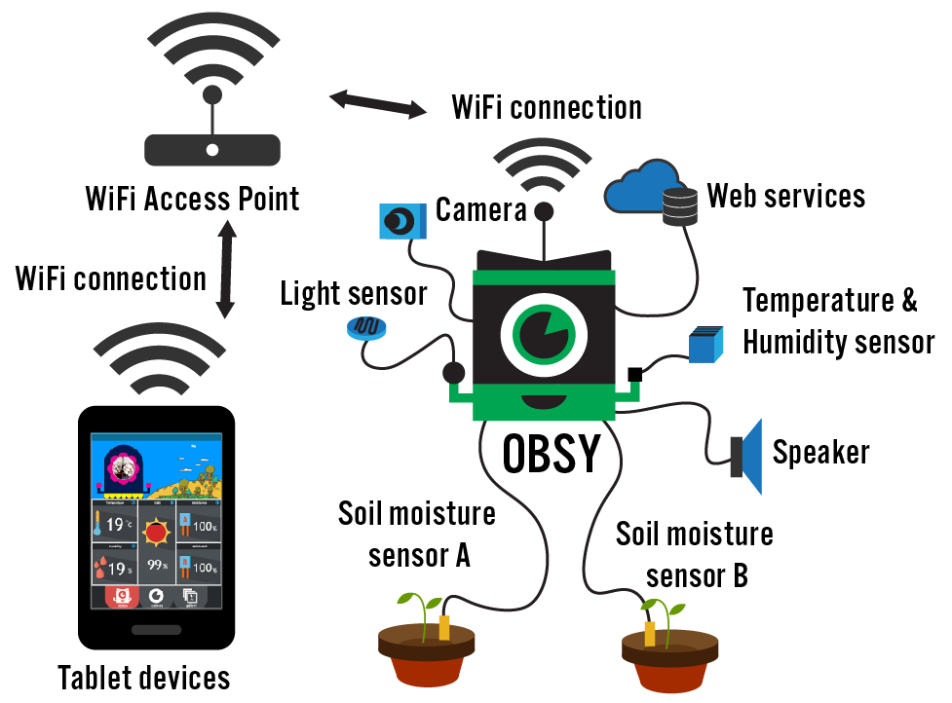
Figure 1. A system diagram for OBSY

Methods
We iteratively designed, developed and tested OBSY an Observation Learning Systems prototype through a user- centred design approach (Figure 1). The OBSY system includes a ubiquitous sensor-based device that was designed to resemble a cartoon octopus and a mobile web application which was hosted from the device. The system was designed to allow primary school students to learn key science concepts by collecting environmental data through the various sensors attached to the OBSY device and then interpreting the data from the web application accessed using tablet computers.
Throughout a period of three years (Oct 2013- April 2016), three studies were carried out, involving various stakeholders such as teachers, head teachers and the students themselves which contributed to the design and development of the OBSY system. The data from these studies formed the basis of the findings described in this paper. Specifically, we conducted an initial user context study where students (N=210) and teachers (N=8) from 2 urban and 2 rural schools in the Northern Thailand were surveyed and later observed and interviewed on their use of the OTPC tablets. Based on the findings, the first prototype of OBSY was created and then used in a feasibility study to investigate the overall perception towards the prototype and assess learning engagement. The feedback from this study was then used to revise OBSY’s design. The final prototype was created and used in a final evaluation study involving 4 rural schools with 244 students and 8 teachers. In this study, OBSY was used to conduct three science related learning activities with third grade students (aged 6-9) after which interviews and discussion groups were carried out. Figure 2 illustrates the studies carried out throughout this project.
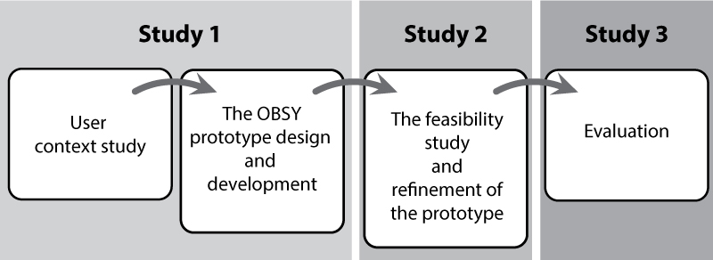
Figure 2. A summary of the studies carried out with OBSY
In this paper, we first discuss how the results from the first study (the user context study) helped conceptualize and lead to the initial design of OBSY. Then, aspects related to the design and technical development of OBSY and the results of the feasibility study are discussed. Finally, the results, findings and reflections from the various interviews, group discussions and observations carried out during the feasibility study and the final evaluation study are analysed and discussed in depth as key reflections.
The study was approved by the researchers’ university research ethics committee. Written consent was granted by the schools’ directors. In Thai schools, the school director and class teachers act as key people with the responsibility to take care of all students in their school. Written consent was provided on behalf of the parents, including permission for video and audio recording. To minimize the disturbance of normal school days and lessons, we only conducted the studies (observation, interview and questionnaire sessions) during a specific one-hour slot dedicated to the students’ independent study. The independent study class is organized twice a week.
RESULTS

Study 1: User context study
The purpose of the first study was to understand how the students and teachers currently approached and used the distributed tablet computers as part of their local educational program and to learn more about the problems encountered when implementing mobile learning technologies (both technical and organizational related). This was done to gain a better understanding of what kind of design would be suitable for the local learning context. Overall, the quantitative results of the questionnaires administered in Study 1 showed visual learning to be the most favourable learning style for the students [44]. In particular, the study showed that rural students had higher anxiety in tablet-based learning than urban students. In the observations and discussions carried out with teachers, they felt that the use of tablets in Thai schools focused too much on the “learning content”, where in many cases students just passively read e-books on the tablet. In particularly, the teachers struggled to integrate the tablets with the local lesson plan as the learning content offered on the tablet was too generalised and not easily customisable to fit the local context. There was also a preference for learning which not only improves students’ knowledge in specific subject areas but also help them develop their soft skills (e.g. critical thinking) [44], [58]. In addition, schools in rural areas tend to have limited budget, lack modern teaching equipment for science education and have unreliable technological infrastructure [37].
Designing the OBSY prototype.
Taking into account all the aforementioned issues from the user context study, three key design objectives were used to guide the initial design of the OBSY prototype.
- Provide active learning with augmented information. The original OTPC learning plans focused too much on passive learning activities and providing a more active learning environment was necessary [46]. In particular, providing learning activities that students could actively participate in and improve their soft-skills while obtaining knowledge relating to their subject domain was preferred. As such, technology that could provide a ubiquitous learning experience would be beneficial (i.e. provide active learning activities augmented by information relating to the taught subject) [46].

- Provide an affordable learning system capable of integration with the local education environment.
Due to the limited budget of the schools, an affordable low-cost platform was required. The system would need to be able to function even when internet connection is unstable or unavailable [45]. In addition, the system would preferably allow students to more easily relate generalized knowledge from the school curriculum to in their local environment
- Provide a child-friendly learning system to reduce anxiety and motivate learning. A more approachable and child-friendly learning tool was needed to help reduce the barriers towards accepting new technology. In particularly, the technology would need to appeal to students who have high anxiety towards traditional technological devices. Ideally, students should not see the learning tool as a technology [46].
Based on this, the OBSY system was developed as a low-cost ubiquitous sensor-based device and a mobile web application to help facilitate learning for primary school students. In particular, the prototype was developed to facilitate science and math education. There was particular interest to improve the quality of education for rural students in these subjects due to the recent national education policy (based on the latest PISA test scores) [25], which were also echoed in the interviews with teachers and administrators. In addition, the learning activities within these subject areas were also particularly suited towards the identified design objectives.
Development of the OBSY prototype
The form factor of the OBSY sensor device was designed to resemble a cartoon “octopus” (See Figure 1). The main reason for this design was to create a more approachable learning device which would appeal to young learners. Thus we suspect that a device which resembles cartoon character dolls (which children generally play with) would be beneficial in this regard. The parts of OBSY were created through 3D printing. The various “tentacles” on the octopus represented sensors attached to the device, allowing OBSY to gather data from the surrounding environment The type of sensors attached to OBSY were selected based on the primary school curriculum [26](moisture and temperature sensors to teach plant growth etc.).
A Raspberry Pi (model B+), an inexpensive, small sized, single board computer was used as the “brain” of the system and is connected to a video camera and various sensors (such as a temperature, humidity and light intensity sensor). To address the problems of unstable (or lack of) internet connection, OBSY also operates as a web server, hosting web applications which visualize real-time sensor data for client tablet computers. A mobile web application on the tablet was created using HTML5, JavaScript and PHP. The user interface was designed with a vivid visual style to appeal to young learners (see Figure 3).
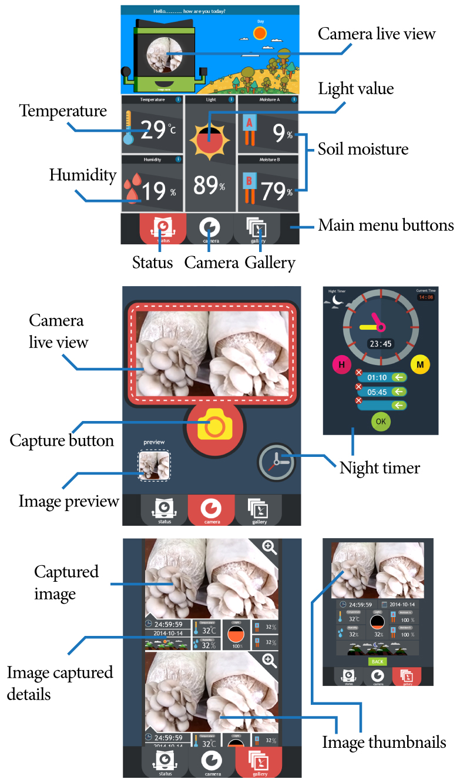
Figure 3. The User Interface of the mobile web application of OBSY, showing the status page (top), camera page (middle) and the image gallery (bottom)
The application consists of three screens: i) the main screen which shows real-time video captured from the OBSY device and displays data from all the sensors, ii) the camera screen which allows students to capture pictures from the current video observation and iii) the gallery screen where students can check and organize all the captured images. These images are presented with cartoon visualizations of data such as the time, day/night, temperature, humidity.
Study 2: The feasibility study and refinement of OBSY
The OBSY prototype was then used to carry out an initial feasibility test with the aim of exploring user engagement and assessing OBSY’s potential in supporting learning through scientific experiments. A mock lesson plan was prepared in which students were asked to use OBSY to carry out a simple science learning activity to gather evidence to distinguish between a “living” and “non-living” thing. This involved students using OBSY to observe growing beans (“a living thing”) and rocks (“a non-living thing”) through the live video stream and captured images and then deciding if it was living or non-living (Figure 4).
Observations were carried out while the students were using OBSY. Afterwards, questionnaires and interview sessions were carried out in which students were asked about their perception of OBSY (questions included OBSY’s aesthetic qualities, the overall design, issues related to usability etc.) as well as their general experience in using OBSY to carry out the learning activities. Finally, participants were involved in brainstorm sessions on how they would like to see OBSY improved and how they would envisage using OBSY outside a classroom context.
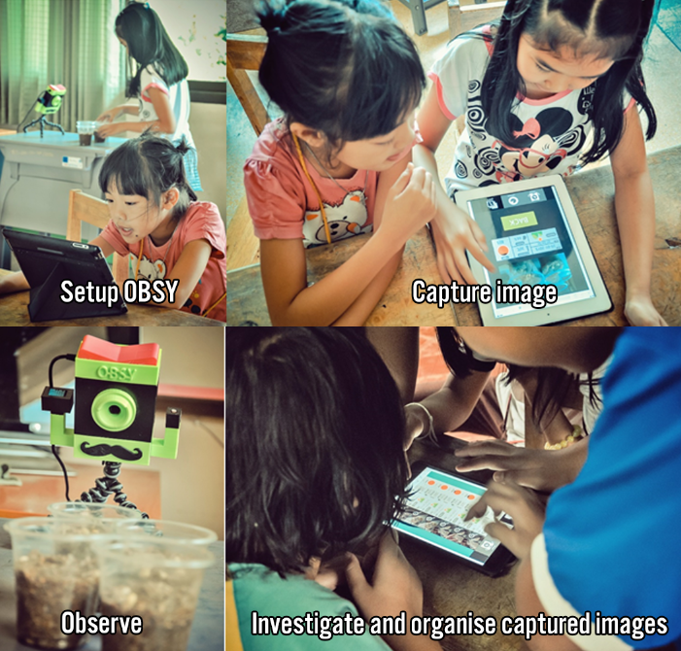
Figure 4: Students engaging with OBSY during the feasibility study
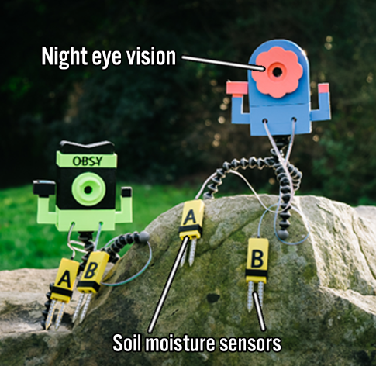
Figure 5. The OBSY 2.0 device
The results from the feasibility test showed that the students were generally enthusiastic about using OBSY. Based on the results from this study, the OBSY device, mobile application and learning activities were iteratively refined. Apart from making changes to improve usability (improving the navigation structure of the application, etc.), the features and functionalities of OBSY were improved to expand the range of scientific concepts that could be explored with OBSY. This was done to better align OBSY to the local school curriculum. A function was added to let students set a photo timer to capture what happens in the science experiment when they are absent from school. In addition, two soil moisture sensors were added to expand the learning context beyond “living and non-living” things (See Figure 5).

Study 3: Evaluation study
The updated version of OBSY was then used in a final evaluation study in four government-supported rural schools with 244 students and 8 teachers. These schools are located close to the Chiang Rai border and the majority of the students are of Akha ethnicity, a disadvantaged ethnic hill tribe who live in the highlands of Chiang Rai’s mountains, extending through Myanmar, Laos and China. Tribal students generally use their own language but are able to speak Thai. However, they often lack the ability to read and write in the Thai language. This study consists of two parts: a controlled experiment study and a qualitative evaluation. In the experiment study learning activity, participants were divided into two groups. In each school, approximately 4 groups of 8 students (4 boys and 4 girls) participated. Four OBSYs devices were used in each school. The OBSY group (N=116) used OBSY to conduct the three science learning activities. These activities include “Hello Mouldy” where students study and investigate how mould grows, “My Little Mushroom” where students investigate what makes mushroom grow in different conditions and “Light Up” where students investigate and understand how light interacts with various objects (see Figure 6). The control group (N=128) carried out the same activities without OBSY using paper and pen.
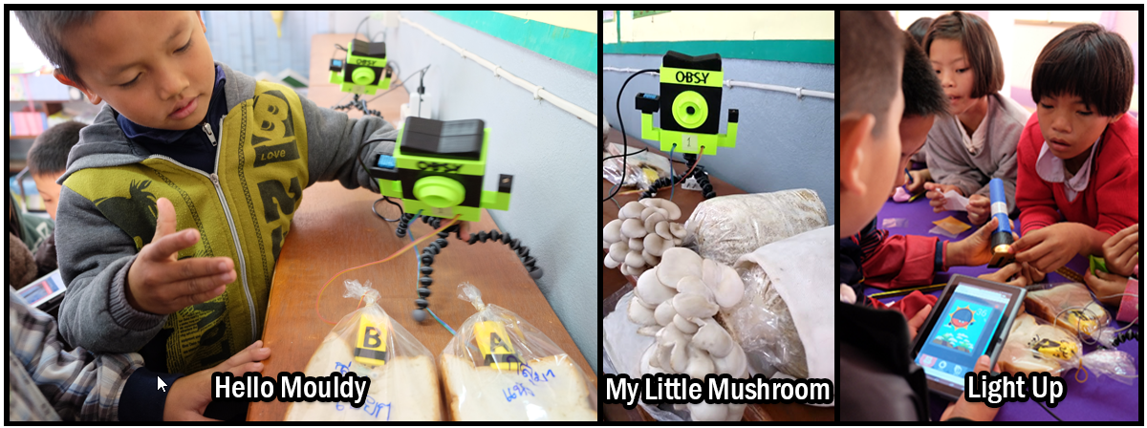
Figure 6. Students using OBSY to carry out the three science learning activities
In the experiment study, the effectiveness of OBSY in facilitating learning outcome was measured using concept maps and assessment tests. Overall, the experiment results showed significant improvements in learning outcome for students in the OBSY group in comparison to the control condition. Regression analysis showed that students who used OBSY had statistically significant higher learning outcomes (β = .359, p < .001) in science than the control group. They also showed a significant improvement in conceptual knowledge based on the evaluation of concept maps (β = .590, p < .001). The scope of this paper however, focuses on the results from the qualitative evaluation, as our main aim is to provide a better understanding from a HCI perspective, of how ubiquitous learning and mobile technology can be better designed and used to facilitate education for rural students.
The qualitative evaluation involved detailed observation of how students in the OBSY group interacted with their friends, teachers and the technology during the learning activities. The research team took video recordings of the group activities to capture valuable insight into their interactions with OBSY. In addition, interviews were carried out with teachers to investigate topics such as their opinions about using OBSY in the classroom, their perception towards OBSY and how they would like to see OBSY improved further. Afterwards, group discussions were carried out with the students to determine what factors led to their interest and engagement with OBSY and to identify potential uses of OBSY within and beyond the classroom setting.
Overall, qualitative data (around 122 hours) was collected from the observation notes, video recordings, interviews and group discussions with the teachers and students from an initial usability test and the final evaluation study. Data from these sources were then analysed using thematic analysis. The data was read through independently by two researchers. Common patterns in the data were identified through coding and further refined into themes as part of the thematic analysis process. Afterwards, the themes were further refined through critical discussion with an additional third researcher to ensure reliability.

Key reflections and insights from the iterative study process
The themes identified from the analysis were further grouped and presented in three main categories. The first relates to the design concept of blending anthropomorphic qualities to the ubiquitous sensor-based learning devices to encourage learning curiosity for young students and the potential role this has in transforming “learning devices” into “learning companions”. The second relates to how the sensor-based technology can be used to augment the existing mobile learning system and help enrich learning by creating a rich experience and personally relevant learning environment. The final concept is related to the creation of a shared interaction space to encourage learning experiences that are rich in social interaction.

Anthropomorphizing the sensor-based learning devices to encourage learning curiosity
A key concept which emerged from the studies was the benefit of adding anthropomorphic qualities to the “devices” within the ubiquitous-sensor context to drive learning curiosity among younger children. It was highlighted by the teachers during the interviews that one of the key strengths of OBSY was the ability to naturally draw in the attention of younger children. In particular, the teachers believed that the aesthetic qualities of OBSY which had a form factor similar to that of cartoon characters, combined with eye catching colours and doll-like appearance helped improve approachability which in turn helped motivate children to engage with OBSY by tapping into their natural curiosity.
“The children liked OBSY and the equipment was attractive to the students. They kept asking what this equipment does…The curiosity towards OBSY draws in crowds of students.” (24 years old, teacher in rural school, man, evaluation study)
“Children were always interested in the form/shape of OBSY… they were excited and wanted to take part due to their curiosity.” (25 years old, teacher in rural school, woman, evaluation study)
Although the use of anthropomorphic qualities to engage younger children in education is not a novel concept (as seen in smart toys etc. [31, 43]), it is interesting to note how this concept could also be applied to sensor-based learning devices. In particular, our results suggest that the anthropomorphic qualities on these devices could be further enhanced by the features of ubiquitous-sensor itself. By being able to obtain, share and display data seamlessly, the range of human-like qualities on such devices could be extended beyond just the aesthetics into “behavioural aspects” as well. For instance, the simple act of connecting the “eye” and “tentacles” of OBSY with a camera and various sensors and then displaying the information on the tablet gave the students the impression that OBSY was “alive”: able to “see” and “feel” the environment. Studies show how adding such qualities could encourage children to perceive the device as more of a “living being” [16], similar to that of an approachable pet.
This aspect was frequently reflected throughout the studies. In some cases, students interacted with OBSY not as a piece of learning technology, but more as a “companion”. One memorable instance was when students were presented with OBSY during the interviews in the feasibility study, they reacted to OBSY’s “human-like” attributes, by placing a toy umbrella over OBSY (perhaps thinking it was hot). In another instance, students placed two OBSY devices close together and engaged in roleplaying a situation where the two OBSY were talking to each other (see Figure 7).
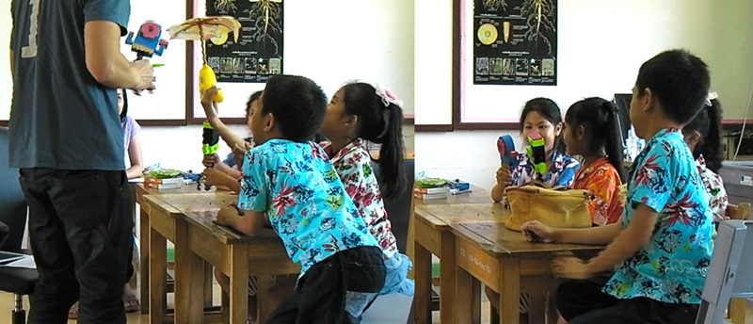
Figure 7. Students interacting with OBSY in a “human-like” manner during the interviews
In other cases, we noticed how students displayed an empathic attitude and showed affection when they talked about OBSY. Some reported wanting to be able to feed OBSY when it is hungry.
“I want it to eat when it is hungry, I want it to be able to smell and grow up” (Student R4, 8 years old, girl, group discussion, the feasibility test)
The value of the anthropomorphic qualities was further highlighted during the discussions with students and teachers about how they would like to see OBSY improved. Due to the anthropomorphized form factor of OBSY, it might not be surprising to find a number of these desirable elements expressed by young students were aimed at enhancing OBSY’s human-like abilities (for instance, wanting OBSY to be able to walk around). What was particularly interesting was to see how students also wished to see the learning content itself being expressed through “human-like” behaviours and interactions. For instance, students did not only want to learn about scientific concepts such as the temperature and humidity by measuring them and viewing the data on the tablet, they wanted OBSY to be able to actually “talk back” and “tell” them the answers through a conversation-like interaction.
“I want it talk to me and tell me the temperature when
temperature and humidity change” (Student U5, 8 years old, girl, group discussion, an initial usability test)”
In another example, when talking about how they would like to use OBSY to learn other classroom subjects, students mentioned wanting OBSY to be able to actually “teach them” the subjects.
“I want to use OBSY to learn English because then it would be able to speak English to me” (Student R5, 9 years old, girl, group discussion, the final evaluation study)
These examples suggest that a more attractive learning environment can be designed for young children by blending in educational content within the “human-like” behavioural features.
The findings also indicated that adding anthropomorphic qualities to the sensor-based learning devices has the potential to allow simple sensor-tools to embody some of the characteristics of a “learning companion” [6]. The playful interactions, discussions and empathic attitude the students had towards OBSY suggested that some may have come to view OBSY as a “friendly companion” within the learning space. Such companions could help reduce anxiety and make learning more engaging [18]. Although artificial learning companions in the context of young learners have been explored previously where more complex robotic devices were developed and deployed [7, 23], this study gives examples of how low-cost 3D printed devices designed with anthropomorphic qualities can exhibit similar features and may have similar advantages in learning outcomes.
Overall, our findings suggest a number of benefits from anthropomorphizing ubiquitous sensor-based devices used in learning. At the most basic level, this could make the devices more inviting for children as sensing devices with human-like attributes might naturally provoke curiosity among children, making learning more interesting. Even within highly structured lessons (such as the science learning activities in the final evaluation study) where students used OBSY as a tool to complete their assigned tasks, the familiarity and attachment created through previous play sessions could make students more receptive and perceive OBSY as less of a “serious learning tool”.

Using sensor-based devices to bring e-learning into the learner’s physical world
The discussions with students and teachers highlighted the importance of employing an experience rich approach towards learning in which students are able to obtain knowledge from authentic learning tasks and take active ownership of their learning experience. This is particularly challenging considering the traditional teaching paradigm commonly employed in Thai schools where the teachers are mainly in charge of the learning experience and students are typically taught to memorize information [55]. In the areas of maths and science in particular, there has been a demand for more interactive hands-on learning activities to teach students scientific concepts and help foster critical thinking skills [4]. However, this could be difficult in underdeveloped areas, where schools typically lack proper scientific equipment necessary to organize such activities.
The results from our studies underlined a number of advantages a ubiquitous sensor-based learning system could have in enhancing the traditional learning approaches at these schools. A key strength observed in the study was the ability to help move learning beyond the conceptual area from the virtual domain (e.g. in books or instructional videos etc.) into the physical domain. Unlike traditional e-learning tools where information is confined mostly to videos and text-based contents, we observed how sensor-based devices can be used to facilitate a more experience rich learning environment where young students are able to “observe and experience” certain scientific concepts hands-on.
“I think that students are able to learn concepts such as percentages and temperature better in a natural setting, by actually experiencing those concepts. Such experimental style education is not commonly used [in Thai Schools]” (55 years old, teacher in a rural school, woman, evaluation study)
Although prior studies have demonstrated how physical world objects (such as plants) could be augmented with educational information through the use of mobile devices and RFID tags [36, 41] , the observations from our studies showed that abstract scientific concepts could also be meaningfully expressed and used for learning through ubiquitous-sensor based devices. In particular, scientific concepts can be made more concrete through visualization and can be “manipulated and experienced” through a relevant context. For instance, students were taught about the concept of time, first by visualization (a rendering of an analog clock was used in the tablet to represent time and the day/night cycle was represented through a graphic rendering of a mountain during the day/night period), then by manipulating it (i.e. setting specific time intervals for OBSY to take photos of plants) and finally by experiencing and reflecting upon it through an easily understood context, (which in this case was by watching how plants grow as time passes). In another example, students learnt about light by experimenting to manipulate light intensity in the physical world.
While some members of the group were reading the value of light intensity from the tablet, other members of the group tried using a piece of paper to cover the light from a mirror in the room and others tried closing the window to reduce the light input on the sensors (9-11 years old, 5 girls and 1 boy, observation video, the final evaluation study)
Therefore, the use of sensor-based learning devices in this study allowed students to have more interaction with the content, potentially resulting in an engaging and active learning experience. Such findings mirror the arguments presented in [52].
Another key benefit which was observed when using OBSY was that it enabled students to learn from examples which are relevant to their daily environment, thus providing more personalized ownership of their learning experience. For example, the concept of “plant life” was not taught using generic examples (such as those shown in textbooks and videos), but from examples of plants which can be more frequently found in the local community. Interviews with the teachers at the end of the evaluation study emphasize some of these benefits.
“It helps them to see the real world rather than watching video clips from YouTube. Video clips from YouTube have been used in the past to show plants growing and animal life cycles but they lack a connection to the students because the environment is different.” (44 years old, teacher in a rural school, woman, feasibility test)
Taking this concept a step further, some of the teachers had even suggested that such a learning system could help expand the learning environment beyond a teacher-classroom context and help create a situation where students partake in learning from their local communities at their own initiative.
“I feel that OBSY could be useful in encouraging learning outside the classroom context, to evoke curiosity and encourage them to use it to obtain new knowledge. Students even come to check on the mushrooms during their lunch break.” (25 years old, teacher in rural school, woman, the final evaluation study)
Similar interests in using OBSY for this purpose were also reflected by the students. For instance, when asked about using OBSY outside the classroom context, students reported being interested in using OBSY to observe the local animals and plants at their own homes. Overall, we believe such examples highlight the potential of sensor-based learning devices in transforming everyday objects and activities into learning opportunities.

Encouraging rich social learning experiences through shared learning spaces
Another key concept which emerged from the design and evaluation of OBSY was how the ubiquitous-sensor platform can help extend the tablet based learning space into a physically sharable learning space. This allows the educational content to be augmented with meaningful information from peer-based social interaction. While in the previous section we discussed the potential of the technology in facilitating rich learning experiences for individual students, our finding are in line with [52] and also suggested that the ubiquitous sensor-based platform can help create shared interaction spaces which allow these learning experiences to be meaningfully shared and discussed with others [11].
For instance, in the OBSY mediated learning activities (in the feasibility and usability studies), we observed that the ubiquitous sensor device seems to help extend the learning space beyond the tablet screen. Due to the active involvement required in manipulating the ubiquitous sensor device to collect meaningful data, the students’ attention and interaction were directed not only to the content within the tablet, but were also diffused into a shared space surrounding both the tablet and the sensor device. In a typical interaction scenario in the evaluation study, we observed that students interacting with the tablet also discussed the readings (temperature etc.) with nearby friends and gave guided instructions to others to better manipulate OBSY.
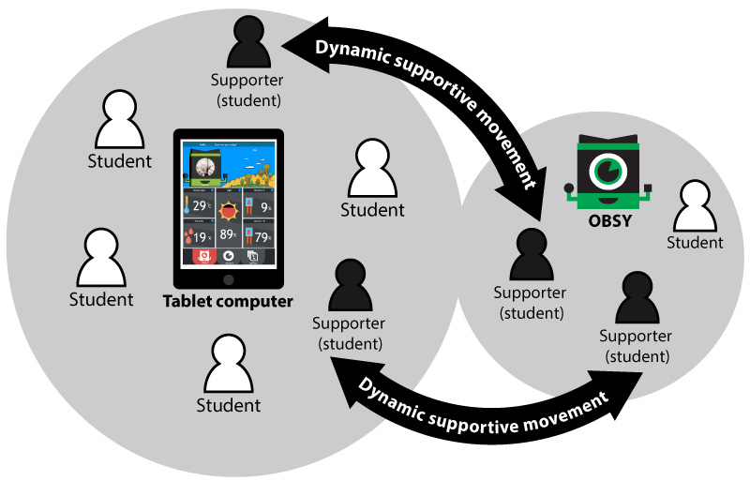
Figure 8. A typical interaction scenario shows that shared learning spaces were formed around the tablet and ubiquitous-sensor device
Some students also naturally took on supportive roles by helping each other adjust the camera and sensors to gather better information (see Figure 8).
One key advantage from these shared interaction spaces was that it enabled the learning content to be shared and discussed meaningfully between the students. In a sense, this allowed the educational content to be further augmented with meaningful information from physically situated peer-based social interaction. For example, we observed in one instance that the scientific concept, “light intensity” was conveyed from one student to another through both verbal and non-verbal interactions in the physical space while they were interacting with OBSY.
A boy waved his hand up and down when he explained to his friends about how much light was captured by OBSY. The hand movement referred to the intensity of the sunlight: moving up when he referred to the high intensity of the light and moving down when he referred to the low light intensity. (8 years old, 5 girls and 1 boy, group observation, an initial usability test)
In addition to the social interactions directed towards the learning content, we also observed other instances of complex group interactions. This included instances such as resolving conflicts, achieving consensus, delegating tasks and sharing access and accomplishments.
“When a teacher asked the students to find out what the temperature was the day before, students looked at the captured images in the image gallery on the tablet device. They faced the difficulty of selecting an image because they had many options. They discussed which the best image was. Student R2 who appeared most confident made the decision. Other students agreed with student R2’s decision by nodding” (8 years old, 5 girls and 1 boy, group observation, an initial usability test)
The benefits of social interaction in these shared interaction spaces were mentioned during the teacher interviews in the final evaluation study. For instance, one teacher stated that there is a natural tendency for children to be social in their learning process (running to each other to discuss concepts etc.) which OBSY helped support. In addition, the teachers also mentioned that social interactions within these spaces could help shift teacher-student relationships in classroom learning. Students took more responsibility in organizing the learning activity and helping guide their peers. They perceived the teacher more as a facilitator with whom they were willing to share new discoveries or findings. Another benefit of the extension of the learning space was that it provided opportunities for students who would have been left out in a conventional Thai classroom context to also have an active role in the learning process. In particular, this provided an opportunity for less confident students to participate in the study. An example of this was shown when one student decided to get involve, joining in the interaction after quietly watching other students complete the task of capturing the image.
Overall, this led us to consider further the use of tablet computers in learning. Even though providing each individual with their own devices has many distinct advantages in education [60], the benefits of the shared learning space should not be overlooked. Perhaps within a classroom context, it might not always be desirable to design a learning context in which every individual student works on his/her own tablet but there should also be room to support shared interaction spaces as well.

DISCUSSION AND CONCLUSION
This paper presented the results of a three-year study in which an educational platform, based on ubiquitous learning and mobile technology was designed, developed and implemented to help facilitate science learning in underdeveloped areas in Thailand. The main contribution of this study is to provide insights into how such educational platforms could be best designed and used to facilitate learning in primary schools in Thailand. The results also suggested that providing ubiquitous sensor devices with anthropomorphic qualities could be beneficial in helping encourage children’s curiosity towards learning. In particular, the observations and interviews suggested that having a form factor that was similar to cartoon characters or dolls helped tap into the students’ curiosity and motivation which encouraged them to be engaged with the learning technology. Sensor-based learning devices could also be used to transform conventional classroom learning into a more experience rich and personally relevant learning environment. This can help move learning beyond the conceptual/theoretical area and enable students to learn through hands-on experience. Moreover, the interviews and observations suggested that in the learning activities, using the ubiquitous sensor platform to observe objects local to their community allowed students to learn from examples more relevant to their daily life. Finally, we observed the formation of a shared-learning space through the use of the tablet and sensor-based learning device which encouraged rich social interaction and led to a more authentic group-based learning experience.

Limitations
Although we have reported mainly the key benefits of using ubiquitous sensor-based technology in learning through our studies, we have also identified some barriers which posed as limitations to our study and could hinder the application of this platform. First, to enable more advanced learning activities to be integrated into the educational platform (for instance, to teach older students), the technical capability of the current device would need to be expanded further (more expensive sensors and processing capacities etc.) thus potentially increasing the cost. The current device, designed specifically around low-cost hardware and open-source software, costs around $60 per unit (though this cost could be decreased through mass-production). Future longitudinal studies would be needed, however, to more accurately evaluate the long-term cost and viability of this technology, in particular, when OBSY is used in a wider array of learning subjects. In addition, although we encountered few usability and technology acceptance problems in our study, we did observe that there were teachers who had less prior experience with technology and were anxious about using new technology. The technical constraints of the OBSY prototypes also resulted in some limitations to the learning activities carried out during this study. For instance, as there was no alternative power source (such as a rechargeable battery) students were limited to certain areas which they could deploy their observation activities. Additionally, issues of privacy and data security would need to be considered more in depth [27].
There are a number of limitations regarding the applicability and generalization of the results in this study. As we focused on primary school students (aged 6-9), whether the findings in this study could be applied to older students will need to be further investigated. In particular, as the design of OBSY system was based on the Thai educational context, whether the findings could be generalized to communities with other cultural backgrounds and whether OBSY could be integrated with the learning culture of different countries would need to be determined. In addition, the learning activities in this study were carried out within one semester and focused on science related learning activities. Further studies would be needed to investigate the appropriate application of this device to concepts in other subjects and for longer periods.

Future Work
We have also identified some promising future research and design directions for ubiquitous sensor-based learning technology. For instance, it had been suggested that the added engagement from the anthropomorphized “things” have the potential to help encourage learning outside the classroom. In particular, integrating a layer of play within the learning experience could provide further motivation for students to engage in self-learning activities [61]. Therefore, it would be interesting to investigate different aspects of anthropomorphism to see which could be implemented in a low-cost manner in educational ubiquitous sensor devices. In addition, researchers could also explore new ways in which sensor-based educational devices could be used to bring learning content into the physical world, thus allowing advanced abstract concepts to be more easily understood. Perhaps, hypothetical scenarios could be created through computer simulations [12, 30, 47] to help students experience and test concepts in other fields such as social science or history. Another important topic which we believe could greatly enhance the value of ubiquitous learning devices would be to find novel ways to integrate social learning through networked smart objects. For example, the integration of sensor-based learning systems with IoT (Internet of Things) technologies could be done to allow either different people from the same community or students from different regions to generate meaningful knowledge together to augment the learning content.
In conclusion, we believe that our study has demonstrated how a ubiquitous sensor-based learning device can be designed and used to facilitate education in underprivileged parts of developing countries and more should be done to further explore this potentially fruitful research area.

ACKNOWLEDGEMENT
We would like to thank the teaching staff and students from the schools who participated in our study and also the research staff in the School Information Technology, Mae Fah Luang University for their support.
REFERENCES
- Michael Anft. 2013. The STEM crisis: Reality or myth. The Chronicle of Higher Education. Retrieved January 19, 2017 from http://www.chronicle.com/article/The-STEM-Crisis-Reality-or/142879
- Elba del Carmen Valderrama Bahamondez, Bastian Pfleging, Niels Henze, and Albrecht Schmidt. 2014. A long-term field study on the adoption of smartphones by children in panama. In Proceedings of the 16th international conference on Human-computer interaction with mobile devices & services (MobileHCI '14). ACM, New York, NY, USA, 163-172. DOI: http://dx.doi.org/10.1145/2628363.2628403
- Elba del Carmen Valderrama Bahamondez, Christian Winkler, and Albrecht Schmidt. 2011. Utilizing multimedia capabilities of mobile phones to support teaching in schools in rural panama. In Proceedings of the SIGCHI Conference on Human Factors in Computing Systems (CHI '11). ACM, New York, NY, USA, 935-944. DOI: https://doi.org/10.1145/1978942.1979081
- Sharon Bailin. 2002. Critical thinking and science education. Science & Education. 11, 4, 361-375.
- Aude Billard. 2003. Robota: Clever toy and educational tool. Robotics and Autonomous Systems. 42, 3, 259-269.
- Chih-Yueh Chou, Tak-Wai Chan and Chi-Jen Lin. 2003. Redefining the learning companion: the past, present, and future of educational agents. Computers & Education. 40, 3, 255-269.
- WEI Chun-Wang, HUNG I-Chun, LEE Ling, and CHEN Nian-Shing. 2011. A joyful classroom learning system with robot learning companion for children to learn mathematics multiplication. TOJET: The Turkish Online Journal of Educational Technology. 10, 2.
- Julián P. Cristia, Pablo Ibarrarán, Santiago Cueto, Ana Santiago and Eugenio Severín. 2012. Technology and child development: Evidence from the one laptop per child program. serie de documentos de trabajo del BID, núm. IDB-WP-304, Banco Interamericano de Desarrollo, Washington, DC.
- Department of eLearning. 2015. Digital Literacy 21st Century Competences for Our Age The Building Blocks of Digital Literacy From Enhancement to Transformation. Green Paper: Digital Literacy. Retrieved January 19, 2017 from https://dge.mec.pt/sites/default/files/ERTE/Estudos_Tecnologias/elc_digital_literacy.pdf
- Ellen Yi-Luen Do. 2015. Creating Unique Technology for Everyone. In Proceedings of the ASEAN CHI Symposium'15 (ASEAN CHI Symposium'15). ACM, New York, NY, USA, 42-45. DOI=http://dx.doi.org/10.1145/2776888.2780363
- Tao Dong, Mark W. Newman, Mark S. Ackerman, and Sarita Schoenebeck. 2015. Supporting reflection through play: field testing the home trivia system. In Proceedings of the 2015 ACM International Joint Conference on Pervasive and Ubiquitous Computing (UbiComp '15). ACM, New York, NY, USA, 251-262. DOI: http://dx.doi.org/10.1145/2750858.2804294
- Matt Dunleavy and Chris Dede. 2014. Augmented reality teaching and learning. In Handbook of research on educational communications and technology, pp. 735-745. Springer New York.
- Ola Erstad. 2007. Conceiving Digital Literacies in Schools-Norwegian Experiences. In Proceedings of the 3rd International workshop on Digital Literacy, 310.
- Leah Findlater, Ravin Balakrishnan, and Kentaro Toyama. 2009. Comparing semiliterate and illiterate users' ability to transition from audio+text to text-only interaction. In Proceedings of the SIGCHI Conference on Human Factors in Computing Systems (CHI '09). ACM, New York, NY, USA, 1751-1760. DOI: https://doi.org/10.1145/1518701.1518971
- Elizabeth FitzGerald and Ann Jones. 2014. Special Issue on Mobile Learning and Educational Mobile HCI. International Journal of Mobile Human Computer Interaction. 6, 3.
- Andrea Francis and Punya Mishra. 2008. Differences in children’s verbal responses and behavioral interactions with anthropomorphic artifacts.
- Andrea Francis and Punya Mishra. 2009. Is AIBO Real? Understanding Children's Beliefs About and Behavioral Interactions with Anthropomorphic Toys. Journal of Interactive Learning Research. 20, 4, 405.
- Agneta Gulz. 2004. Benefits of virtual characters in computer based learning environments: Claims and evidence. International Journal of Artificial Intelligence in Education (IJAIED). 14, 3, 313-334.
- Md. Sanaul Haque and Richard Dybowski. 2014. Advanced QR Code Based Identity Card: A New Era for Generating Student ID Card in Developing Countries. In Proceedings of the 2014 First International Conference on Systems Informatics, Modelling and Simulation (SIMS '14). IEEE Computer Society, Washington, DC, USA, 97-103. DOI=http://dx.doi.org/10.1109/SIMS.2014.24
- Richard Heeks. 2008. ICT4D 2.0: The next phase of applying ICT for international development. Computer. 41, 6, 26-33.
- Juan Pablo Hourcade, Daiana Beitler, Fernando Cormenzana, and Pablo Flores. 2008. Early olpc experiences in a rural uruguayan school. In CHI '08 Extended Abstracts on Human Factors in Computing Systems (CHI EA '08). ACM, New York, NY, USA, 2503-2512. DOI=http://dx.doi.org/10.1145/1358628.1358707
- Juan Pablo Hourcade, Natasha E. Bullock-Rest, and Thomas E. Hansen. 2012. Multitouch tablet applications and activities to enhance the social skills of children with autism spectrum disorders. Personal Ubiquitous Comput. 16, 2 (February 2012), 157-168. DOI=http://dx.doi.org/10.1007/s00779-011-0383-3
- Sheng-Hui Hsu, Chih-Yueh Chou, Yuan-Kai and Tak-Wai Chan. 2007. An investigation of the differences between robot and virtual learning companions' influences on students' engagement. In Digital Game and Intelligent Toy Enhanced Learning, 2007. DIGITEL'07. The First IEEE International Workshop on. 41-48.
- Gwo-Jen Hwang and Chin-Chung Tsai. 2011. Research trends in mobile and ubiquitous learning: A review of publications in selected journals from 2001 to 2010. British Journal of Educational Technology. 42, 4, E65-E70.
- IPST. Thailand PISA 2015 Research Summary. 2017. Retrieved January 19, 2017 from http://pisathailand.ipst.ac.th/pisa/reports/pisa2015summaryreport
- IPST. National scientific Curriculum. Ministry of Education, Bangkok, 2008.
- Meg Leta Jones and Kevin Meurer. 2016. Can (and should) Hello Barbie keep a secret? 2016 IEEE International Symposium on Ethics in Engineering, Science and Technology (ETHICS) 2016. 1-6.
- Chris Joyce, Han Pham, Danae Stanton Fraser, Stephen Payne, David Crellin, and Sean McDougall. 2014. Building an internet of school things ecosystem: a national collaborative experience. In Proceedings of the 2014 conference on Interaction design and children (IDC '14). ACM, New York, NY, USA, 289-292. DOI: http://dx.doi.org/10.1145/2593968.2610474
- Matthew Kam, Akhil Mathur, Anuj Kumar, and John Canny. 2009. Designing digital games for rural children: a study of traditional village games in India. In Proceedings of the SIGCHI Conference on Human Factors in Computing Systems (CHI '09). ACM, New York, NY, USA, 31-40. DOI=http://dx.doi.org/10.1145/1518701.1518707
- Amy M. Kamarainen, Shari Metcalf, Tina Grotzer, Allison Browne, Diana Mazzuca, M. Shane Tutwiler, and Chris Dede. 2013. EcoMOBILE: Integrating augmented reality and probeware with environmental education field trips. Comput. Educ. 68, 545-556. DOI=http://dx.doi.org/10.1016/j.compedu.2013.02.018
- Takayuki Kanda, Takayuki Hirano, Daniel Eaton, and Hiroshi Ishiguro. 2004. Interactive robots as social partners and peer tutors for children: a field trial. Hum.-Comput. Interact. 19, 1, 61-84. DOI=http://dx.doi.org/10.1207/s15327051hci1901&2_4
- Paul Kim, Elizabeth Buckner, Hyunkyung Kim, Tamas Makany, Neha Taleja, and Vallabhi Parikh. 2012. A comparative analysis of a game-based mobile learning model in low-socioeconomic communities of India. International Journal of Educational Development. 32, 2, 329-340.
- Elizabeth M. King and Rebecca Winthrop. 2015. Today's challenges for girls' education. Brookings Global Working Paper Series.
- Charles Kivunja. 2015. Exploring the Pedagogical Meaning and Implications of the 4Cs “Super Skills” for the 21 st Century through Bruner’s 5E Lenses of Knowledge Construction to Improve Pedagogies of the New Learning Paradigm. Creative Education. 6, 2, 224.
- Seth Leighton. 2012. Outcome Document: Asia Pacific Ministerial Forum on ICT in Education (AMFIE) 2012. Thailand: UNESCO Bangkok.
- Gi-Zen Liu and Gwo-Jen Hwang. 2010. A key step to understanding paradigm shifts in e‐learning: towards context‐aware ubiquitous learning. British Journal of Educational Technology. 41, 2, E1-E9.
- Kiatanantha Lounkaew. 2013. Explaining urban–rural differences in educational achievement in Thailand: Evidence from PISA literacy data. Economics of Education Review. 37, 213-225.
- OECD. 2017. Economic Outlook for Southeast Asia, China and India 2016. Organisation for Economic Co-operation and Development. OECD Publishing, Paris. Retrieved January 19, 2017 from http://www.oecd.org/dev/economic-outlook-for-southeast-asia-china-and-india-23101113.htm
- OECD. 2016. PISA 2015 Results in Focus. Retrieved January 19, 2017 from https://www.oecd.org/pisa/pisa-2015-results-in-focus.pdf
- OECD, 2013. Southeast Asian Economic Outlook 2013. Organisation for Economic Co-operation and Development. Retrieved January 19, 2017 from http://www.oecd.org/dev/asia-pacific/saeo2013.htm
- Noritaka Osawa, Katsuji Noda, Satoru Tsukagoshi, Yutaka Noma, Akikazu Ando, Tomoharu Shibuya, and Kimio Kondo. 2007. Outdoor education support system with location awareness using RFID and symbology tags. Journal of Educational Multimedia and Hypermedia. 16, 4, 411.
- Udai Singh Pawar, Joyojeet Pal, Rahul Gupta, and Kentaro Toyama. 2007. Multiple mice for retention tasks in disadvantaged schools. In Proceedings of the SIGCHI Conference on Human Factors in Computing Systems (CHI '07). ACM, New York, NY, USA, 1581-1590. DOI=http://dx.doi.org/10.1145/1240624.1240864
- Lydia Plowman and Rosemary Luckin. 2004. Interactivity, interfaces, and smart toys. Computer, 37, 2, 98-100.
- Pruet Putjorn, Chee Siang Ang, and Farzin Deravi. 2016. Understanding tablet computer usage among primary school students in underdeveloped areas. Comput. Hum. Behav. 55, 1131-1144. DOI=http://dx.doi.org/10.1016/j.chb.2014.09.063
- Pruet Putjorn, Chee Siang Ang, Farzin Deravi, and Narong Chaiwut 2015. Exploring the Internet of “Educational Things”(IoET) in rural underprivileged areas, Electrical Engineering/Electronics, Computer, Telecommunications and Information Technology (ECTI-CON), 2015 12th International Conference on 2015, IEEE. 1-5.
- Pruet Putjorn, CheeAng Siang Ang, and Farzin Deravi. 2015. Learning IoT without the "I"- Educational Internet of Things in a Developing Context. In Proceedings of the 2015 Workshop on Do-it-yourself Networking: an Interdisciplinary Approach (DIYNetworking '15). ACM, New York, NY, USA, 11-13. DOI=http://dx.doi.org/10.1145/2753488.2753489
- Fabian Quint, Katharina Sebastian, and Dominic Gorecky. 2015. A Mixed-reality Learning Environment. Procedia Computer Science. 75, 43-48.
- Y. Rogers, S. Price, G. Fitzpatrick, R. Fleck, E. Harris, H. Smith, C. Randell, H. Muller, C. O'Malley, D. Stanton, M. Thompson, and M. Weal. 2004. Ambient wood: designing new forms of digital augmentation for learning outdoors. In Proceedings of the 2004 conference on Interaction design and children: building a community (IDC '04). ACM, New York, NY, USA, 3-10. DOI=http://dx.doi.org/10.1145/1017833.1017834
- Ken Sakamura and Noboru Koshizuka. 2005. Ubiquitous computing technologies for ubiquitous learning, IEEE International Workshop on Wireless and Mobile Technologies in Education (WMTE'05) 2005, IEEE, 11-20.
- Eunice Sari and Bimlesh Wadhwa. 2015. Understanding HCI education across Asia-Pacific. In Proceedings of the International HCI and UX Conference in Indonesia (CHIuXiD '15), Adi Tedjasaputra, Harry B. Santoso, Eunice Sari, Johanna Hariandja, Emil R. Kaburuan, and Paulus Insap Santoso (Eds.). ACM, New York, NY, USA, 65-68. DOI: http://dx.doi.org/10.1145/2742032.2742042
- Michelle Selinger, Ana Sepulveda, and Jim Buchan. 2013. Education and the Internet of Everything: How ubiquitous connectedness can help transform pedagogy. White Paper, Cisco, San Jose, CA.
- Maria João Silva, João Correia Lopes, Pedro Moreira da Silva, and Maria José Marcelino. 2010. Sensing the schoolyard: using senses and sensors to assess georeferenced environmental dimensions. In Proceedings of the 1st International Conference and Exhibition on Computing for Geospatial Research & Application (COM.Geo '10). ACM, New York, NY, USA, 40, 4. DOI=http://dx.doi.org/10.1145/1823854.1823899
- Evin M. Tas. 2011. ICT education for development — a case study. Procedia Computer Science. 3, 507-512.
- Punnarumol Temdee. 2014. Ubiquitous Learning Environment: Smart Learning Platform with Multi-Agent Architecture. Wirel. Pers. Commun. 76, 3 (June 2014), 627-641. DOI=http://dx.doi.org/10.1007/s11277-014-1730-2
- Chutima Thamraksa. 2003. Student-centered learning: Demystifying the myth. Studies in Language and Language Teaching. 12, 59-70.
- UNESCO. 2015. EDUCATION FOR ALL 2000-2015: achievements and challenges. UNESCO Publishing, Paris. Retrieved January 19, 2017 from http://unesdoc.unesco.org/images/0023/002322/232205e.pdf
- John-Harmen Valk, Ahmed T. Rashid, and Laurent Elder. (2010). Using mobile phones to improve educational outcomes: An analysis of evidence from Asia. The International Review of Research in Open and Distributed Learning. 11,1) 117-140.
- Ratchada Viriyapong and Antony Harfield. 2013. Facing the challenges of the One-Tablet-Per-Child policy in Thai primary school education. Education. 4, 9.
- Mark Warschauer and Morgan Ames. 2010. Can One Laptop per Child save the world's poor? Journal of International Affairs. 64, 1.
- David Whitebread, Penny Coltman, Helen Jameson, and Rachel Lander. 2009. Play, cognition and self-regulation: What exactly are children learning when they learn through play? Educational and Child Psychology. 26, 2, 40.
- World Economic Forum. 2015. New vision for education: unlocking the potential of technology, World Economic Forum, Geneva, Switzerland. . Retrieved January 19, 2017 from http://www3.weforum.org/docs/WEFUSA_NewVisionforEducation_Report2015.pdf
- Zhen-Jia You, Chi-Yuh Shen, Chih-Wei Chang, Baw-Jhiune Liu, and Gwo-Dong Chen. 2006. A robot as a teaching assistant in an English class, Sixth IEEE International Conference on Advanced Learning Technologies (ICALT'06), IEEE, 87-91.
- Gustavo Zurita and Miguel Nussbaum. 2007. A conceptual framework based on activity theory for mobile CSCL. British Journal of Educational Technology. 38, 2, 211-235.

