Dr Joanne Pettitt, University of Kent
Visual-Textual Encounters with a German Grandfather: The Work of Angela Findlay
Abstract
In this article, I consider the artistic and literary work of Angela Findlay, the daughter of a German mother and English father, and the granddaughter of a highly decorated Wehrmacht soldier. Working as a visual artist, public speaker and writer, Findlay moves between representational forms in order to express the complexities associated with her dual heritage and the “legacy of shame” that she carries with her. I take Findlay’s In My Grandfather’s Shadow as a case study that foregrounds new forms of visual-textual witnessing in the descendants of the war generation. I conclude that, by moving between different artistic practices, Findlay is able to encapsulate the complex and transnational experience of being a descendent of both Germany and the Allied nations; in so doing, she challenges the reader to question the conceptual boundaries of testimony, straightforward perceptions of perpetration, and the diluted but nevertheless affected and affective experiences of subsequent generations.
Key Words: Angela Findlay; Second- and Third-generation Holocaust Literature; Generic Hybridity

Author Biography
Dr Joanne Pettitt is a Senior Lecturer in Comparative Literature at the University of Kent, UK. She is co-editor-in-chief of Holocaust Studies: a Journal of Culture and History and Secretary of the British and Irish Association for Holocaust Studies.

‘After years of inexplicable feelings and symptoms, I’ve come to understand that just like we can inherit the physical or character traits of our forebears, so we can inherit their unresolved traumas; that these don’t simply go away, that they remain among our roots like wounds festering in the dark and then erupting into the present as they seek resolution.’ (Findlay, ‘Facing the Past to Liberate the Present’: 0:00:24-0:00:49)

‘I never met my grandfather. A week after I took my first breath, he took his last. But I always felt we connected during those few days when our lives overlapped. As he departed the world and I entered it, our paths crossed. And, like a relay racer passing on the baton, he handed me something.’ (Findlay, In My Grandfather’s Shadow: 5)

Angela Findlay was born to a German mother and English father in 1964. Raised in England, she spent an idyllic childhood surrounded by loving family, the product of a dual heritage unavoidably shaped by the cataclysmic events of the Second World War. Her grandfather – Karl von Graffen – was a talented artillerist and professional soldier who fought in the First World War before going on to become a highly decorated General in the Wehrmacht; his wartime deeds remain ambiguous: he appears to have been well-respected if not always likeable, a willing cog in the so-called war of annihilation, and broadly committed to the Nazi cause, at least in so far as he exhibited a firm belief in the need to defend Germany from the threat of Communism and expand German territory in the East. His postwar reflections, written between 1946-1948 while a prisoner of war in Italy, contain vague references to atrocities and “abhorrent crimes against humanity,” suggesting at least a peripheral knowledge of the fate of the Jews, yet his direct participation in the murders is never confirmed, and there is no written evidence of his having been personally motivated by antisemitism. He had never joined the Nazi party and was found not guilty of all charges against him when he was released after three years as a prisoner of war. Nevertheless, he was a career soldier and had a firm sense of honour, duty and patriotism. Moreover, as a high-ranking member of the German Army, he was responsible for leading his unit and directing operations on the ground. Such a position already indicates that Graffen was complicit in the German war machine and all that it entailed; as Wolfram Wette has shown, the Wehrmacht ‘bears the onus of having waged a war of extermination in Eastern Europe between 1941-1944 in violation of international law.’
First brought to popular attention in the ‘War of Extermination: Crimes of the Wehrmacht’ exhibition between 1995-1999, there is ample photographic and epistolary evidence of the involvement of the Wehrmacht in the roundup and assassination of Jews and other “enemy” groups, particularly Russian civilians. Although it was the subject of vigorous protests from veterans, far-right groups and others, the “Wehrmacht” exhibition attracted hundreds of thousands of visitors and has been considered a starting point for the conversation about the genocidal guilt of rank-and-file officers during the war. Certainly, as recent research has shown, such atrocities were not merely the result of a single order from Hitler ‘but rather gained momentum from impulses on the ground in many different places.’ As Wette demonstrates, the involvement of the German army in acts of extermination was motivated by deeply engrained anti-Bolshevik and anti-Jewish thought that had been in evidence in Germany and elsewhere even before 1933 and that was the focus of much of the propaganda of the period. This at least partly explains why, despite the existence of a handful of apparently reluctant Wehrmacht generals – examined at length in Correlli Barnett’s Hitler’s Generals – Hitler received little opposition to his plans for extermination from the Army. If, in the immediate aftermath of the conflict, the Wehrmacht was successful in constructing itself as an honorable and legitimate machine of war, more recent research has shown that it was deeply implicated, ideologically and logistically, in the crimes of National Socialism. Thus the myth of the “clean hands” of the Wehrmacht has, in recent years, been overturned. This is the “legacy of shame” that Findlay carries as the direct descendant of a Wehrmacht general.
For Findlay, who has spent much of her life working through this legacy, the work of Marianne Hirsch, Sabine Bodeand Gerard Fromm provided a language that enabled her to articulate her experiences. Over the course of her life and research, Findlay found that the intergenerational transfer of guilt could be experienced both psychically and corporeally; it can manifest in one’s personality, behavior and bodily reactions, and it can contribute to identity formation in unexpected and often undetectable ways. Adopting a psychoanalytic approach, Nicholas Abraham and Maria Torok conceptualize these psychical invasions as phantoms, “foreign bodies lodged within the subject,” which “work like a ventriloquist, like a stranger within the subject’s own mental topography.” This heterogeneous presence is reminiscent of what Berger and Berger call, in relation to the children of survivors, “the eternal presence of an absence.”
Descendants of both perpetrators and victims live with these ghosts of the past lodged within their psyches, their lives inevitably defined by their connection to the genocide, no matter which side of history their forebears were on. This is not to say that the experiences of the two groups are commensurate. Critics have long noted “that such attempts to create a false and necessarily shallow sense of connectedness between the heirs of Holocaust victims and their murderers is an insult to history and to the Jewish people whose loss we continue to mourn.” Indeed, children of victims are, according to Berger and Berger, “unified by a search to connect with the past”; their family connections are defined by absence and loss, and their future orientation is shaped by a strong instinct for cultural and familial survival. By contrast, descendants of perpetrators tend to be defined by their relationships with their living families; their worldviews are often marked by a significant rejection of the past and, in contrast to the survival instinct of survivor-descendants, they frequently express a fear of passing on what Dan Bar-On calls the “bad seed” of a perpetrator heritage. At the same time, narratives of catharsis, closure and redemption – played out at across German society, politics, culture, and families – are reserved only for those reckoning with a legacy of inherited culpability; escape from the traumas of the Nazi past is far less likely for those whose families and communities were destroyed by the genocide; the burden is, in this sense, not redeemable or vanquishable for the descendants of victims. Despite these important differences, I follow Sue Vice’s view that:
The confrontation with a wartime legacy of silence about the events of the Holocaust years, albeit experienced from opposite positions in relation to a “vast and chilling” gulf, can generate the sense that such histories, especially in cases where there are common German origins, are “intertwined.”
An inherited sense of displacement and rupture is central to the experience of both generational groups. Any attempt to capture the complexities of these experiences in artistic or literary form must somehow account for the haunting presence of these “buried tombs” as well as the dislocation that occurs as a consequence of the external presence/absence.
What I wish to argue here is that generic hybridity has the potential to encode the heterogeneity of descendent experiences; by taking what Hillary Chute considers a “risk of representation,” authors employ combined textual-visual forms to show that “that trauma does not always have to be disappearance; it can be plenitude, an excess of signification.” Though not exactly the kind of graphic narrative that Chute had in mind, Angela Findlay’s combination of visual art and the written word acts in a similar way to the one outlined above, positioning itself as a new form of “visual-verbal witness” that seeks to express the “textual wounds that struggle to solve the crisis of signification and to heal.”
In her discussion of the third generation, Victoria Aarons demonstrates the ways in which structural patchworks “draw upon a collage of sensations, affects, competing and broken memories, implied and circuitous hints, sideways references and whispered asides, a whiff of knowing, as if the information were bracketed within imaginary dashes, forethought and afterthought, an endnote, a postscript to loss.” In what follows, I will argue that the hybrid composition of Angela Findlay’s In My Grandfather’s Shadow, which alternates between prose and visual media as well as drawing attention to Findlay’s wider artistic practice, lends itself to the disjointed and fragmented nature of descendent experiences but, paradoxically, that these breakages also produce fluidity; the visual components bleed into the textual and vice versa; both, in turn, shape the author’s understanding of her familial history and thus create links between her artistic practice and lived experience. By moving between alternative communicative modes – particularly between text and image – the narrative encodes fracture, producing a kind of scrapbook effect through which the unassimilable is foregrounded; at the same time, the modal slippages are mutable and fluid, hinting at the ancestral connections that tie an individual to events that occurred before they were born. A discussion of what this looks like in Findlay’s work constitutes what follows.
Affective Guilt in Perpetrator-Descendants
Findlay is not alone in feeling an inherited sense of guilt as a descendant of the perpetrator nation and, in recent decades, there has been a relative explosion of testimonies, interviews and creative works from those who feel themselves to have been “born guilty.” In many (if not the majority) of these accounts, guilt is a central motif, even if it is not directly attributable to the subject; it is, in the words of Sigfrid Gauch, a guilt “by proxy.”
Findlay’s sense of personal blameworthiness shapes the narrative of In My Grandfather’s Shadow. Considering the problem through the lens of reincarnation, she writes in her diary:
Within my belly lies evil, past karma undigested and indigestible… I have this niggling thought that I was alive in the Second World War and was responsible for the death of many innocent Jews. I was a Nazi, dedicated to an idealism based on a huge misunderstanding...
In this imagined scenario, the affective guilt that has defined Findlay’s life is replaced with a sense of direct culpability; by funneling the image through the idea of reincarnation – of being reborn into the life and body of another – the author aligns her feeling of blameworthiness with her corporeality. This is a significant feature of Findlay’s process of working through and also manifests in her quest across the war terrains of Europe, through which she attempts to physically embody the spaces of her grandfather’s wartime experiences.
In this context, the final image of the book, in which the artist superimposes herself on top of a ghostly image of her grandfather in uniform as he surrenders to the Americans in La Stanga in May 1945, is particularly revealing:
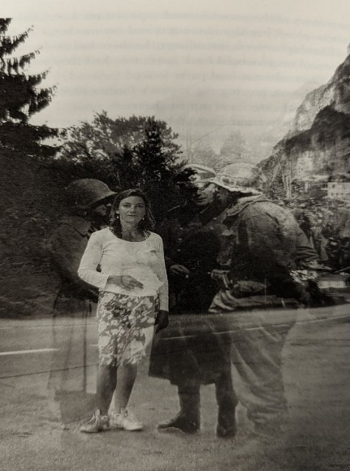

Fig. 1

The boundaries between past and present have been collapsed by the image, an apt illustration of the haunting legacy of perpetration as it continues to endure in the present. The entwinement of her physical presence and the shadowy image of her soldiers articulates the simultaneous intangibility of history and its ongoing significance in the lived present of subsequent generations. It is Findlay’s attempts to understand her place – metaphorical and literal – within the legacy of the Second World War that constitutes the driving force of her journey and shapes her wider artistic practice.
The Early Years: Art as Therapy
For Findlay, growing up with an unconscious burden, art became a therapeutic means of coming to terms with the past; even as a teenager, fighting undiagnosed, poorly understood and at times severe mental health issues, she “discovered that only art, with its mad sanity, made any sense [to her]. Whenever [she] stepped into the paint-splattered studio, with its rickety easels and smell of oils, all self-doubt vanished.” Increasingly, Findlay understands the root of what she calls her “unhelpful attitude to virtually everything” as being connected to her childhood, coming to realize that the anger and disillusionment that she felt with the world was rooted in her family relationships. At first, she does “what many teenagers do” and blamed her mother; later on, she would come to realize that her sense of anger and unbelonging could be traced directly back to her grandfather. The journey to this realization was precipitated by her artistic practice.
In her younger years, Findlay gravitated towards morally ambiguous individuals and “off-the-beaten track experiences,” admitting that she felt “intrigued, a little excited, even, by [her] initiation into the underworld” – a dark euphemism for a deeply distressing experience as a student in Florence. It was, according to the author, the prospect of becoming a victim that contributed to this sense of excitement; in the dangerous scenario in which she finds herself, she could not be the perpetrator that she somehow felt herself to be. As shocking as this may seem, it is nevertheless an important indicator of Findlay’s own complex relationship with the perpetrator/victim paradigm, which functions as a prism, refracting and shaping her sense of self and others.
Following the completion of the History of Art course that had taken her to Italy, Findlay returned to London before continuing her travels to South America – the site of another terrifying experience – before moving to Australia, where she intended to settle and top up her finances. Emerging from a meditative silent retreat in the mountains outside of Sydney, Findlay found herself teaching a mural-painting course for prisoners at Sydney’s largest jail. There, she notes the sense of kinship she felt among the prisoners: “I experienced relief and a strange sense of homecoming. In their stories of incarceration and guilt, I found parts of myself reflected.” She concludes: “I was twenty-three and I was where I needed to be: locked up with the culpable, transforming guilt into rehabilitation and redemption through art.” Findlay may not have understood the significance of the connection she felt with the prisoners at the time, but she notes that ‘the cells in her body united in unanimous approval of [her] mission.’ It is as if, psychologically and corporally, her emersion into the world of unmasked criminality paved the way for her explorations of the nature of perpetrators and a growing awareness of a form of guilt that was harder to articulate, because of its historical weight, the familial dramas that it would likely unleash, and because of its displacement through the generations. In many ways, the straightforward culpability of those already tried and found guilty by law represented an important steppingstone; the yearning to listen to the instinct expressed here is what allowed Findlay, much later in life, to explore her own sense of misplaced blameworthiness. For Findlay, then, the visual arts held the key for her tentative engagements with criminality and offered a means of working through the traumas of her inherited past, even if she did not recognize it at the time. This represents a key step in her journey towards her grandfather. It is only when the institutional and political flaws of the prison system became too much, leading her to hand in her notice, that her “German grandfather stepped out of the wings and on to the stage of [her] life.” The troubling behavior and risks of her youth give way to a purposeful if not fully understood engagement with criminality in her adult years; it is only at the end of this process that the grandfather comes into full view, Findlay now ready to confront her inner demons head-on. The visual arts are the primary means of engagement over the course of this trajectory, and so it is no surprise that it is through this medium that Findlay first begins to probe her ancestral heritage.
Visualizing Home: Findlay’s Artwork
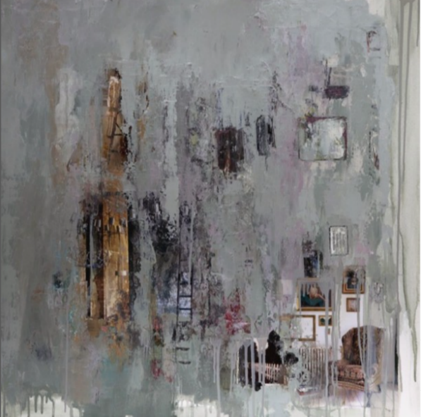
“Remembering a world that once was”

Fig. 2

In a series entitled “Paintings of Home Destroyed” Findlay contemplates the widespread destruction of “home” during World War Two. In “Remembering a world that once was,” she creates a palimpsest, with quintessential images of home obscured beneath an abstract layer of blotted and dripping grey paint. The empty chair is a recurring motif in her work, probably, the author notes, an oblique reference to a story of chairs left behind as her mother’s family fled Berlin as the Soviets approached in 1945. In much the same way that memories of the past return in elusive and foggy fragments, the home appears in the painting as something almost lost. It’s dream-like production of miscellaneous objects casts the idea of home as something intangible, unassimilable and ungraspable, yet still with a material and discernible presence that loiters in the background. The glimpses of home are disordered and surreal: the white picket fence appears next to what appears to be a radiator; a ladder emerges through the centre, leading nowhere. The image thus articulates the murkiness of the concept of home in Findlay’s life as a descendant of both German and English parents: a heritage that is at once familial and historical, rooted in two places at once and yet lacking in a clear and unified sense of belonging.
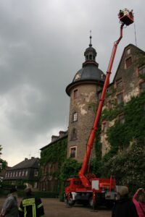



“Rock Drop” (2012)
Fig. 3
“Rock Drop” (2012) is a live-action piece performed and recorded in front of Schloss Laubach in Germany. The scene starts with an innocuous table set outside for a typical English and German breakfast. Having finished setting the table, Findlay ascends forty meters into the air using an aerial platform of a fire engine and proceeds to drop rocks on the table until it is destroyed. The air-borne destruction is reminiscent of falling bombs and invokes the damage done to both sides of the war. Thus, the peaceful alignment of German and English “home” is ruptured in real time. Standing in front of the bombed table, Findlay talks about her family history, “fully aware that every member of the German audience would have stories of their own, many of them untold, and very probably worse than [hers].” Findlay is here telling the story of her mother and her family, not her grandfather; in so doing, she also alludes to the often substantial suffering of German women and children, a feature of the war narrative that is frequently obscured but that nevertheless “contributes a strong ingredient into the cocktail of German intergenerational inheritance.” Findlay’s assumption that her story would have some kind of communal significance marks a transition from the personal to the collective, from the familial to the historical. If, in her early professional life, the artist had sought out the company of those she knew to be guilty because of their incarceration, here, she locates her art within the topographies and social spheres of those likely to have been confronted with the same dilemmas that she was herself working through. The element of live performance is important, here: it encodes the passage of time and shows the destructive effects of Findlay’s past on her present, something that has the potential to become communal in the presence of a live, German audience.
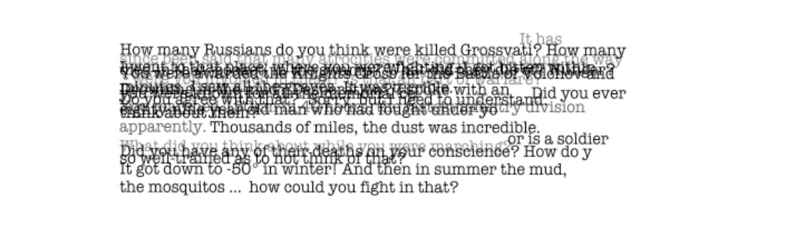
Fig. 4

In “Questions” (2010), Findlay types questions aimed at her German grandfather. The individual sentences are layered, suggesting a kind of bursting out, as if all the words come at once; this cacophony of questions makes the text illegible at points, meaning and clarity drown in the flurry of script. The questions give the impression of both inquiry and accusation, of a need to know and a suspicion that such knowing could cause further discontent. The illegibility also hints at the black lines of censorship as found in letters home and documents of the period; in this, there is also a hint of a kind of knowledge that has been disallowed, prohibited, or rendered silent because of institutional and cultural regulation, something that is particularly significant in the context of the infamous postwar German silence. At the level of form, the work plays with the distinction between the textual and the visual that, according to the artist’s synopsis, “reveal[s] an archaeology of meaning and present[s] the inherent potential in language both for understanding and misunderstanding.” The idea that language can be both a means of communication and miscommunication is important when considered in light of Findlay’s dual heritage, where family stories and documents are received across various languages, and where cultural, historical and linguistic differences add to the growing sense of estrangement. The image may also be understood as a metaphor for the descendant experience in which the younger generations struggle to articulate their questions and concerns, or where the answers are either not forthcoming, unclear or somehow unsatisfactory. These questions take on a particular urgency in the descendants of the perpetrator generation, where the (absent) answers stand for complex family dynamics in which the perpetrator is both an active contributor to the machine of extermination and an often-beloved family member. The loss of comprehension that is afforded through the layering of the questions in the image represents both the inability to reconcile these opposing sides of the perpetrator figure and fully work through the impact of such a damaging history in the present.
In all of these artworks, the past and the present are brought together but, rather than achieving any kind of catharsis or resolution, this juxtaposition leads only to confusion, an obscuring of what was, the vestiges of a home destroyed. The themes that are pertinent to Findlay’s artistic practice, including fragmentation and loss, home and belonging, generational inheritance and the search for a strong sense of self, also form the basis of her first memoir, In My Grandfather’s Shadow (2022), a predominantly textual exploration of Findlay’s familial past, but one that draws heavily on visual elements. The resulting hybridity captures something of the heterogeneous and unassimilable nature of the perpetrator-descendant experience.
The Project: Getting to Know “Groβvati”
“For me,” writes Findlay: “my grandfather existed only as the face of a man in uniform in a framed black-and-white photograph that stood on my mother’s writing desk.” It is the author’s attempt to unravel the complexities of her grandfather’s identity as both a Wehrmacht General and a respected patriarch of the family, to discover his true face and comprehend the man behind the image, that is the driving force of the book. This process begins before the reader opens the book.
The cover of In My Grandfather’s Shadow shows a framed photo of Findlay’s grandfather in a sideways pose hanging on an otherwise bare wall. The photograph is positioned on the far left of the image, cut off down the side of the face by the edge of the page, the nose and most of the eye thus positioned outside of the reader’s view. All that remains is an outline of the face and shoulders clothed in German uniform, including a cap – the military insignia also obscured – and a prominent Knight’s Cross medal hanging around the neck. The grandfather’s portrait is the dominant presence in the image, yet he remains fundamentally unknowable; it is his military accomplishments that define the viewer’s perspective. On the opposite side of the room, a window throws light from outside into the otherwise dark room, the sash bars creating angular shadows that fall directly across the photograph; the effect is reminiscent of prison bars, symbolically reflecting themes of guilt and entrapment that are so central to Findlay’s investigative narrative, while at the same time also casting the image into further shadow. The gloomy shades of the cover hint at the shadows cast by the grandfather’s unresolved trauma, guilt and shame (at least in the author’s interpretation), the long legacy of the war, and the author’s own struggle with depression. The light coming in does, however, evoke a sense of hope; as the author notes, “it is a book of looking for and finding the light.”
A few pages in, there is an old photograph of Findlay’s mother’s writing desk. On it, sits a typewriter, an inkwell, a letter opener and, sitting proudly among these relatively mundane items, a framed photograph of her grandfather, still sporting the Knight’s Cross and military uniform, his face now on full display. The transition from the shadowy and faceless image on the cover to the prominent dignity of the figure on the writing desk acts as a symbolic articulation of Findlay’s own journey from incomprehension and naivety to knowledge and self-awareness; as the subject of the image comes into focus, so too does Findlay’s own sense of self. Yet it is the haziness of the cover image – the first that the reader sees and the one that sets the tone of the book – that is foregrounded from the offset; the revealing of the “face” of the grandfather is part of a longer process of retrieval, one that only comes to fruition in the closing pages, as Findlay finally manages to lay the ghosts of her familial past to rest. In these final pages, the grandfather’s image is captured again, this time looking squarely at the camera and dressed in civilian clothing, indicating the eventual success of the author’s mission to re-humanise the Wehrmacht General.
This long process begins at a party at the family home when Findlay was roughly ten or eleven years old. A dinner guest observes the picture on the desk and comments on the tactlessness of displaying a photo of a “Nazi”; only then does the young Findlay become aware of the potentially controversial role her grandfather had played as a Wehrmacht General, one who may not have been part of the SS, but who nevertheless took orders from Hitler and played a significant role in the war of annihilation in the East:
I knew the Nazis as the baddies in The Sound of Music, but I also knew from my parents that not all Germans were Nazis. And that my grandfather wasn’t one. He was just a German soldier. But thereafter I began to notice the slightly panicked glances exchanged between certain people when they discovered out family’s dual nationality.
As is the case in much of the testimony of children and grandchildren of perpetrators, there is a clear tension between cultural, political and historical understandings of the older generation and their place within the family narrative. Findlay’s family, like many in Germany at the time, firmly believed in the “clean hands” of the Wehrmacht and were proud of Karl’s Knight’s Cross and promotion to General. Yet such respect is clearly at odds with reports of crimes committed against the Jews and others in the East. For Findlay, a key part of the undertaking – subconsciously or otherwise – was to better understand the relationship between these contradictory aspects of her grandfather’s character; by integrating the Wehrmacht General (with all its implications) into her knowledge of her Groβvati – as she comes to label him in one of the final images of the book – she is able to come to terms with her ancestral past and free herself from the emotional burden that it created.
In the epilogue of the book, Findlay acknowledges that ‘there can never be closure or resolution to this episode of history.’ Such a claim may not fit neatly with the personal catharsis that the author experiences as a result of these processes of dehumanization and reintegration – processes through which she gains a deeper understanding of the ways in which an otherwise “good” person could come to contribute to the horrors of the Second World War – but this outlook is reflective of the experience of many descendants of perpetrators whereby the personal comes into conflict with the historical; she cannot and does not pardon her grandfather from his potential crimes, nor does she offer a wider form of absolution, but she does manage to accept her Grandfather’s role in history and, in so doing, she is able to liberate herself from the destructive emotions and dynamics caused by the legacy of her family’s past.
Generic Fluidity: Text as Image
Talking about her work as a public speaker, Findlay acknowledges, “I am often in awe of how the combination of words and art induces shifts in the audience’s understanding of Germans, of prisoners, of history. Even of themselves.” The images that are scattered throughout In My Grandfather’s Shadow are thus not to be understood as merely articles supporting a predominantly textual piece of work; instead, they are key structural components that intertwine with the written word and produce meaning. Yet, as I will argue, the textual fabric of the memoir is also rendered in visual terms. Letters on a page are, at their most basic level, visual patterns that stand in for verbal sounds. The textual is, after all, a fundamentally visual means of communication.
For the most part, letters and postwar reflections from her grandfather are integrated into the body of the text on the page, marked only by an italicized and indented font. There are, however, two examples in which the visual element of the textual form is foregrounded, when the author incorporates photographs of her mother’s diary and her grandfather’s letter with a translation typed beneath. These images are the primary markers of the aesthetic qualities of the written word. They serve to offer an increased sense of authenticity and reinforce the validity of the author’s source, even if the content warrants scrutiny. At the same time, they integrate a sense of the personal; a reminder to the reader that these artefacts were written in an individual hand, not in the universalizing script of the typed font. Thus, we are reminded of the human being behind the General’s wartime experiences. The letter shows, as Findlay observes, “a man in his element as a soldier”: “I’ve already made myself a bit unpopular as I really insist on discipline, so anybody found on the streets misbehaving will be put into a cold room with no furniture for a night […].” It is this that leads the author to declare: “I didn’t like him. He came across as a macho bully, the kind of war-justifying army officer I would have vociferously challenged had he been alive.” In truth, In My Grandfather’s Shadow is more about the author’s quest to work through the traumas she inherited from her grandfather than it is about the precise nature and extent of his culpability. Nevertheless, there are moments - such as this one - where Findlay’s distaste breaks through and the reader is offered a glimpse of her own battle to incorporate all sides of her grandfather’s character into her journey to knowledge and self-forgiveness. It is notable that it is this moment of aversion that is replicated in its handwritten form, almost as if Findlay wishes to decenter the image of the German war machine (represented by the mechanical typed font), instead emphasizing the flawed humanity behind the writing; it is on this basis and at this point that she feels able to confront him, even if this can only happen posthumously and indirectly.
Equally important, the combination of handwritten script and typed translation acknowledges the movement between languages and, by extension, the dual heritage of the author. The movement between the handwritten German and the typed English font foregrounds the push-and-pull nature of her dual heritage, something that is at the heart of Findlay’s experience as a descendent of both Nazi Germany and the Allied governments. It is interesting, from this perspective, to acknowledge that the only extract reproduced in this way demonstrates the incompatibility of the two positions: “I think in the coming months we will first of all be throwing the English out of the Mediterranean so that we have an uninterrupted connection to Africa.” The anti-English sentiment written by hand in German and put forward by the grandfather as he contemplates the evolving theatre of war clearly demonstrates his support for the destructive designs of the German high command, and it creates further contrast with Findlay’s British upbringing; since the book was first published in English – the German translation was released in 2023 – such a view is also likely to create distance between the grandfather and reader. Thus, Karl is rendered foreign and other even as his words are made accessible through the typed translation.
Later, Findlay uses a picture of the envelope without the implied corresponding letter, which is reproduced without italics (unusually) and incorporated into the body of the text. The only information we gain from the letter is name, prisoner number and location of captivity. By reproducing only the envelope, Findlay places emphasis on the absence of her grandfather – then a POW in Rimini, Italy – and the process of transportation. In so doing, she also hints at the vast distances between husband and the wife to whom he was writing on the one level, and, temporally and ethically, between the grandfather and granddaughter on another. What remains is a visual artefact that stands in lieu of the narrating voice, which returns us to his absence and to the bureaucratic processes that enabled it. Elsewhere, I have argued that artefacts such as photographs, diary entries, or old documents function by transforming narratives into sites of multi-temporality in which “the past is brought into the present through the relics that give voice to it.” The envelope hints at the significance of these material embodiments of the past, reminding the reader of the man behind the letter and the circuitous way in which evidence of history is received by subsequent generations. As a highly decorated officer in the German army, writing as a Prisoner of War after suffering defeat, the letter itself may also be understood as a loaded artefact, one that emerges from a context of disempowerment, incarceration and (perhaps) shame into the postwar (and post-generation) domestic sphere. The line between the familial and personal and the political and national is thus broached through the letter form.
The visual aspects of the written form are thus employed by Findlay as a means of expressing the complexities of her heritage, her ambivalent views of her grandfather and the complex way in which historical or familial sources are employed by members of subsequent generations.
Art and Life: The Ashtray
In a chapter entitled “The Ashtray,” introduced with an epigraph from Winston Churchill – “We shall never surrender” – Findlay produces a photograph of her grandfather’s ashtray. Her mother remembers her father sitting in the back room of the house, or on the balcony outside, after the war and smoking cigarette after cigarette – “sometimes up to seventy a day, until he died of lung cancer”: “the scraping of its levered lid as he dropped one stub after another into the black bowl had been the soundtrack to my mother’s teenage years, just as it was now the soundtrack to ours.” The ashtray functions as a symbol of the passing down of the grandfather’s contentious legacy. The persistence of Karl’s smoking – and the implication that it would eventually lead to his death – also suggests a struggle to return to postwar life. It was, as the author acknowledges, something that “made his life tolerable, perhaps hellish, too, in his final years.” The ashtray thus functions as a reminder of the postwar struggles faced by Karl once he had returned home and hints at the kind of perpetrator suffering discussed by Sue Vice:
“Trauma” is a diagnostic rather than a moral concept, and one that may rely on descriptions of behavior rather than the subject’s inner psychological world. Yet it may still seem difficult to consider the nature of such a psychic state in relation to those who were the cause of suffering and death.
Such an understanding is important even if, as Erin McGlothlin observes, “the experience of perpetrators has fallen outside of this normative trauma paradigm.” By alluding to the impact of the war on her grandfather’s psychological state, Findlay reminds the reader of his humanity and acknowledges the difficulties he faced in returning to civilian life; whether these difficulties were wrapped up in feelings of guilt for crimes committed, the humiliation he felt at the hands of his British captors, whether they were merely expressions of a more general struggle to return to postwar life, or even a sense of shame stemming from being on the losing side of the conflict, is unclear.
Nevertheless, this “important relic of [her] grandfather]” becomes a tool for the author’s artistic expression as she begins “to investigate how memory can reside in places; how history can remain resonant in the earth; how the essence of a person can be held in objects.” Later, as she retraces her grandfather’s footsteps across the war terrains of Europe, the tobacco forms part of a cathartic ritual performed by the author: “at every significant spot, I dug a small hole, collected some soil in a labelled plastic bag and filled the cavity with earth brought from my garden in Gloucestershire, mixed with a pinch of British-manufactured Golden Virginia.” Writing of her motivations, Findlay says:
It became my attempt to heal the wounds of the place, people and past. And to offer an apology and ask forgiveness for my grandfather, my family and myself for any guilt we carried.
The act thus becomes one of both fracture and repair; it displaces at the same time that it acknowledges the past and its painful impact. In this, it mimics the modal fluidity of In My Grandfather’s Shadow, where generic hybridity creates a similar effect.
The first time Findlay enacts her ritual of digging up earth and replacing it with tobacco is in the town of Schwerin, where her grandparents had first set up home as a married couple. Inside a castle that her “grandfather had run up every day to report for duty,” her uncle films her “running up the same stairs, euphoric at the affinity it made [her] feel with this energetic, talented young man.” Here, Findlay again places herself in the spaces of her grandfather as she seeks to better connect herself with his life and experiences. This is a process that she repeats throughout her journey into the topographies of the past. It is here, in a significant site of Karl’s youth, that Findlay first performs her ritual with earth and tobacco, an act she acknowledges stems from her artistic practice: “As I had been working with earth, mud and sand in my paintings, using them as carriers of memories of the sites they had come from, it seemed appropriate to perform a little exchange of soil from both countries.” The focus on the blending of British soil and tobacco in the German landscape of her forebear functions as an acknowledgement of the author’s own dual heritage, and symbolically articulates the merging of national heritages, of belonging to both soils. At the same time, the act of digging up the soil suggests a process of disturbance and recreation that feeds into the author’s wider textual and artistic practices and hints at the disturbing sense of history and the question of how to represent it.
The disrupted earth also plays an important role in Findlay’s visual art. As part of her Fine Arts degree at the University of the West of England (UWE) in Bristol, the artist put together a project using the soil she had collected on her travels. Although she describes the project as a “sketch” that she considers “more experimentation with an idea” than a piece of art, the piece articulates the intersections between art, geography and experience with which her work is so centrally concerned.
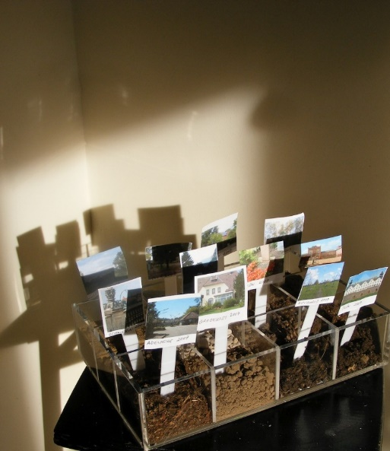
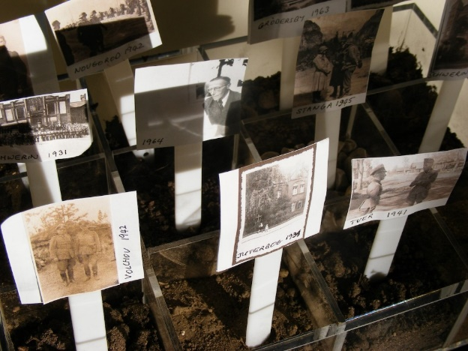

Fig. 5
The earth is separated into sections, with photos, place names and dates being marked in each. In one version, the photos are taken from the time of her grandfather; in another, they show the author’s own journey as she retraces her grandfather’s movements across Europe. In much the same way as the cover image of In My Grandfather’s Shadow, the piece plays with the use of shadow which, according to the artist, was intended to evoke the rows of crosses at a cemetery, a reminder of the extreme loss of life that defined the war. Given Graffen’s position as a high-ranking Wehrmacht general, this commemoration of the war dead without explicit reference to those murdered in cold blood by the Nazi regime cannot be divorced from the possibility of Graffen’s involvement in the German machinery that enabled and encouraged murderous war crimes across much of Europe. Thus the art of commemoration also contains a trace of accusation. The photograph is an ideal medium through which to express the resulting sense of melancholy; as Inga Clendinnen asserts:
[Photographs] are also suffused by bitter affect: like the after-the-event photographs of the dead and the ambulant corpses of Buchenwald and Belsen, they are direct records of our failure, of our guilt.
The photographs employed by Findlay are not of the Holocaust or its emaciated victims, but they contain the seed of the same kind of affective guilt; indeed, an even weightier one, given the ambiguous culpability of the artist’s grandfather. In his groundbreaking work Camera Lucida, Roland Barthes argues that portrait photography creates a rehearsal for death and provides the viewer access to the ongoing psychic work of mourning. The same process is at work in Findlay’s cemetery-structured photographs, which invoke death and provide a therapeutic means for the artist to deal with her inherited past. Barthes’ dead subject is both the content of the image and the resounding presence of the murdered, notable by their visual absence but implied by the multiple segments and the cemetery-like construction of the piece. By aligning the two versions, we get a broader sense of the generational inheritance of this legacy; Findlay’s deathly image replaces that of her grandfather in the terrains of war and murder.
The transition from family artefact to artistic practice, then finally to ceremonial ritual demonstrates the fluidity of expression in Findlay’s work: from the physical (ashtray), to the visual (artwork), to the experiential and performative (ritual), and back again. In this case, Findlay creates a clear link between artistic practice and her experiences as she traverses the terrains encountered by her grandfather during the war, particularly the Eastern Front and the Italian theatre where her grandfather’s war ended. The topographies of the past thus form an important part of her own process of working through her familial traumas.
In the end, following many decades of introspection and her extended trip to Russia with her now-elderly mother, Angela Findlay succeeds in reconciling her familial heritage and sense of self. The book ends on a note of redemption and release: “As if discarding a skin, I released my ethereal empty rucksack and, in my mind’s eye, watched it float into the sky like a Chinese lantern.” Despite this emerging sense of liberation from the past, in the epilogue, the author acknowledges that “there can never be closure or resolution to this episode of history.” She goes on: “Laying my grandfather’s memory to rest on that beach in Italy did, however, mark a gentle closing of a door on that part of my family’s past, a relinquishment of my misplaced sense of personal culpability and the beginning of a new, forward-looking way of being.” She concludes with a reflection on her plan to meet the grandchildren of the American colonel who had arrested her grandfather in La Stanga, Italy: “the hope is that one day soon, the grandchildren of that American colonel and German general will stand together in harmony on the spot where their grandfathers met as adversaries in May 1945. And so the healing continues.” The final words of the book thus return us to the generational process of healing; the language of cleansing and expurgation suggests a certain hope for the future, a hope that can only be realized through the passage of time and the integration of different generational experiences.
This cathartic resolution may be understood within the wider context of German memory. If, as Bill Niven suggests, “the 1992-1998 period was characterized by widespread historiographical, media and public interest in the issue of German perpetration and guilt, and Jewish victimhood,” the post-1998 years have been seen an influx of cultural outputs that have centralized German wartime suffering. A corresponding search for national redemption has been coupled with cultural representations that foreground the role of the “good German”, Schindler’s List undoubtedly the most prominent example among them. The spate of post-generational accounts that have appeared in subsequent years suggests that this cultural shift has provided the space for descendants of the perpetrator nation to discuss their own experiences alongside their feelings of pain, adversity, and even trauma. Findlay’s narrative may thus be understood as part of a wider German trend in which the desire to move on from the past is foregrounded as part of a trajectory of national atonement and healing. This propensity sets the descendants of perpetrators in stark opposition to the offspring of the victims of Nazi persecution, for whom no such hope for catharsis or purification exists. Conclusion
In My Grandfather’s Shadow is marked by hybridity and fluidity. Perhaps as a result of Findlay’s own eclectic practices, the book resists conformity to standard generic boundaries. It is transitional, multimodal and full of slippage between image, text, history and the present. It also defies accepted psychological models, instead focusing on a central argument about affective transfer that may at times tip into being “arty-farty” and “hippy-dippy.” Certainly, the book has not been without its critics, most prominent among them Matthew Reisz who, writing for The Guardian, concludes:
If all this has brought Findlay some closure, that is obviously a good thing. But it still feels highly unsettling to watch a woman who has dedicated her book to “all those whose lives are affected by discrimination, oppression or war” searching so desperately for redeeming qualities in a decorated Wehrmacht general.
This may be a fair point, but it does not account for the complexities of the perpetrator-descendent experience, which is in many ways defined by the tension between love and condemnation, between family loyalty and historical outrage, and by the need to move on from the past and live one’s own life as an individual free of the traumas and shame of previous generations. As Findlay herself argues, she is “seeking redeeming qualities in [her] own grandfather not in a generic decorated Wehrmacht officer. [She is] seeking a way to accept rather than reject, to find peace rather than live with shame.” The generic fluidity employed by Findlay encodes the sense of displacement and heterogeneity that comes on the back of these experiences. By drifting freely across a range of artistic practices, Findlay depicts the complex and transnational experience of being a descendent of both perpetrator and victor nations; in so doing, she challenges the reader to question the conceptual boundaries of testimony, straightforward perceptions of perpetration, and the diluted but nevertheless affected and affective experiences of subsequent generations.

Angela Findlay, In My Grandfather’s Shadow: a Story of War, Trauma and the Legacy of Silence (London: Bantam Press, 2022), 328.
Wolfram Wette, The Wehrmacht: History, Myth, Reality (Cambridge, MA: Harvard UP, 2006), translated by Deborah Lucas Schneider, 292.
In academic literature, one of the first studies to appear was Omer Bartov’s groundbreaking Hitler’s Army (Oxford, 1992). David Harrisville’s more recent Virtuous Wehrmacht: Crafting the Myth of the German Soldier on the Eastern Front, 1941-1944 (2021) uses communications sent via the Feldpost (military mail) to reveal the strategies by which soldiers maintained their innate sense of goodness; in so doing, Harrisville argues, these letters also sowed the seeds of the myth of the virtuous Wehrmacht to families back home.
Wette, The Wehrmacht, 293.
Correlli Barnett (ed.), Hitler’s Generals (London: Weidenfeld and Nicolson, 1990).
See: Ben Shepherd, “The Clean Wehrmacht, the War of Extermination, and Beyond.” The Historical Journal 52, no. 2 (2009): 455-473; Hannes Heer and Klaus Naumann (eds.), War of Extermination: the German Military in World War II 1941-1944 (New York: Berghahn, 2000); Bryce Sait, The Indoctrination of the Wehrmacht: Nazi Ideology and the War Crimes of the German Military (New York: Berghahn, 2019); Omer Bartov, The Eastern Front, 1941-1945: German Troops and the Barbarism of Warfare (Hampshire: Palgrave, 1985/2001).
The resulting debates could be discerned across the spectrum of German society, in politics, culture, academic discourses, and in family homes. However, the opening of this hitherto taboo subject did not necessarily lead to a linear shift in the memory politics of Germany; indeed, rather than resulting in an exclusive focus on national perpetration and shame, as might have been expected, certain periods have given way to a more detailed emphasis on notions of German victimhood. At other moments, these seemingly distinct positions have been conflated so that the boundaries between perpetration and victimhood have become increasingly blurred. This is articulated most forcefully through the restoration of Berlin’s Neue Wache in 1995, which removed all distinction between perpetrators and victims. See: Siobhan Kattago, “Representing German Victimhood and Guilt: The Neue Wache and Unified German Memory”, German Politics and Society, 163.48 (1998): 86-104. For a more general discussion of German wartime memory, see, for example: Aleida Assmann, Shadows of Trauma: Memory and the Politics of Postwar Identity (New York, Fordham UP: 2016); Dagmar Barnouw, The War in the Empty Air: Victims, Perpetrators, and Postwar Germans (Indiana, Indiana UP: 2005); Bill Niven (ed.), Germans as Victims (Hampshire, Palgrave: 2006); Caroline Sharples, Postwar Germany and the Holocaust (London, Bloomsbury: 2015).
Findlay, In My Grandfather’s Shadow, 335.
Nicholas Abraham and Maria Torok, The Shell and the Kernal: Renewals of Psychoanalysis, volume 1 (Chicago: Chicago UP, 1994), 174.
Ibid., 173.
Alan L. Berger and Naomi Berger (eds.), Second Generation Voices: Reflections by Children of Holocaust Survivors and Perpetrators (New York: Syracuse UP, 2001), 1; italics in original.
Ibid., 10.
Ibid., 9.
Dan Bar-On, Legacy of Silence: Encounters with Children of the Third Reich (Cambridge, MA: Harvard UP, 1989), 330.
Sue Vice, “Distant Relations: Third Generation Perpetrator Descendants Writing in English,” in Emerging Trends in Third-Generation Holocaust Literature, edited by Alan Berger and Lucas F. W. Wilson (London: Lexington Books, forthcoming): 169-184, 169.
Abraham and Torok, The Shell and the Kernal, 172.
The way that these familial legacies are encountered and dealt with differ between the second and third generations. For further discussion, see Vice, “Distant Relations” and Aarons Third-Generation Holocaust Representation.
Hillary Chute, Disaster Drawn: Visual Witness, Comics and Documentary Form (Cambridge, MA: Harvard UP, 2016), 7-8.
Ibid., 8.
Erin McGlothlin, Second-Generation Literature: Legacies of Survival and Perpetration (Suffolk: Boydell and Brewer, 2006), 12-13.
Victoria Aarons, Third-Generation Holocaust Representation: Trauma, History and Memory (Illinois: Northwestern UP, 2017), 5.
See, for examples: Ze’evi, Chanoch (dir.) Hitler’s Children (Maya Productions, 2011);; Dan Bar-On, Legacy of Silence: Encounters with Children of the Third Reich (Cambridge MA: Harvard UP, 1989); Gabriele Schwab, “Haunting Legacies: Trauma in Children of Perpetrators,” Postcolonial Studies 7.2 (2006): 177-195; Helga Schneider, Let me Go: My Mother and the SS (London: Vintage, 2001); Katrin Himmler, The Himmler Brothers. Trans. Michael Mitchell. (London: Pan Books, 2007); Malte Ludin (dir.), 2 or 3 Things I Know About Him (Absolut Medien); Martin Davidson, The Perfect Nazi: Unmasking my SS Grandfather (London: Penguin, 2010); Niklas Frank, In the Shadow of the Reich (New York: Alfred A. Knopf, 1991); Sigfrid Gauch, Traces of My Father (Illinois: Northwestern UP, 1996); Nora Krug, Belonging (New York: Scribner, 2019); Stephan Lebert, My Father’s Keeper: The Children of Nazis: An Intimate History of Damage and Denial (London: Abacus, 2000); Peter Sichrovsky, Born Guilty: Children of Nazi Families (New York: Basic Books, 1988).
Sigfrid Gauch, Traces of my Father (Illinois: Nortwestern UP, 1996), 88.
Findlay, In My Grandfather’s Shadow, 98.
Findlay, In My Grandfather’s Shadow, 36.
Ibid., 37.
Ibid., 36.
Ibid., 40.
Ibid., 38-39.
Ibid., 46.
Ibid.
Ibid., 46.
Ibid., 110.
Ibid., 238-239.
Angela Findlay, “personal correspondence,” 19 September, 2023.
https://www.angelafindlay.com/past-projects/questions-2010/, last accessed 20 July, 2023.
Findlay, In My Grandfather’s Shadow, 18.
Angela Findlay, “personal correspondence,” 29 September, 2022.
Ibid..
Findlay, In My Grandfather’s Shadow, 19.
Ibid., 393.
Ibid., 376.
Ibid., 33.
Ibid., 120.
Ibid.
Ibid.
Ibid., 121.
Ibid., 120.
Ibid., 259.
Joanne Pettitt, “Holocaust Narratives: Second-Generation ‘Perpetrators’ and the Problem of Liminality,” The European Legacy 23.3 (2018), 286-300: 291.
Findlay, In My Grandfather’s Shadow, 112.
Ibid.
Ibid.
Ibid., 132.
Sue Vice, “Exploring the Fictions of Perpetrator Suffering,” Journal of Literature and Trauma Studies 2, no. 1-2 (2013): 15-25, 17.
Erin McGlothlin, “Perpetrator Trauma,” in The Routledge Companion to Literature and Trauma, edited by Colin Davis and Hanna Meretoja (London: Routledge, 2020): 100-110, 100.
Findlay, In My Grandfather’s Shadow, 119.
Ibid., 133.
https://www.theforgivenessproject.com/stories-library/angela-findlay/, last accessed 20 July, 2023.
Findlay, In My Grandfather’s Shadow, 132.
Ibid., 132-133.
Angela Findlay, “Personal Correspondence,” 24 October, 2022.
Ibid.
Roland Barthes, Camera Lucida (New York, Hill & Wang: 1981).
Findlay, In My Grandfather’s Shadow Ibid., 392.
Ibid., 393.
Ibid.
Ibid., 395.
Bill Niven, Germans as Victims, (Hampshire, Palgrave: 2006): 7.
Angela Findlay, Instagram Post (28 June, 2023): https://www.instagram.com/p/CuCqSaEt9Pe/?hl=en-gb, last accessed 20 July, 2023.
Matthew Reisz, “In My Grandfather’s Shadow by Angela Findlay Review – in Search of the “Macho bully” she never knew,” The Guardian 19 July, 2022: https://www.theguardian.com/books/2022/jul/19/in-my-grandfathers-shadow-by-angela-findlay-review-a-story-of-war-trauma-and-the-legacy-of-silence, last accessed 20 July, 2023.
Angela Findlay, “Private correspondence”, September 11, 2023.

