Drawn to the Light Press

Issue 8

February 2023

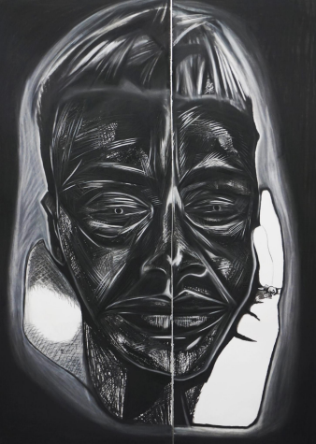

Boy, with Claddagh Ring Áine Rose
Editor: Orla Fay

Published by Drawn to the Light Press

ISSN 2737-7768

Next issue: June 2023

https://drawntothelightpress.com

Twitter: @DrawnPress

Instagram: @drawntothelightpress

Facebook: @drawnpress22

Patrons: Anthony Wade
Arthur Broomfield
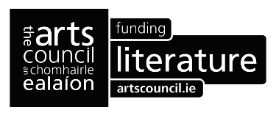

Drawn to the Light Press is edited, designed, and produced by Orla Fay.

Cover design Boy, with Claddagh Ring by Áine Rose
Back Cover Design November third, Derry Áine Rose Connell

The works included in this issue are copyright of the poets and artists ©2023 and may not be reproduced or changed in any way without the permission of the individual author.

Drawn to the Light Press is ©2023 of the editor. All rights reserved

Contents

Unslumbering Bear | James Finnegan | 6
Fishmonger | Ion Corcos | 7
A Red-winged Blackbird Sings by Niagara Falls | R.J. Breathnach | 8
Toying with Memory | C.R. Green | 9
Plato’s Cave | Rosaline Callaghan | 10
Visitation Sunday | Declan Kavanagh | 11
Troubled | Bobbie Sparrow | 12
A New Granddaughter | Mary Melvin Geoghegan | 14
The Long Gaze | Kate Ennals | 14
Master of None | Jeanna Ní Ríordáin | 15
Tinnitus | Patrick Deeley | 16
Upturned Day | Stephen McNulty | 17
Cold | Faye Boland | 18
Run from you to become you | Maura McDonnell | 19
Diary Of A Daffodil | F.C. Andrews | 20
Sailing in the Blue | John Knight | 22
Sailing Haiga | Betty O'Sullivan, Imelda Reynolds, Tom Kennedy, Pat Fitzgerald | 23
The Orange Grove | Ted McCarthy | 24
My Father Dreams of my Mother | Byron Beynon | 25
Flower Girl | Rachael Stanley | 26
Contact with Boitshwarelo | Kevin Conroy | 27
Ersimum | Matt Stanley | 28
Bygones | Peter Adair | 29
Letting Go Of All That Was | Mandy Beattie | 30
The Day’s Report | Tom Driscoll | 31
Feast | Úna Nolan | 32
Herring | Ciarán O’Rourke | 33
Ummeryroe | John Noonan | 34
When I Grow Tired | Katherine Noone | 35
Fire on Fir | Dol DeBie | 36
How Close, this Far | Maeve McKenna | 37
“The Night of the Concert” | Steve Nimmons | 38
Patrick’s Sheelagh | John Ennis | 39
Looking for Lost Scriptures | Strider Marcus Jones | 40
She, Nature | Sandra Clarke | 41
Hope is The Thing | Noelle Lynskey | 42
The Skylark at Baltray. | Honor Duff | 43
Trichotillomania | Áine Rose Connell | 44
Pet Rescue | Ben Banyard | 45
Saint Brigid | Patrick Joseph Tuohy | 46
An Interruption of Swans, St Brigid’s Day | Lynn Caldwell | 47
The Crossing | Helena McCanney | 49
A Prayer to St. Brigid | Barbara Bruhin Kenney | 50
Notes on Contributors |  | 51

Editorial

To honour the first bank holiday for St. Brigid the Little Fires of Brigid poetry competition was run this year. Sincere thanks to Siobhán McLaughlin for judging the entries and choosing the winners included herein:

Overall winner: 'An Interruption of Swans, St. Brigid's Day' - Lynn Caldwell (Dublin)
Runners-up: 'The Crossing' - Helena McCanney (Dublin)
'A Prayer to St.Brigid' - Barbara Bruhin Kenney (Canada).

On this very Bank Holiday Monday morning thank you to all the contributors to the magazine for their poetry and artwork.

To those reading, I hope the pale glow of the snow moon, the snow drop, and the gold of the daffodil, and all that grows embraces your spirit in the weeks to come as we are drawn to the light of spring.

Until the next submission period!

Orla Fay 06/02/2023

Unslumbering Bear

what exactly is the angel’s angle
and what kind of angel is there
someone once said things are quite quiet
two become one and one becomes two
where cleave is stuck then becomes unstuck
as if history breaks us and un-breaks us
Green Gable and Great Gable
the difference - one is green the other higher
one bright from a distance - the other dark
an all-out invasion of a city
warns its residents to flee
an ineffable all out
metal and flesh and soul and blood
where can I run to
who can I turn to
it is no longer quite quiet
there is no angel’s angle
or if there’s an angel it has fallen far
as far as an unslumbering bear

James Finnegan

Fishmonger

Rocks and shingle, groynes, and salt,
the North Sea grey, seagulls low;
on the cliff, winter. My gloves are not made for this.
The wind farms in fog,
we make our way along the damp brick
of High Street,
stop at a window display of sweets,
at a charity shop
full of old men’s jackets, handknitted scarves,
games and Christmas cards.
We pass a tiler on a terrace rooftop,
St Peter’s church in white mist,
a greengrocer’s stall full of leeks.
As we turn into a lane for home, a fishmonger
throws a bucket of ice over his fence
onto the path we share;
too frozen to melt for hours.
We make a pot of tea, eat pink-iced finger buns,
read Larkin from the library,
our bodies close, like when we met.

Ion Corcos

A Red-winged Blackbird Sings by Niagara Falls

Feathers like black diamond
with a streak of opal
passing by my head
and filling my ears with song.

The water is humming
along with the tune
as it free dives off the edge.
Twisting and turning
like wings on the North wind.

The Falls are lit up purple,
and the mist carries the colour
up to soak into the bones
of my knee as it bends.
You tell me that you love me,
and I ask if that means yes.
Yes.

That single note is sweeter
than any song
of a red-winged blackbird.

R.J. Breathnach

Toying with Memory

The mother wakes up with thoughts
of what she might have said

while her young sons played
on the floor with Matchbox cars

& GI Joe´s if only there had been
time & words & fewer up & downs:

how life is really a battle
& loving is not really easy

how finding real work you love
will make the real battle easier

how life is really a vehicle
& love will be the fuel

C.R. Green

Plato’s Cave

So, what does come first the egg cell or the chicken?
And, what goes last, the dyin’ or the livin’?

Who mends the rends in holy water?
Why does my cast off god love slaughter?

How much does it weigh ~ a wretched bloodstain?
Have you seen the view from grief’s gentlest mountain?

What do streams drink when they’re thirsty?
What’s the cost of malice or the price of mercy?

Does a sun keen low when it’s eclipsed?
Who comforts prayer when the drunk’s relapsed?

Do waves feel proud when in trough, not crest?
Does a cuckoo feel at home in a pillaged nest?
Where do exhausted raindrops rest?
Why did my lover love her best?

Rosaline Callaghan

Visitation Sunday

He took me to Knowth
and Dowth, to visit the dead we had forgot.
Buried in chambers, in vanished splendor:
carefully wrapped secrets
scenting their sweet repose.

We dreamed them in their wintery
necropolis: mouths gaping, pupils dilated
waiting in ecstasy
as cold mathematics turned golden
the sunlit passage honeying flesh.

That solstice I crawled
into another man’s silence
needing to bless or be blessed.
Circling
a cruciform ritual of absence.

This is another fantasy —
This is another history.
When ancients seemed closer
on a rare visitation Sunday
cautiously

driving to kill time: ‘Knowth to do,
Knowth to do’.
His little joke,
his little love,
buried in Dowth.

Declan Kavanagh

Troubled

They said he had blood on his hands.
At night I only saw white knuckled strain
opening doors, his sleepwalk through
dark rooms, forbidden words on chafed lips.

They said he knelt with the broken,
clemency for men gripping cups of shame.
His own pain lay beyond my reach,
grey silt soaked by a lake of whiskey.

They said he had passion,
blind to obstacles, he forged ahead.
I only felt weak breath on my neck
and his dark refusal.

They said he was fearless,
walked bold into bootleg rooms.
When the badges seized our car
I turned my back, although

they said he had charm.
Drove from Dublin to Koblenz
for a case of Sonnenuhr Reisling because
I said it tasted like the tears of angels.

They said he drank with any man,
told stories of Brits and borders,
married a girl like Peter Pan
and lost her when she woke.

They said he loved dogs,
when they broke down his door
the terrier cried by his bloated shell.
They said he’d been gone for days.

Bobbie Sparrow

A New Granddaughter

out on the clothesline -
she pegs up all the tiny baby grows.
Enjoying how the wind takes over
creating dangling legs and out stretched arms.
Unknown -
I too enter the moment
trespassing on her privacy
seized with longing.

Mary Melvin Geoghegan

The Long Gaze

As she feeds, her big blue eyes
direct her gaze into my throat
down to my ribs, to root in my heart
I hold her close, not letting go
but she grows and grows
and soon a whirly bird comes
speculates on her future
She soars on its wings
takes her blue gaze with her.

Kate Ennals

Master of None

As satisfying as it must feel to complete a masterpiece –
One perfect piece of art, and as gratifying as it must be,
To have one’s work universally admired, I often think,
That this moment must be met with a degree of sadness

Having added the last brush stroke to a flawless tableau
Or penned the final rewrite of a poem, I wonder does
The artist’s initial rush and sense of joy soon subside
To loneliness, having so completely borne their soul

In Renaissance times, Florentine artists, so overcome
By the beauty of their sculptures, and convinced they
Could never replicate such perfection, saw fit to fling
Themselves off the Ponte Vecchio into the River Arno

Modern artists may not take such drastic measures, yet
Still they face uncertainty and fear. Hemingway said the
Writer cannot retire or lead a normal life – everywhere
He is met with the expectation of what comes next

And so the grand artiste spends their remaining days
Trying to match, if not surpass, their best work, striving
To maintain their relevance, cement their permanence
And grant immortality to their œuvre

Meanwhile, all of us artists not fated to produce
A masterpiece or a work of note will never know
That feeling – we labour in vain, bearing our souls
In the same way, but destined to remain mediocre

We leave nothing behind or nothing to show for a
Lifetime of toil and soul-searching, but, at least we
Dreamed big, lived with stars in our eyes, and tried
To follow the masters.

Jeanna Ní Ríordáin

Tinnitus

As if a watch ticked in your ear,
this pulse you hold level
and apart. And there you were,
such a silence ago, a child
holding the dead weight
of the dark as you listened out,
the folded leaf of one lug
given to the goose feather pillow.

Patrick Deeley

Upturned Day

This morning I woke the alarm clock
washed the shower
unscrambled some eggs and
pushed the car to work.

At lunch a sandwich ate most of me
and threw the rest into the bin.

There, I stared at old fashion magazines
until they had judged themselves sufficiently.

Soon after, a garbage truck
emptied me into the nearest house
where a landlady insisted
she pay me rent.

In the afternoon, a lightbulb changed me.

As the dusky sun rose,
I let a phone rub my face
so that we could spy
on Google together.

Then I unwrote this poem
As sleep fell into me.

Stephen McNulty

Cold
after Ann Gray

When I speak to my white rabbit
she looks at me with pink eyes
as if she understands.

I whisper that she will not be lonely
forever, that even departed souls
find company in the stars.

First her ears twitch, then her whiskers
as I feed her plantain
from my palm's platform.

I speak of wishbones, tea leaves
and the tarot reader’s prophesy.
She settles, ears curving over the hummock

of her back and she tells of warrens
that tunnel below tree roots, gaps
milky with moonlight.

When she is silent I nuzzle into her fur.
I tell her you were cold
as a wet, slippery fish, that your spine

was fishbone-frail, that you thumped
a bassnote like a mackerel’s tail flapping
in the hollow bucket of your mind.

Faye Boland
Run from you to become you

Once my presence was:
strong, bones, teeth.
It was belief
unwavering, quiver-free.
No need for vision, or
the impact of now.
I could not hear the old woman call.

Not I, then, till,
it disappeared.
Crumbling to doubt?
dust, coffee-stained, soft decay.
Sinking structures
towards the clay.
No self-sway, but,
falling into many spaces,
Then I see her, already waiting.

She holds my hand and whispers,
"Now do you see?" we nod in unison.
How can we tell the young woman,
to hell with bending in two to another's
telling of your story.
When someone says 'you', just run.

Maura McDonnell

Diary Of A Daffodil

Do they love me
because I have mastered

the art of death and resurrection
the two intangible disbeliefs?

Or is it my fiery toothed face
hung bold like a megaphone

on a wispy cream halo
they so fiercely endear?

I do not know.
But to be rooted to the cold earth

and left reaching for life
is torturous.

Not to mention
maintaining this figure,

lean and vulnerable
to the toddler’s stamps.

The end of April.
Time for another clinical execution.

I have never seen the summer.
The sweet old lady

who lives in the house
could be gone next year.

Life is a series of endings

F. C. Andrews

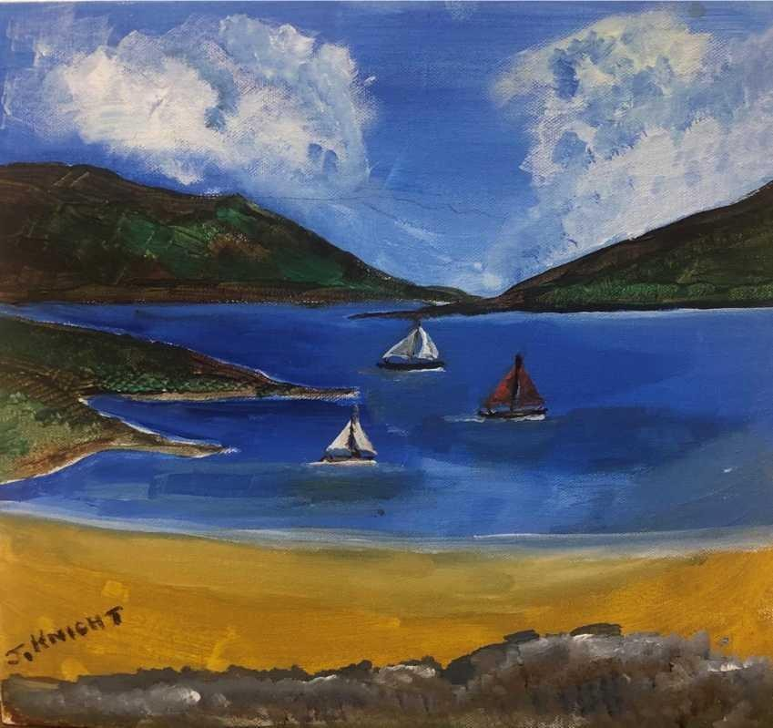

Sailing in the Blue John Knight

Sailing Haiga

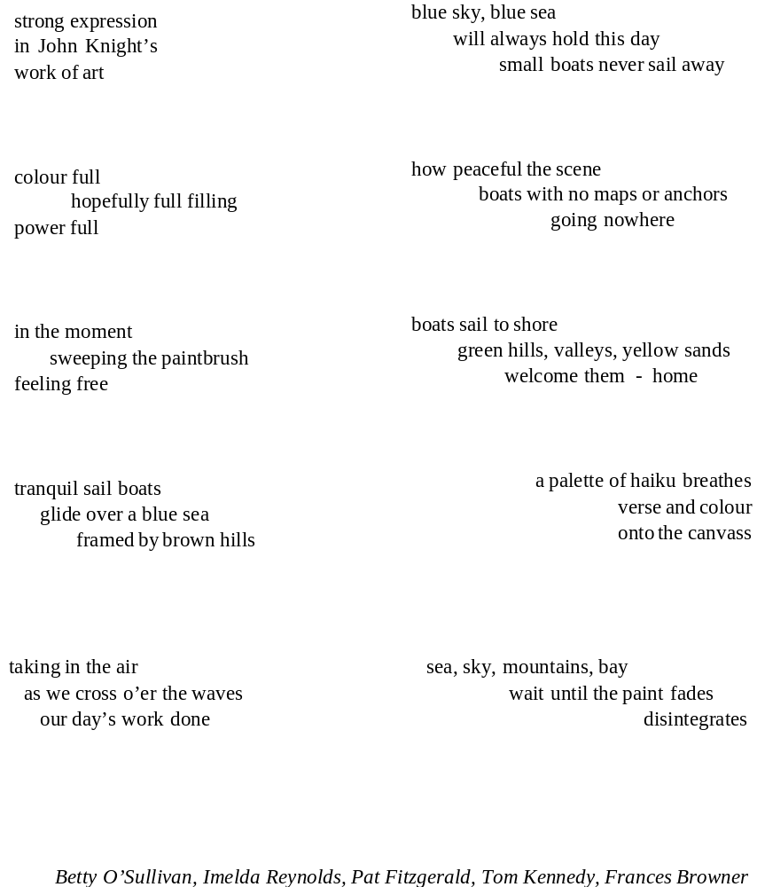

The Orange Grove

An orange grove – seemingly miraculous
the way they thrive in a dry plain -
lights the switched-on screen on a foggy morning.
Every year there is a first picture
to remind that summer is gone for good,
that it has passed beyond remnants.

Is that why the attic box
of photographs remains untouched?

The multitude of tiny fruits are tongues of fire,
the greens seem to give off the only heat
in the room. Click on. A meadow. Normandy,
maybe, the sea just past a dark uneven ridge.

Why are we, so afraid of death, so enamoured
of dead things – a season, a scene
dried onto a board a hundred years ago?
As if the apple, bitten twice, had withered
in front of their fascinated eyes.

Elvis. Diana. Bowie. They make us feel like God,
blessing them in retrospect. We step for a moment
out of the stream that carries us all.
We shiver, briefly. We dry in the sun.

Ted McCarthy

My Father Dreams of my Mother

Sleep comes and in a rare dream
you are with me,
real and human once more
you spoke and comforted me,
your exact warmth recalling
those fresh decades we knew.
My shining heart
you lived like a summer
that shimmered across
burning grains
as my intimate embrace paused,
I tried to find
those banned ways
where death had taken you,
but then the bitter morning light
demolished my restless search,
I stumbled and lost
sight of your graceful shadow.

Byron Beynon

Flower Girl

I remember that yellow taffeta
an eight year old carried away
to fairyland for the day
trips back and forth
to the dress maker -
maker of magic as she
wove her nimble fingers
through yards upon yards
of crisp silky fabric
rustling like whirling leaves
in autumn.
I pull out the old album
and the years fall away
the older woman looking
at her childhood self,
now coming through
the corridor of memory
I hear the words of my grandmother
your life is like a day in a book.

Rachael Stanley

Contact with Boitshwarelo

The river where I paddle has a widow swan
raising five dingy-grey cygnets in silent grace,
too busy to trace her lost mate or mourn,
knows my hello and is partial to lettuce.

She lands, foot-slapping the water by her island nest
to warn intruders, and gathers her fledglings.
She dabbles and dips, tail upending, then stares as I go past.
The all-white runt rides her back as the family forages.

Paddling by, one time, rapt in the cadence of running the river,
wavetrains, stoppers, in the flow of its surging pulse,
eddy lines and those moods of whitewater,
lost in the splash and summer hum,

a sudden thump behind, great wings beating, hissing.
My reflexes tuck, sweep and hip-snap in an easy roll
to burst through bubbles and see our swan, all show and bluster
saving her young ones – white lightning, loving what she loves.

Hello with bread in the water reminds her I’m friend.
She rumbles and triple snorts Thank you, head curving in the air,
evoking past heart-shaped entwining with her lifemate
while grey mini-bundles whistle and rummage about.

I name her ‘Forgiveness’ – Hello
beautiful Boitshwarelo.

Kevin Conroy

Erysimum

See how windblown seeds
take root in concrete.
Tread carefully.

Take off your shoes
to feel the vitality of decay.
Breathe in its rich aroma.

Water me
down into the fissures
and accumulations of years.

As my essence escapes
into overlooked places,
I’ll show you

Forgotten memorials.
In the spaces between bricks:
cloth of gold.

Stand in broken shade and hear,
amongst the rustle and murmur,
words of the Gods

whispered into the desolation,
where I - half turning -
will see you.

You are oak and linden
and I am just
pillar of salt

Matt Stanley

Bygones

Three girls natter and push
the wheelchairs along the promenade
past mums with prams, tattooed dads.

I glance at one ancient face
pallid in autumn sunlight.
Startled, he looks back at me,

as if searching for a face,
trying to find a name,
a friend – say – from the 1950s.

But the wheelchairs roll on.
Boyfriends, deaths –
no old men below.

His gaze chills the air,
clouds hide the sun.
I feel his blanket over my knees.

Peter Adair

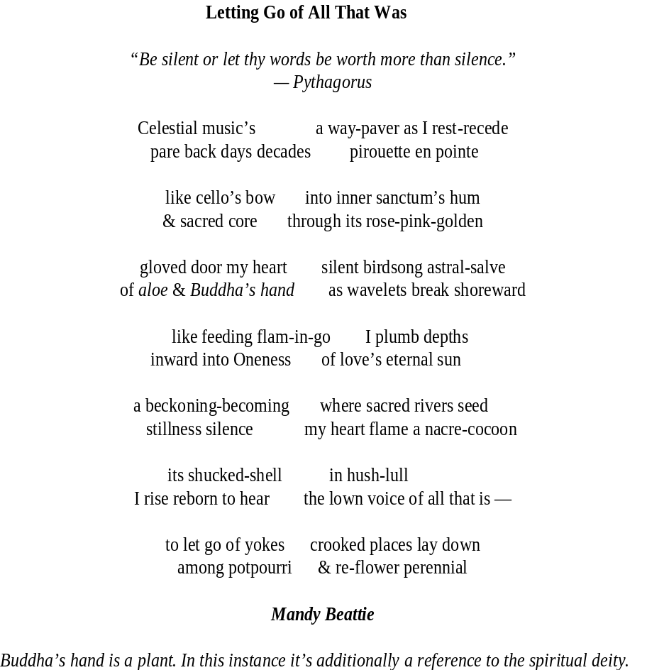

The day’s report
No matter that I’ve not seen the river today.
It wasn’t raining this morning, but I’d heard it might
and this served as excuse enough for the lapse
in practice, from my daily mile along the canal
to the Lawrence Mill Wasteway, then the River Walk
where the blue heron stands its stately watch.
The bird does so whether I am there to notice it or not
and the river doesn’t need to be reminded
about a twenty-year-old song where I couldn’t quite
manage the syllables or the specificity of its name—
About now anything new I’d sing or say ‘d be disingenuous,
just as empty as comfort whispered into the ear
of a corpse. Today, I do not love my own mind. I cannot hear
my voice, bleak, bleating, pained, the same black paint.

Tom Driscoll

Feast

In the mornings we wake tangled
In grey sheets, unwashed and
Cold in the winter air

Your floor is clothes coated and
you’re out of milk again, I’ll
Have coffee black but I hate it
I’ll pull you back to bed to drink
It tastes better with you cradled around me

In the evening we go blackberry picking
And stain our fingers and each
Others lips, dark and bruised looking.
You rub slow circles on the inside of my wrist,
Staining them bloody on the bus home,
I shiver in the gaps of my spine

I want to gorge myself on you,
Your smell, your taste, the skin under your earlobe
Feast until my stomach
Stretches taut, pale and rounded
I want to live on the roof of your mouth
Drop like honey on your tongue

I want you to shred me sweeter,
tear me methodically at the seams;
strip flesh from elbows, the knees.
Rub my skin into butter, like breadcrumbs
My insides melt into sugar and kidneys
Chew on the stringy sinnews of my muscles and
Pull my ribs apart to feast on my deflating lungs
Snap my Achilles heels, dip the whole thing in custard.

Your mouth will be red-rimmed and overflowing
You will never go hungry
I want you to live on me

Úna Nolan

Herring
Suzanne Valadon, 1936

Appetite renews the light. Shut your eyes
and life comes back: the bric-à-brac of loss
restored, the vanished day a-buzz.
As painters do, to find a world
in the cluttered hum of every separate thing.
So in this Still Life with Herring,
even the sickly brims with love.
The grey-wine bottle-crate is blocked
by a wheaten, wickered chair;
the resting cloth a tossed luxuriance.
On a plate, the dead fish – straining skywards – lies
beside a heart-shaped lemon, round as a rock.

Ciarán O'Rourke

Ummeryroe
i.m. of artist John O’Connor
A bog is also there, and I have used
It as a starting point for work.

Shades of sunlit bog, the kind of light
only your wetlands offer, as though
brightness spreads its skin
beneath heather and red berry rowan,
root-wisps hold this soft ground afloat
on the waver of yellow moss -
a sanctuary for absorption.
Body curved to canvas you wipe
bog cotton whiteness between grasses
blurred in their sway,
brush slanting sunlight
across an azure sweep of sky,
warming dragonfly and sundew plants,
its rays’ reach your hand, reins-like
guide you home the red hares’
frayed pathway between ferns.

John Noonan

When I grow Tired
looking at the rain
I see the lush grass and flowers in full bloom.
Amidst the annoyance of bustling crowds
one pauses to greet another.

When I grow tired of a painful
shoulder,
I think of the support it rendered to the
sick and needy.

Rather than tire of your weakness
I remember the robust, rollicking years.

Katherine Noone

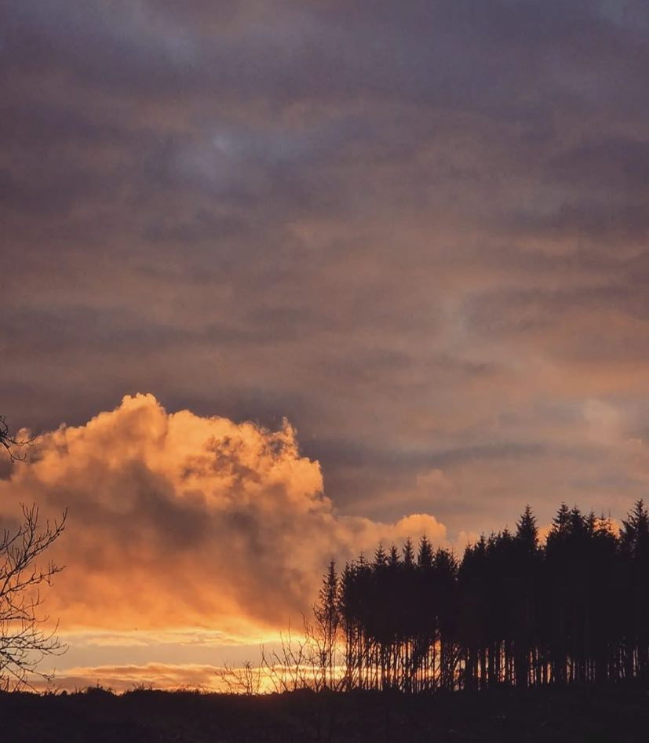

Fire on Fir Dol De Bie

How Close, this Far

Oh, great illusion of nature —
black spines static against a pink halo
so delicate, from here I imagine the bolt
of being has constructed this scene.

Remote structures are a composition
of stencils sketched over an orange palette
where tapestries of vapour heave with tears,
weight unbearable as witness itself.

Distance is a baffling closeness the cold earth
distorts in its dark hex. Time, or the elements,
will not reunite us, remain as we must to live
as ghosts of ourselves, the sky a smeared
mirror of reflection unable to see.

Maeve McKenna

“The Night of the Concert”

I was willing contraband
smuggled over the walls
of her college dorm
that late night return, in suede shoes.

She’d bought us brandy in the Crown Bar
and with her gothic raven hair
hid my teenage looks
from the city’s inquisitorial gaze.

I held her waist
in the shadows of Amelia Street
as we danced, over
to A Promise and The Killing Moon.

In the morning
I took the train to school
read the NME and blew smoke rings
against the fogged carriage windows.

Steve Nimmons

Patrick’s Sheelagh
musing on the Confesio mss

And looking over his shoulder just what
did I read but the invitation of the boys
from Massalia ‘sugere mammellas eorum’.
My honey complaining his Latin so desperate
bad, he’d never set foot over in papal Rome
bowing and scraping to the lads in ermine
lock horns with scrawny half-naked Jerome
acting the monkey with a poor skull not his own.
So, I may be Sheelagh, but don’t I lay down the law
wedging my saint’s head between my breasts
the way a woman should always treat her ghrá.
And when I meet them, his ‘seniores mei’, I’ll tell
them to go fuck themselves.
For my fellow’s one of the Céli Dei, from the Barrow.
I keep him for myself on the straight and narrow.

John Ennis

Looking for Lost Scriptures
walking through bluebell wood,
i saw a tramp
on a quarry stone
taking pictures
with his face.
what time was he
with every season marked-
some leper, misunderstood-
branded with misfits stamp,
or you without your god at home
looking for lost scriptures
in the wrong place.
desire drives this destiny
now its soul has disembarked
with nostalgia from the neighbourhood
living life in lamp.
Strider Marcus Jones

She, Nature

She wondered if the same thoughts ran with people,
like hers, if they thought as she did.
Pondered on trees and rivers,
in the witnessing, and her living
on the graveyard shift.

It was not her intention
to allow this meandering.
Rather lose herself to the fern fronds,
busily gestating, cradle capped,
sprung to life, announcing their newness.
Become so intoxicated by the pungent wild garlic,
promise of a sprinkling of white flowers,
her mind would be diverted.

The many ways and many places,
to leave and enter life.
Celtic traditions speak of nature,
mothers leaning against trees.
Support in the birthing, giving of life –
Power of nature, grit of woman.

Sandra Clarke

Hope Is The Thing
- after Emily Dickinson

In your wake, a daily flurry
of feathers fall, pure white
handfuls of angel gifts
to light and guard

sprinkled wingfalls from above
land on the green grass
light as silky snowflakes,
to rule and guide

cleaved into a patio crack
a lone quill
stands

a nudge of hope
to inspire
a dip down my wordwell.

Noelle Lynskey

The Skylark at Baltray.

Do I dare to write a poem about a skylark,
Shelley's ghost at my shoulder, disapproving?
But he was not there that day, as I was, hearing
at first a curlew's grievous cry, nor did he witness
my delight to find, scattered in sandy soil,
clusters of wildflower posies, diminutive jewels,
those pansies also called 'hearts ease', harebells
tinkling in the wind, wild violets and eyebright.

Such bounty sufficed for one day, but there came
more blessings, when a skylark suddenly spiralled
out of the Marram grass, making me stop, spellbound
Shelley's ode in my ears as I stood, dazed with delight,
the skylark oblivious to all but that seldom heard song,
transporting me on its wings to a sphere where
all is well with the world around us
and there is no pain, or death or wrong.

“Skylark thou art my joy eternal”
Shelley's voice whispered faint with a sigh,
“but you who conjured me up again at that sea-wrought place
should know how I remember with sadness
a day long ago, that storm on Spezi, my boat a toy,
tossed among waves rolling darkly in on the tide.
Will any poem you write be as well-remembered?
Farewell before I weep, remembering how I died”.

Honor Duff

Trichotillomania

I used to braid Scoobie strings, plait the platinum
heads of Barbie dolls, watch the locked knots tied
to never break by my fisherman father

I was four when my hair was cut up like a boy
when fingers plucked strands into strings.
I was a musician who fine-picked pings

strum long enough, you’ll find yourself bald.
Put it like this, why does the urge to twirl in swirly dance
of nail and curl, to carve a hole in a moment of time

like cranking your neck towards the small crack
in the car window, welcome a hit of wind,
find me as a secret prayer before I sleep?

I hear the stride of my beloved through the front door,
a quick unwrap to throw a baubin around a bun,
distracting his gaze away from the wavy nest fallen to the floor

which he doesn’t notice being placed gently into compost,
my soft crown, hoovered up by Morphy Richards
or thrown out the window for the birds to claim.

Áine Rose Connell

Pet Rescue

We let them into our lives,
share our stories with them,
swear that somehow they understand,
return our love unconditionally.

But there’s a trade-off
to pouring all of this care
into their concentric lives:

one day we’ll have to say goodbye,
wonder why we sabotaged our emotions.

Perhaps we must accept that all love,
once given, will leave us in the end,

but that in itself is no reason
not to hold the candle to our face.

Ben Banyard

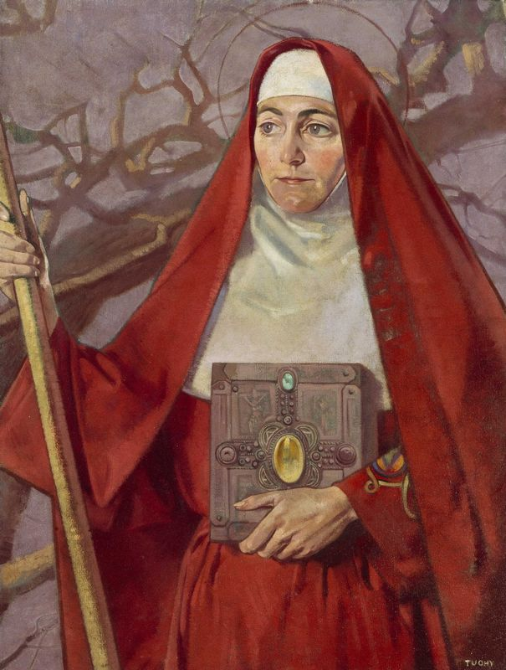

Saint Brigid Patrick Joseph Tuohy

An Interruption of Swans, St Brigid’s Day

Carefully scraping the thick
foam of meringue
into a bowl to be gently folded
with the sweet batter of butter, eggs, sugar
I am startled by the urgency of wings
swans
the sky blue behind their white.

Lavender and rosemary cake
for St Brigid's Day,
Bríd of poets, babies,
fugitives and travellers –
all welcome to share
seeds, herbs,
this abundance.

We are welcoming spring
a scrap of colour fluttering
in winter’s sharp breeze,
embracing a new year
with cake.

The swans move
from canal to river
crossing the city
fierce and graceful,
nesting in rushes.

They never look down –
Dublin’s rust-red bricks below
and me in my back garden
arms outstretched,
white sheets billowing,
ready for spring.

Lynn Caldwell

The Crossing

The sound of a secret settlement.
A mother and daughter sit
silently weaving rush crosses
as the earth stirs
from its brazen slumber.
In a hum like muffled rosary
they bleat in focus. The girl
turns her cross clockwise
by one quarter
and introduces another rush, outside
a crescent moon.
Crossing the threshold from winter to spring,
the air mourns their hush as they weave
and cart the woes
that bind them
deep into this world
and closer
to the next.

Helena McCanney
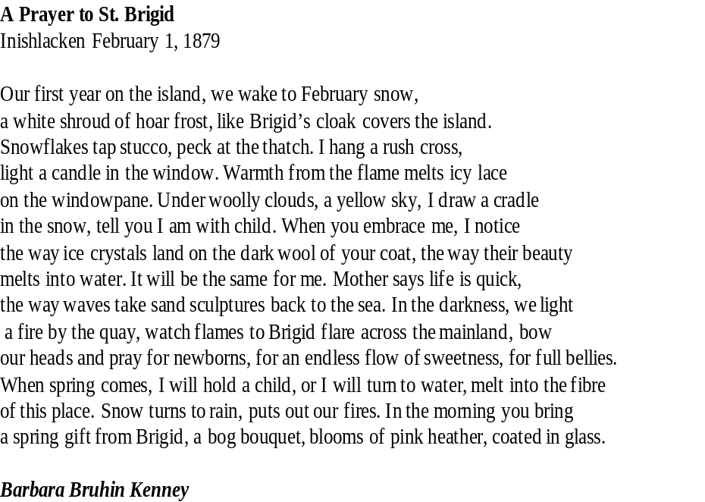

Notes on Contributors

Peter Adair’s poems have appeared in The Honest Ulsterman, PN Review, Drawn to the Light,The Bangor Literary Journal, Poetry Ireland Review, Boyne Berries, A New Ulster and elsewhere. He has been shortlisted for the Seamus Heaney Award for New Writing. An e-pamphlet Calling Card is available from Rancid Idol Productions and Amazon. He lives in Bangor, Co Down.

F. C. Andrews achieved his undergraduate degree in Human Nutrition from University College Dublin in 2021. Andrews is currently a student on the M.Phil. in Creative Writing programme at Trinity College Dublin, where his writing explores themes such as nature, isolation, and transience. His work has previously appeared in literary and arts magazine Icarus.

Ben Banyard lives in Portishead, on the Severn Estuary just outside Bristol. His third collection, Hi-Viz, was published by Yaffle Press in 2021. Ben edits Black Nore Review (https://blacknorereview.wordpress.com) and blogs at https://benbanyard.wordpress.com

Mandy Beattie frequently loses herself in poetry & imaginings. She’s been published in numerous journals such as Poets Republic, Lothlorien, Ink, Sweat & Tears, Dreich, WordPeace, Visual Verse, Wildfire Words, Spilling Cocoa by Martin Amis, Last Stanza, The Haar, Poets Choice, Marble Poetry & more. Short story in Howl, New Irish Writing. Shortlisted, Black Box Competition.

Byron Beynon coordinated Wales's contribution to the anthology Fifty Strong (Heinemann). His work has featured in several publications including Boyne Berries Magazine, Cyphers, The London Magazine, Wild Court, English, The Journal of the English Association, Wasifiri, Poetry Wales and the human rights anthology In Protest (University of London and Keats House Poets). Collections include The Echoing Coastline (Agenda), Cuffs (Rack Press) and Where Shadows Stir (The Seventh Quarry Press).

Faye Boland won the Robert Leslie Boland Prize 2018 and the Hanna Greally International Literary Award 2017. She was a finalist in the Irish Times National Poetry Award 2022, highly commended for the Desmond O' Grady Prize 2019 and shortlisted in 2013 for the Poetry on the Lake XIII International Poetry Competition. Her first poetry collection Peripheral was published in 2018.

R.J. Breathnach is a Wexford-born journalist and writer based in Meath, Ireland. His work has been published in The Madrigal, The Wexford Bohemian, and The Honest Ulsterman, among others. His debut poetry chapbook, I Grew Tired of Being a Zombie, is available from Alien Buddha Press.

Lynn Caldwell's work has been published in Poetry Ireland Review; anthologies Writing Home and The Book of Life (Dedalus Press); Cyphers; Crannog; Crosswinds Poetry Journal; The Irish Times; and Aesthetica’s Creative Writing Anthology; and has featured on RTE's Sunday Miscellany. Now a Dubliner, Lynn is a Canadian calling Ireland her second home.

Rosaline Callaghan shares her Derry home with rescue cat, Beannacht. She’s a retired barrister, also living with Hereditary Amyloidosis, a rare, progressive, fatal disease from North-West Donegal, for which there was no treatment until a couple of years ago. She has written a book on her experience of the condition entitled Donegal Amy - available on wildstoryteller.com and Amazon. Her poems are included in the anthologies Heartland and Threshold. Polydipsia was shortlisted in the Saolta Arts ‘Poems for Patience’ competition 2022. Her poem Parenthesis features on a Bogside Mural as part of the ‘From Bloody Sunday to Brexit’ project. She’s 62, five feet, slightly round, and divides her time between writing, ignoring housework, killing houseplants, and trying to cuddle said cat.

Sandra Clarke is a poet living in Waterford. She was chosen to participate in the Poetry Ireland, Poetry Town Initiative 2021. She was awarded bursary assistance from Waterford City and County Council, working with poet Grace Wells and completing the Writers
Incubation and Literature Mentoring Programme with poet and writer Lani O’ Hanlon. She has completed master classes with poet and writer, Thomas Mc. Carthy. She has participated in several courses with the Irish Writers Centre and has been grateful to work with poet Grace Wilentz in the latest Gallery Goes Workshop Series.

Kevin Conroy has been published in The Irish Times, The Stony Thursday Book, One by jacar press, The Galway Review, the Moth, The Bangor Literary Journal, Tales From The Forest, Skylight 47, THE SHOp, Southword, Burning Bush II, Boyne Berries, The Blue Max Review, The Curlew, Sixteen Literary Magazine, erbacce, The Runt magazine, and appeared in the Ireland Chair of Poetry Anthology 2020, Poets meet Politics & Hibernian Writers anthologies. Runner-up in The Patrick Kavanagh Poetry Award 2016. His debut collection is to be published by Salmon Poetry.

Ion Corcos was born in Sydney, Australia in 1969. He has been published in Cordite, Meanjin, Wild Court, The Sunlight Press, and other journals. Ion is a nature lover and a supporter of animal rights. He is the author of A Spoon of Honey (Flutter Press, 2018).

Dolores De Bie lives in rural Sligo, Ireland. She is passionate about capturing nature's invisibility to the naked eye through the lens of a camera. Dolores posts actively on Instagram. Her photographs can be found at https://www.instagram.com/doldebie/.

Patrick Deeley was born in Loughrea, Co. Galway. Seven collections of his poems were published by Dedalus Press, and other works have appeared in translation to French, Italian, Ukrainian and Spanish. patrickjdeeley@gmail.com.

Tom Driscoll lives in Framingham, Massachusetts USA with his wife, artist Denise Driscoll. He’s published several collections of poems, most recently ‘Odd Numbers’ (2017).

Honor Duff, a native of Dublin, now lives in County Cavan. Her poems have been placed and commended in several competitions, including the Francis Ledwidge Awards, the Goldsmith Poetry
Competition, the Red Line Festival and have been published in various journals including, Boyne Berries, Crannog, Windows, The Stony Thursday Book and Skylight 47.

Kate Ennals is a board member of Irish PEN/PEN na h'Éireann. Her published collections include At the Edge & Threads (Lapwing), Elsewhere (Vole Imprint) & forthcoming Practically A Wake (Salmon Spring 23).

John Ennis’s work has recently been published in Poetry Ireland Review 137 (2022), The Waxed Lemon (2022), Contemporary Surrealist and Magical Realist Poetry Lamar University Texas (2022) and in Winter Anthology edited by Sourav Sarkar (2022. His Later Selected Poems Going Home to Wyoming (BookHub) appeared in 2020.

James Finnegan, Dublin born, was the second-prize winner in the 2022 Gregory O’Donoghue International Poetry Competition and also the second-prize winner in the 2022 Allingham Poetry Competition and was shortlisted in the 2021 Bridport Poetry Prize and in the 2018 Hennessy Literary Awards for Emerging Poetry. A sonnet, ‘The Weather-Beaten Scarecrow’, was published in The Irish Times in August 2021. A new collection of poems by James, The Weather-Beaten Scarecrow, was published by Doire Press in September 2022.

Mary Melvin Geoghegan has five collections of poetry published. Her last collection As Moon and Mother Collide was published with Salmon Poetry (2018). Her next collection There Are Only a Few Things will be published with Salmon in 2023. Her work has been widely published. Shortlisted for The Fish Poetry Award, Francis Ledwidge, Cúirt New Writing, The Francis Ledwidge, Padraic Column Inaugural Poetry Competition, The Jonathan Swift Poetry Award, 2019, 2020, The Desmond O’Grady International 2022 Poetry Prize and Poems for Patience 2022. She won The Longford Festival Award for Poetry in 2013. A member of the Writers in Schools Scheme with Poetry Ireland and has edited several anthologies of children’s poetry.

The short stories and poems of CR Green have been published in the United States, Ireland, and New Zealand where she immigrated with her family in 1997.

Strider Marcus Jones is a poet, law graduate and former civil servant from Salford, England with proud Celtic roots in Ireland and Wales. He is the editor and publisher of Lothlorien Poetry Journal https://lothlorienpoetryjournal.blogspot.com/. A member of The Poetry Society, his five published books of poetry https://stridermarcusjonespoetry.wordpress.com/ reveal a maverick, moving between cities, playing his saxophone in smoky rooms. His poetry has been published in numerous publications including: The Huffington Post USA; The Stray Branch Literary Magazine; Crack The Spine Literary Magazine, The Lampeter Review and Dissident Voice.

Declan Kavanagh teaches English literature at the University of Kent, Canterbury. His poetry has been previously published in Datableed: poetry zine. He is currently working toward his first chapbook of poems.

Barbara Bruhin Kenney is working on a collection of poetry about Inishlacken (Inis Leacan), her ancestral home in the west of Ireland. Her poetry has been published in The Lyric and Feels Magazine. She has read her poetry on Connemara Community Radio and at the Eden Mills Fringe. One of her poems inspired a painting by Irish Artist, Rosie McGurran, URA, who gifted the painting to former Irish President, Mary McAleese, at the opening of the Gerard Dillon Gallery in Belfast.

John Knight was born and raised in Dun Laoghaire. At age 14, he became a deck boy on the MV Munster, part of the British & Irish Steam Packet Company, later the B & I Line. This was the first of many ships for John who ploughed the waves for 40 years before retiring from sea. By then he was happily married and became a part-time Sacristan in St. Michael's Church. Today he is a member of the Dun Laoghaire Active Retirement Association where he enjoys creative writing and art classes. John also plays the piano in the Royal Marine Hotel.

Noelle Lynskey, passionate about poetry, just completed her MA (Creative Writing) in UL. Selected as Strokestown’s Poet Laureate in 2021 her writing is widely published. She works as a community pharmacist in Portumna where she facilitates Portumna Pen Pushers writing group and is artistic adviser to Shorelines Arts Festival.

Helena McCanney designs learning for a living and writes to experience life more fully. Helena was born in Dublin and lives beside Phoenix Park, which she thinks of as her holodeck – a safer alternative to reality. She recently completed an MA in Creative Writing in Dublin City University.

Ted Mc Carthy is a poet and translator living in Clones, Ireland. His work has appeared in magazines in Ireland, the UK, Germany, the USA, Canada, and Australia. He has had two collections published, 'November Wedding', and 'Beverly Downs'.
His work can be found on www.tedmccarthyspoetry.weebly.com.

Maura McDonnell is an artist that explores many forms and mediums. She started out studying music, mathematics and history in the 1980s for her degree and then taught music in the prison service for many years. After returning to college in the 90s, where she studied Music and Media technologies, she started to create digital abstract films and visual art with a musical and poetic expression to what she calls a 'visual music'. She eventually completed a PhD on Visual Music and Creative Arts in Trinity College in 2019. She lectures part-time on the music technology programme there. Maura was born in London to Irish parents, and has also lived in Manchester, Leitrim, Longford, Cavan, Fermanagh, Carlow and has moved/returned to Maynooth, Co. Kildare three times, where she now lives. Maynooth is a significant place for her, and it features a lot in her art. Maura has always loved to write but mainly wrote privately until she started writing poetry more consciously at the beginning of lockdown to prompts by the then Poetry Ireland’s Poet in Residence, Catherine Ann Cullen. She attended Angela T. Carr's inaugural poetry course.

Maeve McKenna lives in Sligo, Ireland. Her work has been placed in several international poetry competitions and published widely, including Mslexia, Banshee, The Stony Thursday Book and forthcoming in Rattle. Maeve was one of three finalists in the Eavan Boland Mentorship Award 2020. She was part of a collaboration with three poets which won the Dreich Alliance Pamphlet Competition. Her debut pamphlet, A Dedication to Drowning, was published in February 2022, by Fly on the Wall Press. A second pamphlet will be published in the Spring, 2023. She is currently a MA student of Poetry at Queens University, Belfast.

Stephen McNulty scribbles things whenever he is not forcing a member of the public into a CT scanner. His poems have appeared in Boyne Berries, Drawn to the Light, ROPES, Spilling Cocoa Over Martin Amis, Strukturriss and Vox Galvia.

Steve Nimmons is a writer and documentary photographer from Ballymena, Northern Ireland. He was first published in The Full Moon Poetry Broadsheet in 1994. His work explores culture, identity and relationships between creative writing, photography, and visual art.

Jeanna Ní Ríordáin is an Irish-language translator from West Cork. Her poetry has been featured in The Quarryman, Poetry in the Time of Coronavirus: The Anthology, Volume Two, pendemic.ie, Lothlorien Poetry Journal, The Melting Pot: A Mental Health Anthology, Otherwise Engaged Literature and Arts Journal and Burrow.

Úna Nolan enjoys writing so much she occasionally forgets to be embarrassed about it. She has been previously published in Crossways Literary Journal, Green Carnations Anthology, The New Word Order, The Madrigal Press, Morning Fruit Magazine, An Áitiúil Anthology, Sweet Tooth Magazine, Bulllshit Lit Magazine, Londemere Magazine and Palest Blue Magazine. She is editor in chief of the Martello Journal's 'Sanctuary'.

John Noonan lives near Dundalk and is a member of Dundalk Writers. He has had poetry published in magazines and journals in Ireland and abroad. His first play "Winter Window" was recently performed. John won the Goldsmith Poetry Award in 2012.

Katherine Noone’s first poetry collection ‘Keeping Watch’ was published 2017.Her second collection ‘Out Here’ was published in 2019, both by Lapwing Publications Belfast. Her poetry is published in magazines and journals in Ireland, U.K. Canada and U.S.A. She lives in Galway and attends the poetry workshop at Galway Art Centre.

Ciarán O'Rourke is a previous winner of the Cúirt New Irish Writing Award, the Fish Poetry Prize, and the Westport Poetry Prize. His two collections, The Buried Breath (2018) and Phantom Gang (2022), are published by The Irish Pages Press.

Áine Rose has been published in Roi Fainéant Press, Irish Arts Review and Drawn to the Light Press. A Donegal artist, poet and speech & language therapist; she was awarded the Emerging Artist Bursary from Arts & Health, Arts Council & HSE (2022). She currently works as a Speech Therapist for Teleatherapy, an app aiming to digitalise elements of speech therapy for individuals with Parkinson's Disease. She is an artist facilitator with the Arts for Health team in Uillinn: West Cork Arts Centre. Áine paints from her home in West Cork.

Sailing Haiga - Haiku by Betty O'Sullivan, Imelda Reynolds, Tom Kennedy, Pat Fitzgerald and artist, John Knight, members of Dun Laoghaire Active Retirement Association with their tutor - poet, author, Frances Browner, Dun Laoghaire ETB.

Bobbie Sparrow has been published in many journals and anthologies. Her two Chapbooks have been commended and placed. She has had many poems succeed in competitions. She is trying to get famous enough to live up to her name. She likes lakes.

Matt Stanley is a new writer from Kent. He is a primary teacher and lives in Folkestone. He has a particular interest in queer ecology and sea sports.

Rachael Stanley’s work has appeared in various journals and anthologies. Her poetry has previously appeared in Drawn to the Light Press, issue 6. Her poem Destruction was selected for an online exhibition for culture night on an anti-war, pro peace theme in September 2022 on the Smashing Times International Centre for the Arts and Equality website. She was commended in the Francis Ledwidge Poetry Competition in 2019 and again in December 2022. She lives in Dublin.

Patrick Tuohy (27 February 1894 – August 1930) was an Irish portrait, narrative, and genre painter.

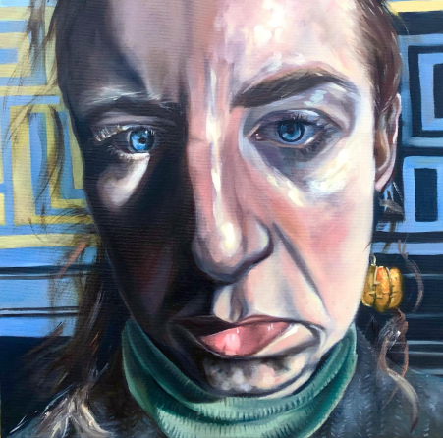

November third, Derry Áine Rose Connell

€15
ISSN 2737-7768

