Progressive Multifocal Leukoencephalopathy secondary to idiopathic CD4 lymphocytopenia treated with Pembrolizumab.

Kyriakoula Varmpompitiª, Andrew Westwood^{b}, Aaron Ben-Joseph^{b}, Naomi Sibtainª, Mohammad A A Ibrahimª, Biba Stantonª, Mark Zuckermanª, Robert Hadden^{a,b}, Laura Mantoan Ritterª

ª King’s College Hospital NHS Foundation Trust, London, United Kingdom
^{b} Maidstone and Tunbridge Wells NHS Tust, Hermitage Lane Maidstone, Kent, United Kingdom

Corresponding Author:

Dr Kyriakoula Varmpompiti, MD, MSc
King’s College Hospital NHS Foundation Trust
Denmark Hill, London
SE5 9RS
(kyriakivarbo@gmail.com)

Abstract 100/100 words

Background
Progressive multifocal leukoencephalopathy (PML) is a rare demyelinating disease due to a lytic infection of oligodendrocytes caused by John Cunningham polyoma virus (JCV) infection. Idiopathic CD4+ T-cell lymphocytopenia (ICL) is a very rare cause of PML.

Methods
We present a case of PML secondary to ICL treated with 3 doses of Pembrolizumab, a Programmed-Death-1 Immune Checkpoint Inhibitor following with complete resolution of symptoms and conduct a review of the literature.

Conclusion
This report illustrates the objective clinical and radiological improvement in a case of PML due to ICL and suggests further study of immune checkpoint inhibitors as potential treatment for cases of PML.

Keywords: Progressive multifocal leukoencephalopathy, John Cunningham Virus, Idiopathic lymphocytopenia, Neuroinflammation, Pembrolizumab, PD-1 Checkpoint Inhibitor

Abbreviation: PML, Progressive multifocal leukoencephalopathy; CNS, Central Nervous System; JCV, John Cunningham virus; ICL. Idiopathic Lymphocytopenia; PD1; Programmed cell death 1; ICIs, Immune Checkpoint Inhibitors; HIV, Human Immunodeficiency virus; CSF, Cerebrospinal fluid; IRIS, Immune Reconstitution Syndrome; OCB, Oligoclonal Bands

2127 with references/ 2000 words

1. Introduction
Progressive multifocal leukoencephalopathy (PML) is a progressive and often fatal disease of the Central Nervous System (CNS) caused by John Cunningham virus (JCV) (Berger, 2014). JCV is an opportunistic pathogen and JCV antibodies are present in around 90% of the adult population worldwide (Wollebo et al., 2015, Viscidi et al. 2011). In immunocompromised patients, JCV may reactivate and cause a lytic infection of the subcortical white matter oligodendrocytes, producing focal demyelinating white matter lesions on imaging and neurological disability. PML is particularly seen in patients with impaired cell-mediated immunity caused by HIV infection, immunosuppressive drugs, hematological and autoimmune disease as well as idiopathic forms of lymphopenia (Cortese I et al., 2019; Berger et al., 2014).
Idiopathic CD4+ lymphocytopenia (ICL) is a syndrome described in HIV-negative patients with an absolute CD4+ T-lymphocyte count of less than 300 cells/µL or of less than 20% total T-cells on more than one occasion and absence of any immunodeficiency or immunosuppressive therapy (Melzi et al., 2008; Smith et al., 1993). Patients with reduced CD4+ T cell counts are susceptible to opportunistic infections (Lisco A et al., 2023). It has been described as a rare cause of PML, with only 26 cases in the literature, without specific treatment and variable outcome (Aggrawal D et al., 2019; Hayashi Y et al., 2008; Dato C et al., 2020; Sutton P et al., 2020; Kobayashi Z et al., 2013; Fukumoto T et al., 2021). Treatment strategies so far include withdrawal of immunosuppressive therapies, plasma exchange, mirtazapine, mefloquine, immunomodulatory drugs (Castle N et al., 2019), antiviral agents including cidofovir and chemotherapy agents such as cytarabine (Patel A, Patel J, Ikwuagwu J., 2010) with questionable outcomes. More recently, the focus has been on therapeutic strategies that promote the recovery of antiviral immune responses, such as interleukin-7 (Lajaunie R et al., 2022) and immune checkpoint inhibitors (ICIs) (Boumaza X et al., 2022; Cortese I. et al, 2019; Walter O et al., 2019).
Cortese et al. demonstrated a potential effect of PD-1 inhibition on JCV in the Central Nervous System (CNS) and possibly survival, using Pembrolizumab 2 mg per kg every 4 to 6 weeks in five out of eight patients with PML, with or without Human Immunodeficiency virus (HIV) infection (Cortese I et al., 2019). A more recent retrospective review of 79 PML patients secondary to various predisposing conditions including ICL, haematological malignancies, HIV, cancer and transplant patients showed that CSF JCV DNA load decreased significantly 1-month post-treatment with an immune checkpoint inhibitor in survivors compared to non-survivors (p < 0.0001) (Boumaza X et al., 2022).
In this paper, we report an individual with ICL and PML who was successfully treated with pembrolizumab and review the literature, summarizing the associated clinical features and prognostic indicators.

2. Case summary
A 67-year-old right-handed previously independent man presented to his local hospital with worsening left-sided weakness, dysarthria, and ataxia. Past medical history included hypertension and hypercholesterolemia. He was treated as having had a cerebellar infarct after computed tomography (CT) head imaging showed right cerebellar hypodensity. Three months after he was discharged, he presented with worsening bulbar weakness complicated by aspiration pneumonia, worsening dysarthria and ataxia. MRI brain showed cerebellar and brainstem signal abnormalities and a low level of JCV DNA was detected in the Cerebrospinal Fluid (CSF) (623 copies/ml). He was HIV negative and had no risk factors for immunosuppression and was transferred to the tertiary neurosciences center for further investigations.
Clinical examination revealed marked bulbar weakness, dysphagia and non-sustained gaze-evoked nystagmus towards the right. There was bilateral asymmetric (right more than left) gross ataxia with dysmetria and intention tremor with brisk reflexes.
Serial MRI brain imaging showed progressive posterior fossa T2 hyperintensity and T1 hypointensity with right-sided predominance, without mass effect, restricted diffusion or contrast enhancement (Fig. 1), overall suggesting PML. No inflammatory changes were seen on the MRI spine. Laboratory results (table 1) revealed mild lymphopenia (0.9x10⁹/L, normal range 1-10x10⁹/L) with a low CD4 count (263 cell/μL, normal range 300-1400 cell/μL), low CD8 cells (170 cells/μL, normal range 200-900 cells/ μL) and NK cells (59 cells/μL, normal range 90-600cells/μL). Previous blood analyses showed persistent lymphopenia (0.9x10⁹/L) one year prior to the current presentation, hence transient lymphopenia due to a possible concurrent infection was unlikely. HIV test was negative. The patient received a 2-week course of steroids without response. An extensive work up including infective screen, body CT scan and Positron Emission Tomography scan were negative.
CSF analysis showed no cells, normal protein, and glucose, however JCV DNA was positive on two occasions (623 copies/ml and 75.8 copies/ml) (Table 2). Given the low positive titres of JCV DNA in the CSF, JCV antibodies were tested and detected intrathecally. Incidentally, the patient was found to have raised κ and λ light chains on serum electrophoresis with a normal ratio and IgM λ monoclonal paraprotein present at 3g/dL, diagnosed as monoclonal gammopathy of unknown significance.
Based on the above findings and the absence of any predisposing factor for immunodeficiency the patient was diagnosed with PML secondary to idiopathic CD4+ T-cell lymphopenia. He continued to deteriorate clinically and was bedbound and radiologically (figure 2), and was treated with 3 doses of Pembrolizumab 2mg/kg (Cortese et al., 2019). The first pembrolizumab dose was tolerated without any complications and led to mild improvement in his tremor and ataxia in his arms after a week. He continued to improve after further inpatient neurorehabilitation and 4 weeks later he received a second infusion. One month later, his gait improved to allow him to use a Zimmer Frame and his dysphagia resolved and was able to have oral feed. Repeat MRI brain showed improved in the extent of T2 hyperinstensity in the pons, right middle cerebellar peduncle and the right cerebellar hemisphere (figure 3). Off note, the patient developed allodynia in the right upper limb, affecting soft tissue and joints and right arm was stiff with mild oedema. There was no evidence of erythema or cellulitis and treated as inflammatory arthritis with steroids for two weeks followed by resolution.
Four months after the second dose he began to deteriorate clinically with unsteadiness and bulbar symptoms and in view of the previous improvement, a third dose of pembrolizumab was administered 5 months after the second dose. However, at that time he was unable to chew or speak, unable to walk, had developed diarrhea and fecal incontinence. He was too unwell to tolerate a repeat MRI. Around three months after the last dose of pembrolizumab he developed sepsis, aspiration pneumonia, Clostridium difficile colitis and died.

3. Discussion
This is a case of HIV negative PML in the context of ICL. The clinical spectrum of ICL ranges from an incidental laboratory finding (Zonios DI et al., 2008) to life-threatening complications that mimics the clinical course of HIV-infected patients (Luo L et al., 2008). According to recent reports, PML has been described in several patients who were eventually diagnosed with ICL (Boumaza X et al., 2022; Cortese I. et al, 2019). Our patient had a significantly long period of lymphopenia starting at least 1 year prior to his presentation. Additionally, there was also no history of previous immunosuppressive treatment as the patient received 2 weeks of steroids. This is consistent with a primary cause for his persistent lymphopenia. Nevertheless, our patient did not have genetic testing to rule out known causes of inborn errors of immunity or constitutional bone marrow failure syndromes which is one of the limitations of our report (Lisco A et al., 2023).
In a recent literature review studying PML cases treated with ICIs, only 5 out of 53 cases had underlying HIV infection; four of these had a favorable outcome (Corey S., 2022). Pembrolizumab has been suggested to benefit HIV positive patients whilst on antiretroviral therapy (Pinnetti C et al., 2022), However, there is a risk of IRIS. In a recent case report, pembrolizumab was seen to be effective in treating PML in an HIV-positive patient whilst off antiretroviral therapy (Sim B et al., 2022).
Table 3 includes cases of HIV-negative PML caused by ICL. The literature review was conducted by searching the Pubmed database using the MeSh terms ((progressive multifocal Leukoencephalopathy) OR (PML)) AND (Idiopathic CD4 lymphopenia). We identified 26 patients, the majority were male (22 cases), two female and two of unknown gender. The patients’ ages ranged between 30 to 87 years (median 55, Interquantile range 26). CD4 counts varied between 39 to 294/μL (mean 161.75, SD 81.02). Treatments used include mirtazapine, mefloquine, methylprednisolone alone or in combination, as well as cidofovir, cytarabine interferon, and IL-7, but do not permit any clear conclusions to be drawn on their efficacy. Over a variable follow-up period of up to 5 years, 10 out of 26 patients died, and 14 survived out of which 7 were stable, 4 were worse and 3 improved. Two cases had unknown outcome.
Pembrolizumab has been used in cases of HIV-associated PML with (Coltart H et al., 2023) and without IRIS (Sim BZ et al., 2022) with clinical improvement. Cortese described eight individuals with PML, and five patients clinically improved or stabilized and had a reduction in the JCV DNA load. In a more recent review and meta-analysis, Boumaza X. included both published and unpublished cases of patients who received ICIs as add-on to standard care for PML in order to minimize the publication bias (Boumaza X et al., 2022). A total of 79 patients were involved with PML due to various causes including hematological malignancies, primary immunodeficiencies, HIV/AIDS, chronic inflammatory diseases, solid neoplasm and transplant recipients. Fourteen patients had primary immunodeficiencies, 2 out of which had ICL. The ICIs used for ICLs patients were pembrolizumab and nivolumab. One-year survival following ICI initiation was 51.9% and was similar across all causes except for kidney transplant recipients (48.1% died, 18.4% from PML-IRIS).
Our patient received 3 doses of Pembrolizumab 2mg/kg (Cortese et al., 2019). He demonstrated neurological and radiological improvement; however, he passed away shortly after the 3rd infusion because of aspiration pneumonia and septicemia. With this case report we have shown that Pembrolizumab can be effective for the treatment of PML in the context of ICL. There were no significant side effects including Immune Reconstitution Syndrome (IRIS). Nevertheless, the patient developed right arm allodynia with soft tissue and joint pain and stiffness, without any infective features. This was improved with a short course of steroids. Arthritis in the context of IRIS has been described in HIV patients (Eyer-Silva Wde A et al., 2010). It is difficult to rule out completely the possibility of IRIS contributing to his clinical deterioration after the 3rd pembrolizumab dose. However, the patient also developed Clostridium difficile colitis 5 months after the 3rd dose of Pembrolizumab. Clostridium difficile colitis has never been described as a result of IRIS and was probably secondary to the long courses of antibiotics for the recurrent aspiration pneumonias. Taken together, we would advocate considering pembrolizumab for PML treatment earlier, to prevent or delay longer term morbidity and mortality.
Our patient had two positive JCV DNA load in the CSF a high and a low positive (623 copies/ml and 75.8 copies/ml, respectively) prior to Pembrolizumab. It could be possibly attributed to steroids. However, he continued to deteriorate clinically and radiologically. JCV antibodies were tested in the CSF and were positive. Unfortunately, CSF was not tested after Pembrolizumab. Boumaza found that CSF JCV DNA load decreased significantly by 1-month post-treatment in survivors compared to non-survivors (p<0.0001) irrespective of the PML predisposing condition. This is in keeping with prior literature indicating that survival improves with declining CSF JCV DNA load (Bossolasco S et al., 2005; De Luca A et al., 2000).
The natural history of ICL has not been well described. In Boumaza’s case series some patients continued to demonstrate progression of lymphocytopenia over time, however seven out of 39 had shown spontaneous remission after 3 years follow up (Boumaza X et al., 2022). In our patient CD4 cells normalized after the second dose of pembrolizumab. In Boumaza’s review, survival was not associated with normalization of CD4 or CD8 T-cell counts. While CD4 counts are an excellent way to estimate the severity of immunodeficiency in AIDS, they are less reliable predictors of PML risk or outcomes than in many other co-infectious complications. Progressive increase in CD4+ T cell counts was observed in 2 patients during follow up, which was significant increase by a factor of 1.044 per year (Lisco A et al., 2023) ICL can be associated with reduction of all lymphocyte subsets (Zonios DI et al., 2008)

4. Conclusion
This case adds to the growing body of evidence that the introduction of immunomodulators -and especially pembrolizumab- have shown promising results. Further research and clinical trials, such as in the form of “n-of-1 trials” for rare diseases, are needed to assess their efficacy for this disease.

Figure 1.
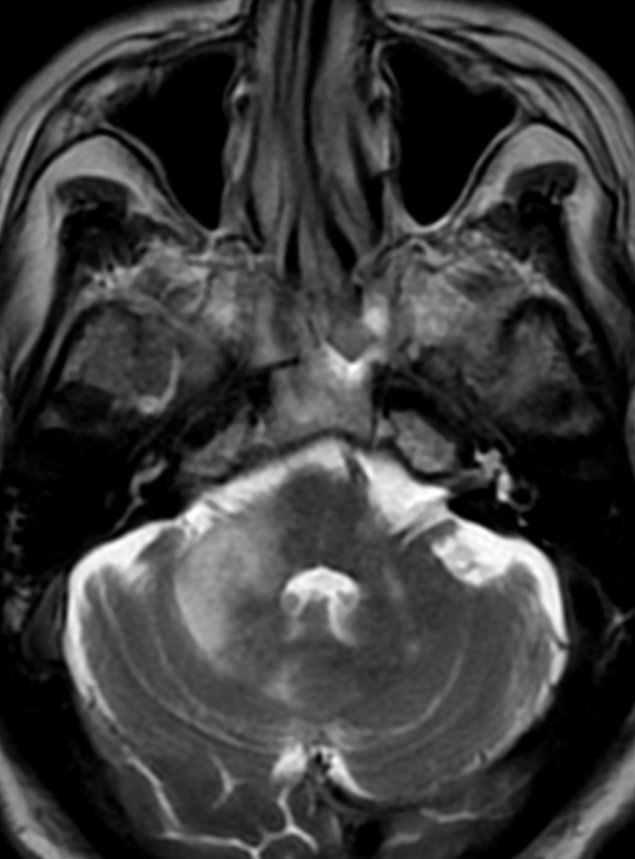
Figure 1. Axial T2w image shows confluent T2 hyperintensity the right cerebellar peduncle with extension into the adjacent pons and cerebellar hemisphere.

Figure 2.
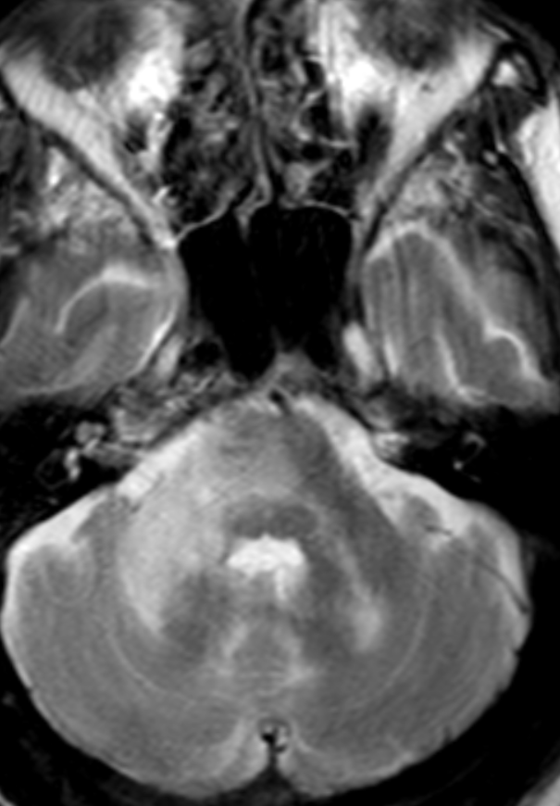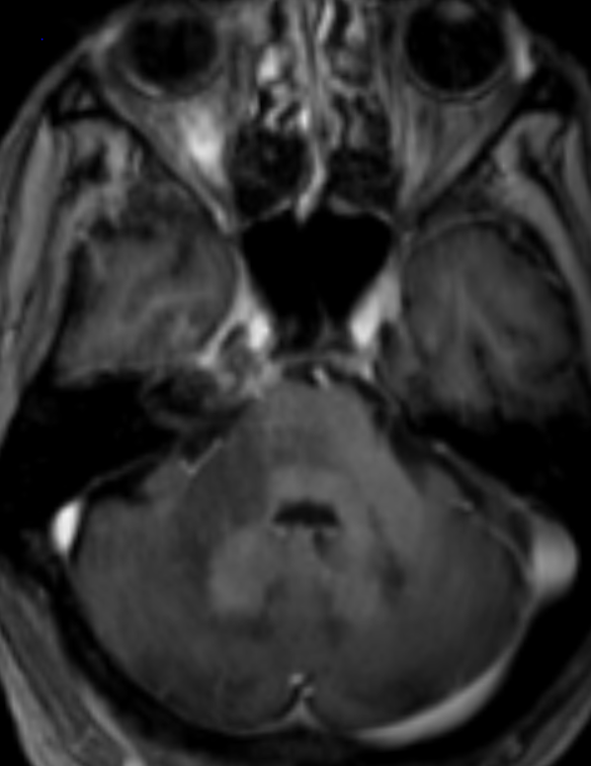
Figure 2. a) Repeat MRI performed 4 weeks later showed progression of signal change into the pons and both cerebellar hemispheres, without mass effect. b) Axial T1 post gadolinium image shows corresponding T1 hypointensity with absent enhancement

Figure 3.
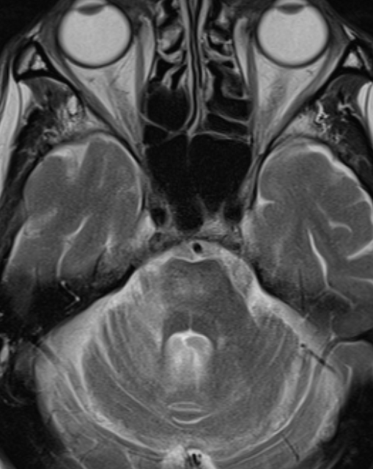
Figure 3. Follow up MRI performed 6 months later shows a marked reduction in the extent of T2 hyperintensity in the pons, right middle cerebellar peduncle and right cerebellar hemisphere.

Table 1. Blood tests
Lymphocyte Subsets |  |  |  |  | Immunoglobulins and Serum electrophoresis |  |  |  | Immunological and infection screen
 | Before 1st dose |  | After 2nd dose | Normal range |  |  |  | Normal Range
CD3% | 75 |  | 80 | 55-83% | IgG 1 | 3.662 |  | 3.80 - 9.30g/L | Anti CASPR2 | negative
CD3 Cells | 421 |  | 780 | 700-2100cells/Ul | IgG2 | 2.346 |  | 2.40 - 7.00g/L | Anti-LGi1 abs | negative
CD4% | 44 |  | 41 | 28-57% | IgG3 | 0.707 |  | 0.20 - 1.80g/L | Anti- haemophillus ab | 0.69
CD4 cells | 263 |  | 406 | 300-1400cell/Ul | IgG4 | 0.006 |  | 0.052–1.250 g/L | Pneum cap polysac IgG Ab total | 44.1mg/L
CD8% | 28 |  | 37 | 10-39% | IgG | 7.21 |  | 6.0 - 16.0g/L | Nuclear abs | negative
CD8 cells | 170 |  | 369 | 200-900 cells/Ul | Serum kappa light chains | 21.19 |  | 3.3 – 19.4 mg/L | MPO/ PR3 | negative
B cells % | 6 |  | 1 | 6-19% | Serum lamba light chains | 26.9 |  | 5.71 – 26.3 mg/L | IgG2 Pneumococall abs | 24.7
B Cells absolute counts | 35 |  | 13 | 100-500 cells/Ul | kappa:lamda ratio | 0.86 |  | 0.26 to 1.65 | anti tetanus toxoid ab Ig | <0.10
NK% | 11 |  | 12 | 7-31% | b2 microglobulin | 3.07 |  | 0.70-1.80 mcg/mL | B-D Glucan | negative
NK cells | 59 |  | N/a | 90-600 cells/Ul | IgM lamda monoconal paraprotein | present |  |  | Aspergillus EIA | Negative
Lymphocyte Sum | 515 |  | N/a |  | paraprotein concentration | 3 (g/L) |  |  | Treponema antibody | Negative
 |  | Virology (in blood)
HTLV type 1&2 antibody |  |  | Negative |  | CSF JCV DNA |  | 75.8 IU/ml |  | EBV VCA IgG | positive
HCV antibody  HCV RNA |  |  | Negative |  | CSF Enterovirus RNA |  | negative |  | Adenovirus DNA | <10 (IU/ml)
HIV-1 RNA |  |  | <20 copies/ml |  | HB surface antigen |  | negative |  | EBV DNA (log 10 IU/mL) | 2.3
VZV DNA |  |  | Negative |  | VZV IgG |  | Positive |  | SARS CoV-2 RNA | Negative
Blood CMV DNA |  |  | <10 IU/ml |  | Blood EBV DNA |  | 533 IU/ml |  | CSF HSV1 & 2 DNA | Negative
Abbreviations: NK: Natural Killers; Ig; Immunoglobulin; CASPR2: Contacting Associated Protein Like 2; LGi1 : Leucine Rich Glioma inactivated 1; VGKC; Voltage Gated Potassium Channel; EIE; Enzyme Immunoassay; HTLV: Human T-lymphotropic Virus; HIV; Human Immunodeficiency Virus; CMV: Cytomegalovirus; JC Virus: John Cunningham Virus; EBV: Epstein Barr Virus; HSV; Herpes Simplex Virus

Table 2.
CSF tests At presentation Prior to starting Pembrolizumab
Glucose | 3.9mmol/L | 3.9mmol/L
Protein | 0.51 g/L (0.25-0.45 g/L) | 0.43 g/L (0.25-0.45 g/L)
CSF IgG | 0.060 g/L (<0.026 g/L) | Not done
CSF albumin | 0.26 g/L (0.00 - 0.24 g/L) | Not done
WBC count | <5 (/cmm) | <5 (/cmm)
RBC count | 5(/cmm) | 7 (/cmm)
Oligoclonal bands | Unmatched intrathecal OCB | Not done
Virology* | Negative | Negative
JCV DNA | Positive (623 copies DNA.ml) * | Positive (75.8 IU/ml)
JCV antibody | Not done | Positive
Cytology | Negative | Negative
*CSF Virology includes CMV DNA, Adenovirus DNA, HSV1 and 2 DNA, Varicella zoster virus DNA, Enterovirus RNA, EBV DNA, JCV virus DNA Abbreviations: CSF: Cerebrospinal Fluid; IgG: Immunoglobulin G; WBC: White Blood Cells RBC: Red Blood Cells; OCB: Oligoclonal Bands; JCV John Cunningham Virus
**CSF was tested three times for JCV PCR, the first time it was positive and the following two times negative, prior to Pembrolizumab infusion.

Table 3. Literature review of PML in the context of ICL
Author, date | age/sex | Underlying disorder | CD4 count/μLbefore treatment | clinical manifestations | MRI PML lesion distribution | diagnosis | JCV | treatment | outcome
Fukumoto T, 2021 | 54/male | ICL and alcoholism | 78 | progressive dysarthria and gait disturbance for over one month, hemifacial dysesthesia, dysarthria, ataxia. Akinetic mutism after 4 months | pons and middle cerebellar peduncles | CSF and MRI | positive in CSF | cytarabine | remained in vegetative state and death from acute obstructive cholangitis after 11 years
Dato C, 2020 | 40/male | ???? | 210 | progressive speech disturbance over 3 months, Gerstmanns syndrome, cognitive impairment | parietal and occipital lobe, extending to the splenium of the corpus callosum, the inner temporal lobe WM and the left external capsula | CSF and MRI | positive in CSF | mirtazapine | mild deterioration in cognitive impairment after 2 years
Sutton P, 2020 | 87/male | ICL | 259 | unsteadiness, diplopia, severe dysarthria, ataxia | bilateral cerebellar hemispheres, left brachium pontis and left pons | CSF and MRI | positive in CSF | supportive care | died 15 days after admission
Aggarwal D, 2019 | 45/male | ICL | 217 | behavioral alteration, progressive right-sided weakness | left frontoparietal and right temporoparietal | brain biopsy consistent with PML | Positive PCR in CSF | mirtazapine | died of aspiration pneumonia ? 2 months
Kano Y, 2018 | 75/male | ICL | 217 | dysarthria and left facial paralysis | left frontoparietal and right temporoparietal | brain biopsy consistent with |  | mirtazapine | died of aspiration pneumonia ? 2 months
Aghoram et al, 2018 | 36/male | ICL | 50 | Left-sided weakness, cognitive dysfunction, anarthria, dysphagia, stridor, and right-sided cerebellar signs | right precentral gyrus | brain bioppsy consistent with PML | negative CSF 4 times | Mirtazapine + mefloquine | Died 29 months after onset
Nambirajan A, 2018 | 44/male | ICL | 110 | impaired vision, behavioral changes, left hemiparesis | Right parietal subcortical area, followed by cerebellar hemispheres, left medulla, both thalami, and internal capsule | brain biopsy consistent with | PCR positive in CSF | Mefloquine | Died 11 months after onset of illness
Aotsuka Y, 2016 | 66/male | ICL | 140 | progressive gait and speech impairement x1.5 months | right frontoparietal lobe | JCV positive in CSF | positive PCR in CSF | IL-7 and dmaraviroc | stable 2 years after onset
Gupta H V, 2016 | 33/male | ICL and failure | 84 | Right visual field deficit, headache, memory problems × 3 weeks | left cerebellum, brainstem, and middle cerebellar peduncle | brain biopsy consistent with pml and JCV positive | positive in CSF | Mefloquine + methylprednisolone | Died 3 months after onset
Izaki S, 2015 | 77/female | ICL | 181 | Slowly progressive cerebellar ataxia × 6 months | Left parietal, temporal, occipital, and insular regions | MRI and CSF | na | Mirtazapine + mefloquine | Stable 12 months after onset
Kobayashi Z, 2013 | 81/male | ICL and CKD on dialysis, HF | 294 | 3 week history of worsesning gait disturbance, right muscle cramp and hemiparesis, following left hemiparesis and dysphagia | left frontal and parietal lobes and right parietal lobe | CSF and MRI | positive in CSF | mefloquine | died 4 months after onset
Delgado-Alvarado M, 2013 | 72/male | ICL and biliary cystadenocarcinoma of liver | 247 | dysarthria, ataxia and cognitive impairment.  Acute onset with further progression | B/L cerebellar peduncles and upper left dorsal pons | MRI and CSF | positive PCR in CSF | mefloquine | Stable 22 months after onset
Moloney F, 2012 | 55/male | ICL | 242 | Gradual onset upper limb weakness × 3 months Dysarthria + | Right  frontoparietal  region, cerebellum  and midbrain | na | positive PCR in CSF | mirtazapine +mefloquine | clinical and  radiological improvement  persisting 34 months after  onset
Patel A, 2010 | na | ICL | 39 | Progressive right-sided weakness, numbness, aphasia | right hemisphere | na | positive PCR in CSF | na | na
Puri V, 2010 | 30/male | ICL | 87 | Progressive cognitive decline, acute right-sided weakness | Throughout brain | brain biopsy consistent with pml and JCV positive | Positive in serum sample | Cidofovir, risperidone, mefloquine, brincidofovir, IL-7 | Stable 8 weeks after therapy
Gheuens S, 2010 | 49/male | ICL | 81 | progressive expressive aphasia | Left temporal lobe extending to left parietal and frontal lobe | brain biopsy | na | Supportive care | Died within 3 months of onset of illness
Gheuens S, 2010 | 61/male | ICL | 80 | progressive right hemiparesis and expressive aphasia | frontal lobes bilaterally | brain biopsy showed PML | JCV-specific lymphocytes in blood | mirtazapine | slowly worsening 2 months after onset
Hayashi Y, 2008 | 71/male | ICL and Sjogren | 272 | dementia, right hemiparesis, ataxia, akinetic mutism after 3 months | left frontal white matter thalamus, cerebellum and brainstem. | CSF JCV  PCR, Biopsy | CSF JCV  PCR, Biopsy | Steroid pulse  therapy Cytarabine iv, | alive  18 months after  onset of symptoms  without  improvement
Harel A, 2008 | 63/female | ICL | 176 | progressive left hemiparesis x6 months | na | JCV in brain biopsy and CSF | negative twice in CSF | mirtazapine +mefloquine | improved after 11 months
Melzi S, 2008 | na | ICL, previous syphilis and psoriasis | 294 | Right hemiplegia | left frontoparietal lobes corpus callosum and left brainstem | na | negative CSF | IFNa | recovery 5 years after onset
Inhoff O, 2007 | 82/male | ICL | reduced but na | Difficulty swallowing, severe dysarthria, nystagmus on lateral gaze, and ataxia | left frontal lobe | na | na | cidofovir | Alive after 1 month of admission but worsening
Rueger MA, 2006 | 39/ male | Kaposi sarcoma, ICL | 201 | Vertigo and progressively unsteady gait, slurred speech, diplopia | left frontal lobe | na | JCV DNA in CSF and serum, PCR +antibodies | na | died 3 months after admission from pneumonia
Kokubun N, 2005 | 61/male | ICL | 80 | mild dementia and left hemiparesis | Medial cerebellar peduncle and cerebellum | JCV IHC on biopsy sample | JCV DNA in serum | amantadine | Alive 20 months after onset of illness
Haider S, 2000 | 49 male | ICL | 119 | diplopia, progressive right upper limb weakness, paresthesias and cognitive decline, impaired speech | right frontal lobe | brain biopsy consistent with PML | JCV IHC on biopsy sample | na | na
Iwase T, 1998 | 57male | ICL | 202 | Dysarthria, gait abnormalities, ataxia | left subcortical, thalamic and cerebellar regions | Na | NA | cidofovir | died 4months from symptom onset of aspiration pneumonia
Chikezie PU, 1997 | 47/male | TB and ICL | 139 | Confusion and speech difficulty × 4 days | Brainstem and cerebellum | Na | JCV DNA in peripheral blood | ATT + high-dose steroid therapy | Alive 3 years after onset of illness, no improvement
Chikezie PU, 1997 | 47/male | MI (4 years back) and ICL | <100 | Confusion and speech difficulty × 4 days | left frontal lobe | na | ISH for JCV on biopsy | na | Stable 2 months after onset of illness, but developing new lesions

