Experimental Demonstration of All-optical Input Masking in Photonic Time-stretch Reservoir Computing

Yuanli Yue, Member, IEEE, Hao Zhang, and Chao Wang, Member, IEEE

Abstract—We propose and experimentally demonstrate a photonic reservoir computing (RC) system with integrated all-optical input masks to enhance processing performance. Leveraging photonic time-stretch (PTS) and spectral mixing, the system employs optical wavelengths as virtual reservoir nodes, thereby improving spectral interaction and memory capacity during feedback. To overcome electronic bottlenecks and reduce bandwidth requirements, we design two optical input mask schemes: (i) a programmable optical filter based on parallel diffraction gratings, and (ii) an analog mask generated by a Mach-Zehnder Interferometer (MZI). Both approaches introduce randomness directly in the optical domain prior to modulation, enriching reservoir dynamics without relying on high-speed electronics. Proof-of-concept experiments on waveform and spoken-digit classification validate the effectiveness of our method. The proposed system achieves accuracies of 97.19% with the MZI-based mask and 98.16% with the diffraction gratings mask, compared with 80.65% in the no-mask case. These results demonstrate that all-optical masking not only significantly improves classification performance but also alleviates electronic constraints, making it highly suitable for real-time recognition in high-speed photonic imaging systems.

Index Terms—All-optical reservoir computing, optical input mask, photonic time-stretch, spectrum mixing, optical neuromorphic computing, ultrafast signal processing

I. INTRODUCTION
A
RTIFICIAL intelligence (AI) based on neural networks has been widely applied in tasks such as time-series prediction and pattern classification [1–4]. Among these models, recurrent neural networks (RNNs) are particularly suitable for time-dependent processing due to their inherent memory capability [5]. However, conventional RNNs suffer from training inefficiencies caused by vanishing and exploding gradients, leading to slow convergence and high computational overhead [5,6]. Reservoir computing (RC) has therefore been proposed as an alternative framework, where the internal reservoir remains fixed and only the output layer is trained, enabling efficient temporal processing with significantly reduced training complexity [7,8].
RC systems can be broadly categorized into spatially distributed and delay-based implementations [9,10]. While spatially distributed RC provides strong computational capability, it requires large physical networks. In contrast, delay-based RC offers a simpler and more hardware-efficient architecture by using time-delayed feedback to emulate multiple virtual nodes [11–14].
Photonic time-stretch (PTS), originally developed for ultrafast imaging, enables real-time acquisition of high-speed events [15]. However, the large data volumes generated by PTS require efficient real-time processing methods [16,17]. Reservoir computing provides a promising solution and has been explored for real-time optical signal recognition in PTS systems [18].
In delay-based RC, an input mask is typically applied before the reservoir to enhance system dynamics and diversify transient responses [19,20]. Most implementations rely on electronic masks, which require high-bandwidth hardware and limit system scalability [21,22]. In delay-based all-optical RC, masking is usually implemented through time multiplexing within a single delay period to generate virtual nodes. Resolving these masked states typically requires oversampling at the receiver, which increases the bandwidth requirements of the detection and digitization stages.
All-optical masking has also been investigated in previous photonic reservoir computing implementations. For example, Kühl et al. demonstrated implicitly masked parallel micro-ring resonator reservoir computing, where variations in the coupling ratios of multiple micro-ring resonators effectively replace explicit input masking for high-speed PAM-4 transmission equalization [23]. Unlike such implicit masking induced by device-level responses, our work focuses on explicit optical input masking integrated with photonic time-stretch and spectral mixing, enabling flexible mask design and enhanced reservoir dynamics for ultrafast classification tasks.
To overcome these limitations, we propose an all-optical input masking scheme that integrates photonic time-stretch with spectral mixing [24]. By implementing the masking process directly in the optical domain, the proposed method avoids electronic bottlenecks and reduces bandwidth requirements [25, 26].
In this work, we experimentally demonstrate a photonic reservoir computing system with integrated all-optical input masks. Two approaches are investigated: a parallel diffraction-grating-based mask and a Mach–Zehnder interferometer (MZI) mask. By implementing masking directly in the optical domain prior to modulation, the proposed system enhances reservoir dynamics while reducing reliance on high-speed electronics. Proof-of-concept experiments on waveform and spoken-digit classification tasks validate the superior accuracy of our system compared with conventional implementations.
The rest of this paper is organized as follows. Section II introduces the theoretical framework of RC and describes the principle of optical input masking. Section III presents two optical mask designs and performance evaluation. Section IV concludes with a summary and highlights the significance of all-optical masking for photonic time-stretch systems.
Fig. 1. (a) Schematic of the photonic reservoir computer with an all-optical input mask. MLL: Mode-Locked Laser, DCF: Dispersion Compensating Fibre, MZM: Mach-Zehnder modulator, AWG: Arbitrary Waveform Generator, VOA: Variable Optical Attenuator, SOA: Semiconductor Optical Amplifier, PD: Photodetector, OSC: Oscilloscope. (b) optical input mask using parallel diffraction gratings. (c) optical input mask using MZI structure.

II. Principle

A. PTS-assisted photonic RC
Reservoir computing processes time-series data by projecting the input signal into a high-dimensional dynamical system, where only the output layer is trained while the reservoir remains fixed. The reservoir dynamics and state update are described by Eq. (1) and Eq. (2).
$\tilde{x}\left(n\right)=\tanh\left(W_{in}\left[1;u\left(n\right)\right]+Wx\left(n-1\right)\right)$ (1)
$x\left(n\right)=\left(1-α\right)x\left(n-1\right)+α\tilde{x}\left(n\right)$ (2)
where $u(n)$ denotes the input signal at time step 𝑛, tanh(∙) is the activation function, 𝑥(𝑛) is the reservoir state vector, and 𝑊𝑖𝑛 and 𝑊 are the input and recurrent weight matrices. $α$ is the leaking rate. The reservoir output is obtained through a linear readout as given in Eq. (3).
$y\left(n\right)=W_{out}x\left(n\right)$ (3)
In this work, RC is implemented using photonic time-stretch (PTS), which enables a direct mapping between wavelength and time. As shown in Fig. 1(a) and Fig. 1(b), the system combines time stretching with spectral mixing. A short pulse from a mode-locked laser (MLL) is first broadened by a dispersion-compensating fiber (DCF). Instead of applying a temporal mask through direct modulation, an optical spectral filter is used to shape the spectrum. Due to the one-to-one wavelength–time mapping after stretching, temporal masks can be realized directly in the optical domain. The Gaussian pulse is multiplied by the optical mask and then modulated by a Mach–Zehnder modulator (MZM), forming the masked input to the photonic reservoir.

B. Spectrum Mixing
Within the proposed photonic reservoir computing system, photonic time-stretch enables a one-to-one mapping between wavelength and time, allowing individual wavelength components of the broadband optical signal to be treated as virtual reservoir nodes. After time-stretching, nonlinear interactions among these wavelength nodes are intentionally introduced to establish inter-node coupling and enrich the reservoir dynamics.
The interconnection among wavelength-based reservoir nodes is achieved through spectral mixing in a semiconductor optical amplifier (SOA), where nonlinear effects such as four-wave mixing (FWM) occur. Through the FWM process, wavelength conversion takes place, generating new frequency components that enable energy exchange and coupling among different wavelength channels. For example, conjugate components can be generated at wavelengths $λ_{C1}$ and $λ_{C2}$, satisfying:
$(\frac{1}{λ_{C1}}=\frac{1}{λ_{P1}}+\left(\frac{1}{λ_{P1}}-\frac{1}{λ_{S}}\right))$ (4)
$(\frac{1}{λ_{C2}}=\frac{1}{λ_{P2}}+\left(\frac{1}{λ_{P2}}-\frac{1}{λ_{S}}\right))$ (5)
where $λ_{P1}$ and $λ_{P2}$ denote pump wavelengths and $λ_{S}$ represents the signal wavelength.
In conventional delay-based RC implementations, temporal input masks are typically generated using high-speed electronic arbitrary waveform generators, which impose stringent bandwidth requirements [2]. In contrast, photonic time-stretch systems allow temporal masking to be equivalently implemented in the spectral domain. By shaping the optical spectrum prior to modulation, a temporal mask can be realized directly in the optical domain after time-stretching, thereby reducing reliance on high-speed electronics.
Based on this principle, optical spectral filtering provides an effective means to implement input masking while simultaneously facilitating spectral interaction among wavelength-based reservoir nodes. In this work, two optical input masking approaches are investigated: a discrete mask based on parallel diffraction gratings and a continuous mask generated using an unbalanced Mach–Zehnder interferometer (MZI). The detailed designs of these optical masks and their roles in shaping the reservoir input dynamics are described in the following subsections.

C. Optical mask with a parallel diffraction gratings
This approach implements an all-optical input mask by converting the in-fiber optical signal into spatially dispersed light using a pair of diffraction gratings. In our proposed photonic RC scheme, a direct mapping between the wavelength and time domains facilitates an alternative approach for implementing temporal masks. Owing to the wavelength–time mapping enabled by photonic time-stretch, spectral filtering directly translates into temporal masking, which enhances the diversity of the reservoir input states. One straightforward approach to incorporate an optical mask involves employing an optical spectral filter with a random binary response to shape the optical spectrum. This effectively integrates the binary random mask into the temporal signal. However, commercially available programmable filters (e.g., Coherent) often exhibit high cost and insertion loss, making them less suitable for experimental implementation.
Instead, the proposed optical mask utilizes a pair of diffraction gratings to spatially disperse the broadband optical pulse, which then passes through a fabricated spatial mask with random binary slots, as illustrated in Fig. 1(c). The broadband optical pulse is spatially dispersed by a pair of diffraction gratings and passes through a fabricated spatial mask with random binary slots. The different slot sizes correspond to different sampling intervals in the time domain or spectrum. Based on the photonic time stretch characteristic, the complexity of the filtered spectrum is increased, enhancing the dynamic capabilities of the photonic time-stretch-based RC system. Following this, mask information is incorporated into the optical domain after the binary metal mask.
Following spectral masking, the Gaussian optical pulse is multiplied by the binary mask in the optical link. The masked pulse is subsequently modulated by a Mach–Zehnder modulator (MZM) carrying the input signal to be classified. Nonlinear coupling among wavelength-based reservoir nodes is then introduced by a semiconductor optical amplifier (SOA), where spectral comb lines act as virtual nodes facilitating inter-neuron interaction.
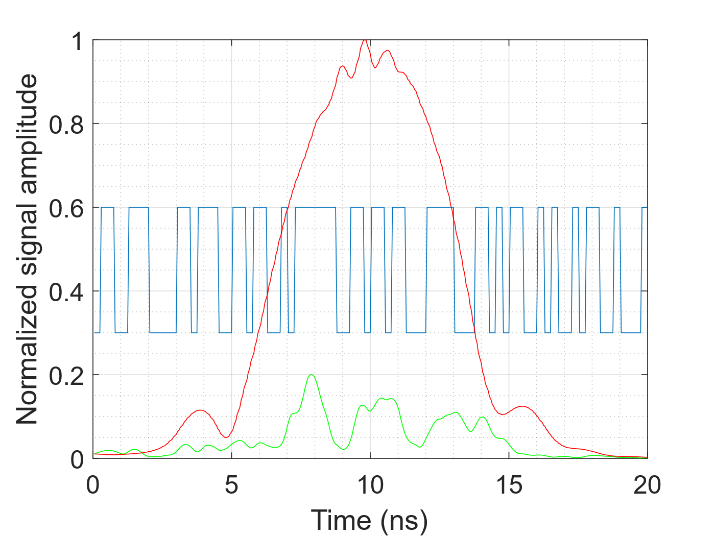
Fig. 2. Designed binary optical mask with non-uniform slot widths (blue curve), the time-stretched optical spectrum before masking (red curve), and the resulting spectral response after photonic time-stretching and filtering using parallel diffraction gratings (green curve).
As shown in Fig. 2, the fabricated spatial mask consists of a random binary sequence with a fixed minimum slot width, determined by the fabrication resolution and grating dispersion. The sequence of the binary mask can be further optimized to enhance reservoir dynamics and improve classification performance. The corresponding spectral response after filtering is also shown in Fig. 2, demonstrating that the diffraction-grating-based structure effectively functions as a programmable optical spectral filter.

D. Optical mask with MZI-based Structure
In contrast to the diffraction-grating-based approach, which relies on spatial spectral dispersion, an alternative all-optical masking scheme is implemented using an unbalanced Mach–Zehnder interferometer (MZI), as illustrated in Fig. 1(d). The MZI structure offers the advantage of producing a high chirp rate by controlling the time delay in one of its arms. Consequently, the resulting mask becomes an analog optical signal, significantly enriching the dynamic states within the reservoir layer. This approach provides a compact and fiber-compatible solution for generating continuous analog optical masks.
To generate the chirped optical pulse, a single-mode fiber is inserted into one arm of the MZI to introduce an imbalance in both time delay and dispersion [24]. The frequency-domain transfer function of the unbalanced MZI can be expressed as:
$H_{2}\left(ω\right)=\frac{1}{2}\left[exp\left(-jωt_{1}+j\frac{{\ddot{Φ}}_{p}}{2}\right)+exp\left(-jωt_{2}\right)\right]$ (6)
where $t_{1}$ and $t_{2}$ represent the time delays in the two MZI arms, ${\ddot{Φ}}_{ω}={\frac{d^{2}θ_{ω}^{2}}{dω^{2}}|}_{ω=ω_{0}}({ps}^{2})$ is the second-order dispersion coefficient, and $∆t=t_{2}-t_{1}$ denotes the time delay difference between the two arms of the unbalanced MZI. Given that higher-order dispersion is negligible, only the second-order dispersion is considered. Hence, an all-optical masking process is integrated into the input layer using an MZI-based optical mask.
Compared with binary masks generated using diffraction gratings, the MZI-based optical mask produces a continuous temporal modulation. After sampling by the reservoir nodes, this continuous chirp-coded waveform results in non-uniform effective sampling across the stretched pulse, thereby enhancing the diversity of the reservoir states. As illustrated in Fig. 3, the chirp-coded waveform provides richer dynamics compared to a binary mask and previous masks using parallel diffraction gratings.
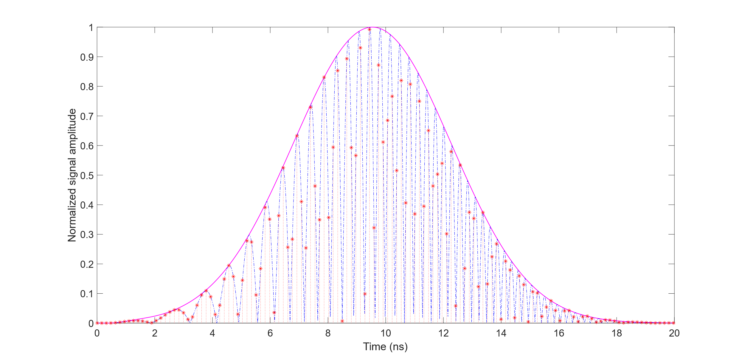
Fig. 3. Time-stretched chirped optical pulse envelope (solid curve) after spectral chirp encoding, together with uniformly sampled reservoir node states. The vertical dashed lines indicate the uniform sampling positions defined by the optical filter, and the red dots represent the sampled node amplitudes.
Based on the above principles, photonic time-stretch, spectral mixing, and all-optical input masking collectively establish a high-dimensional dynamical reservoir with enriched nonlinear and memory characteristics. In the following section, the experimental implementation of the proposed photonic reservoir computing system is described.

III. Experiment setup and Results
This section presents the experimental implementation of the proposed photonic RC system and evaluates its performance on waveform and spoken-digit classification tasks.

A. Experiment Setup
Fig. 1(b) illustrates the experimental setup of the all-optical reservoir computing system based on photonic time-stretch and spectral mixing. A mode-locked laser (Calmar Mendocino FP) is used as the optical source, generating broadband optical pulses with a pulse width of approximately 800 fs at a repetition rate of 50 MHz. Due to insertion losses in the optical masking stage, the average optical launch power was set to approximately 200 mW. The pulses are stretched to about 12 ns using a dispersion-compensating fiber (DCF) with a dispersion of −1.04 ns/nm, enabling wavelength–time mapping. In addition, a booster EDFA and an SOA within the reservoir layer were employed to compensate for system losses and to ensure sufficient optical power levels at the feedback loop and the photodetector.
After time-stretching, the optical input mask is applied directly in the optical domain. Two optical masks are investigated: a parallel diffraction-grating-based mask and an unbalanced MZI-based mask. The masked optical signal is subsequently modulated by a MZM driven by the input signal to be classified.
Nonlinear interaction and spectral mixing among wavelength channels are realized using a semiconductor optical amplifier (SOA, Thorlabs SOA1117P). The SOA is operated at a driving current of 350 mA to provide sufficient gain and nonlinear response for reservoir state generation. After optical-to-electrical conversion by a high-speed photodetector (bandwidth 75 GHz), the reservoir states are captured using a high-speed oscilloscope.
The readout layer is implemented electronically in the digital domain. The recorded reservoir states are processed offline using linear regression to obtain the output weights. For classification tasks, a winner-takes-all decision strategy is applied to the regression outputs to determine the final class label.

B. Experimental Characterization of Reservoir Dynamics
To experimentally evaluate the dynamic properties of the proposed photonic reservoir computing system, we first characterize the system consistency, nonlinear behavior induced by spectral mixing, and the memory capacity enabled by delayed feedback. These properties are critical for assessing the suitability of the reservoir for time-dependent signal processing and classification tasks.
System consistency is examined by injecting identical input bit patterns into the reservoir over multiple periods. As shown in Fig. 4(a) and Fig. 4(b), the reservoir responses remain highly repeatable across successive periods, indicating stable system operation and good reproducibility of the generated reservoir states. Such consistency is essential for reliable training and testing in reservoir computing systems.
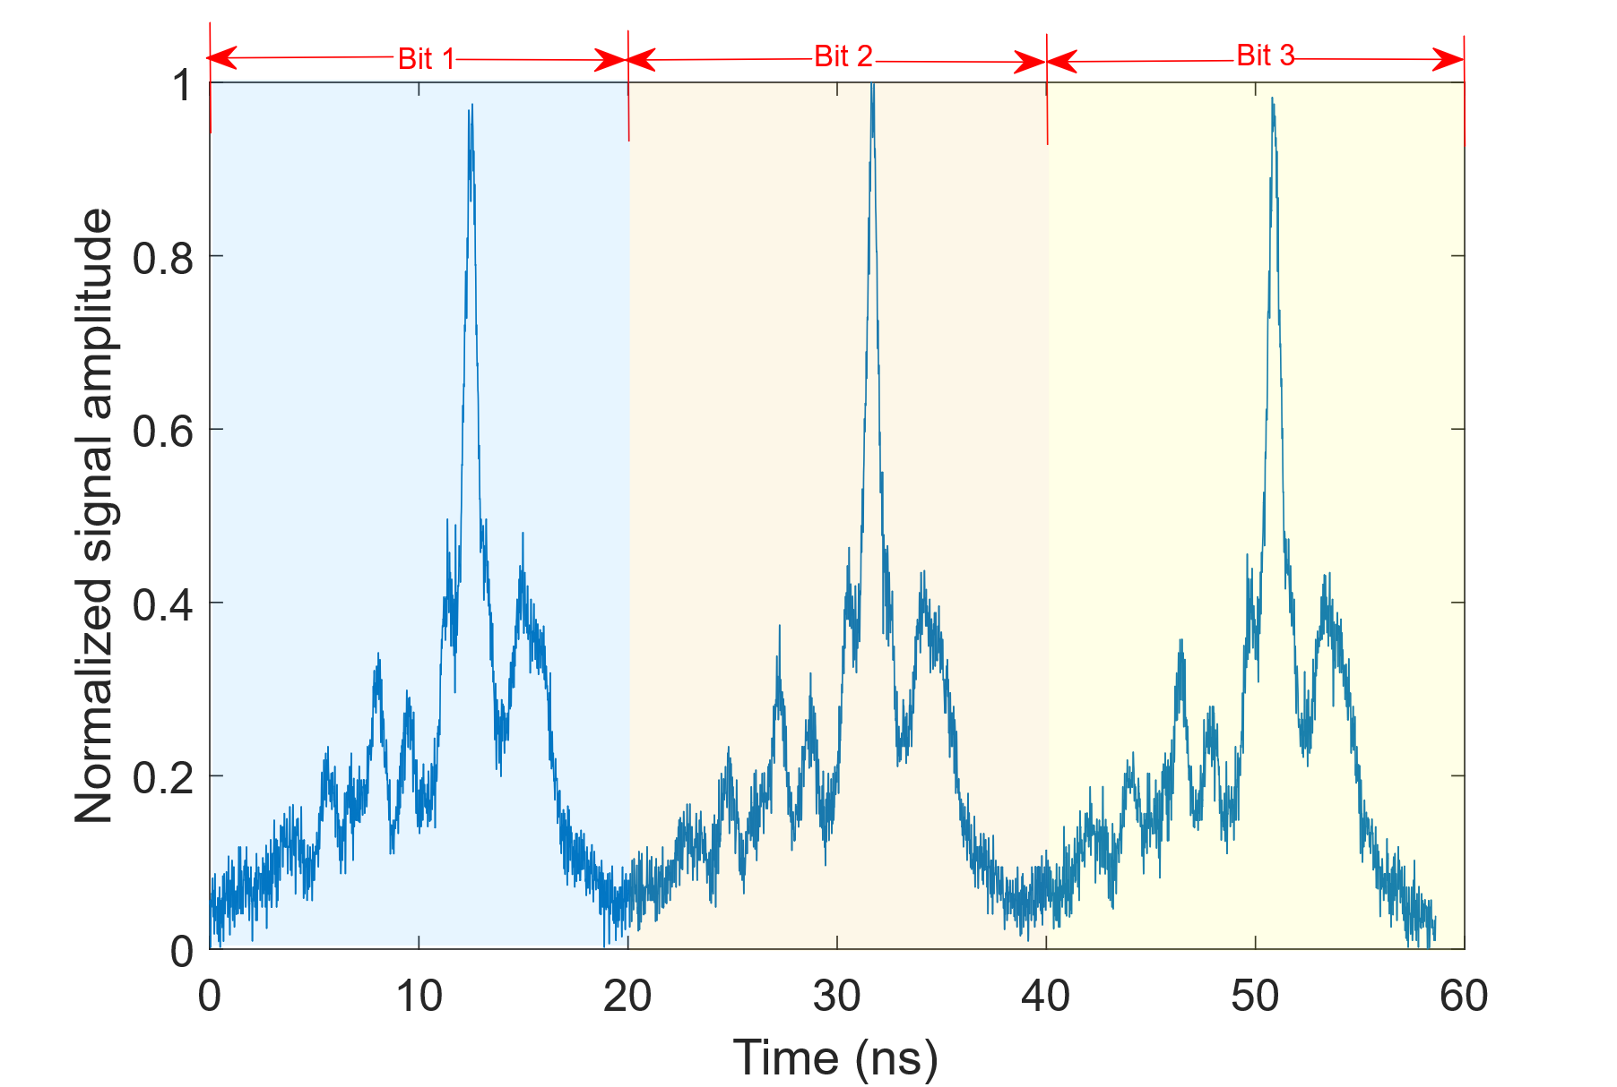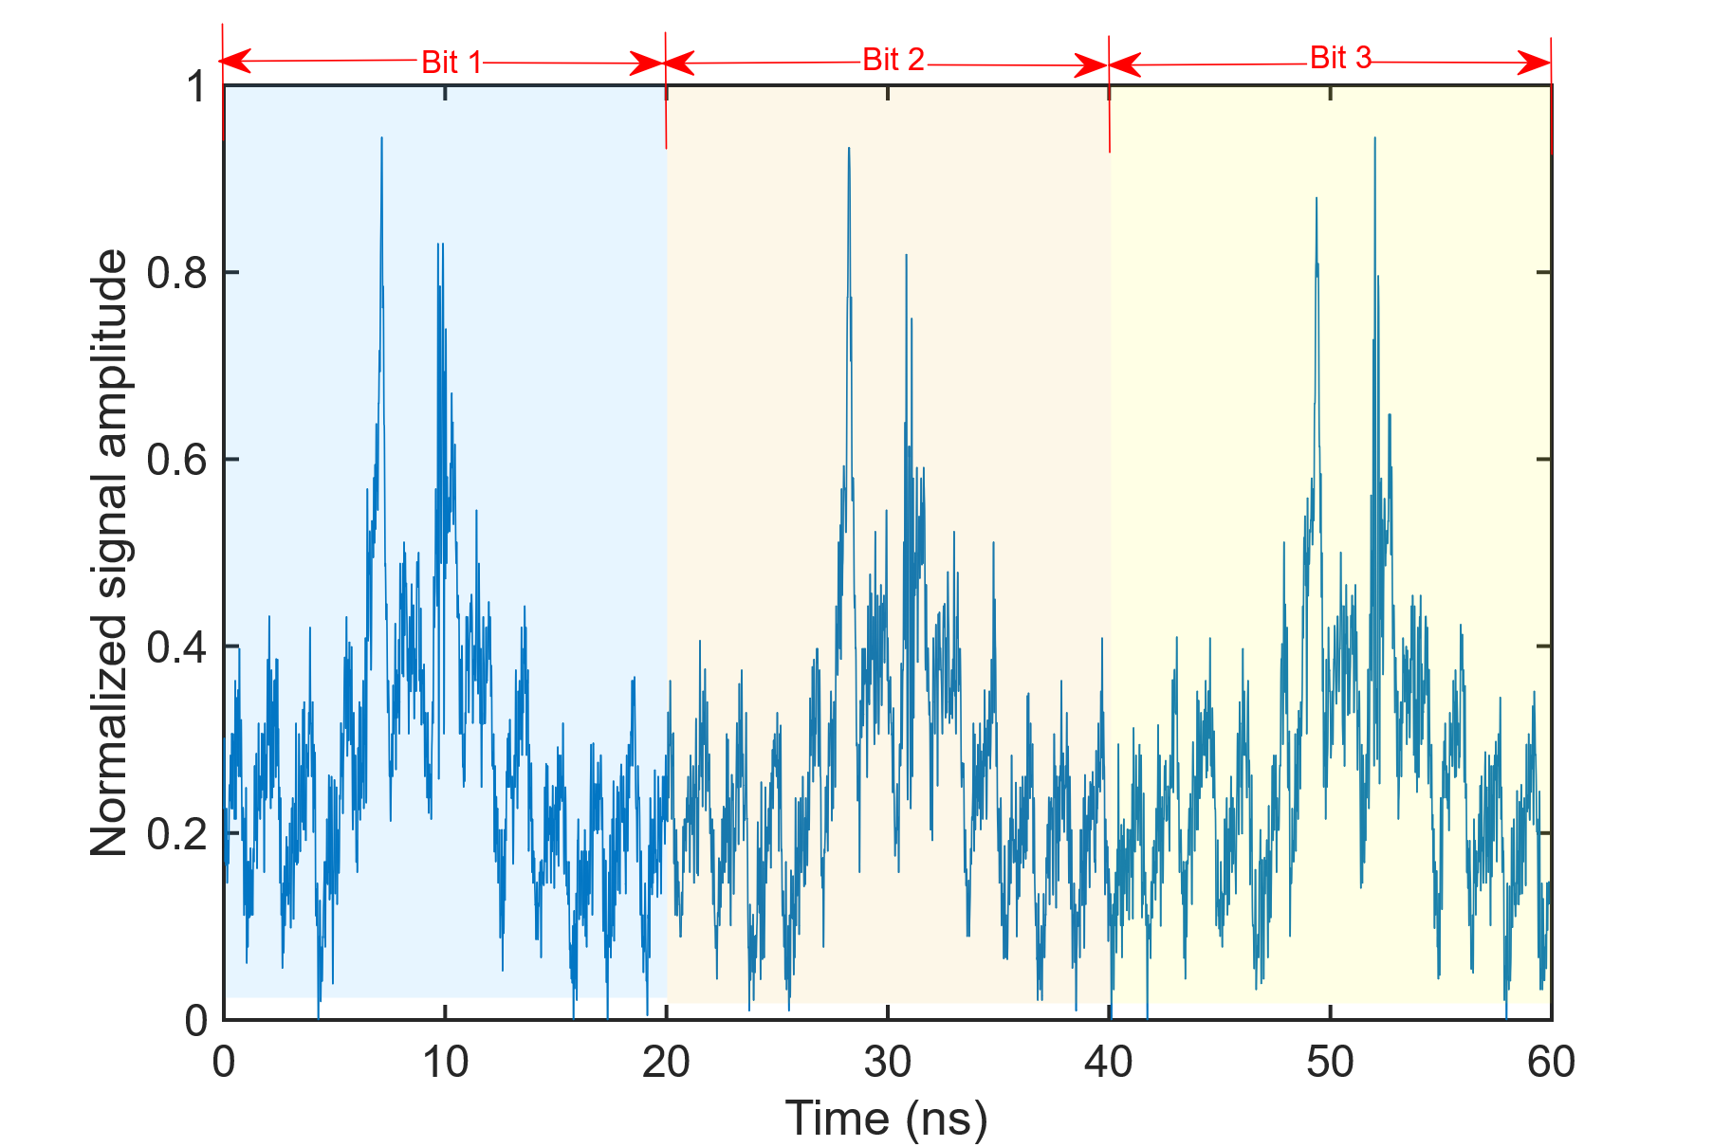
(a) (b)
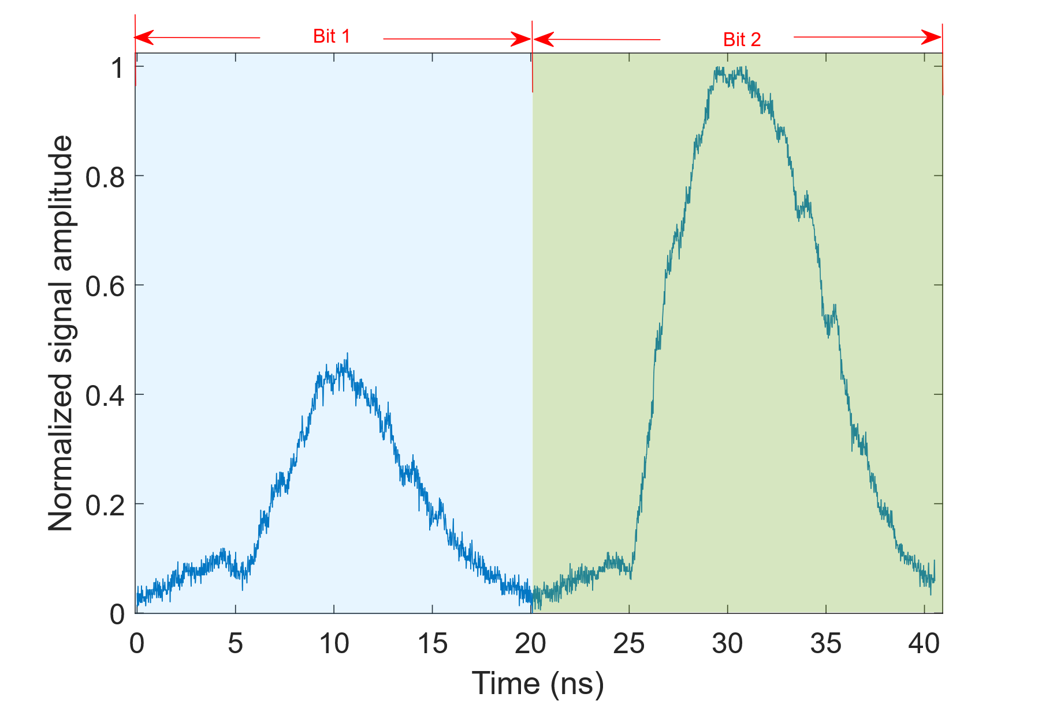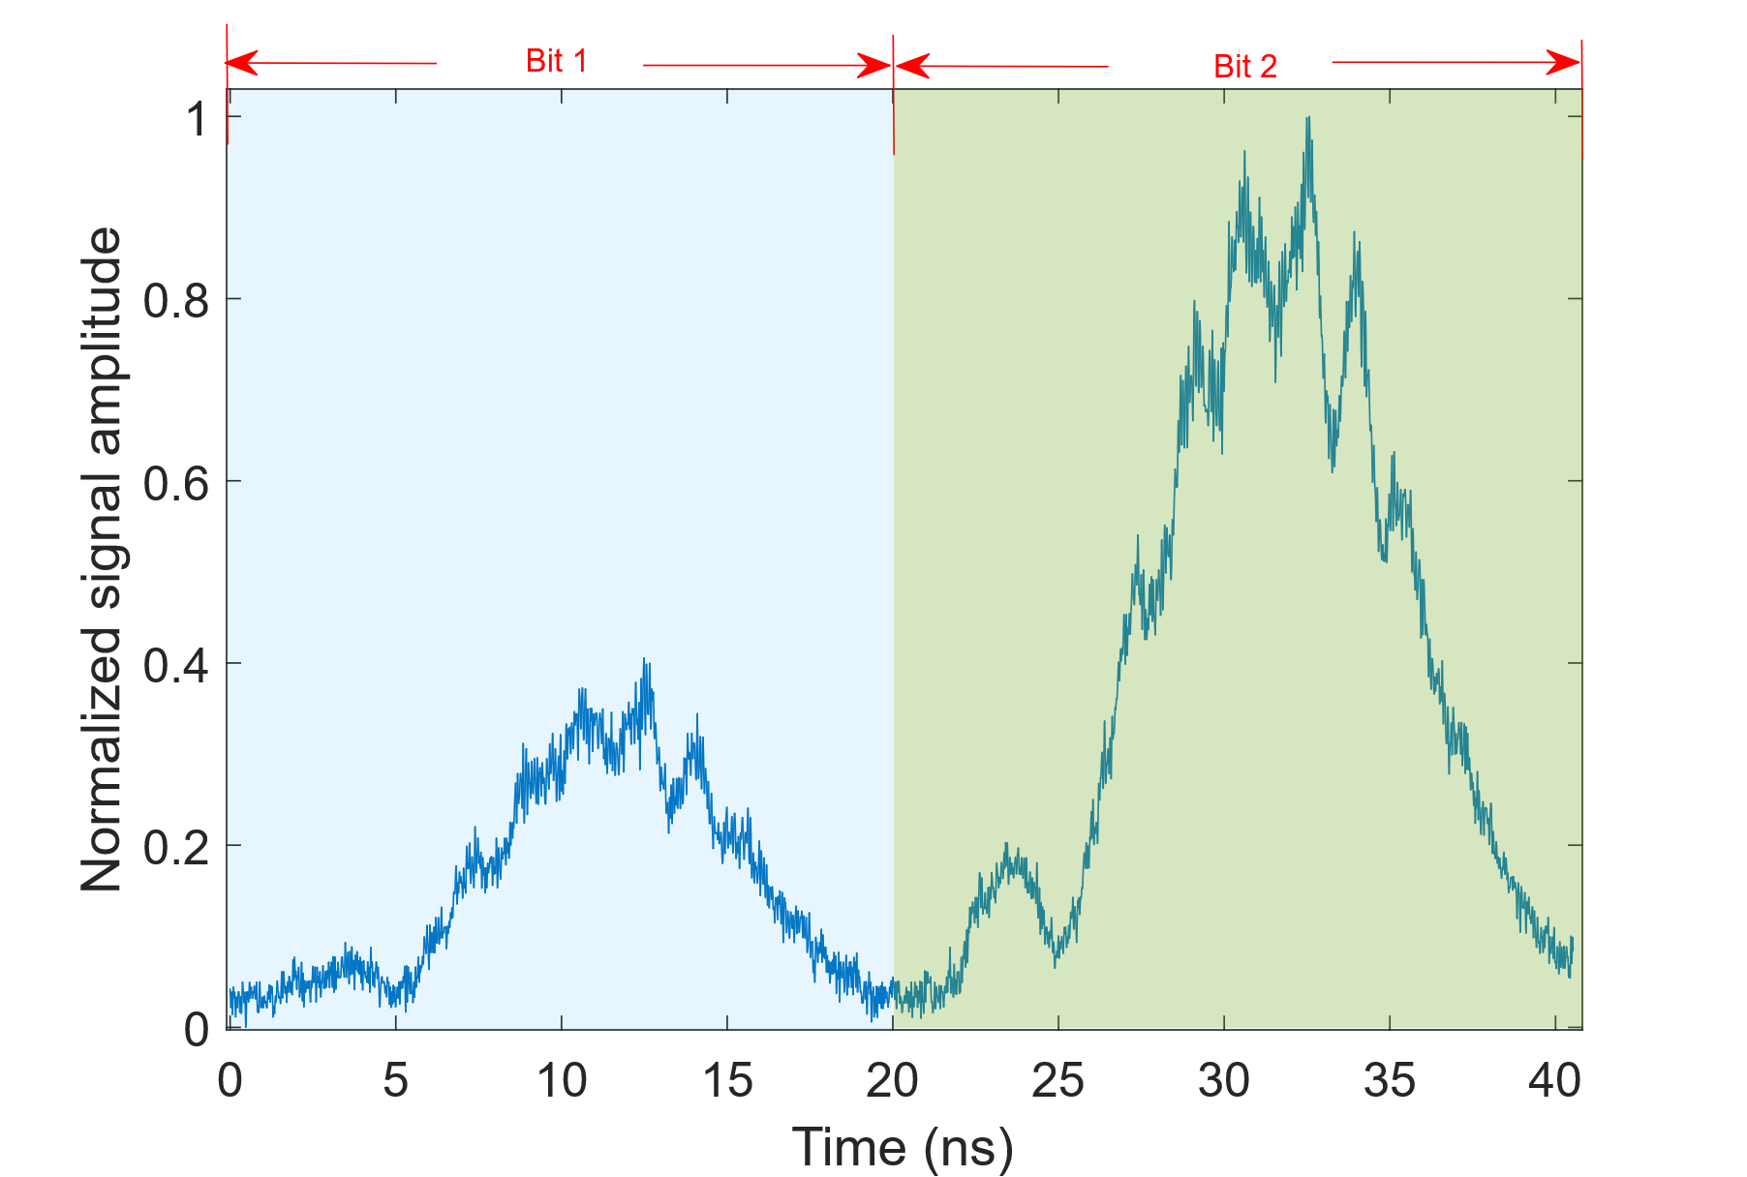
(c) (d)
Fig. 4. System consistency and nonlinear influence in the photonic reservoir computing system. (a), (b) Measured time-domain responses for identical input bit sequences before and after spectrum mixing, demonstrating the consistency of the system. (c), (d) Measured responses for different input bit sequences before and after spectrum mixing, illustrating the nonlinear influence introduced by the SOA-based spectral mixing. The shaded regions indicate individual bit durations. All waveforms are normalized to their maximum amplitude.
To further investigate the nonlinear effects introduced by spectral mixing in the semiconductor optical amplifier (SOA), we compare the reservoir responses before and after nonlinear amplification. Fig. 4(c) and Fig. 4(d) illustrate that, while identical input patterns produce nearly identical outputs in the linear regime, varying input patterns result in amplitude-dependent distortions after nonlinear amplification. This behavior confirms the presence of nonlinear interactions among wavelength channels induced by four-wave mixing in the SOA, which plays a key role in enriching the reservoir dynamics.
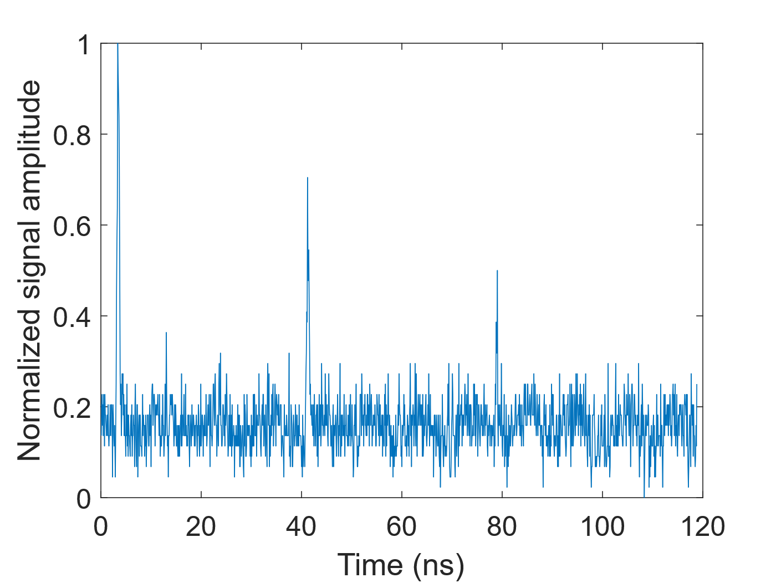
Fig. 5. Measured memory capacity of the photonic reservoir computing system, where the feedback loop period is fixed at ~20 ns. The memory capacity characterizes how long the input information is retained in the reservoir layer in terms of the number of feedback loop round trips.
In addition to nonlinearity, memory capacity is another fundamental requirement for effective reservoir computing. In the proposed system, memory is introduced through delayed optical feedback combined with asymmetric coupling. The pulse repetition period is approximately 20 ns, while the feedback delay is set to about 40 ns, allowing information from previous periods to be injected into subsequent reservoir states. The experimentally measured memory capacity is presented in Fig. 5, demonstrating that the delayed feedback extends the effective temporal memory of the reservoir by approximately two additional periods.
The above experimental results confirm that the proposed photonic reservoir exhibits key characteristics required for reservoir computing, including consistency, nonlinearity, and short-term memory.

C. Basic Waveform Classification
We leverage the photonic reservoir computing system for waveform classification, distinguishing between rectangle waves and triangular waves.
To preliminarily validate the proposed system, a simple waveform classification task distinguishing rectangular and triangular waves is performed as a proof-of-concept demonstration. For rigorous and widely accepted quantitative evaluation, the spoken-digit classification task based on the standard NIST TI-46 corpus is employed as the primary benchmark in this work.
In the experiment, 30 datasets with different frequencies are generated for each waveform type, resulting in 60 datasets in total. Among them, 20 rectangular waves and 20 triangular waves are used for training, while the remaining 10 datasets for each class are reserved for testing. Representative testing waveforms are illustrated in Fig. 6. Given the simplicity of the task, this dataset partition is sufficient to assess the basic classification capability of the proposed system.
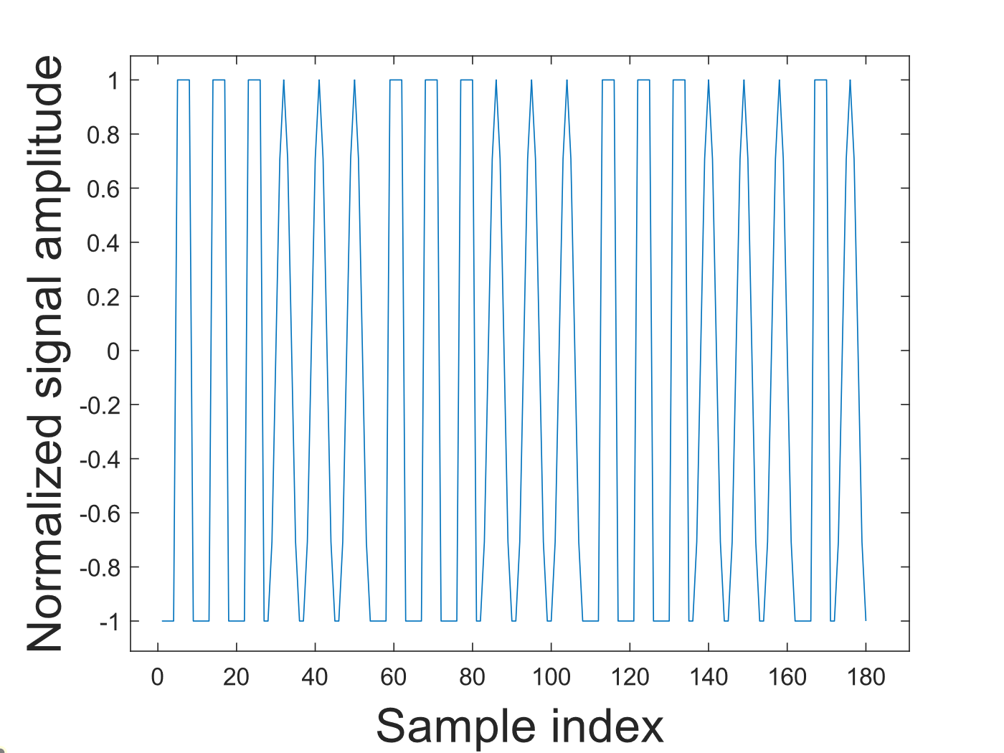
Fig. 6. Representative input waveforms used for training and testing in the basic waveform classification task. The horizontal axis denotes the sample index of the discrete input sequence, and all waveforms are normalized in amplitude.
Two optical input mask schemes are evaluated in this task. Fig. 7 shows the classification results obtained using the proposed photonic reservoir computing system with optical input masking. In the readout layer, two output nodes are assigned to represent rectangular and triangular waveforms, respectively. A winner-takes-all decision strategy is applied, in which the output node with the higher response determines the final classification result. Despite minor fluctuations in the output amplitudes, both waveform types are correctly recognized, demonstrating reliable classification performance.
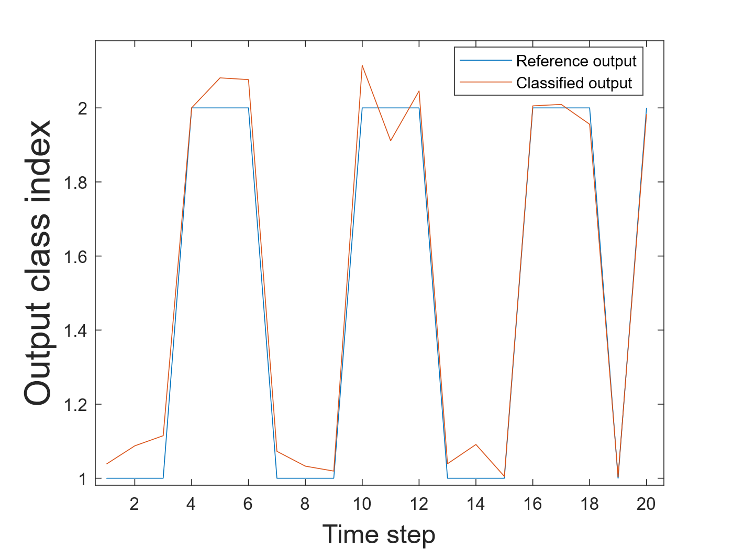
Fig. 7. Classification results of the basic waveform task using the parallel diffraction-grating-based optical mask. The blue curve represents the reference output levels for rectangular and triangular waveforms, while the orange curve shows the corresponding classified output levels obtained from the photonic reservoir.
In addition to qualitative classification results, the performance of the time-series classification task is quantitatively assessed using the normalized mean square error (NMSE) between the reservoir output and the target output. The NMSE is defined as [18]
$\text{NMSE}=\frac{{\left\langle {\left(y\left(n\right)-\hat{y}\left(n\right)\right)}^{2}\right\rangle }_{n}}{{\left\langle {\left(y\left(n\right)-{\left\langle y\left(n\right)\right\rangle }_{n}\right)}^{2}\right\rangle }_{n}}$ (7)
where $y\left(n\right)$ denotes the reservoir output, and $\hat{y}\left(n\right)$ denotes the target output. ${\left\langle ⋅\right\rangle }_{n}$ represents the average over discrete time steps $n$. A lower NMSE corresponds to better agreement between the predicted and target outputs. For example, when using the optical input mask based on parallel diffraction gratings, an NMSE of approximately 0.124 is obtained, indicating effective temporal mapping and classification capability enabled by the optical masking process.

D. Spoken-digit Classification Task
To quantitatively evaluate the performance of the proposed photonic reservoir computing system, an isolated spoken-digit classification task is conducted using the widely adopted NIST TI-46 spoken-digit dataset [27]. The dataset consists of ten spoken digits (0–9), each uttered by ten different speakers. Representative temporal waveforms of the spoken-digit signals are shown in Fig. 8. During the experiment, the spoken-digit signals are sequentially injected into the reservoir, and the corresponding reservoir states are collected at the readout layer.
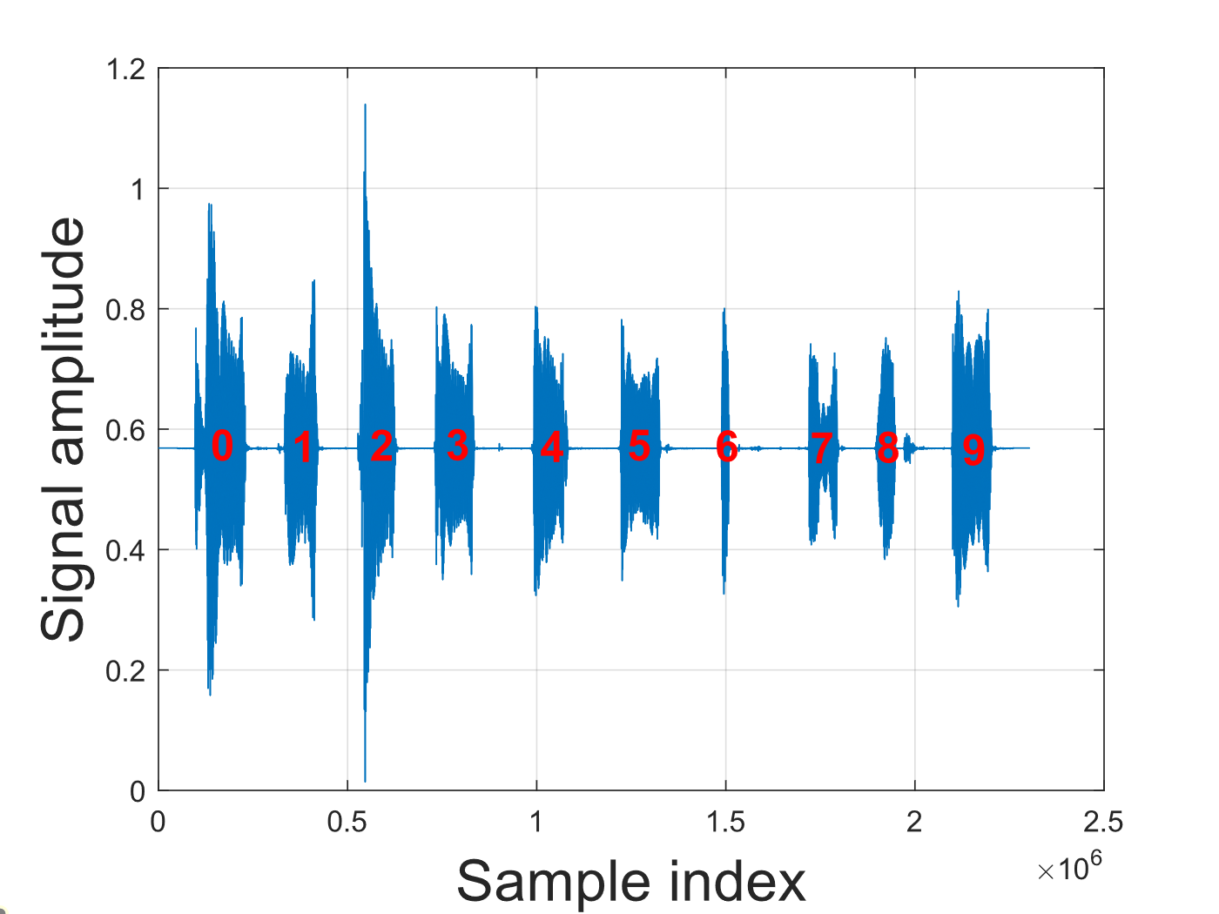
Fig. 8. Representative spoken-digit audio waveforms (digits 0–9) used as input signals for the spoken-digit classification task. The horizontal axis denotes the sample index of the audio signal, and the waveform amplitudes are normalized.
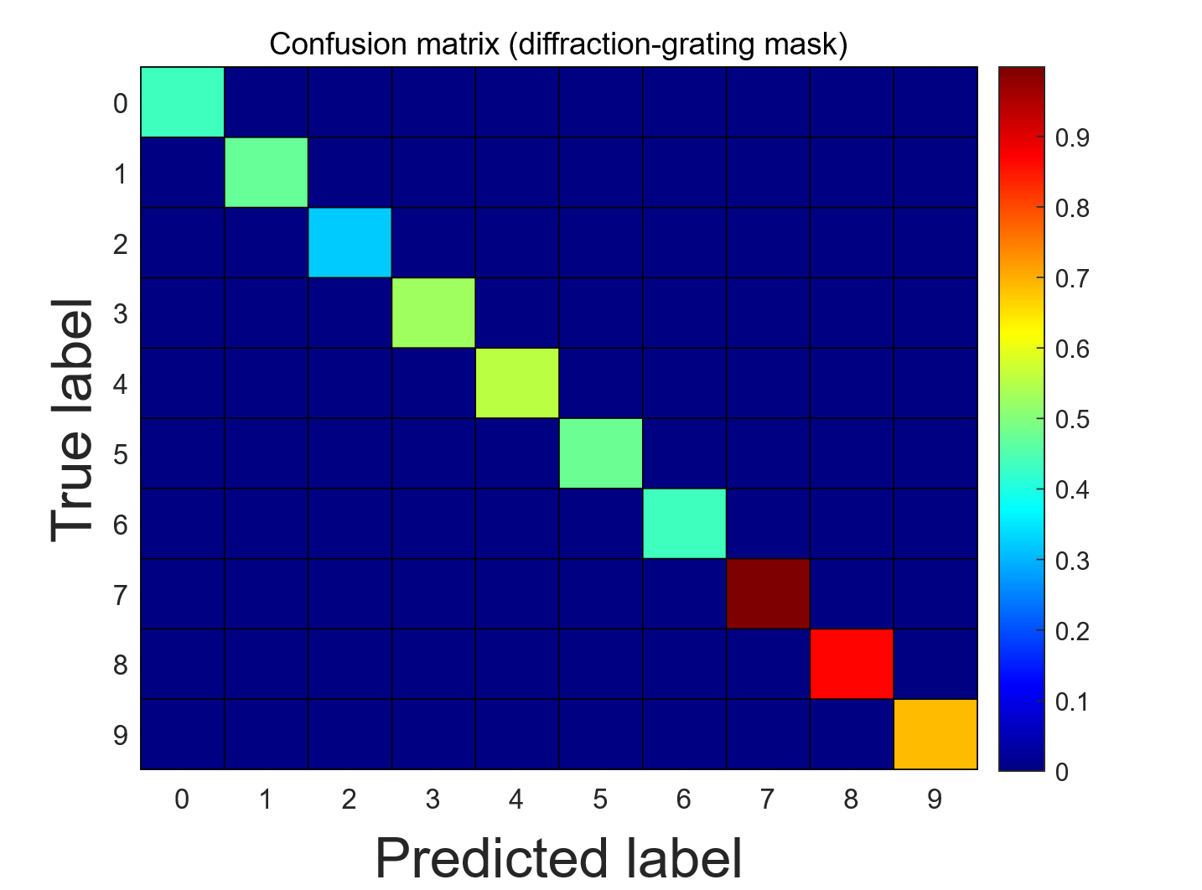
Fig. 9. Confusion matrix of the spoken-digit classification task using the parallel diffraction-grating-based optical mask. The rows correspond to the true digit labels, and the columns represent the predicted labels. The color bar indicates the normalized classification probability.
We first evaluate the system performance using the optical input mask based on parallel diffraction gratings. In this configuration, 24,000 data points are used for training and 4,400 data points for testing. The optical mask is applied in the optical domain after photonic time-stretching, as described in Section A in this part. Recall to the Fig. 2, in this setup, we feature a minimum width of 0.3mm and is manufactured with high precision. The mask length was determined by the spatial extent of the spectrally dispersed optical beam after the second diffraction grating (approximately 5 cm), considering fabrication precision and grating resolution. Comprising 179 binary random values, this mask enriches dynamics and responses within the reservoir layer. The classification results are summarized using a confusion matrix computed with a winner-takes-all decision strategy, as shown in Fig. 9. The color scale ranges from blue (0) to red (1), with higher values indicating better recognition accuracy. Overall, high recognition rates are observed for most spoken digits, confirming the effectiveness of the diffraction grating-based optical masking scheme.
During the classification stage, a winner-takes-all decision strategy is adopted, in which the output node with the highest response determines the recognized digit. To gain further insight into the classification behavior beyond overall accuracy, the distribution of the classification outputs for individual spoken digits is shown in Fig. 10.
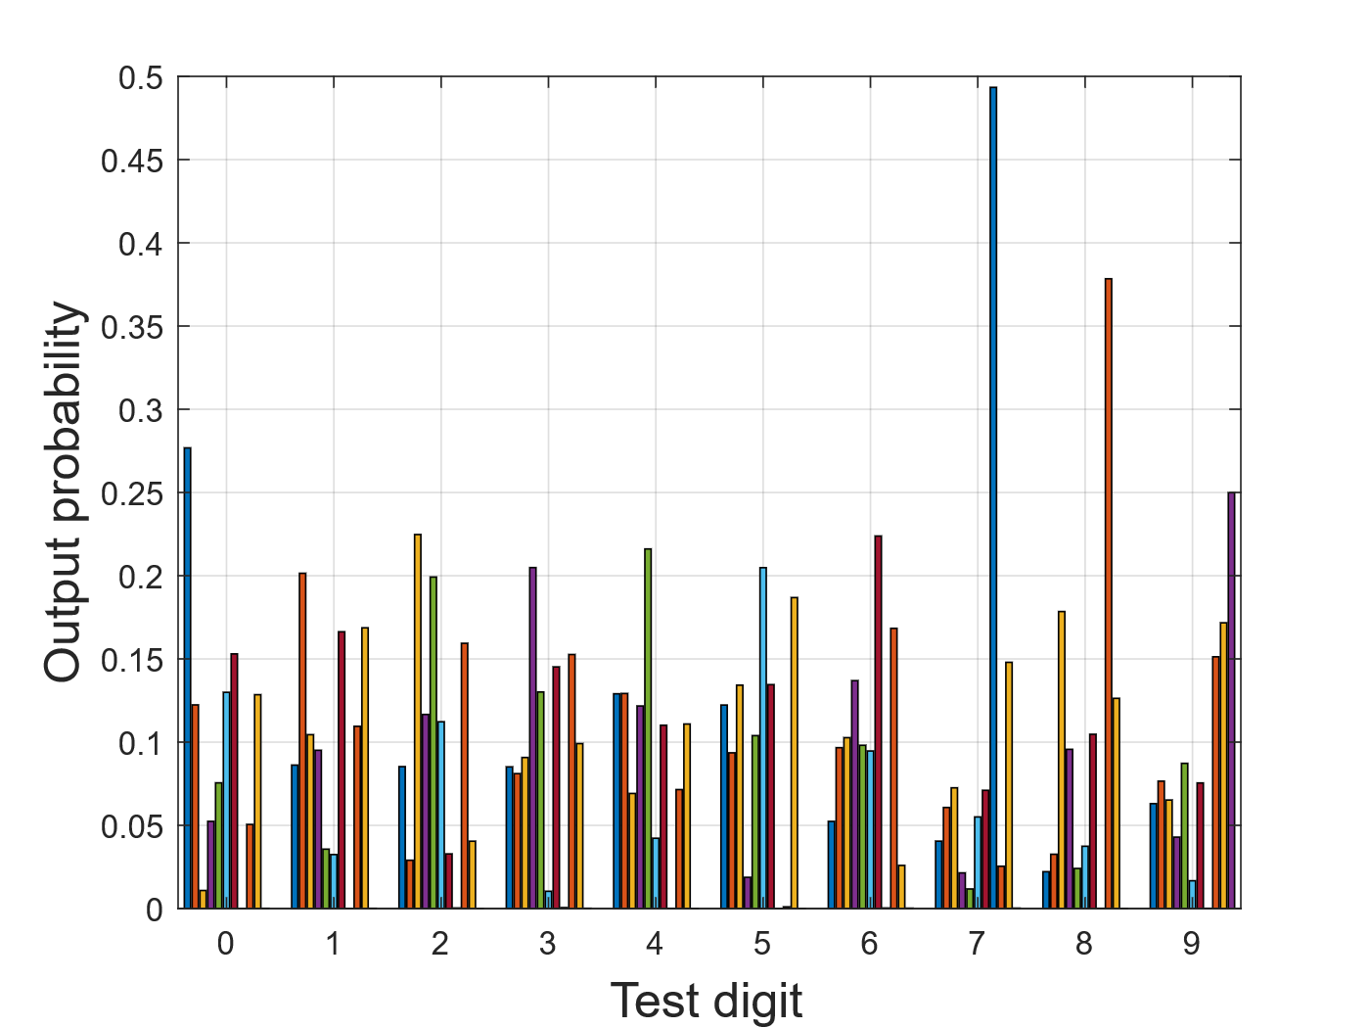
Fig. 10. Distribution of the classified outputs for the spoken-digit recognition task using the parallel diffraction-grating-based optical mask. For each spoken-digit label (0–9), the normalized readout outputs corresponding to different classes are shown, illustrating the relative classification confidence among digit classes.
As can be observed from Fig. 10, digits such as ‘0’, ‘4’, ‘7’, and ‘8’ exhibit more distinctive output distributions with clearer separation from other classes. This indicates that the corresponding reservoir states occupy more separable regions in the readout space, leading to higher recognition confidence and accuracy. In contrast, digits ‘1’, ‘2’, ‘5’, and ‘6’ present more overlapping output distributions, suggesting increased similarity in their temporal and spectral features after reservoir processing, which makes them more challenging to distinguish.
These observations are consistent with the confusion matrix in Fig. 9, where digits with more separable output distributions correspond to higher diagonal values.
Secondly, we evaluate the spoken-digit classification performance using the MZI-based optical input mask. The unbalanced MZI introduces a non-uniform temporal sampling of the time-stretched optical pulse, generating a chirp-coded mask that enriches the reservoir dynamics by providing a broader and more continuous temporal feature mapping.
The experimental setup follows the configuration described in Section A in this part. Fig. 11(a) and 11(b) show the experimentally measured time-stretched optical pulse after spectral chirp encoding and the corresponding sampled reservoir node states, respectively. The unbalanced MZI incorporates an optical delay line (General Photonics VDL001) and a 500-m single-mode fiber, forming a dispersion arm and a delay arm. The resulting chirped pulse spans a microwave frequency range from approximately 7 to 29 GHz within the stretched temporal window. By adjusting the delay line or fiber length, the chirp characteristics can be flexibly tuned. The corresponding spoken-digit classification results obtained with the MZI-based optical mask are presented in Fig. 12, demonstrating reliable recognition of digits from 0 to 9.
The classification performance is further quantified using a confusion matrix, also shown in Fig. 12. From the diagonal entries of the matrix, digits ‘3’, ‘6’, ‘8’, and ‘9’ exhibit relatively higher recognition accuracy, whereas digits ‘5’ and ‘7’ show comparatively lower performance. This behavior can be attributed to the increased similarity in their temporal–spectral features after reservoir processing, which leads to partial overlap in the readout space despite the enhanced dynamics introduced by the MZI-based mask.
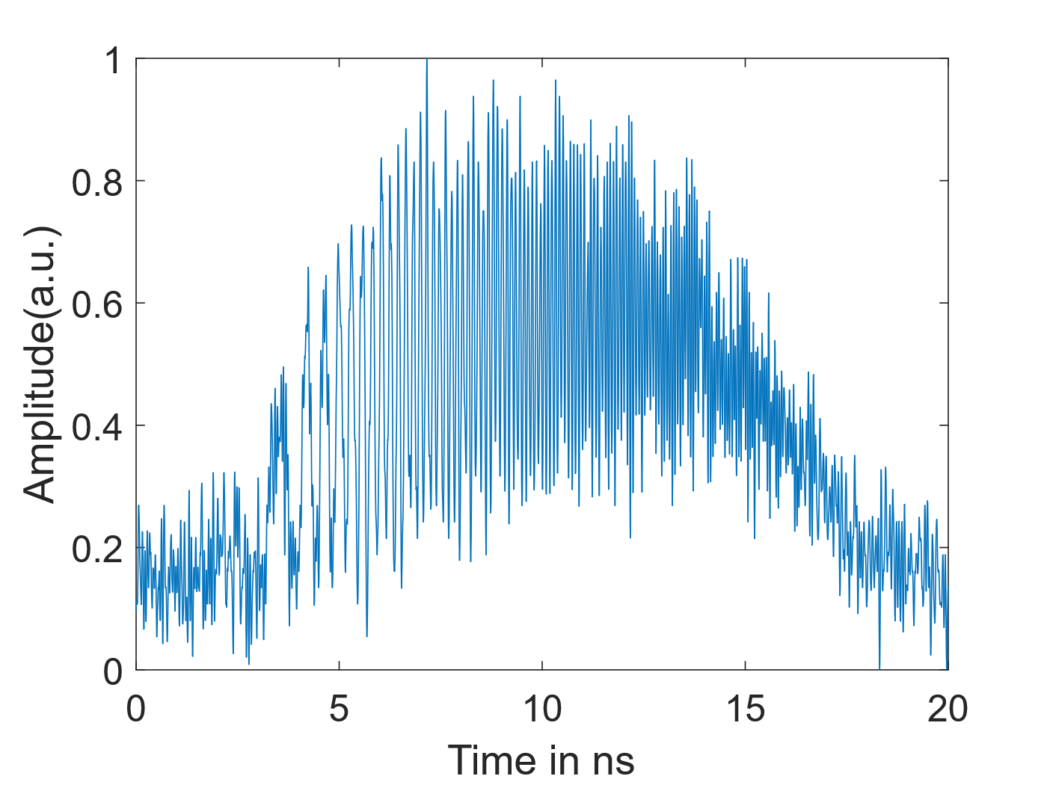
(a)
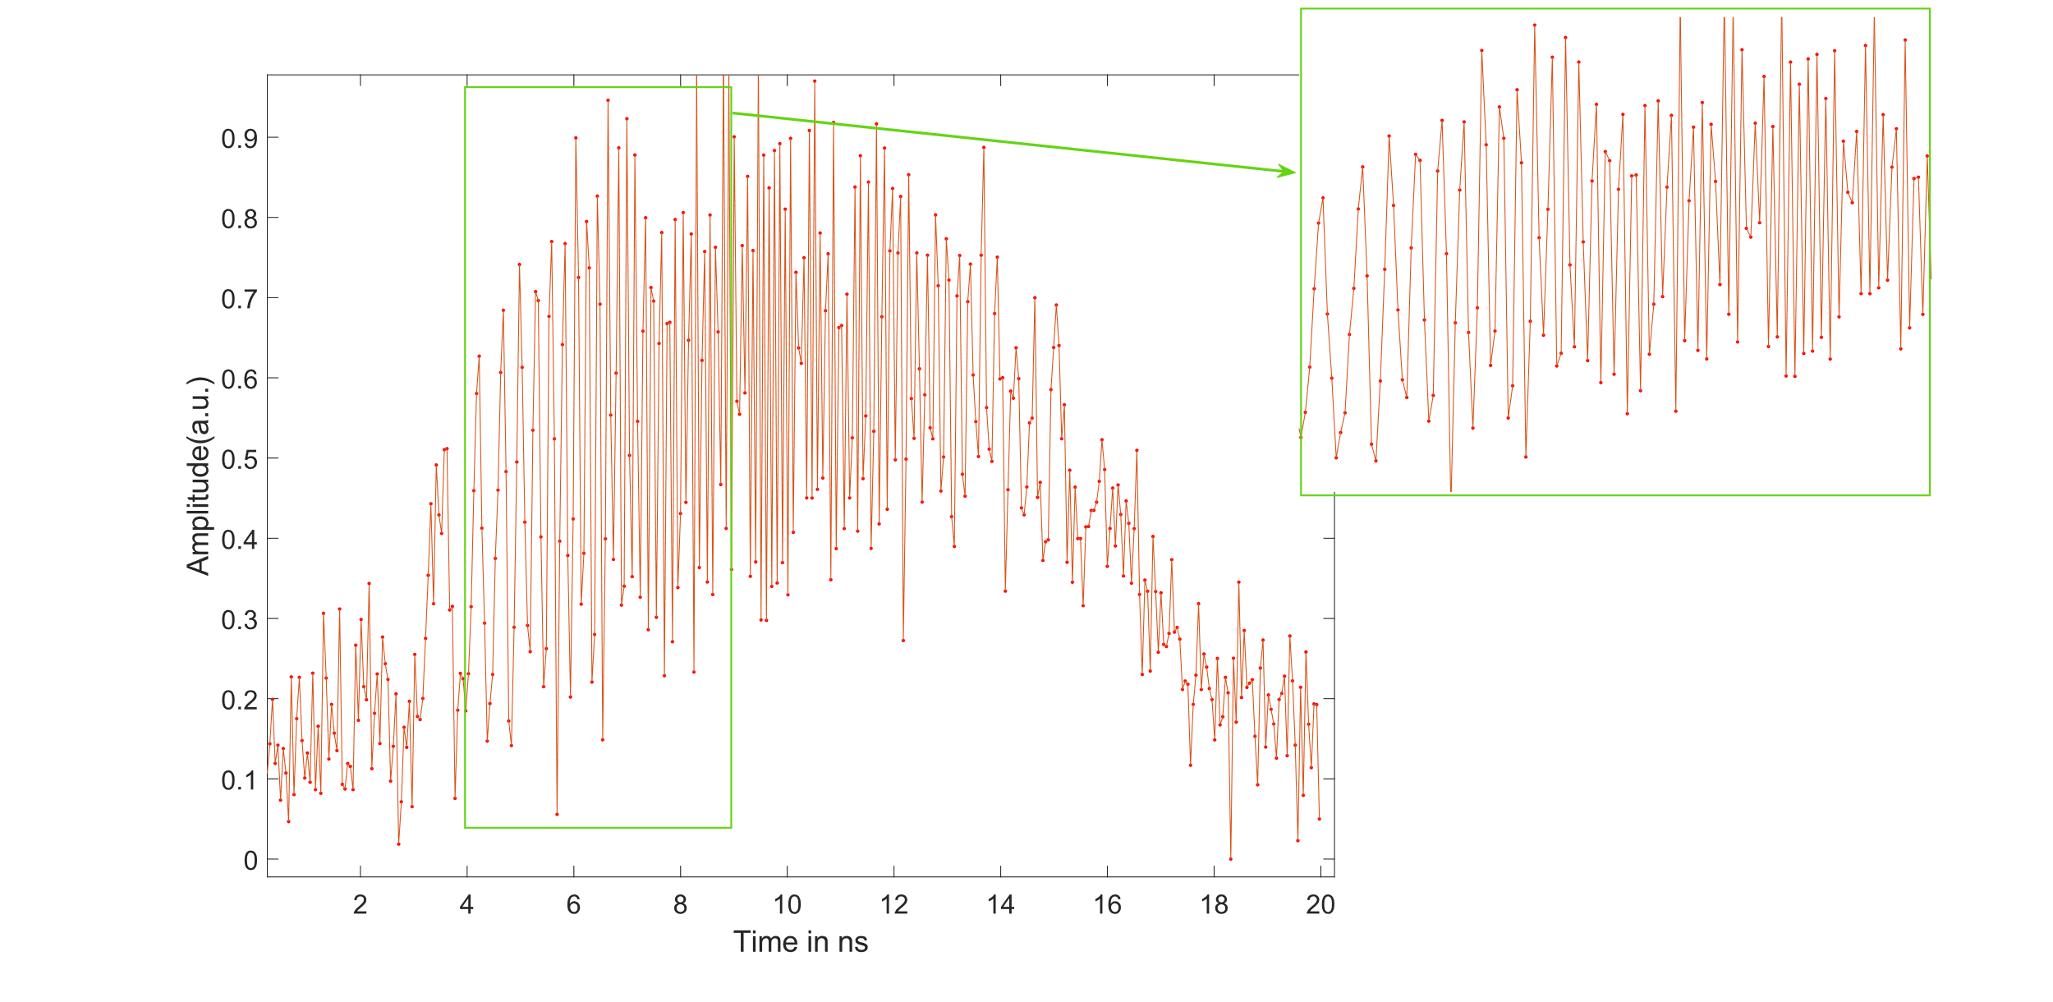
(b)
Fig. 11. (a) Measured time-stretched optical pulse after spectral chirp encoding using the unbalanced Mach–Zehnder interferometer (MZI). (b) Corresponding reservoir node states generated by the MZI-based optical mask, showing non-uniform sampling in time. The highlighted regions emphasize the irregular sampling intervals introduced by the unbalanced MZI, which enrich the reservoir dynamics.
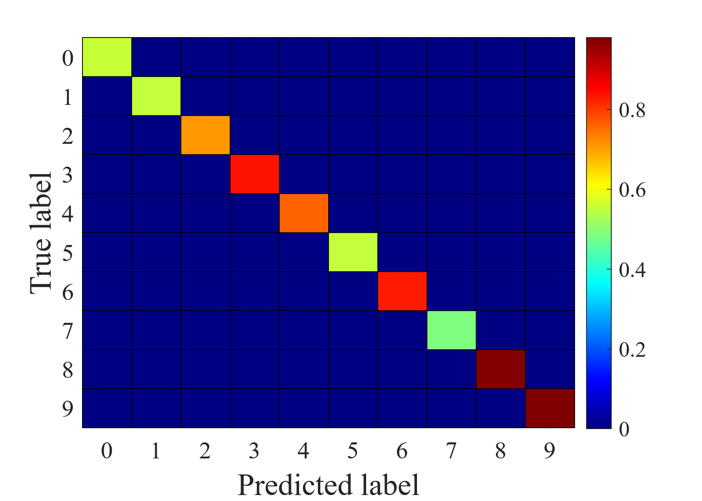
Fig. 12. Confusion matrix of the spoken-digit classification task using the MZI-based optical mask. The rows correspond to the true digit labels, and the columns represent the predicted labels. The color bar indicates the normalized classification probability.
To further analyze the classification behavior, the output distributions of the readout layer for individual spoken digits are examined, as shown in Fig. 13. Digits such as ‘0’, ‘2’, ‘4’, ‘6’, ‘8’, and ‘9’ exhibit more distinct output distributions with clearer separation from other classes, indicating higher classification confidence. In contrast, digits ‘5’ and ‘7’ present more overlapping distributions with other digits, suggesting reduced class separability in the reservoir state space and consequently lower recognition performance.
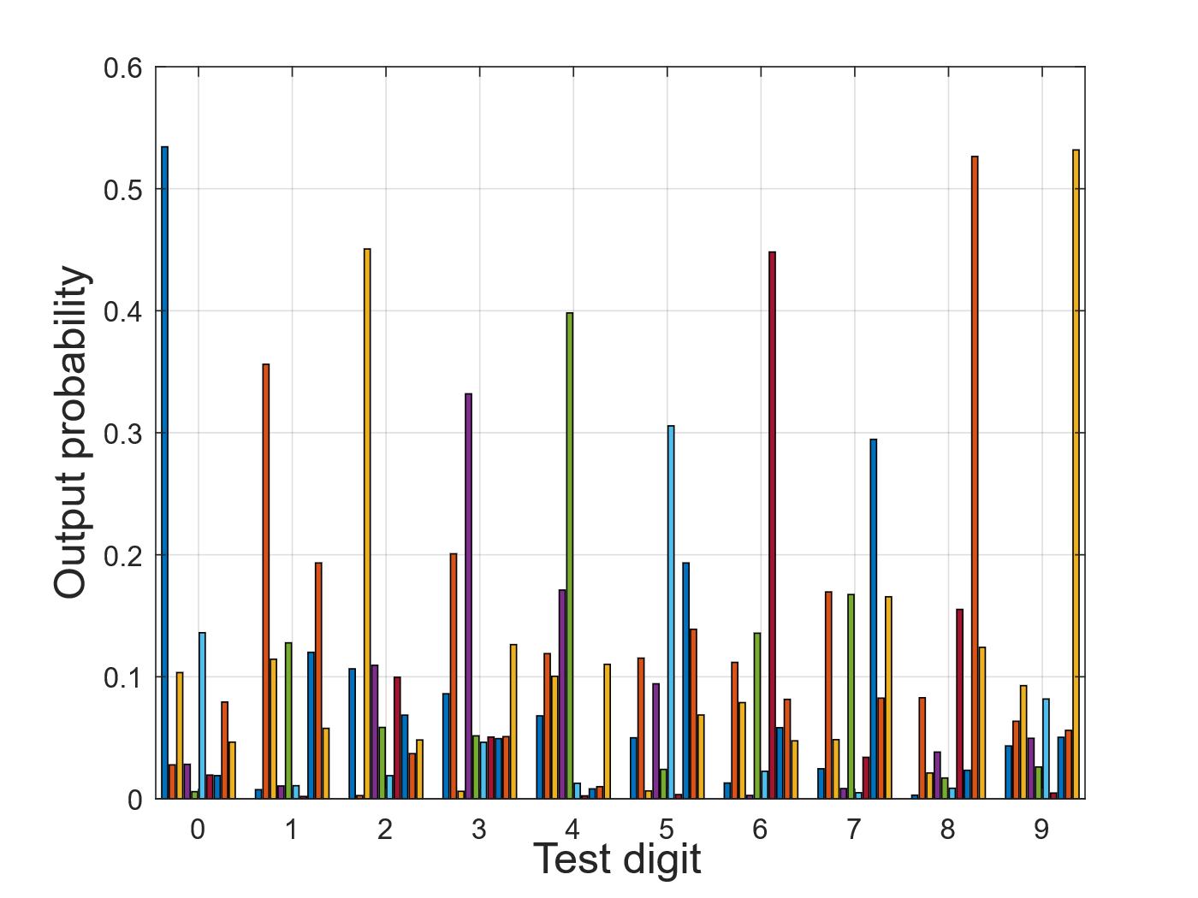
Fig. 13. Distribution of the classified outputs for the spoken-digit recognition task using the MZI-based optical mask. For each spoken-digit label (0–9), the normalized readout outputs corresponding to different classes are shown, illustrating the relative classification confidence among digit classes.
A quantitative summary of the spoken-digit classification performance is provided in Table I. Using the MZI-based optical input mask, an overall classification accuracy of approximately 97.19% is achieved, while the parallel diffraction grating-based mask yields a slightly higher accuracy of about 98.16%. For comparison, the classification accuracy without applying any optical input mask is approximately 80.65%, highlighting the effectiveness of all-optical masking in enhancing system performance.
TABLE I
The Classification Accuracy and NMSE with different mask in photonic RC System.
Optical Mask | Classification Accuracy | NMSE^{b}
Optical Mask using Parallel Diffraction Gratings | 98.16% | 0.59619
Optical Mask using MZIª Structure | 97.19% | 0.4613
Photonic RC System without Mask | 80.65% | 0.7489
ªMZI: Mach-Zehnder Interferometer.
^{b}NMSE: normalized mean-square error.
In addition to classification accuracy, the normalized mean square error (NMSE) is evaluated to assess the fidelity of the reservoir outputs with respect to the target responses. The MZI-based optical mask achieves a lower NMSE of 0.4613 compared with 0.59619 obtained using the diffraction grating-based mask. This indicates that the continuous, chirp-coded masking provided by the MZI leads to smoother and more accurate temporal mapping, whereas the diffraction grating-based mask favors class-level separability, resulting in slightly higher decision accuracy. These results demonstrate that the two optical masking schemes offer complementary advantages, and both significantly outperform the no-mask configuration.
The spoken-digit classification results further reveal differences in class separability among digits. Digits such as ‘0’, ‘4’, ‘6’, and ‘8’ exhibit higher recognition accuracy due to their more distinctive temporal and spectral characteristics. In contrast, digits such as ‘5’ and ‘7’ show greater overlap with other classes, leading to comparatively lower classification accuracy.
Classification accuracy and NMSE evaluate different aspects of system performance: accuracy reflects decision correctness, whereas NMSE measures regression fidelity of the reservoir outputs. The diffraction-grating-based mask achieves slightly higher classification accuracy due to enhanced class separability from discrete spectral filtering. In contrast, the MZI-based mask produces a continuous chirp-coded waveform, leading to richer temporal dynamics and smoother reservoir responses, which results in a lower NMSE.
These results indicate that classification accuracy and NMSE capture complementary aspects of system performance. While classification accuracy reflects the final decision correctness, NMSE provides a measure of how closely the reservoir outputs follow the target trajectories. Therefore, the two optical masking schemes offer different advantages depending on the performance metric of interest, highlighting the flexibility of the proposed all-optical masking approach.

IV. Conclusion
In this work, we experimentally demonstrated a photonic reservoir computing system with integrated all-optical input masking. Two optical masking schemes based on parallel diffraction gratings and an unbalanced MZI were investigated.
Experimental results from waveform and spoken-digit classification tasks show that the proposed optical masking significantly improves classification performance compared with the no-mask configuration. The diffraction-grating-based mask achieves slightly higher classification accuracy, while the MZI-based mask provides lower NMSE, indicating improved temporal mapping fidelity.
These results demonstrate that all-optical masking enhances the computational capability of photonic reservoir computing while reducing reliance on high-speed electronics, showing strong potential for ultrafast photonic signal processing applications.

References
- G. Tanaka, T. Yamane, J. B. Héroux, R. Nakane, N. Kanazawa, S. Takeda, ... & A. Hirose, “Recent advances in physical reservoir computing: A review,” Neural Networks, 115, 100-123, 2019.
- L. Appeltant, M. C. Soriano, G. Van der Sande, J. Danckaert, S. Massar, J. Dambre, ... & I. Fischer, “Information processing using a single dynamical node as complex system,” Nature communications, 2(1), 468, 2011.
- M. Rafayelyan, J. Dong, Y. Tan, F. Krzakala, & S. Gigan, “Large-scale optical reservoir computing for spatiotemporal chaotic systems prediction,” Physical Review X, 10(4), 041037, 2020.
- Y. Yue, S. Li, Y. Feng, A. Zhang, & C. Wang, “Real-time identification of frequency-hopping millimeter-wave signals using photonic time stretch and reservoir computing,” In Real-time Photonic Measurements, Data Management, and Processing VI. Vol. 11902, pp. 108-112. SPIE, October, 2021.
- A. Sherstinsky, “Fundamentals of recurrent neural network (RNN) and long short-term memory (LSTM) network,” Physica D: Nonlinear Phenomena, 404, 132306, 2020.
- S. Li, W. Li, C. Cook, C. Zhu, & Y. Gao, “Independently recurrent neural network (indrnn): Building a longer and deeper rnn,” in Proceedings of the IEEE conference on computer vision and pattern recognition. pp. 5457-5466, 2018.
- H. Jaeger, H. Haas, “Harnessing nonlinearity: predicting chaotic systems and saving energy in wireless communication,” Science, vol. 304, no. 5667, pp. 78- 80, Apr. 2004.
- Y. Yue, C. K. Mididoddi, N. Jing, & C. Wang, “Reservoir computing assisted ultrafast user localization in beam steering optical wireless system,” IEEE Photonics Technology Letters, 33(18), 1030-1033, 2021.
- K. Harkhoe, G. Verschaffelt, & G. Van der Sande, “Neuro-inspired computing with spin-VCSELs,” Applied Sciences, 11(9), 4232, 2021.
- K. Harkhoe, G. Verschaffelt, A. Katumba, P. Bienstman, & G. Van der Sande, “Demonstrating delay-based reservoir computing using a compact photonic integrated chip,” Optics express, 28(3), 3086-3096, 2020.
- A. Argyris, J. Schwind, & I. Fischer, “Fast physical repetitive patterns generation for masking in time-delay reservoir computing,” Scientific reports, 11(1), 6701, 2021.
- J. Tao, Z. Wu, D. Yue, X. Tan, Q. Zeng, & G. Xia, “Performance enhancement of a delay-based Reservoir computing system by using gradient boosting technology,” IEEE Access, 8, 151990-151996, 2020.
- M. Nakajima, K. Tanaka, & T. Hashimoto, “Scalable reservoir computing on coherent linear photonic processor,” Communications Physics, 4(1), 20, 2021.
- R. Li, Y. Shen, B. Lin, J. Yu, X .He, & C. Wang, “Scalable wavelength-multiplexing photonic reservoir computing,” APL Machine Learning, 1(3), 2023.
- A. Mahjoubfar, D. V. Churkin, S. Barland, N. Broderick, S. K. Turitsyn, & B. Jalali, “Time stretch and its applications,” Nature Photonics, 11(6), 341-351, 2017.
- K. Goda, A. Ayazi, D. R. Gossett, J. Sadasivam, C. K. Lonappan, E. Sollier, ... & B. Jalali, “High-throughput single-microparticle imaging flow analyzer,” in Proceedings of the National Academy of Sciences, 109(29), 11630-11635, 2012.
- Y. Yue, S. Liu, Y. Feng, & C. Wang, “An all-optical reservoir computer based on time stretch and spectral mixing,” In 2022 Conference on Lasers and Electro-Optics (CLEO) (pp. 1-2). IEEE, May, 2022.
- Y. Yue , S. Liu, Y. Zhai, & C. Wang, “Experimental Implementation of An All-Optical Reservoir Computer Using Photonic Time Stretch and Spectral Mixing,” In 2022 IEEE International Topical Meeting on Microwave Photonics (MWP) (pp. 1-3). IEEE, October, 2022.
- J. Nakayama, K. Kanno, & A. Uchida, “Laser dynamical reservoir computing with consistency: an approach of a chaos mask signal,” Optics express, 24(8), 8679-8692, 2016.
- Y. Kuriki, J. Nakayama, K. Takano, & A. Uchida, “Impact of input mask signals on delay-based photonic reservoir computing with semiconductor lasers,” Optics express. 26(5), 5777-5788, 2018.
- B. Schneider, J. Dambre, & P. Bienstman, “Using digital masks to enhance the bandwidth tolerance and improve the performance of on-chip reservoir computing systems,” IEEE transactions on neural networks and learning systems, 27(12), 2748-2753, 2015.
- Y. Kuriki, J. Nakayama, K. Takano, & A. Uchida, “Impact of input mask signals on delay-based photonic reservoir computing with semiconductor lasers,” Optics express, 26(5), 5777-5788, 2018.
- S. Kühl, L. E. Kruse, and S. Pachnicke, “56 Gbaud PAM-4 transmission equalization using implicitly masked parallel micro-ring resonator reservoir computing,” in Proc. Eur. Conf. Opt. Commun. (ECOC), 2022, pp. 1–4.
- Y. Yue, S. Liu, R. Zhang, T. Luan, A. Zhang, & C. Wang, “Experimental Investigation of an Optical Reservoir Computer with MZI-based Optical Mask,” In 2023 International Topical Meeting on Microwave Photonics (MWP) (pp. 1-4). IEEE, October, 2023.
- Y. Yue, S. Liu, W. Xu, & C. Wang, “Experimental Investigation of Time-Stretch-Based Reservoir Computing with an Optical Input Mask,” In EPJ Web of Conferences (Vol. 287, p. 13010). EDP Sciences, 2023.
- Y. Yue, S. Liu, Y. Zhai, & C. Wang, “Enhanced photonic time-stretch reservoir computing using all-optical input masks,” In 2022 IEEE Photonics Conference (IPC) (pp. 1-2). IEEE, November, 2022.
- M. Liberman, R. Amsler, K. Church, E. Fox, C. Hafner, J. Klavans, et al., “Ti 46-Word. Linguistic Data Consortium,” Philadelphia, PA, 1993.

Manuscript received ***. This work was supported in part by the Royal Society under Grant IEC\NSFC\242355, in part by the Engineering and Physical Sciences Research Council (EPSRC) under Grant EP/S005625/1, and in part by National Natural Science Foundation of China under Grant No. W2421034. (Corresponding author: Chao Wang.) Yuanli Yue and Chao Wang are with the School of Engineering Mathematics and Physics, University of Kent, CT2 7NZ Canterbury, U.K. (e-mail: yy282@kent.ac.uk; c.wang@kent.ac.uk). Hao Zhang is with Institute of Modern Optics, College of Electronic Information and Optical Engineering, Nankai University, Tianjin 300350, China. (e-mail: haozhang@nankai.edu.cn).

