Supplementary materials

- Mean likeability (top) and offensiveness (bottom) scores for each label.
- Table of participants for qualitative data only
- Questions participants were asked in the study
- Examples of suggested terms under ‘other’ for each group

Autism
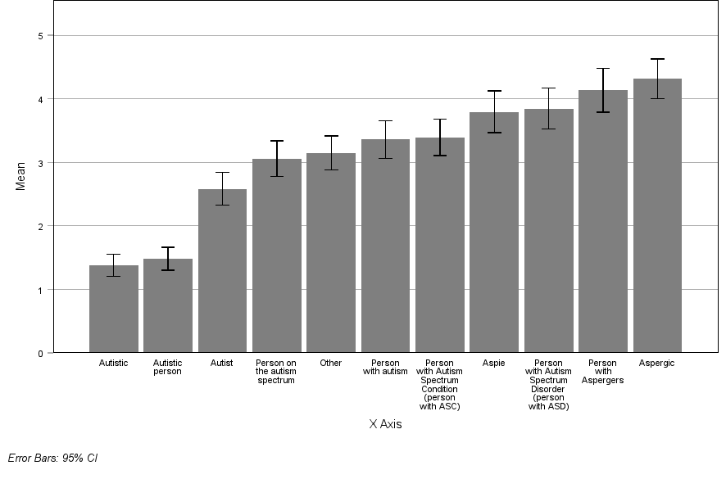
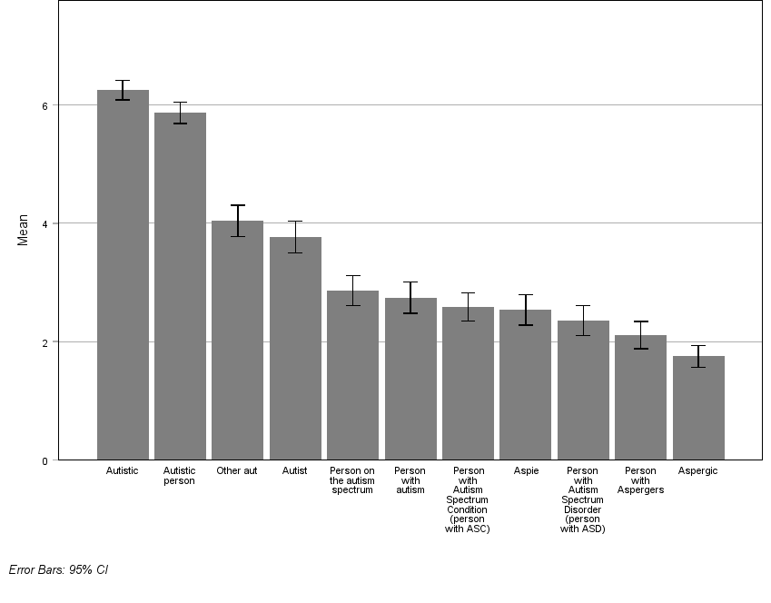
Mean offensiveness rating
Mean likeability rating
ADHD

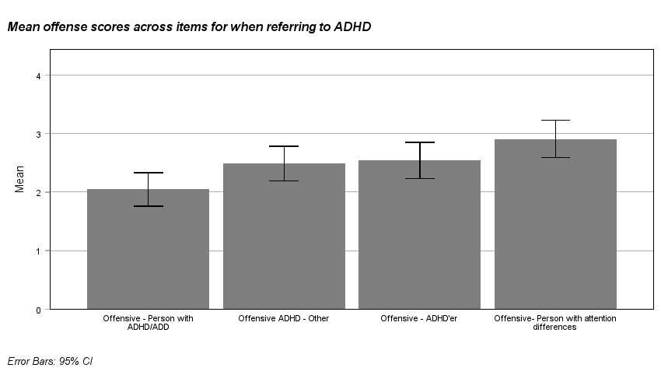
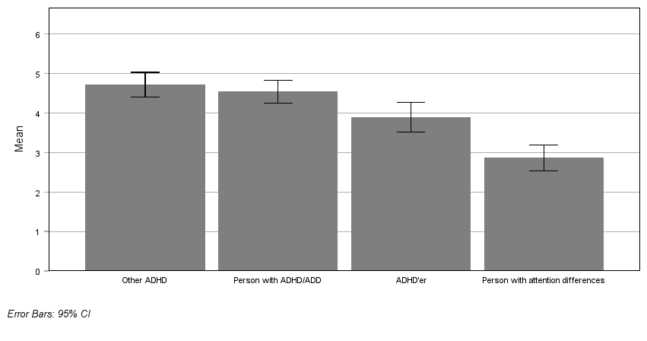
Mean likeability rating
Mean offensiveness rating
Mean offensiveness rating
Stuttering

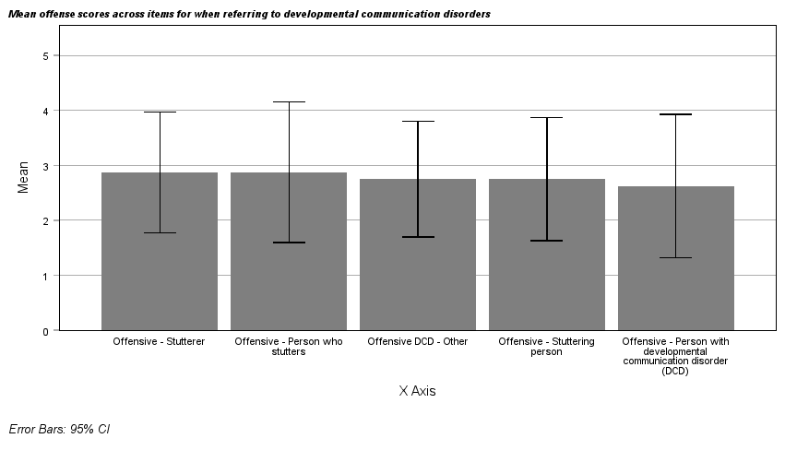
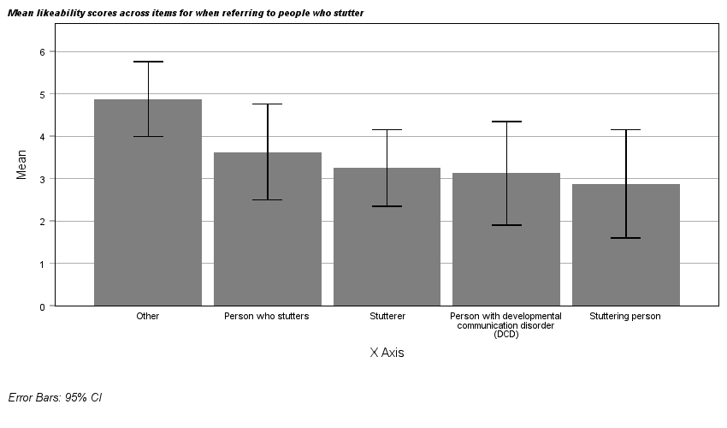
Mean offensiveness rating
Mean likeability rating
Dyscalculia

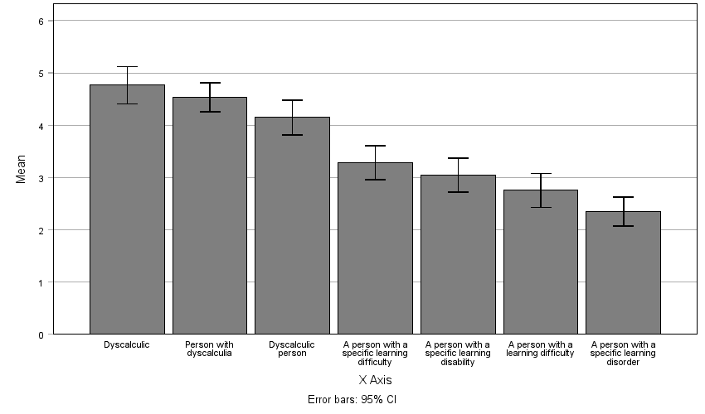
Mean likeability rating

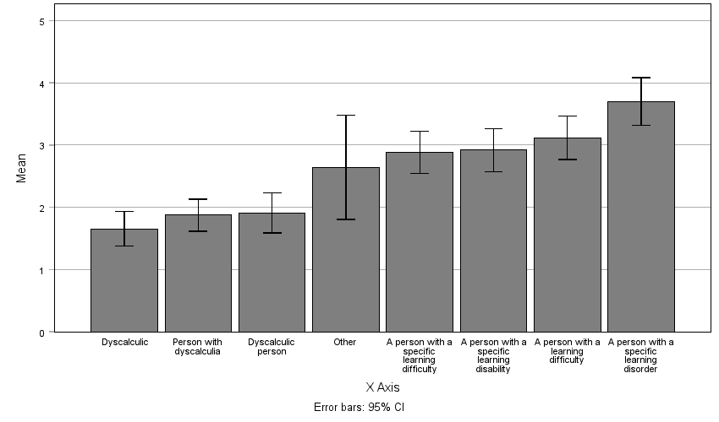
Mean offensiveness rating

Dysgraphia

Dysgraphia

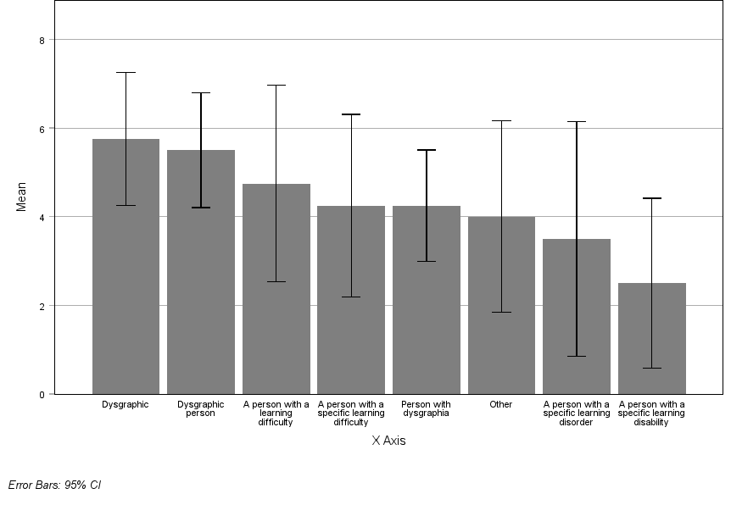
Mean likeability rating

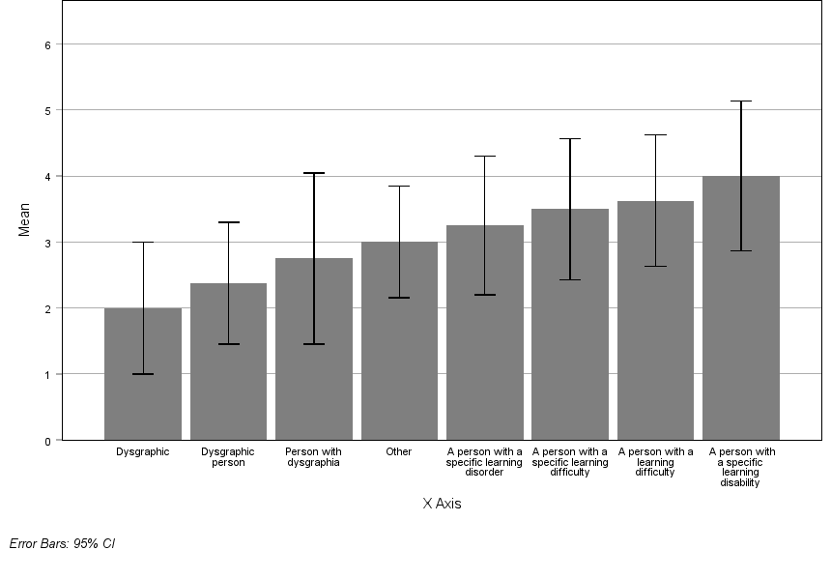
Mean offensiveness rating
Dyslexia
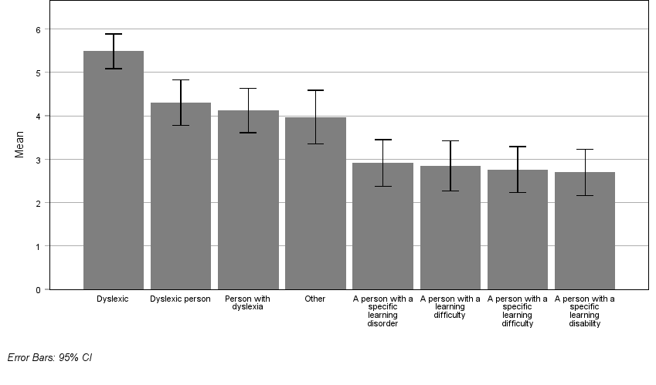
Mean likeability rating

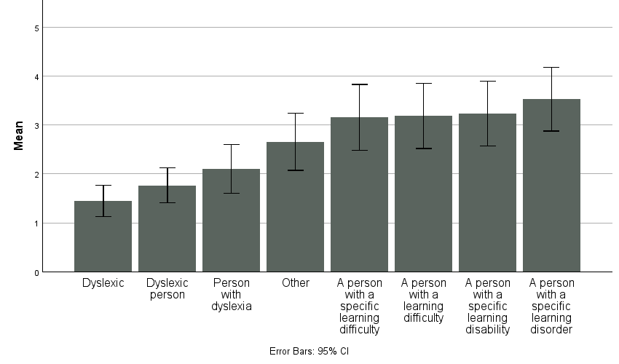
Mean offensiveness rating

Dyspraxia

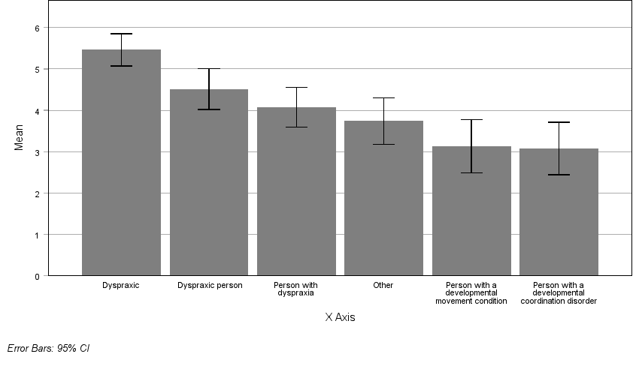
Mean likeability rating

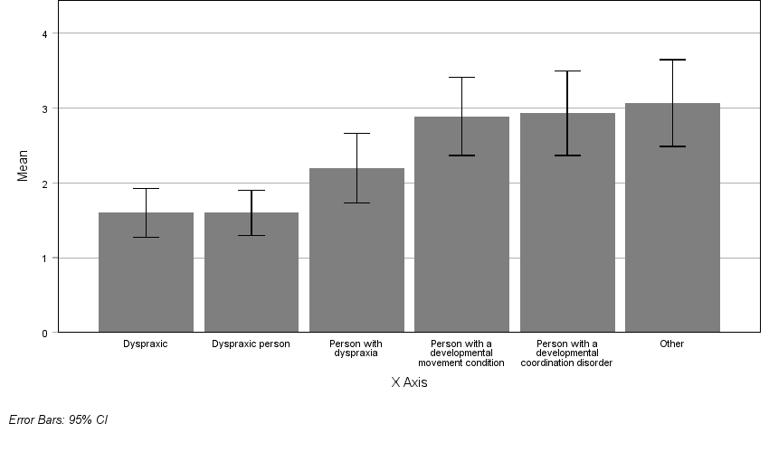
Mean offensiveness rating

AAC users and non-speaking

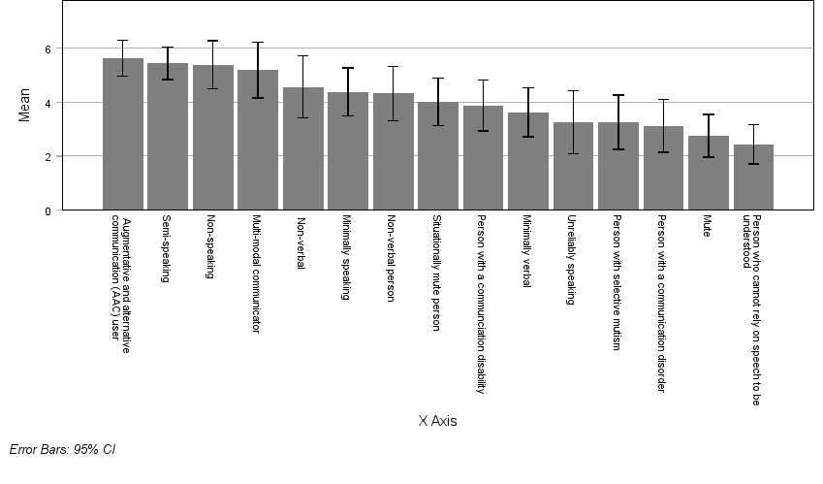
Mean likeability rating

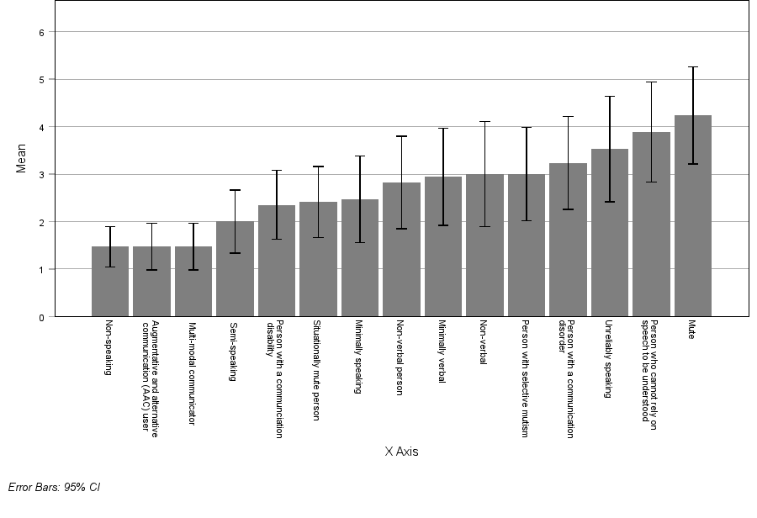
Mean offensiveness rating

PDA

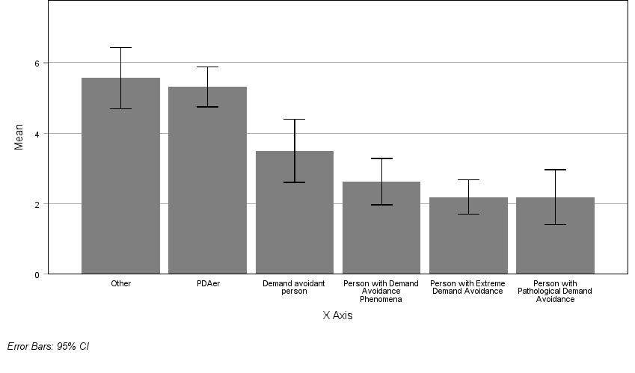
Mean likeability rating

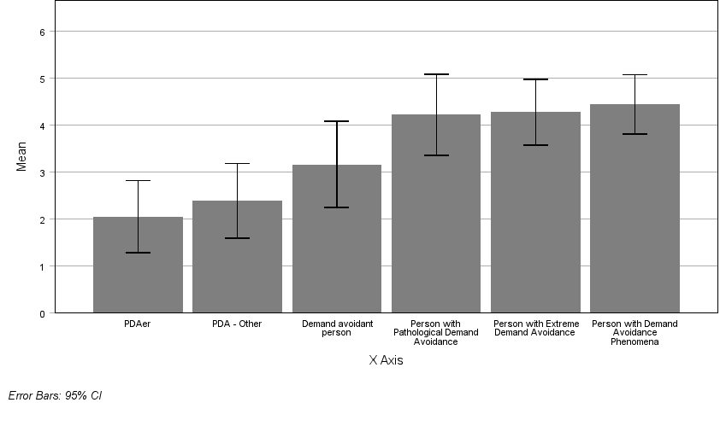

Mean offensiveness rating

SPD

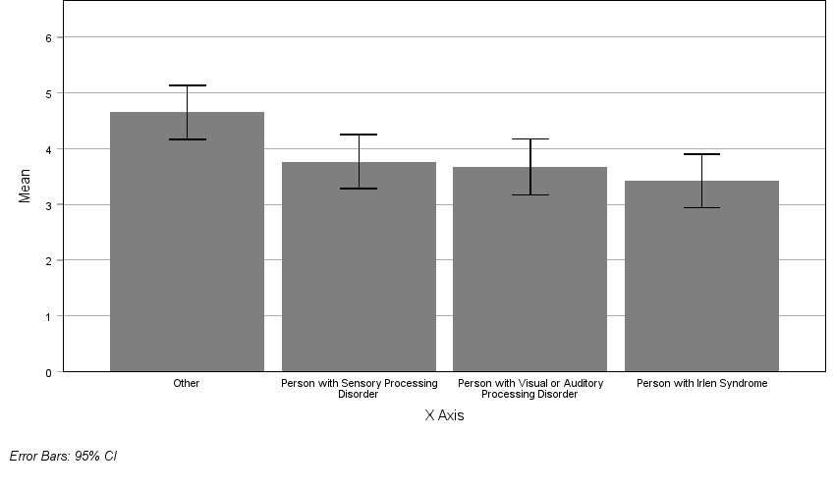
Mean likeability rating

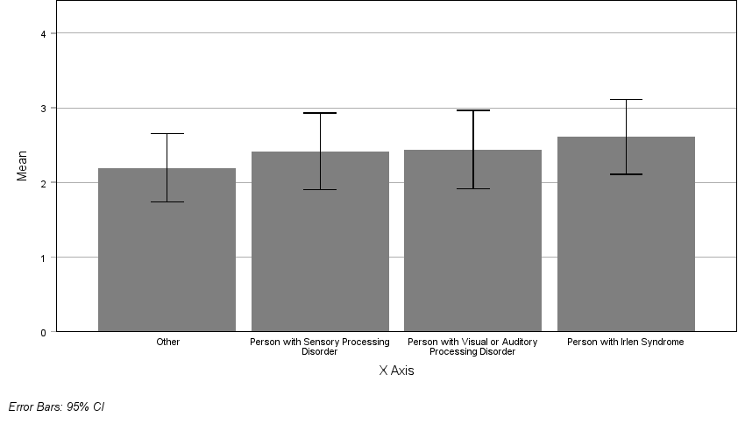
Mean offensiveness rating

Tourette Syndrome

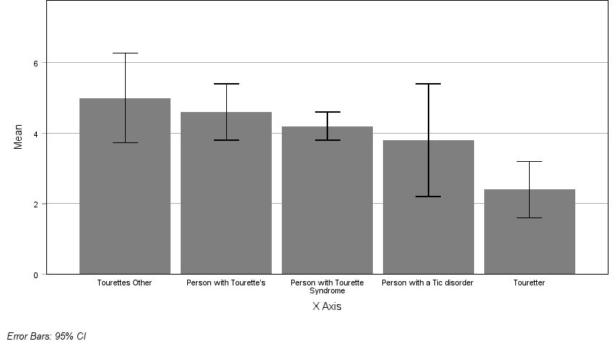
Mean likeability rating

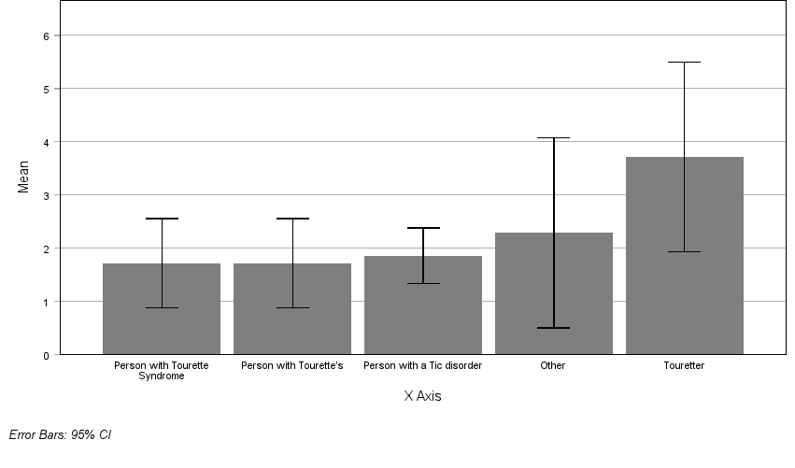
Mean offensiveness rating

Supplementary table 1: Demographic data for participants who answered the qualitative question on each label

Demographic |  | N | %
Disability type | Autism | 406 | 79.5
 | ADHD | 246 | 48.1
 | Stuttering | 12 | 2.70
 | Dyscalculia | 48 | 9.40
 | Dysgraphia | 10 | 2.00
 | Dyslexia | 101 | 19.8
 | Dyspraxia | 108 | 21.1
 | AAC users and non-speaking people | 15 | 2.90
 | Learning disability | 2 | .25
 | Pathological Demand Avoidance | 62 | 12.1
 | Sensory processing disorder | 141 | 27.6
 | Tourette syndrome | 19 | 3.7
Identify as disabled | Yes | 473 | 92.6
 | No | 38 | 7.4
Does your condition reduce your ability to carry out day-to-day activities? | Yes a lot | 196 | 38.4
 | Yes a little | 266 | 52.1
 | Not at all | 46 | 9.0
 | Prefer not to say/ not disclosed | 508 | 99.4
Gender | Woman | 328 | 65.1
 | Man | 61 | 12.1
 | Non-Binary | 93 | 18.5
 | Other | 4 | .8
 | Questioning | 16 | 3.2
 | Not specified | 2 | .4
Place of residence | England | 415 | 82.3
 | Scotland | 56 | 11.1
 | Wales | 23 | 4.6
 | Northern Ireland | 10 | 2.0
 | Prefer not to say | 0 | 0.15
Race & Ethnicity | White British and Irish | 470 | 93.3
 | Mixed race | 15 | 3.0
 | Asian and British Asian | 6 | 1.2
 | Black, African, Caribbean | 2 | 0.4
 | Any other background | 11 | 2.2
Employment status | Full- time employed | 161 | 31.9
 | Part-time employed | 118 | 23.4
 | Self-employed | 56 | 11.1
 | Unemployed | 44 | 8.7
 | Retired | 10 | 10.0
 | Student | 94 | 18.7
 | Unable to work | 76 | 15.1
 | Carer | 38 | 7.5
 | Other | 26 | 5.2
Highest Qualification | Other | 35 | 3.9
 | None | 5 | 1.00
 | GCSEs / Standard Grades / other equivalent high school qualifications | 17 | 3.40
 | A Levels / Highers / other equivalent high school qualifications | 60 | 11.9
 | National Vocational Qualification or equivalent | 26 | 5.2
 | Undergraduate degree | 156 | 31.0
 | Taught postgraduate degree (Masters or equivalent) | 166 | 32.9
 | Doctorate (PhD) | 38 | 7.5
 | Other (Please Specify) | 36 | 7.1

Study Questions

3. Survey QUESTIONS
Part 1: About you
Gender
What is your gender? Tell us the word(s) you think are relevant - you are free to give as much detail as you like in this box. [open textbox]
What is your age?
What is your race/ethnicity?
Note - these have been chosen according to the census - if none of these are the words you would use to describe your race or ethnicity, please choose other and type the right word into the box

White
- English, Welsh, Scottish, Northern Irish or British
- Irish
- Gypsy or Irish Traveller
- Any other White background

Mixed or Multiple ethnic groups
- White and Black Caribbean
- White and Black African
- White and Asian
- Any other Mixed or Multiple ethnic background

Asian or Asian British
- Indian
- Pakistani
- Bangladeshi
- Chinese
- Any other Asian background

Black, African, Caribbean or Black British
- African
- Caribbean
- Any other Black, African or Caribbean background

Other ethnic group
- Arab
- Any other ethnic group

- Prefer not to say

- Disability status
Do you have a physical or mental health condition or disability lasting or expected to last 12 months or more? (yes / no)

If yes: Does your condition or disability reduce your ability to carry-out day-to-day activities?
- Yes, a lot
- Yes, a little
- Not at all

What is your highest level of education?
- None
- GCSEs / Standard Grades / other equivalent high school qualifications
- A Levels / Highers / other equivalent high school qualifications
- National Vocational Qualification or equivalent
- Undergraduate degree
- Taught postgraduate degree (Masters or equivalent)
- PhD
- Other (please specify) [open text box]
What is your current employment status?
- Employed full time
- Employed part time
- Self-employed
- Retired
- Unemployed
- Unable to work
- Carer
- Student
- Other (please specify)
Where do you currently live in the UK?
- England
- Scotland
- Wales
- Northern Ireland

1. Please read this list and tick all of the ones that apply to you.
Note: Self-diagnosis here is OK.

Attention Deficit Hyperactivity Disorder (ADHD) or Attention Deficit Disorder (ADD)
Autism (may also be referred to or diagnosed as Autism Spectrum Disorder/Condition, Asperger’s/Asperger Syndrome, High/Low Functioning Autism and PDD-NOS (Pervasive Developmental Disorder Not Otherwise Specified))
Developmental language conditions such as stuttering, Developmental Communication Disorder, receptive and expressive language disorder
Dyscalculia
Dysgraphia
Dyslexia
Dyspraxia / Developmental coordination disorder
Epilepsy
Global Developmental Delay
An assisted communication user ( i.e., semi-speaking, non-speaking, multi-modal communicator)
Learning disabilities also known as Intellectual disability
Pathological Demand Avoidance (PDA)
Sensory Processing Disorder, Visual Processing Disorder (sometimes known as Irlen Syndrome) or Auditory Processing Disorder
Tics or Tourette’s Syndrome
Other
None of the above

2. You selected ‘other’ - please use the box below to tell us what is missing from the list.

If None - filter to leave the survey.

For each of the disabilities you ticked before, you will now be asked some questions about your language preferences. We will consider each disability separately.

About language and [NAME OF DISABILITY]

1. Have you been formally diagnosed?
This information will be useful in our analysis, we fully recognise self-diagnosis.
Yes
No
Undergoing diagnosis
Prefer not to say

2. Below are some names given to [disability name]…
For each word(s), select how much you like, or do not like, each one.

 | Strongly dislike | Dislike | Dislike a little bit | Neither like or dislike | Like a little bit | Like | Strongly like
WORD 1
WORD 2 etc.

For each word(s), select how much you think each one is offensive (i.e. rude, bad)

 | Not at all offensive | Low offensiveness | Slightly offensive | Neither offensive or inoffensive | Moderately offensive | Very offensive | Extremely offensive
WORD 1
WORD 2 etc.

Now thinking of these words, please put them in order from your least favourite to most favourite. In other words, which one is your number one top favourite, and then put the rest all in order to your least favourite, most disliked one.
[ALL WORDS]

Thinking of these words again, please put them in order from most offensive to least offensive.
[ALL WORDS]

Qualitative Q after every one:
“You chose ____ as your most preferred/offensive label, why do you prefer/dislike this label?”
Is there anything else you want to tell us? …

Neurodiversity check

- Have you heard of the term neurodiversity?
Yes
No
Not sure

- If yes: Do you use words related to neurodiversity to describe yourself? For example “I am neurodivergent”
Yes
No
Not sure
If yes/no: provide explanation?

- Is there anything else you would like to tell us about neurodiversity and the words language used? [open free text box – no character limit]

- How do you feel about the words (linked to your neurodiversity) used towards you by other people?

- Please feel free to give examples of language you liked and also language you didn’t like. You can choose to tell us about who uses language you like and who uses language you don’t like, such as family, friends, health professionals, employers etc. You may also want to think about where, when and why

Thinking of these words, please put them in order from most offensive to least offensive. So most offensive on top, and least offensive at the bottom.

Appendix:
LIST OF TERMS TO USE FOR EACH CONDITION

A. ADHD (Attention Deficit Hyperactivity Disorder) / ADD (Attention Deficit Disorder)
Person with ADHD / ADD
ADHDer
Has attention differences
Other (please specify)

B. Autism
person with autism,
person on the autism spectrum,
person with autism spectrum disorder (person with ASD)
person with autism spectrum condition (person with ASC)
autistic,
autistic person
Autist
Person with Asperger’s
Aspie
Aspergic
Other (please specify)
C. Developmental language conditions such as stuttering, Developmental Communication Disorder, receptive and expressive language disorders
Person who stutters
Stutterer
Stuttering person
Person with developmental communication disorder (DCD)
Other (please specify)
D. Dyscalculia
Person with dyscalculia
Dyscalculic
Dyscalculic person
A person with a specific learning difficulty
A person with a specific learning disability
A person with a specific learning disorder
Other (please specify)
E. Dysgraphia
Person with dysgraphia
Dysgraphic
Dysgraphic person
A person with a specific learning difficulty
A person with a specific learning disability
A person with a specific learning disorder
A person with a learning difficulty
Other (please specify)
F. Dyslexia
Person with dyslexia
Dyslexic
Dyslexic person
A person with a specific learning difficulty
A person with a specific learning disability
A person with a specific learning disorder
A person with a learning difficulty
Other (please specify)
G. Dyspraxia
Person with dyspraxia
Person with Developmental coordination disorder
Dyspraxic
Dyspraxic person
Person with a developmental movement condition
Other (please specify)
H. Global Development Delay
Person with Global Development Delay
Other (please specify)
I. Non-speaking - tell us why you are non-speaking (apraxia, selective/ situational mutism, other) then:
Apraxia
Selective or situational mutism
Which words do you prefer:
Non-verbal person
Situationally mute person
Person with selective mutism
Mute
semi-speaking
unreliably speaking
minimally speaking
multi-modal communicator
augmentative and alternative communication (AAC) user
person who cannot rely on speech to be understood
Non-verbal
Minimally verbal
Non-speaking
Person with a communication disorder
Person with a communication disability
J. Learning disabilities
Person with a learning disability
Person with learning difficulties
Person with a cognitive disability
Learning disabled person
Person with intellectual/cognitive impairment
Person with complex needs
Other (please specify)
K. PDA
Person with Pathological Demand Avoidance
Person with Extreme Demand Avoidance
Person with Demand Avoidance Phenomena
Demand avoidant person
PDAer
Other (please specify)
L. Sensory Processing Disorder, Visual Processing Disorder (sometimes known as Irlen Syndrome) and Auditory Processing Disorder
Person with Sensory Processing Disorder
Person with Visual or Auditory Processing Disorder
Person with Irlen Syndrome
Other (please specify)
M. Tics or Tourette’s
Person with Tourette Syndrome
Person with Tourette’s
Touretter
Person with a Tic disorder
Other (please specify)
N. Other
If yes:
Please tell us the name of any diagnosis or self-identification in this box:
What words do you like to use when talking about your diagnosis / how you self-identify - for example, “I am a person with…” “I am …”
What words do you not like or find offensive when talking about your diagnosis / how you self-identify?

4. Examples of alternative terminology suggested in ‘other’

Autism

Autie
Neurodivergent
Has autism
On the spectrum
Person with an autistic mind / PAM
Takiwatanga

ADHD

ADHD person
Neurodiverse
Is ADHD
I experience attention differences
VAST (Variable Attention Stimulus Trait)
ADHDifferent
Person with dopamine deficiency
DAVE: Dopamine attention variability executive dysfunction
DREADpirate

Dyslexia

Neurodivergent

Dyscalculia

Individual diagnosed with dyscalculia

Dyspraxia

Person with DCD
Person with movement differences

Non-Speaking

Semi verbal - Mutism and find it hard to talk
Selective mutism
Situational mutism

PDA

Demand avoidant
Demand anxious
Pervasive drive for autonomy
PDA Person
Autonomy driven autistic
ND
I’m PPDA

SPD

Person who has SPD
Person with visual/auditory processing issues, highly sensitive
I have sensory processing difficulties
Sensory processing differences

Tourettes

Person who has Tourettes
Motor Tics
Neurodivergent

