An Intelligent Diagnostic approach for diabetes Using rule-based Machine Learning techniques

Contributing authors: Wenlin Zhang, Syed Ghufran Khalid, Soban Sadiq, Gary Tse, …

Abstract
To improve the diagnostic reliability of diabetes mellitus (DM), rule-based machine learning techniques has been proposed. However, the existing studies are highly diverse with a lack of summarization on the state-of-the-art. To address this gap, we comprehensively reviewed some recent studies. Overall, rule-based methods improved the performance and explainability of the machine learning algorithms, providing direct reference for personalized recommendation and clinical intervention of DM. However, the quality and availability of data limited the reliability of the algorithms. The current algorithms focus on fuzzy system and its optimizations, with a scarce of more complex methods. In the future, the rule-based machine learning algorithms can be improved by using large-scale datasets and more complex structures with better clinical knowledge interpretation, where internet-of-things and advanced artificial intelligence algorithms will play a key role.

Introduction:
Diabetes mellitus (DM) is a chronic, metabolic disease characterized by elevated levels of blood glucose due to either lack of insulin or insulin resistance (1). Diabetes has more than 100 complications which can lead to blindness, lower limb amputation, kidney failure, heart attacks, stroke, and other life-threatening clinical events. In last 30 years, DM has become a global public health crisis with the number of patients arising from 108 million in 1980 to 422 million in 2014, with an increasing mortality rates by age (2). DM is also a heavy economic burden to the society, according to an investigation held by the American Diabetes Association in 2017, in America, the cost of diagnosed diabetes is at $327.2 billion. Together with prediabetes (10.7%, $43.4 billion), and gestational diabetes mellitus (0.4%, $1.6 billion) combine with the prior estimate for diagnosed diabetes to total $403.9 billion annually (3). Currently, there is no complete cure for diabetes; patients must be cautious of avoiding risk factors and constantly take medicines, which burdens the patient greatly.

Early diagnosis of diabetes can reduce the treatment cost and the risks of severe clinical events (4). At present, the diagnosis of DM mainly relies on doctors’ expertise on whether the patient's physiological parameters, especially the blood glucose and hemoglobin A1c (HbA1c), are within the normal range. Usually, this kind of diagnosis is time-consuming, as patients are observed over time and re-examined data are used to conclude. Reliable prediction and early detection of the symptoms play a key role in providing timely and efficient clinical intervention of DM to control the progress and minimize the relevant risks.

Some early detection systems of DM has been developed using machine learning and deep learning approaches with high testing accuracy (5, 6). However, as scientists dive into understanding the disease, the black-box nature of unsupervised machine learning and deep learning classifiers is getting undesired. Meanwhile, some key features can be identified as potential risk factors using statistical analysis where large-scale validation is needed. We demand an intelligent system that can help us make predictions and give suggestions on which feature has the highest correlation rather than being a clever classifier.

The rule-based approach is the domain-specific expert system that uses rules to make deductions or choices. The rules are referred to as ‘If statements’ as they tend to follow the line of ‘IF X happens THEN do Y’. Using if-then rules improves the interpretability of the results and provides more insight into the classifier structure and decision-making process. Rule-based clinical decision support systems have been gaining increasing popularity, which can be categorized into knowledge based (i.e., rules derived from clinical guidance or expertise) and non-knowledge based (i.e., rules automatically extracted from clinical data) to suit different clinical application scenarios (7). Recently, some rule-based machine learning methods have been proposed for the early diagnosis of DM, but there is a lack of comprehensive review. In this chapter, we aim to provide an initial review of the state-of-the-art and summarize the advantages and limitations to provide a reference for future studies.

Literature search strategy
We conducted this systematic literature review by searching through PUBMED/MEDLINE, Medscape, IEEE Xplore Digital Library, and Scopus databases for all the articles containing the keywords "rule-based machine learning" in combination with "diabetes" or "diabetes mellitus (DM)" combined with "early detection" or "diagnostic" or "prediction" in the titles or abstract. The computer-based search combined free text and medical subject headings with the abovementioned keywords. The results were restricted to the studies published in English from 1st January 2015 to 1st September 2022.

More than 50 articles were found. Excluding the irrelevant results and those written in other languages with parallel English versions, 29 items were finally selected. There were one book chapter, 22 journal articles and six conference papers.

We included only original research studies that adopted rule-based methods for diagnosing diabetes. Since the rule-based methods include rule association mining, learning classifier systems, and fuzzy logic concepts, we classify those studies into three categories based on the proposed rule-based algorithm: fuzzy system based, SVM based and others. In data preprocessing, the dimensionality reduction and over-sampling are widely used. For detailed analysis, the three categories are further divided into sub-categories according to their performance and subsequent algorithm. In the end, we summarized the innovations and limitations of the state-of-the-art and suggested some directions for future works.

System overview
As illustrated in Figure 1, a general architecture of rule-base machine learning system for diabetes diagnosis consists of several essential steps: the pre-processing of clinical data, the development of classification algorithm, the rule-based optimization of the machine learning algorithm to form a hybrid algorithm, and the evaluation of algorithm’s performance. Finally, the algorithm can be further validated and optimized in different application scenarios.

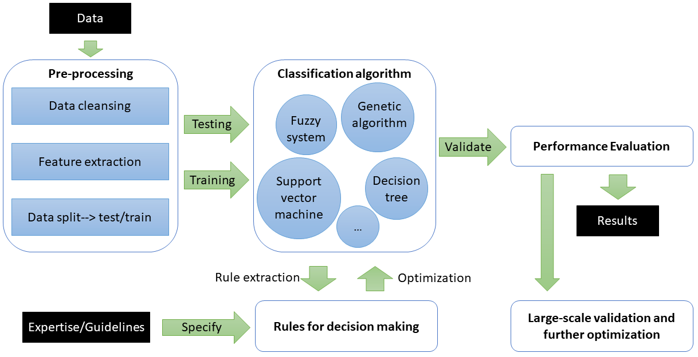
Figure 1. Flow diagram of a general rule-based machine learning algorithm

Dataset
Most researchers developed or tested their model on the Pima Indians Diabetes Dataset (PIDD, or PID dataset), originally from the National Institute of Diabetes and Digestive and Kidney Diseases. In contains information of 768 women from a population near Phoenix, Arizona, USA. In particular, all patients are females at least 21 years old of Pima Indian heritage. Pima Indians are a Native American group that was deemed to have a high incidence rate of diabetes mellitus (8). The objective of the dataset is to predict whether or not a patient has diabetes diagnostically. The dataset has 9 columns and 768 rows where 500 are negative (non-diabetic, marked as 0) and 268 are positive (diagnosed with DM, marked as 1). This dataset is insufficient for making real-world predictions as the dataset only included female patients from a certain ethnic group. There are misleading or missing values in the datasets. In addition, it is no longer updated and maintained due to permission restrictions. Therefore, this PIDD provides important reference for DM detection algorithms whilst there is a high need for new datasets to cover more cohorts and potential risk factors.

Some researchers used new datasets in algorithm development. Lukmanto et al. used the data collected from survey activities at one of the eastern Jakarta hospital laboratories in Indonesia (9). Han et al. used data from the China Health and Nutrition Survey (CHNS), which has a number of 7913 instances (10). Fetaji et al. used three datasets: PIDD, the UCI dataset which has been used in 29 research projects, and the Kosovo dataset extracted from a doctoral thesis (11). Muhammad et al. collected their data from the Murtala Mohammed Specialist Hospital, Kano State, in Nigeria (12). Hao et al. uses Diabetes Medical Examination Data collected by Beijing Hospital (DMED-BH) (13). Compared with PIDD, these new datasets included more attributes and instances, which enriched DM-related information and may provide more potential risk factors. However, they are not open-access due to ethic concerns, leading to difficulties in performing multicenter large-scale studies.

Dataset is a crucial part of machine learning. The combination of different datasets can improve the reliability of the algorithms, and the robustness against individual differences. An open platform where researchers, and even patients can share and use data may bring in revolutionary changes in algorithm development towards high accuracy, fine-grained classification, and patient-specific evaluation for precise medicine. To achieve this, further investigation is necessary on data management and ethical issues including data privacy and security.

Study | Number of subjects (DM vs control) | Dataset | Features/Predictors | Preprocessing methods | Training data | Testing data
Ramezani et al. 2018 (14) | 268 DM and 500 non-DM | Pima Indians Diabetes Dataset | 8 medical predictors: age, blood pressure, pregnancy, glucose, insulin, skin thickness, diabetes pedigree function, body mass index (BMI) | Multiple imputation analysis: inference missing values; dimensionality reduction: neglect insignificant attribute | 3-fold cross-validation (CV)
Hayashi and Yukita 2016 (15) | 268 DM and 500 non-DM | Pima Indians Diabetes Dataset |  | Sample selection technique to extract a fewer number of rules and lower average number of antecedents | 768 | 768
Nagaraj and Deepalakshmi 2022 (16) | 268 DM and 500 non-DM | Pima Indians Diabetes Dataset |  | Convert raw data into categorical data for effective implementation | 537 (70%) | 231 (30%)
Karthikeyan et al. 2019 (17) | 268 DM and 500 non-DM | Pima Indians Diabetes Dataset |  | Three modified training datasets:  1. Missing values replaced with a mean value;  2. Missing values removed;  3. A three-class variable (non-DM, pre-DM, DM) derived from 41 instances | 768 | 3*768
Lukmanto et al. 2019 (18) | 268 DM and 500 non-DM | Pima Indians Diabetes Dataset |  | 1. Removal of features with missing value over 5%;  2. F-score for feature selection | 342 (87%) | 50 (13%)
Feng et al. 2015 (19) | 268 DM and 500 non-DM | Pima Indians Diabetes Dataset |  | Not mentioned | Leave-one-out approach: use all of the data from each dataset for training, then one sample was removed from the dataset as the test sample, and this was repeated until all of the samples had been tested.
Aamir et al. 2021 (20) | 268 DM and 500 non-DM | Pima Indians Diabetes Dataset |  | Normalization to (0,1) scale | 52% | 48%
Siva Shankar G. and Manikandan K. (21) | 268 DM and 500 non-DM | Pima Indians Diabetes Dataset |  | Not mentioned | k-fold CV
Azad et al. 2022 (22) | 268 DM and 500 non-DM | Pima Indians Diabetes Dataset |  | 1. Handle missing value using Naïve Bayes algorithm;  2. Oversampling the minority class;  3. Dimensionality reduction. | Split test methodology on 60–40%,  65–35%, 70–30%, 75–25% and 80–20%; ten times for each split and the best five outcomes were recorded.
Cheruku et al. 2022 (23) | 268 DM and 500 non-DM | Pima Indians Diabetes Dataset |  | 1. Normalization;  2. Feature selection | 10-fold CV
Cheruku et al. 2017 (24) | 268 DM and 500 non-DM | Pima Indians Diabetes Dataset |  | Not mentioned
Pourpanah et al. 2016 (25) | 268 DM and 500 non-DM | Pima Indians Diabetes Dataset |  | Not mentioned | 80% | 20%
Porebski and Straszecka 2014 (26) |  |  |  |  | Not mentioned
Beloufa and Chikh 2013 (27) |  |  |  |  | 10-fold CV
Mehra et al. 2020 (28) | 268 DM and 500 non-DM | Pima Indians Diabetes Dataset |  | Linguistic summarization (LS): eliminate the outliers | 768
Sagir and Sathasivam 2017 (29) | 268 DM and 500 non-DM | Pima Indians Diabetes Dataset | 7 medical predictors: blood pressure, pregnancy, glucose, insulin, skin thickness, diabetes pedigree function, body mass index (BMI) | Not mentioned | 2/3 | 1/3
Abiyev and Altiparmak 2021 (30) | Not mentioned | Original and extended Pima Indian datasets | 8 medical predictors: age, blood pressure, pregnancy, glucose, insulin, skin thickness, diabetes pedigree function, body mass index (BMI) | Calculating the maximum, mean, standard deviation, and and correlation values ​​for all features | 2000 | 2000 & 768
Mansourypoor and Asadi 2017 (31) | Not mentioned | Pima Indian Diabetes and BioSat Diabetes Dataset (768+403 subjects) |  | Reducing the numbers of rules:  1. Rule learning; 2. Rule pruning; 3. pruning rule antecedents; 4. evolutionary rule selection. | Not mentioned
Gürbüz et al. 2013 (32) | 268 DM and 500 non-DM | Pima Indians diabetes datasets and Wisconsin breast cancer dataset |  | Normalization | 560 | 208
Lukmanto and Irwansyah (9) | Not mentioned | Survey and interview data collected from eastern Jakarta, Indonesia | 3 types of indicators: glucose test results, age, and doctor statement (polyuria, polydipsia or polyphagia) | Knowledge-based range value of each input variable as a basis for determining the fuzzy value (e.g., the numerical value indicating high blood glucose) | No training | 311
Lahsasna and Seng 2017 (33) | Not mentioned | UCI Repository of Machine Learning Databases | Not mentioned | Feature selection | 10 independent iterations with different data partitions of 10-cross validation procedure (10 × 10 CV)
Han et al. 2014 (10) | 7913  (646 DM, 7267 non-DM) | China Health and Nutrition Survey (CHNS) | 9 predicators: hemoglobin A1c (HbA1c), triglyceride (TG), uric acid (UA), high-density lipoprotein (HDL), age, diastolic blood pressure (DBP), cholesterol (CHOL), waist and weight | Feature selection (56->9 features) | 90% for rule extraction | 10%
Muhammad et al. 2020 (12) | 383 | Data collected from the Murtala Mohammed Specialist Hospital, Kano State, in Nigeria | 9 attributes: age, family history, glucose, CHOL, blood pressure (BP), HDL, triglyceride, BMI, and the diagnosis result | Calculating the correlations between attributes before training | Not mentioned
Hao et al. 2022 (13) | 6503 DM and 36,853 non-DM | Diabetes Medical Examination Data collected by Beijing Hospital (DMED-BH) | 17 indicators from routine physical examination, blood test, and questionnaire survey | feature selection by chi-squared test | 5-fold CV for feature selection

Pre-processing methods
To deal with the imbalanced data distribution, many researchers normalized the data according to the statistical properties (20, 32)(23). Normalization can help scale down each attribute to a specific interval, reduce data redundancy and improve the training stability and the performance of machine learning models. Therefore, data normalization has been widely used in the pre-processing of DM-related clinical datasets (34).

The health records often consist of high dimensionality features with considerable missing values. As aforementioned, there are missing values in the PIDD. Therefore, besides data normalization, the majority of pre-processing methods fall in two categories: missing value operations and feature selection.

Lukmanto et al. tried to remove missing values and attributes that had missing values over 5% (18). Ramezani et al., adopted multiple imputation analyses to infer missing values (14). Azad et al. used Naïve Bayes algorithm and random forest (RF) classifiers to predict the missing values (22). In Karthikeyan et al.’s work, they generated 3 testing datasets with different methods of handling missing matters and evaluated them separately (17). The results showed that removing the missing values had better performance than substituting the mean value for the missing values; which might be caused by the outliers in the dataset. Furthermore, replacing the missing values using variables generated by a rules-based classifier showed the highest accuracy, which offers an intuition on how the rule-based techniques help facilitate the model.

With or without handling missing values, researchers took different measures to overcome the "curse" of high dimensionality. Al-Behadili et al. conducted rule pruning which is a common technique in rule-based classifiers that reduces the size of the discovered rules by avoiding the overfitting noisy data during pre-processing (35). Meanwhile, feature selection (i.e., sample selection, or dimensionality reduction) is also commonly used in pre-processing (10, 13, 18, 23).

Some studies focused on outlier detection/ removal, which is essential in many scenarios because they can adversely affect the algorithm performance by influencing the distribution of data and the range of attributes. Mehra et al. used linguistic summarization (LS) in their research to eliminate the outliers (28).

Finally, in splitting of the dataset, most of the research uses k-fold cross-validation (CV) to separate the training and testing dataset for splitting the dataset. Some researchers focused on rule extractions, so they split the data into k parts, use n/k (n<k) to extract the rules and leave ones to test the model (10).

Algorithms for classification
As shown in Figure 2, the classification algorithms used in the studies are highly diverse. Since 2013, most researchers have taken a hybrid way to get better performance on the classification task. The most commonly adopted hybrid system is composed of fuzzy system with genetic algorithm (GA), fuzzy system with decision tree (DT), and support vector machine (SVM) with DT. Generally speaking, the fuzzy system itself can generate the if-then rules while other algorithms (GA, bat algorithms (BA), and particle swarm optimization (PSO), etc.) were adopted in the hybrid models to optimize the fuzzy classifiers (23, 25, 31, 36, 37). Some researchers used fuzzy decision trees, while only few attempted to build completely different integration model (16, 38, 39). As for the SVM, since it could not be interpreted directly, the focus lies in extracting the correct rules from the obtained SVM model (10, 13, 18, 32, 40). Some other methods were also proposed, but they are scattered and without a systematic approach.
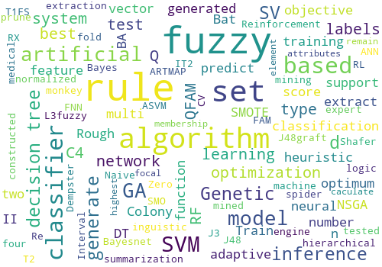
Figure 2. Word cloud analysis for algorithm used in selected research

- Fuzzy system
The term "fuzzy" refers to the fact that it helps to deal with concepts that cannot be expressed as "true" or "false" but rather as "partially true". This fuzzy logic allows overlapping class definitions, uncertainty and vagueness (23), therefore improves flexibility and classification performance of medical decision support systems (41, 42). The fuzzy if–then classification rules are represented by linguistic terms that can be easily interpreted and examined by human operators so that their expertise can be used in the design of the controller. This makes it easier to mechanize tasks that are already successfully performed by humans (43, 44).

In 1995, Ishibuchi et al. developed a genetic algorithm-based fuzzy system to generate if-then rules and achieved good classification accuracy (45). The generation of fuzzy if-then rules was further investigated in following years (45-49). As fuzzy classifier depends on the rules, more rules can generate better classification results. Thus, how to generate more rules without increasing computation load became a hot topic. To deal with that, algorithms like heuristic approaches (50), neural networks (30, 51, 52), GA (36), PSO (37) and ant colony optimization (ACO) (53) have been introduced in the optimization of classifiers.

In 2009, Karahoca et al. built an adaptive neuro-fuzzy inference system (ANFIS) for predicting diabetes which outperformed the Multinomial Logistic Regression (54). In 2010 and 2011, Ganji and Abadeh used ACO algorithm to generate fuzzy classification rules called FSC-ANTMINER for diabetes disease diagnosis (42, 55). They have used artificial ants to explore the search space and gradually make fuzzy candidate rules. Afterwards, in 2013, Beloufa and Chikh proposed a modified Artificial Bee Colony (ABC) learning method with a mutation operator which showed better performance in differentiating DM and non-DM subjects (27). Pourpanah et al. in 2015 proposed a hybrid system by building a Fuzzy ARTMAP (FAM) classifier with Q-learning then using GA to optimize the classifier and extract rules (25). In the same year, Feng et al. developed a new variable coded hierarchical fuzzy model with PSO and GA for optimization (19). In 2016, Porebski and Straszecka proposed a fuzzy system based on the Dempster-Shafer theory and applied it in the diagnosis of appendicitis and DM (26). The research in optimization continues to be carried out, as in 2019, Siva Shankar G. and Manikandan K. use grey wolf optimization, which has shown better result than ACO (21).

More hybrid approaches were proposed in recent years. Ramezani et al. combined logistic regression and adaptive network-based fuzzy inference system which enabled the imputation of missing values in data-derived diagnosis of DM (14). Sagir and Sathasivam optimized the adaptive neuro-fuzzy inference system with modified Levenberg-Marquardt algorithm, which showed superior performance compared to the conventional ANFIS (29). Cheruku et al. combined Rough Set Theory (RST) and Bat optimization Algorithm (BA) to build a fuzzy rule miner for DM detection (23). Lahsasna and Seng investigated two variant fuzzy classifiers and their ability to optimize the conventional one. The first classifier was used to find non-dominated fuzzy rule-based systems with better interpretability-accuracy trade-off by using an enhanced version of multi-objective genetic algorithm (NSGA-II) called Controlled Elitism NSGA-II (33). The second approach was based on the first one with an additional feature selection step to improve the quality of the generated rules.

Besides optimizing fuzzy classifiers, there are also attempts towards integrated fuzzy decision trees. In 2019, Anuradha et al. developed a fuzzy decision tree classifier based on ant colony meta-heuristic (38). Chen et al. proposed a decision tree-initialized neuro-fuzzy approach: a decision tree (C4.5) was used to initialize and generate crisp rules that were transformed with categorical values replaced by Gaussian membership functions to form the adaptive network-based fuzzy inference system (39). The process is much more complicated but rewardable since it can derive the optimal set of accurate fuzzy rules. Recently, Nagaraj and Deepalakshmi built a rule-based expert recommendation system based on a decision tree where the results were input into a fuzzy system for further analysis (16).

There are also other integrated approaches, for example, Abiyev et al. integrated neural network with fuzzy systems and built type-2 fuzzy neural network (T2-FNN) for predicting diabetes (30, 52) and achieved high accuracy in classification for average 99.5% in two testing sets. Mansourypoor and Asadi sued GA to optimize the fuzzy classifiers and Reinforcement Learning to do evolutionary tuning of the membership functions and weight adjusting (31). Mehra et al. proposed an integrated model by building an Interval type-2 (IT2) based Fuzzy set with linguistic summarization to help convey the extracted rules more easily to be understood (28).

- SVM

SVM is a supervised learning algorithm that is commonly used in two-group classification problems. Trained by a set of examples from two categories, an SVM algorithm builds a model that assigns new examples to one category or the other, making it a non-probabilistic binary linear classifier (56).

SVM can alleviate over-fitting and the curse of dimensionality even in small samples, providing the flexibility in analyzing clinical datasets for diagnosis (57). Even though the traditional SVM is a “black box” model, with additional explanation modules and algorithms, hybrid systems can be developed to derive intelligible representation and comprehensible ruleset.

In 2010, Barakat et al. appended a rule-based explanation component to the SVM algorithm, where the extracted rules were correct and useful in DM diagnosis as confirmed by domain experts (40). In 2014, Gürbüz and Kılıç developed an adaptive support vector machine to classify diabetic data. They first normalized the data, fed the data to the ASVM and used if-then rules to make decisions (32). These early attempts provided the possibilities of interpreting the "black-box" model, which inspired subsequent researchers to re-use the generated rules as a parameter to train the systems. In 2015, Han et al. fed the extracted SVs into constructing a RF model, which generated rule sets that reached an average precision of 94.2% in diagnosing DM (10). Although SVM-based classification is widely used in the diagnosis of DM, its combination with rule extraction deserves further investigation (58, 59).

Besides adding an intelligent module, another novel approach is the fuzzy SVM system that combines fuzzy logic with SVM. In 2019, Lukmanto et al. used feature selection and fuzzy SVM as a classifier to generate fuzzy rule sets (18). Recently, Hao et al. proposed a method based on the Biased RF and fuzzy SVM (13). They first extracted SVs, then used the fuzzy SVM to predict the SV labels which were fed to the Biased RF to generate the rules.

- Other algorithms

Recently years witnessed the development of other novel approaches, for example, the hybrid model of Re-RX with J48graft combined with sampling selection proposed by Hayashi and Yukita (15) in 2016. Re-RX is a white-box rule extraction method, but it always generates more rules than needed. The integration of J48graft improved the performance of the system in both precision and interpretability. In 2017, Cheruku et al. built a rule-miner system based on the spider monkey optimization algorithm which outperformed existing algorithms in mean rule length and mean ruleset size (24). Karthikeyan et al. comprehensively tested four rule-based techniques, namely Zero R, Naive Bayes, Bayesnet and J48, on 4 datasets generated with different strategies of handling missing values, there the best performance appeared on the dataset with an three-class DM indicator (non-DM, pre-DM, DM) generated by rule-based method (17). In 2022, Azad et al. developed a DM prediction model with a four-layer framework consisting of Synthetic Minority Oversampling Technique, Genetic Algorithm and Decision Tree (PMSGD), which reduced error rate to help decision-making (22).

Table 2. The algorithms, performance, and application scenarios in recent studies.

Study | Algorithm name or architecture | Performance | Application scenarios
Abiyev and Altiparmak 2021 (30) | Type-2 fuzzy neural network (T2-FNN) | Accuracy (ACC): 99.06%,  precision : 99.2%,  sensitivity: 100% | Diagnosis of other diseases
Mehra et al. 2020 (28) | Type -1 J3:L3 fuzzy sets (T1FS);  Interval type-2 (IT2  linguistic summarization) | N/A (no testing, only rules generated) | Utilizing dataset and provide maximum reliable rules
Mansourypoor and Asadi 2017 (31) | Genetic algorithm (GA) and Reinforcement Learning (RL) | ACC: 82.5% and 96.5% | It can be used as an expert system to help both physicians and ordinary individuals.
Ramezani et al. 2018 (14) | Artificial neural network (ANN) and fuzzy logic | 3-fold CV  ACC: 88.05% | Making diagnosis with missing values
Hayashi and Yukita 2016 (15) | Recursive-Rule eXtraction (Re-RX) with J48graft | 10-fold CV  ACC:83.83%  Area under the ROC Curve (AUC): 0.816 | Medical decision making, including the diagnosis of T2DM
Nagaraj and Deepalakshmi 2022 (16) | C4.5 decision tree algorithm and fuzzy inference system | ACC 98.87% | Precise prediction and personalized recommendations for DM prevention (normal living, nutrition control, exercise, and medications)
Karthikeyan et al. 2019 (17) | Four algorithms: Zero R, Naive Bayes, Bayesnet, and J48 | ACC (%) of zero R, Naive Bayes, Bayesnet, and J48 on three datasets:  1: 65.1042, 74.8698, 78.776, and 87.1094  2: 63.4146, 80.4878, 87.9049, and 90.2439  3: 48.7805, 92.6829, 92.6829, and 98.2122 | Precise prediction of DM
Lukmanto et al. 2019 (18) | Fuzzy rule-based support vector machine (SVM) | ACC: 89.02% | Precise prediction of DM
Lukmanto and Irwansyah 2015 (9) | Fuzzy hierarchical model | ACC: 87.46% | Precise prediction of DM
Gürbüz et al. 2013 (32) | Adaptive support vector machine (ASVM) | ACC: 97.39% (multi-fold CV)  sensitivity: 96.77% specificity: 97.69%  ROC: 0.9721 | Diagnosis of different kinds of disease
Cheruku et al. 2017 (24) | Spider monkey optimization algorithm (SMO) | ACC: 89.87% (10-fold CV)  average sensitivity: 94.6%. | Precise prediction of DM
Pourpanah et al. 2016 (25) | 1. Train QFAM (Fuzzy ARTMAP (FAM) classifier with Q-learning), get Q score, use Q score to prune QFAM  2. Rule extraction with the GA from QFAM | Accuracy rate (%) of QFAM-GA: 85.6, 84.75, and 84.52 in 5%, 10%, and 20% noises;  87.42, 87.69, and 74.22 in pruning of 0.3, 0.5, and 0.8 | The propose method provides a useful decision support tool in assisting their clinical decision-making processes.
Han et al. 2014 (10) | SVM + RF  SVM model, constructed by best fold of CV, was applied to predict the labels of SVs, then the artificial data were used to train an RF model. All decision trees of RF were the generated rule sets. | Weighted average precision : 94.2%,  weighted average recall : 93.97% | This will provide an enhanced opportunity for timely and appropriate intervention to apply, which may reduce the incidence of diabetes and its complications.
Porebski and Straszecka 2014 (26) | Dempster-Shafer theory (DST) and Fuzzy Sets theory (FST) were used to support medical decision and provide heuristic rules. Basic probability assignment provided rules uncertainty. The fuzzy membership function was used for symptom interpretation. | The best inference efficiency reached 97% which means that only six out of 215 cases were diagnosed incorrectly. | The method creates opportunities to choose between general or specific knowledge used in the diagnosis support and the level of precision of considered symptoms. They can be successfully used in knowledge engineer and human expert cooperation.
Sagir and Sathasivam 2017 (29) | Adaptive network based fuzzy inference system with classifier (ANFIS) trained with Modified Levenberg-Marquardt algorithm | ACC: 82.30%, sensitivity: 66.23 %,  specificity: 89.76 % | An efficient diagnosis system for physician
Beloufa and Chikh 2013 (27) | Modified Artificial Bee Colony (ABC) algorithm fuzzy classifier learning | ACC: 84.21%,  sensitivity: 83.45%,  specificity: 84.60% | Easy to read result (less rules) for physician
Muhammad et al. 2020 (12) | Six different algorithms: logistic regression, SVM, K-nearest neighbor (KNN), RF, naive Bayes and gradient booting | ACC: 88.76% in RF,  AUC: 86.28% in RF and gradient booting, both the best. | The model will help health workers and medical personnel in diagnosing type 2 DM among the suspected patients.
Hao et al. 2022 (13) | 1. A fuzzy SVM was used to predict the SV labels. The SVM-derived SVs and predicted labels make up the artificial dataset fed to the biased RF to generate rules.  2. A rule reduction module was developed to remove redundant conditions and rules. | on DMED-BH dataset:  ACC: 96.92%,  precision 94.81%,  recall: 93.11%,  F1 : 0.9395;  on PID dataset: ACC: 96.84%,  precision: 95.23%,  recall: 93.64%  F1: 0.9442;  on CHNS dataset:  ACC: 94.92%,  precision: 92.87%,  recall: 92.98%,  F1: 0.9292 | It provides the basis for early intervention measures for diabetic patients.
Feng et al. 2015 (19) | 1. GA: to determine the best combination of feature inputs.  2. DNA coding: to reduce the number of rules in each fuzzy subsystem.  3. Chaotic particle swarm optimization (CPSO): to tune the weight of each rule.  4. A multi-objective optimum fitness function: to minimize the number and length of rules. | The ACC was 73.70% with 53 rules and 79.17% with 2489 rules. | It provides accurate classification with lower number of fuzzy rules, which may provide easy to read result for physicians and enable the applications in DM detection with low sample sizes.
Aamir et al. 2021 (20) | Fuzzy logic was combined with the cosine amplitude method which detected the belongingness (degree of membership) to construct two fuzzy classifiers. | ACC, recall, precision, and F-measure: 96.47%, 95.76%, 93.39%, and 94.56% for Classifier 1; 95.38%, 89.83%, 95.50%, and 92.58% for Classifier 2. | Accurate detection of DM at an early stage
Siva Shankar G. and Manikandan K. (21) | Grey wolf optimization algorithm to optimize fuzzy rules. | ACC: 81.16%, precision: 76.24%, recall: 80.48% | It improves the accuracy of DM prediction by optimizing the features globally.
Azad et al. 2022 (22) | A four-year Prediction Model using Synthetic Minority Oversampling Technique, Genetic Algorithm and Decision Tree (PMSGD) | ACC, precision, sensitivity, and ROC in the best outcome: 82.1256%, 80.70%, 85.98%, and 0.8511. | Automatic diabetes analysis and prediction with high precision
Cheruku et al. 2022 (23) | Rough Set Theory (RST) and Bat optimization Algorithm (BA) to extract the best features from the dataset and to generate a set of fuzzy rules, respectively | ACC: 85.33%, sensitivity: 92.6%,  specificity: 70.68%, G-Measure: 80.59% | A robust decision support system
Lahsasna and Seng 2017 (33) | Fuzzy reasoning: to generate fuzzy rules; Multi-objective GA: to optimize fuzzy rule-based systems; Two iterative algorithms (Michigan and Pittsburg): to find good individual rules; Two variant fuzzy classifiers: NSGA-II and Controlled Elitism NSGA-II | Average error rate:  proposal 1: 18.43%,  proposal 2: 18.33% | The two variant fuzzy classifiers improved the accuracy-interpretability trade-off to suit different clinical applications.

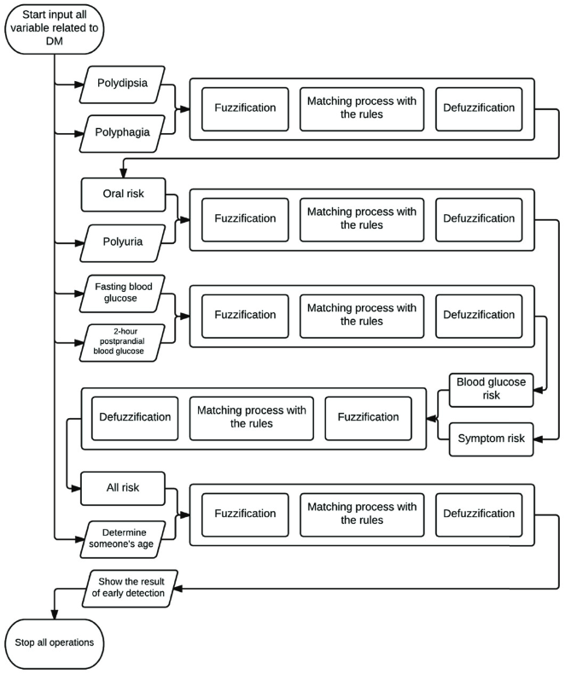
Figure 3. An example of rule-based algorithm for early detection of diabetes mellitus using Fuzzy
Hierarchical Model proposed by Lukmanto and Irwansyah (9).

Application scenarios
The commonest application of machine learning-aided clinical data analysis algorithms is binary classification of DM risk/status (i.e., DM and non-DM) based on health records (60). The rule-based models not only enable the detection of DM at an early stage (20) but also can provide the extracted rules to disclose the relevant risk factors.
Based on these details, the clinicians can make personalized recommendations for DM prevention (normal living, nutrition control, exercise, and medications) (16), and optimize the plans for early clinical intervention (13). Technically, the latest rule-based methods provides some unique advantages, including the possibility of diagnosis with missing values (14), the easy to read result (less rules) to reduce the workload of physicians (19, 27), and the ability of tailoring the accuracy-interpretability trade-off to suit different clinical applications (33). In the future, the rule-based algorithms can be integrated in expert systems to help both physicians and ordinary individuals (31). This will provide an enhanced opportunity for timely and appropriate intervention to apply, which may reduce the incidence of diabetes and its complications (10).

The system is also prospective to be applied to other diseases. Gürbüz and Kılıç use the PIDD, Wisconsin breast cancer, Liver disorders, SPECT heart, and Lung cancer datasets to test the performance of their system with an accuracy of 97% in the first 2 datasets and around 80% for the last three (32). Pourpanah et al. (25) tested their hybrid model QFAM-GA for classification accuracy and number of rules generated on 7 UCI benchmark datasets including Iris, PID, Dermatology, Glass, Sonar, Wine, and Starlog (heart) (61). The performance reaches an average of 90% accuracy in the seven datasets and generated useful explanations targeted each test sample. The results show that the diabetes early prediction system is transplantable for other diseases, which provides the possibility of a universal diagnostic framework.

Limitations and future directions
Firstly, the majority of recent studies still reply on the PID dataset. Many new datasets are small-scale and not open-access. The limited data availability affects the reliability of the rule-based machine learning algorithms and their applicability to different cohorts. Secondly, current rule-based methods focus on fuzzy system and its optimizations, with a scarce of more complex methods. The genre and performance of state-of-the-art is not comparable with deep learning methods. Finally, there is a scarce of in-depth investigation of pathophysiological factors, e.g., comorbidities of DM and cardiovascular diseases, in the current rule-based methods from a clinical perspective.
Some improvements can be considered in future studies (Figure 4). First, the rule-based methods can be improved by using large-scale multi-center datasets, which is available using internet-of-things (IoT) via wearable sensors, mobile access, and cloud services. Second, advanced algorithms can be developed on standardized techniques (e.g., for data preprocessing), combination with non-knowledge based methods to enhance the reliability of the results, and clinical/medical knowledge representation to achieve high applicability in different cohorts. Finally, the interoperability with the electronic heath record (EHR) system can be improved to achieve real-world application.

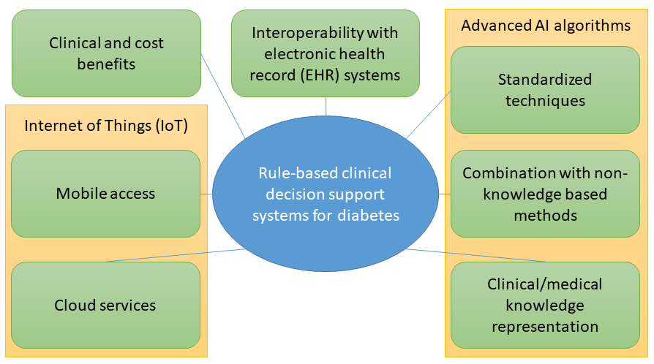
Figure 4. Recommendations for rule-based rule-based clinical decision support systems for diabetes (7)

Conclusion
The rule-based machine learning algorithms brought in revolutionary changes in the AI-assisted diagnosis of DM by improving the explainability of the results. However, the current studies are mainly based on small-scale datasets and simple structures. In the future, the rule-based machine learning algorithms can be improved by using large-scale datasets and more complex structures with better clinical knowledge interpretation, where internet-of-things and advanced artificial intelligence algorithms will play a key role.

Reference:
1. American Diabetes A. Diagnosis and Classification of Diabetes Mellitus. Diabetes Care. 2010;33(Supplement_1):S62-S9.
2. Organization WH. Global report on diabetes: World Health Organization; 2016.
3. O’Connell JM, Manson SM. Understanding the Economic Costs of Diabetes and Prediabetes and What We May Learn About Reducing the Health and Economic Burden of These Conditions. Diabetes Care. 2019;42(9):1609-11.
4. Herman WH, Ye W, Griffin SJ, Simmons RK, Davies MJ, Khunti K, et al. Early Detection and Treatment of Type 2 Diabetes Reduce Cardiovascular Morbidity and Mortality: A Simulation of the Results of the Anglo-Danish-Dutch Study of Intensive Treatment in People With Screen-Detected Diabetes in Primary Care (ADDITION-Europe). Diabetes Care. 2015;38(8):1449-55.
5. Chaki J, Thillai Ganesh S, Cidham SK, Ananda Theertan S. Machine learning and artificial intelligence based Diabetes Mellitus detection and self-management: A systematic review. Journal of King Saud University - Computer and Information Sciences. 2022;34(6, Part B):3204-25.
6. Fregoso-Aparicio L, Noguez J, Montesinos L, García-García JA. Machine learning and deep learning predictive models for type 2 diabetes: a systematic review. Diabetology & Metabolic Syndrome. 2021;13(1):148.
7. Papadopoulos P, Soflano M, Chaudy Y, Adejo W, Connolly TM. A systematic review of technologies and standards used in the development of rule-based clinical decision support systems. Health and Technology. 2022;12(4):713-27.
8. Chang V, Bailey J, Xu QA, Sun Z. Pima Indians diabetes mellitus classification based on machine learning (ML) algorithms. Neural Computing and Applications. 2022.
9. Lukmanto RB, Irwansyah E. The Early Detection of Diabetes Mellitus (DM) Using Fuzzy Hierarchical Model. Procedia Computer Science. 2015;59:312-9.
10. Han L, Luo S, Yu J, Pan L, Chen S. Rule extraction from support vector machines using ensemble learning approach: an application for diagnosis of diabetes. IEEE Journal of Biomedical Health Informatics. 2014;19(2):728-34.
11. Fetaji B, Fetaji M, Ebibi M, Ali M, editors. Predicting Diabetes Using Diabetes Datasets and Machine Learning Algorithms: Comparison and Analysis. Emerging Technologies in Computing; 2021 2021//; Cham: Springer International Publishing.
12. Muhammad LJ, Algehyne EA, Usman SS. Predictive Supervised Machine Learning Models for Diabetes Mellitus. SN Computer Science. 2020;1(5):240.
13. Hao J, Luo S, Pan L. Rule extraction from biased random forest and fuzzy support vector machine for early diagnosis of diabetes. Scientific Reports. 2022;12(1):9858.
14. Ramezani R, Maadi M, Khatami SM. A novel hybrid intelligent system with missing value imputation for diabetes diagnosis. Alexandria Engineering Journal. 2018;57(3):1883-91.
15. Hayashi Y, Yukita S. Rule extraction using Recursive-Rule extraction algorithm with J48graft combined with sampling selection techniques for the diagnosis of type 2 diabetes mellitus in the Pima Indian dataset. Informatics in Medicine Unlocked. 2016;2:92-104.
16. Nagaraj P, Deepalakshmi P. An intelligent fuzzy inference rule-based expert recommendation system for predictive diabetes diagnosis. International Journal of Imaging Systems and Technology. 2022;32(4):1373-96.
17. Karthikeyan R, Geetha P, Ramaraj E, editors. Rule Based System for Better Prediction of Diabetes. 2019 3rd International Conference on Computing and Communications Technologies (ICCCT); 2019; Chennai, India: IEEE.
18. Lukmanto RB, Suharjito, Nugroho A, Akbar H. Early Detection of Diabetes Mellitus using Feature Selection and Fuzzy Support Vector Machine. Procedia Computer Science. 2019;157:46-54.
19. Feng T-C, Li T-HS, Kuo P-H. Variable coded hierarchical fuzzy classification model using DNA coding and evolutionary programming. Applied Mathematical Modelling. 2015;39(23):7401-19.
20. Aamir KM, Sarfraz L, Ramzan M, Bilal M, Shafi J, Attique M. A Fuzzy Rule-Based System for Classification of Diabetes. Sensors [Internet]. 2021; 21(23).
21. G SS, K M. Diagnosis of diabetes diseases using optimized fuzzy rule set by grey wolf optimization. Pattern Recognition Letters. 2019;125:432-8.
22. Azad C, Bhushan B, Sharma R, Shankar A, Singh KK, Khamparia A. Prediction model using SMOTE, genetic algorithm and decision tree (PMSGD) for classification of diabetes mellitus. Multimedia Systems. 2022;28(4):1289-307.
23. Cheruku R, Edla DR, Kuppili V, Dharavath R. RST-BatMiner: A fuzzy rule miner integrating rough set feature selection and Bat optimization for detection of diabetes disease. Applied Soft Computing. 2018;67:764-80.
24. Cheruku R, Edla DR, Kuppili V. SM-RuleMiner: Spider monkey based rule miner using novel fitness function for diabetes classification. Computers in Biology and Medicine. 2017;81:79-92.
25. Pourpanah F, Lim CP, Saleh JM. A hybrid model of fuzzy ARTMAP and genetic algorithm for data classification and rule extraction. Expert Systems with Applications. 2016;49:74-85.
26. Porebski S, Straszecka E, editors. Rule extraction using the dempster-shafer theory in the medical diagnosis support. 2016 Third European Network Intelligence Conference (ENIC); 2016; Wroclaw, Poland: IEEE.
27. Beloufa F, Chikh MA. Design of fuzzy classifier for diabetes disease using Modified Artificial Bee Colony algorithm. Computer Methods and Programs in Biomedicine. 2013;112(1):92-103.
28. Mehra P, Seth T, Muhuri PK, editors. Generating quality IF-THEN rules for diabetes using linguistic summarization. 2020 IEEE International Conference on Fuzzy Systems (FUZZ-IEEE); 2020; Glasgow , United Kingdom: IEEE.
29. Sagir AM, Sathasivam S, editors. Design of a modified adaptive neuro fuzzy inference system classifier for medical diagnosis of Pima Indians Diabetes. 24th National Symposium on Mathematical Sciences: Mathematical Sciences Exploration for the Universal Preservation; 2017; Kuala Terengganu, Malaysia: AIP Publishing LLC.
30. Abiyev RH, Altiparmak H. Type-2 Fuzzy Neural System for Diagnosis of Diabetes. Mathematical Problems in Engineering. 2021;2021:5854966.
31. Mansourypoor F, Asadi S. Development of a Reinforcement Learning-based Evolutionary Fuzzy Rule-Based System for diabetes diagnosis. Computers in Biology and Medicine. 2017;91:337-52.
32. Gürbüz E, Kılıç E. A new adaptive support vector machine for diagnosis of diseases. Expert Systems. 2014;31(5):389-97.
33. Lahsasna A, Seng WC. An improved genetic-fuzzy system for classification and data analysis. Expert Systems with Applications. 2017;83:49-62.
34. Wang Q, Cao W, Guo J, Ren J, Cheng Y, Davis DN. DMP_MI: an effective diabetes mellitus classification algorithm on imbalanced data with missing values. IEEE Access. 2019;7:102232-8.
35. Al-Behadili HNK, Ku-Mahamud KR, Sagban R, editors. Rule pruning techniques in the ant-miner classification algorithm and its variants: A review. 2018 IEEE Symposium on Computer Applications & Industrial Electronics (ISCAIE); 2018; Penang Island, Malaysia: IEEE.
36. Lee MA, Takagi H, editors. Integrating design stage of fuzzy systems using genetic algorithms. Second IEEE International Conference on Fuzzy Systems; 1993; San Francisco, California, United States: IEEE.
37. Shi Y, Eberhart RC, editors. Fuzzy adaptive particle swarm optimization. 2001 Congress on Evolutionary Computation; 2001; Seoul, Korea: IEEE.
38. Anuradha, Singh A, Gupta G. ANT_FDCSM: A novel fuzzy rule miner derived from ant colony meta-heuristic for diagnosis of diabetic patients. Journal of Intelligent & Fuzzy Systems. 2019;36:747-60.
39. Chen T, Shang C, Su P, Keravnou-Papailiou E, Zhao Y, Antoniou G, et al. A Decision Tree-Initialised Neuro-fuzzy Approach for Clinical Decision Support. Artificial Intelligence in Medicine. 2021;111:101986.
40. Barakat N, Bradley AP, Barakat MNH. Intelligible support vector machines for diagnosis of diabetes mellitus. IEEE Transactions on Information Technology in Biomedicine. 2010;14(4):1114-20.
41. Simoes MG, Bose BK, Spiegel RJ. Design and performance evaluation of a fuzzy-logic-based variable-speed wind generation system. IEEE Transactions on Industry Applications. 1997;33(4):956-65.
42. Ganji MF, Abadeh MS. A fuzzy classification system based on Ant Colony Optimization for diabetes disease diagnosis. Expert Systems with Applications. 2011;38(12):14650-9.
43. Zadeh LA. Fuzzy sets. Information and Control. 1965;8(3):338-53.
44. Sivanandam SN, Sumathi S, Deepa SN. Introduction. In: Sivanandam SN, Sumathi S, Deepa SN, editors. Introduction to Fuzzy Logic using MATLAB. Berlin, Heidelberg: Springer Berlin Heidelberg; 2007. p. 1-9.
45. Ishibuchi H, Nozaki K, Yamamoto N, Tanaka H. Selecting fuzzy if-then rules for classification problems using genetic algorithms. IEEE Transactions on Fuzzy Systems. 1995;3(3):260-70.
46. Roubos H, Setnes M. Compact and transparent fuzzy models and classifiers through iterative complexity reduction. IEEE Transactions on Fuzzy Systems. 2001;9(4):516-24.
47. Ishibuchi H, Yamamoto T. Fuzzy rule selection by multi-objective genetic local search algorithms and rule evaluation measures in data mining. Fuzzy Sets and Systems. 2004;141(1):59-88.
48. Nozaki K, Ishibuchi H, Tanaka H. Adaptive fuzzy rule-based classification systems. IEEE Transactions on fuzzy Systems. 1996;4(3):238-50.
49. Ishibuchi H, Nakashima T, Murata T. Performance evaluation of fuzzy classifier systems for multidimensional pattern classification problems. IEEE Transactions on Systems, Man, Cybernetics, Part B
1999;29(5):601-18.
50. Ishibuchi H, Nozaki K, Tanaka H. Distributed representation of fuzzy rules and its application to pattern classification. Fuzzy Sets and Systems. 1992;52(1):21-32.
51. Chakraborty D, Pal NR. A neuro-fuzzy scheme for simultaneous feature selection and fuzzy rule-based classification. IEEE Transactions on Neural Networks. 2004;15(1):110-23.
52. Altıparmak H, Abiyev R, Tüzünkan M, editors. Diagnosis of Diabetes Using Type-2 Fuzzy System. Intelligent and Fuzzy Systems; 2022 2022.07.02; Cham: Springer International Publishing.
53. Abadeh MS, Habibi J, Soroush E, editors. Induction of fuzzy classification systems using evolutionary ACO-based algorithms. First Asia International Conference on Modelling & Simulation (AMS'07); 2007; Phyket, Thailand: IEEE.
54. Karahoca A, Karahoca D, Kara A, editors. Diagnosis of diabetes by using adaptive neuro fuzzy inference systems. 2009 Fifth International Conference on Soft Computing, Computing with Words and Perceptions in System Analysis, Decision and Control; 2009; Famagusta, North Cyprus: IEEE.
55. Ganji MF, Abadeh MS, editors. Using fuzzy ant colony optimization for diagnosis of diabetes disease. 2010 18th Iranian Conference on Electrical Engineering; 2010; Isfahan, Iran: IEEE.
56. Noble WS. What is a support vector machine? Nature Biotechnology. 2006;24(12):1565-7.
57. Yue C, Xin L, Kewen X, Chang S, editors. An intelligent diagnosis to type 2 diabetes based on QPSO algorithm and WLS-SVM. 2008 International Symposium on Intelligent Information Technology Application Workshops; 2008; Shanghai, China: IEEE.
58. Soliman OS, AboElhamd EJapa. Classification of diabetes mellitus using modified particle swarm optimization and least squares support vector machine. 2014.
59. Thaiyalnayaki KJIJoCR, Review. Classification of diabetes using deep learning and svm techniques. 2021;13(01):146.
60. Momenzadeh A, Shamsa A, Meyer JG. Clinical interpretation of machine learning models for prediction of diabetic complications using electronic health records. medRxiv. 2022:2022.03.11.22272039.
61. UCI machine learning repository. http://archive.ics.uci.edu/ml/index.php, accessed Oct. 15, 2022 2010 [

