3.12 Clinical application of machine learning and Internet-of-Things in comorbid depression among diabetic patients
Contributing authors: Haipeng Liu ¹, Wenlin Zhang ², Choon Hian Goh ³, Fangyu Dai ⁴, Soban Sadiq ⁵, Gary Tse ^{5,6,7}
1 Research Centre for Intelligent Healthcare, Coventry University, Coventry, UK
2 College of Pharmaceutical Sciences, Zhejiang University, Hangzhou, China
3 Department of Mechatronics and Biomedical Engineering, Faculty of Engineering and Science, Universiti Tunku Abdul Rahman, Selangor, Malaysia
4 Department of Neurology, Zhoushan Hospital, Wenzhou Medical University, Zhoushan, Zhejiang Province, China
5 Kent and Medway Medical School, University of Kent and Canterbury Christ Church University, Canterbury, UK
6 Tianjin Key Laboratory of Ionic-Molecular Function of Cardiovascular Disease, Department of Cardiology, Tianjin Institute of Cardiology, Second Hospital of Tianjin Medical University, Tianjin, China
7 School of Nursing and Health Studies, Hong Kong Metropolitan University, Hong Kong, China

Introduction: the comorbidity of diabetes and depression
Diabetes mellitus (DM) is a chronic medical condition in which the body cannot properly regulate glucose levels in the blood. In the long term, if uncontrolled, DM patients are at increased risks of developing complications including ischaemic heart disease, stroke, kidney failure, blindness, neuropathy, and death (1-3). It is estimated that 40% of DM patients have developed at least three comorbidities while majority have at least one comorbid chronic disease (4).
DM-related mental and psychological co-morbidities have become one of the major factors influencing healthcare costs (5). Several studies have demonstrated a link between diabetes and mental health problems (6, 7). A wide range of psychiatric disorders, including major depressive disorder, bipolar and related disorders, schizophrenia spectrum and other psychotic disorders, anxiety disorders, sleep disorders, eating disorders and stress-related disorders are more prevalent in people with diabetes compared to the general population (7). In particular, the risk of developing depression is increased by 2-3 folds in people with DM (8). Depression is a common mental disorder and a leading cause of disability worldwide, with a prevalence about 5% globally (9). Depression frequently occurs together with diabetes where the prevalence ranges from 8% to 18% (10), which is about twice of that among the people without diabetes (11).
Even since 1675, Willis already recognised that people who experienced “significant life stress, sadness or long sorrow” were more likely to suffer from diabetes (12). However, until recently the diabetes-depression comorbidity is still unrecognized and untreated in approximately two thirds of the patients with it (13). Although the underlying pathology is not fully understood, some risk factors associated with the presence of depression in patients with diabetes have been identified, including high body mass index (BMI), female sex, younger age, not having a spouse, poor social support, lower education, low socioeconomic status, poor glycemic control, presence of diabetic complications, presence of medical comorbidity, physical impairment and previous history of depression (10, 14, 15).
DM-related depression is associated with poorer glycemic control and increased risk of complications (16-18). A meta-analysis of studies published until 2018 showed that, compared with the patients with diabetes alone, the patients with diabetes-depression comorbidity have a 47.9% increase in cardiovascular mortality, 36.8% increase in coronary heart disease and 32.9% increase in stroke (19). It is also associated with a decrease in quality of life and an increase in healthcare spending (20). Depressive symptoms can interfere with diabetes management and increase the risk of diabetes-related complications, which may shift priority away from diabetes and complicate patients’ self-management (4). Depression can lead to cognitive decline and further aggravate the vicious cycles of self-care ability, leading to insufficient physical exercise, non-adherence to diet, and irregular intake of medications (21). To reduce the burden of diabetes-related depression, the early recognition, effective treatment, and proper management of depressive comorbidity among people with diabetes is essential.

Diagnosis, treatment, and management of diabetes-depression comorbidity: gaps in automatic and standardized approaches
The diagnosis of diabetes-depression comorbidity requires a thorough assessment of medical and psychological symptoms. A comprehensive physical examination, laboratory tests, and psychometric assessments should be conducted to identify the presence of comorbidity. The presence of depressive symptoms should be assessed using standardized diagnostic interviews, such as the Diagnostic and Statistical Manual of Mental Disorders (DSM-IV) criteria or the Patient Health Questionnaire (PHQ-9) (22, 23). These diagnostic methods depends on multiple professional tests, patient’s presence and clinician’s expertise. The early and accurate diagnosis of diabetes-depression comorbidity is still an unmet need especially in some low-income countries that lack the resources – both human and financial – to detect depression (24).
The treatment and management of diabetes-depression comorbidity typically involves a combination of pharmacological, psychotherapeutic, and lifestyle interventions. Antidepressants, psychotherapy, and lifestyle modifications are important components of a successful treatment plan. Pharmacological interventions are often tailored patient-specifically and monitored closely by a physician. Psychotherapy, such as cognitive behavioral therapy, can help address underlying psychological issues and provide the patient with coping strategies. Pharmacological and psychological interventions are effective in improving depression symptoms, while collaborative care programs that simultaneously manage both disorders showed higher efficiency in improving diabetes-related outcomes (25). Limited evidence from short-to-medium term Randomised controlled trials (RCTs) predominantly conducted in the USA suggests that collaborative care for depression significantly improves both depression and glycaemia outcomes, independently, in people with comorbid depression and diabetes (26). Finally, lifestyle modifications, such as regular physical activity, healthy eating, and stress management, can help to improve overall wellbeing and relieve the depression in patients with diabetes (27). The management of diabetes-depression comorbidity involves monitoring of both medical and psychological symptoms. The depression improvement had a favourable effect on glycaemic control that was weight independent (28). Regular follow-up visits and laboratory tests can help to monitor the progression of diabetes, while psychological assessments can help to monitor the progression of depression. In addition, patient education and support, such as peer support groups, can effectively improve the self-management and ensure timely intervention.
In summary, diabetes-depression comorbidity is a major health concern, and requires a comprehensive assessment, treatment, and management plan, which involved various healthcare and medical resources. Through the use of pharmacological, psychotherapeutic, and lifestyle interventions, as well as regular monitoring, it is possible to successfully manage this condition and improve the quality of life for those affected. However, there is currently no automated, standardized approach to predict depression comorbidity in diabetes. Further research is needed to develop effective interventions for the treatment of diabetes-related depression comorbidity.

Machine learning and Internet-of-Things: possible solutions?
The advancement of wearable devices, wireless transmission technologies, and computer science commonly laid technical groundwork for the remote monitoring, automatic diagnosis, data-enhanced decision making, and daily management of different diseases based on Internet of Things (IoT) and artificial intelligence (AI).
The Internet of Things (IoT) is a system of wireless, interrelated, and connected digital devices that can collect, send, and store data automatically over a network without requiring human-to-human or human-to-computer interaction (29). An IoT enables cloud-based computations and real-time transmission of data among difference devices including wearable sensors, medical devices, smartphones, and computers. AI technologies, especially machine learning (ML) algorithms empower the IoT to demystify hidden patterns in bulk data for optimal prediction and recommendation systems. Different hybrid ML frameworks have been developed which work smartly to improve the decision-making process in healthcare area (30). Advanced ML algorithms can effectively integrate different data sources, including the patient data collected from patient electronic health records (EHR), Internet of Things (IoT) sensor devices, wearables and mobile devices, web-based information and social media, providing the possibilities of personalized healthcare and precise medicine (31). Recent years, there is an increase in IoT-based solutions in the prediction, treatment, and management of diabetes (32-36). However, there is a scarce of comprehensive review on the application of ML and IoT in diabetes-depression comorbidity.
To comprehensively explore the application of ML and IoT in the diagnosis, treatment, and management of the comorbidity between diabetes and depression, a systematic search of the literature was conducted in some mainstream databases (Web of Science, PUBMED/MEDLINE, Medscape, IEEE Xplore Digital Library, and Scopus) were searched for all articles containing the keywords "diabetes comorbid depression" and "diabetes-depression comorbidity" in titles and/or abstract. The computer-based searches combined free text, subject headings for the medical field, and the aforementioned combination of keywords, with results limited to publications in English. Studies published between 1 January 2014 and 1 September 2022 were included to ensure updated results. The search yielded 277 articles, of which 21 were selected for further analysis and review. The results revealed some important aspects of the state-of-the-art: remote health monitoring and diagnosis, disease awareness and prevention, disease risk analysis, and health data fusion. The commonest ML techniques in existing studies include support vector machine, artificial neural networks, and decision tree. The findings of this review can provide an in-depth understanding of the role of IoT and ML techniques in detecting diabetes-depression comorbidity, and help inform future research in this field. Furthermore, the potential of using IoT+ML to predict comorbidity of diabetes and depression should be further explored to develop more effective methods for disease management.
In the following sections, some state-of-the-art applications of IoT and ML in healthcare monitoring especially in DM-relevant areas were reviewed to explore the potential of using IoT+ML to predict comorbidity of diabetes and depression.

Machine learning-based solutions

a) Detection/prediction of comorbid depression in diabetic patients
The early and accurate detection/prediction of diabetes-depression comorbidity is the commonest application of IoT+ML techniques in recent studies. In order to predict comorbid depression in diabetic patients, Jin et al. developed a benchmark model in 2014 using ridge multinomial logistic regression and the C4.5 decision tree induction algorithms (37). Their data were retrieved from The Diabetes-Depression Care-management Adoption Trial (DCAT) (38, 39), a sizable clinical trial that examined three approaches for providing depression care to diabetic patients. Each of the 1406 patient records in this dataset has 29 baseline variables and one outcome. The variables can be categorized into demographic, diabetes severity, functional status, depression severity, clinical trial-related, and patient satisfaction variables. The outcome was a three-level depression severity measurement derived from the depression symptoms at 6 months: not depressed, mild/moderate depression, or major/severe depression. Based on the extensive dataset produced by DCAT, the authors developed the ML models to predict depression severity. The prediction models were evaluated using three-fold cross validation. The percentage of correctly classified test instances served as a measure of the prediction models' overall accuracy. The benchmark model achieved the accuracy of 72.5%. The models provided reference for the development of clinically applicable predictive analytics tools.
In 2015, Jin et al. proposed a generalized multilevel regression model based on a longitudinal dataset from a recent large-scale clinical trial to predict depression severity and the presence of major depression among patients with diabetes (40). The severity of depression was measured by the Patient Health Questionnaire PHQ-9 score. Two time-invariant and 10 time-varying predictors were selected for the model. The study evaluated the predictive accuracy of PHQ-9 scores and the classification ability of the predicted scores by using root-mean-square errors (RMSE) and areas under the receiver operating characteristic (ROC) curve. The results showed that incorporating historical records and using them to update the model may improve both predictive accuracy and classification ability of the predicted scores. Subject-specific predictions (for individual patients with historical records) achieved RMSE about 4 and areas under the ROC curve about 0.9, which were better than population-average predictions.
In 2019 Jin et al. again investigated the use of patient-reported data to match depression screening intervals with depression risk profiles in primary care patients with diabetes (41). The study used a regression-based data mining technique to analyze 53 demographics, clinical variables, and patient-reported variables to develop three prediction models for major depression at 6, 12, and 18 months from baseline. Five patient-reported variables were selected in the prediction models: (1) Patient Health Questionnaire 2-item score; (2) the Sheehan Disability Scale; (3) previous problems with depression; (4) the diabetes symptoms scale; and (5) emotional burden of diabetes. The depression prediction models had an AUROC>0.80, and the analysis demonstrated that leveraging patient-reported data and prediction models can help improve identification of high-risk patients and clinical decisions about the depression screening interval for diabetes patients.
A temporal deep learning model with a transformer architecture was presented in a 2021 study by Meng et al. to perform bidirectional representation learning on EHR sequences for depression prediction (42). The model combined five disparate and highly dimensional data sources from the EHR and processed them temporally for the prediction of chronic diseases at different prediction windows. Compared to the best baseline model, the model predicted depression with the highest increases in precision-recall area under the curve (PRAUC) from 0.70 to 0.76. The model's interpretability was also enhanced by the self-attention weights in each sequence, which showed how different codes interacted internally (42). This study demonstrates that this model can accurately and interpretably predict depression with high precision, which may be helpful for developing clinical decision support systems for chronic disease screening and early detection in the future.

b) Estimation of healthcare cost/burden: guidance for public health policy
The machine learning algorithms can estimate/predict the healthcare cost and burden caused by diabetes-depression comorbidity, which provide reference for public health policy. In 2015, Jin et al. proposed a clinical forecasting model to predict comorbid depression among patients with diabetes and explored the efficacy of a model-based screening policy that aimed to save resources and time (43). Four machine learning models were trained and validated using data from two safety-net clinical trials, and logistic regression was chosen as the ultimate forecasting model. Compared to mass screening, the model-based policy can save approximately 50-60% of provider resources and time at the price of missing identification of about 30% of patients with depression. Two other heuristic-based partial screening policies identified depression at rates similar to those of the model-based policy, but cost more in resources and time (43).
Huang et al. (2017) investigated health care utilization and expenditure among diabetic patients with and without depression disorder in Taiwan using the National Health Insurance claims database with multiple logistic regression analysis (44). The study revealed that health care utilization and expenditures for diabetic patients with depression were significantly higher than those without depression. Additionally, gender, complications, time, and urbanization were associated with health care utilization and expenditures. The findings of the study can contribute to the understanding of the impact of depression on health care utilization and expenditure among diabetic patients.
Nowakowska et al. (2019) examined the comorbidity burden of type 2 diabetes mellitus (T2DM) in a large primary care cohort from England (45). Using the Clinical Practice Research Datalink (CPRD) linked with the Index of Multiple Deprivation (IMD) data, the authors identified the patients with T2DM, and calculated the crude and age-standardised prevalence of 18 chronic conditions present at and after the T2DM diagnosis. Moreover, they used linear regression to forecast the prevalence of 6 commonest conditions in 2027. Finally, agglomerative hierarchical clustering was used to identify comorbidity clusters. The results of the study suggest that comorbidities are common among the aimed population, with high between-patient variability in comorbidity patterns where mental health is a growing concern. The findings of this study emphasise the need for patient-centred healthcare and interventions that target both physical and mental health in this population.
In 2021, Brüne et al. aimed to investigate the health care use and costs in individuals with diabetes with and without comorbid depression in Germany (46). Data from a 2013 cross-sectional survey of randomly sampled members of a nationwide German statutory health insurance (SHI) provider with diabetes was longitudinally linked with SHI data covering four quarters before and after the survey to analyze health care use and costs. Multiple regression models were used to estimate the association between depression groups and the cost categories total health care, inpatient care, outpatient care, and medication and assistive devices. The cost ratios (CRs) with adjustment for sociodemographic/socioeconomic factors and comorbidities was calculated for two groups with and without symptoms or diagnosis of depression. The results showed that annual mean total health care costs were higher for patients with comorbid depression than without, and that excess costs were highly associated with comorbidities, with mental health care costs being very low for patients without depression and relatively low for those with depression. Thus, this study suggests that costs are significantly higher when comorbid depression is present either as symptoms or diagnosed, though excess costs for mental health services were rather low (46).
These findings commonly provide direct reference for public health policy to improve the quality of healthcare service for patients with diabetes-depression comorbidity at lower cost.

c) Healthcare monitoring and daily management
The possibility of using passive smartphone sensing to enhance risk stratification for patients with diabetes and depression was explored by Sarda et al. in 2019 (47). In this cross-sectional observational study, a smartphone-sensing app was used to measure the activity, mobility, sleep, and communication behaviors of 47 participants with diabetes. The supervised classification predictive modelling was performed with derived sensing variables as input to construct and compare classifiers that could risk-stratify people with diabetes based on symptoms of depression. The study discovered that those with diabetes and self-reported major depressive disorder symptoms had lower levels of social interaction and activity. The extreme gradient boosting machine-learning classifier provided the best performance with an average cross-validation accuracy of 79.07% in classifying the depressive symptoms. The results indicated that risk stratification for diabetes and depression patients may be enhanced by passive smartphone sensing, and highlighted the importance of IoT+ML strategy in mental healthcare for diabetes patients (47).

Other state-of-the-art methods
There are also studies that use other methods than machine learning ways to find relationships between diabetes and depression. In 2016, Egede et al. examined the medical expenditure associated with depression, diabetes, and diabetes-depression comorbidity in the United States between 2004 and 2011 (48). By analyzing the data from the Medical Expenditures Panel Survey, the authors found that, after adjusting for socio-demographic factors, compared with the people without any of the conditions, the incremental costs of diabetes and depression and were only $2692 and $2654, whilst that of diabetes-depression comorbidity was $6037. Meanwhile, the annual average aggregate costs of diabetes, depression, and diabetes-depression comorbidity were $150.1 billion, $238.3 billion, and $77.6 billion (48). This study provides evidence that cost savings can be achieved through more effective screening, diagnosis, and treatment of depression among patients with diabetes.
Hay et al. in 2017 investigated the cost-effectiveness of an information and communication technology (ICT)-facilitated depression care management program in a sample of 1406 safety-net primary care predominantly Hispanic/Latino patients with T2DM recruited in a nonrandomized Diabetes-Depression Care-Management Adoption Trial (DCAT) (49). The technology-facilitated care delivery model provided low-intensity periodic calls to the patient to assess their depression symptoms and treatment adherence. Results showed a significant improvement in depression-free days (DFDs) and quality-adjusted life-years (QALYs) for patients in the technology-facilitated care group compared to the usual care group, with medical costs being significantly lower for the technology-facilitated care group. The authors concluded that the ICT-facilitated depression care delivery model was cost-effective compared to the supported care delivery model and dominant compared to the usual care delivery model (49).
In 2019, Cummings et al. explored the effects of cognitive behavioral therapy (CBT) plus lifestyle counseling on hemoglobin A1c (HbA1c) levels in rural adults with T2DM and comorbid depressive or regimen-related distress (RRD) symptoms (50). The study was a randomized controlled trial of a 16-session severity-tailored CBT plus lifestyle counseling intervention compared to usual care. Results showed that the intervention was associated with marginally significant improvements in HbA1c levels, as well as significantly greater improvements in RRD, depressive symptoms, self-care behaviors, and medication adherence across 12 months. Analyses showed a correlation between improvements in HbA1c levels and improvements in RRD and adherence. The authors concluded that tailored CBT with lifestyle counseling can improve behavioral outcomes, and may improve HbA1c levels in rural patients with T2D and comorbid depression and/or RRD symptoms (50).
The study by Prigge et al. in 2022 investigates the risk of all-cause and cause-specific mortality among participants with either diabetes or depression, or both, in a large prospective cohort study in the UK (51). The results showed that the risk of all-cause, cancer and other mortality among those with comorbid depression and diabetes exceeded the sum of the risks due to diabetes and depression alone, indicating a synergistic effect on mortality risk, largely driven by deaths from cancer and causes other than circulatory disease and cancer (51). This highlights the importance of considering comorbid depression and diabetes together in order to accurately assess mortality risk.

Role of IoT+ML solutions: towards early diagnosis, individualized treatment, and long-term management
The IoT-based solutions have been successfully applied in the management of diabetes. As shown in Figure 1, the wearable sensors, smartphones, and computers can be connected by IoT and generate real-time healthcare and medical data for cloud computing, including physiological parameters including vital signs (heart rate, respiratory rate, body temperature, blood pressure), glucose, contextual data (i.e. environmental temperature) and self-reported measures. Demographic features and lab test results can also enrich the dataset. Such data would be in graphical and human-readable forms for end users such as medical specialists and patients to promote bidirectional communication between patients and doctors, offering tele-care and telemedicine platforms for multi-faceted self-management of diabetes (52).
The presence of comorbidities can influence how diabetes patients prioritize their self-management behaviors (4). It is thus important to consider comorbidity type and severity when managing diabetes patients. The course of depression in patients with diabetes is chronic and severe; even with successful treatment, as many as 80% of patients with diabetes will experience depression relapse over a 5-year period (13). Therefore, by enabling real-time monitoring and cloud storage of longitudinal healthcare data, the IoT-based solutions can meet the needs for long-term management and early diagnosis of comorbid depression. Especially, effective self-management is an major challenge among older adult DM patients of which many have difficulty adhering to guidelines, where IoT and sensor-based home monitoring can predict the glucose level and improve the daily management, generating a novel idea called “persuasive sensing” (36). Some wearable devices (Figure 2), e.g., smartwatches, enable the daily monitoring of the users’ mental health status especially in low-resources areas, where the IoT-based solutions provide the possibilities of real-time monitoring and efficient distribution of limited medical resources (53). Some biomarkers extracted from the signals can reflect neural activities, e.g., photoplethysmographic pulse waveform (54, 55), heart rate variability derived from electrocardiogram (56), therefore, might provide useful information of depression. Big data analytics, e.g., streaming analytics, enables the cloud-based real-time data analysis for early detection, feedback, and intervention for comorbid depression (57).
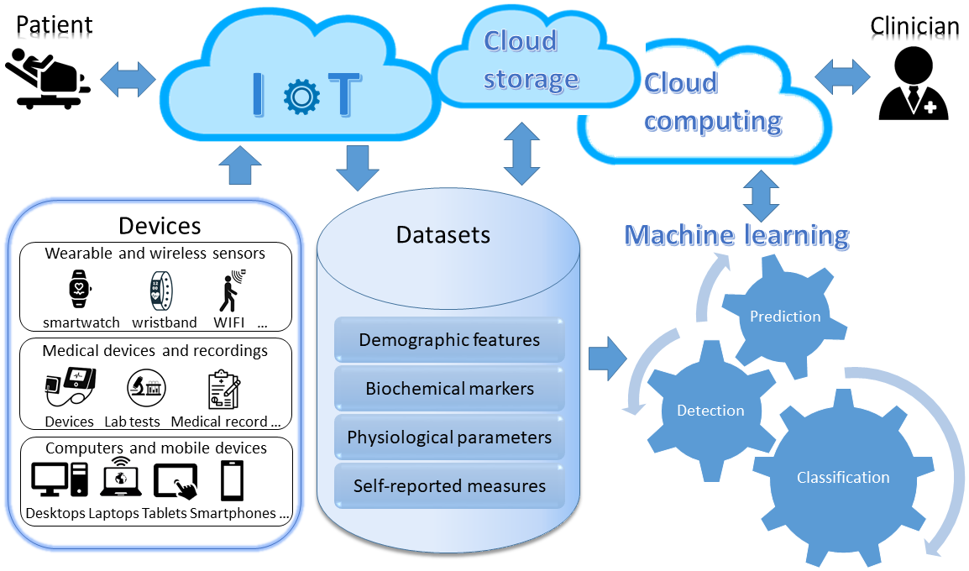 Figure 1. Workflow of Internet-of-Things (IoT) and machine learning in diabetes-depression comorbidity.
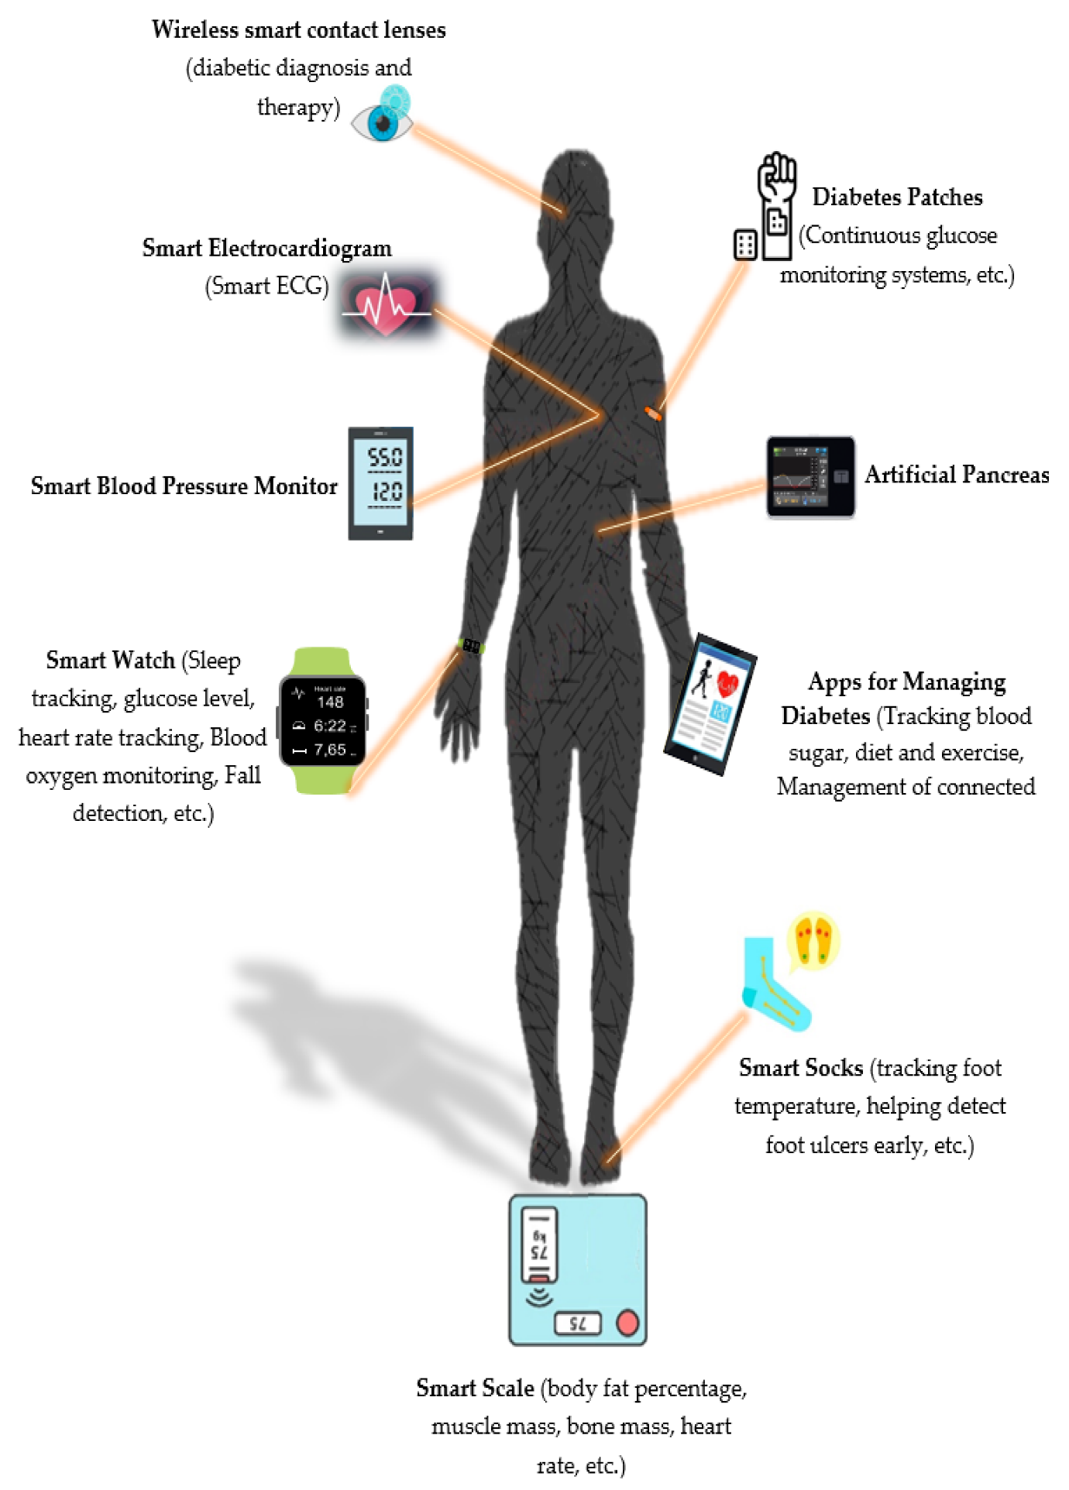
Figure 2. Wearable devices used to support patients with diabetes, by Makroum et al., 2020 (58).
As reported in recent studies, machine learning has been widely applied in early detection/diagnosis of depression in patients with diabetes, with the results used as reference for individualized treatment and management, whereas, there is a scarce of studies in predicting/evaluating the treatment efficacy. On the one hand, patient-tailored treatment has been recommended by recent guidelines of DM treatment (28). Machine learning can accurately predict blood glucose levels even in non-standard diabetic patients or those with rarer types of diabetes, providing direct reference for individualized insulin treatment (59). Furthermore, recently improvement in wearable sensors enables more multi-dimensional and multimodal data that could enrich DM-related physiological information and improve the performance of machine learning algorithms in guiding individualized treatment and management of diabetes (58). The application of machine learning in relevant areas, e.g., food identification and classification, can provide reference for different aspects of daily management for patients with DM (60). On the other hand, in a recent systematic review on the prediction of depression treatment outcomes using machine learning, Sajjadian et al. found a negative relationship between study quality and prediction accuracy, combined with a lack of independent replication (61). Therefore, the potential of machine learning applications for personalizing the treatment of depression deserve further exploration.
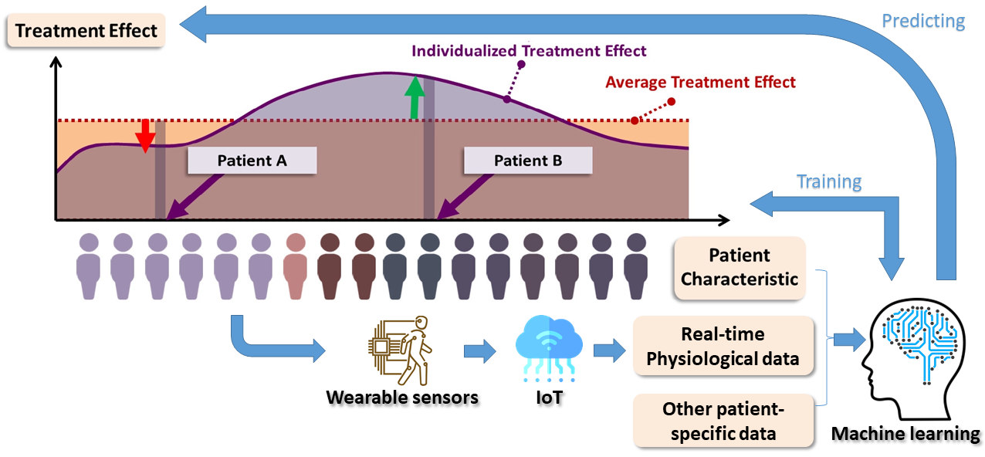
Figure 3. Application of machine learning in predicting individualized treatment effect of diabetes-depression comorbidity, adapted from Bica et al., 2020 (62).

Limitations and future directions
There are some limitations in current studies. First, the proposed methods are highly heterogeneous and not standardized especially in data pre-processing. This leads to the difference in data quality and low portability of the proposed algorithms to other cohorts. Second, as aforementioned, the exploration on individualized treatment and management of depression is limited. In addition, currently studies focus on the clinical application, with the in-depth investigation on the pathophysiology of comorbid depression being neglected. Finally, with limited hardware development, the proposed algorithms have not been integrated into an intact device that enables large-scale production and application.
In future studies, some standardized modules can be developed to ease the pre-processing of data from wearable sensors (e.g., filtering of electrocardiaogram and photoplethysmography) and EHRs (e.g., automatic data cleansing). Secondly, the prediction of individualized treatment efficacy can be explored by utilizing different data types to train and individualize the machine learning models (Figure 3). In addition, based on the multidimensional and multimodal healthcare and medical data, the pathology of diabetes-depression can be investigated. Finally, a hardware system with wireless data transmission function can be developed where machine learning, IoT, and cloud computing can be integrated for real-world application.

Conclusions
Based on wearable sensing technology, IoT and ML are playing an increasingly important role in the diagnosis, treatment, and management of diabetes-depression comorbidity. The IoT+ML solutions provide important reference for clinical practice, while the applications in individualized treatment and pathological investigation deserve more investigation.

References
1. Lee S, Zhou J, Wong WT, Liu T, Wu WKK, Wong ICK, et al. Glycemic and lipid variability for predicting complications and mortality in diabetes mellitus using machine learning. BMC Endocrine Disorders. 2021;21(1):94.
2. Lee S, Zhou J, Guo CL, Wong WT, Liu T, Wong ICK, et al. Predictive scores for identifying patients with type 2 diabetes mellitus at risk of acute myocardial infarction and sudden cardiac death. Endocrinology, Diabetes & Metabolism. 2021;4(3):e00240.
3. Lee S, Zhou J, Leung KSK, Wu WKK, Wong WT, Liu T, et al. Development of a predictive risk model for all-cause mortality in patients with diabetes in Hong Kong. BMJ Open Diabetes Research &amp; Care. 2021;9(1):e001950.
4. Kerr EA, Heisler M, Krein SL, Kabeto M, Langa KM, Weir D, et al. Beyond Comorbidity Counts: How Do Comorbidity Type and Severity Influence Diabetes Patients’ Treatment Priorities and Self-Management? Journal of General Internal Medicine. 2007;22(12):1635-40.
5. Hutter N, Schnurr A, Baumeister H. Healthcare costs in patients with diabetes mellitus and comorbid mental disorders—a systematic review. Diabetologia. 2010;53(12):2470-9.
6. Ducat L, Philipson LH, Anderson BJ. The Mental Health Comorbidities of Diabetes. JAMA. 2014;312(7):691-2.
7. Robinson DJ, Coons M, Haensel H, Vallis M, Yale J-F. Diabetes and Mental Health. Canadian Journal of Diabetes. 2018;42:S130-S41.
8. Roy T, Lloyd CE. Epidemiology of depression and diabetes: A systematic review. Journal of Affective Disorders. 2012;142:S8-S21.
9. Organization WH. Depression and other common mental disorders: global health estimates. World Health Organization; 2017.
10. Andreoulakis E, Hyphantis T, Kandylis D, Iacovides A. Depression in diabetes mellitus: a comprehensive review. Hippokratia. 2012;16(3):205-14.
11. Sartorius N. Depression and diabetes. Dialogues in Clinical Neuroscience. 2018;20(1):47-52.
12. Lloyd CE, Roy T, Nouwen A, Chauhan AM. Epidemiology of depression in diabetes: International and cross-cultural issues. Journal of Affective Disorders. 2012;142:S22-S9.
13. Katon WJ. The Comorbidity of Diabetes Mellitus and Depression. The American Journal of Medicine. 2008;121(11, Supplement 2):S8-S15.
14. Blazer DG, Moody-Ayers S, Craft-Morgan J, Burchett B. Depression in diabetes and obesity: Racial/ethnic/gender issues in older adults. Journal of Psychosomatic Research. 2002;53(4):913-6.
15. Parikh R, Bhargava Y, editors. Lower Socio-Economic Position Associated With Higher Odds Of Diabetes-Depression Comorbidity. 2021 43rd Annual International Conference of the IEEE Engineering in Medicine & Biology Society (EMBC); 2021: IEEE.
16. Kim H, An S-Y, Han S, Kim D, Hong C, Kim Y, et al. The association of diabetes duration and glycemic control with depression in elderly men with type 2 diabetes mellitus. 2019;24(1):17-.
17. Fung AC, Tse G, Cheng HL, Lau ES, Luk A, Ozaki R, et al. Depressive symptoms, co-morbidities, and glycemic control in Hong Kong Chinese elderly patients with type 2 diabetes mellitus. Frontiers in Endocrinology. 2018;9:261.
18. Fung ACH, Tse G, Cheng HL, Lau ESH, Luk A, Ozaki R, et al. Depressive Symptoms, Co-Morbidities, and Glycemic Control in Hong Kong Chinese Elderly Patients With Type 2 Diabetes Mellitus. Front Endocrinol (Lausanne). 2018;9:261.
19. Farooqi A, Khunti K, Abner S, Gillies C, Morriss R, Seidu S. Comorbid depression and risk of cardiac events and cardiac mortality in people with diabetes: A systematic review and meta-analysis. Diabetes Research and Clinical Practice. 2019;156:107816.
20. Jing X, Chen J, Dong Y, Han D, Zhao H, Wang X, et al. Related factors of quality of life of type 2 diabetes patients: a systematic review and meta-analysis. Health and Quality of Life Outcomes. 2018;16(1):189.
21. Sullivan MD, Katon WJ, Lovato LC, Miller ME, Murray AM, Horowitz KR, et al. Association of Depression With Accelerated Cognitive Decline Among Patients With Type 2 Diabetes in the ACCORD-MIND Trial. JAMA Psychiatry. 2013;70(10):1041-7.
22. Khamseh ME, Baradaran HR, Javanbakht A, Mirghorbani M, Yadollahi Z, Malek M. Comparison of the CES-D and PHQ-9 depression scales in people with type 2 diabetes in Tehran, Iran. BMC Psychiatry. 2011;11(1):61.
23. de Jonge P, Alonso J, Stein DJ, Kiejna A, Aguilar-Gaxiola S, Viana MC, et al. Associations between DSM-IV mental disorders and diabetes mellitus: a role for impulse control disorders and depression. Diabetologia. 2014;57(4):699-709.
24. Leone T, Coast E, Narayanan S, de Graft Aikins A. Diabetes and depression comorbidity and socio-economic status in low and middle income countries (LMICs): a mapping of the evidence. Globalization and Health. 2012;8(1):39.
25. Oladeji BD, Gureje O. The Comorbidity between Depression and Diabetes. Current Psychiatry Reports. 2013;15(9):390.
26. Atlantis E, Fahey P, Foster J. Collaborative care for comorbid depression and diabetes: a systematic review and meta-analysis. BMJ Open. 2014;4(4):e004706.
27. de Groot M, Doyle T, Kushnick M, Shubrook J, Merrill J, Rabideau E, et al. Can Lifestyle Interventions Do More Than Reduce Diabetes Risk? Treating Depression in Adults With Type 2 Diabetes With Exercise and Cognitive Behavioral Therapy. Current Diabetes Reports. 2012;12(2):157-66.
28. Huang ES. Management of diabetes mellitus in older people with comorbidities. BMJ. 2016;353:i2200.
29. Kelly JT, Campbell KL, Gong E, Scuffham P. The Internet of Things: Impact and Implications for Health Care Delivery. J Med Internet Res. 2020;22(11):e20135.
30. Aldahiri A, Alrashed B, Hussain W. Trends in Using IoT with Machine Learning in Health Prediction System. Forecasting [Internet]. 2021; 3(1):[181-206 pp.].
31. Ahamed F, Farid F, editors. Applying internet of things and machine-learning for personalized healthcare: Issues and challenges. 2018 International Conference on Machine Learning and Data Engineering (iCMLDE); 2018; Sydney, Australia IEEE.
32. Bhatia M, Kaur S, Sood SK, Behal V. Internet of things-inspired healthcare system for urine-based diabetes prediction. Artificial Intelligence in Medicine. 2020;107:101913.
33. Al-Taee MA, Al-Nuaimy W, Al-Ataby A, Muhsin ZJ, Abood SN, editors. Mobile health platform for diabetes management based on the Internet-of-Things. 2015 IEEE Jordan conference on applied electrical engineering and computing technologies (AEECT); 2015; Amman, Jordan: IEEE.
34. Barata JJR, Munoz R, Silva RDDC, Rodrigues JJ, De Albuquerque VHC. Internet of Things based on electronic and mobile health systems for blood glucose continuous monitoring and management. IEEE Access. 2019;7:175116-25.
35. Rodríguez-Rodríguez I, Rodríguez J-V, Molina-García-Pardo J-M, Zamora-Izquierdo M-Á, Martínez-Inglés M-TM. A Comparison of Different Models of Glycemia Dynamics for Improved Type 1 Diabetes Mellitus Management with Advanced Intelligent Analysis in an Internet of Things Context. Applied Sciences [Internet]. 2020; 10(12).
36. Chatterjee S, Byun J, Dutta K, Pedersen RU, Pottathil A, Xie H. Designing an Internet-of-Things (IoT) and sensor-based in-home monitoring system for assisting diabetes patients: iterative learning from two case studies. European Journal of Information Systems. 2018;27(6):670-85.
37. Jin H, Wu S, editors. Developing depression symptoms prediction models to improve depression care outcomes: preliminary results. Proceedings of the 2nd International Conference on Big Data and Analytics in Healthcare; 2014; Singapore.
38. Wu S, Ell K, Gross-Schulman SG, Sklaroff LM, Katon WJ, Nezu AM, et al. Technology-facilitated depression care management among predominantly Latino diabetes patients within a public safety net care system: Comparative effectiveness trial design. Contemporary Clinical Trials. 2014;37(2):342-54.
39. Wu S, Vidyanti I, Liu P, Hawkins C, Ramirez M, Guterman J, et al. Patient-Centered Technological Assessment and Monitoring of Depression for Low-Income Patients. The Journal of Ambulatory Care Management. 2014;37(2).
40. Jin H, Wu S, Vidyanti I, Di Capua P, Wu B. Predicting Depression among Patients with Diabetes Using Longitudinal Data: A Multilevel Regression Model. Methods of Information in Medicine. 2015;54(06):553-9.
41. Jin H, Wu S. Use of Patient-Reported Data to Match Depression Screening Intervals With Depression Risk Profiles in Primary Care Patients With Diabetes: Development and Validation of Prediction Models for Major Depression. JMIR Form Res. 2019;3(4):e13610.
42. Meng Y, Speier W, Ong MK, Arnold CW. Bidirectional representation learning from transformers using multimodal electronic health record data to predict depression. IEEE Journal of Biomedical and Health Informatics. 2021;25(8):3121-9.
43. Jin H, Wu S, Di Capua P. Development of a Clinical Forecasting Model to Predict Comorbid Depression Among Diabetes Patients and an Application in Depression Screening Policy Making. Preventing chronic disease. 2015;12:E142.
44. Huang C-J, Hsieh H-M, Chiu H-C, Wang P-W, Lee M-H, Li C-Y, et al. Health Care Utilization and Expenditures of Patients with Diabetes Comorbid with Depression Disorder: A National Population-Based Cohort Study. Psychiatry Investigation. 2017;14(6):770-8.
45. Nowakowska M, Zghebi SS, Ashcroft DM, Buchan I, Chew-Graham C, Holt T, et al. The comorbidity burden of type 2 diabetes mellitus: patterns, clusters and predictions from a large English primary care cohort. BMC Medicine. 2019;17(1):145.
46. Brüne M, Linnenkamp U, Andrich S, Jaffan-Kolb L, Claessen H, Dintsios C-M, et al. Health Care Use and Costs in Individuals With Diabetes With and Without Comorbid Depression in Germany: Results of the Cross-sectional DiaDec Study. Diabetes Care. 2020;44(2):407-15.
47. Sarda A, Munuswamy S, Sarda S, Subramanian V. Using Passive Smartphone Sensing for Improved Risk Stratification of Patients With Depression and Diabetes: Cross-Sectional Observational Study. JMIR Mhealth Uhealth. 2019;7(1):e11041.
48. Egede LE, Bishu KG, Walker RJ, Dismuke CE. Impact of diagnosed depression on healthcare costs in adults with and without diabetes: United States, 2004–2011. Journal of Affective Disorders. 2016;195:119-26.
49. Hay JW, Lee P-J, Jin H, Guterman JJ, Gross-Schulman S, Ell K, et al. Cost-Effectiveness of a Technology-Facilitated Depression Care Management Adoption Model in Safety-Net Primary Care Patients with Type 2 Diabetes. Value in Health. 2018;21(5):561-8.
50. Cummings DM, Lutes LD, Littlewood K, Solar C, Carraway M, Kirian K, et al. Randomized Trial of a Tailored Cognitive Behavioral Intervention in Type 2 Diabetes With Comorbid Depressive and/or Regimen-Related Distress Symptoms: 12-Month Outcomes From COMRADE. Diabetes Care. 2019;42(5):841-8.
51. Prigge R, Wild SH, Jackson CA. Depression, diabetes, comorbid depression and diabetes and risk of all-cause and cause-specific mortality: a prospective cohort study. Diabetologia. 2022;65(9):1450-60.
52. Albahri AS, Alwan JK, Taha ZK, Ismail SF, Hamid RA, Zaidan AA, et al. IoT-based telemedicine for disease prevention and health promotion: State-of-the-Art. Journal of Network and Computer Applications. 2021;173:102873.
53. Kumar P, Chauhan R, Stephan T, Shankar A, Thakur S, editors. A machine learning implementation for mental health care. Application: smart watch for depression detection. 2021 11th International Conference on Cloud Computing, Data Science & Engineering (Confluence); 2021; Noida, India: IEEE.
54. Khalid SG, Ali SM, Liu H, Qurashi AG, Ali U. Photoplethysmography temporal marker-based machine learning classifier for anesthesia drug detection. Medical & Biological Engineering & Computing. 2022;60(11):3057-68.
55. Kontaxis S, Gil E, Marozas V, Lazaro J, Garcia E, Posadas-de Miguel M, et al. Photoplethysmographic waveform analysis for autonomic reactivity assessment in depression. IEEE Transactions on Biomedical Engineering. 2020;68(4):1273-81.
56. Schiweck C, Piette D, Berckmans D, Claes S, Vrieze E. Heart rate and high frequency heart rate variability during stress as biomarker for clinical depression. A systematic review. Psychological Medicine. 2019;49(2):200-11.
57. Ara A, Ara A, editors. Case study: Integrating IoT, streaming analytics and machine learning to improve intelligent diabetes management system. 2017 International conference on energy, communication, data analytics and soft computing (ICECDS); 2017; Chennai, India: IEEE.
58. Makroum MA, Adda M, Bouzouane A, Ibrahim H. Machine Learning and Smart Devices for Diabetes Management: Systematic Review. Sensors [Internet]. 2022; 22(5).
59. Shifrin M, Siegelmann H. Near-optimal insulin treatment for diabetes patients: A machine learning approach. Artificial Intelligence in Medicine. 2020;107:101917.
60. Sowah RA, Bampoe-Addo AA, Armoo SK, Saalia FK, Gatsi F, Sarkodie-Mensah B. Design and Development of Diabetes Management System Using Machine Learning. International Journal of Telemedicine and Applications. 2020;2020:8870141.
61. Sajjadian M, Lam RW, Milev R, Rotzinger S, Frey BN, Soares CN, et al. Machine learning in the prediction of depression treatment outcomes: a systematic review and meta-analysis. Psychological Medicine. 2021;51(16):2742-51.
62. Bica I, Alaa AM, Lambert C, van der Schaar M. From Real-World Patient Data to Individualized Treatment Effects Using Machine Learning: Current and Future Methods to Address Underlying Challenges. Clinical Pharmacology & Therapeutics. 2021;109(1):87-100.

