# 15. Predicting treatment response in diabetes: the roles of machine learning-based models

Contributing authors: Wenfei Wu ¹, Wenlin Zhang ², Soban Sadiq ³, Gary Tse ^{4,5} , Syed Ghufran Khalid ⁶, Yimeng Fan ⁷, Haipeng Liu ⁸

1 College of Life Sciences, Zhejiang University, Hangzhou, China
2 College of Pharmaceutical Sciences, Zhejiang University, Hangzhou, China
3 Kent and Medway Medical School, Canterbury Christ Church and University of Kent, Canterbury, United Kingdom
4 Tianjin Key Laboratory of Ionic-Molecular Function of Cardiovascular Disease, Department of Cardiology, Tianjin Institute of Cardiology, Second Hospital of Tianjin Medical University, Tianjin, China
5 School of Nursing and Health Studies, Hong Kong Metropolitan University, Hong Kong, China
6 Faculty of Health, Education and Life Sciences, Birmingham City University, Birmingham, United Kingdom
7 Department of Ophthalmology, The First Affiliated Hospital of Xi’an Jiaotong University, Xi’an, China
8 Research Centre for Intelligent Healthcare, Coventry University, Coventry CV1 5FB, United Kingdom

Correspondence to:
Haipeng Liu, PhD
Research Centre of Intelligent Healthcare, Faculty of Health and Life Science, Coventry University, Coventry CV1 5FB, United Kingdom
Email: haipeng.liu@coventry.ac.uk

Introduction
Diabetes mellitus (DM) is defined as a group of metabolic disorders characterized by a high blood sugar level (hyperglycemia) over a prolonged period of time mainly caused by abnormal insulin secretion and/or action. There are two major clinical types, type 1 and type 2 diabetes (T1D and T2D). T2D appears to be the most common type (90% of all diabetic patients), mainly characterized by insulin resistance and various degrees of β-cell dysfunction, whereas T1D is thought to associated with β-cell destruction and absolute insulin deficiency (1). The underlying etiology of DM is not fully understood while some risk factors have been identified, e.g., overweight or obese, high-risk race/ethnicity, hypertension, and physical inactivity.
Hemoglobin A1c (HbA1c) is a widely used marker to reflect average blood glucose levels in 2-3 months. It quantifies the percentage of hemoglobin in the bloodstream that has been post-translationally glycosylated. HbA1c test plays a critical role in the management of the patient with diabetes, with targeting HbA1c of 53 mmol/mol (7.0%) or less (2). In addition to its role as a marker of glycemic control, in 2009, HbA1c was recommended for diagnosis of diabetes with cut point of 6.5% (3). HbA1c has been accepted as a standard evaluation for the treatment efficacy of DM. Recent works have used HbA1c as well as measures of its variability for risk prediction (4-8).
Based on evidence-based medical guidelines, personal physiological indicators, and life behavior data, the prediction of DM treatment response can provide specific suggestions on self-management for the patients, and real-time reference in clinical intervention and medication for the clinicians. Digital management that puts patients at the center and relies on data-driven decision-making is an ideal solution for diabetes management. The remarkable advances in biotechnology, bioinformatics and data science have led to a significant production of data related to diabetes treatments, such as high throughput genetic data and clinical information generated from large Electronic Health Records (EHRs). EHRs enable researchers to perform epidemiological analysis based on large datasets, and help patients to better understand their own health condition (9). Among the traditional data processing methods in developing prediction models of treatment response, logistic regression is a mainstream one with successful applications in DM (10). However, traditional methods could not handle big data to afford future clinical applications.
Recent development of artificial intelligence (AI) provides this possibility to fill this research gap. The application of machine learning and data mining methods in biosciences is presently, more than ever before, vital and indispensable in efforts to transform intelligently all available information into valuable knowledge. Based on advanced computing techniques (e.g., cloud computing) and artificial intelligence (AI) algorithms (e.g., artificial neural networks and ensemble learning methods), researchers have initially explored the prediction of the symptoms of DM and relevant complications, as well as the treatment response. However, there are limited studies based on AI algorithms to establish models and predicting treatment response in diabetes.
Hence, in the framework of this study, efforts were made to review the current literature on machine learning and data mining approaches in diabetes research, focusing on the prediction of treatment response.

Research strategy
We conducted this literature-based review by searching through PUBMED/MEDLINE and Web of Science databases. The query was “machine learning AND (diabetes OR diabetes mellitus) AND therapeutic effect”. All the items with relevant information in the title, abstracts and keywords were selected. Studies published from 1 January 2012 to 1 September 1 2022 were included. A total of 131 items were initially identified. All recovered articles were inspected manually. Articles that did not contain machine learning methods, for instance, articles with simple statistical analyses and other irrelevant results, were excluded. Manual inspection further narrowed down to 10 articles.

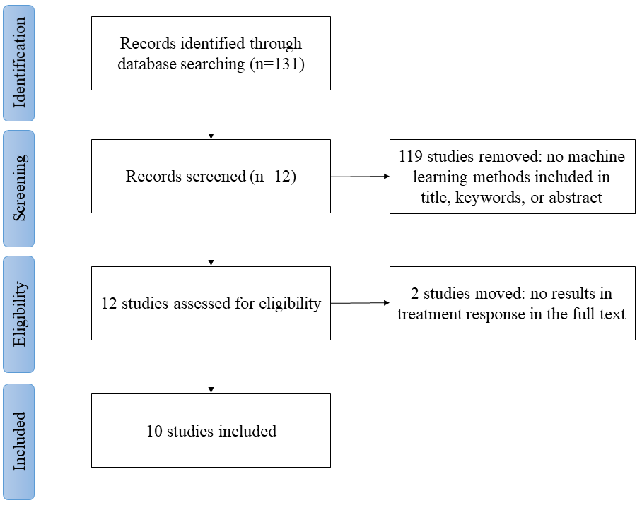
Fig 1 Flowchart of literature screening

Results
### Types of diabetes
The articles collected are all about T2D. This may be largely due to the fact that T2D is the commonest type. In addition, the T2D patients have more severe symptoms, for which the clinical intervention and the prediction of treatment response is more important.

Table 1. Summary of the datasets in included studies.
Study | Dataset | Number of included subjects | Data type | Pre-processing | Data availability
Eghbali-Zarch et al. 2019 (11) | National U.S. Health Plan | 37501 | medical claims, pharmacy claims, laboratory data, and eligibility information | N/A | Yes
Murphree et al. 2018 (12) | Administrative claims data across the continental U.S. from years 1994–2009 release by a health care company | 12,147 | HbA1c at baseline,  demographics, and comorbidities | Patients with HbA1c measurements less than 5.7% were excluded prior to metformin prescription.  The cohort was pre-screened to remove recording errors. | No
Huang et al. 2021 (13) | Two T2D metabolomics datasets from Shanghai Jiao Tong University Affiliated Sixth People’s Hospital | 116 | 2 h plasma glucose (2hPG), anthropometric traits and fasting plasma glucose (FPG) | N/A | No
Kang et al. 2018 (14) | Electronic medical records (EMR) data collected from Seoul National University Hospital | 3169 (45,384 prescription instances) | personal characteristics and medical condition,  prescription of anti-diabetic drugs and other drugs | N/A | No
Koren et al. 2019 (15) | Electronic medical charts of Maccabi Health Services, the second largest health service organization in Israel | 499 (from 26 537) | weight, age, BMI, and smoking status | Patients and controls were matched in age, weight, BMI etc except for medication. | No
Oikonomou et al. 2022 (16) | Datasets collected for CANVAS and CANVAS-R trials available through the Yale University Open Data Access Project | 4327 | 126 variables including demographic data, biochemical test results, and medical history.  75 features were selected for algorithm training., The top 15 features were used to create an easy-to-use clinical model | The variables with >20% missingness were excluded (35 removed). Pairwise correlations were calculated across variables to avoid collinearity (16 removed). | original data not available, resultant diagnostic tool available
Wang et al. 2020 (17) | Multicenter datasets collected from 27 hospitals in 6 cities across North China from 2016-2017 | 2787 | Basic information, biochemical indices, and diabetes-related data | All data from the questionnaire were thoroughly scrutinized, and missing or illogical options were reassessed and modified. | No
Yang et al. 2020 (18) | Taiwan’s National Health Insurance Research Database | 19853 | The composite CVD event, three-point major adverse cardiovascular event (MACE), and all-cause mortality. | N/A | Yes
Yang et al. 2021 (19) | A 5% random sample of Medicare beneficiaries from 2012–2016 in the U.S. | 13904 | Sociodemographic information, diabetes duration, comorbidities, and other medications | The beneficiaries who did not have continuous Medicare Part D enrolment in the year prior to index date or during the follow-up period were excluded. | No
Zou et al. 2022 (20) | Data from five randomised, double-blinded, multi-centre clinical trials available on Yale University Open Data Access (YODA) Project | 6365 | Randomised, double-blinded, multicentre clinical trials of canagliflozin: homeostasis model assessment for beta-cell function and for insulin resistance (HOMA2-%B and HOMA2-IR), body mass index (BMI), HbA1c and age | Five features were excluded for being missing in more than 20% of samples or being in high collinearity with existing variables (Pearson coefficient >0.7). Skew variables were log10-transformed. Missing data were generated by multiple imputations. | Yes

### Comparison of data types
The majority of the included studies are based on longitudinal observations, where control groups are uncommon. The data used in these studies can be divided into three categories. Medical insurance and its claims data consist the mainstream database studies (Table 1) (11, 12, 15, 18). Another category is clinical data including biochemical test results (13, 17). In addition, Kang et al. used the prescription data collected from a local hospital (14).

#### a. Medical and pharmacy claims
Eghbali-Zarch et al. (11) and Murphree et al. (12) used the National U.S. Health Plan dataset which contains medical claims, pharmacy claims, and demographic data. Koren et al. (15) and Yang et al. (18) used the datasets extracted from the electronic medical charts of Maccabi Health Services which is the second largest health service organization in Israel insuring over 2 million members, and the National Health Insurance Research Database of Taiwan, respectively. These are medical health insurance data, which differ in items and structure between different countries. All four datasets have sample sizes above 10,000. This type of dataset has an advantage in time series analysis. Time series analysis is a specific method of analyzing a sequence of data points collected over an interval of time. In time series analysis, analysts record data points at consistent intervals over a set period of time rather than recording the data points intermittently or randomly. These datasets often include long-term inclusive recordings no less than ten years. For example, the National U.S. Health Plan database includes various data for approximately 1.4 million persons across the continental United States spanning the years 1994–2009.

#### b. Clinical dataset with physiological and biochemical indicators

On the clinical dataset, Huang et al. developed their own T2D metabolomics datasets from Shanghai Jiao Tong University Affiliated Sixth People’s Hospital (13). They collected 2-hour plasma glucose (2h-PG), anthropometric traits and fasting plasma glucose (FPG) index, but the sample size was less than 1000. Wang et al. (17) collected the data of the first five outpatients on a daily basis from January 2016 to December 2017, with 2787 consecutive patients who met the inclusion and exclusion criteria were eventually included. Their data types include basic information (sex, age, smoking status, alcohol consumption, marital status, etc.), biochemical indices, and diabetes-related biomarkers (typical characteristics of diabetes, duration of diabetes, exercise, diet, oral medications, complications, hypoglycemia, insulin injection time and injection dosage, etc.). The advantage of clinical data is that there are specific and objective data that can reflect the real-time physiological status of patients. Accordingly, several machine learning models were trained using variables available to predict the effect on HbA1c level to characterize the treatment efficacy.

#### c. Prescription data
Like medical and pharmacy claims, prescription from EHRs can cover a long period of time. Moreover, prescriptions can include the details of medications and the doses. With increasingly popularization of electronic medical records, we can obtain all prescription records for a certain number of people within the year, enabling sequential modeling (15).
An advanced medical data preprocessing framework that enables automatic anonymization, screening of some sensitive information, and data extraction, which can be considered in future studies to overcome potential ethical concerns from the large-scale use EHR data.

### Medications
The medical treatment of diabetes is divided into oral medications and insulin (Figure 2). Oral medications can be classified in two categories according to their mechanisms: 1) those lower blood sugar by stimulating secretion of insulin: sulfonylureas, glinides, DPP-4 inhibitors; and 2) through other mechanisms: biguanide (metformin), thiazolidinediones (TZD), alpha-glucosidase inhibitors, sodium-glucose co-transporter-2 (SGLT2) inhibitors (including canagliflozin), and glucagon-like peptide-1 receptor agonists (GLP-1 RAs).
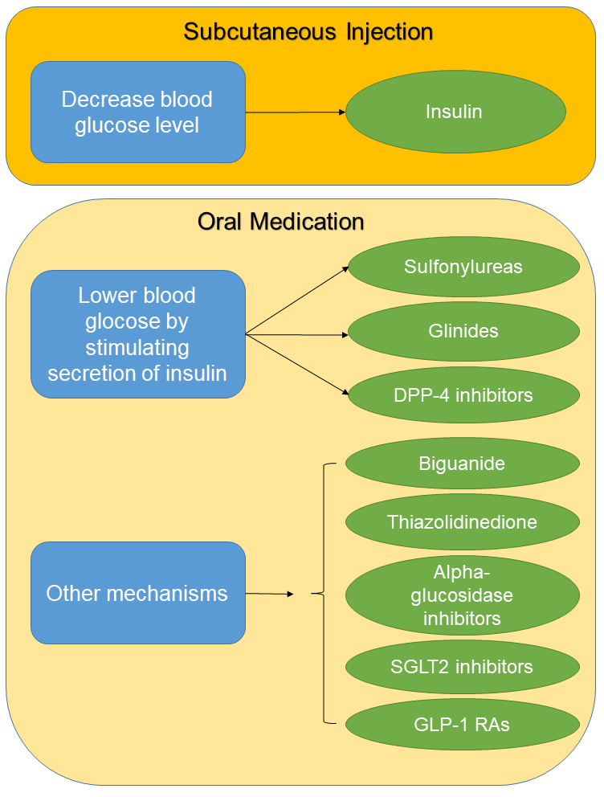
Figure 2. Medication for diabetes mellitus.

- Metformin
All clinical practice guidelines recommend metformin as the first line pharmacologic agent for the management of diabetes, and suggest its use in prediabetes as well (21). Murphree et al. used stacked classifiers for individualized prediction of glycemic control following initiation of metformin therapy in T2D (12).

- Sulfonylurea
Sulfonylurea acts by increasing insulin release from the beta cells in the pancreas (22), and has been widely applied in anti-diabetic medication of T2D (23). Huang et al. analyzed two T2D metabolomics datasets to explore patients’ metabolic responses against the gliclazide, which is a sulfonylurea type of anti-diabetic medication for clinical decision-making(13). They found that the network biomarker selected by the proposed algorithm contains predictive information related to the patients’ suitability for gliclazide treatment, which may provide reference for personalized medicine of T2DM patients by sulfonylurea therapy.

- Dipeptidyl Peptidase-4 (DPP-4) Inhibitors
Glucagon increases blood glucose levels, and DPP-4 inhibitors reduce glucagon and blood glucose levels. The mechanism of DPP-4 inhibitors is to increase incretin levels (24), which inhibits glucagon release and in turn increases insulin secretion, decreases gastric emptying, finally, lowers blood glucose levels. Yang et al. explored heterogeneous treatment effects of the real-world use of DPP-4 inhibitors vs. sulfonylureas on cardiovascular diseases (CVD) and mortality in patients with T2D (18). They found that CVD history, ischemic stroke or transient ischemic attack history, and age were important factors contributing to heterogeneous CVD effects of DPP-4i vs. SU.

- Sodium-glucose Cotransporter 2 (SGLT2) Inhibitors
Canagliflozin is a new SGLT2 inhibitor (25), which is recently recommended as the second-line medication class to be tried after metformin for T2D. Yang et al. used machine learning methods to predict the risk of lower extremity amputations associated with canagliflozin among the diabetes patients treated with canagliflozin (19). Zou et al. investigated if diabetes subgroups, identified by data-driven clustering or supervised machine learning methods, respond differently to canagliflozin (20). The results showed different responses among data-driven clusters of individuals to canagliflozin in glucose lowering but not renal outcome prevention.

- Alpha 1‐adrenoceptor antagonists
The alpha-1 adrenergic receptor antagonists are a family of agents that bind to and inhibit type 1 alpha-adrenergic receptors and thus inhibit smooth muscle contraction. It might have a potential role in treating DM but has not been recommended yet in many guidelines (26). Based on machine learning and big data, Koren et al. compared the treatment efficacy of alpha 1-adrenoceptor antagonists and other medication classes for diabetes control (15). The authors suggested that alpha 1-adrenoceptor antagonists have promising treatment efficacy and warrant further investigation.

- Combinations of anti-diabetic drugs
Current recommendation is sequential addition of oral agents to metformin, which has been the standard of care. Indeed, there are data supporting initial combination therapy but it is not mainstream use (27). To address the research gap in the optimization of combination therapy, Eghbali-Zarch et al. used a Markov decision process to find the best dosing regimen between metformin, sulfonylurea, and insulin (11). The model can be extended to consider other anti-diabetic medications and include the determination of the optimal dosing regimen for diabetes patients as a novel pathway towards precise medicine.

### The result of algorithm
Various AI algorithms have been used in predicting treatment response in DM research, mainly utilized in specified primary studies (Table 2). The neural networks and ensemble tree models are more common, while single decision trees were also investigated.

Table 2. Summary of the algorithms in included studies.

Study | Drugs used in medication | Algorithms | Training/testing dataset (No. of subjects or data segments) | Performance
Eghbali-Zarch et al. 2019 (11) | Metformin, sulfonylurea, and insulin | Markov decision model | N/A | N/A
Murphree et al. 2018 (12) | Metformin | Base models: linear logistic regression, tree-based models (e.g. random forest, stochastic gradient boosting [gbm]), neural networks and several other approaches (e.g. regression splines, discriminant analysis); a non-linear (gbm) stack of all base models, and a linear stack of a subset of maximally diverse models. | 2419/9716 | Five-fold cross-validation, AUC ranged from 0.58 to 0.75
Huang et al. 2021 (13) | Gliclazide | Differential metabolic network construction (DMNC) | 90/26 | On validation dataset: AUC=1.000,  sensitivity=1.000,  specificity=1.000
Kang et al. 2018 (14) | Multiple anti-diabetic and other drugs | Recurrent neural network (RNN) and feed-forward neural network (FNN) | 634/2535 | Five-fold cross-validation,  RNN: AUC=0.8667,  RMSE=0.624  FNN: AUC=0.8494,  RMSE=0.652
Koren et al. 2019 (15) | α1‐adrenoceptor antagonists | Decision trees and  fully connected neural networks | N/A | N/A
Oikonomou et al. 2022 (16) | Canagliflozin | Chained random forests with predictive mean matching | 3427/5808 | Identification of patient phenotypes on testing dataset: HR 0.60 [95% CI 0.41–0.89] vs. 0.99 [95% CI 0.76–1.29]; Pinteraction = 0.04)
Wang et al. 2020 (17) | Insulin and oral hypoglycemic drugs (biguanides, sulfonylureas prolactin, glidides, and DPP-4 inhibitors) | An EN regression was used to address variable collinearity. Three common machine learning algorithms (random forest [RF], support vector machine [SVM], and back propagation artificial neural network [BP-ANN]) were used to simulate and predict blood glucose status. | 1951/836 | RF: AUC=0.73,  sensitivity=0.79,  specificity=0.70;  SVM: AUC=0.61,  sensitivity=0.84,  specificity=0.73;  BP-ANN: AUC=0.70,  sensitivity=0.78,  specificity=0.73
Yang et al. 2020 (18) | Dipeptidyl, peptidase-4 inhibitors, sulfonylureas | Classification and regression tree (CART) | 15882/3971 | AUC:0.646-0.719
Yang et al. 2021 (19) | Canagliflozin | Four machine learning approaches (elastic net, least absolute shrinkage and selection operator [LASSO], gradient boosting machine and random forests) were used to predict LEA risk after canagliflozin initiation | 6953/6951 | AUC=0.81 (95% CI: 0.76, 0.86)
Zou et al. 2022 (20) | Canagliflozin  sitagliptin, glimepiride, and metformin | a spectrum of supervised machine learning methods: linear regression, random forest (RF), XGBoost, k-nearest neighbours (kNN) and support vector machine (SVM) | 5720/636 | The effect of canagliflozin vs placebo on albuminuria progression differed significantly between the high-risk (HR 0.67 [95% CI: 0.57, 0.80]) and low-risk  groups (HR 0.91 [0.75, 1.11]) (Pinteraction=0.016).

#### Ensemble tree models
- EXtreme Gradient Boosting (XGBoost)
EXtreme Gradient Boosting (XGBoost) is an ensemble learning algorithm. Salient features of XGBoost which make it different from other gradient boosting algorithms include clever penalization of trees, a proportional shrinking of leaf nodes, newton boosting and so on (28). Zou et al. used XGBoost to make a post hoc analysis of canagliflozin clinical trial data (20). The maximum internal average area under the receiver-operating characteristic curve (ROC AUC) of the prediction model was achieved using XGBoost (0.71 [95% CI 0.67, 0.74]), compared with other commonly used algorithms including logistic regression, random forest (RF), XGBoost, k-nearest neighbours (kNN) and support vector machine (SVM).

- Gradient boosting machine (GBM)
Gradient Boosting Machine (GBM) is a forward learning ensemble method widely used in regression and classification. A GBM algorithm is trained by taking the probabilities from all base models and using these as predictors. Murphree et al. (12) calculated the probabilities assigned to a randomly chosen subset of the data by the base models where GBM and some other algorithms commonly consist the best integration. The AUC ROC derived from five-fold cross-validation ranged from 0.58 to 0.75.

#### Neural networks
- Recurrent neural network (RNN)
A recurrent neural network (RNN) is a type of artificial neural network which uses sequential data or time series data. Kang et al. (14) employed a RNN to build the sequential prediction model, because of its ability to deal with arbitrary length sequences of vectors as inputs. This makes it suitable for patient-specific modeling, for which each patient has a different number of previous records. The AUC ROC was higher than 0.85 in the prediction of any time interval higher than 3 months.

- Differential metabolic network construction (DMNC)
Huang et al. proposed a novel method named differential metabolic network construction (DMNC) to identify metabolic signals for personalized medicine in the treatment of T2D (13). A network biomarker was defined to assess the patients’ suitability for gliclazide modified-release therapy. It can be effective in the prediction of significant responders from nonsignificant responders, achieving AUC ROC values of 0.893 and 1.000 for the discovery and validation sets, respectively. Compared with the metabolites selected by the other methods, the network biomarker selected by DMNC was more stable and precise to reflect the patient-specific metabolic responses, thereby contributing for the personalized medicine of T2D patients (13).

#### Other algorithms
- Elastic net (EN)
The high-dimensionality (a higher number of features compared to sample size) and the high degree of multi-collinearity are two common challenges in medical data analysis. Elastic net, a type of sparse modelling method has been proposed to address these issues. It combines least absolute shrinkage selector operator (LASSO) and ridge regression regularization in order to remove all unnecessary coefficients but not the informative ones to eliminate certain predictors to avoid overfitting. Elastic net has been applied in treatment response of different diseases (29). Yang et al. used different machine learning algorithms to predict the risk of lower extremity amputations among diabetes patients treated with canagliflozin, where LASSO and EN derived the AUC ROC of 0.812 and 0.771, respectively (19, 30).

Discussion
Currently, there are limited applications of machine learning in predicting treatment response of DM. The existing studies are highly diverse in data source, algorithm, and application scenario. Despite the lack of large-scale validation on different cohorts and real-world applications, these studies demonstrated that AI-assisted data analysis is a promising method in predicting treatment response in diabetes and relevant complications. In following paragraphs, we will summarize the advantages and limitations of the state-of-the-art, and discuss the future directions.

### Advantages
First, the machine learning algorithms showed high efficiency and flexibility in processing heterogeneous datasets. The computational task of predicting drug response is challenging due to the large data size and the diversities of data structure, where AI may bring revolutionary changes in the exploration for computational drug response prediction models and ultimately result in more accurate tools for therapy response (31). Second, some existing models exploited healthcare datasets on provincial or national levels (11, 12, 18), which laid the groundwork for standardized prediction models and subsequent clinical applications via the integration into the existing healthcare systems. Last but not least, many authors compared the performance of different machine learning models, providing reference for the selection of the most suitable algorithm which depends on the application scenario and the dataset’s features. In summary, these preliminary studies commonly consist the first step towards data-driven, patient-specific, and real-time prediction of treatment response of diabetes.

### Limitations
- Limitations in data: the balance between size, diversity, and integrity
The numbers of patients are less than 40000 for all, which becomes are major limitation in the development and validation of more advanced algorithms (13, 15). The Medicare dataset is characterized by a large sample size, however, it is not standardized or specifically designed for clinical research, leading to some difficulties in application. Koren et al. found it difficult to conclude whether women would also benefit from α1‐adrenoceptor antagonists (15). Yang et al. (19) could not rule out residual confounding by unmeasured factors (e.g., prescribers’ preferences or behaviors, patients’ preferences or their lifestyle behaviors, and laboratory data).
In addition, we noted there is lack of studies based on global datasets. though some studies adopted the multi-center data collection strategy. For example, Wang et al. (17) investigate the general status of diabetic blood glucose control and its influencing factors in insulin-treated T2D outpatients based on multicenter data collected from from 27 hospitals in 6 cities across North China. The heterogeneity among different datasets in genes, ethnicity, and physiological conditions play a key role in and understanding the pathology of diabetes and evaluating the treatment efficacy (32). Another challenge for multi-center data analysis is the availability of data. Many datasets, especially locally collected ones, are not open-access and generally cannot be accessed by researchers outside of their collaborations (Table 1).
Another issue is the high exclusion rate in pre-processing, which is inevitable especially for large-scale and longitudinal datasets. For example, Zou et al. excluded more than half of the participants of the CANVAS program when analysing the clinical outcomes (20). There is a high need for advanced algorithms to cope with the recordings with partially missing items to maximally exploit the existing datasets.
Of note, there is a balance among the size, diversity, and integrity of datasets. The existing datasets collected from different centers are highly diverse in content, size, and quality. The quality and integrity of data might be compromised in large-scale long-term data collection. The collection of multicenter datasets based on standardized protocols can be demanding and time-consuming, therefore difficult to cover all the details. These issues deserve more attention in developing the strategies of data collection and analysis.

- Limitations of algorithms
Reliable and efficient data pre-processing is an essential requirement for big data analysis. The prescreening and exclusion of items/features with significant missing data is a common method (12, 16, 19, 20). Koren et al. matched the cases in target and control groups (15). Oikonomou et al. (16) and Zou et al. (20) considered the correlation and collinearity between features in data preprocessing, which paved the way for the preprocessing of multi-center, large-scale, and multimodal medical data. Despite these valuable attempts, there is a lack of well-established framework for in-depth data preprocessing. The methods in existing works are not standardized and often consist of some simple steps.
In general, the performances of current algorithms are sufficiently high for clinical application. The AUC is below or around 0.8 in some studies (12, 17-19). Of note, Huang et al. achieved a high AUC on the validation dataset (approximately 1.00), whilst the method of dataset partition might play an important role in the heterogeneity between subsets for training, validation, and testing, which warrants further attention especially in the cases of small scale datasets and repeated observations (13).
In addition, there is a scarce of deep learning algorithms, partially due to the limited size and heterogeneity of the datasets. Deep learning methods showed promising efficacy in clustering patients with T2D into different clinical profiles and trajectories based on the longitudinal observations (33). The majority of existing studies used common machine learning methods or their combinations, while fine-grained classification and quantitative evaluation call for more attempts in deep learning methods.

### Future directions
Applying the results of model development to reality will facilitate the development of personalized medicine，and include the determination of the optimal dosing regimen for diabetes patients, like identifying the best frequency and dosage of drugs.
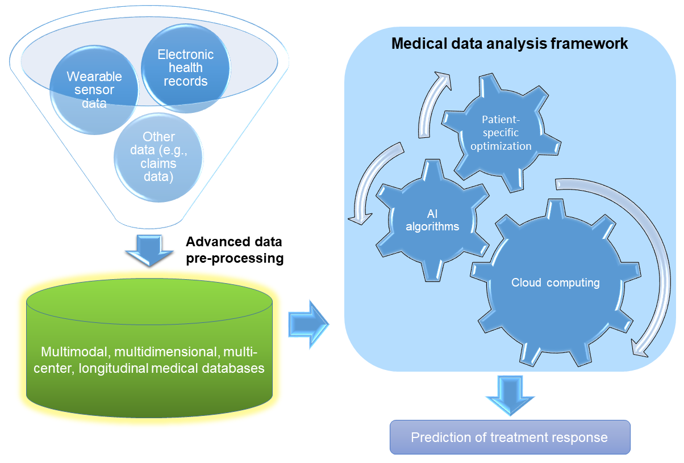
Figure 3. Future computational frameworks for predicting the treatment response of diabetes mellitus.

In terms of model development and disease analysis, we can have the following outlook.
Firstly, some models are based on only a single diabetes drug, the model can be extended to consider other anti-diabetic medications. Meanwhile, understanding which patient subgroups are more likely to respond to treatment and identifying factors associated with response may result in targeted treatment decisions and alter the interpretation of efficacy or effectiveness of results (34). Fine-grained classification of patients, their clinical profiles and trajectories could bring more specific results towards precise medicine (33).

Secondly, based on more high-quality datasets, advanced data preprocessing methods and deep learning algorithms can be developed to analyze multidimensional and multimodal data including genetic data (35), imaging data (36), and quantitative sensing metrics (37), to reveal more pathophysiological factors relevant to the treatment response.
Lastly, regarding data collection, the acquisition of clinical datasets is often require heavy workload. Even with the availability of coded data, acquisition and download may be labor intensive especially where a large population of patients and multiple data fields are required (38). In the future, we could achieve real-time clinical data collection using wearable sensors and internet-of-things (IoT) technology, where wireless sensing, cloud computing, and data security will be essential components. Smart watches and wristbands that detect multiple physiological parameters and biosignals (e.g., heart rate, heart rate variability, blood pressure, electrocardiogram, photoplethysmography, etc.), blood glucose meters, and other portable devices (39) can help generate large-scale longitudinal datasets, allowing instant prediction of treatment response thereby efficiently distributing the medical resources and reducing the disease burden (40).

LIMITATIONS
This is a preliminary review that is highly focused. Specific keywords were used such as “machine learning”. However, there are several additional keywords that could possibly be used concerning specific algorithms, e.g., neural networks or specific tasks (i.e. predictive modeling), that belong to the field of machine learning and data mining without mentioning the current terms. In that sense, the results of this research are not exhaustive.

References
1. American Diabetes A. 2. Classification and Diagnosis of Diabetes: Standards of Medical Care in Diabetes—2019. Diabetes Care. 2018;42(Supplement_1):S13-S28.
2. Diabetologiczne AT. Tests of glycemia in diabetes. 2001(4).
3. International Expert Committee report on the role of the A1C assay in the diagnosis of diabetes. 2013.
4. Lee S, Jeevaratnam K, Liu T, Chang D, Chang C, Wong WT, et al. Risk stratification of cardiac arrhythmias and sudden cardiac death in type 2 diabetes mellitus patients receiving insulin therapy: A population-based cohort study. Clinical Cardiology. 2021;44(11):1602-12.
5. Lee S, Zhou J, Leung KSK, Wu WKK, Wong WT, Liu T, et al. Development of a predictive risk model for all-cause mortality in patients with diabetes in Hong Kong. BMJ Open Diabetes Research &amp; Care. 2021;9(1):e001950.
6. Lee S, Zhou J, Wong WT, Liu T, Wu WKK, Wong ICK, et al. Glycemic and lipid variability for predicting complications and mortality in diabetes mellitus using machine learning. BMC Endocrine Disorders. 2021;21(1):94.
7. Lee S, Liu T, Zhou J, Zhang Q, Wong WT, Tse G. Predictions of diabetes complications and mortality using hba1c variability: a 10-year observational cohort study. Acta Diabetologica. 2021;58(2):171-80.
8. Qi W, Zhang N, Korantzopoulos P, Letsas KP, Cheng M, Di F, et al. Serum glycated hemoglobin level as a predictor of atrial fibrillation: A systematic review with meta-analysis and meta-regression. PLOS ONE. 2017;12(3):e0170955.
9. Neves AL, Freise L, Laranjo L, Carter AW, Darzi A, Mayer E. Impact of providing patients access to electronic health records on quality and safety of care: a systematic review and meta-analysis. BMJ quality & safety. 2020;29(12):1019-32.
10. Tu JV. Advantages and disadvantages of using artificial neural networks versus logistic regression for predicting medical outcomes. Journal of clinical epidemiology. 1996;49(11):1225-31.
11. Eghbali-Zarch M, Tavakkoli-Moghaddam R, Esfahanian F, Azaron A, Sepehri MM. A Markov decision process for modeling adverse drug reactions in medication treatment of type 2 diabetes. Proceedings of the Institution of Mechanical Engineers, Part H: Journal of Engineering in Medicine. 2019;233(8):793-811.
12. Murphree DH, Arabmakki E, Ngufor C, Storlie CB, McCoy RG. Stacked classifiers for individualized prediction of glycemic control following initiation of metformin therapy in type 2 diabetes. Computers in biology and medicine. 2018;103:109-15.
13. Huang X, Zhou Y, Tang H, Liu B, Su B, Wang Q. Differential metabolic network construction for personalized medicine: Study of type 2 diabetes mellitus patients' response to gliclazide-modified-release-treated. Journal of Biomedical Informatics. 2021;118:103796.
14. Kang S. Personalized prediction of drug efficacy for diabetes treatment via patient-level sequential modeling with neural networks. Artificial intelligence in medicine. 2018;85:1-6.
15. Koren G, Nordon G, Radinsky K, Shalev V. Identification of repurposable drugs with beneficial effects on glucose control in type 2 diabetes using machine learning. Pharmacology Research & Perspectives. 2019;7(6):e00529.
16. Oikonomou EK, Suchard MA, McGuire DK, Khera R. Phenomapping-Derived Tool to Individualize the Effect of Canagliflozin on Cardiovascular Risk in Type 2 Diabetes. Diabetes Care. 2022;45(4):965-74.
17. Wang J, Wang M-Y, Wang H, Liu H-W, Lu R, Duan T-Q, et al. Status of glycosylated hemoglobin and prediction of glycemic control among patients with insulin-treated type 2 diabetes in North China: a multicenter observational study. Chinese medical journal. 2020;133(01):17-24.
18. Yang C-Y, Lin W-A, Su P-F, Li L-J, Yang C-T, Ou H-T, et al. Heterogeneous Treatment Effects on Cardiovascular Diseases With Dipeptidyl Peptidase-4 Inhibitors Versus Sulfonylureas in Type 2 Diabetes Patients. Clinical Pharmacology & Therapeutics. 2021;109(3):772-81.
19. Yang L, Gabriel N, Hernandez I, Winterstein AG, Guo J. Using machine learning to identify diabetes patients with canagliflozin prescriptions at high-risk of lower extremity amputation using real-world data. Pharmacoepidemiology and Drug Safety. 2021;30(5):644-51.
20. Zou X, Huang Q, Luo Y, Ren Q, Han X, Zhou X, et al. The efficacy of canagliflozin in diabetes subgroups stratified by data-driven clustering or a supervised machine learning method: a post hoc analysis of canagliflozin clinical trial data. Diabetologia. 2022;65(9):1424-35.
21. Sanchez-Rangel E, Inzucchi SE. Metformin: clinical use in type 2 diabetes. Diabetologia. 2017;60(9):1586-93.
22. Seino S. Cell signalling in insulin secretion: the molecular targets of ATP, cAMP and sulfonylurea. Diabetologia. 2012;55(8):2096-108.
23. Sola D, Rossi L, Schianca GPC, Maffioli P, Bigliocca M, Mella R, et al. State of the art paper sulfonylureas and their use in clinical practice. Archives of Medical Science. 2015;11(4):840-8.
24. Mcintosh CH, Demuth H-U, Pospisilik JA, Pederson R. Dipeptidyl peptidase IV inhibitors: how do they work as new antidiabetic agents? Regulatory peptides. 2005;128(2):159-65.
25. Neal B, Perkovic V, Mahaffey KW, De Zeeuw D, Fulcher G, Erondu N, et al. Canagliflozin and cardiovascular and renal events in type 2 diabetes. New England Journal of Medicine. 2017;377(7):644-57.
26. Traish A, Kim N, Moreland R, Goldstein I. Role of alpha adrenergic receptors in erectile function. International journal of impotence research. 2000;12(1):S48-S63.
27. Vilar L, Canadas V, Arruda MJ, Arahata C, Agra R, Pontes L, et al. Comparison of metformin, gliclazide MR and rosiglitazone in monotherapy and in combination for type 2 diabetes. Arquivos Brasileiros de Endocrinologia & Metabologia. 2010;54:311-8.
28. Chen T, Guestrin C, editors. Xgboost: A scalable tree boosting system. Proceedings of the 22nd acm sigkdd international conference on knowledge discovery and data mining; 2016.
29. Fukushima A, Sugimoto M, Hiwa S, Hiroyasu T. Elastic net-based prediction of IFN-β treatment response of patients with multiple sclerosis using time series microarray gene expression profiles. Scientific Reports. 2019;9(1):1822.
30. Yang L, Gabriel N, Hernandez I, Winterstein AG, Guo J. Using machine learning to identify diabetes patients with canagliflozin prescriptions at high‐risk of lower extremity amputation using real‐world data. Pharmacoepidemiology and Drug Safety. 2021;30(5):644-51.
31. Adam G, Rampášek L, Safikhani Z, Smirnov P, Haibe-Kains B, Goldenberg A. Machine learning approaches to drug response prediction: challenges and recent progress. npj Precision Oncology. 2020;4(1):19.
32. Redondo MJ, Hagopian WA, Oram R, Steck AK, Vehik K, Weedon M, et al. The clinical consequences of heterogeneity within and between different diabetes types. Diabetologia. 2020;63(10):2040-8.
33. Manzini E, Vlacho B, Franch-Nadal J, Escudero J, Génova A, Reixach E, et al. Longitudinal deep learning clustering of Type 2 Diabetes Mellitus trajectories using routinely collected health records. Journal of Biomedical Informatics. 2022;135:104218.
34. Cantrell RA, Alatorre CI, Davis EJ, Zarotsky V, Le Nestour E, Carter GC, et al. A review of treatment response in type 2 diabetes: assessing the role of patient heterogeneity. Diabetes, Obesity and Metabolism. 2010;12(10):845-57.
35. van Leeuwen N, Nijpels G, Becker ML, Deshmukh H, Zhou K, Stricker BHC, et al. A gene variant near ATM is significantly associated with metformin treatment response in type 2 diabetes: a replication and meta-analysis of five cohorts. Diabetologia. 2012;55(7):1971-7.
36. Hui VWK, Szeto SKH, Tang F, Yang D, Chen H, Lai TYY, et al. Optical Coherence Tomography Classification Systems for Diabetic Macular Edema and Their Associations With Visual Outcome and Treatment Responses – An Updated Review. The Asia-Pacific Journal of Ophthalmology. 2022;11(3).
37. Wilkinson ID, Teh K, Heiberg-Gibbons F, Awadh M, Kelsall A, Shillo P, et al. Determinants of Treatment Response in Painful Diabetic Peripheral Neuropathy: A Combined Deep Sensory Phenotyping and Multimodal Brain MRI Study. Diabetes. 2020;69(8):1804-14.
38. Zhou J, Lee S, Wang X, Li Y, Wu WKK, Liu T, et al. Development of a multivariable prediction model for severe COVID-19 disease: a population-based study from Hong Kong. npj Digital Medicine. 2021;4(1):66.
39. Schwartz FL, Marling CR, Bunescu RC. The promise and perils of wearable physiological sensors for diabetes management. Journal of diabetes science and technology. 2018;12(3):587-91.
40. Chakroborty S, Gupta M, Devishamani CS, Patel K, Ankit C, Ganesh Babu TC, et al. Narrative review of artificial intelligence in diabetic macular edema: Diagnosis and predicting treatment response using optical coherence tomography. Indian Journal of Ophthalmology. 2021;69(11).

