RESEARCH ARTICLE
SHORT TITLE: Molecular mechanisms of the HCM β-myosin R403Q mutation
Molecular mechanisms of altered contraction with the β-myosin R403Q mutation in porcine ventricular muscle and a human stem cell-derived cardiomyocyte model
Sonette Steczina^{1,2,3,*}, Saffie Mohran^{1,2,3,*}, Matthew C. Childers^{1,2}, Timothy S. McMillen^{2,4}, Ateeqa Naim⁵, Matvey Pilagov⁵, Marica Dente⁶, Kristina B. Kooiker^{2,3,7,8}, Christian Mandrycky^{1,2}, Khushi Tawde⁹, Jennifer Hesson³, Jing Zhao¹⁰, Julie Mathieu³, J. Manuel Pioner¹¹, Michael A. Geeves⁵, Weikang Ma^{12,13}, Farid Moussavi-Harami^{2,3,7,8}, Neil M. Kad⁵, Michael Regnier^{1,2,3,8,§}

¹Department of Bioengineering, University of Washington, Seattle, WA 98109 USA
²Center for Translational Muscle Research, University of Washington, Seattle, WA 98109, USA
³Institute for Stem Cell and Regenerative Medicine, University of Washington, Seattle WA, 98109, USA
⁴Department of Anesthesiology and Pain Medicine, University of Washington, Seattle, WA 98109, USA
⁵School of Natural Sciences, University of Kent, Canterbury, UK
⁶Department of Experimental and Clinical Medicine, Division of Physiology, University of Florence, Italy
⁷Division of Cardiology, Department of Medicine, University of Washington, Seattle, WA 98109, USA
⁸Center for Cardiovascular Biology, University of Washington, Seattle, WA, USA
⁹Department of Biology, University of Washington, Seattle, WA, USA
¹⁰College of Basic Medical Sciences, Dalian Medical University, Dalian, Liaoning, China
¹¹Department of Biology, University of Florence, Florence, Italy
¹²BioCAT, Department of Biology, Illinois Institute of Technology, Chicago, IL, USA.
¹³Center for Synchrotron Radiation Research and Instrumentation, Illinois Institute of Technology, Chicago, IL, USA.
*Authors contributed equally to this work.
§Correspondance: Michael Regnier – Email: mregnier@uw.edu
- ABSTRACT
The R403Q mutation in the sarcomere protein beta-myosin heavy chain (β-MHC) is a known genetic cause of hypertrophic cardiomyopathy (HCM), associated with ventricular hypercontractility, impaired relaxation, and cardiac arrhythmias. Despite extensive research, the mutations impact on myosin contractile properties remains unclear, likely due, at least in part, to discrepancies across different model systems. In this study, we used a multidisciplinary approach to explore mutational effects using two distinct heterozygous R403Q systems: a Yucatan minipig model and human induced pluripotent stem cell-derived cardiomyocytes (hiPSC-CMs). X-ray diffraction of R403Q minipig ventricular muscle demonstrated reduced order of the thick filament, suggesting destabilization of the inhibited OFF (vs. ON) state of myosin in relaxed muscle, which correlated with elevated force at submaximal calcium. Super-resolution, single-molecule fluorescence microscopy indicated elevated ATPase activity in thick filament zones lacking cardiac myosin binding protein-C (cMyBP-C). Furthermore, R403Q myofibrils exhibited slower activation and relaxation kinetics, with reduced sensitivity to ADP. Molecular dynamics simulations suggested that altered interactions at the actomyosin interface contribute to these effects, rather than changes at the nucleotide binding pocket, typically associated with ADP release. Human engineered heterozygous R403Q hiPSC-CMs exhibited reduced maximal myofibril force, slowed relaxation kinetics, and hypercontraction in engineered heart tissue constructs−consistent with HCM phenotypes observed in the heterozygous porcine model. Our results demonstrate that the R403Q mutation induces contractile dysfunction within the early stages of stem cell derived cardiomyocyte development and in juvenile minipigs, and that hypercontractility and slower contractile kinetics may result from a combination of an increased population of activated (ON) myosin heads and delayed detachment during cross-bridge cycling, respectively.

Keywords: cardiac myosin; cross-bridge cycling; Hypertrophic cardiomyopathy; hypercontractility; myosin recruitment
- INTRODUCTION
The first genetic mutation linked to hypertrophic cardiomyopathy (HCM) was the R403Q missense mutation in the sarcomeric protein beta-myosin heavy chain (β-MHC) (1). For patients with the R403Q mutation and many other HCM-causing mutations in sarcomere proteins, the phenotypic profile often includes ventricular hypercontractility, impaired relaxation, and a high incidence of cardiac arrhythmias (2). Due to the severity of the R403Q mutation, it has been a focus of several studies aimed at uncovering the pathological mechanisms that lead to disease progression.
There have been contradictory reports of the effects of the R403Q mutation on the kinetics of contraction and relaxation, likely due in part to the differences in model systems and myosin isoforms studied. Rodent hearts predominantly express the α-MHC isoform, and measures of myosin activity and product release rates associated with the cross-bridge cycle differ for α-MHC with the R403Q mutation when compared to transgenic mice expressing β-MHC with the R403Q mutation (3, 4). A more recent study using a heterozygous transgenic rabbit model, which expresses the β-MHC isoform, Lowey et al. (5) reported slower in vitro motility, unimpaired ATPase activity, and reduced force and velocities in isolated myofibrils with the heterozygous R403Q mutation. The contractile abnormality of isolated myofibrils with the R403Q mutation is inconsistent with results reported for myofibrils from human myectomy samples, which have consistently shown faster cross-bridge cycling kinetics for R403Q myofibrils compared to mutation negative control human myofibrils (6, 7). Furthermore, Witjas-Paalberends et al. proposed that the R403Q mutation significantly decreases myosin head efficiency, suggesting that myosin heads cycle faster and consume more ATP to generate a similar amount of force compared to controls (7). The faster myofibril cross-bridge cycling rates in human myectomy tissue is consistent with results from an earlier study on isolated β-MHC from human HCM R403Q patients, as determined by an in vitro motility assay (8). This study also reported a shorter power-stroke step duration, measured via single-molecule laser trap, which the authors postulated was due to altered ADP release or destabilization of strong actomyosin interactions. Other reports on ADP release have been contradictory and are also likely affected by the model system and myosin isoform used (4, 9), but destabilization of the actomyosin binding surface has been suggested from follow-up studies (9, 10).
The contradictory results among mouse models, transgenic rabbits, and human myectomy samples motivated the generation of a large animal model of the heterozygous R403Q mutation with a rapidly developing HCM phenotype of hypercontractility, hypertrophy, and an approximately equal ratio of wildtype and mutant protein (11-13). This model has been used as a tool to study the low ATPase, super-relaxed (SRX) state of β-MHC, the mode of action of the myosin targeted, small molecule inhibitor mavacamten (11), and for X-ray diffraction studies as a method to quantify cardiac thick filament structural disarray associated with HCM (14). However, the conflicting reports on contractile mechanics, kinetics, and energetics remain, and little is known about the altered myosin structure that underlies the contractile abnormalities. There is also a lack of information regarding when and how the disease process is initiated by the R403Q mutation.
To address these questions, we have employed a variety of biophysical, biochemical, and computational approaches in two model systems, the Yucatan minipig and human induced pluripotent stem cell-derived cardiomyocytes (hiPSC-CM) that contain the heterozygous R403Q mutation. Our results suggest that the R403Q mutation enhances myosin recruitment from the thick filament backbone, as seen by increased thick filament disorder in resting porcine tissue using X-ray diffraction. Single-molecule fluorescent ATP (Cy3-ATP) tracking using super-resolution microscopy revealed an increased population of high-ATPase-activity myosin heads relative to low-ATPase-activity myosin heads for R403Q myofibrils, specifically in the regions of the sarcomere where cardiac myosin binding protein-C (cMyBP-C) is absent. This greater population of readily available myosin was correlated with enhanced force during sub-maximal calcium activation, consistent with calcium levels seen in cardiac function, manifesting as higher calcium sensitivity of myofibrils, cells, and tissue. Interestingly, maximal calcium activated force in demembranated ventricular tissue strips was slightly, but not significantly, reduced. Maximal specific force in isolated myofibrils was significantly reduced and the contraction and relaxation kinetics were slowed and less sensitive to elevated ADP. Molecular dynamics (MD) simulations of β-MHC bound to actin in the post-powerstroke, ADP-bound state suggest altered binding interactions of myosin at the actin interface, but no alteration in ADP nucleotide handling within the nucleotide binding pocket. In a human cell-based model of the R403Q mutation (heterozygous), myofibrils recapitulated results from adult minipig ventricle myofibrils, with slower kinetics during the fast phase of relaxation. Twitch force measurements in engineered heart tissue (EHT) constructs demonstrated hypercontractility and delayed relaxation, consistent with HCM patient phenotypes. Together, our results provide increased insight into the multiple molecular mechanisms of hypercontractility and slowed relaxation resulting from the myosin R403Q mutation in cardiac muscle.

- METHODS AND MATERIALS
Collection of porcine tissue.
Isolated hearts from 1-month-old, sibling-matched WT (N = 3) and R403Q (N = 3) male Yucatan pigs were provided by Exemplar Genetics Inc. Humane euthanasia and tissue collection procedures were approved by the Institutional Animal Care and Use Committees at Exemplar Genetics. The procedures were conducted according to the principles in the "Guide for the Care and Use of Laboratory Animals", Institute of Laboratory Animals Resources, Eighth Edition (15), the Animal Welfare Act as amended, and with accepted American Veterinary Medical Association (AVMA) guidelines at the time of the experiments (16).
X-Ray diffraction.
Left ventricular myocardium samples were prepared as described previously (17, 18). Briefly, samples of frozen left ventricular myocardium were permeabilized in relaxing solution (2.25 mM Na₂ATP, 3.56 mM MgCl₂, 7 mM EGTA, 15 mM sodium phosphocreatine, 91.2 mM potassium propionate, 20 mM imidazole, 0.165 mM CaCl₂, 15 U/mL creatine phosphate kinase containing 15 mM 2,3-butanedione 2-monoxime (BDM), 1% Triton X-100, and 3% dextran at pH 7) at room temperature for 2 – 3 h. Muscles were then washed with fresh relaxing solution for ~10 mins, 3 times. The tissue was dissected into ~300 μm diameter fiber bundles and clipped with aluminum T-clips. The preparations were then stored in cold (4 °C) relaxing solution with 3% dextran for the day’s experiments. X-ray diffraction experiments were performed using the small-angle X-ray diffraction instrument on the BioCAT beamline 18ID at the Advanced Photon Source, Argonne National Laboratory (19). The X-ray beam energy was set to 12 keV (0.1033 nm wavelength) at an incident flux of ~5 × 10¹² photons per second in the full beam. The X-ray beam was focused to ~250 × 250 μm at the sample position and to ~150 × 30 µm at the detector. The specimen-to-detector distance was approximately 3.5 m. The muscles were incubated in a customized chamber, and experiments were performed at 28 – 30 °C. The muscles were stretched to a sarcomere length of 2.3 µm by monitoring the laser diffraction patterns from a helium-neon laser (633 nm). The X-ray patterns were collected in relaxing solutions with 100% ATP or 100% dATP on a MarCCD 165 detector (Rayonix Inc., Evanston, IL) with a 1 s exposure time.
To minimize radiation-induced muscle damage, the muscle samples were oscillated along their horizontal axes at a velocity of 1 – 2 mm/s. The irradiated areas were moved vertically after each exposure to avoid overlapping X-ray exposures. The data were analyzed using the MuscleX software package developed at BioCAT (20). The equatorial reflections were measured by the “Equator” routine in MuscleX to calculate the equatorial intensity ratio, I_{1,1}/I_{1,0}, and inter-filament lattice spacing, d_{1,0}, as described previously (21). The intensities and spacings of meridional and layer line reflections were measured using the “Projection Traces” routine in MuscleX after the patterns were quadrant-folded and the diffuse scattering subtracted to improve the signal-to-noise ratio, as described previously (21, 22). Three to four patterns were collected under each condition, and spacings and intensities of X-ray reflections extracted from these patterns were averaged.
Single-molecule ATP tracking.
Porcine myofibril isolation, fluorescent staining, image acquisition, and data analysis for single-molecule ATP tracking were performed as recently published (23). Briefly, a ~3 mm² piece of -80 °C frozen porcine left ventricular tissue was cut from a larger segment of either WT or R403Q tissue and rapidly thawed in ice-cold Rigor Buffer (20 mM MOPS, 132 mM NaCl, 5 mM KCl, 4 mM MgCl₂, 5 mM EGTA, 10 mM NaN₃, 5 mM DTT, 20 mM BDM, protease inhibitor cocktail (A32965; Thermo Scientific), pH 7.1). While continuously submerged in Rigor Buffer, tissue was cut into 0.5 – 1 mm thick strips and pinned down at slack length with tungsten rods secured into a Sylgard™ polydimethylsiloxane (PDMS)-coated petri dish. Rigor Buffer was then substituted with a permeabilization solution (Rigor Buffer + 0.5% Triton X-100). Overnight permeabilization was performed with gentle agitation at 4 °C. The following day, permeabilization solution was replaced with fresh Rigor Buffer and washed three times. Tissue strips were then further cut down to 0.25 – 0.5 mm thick strips on ice submerged in Rigor Buffer and then transferred to a 2 mL micro-centrifuge tube with 500 μL of Rigor Buffer. To isolate single myofibril bundles, an ethanol-cleaned and water-washed Tissue Ruptor II was used at the lowest speed for 2 × 10 s with a 1 min rest on ice. The myofibril concentration for antibody staining was kept constant by diluting the isolated myofibril suspension to an optical density (OD) of ~0.4 at 600 nm using a 7315 UV-VIS spectrophotometer (Jenway). To fluorescently label alpha-actinin containing Z-lines, myofibrils were simultaneously incubated with 12 – 18 nM anti-α-actinin mouse antibody (A7811, Sigma-Aldrich) and 6 nM Alexa-488 goat anti-mouse IgG (A11001, ThermoFisher Scientific) with 1 mg/mL bovine serum albumin (BSA, Sigma) at 4 °C for 1.5 h under constant rotation and protected from light.
During antibody incubation, myofibril imaging chambers were constructed as previously described (24). Briefly, ethanol cleaned, and plasma treated coverslips were coated with 5 μL of 15 μg/mL poly-L-Lysine (PLL, Sigma) and allowed to dry for 30 mins. Imaging chambers were subsequently assembled and 100 μL of Rigor buffer was flowed in prior to the entire myofibril-antibody incubation solution. This was incubated at 4 °C for 30 mins to allow for myofibrils to adhere to the coverslip surface and then washed twice with 100 μL of Wash Buffer (Rigor Buffer without BDM) with a 1 min pause at 4 °C in between washes. Prior to imaging, 100 μL of Imaging Buffer (Wash Buffer, 10 – 15 nM Cy3-ATP, 5 mM ATP, and 2 mM Trolox) was flowed into the imaging chamber. Cy3-ATP was produced and gifted by Dr. C.P. Toseland, University of Sheffield, Sheffield, UK (25). For dATP experiments, the 5 mM ATP in the above Imaging Buffer was replaced with 5 mM dATP (GenScript).
Microscope specifications and image acquisition scheme have been described in a recent publication (23). Briefly, an oblique angle fluorescence (OAF) microscope was used with a 561 nm laser (20 mW, OBIS LS laser, Coherent, USA) to excite Cy3-ATP and a 488 nm laser (20 mW, Oxxius) to excite the α-actinin labeled Z-lines and fluorescence images captured using an OrcaFlash 4.2 camera (Hamamatsu). Stroboscopic illumination was used with 5 sequential frames each consisting of 200 ms 561 nm laser exposure followed by 1.8 s with no illumination. The 6th frame included an additional 200 ms frame exposure using the 488 nm laser during the 1.8 s dark period of that frame. This illumination pattern was repeated for 1000 frames and controlled by a custom-built Arduino system. One myofibril was imaged per chamber to minimize build-up of ADP.
As utilized by Pilagov et al., (23, 24) the sequence of 1000 frames per myofibril was split into two stacks, one containing all sequential Z-line frames and one containing all sequential Cy3-ATP frames. Any myofibril that exhibited drift in the x- or y-direction was corrected using the Drift Correct ImageJ plugin to ensure that Z-lines remained in the same location across the duration of the video. Then TrackMate, ImageJ plugin (26), was used to extract the spatiotemporal location of each Cy3-ATP molecule and Z-line within each myofibril. In tracking the binding lifetime of individual Cy3-ATP molecules, a linking and gap-closing distance of 100 nm per track was used as well as a 5-frame gap-closing max frame gap.
The spatial resolution of TrackMate’s results for each Cy3-ATP binding event within each myofibril were superimposed on the TrackMate determined spatial localization of the fluorescent Z-lines using Microsoft Excel. Each sarcomere was analyzed individually by first fitting two straight lines through two consecutive Z-lines, correcting any tilt in the Z-lines, and subsequently correcting the placement of the Cy3-ATP molecules with respect to the tilt corrected Z-line positions. The position of each Z-line was determined by binning the x and y coordinates of these corrected Cy3-ATP molecules and then fitting them to a Gaussian distribution (24). The spatial precision of Cy3-ATP localization was previously determined to be 29.2 nm in the x coordinate and 26.7 nm in the y coordinate for this system (24). Sarcomere length was determined from the distance between two consecutive Z-lines. Data was only collected from sarcomeres with a sarcomere length ≥1.7 μm. For sarcomeres that met this criterion, the M-line was assumed as the mid-point between the Z-lines, and the sub-sarcomere zones were calculated based on the M-line. For this study on the cardiac muscle sarcomere, the P-zone was designated as 0 – 159 nm from the M-line, the C-zone was 160 – 500 nm from the M-line, and the D-zone was 501 – 800 nm from the M-line (27, 28). All Cy3-ATP molecules localized within a sarcomere were then binned into these three zones based on their x and y position relative to the Z-lines, any outside this range were discarded.
The location of each Cy3-ATP binding event within a sarcomere was also accompanied by the respective duration of attachment extracted by TrackMate. Each frame interval was 2 s. All Cy3-ATP data per sarcomere was analyzed together and separately per sub-sarcomere zones. Data across the entire sarcomere was fit to the sum of three exponential fits using Excel’s Solver GRG nonlinear function as in Pilagov et al. (23, 24). Data for each zone of the three zones was then fit to the sum of three exponentials again using Excel’s Solver GRG nonlinear function. Both an amplitude and a rate constant, k, were calculated per exponential. Using the rate constant (k_{DRX}) of the DRX population and the rate constant (k_{fit}) and amplitude (AMP_{fit}) fit to the SRX population, we calculated a corrected amplitude for the SRX population based on the following equation: AMP_{CORR} = AMP_{fit}*(k_{DRX}/k_{fit}) (24).
Demembranated tissue mechanics.
Frozen porcine tissue sections were thawed and permeabilized overnight at 4 °C in 50:50 glycerol relaxing solution (100 mM KCl, 10 mM MOPS, 5 mM K₂EGTA, 9 mM MgCl₂ and 5 mM Na₂ATP (pH 7.0 with KOH), 1% (v/v) Triton X-100, 1% protease inhibitor (Sigma P8340), and 50% (v/v) glycerol). The following day, permeabilized tissue was washed and stored in the same 50:50 glycerol relaxing solution, but without Triton X-100. Samples were stored at -20 °C for up to one week. Thin strips of permeabilized porcine tissue were dissected and mounted between a force transducer (Aurora Scientific, model 400A) and a motor (Aurora Scientific, model 315C) using aluminum T-clips (Aurora Scientific) (29). Sarcomere length (SL) was set to ~ 2.3 μm. Experiments were conducted in physiological solution (pH 7.0) at 21 °C containing a range of pCa concentrations (−log₁₀[Ca²⁺]) from 9.0 to 4.0. Tissues were allowed to reach steady-state force (F) at each pCa. F-pCa curves were collected and analyzed with custom code using LabView software and were fitted to the Hill equation to calculate pCa₅₀, the pCa at half-maximal force, and the Hill coefficient (n_{H}), a measure of the cooperativity of force (30). The rate of tension redevelopment (k_{tr}) was measured at maximal pCa and calculated from the half time of force recovery following a 15% rapid release−restretch transient. To measure tissue stiffness, high-frequency stiffness (HFS) was measured by applying a 1000 Hz sinusoidal length change of ± 0.5% of the muscle length (ML) and was calculated from the ratio of peaks of the Fourier transform of the force and ML signals.
To determine the effect of inorganic phosphate (P_{i}) inhibition on demembranated tissue, the same F and k_{tr} measurements were collected as described above, in the same physiological solutions at pCa 9.0 and pCa 4.5 (21 °C) with incorporation of either 0, 1, 3, or 10 mM [P_{i}] (30).
Myofibril mechanics.
Slices of minipig cardiac tissue were permeabilized overnight at 4 °C in rigor solution containing 2 mM DTT and 1% (v/v) Triton X-100. The following day, demembranated tissues were rinsed twice in rigor solution (2 mM DTT, 1:100 dilution of protease inhibitor (Sigma)) before being homogenized for 10 s at low speed with a Tissue Ruptor II and then stored on ice until use. Myofibril activation and relaxation measurements were performed on a custom-built setup as previously described (31, 32). Briefly, myofibrils were mounted between two glass needles, one a force transducer with a known stiffness (7.7 nN/μm) and the other an inflexible motor arm. A dual diode system measured force based on needle deflection. A double-barreled glass pipette delivered relaxing (pCa = 8.0) and maximal activating (pCa = 4.5) solutions to the mounted myofibril. Calcium sensitivity measurements were not performed in myofibrils due to the fragile nature of these small preparations that allow for a limited number of activations. To investigate changes in ADP release from myosin during the slow phase of relaxation, myofibrils were activated and relaxed in pCa 4.5 and pCa 8.0, respectively, and then paired measurements were performed in pCa 4.5 and pCa 8.0, with 50% of the 5 mM nucleotide pool replaced with ADP (50:50 ADP:ATP, each at 2.5 mM). Activation and relaxation data were collected at 21 °C and analyzed as previously described (32).
Molecular-dynamics simulations.
Model Preparation. The model of the post-powerstroke-like actomyosin cross-bridge was based on multiple cryo-EM structures solved by Doran et al. (PDB ID: 8EFH) (33). The authors of the cryo-EM structure presented three structures in total: (1) a particle-averaged structure of rigor-like myosin + ELC (PDB: 8EFD), (2) a helically reconstructed structure of post-powerstroke myosin (myosin.ADP.Mg²⁺) in complex with a thin filament (actin 5mer + tropomyosin) (PDB: 8EFH), and (3) a single-particle reconstruction of post-powerstroke myosin.ADP.Mg²⁺ + ELC complex (PDB: 8EFE). In the helically averaged structure, the tail and ELC were not modeled. This was also the case in the authors’ model of the rigor-state complex. Our model is based on these structures. We retained the F-actin pentamer, and the tropomyosin strands were removed. The missing N-terminal residues for each actin monomer (CDDEE) were built using Modeller (34). We created hybrid structures for myosin by combining myosin chains from 8EFH and 8EFE. Residues 6 – 702 from the 8EFH structure were retained for the motor domain (to define appropriate interactions with the thin filament), and residues 703 – 796 from 8EFE were grafted onto it. Coordinates for missing residues were built using Modeller. The ELC was modeled based on its structure in 8EFE. Residues 707 – 850 of myosin and the RLC residues were built via homology modeling using PDB: 3I5G (35) as a template and grafted onto our system. Our final model includes a thin filament pentamer, β-myosin.ADP.Mg²⁺, the ELC, and the RLC. His protonation states at pH 7.0 were predicted using the H++ webserver (36).
Molecular Simulation. The resulting system was prepared for molecular dynamics simulation using the AMBER20 simulation package (37). Hydrogen atoms were modeled onto the initial structure using the leap module of AMBER, and each protein was solvated with explicit water molecules in a truncated octahedral box, and ~120 mM KCl counterions were added. The hydrogen mass repartitioning scheme was employed to enable a 4-fs timestep (38). Protein atoms were modeled with the ff14SB force field, water molecules were modeled with the TIP3P force field (39), metal ions were modeled using the Li and Merz parameter set (40-42), and ADP molecules were treated with the GAFF2 force field (43). Partial charges for ADP were derived from a restrained electrostatic potential fit to quantum mechanics calculations performed using ORCA (44). Each system was minimized in three stages. First, hydrogen atoms were minimized for 1,000 steps in the presence of 25 kcal/mol restraints on all heavy atoms. Second, all solvent atoms were minimized for 1,000 steps in the presence of 25 kcal/mol restraints on all protein atoms. Third, all atoms were minimized for 8,000 steps in the presence of 25 kcal/mol restraints on all backbone heavy atoms (N, O, C, and Cα atoms). After minimization, systems were heated to 310 K using the NVT (constant number of particles, volume, and temperature) ensemble and in the presence of 25 kcal/mol restraints on backbone heavy atoms. Next, the systems were equilibrated over five successive stages using the NPT (constant number of particles, pressure, and temperature) ensemble. The systems were equilibrated for 5.4 ns in the presence of restraints on backbone heavy atoms that successively decreased from 25 kcal/mol to 0 kcal/mol. A 10 Å nonbonded cutoff was used for all preparation and production simulations. The equilibrated systems were then simulated using conventional molecular dynamics protocols in the NVT ensemble in triplicate for 500 ns each (6 total simulations at 500 ns each = 3 µs total sampling), and coordinates were analyzed every 10 ps.
Molecular Analyses. Residue-residue contacts in the simulations, interatomic distances, and nucleotide-myosin interaction energies were calculated with cpptraj (45). Two residues were considered in contact with one another if at least one pair of heavy atoms was within 5 Å. Protein images were generated with UCSF Chimera (46).
Human induced pluripotent stem cell generation, maintenance, and cardiomyocyte differentiation.
Clustered regularly interspaced short palindromic repeats and CRISPR-associated protein 9 (CRISPR/Cas9) was used to induce the MYH7 c.1208G>A (R403Q) mutation in a well-established (WTC-11) human induced pluripotent stem cell (hiPSC) line (derived from skin fibroblasts, male). 1×10⁶ WTC-11 hiPSCs were electroporated with Cas9 (0.3 μM, Sigma) and gRNA (1.5 μM, Synthego, TCATTGCCCACTTTCACCCG) as an RNP complex, along with 2 μM of single stranded DNA (ssDNA, AGTCTGCCTACCTCATGGGGCTGAACTCAGCCGACCTGCTCAAGGGGCTGTGCCACCCTCAGGTGAAAGTGGGCAATGAGTACGTCACCAAGGGGCAGAATGTCCAGCAGGTGGGTCCATC, IDT) using Amaxa nucleofector (Human Stem Cell Kit 2) in the presence of Y-27632 ROCK inhibitor (10 μM, Selleck Chemicals), with or without HDR enhancer (IDT). Individual colonies were hand-picked and plated into 96 well plates. DNA was extracted using QuickExtract™ DNA Extraction Solution (Epicentre #QE09050) and nested PCR was performed using custom primers: F: GGCAGCTGTCAAGTCATGGA and R: AGATCTCGAAGCCAGCGATG. The PCR product was purified using EXO-SAP enzyme (ThermoFisher) and sent for Sanger sequencing analysis (Genewiz). One representative hiPSC clone (clone 99), which was unsuccessfully gene-edited and wildtype for the MYH7 gene sequence, was selected as our control line for this study (Supplemental Figure S4). One hiPSC clone (clone 62), confirmed to have a heterozygous R403Q mutation in MYH7, was used as our representative R403Q hiPSC line (Supplemental Figure S4). CRISPOR (47) was used to predict and evaluate potential off-target cut sites for our gRNA. Based on the program’s “off-target score,” the analysis identified DNA sequences containing 1 (exon: MYH6), 3 (exon: MYH13; intron: SHANK2, RP11-363N22.2), and 4 (exon: MYH1, MYH3, MYH8) nucleotide mismatches that could serve as potential off-target sites for the gRNA. Both clones were analyzed for possible off-target mutations in these genes using custom PCR primers listed in Supplemental Table S1, followed by Sanger sequencing, which confirmed the absence of mutation in all regions analyzed. Selected hiPSC clones were expanded, confirmed to be negative for mycoplasma, and banked in liquid nitrogen.
The genomic allele copy number and wildtype/heterozygous status of the clones were confirmed by ddPCR using the QX200 Manual Droplet Digital PCR System (Bio-Rad) as per the manufacturer’s protocol. A custom ddPCR Mutation Detection assay containing one PCR primer set and two probes (one for WT (HEX) and one for mutant detection (FAM)) was designed by BioRad (Supplemental Figure S4).
The protocol for hiPSC maintenance and differentiation into human induced pluripotent stem cell-derived cardiomyocytes (hiPSC-CMs) was based on our recent publication (48). Briefly, a small molecule, WNT signal modulation protocol was used to differentiate hiPSCs that had been cultured on 1X Matrigel (Corning) in mTeSR1 media (STEMCELL™ Tech). CHIR99021 (Cayman Chemicals) and WNT C-59 (Tocris) were used between day 0 – 2 and 2 – 4 of the cardiomyocyte differentiation process, respectively. Basal media used between day 0 – 6 was Roswell Park Memorial Institute (RPMI) media supplemented with 213 μg/mL ascorbic acid 2-phosphate (Sigma) and 500 μg/mL bovine serum albumin (BSA, Sigma). After day 6, basal media was changed to RPMI and 1X B27 supplement (ThermoScientific), denoted as cardiomyocyte maintenance media. On day 14, wells with >70% visually beating hiPSC-CMs were replated in replating media (RPMI + 1X B27 supplement + 0.5% FBS + 10 μM Y-27632 ROCK inhibitor) for lactate purification. Lactate purification (4 mM sodium L-lactate, Sigma) in glucose-free RPMI basal media (ThermoFisher) was initiated on day 15 and continued for four days. Starting on day 19, hiPSC-CMs were returned to cardiomyocyte maintenance media for long term culture.
Cell patterning, myofibril isolation and myofibril mechanics.
To perform hiPSC-CM myofibril kinetics experiments, hiPSC-CMs were cultured for 7 days (day 35 – 45 post-initiation of cardiomyocyte differentiation) on lined patterns of stamped Matrigel to elongate and mature hiPSC-CM myofibrils prior to myofibril isolation, as recently published (48). Briefly, PDMS stamps with the lined pattern geometry were coated with 5X Matrigel overnight, stamped onto an 18 mm coverglass, and subsequently placed stamp-side down onto a 10 kPa polyacrylamide gel crosslinked with 10% ammonium persulfate (APS, Sigma) and TEMED (BioRad) which had been pipetted onto a plasma-treated, bind-silane coated, glass-bottom 6-well culture dish. On ~ day 38 post-initiation of differentiation, ~ 5×10⁵ hiPSC-CMs were replated onto this patterned surface in modified replating media (RPMI + 1X B27 supplement, and 10 μM Y-27632 ROCK inhibitor). To elevate the basal media’s calcium concentration to 1.1 mM, patterned hiPSC-CMs were fed with RPMI and DMEM minus glucose in a 50:50 ratio with 1X B27 supplement. Media was changed every 48 hours for 1 week until the day of myofibrils isolation (hiPSC-CMs 7 days on patterned surface).
At day 42 – 48 post-initiation of differentiation, myofibrils were isolated from cells cultured on patterned surfaces by permeabilizing the tissue in pCa 8.0 relaxation solution (170 mM ionic strength, 3 M pMg, 15 mM total EGTA, 80 mM total MOPS, 5 mM MgATP, 15 mM total creatine phosphate, 83 mM free K, and 52 mM free Na, pH 7.1 at 4 °C) with 1:100 protease inhibitor cocktail (PIC, Sigma) and 1% (v/v) Triton X-100 (Acros Organics) for 10 mins on ice (48, 49). After washing twice with pCa 8.0 containing PIC, myofibrils were collected from the plate using a cell scraper and transferred into a tube. To separate bundles of myofibrils, the myofibril solution was gently homogenized ~10 – 15 times using a Dounce tissue grinder pestle (Sigma).
Isolated myofibrils were then plated onto our custom-built myofibril apparatus, and individual myofibrils were picked up from the glass microscope surface between two glass microprobes (21 °C). One microprobe was controlled as a motor arm to set myofibril length to 2.3 μm, and the second microprobe acted as an optical-based force probe with a known stiffness (7.7 nM/nm). A double-barreled pipet enabled rapid Ca²⁺ switching, allowing measurement of myofibril force and contraction/relaxation kinetics at the millisecond timescale (48-50). To achieve maximal activation, all myofibrils were activated with pCa 4.5. To investigate changes in ADP release from myosin during the slow phase of relaxation, myofibrils were activated and relaxed in pCa 4.5 and pCa 8.0, respectively, with 50% of the 5 mM nucleotide pool replaced with ADP (50:50 ADP:ATP, each at 2.5 mM) (48).
EHT generation, culture, and intact contraction experiment.
Casting and maintenance of EHTs from hiPSC-CMs and HS27a human bone marrow stromal cells followed a protocol from Bremner et al. (51). Day 24 hiPSC-CMs from both cell lines and HS27a stromal cells were prepared in cardiomyocyte maintenance media (RPMI 1640 and 1X B27 Supplement). Appropriate volumes of cardiomyocytes and stromal cells were combined to achieve a cell count of 5×10⁵ hiPSC-CMs and 5×10⁴ HS27a cells per EHT. These cells were then resuspended in a volume of cardiomyocyte maintenance media sufficient to achieve 87 μL per EHT. The mold for the EHT was cast into 2% agarose, aliquoted into a 24-well dish, using a 3D-printed polylactic acid (PLA) spacer gifted by Dr. Nathan Sniadecki, University of Washington. The rack of PDMS posts with one flexible and one rigid post was also gifted to us by Dr. Sniadecki. This rack of posts was placed into the agarose EHT mold, and the cell mixture of 87 μL + 10 μL fibrinogen + 3 μL thrombin per EHT was pipetted into the mold to cast around each set of PDMS posts for 90 mins. The fibrin-gel encapsulated hiPSC-CMs and stromal cells, now adhered between the PDMS posts, were then lifted out of the agarose mold and transferred to a fresh 24-well plate with EHT culture media (RPMI 1640, 2% B27 Supplement, 5 g/L aminocaproic acid). Media was refreshed every 48 hours.
After three weeks in culture (day 45 post-initiation of hiPSC-CM differentiation), intact isometric contraction measurements were performed using the IonOptix™ Intact Muscle Chamber system. EHTs were cut off the PDMS posts and clipped between two, 1 mm wide platinum ribbon Omega clips. The EHT could then be suspended between length controller and force transducer probes within the IonOptix™ Intact Muscle Chamber system with circulating and oxygenated DMEM/F12 media supplemented with calcium to achieve 1.8 mM Ca²⁺. Media bath was maintained at 30 – 33 °C. EHTs were stretched to an optimal sarcomere length by stretching the tissue to maximize peak twitch amplitude. Intact twitch recordings were collected at 1 Hz pacing frequency (10 V stimulation and 10 ms duration). Twitch recordings were analyzed using the IonOptix IonWizard software. Force was normalized to EHT cross-sectional area assuming an elliptical shape.
Myosin isoform stoichiometry.
Protein lysates were isolated from both porcine myofibril samples (N = 3) and day 45 hiPSC-CMs (N = 2 – 3). For porcine myofibril samples, frozen pellets were thawed on ice and resuspended in sample lysis buffer (5% SDS, 0.75% sodium deoxycholate, 50 mM Tris-HCl pH 8.5, and 1:100 PIC). Samples were boiled at 95 °C for 10 mins, centrifuged at max speed for 15 mins, and the supernatant was collected and stored in a fresh tube prior to freezing at -80 °C. For hiPSC-CMs, cells cultured on a flat plastic substrate in basal cardiomyocyte media for 45 days were collected, spun down at 1,000 rpm for 5 min, and flash-frozen in liquid nitrogen before storage at -80 °C. At a later date, hiPSC-CMs cell pellets were thawed on ice, resuspended in 200 μL of the same sample lysis buffer, boiled at 95 °C for 10 mins, and centrifuged again at maximum speed for 15 mins. The resulting supernatant was stored at -80 °C for future experiments. Protein concentrations for both porcine and hiPSC-CM samples were determined using the Pierce™ BCA Protein Assay Kit (Thermo Scientific).
For myosin isoform analysis, gels were cast with a 6% acrylamide resolving gel (37.5:1 acrylamide:DATD) and a 2.95% acrylamide stacking gel (5.6:1 acrylamide:DATD) using mini gel plates with a 0.75 mm gel spacer and comb. TEMED and 10% APS were used as crosslinking agents. Protein lysates containing 0.55 μg of protein for porcine samples or 10 μg for hiPSC-CMs were mixed 1:1 with 2X Laemmli buffer (BioRad) containing β-mercaptoethanol (β-ME), boiled at 95 °C for 30 s, vortexed, and boiled again at 95 °C for 10 mins. Running buffer was composed of 50 mM Tris base, 0.384 M Glycine, and 0.1% (w/v) sodium dodecyl sulfate (SDS). Running buffer contained within the gel running cassette contained 0.14% β-ME. Gels were run for ~2 hours at 4 °C, at 16 mA per gel, with constant stirring. Gel electrophoresis was stopped manually when the 150 kDa ladder band (BioRad Precision Plus Dual Color Protein Ladder) disappeared from the gel. Gels were then removed from the casting plates and fixed for 1 hour in 45% methanol and 10% acetic acid at room temperature with constant agitation. Myosin bands were visualized by overnight staining with 1X One-Step Lumitein™ Protein Gel Stain (Biotium) at room temperature with constant agitation, protected from light. The next day, gels were destained twice in ultrapure water for 5 mins, and imaged using a BioRad ChemiDoc under SYPRO Ruby protein stain settings.
Phosphorylation analysis.
Protein lysates isolated from both porcine and hiPSC-CM samples were also used to quantify phosphorylation of key sarcomeric proteins of interest (cMyBP-C, cTnI, and RLC). 10 μg of protein from each sample were combined 1:1 with 2X Laemmli buffer containing β-ME, boiled for 5 mins at 95 °C, and spun down at maximum speed for 5 mins. Samples were then loaded onto a 4 – 20% gradient MiniPROTEAN® TGX Stain-Free Protein Gel (BioRad). Tris-glycine running buffer was prepared with 0.1% (w/v) SDS. The BioRad Precision Plus Dual Color Protein Ladder was used at a 1:25 dilution in 2X Laemmli buffer. Gels were run at 250 V until the dye front reached the bottom. Phosphorylation was quantified using the Pro-Q™ Diamond Phosphoprotein Gel Stain Kit (Invitrogen) following the manufacturer’s protocol. Briefly, gels were fixed in 50% methanol and 10% acetic acid twice for 30 mins each, washed in ultrapure water three times for 10 mins, and then stained with Pro-Q™ Diamond stain for 90 mins at room temperature with constant agitation while protected from light. Stained gels were then destained (20% acetonitrile, 50 mM sodium acetate, pH 4.0) three times for 30 mins and washed in ultrapure water twice for 5 mins. Gels were imaged using a BioRad ChemiDoc with the Pro-Q™ Diamond settings. To quantify total protein, gels were subsequently stained overnight with SYPRO® Ruby Protein Gel Stain (Invitrogen) and then destained for 30 mins (10% methanol, 7% acetic acid). SYPRO® Ruby-stained gels were imaged using the SYPRO® Ruby settings on the BioRad ChemiDoc. Gel analysis was performed using ImageJ2 (version 2.14.0/1.54j). Densitometry of Pro-Q™ Diamond phosphorylation bands was normalized to corresponding total protein bands from the SYPRO® Ruby stain. Porcine samples were analyzed for cMyBP-C, cTnI, and RLC phosphorylation. HiPSC-CM samples were analyzed for cMyBP-C and RLC phosphorylation, but not cTnI, as no cTnI was detected at day 45 in a previous HCM hiPSC-CM line studied in our lab (48).
Statistics.
Data are presented as mean ± standard error of the mean (SEM). Statistical analyses comparing technical replicates within each group were performed using GraphPad Prism (version 9.4.1). A threshold for statistical significance was set at p < 0.05. Normality was assessed using the Shapiro-Wilk test. For data that were normally distributed, statistical comparisons were made using either an unpaired, two-tailed Student’s t-test with Welch’s correction or a two-way ANOVA with Tukey’s multiple comparisons test. For non-normally distributed data, the nonparametric Mann-Whitney test was used.

- RESULTS
Effect of the R403Q mutation on myosin populations in relaxed porcine ventricular muscle.
Myosin heads that are free from the thick filament backbone exhibit higher ATPase activity and make up the readily available pool of myosins that can contribute to cross-bridge formation and cycling during contraction. We used two approaches to determine how this population is affected by the R403Q mutation: low-angle X-ray diffraction and super-resolution single-molecule fluorescence microscopy. These experiments utilized tissue from juvenile R403Q Yucatan minipigs at one month of age, a developmental stage at which sarcomeres are as mature as those in older pigs. Moreover, hypercontractility and hypertrophy have been reported to be prominent at one to two months of age (11). Adult R403Q Yucatan minipig tissue was not used in these experiments because it exhibits considerable myocyte disarray and fibrosis, and there is a markedly increased incidence of sudden cardiac death by one year of age (52).

X-Ray diffraction. In the equatorial plane, the ratio of the intensities of the 1,1 and 1,0 reflections, I_{1,1}/I_{1,0}, reports the radial position of myosin heads relative to actin filaments in sarcomeres (17, 53). Example X-ray patterns for WT, R403Q, and R403Q with 2-deoxy-ATP (dATP: a strong myosin activator) (18, 54) in place of ATP in resting myocardium (pCa 8.0) are shown in Figure 1A and Supplemental Figure S1A−C. There was no significant difference in I_{1,1}/I_{1,0} between WT (0.28 ± 0.01) and R403Q (0.27 ± 0.02), but the ratio was significantly increased in R403Q with dATP treatment (0.34 ± 0.02). Inter-filament lattice spacing (d_{1,0}) was significantly greater in R403Q (38.83 ± 0.28 nm) than in WT (37.99 ± 0.22 nm) and was not further increased by dATP (Figure 1C). In the meridional plane, the intensities of the myosin-based layer line (I_{MLL1}) and third-order myosin reflection (I_{M3}) reflect the degree of ordering of myosin heads on the thick filament backbone. I_{MLL1} and I_{M3} were significantly lower in R403Q myocardium for both ATP and dATP conditions (Figure 1D,E). The spacing of the sixth-order myosin based reflection (S_{M6}) increases when myosin heads shift from the OFF to ON state (17, 18, 55). S_{M6} was significantly larger in R403Q myocardium (7.261 ± 0.001 nm) than in WT myocardium (7.243 ± 0.002 nm) (Figure 1F). Replacement of ATP with dATP did not result in a further change. We previously reported (18) that replacement of ATP for dATP in WT porcine ventricular muscle results in increased lattice spacing (d_{1,0}) and intensity ratio (I_{1,1}/I_{1,0}), reduced thick filament structural order (I_{MLL1} and I_{M3}), and increased S_{M6} to a similar extent as we now report for R403Q + dATP. Taken together, the data suggest that the R403Q mutation reduced the ordering of myosin heads on the thick filament, facilitating the OFF-to-ON transition without significantly effecting the intensity ratio. This was accompanied by increased inter-filament lattice spacing, without myosin heads moving significantly away from the thick filament backbone toward the thin filaments.
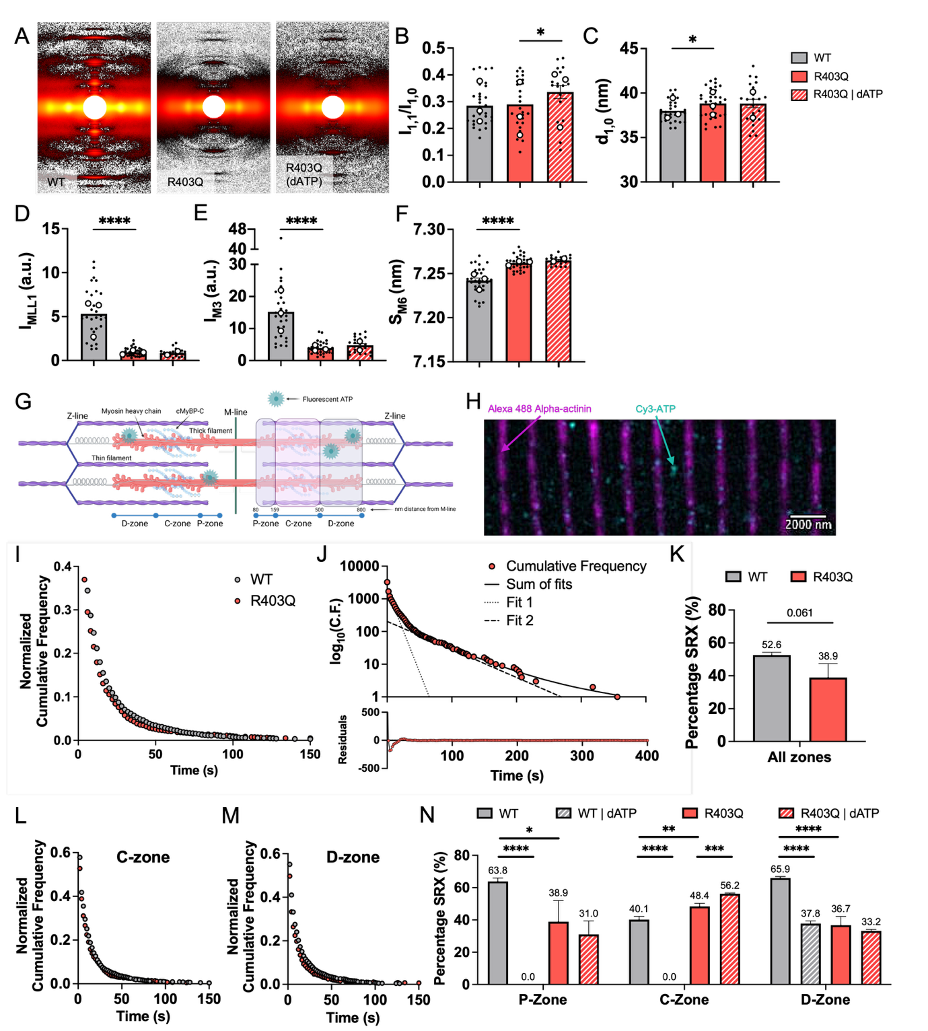
Figure 1. R403Q mutation elevated both structural and biochemical myosin recruitment in porcine myocardium. (A) Sample X-ray diffraction patterns (uncropped patterns in Supplemental Figure S1) for WT, R403Q, and R403Q tissue treated with 100% dATP nucleotide under relaxed conditions during small-angle X-ray exposure. Summary data for (B) the intensity ratio of the primary equatorial reflections (I_{1,1}/I_{1,0}), (C) lattice spacing (d_{1,0}), (D) intensity of the first-order myosin-based layer line (I_{MLL1}), (E) intensity of the third-order myosin-based meridional reflection (I_{M3}), and (F) spacing of the sixth-order myosin-based meridional reflection (S_{M6}). Paired measurements of R403Q porcine tissue were performed with and without 100% dATP in the relaxation solutions (WT: N = 3, n = 30 – 31; R403Q: N = 3, n = 26 – 35; R403Q | dATP: N = 2 – 3, n = 17 – 23). N = number of biological replicate minipigs; n = number of technical replicate X-ray diffraction patterns analyzed. (G) Schematic showing the cardiac myofibril sarcomere, illustrating key sarcomere proteins and nanometer spacing of the P-, C-, and D-zones of the thick filament relative to the M-line. (H) Representative R403Q porcine ventricular myofibril with overlay of Z-lines stained against α-actinin (magenta, 488 nm illumination) and fluorescently labeled Cy3-ATP molecules (cyan, 561 nm illumination) (scale bar = 2000 nm). (I) Normalized cumulative frequency graph of all Cy3-ATP binding lifetimes averaged across the entire sarcomere for both WT (grey circles) and R403Q (red circles) myofibrils. (J) Same cumulative frequency data for R403Q myofibrils with frequency transformed onto a logarithmic scale (top). Dashed lines show individual exponential fits for DRX (Fit 1) and SRX (Fit 2) populations, which make up a cumulative fit of three exponentials (Sum of fits, black solid line). Residuals for the sum of the three exponential fits are shown for the R403Q data (bottom). (K) Percentage of myosin heads quantified to be in the SRX biochemical state in WT and R403Q myofibrils, averaged across the entire thick filament. Normalized cumulative frequency graphs of Cy3-ATP binding lifetimes specifically in the (L) C-zone and the (M) D-zone for both WT and R403Q myofibrils. (N) Percentage of myosin heads quantified to be in the SRX state, broken down by P-, C-, and D-zones of the thick filament for WT and R403Q myofibrils in the presence of either unlabeled 5 mM ATP or 5 mM dATP (both using 10 – 15 nM Cy3-ATP; WT: N = 3, WT | dATP: N = 3, R403Q: N = 3, R403Q | dATP, N = 2). The number of Cy3-ATP binding events for ‘all zones’ and for each sub-zone are listed in Supplemental Table S2. N = number of biological replicate minipigs. Data are shown as mean ± SEM. Significance calculated with Student’s t-test, *p < 0.05, **p < 0.01, ***p < 0.001, ****p < 0.0001.

Single-molecule ATP tracking. To further investigate the impact of the R403Q mutation on myosin structure in resting muscle, we employed a single-molecule fluorescence approach using isolated cardiac myofibrils. Alpha-actinin stained Z-lines were used as the point of reference for the edges of sarcomeres (Figure 1G,H). Only myofibrils with an average sarcomere length of ≥1.7 μm were used for analysis to ensure that the integrity of the sub-zones of the sarcomere was not compromised. The exact location with respect to the fluorescent Z-lines and duration of binding of fluorescently labeled Cy3-ATP molecules were determined (Figure 1H). An overlay of the normalized cumulative frequency graph for all events across the entire sarcomere is presented in Figure 1I. ATP binding lifetime data across the entire sarcomere and in each sub-sarcomere zone were fitted to the sum of three exponentials by minimizing the natural log of the sum square difference. Error analysis of the fit residuals (Figure 1J) indicated that three processes produced the optimal fit for both WT and R403Q datasets. Taking the natural log of the cumulative distribution data best illustrates the underlying exponential fits. The fastest population was not analyzed further since it was consistent with non-specific binding of Cy3-ATP (Figure 1J) (24, 56, 57). The slower two rates were attributed to the DRX and SRX populations.
The data averaged across the entire sarcomere thick filament suggested a total decrease in the percentage of heads in a low ATPase state for R403Q myofibrils relative to WT myofibrils, though the difference was not statistically significant (p = 0.061) (Figure 1K, Supplemental Table S2). When the results were broken down to the sub-sarcomere zones, the reduction in low ATPase heads in the R403Q vs WT myofibrils was attributed specifically to the P- (38.9 ± 13.17% vs. 63.8 ± 2.08%, p = 0.017) and D-zones (36.7 ± 5.43% vs. 65.9 ± 0.93%, p < 0.0001) (Figure 1L−N, Supplemental Table S2). The C-zone, which contains cMyBP-C, showed a significant increase in low ATPase myosin heads (48.4 ± 1.97% vs. 40.1 ± 2.12%, p = 0.007) for R403Q vs WT myofibrils (Figure 1L-N, Supplemental Table S2).
To determine whether C-zone myosin was still regulated by cMyBP-C, we replaced the entire pool of unlabeled ATP in the imaging buffer with the strong myosin activator, dATP, while Cy3-ATP was maintained as the fluorescent ATP indicator. cMyBP-C is a key regulatory protein positioned within the C-zone of the thick filaments in cardiac sarcomeres (58). The protein’s C-terminal domain anchor it to the myosin filament backbone, whereas its N-terminal regions can interact with both the myosin head region and F-actin in the thin filaments (58). Through these interactions, cMyBP-C modulates the formation and kinetics of actin–myosin cross-bridges, thereby influencing cardiac muscle contraction and relaxation (59-61). In WT myofibrils, dATP completely eliminated low ATPase myosin in the P- and C-zones and significantly reduced low ATPase myosin in the D-zone (Figure 1N). In contrast, R403Q myofibrils with dATP exhibited no further decrease in low ATPase myosin in the P-zone and the D-zone, but a slight increase in low ATPase myosin in the C-zone (Figure 1N). Subsequently, the impact of dATP averaged across the thick filament was not significant for R403Q myofibrils (p = 0.207, Supplemental Table S2). Thus, single-molecule analysis revealed that the R403Q mutation reduced low ATPase myosin heads in regions not regulated by cMyBP-C, while dATP can eliminate low ATPase myosins in the cMyBP-C zone to increase the amount of myosin in higher ATPase states. Combined with the X-ray data, these results suggest that for sarcomeres with the R403Q mutation, the net increase in ON (higher ATPase) myosin- in P- and D-zones, countered by the moderate decrease of ON myosin in the C-zone, may explain why the intensity ratio I_{1,1}/I_{1,0} (average of all myosin heads) is not increased for R403Q muscle in X-ray diffraction.

Effect of the β-myosin R403Q mutation on contractile and cross-bridge properties in porcine ventricular muscle.
Demembranated tissue mechanics. To determine the relationship between increased myosin availability (DRX cross-bridges) in resting cardiac muscle and force developed during Ca²⁺ activation, we measured steady-state force and the rate of force redevelopment following a rapid release−re-stretch protocol with varying concentrations of Ca²⁺. Normalized force−pCa curves are shown in Figure 2A. Maximal specific force (pCa 4.5) was not significantly different between R403Q and WT controls (Figure 2B, Supplemental Figure S2), but the Ca²⁺ sensitivity of force (pCa₅₀) was significantly greater in the R403Q tissue (Figure 2C), with no significant difference in the Hill coefficient (n_{H}; Figure 2D). High-frequency stiffness analysis suggested no difference in the number of cycling cross-bridges at a given force level, indicating that increases in force are likely due to increases in the cross-bridge recruitment (Supplemental Figure S3). The enhanced sub-maximal force with the R403Q mutation suggests that at least some of the increased number of myosins made available in resting muscle can be recruited for force development. The rate of tension redevelopment, k_{tr}, at maximal Ca²⁺ was slightly, but not significantly, reduced (Figure 2E), suggesting maximal cross-bridge cycling rate may be somewhat affected by the R403Q mutation.
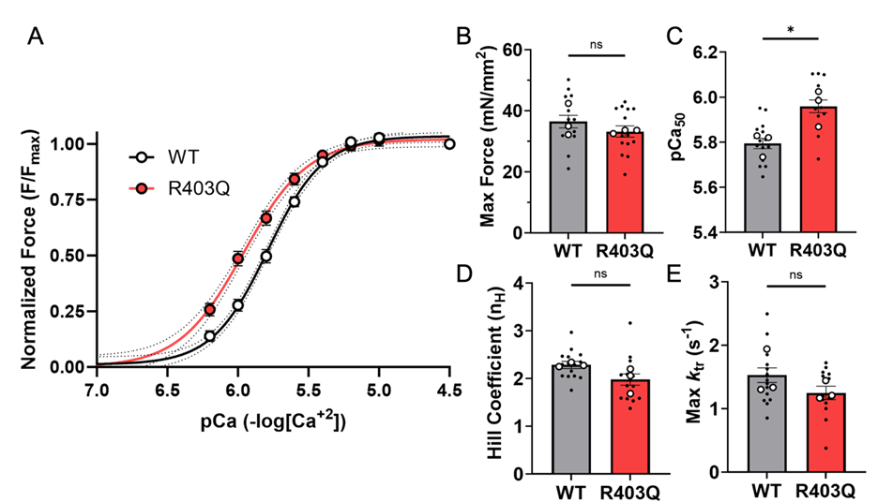
Figure 2. Isometric contraction of demembranated R403Q tissue reveals elevated calcium sensitivity. (A) Normalized force-pCa curves from permeabilized WT (black line) and R403Q (red line) porcine ventricular strips, and corresponding parameters of (B) force at maximal calcium activation solution (pCa 4.5), (C) pCa required for 50% maximum force (pCa₅₀), (D) calculated Hill coefficient (n_{H}), and (E) rate of tension redevelopment at maximal calcium (max k_{tr}) (WT: N = 3, n = 14; R403Q: N = 3, n = 14). Data are presented as mean ± SEM. N = number of biological replicate minipigs; n = number of technical replicates. Unpaired, two-tailed Student’s t-test with Welch’s correction, *p < 0.05.

Myofibril mechanics. To determine how the R403Q mutation impacts cross-bridge chemo-mechanics, we measured the kinetics of contraction and relaxation of single contractile organelles, i.e., myofibrils. Isolated myofibrils were suspended between an optically based force transducer and a length-controlling lever arm at a sarcomere length of 2.3 μm. Example force traces during the activation−relaxation protocol, switching from pCa 8.0 to 4.5, then back to 8.0, are shown in Figure 3A and B for both WT and R403Q porcine myofibrils. Average normalized force traces are also presented to highlight changes in kinetics during the exponential phases of contraction and relaxation (Figure 3C).
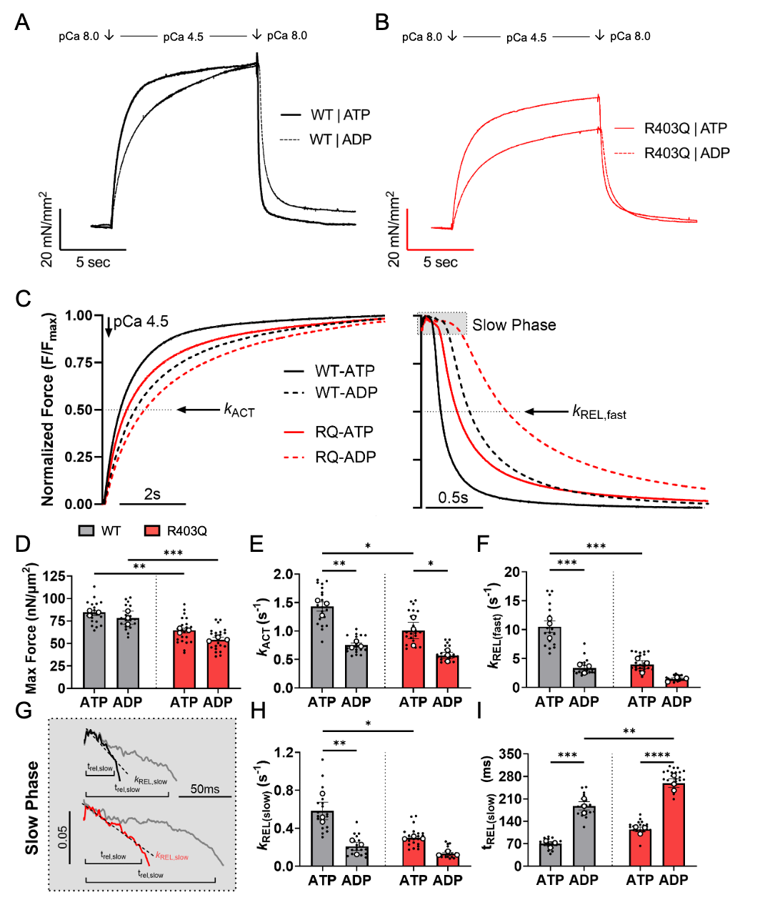
Figure 3. Porcine myofibrils with the heterozygous R403Q mutation exhibit reduced myofibril maximum force and slower contraction and relaxation kinetics. Representative myofibril force traces for (A) WT and (B) R403Q porcine myofibrils when maximally Ca²⁺ activated in pCa 4.5 and then relaxed in pCa 8.0. Paired myofibril traces were collected in the presence of 100% ATP and subsequently in the presence of 50% ATP and 50% ADP. Dashed lines indicate myofibril traces in the presence of elevated ADP. (C) Average normalized myofibril kinetics traces highlighting the exponential phases of contraction and relaxation for both WT (black line) and R403Q (red line) hiPSC-CM myofibrils. Dashed lines indicate average normalized kinetics traces in the presence of elevated ADP. Contractile dynamics parameters at maximal pCa 4.5 include: (D) maximal force, (E) rate of activation (k_{ACT}), (F) rate of the fast phase of relaxation (k_{REL,fast}), (G) WT and R403Q traces (grey) highlighting the slow phase of relaxation (with a manual offset between the two cell lines for visualization) before and after the ADP inhibition experiment, (H) rate of the slow phase of relaxation under isometric length conditions (k_{REL,slow}), and (I) duration of the slow phase of relaxation (t_{REL,slow}) (WT: N = 3, n = 19; R403Q: N = 3, n = 22). Data are presented as mean ± SEM. N = number of biological replicate minipigs; n = number of myofibril technical replicates. Two-way ANOVA with Tukey post-hoc test, *p < 0.05, **p < 0.01, ***p < 0.001, ****p < 0.0001.

Maximal force (pCa 4.5) was significantly lower in R403Q myofibrils relative to WT (Figure 3D, Supplemental Table S3), and the rate constant (k_{ACT}) of force development was slower (Figure 3E, Supplemental Table S3). The rate constant of the main, fast phase of relaxation (k_{REL,fast}) was also significantly slower for R403Q myofibrils (Figure 3F, Supplemental Table S3). The initial phase of relaxation can be quantified based on two parameters: the rate constant derived from the slope of the linear phase (k_{REL,slow}) and the duration of the linear phase (t_{REL,slow}) (Figure 3G). k_{REL,slow} reflects the rate of cross-bridge detachment (62, 63), and t_{REL,slow} reflects the time it takes for thin filaments to deactivate (64). The k_{REL,slow} was slower for R403Q vs WT myofibrils (Figure 3H, Supplemental Table S3), suggesting the mutation slows myosin detachment kinetics, but t_{REL,slow} was not significantly different (p = 0.0658, Figure 3I, Supplemental Table S3).
Slower force development (k_{ACT}) and relaxation (k_{REL,slow}, k_{REL,fast}) with the R403Q mutation could result from slower ADP release from myosin. ADP release can be probed with a product inhibition experiment, which was done by using activation and relaxation solutions containing a 50:50 ATP:ADP mixture (5 mM total). As expected, this slowed k_{ACT}, k_{REL,slow}, and k_{REL,fast}, and prolonged t_{REL,slow} in WT myofibrils (Figure 3E-I). Interestingly, while elevated ADP also prolonged k_{ACT} and t_{REL,slow} for R403Q myofibrils, relaxation (k_{REL,slow}, k_{REL,fast}) was not significantly prolonged. This suggests that the R403Q mutation may result in modest impairment in ADP release associated with cross-bridge detachment, such that elevated ADP has little additional effect.

Human models.
hiPSC-CM myofibril contractile properties. The slower contractile kinetics of myofibrils with the R403Q mutation in pig ventricular muscle conflict with the faster kinetics of contraction and relaxation observed in myofibrils from myectomy samples from patients with the R403Q mutation (6, 7). Thus, to determine if differences were due to species or other factors, and to study the early stages of disease initiation, we engineered the heterozygous β-MHC R403Q mutation into WTC-11 human induced pluripotent stem cells (hiPSCs) using CRISPR/Cas9 gene editing (Figure 4A, Supplemental Figure S4), as described in the Methods. R403Q and WT hiPSCs were differentiated into cardiomyocytes (hiPSC-CMs), then replated onto Matrigel with a stamped lined pattern and cultured in the presence of elevated Ca²⁺ for 1 week (day 38 – 45 post initiation of differentiation) to enhance cell maturation and myofibril elongation (Figure 4B) (48). Although 45-day-old hiPSC-CMs may be considered by some to be immature, the myofibril organelles utilized in this study express the ‘mature’ myosin isoform, beta-myosin heavy chain (β-MHC), which predominantly dictates adult ventricular contractile kinetics for activation and relaxation. Consistent with a recent publication from our group using hiPSC-CMs (48), β-MHC is the dominant isoform by day 30 and remains predominant through day 45, when myofibril kinetics were assessed. β-MHC protein expression was confirmed in both WT and R403Q minipig tissue and in day 45 WT and R403Q hiPSC-CMs (Supplemental Figure S5). Gel separation of α- and β-MHC isoforms confirmed that all replicate samples from both minipig and hiPSC-CMs contained exclusively β-MHC. In addition to myosin isoform expression, culturing myocytes on patterned substrates greatly assists in maturation and elongation of myofibrils to adult size, which was critical for these experiments. This approach enabled isolated myofibrils to be mounted on the myofibril apparatus between a length controller and a force transducer, where they were stretched to a 2.3 μm sarcomere length with well- defined, visible sarcomeres (Figure 4C,D).
Force traces were collected for isolated myofibrils from both WT and R403Q hiPSC-CMs when maximally Ca²⁺ activated (pCa 4.5), then relaxed (pCa 8.0) (Supplemental Figure S6). Figure 4E shows normalized average force traces from both WT and R403Q hiPSC-CM myofibrils. The data for all measurements demonstrate that force was similar (Figure 4F, Supplemental Table S3), and k_{ACT} was not significantly different (Figure 4G, Supplemental Table S3) between WT and R403Q hiPSC-CM myofibrils. This differs somewhat from the porcine myofibril data, where both parameters were significantly reduced by the R403Q mutation. However, the relaxation kinetics (Figure 4H) agree better with the porcine data, with the R403Q myofibrils having reduced k_{REL,fast}, a non-significant reduction in k_{REL,slow}, and prolonged t_{REL,slow} (Figure 4I-K, Supplemental Table S3).
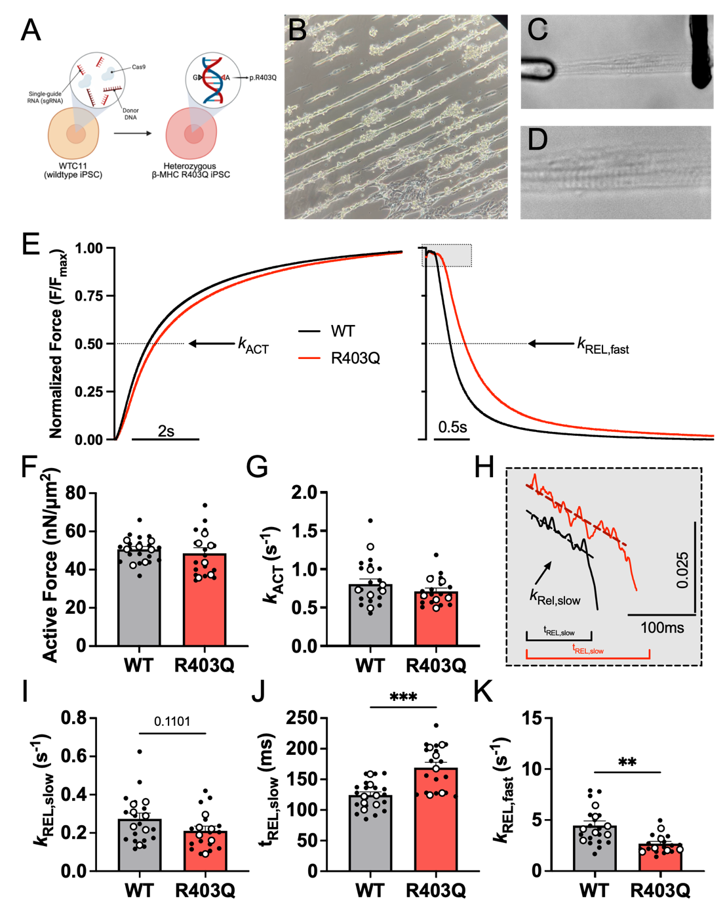
Figure 4. HiPSC-CM myofibrils with the heterozygous R403Q mutation exhibit impaired relaxation kinetics and prolonged thin filament deactivation. (A) Schematic illustration of CRISPR/Cas9 gene editing of WTC-11 hiPSCs to engineer the heterozygous R403Q mutation in the MYH7 gene. (B) Representative image of hiPSC-CMs cultured on lined patterned Matrigel prior to myofibril isolation and (C) a bundle of isolated hiPSC-CM myofibrils mounted between two glass needles for mechanical measurements. (D) Magnified view of myofibril bundle highlighting sarcomere Z-lines. (E) Average normalized force traces showing the exponential phases of contraction and relaxation for both WT (black line) and R403Q (red line) hiPSC-CM myofibrils. Contractile dynamics parameters at maximal pCa 4.5 from day 42 – 48 hiPSC-CM myofibrils include: (F) maximal active force, (G) rate of activation (k_{ACT}), (H) WT and R403Q traces illustrating the slow phase of relaxation (manual offset for visualization), (I) rate of the slow phase of relaxation under isometric conditions (k_{REL,slow}), (J) duration of the slow phase of relaxation (t_{REL,slow}), and (K) rate of the fast phase of relaxation (k_{REL,fast}) (WT: N = 7, n = 18 – 19; R403Q: N = 6, n = 16 – 17). Data are presented as mean ± SEM. N = number of biological replicate differentiation batches; n = number of myofibril technical replicates. Unpaired, two-tailed Student’s t-test with Welch’s correction, **p < 0.01, ***p < 0.001.

EHT contractile properties. To determine how the R403Q mutation affects intact muscle twitches, we cast the hiPSC-CMs into fibrin scaffold-based EHT constructs affixed to PDMS posts. At the time of casting, WT EHTs had 99.1% hiPSC-CM purity and R403Q EHTs had 97.8% hiPSC-CM purity (data not shown). EHTs beat spontaneously for three weeks following seeding. For measurements, EHTs were removed from the PDMS posts and mounted between a force transducer and a length controller to measure isometric tissue force and kinetics of contraction and relaxation at 1 Hz pacing frequency (Figure 5A). EHT cross-sectional area (CSA) was used to normalize peak force (Figure 5B). At 1 Hz pacing frequency, EHTs with the heterozygous R403Q mutation exhibited 50% greater twitch force than WT EHTs (Figure 5C,D). During the contraction phase, R403Q EHTs reached 50% force faster than WT EHTs (Figure 5E). However, the time to peak force was not significantly different (Figure 5F). The 50% relaxation time was not significantly different between WT and R403Q EHTs, but the 90% relaxation time was significantly prolonged (Figure 5G,H). Overall, these results demonstrate the heterozygous R403Q EHTs produce greater peak force and have impaired relaxation compared to WT EHTs. We also calculated the relative tension time index (TTI) (29, 65) between WT and R403Q EHTs. TTI is determined from the area under the twitch curve. When normalized relative to WT EHTs, TTI for R403Q EHTs was a positive value, which is predictive of a HCM hypercontractile phenotype (Figure 5I) (65).
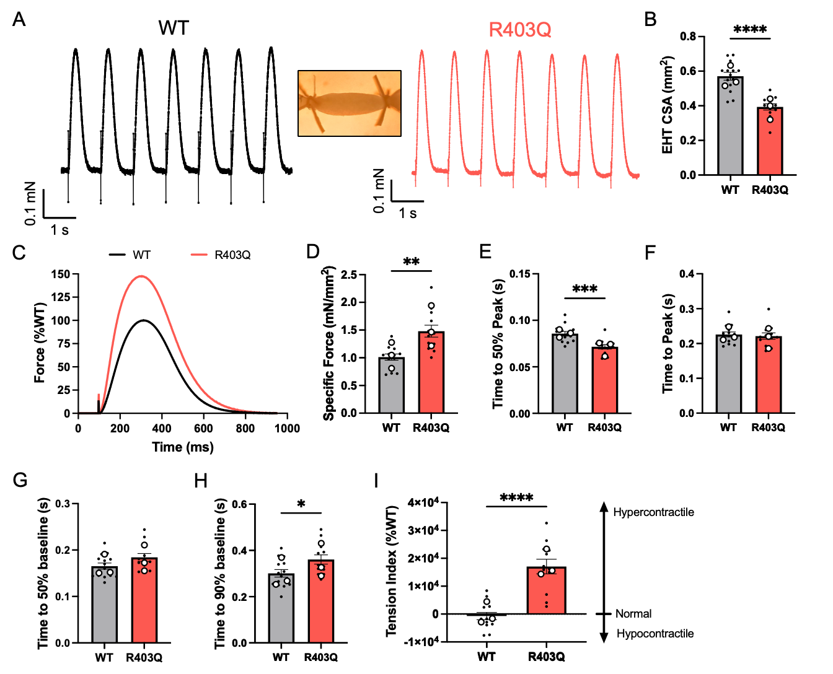
Figure 5. R403Q EHTs exhibit hypercontractility and impaired relaxation during isometric contraction. WT and R403Q hiPSC-CMs at day 24 post-initiation of differentiation were cast around one rigid and one flexible PDMS post in a 3D fibrin mold. EHTs matured and compacted around the PDMS posts for three weeks. At this three-week time point (day 45 post-initiation of differentiation), EHTs were removed from the PDMS posts and suspended between a force transducer and a length controller in an IonOptix™ Intact Muscle Chamber apparatus. (A) Representative original force traces at 1 Hz pacing frequency for WT (black line) and R403Q (red line) EHTs. Inset shows a representative image of an EHT mounted between the force transducer and length-controlling arms of the IonOptix™ system. (B) Average cross-sectional area (CSA) of EHTs. (C) Average tissue force traces normalized to CSA for WT (black line) and R403Q (red line) EHTs, with WT set at 100%. (D) Twitch specific force normalized to CSA. (E) Time to 50% peak contraction, (F) time to peak force, (G) time to 50% relaxation, and (H) time to 90% relaxation. (I) Relative tension−time index (TTI), expressed as a percent of WT (set to zero) (WT: N = 3, n = 14; R403Q: N = 3, n = 12). All results were analyzed at a 1 Hz pacing frequency. Data are presented as mean ± SEM. N = number of biological replicate differentiation batches; n = number of EHT technical replicates. Unpaired, two-tailed Student’s t-test with Welch’s correction, *p < 0.05, **p < 0.01, ***p < 0.001, ****p < 0.0001.

Molecular Dynamics (MD) simulations.
To study changes in myosin structure that could result in altered interactions between actin and myosin that give rise to the observed changes in relaxation, we performed MD simulations of pre-powerstroke myosin and post-powerstroke actomyosin.
Pre-powerstroke myosin
Assessment of electrostatic surface potential. MD simulations of pre-powerstroke myosin provide insight into the structure of myosin presented to actin (for binding) following ATP hydrolysis to ADP and inorganic phosphate. Simulations of pre-powerstroke human β-cardiac myosin (M.ADP.Pi) were performed for WT and R403Q. We used the NMRClust algorithm (66) as implemented in UCSF Chimera (46) to cluster the WT and R403Q simulations on residues involved in actin binding: the lower 50 kDa domain helix-loop-helix motif (residues 519−554), loop 4 (residues 363−376), and the cardiomyopathy loop (residues 401−415) (Figure 6A-C). NMRClust yielded a large number of lowly populated clusters with low intra-cluster RMSDs, indicating that the actin binding regions did not experience large-scale conformational changes in these simulations. The top three WT cluster representatives described 14%, 7%, and 6% of the total ensemble (Figure 6A); the top three R403Q cluster representatives described 7%, 6%, and 6% of the total ensemble (Figure 6B). Next, we compared the Cα RMSD of the top three cluster representatives for only the residues used to form clusters. The average RMSD was 1.6 Å among the WT representatives, 1.2 Å among the R403Q representatives, and 1.7 Å between the WT and R403Q representatives. Inspection of the representatives show that differences in WT/R403Q structure and clustering properties are attributable to differential sampling of the cardiomyopathy loop, as expected (Figure 6C). Next, we mapped the Coulombic electrostatic potential onto the surface for each WT (Figure 6D) and R403Q (Figure 6E) cluster representative. The R403Q mutation reduced positive electrostatic potential in the vicinity of the cardiomyopathy loop and also modulated the electrostatic potential of loop 4 but had minimal effects on the electrostatic potential of the helix-loop-helix motif. This suggests minimal impact on electrostatic interaction between pre-powerstroke myosin and thin filament actin. However, in the interacting-heads motif (IHM) state, R403 of the blocked head forms interactions with free head residues Y455 and Q454 (67) and in prior MD simulations, the blocked head cardiomyopathy loop formed numerous interactions with the HO-linker loop of the free head (68). Thus, altered electrostatic interactions due to R403Q may affect IHM stability more than actomyosin association.

Figure 6. Effects of R403Q on the electrostatic surface potential of pre-powerstroke myosin. We extracted three representative myosin conformations from WT and R403Q pre-powerstroke myosin simulations. The (A) WT and (B) R403Q cluster representatives were then aligned to residues in the helix-loop-helix (HLH) motif, loop 4, and the cardiomyopathy loop (CM-loop). A comparison of the first WT and R403Q cluster representative (C) highlights that the major conformational difference is in the CM-loop. Mapping of the electrostatic potential onto the protein surface displays regions of net positive potential in blue and negative potential in red (D,E). Comparison of the WT (D) and R403Q (E) maps shows a decrease in positive potential in the CM-loop of the R403Q simulations.

Post-powerstroke myosin-actin. The slower relaxation of force in myofibrils with the R403Q mutation (assessed with k_{rel,fast}, k_{rel,slow}, and t_{rel,slow}) and the reduced sensitivity of relaxation to elevated ADP suggest potentially altered post-powerstroke myosin-actin interactions. At the molecular scale, impaired relaxation may be attributed to altered ADP release, ATP binding, and/or the detachment of myosin heads from the thin filament. MD simulations of the post-powerstroke actomyosin complex (Figure 7A) investigated mechanisms by which the R403Q mutation impacts myosin-actin interactions. R403 is in the cardiomyopathy loop (CM-loop, residues 397 – 416), a β-hairpin in the upper 50 kDa domain of myosin that interacts with actin filaments when the myosin cleft is closed. In the cryo-EM structure, the CM-loop twists such that one side faces the thin filament and the other faces the myosin upper 50 kDa domain. We analyzed interactions made by the CM-loop and interactions at the actomyosin interface. The cryo-EM structure and the WT simulations indicate that R403 forms a salt bridge with E603 and that the aliphatic portion of the side chain stacks against Y410 (Figure 7B). R403Q modulated contacts between residues within the CM-loop (Figure 7C,D) as well as between myosin and actin. The Q403 – E603 electrostatic interactions were weaker, and the side chain did not stack as well against Y410 (Figure 7C). We also observed statistically significant differences in contacts made by the upper 50 kDa domain and loop 2 of myosin with the negatively charged N-terminus and the D24 – E31 loop of actin. Changes in residue-residue interactions oriented the CM-loop closer to the thin filament: for the WT simulations, the average distance between the CM-loop and the center of mass of the central actin monomer was 18.8 ± 0.3 Å; for the R403Q simulations, the average distance was 18.0 ± 0.1 Å (p = 0.01). We calculated the linear interaction energy at the actin-myosin interface and between the cardiomyopathy loop and actin for the WT and R403Q simulations. The R403Q mutation resulted in a stronger interaction between the cardiomyopathy loop and actin relative to WT (WT: -133 ± 43.8 kcal/mol; R403Q: -143 ± 41.5 kcal/mol; an 8% increase in interaction energy, errors are standard deviations), though this difference was not statistically significant. R403Q also increased the interaction energy between actin and myosin (WT: -2122 ± 213 kcal/mol; R403Q: -2328 ± 195 kcal/mol), a difference that was also not statistically significant. Note that this calculation does not account for the contributions of solvent to the interaction energy, the entropy of solvation, and only considers the post-powerstroke (AM.ADP*) conformation.
Next, we analyzed interactions between the strongly bound myosin motors and ADP. Consistent with an ‘open’ conformation of the nucleotide binding pocket, there was large variation between simulations in interactions between ADP and the purine binding loop and switch 1 of myosin (Figure 7E). We observed few statistically significant changes in the interactions between myosin motors and their bound nucleotides. Additionally, we calculated the linear interaction energy between myosin and ADP.Mg²⁺ and observed no significant change in the interaction energy (WT: -347 ± 24; R403Q: -354 ± 24, p = 0.75). Our simulations suggest that modification of the myosin−thin filament interaction and/or detachment likely contributes more to the R403Q variant’s impaired relaxation than modification of myosin−ADP affinity.
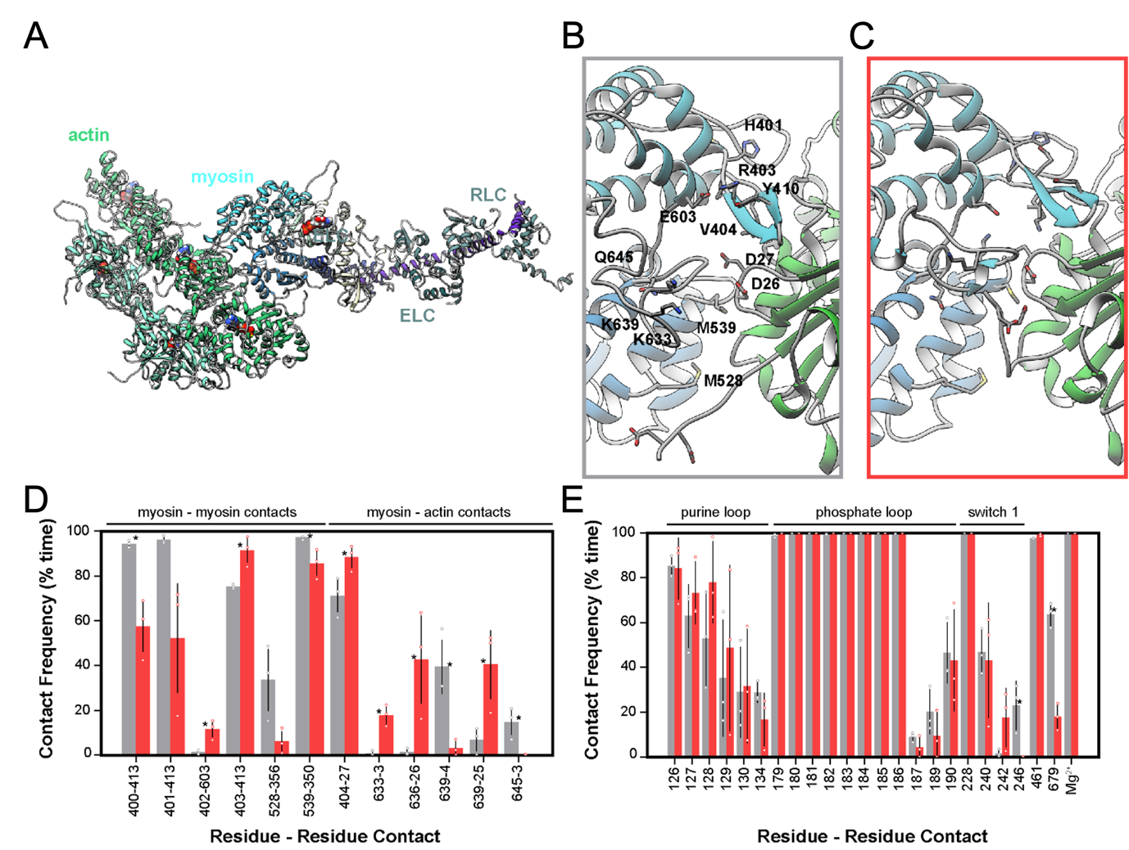
Figure 7. MD simulations of post-powerstroke WT and R403Q myosin. (A) Snapshot of the simulated system containing an actin pentamer, an ADP.Mg²⁺-bound myosin motor, the essential light chain (ELC), and regulatory light chain (RLC). Snapshots obtained from the (B) WT (grey) and (C) R403Q (red) simulations show that R403Q leads to altered interactions within the cardiomyopathy loop (CM-loop) and at the actomyosin interface. (D) Protein-protein contact frequencies (expressed as % simulation time) between myosin and actin residues in the WT (grey) and R403Q (red) simulations. (E) Contact frequencies (expressed as % simulation time) between myosin residues and ADP.Mg²⁺. Unpaired, two-tailed Student’s t-test, *p < 0.05.

- DISCUSSION
In this study, we employed a variety of biophysical, biochemical, and computational approaches to understand the detailed molecular mechanisms underlying altered contractile function in cardiac muscle containing the MYH7 R403Q mutation, and to resolve apparently conflicting results in the literature (5-7). We used two model systems that naturally express predominantly MYH7: the Yucatan minipig model and a human induced pluripotent stem cell derived cardiomyocyte (hiPSC-CM) model, both of which contain the heterozygous R403Q mutation. Our results show that the mutation results in a hypercontractility at the tissue level under physiological Ca²⁺ levels typical of cardiac twitches, while slightly reducing the maximal force production capacity of the contractile organelles, i.e., myofibrils. The R403Q mutation also prolongs the early, linear phase of relaxation in juvenile minipigs and the major fast phase of relaxation in both minipigs and early-stage hiPSC-CMs. This appears to result at least in part from a reduced rate of cross-bridge detachment, as indicated by k_{REL,slow}, which can prolong the initial phase of relaxation (t_{REL,slow}). Computational simulations suggest this is not due to altered ADP release from the nucleotide-binding pocket, but rather by changes at the myosin-actin interface that retard cross-bridge dissociation. Finally, and importantly, we find that long-term cultured hiPSC-CMs can produce myofibrils with contractile properties similar to those of adult porcine myofibrils, similar to findings we recently reported for a cMyBP-C mutation that results in haploinsufficiency (48).
The R403Q mutation increases the number and ATP turnover rate of myosins available for contraction in resting cardiac muscle.
The greater submaximal force generated by R403Q myofibrils may result, at least in part, from an increased number of myosin heads that are initially available to bind to thin filaments once Ca²⁺ activates thin filaments. These additional myosin heads appear to come primarily from the thick filament D-zone, with some contribution from the P-zone. X-ray diffraction of relaxed minipig ventricular tissue suggests that the R403Q mutation disrupts the quasi-helical ordering of myosin heads on the thick filament backbone, similar to what occurs in contracting muscle, as indicated by reduced intensity of the first-order myosin-based layer line (I_{MLL1}) and third-order myosin-based meridional reflection (I_{M3}), and a significant increase in the sixth-order myosin-based meridional reflection (S_{M6}). This greater disorder of myosin heads suggests a shift in the population of myosin heads from the OFF state toward a more ON state for R403Q cardiac muscle. Interestingly, we did not observe a change in the intensity ratio of the primary equatorial reflections (I_{1,1}/I_{1,0}), which is thought to be a measure of myosin head movement towards the thin filaments (17, 53). We have reported a similar pattern of change when dATP replaces ATP in relaxed cardiac muscle, but dATP also increases I_{1,1}/I_{1,0} (18). The nucleotide dATP is a powerful myosin activator and was used to determine if the regulation by cardiac myosin binding protein-C could be overcome in the C-zone, and to demonstrate that further recruitment could be achieved from the P- and D-zones. Our results may be partially explained by the fact that X-ray diffraction provides an average of all myosins in the sarcomere. Another possible explanation for the R403Q results is that the stability of myosin on the thick filament backbone is disrupted by the mutation but the radial position of myosin relative to actin is not significantly affected, relative to WT tissue samples. Resting stiffness measurements of permeabilized cardiac strips support the notion that the R403Q mutation may not increase weak binding between actin and myosin (Supplemental Figure S3). In contrast, we have reported that dATP increases the positive charge on the actin binding surface (69) and increases electrostatic interactions between myosin and actin (54). This draws myosin heads toward thin filaments and increases weak binding. These dATP-induced electrostatic changes do not mimic the electrostatic landscape of myosin in the presence of the R403Q mutation. However, in relaxed R403Q muscle tissue where ATP was replaced with dATP, I_{1,1}/I_{1,0} was significantly increased. The impact of dATP was less in R403Q porcine tissue compared to what we previously reported for WT porcine tissue (18), suggesting that the R403Q mutation has similar but incomplete effects on sarcomere structure compared to dATP. Like dATP, R403Q disrupts the IHM of myosin by the weakening of a salt-bridge interaction between blocked head R403 and free head Q454/Y455 (68, 70, 71).
Our results from single-molecule tracking of ATP in isolated and relaxed myofibrils suggest that, consistent with the unimpaired I_{1,1}/I_{1,0} seen in the X-ray diffraction results between R403Q and WT tissue, there was not a statistically significant change in the average ATPase activity of myosin heads across the entire R403Q and WT thick filament. However, when subdivided into the P-, C-, and D-zones of the thick filament, a reduction in high ATPase myosin heads occurs primarily in the P- and D-zones where cMyBP-C is not present. Although the distribution of R403Q myosin incorporation along the thick filament is unknown, cMyBP-C appears to be able to regulate the overall thick filament distribution of heads in R403Q myofibrils by moderately increasing the population of ON (higher ATPase) heads specifically in the C-zone. A recent publication from our group (23) reported that haploinsufficiency of cMyBP-C in the C-zone, caused by the MYBPC3-c.772G>A mutation, leads to a reduction in the proportion of myosins in the SRX state in the C-zone relative to HCM mutation-negative control hearts. These results suggest that decreased cMyBP-C within the C-zone impairs the zones ability to maintain normal regulation of thick filament ATP turnover. The results from this study suggest that under conditions of the R403Q mutation, where cMyBP-C expression is unaltered, the presence of cMyBP-C specifically in the C-zone (but not in the D- or P-zones) appears sufficient to stabilize thick filament regulation, despite the mutation being present across all zones. Although multiple previous reports have shown that PKA phosphorylation (72, 73) or loss of cMyBP-C (74) can alter acto-myosin cross-bridge cycling and the kinetics of force, we confirmed that the observed changes in ATP turnover in the C-zone were not due to differences in cMyBP-C phosphorylation (Supplemental Figure S7). Replacing the dark ATP nucleotide pool with dATP during single-molecule image acquisition demonstrated that dATP is a potent biochemical activator in WT myofibrils. The R403Q mutation had no further effect on the population of SRX heads. Although the validity of the mant-ATP chase experiment to quantify the SRX/DRX ratio remains under debate (75), our results from the single-molecule assay are consistent with reports using mant-ATP chase that suggest the R403Q mutation reduces the proportion of SRX heads in the R403Q minipig model (11), an R403Q rodent model (76), and for isolated 25-hep HMM constructs (70). Together, these structural and biochemical data suggest that the R403Q mutation results in both greater disorder of myosin heads at the thick filament backbone, as they shift toward more ON heads, but also elevated basal ATPase rates of these heads, priming myosins to be more available to bind to actin in the presence of Ca²⁺.
Are the kinetics of altered myofibril contractile properties due to changes in actin-myosin interactions?
Reduced maximal force in R403Q porcine ventricular myofibrils is consistent with findings in myofibrils from human myectomy tissue (6, 7) and from the R403Q transgenic rabbit model (5). Optical trap experiments on isolated β-cardiac S1 with the R403Q mutation have suggested reduced intrinsic and ensemble force (9). This suggests the R403Q mutation may reduce maximal myofibril force in part because increased myosin head recruitment does not fully compensate for diminished intrinsic force produced per myosin molecule. Although myofibrils from R403Q models exhibit reduced maximal force, the mutation simultaneously increases calcium sensitivity and promotes hypercontractility at the tissue level. This apparent discrepancy, which has been reported for multiple models of HCM (77, 78), including for human myectomy samples with the R403Q mutation (7), likely reflects a greater proportion of myosin heads in the high ATPase (ON) state at submaximal calcium concentrations, enhancing force generation under physiological conditions.
While the R403Q mutation resulted in diminished maximal myofibril force consistently in porcine, human, and rabbit tissue, the slower contraction kinetics align with findings from the rabbit model but not with data from human myectomy tissue. Our CRISPR/Cas9-generated heterozygous R403Q hiPSC-CM model did not exhibit changes in activation kinetics or maximal force of myofibrils, but demonstrated impairments in the exponential phase of relaxation and thin filament deactivation time consistent with the porcine R403Q myofibrils (Supplemental Figure S8). These differences in kinetics are not due to altered α/β-MHC ratios (Supplemental Figure S6), but may point to the necessity to control for confounding variables such as age, disease progression, and drug treatment history associated with HCM patients. Based on the slower rates of cross-bridge detachment during the isometric, slow phase of relaxation, this may result from impaired product release during the cross-bridge cycle. No changes in phosphate release were detected in the porcine R403Q tissue relative to WT (Supplemental Figure S9) and only modest changes in ADP release in the porcine tissue (but not in hiPSC-CMs) were identified (Supplemental Figure S10). Our MD simulations suggest a series of structural changes to myosin-ADP in its interaction with actin precede detachment in the force-bearing, post-powerstroke cross-bridge state. R403Q simulations showed increased contact frequency time between actin and myosin at multiple interfaces, while contact frequencies remained unimpaired within the nucleotide binding pocket between R403Q myosin and ADP.Mg²⁺. These structural changes at the actomyosin interface may be associated with changes in myosin detachment kinetics. The increased contact time at the actomyosin interface could also be associated with slower cross-bridge detachment (22).
Experiments performed in permeabilized tissue and myofibril preparations focused on the impact of the R403Q mutation on sarcomere function. To more closely mimic what occurs in the human heart, we compared WT and heterozygous R403Q hiPSC-CMs cast into 3D EHT constructs. Isometric twitch measurements at physiological, submaximal calcium (pCa 5.6) showed elevated peak tension in R403Q EHTs despite having smaller cross-sectional area. This is consistent with our findings of elevated Ca²⁺ sensitivity (pCa₅₀) in the R403Q minipig permeabilized cardiac strips.
In conclusion, with the two R403Q model systems presented, we have performed a multi-scale interrogation of the mechanisms of contractile dysfunction caused by the β-MHC R403Q mutation. With the aim of clarifying how the R403Q mutation affects contractile function of myofibrils, we show that the kinetics of contraction is slower than control myofibrils in young pigs and relaxation is slower than control myofibrils in young pigs and early stage HCM hiPSC-CMs. We suggest that instead of altered nucleotide handling, this mutation in the cardiomyopathy loop increases the binding interaction time between myosin and actin which may alter cross-bridge detachment speed despite there being enhanced structural and biochemical thick filament myosin recruitment in sub-sarcomere zones that do not contain cMyBP-C as determined by X-ray diffraction and single-molecule imaging.

ACKNOWLEDGMENTS
The authors would like to thank Dr. Thomas Irving and Dr. Corrado Poggesi for their active discussions on this project. The authors acknowledge the Institute for Stem Cell and Regenerative Medicine’s Ellison Stem Cell Core at the University of Washington, as well as Dr. Nathan Sniadecki and Alex Goldstein (University of Washington) for their technical assistance with engineered heart tissues.
GRANTS
This research used resources from the University of Washington Center for Translational Muscle Research, supported by NIH National Institute of Arthritis and Musculoskeletal and Skin Diseases under Award Number P30AR074990 (M. Regnier). This research used resources of the Advanced Photon Source, a U.S. Department of Energy (DOE) Office of Science User Facility operated for the DOE Office of Science by Argonne National Laboratory under Contract No. DE-AC02-06CH11357. BioCAT is supported by grant P30GM138395 from the National Institute of General Medical Sciences of the National Institutes of Health. This work was supported by National Institutes of Health grants R01HL128368 (M. Regnier), R01HL157169 (F. Moussavi-Harami), R01HL171657, (W. Ma). This work was supported by Horizon Europe HORIZON-HLTH-2023-TOOL-05 SMASH-HCM. grant number 101137115 (J.M. Pioner). Partial funding for S. Steczina was provided by a NRSA F31 predoctoral fellowship, award number F31HL164060 from the National Institutes of Health. Partial funding for M.C. Childers was provided by award numbers T32HL007828 and K99HL173646 from the National Heart, Lung, and Blood Institute. The content is solely the responsibility of the authors and does not necessarily represent the official view of the NHLBI or the NIH.
DISCLOSURES
M.R. discloses that he is a co-founder and equity holder in StemCardia, Inc and an equity holder in KineaBio, Inc. W.M. consults for Edgewise Therapeutics, Cytokinetics Inc., and Kardigan Bio, but this activity has no relation to the current work.
AUTHOR CONTRIBUTIONS
MR, NK, FM-H, WM, and MG conceived and designed the research. SS, SM, MCC, TSM, AN, MD, KBK, CM, KT, JH, JM, and WM performed the experiments. SS, SM, MCC, TSM, MD, KT, JZ, JM, and WM analyzed the experimental data. SS, SM, MCC, TSM, AN, MP, MD, KBK, CM, JM, JMP, MAG, WM, FM-H, NK, and MR interpreted results of the experiments. SS, SM, MCC, TSM, and JM prepared the figures. SS and MR drafted the manuscript. All authors contributed to editing and revising the manuscript. All authors approved the final version for publication.

SUPPLEMENTAL MATERIAL
Supplemental Table S1. Custom primers used to evaluate potential off-target cut sites for the gRNA used for CRISPR/Cas9 genome editing the heterozygous R403Q mutation into the MYH7 gene.
Number of mismatches | Gene | Exon/intron | Forward primer | Reverse primer
1 | MYH6 | exon | AACAGTGCTAGACAGGTGCC | AGGAGCAAGCGAGTGATTGT
3 | MYH13 | exon | GGTGAGGCTGGAAACACAGA | GTTCCTGAGAACCATGGGCC
3 | SHANK2 | intron | CTTTGGACAGGGCTAGCTCC | TTCTGCAGGGCAATGGAGAG
3 | RP11-363N22.2 | intron | CAGGACATGGGACCCACTTC | TAAACAGGCCATGGAACCCC
4 | MYH1 | exon | GGCATGCTATATGACTGCAGC | TCAAGCAAAAGCAGCGTGAG
4 | MYH3 | exon | GAGGGATGACCAGGGCTTTC | AGGATCATGAAACCAATTTCCCTC
4 | MYH8 | exon | GGTGTACCTGACATGTGGCA | TTCTCGTAGACGGCTTTGGC

Supplemental Table S2. Quantification of the percentage of myosins in the SRX state in WT and R403Q porcine ventricular myofibrils. ATP binding lifetimes per ATP binding events were calculated and localized within the sub-sarcomere regions of the thick filament for WT and R403Q myofibrils. Single-molecule analysis was performed in the presence of saturating ATP or saturating dATP nucleotide (100%). Percentage super relaxed state (% SRX) myosin was calculated as an average across the entire sarcomere (‘all zones’) and sub-divided between the P-, C- and D-zones. N = number of minipig biological replicates. Number of events (n =) are provided for total tracked events and number of events attributed to each zone. Data are presented as mean ± SEM. Significance calculated with Student’s t-test, *p < 0.05, **p < 0.01, *** p < 0.001, **** p < 0.0001.
 |  |  | All zones | P-zone | C-zone | D-zone
Genotype ± treatment | N | Number of myofibrils | % SRX  (n) | % SRX  (n) | % SRX  (n) | % SRX  (n)
WT minipigs | 3 | 32 | 52.64% ± 1.69% (3000) | 63.84% ± 2.08% (855) | 40.15% ± 2.12% (1354) | 65.93% ± 0.93% (1378)
WT minipigs +  100% dATP | 3 | 10 | 22.36% ± 0.91%**** (1239) | 0%****  (376) | 0%****  (377) | 37.78% ± 1.62%**** (485)
R403Q minipigs | 3 | 17 | 38.94% ± 8.42% (2092) | 38.90% ± 13.17%* (502) | 48.38% ± 1.97%** (936) | 36.74% ± 5.43%**** (704)
R403Q minipigs +  100% dATP | 2 | 20 | 50.81% ± 3.46% (1910) | 30.99% ± 8.40% (520) | 56.23% ± 0.42%*** (897) | 33.24% ± 0.90% (1170)
Supplemental Table S3. Summary of Yucatan minipig and hiPSC-CM myofibril force and kinetics parameters at maximal calcium concentration in the presence and absence of ADP. Myofibrils were isolated from both porcine ventricular tissue sections and hiPSC-CMs. Myofibril contractile experiments were performed at maximal calcium (pCa 4.5) with either 5 mM ATP or with 50:50 ATP:ADP (2.5 mM of each nucleotide). k_{ACT} = rate of activation; k_{REL,slow} = rate of slow phase of relaxation; t_{REL,slow} = duration of the slow phase of relaxation; k_{REL,fast} = rate of fast phase of relaxation. Data presented as mean ± SEM. N = number of minipig/hiPSC-CM biological replicates; n = number of myofibril technical replicates.
 |  |  |  | Specific Force | k_{ACT} | k_{REL,slow} | t_{REL, slow} | k_{REL,fast}
[ATP], mM | [ADP], mM | Myofibril group | N, n | mN/mm² | s⁻¹ | s⁻¹ | ms | s⁻¹
5.0 | 0.0 | Porcine WT | 3, 19 | 83.93 + 2.95 | 1.43 + 0.08 | 0.58 + 0.05 | 69.53 + 3.38 | 10.53 + 0.80
5.0 | 0.0 | Porcine R403Q | 3, 22 | 64.31 + 3.02 | 1.07 + 0.06 | 0.31 + 0.02 | 121.27 + 3.97 | 4.19 + 0.30
5.0 | 0.0 | hiPSC-CM WT | 7, 18 - 19 | 50.54 ± 1.52 | 0.81 ± 0.07 | 0.27 ± 0.03 | 124.05 ± 5.30 | 4.47 ± 0.45
5.0 | 0.0 | hiPSC-CM R403Q | 6, 16 - 17 | 48.43 ± 2.97 | 0.72 ± 0.04 | 0.21 ± 0.02 | 168.71 ± 8.74 | 2.69 ± 0.23
2.5 | 2.5 | Porcine WT | 3, 19 | 78.21 + 2.95 | 0.76 + 0.03 | 0.21 + 0.02 | 186.79 + 7.57 | 3.41 + 0.32
2.5 | 2.5 | Porcine R403Q | 3, 22 | 54.98 + 2.64 | 0.60 + 0.03 | 0.14 + 0.01 | 274.73 + 5.71 | 1.53 + 0.09
2.5 | 2.5 | hiPSC-CM WT | 7, 18 - 19 | 45.53 ± 1.43 | 0.50 ± 0.03 | 0.14 ± 0.02 | 248.84 ± 12.18 | 2.21 ± 0.19
2.5 | 2.5 | hiPSC-CM R403Q | 6, 16 - 17 | 44.63 ± 3.66 | 0.48 ± 0.02 | 0.12 ± 0.02 | 303.59 ± 14.10 | 1.43 ± 0.11

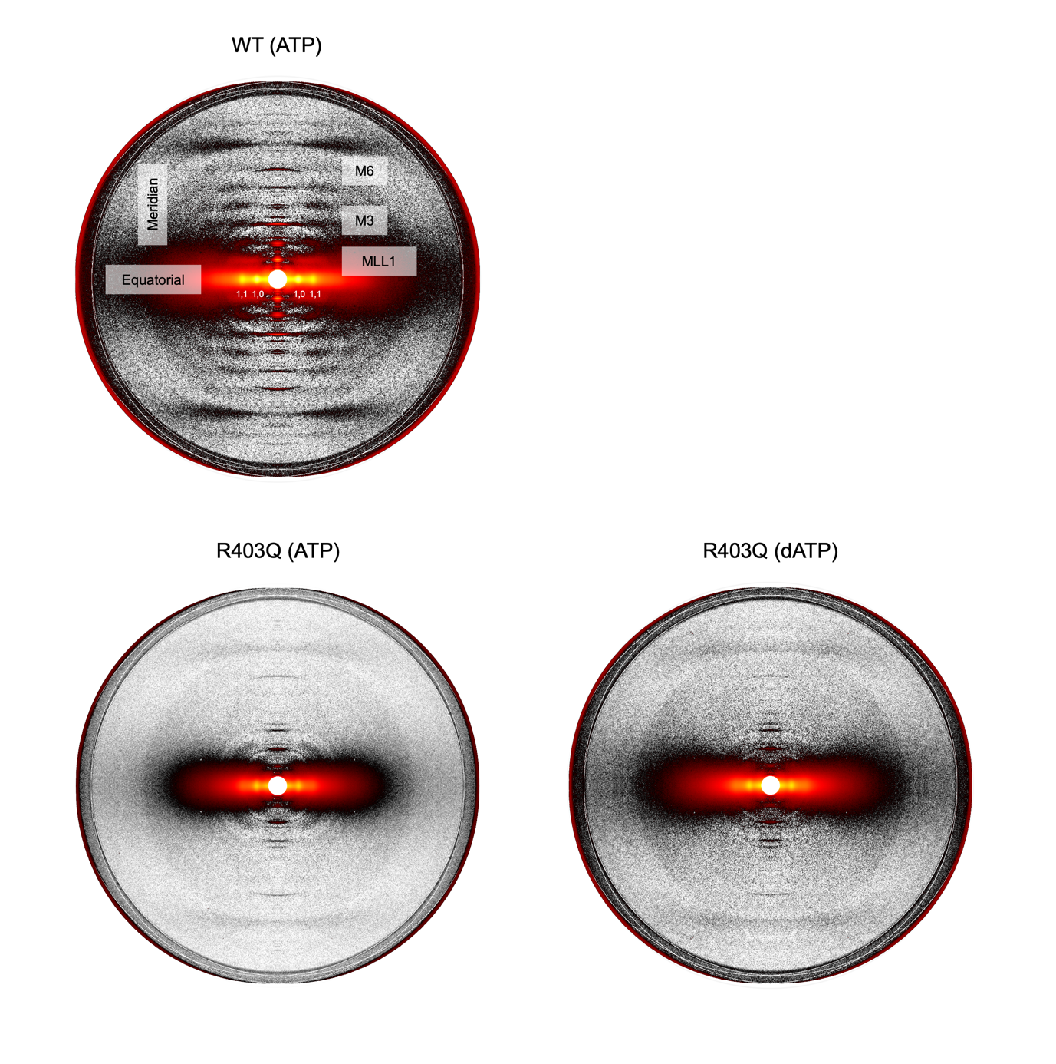
Supplemental Figure S1. Original (un-cropped and un-edited), sample X-ray diffraction patterns used for quantification. Sample X-ray diffraction patterns of (A) WT and (B) R403Q porcine ventricular myocardium under resting conditions. (C) Sample X-ray diffraction pattern of R403Q myocardium incubated with 100% dATP at the time of data collection.

Supplemental Figure S2. Force-pCa curves from isolated uniaxially aligned porcine ventricle tissue strips from WT (grey line) and R403Q (red line) littermate minipigs. WT: N = 3, n = 14; R403Q: N = 3, n = 14. Data are presented as mean ± SEM. N = number of biological replicate minipigs; n = number of technical replicates.

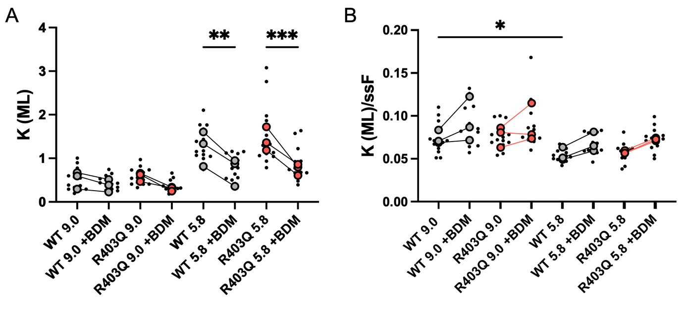
Supplemental Figure S3. No differences in tissue stiffness were identified between WT (grey) and R403Q (red) myocardium. High-frequency stiffness (HFS) was measured by applying a 1000 Hz sinusoidal length change (±0.5% muscle length (ML)) under relaxed conditions and submaximal calcium activation (pCa 5.8). To exclude impact of bound cross-bridges, stiffness was also measured in the presence of BDM. Two-way ANOVA with Tukey post hoc test, *p < 0.05, **p < 0.01, ***p < 0.001.
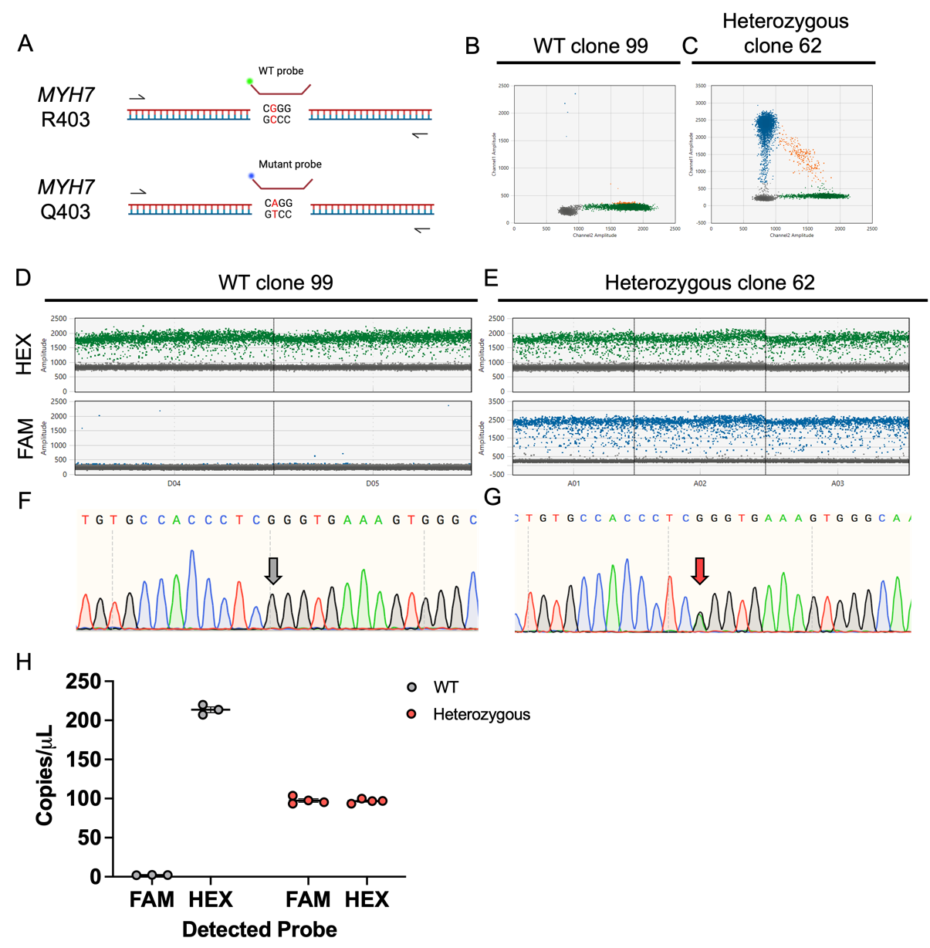
Supplemental Figure S4. Digital droplet PCR (ddPCR) was used to confirm correct CRISPR/Cas9 genome editing to insert the expected MYH7 c.1208G>A (R403Q) mutation into human, wildtype WTC-11 hiPSCs. (A) Schematic of ddPCR assay set up. A primer pair and two probes (a HEX-wildtype (WT) probe and a FAM-mutant probe) were used to detect both mutant and WT alleles in the same reaction. 2D amplitude view showing (B) WT clone 99 and (C) heterozygous clone 62. 1D amplitude view of HEX and FAM probes for (D) WT and (E) heterozygous. Accompanying Sanger Sequencing for (F) WT and (G) heterozygous clones. (H) ddPCR concentration graph showing the number of DNA copies per microliter detected with each probe (WT: N = 1, n = 3, heterozygous: N = 1, n = 4). N = number of biological replicates; n = number of technical replicates.

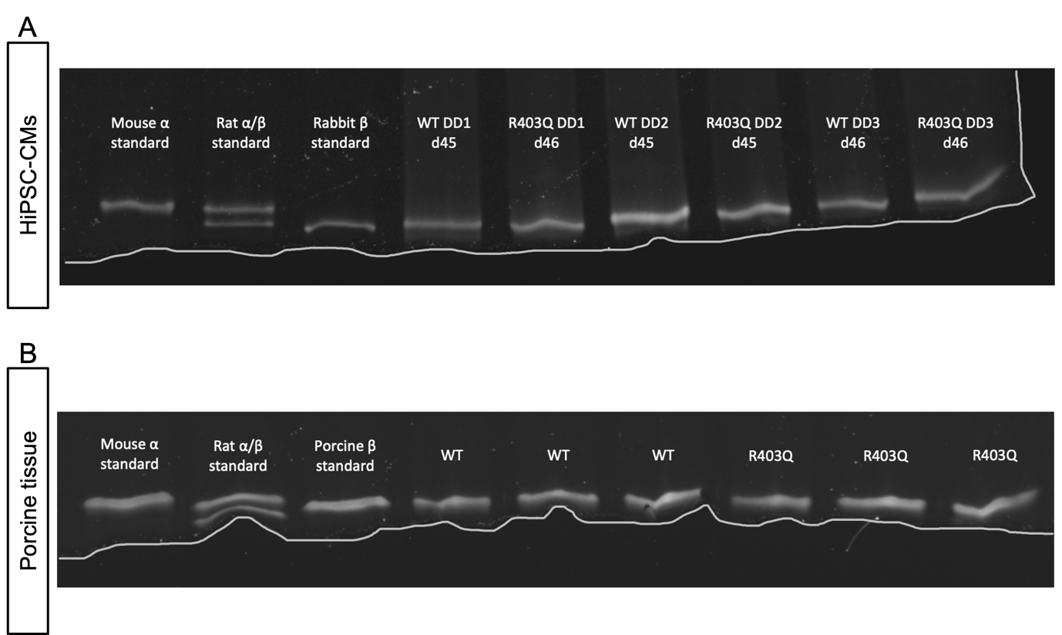
Supplemental Figure S5. Gel separation between (A) human hiPSC-CM and (B) porcine α- and β-MHC isoforms for WT and heterozygous R403Q samples. For human MHC, α-MHC isoform is 224 kDa, while the β-MHC isoform is 223 kDa. (A) For hiPSC-CM samples, day 45 – 46 whole cell protein lysates were run on a myosin separation gel for WT (N = 3, n = 1) and R403Q (N = 3, n = 1) samples. Controls were protein lysates from isolated mouse, rat, and rabbit cardiac tissue myofibrils (top gel). (B) For porcine samples, proteins were lysed from isolated myofibrils and run on a separation gel for WT (N = 3, n = 1) and R403Q (N = 3, n = 1) samples. Controls were protein lysates from isolated mouse, rat and non-transgenic porcine cardiac tissue myofibrils (bottom gel). N = number of biological replicate minipigs; n = number of technical replicates. A white line was manually drawn to designate the border of the gel.

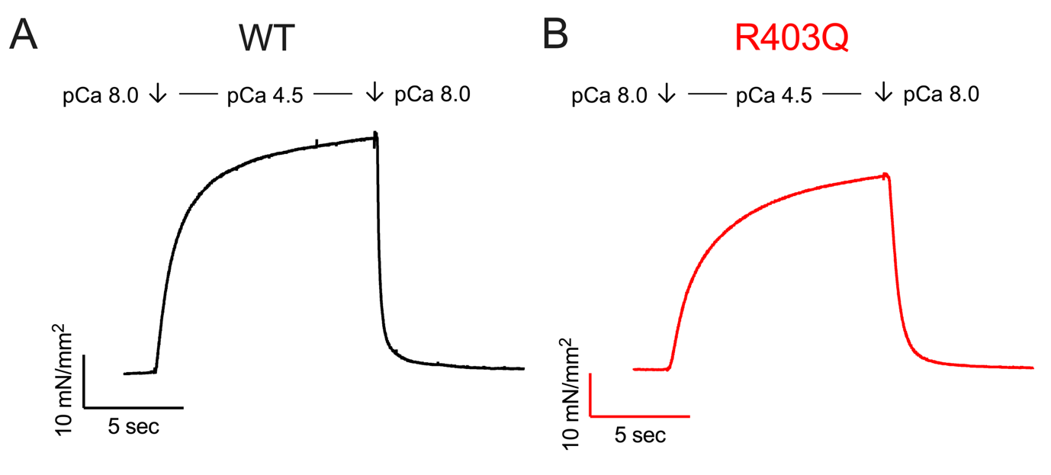
Supplemental Figure S6. Representative force traces of isolated myofibrils from (A) WT and (B) R403Q hiPSC-CMs. Isolated hiPSC-CM myofibrils are mounted between two glass needles for mechanical measurements. A double barrel pipet is used to expose myofibrils to maximally activating (pCa 4.5) calcium solution and then subsequently exposed to relaxation solution (pCa 8.0).

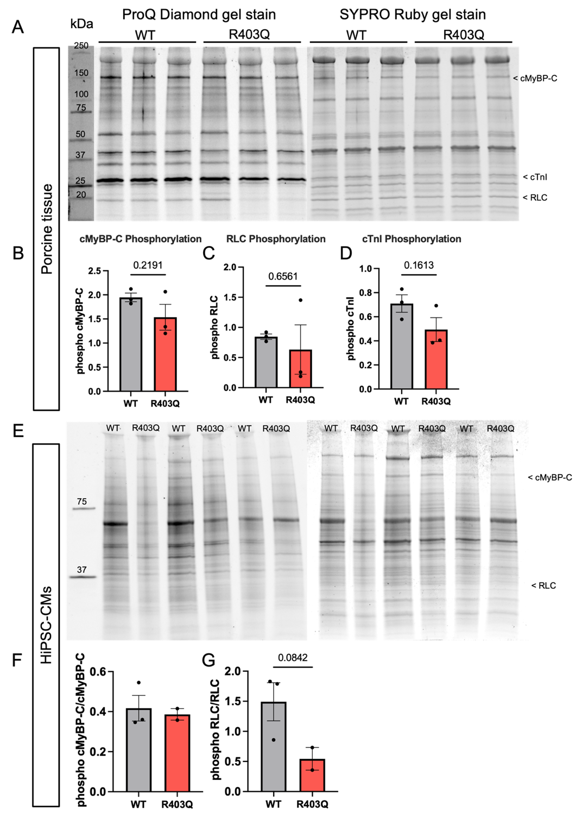
Supplemental Figure S7. Phosphorylation profile of key sarcomeric proteins, cMyBP-C, RLC, and cTnI in both porcine myofibrils and human iPSC-CM cell lysates. (A) Uncropped and unedited Pro-Q Diamond and Coomassie total protein gel stains on lysates from WT and R403Q isolated porcine ventricular myofibrils. Densitometry analysis was performed on cMyBP-C, RLC, and cTnI bands from both gels, with Pro-Q phosphorylation bands normalized to corresponding total protein band. Quantification of phosphorylated (B) cMyBP-C, (C) RLC, and (D) cTnI (WT: N = 3, n = 1; R403Q: N = 3, n = 1). (E) Uncropped and unedited Pro-Q Diamond and Coomassie total protein gel stains on lysates from day 45 – 46 WT and heterozygous R403Q hiPSC-CMs. Quantification of phosphorylated (F) cMyBP-C and (G) RLC (WT: N = 3, n = 1; R403Q: N = 2, n = 1). No quantification of cTnI band was possible in hiPSC-CM samples. Ladder used was a Precision Plus Protein™ Dual Color Standards ladder. Data are presented as mean ± SEM. N = number of biological replicates; n = number of technical replicates run per sample. P value was determined by unpaired, two-tailed Student’s t-test with Welch’s correction.

Supplemental Figure S8. R403Q mutation induced changes in myofibril kinetics parameters exhibit similarities between day 45 hiPSC-CM derived myofibrils and porcine ventricular myofibrils. For each myofibril kinetics parameter calculated from the isolated myofibril experiment at maximal calcium activation (pCa 4.5), percent change was calculated between the mutant and its corresponding control. The dashed black line corresponds to zero, indicating no change between mutant and control.

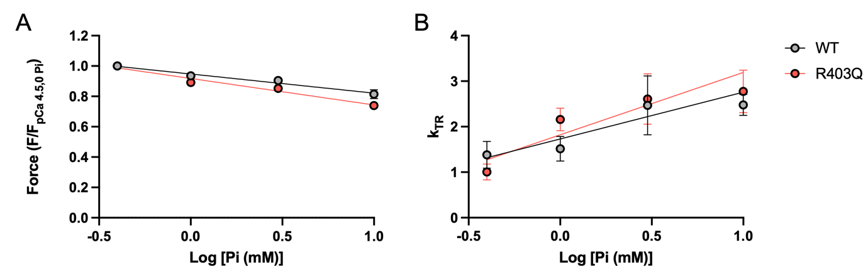
Supplemental Figure S9. Permeabilized WT and R403Q ventricular strips did not exhibit impairments in phosphate release. (A) Force and (B) k_{TR} measurements for WT and R403Q porcine ventricular tissue were taken in the presence of increasing concentrations of inorganic phosphate (Pi). The linear relationship between relative force and log[Pi (mM)] in permeabilized mechanics was plotted for both parameters. Data are presented as mean ± SEM.
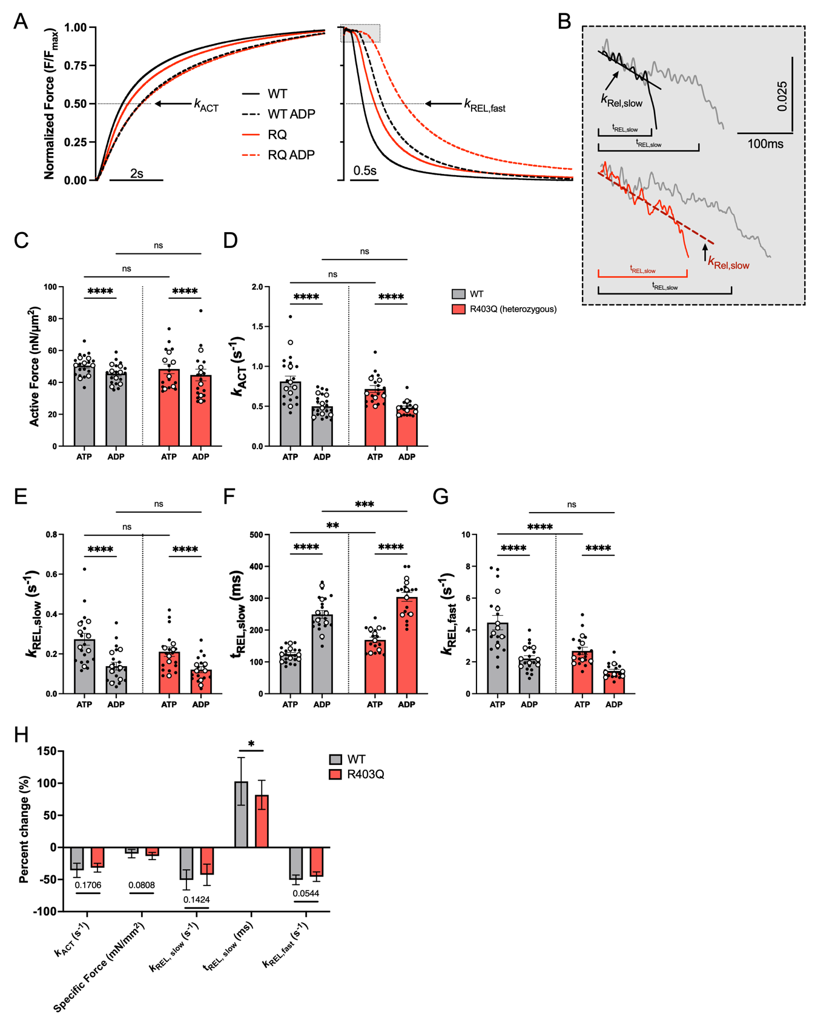
Supplemental Figure S10. HiPSC-CM myofibrils with the R403Q mutation exhibit less alteration of ADP release than adult myofibrils. (A) Average normalized myofibril kinetics traces for WT and R403Q hiPSC-CM myofibrils with and without the presence of elevated ADP in the maximal calcium activation solution (pCa 4.5). (B) Traces highlighting the slow phase of relaxation (with a manual offset for visualization) before and after ADP inhibition experiment for WT (top black: 100% ATP, top grey: 50% ATP:50% ADP) and R403Q (bottom red: 100% ATP, bottom grey: 50% ATP:50% ADP) hiPSC-CM lines. Quantification of (C) maximal force, (D) rate of activation (E) rate of the slow phase of relaxation, (F) duration of the slow phase of relaxation, and (G) rate of the fast phase of relaxation before and after paired ADP inhibition experiment (WT | ATP: N = 7, n = 19; WT | ADP: N = 7, n = 18 – 19; R403Q | ATP: N = 6, n = 17, R403Q | ADP: N = 6, n = 16 – 17). (H) Percent change in each myofibril parameter after ADP inhibition experiment for both WT and R403Q hiPSC-CMs. Data presented as mean ± SEM. N = number of biological replicate differentiation batches; n = number of myofibril technical replicates. Two-way ANOVA with Tukey post-hoc test, *p < 0.05, **p < 0.01, ***p < 0.001, ****p < 0.0001.

- Citations.
1. Geisterfer-Lowrance AAT, Kass S, Tanigawa G, Vosberg H-P, McKenna W, Seidman CE, et al. A molecular basis for familial hypertrophic cardiomyopathy: A beta cardiac myosin heavy chain gene missense mutation. Cell. 1990;62:999-1006.
2. Maron BJ, Desai MY, Nishimura RA, Spirito P, Rakowski H, Towbin JA, et al. Diagnosis and Evaluation of Hypertrophic Cardiomyopathy: JACC State-of-the-Art Review. J Am Coll Cardiol. 2022;79(4):372-89.
3. Lowey S, Lesko LM, Rovner AS, Hodges AR, White SL, Low RB, et al. Functional effects of the hypertrophic cardiomyopathy R403Q mutation are different in an alpha- or beta-myosin heavy chain backbone. J Biol Chem. 2008;283(29):20579-89.
4. Lowey S, Bretton V, Gulick J, Robbins J, Trybus KM. Transgenic mouse alpha- and beta-cardiac myosins containing the R403Q mutation show isoform-dependent transient kinetic differences. J Biol Chem. 2013;288(21):14780-7.
5. Lowey S, Bretton V, Joel PB, Trybus KM, Gulick J, Robbins J, et al. Hypertrophic cardiomyopathy R403Q mutation in rabbit beta-myosin reduces contractile function at the molecular and myofibrillar levels. Proc Natl Acad Sci U S A. 2018;115(44):11238-43.
6. Belus A, Piroddi N, Scellini B, Tesi C, D'Amati G, Girolami F, et al. The familial hypertrophic cardiomyopathy-associated myosin mutation R403Q accelerates tension generation and relaxation of human cardiac myofibrils. J Physiol. 2008;586(15):3639-44.
7. Witjas-Paalberends ER, Ferrara C, Scellini B, Piroddi N, Montag J, Tesi C, et al. Faster cross-bridge detachment and increased tension cost in human hypertrophic cardiomyopathy with the R403Q MYH7 mutation. J Physiol. 2014;592(15):3257-72.
8. Palmiter KA, Tyska MJ, Haeberle JR, Alpert NR, Fananapazir L, Warshaw DM. R403Q and L908V mutant cardiac myosin from patients with familial hypertrophic cardiomyopathy exhibit enhanced mechanical performance at the single molecule level. Journal of Muscle Research and Cell Motility. 2000;21:609-20.
9. Nag S, Sommese RF, Ujfalusi Z, Combs A, Langer S, Sutton S, et al. Contractility parameters of human b-cardiac myosin with the hypertrophic cardiomyopathy mutation R403Q show loss of motor function. Sci Adv. 2015.
10. Volkmann N, Lui H, Hazelwood L, Trybus KM, Lowey S, Hanein D. The R403Q myosin mutation implicated in familial hypertrophic cardiomyopathy causes disorder at the actomyosin interface. PLoS One. 2007;2(11):e1123.
11. Anderson RL, Trivedi DV, Sarkar SS, Henze M, Ma W, Gong H, et al. Deciphering the super relaxed state of human beta-cardiac myosin and the mode of action of mavacamten from myosin molecules to muscle fibers. Proc Natl Acad Sci U S A. 2018;115(35):E8143-E52.
12. Green EM, Weiss RM, Divekar A, Bartholomew Ingle SR, Henze M, Evanchik MJ, et al. Abstract 14467: A Minipig Genetic Model of Hypertrophic Cardiomyopathy. Circulation. 2016;134(suppl_1):A14467-A.
13. Henze M, Anderson R, Wong F, Weiss R, Divekar A, Meyerholz D, et al. Cardiac muscle function across the natural history of a genetic minipig model of hypertrophic cardiomyopathy. J Mol Cell Cardiol. 2017;112:166.
14. Ma W, Gong H, Jani V, Lee KH, Landim-Vieira M, Papadaki M, et al. Myofibril orientation as a metric for characterizing heart disease. Biophys J. 2022;121(4):565-74.
15. Guide for the Care and Use of Laboratory Animals. The National Academies Collection: Reports funded by National Institutes of Health. 8th ed. Washington (DC)2011.
16. Leary SL, Underwood WJ, Anthony R, Cartner SC, Corey D, Grandin T, et al., editors. AVMA Guidelines for the Euthanasia of Animals: 2013 Edition2013.
17. Ma W, Irving TC. Small Angle X-ray Diffraction as a Tool for Structural Characterization of Muscle Disease. Int J Mol Sci. 2022;23(6).
18. Ma W, McMillen TS, Childers MC, Gong H, Regnier M, Irving T. Structural OFF/ON transitions of myosin in relaxed porcine myocardium predict calcium-activated force. Proc Natl Acad Sci U S A. 2023;120(5):e2207615120.
19. Fischetti R, Stepanov S, Rosenbaum G, Barrea R, Black E, Gore D, et al. The BioCAT undulator beamline 18ID: a facility for biological non-crystalline diffraction and X-ray absorption spectroscopy at the Advanced Photon Source. J Synchrotron Radiat. 2004;11(Pt 5):399-405.
20. Jiratrakanvong J, Shao J, Li J, Menendez Alvarez M, Li X, Das P, et al. MuscleX: data analysis software for fiber diffraction patterns from muscle. J Synchrotron Radiat. 2024;31(Pt 5):1401-8.
21. Ma W, Gong H, Irving T. Myosin Head Configurations in Resting and Contracting Murine Skeletal Muscle. Int J Mol Sci. 2018;19(9).
22. Ma W, Childers M, Murray J, Moussavi-Harami F, Gong H, Weiss R, et al. Myosin dynamics during relaxation in mouse soleus muscle and modulation by 2'-deoxy-ATP. J Physiol. 2020;598(22):5165-82.
23. Pilagov M, Steczina S, Naim A, Regnier M, Geeves MA, Kad NM. Spatially resolving how cMyBP-C phosphorylation and haploinsufficiency in porcine and human myofibrils affect beta-cardiac myosin activity. J Gen Physiol. 2025;157(5).
24. Pilagov M, Heling L, Walklate J, Geeves MA, Kad NM. Single-molecule imaging reveals how mavacamten and PKA modulate ATP turnover in skeletal muscle myofibrils. J Gen Physiol. 2023;155(1).
25. Toseland CP, Webb MR. Fluorescent nucleoside triphosphates for single-molecule enzymology. Methods Mol Biol. 2011;778:161-74.
26. Tinevez JY, Perry N, Schindelin J, Hoopes GM, Reynolds GD, Laplantine E, et al. TrackMate: An open and extensible platform for single-particle tracking. Methods. 2017;115:80-90.
27. Tonino P, Kiss B, Gohlke J, Smith JE, 3rd, Granzier H. Fine mapping titin's C-zone: Matching cardiac myosin-binding protein C stripes with titin's super-repeats. J Mol Cell Cardiol. 2019;133:47-56.
28. Bennett P, Rees M, Gautel M. The Axial Alignment of Titin on the Muscle Thick Filament Supports Its Role as a Molecular Ruler. J Mol Biol. 2020;432(17):4815-29.
29. Powers JD, Kooiker KB, Mason AB, Teitgen AE, Flint GV, Tardiff JC, et al. Modulating the tension-time integral of the cardiac twitch prevents dilated cardiomyopathy in murine hearts. JCI Insight. 2020;5(20).
30. Kooiker KB, Mohran S, Turner KL, Ma W, Martinson A, Flint G, et al. Danicamtiv Increases Myosin Recruitment and Alters Cross-Bridge Cycling in Cardiac Muscle. Circ Res. 2023;133(5):430-43.
31. Moussavi-Harami F, Razumova MV, Racca AW, Cheng Y, Stempien-Otero A, Regnier M. 2-Deoxy adenosine triphosphate improves contraction in human end-stage heart failure. J Mol Cell Cardiol. 2015;79:256-63.
32. Racca AW, Beck AE, Rao VS, Flint GV, Lundy SD, Born DE, et al. Contractility and kinetics of human fetal and human adult skeletal muscle. J Physiol. 2013;591(12):3049-61.
33. Doran MH, Rynkiewicz MJ, Rasicci D, Bodt SML, Barry ME, Bullitt E, et al. Conformational changes linked to ADP release from human cardiac myosin bound to actin-tropomyosin. Journal of General Physiology. 2023;155(3).
34. Sali A, Blundell TL. Comparative protein modelling by satisfaction of spatial restraints. J Mol Biol. 1993;234(3):779-815.
35. Yang Y, Gourinath S, Kovács M, Nyitray L, Reutzel R, Himmel DM, et al. Rigor-like Structures from Muscle Myosins Reveal Key Mechanical Elements in the Transduction Pathways of This Allosteric Motor. Structure. 2007;15(5):553-64.
36. Anandakrishnan R, Aguilar B, Onufriev AV. H++ 3.0: automating pK prediction and the preparation of biomolecular structures for atomistic molecular modeling and simulations. Nucleic Acids Research. 2012;40(W1):W537-W41.
37. Case DA, Belfon K, Ben-Shalom IY, Brozell SR, Cerutti DS, T.E. Cheatham I, et al. AMBER 2020. University of California, San Francisco2020.
38. Hopkins CW, Le Grand S, Walker RC, Roitberg AE. Long-Time-Step Molecular Dynamics through Hydrogen Mass Repartitioning. Journal of Chemical Theory and Computation. 2015;11(4):1864-74.
39. Jorgensen WL, Chandrasekhar J, Madura JD, Impey R, Klein ML. Comparison of simple potential functions for simulating liquid water. Journal of Chemical Physics. 1983;79:926-35.
40. Li P, Song LF, Merz KM, Jr. Parameterization of highly charged metal ions using the 12-6-4 LJ-type nonbonded model in explicit water. J Phys Chem B. 2015;119(3):883-95.
41. Li P, Song LF, Merz KM, Jr. Systematic Parameterization of Monovalent Ions Employing the Nonbonded Model. J Chem Theory Comput. 2015;11(4):1645-57.
42. Li P, Merz KM, Jr. Taking into Account the Ion-induced Dipole Interaction in the Nonbonded Model of Ions. J Chem Theory Comput. 2014;10(1):289-97.
43. He X, Man VH, Yang W, Lee TS, Wang J. A fast and high-quality charge model for the next generation general AMBER force field. J Chem Phys. 2020;153(11):114502.
44. Neese F, Wennmohs F, Becker U, Riplinger C. The ORCA quantum chemistry program package. J Chem Phys. 2020;152(22):224108.
45. Roe DR, Cheatham TE, III. PTRAJ and CPPTRAJ: Software for Processing and Analysis of Molecular Dynamics Trajectory Data. Journal of Chemical Theory and Computation. 2013;9(7):3084-95.
46. Pettersen EF, Goddard TD, Huang CC, Couch GS, Greenblatt DM, Meng EC, et al. UCSF Chimera--a visualization system for exploratory research and analysis. J Comput Chem. 2004;25(13):1605-12.
47. Concordet J-P, Haeussler M. CRISPOR: intuitive guide selection for CRISPR/Cas9 genome editing experiments and screens. Nucleic Acids Research. 2018;46(W1):W242-W5.
48. Steczina S, Mohran S, Bailey LRJ, McMillen TS, Kooiker KB, Wood NB, et al. MYBPC3-c.772G>A mutation results in haploinsufficiency and altered myosin cycling kinetics in a patient induced stem cell derived cardiomyocyte model of hypertrophic cardiomyopathy. J Mol Cell Cardiol. 2024;191:27-39.
49. Mohran S, Steczina S, Mandrycky C, Kao K, Regnier M. Measuring the Contractile Kinetics of Isolated Myofibrils from Human-Induced Pluripotent Stem Cell Derived Cardiomyocyte (hiPSC-CM) Models of Cardiomyopathy. 2024. In: Methods Mol Biol [Internet]. [213-33]. Available from: https://www.ncbi.nlm.nih.gov/pubmed/38038851.
50. Pioner JM, Racca AW, Klaiman JM, Yang K-C, Guan X, Pabon L, et al. Isolation and Mechanical Measurements of Myofibrils from Human Induced Pluripotent Stem Cell-Derived Cardiomyocytes. Stem Cell Reports. 2016;6(6):885-96.
51. Bremner S, Goldstein AJ, Higashi T, Sniadecki NJ. Engineered Heart Tissues for Contractile, Structural, and Transcriptional Assessment of Human Pluripotent Stem Cell-Derived Cardiomyocytes in a Three-Dimensional, Auxotonic Environment. Methods Mol Biol. 2022;2485:87-97.
52. Green EM, Weiss RM, Divekar A, Bartholomew Ingle SR, Henze M, Kawas R, et al. Abstract 16: A Minipig Genetic Model of Hypertrophic Cardiomyopathy. Circulation Research. 2017;121(suppl_1):A16-A.
53. Haselgrove JC, Huxley HE. X-ray evidence for radial cross-bridge movement and for the sliding filament model in actively contracting skeletal muscle. J Mol Biol. 1973;77(4):549-68.
54. Powers JD, Yuan C-C, McCabe KJ, Murray JD, Childers MC, Flint GV, et al. Cardiac myosin activation with 2-deoxy-ATP via increased electrostatic interactions with actin. Proceedings of the National Academy of Sciences. 2019;116(23):11502.
55. Jani VP, Song T, Gao C, Gong H, Sadayappan S, Kass DA, et al. The structural OFF and ON states of myosin can be decoupled from the biochemical super- and disordered-relaxed states. PNAS Nexus. 2024;3(2):pgae039.
56. Amrute-Nayak M, Lambeck KA, Radocaj A, Huhnt HE, Scholz T, Hahn N, et al. ATP turnover by individual myosin molecules hints at two conformers of the myosin active site. Proc Natl Acad Sci U S A. 2014;111(7):2536-41.
57. Usaj M, Moretto L, Vemula V, Salhotra A, Mansson A. Single molecule turnover of fluorescent ATP by myosin and actomyosin unveil elusive enzymatic mechanisms. Commun Biol. 2021;4(1):64.
58. Squire JM, Luther PK, Knupp C. Structural evidence for the interaction of C-protein (MyBP-C) with actin and sequence identification of a possible actin-binding domain. J Mol Biol. 2003;331(3):713-24.
59. Colson BA, Bekyarova T, Fitzsimons DP, Irving TC, Moss RL. Radial displacement of myosin cross-bridges in mouse myocardium due to ablation of myosin binding protein-C. J Mol Biol. 2007;367(1):36-41.
60. Colson BA, Bekyarova T, Locher MR, Fitzsimons DP, Irving TC, Moss RL. Protein kinase A-mediated phosphorylation of cMyBP-C increases proximity of myosin heads to actin in resting myocardium. Circ Res. 2008;103(3):244-51.
61. Tong CW, Stelzer JE, Greaser ML, Powers PA, Moss RL. Acceleration of crossbridge kinetics by protein kinase A phosphorylation of cardiac myosin binding protein C modulates cardiac function. Circ Res. 2008;103(9):974-82.
62. Tesi C, Piroddi N, Colomo F, Poggesi C. Relaxation kinetics following sudden Ca(2+) reduction in single myofibrils from skeletal muscle. Biophys J. 2002;83(4):2142-51.
63. Poggesi C, Tesi C, Stehle R. Sarcomeric determinants of striated muscle relaxation kinetics. Pflugers Arch. 2005;449(6):505-17.
64. Kreutziger KL, Piroddi N, McMichael JT, Tesi C, Poggesi C, Regnier M. Calcium binding kinetics of troponin C strongly modulate cooperative activation and tension kinetics in cardiac muscle. J Mol Cell Cardiol. 2011;50(1):165-74.
65. Davis J, Davis LC, Correll RN, Makarewich CA, Schwanekamp JA, Moussavi-Harami F, et al. A Tension-Based Model Distinguishes Hypertrophic versus Dilated Cardiomyopathy. Cell. 2016;165(5):1147-59.
66. Kelley LA, Gardner SP, Sutcliffe MJ. An automated approach for clustering an ensemble of NMR-derived protein structures into conformationally related subfamilies. Protein Eng. 1996;9(11):1063-5.
67. Grinzato A, Auguin D, Kikuti C, Nandwani N, Moussaoui D, Pathak D, et al. Cryo-EM structure of the folded-back state of human β-cardiac myosin. Nature Communications. 2023;14(1):3166.
68. Childers MC, Geeves MA, Regnier M. Interacting myosin head dynamics and their modification by 2'-deoxy-ADP. Biophys J. 2024.
69. Nowakowski SG, Regnier M, Daggett V. Molecular mechanisms underlying deoxy-ADP.Pi activation of pre-powerstroke myosin. Protein Sci. 2017;26(4):749-62.
70. Sarkar SS, Trivedi DV, Morck MM, Adhikari AS, Pasha SN, Ruppel K, et al. The hypertrophic cardiomyopathy mutations R403Q and R663H increase the number of myosin heads available to interact with actin. Sci Adv. 2020;6:eaax0069.
71. Nag S, Trivedi DV, Sarkar SS, Adhikari AS, Sunitha MS, Sutton S, et al. The myosin mesa and the basis of hypercontractility caused by hypertrophic cardiomyopathy mutations. Nat Struct Mol Biol. 2017;24(6):525-33.
72. Colson BA, Patel JR, Chen PP, Bekyarova T, Abdalla MI, Tong CW, et al. Myosin binding protein-C phosphorylation is the principal mediator of protein kinase A effects on thick filament structure in myocardium. J Mol Cell Cardiol. 2012;53(5):609-16.
73. Stelzer JE, Patel JR, Walker JW, Moss RL. Differential Roles of Cardiac Myosin-Binding Protein C and Cardiac Troponin I in the Myofibrillar Force Responses to Protein Kinase A Phosphorylation. Circulation Research. 2007;101(5):503-11.
74. Stelzer JE, Dunning SB, Moss RL. Ablation of cardiac myosin-binding protein-C accelerates stretch activation in murine skinned myocardium. Circ Res. 2006;98(9):1212-8.
75. Mohran S, Kooiker K, Mahoney-Schaefer M, Mandrycky C, Kao K, Tu AY, et al. The biochemically defined super relaxed state of myosin-A paradox. J Biol Chem. 2024;300(1):105565.
76. Toepfer CN, Garfinkel AC, Venturini G, Wakimoto H, Repetti G, Alamo L, et al. Myosin Sequestration Regulates Sarcomere Function, Cardiomyocyte Energetics, and Metabolism, Informing the Pathogenesis of Hypertrophic Cardiomyopathy. Circulation. 2020;141(10):828-42.
77. van Dijk SJ, Dooijes D, dos Remedios C, Michels M, Lamers JM, Winegrad S, et al. Cardiac myosin-binding protein C mutations and hypertrophic cardiomyopathy: haploinsufficiency, deranged phosphorylation, and cardiomyocyte dysfunction. Circulation. 2009;119(11):1473-83.
78. Hoskins AC, Jacques A, Bardswell SC, McKenna WJ, Tsang V, dos Remedios CG, et al. Normal passive viscoelasticity but abnormal myofibrillar force generation in human hypertrophic cardiomyopathy. J Mol Cell Cardiol. 2010;49(5):737-45.

