The Journal of Law and Society in Context:

A Bibliometric Analysis

C. Boulanger, N. Creutzfeldt, & J. Hendry*

On this, the occasion of its 50th anniversary, we employ a quantitative analysis of the Journal of Law & Society (JLS) to chart empirically the evolution of UK socio-legal studies. By tracing the influence/s of the JLS upon the development of socio-legal research in the UK, not only do we demonstrate a new mode of exploring knowledge production in the field of socio-legal studies, but we also illustrate how computational methods can augment hermeneutical approaches to mapping socio-legal trends.
Through (a blend of) three different analytical approaches – descriptive analyses of bibliographic metadata, text-linguistic analyses of content (metadata or fulltext), and network analyses of citation graphs – we generate comparative information about the JLS since its 1974 inception. We then employ this data to interrogate the JLS’s own narratives: using predictions, ambitions, and statements of intent made by Editor-in-Chief Phil Thomas published either within or regarding the JLS, we present a map of the journal’s role within, impact upon, and enduring contribution to UK socio-legal studies.

Introduction
The Journal of Law & Society (JLS) has been, since its 1974 inception, a leading vehicle and driving force for socio-legal studies scholarship in the United Kingdom and beyond. It is due to this particular prominence that we selected the JLS – in the form of its fifty-volume aggregation - as the subject of our bibliometric and statistics-based analysis, an analysis that aims to map and contextualise the development of the scholarly field that has come to be known as socio-legal studies, and the particular influence/s the JLS has had upon that development.
Our goal is, using a “Probebohrungen” approach, to provide a contextualised picture of the JLS - and, through this, socio-legal studies - over the past half century, one that not only depicts notable trends and dynamics but also brings into clear view the effects of inter alia the 1990 creation of the Socio-Legal Studies Association (SLSA), the post-92 expansion in UK Higher Education, the Research Excellence Framework (REF), and socio-legal scholarship’s steady movement from the academic periphery to the centre. Contextualising the data gleaned from the bibliometrics is thus crucial: although the data can show us trends and patterns, without being placed in context this information is only indicative.
To that end, not only do we structure our analysis around notable considerations – namely, i) beginnings, ii) influences, iii) the JLS’ contribution to UK socio-legal studies, iv) dominant voices and themes, and v) methods and theory– we contextualise these considerations through the lens of predictions, aspirations, and statements of intent made by JLS Editor-in-Chief Phil Thomas. These we draw from three discrete sources: a) our own 2021 semi-structured interview with Phil Thomas, b) the 2015 interview with Phil Thomas, undertaken by Christos Boukalas and Lydia Hayes, and c) the editorial from the 1974 first issue of the JLS, when it was still known as the British Journal of Law & Society. These rich sources not only allow us to interrogate, through JLS bibliometric data, the development of the Journal on its own terms, but also – through the lens of the JLS, and using the Journal as a barometer – to chart empirically the evolution of (UK) socio-legal studies.
We used three different types of quantitative analyses: i) descriptive analyses of bibliographic metadata, ii) text-linguistic analyses of a corpus if fulltext articles and, iii) network analyses of citation graphs. These combined to produce rich sets of data on the JLS, one we could effectively interrogate in terms of existing narratives and assumptions. We should acknowledge here that we restricted ourselves only to questions that could be meaningfully addressed by the data, which is to say, that the salient information was included within the published corpus of the JLS. For example, as the journal does not publish author demographic information, we are unable to determine the respective career stages of contributors; likewise, as the JLS does not include article keywords, any bibliometric methods reliant on keyword analysis is precluded. This is also the case for institutional affiliations: incomplete data at source level means that we have not attempted to produce what would necessarily be a skewed representation. Instead, where necessary, we employ statistics produced by Ao and Munyard in March 2021 to show differing patterns in contributor institutions over the years, notably the changes post-1992.
Similarly, as this is the first study of this kind within the field of socio-legal studies, we are careful not to draw overly broad conclusions, nor to supply statistics or percentages. Our intention is rather to explore those key moments, significant developments, prominent dynamics, clear patterns, and notable trends - identifiable within the JLS – that combine to shape UK socio-legal studies, and to speculate as to the Journal’s role as a driver of many of those trends. In scrutinising the social conscience of the JLS, moreover, and its key role as a barometer for socio-legal studies in the UK, we draw attention to where there are gaps: overlooked debates, unheard voices, and unseen issues, and use these gaps to inform a potential direction of travel for the JLS for the next fifty years. This investigation into ‘what is missing’ constitutes our final theme.
Our analysis proceeds over three parts. First, we provide a brief contextualised history of the JLS, including the circumstances of its launch, the institutional permanence of its home at Cardiff Law School, and the (arguably correspondent) stability of its Editorial Board. Next, we supply an explanation of our bibliometric methods, showing the contributions and limitations of each specific approach, and illustrating how we generated our JLS dataset; for a detailed account of the methodology, plus visualizations awkward to publish in print, see the accompanying online blogpost. Third, under the five themes already identified, we cluster predictions, ambitions, and statements of intent made by the Journal’s Editor-in-Chief (hereafter EiC) and use these to ask precise questions of our search algorithms. This quinquepartite section sees us consider the JLS historically, contemporaneously, relationally, and contextually to create a detailed study that showcases the key contribution of this journal to the development of research and scholarship in UK socio-legal studies. We conclude by discussing other potential applications within the field for this kind of blend of computational and hermeneutical methods.

History & Positioning: a brief chronicle of the JLS
As Roger Cotterrell recently observed, socio-legal studies nowadays tends to be viewed as ‘a wider reaching-out – beyond the intellectual traditions of sociology of law that are significantly rooted in sociology as a discipline – into many knowledge fields in the social and human sciences and the humanities that can illuminate the nature of law’. He is not isolated in this conviction that the strength and potential of socio-legal studies lies in this inclusive, even expansive, quality. Sally Wheeler has also reflected on how the label ‘socio-legal’ - in contrast to ‘law and –’ approaches - is about ‘moving beyond the “and”’, while Jennifer Hendry has noted that the ‘sociolegal studies umbrella appears not only to extend over a range of approaches and methods, but also serves to encompass a broad interpretation of the “legal”’. Indeed, as we observed elsewhere, socio-legal studies’ ‘fluid disciplinary contours easily accommodate methodological and theoretical development in both the sociological and the legal fields’.
While this embracive portrayal of socio-legal studies might seem overtly contemporary, we submit that this ‘reaching out’ quality of socio-legal studies has always been key for the JLS, which clearly intended to establish itself as a vehicle for intellectually curious scholarship. Consider this statement from Thomas:
I come from an era when there were very few journals in which academics could publish. And the leading journals would have been the Cambridge Law Journal and Law Quarterly [Review]. I don't know who reads those journals these days. […] And yet they were the dominant journals. […] The point that I started to talk about was, if you are embarking on a different form of scholarship, then the Cambridge Law Journal would not be interested in publishing it. Therefore, if you are a serious scholar with a view to getting your ideas out, you need a vehicle. No vehicle, no transport means you’re static, you're stuck. And for me the JLS was the vehicle which was able to transport the ideas and work of this new generation of scholars.
This enabling ambition is evident from the Journal’s very earliest days: the (then BJLS) first issue Editorial not only articulated the Journal’s main intellectual objective as being the development of ‘an understanding of the operation and effect of law in society’, but also to facilitate the promotion, to a wider audience, of the nascent body of socio-legal scholarship already in existence at the time. The Editorial moreover set out boldly the following goal: ‘The aim of Journal of Law and Society is to follow this tradition of transcending disciplinary boundaries by taking as its focus the subject area of law in society’. While we explore this cornerstone JLS ambition to boundary-transcending socio-legal scholarship later in Part 5, it is worth highlighting here how radical it was, in 1974, to open with such a commitment, let alone to maintain it.
It is likely that, with such an unconventional – for the legal academy, at least – opening agenda, the JLS was unprepared for the levels of success it achieved. Originally published by Professional Books Limited for the University College Cardiff, this was only for the first few years: in 1977 University College Cardiff Press took over the publishing contract, albeit also for a brief period. 1981 saw the beginning of a period of extended stability, however, when publication of the journal was taken on by Oxford-based publishing house Blackwell Publishers, latterly Blackwell Publishing (2001), and since 2007 Wiley-Blackwell. Commencing with just two issues and 215 pages annually, the journal increased to three issues between 1984 and 1987, which is when it moved to four issues and close to double its initial print run of 510 pages per year. Currently publishing on the same quarterly basis, the JLS now not only runs to over 900 pages annually but also supplements these further with special sections (formerly special issues), a website, and a blog.
Its Editorial Board has undergone comparable expansion: the 1974 founding group of Thomas plus four Assistant Editors had by 1994 expanded to number ten in total, while the contemporary 2024 Editorial Board numbers thirteen strong. For anyone wondering: while the first woman joined the Editorial Board in 1985, just nine years after launch, a decade later only three women had served as Assistant Editors, and not always concurrently. The gender balance improved over the intervening years, however: at the time of writing, the Editorial Board composition is approximately one third female, with four women members from a total of 13.
Finally, the demographic arrangement of the JLS Editorial Board is underpinned – even determined – by the composition of Cardiff Law School, from where the Board is predominantly drawn. Indeed, the JLS has a policy of inviting as Assistant Editors socio-legal-minded scholars either employed at Cardiff Law School or who have a close affiliation with the school, having worked there and served as an Editorial Board member previously. Notably, this necessary Cardiff-connection does not extend to the Journal’s Advisory Board, which comprises academics who represent a wide range of disciplines, as well as national and international institutions.

Brief methods overview
To generate the data from the JLS corpus we applied three different types of analyses: descriptive analyses of bibliographic metadata, text-linguistic analyses of content (metadata or fulltext), and network analyses of citation graphs computed from existing and self-generated data. We relied mainly on two datasets: the ‘JLS corpus’ is a text corpus of all (B)JLS articles published from 1974 to 2022, extracted from PDFs that were downloaded from the publisher. The ‘JLS dataset’ contains metadata and data on the cited literature of each of these articles, and was produced by merging bibliographic and bibliometric metadata and data generated from the corpus data using citation-mining techniques.
The descriptive analysis and bibliometric metadata allowed us to run basic analysis that detected broad trends in the datase, for example, the number of articles and the most published authors per year. The text-linguistic analysis (using so-called Natural Language Processing (NLP) methods) further enabled us to look at unstructured textual data, allowing us to compare frequencies and patterns over time. We were also able to apply this to a more sophisticated query and do ‘topic modelling’ through an unsupervised machine learning approach that grouped words that appear together in the same document in a statistically significant way. Network analysis of citation graphs - in its most basic application – was then employed to explore the ‘reach’ of authors; this approach can be further operationalised to expose relationships that would be impossible to plot manually.

The JLS as barometer for socio-legal studies?
In this section we draw on data from the Journal of Law and Society to highlight trends and notable themes that we then embed in the wider context of socio-legal studies. As mentioned above, these themes are: i) beginnings, ii) influences, iii) the JLS’ contribution to UK socio-legal studies, iv) dominant voices and themes, and v) methods and theory. A key motivation for our analysis of the JLS has been the desire to show(case) its evolution over time, and to scrutinise (the narrative of) the Journal’s key role in the development of UK socio-legal studies. Our first task was to identify significant temporal junctures, with the aim of getting a sense of the zeitgeist within which the JLS was created, including its sense of social conscience. The second task was to identify indicators of change by charting the measurable effects such critical moments had upon the JLS as illuminated by our data.

Beginnings
The study of the action of law in society has an old tradition. In the nineteenth century such scholars as Dicey, Durkheim, Maine, Marx and Weber established this area as crucially important to those who wished to understand society. The aim of the British Journal of Law and Society is to follow this tradition of transcending disciplinary boundaries by taking as its focus the subject area of law in society.
If looking for statements of a journal’s intent, one need look no further than the inaugural issue’s editorial. This 1974 editorial includes one stated aim, quoted above, that the journal follows the ‘old tradition’ of studying the action of law in society and, through this, better understand society. Taking this published statement from Thomas as our starting point, and with a view to ascertaining the relative import and influence of classical scholars, we searched our dataset for the number of times those names quoted had been mentioned in the JLS corpus. By way of calibration, to this list of names we added selected other comparably prominent classical scholars from across the social sciences and humanities.
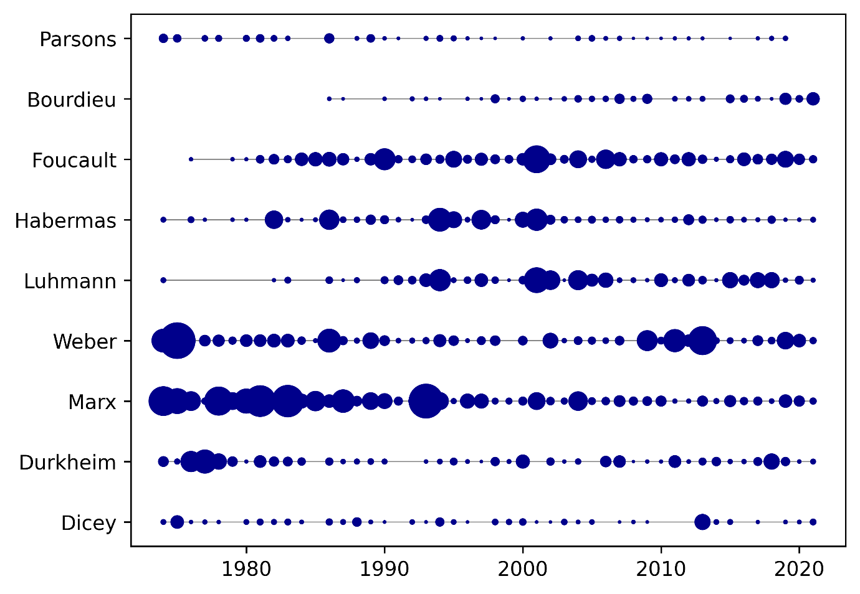
Fig. 1: Frequency analysis of “classic” authors in the sociolegal tradition, handpicked (Source: JLS corpus, adjusted for corpus size per year)
Fig. 1 is a scatterplot of mentions of the names of scholars over time, adjusted for the size of text corpus of each year. It shows that, for example, while the work of both Karl Marx and Max Weber has been referred to throughout the lifetime of the journal, these show different patterns, with Weber having clusters of mentions while Marx is mentioned consistently throughout. We can see that Foucault became a steady feature from the 1980s onwards, whereas Bourdieu starts to be cited around 1988 but with only sporadic reoccurrences until a flurry around 2019. Interestingly, although Luhmann was mentioned in the earliest issues of the journal, subsequent citations were few and far between until the mid-1990s, when they pick up noticeably and then continue in a steady if piecemeal vein. The figure further shows Habermas being mentioned in intermittently regular intervals, with a spell of notable prominence between 1992-2002.
Although interesting in how is displays the relative prominence in the JLS over time of those authors drawn from the Thomas quote plus others selected as comparably prominent in the field (broadly stated), this figure is of course not representative of overall citations in the Journal. To derive the 20 most-cited authors from the JLS data (Fig. 2), we instead generated an aggregated view of authors cited in the JLS, one that depicts the total amount of mentions, as opposed to their relative clustering over time.
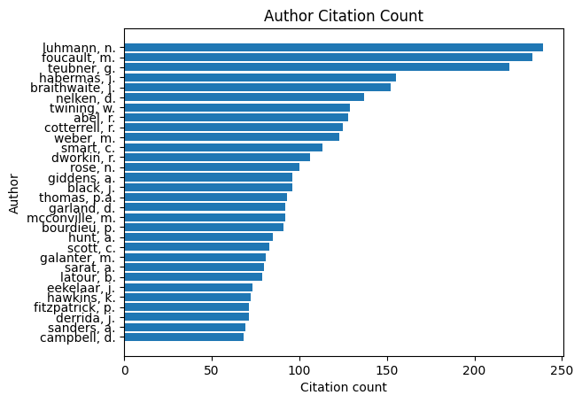
Figure 2: Number of citations of authors (Source: JLS dataset)
We can still identify clear citation trends: for example, the three most cited scholars are Foucault, Luhmann, and Teubner, with other well-known scholars such as Habermas, Braithwaite and Nelken following some distance behind.

Influences
There were several established, doctrinal journals available, so I was seeking to open up something radically different, a new dynamic that would produce something new. In this sense, you can say that JLS was born out of the spirit of 1968, it was born out of that feeling. […] While a wide range of theoretical influences (Marxism, feminism, sociology of law, critical legal studies, anarchism) and social movements influenced the early period of socio- legal studies and of the JLS; the catalyst was the weight of personal experience that a young generation of scholars had gained in the 1960s and their limited capacity to express it in the Law School as it then stood.
The JLS came into being to fill a gap, to create a new outlet for academic progressive voices that were, at the time, confined to their law schools and the then-dominant paradigm of doctrinal legal study. When exploring the voices that were cited in the beginnings of the Journal, therefore, we were keen to explore the ‘influences’ and the interrelationship with progressive and alternative scholarship. One initial way of gauging how such influences manifested was to look for the terms specifically mentioned by Thomas and to explore the frequency and regularity of their occurrence over time. We present our findings across five decades in figure 3 below; we arrived at this figure by searching for the following terms: social movements, anarchism, critical legal studies, sociology of law, Marxism, and feminism.
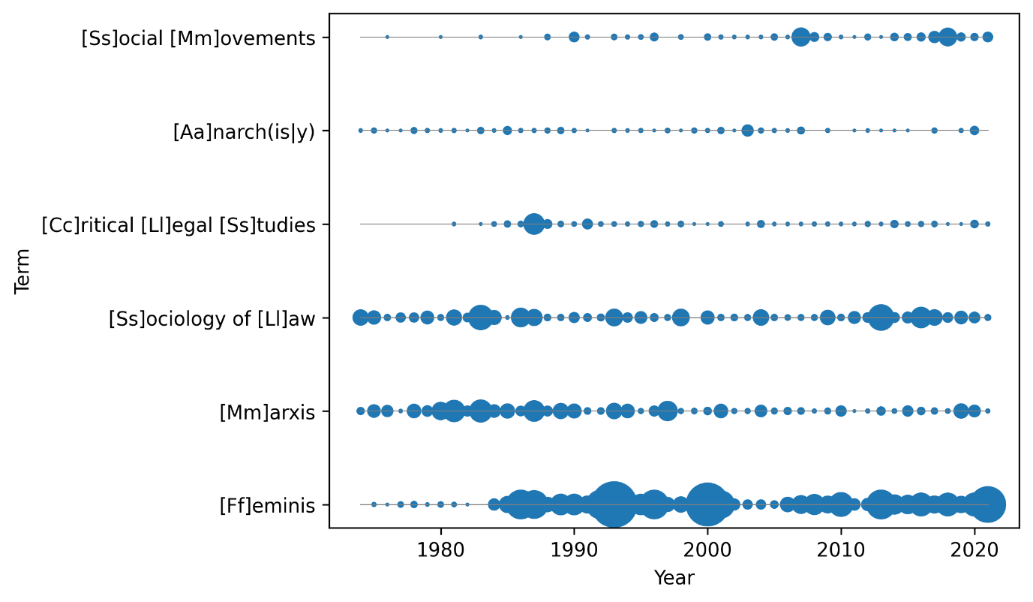
Fig, 3: Frequency analysis of terms identifying theoretical influences (Source: JLS corpus, adjusted for corpus size per year)
Fig. 3 shows the distribution of the six terms we looked for in the dataset. Most apparent from this visualisation is how use of the term feminism is effectively continuous from the mid-1980s onwards, if more prominent between 1985-2002 and again 2009-2023. The search term Marxism, however, shows the opposite trend: although mentioned regularly throughout the JLS’ fifty years, Marxism was more prominent in the first half of the Journal’s life (1974-1998), waning somewhat since the turn of the millennium. A more consistent topic of discussion in the JLS is the term the sociology of law, which shows a steady pattern of author mentions. Critical legal studies start being mentioned in the 1980s, with a short spike in 1988 that is almost certainly attributable to that year’s Special Issue on Law, Democracy and Justice, followed by regular if intermittent mentions that appear almost cyclically. By contrast, the term anarchy/anarchism is mentioned only sporadically throughout the five decades of the JLS.

The JLS’ and Socio-Legal Studies in the UK
I think that's a challenge for the contemporary scholar, especially in these times of crisis and social upheaval, to say: should I be writing about this or, should I contextualise what I'm writing so that it connects with broader social issues and interests? It comes back to the question of engagement and commitment. Similarly, with the JLS I would like to think that there is a direction of the journal, but I'm continually restless about it. I would like to see ever more critical bite in its content. I would like the JLS to continue to be a vehicle for scholarship which has something special to say about the issues of the moment or the emerging issues.
When considering the role and contribution of the JLS after forty years of the Journal’s existence, the questions the EiC asks himself have clearly evolved from seeing the Journal as filling a gap and providing socio-legal voices with an outlet, to considering the Journal’s position and role as a vehicle for broader social engagement: how can and should the JLS encourage and support cutting-edge, exciting, and engaged socio-legal work?
The JLS's current website proclaims an enduring fidelity to innovative, important, and potentially impactful socio-legal scholarship (quoting Thomas): ‘I would like the JLS to continue to be a vehicle for scholarship which has something special to say about the issues of the moment or the emerging issues [...] I would like the JLS to publish socio-legal work that addresses contemporary pressing matters’. This is very clearly a key institutional goal, the commitment to which can be traced back to the 1974 inaugural issue:
We consider that the publication of this Journal is especially valuable at a time when the legal profession in England and Wales is undergoing changes which could produce a broadening of its perspectives. Notably, the profession is moving towards an increasing reliance upon institutions of higher education for its formal training. We hope that this will result in teaching programmes orientated towards providing both an interest in, and an understanding of, those processes whereby laws operate in society. The Journal will contribute to the achievement of this goal by helping to establish a sound theoretical basis for the study of law in society.
In terms of timeliness and topicality, we were keen to explore how selected important moments, both political and academic, were reflected in the JLS dataset. To do this, we looked for key phrases around research and innovation (R&I), knowledge exchange, impact, and esteem (KEI), and student education (SE) indicators that have become tools by and through which institutional success and funding in UK academia is measured and assessed.
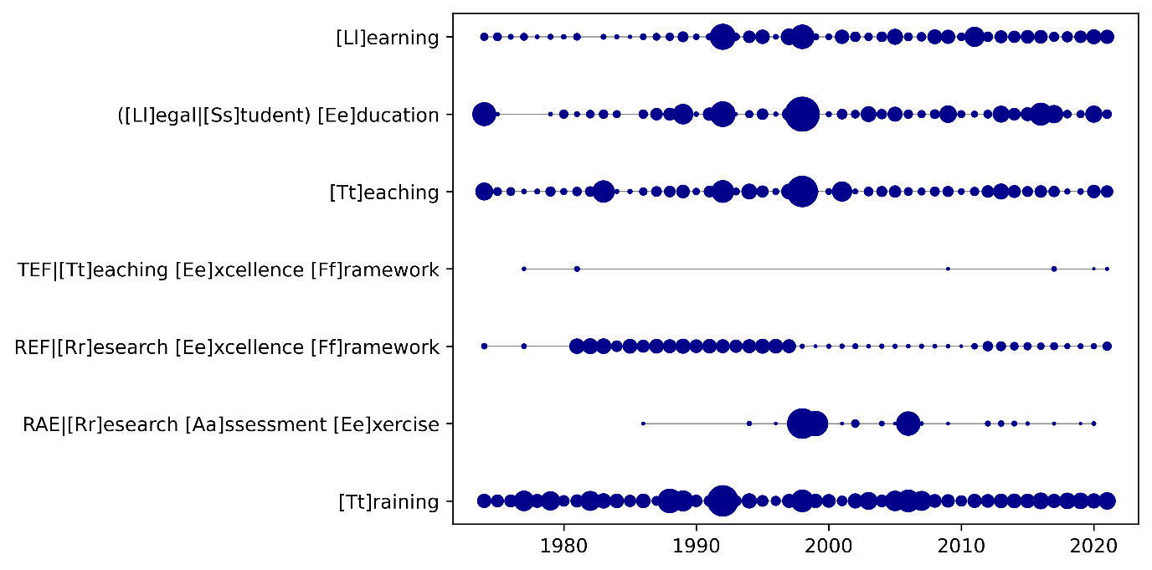
Fig. 4: Frequency analysis of terms of terms related to teaching, training, and research evaluation (Source: JLS corpus, adjusted for corpus size per year)
Figure 4 shows the distribution of the mention of learning, legal education, teaching TEF, REF, RAE, and training. As an indicator of a continued interest, this figure shows that there is mention of most of the terms in the JLS data, with learning, legal education, and teaching all being topics regularly discussed within the Journal. We are of the view that this relates to changes in UK legal education in 1992 − something that we consider in the next section − and, to a lesser extent, the introduction of the various RAE and REF. Another consideration is that from the early 1990s onwards, the newly-minted SLSA was starting to exert an influence relative to its stated aim: ‘for the public benefit to advance education and learning in the field of socio legal studies and to promote research, the useful results of which shall be published for the public benefit, teaching and the dissemination of knowledge in the field’.
The overall developments we trace in figure 4 had a significant influence on socio-legal studies in the UK. In relation to research, the RAE and REF brought with them increased pressures on individual research outputs, introduced impact as an essential element of the academic profession, encouraged interdisciplinarity, and established a clear expectation to publish. Universities were tasked with evidencing how their research culture contributes to shaping high-quality and impactful research that in turn contributes to societal and policy change. Moreover, in relation to teaching, changes in Higher Education had an impact on socio-legal studies in the UK. These changes are driven by technological advances, government policies, shifts in pedagogical approaches.

Dominant Voices and Themes
Having considered selected systemic issues, in this part we ask of our data the question: whose are the dominant voices in the JLS, and how have these shaped the respective development of the Journal and of UK socio-legal studies? We started by looking at datapoints concerning locations and institutions, then surveyed quantitatively who had been most present within the discourse. In doing so, we also considered the influence of gendered factors, as well as looking to identify the most popular research themes throughout the lifetime of the JLS thus far. We bring these in connection with the wider field of socio-legal studies in each section.

Institutions and Geography
Attitudes have been conditioned hitherto by the boundaries of academic disciplines rather than subject matter. Thus, we see as the principal function of the Journal the task of focusing intellectual interest upon a subject area which, although neglected in the recent past in the United Kingdom, is now undergoing a renaissance, particularly in departments of law and sociology at several universities and polytechnics.
Following on from this quote from the earliest beginnings of the journal, and in view of the post-1992 developments in UK tertiary education mentioned above, we thought it worth investigating where authors’ institutional homes were at the time of their publishing articles in the JLS. The data collected by Ao and Munyard shows the spread of JLS authors based at historic and new universities respectively: perhaps unsurprisingly, we can see that most authors came and still come from old universities, with a very small number coming from post-92 institutions.
The quality of the journal has gone up, and also its reach. Our authors and readership spread way beyond the UK – our readership and hopefully relevance is truly international.
Ao and Munyard manually collected data on the origin of authors for the period of 1995-2020, and ranked tables of author locations correspondent to continents. While the data does not really allow for definitive statements in this regard, we can say that most contributors come from Europe, alongside a small yet steady rate of contributions from authors in North America and Oceania, with the former waning slightly since the late 1990s and the latter increasing by much the same relative extent.
The post-92 institutions enriched the landscape of socio-legal studies through providing – in comparison to Russell Group institutions – a more diverse student body with non-traditional backgrounds, usually strong ties to local communities with outreach initiatives. Russell Group institutions, on the other hand, have a long history of legal education and research, carry a certain reputation, and have access to resources. These institutional factors play a role in the evolution of socio-legal studies which can be seen in the data that Ao and Munyard collected.

Dominant voices / most cited
So the JLS’ contributing authors are, if not exclusively, then at least predominantly drawn from the UK’s own historic institutions. But who are these authors, and – more importantly - how can we determine the JLS’ ‘most dominant voices’ from our own dataset? In undertaking this task we made use of two metrics: first, who published most (author/co-author) in the Journal and, second, who was most cited across JLS articles. As our data covers the period 1974-2022, we were able to pose both questions over the whole time, which we did in 10-year time segments starting from 1974, with a view to this showing results that could then be compared. This approach has the drawback of potentially diluting trends in the data that do not align with the observation windows (known as ‘boundary problems’), however, by enabling a diachronic observation, this approach significantly improves upon a static analysis of the entire dataset. As they cannot be meaningfully reproduced in print, the resulting graphs can be found and explored in detail online, and we narrate them here.
Fig. 5 shows an example of a network graph that results from a search for those authors that were cited by the 20 most-published authors. The interactive visualization published online allows to see trends and changes across different decades. It also allows us to see the names of the authors, something not possible in Fig. 5, which has been reduced to the graph-topology, i.e. the particular way in which the nodes and edges are connected, its distinctive shape.
Fig. 5 shows some overlap in the literature used by these most-published authors, but what is most interesting is how the topology (mostly radial structures with few connecting nodes) shows those overlaps as being quite small. This tells us that the literature used by the 20-most published authors in the JLS in each period is extremely diverse and, importantly, does not orbit around any established canon. Something else worth noting is how, while there is obvious overrepresentation of male authors at the beginning, from the Journal’s earliest days women are among the JLS’ the most-published authors (see, for example, Joanne Conaghan, Carol Smart for the 1984-1993 period).

Fig.5: Aggregated citation network of most-published authors with main cited authors, 1994-2003 (Source: JLS dataset)
In the 1974-1983 period, Marxist authors such as E.P. Thompson are clearly dominant, but in the 1980s and early nineties the theoretical landscape had diversified, with systems theorists Luhmann and Teubner leading the field – a trend that will continue in later decades. Legal theory, broadly understood, is present with Habermas, Hart, and Dworkin, while social and sociological theory is represented by Bourdieu and Giddens. Criminologist John Braithwaite has a strong citation presence, as do Feminist scholars Carol Smart and Catherine MacKinnon, while Rick Abel and Marc Galanter represent US Law and Society scholarship. These citation patterns broadly continue into the second part of the 1990s and early 2000s: in the next decade (2004-2013) Bourdieu and Latour both appear on the scene, alongside socio-legal scholars such as Julia Black and Colin Scott. We also see an upsurge in citations of the scholarship of Max Weber. Finally, in 2014-2023, we see the works of William Twining and JLS editor Thomas among the top-ten most cited.
The charted changes in the JLS indicate that it is possible to interrogate more broadly the nature of the questions asked and the scholarship pursued in socio-legal studies. We argue that this reflects the demands upon the UK academy during any given REF cycle: to be engaged with topical and theoretical informed research, to explore social problems and to engage with innovative empirical approaches.

Gender
[The journal] was originally dominated by men. […] So what I'm recollecting is that we started to have a number of book reviews coming in from women and then papers coming in from women. Not necessarily about gender-based topics, not necessarily. And then today, I don't know what the split is today, but I think we have more female authors than male. I think. […] Yeah, and this is this is not by choice. This is all based upon the quality of the work that comes in. I mean, one of the things to add to that is that we would love to see more work coming from the global South. But we don't get it. We don't have it because the quality is not there. We've decided not to be positively discriminatory in order to produce stuff from the global South. So, if it's not good enough, it's not good enough. But we are hugely international now.
Another interesting indicator of the Journal’s development is gender. Ao and Munyard’s 1995-2020 data, which had been hand-coded for gender for the first time, shows a development from a male-dominated authorship to an almost gender-balanced distribution. To extend the observation period to the beginning of the JLS in 1978, however, we needed additional data, but manually categorizing those early articles was neither practical nor feasible. Instead, we employed an algorithm that automatically classified contributors’ first names to give us a better, if incomplete picture. This visualization (Fig. 6). shows that, since 1978, the number of female contributors has indeed increased from approximately 20% to heading towards 50% today.
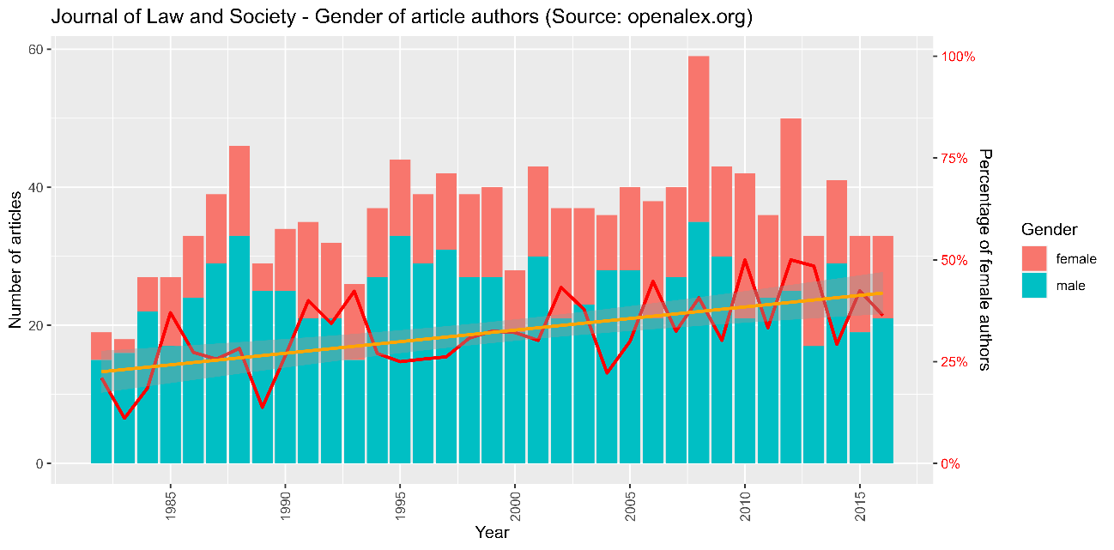
Fig.6: Articles published in the JLS with gender distribution (Source: crossref.org)
When we look at the field of socio-legal studies in the UK with a focus on gender, however, the publishing trajectories identified in the JLS do not match the developments of the field overall. Gender disparities in academia have always been a subject of concern and interrogation; with a growing body of literature, we can see how gender reflects changes in academia. Increased gender diversity is evident across in the field, but gender disparities nonetheless remain: indeed, Duff & Webley suggest that ‘the continued disparity in male-female promotion trajectories is, at least in part, a function of the way in which talent, merit, or excellence is understood and operationalised in the academy more widely’.

Themes
As mentioned earlier, to analyse the development of journal article themes and topics quantitatively, researchers usually rely on keywords extracted from databases. Since the JLS articles do not have keywords as metadata, we had to find a different way of identifying JLS articles topics. One option is topic modelling, which ‘seeks to automatically discover thematically coherent ‘topics’ within a large collection of texts’ or, in layman’s terms, a way to discover within texts topics that are not explicitly stated. In doing this we used BERTopic, an advanced topic modelling library which not only looks at tokens of text but uses so-called ‘word embeddings’ that are able to connect words with similar meanings.
Table 1 is a generated list of topics, accompanied by the most frequently occurring keywords defining each topic, and the number of documents within which this topic has been identified. Perhaps unsurprisingly, at the very top of the list (topic 1) we find the topic socio-legal studies, followed by family law (topic 2), court and judges (3), legal education, (4) police and crime (5), and feminism & law (6). Further topics identified by the algorithm can be loosely sorted into more general themes such as feminism, gender, and sexuality (9, 16 and 36 respectively), the environment (9), human rights & development (10 and 11), labour, economy and capitalism (12, 13, and 22 respectively), health (15 and 25), and the welfare state (24). Prominent political, constitutional, and international issues also feature in this list of topics: the political situation in Northern Ireland is high up (7), while Europe (20), South Africa (17) and Iraq (37) also appear.
No | KW1 | KW2 | KW3 | KW4 | Count
1 | law | legal | social | sociology | 163
2 | children | family | child | parents | 67
3 | court | judges | judicial | judge | 60
4 | education | students | law | legal | 59
5 | police | evidence | criminal | officers | 40
6 | women | feminist | gender | law | 37
7 | ireland | northern | irish | political | 33
8 | housing | local | property | law | 33
9 | sex | prostitution | sexual | workers | 30
10 | environmental | pollution | water | waste | 30
11 | rights | human | right | development | 25
12 | corporate | governance | shareholders | directors | 25
13 | economic | law | economics | weber | 24
14 | aid | legal | lawyers | cases | 24
15 | safety | regulatory | regulation | health | 23
16 | rape | sexual | justice | violence | 21
17 | south | african | africa | rights | 20
18 | information | government | data | assembly | 20
19 | women | affirmative | discrimination | equal | 20
20 | constitutional | constitutionalism | european | political | 18
21 | legal | subject | sat | police | 18
22 | labour | employment | workers | industrial | 18
23 | contract | contracts | parties | law | 18
24 | welfare | benefit | social | security | 17
25 | medical | doctors | negligence | patients | 17
26 | mental | patients | patient | health | 16
27 | police | miners | strike | coal | 15
28 | marx | law | class | legal | 15
29 | sentencing | offenders | process | criminal | 15
30 | french | droit | law | legal | 14
31 | social | crime | justice | hamilton | 13
32 | corruption | political | brazilian | anticorruption | 13
33 | private | regulation | regulatory | international | 12
34 | film | films | courtroom | trial | 12
35 | religious | jews | religion | jewish | 12
36 | abortion | foetus | women | pregnancy | 11
37 | violence | war | law | iraq | 10
Table 1: JLS themes computed via BERTopic topic modelling (Source: JLS corpus)
While Table 1 provides an interesting, if largely descriptive, overview of the themes that have been discussed in the JLS during its lifetime, a longitudinal analysis is needed to provide more in-depth insights, although this requires extended visualizations and narrations far beyond the scope of this article. What we can say about the trends in Table 1 is that they show us how the JLS provides a platform for (the discussion of) pressing social issues and addressing problems of the time, while remaining firmly grounded in theoretical debates.

Methods and Theory
Having generated this list of JLS topics computationally, we now turn our attention to exploring the Journal’s content beyond those base topics, specifically the methods, theories, and disciplines drawn upon by contributing authors. Within the data available, we were keen to investigate the respective prominence of theory and methods, not least because – as Thomas states in the quote given below – theoretical engagement is a key consideration for the JLS Editorial Board.

Mentions of methods and theory
As for what today's editorial board is looking to publish, well, we are open to articles from around the world, addressing all areas of law, and taking a wide range of theoretical approaches. However, we are looking for work that is theoretically engaged. We are happy to have empirical material within it, but data alone won't do. An article has to be theoretically based.
We ran a search of the JLS corpus to discover how often the following phrased were mentioned: multidisciplinary, interdisciplinary, perspectives / lens, concept, theory, method, qualitative, and quantitative.
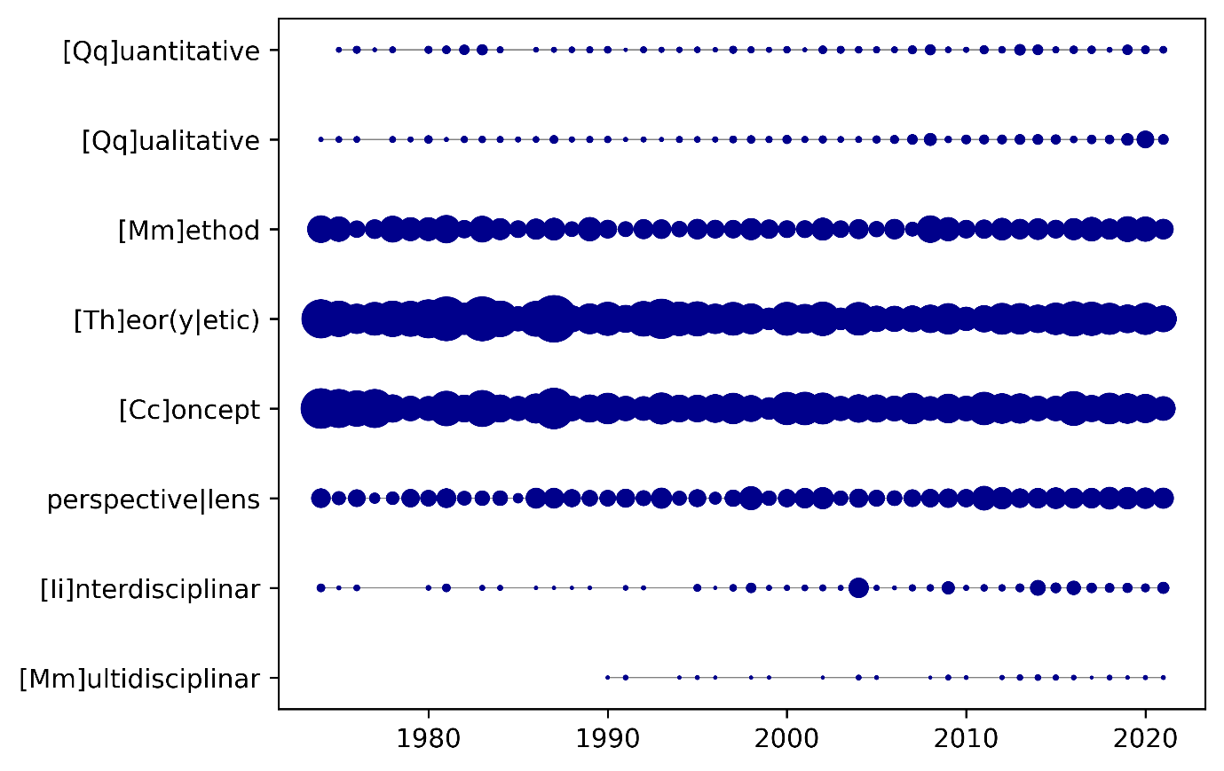
Fig. 7: Frequency analysis of terms related to disciplinarity and theory/method (Source: JLS corpus, adjusted for corpus size per year)
Figure 7 shows that, while the use of theory and method is consistent throughout, it is noticeable that theory is mentioned far more than method; indeed, concept has been used regularly over the past five decades of JLS publications. To provide more fine grain detail, as a sub-division of method we asked about the use of the terms qualitative and quantitative, both of which had been mentioned since the early days of the Journal, albeit sporadically. This changed early in the new millennium, however, where the numbers noticeably trend upwards, although not equally across the two: indeed, and although the marked escalation in the mention of qualitative methods can be largely attributed to JLS special issues, it is noteworthy that, by comparison, the term quantitative is mentioned far less often. In terms of statements concerning the disciplinary contours of socio-legal studies, we can see the use of interdisciplinary has also been growing since the 2000s, whereas multidisciplinary remains at the margins; we consider this disjunction further in the next section.
This interplay of the Journal’s strong theoretical focus and the consistent presence of methodological research considerations was worth further investigation, not least because Thomas’ position on this is clear:
Socio-legal studies does depend upon data. So as far as the JLS is concerned, I've always looked for material which is data based upon theory. Data itself for me is meaningless. Theory and data make sense for the sort of scholarship which I would like to see published in the journal. I like radical scholarship. It's hard to get, there's not a lot of radical scholarship, let's be honest about that. But even scholarship which is a mixture of theory and quality data pushes us forward. It advances our awareness, our policies and a lot of SLSA stuff is about policy. How can we get a better policy as a consequence of the information that we have gathered?
Figure 8 below visualises the mentions of regression, interview, survey, data, empirical, and methodological approach in the JLS. Here we can see a clear trend of growth in the mention of interviews, data and empirical, as well as surveys, which are mentioned more or less consistently until this thickens in 2002. There is also a visible increase of the mention of data and interviews that occurred in 2016-2019, a spike we initially thought to attribute to special issues during that period but which, on closer investigation, proved not to be the case.
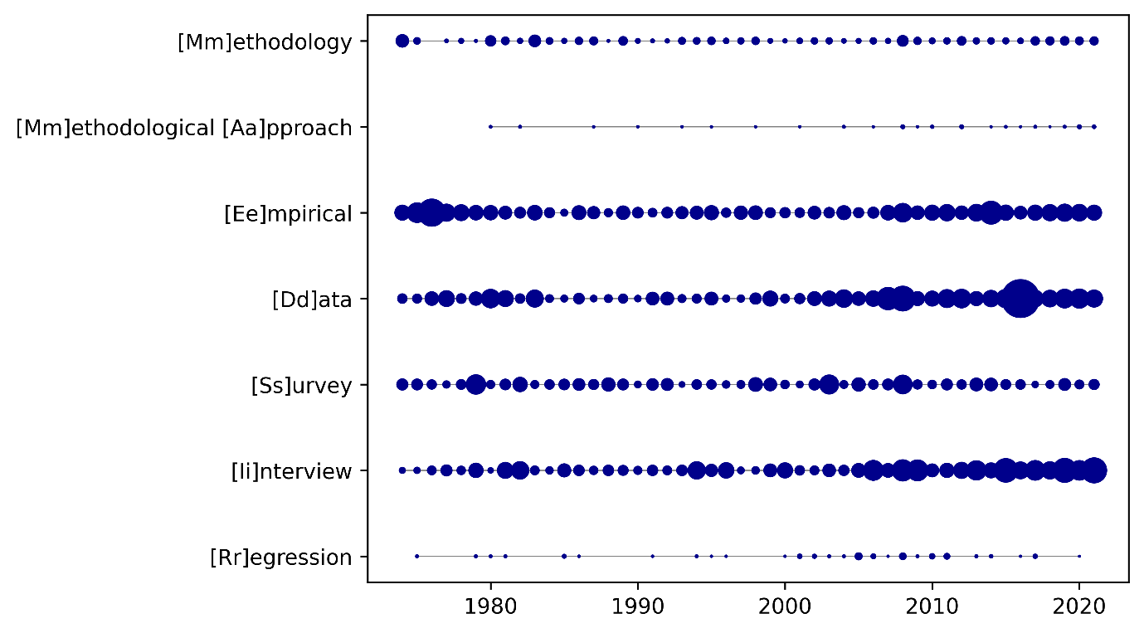Fig. 8: Frequency analysis of terms related to data-driven and empirical approaches, adjusted for corpus size per year (Source. JLS-corpus, adjusted for corpus size per year)
Research methods have been integral to the development of socio-legal studies in the UK since its inception. A commitment to empirical analysis and interdisciplinary approaches has grown and developed over time. Contrary to what we found in the JLS, the field has been continuously engaging in a conversation about research methods. One of the drivers for this is the introduction by the Economic & Social Research Council (ESRC) of their Doctoral Training Partnerships and methods-focused training via funded Masters (MA) programmes prior to studentship-supported doctoral study. There is a clear impetus here towards a solid methods grounding for the next generation of socio-legal scholars - both qualitative and quantitative methods training that provides doctoral candidates with the skills to conduct high-quality research.

Disciplines
With interdisciplinarity being a consistent trend, what then are the disciplines mentioned in the JLS? The data in figure 10 shows us that, over the past 50 years, terms such as jurisprudence, sociology, criminology, economics, and psychology have all had regular mentions, albeit in different waves. Sociology receives the most total mentions, while jurisprudence was mentioned most at the outset of the journal yet has maintained a steady presence ever since. Anthropology had the most mentions between 1980-82, largely driven by the prominence of discussions on legal pluralism and unofficial law. Similarly, psychology featured in the early days but has been mentioned only intermittently since 1980. This figure not only demonstrates that the JLS has always been open to publishing research from different disciplines, but also that the field of socio-legal studies can be considered – empirically – as a broad church.
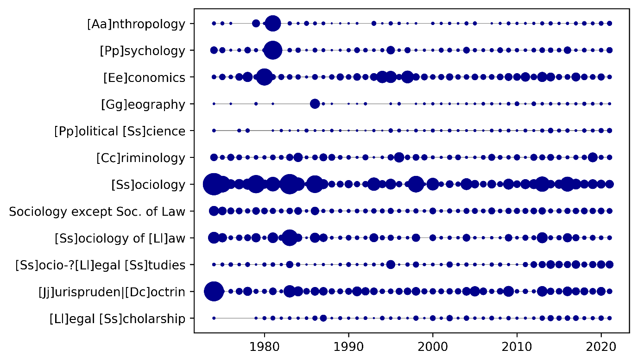Fig. 9: Occurrence of academic disciplines (Source: JLS corpus, adjusted for corpus size per year)
The field of socio-legal studies can be described as interdisciplinary, so this is something we wanted to scrutinise within the JLS corpus. The findings, shown in Fig. 9, were interesting: despite a clear propensity towards sociology, the JLS corpus shows that interdisciplinarity does not extend so far beyond those. Criminology and the Law & Economics field are notable in being present but relatively minimal compared to the self-identifying legal-social-scientific research published, while another interesting observation is that political science, although being mentioned on a regular basis, is not prominent compared to the other disciplines searched for.
The disciplinary self-identification of the field itself is another question to which our data might add some perspective. With references to a widely-cited 1976 article by Campell and Wiles, in 2001, Travers has described the empirical study of law as a struggle between the camps of ‘sociology of law’ and ‘socio-legal research’, the former being theoretically interested, the latter having a largely a-theoretical and policy-oriented research agenda. Against views that argued that the sociology of law and socio-legal studies had already merged by then, Travers was of the view that there were ‘still too few theoretically informed empirical studies’ and that the ‘sociology of law has virtually disappeared as an academic subject in Britain’. While our data shows that the term ‘sociology of law’ is clearly less prevalent in the recent decades compared to the 1970s and 1980s, and that ‘socio-legal studies’ has been mentioned more often since the mid- 2010s, ‘sociology of law’ is still present in socio-legal scholarship. In the previous section we found that theory and methods play an important role in the JLS, this could suggest that socio-legal studies – as mirrored in the JLS – has embraced the theoretical ambitions of the sociology of law.
Looking beyond this corpus, a good indicator of the prominence of interdisciplinarity within socio-legal studies in the UK is the SLSA Annual Conference and its streams (consistent across conferences) and current topics (dynamic, changing annually), which reflect well the evolving interests and topical concerns within the field at any given point. Once more, and in line with our findings, this highlights a general propensity for UK socio-legal studies to employ theoretical perspectives and social-scientific methods but not to engage explicitly with other academic disciplines beyond the legal, criminological, and sociological. This is not to say that there are not instances of interdisciplinary scholarship but rather that these are neither prominent nor consistent across the field.

Outlook and Conclusion
Socio-legal studies was always oppositional, you could almost define it as something that is not doctrinal - as something that isn't, the `other', rather than something that is. So, one of the ongoing challenges of socio-legal studies is what is it? Are we talking about society or sociology of law? Is it interdisciplinary/multidisciplinary? Is it a new discipline? Does it represent a paradigmatic shift? Is it something which is breaking a mould? There's a lot written about this, and I think different people understand different things - it's a floppy term. It is not clearly defined so as it's become more popular, more commonplace, and more accepted, it's also become less visible. I think there's a real issue about its function and boundaries. I don't have the answer but neither do I lose sleep over it.
Fifty years of the JLS have overseen considerable developments in UK socio-legal studies, but none more than its shift from the academic periphery to its mainstream. One need only look at the expansion in the JLS itself to see the increased demand for such a vehicle, for such scholarship, but we can point also to other indicators: the existence of other journals and blogposts, for one, alongside the growth of the SLSA, and the increase in both the number of attendees and the variety of streams at its Annual Conferences. Socio-legal studies is in rude health in the UK: indeed, it could even currently be said to be experiencing an unprecedented level of prosperity and appeal. While this is not the case across the continent, and further work is required to elucidate such divergence across jurisdictions, some drivers of success can be readily noted in the UK: the escalating REF impact agenda, for example, but also the embracive nature of the discipline. The extent to which this accommodative breadth might lead to disciplinary dilution is yet to be seen, but for now it can be seen as both a feature and a strength.

The JLS is one of the leading socio-legal outlets in the UK, and an important forum for socio-legal voices both national and international, especially as socio-legal scholarship evolves in other jurisdictions. In light of our discussions above, and informed by Thomas’ ambitions and aims for the JLS, we now reflect on what it is that might be missing from the picture. We engage with this in two steps, focusing first on the JLS bibliometrics, then on the Journal’s key role in terms of UK socio-legal studies.

By utilizing bibliometric and other quantitative methods, we have showcased the extent of knowledge that can be extracted regarding the JLS. However, as socio-legal scholars rather than bibliometricians, it is crucial for us to understand the implications of these analyses for the field of socio-legal studies itself. We believe there to be good reasons to extend this line of inquiry beyond looking at individual journals, and furthermore that these methods have potential beyond that which they have traditionally been used for, i.e., generating ‘impact’ metrics. Socio-legal studies is no longer the plucky upstart, no longer either as niche or peripheral as it was when the JLS first took on the task of providing it with a vehicle, with the result that even experts find it challenging to survey the publication landscape and to identify topical trends. Bibliometric methods can help with this task, as well as with giving doctoral and early career researchers useful information as to where their own research might fit, where potential connections could be forged, and where their networks and audiences might be situated.

Not only are bibliometrics able to highlight those areas where socio-legal research has not yet paid sufficient attention, and which additional perspectives might enrich the literature and give a more complete picture of the role of law in the social, but they can also add a much-needed empirical and comparative dimension to the intellectual and social history of socio-legal studies. Indeed, to know how the field should and could progress, it is important to know where it – and we – are coming from – as well as seeking to discover which comparable trajectories have developed in other research communities.
In terms of trajectories, then, we want to conclude our discussion by highlighting three considerations that emerged from our data analysis, and which – we suggest – should inform the Journal and the field’s next fifty years.
Diversity
As we saw, female authors and women on the JLS board were initially a minority. While the latter can be explained by the way the JLS recruits board members, in that it limits itself to the academics at Cardiff Law School, the female authorship of the JLS has grown significantly and now reflects far better the field of socio-legal studies in the UK. Women have played a crucial role in shaping socio-legal studies through their scholarship, activism, leadership, and mentorship, and, as we were able to illustrate in figure 17, contributions by female authors have seen steady growth over the years to now being effectively equal with male authors.
Our data showed that a broader demographic representation (beyond gender) in the authorship of the Journal would be a welcome step. This is true for the field overall, a concerted effort of all those who identify as social-legal scholars needs to be made to include diverse voices, for example, from the Global South. It is important for the diversity of socio-legal thought that additional perspectives find their way into our socio-legal narratives.
Indeed, while diversity of thought is vital, so is diversity within and across the ‘dominant voices’ of UK socio-legal scholarship, and it is here in particular that the JLS has a key role to play. For example: it is undeniable that the ‘JLS frequent flyers’ - those scholars published in the Journal six or seven times in their career – are all prominent and influential figures within UK socio-legal studies. This not only begs the question as to whether publishing frequently in the JLS in fact makes one a dominant voice, but also highlights the importance of the vehicle to the ambition of diversity of authorship. A key consideration for the Journal’s next fifty years is the responsibility it has to deliver this ambition.
Quality over inclusivity
Within the JLS Editorial Board, there is a clear steer to only accept the highest quality submissions, which is likely to be a contributing factor to the comparatively limited representation of authors from post-92 UK institutions and the Global South. The breadth of authorship in the JLS clearly lacks geographical cover, but greater inclusivity could be promoted with a view to countering this trend. For example, perspectives could be broadened by actively seeking submissions and working with authors from different backgrounds, methodologies, and lived experiences. Underrepresented voices, now identified, need to be encouraged, with a view to generating a more inclusive body of research and including a greater variety of perspectives. This encouragement could take the form of mentoring programmes, writing workshops, and guidance on navigating the publication process; the JLS might also want to provide mentorship for underrepresented scholars. Active engagement and support can help to address systemic and structural barriers, as we recognised collectively that high quality research can come from a range of perspectives and scholarly backgrounds. Maintaining its own high standards, the JLS can further contribute to a more inclusive, diverse, vibrant, and impactful scholarly community.
Strength in both theory and methods
Theory and methods have both been centrally important throughout the lifetime of the JLS. While theoretically informed papers have arguably dominated the JLS (as per Thomas’ ambitions) over the past decade, methods have recently received more dedicated attention within its pages. Mulcahy and Cahill-O'Callaghan, for example, edited two Special Supplements of the JLS on methodology, and made it a point in their introduction to challenge some of the assumptions that, they argue, underpin socio-legal empirical research. They emphasised that ‘... the socio-legal community in the UK fails new entrants to the field who want to undertake empirical work by our lack of in-depth engagement with, or development of, debates about epistemology, methodology, and method’, and made a deliberate effort both to destigmatise quantitative methods and to invite a more generous application of them in socio-legal methodologies. In this regard, a key concern for socio-legal studies is how, they argue, those who see themselves as sociologists of law have a tendency to treat theory and empirical observations as distinct, a separation that they argue is both unnecessary and limiting.
This argument is intriguing, not only because of the methodological lack it identifies, but also because it suggests that the JLS's mission to infuse the socio-legal field with ambition in theory and theoretical approaches has been successful. Indeed, as our discussion of theoretical influences and dominant voices (sections 3.2 and 3.4.2) has shown, there is great theoretical diversity within the pages of the JLS, and no sense of a socio-legal theoretical canonical approach. This variety of voices and positions is a genuine strength, both of the Journal and of the socio-legal field, and – we argue – puts to the lie Travers’ turn of the millennium fear about an atheoretical discipline: in our view, his concerns about intellectual stagnation within socio-legal studies have not been realised.
The interaction and intersection of theory, methods, and empirical methodologies within socio-legal studies will and should be the subject of ongoing discussion. Moving forward, for the JLS this might mean that a more quantitative focus, or even a mixed-methods approach, be more readily included. Such a development would certainly be welcomed by Mulcahy and Cahill-O’Callaghan, although their key point remains salient: to ascertain high-level methodological rigour in a submitted paper, reviewer expertise must be available, just as the JLS has long relied upon for theoretically minded papers. We hope that this opening foray into bibliometrics and socio-legal studies might help to provoke a start in this trend.

* The authors are grateful to Jiří Přibáň, Dave Cowan, and the Centre of Law & Society at Cardiff University for the opportunity to present this paper as the inaugural lecture of the Journal of Law and Society 50th Anniversary Series. We would like to thank Phil Thomas, Rachel Cahill-O'Callaghan, and Daniel Wincott for their comments on an earlier draft, as well as the anonymous reviewers from the JLS’ Editorial Board. Grateful thanks are also due to the Max Planck Institute for Legal History and Legal Theory (mpilhlt), Frankfurt, for the ongoing funding and support of our Socio-Legal Trajectories project, of which this research forms part.
In the UK at least: different jurisdictions favour different names for the study of law in society, but we will restrict ourselves to the preferred UK terminology.
This translates as ‘test-drilling’, an approach with an experimental quality to ‘probing’ the sample, otherwise known as exploratory quantitative analysis. This approach is one that moves quantitative scholarships away from statistical significance - which so often dominates political science - to patterns, which lead not to answers but rather to questions.
For further detail, see https://slsa.ac.uk/index.php/what-is-slsa, accessed 31/05/23
On post-92 institutions, see https://en.wikipedia.org/wiki/Post-1992_university (accessed 31/05/23)
Formerly the Research Assessment Exercise (RAE. 1986-2008).
Sally Wheeler explains her preference for the label socio-legal ‘movement’ by virtue of its being ‘a clarion call to the academy to move socio-legal studies from a position of marginality within most law schools to a position of pre-eminence’. S. Wheeler, ‘Socio-Legal Studies in 2020’ (2020), 47 Journal of Law & Society, supplement S209–S226, S211-212; see also S. Wheeler and P. Thomas, ‘Socio-Legal Studies’ in D. Hayton (ed.) Law’s Future(s) (2000, Hart: London) 2000. 267–280, 271.
Consideration of ‘dominant voices’ not only shows who had access to the journal as a vehicle for publication, but also who choose the journal as the vehicle to convey their arguments; this combination contributed to shaping socio-legal studies in the UK.
This interview, held on 12/11/2021, is part of a series of interviews with socio-legal scholars undertaken under the auspices of the Max Planck Institute for Legal History & Legal Theory (mpilhlt)-funded project ‘Socio-Legal Trajectories in Germany and the UK’. Hereafter cited as Interview A.
P. Thomas, C. Boukalas, and L. Hayes ‘The Journal of Law and Society at 40: History, Work, and Prospects’(2015),https://onlinelibrary.wiley.com/pb-assets/assets/14676478/jols_at_40-1509472962000.pdf (accessed 31/05/2023). Hereafter cited as Interview B.
P. Thomas, ‘Editorial’ (1974) Brit JL & Society 1, at 1 Hereafter cited as Editorial C. The 1982 rebrand as the Journal of Law & Society was suggested by publisher Blackwell to sound more ‘international’. P. Thomas, personal communication.
The JLS corpus data does not include this information either consistently or comprehensively.
See section 4.2 below. The Ao & Munyard statistics are considered ‘grey literature’: Ao, Mizzette, und Joshua Munyard. 2021. 'The Journal of Law and Society (Est. 1974) - A review of the most recent twenty-five years (1995-2020)’. Document on file with the authors and also with the Journal.
Bibliometric literature reviews are common in other areas of research. See, for example: Iqbal, W. et al. (2019) ‘A bibliometric analysis of publications in computer networking research’, Scientometrics, 119(2), pp. 1121–1155; Hider, P.M. (1997) ‘Three Bibliometric Analyses of Anthropology Literature’, Behavioral & Social Sciences Librarian, 15(1), pp. 1–17.
See C. Boulanger, N. Creutzfeldt, & J. Hendry, ‘The Journal of Law and Society in Context: Our Bibliometric Methodology’ (2023), https://journaloflawandsociety.co.uk/blog/XXXX.
Roger Cotterrell, 'A socio-legal quest: from jurisprudence to sociology of law and back again’ (2023), 50 J. Law Soc. 3–16, at 4.
S. Wheeler supra n6, S216
J. Hendry, ‘One Umbrella or Two? Comparative (Socio-)Legal Studies in light of Globalisation’ (2021), 16 Journal of Comparative Law 552-568, at 556. On this issue of the scope of socio-legal studies, Phil Thomas has reminisced: ‘from the start, the JLS carried a restlessness about law - what is law?’ (Interview B, 3), continuing to add that ’an ongoing challenge of socio-legal studies is that of establishing what it actually is’ (Interview B, 6).
J. Hendry, N. Creutzfeldt, & C. Boulanger, ‘Socio-Legal Studies in Germany and the UK: Theory and Methods’ (2020), 21 German Law Journal, 1309-1317, at 1309; N. Creutzfeldt, K. McConachie & M. Mason, Routledge Handbook of Socio-legal Theory and Method (2019).
Interview A. Importantly for our purposes, this statement provides an insight into Thomas’ own conception of his role, that is, as a mediator of the new emerging scholarship.
Editorial C, 2
Editorial C, 1
Thomas has been quoted as saying that the Journal of Law and Society and the discipline of socio-legal studies ‘were both formed at the same time as a spontaneous alternative to the Law School establishment, its pedagogy and its ideology’, in Ao and Munyard, op. cit., n. 12 at 3.
As Cowan, Mulcahy and Wheeler point out, ‘for half a century [the JLS] has been responsible for publishing challenging articles and constantly enriching and disrupting accounts of its perimeters’. See ’Introduction: Celebrating Phil Thomas at 80’ (2020), 47 Journal of Law & Society S187–S190, at S187.
Formed by the merger of John Wiley & Sons Global Scientific, Technical, and Medical business with Blackwell Publishing in 2007. https://en.wikipedia.org/wiki/Wiley-Blackwell (accessed 08/06/23)
J. Wiltshire, ‘JLS at 20’ (1995), at 1 (document on file with the authors).
Volume 22 runs to a total of 997 pages, inclusive of the annual supplement.
As Ao and Munyard explain in their JLS History: ‘The Journal of Law and Society published an annual special issue addressing salient issues and matters of significance. Additional special issues are published sporadically. These special issues typically featured guest editors. Between 1995 and 2020 there have been fifty-three guest editors involved in the production of the Journal’s special issues. Sixteen of these guest editors are women.’ Ao and Munyard, op. cit., n. 12, at X.
https://journaloflawandsociety.co.uk/
https://journaloflawandsociety.co.uk/jlsblog/
Zenon Bankowski, Gareth Lewis, D.R. Miers, and Geoff Mungham.
June 2023.
’With the exception of M. Levi, C. May and G. Mungham, who were members of the Department of Sociology and Social Administration in Cardiff, all members have been drawn from and based in Cardiff Law School.’ Wiltshire, op. cit., n. 25, at 2-3.
’Throughout the period spanning 1995 to 2020, there have been forty-eight members of the advisory board. Seventeen of the members of the advisory board are women.’ Ao and Munyard, op. cit., n.12, at 7. As Thomas has observed, ’The quality of the journal has gone up, and also its reach. Our authors and readership spread way beyond the UK - our readership and hopefully relevance is truly international’. See P. Thomas , op. cit., n.8, at 4.
Editorial C, 1.
We are painfully aware that these are all white men, but certainly belong to what is believed to be the sociological canon. For a critical discussion on this canon, see B. Grüning and M. Santoro, ‘Is there a canon in this class?’ (2021), 31 International Review of Sociology, 7–25.
Interview B.
Interview B, 6.
Interview B, 6.
Editorial C, P. Thomas, op. cit., n. 9 (emphasis added).
We initially included within these search terms the Teaching Excellence Framework, or TEF, but no results were returned.
The first Research Assessment Exercise (RAE) was undertaken in 1986, with subsequent exercises held in 1989, 1992, 1996, 2001 and 2008. The Research Excellence Framework (REF) first took place in 2014, then in 2021, with the next one planned, as recently announced, for 2028.
https://www.slsa.ac.uk/index.php/what-is-slsa, accessed 29/06/23, our emphasis.
H. Khazragui & J. Hudson, ‘Measuring the benefits of university research: impact and the REF in the UK’ (2015), 24 Research Evaluation, 51-62; J. Conaghan, J. ‘Legal research and the public good: the current landscape’ (2023), Legal Studies 1–14.
R. Deem, S. Hillyard, M. Reed, and M. Reed, Knowledge, higher education, and the new managerialism (2007); A. Bradney, F. Cownie, J. Masson, A.C. Neal, and D. Newell, How to study law (2017); F. Cownie, Legal academics (2004).
Editorial C, P. Thomas, op. cit., n. 9, at 1.
Ao and Munyard, op.cit., n. 12. We employ this data since there is no reliable information on institutions and geographical origin of the authors to be gleaned from our own dataset.
Interview B, 4.
We are aware that this privileges older scholars academically active over a longer period.
This problem typically arises when temporal or spatial data points are separated into more or less arbitrary slices, or ‘windows’, and then aggregated. Dividing the data in different ways might lead to very different observations. And as before, the artificial cut-off introduced by looking only at the ‘top x’ scholars hides those which are ranked lower in insignificant ways which might be completely due to noise in the data.
Explore the graph online at https://cboulanger.github.io/jls-bibliometry/article-fig-05-nav-1984-1993.html.
These developments can also be observed when querying for the inverse relationship – the most cited authors of each decade with the authors that cite them most. See the online graph visualizing this relationship at https://cboulanger.github.io/jls-bibliometry/jls-most-cited-with-most-citing-1974-1983.html.
Interview A, P. Thomas, op. cit. n. 7
Ao and Munyard, op. cit., n. 12
It is to be noted that automatic gender classification is a highly problematic process that can only be used at a scale where misclassifications will cancel each other out. It also ignores non-binary gender classifications. K. Stanczak and I. Augenstein, ‘A Survey on Gender Bias in Natural Language Processing‘ (2021), available at http://arxiv.org/abs/2112.14168.
R. Collier, ‘The changing university and the (legal) academic career–rethinking the relationship between women, men and the ‘private life’ of the law school’ (2002). 22 Legal Studies 1-32; C. Westoby, J. Dyson, F. Cowdell and T. Buescher, ‘What are the barriers and facilitators to success for female academics in UK HEIs? A narrative review’ (2021), 33 Gender and Education, 1033-1056.
C. Morris, T. Hinton-Smith, R. Marvell and K. Brayson, ‘Gender back on the agenda in higher education: Perspectives of academic staff in a contemporary UK case study’ (2022), 31 Journal of Gender Studies 101-113. G. Santos and S. Dang Van Phu, ‘Gender and academic rank in the UK’ (2019), 11 Sustainability 3171; L. Duff and L. Webley., Gender and the legal academy in the UK (2021); C. Ashford, ‘Socio-Legal perspectives on gender, sexuality and law’ (2010), 31 Liverpool Law Review, 1-12; R. Hunter, ‘The gendered ‘socio’ of socio-legal studies’ (2013), in Exploring the ‘Socio’ of Socio-Legal Studies, ed. D. Feenan, 205-227; C. Menkel-Meadow, ‘Uses and abuses of socio-legal studies’ (2019), in eds. N. Creutzfeldt, M. Mason, K. McConnachie, Routledge handbook of socio-legal theory and methods, 35-57.
L. Duff and L. Webley, Gender and the legal academy in the UK (2021), at 1.
See, for example, D. Maltseva and V. Batagelj ‘Towards a systematic description of the field using keywords analysis: main topics in social networks’ (2020), 123 Scientometrics 357–382.
G. Brookes and T. McEnery, ‘The utility of topic modelling for discourse studies: A critical evaluation’ (2019), 21 Discourse Studies 3–21, at 4.
M. Grootendorst (2022) ‘BERTopic: Neural topic modeling with a class-based TF-IDF procedure’. arXiv. Available at: https://doi.org/10.48550/arXiv.2203.05794
See the blog post (n. 14) for probes into longitudinal analyses. It also contains a link to an interactive online version in which you can manipulate the visibility of clusters to see how they relate to each other.
Interview B, 4, our emphasis
Interview A, 12.
Notably October 2017, Volume 44, Issue S1, Special Supplement: Main Currents in Contemporary Sociology of Law.
Routledge Handbook of Socio-Legal Theory and Methods, N. Creutzfeldt et al. eds.
See https://www.ukri.org/what-we-do/developing-people-and-skills/esrc/doctoral-training-partnerships/ (accessed 13/10/23).
See J. Hendry, op. cit., n. 20.
See our blogpost (n. 14) for further evidence in this regard.
C.M. Campbell and P. Wiles. ‘The Study of Law in Society in Britain’ (1975), 10 Law & Society Review 551–82.
M. Travers, ‘Sociology of Law in Britain’ (2001), 32 The American Sociologist 26–40, at 26.
Ibid.
See https://www.slsa.ac.uk/index.php/streams-and-themes (accessed 16/10/23).
Interview B, 5-6.
See our ongoing Socio-Legal Trajectories project (n. 76); also see J. Hendry, N. Creutzfeldt, and C. Boulanger, ‘Socio-Legal Studies in Germany and the UK: Theory and Methods’ (2020), 21 German Law Journal 1309-1317 and the rest of the GLS special issue dedicated to the theme, which we edited.
We want to reiterate that we used algorithms to ask basic questions of the database to get a better understanding of the pearls of information we can extract from the data. This is only a start to a much more sophisticated future of bibliometric data analysis.
We explore this in a bi-national project at the Max Planck Institute for Legal History and Legal Theory, in which we compare the histories and current states of socio-legal studies in the UK and Germany, and in which we will make heavy use of comparative bibliometrics. See https://www.lhlt.mpg.de/2512903/socio-legal-trajectories (accessed 23/11/2023).
Our thanks to Rachel Cahill-O'Callaghan for this insightful observation.
Collaborative activities in this regard have already commenced, for example: https://www.law.ox.ac.uk/content/news/call-papers-crafting-socio-legal-methods-local-realities-and-global-debates-british (accessed 16/10/23)
L. Mulcahy and R. Cahill-O’Callaghan, ‘Introduction: Socio-Legal Methodologies’ (2021) 48 J. of Law and Society 1.
Id. pp. i-ii, S1-S117.
Id p S2.
M. Travers, op. cit., n. 70, at 26, writes: ‘There are many people who … present socio-legal research either as a multi-disciplinary subject with sociology along with economics, psychology, and social policy as constituent disciplines or as a policy science that has absorbed sociological ideas and perspectives. My own view is that there are still too few theoretically-informed empirical studies directed at policy audiences, or which address general questions, to support this optimistic assessment’(in-text references removed, emphasis added).

