Real-time automated species level detection of trade document systems to reduce illegal wildlife trade and improve data quality.

Authors: Michael F Tlusty¹, Donna-Mareè Cawthorn^{2,3}, Orion LB Goodman⁴, Andrew L Rhyne⁵, David L Roberts⁴

¹School for the Environment, University of Massachusetts Boston, Boston, MA, 02125, USA ²School of Biology and Environmental Sciences, University of Mpumalanga, Nelspruit, 1200, South Africa
³ Department of Agriculture and Fisheries, Queensland Government, Brisbane, Queensland, 4001, Australia
⁴Durrell Institute of Conservation and Ecology, School of Anthropology and Conservation, University of Kent, Marlowe Building, Canterbury, Kent, CT2 7NR, UK
⁵Department of Biology, Marine Biology, and Environmental Science, Roger Williams University, Bristol, RI, USA

*Corresponding Author: Michael F Tlusty, School for the Environment, University of Massachusetts Boston, Boston, MA, 02125, USA; Email: Michael.Tlusty@umb.edu

Abstract
Biodiversity fuels the international wildlife trade, much of which is illegal and/or unsustainable. Border agents are typically overburdened, having to manually inspect import documents to ensure the legality of contents for often ≥100 shipments per day. Delaying shipments for inspection must be balanced against maintaining live animal welfare and reducing undue costs for traders. Biodiversity within the wildlife trade cannot be accurately estimated because of the multiple harmonization systems used to organize business transactions. Harmonizing wildlife trade data ignores species level classifications and aggregates data at less granular taxonomic or commodity level groupings. Here we describe a Real-Time Automated Species-Level Detection (RTASLD) system that assesses shipment declarations and invoices to collect data on species being traded. We use this to demonstrate how taxonomic imprecision on declarations and invoices can blur trade statistics and, at worst, be intentionally manipulated to conceal illegal wildlife. We address how taxonomic imprecision can interplay with Convention on the International Trade in Endangered Species of Wild Fauna and Flora (CITES) listed species. When only one or a subset of species within a genus are CITES listed, referred to as a Mixed-CITES-Genus, illegal trade can occur by identifying only to the genus level, and not to the species level which requires a declaration and CITES paperwork. RTASLD can be used to help border wildlife inspectors identify increased risk or presence of illegal wildlife trade that is occurring. Accurate species-level collection of trade data will help to better track biodiversity, stop illegal wildlife trade and maintain business expedience.
Keywords: Automated Invoice Capture; CITES; Customs; Disinformation; Harmonized System; Illegal Wildlife Trade; LEMIS; Misinformation; Wildlife Trafficking
Introduction
The global trade of wild fauna and flora is a multi-billion-dollar business at the intersection of science and commerce (Supplementary Table S1) that is based on high biodiversity (FATF 2020). Yet business and biodiversity science each have different needs. Global trade necessitates speed and efficiency, while biodiversity science requires meticulously detailed taxonomic information. The former relies on aggregated codes of commercially valuable products, while the latter relies on a precise species list. However, considering that many species are threatened or endangered, aggregating data at anything more than a species level can result in illegal trade (Symes et al. 2018). This is one primary reason why wildlife trafficking occurs through otherwise legal channels (van Uhm 2018).

From the business perspective, the World Customs Organization (WCO) developed the Harmonized Commodity Description and Coding System (HS) to avoid “confusion, lengthy searches and delay” (World Customs Organization 2022). The HS is a “goods nomenclature system” (World Customs Organization 2022) that relies on classifying all traded goods into ca. 5,000 commodity groups through a six-digit (HS-6) code. The HS aggregates products under similar codes, and this aggregation for wildlife trade can be taxonomically “broad” to phylum or class, or more “specific” to an order, family, genus and on rare occasion, to a species (Andersson et al. 2021). Harmonized systems such as the WCO’s HS were never intended to collect biological information. These systems are used for customs purposes, such as the levying of duties and taxes, and in the case of the US Law Enforcement Management System (LEMIS), to determine the amount of trade and hence staffing needs at ports. The US LEMIS system is also distinct from the HS in that it is an alphabet-based code rather than a numerical one.

From the scientific perspective, the Convention on Biological Diversity (UNEP 1992) defines biodiversity as diversity within species, between species, and of ecosystems. Besides binomial nomenclature, there are multiple numerical coding systems for species including, but not limited to, Taxonomic Serial Numbers (Gerson et al. 2008), Integrated Taxonomic Information System (ITIS 2022), and the Global Biodiversity Information Facility (GBIF 2020). Yet mandated reporting on global wildlife trade to a species level only exists for those listed on the appendices of the Convention on the International Trade in Endangered Species of Wild Fauna and Flora (CITES; Andersson et al. 2021). CITES is one of the predominant systems to monitor, manage and (if necessary) limit the trade in threatened species through both trade bans and controls (UNEP 1992). Species considered to be threatened, that may become threatened by trade, or are look-alikes of a listed species, are identified on one of three appendices (Supplementary Fig. S1). Under the CITES system, a traded species that is CITES listed and is not declared, is declared improperly, or is declared properly without the appropriate CITES certification, is considered illegal.

Live venomous species imported into the US present another case where wildlife commodities should be identified to the species level. Although all venomous species are required to be listed separately on the USFWS declaration forms, a significant proportion of venomous lionfish (e.g. Pterois volitans) and rabbitfish (e.g. Siganus vulpinus) are not declared appropriately. Penalties exist for incorrectly and imprecisely declaring species, including but not limited to informal warnings, formal warnings, seizure of property, and civil penalties (Wildlife and Fisheries 2023a; Wildlife and Fisheries 2023b; Wildlife and Fisheries 2023c). However, these corrective measures must be initiated by already overburdened border wildlife inspectors.

The policy around international trade more typically meets the needs of business over science, as evidenced by the WCO and country specific HS-based systems. In the US in 2021, 123 US wildlife inspectors handled 157,752 declared shipments (U.S. Fish and Wildlife Service Office of Law Enforcement 2021). This overwhelming level of trade initially justifies the need for harmonized codes and reliance on declarations, so that inspectors can get through the mountains of paperwork. Yet the reliance on harmonization accepts taxonomic imprecision that has important implications for wildlife trade and, at worst, creates gaps where illegal wildlife trade (IWT) can occur (Symes et al. 2018). There have been numerous recent calls to increase the granularity of the HS (Chan et al. 2015; Cawthorn & Mariani 2017; Drinkwater et al. 2020; Andersson et al. 2021).

We suggest that, rather than relying solely on HS or equivalent systems, the best way forward is for all wildlife data to be recorded to a species level. A decade ago, Smith et al. (2008) claimed that the US was “drowning in unidentified fishes” since over 100 million fishes were being imported as marine or freshwater tropical fish (LEMIS codes MATF or FWTF). In response, Rhyne et al. (2012, 2017) developed a real-time automated species-level detection (RTASLD) to evaluate whether declaration data within the USFWS system are equivalent to what is presented on the invoice. This analytical platform was the grand prize winner for the USAID Wildlife Crime Tech Challenge. Described by Rhyne et al. (2017) and branded the Nature Intelligence System (www.wildlifedetection.org), this system alerts border agents to taxonomic imprecision and data anomalies on trade paperwork (Fig.1). Rhyne et al. (2017) reported that just over 2,300 species declared as MATF species were imported into the US. Here we use this tool first to understand discrepancies with LEMIS data, and then for CITES listed species (Blundell & Mascia 2005).
CITES species can be intentionally misidentified under a general HS code, thus hiding them in otherwise legal trade. This opportunity is amplified when not all species within a genus are CITES listed, a scenario we refer to as a Mixed-CITES-Genus (MCG, see graphical abstract). Hence, we also address the prevalence of MCG across all taxa, and address how declaration of CITES species can intersect with trade of non-CITES congenerics. We then demonstrate cases of IWT identified through the RTASLD platform originating from the misidentification of species that require health certificates on import to Canada. We further address additional outcomes of taxonomic imprecision beyond IWT, including the loss and/or erosion of information through trade data errors. These examples demonstrate that recording wildlife trade data at anything less granular than the species level will result in low quality trade statistics and increase the opportunity for IWT.

Methods
RTASLD: This system uses optical character recognition (ABBYY FlexiCapture 9.0) to digitize both invoices and declarations, and from the species data on the invoice, recreates the shipping declaration, and flags inconsistencies between the original and recreated declaration (Fig. 1). In the US, species of interest, such as those that are CITES-listed or venomous, are to be individually identified on a declaration form (USFWS Form 3-177). Conversely, non-CITES and non-venomous species may be declared using a “group” code, such as MATF, the code for Marine Aquarium Tropical Fish. More detailed species code data may be available but are not mandated to be entered into the Law Enforcement Management Information System (LEMIS, data available at https://www.fws.gov/library/collections/office-law-enforcement-importexport-data). The Nature Intelligence System corrects species information only when species names were misspelled, listed by only a common name, or listed under a junior synonym.

Species were identified to the greatest taxonomic detail available as often as they were listed without a species identity (e.g., ‘Chrysiptera sp.’), or the species was otherwise ambiguous (e.g., ‘hybrid Acanthurus tang’). In these cases, the genus (and all higher-level taxonomic information) was recorded, and the species would be recorded as “sp.”. Shipments with inconsistencies between recreated and provided declarations, as well as those with significant taxonomic imprecision are automatically flagged for inspection by border agents, allowing them to spend less time sorting through paperwork and more time inspecting shipments. The initial use of this RTASLD analytical platform was on 19,575 invoices over 4 years (2004/05, 2008, 2009, 2011), with anonymized results available at www.aquariumtradedata.org.

Mixed-CITES-Genera (MCG): To evaluate the proportions of species with full CITES coverage and those in MCG within the kingdoms Animalia and Plantae, we adopted a multi-step approach, comparing the listings in each CITES appendix with the current taxonomy and number of species within genera, families and orders recorded in various authoritative taxonomic online databases. For animals, we used the ‘Catalogue of Life’ (CoL, www.catalogueoflife.org) as the primary reference database, cross-checking records in the Integrated Taxonomic Information System (ITIS, www.itis.gov). For plants, we used the Royal Botanic Gardens, Kew’s ‘World Checklist of Selected Plant Families’ (WCSP, http://wcsp.science.kew.org) and ‘Plants of the World Online’ repository (www.plantsoftheworldonline.org).

We began by creating a database of all current CITES listings (valid 26 Nov 2019; www.cites.org) and recorded the appendix and taxonomic level (i.e., species, genus, family, order) associated with each listing. Where entire orders, families or genera were listed, we recorded the number of species covered by CITES in each and termed these ‘full CITES coverage’ listings. Where CITES listings were at the species level, we recorded the number of extant species existing in that applicable genus as specified in the reference taxonomic databases, as well as the number of species listed from that genus in CITES. If all known species within a given genus were CITES listed, we included this with our ‘full coverage’ listings. However, if not all species within a given genus were CITES listed, the entry was flagged and termed a MCG. Additionally, MCG were taken to include cases where CITES listings were at the genus level, but where one or more species within the relevant genera were exempt from the CITES provisions. Differences in taxonomic classifications in the CITES list and reference databases were also flagged. The records in our dataset were then further reduced to determine the number of species with full coverage due to genus-, family- or order-level listings, as well as the number of species present in MCG.

The Canada Border Services Agency (CBSA): This test used the Nature Intelligence System to analyze 52 paper transactions from 6 vendors and 17 importers, as well as 18 Integrated Import Declarations [IID] from 16 vendors, 14 importers, and 12 customs brokers (Gerson and Remmal 2021). The transactions included both freshwater and marine ornamental fish, seafood items, and freshwater plants. All documents were anonymized prior to analysis, and part of this process omitted any CITES or phytosanitary documents with the invoices. The Nature Intelligence System collected data relevant to species, origin, and quantity. The shipment data were then automatically assessed for species included on a CITES appendix, or on Canada’s Aquatic Invasive Species (AIS, https://www.dfo-mpo.gc.ca/species-especes/ais-eae/about-sur/index-eng.html#species) or Aquatic Animal Health (AAH, https://inspection.canada.ca/animal-health/aquatic-animals/imports/eng/1299156741470/1320599337624) lists. Efficiency was determined if Border Services Officers appropriately identified the correct other government department to refer the flagged species. For AIS, these were to be referred to the Department of Fisheries and Oceans Conservation & Protection. For CITES species, this were to be referred to Environment and Climate Change Canada Wildlife Enforcement. For AAH species, these were to be referred to the Canadian Food Inspection Agency Operations and Enforcement and Investigation Services. The 70 commercial transactions were hand selected by CBSA personnel (not a randomized trial), and half of the invoices and all of the IIDs in this test were originally released in error (contained AIS, AAH or CITES species without certifications).

Results
RTASLD: The total number of individuals imported into the US and reported within the LEMIS database under wildlife code MATF for 2011 was 11,586,805, while Rhyne et al. (2017) counted 6,892,960 individuals from the invoice-based data. Similarly, LEMIS listed species codes for 199 marine fish species, and in LEMIS, individuals identified by an alphabetical species code comprised only 8.1% of all marine aquarium fish imported into the US. In contrast, Rhyne et al. (2017) identified 1,798 species that particular year.

During the evaluation of nearly 20,000 invoices, the RTASLD came across the apparent intentional mislabeling of a humphead wrasse (Cheilinus undulatus) on an invoice (Fig. 2). These five individuals were not declared as being CITES (no CITES permit was provided, and fish were not listed on the accompanying Form 3-177). Evidence of intentional misidentification is that these fish were not listed to the proper scientific name on the invoice, whereas all other species on the same invoice were correctly described (Fig. 2). We realize this is a singular case, but in comparing our invoice-based data, LEMIS and CITES datasets, further evidence of the illegal trade of C. undulatus is observed. The RTASLD system (Rhyne et al. 2017) consistently found more C. undulatus in trade than were reported by CITES or LEMIS (Table 1). There is also an inconsistent volume of trade reported by trading partners (Supplemental Figure S2, S3). Of note is the increasing proportion of individuals that are being identified only to genus as Cheilinus sp. on invoices that need to be reconciled against the significant C. undulatus exports reported by Malaysia (Supplemental Figure S2, S3). A taxonomic imprecision rate of nearly 40% for a genus of seven species that contains one identified as CITES indicates a potential route for IWT.

Mixed-CITES-Genera (MCG) are extensive and occur across all taxa. Considering animals and plants, MCG range from ≤15 each for amphibia and fishes, to 51 for plants, and through to >60 each for mammals and birds (Fig. 3, Supplementary Table S2). In the cases of mammals and birds, 126 and 131 CITES-listed species fall into MCG, respectively, which in turn corresponds to 14% and 9% of all listed species in these classes (Fig. 4a). Other groups with similarly high proportions of listed MCG species include amphibians (14%), fishes (11%) and reptiles (7%), whereas such proportions are considerably lower for plants (2%) and invertebrates (0.2%). MCG occur across all CITES appendices, encompassing 138, 241 and 101 species in Appendices I, II and III, respectively (Fig. 4a). Within animals, 39 vertebrate orders and 10 invertebrate orders have MCG, of which 13 and 4, respectively, have 100% of their CITES species in mixed genera (Supplementary Fig. S4a,b). Within plants, 27 orders have MCG, with eight of those having all listed species in mixed genera (Supplementary Fig. S4c).

CBSA testing indicated that during review and analysis of the 70 commercial transactions, nearly 900 species were found with 10 were AIS, 15 had AAH requirements, and 50 were CITES listed (Gerson & Remmal 2021). For the 17 transactions with CITES species, 13 were originally released in error, while 15 were referred to ECC or returned for more information during the test. Ten transactions had AIS violations and had all been released in error, while all were properly referred to DFO in the test. Finally, for AAH species, 27 of the 38 transactions were released in error, and in the test, 30 of the 38 were properly referred to CFIA or returned for more information. In one of the cases of an AAH species, the olive flounder (Paralichthys californicus) was being imported from Korea (Gerson & Remmal 2021). P. californicus is not native to Korea, and these shipments were P. olivaceus, as indicated by olive being written in Korean after the species name. This is an AAH violation, as in Canada, live P. olivaceus from Korea requires an Aquatic Animal Health Import Permit issued by the regulatory authority in Canada and a Zoosanitary Export Certificate from the regulatory authority in the exporting country. In this case, a specimen lacking these documents would represent an illegal shipment. There were several invoices in this test demonstrating this illegal behavior from the same exporter, and this is likely to be more prevalent than beyond the transactions explored in this test.

During this test, HS codes were automatically determined from the invoices, and six of the 18 IID transactions (33%) and 46 of the 52 paper transactions (88%) had HS errors. Some of these were errors observed elsewhere (Rhyne et al. 2017) such as declaring a guppy, Poecilia reticulata, as a marine fish (HS code 0301.19 instead of 0301.11), or the opposite for the marine unicorn fish, Naso lituratus. Others are more egregious, where the giant clam, Tridacna maxima, corals such as Fungia spp. or multiple instances of aquatic plants were declared as marine fish (HS code 0301.19). We also observed Beluga caviar (HS code 1604.31) being declared as HS code 2005.99 – Vegetables And Mixtures Of Vegetables Prepared Or Preserved Otherwise Than By Vinegar, Acetic Acid Or Sugar, Not Frozen. HS codes often do not agree with the products as invoiced.

Discussion
Eskew et al. (2020) state that “Characterization of the direct harvest and subsequent trade in wildlife is conceptually straightforward and should be aided by existing governmental monitoring programs.” The work presented here demonstrate that harmonization of taxonomic information leads to a route for IWT, as well as erroneous and lower quality data, and an inability to determine the taxonomic richness or history of any harmonized group of animals or commodities in trade. The mischaracterization of wildlife trade data can ultimately mislead development and analysis of policy (Challender et al. 2022). LEMIS counts of individual marine fish imports to the US based on declared values being 1.68 times greater than data collected from invoices is likely a result of invertebrates and freshwater fish species being mistakenly included in the LEMIS count (Rhyne et al. 2017). This fundamental difference shows how harmonization of species on declarations can present an incorrect picture wildlife imports into the US.

HS reduces information and increases opportunity for IWT. Harmonization truncates information causing a lack of taxonomic precision where individuals are often not identified to the species level, but rather to a higher taxonomic grouping (Gerson et al. 2008). Along with the information presented here, other noticeable instances of intentional mislabeling leading to IWT stand out. In 2017, 7.2 tons of elephant Ivory were labeled as frozen fish and found in the port of Hong Kong only because a customs official noticed the volume and weight of a container was lighter than it should have been (Leung and Carvalho 2017). This follows a 2011 seizure of more than 2 tons of elephant ivory in Bangkok (Schearf 2011) and a 2007 seizure in Hong Kong of 4,400 kilograms of frozen pangolin carcasses (TRAFFIC 2007) both hidden as frozen fish.

In India, attempts to halt the trade of the IUCN Red Listed red lined torpedo barb (a species complex primarily consisting of Puntius denisonii and P. chalakkudiensis) saw records of this fish species disappear from trade registries, while there was no overall decrease in the total number of fish exports (Raghavan et al. 2013). The red lined torpedo barb was still exported, but its identity on paperwork changed to a broad ‘blanket’ harmonized term (live ornamental fish) or an identification within a non-specific group label (e.g. Barb/Puntius Group) (Raghavan et al. 2013). Harmonized codes may result in many valuable and potentially threatened taxa eluding monitoring as they are grouped under vague generic classifications that cannot be later disaggregated into smaller, distinct taxonomic units (Chan et al. 2015; Cawthorn & Mariani 2017; Cawthorn et al. 2018).

MCG may occur for a variety of reasons. One is because of the use of exceptions under CITES listings (Fig. 4b). For example, in the case of Aloe, the entire genus is listed (>500 species), however the commercially important trade in A. vera and finished products of A. ferox (USFWS 2019) are exceptions and not CITES listed. Other exceptions also exist, including certain trades in plant hybrids, seeds, micropropagated material, finished timber products and cosmetics packaged and ready for sale. Because of the time it takes CITES to update their species lists, it can serve as a latent harmonization mechanism. Arapaima gigas, a CITES Appendix II species, is traded as an ornamental fish, as well as for its meat and leather. Although there are currently four extant Arapaima species (A. agassizii, A. gigas, A. leptosome, A. mapae, Froese and Pauly 2021), only the single species, A. gigas, was known when it was CITES listed. This is the name that must be used on any CITES permit concerning any Arapaima specimen. The three other species names are inadmissible on CITES permits and trade documents. Claiming one of the three ‘different’ Arapaima species on a CITES document would be invalid according to the CITES. Because of this, the level of trade of A. gigas is overreported while that of the other three species cannot be determined.

Any lag in updating CITES nomenclature may have serious implications for newly described species that may also be rare and/or threatened. As a second exemplar, Paphiopedilum slipper orchids are listed on CITES Appendix I due to threats from the international horticultural industry. New species continue to be discovered and are highly sought-after by collectors. However, the CITES listing of this genus was only recently updated (Govaerts et al. 2019), the first revision since 2006 (McGough et al. 2006). This 13-year lag resulted in none of the newly described species appearing in the CITES Trade Database (https://trade.cites.org) or the Species+ database (https://speciesplus.net). Specifically, P. vietnamense was described in 1999, only to be declared ‘Extinct in the Wild’ in 2003 (Averyanov et al. 2003). It was over-collected via poaching (Roberts & Dixon 2008), and within the first year of discovery, it is estimated that nearly US$1m had been traded illegally (Averyanov et al. 2001). Even if this trade had occurred with the required CITES permits, it would have been recorded as ‘Paphiopedilum spp.’ As the CITES nomenclature at the time relied on Roberts et al. (1995), it was not until 2006 that the P. vietnamense species entered the CITES nomenclature (McGough et al. 2006). Since these slipper orchids are captured in the CITES trade database only as ‘spp.’, it is not possible to monitor their trade or to hold Parties accountable for allowing trade in material from these plants.

Negligent vs intentional misinformation. Esmail et al. (2020) and Challender et al. (2022) address the mischaracterization of wildlife trade leading to misinformation as a means to influence policy and practice. But the cases discussed here span more than misinformation via negligence in the presentation of information. In some cases, there appears to be the intent to deceive through misinformation. The humphead wrasse example (Fig 1) and the ivory smuggled into Hong Kong in 2017 are cases of intentional misinformation (disinformation) as the intent of the action was to hide the identity of the commodities. However, other cases, such as identifying freshwater guppies as marine fish or not identifying fish to the species level (Rhyne et al. 2017) are omissions of data or neglectful misinformation, as they are more likely due to haste than to an attempt to obscure goods. For those businesses trading non-CITES species, the penalties for taxonomic imprecision are lower and dependent on the wildlife inspector being able to catch the violation in real time. The volume of shipments needing review and clearance each day presents substantial difficulty for enforcement agents.

Without assistance, such as from the Nature Intelligence System, inspectors have little time to manually read every single page of an invoice to ensure it matches the declaration, and to ensure that illegal species are not hidden using the taxonomically imprecise “sp.” notation. It is untenable for inspectors to automatically know all MCG and to manually scan to ensure a CITES species is not being included through taxonomic imprecision. Challender et al. (2015) suggest a lack of knowledge and monitoring of listed species is also an impediment for successful CITES implementation – the burden of this expectation can be eased through RTASLD. There is a fine line between accidentally (misinformation) and intentionally (disinformation) misidentifying species on trade documents. However, a lack of taxonomic precision on these documents can be an indication of improper trade practices. In an industry where there is value in biodiversity and rare species often attract greater value (Rhyne et al. 2014), taxonomic imprecision indicates a shipment may need further inspection by border agents. The ultimate distinction between dis- and misinformation depends on how governments address intent in wildlife prosecutions (United States v. McKittrick 1998).

The need to adopt data intensive solutions. Many countries are changing to digitized data systems rather than paperwork. However, these new systems need to adopt data intensive solutions to analyze the detailed species-level information on shipments. We contend that RTASLD makes it possible for wildlife trade management authorities to adopt a data rich species-level assessment (see Gerson and Remmal 2021). Taxonomy data can avoid many of the pitfalls of maintaining multiple systems of harmonized codes at the global level. Beginning by collecting species-level data, individual agencies choose to aggregate the species-level data to their own coding system / trade database (be it CITES, HS, LEMIS or some other system). A data intensive approach maintains all information and avoids the issue that once the shipment details are harmonized, the ability for any detailed analysis of contents is forever lost.

The question of internationally valid trade codes has been problematic since the 1940’s (Viner 1947), and is still widely contested, particularly for the trade in wildlife (Blundell & Mascia 2005, Fragoso & Ferriss 2008; Gerson et al. 2008; Smith et al. 2008; Chan et al. 2015; Petrossian et al. 2016). For the trade in live wildlife, expedience is important as any delay in processing documents of record or inspections during import or export can damage or ruin the shipment. Delays can lead to poor or even fatal welfare conditions for the wildlife, a situation to be avoided at all costs. Expediency is balanced against the inspection process to meet legal obligations to ensure shipment contents are accurately declared and do not include illegal, harmful or injurious wildlife. For example, in the US, the economic and temporal cost of wildlife inspection was used to change the agency in charge of inspection oversight for sea urchins (Echinoidea) from USFWS to the US Food and Drug Agency (Public Law 115-334 2018). There is also a need to quickly process live animal shipments that must not interfere with meeting CITES treaty obligations. As international and regional laws often differ, sovereign countries may require more detailed information about species in a shipment than CITES dictates. For instance, the coral genus Acropora is listed on Appendix II of CITES. Species identification is challenging and CITES requires only listing any Acropora spp. to the genus level. However, because the Caribbean corals, A. palmata and A. cervicornis, are listed on the US Endangered Species Act (ESA), USFWS requires importers to list all species of Acropora to the species level. This rule applies to all shipments of Acropora imported into the US regardless of the country of origin. Collecting species-level data would allow both the USFWS to meet ESA requirements, while providing CITES with their data at a genus level.

Automated data systems are the ideal way to help identify those shipments likely to contain illegal or unverified wildlife. Such systems can check CITES lists, as well as national approved / unapproved lists, or species of concern (Fig. 1). This automated check can help customs and wildlife inspectors at ports to more effectively find illegal wildlife hidden within routine shipments and help curtail wildlife trafficking (van Uhm 2018). We suggest that data intensive methods can maintain the balance between expediency and veracity by enabling the collection and analysis of all information from a shipment that is needed for the shipment to be processed both rapidly and effectively. These data-intensive solutions may also assist agencies with the updating of taxonomic information. Adding a flag for an emerging concern (presence of a new disease or invasive species) is a simple process that does not rely on program updates that occur every three or more years.

The benefit of this invoice-based optical character recognition software processing is that machine learning can then evaluate trends in trade (both in species, and between trading partners). This system can track historical trading partners, can curtail illegal wildlife trade and identify the trading partners that facilitate illegal trade. A second benefit is that a data intensive system provides more accurate taxonomic information of trade. This can improve management of data deficient species and allows the tracking of entry of new species into the wildlife trade. Anomalies in taxonomy, values, quantities or even volumes can be detected as a first line effort to deter the movement and trafficking of illegal and injurious wildlife. Having trade partners declare this species-specific information will avoid the lack of knowledge excuse and that they did not realize that unregulated wildlife was in a shipment. A data intensive approach maintains the balance between veracity and expediency of the legal shipments of live wildlife, while better combating and curtailing the trade in illegal wildlife. This approach will also flag shipments with anomalies that require further hands-on inspection by a border agent. A policy level change to a data rich information capture method will reduce the burden for border agents to sort through hundreds of pages of documents and focus on those shipments likely harboring illegal wildlife.

Conclusion
The guise of “expedient business practices” competes with the need to illuminate the true extent of biodiversity in wildlife trade and, as a result, a conflict is created between science and business with policy caught between. The trade in wildlife has been under recent scrutiny given it is a source of emerging infectious diseases (Swift et al. 2007, Challender et al. 2020). Trade adaptations have included the plant passport, developed in the EU to determine plant movement for contract tracing of disease (European Commission 2020). However, changes for animals have been less pronounced. CITES was set up to monitor, regulate and where necessary ban trade in those species that are threatened by trade. By not continually updating taxonomic lists in real time, they are failing to accurately document trade in some of the most critically endangered species, such as newly described species. Traders swiftly react to descriptions of new species (e.g., new species of Paphiopedilum slipper orchids) and proposed changes in CITES (Leader-Williams 1999). The only way this system will be effective is for all fine detailed information to be recorded to a species level. Then the data can be parsed out into one of the numerous coding systems without losing vital underlying information. This data intensive system needs to be applied to all wildlife trade where details of the immense amount of biodiversity are currently clouded by harmonization systems.

Acknowledgements.
We thank the diligent work of three reviewers who provided a great deal of insight into this topic, and helped us craft a better telling of our data.

Supplementary Materials
Materials and Methods
Fig S1 – S4
Table S1 – S3

References
Andersson, A.A., Tilley, H.B., Lau, W., Dudgeon, D., Bonebrake, T.C. & Dingle, C. (2021). CITES and beyond: Illuminating 20 years of global, legal wildlife trade. Global Ecology and Conservation, 26, e01455.
Averyanov, L., Cribb, P., Phan, K. & Nguyen, T. (2003). Slipper Orchids of Vietnam: with an Introduction to the Flora of Vietnam. Royal Botanic Garden, Kew, UK.
Averyanov, L., Phan, K. & Nguyen, T. (2001). The distribution of Paphiopedilum vietnamense and its current status in the wild. Orchid Digest, 65, 158–162.
Blundell, A.G. & Mascia, M.B., 2005. Discrepancies in reported levels of international wildlife trade. Conservation Biology, 19(6), pp.2020-2025.
Cawthorn, D. & Mariani, S. (2017). Global trade statistics lack granularity to inform traceability and management of diverse and high-value fishes. Scientific reports, 7, 1–11.
Cawthorn, D.-M., Baillie, C. & Mariani, S. (2018). Generic names and mislabeling conceal high species diversity in global fisheries markets. Conservation Letters, 11, e12573.
Chan, H.-K., Zhang, H., Yang, F. & Fischer, G. (2015). Improve customs systems to monitor global wildlife trade. Science, 348, 291–292.
Challender, D.W., Brockington, D., Hinsley, A., Hoffmann, M., Kolby, J.E., Massé, F., Natusch, D.J., Oldfield, T.E., Outhwaite, W., ’t Sas‐Rolfes, M. and Milner‐Gulland, E.J., 2022. Mischaracterizing wildlife trade and its impacts may mislead policy processes. Conservation Letters, 15(1), p.e12832.
Challender, D., Hinsley, A., Veríssimo, D. and t'Sas-Rolfes, M., (2020). Coronavirus: why a blanket ban on wildlife trade would not be the right response. The Conversation, 8.
Challender, D.W., Harrop, S.R. and MacMillan, D.C., (2015). Towards informed and multi-faceted wildlife trade interventions. Global Ecology and Conservation, 3, pp.129-148.
Drinkwater, E., Outhwaite, W., Oldfield, T., Floros, C. (2020). Cracking the Code: An analysis of Customs HS codes used in the trade in wild animals and plants from Africa to Asia. Traffic. Cambridge UK. 80 pgs.
Eskew, E.A., White, A.M., Ross, N., Smith, K.M., Smith, K.F., Rodríguez, J.P., Zambrana-Torrelio, C., Karesh, W.B. and Daszak, P., (2020). United States wildlife and wildlife product imports from 2000–2014. Scientific Data, 7(1), pp.1-8.
Esmail, N., Wintle, B.C., t Sas‐Rolfes, M., Athanas, A., Beale, C.M., Bending, Z., Dai, R., Fabinyi, M., Gluszek, S., Haenlein, C. and Harrington, L.A., (2020). Emerging illegal wildlife trade issues: A global horizon scan. Conservation Letters, 13(4), p.e12715.
European Commission. (2020). Trade in plants and plant products within the EU [WWW Document]. URL https://ec.europa.eu/food/plant/plant_health_biosecurity/trade_eu_en
FAO (Food and Agriculture Organization). (2016). FAO Yearbook 2014: Fishery and Aquaculture Statistics. Pp. 7, 50. Rome: FAO. URL www.fao.org/3/a-i5716t.pdf
FAO (Food and Agriculture Organization). (2017). FAO Yearbook 2015: Fishery and Aquaculture Statistics. Pp. 7, 52. Rome: FAO. URL www.fao.org/3/a-i7989t.pdf
FAO (Food and Agriculture Organization). (2018). FAO Yearbook 2016: Fishery and Aquaculture Statistics. Pp. 7, 52. Rome: FAO. URL www.fao.org/3/i9942t/I9942T.pdf
FAO (Food and Agriculture Organization). (2019). FAO Commodity and Trade Database 1976-2016. URL www.fao.org/fishery/statistics/global-commodities-production/en
FATF. (2020). Money Laundering and the Illegal Wildlife Trade. Paris, France.
Fragoso, G. & Ferriss, S. (2008). Monitoring international wildlife trade with coded species data: Response to Gerson et al. Conservation Biology, 22, 1648–1650.
Froese, R. and D. Pauly. Editors. 2021. FishBase. World Wide Web electronic publication. www.fishbase.org, version (08/2021).
GBIF: The Global Biodiversity Information Facility (2022) What is GBIF?. Available from https://www.gbif.org/what-is-gbif. Accessed 28 December 2022
Gerson, H. and Remmal, Y. (2021). Report on use of the Nature Intelligence System: Automated Screening of Commercial Import Documentation – Simulation. Canada Border Services Agency unpublished, 36 pgs.
Gerson, H., Cudmore, B., Mandrak, N.E., Coote, L.D., Farr, K. & Baillargeon, G. (2008). Monitoring international wildlife trade with coded species data. Conservation Biology, 22, 4–7.
Govaerts, R., Caromel, A., Dhanda, S., Davis, F., Pavitt, A., Sinovas, P. & Vaglica, V. (2019). CITES Appendix I Orchid Checklist: Second Version. Royal Botanic Garden, Kew, UK.
ITIS 2022. Integrated Taxonomic Information System (ITIS), www.itis.gov, CC0, https://doi.org/10.5066/F7KH0KBK. Accessed 28 Dec 2022.
Leader-Williams, N. (1999). More evidence needed on effect of ivory ban. Nature. 400, 610.
Leung, C., & Carvalho, R. ( 2017). Three arrested after Hong Kong customs seizes 7.2 tonnes of ivory from ‘frozen fish’ container in record HK$72 million bust. South China Morning Post, 6 July 2017.
May, C. 2017. Transnational crime and the developing world. Washington, DC: Global Financial Integrity.
McGough, H., Roberts, D., Brodie, C. & Kowalcz, J. (2006). CITES and Slipper Orchids: An introduction to slipper orchids covered by the Convention on International Trade in Endangered Species. Royal Botanic Gardens, Kew, UK.
Nellemann, C., Henriksen, R., Kreilhuber, A., Stewart, D., Kotsovou, M., Raxter, P., Mrema, E. & Barrat, S. (2016). The rise of environmental crime: a growing threat to natural resources, peace, development and security. United Nations Environment Programme (UNEP), Nairobi, Kenya.
Petrossian, G.A., Pires, S.F. & van Uhm, D.P. (2016). An overview of seized illegal wildlife entering the United States. Global Crime, 17, 181–201.
Public Law 115-334. (2018). Agriculture Improvement Act of 2018. https://www.govinfo.gov/content/pkg/PLAW-115publ334/pdf/PLAW-115publ334.pdf.
Raghavan, R., Dahanukar, N., Tlusty, M.F., Rhyne, A.L., Krishna Kumar, K., Molur, S. & Rosser, A.M. (2013). Uncovering an obscure trade: Threatened freshwater fishes and the aquarium pet markets. Biological Conservation, 164. 158-169.
Rhyne, A.L., Tlusty, M.F. & Kaufman, L., (2014). Is sustainable exploitation of coral reefs possible? A view from the standpoint of the marine aquarium trade. Current Opinion in Environmental Sustainability, 7, pp.101-107.
Rhyne, A.L., Tlusty, M.F., Schofield, P.J., Kaufman, L., Morris Jr., J.A. & Bruckner, A.W. (2012). Revealing the appetite of the marine aquarium fish trade: The volume and biodiversity of fish imported into the united states. PloS ONE, 7 (5) p.e35808.
Rhyne, A.L., Tlusty, M.F., Szczebak, J.T. & Holmberg, R.J. (2017). Expanding our understanding of the trade in marine aquarium animals. PeerJ, 2017. P.e2949.
Roberts, J., Beale, C., Benseler, J., McGough, H. & Zappi, D. (1995). CITES Orchid Checklist, Volume 1. Royal Botanic Gardens, Kew, UK.
Roberts, D.L. & Dixon, K.W., 2008. Orchids. Current Biology, 18(8), pp.R325-R329.
Romagosa. (2014). Global trade in live vertebrates and the contribution to biological invasions. In: Invasive Species in a Globalized World. University of Chicago Press, Chicago, pp. 115–146.
Schearf, D. (2011). Huge Illegal Shipment of Elephant Tusks Seized in Thailand. VOA News, 31 March 2011.
Smith, K.F., Behrens, M.D., Max, L.M. & Daszak, P. (2008). U.S. drowning in unidentified fishes: Scope, implications, and regulation of live fish import. Conservation Letters, 1, 103–109.
Swift, L., Hunter, P.R., Lees, A.C. & Bell, D.J. (2007). Wildlife trade and the emergence of infectious diseases. EcoHealth, 4, 25–30.
Symes, W.S., McGrath, F.L., Rao, M. & Carrasco, L.R. (2018). The gravity of wildlife trade. Biological Conservation, 218, 268–276.
TRAFFIC (2007). Tons of frozen pangolins detected in Hong Kong. The TRAFFIC Report, 5(1) 10.
UN Comtrade (United Nations Commodity Trade Statistics Database). 2019. International Trade Statistics Database. URL https://comtrade.un.org
UNECE/FAO (United Nations Economic Commission for Europe / Food and Agriculture Organization). 2018. Game meat: Production and trade in the UNECE region. A pilot questionnaire. URL www.unece.org/fileadmin/DAM/timber/meetings/2018/20180321/game-meat-draft-2018-03.pdf
UNEP. 1992. Convention on biological diversity. Nairobi Kenya: UNEP.
United States v. McKittrick. (1998). 142 F.3d 1170, 1177 (9th Cir. 1998). https://caselaw.findlaw.com/us-9th-circuit/1286007.html
U.S. Fish and Wildlife Service Office of Law Enforcement. (2021) Law enforcement at a glance. https://www.fws.gov/le/pdf/LE-at-a-Glance.pdf. Updated 10/28/2021
USFWS. (2019). Notice to the Wildlife Import / Export Community: Changes to CITES Species Listing [WWW Document]. URL https://www.fws.gov/le/publicbulletin/09-09-2019-Changes-to-CITES-Species-Listings.pdf
Van Uhm, D. (2018). Wildlife and laundering Interaction between the under and upper world. In: Green Crimes and Dirty Money. Routledge, London, pp. 197–211.
Viner, J. (1947). Conflicts of principle in drafting a trade charter. Foreign Affairs, 25, 612–628.
Wildlife and Fisheries. (2023a). 50 C.F.R. § 11 https://www.ecfr.gov/current/title-50/chapter-I/subchapter-B/part-11
Wildlife and Fisheries. (2023b). 50 C.F.R. § 12 https://www.ecfr.gov/current/title-50/chapter-I/subchapter-B/part-12
Wildlife and Fisheries. (2023c). 50 C.F.R. § 14 https://www.ecfr.gov/current/title-50/chapter-I/subchapter-B/part-14?toc=1
World Customs Organization (2022). The HS: a Multi-Purpose Tool. https://www.wcoomd.org/en/topics/nomenclature/overview/hs-multi-purposes-tool.aspx . Accessed Dec 28, 2022

Table 1. US import totals for live wrasses of the genus Cheilinus over three years. Between 19.5 and 38.6% of wrasses imported over the study period were specified on commercial invoices (see aquariumtradedata.org) only to the genus level (i.e. invoiced as “Cheilinus sp.”). Invoice data identified the CITES-listed C. undulatus only a small number of times, while the numbers listed in the LEMIS and CITES databases were generally even fewer.

Taxonomic  classification |  | 2008 |  |  |  | 2009 |  |  |  | 2011
Taxonomic  classification |  | Invoices | LEMIS | CITES |  | Invoices | LEMIS | CITES |  | Invoices | LEMIS | CITES
Taxonomic  classification |  | N (%) | N | N |  | N (%) | N | N |  | N (%) | N | N
Total Cheilinus |  | 1331 |  |  |  | 1254 |  |  |  | 2004
To genus (Cheilinus sp.) |  | 259  (19.5%) |  |  |  | 300  (23.9%) |  |  |  | 774  (38.6%)
C. undulatus (CITES) |  | 7  (0.5%) | 2 | 2 |  | 11  (0.9%) | 3 | 6 |  | 4  (0.2%) | 0 | 0
C. abudjubbe |  | 14  (1.1%) |  |  |  | 7  (0.6%)
C. chlorourus |  | 7  (0.5%) |  |  |  | 8  (0.6%) |  |  |  | 1  (0.7%)
C. fasciatus |  | 211  (15.9%) |  |  |  | 229  (18.3%) |  |  |  | 707  (35.3%)
C. lunulatus |  | 267  (20.1%) |  |  |  | 106  (8.5%)
C. oxycephalus |  | 552  (41.5%) |  |  |  | 568  (45.3%) |  |  |  | 451  (22.5%)
C. trilobatus |  | 14  (1.1%) |  |  |  | 25  (2.0%) |  |  |  | 54  (2.7%)
0 775
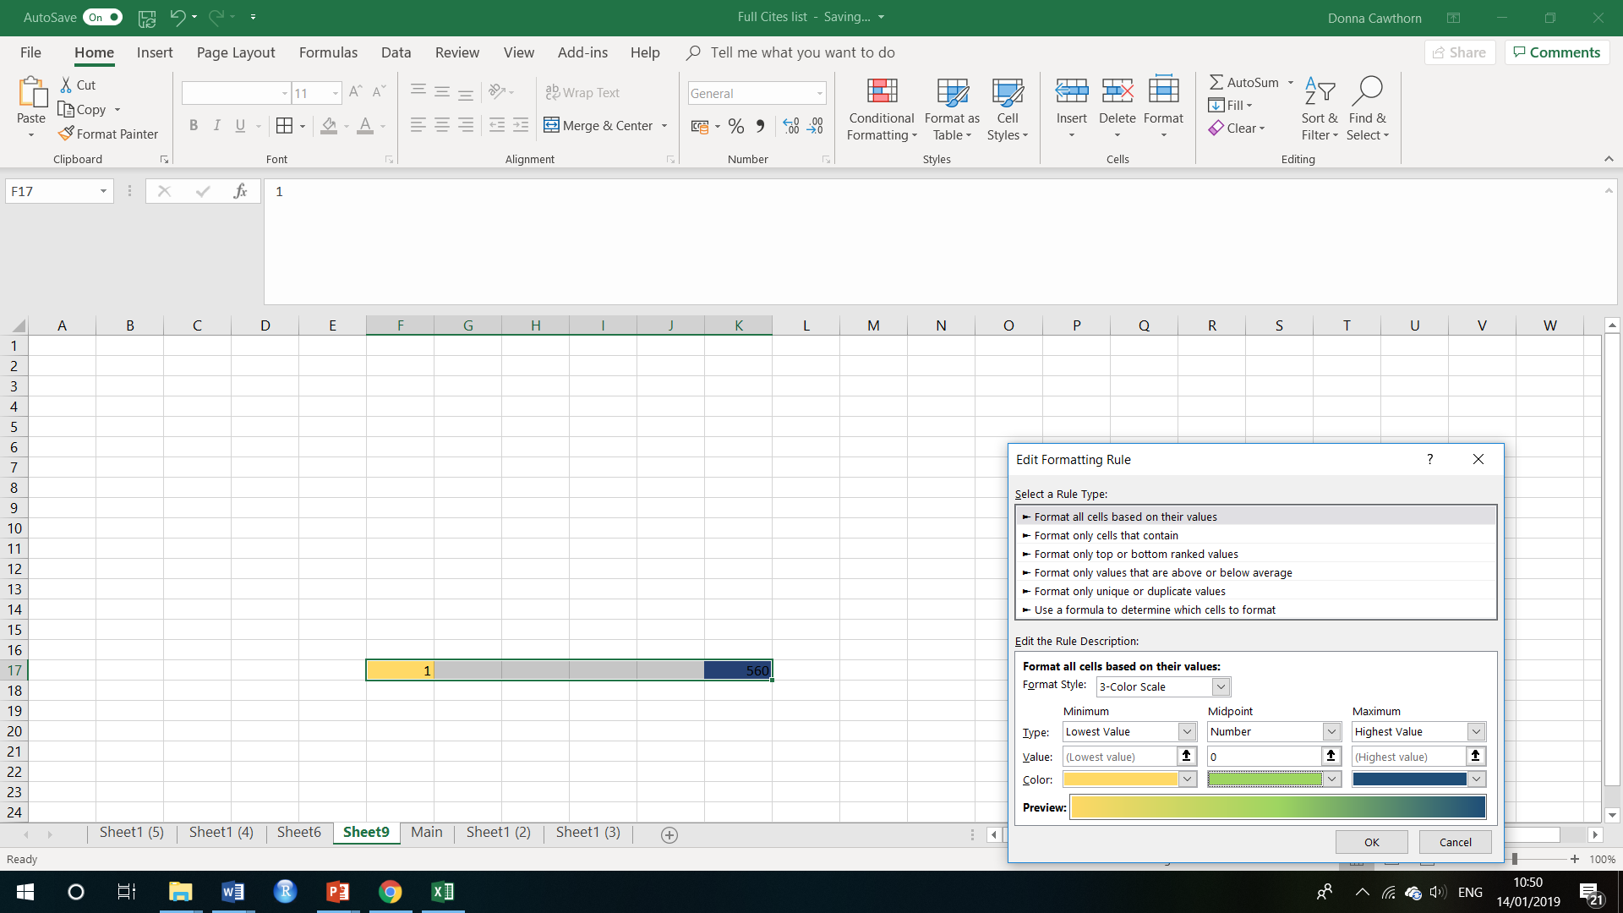

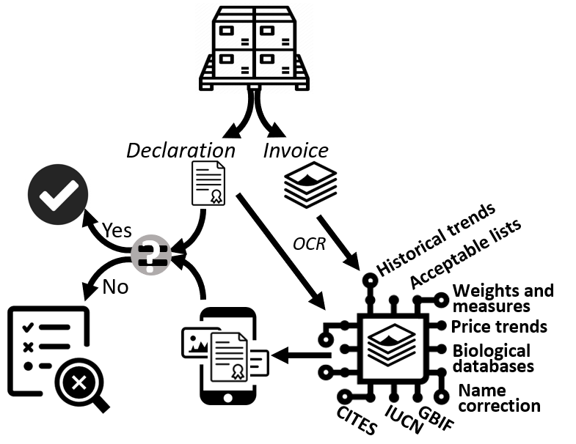
Figure 1. Schematic of the Nature Intelligence System (www.wildlifedetection.org) featuring Real Time Automated Species-level Detection. Shipment paperwork contains declarations, certifications and invoices. The Nature Intelligence System uses optical character recognition to automatically collect species level information from the invoice along with declaration information. It compares the information presented to biological, historical, and value data. The Nature Intelligence System summarizes shipment information for a port inspector. If declared information agrees with the invoice analysis, the shipment is flagged to be cleared where if the data do not align, the shipment is flagged for further inspection.
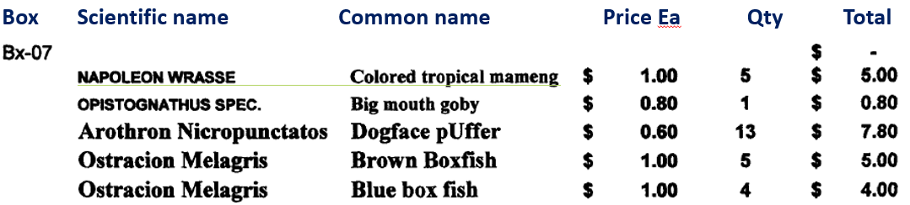
Figure 2. Image capture of an invoice from a shipment of marine aquarium tropical fish. The first column is the scientific name of the fish, and the second column is the common name. No further invoice data can be provided based on adherence to confidentiality norms. Note that the Napoleon (Humphead) wrasse, a CITES appendix II (A2bd+3bd) species, does not follow the naming convention for the rest of the species. These individuals were also not declared on the associated USFWS Form 3-177, and as such constitute illegal wildlife trade. Also of note is that the big mouth goby is listed only to the genus (Opistognathus) and not the species level. This is considered misinformation given that all species in this genus are classified as IUCN LC (n= 23) or data deficient (n=14), and the only consequence is the loss of trade data for this species complex.

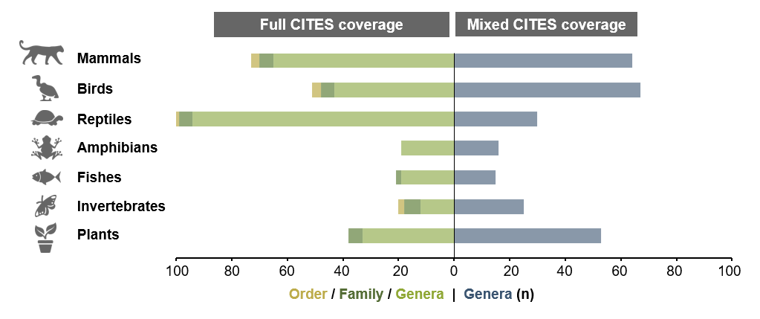
Figure 3. Mixed-CITES genus listings within the kingdoms Animalia and Plantae. The number of order-, family- and genus-level listings under which all constituent species are covered by CITES (left) compared with the number of mixed-CITES-genera (right) within different animal groups and plants. Mixed-CITES-genera are classified as those containing one or more CITES-listed species, as well as non-CITES species.
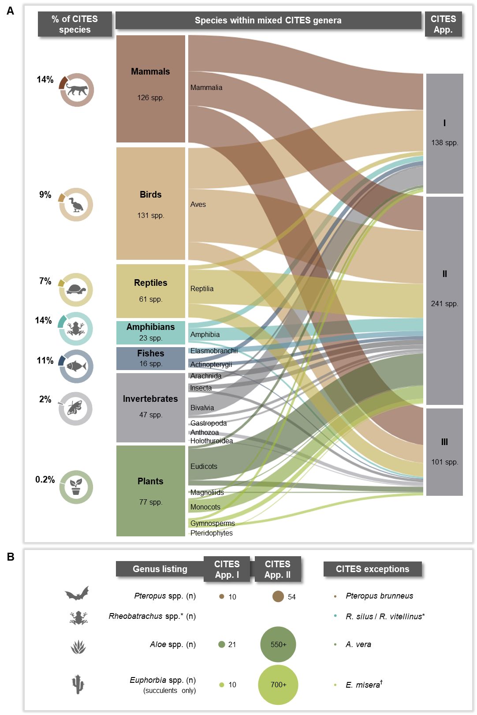
Figure 4. Two reasons for Mixed-CITES listings. (A) Shows cases where mixed genera arise due to the CITES listing of only certain species within a genus. The breakdown includes the numbers of CITES species in each appendix that fall into mixed genera (middle, right), and as proportions of all CITES-listed species (left) within each animal and plant group. (B) Shows cases where mixed CITES genera arise due to genus-level CITES listings, with exceptions made for certain species.

Notes:
*The listing of Rheobatrachus spp. (except for R. silus and R. vitellinus) is peculiar given that this refers to a genus of extinct gastric-brooding frogs native to Queensland, Australia. The genus consisted of only the latter two exempt species, both of which became extinct in the 1980s.
^{Ϯ} Some artificially propagated species are also exempt from CITES.

Supplementary Materials:

Materials and Methods
Figures S1-S4
Tables S1-S3

Figure S1. CITES coverage within the kingdoms Animalia and Plantae. Number of CITES species listed per appendix across different animal groups and plants (bar charts), and as proportions of the total number of extant species existing in each group (donut charts). Numbers of extant species for each group were derived from the International Union for Conservation of Nature (IUCN) summary statistics [IUCN Red List version 2019-3, www.iucnredlist.org].

Figure S2. Discrepancies in CITES trade data relating to US Cheilinus undulates imports. Differences (green dots) between US-reported imports (left) and partner-reported exports (right) of live Cheilinus undulatus individuals (CITES App. II) for 2008–2011 as recorded in the CITES Trade Database* . Country names in parentheses on the right are export reporters, whereas those on the left are the US-reported origins of imports.

Figure S3. Global discrepancies in CITES trade data for Cheilinus undulates. (A) Narrow bars indicate log₁₀-transformed numbers of live C. undulatus individuals (CITES App. II) reported as imported (green bars, left) and exported (blue bars, right) by all global reporters for the years 2005–2014, as recorded in the CITES Trade Database (CITES trade statistics derived from the CITES Trade Database, UNEP World Conservation Monitoring Centre, Cambridge, UK). Thick grey bars indicate log₁₀-transformed discrepancies between these figures. (B) Bilateral trade flows of live C. undulatus based on reported imports (green) and exports (blue), where the width of bands represents aggregate quantities (numbers of individuals) for 2005–2014. Coloured segments in the outer circle designate reporter countries, whereas clear segments designate partner countries. (C) Discrepant C. undulatus trade flows revealed through bilateral import and export comparisons, where the width of bands represents aggregate quantities for 2005–2014. Coloured segments in the outer circle indicate import reporters (green) and export reporters (blue), whereas grey segments indicate non- or under-reporting partner countries. (D) Reconciliation of reported and discrepant C. undulatus trade volumes, aggregated for the years 2005–2014. The green bar represents total reported imports, the blue bar represents total reported exports and the grey bar represents the discrepancy between the two aforementioned quantities.

Figure S4 (A-C). Full- and mixed-CITES listings by taxonomic order in the kingdoms Animalia and Plantae. (A) Represents different vertebrate groups and orders in the phylum Chordata, (B) represents different invertebrate groups and orders across various phyla, and (C) represents different plant groups and orders. In (A), (B) and (C), the left panels show the number of order-, family- and genus-level listings under which all constituent species are covered by CITES. The right panels indicate the number of mixed-CITES genera (wide bars), as well as the number of CITES species within mixed genera (narrow bars) and as percentages of all CITES-listed species. Mixed-CITES genera are those in which at least one species is CITES listed, but others are not.

Table S1. Scale of legal and illegal wildlife production and trade. Global values (US$ billion) of reported wildlife production, exports and imports for the years 2014–2016 (including means and standard deviations [SDs]), compared with estimated annual values associated with illegal / unreported wildlife production and trade.^{i} Estimated revenues generated through other forms of transnational crime are also indicated.

Table S2. Full- and mixed-CITES coverage within different animal and plant groups. The number of order-, family- and genus-level listings under which all constituent species are included under CITES are shown in the middle panel, whereas the number of mixed-CITES genera and incorporated CITES-listed species are shown in the right-hand panel. Mixed-CITES genera are classified as those containing one or more CITES-listed species, as well as non-CITES species. Numbers of mixed genera and CITES species within mixed genera are additionally expressed as percentages of total CITES-listed genera and species. Entries marked with a ‘T’ refer to ‘true mixed CITES genera’, in which only certain species within a genus are CITES listed and others are not. Entries marked with an ‘E’ refer to ‘exceptions’, in which an entire genus is CITES listed with the exception of one or more species.

Table S3. Lack of taxonomic precision in LEMIS data. Data as described by Romagosa (38) and updated through part of 2016. For each taxa, we calculated the number of distinct shipments, the total number of individuals shipped, the percentage of shipments with individuals identified as a sp. designation, and for those shipments containing individuals identified as SP., the average percent of taxonomically imprecise individuals within the shipment.

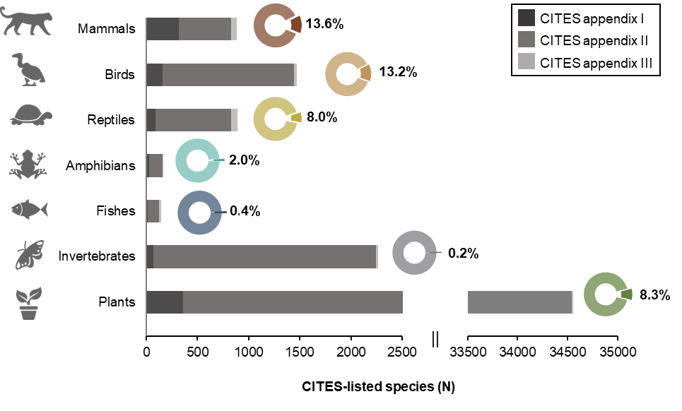

Figure S1. CITES coverage within the kingdoms Animalia and Plantae. Number of CITES species listed per appendix across different animal groups and plants (bar charts), and as proportions of the total number of extant species existing in each group (donut charts). Numbers of extant species for each group were derived from the International Union for Conservation of Nature (IUCN) summary statistics [IUCN Red List version 2019-3, www.iucnredlist.org].

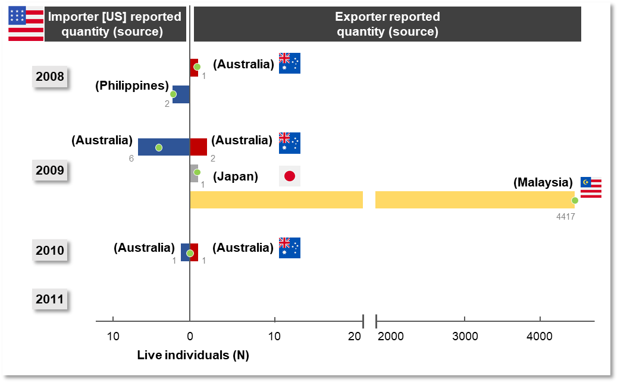

Figure S2. Discrepancies in CITES trade data relating to US Cheilinus undulates imports. Differences (green dots) between US-reported imports (left) and partner-reported exports (right) of live Cheilinus undulatus individuals (CITES App. II) for 2008–2011 as recorded in the CITES Trade Database* (CITES trade statistics derived from the CITES Trade Database, UNEP World Conservation Monitoring Centre, Cambridge, UK). Country names in parentheses on the right are export reporters, whereas those on the left are the US-reported origins of imports.

- Note: Data in the CITES Trade Database are derived from mandatory annual reports submitted by individual Parties to CITES detailing their international trade in CITES-listed species. Although advised to base annual reports on permits used, some Parties simply report on the number of permits / certificates issued. Consequently, inaccuracies in reported trade volumes may exist in the CITES Trade Database if transactions do not transpire or if fewer specimens are traded than specified on the permit. Compounding the problem, annual reports are often incomplete, some Parties do not submit timeously or for extended periods due to internal problems (e.g. civil wars, lack of resources etc.) and insufficient detail is often provided on the source of materials (wild or captive-bred), seized or confiscated specimens, and units of measurement (UNEP‐WCMC 2013).
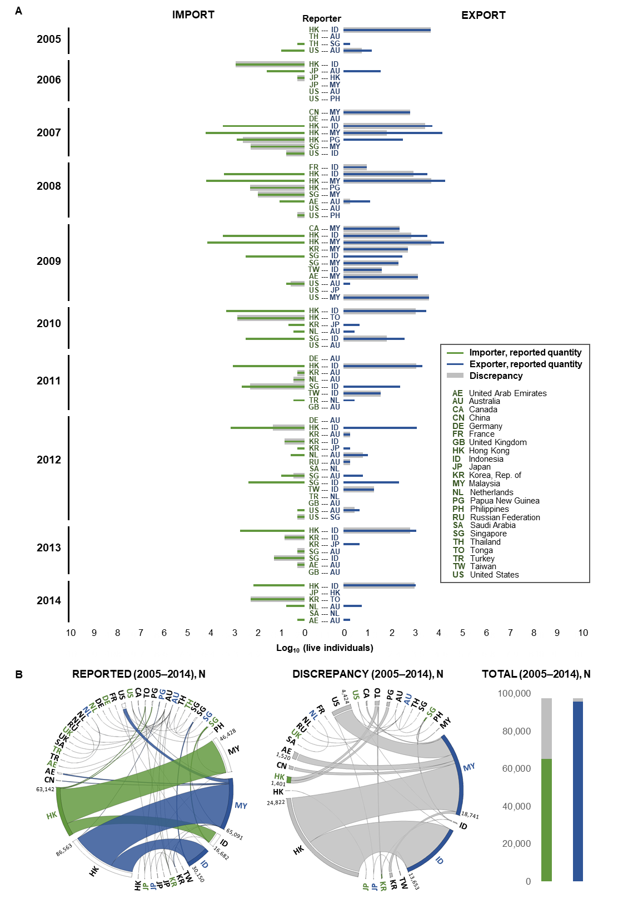
C D

Figure S3. Global discrepancies in CITES trade data for Cheilinus undulates. (A) Narrow bars indicate log₁₀-transformed numbers of live C. undulatus individuals (CITES App. II) reported as imported (green bars, left) and exported (blue bars, right) by all global reporters for the years 2005–2014, as recorded in the CITES Trade Database (CITES trade statistics derived from the CITES Trade Database, UNEP World Conservation Monitoring Centre, Cambridge, UK). Thick grey bars indicate log₁₀-transformed discrepancies between these figures. (B) Bilateral trade flows of live C. undulatus based on reported imports (green) and exports (blue), where the width of bands represents aggregate quantities (numbers of individuals) for 2005–2014. Coloured segments in the outer circle designate reporter countries, whereas clear segments designate partner countries. (C) Discrepant C. undulatus trade flows revealed through bilateral import and export comparisons, where the width of bands represents aggregate quantities for 2005–2014. Coloured segments in the outer circle indicate import reporters (green) and export reporters (blue), whereas grey segments indicate non- or under-reporting partner countries. (D) Reconciliation of reported and discrepant C. undulatus trade volumes, aggregated for the years 2005–2014. The green bar represents total reported imports, the blue bar represents total reported exports and the grey bar represents the discrepancy between the two aforementioned quantities.

- Note: Data in the CITES Trade Database are derived from mandatory annual reports submitted by individual Parties to CITES detailing their international trade in CITES-listed species. Although advised to base annual reports on permits used, some Parties simply report on the number of permits / certificates issued. Consequently, inaccuracies in reported trade volumes may exist in the CITES Trade Database if transactions do not transpire or if fewer specimens are traded than specified on the permit. Compounding the problem, annual reports are often incomplete, some Parties do not submit timeously or for extended periods due to internal problems (e.g. civil wars, lack of resources etc.) and insufficient detail is often provided on the source of materials (wild or captive-bred), seized or confiscated specimens, and units of measurement (UNEP‐WCMC 2013).
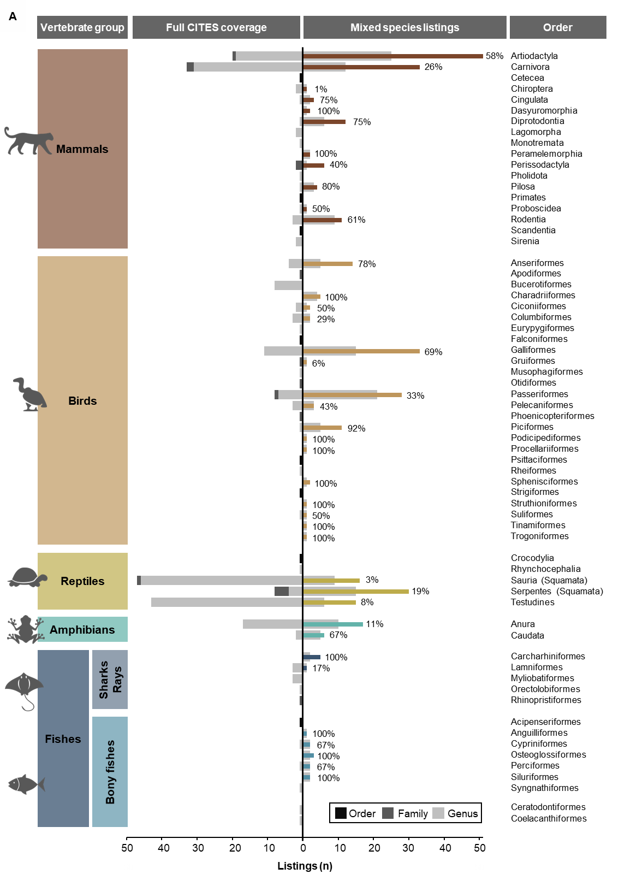
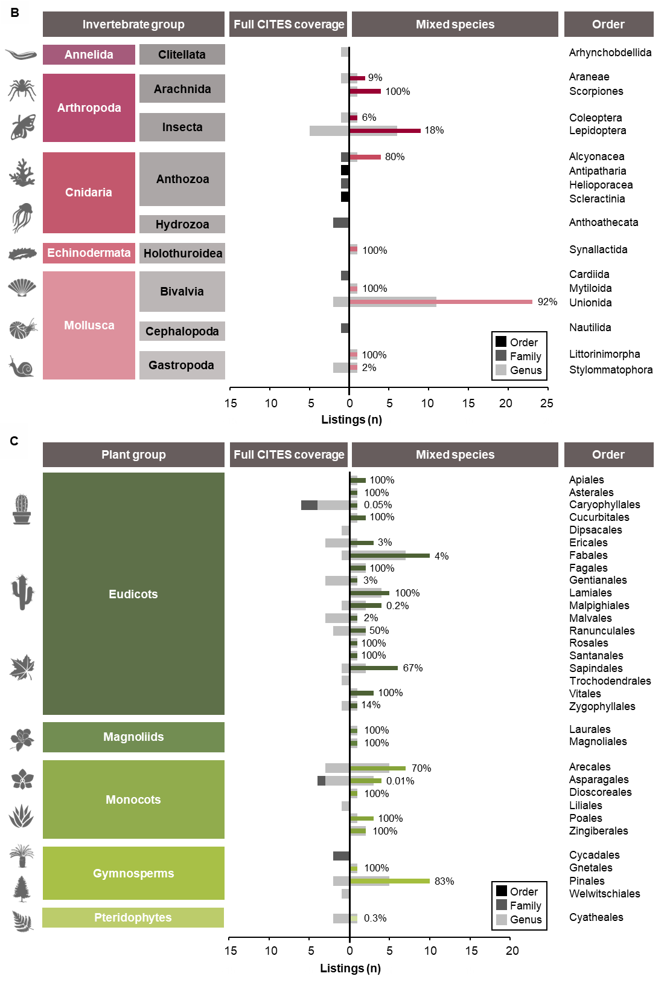
Figure S4 (A-C). Full- and mixed-CITES listings by taxonomic order in the kingdoms Animalia and Plantae. (A) Represents different vertebrate groups and orders in the phylum Chordata, (B) represents different invertebrate groups and orders across various phyla, and (C) represents different plant groups and orders. In (A), (B) and (C), the left panels show the number of order-, family- and genus-level listings under which all constituent species are covered by CITES. The right panels indicate the number of mixed-CITES genera (wide bars), as well as the number of CITES species within mixed genera (narrow bars) and as percentages of all CITES-listed species. Mixed-CITES genera are those in which at least one species is CITES listed, but others are not.

SUPPLEMENTARY Tables

Supplemental Table S1. Scale of legal and illegal wildlife production and trade. Global values (US$ billion) of reported wildlife production, exports and imports for the years 2014–2016 (including means and standard deviations [SDs]), compared with estimated annual values associated with illegal / unreported wildlife production and trade.^{i} Estimated revenues generated through other forms of transnational crime are also indicated.

Supplemental Table S2. Full- and mixed-CITES coverage within different animal and plant groups. The number of order-, family- and genus-level listings under which all constituent species are included under CITES are shown in the middle panel, whereas the number of mixed-CITES genera and incorporated CITES-listed species are shown in the right-hand panel. Mixed-CITES genera are classified as those containing one or more CITES-listed species, as well as non-CITES species. Numbers of mixed genera and CITES species within mixed genera are additionally expressed as percentages of total CITES-listed genera and species. Entries marked with a ‘T’ refer to ‘true mixed CITES genera’, in which only certain species within a genus are CITES listed and others are not. Entries marked with an ‘E’ refer to ‘exceptions’, in which an entire genus is CITES listed with the exception of one or more species.

Supplemental Table S3. Lack of taxonomic precision in LEMIS data. Data are from Romagosa 2014. For each taxa, we calculated the number of distinct shipments, the total number of individuals shipped, the percentage of shipments with individuals identified as a sp. designation (also including NA, CITES birds CITES mammals, {freshwater sp.}, {including goldfish}, and {marine sp.}), and for those shipments containing individuals identified as SP., the average percent of individuals identified as “sp.” within the shipment.

Supp. Table S1. Scale of legal and illegal wildlife production and trade. Global values (US$ billion) of reported wildlife production, exports and imports for the years 2014–2016 (including means and standard deviations [SDs]), compared with estimated annual values associated with illegal / unreported wildlife production and trade.^{i} Estimated revenues generated through other forms of transnational crime are also indicated.

Category |  |  | Classification | Description | REPORTED |  |  |  |  |  |  |  |  |  |  |  |  |  |  |  | ILLEGAL / UNREPORTED |  |  | Source
 |  |  | Classification | Description | Production value (US$ billion) |  |  |  |  | Export value (US$ billion) |  |  |  |  | Import value (US$ billion) |  |  |  |  |  | Value (US$ billion)
 |  |  | Classification | Description | 2014 | 2015 | 2016 | Mean annual | SD | 2014 | 2015 | 2016 | Mean annual | SD | 2014 | 2015 | 2016 | Mean annual | SD |  | Lower estimate | Higher estimate
FISH AND FISHERY PRODUCTS |  | Marine fisheries | Capture production | Fish, crustaceans, molluscs etc. | 109.195 | 105.920 | 114.000 | 109.705 | 4.064 |  |  |  |  |  |  |  |  |  |  |  |  |  |  | 1–3 ^{ii–iv}
 |  | Marine fisheries |  |  | 109.195 | 105.920 | 114.000 | 109.705 | 4.064
 |  | Fish and fishery  products for  food | ISSCAAP^{v} group | Marine fishes |  |  |  |  |  | 64.605 | 58.860 | 60.654 | 61.373 | 2.939 | 65.885 | 40.648 | 61.966 | 56.167 | 13.582 |  |  |  |  | 4
 |  | Fish and fishery  products for  food | ISSCAAP group | Squids, cuttlefishes, octopuses |  |  |  |  |  | 8.464 | 8.145 | 9.104 | 8.571 | 0.488 | 6.536 | 6.183 | 7.039 | 6.586 | 0.430 |  |  |  |  | 4
 |  | Fish and fishery  products for  food | ISSCAAP group | Lobsters, spiny lobsters |  |  |  |  |  | 4.232 | 4.326 | 4.407 | 4.322 | 0.087 | 3.710 | 3.774 | 3.961 | 3.815 | 0.131 |  |  |  |  | 4
 |  | Fish and fishery  products for  food | ISSCAAP group | Crabs, sea spiders |  |  |  |  |  | 3.614 | 3.461 | 3.647 | 3.574 | 0.099 | 3.825 | 3.634 | 3.923 | 3.794 | 0.147 |  |  |  |  | 4
 |  | Fish and fishery  products for  food | ISSCAAP group | King crabs, squat lobsters |  |  |  |  |  | 0.783 | 0.720 | 0.773 | 0.759 | 0.034 | 0.504 | 0.464 | 0.548 | 0.506 | 0.042 |  |  |  |  | 4
 |  | Fish and fishery  products for  food | ISSCAAP group | Miscellaneous marine crustaceans |  |  |  |  |  | 0.609 | 0.473 | 0.465 | 0.516 | 0.081 | 0.561 | 0.449 | 0.478 | 0.496 | 0.058 |  |  |  |  | 4
 |  | Fish and fishery  products for  food | HS^{vi} 02.08.40 | Marine mammal meat |  |  |  |  |  | 0.019 | 0.016 | 0.015 | 0.017 | 0.002 | 0.014 | 0.011 | 0.010 | 0.011 | 0.002 |  |  |  |  | 5
 |  | Fish and fishery  products for  food |  |  |  |  |  |  |  | 82.326 | 76.001 | 79.066 | 79.131 | 3.163 | 81.035 | 55.163 | 77.925 | 71.374 | 14.125
 |  | Ornamental/  other purposes | HS 03.01.10/11/19 | Live ornamental fishes |  |  |  |  |  | 0.359 | 0.332 | 0.340 | 0.344 | 0.014 | 0.303 | 0.271 | 0.289 | 0.287 | 0.016 |  |  |  |  | 5
 |  | Ornamental/  other purposes | ISSCAAP group | Corals |  |  |  |  |  | 0.165 | 0.173 | 0.158 | 0.165 | 0.007 | 0.177 | 0.175 | 0.157 | 0.170 | 0.011 |  |  |  |  | 4
 |  | Ornamental/  other purposes | ISSCAAP group | Pearls, mother-of-pearl, shells |  |  |  |  |  | 0.012 | 0.013 | 0.012 | 0.012 | 0.001 | 0.011 | 0.010 | 0.011 | 0.011 | 0.001 |  |  |  |  | 4
 |  | Ornamental/  other purposes | ISSCAAP group | Sponges |  |  |  |  |  | 0.009 | 0.009 | 0.011 | 0.010 | 0.001 | 0.008 | 0.007 | 0.008 | 0.008 | 0.001 |  |  |  |  | 4
 |  | Ornamental/  other purposes |  |  |  |  |  |  |  | 0.545 | 0.527 | 0.521 | 0.531 | 0.012 | 0.499 | 0.463 | 0.465 | 0.476 | 0.020
 |  |  |  |  | 109.195 | 105.920 | 114.000 | 109.705 | 4.064 | 82.871 | 76.528 | 79.587 | 79.662 | 3.172 | 81.534 | 55.626 | 78.390 | 71.850 | 14.138 |  | 15.5 | 36.4 |  | 6 ^{vii}
TIMBER AND TIMBER PRODUCTS |  | Roundwood | HS 44.01.10 | Fuel wood |  |  |  |  |  | 0.577 | 0.490 | 0.551 | 0.539 | 0.044 | 0.502 | 0.419 | 0.375 | 0.432 | 0.064 |  |  |  |  | 5
 |  | Roundwood | HS 44.03.20/41/49/91/92/99 | Industrial roundwood |  |  |  |  |  | 13.927 | 10.947 | 10.521 | 11.798 | 1.856 | 22.160 | 16.364 | 15.533 | 18.019 | 3.610 |  |  |  |  | 5
 |  | Roundwood |  |  |  |  |  |  |  | 14.504 | 11.438 | 11.072 | 12.338 | 1.885 | 22.662 | 16.783 | 15.908 | 18.451 | 3.673
 |  | Wood charcoal, chips, particles, pellets, etc. | HS 44.02.90 | Wood charcoal |  |  |  |  |  | 0.747 | 0.782 | 0.819 | 0.783 | 0.036 | 1.156 | 1.175 | 1.143 | 1.158 | 0.016 |  |  |  |  | 5
 |  | Wood charcoal, chips, particles, pellets, etc. | HS 44.01.21/22 | Wood chips and particles |  |  |  |  |  | 3.980 | 4.004 | 3.851 | 3.945 | 0.082 | 5.270 | 5.252 | 5.184 | 5.235 | 0.046 |  |  |  |  | 5
 |  | Wood charcoal, chips, particles, pellets, etc. | HS 44.01.31 | Wood pellets |  |  |  |  |  | 2.636 | 2.476 | 2.106 | 2.406 | 0.272 | 2.876 | 2.709 | 2.437 | 2.674 | 0.221 |  |  |  |  | 5
 |  | Wood charcoal, chips, particles, pellets, etc. | HS 44.01.39 | Wood residues |  |  |  |  |  | 0.886 | 0.782 | 0.713 | 0.793 | 0.087 | 0.775 | 0.624 | 0.583 | 0.660 | 0.101 |  |  |  |  | 5
 |  | Wood charcoal, chips, particles, pellets, etc. |  |  |  |  |  |  |  | 8.248 | 8.043 | 7.489 | 7.927 | 0.393 | 10.077 | 9.761 | 9.347 | 9.728 | 0.366
 |  | Sawn wood | HS 44.07.10 | Sawn wood, coniferous |  |  |  |  |  | 27.835 | 23.505 | 17.410 | 22.917 | 5.237 | 27.202 | 23.836 | 24.476 | 25.171 | 1.787 |  |  |  |  | 5
 |  | Sawn wood | HS 44.07.20 – 44.07.99 | Sawn wood, non-coniferous |  |  |  |  |  | 9.465 | 8.800 | 8.834 | 9.033 | 0.374 | 12.684 | 11.897 | 11.071 | 11.884 | 0.806 |  |  |  |  | 5
 |  | Sawn wood |  |  |  |  |  |  |  | 37.300 | 32.306 | 26.245 | 31.950 | 5.536 | 39.885 | 35.733 | 35.547 | 37.055 | 2.453
 |  | Wood-based  panels | HS 44.08 | Veneer Sheets |  |  |  |  |  | 2.622 | 2.483 | 2.314 | 2.473 | 0.155 | 3.201 | 3.095 | 3.029 | 3.108 | 0.087 |  |  |  |  | 5
 |  | Wood-based  panels | HS 44.10 | Particle board |  |  |  |  |  | 7.877 | 6.862 | 5.806 | 6.848 | 1.036 | 8.008 | 6.886 | 7.219 | 7.371 | 0.576 |  |  |  |  | 5
 |  | Wood-based  panels | HS 44.11 | Fibreboard |  |  |  |  |  | 10.310 | 9.223 | 9.003 | 9.512 | 0.700 | 10.024 | 8.506 | 8.427 | 8.986 | 0.900 |  |  |  |  | 5
 |  | Wood-based  panels | HS 44.12.31/32/39/94/99 | Plywood |  |  |  |  |  | 16.379 | 15.103 | 14.540 | 15.341 | 0.942 | 14.367 | 13.519 | 12.726 | 13.537 | 0.820 |  |  |  |  | 5
 |  | Wood-based  panels |  |  |  |  |  |  |  | 37.189 | 33.671 | 31.663 | 34.174 | 2.797 | 35.600 | 32.006 | 31.401 | 33.002 | 2.270
 |  | Pulp of wood/  other fibre; recovered  paper | HS 47.01/02/03/04/05 | Wood pulp |  |  |  |  |  | 35.253 | 33.175 | 26.314 | 31.581 | 4.678 | 38.714 | 37.947 | 35.492 | 37.384 | 1.683 |  |  |  |  | 5
 |  | Pulp of wood/  other fibre; recovered  paper | HS 47.06 | Other fibre pulp |  |  |  |  |  | 0.605 | 0.534 | 0.531 | 0.557 | 0.042 | 0.685 | 0.656 | 0.602 | 0.648 | 0.042 |  |  |  |  | 5
 |  | Pulp of wood/  other fibre; recovered  paper | HS 47.07 | Recovered paper |  |  |  |  |  | 9.313 | 8.776 | 8.846 | 8.978 | 0.292 | 10.947 | 10.366 | 10.197 | 10.503 | 0.394 |  |  |  |  | 5
 |  | Pulp of wood/  other fibre; recovered  paper |  |  |  |  |  |  |  | 45.171 | 42.485 | 35.691 | 41.116 | 4.886 | 50.347 | 48.968 | 46.290 | 48.535 | 2.062
 |  | Paper, paperboard | HS 48 | Paper, paperboard, products of |  |  |  |  |  | 115.863 | 101.873 | 94.617 | 104.118 | 10.800 | 118.875 | 103.060 | 98.251 | 106.729 | 10.791 |  |  |  |  | 5
 |  | Paper, paperboard |  |  |  |  |  |  |  | 115.863 | 101.873 | 94.617 | 104.118 | 10.800 | 118.875 | 103.060 | 98.251 | 106.729 | 10.791
 |  |  |  |  |  |  |  |  |  | 258.275 | 229.816 | 206.777 | 231.622 | 25.797 | 277.445 | 246.311 | 236.745 | 253.500 | 21.282 |  | 50.7 | 152.0 |  | 7 ^{viii}
WILD ANIMAL AND PLANT PRODUCTS |  | Live animals | HS 01.06.11 | Primates |  |  |  |  |  | 0.099 | 0.078 | 0.100 | 0.093 | 0.012 | 0.129 | 0.139 | 0.145 | 0.137 | 0.008 |  |  |  |  | 5
 |  | Live animals | HS 01.06.20 | Reptiles |  |  |  |  |  | 0.040 | 0.045 | 0.047 | 0.044 | 0.004 | 0.042 | 0.043 | 0.044 | 0.043 | 0.001 |  |  |  |  | 5
 |  | Live animals | HS 01.06.31 | Birds of prey |  |  |  |  |  | 0.018 | 0.022 | 0.027 | 0.022 | 0.004 | 0.007 | 0.006 | 0.006 | 0.006 | 0.000 |  |  |  |  | 5
 |  | Live animals | HS 01.06.32 | Birds, Psittaciformes |  |  |  |  |  | 0.032 | 0.029 | 0.032 | 0.031 | 0.002 | 0.015 | 0.015 | 0.015 | 0.015 | 0.000 |  |  |  |  | 5
 |  | Live animals |  |  |  |  |  |  |  | 0.188 | 0.174 | 0.206 | 0.189 | 0.016 | 0.192 | 0.202 | 0.210 | 0.201 | 0.009
 |  | Animal products  for clothing | HS 41.03.20; 41.06.40; 41.13.30 | Reptile skins: raw, tanned, leather |  |  |  |  |  | 0.659 | 0.552 | 0.549 | 0.587 | 0.062 | 0.695 | 0.615 | 0.628 | 0.646 | 0.043 |  |  |  |  | 5
 |  | Animal products  for clothing | HS 43.01.10 | Fur skins, mink |  |  |  |  |  | 4.218 | 4.420 | 2.365 | 3.668 | 1.133 | 3.718 | 3.616 | 2.398 | 3.244 | 0.734 |  |  |  |  | 5
 |  | Animal products  for clothing | HS 43.01.60 | Fur skins, fox |  |  |  |  |  | 0.422 | 0.341 | 0.144 | 0.303 | 0.143 | 0.208 | 0.185 | 0.124 | 0.173 | 0.043 |  |  |  |  | 5
 |  | Animal products  for clothing | HS 43.01.70/80/90 | Fur skins, other animals |  |  |  |  |  | 0.349 | 0.190 | 0.127 | 0.222 | 0.115 | 0.383 | 0.207 | 0.134 | 0.241 | 0.128 |  |  |  |  | 5
 |  | Animal products  for clothing |  |  |  |  |  |  |  | 5.649 | 5.503 | 3.186 | 4.779 | 1.382 | 5.005 | 4.623 | 3.284 | 4.304 | 0.903
 |  | Animal products  for food |  | Game/venison meat |  |  |  |  |  |  |  | 0.340 | 0.340 |  |  |  | 0.214 | 0.214 |  |  |  |  |  | 8 ^{ix}
 |  | Animal products  for food | HS 02.08.30 | Primate meat |  |  |  |  |  | 0.002 | 0.000 | 0.000 | 0.001 | 0.001 | 0.001 | 0.001 | 0.001 | 0.001 | 0.000 |  |  |  |  | 5
 |  | Animal products  for food | HS 02.08.50 | Reptile meat |  |  |  |  |  | 0.004 | 0.005 | 0.006 | 0.005 | 0.001 | 0.004 | 0.005 | 0.005 | 0.005 | 0.001 |  |  |  |  | 5
 |  | Animal products  for food | HS 04.09 | Natural honey |  |  |  |  |  | 2.330 | 2.300 | 2.209 | 2.279 | 0.063 | 2.309 | 2.318 | 2.015 | 2.214 | 0.173 |  |  |  |  | 5
 |  | Animal products  for food |  |  |  |  |  |  |  | 2.335 | 2.305 | 2.555 | 2.398 | 0.136 | 2.314 | 2.325 | 2.235 | 2.291 | 0.049
 |  | Animal trophies,  ornamentals | HS 05.07.10; 96.01.10 | Ivory and articles thereof |  |  |  |  |  | 0.032 | 0.019 | 0.018 | 0.023 | 0.008 | 0.041 | 0.028 | 0.023 | 0.031 | 0.010 |  |  |  |  | 5
 |  | Animal trophies,  ornamentals | HS 05.06.90; 05.07.90; 96.01.90 | Tortoiseshell, bones, horns etc. |  |  |  |  |  | 0.565 | 0.636 | 0.588 | 0.596 | 0.036 | 0.484 | 0.497 | 0.474 | 0.485 | 0.012 |  |  |  |  | 5
 |  | Animal trophies,  ornamentals |  |  |  |  |  |  |  | 0.597 | 0.655 | 0.606 | 0.619 | 0.032 | 0.525 | 0.526 | 0.496 | 0.515 | 0.017
 |  | Plant products  for food | HS 07.09.52/59; 07.11.59;  07.12.39; 20.03.20/90 | Truffles and mushrooms  (other than Agaricus spp.) |  |  |  |  |  | 2.484 | 2.595 | 2.842 | 2.640 | 0.183 | 1.508 | 1.439 | 1.451 | 1.466 | 0.037 |  |  |  |  | 5
 |  | Plant products  for food | HS 08.10.40; 20.08.93; 20.09.81 | Forest berries, products thereof |  |  |  |  |  | 2.389 | 2.495 | 2.963 | 2.616 | 0.306 | 2.364 | 2.575 | 3.150 | 2.697 | 0.407 |  |  |  |  | 5
 |  | Plant products  for food | HS 17.02.20 | Maple sugar/syrup |  |  |  |  |  | 0.339 | 0.343 | 0.353 | 0.345 | 0.007 | 0.338 | 0.343 | 0.351 | 0.344 | 0.007 |  |  |  |  | 5
 |  | Plant products  for food | HS 08.01.21/22 | Brazil nuts |  |  |  |  |  | 0.294 | 0.343 | 0.322 | 0.320 | 0.024 | 0.282 | 0.469 | 0.324 | 0.358 | 0.098 |  |  |  |  | 5
 |  | Plant products  for food |  |  |  |  |  |  |  | 5.507 | 5.775 | 6.481 | 5.921 | 0.503 | 4.492 | 4.827 | 5.277 | 4.865 | 0.394
 |  | Medicinal and  aromatic plants | HS 12.11.20 | Ginseng |  |  |  |  |  | 0.651 | 0.569 | 0.526 | 0.582 | 0.063 | 0.517 | 0.553 | 0.560 | 0.543 | 0.023 |  |  |  |  | 5
 |  | Medicinal and  aromatic plants | HS 12.11.90 | Bark, leaves, roots, other plant parts |  |  |  |  |  | 2.811 | 2.502 | 2.512 | 2.608 | 0.176 | 2.711 | 2.488 | 2.497 | 2.566 | 0.126 |  |  |  |  | 5
 |  | Medicinal and  aromatic plants |  |  |  |  |  |  |  | 3.462 | 3.071 | 3.038 | 3.190 | 0.236 | 3.228 | 3.041 | 3.057 | 3.109 | 0.103
 |  | Exudates: latex,  natural gums, resins | HS 40.01.10 | Latex |  |  |  |  |  | 1.958 | 1.482 | 1.488 | 1.643 | 0.273 | 2.453 | 1.604 | 1.527 | 1.861 | 0.514 |  |  |  |  | 5
 |  | Exudates: latex,  natural gums, resins | HS 40.01.30 | Balata, guayule, chicle, percha etc. |  |  |  |  |  | 0.015 | 0.014 | 0.016 | 0.015 | 0.001 | 0.018 | 0.013 | 0.015 | 0.016 | 0.003 |  |  |  |  | 5
 |  | Exudates: latex,  natural gums, resins | HS 13.01.10/20/90 | Gum Arabic, lac, other gums/resins |  |  |  |  |  | 0.543 | 0.486 | 0.483 | 0.504 | 0.034 | 0.825 | 0.821 | 0.819 | 0.822 | 0.003 |  |  |  |  | 5
 |  | Exudates: latex,  natural gums, resins |  |  |  |  |  |  |  | 2.516 | 1.982 | 1.987 | 2.162 | 0.307 | 3.296 | 2.439 | 2.361 | 2.699 | 0.519
 |  | Other animal and plant products | HS 15.21.90 | Beeswax, other insect waxes |  |  |  |  |  | 0.177 | 0.152 | 0.142 | 0.157 | 0.018 | 0.158 | 0.151 | 0.145 | 0.151 | 0.006 |  |  |  |  | 5
 |  | Other animal and plant products | HS 05.11.00 | Ambergris, castoreum, civet, musk, cantharides, bile glands etc. |  |  |  |  |  | 0.175 | 0.161 | 0.152 | 0.163 | 0.012 | 0.220 | 0.216 | 0.218 | 0.218 | 0.002 |  |  |  |  | 5
 |  | Other animal and plant products | HS 45.01; 45.02 | Natural cork |  |  |  |  |  | 0.217 | 0.180 | 0.194 | 0.197 | 0.018 | 0.267 | 0.233 | 0.244 | 0.248 | 0.017 |  |  |  |  | 5
 |  | Other animal and plant products | HS 14.01.10/20/90 | Bamboo, rattans etc. for plaiting |  |  |  |  |  | 0.159 | 0.177 | 0.166 | 0.168 | 0.009 | 0.245 | 0.250 | 0.230 | 0.242 | 0.011 |  |  |  |  | 5
 |  | Other animal and plant products | HS 06.04 | Foliage, branches, grasses, mosses etc.: bouquets/ornamentals |  |  |  |  |  | 1.170 | 1.091 | 1.151 | 1.137 | 0.041 | 1.198 | 1.105 | 1.103 | 1.135 | 0.055 |  |  |  |  | 5
 |  |  |  |  |  |  |  |  |  | 1.898 | 1.762 | 1.805 | 1.822 | 0.070 | 2.088 | 1.955 | 1.939 | 1.994 | 0.082
 |  |  |  |  |  |  |  |  |  | 22.152 | 21.227 | 19.863 | 21.081 | 1.151 | 21.140 | 19.938 | 18.860 | 19.979 | 1.141 |  | 5.0 | 23.0 |  | 6
TOTAL (FISHERIES, TIMBER, ANIMALS, PLANTS) |  |  |  |  |  |  |  |  |  | 363.298 | 327.571 | 306.227 | 332.365 | 28.836 | 380.120 | 321.875 | 333.995 | 345.330 | 30.733 |  | 71.2 | 211.4
OTHER TRANS-NATIONAL CRIME | COUNTERFEITING / PIRATE GOODS |  |  |  |  |  |  |  |  |  |  |  |  |  |  |  |  |  |  |  | 923 | 1130 |  | 6
OTHER TRANS-NATIONAL CRIME | DRUG TRAFFICKING |  |  |  |  |  |  |  |  |  |  |  |  |  |  |  |  |  |  |  | 426 | 652 |  | 6
OTHER TRANS-NATIONAL CRIME | HUMAN TRAFFICKING |  |  |  |  |  |  |  |  |  |  |  |  |  |  |  |  |  |  |  |  | 150.2 |  | 6
OTHER TRANS-NATIONAL CRIME | SMALL ARMS / WEAPONS TRAFFICKING |  |  |  |  |  |  |  |  |  |  |  |  |  |  |  |  |  |  |  | 1.7 | 3.5 |  | 6
OTHER TRANS-NATIONAL CRIME | ORGAN TRAFFICKING |  |  |  |  |  |  |  |  |  |  |  |  |  |  |  |  |  |  |  | 0.84 | 1.7 |  | 6
- These values serve only as indicators of the scale of wildlife trade as only certain commodity groups are included, some commodity codes can cover both wild-captured and farmed / captive-bred species and there is high uncertainty associated with estimates of illegal trade.
- Marine capture production value (2014) = 81,549,353 t x $1,339/t. See reference 1
- Marine capture production value (2015) = 81,164,685 tons x $1,305/ton. See reference 2.
- Marine capture production value (2016) = 79,276,848 t x $1,438/t. See reference 3.
- ISSCAAP = International Standard Statistical Classification of Aquatic Animals and Plants.
- HS = Harmonized System code.
- Illegal and unregulated fishing is estimated to represent ca. 15–35% of the global marine capture fisheries production volume (i.e. 12–28 million t annually) and 14–33% of its annual value. This excludes unregulated fisheries, IUU fishing in inland waters and illegal open sea discards, which may additionally account for tens of billions of USD. See reference 6.
- Illegal timber trade is estimated to represent 10–30% of total global trade in timber products. See reference 7.
- Estimates available only for UNECE countries and for 2016. See reference 8.
References
- FAO (Food and Agriculture Organization). 2016. FAO Yearbook 2014: Fishery and Aquaculture Statistics. Pp. 7, 50. Rome: FAO. URL www.fao.org/3/a-i5716t.pdf
- FAO (Food and Agriculture Organization). 2017. FAO Yearbook 2015: Fishery and Aquaculture Statistics. Pp. 7, 52. Rome: FAO. URL www.fao.org/3/a-i7989t.pdf
- FAO (Food and Agriculture Organization). 2018. FAO Yearbook 2016: Fishery and Aquaculture Statistics. Pp. 7, 52. Rome: FAO. URL www.fao.org/3/i9942t/I9942T.pdf
- FAO (Food and Agriculture Organization). 2019. FAO Commodity and Trade Database 1976-2016. URL www.fao.org/fishery/statistics/global-commodities-production/en
- UN Comtrade (United Nations Commodity Trade Statistics Database). 2019. International Trade Statistics Database. URL https://comtrade.un.org
- May, C. 2017. Transnational crime and the developing world. Washington, DC: Global Financial Integrity.
- Nellemann, C., Henriksen, R., Kreilhuber, A., Stewart, D., Kotsovou, M., Raxter, P., Mrema, E., & Barrat, S. 2016. The rise of environmental crime: A growing threat to natural resources, development and security. A UNEP-INTERPOL Rapid Response Assessment. Nairobi, Kenya: UNEP.
- UNECE/FAO (United Nations Economic Commission for Europe / Food and Agriculture Organization). 2018. Game meat: Production and trade in the UNECE region. A pilot questionnaire. URL www.unece.org/fileadmin/DAM/timber/meetings/2018/20180321/game-meat-draft-2018-03.pdf

Supplemental Table S2. Full- and mixed-CITES coverage within different animal and plant groups. The number of order-, family- and genus-level listings under which all constituent species are included under CITES are shown in the middle panel, whereas the number of mixed-CITES genera and incorporated CITES-listed species are shown in the right-hand panel. Mixed-CITES genera are classified as those containing one or more CITES-listed species, as well as non-CITES species. Numbers of mixed genera and CITES species within mixed genera are additionally expressed as percentages of total CITES-listed genera and species. Entries marked with a ‘T’ refer to ‘true mixed CITES genera’, in which only certain species within a genus are CITES listed and others are not. Entries marked with an ‘E’ refer to ‘exceptions’, in which an entire genus is CITES listed with the exception of one or more species.
 | Phylum | Class  / group |  | FULL SPECIES COVERAGE UNDER CITES |  |  |  |  |  |  |  |  |  | MIXED SPECIES LISTINGS
 | Phylum | Class  / group |  | Order-level listings  (N) | Family-level listings (N) | Genus-level listings* (N) |  | Total genera covered (N) | Species  covered (N) |  |  |  |  | Genera, mixed  CITES  (N) |  | CITES species in  mixed genera (N) |  |  |  |  | % of total listed genera | % of total listed species
 | Phylum | Class  / group |  | Order-level listings  (N) | Family-level listings (N) | Genus-level listings* (N) |  | Total genera covered (N) | App.  I | App.  II | App.  III | Total |  |  |  | App.  I | App.  II | App.  III | Total |  | % of total listed genera | % of total listed species
Vertebrates | Chordata | Mammalia |  | 3 | 5 | 65 |  | 218 | 264 | 417 | 15 | 696 |  | T | 63 | 42 | 40 | 43 | 126 |  | 22% | 14%
Vertebrates |  | Mammalia |  | 3 | 5 | 65 |  |  |  |  |  |  |  | E₁ | 1 | 10 | 54 |  | 64 |  | 0.4% | 7%
Vertebrates |  | Aves |  | 3 | 5 | 43 |  | 377 | 110 | 1221 | 6 | 1337 |  | T | 67 | 49 | 61 | 21 | 131 |  | 15% | 9%
Vertebrates |  | Reptilia |  | 1 | 5 | 94 |  | 129 | 82 | 703 | 42 | 827 |  | T | 30 | 5 | 40 | 16 | 61 |  | 19% | 7%
Vertebrates |  | Amphibia |  |  |  | 19 |  | 19 | 18 | 119 | 2 | 139 |  | T | 15 | 6 | 15 | 2 | 23 |  | 43% | 14%
Vertebrates |  | Amphibia |  |  |  | 19 |  |  |  |  |  |  |  | E₂ | 1 |  | 2 |  | 2 |  | 3% | 1%
Vertebrates |  | Elasmobranchii |  |  | 1 | 7 |  | 9 | 6 | 17 | 23 | 46 |  | T | 3 |  | 6 |  | 6 |  | 25% | 12%
Vertebrates |  | Actinopterygii |  | 1 |  | 3 |  | 9 | 3 | 79 |  | 82 |  | T | 9 | 5 | 4 | 1 | 10 |  | 50% | 11%
Vertebrates |  | Sarcopterygii |  |  |  | 2 |  | 2 | 2 | 1 |  | 3
Vertebrates | TOTAL | 7 |  | 8 | 16 | 233 |  | 763 | 485 | 2557 | 88 | 3130 |  | T | 187 | 107 | 166 | 83 | 357 |  | 20% | 10%
Vertebrates | TOTAL | 7 |  | 8 | 16 | 233 |  |  |  |  |  |  |  | E | 2 | 10 | 56 | 0 | 66 |  | 0.2% | 2%
Invertebrates | Annelida | Clitellata |  |  |  | 1 |  | 1 |  | 2 |  | 2 |  | T |  |  |  |  |  |  | 0% | 0%
Invertebrates | Arthropoda | Arachnida |  |  |  | 1 |  | 1 |  | 20 |  | 20 |  | T | 2 | 0 | 6 |  | 6 |  | 67% | 23%
Invertebrates |  | Insecta |  |  |  | 6 |  | 6 | 1 | 39 | 17 | 57 |  | T | 7 | 2 | 5 | 3 | 10 |  | 54% | 15%
Invertebrates | Cnidaria | Anthozoa |  | 2 | 2 |  |  | 303 |  | 1818 |  | 1818 |  | T | 1 |  |  | 4 | 4 |  | 0.3% | 0.2%
Invertebrates |  | Hydrozoa |  |  | 2 |  |  | 30 |  | 258 |  | 258 |  | T |  |  |  |  |  |  | 0% | 0%
Invertebrates | Echinodermata | Holothuroidea |  |  |  |  |  |  |  |  |  |  |  | T | 1 |  |  | 1 | 1 |  | 100% | 100%
Invertebrates | Mollusca | Bivalvia |  |  | 1 | 2 |  | 4 | 2 | 11 |  | 13 |  | T | 12 | 21 | 3 |  | 24 |  | 75% | 65%
Invertebrates |  | Cephalopoda |  |  | 1 |  |  | 1 |  | 7 |  | 7 |  | T |  |  |  |  |  |  | 0% | 0%
Invertebrates |  | Gastropoda |  |  |  | 2 |  | 2 | 45 |  |  | 45 |  | T | 2 |  | 2 |  | 2 |  | 50% | 4%
Invertebrates | TOTAL | 9 |  | 2 | 6 | 12 |  | 348 | 48 | 2155 | 17 | 2220 |  | T | 25 | 23 | 16 | 8 | 47 |  | 7% | 2%
ANIMALIA | TOTAL | 16 |  | 10 | 22 | 245 |  | 1111 | 533 | 4712 | 105 | 5350 |  | T | 212 | 130 | 182 | 91 | 404 |  | 16% | 7%
ANIMALIA | TOTAL | 16 |  | 10 | 22 | 245 |  |  |  |  |  |  |  | E | 2 | 10 | 56 | 0 | 66 |  | 0.2% | 1%
Plantae | Tracheophyta | Eudicots |  |  | 2 | 21 |  | 170 | 82 | 3600 | 2 | 3684 |  | T | 30 | 3 | 37 | 6 | 46 |  | 15% | 1%
Plantae |  | Eudicots |  |  | 2 | 21 |  |  |  |  |  |  |  | E₃ | 1 | 10 | 705 |  | 715 |  | 1% | 16%
Plantae |  | Magnoliids |  |  |  |  |  |  |  |  |  |  |  | T | 2 |  | 1 | 1 | 2 |  | 100% | 100%
Plantae |  | Monocots |  |  | 1 | 7 |  | 942 | 136 | 29058 | 1 | 29195 |  | T | 12 | 2 | 15 |  | 17 |  | 1% | 0.06%
Plantae |  | Monocots |  |  | 1 | 7 |  |  |  |  |  |  |  | E₄ | 1 | 21 | 552 |  | 573 |  | 0% | 2%
Plantae |  | Gymnosperms |  |  | 2 | 3 |  | 13 | 102 | 254 |  | 356 |  | T | 6 | 3 | 5 | 3 | 11 |  | 32% | 3%
Plantae |  | Pteridophytes |  |  |  | 2 |  | 2 |  | 317 |  | 317 |  | T | 1 |  | 1 |  | 1 |  | 33% | 3%
PLANTAE | TOTAL | 5 |  |  | 5 | 33 |  | 1127 | 320 | 33229 | 3 | 33552 |  | T | 51 | 8 | 59 | 10 | 77 |  | 4% | 0.2%
PLANTAE | TOTAL | 5 |  |  | 5 | 33 |  |  |  |  |  |  |  | E | 2 | 31 | 1257 | 0 | 1288 |  | 0.2% | 4%
*Includes genus-level CITES listings, as well as species-level listings for which all extant species within a given genus are CITES listed.
E₁ (exception 1) = mixed CITES genus due to the exclusion of Pteropus brunneus from the genus-level CITES listing of Pteropus spp.
E₂ (exception 2) = mixed CITES genus due to the exclusion of Rheobatrachus silus and R. vitellinus from the genus listing of Rheobatrachus spp. Note that the latter two species are the only recognised members of the genus and both are extinct.
E₃ (exception 3) = mixed CITES genus due to the exclusion of Euphorbia misera from the genus-level listing of Euphorbia spp. Some artificially propagated species are also excluded.
E₄ (exception 4) = mixed CITES genus due to the exclusion of Aloe vera from the genus-level listing of Aloe spp.

Supplemental Table 3. Lack of taxonomic precision in LEMIS data. Data as described by Romagosa (2014), and updated through part of 2016. For each taxa, we calculated the number of distinct shipments, the total number of individuals shipped, the percentage of shipments with individuals identified as a sp. designation (also including NA, CITES birds CITES mammals, {freshwater sp.}, {including goldfish}, and {marine sp.}), and for those shipments containing individuals identified as SP., the average percent of individuals identified as “sp.” within the shipment.
Taxa | Distinct shipments | Total # of Individuals | % of shipments with individuals identified as SP. | % of individuals identified as SP. within +SP shipments
AMPHIBIANS | 64203 | 170489 | 20.4% | 92.3%
ANNELIDA | 13400 | 27336 | 2.8% | 95.3%
ARACHNIDA | 15440 | 37959 | 40.8% | 92.8%
AVES | 187366 | 523344 | 6.0% | 82.4%
CNIDARIA | 83259 | 506455 | 56.4% | 86.3%
CRUSTACEA | 144503 | 289819 | 12.0% | 97.0%
ECHINODERMATA | 28430 | 51702 | 43.1% | 97.4%
FLORA | 2526 | 4715 | 16.3% | 99.0%
INSECTA | 55637 | 148670 | 13.5% | 89.8%
MAMMALIA | 803157 | 2408346 | 4.4% | 73.6%
MISCELLANEOUS | 154381 | 306583 | 4.4% | 97.0%
MOLLUSCA | 774629 | 1699001 | 13.7% | 95.3%
PISCES | 472683 | 992512 | 7.6% | 95.2%
REPTILIA | 378450 | 1069144 | 7.9% | 86.9%

