The Throw of Isis-Aphrodite: a rare decorated knucklebone from the Metropolitan Museum of New York

Abstract
Knucklebones were ubiquitous objects in the ancient world and they had several meanings, from gaming pieces to oracular dice. The study of a new unpublished decorated knucklebone from Graeco-Roman Egypt with a ‘Baubo’ image of a squatting naked woman, preserved at the Metropolitan Museum of New York, offers the opportunity to explore the variety of contexts of use of decorated knucklebones in this area: from play and divination to Orphic rituals and local religious festivals. Its decorated sides represent three Graeco-Egyptian deities whose meanings and magical interactions can be understood through the comparison with other Romano-Egyptian gaming pieces, terracottas, magical gems and papyri.

This article will focus on a very rare stone knucklebone preserved at the Metropolitan Museum of New York. The Metropolitan knucklebone represent three Graeco-Egyptian gods: on the plantar side Isis-Aphrodite, on the medial side Eros, and on the lateral side a bearded character wearing a Phrygian cap and a transparent tunic down to the hips (Figure 1a-d).

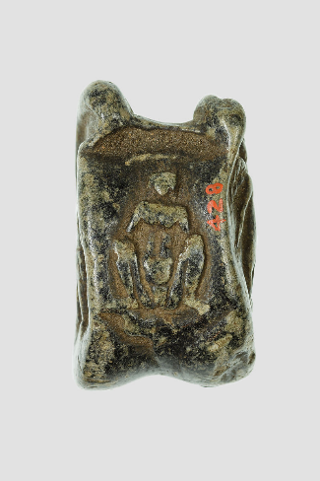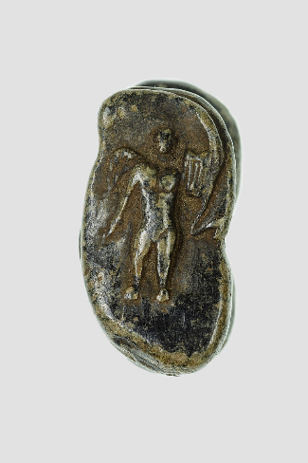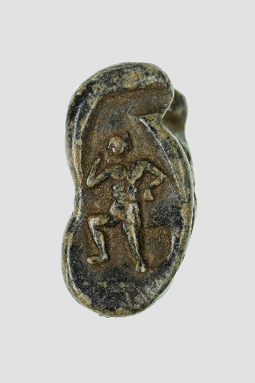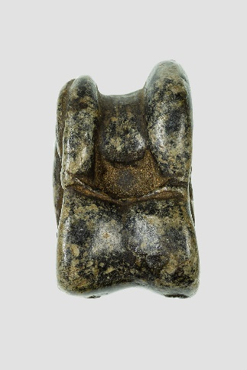
Insert 1a, 1b, 1c, 1d next to each other (see above)
Figures 1a-d: Gabbro knucklebone decorated with the images of Baubo/Isis-Aphrodite (a), Eros (b) and a bearded figure wearing a Phrygian cap (c); the fourth side (d) is not decorated and is shaped like the dorsal side of a real knucklebone. Metropolitan Museum, Gift of Egypt Exploration Fund. Accession Number: O.C.428.

The main aim of this study is to examine its iconography and context and establish its date. However, this article will also offer me the opportunity to examine the contexts of use of knucklebones in Ptolemaic and Roman Egypt.

Mentioned in ancient sources as ἀστράγαλος in Greek and talus in Latin, the astragalus or knucklebone is part of the hind-leg in four footed mammals such as sheep or goat and was used as gaming piece. The object examined in this article is not an actual bone, but a small 3.7cm-long imitation in gabbro stone. While most of these objects do not have any signs nor decorations, this one was decorated on three of its four sides while its rear side reproduced a knucklebone realistically but was left undecorated (Figure 1d). The lack of wear and tear on each side attests that it was either not used or it was not thrown on a hard surface. Indeed, it could have been thrown on a soft surface such as sand.
The museum catalogue dates this object to the Ptolemaic period and lists it as a gift to the Metropolitan Museum from the Egypt Exploration Fund (EEF) in 1906. Unfortunately, no more details about its archaeological context are provided in the EEF excavation notes.
In the Graeco-Roman World, both real knucklebones and their imitations can be found in various contexts: caves sanctuaries, graves, houses and cities which suggest several meanings and contexts of use.
Their use as gaming pieces is attested in Egypt, in the Near East and in the Graeco-Roman World. Classical sources attest two kinds of games: skill games used knucklebones as gaming pieces, so their sides did not have a particular value and they could also be easily replaced by other types of pieces or even nuts. In other games, they were used as dice, so the four sides of the knucklebone called dorsal, medial, plantar and lateral were given a specific numeric value. In Greek and Roman games, the lateral view (Χῖον, one of the narrower sides) was worth one point, the dorsal (ὕπτιον, slightly concave) three points, the plantar (τὸ πρανές, slightly convex) four points and the medial side (τὸ Κῷον) six, because it was the least probable throw; 2 and 5 points were excluded. In sets of knucklebones, the different combinations of numeric values were seen as better or worse according to the game rules. In a gambling game of four knucklebones mentioned by Suetonius, the winning throw was called ‘of Venus’ when the dice turned up different numbers (1, 3, 4, 6), while the losing throw was called ‘of the dog’ (1111) or of 6, despite the fact that these combinations were more unlikely to achieve. Such names for the throws might have also been used in statue divination.
In this article, I will show that the Metropolitan Museum knucklebone is a rare example of a decorated stone knucklebone in Egypt, and it represents a combination of Graeco-Egyptian deities who received official cults and festivals in Egypt, but also appeared in private magical object such as gems. I will start by talking about knucklebones in Graeco-Roman Egypt, in order to investigate some possible contexts for the use of this knucklebone, and then I will discuss its iconography.

1. Knucklebones in Graeco-Roman Egypt
Plato famously credited the Egyptians with the invention of knucklebone games, but this is not entirely accurate. The Egyptians did invent the senet, a board game with thirty squares and a variable number of pieces, but the knucklebones were a Near Eastern import, added as dice to the senet game only in the Second Intermediate Period when they started to be used in pairs as randomising devices as an alternative to the more traditional 4 throw sticks. However, knucklebones were only rarely associated with the senet boards and the boards themselves disappeared in the Late Dynastic Period.
From the Ptolemaic period, there are papyri which confirm that knucklebones continued to be produced and used in Egypt independently from the senet. The use of gazelle knucklebones as gaming pieces is attested in three papyri of the 3rd c. BC archive of the Carian Zenon, the private secretary of the Ptolemaic minister of finances Apollonios. Cleopatra was also said to entertain Antony with a game of dice which could have been knucklebones. On the contrary, the scarcer attestations of knucklebones in Roman Italy, suggests that this gaming piece remained mainly Greek in its use and rules. Indeed Pollux of Naukratis still describes Greek rules for knucklebone games in the late 2nd c. AD. Therefore, it is not surprising that knucklebones survived longer and in a wider range of contexts in a strongly Hellenised province such as Egypt.

1.1 Orphic rituals involving knucklebones?
Knucklebones are also mentioned in the Ptolemaic Papyrus Gurôb 1 (3rd c. BC), whose content may suggest that they were not only used as dice for games, but also for rituals. The text from Papyrus Gurôb 1 was interpreted as an orphic set of instructions for orpheotelestai which included both prayers and practical provisions to celebrate a ritual in honour of the baby Dionysos Zagreus, the son of Zeus and Persephone. According to the myth, the Titans distracted Dionysus with toys and then killed him and dismembered his body. However, Zeus eventually brought Dionysus back to life and incinerated the Titans with his bolt. In the ritual described by the papyrus, the initiate had to participate to an animal sacrifice which represented the murder of Dionysos. The sacrifice was followed by a prayer and a list of sacred objects that had to be put into a basket (kalathos), including knucklebones: ‘A cone, bull-roarer, knucklebones, mirror.’
Clement of Alexandria (150-215 AD) describes a very similar list of sacred objects which includes the knucklebones as part of a ritual for Dionysos Zagreus. This also suggests that the Orphic (or Eleusinian) rituals attested in the 3rd c. BC were still practised in the 3rd c. AD and the knucklebones were still used.
It is evident from this passage that some knucklebones in Egypt had a ritual and perhaps magical use in Orphic (or Eleusinian) rituals.

1.2 Decorated artificial knucklebones from Graeco-Roman Egypt
Most bone and stone knucklebones were not decorated, but there are archaeological attestations of artificial Graeco-Roman Egyptian knucklebones that have decorations. The production of artificial knucklebones allowed skilled craftsmen more freedom of artistic expression than with natural knucklebones: two ivory knucklebones were shaped like baboons and gold and bone ones like ithypallic dwarves with raised arms.
Two steatite knucklebones from the Kelsey and Petrie Museum were very similar in size and materials to the Metropolitan Museum knucklebone examined in this article. The one from the Kelsey Museum is a valuable comparison because it is the only Egyptian decorated knucklebone with a partially known archaeological context: excavation notes report it to have been found in the Fayyum village of Karanis. Both the Kelsey and the Petrie knucklebones have explicit sexual scenes represented on their lateral sides, while an unclear figure is represented on the other side. Their dorsal and plantar sides are left undecorated. The lateral side of Kelsey knucklebone shows a man kneeling towards a reclining woman, kissing her lips and having intercourse with her (Figure 2, above). The lateral side of the Petrie Museum one represents a woman taken from the rear by a man.
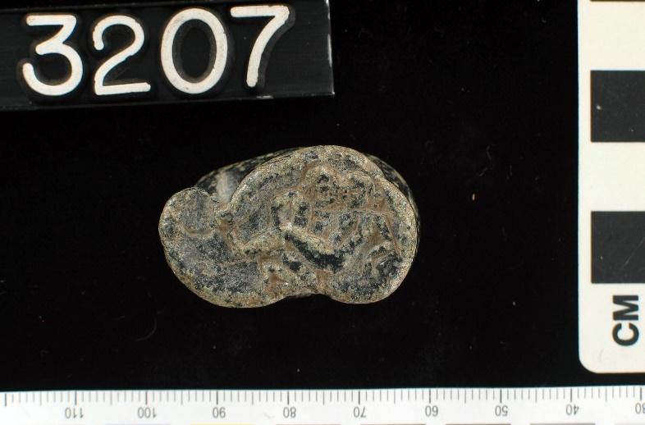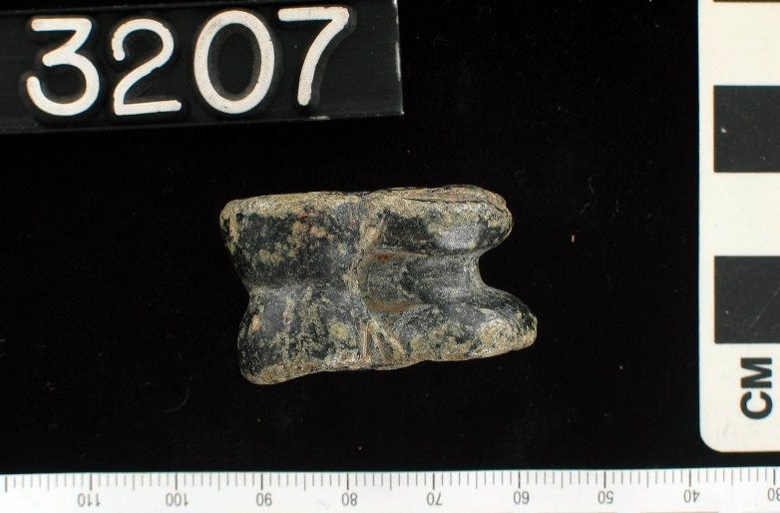
Please insert figures 2a and 2b one above the other as suggested above (colour scale cropped out)
Figure 2: Steatite knucklebone decorated with an erotic scene on the lateral side (above) and with an undecorated dorsal side (below). From Egypt. Roman Period. Kelsey Museum. Accession number: 3207. Photo courtesy of the Kelsey Museum.

The Metropolitan Museum knucklebone has an almost identical double in the Basel Museum which represents the same characters on the decorated sides (Figures 3, 7, 9, right) and has a dorsal side left undecorated. Despite the similarities, I do not think that the Basel and the Metropolitan knucklebones were part of a set like the baboon knucklebones mentioned above, because they were made of two different stones. Also the Basel knucklebone looks more worn than the one from the Metropolitan Museum: it has signs of wear and tear and it is chipped in various parts (although some of the chipping damage could be modern). The decoration also seems slightly more schematic than then one on the Metropolitan knucklebone.

1.3 Romano-Egyptian oracular dice with names of Egyptian deities
The Metropolitan and the Basel knucklebones are almost unique because they represent deities on three sides. This suggests that it was either used to establish a relationship with those deities or to obtain something which was related to the deities’ function. Petitions to the gods through knucklebones are attested in the Graeco-Roman world, and especially in Asia Minor where temple inscriptions preserve prayers pronounced together with the throw of the knucklebones. Statue divination with knucklebones was also practiced and it can be observed in coins.
In Graeco-Roman Egypt there are examples of dice with names of deities which could have had a similar function and magical papyri show that sets of three six-cube dice (hexahedra) were more specifically used in the Homeromanteia. Two Roman dice with names of Egyptian gods were interpreted as oracular dice: a limestone hexahedron die with the hieroglyphic names of six Egyptian gods from the Petrie Museum (UC3816), and a limestone icosahedron die with twenty Demotic divine names, from the Necropolis of Qaret el-Muzzawaqa (Dakhleh Oasis). The icosahedron was found in a necropolis and so it was almost certainly found in a tomb, although the primary use before its deposition was probably divinatory. The same could be said for the Metropolitan and Basel knucklebones: it is possible that they were found in tombs, but the signs of wear and tear on the Basel knucklebone show that it was originally used, so this excludes that fact that these knucklebones were produced exclusively as funerary offerings.
The comparison with the two oracular dice with names of deities may suggest that the Metropolitan Museum and the Basel knucklebones were also used in the contexts of divination. However, in the Graeco-Egyptian context, it is less clear why these dice were shaped like knucklebones rather than the more common cubic or multi-faced dice. It is worth exploring the possibility that the use and context of these knucklebones may be different from the one of the inscribed oracular dice.

To conclude this preliminary overview, the sources from the Ptolemaic and Roman Period place knucklebones in four possible contexts: play, divination, funerary depositions and Orphic rituals. However, only a detailed analysis of the iconography of the three decorated sides of Metropolitan Museum knucklebone will shed more light on its possible context.

2. The iconography of the Metropolitan Museum knucklebone
The interpretation of the context of the Metropolitan knucklebone depends on the identification of its decorations which is made more challenging by the lack of inscribed names. Therefore, I will provide more specific textual and iconographic evidence for the interpretation of each side. A photo of each side of the Basel knucklebone will be provided for comparison.

2.1 Plantar side: ‘Baubo’ figure of Isis-Aphrodite
The plantar side of the Metropolitan knucklebone (Figure 3, left) has a representation of a naked woman with a prominent belly, in a squatting position with spread legs. It is unclear whether the figure is giving birth because she is not sitting on a birthing stool. A similar figure is also represented in the almost identical knucklebone from the museum of Basel (Figure 3, right). Unlike the Basel example, the Metropolitan figure seems to be wearing a headdress, perhaps a feathered one.
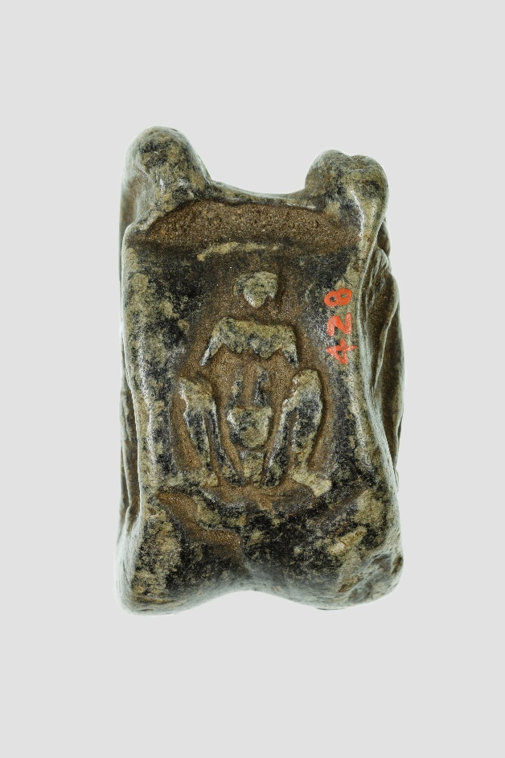
Please include photos 3a and 3b next to each other as suggested above
Figure 3: Left: plantar side of Metropolitan Museum gabbro knucklebone. Length 3.7cm x Width 2.2cm. Right: plantar side of the Basel Museum steatite knucklebone. Antikenmuseum Basel und Sammlung Ludwig. Accession number: inv. BS 1209. Length 3.9cm x Width 2.4cm.

Childbearing women were only schematically represented in Dynastic Egypt and the earliest frontal figures of women with spread legs did not appear until the Late Dynastic Period. The earliest of such figures were very roughly carved on limestone plaques found in great numbers in Naucratis and Memphis and dated between the 6th and the 4th c. BC. One of these plaques was found by the Great Temenos in Naucratis (Figure 4).

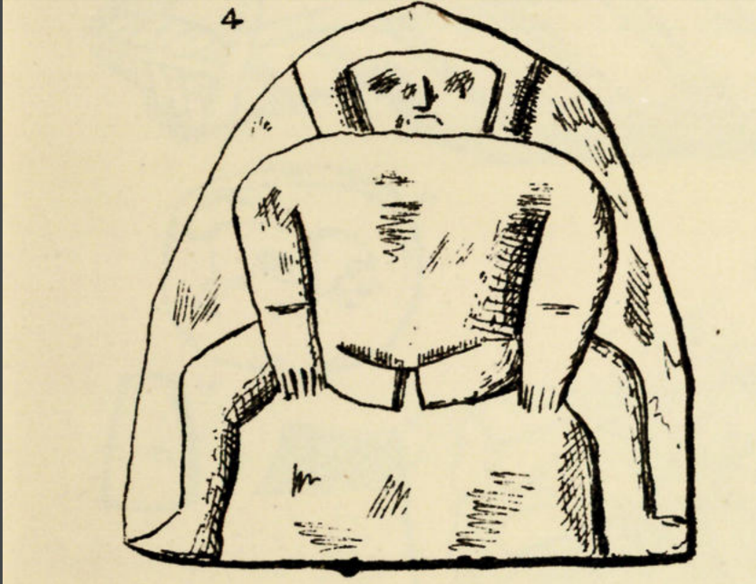
Figure 4: Drawing by W. Flinders Petrie of plaque found by the Great Temenos in Naukratis. W. M. F. Petrie, Naukratis 1884-5, I, (London, 1886), pl. XIV, n. 4.

Images of childbearing women and women with spread legs also started to be represented on Tanagra-style terracottas produced in Egypt from the Ptolemaic period. Some terracottas had the attributes of Isis-Aphrodite and had a gracious body. Others had little or no attributes, a plump body and spread legs to reveal the genitals. These elusive terracottas are still commonly called Baubo, the name of an old lady who showed her genitals to Demeter in order to distract her from the pain of Persephone’s loss. The name Baubo is present in the Orphic fragments of Clement of Alexandria and Arnobius which describe the episode of the rape of Persephone. However, Baubo also received a cult in association with Demeter in various areas of the Greek world as shown by both inscriptions and figurines. The reason for calling the Egyptian terracottas ‘Baubo terracottas’ is the gesture performed by these ladies of showing their genitals like Baubo did with Demeter. However, another reason is also the clear connection of some of these Egyptian terracottas with Demeter: there are various attestations of this Egyptian Baubo figure sitting on a boar (Figure 5), a gesture which recalls the wild boars sacrificed during the Greek festival of the Thesmophoria. Both the Eleusinian rituals and the Thesmophoria were celebrated in the Eleusis district of Alexandria, so these terracottas could have been used in such contexts.

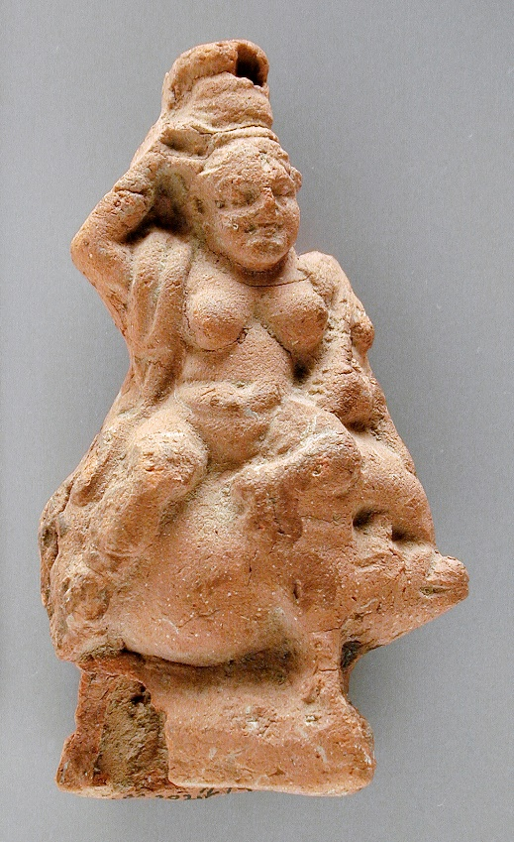
Figure 5: Terracotta representing Baubo sitting on a boar. From Egypt. Graeco-Roman Period. LACMA Museum, Gift of Jerome F. Snyder. Accession number M.80.202.274.

However, it is likely that most Baubo figures in Egypt did not have an exclusive connection with Demeter and therefore they cannot be identified with the Classical Baubo. Indeed, the Late Dynastic plaques from which they derive their iconography were much earlier than the Ptolemaic import of the Demeter cults and festivals to Egypt. And such figures continued to be produced in Naukratis, although in terracotta form rather than plaques. Furthermore, many Baubo terracottas shared attributes with Isis-Aphrodite Anasyrmene (who lifts the skirt) such as the squatting position, the snake anklets and chestbands. It is clear that the term Baubo cannot be used literally but only as a typological term in Graeco-Roman Egypt to define a broad group of representations of women with either a plump or pregnant belly who expose their genitals. Such group includes both generic female figures who could be embodiments of abstract ideas (fertility, childbirth, sex) and actual goddesses.

Dasen interpreted more specifically the childbearing woman on the knucklebone from Basel as Omphale, the Lydian queen who subjugated Heracles, swapped clothes with him and held his club. There is a strong link between Omphale and the knucklebones in the Classical world, because Herodotus credits the Lydians with the invention of the game of knucklebones and the image of Herakles also appears connected to knucklebones. Regarding the queen’s connection with the ‘Baubo’ type, Dasen showed that childbearing women on the Roman Egyptian magical gems could be identified with Omphale thanks to the attribute of the club and the association with Herakles fighting a lion on the other side of the gem. She also noticed that the club-holding Omphale in Romano-Egyptian gems and terracottas was no longer just the Lydian queen, but a more powerful goddess who protected female health, especially the one of pregnant and childbearing women. Moreover, on another gem a Baubo-like female figure washing her genitals could be safely identified as Omphale despite not holding a club thanks to the name Omphale written under her figure. Therefore, it is clear that the identification of such Baubo figures with Omphale could potentially be extended to other amulets and terracottas of women holding clubs (Figure 6) and even some types on gems and terracottas without clubs.

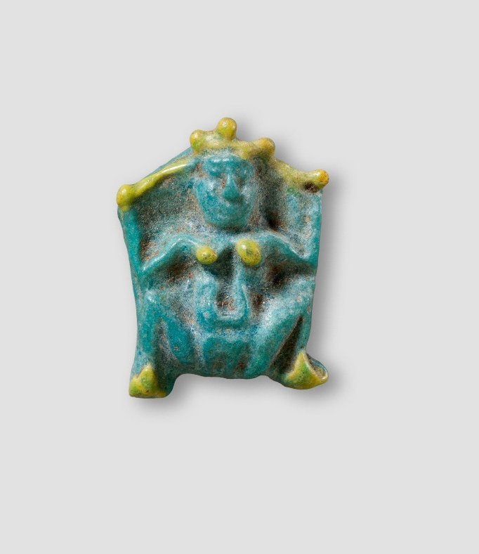
Insert figure 6 here. Crop background a bit to fit image.
Figure 6: Small faience amulet of Baubo-Omphale holding two clubs. The clubs, headdress, breast and feet are marked with a bright yellow colour. Roman Period. Theodore M. Davis Collection, Bequest of Theodore M. Davis, 1915. Metropolitan Museum. Accession Number: 30.8.346.

However, the Baubo figure represented in the Metropolitan Museum knucklebone has no attributes nor inscribed names, although a faint line over the head with three vertical lines underneath which could represent a feathered hairdress, perhaps the feathered crown of Beset, the female counterpart of the dwarf demon Bes, who was sometimes associated with Isis-Aphrodite Anasyrmene. The squatting position is the same one assumed by Roman bronze dice representing generic female figures with spread legs. One bronze example from the British Museum represents a squatting woman in labour with four dots on her front torso: two on her breast and two on her belly. The combination of her squatting legs and arms behind the back recalls the shape of a knucklebone. The use of this die as a knucklebone is also suggested by the fact that the value of four (dots), on the front torso of the woman corresponds with the value of four of the pranes side, the larger frontal side of the bone. Squatting figures shaped like a knucklebone were already known through the baboon and the dwarf gaming pieces from Ptolemaic Egypt mentioned above, so these bronze ‘Baubo’ dice seem to be a further development of this idea across the Roman Empire.
The parallel of the bronze ‘Baubo’ dice with the Baubo figure on the Metropolitan knucklebone suggest that the squatting woman in the knucklebone represented primarily an abstract embodiment of sex, fertility and childbirth, with very likely allusions (rather than a complete identification) to Isis-Aphrodite due to her association with Eros and Harpocrates on the other two sides of the knucklebone. Sexuality was an important element of this knucklebone and this leaves us with possible interpretations about its context to which I will return after the analysis of the other two sides.

2.2 Medial side: Eros
The medial side of the Metropolitan knucklebone (Figure 7, left) represents an adult man, standing frontal and naked with wings over his shoulders and holding a lyre on his right side. He wears no hat nor headdress while the Basel example (Figure 7, right) seems to be wearing a soft hat, perhaps a Phrygian cap.
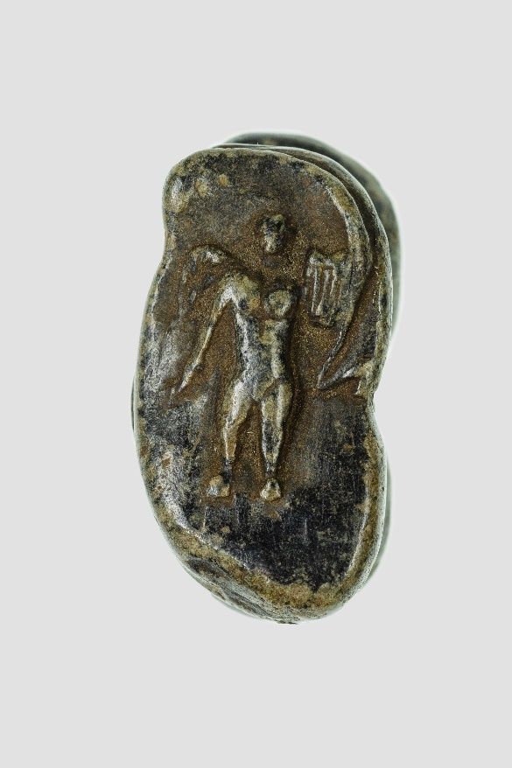
Please include photos 7a and 7b next to each other as suggested above
Figure 7: Left: medial side of the Metropolitan Museum gabbro knucklebone. Right: medial side of the Basel Museum steatite knucklebone.

The figure in the Basel knucklebone was interpreted by Dasen as Eros, and this interpretation also applies well to the Metropolitan Museum knucklebone. Not only the iconography is quite clear, but also the reasons for Eros to be represented on a knucklebone are evident: there was a long-lasting association between Eros and the knucklebones in the Greek-speaking world since the 6th c. BC. The poet Anacreon said in a poem that the astragali of Eros were ‘madness and uproar’. An image of Eros holding a lyre similar to the one represented on the Metropolitan knucklebone features prominently on a 5th c. knucklebone-shaped askos vase produced in Athens (Figure 8).

Insert figure 8, crop background
Figure 8: Terracotta vase in the form of an astragal (knucklebone) representing Eros holding a lyre. Attributed to an artist recalling the Painter of London D 12. From Athens, 460 BC. Credit Line: Harris Brisbane Dick Fund, 1940. Metropolitan Museum. Accession Number: 40.11.22.

In an Attic hydria from the same period, a boy Eros hovers over two girls playing knucklebones, crowning the winner. On a 4th c. BC bronze mirror from Corinth, Aphrodite herself is represented playing knucklebones with Pan, while Eros is staying behind her. From the Hellenistic period, terracotta winged figures of Eros holding bags of knucklebones are also attested.
In a 5th c BC Lucanian bell krater, an ephebos crowns Eros while he plays knucklebones on his own. In the Anthologia Palatina, Eros is depicted a knucklebone player since he was a baby on his mother’s lap. Eros is also described as a young but skilled knucklebone player in Apollonius Rhodius’ Argonautica, a Greek epic poem written in Ptolemaic Egypt. In this episode Eros was not playing alone but against the cup-bearer of the gods Ganymede whom he defeated by cheating, taking all his knucklebones.
This episode from the Argonautica was represented in Graeco-Roman art and appears in later authors. In Nonnus’ Dionysiaca, Eros wins against Hymenaios (marital love) instead of Ganymedes who was acting as the umpire. This change in the role of Ganymedes may seem a later tradition, but it connects more directly than Apollodorus with the 5th century vase representation of the ephebos crowning Eros which could be identified as Ganymedes. So, the position of Eros on the winning side of the Metropolitan knucklebone is easy to explain: in both Classical and Hellenistic Greek art and literature, Eros is always depicted as the winner at knucklebones (or kottabos). The position of Ganymedes is more variable: he is either defeated in the ‘Argonautica tradition’ or he is the umpire of the game and the ephebos who crowns Eros.

2.3 Lateral side: Ganymedes or Kronos (in association with Harpocrates)
The figure on the lateral side of the Metropolitan knucklebone (Figure 9, left), is a bearded man who wears a sort of short and transparent tunic to the hips and is standing on a three-quarter position. He is wearing a Phrygian cap and brings his right hand to his face to cover his mouth with the index finger.

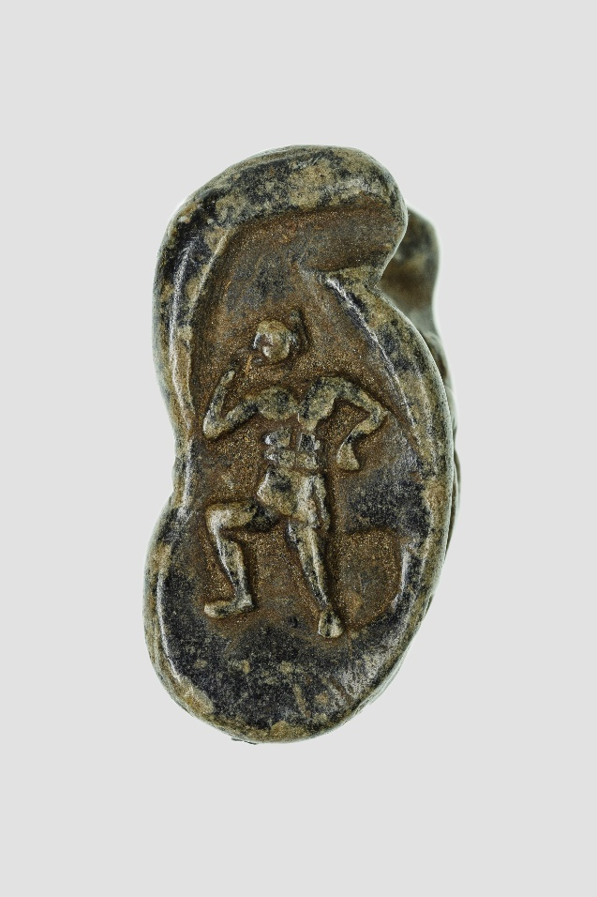
Please include photos 9a and 9b next to each other as suggested above
Figure 9: Left: lateral side of the Metropolitan museum gabbro knucklebone. Right: lateral side of the Basel museum steatite knucklebone.

Considering that the other two sides of the knucklebone represent divine characters, it is more likely that this third figure was either a god or a mythological hero rather than a worshipper. The cap and the beard may suggest some sort of thematic connection with a knucklebone-shaped bronze ithyphallic dwarf at the British Museum. However, the figure on the Metropolitan knucklebone is not a squatting dwarf with raised hands, he does not have an evident phallus, and he performs the finger to mouth gesture of a solar child-god, which in the Graeco-Roman Period can be often, although not exclusively, identified with Harpocrates. Also, the body position is associated with the child-god: a comparison with Roman magical gems shows that the hand on the hip, the bent knee and three-quarter position are typical of the type of ‘Harpocrates’ sitting on a lotus flower. However, there are evident variations to this type on this knucklebone: the lotus is not represented and the figure is an adult or adolescent figure who is assuming a childish pose. So, while this figure is definitely a manifestation of ‘Harpocrates’, his very unusual adult representation suggests a combination with another adult deity. Interestingly, the figure on the Basel knucklebone (Figure 9, right) is different from this one because, beside the-finger-to-mouth gesture and three-quarter position, it is also a child figure, without beard and with a childish body.
I will give two possible interpretations of the bearded male figure on the Metropolitan knucklebone which will also allow me to discuss three possible contexts of use for this knucklebone.

One hypothesis that can be safely ruled out is that the knucklebone was connected to Orphic rituals, a use that was suggested by the 3rd c. BC Gurob Papyrus discussed above. If we assume that the Metropolitan knucklebone was a used in one of these rituals, the man with the Phrygian cap could represent the young Dionysos before he was killed and dismembered by the Titans. Indeed, being Dionysos Zagreus a child god himself, his association with Harpocrates would be perfectly plausible. However, in the Metropolitan knucklebone, the figure is not a child-like Zagreus, but a bearded young man. Secondly, it is unclear why the child Dionysos Zagreus should be associated with Eros. Also, according to sources mentioned above, the knucklebone-symbola were not meant to be thrown as dice, but to be hidden in a kalathos basket and possibly after the initiation, stored safely in the houses of the mystai. The three decorated faces on the Metropolitan knucklebone show that it was meant to be thrown and the wear and tear on the Basel one confirms that too.

My first interpretation for this figure is that it represented the immortal cup-bearer Ganymedes. In Roman art, Ganymedes wears a Phrygian hat, like the figure on the knucklebone. The muscular body of the character on the knucklebone presents him as a potentially desirable young man, as in fact Ganymedes is described to be in numerous sources. The presence of Eros on the opposite medial side of the knucklebone creates a direct opposition with the Ganymedes figure. In the Argonautica episode, Ganymedes was an opponent to Eros because he had lost at a game of knucklebones against him and after his loss he was pitied by Aphrodite and described by her as a naïve child as opposed to Eros. However, the two boys are also said to have much in common and the author does not even need to explain to his readers why this is the case: they are both a source of love and intense sexual desire. Indeed, Plato uses the example of Zeus’ love for Ganymedes to define the nature of the god’s sexual desire (himeros) and Lucian jokes about how Zeus is so struck with love for him that he lays his godly duties aside to play knucklebones with him. Therefore both Eros and Ganymedes might have been represented on the knucklebone not so much as opponents to each other, but to grant the love and desire they were believed to inspire.
The identification of the knucklebone figure with both Ganymedes and an Egyptian solar child-deity is plausible due to the cup-bearer’s young age and his association with Isis-Aphrodite through Eros. The positive connection with the child-deity also suggests that none of the sides of this knucklebone was a losing one: each one gave some sort of reward, an assigned task or a magical outcome in the context of the throwing game. This ‘win-win’ throw would have been similar to the one proposed by Tait and Minas-Nerpel for the Roman dice with the names of Egyptian gods.

Furthermore, there is a second possible identification of the bearded figure on the lateral side which would justify the presence of a more adult version of Harpocrates. On a 2nd c. AD Roman magical gem, Harpocrates is represented with an adult body but with a childish pose and is identified by Mastrocinque with the Greek Titan Kronos (Figure 10).

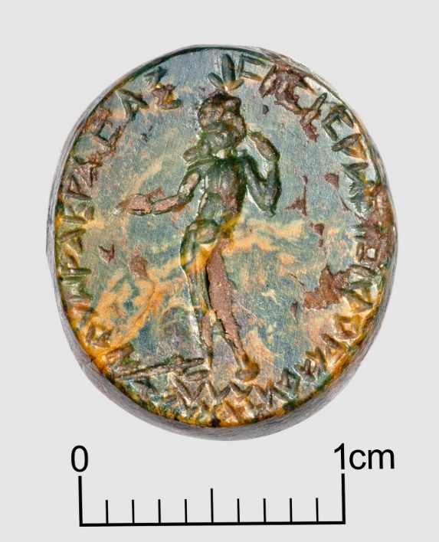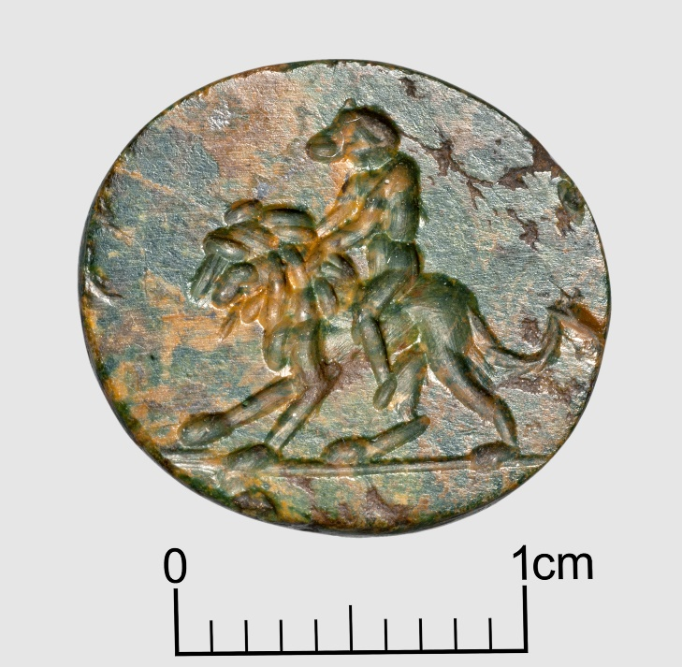
Please insert images 10a and 10b as suggested above
Figure 10: Magical gem: Harpocrates-Kronos, σισισρω-logos (left) baboon-headed figure riding a lion (right). Bibliothèque nationale de France, Cabinet des Médailles. Inventory 58.2195. Serge Oboukhoff © BnF-CNRS-MSH Mondes.

Kronos was not an unusual subject to associate with knucklebones: in the astragalomanteia from Asia Minor, the Titan dictated the outcome of throws in an ambiguous way; sometimes a negative one for eating his own children and sometimes a positive one due to his identification with time. In Egypt, the cult of Kronos was established from the beginning of the foundation of Alexandria. He was particularly worshipped in Tebtunis where he was associated with the crocodile god Suchos and the father of Osiris and earth god Geb, but he was also introduced into Egypt at the same time as Sarapis and in close connection to him and the whole Osirian family. Kronos joined the Osirian cycle as an Egyptian re-interpretation as both a solar god and also a personification of endless and cyclical time. A birthday festival in his honour called Kronia was celebrated in Egypt on winter solstice which was also an essential time for the calendar of the Osirian mysteries and in particular Harpocrates’ birth. Indeed, on winter solstice Isis had given birth to Harpocrates, according to Plutarch, although earlier Graeco-Roman Egyptian sources associated the winter solstice with his gestation. Mastrocinque provided detailed comparisons with other gems and magical spells to justify the identification of Kronos with Harpocrates on the Roman magical gem CBd−3574, and argued that the gods were combined as two aspects of the same solar deity, an adult one (Kronos-Osiris) and a child one (Harpocrates).
The combination of child-god and older god can also be seen in the Fayyumite crocodile versions of Kronos: Kronos-Soknebtynis and Kronos Soknopaious were both worshipped in combination with a younger child-version of themselves.
Therefore, this evidence supports the interpretation of the figure on the knucklebone as a combination between the two solar deities Harpocrates and Kronos. If we accept such identification, there is a further possible connection with the Egyptian Cronia/Kronia. Its winter solstice celebration corresponded more or less with the time of the year when the Roman festival of the Saturnalia was celebrated, and indeed at least from a later period, Egyptian Kronia and Roman Saturnalia were probably perceived as the same festival, despite the fact that the Saturnalia in Rome ended on 23 December rather than on 25. If the Egyptian Kronia were introduced by the Ptolemies alongside the cult of Kronos, they might have been initially modelled on the Attic Greek Kronia rather than the Roman Saturnalia, although the Romans believed that their own Saturnalia originated from this Greek festival which equally involved a temporary social reversal for slaves. It is possible that the Egyptian Kronia evolved to be more similar to the Roman Saturnalia, but unlike in other parts of the Graeco-Roman World, the association of Kronos with the Osirian family remained an element of the Egyptian festival: during the main day of the Kronia, a festival to Isis (Kikellia) was also celebrated in Alexandria. Beside the possible identification of Harpocrates with Kronos, there are two other elements which could connect the knucklebone figure with the Kronos and the Kronia/Saturnalia. Knucklebones were at the very centre of this festival’s meaning: they represented a game played during the mythical golden age of Kronos when slavery did not exist, everyone was socially equal and enjoyed peaceful leisure and prosperity. For this reason, during the temporary return to this ‘golden age’, games with knucklebones and dice were allowed for socially sanctioned practices such as gambling. Furthermore, Saturnalia’s knucklebones were a symbol of equality, as both Martial and Athaenaeus stress the fact that during this time of reversal, slaves were finally able to play knucklebones with citizens like equals, all wearing a Phrygian (or liberty) cap which was normally worn only by freedmen. As noticed above, the cap worn by the Harpokrates-Kronos figure on the Metropolitan knucklebone is a Phrygian cap.
The reasons for a possible connection of Harpocrates-Kronos with Isis-Aphrodite are evident being both Harpocrates and Kronos part of the Osirian cycle. However, it is less clear why Kronos and Eros would appear on the opposite sides of the same knucklebone. This can be further explained through the evidence of Greek magical papyri and other Roman magical gems. When Kronos is either mentioned in spells or represented on Graeco-Roman magical gems, he is presented as an emasculated deity, and therefore is associated with chastity or asexuality, which were the exact opposites of what Eros could offer. However in magical papyri, Kronos’ is also defined as hermaphrodite, a very positive characteristic in the context of magic. The magical interaction between Eros and Kronos, suggests that the Metropolitan Museum knucklebone was used as a love die. It needs to be stressed that individually, on gems and magical papyri, Eros and Kronos were not exclusively linked with love and sexuality but when together, the two gods seemed to interact in this context. Also, the fact that Eros was represented on the knucklebone holding a lyre rather the usual objects he holds in magical gems (torch, bow or whip), suggests a more conventional interpretation of Eros as the god of love (who wins at knucklebones). On the other side, Kronos’ association with love is also stressed by his identification with Harpocrates. Harpocrates-on-a-lotus-flower had a positive meaning in love magic as suggested by a Roman love gem and a love spell on a magical papyrus. Isis-Aphrodite and Eros were represented together in magical gems and the pair was represented with Harpocrates-on-the-lotus flower in a magical black hematite pendant.

As I have shown, the Metropolitan knucklebone shares themes and ideas with the magical gems and papyri, but the representation of Eros with the lyre is associated with earlier Greek traditions. This suggests, in my opinion, an earlier date for the knucklebone than the one of most magical gems, normally dated to the 2nd-3rd c AD. The Metropolitan knucklebone could date to the late Ptolemaic or more likely, to the early Roman Period (1st c. AD), although there are not enough archaeologically provenanced comparisons, at the moment, to confirm this date. The shape of this object as a knucklebone also suggests a different use from the magical gems: its throw aimed proactively for a more immediate outcome, either an oracular answer or a victory against an opponent. Therefore, the interaction of the deities on the Metropolitan knucklebone was primarily associated with the player’s quest for love and sexual gratification, either through magic, or perhaps in more secular terms, through gambling.

Conclusions
The study of this rare decorated knucklebone from the Metropolitan Museum allowed me to explore the use of knucklebones in Graeco-Roman Egypt. In the Ptolemaic Period, knucklebones were no longer associated with the Egyptian game of senet and were played with Greek rules which lasted well into the Roman period in Egypt.
The Metropolitan knucklebone probably came in a set, like other decorated knucklebones, and as the existence of the almost identical Basel example suggests. The comparison with the Basel example with signs of wear and tear, allows to establish that these knucklebones were actually used. It is possible that they were included in a tomb, but they were not produced exclusively as tomb offerings.
The combination of a Baubo figure, Eros and Ganymedes or Kronos (in association with Harpocrates) on this knucklebone had a clear magical meaning in connection with the search for love, sex and perhaps fertility. This interpretation also connects this knucklebone with the two erotic knucklebones from the Kelsey and Petrie Museum mentioned above, although their interpretation will need more study.
The comparisons with the Roman magical gems and magical papyri spells suggest that the Metropolitan knucklebone could have been used as a love die for a private personal use or a as a die for gambling against an opponent. The presence of a Phrygian capped Kronos figure may allude to the knucklebone games of the Kronia/Saturnalia where this gaming piece might have been used. The Egyptian Kronia/Saturnalia definitely looked very different from both the Greek Kronia and the Roman Saturnalia, by a religious and cultic point of view because of their links with the Osirian cycle, but almost certainly, in more practical terms, they equally allowed a time of social relaxation which prominently involved knucklebone gaming and gambling.

Metropolitan Museum, O.C.428. Length 3.7cm; Width 2.2cm; Thickness 2cm.
U. Schädler, ‘Spielen mit Astragalen’, AA 1 (1996), 61-73; J. Dandoy, ‘Astragali, the Ubiquitous Gaming Pieces’, Expedition 38 (1996), 51.
As Minas-Nerpel suggested for her analysis of a Roman icosahedron die. M. Minas-Nerpel, ‘A Demotic Inscribed Icosahedron from Dakhleh Oasis’, JEA 93 (2007), 109.
Knuckle bone (astragal) with image of Omphale <https://www.metmuseum.org/art/collection/search/551035> accessed 31.10.2021
Thousands of knucklebones were found in the Corycian cave: P. Amandry, ‘Os et coquilles, L’Antre Corycien’, Bulletin de correspondance hellénique, (Supplément IX, 1984), 347−378.
For knucklebones found in Greek sanctuaries: D. Reese, ‘Worked Astragali’, in J. W. and M. C. Shaw, Kommos IV: The Greek Sanctuary (Princeton, 2000), 398−401.
The Classical tombs of Locri show an anomalous amount of knucklebones surrounding the skeletons. B. Carè and B. Elia, ‘Ancora sulla astragalomania a Locri Epizefiri. La documentazione dalla necropoli in contrada Lucifero’. In: Orizzonti. Rassegna di Archaeologia (2004), 77-91.
S. J. Morewitz, J. Neils, J. H. Oakley, K. Hart, L. A. Beaumont, Coming of Age in Ancient Greece: Images of Childhood from the Classical Past (New Haven, 2003), 146, 173, 246−47, 277−79.
For Egypt and the Near East: W. Crist, A.-E. Dunn-Vaturi, A. de Voogt, Ancient Egyptians at Play: Board Games Across Borders, London, 2016. For the Graeco-Roman World: A. Mau, ‘Ἀστράγαλος’, RE 2.2 (1896), 1793– 95. U. Schädler, AA 1, 61-73; B. Carè, Astragalomania. New Perspectives in the Study of Knucklebones in the Ancient World, Berlin. Forthcoming 2023.
B. Carè, ‘Il gioco degli astragali: un passatempo tra antico e moderno’, Ludica 15-16 (2009-2010), 32.
Dandoy, Expedition 38, 51.
Ibid., 32.
Mau, RE 2.2, 1794. Propertius, Elegies 4.9.17; Ovid, Ars Amatoria 2.205, Fasti 2.473.
J. Marquardt, Das Privatleben der Römer, II, (Darmstadt, 1886), 850.
Svetonius, Life of Augustus, 71.4
See also Martial, Epigrams 14, 14.
See also Pollux, Onomasticon, 9, 113-114.
Pseudo-Lucian, Amores 16.
Plato (Phaedrus 274d) attributes the invention to the Egyptian god Thoth.
The earliest knucklebones associated with the senet boards were found inside a coffin in Asasif, Thebes ( 1635–1458 BC): Game Box for Playing Senet and Twenty Squares <https://www.metmuseum.org/art/collection/search/553268> accessed 18.05.2021.
Piccione brings the example of the tomb of Tutankhamon where senet boards were found with both the sticks and the knucklebones. The knucklebones were introduced in connection with the Near Eastern game of twenty squares. P. Piccione, ‘The Egyptian Game of Senet and the Migration of the Soul’, in I. Finkel (ed.), Board Games in Perspective: Proceedings of the Colloquium on Board Games of the Ancient World, (London, 2007), 54−63.
Crist et al., Ancient Egyptians at Play, 62−66.
P. Cair. Zen. 1 59069 (257 BC, Kharabet el Gerza, ancient Philadelphia); PSI IV 331 (257−56 BC, Philadelphia, Arsinoites); PSI IV 444 (also known as P. Cair. Zenon I 59019). Zenon was at first a business representative and private secretary of the dioiketes (minister of finances) Apollonios. Later he became the manager of an estate of Apollonios in Philadelpheia. R. Haensch, ‘Spiele und Spielen in Römischen Ägypten: die Zeugnisse der Vershiedene Quellenarten’, Revue Archimede 6 (2019), 175−185.
Plutarch, Antony 29.1.
L. A.V. Becq de Fouquières, Les jeux des Anciens: leur description, leur origine, leurs rapports avec la religion, l’histoire, les arts et les moeurs (Paris, 1873), 352. Carè, Ludica 15-16, 32.
M. Vespa, ‘Knucklebone Faces and Throws: Play, Rules, and Rhetorical Discourse in Julius Pollux’. Mnemosyne 1 (2021), 1-18.
P. Gurôb 1; Pack 2 2464. J. Hordern, "Notes on the Orphic Papyrus from Gurôb (P. Gurôb 1; Pack² 2464)." ZPE 129 (2000), 131−140 (with further bibliography). A. Bernabé, ‘La toile de Pénélope: a-t-il existé un mythe orphique sur Dionysos et les Titans?’, Revue de l’histoire des religions 219 (2002), 341. The authors express different position on whether this is an Orphic and Eleusinian text or just an Orphic text with parallels with Eleusinian texts.
Mystery Cults in the Greek and Roman World <https://www.metmuseum.org/toah/hd/myst/hd_myst.htm> accessed 12.05.2021.
Diodorus Siculus (Library of History 4.4.1, 5, 4.5.2, 4.6.1; 5.75.4) explains that there were two versions of Dionysos: one son of Zeus and Semele and one older Dionysos son of Zeus and Persephone. There are later sources as well, the most complete is Nonnus, Dionysiaca 4.268, 5.562, 6.155, 10.290.
Levaniouk argued that the killing and the consumption of the meat gave the initiate the Titans’ pollution and required a purification. O. Levaniouk, ‘The Toys of Dionysos’, HSCP 103 (2007), 164.
Levaniouk, HSCP 103, 166−167.
Hordern, ZPE 129, 139 nn. 29−30.
Proptrepticus 2.17.2; see also Anthologia Palatina 6.309.
In Exortation to the Greeks 2.21, Clement of Alexandria reports that in Eleusinian mysteries sacred objects are also put into a kalathos. Among these sacred objects there are according to Clement a representation of female genitalia.
A connection with Demeter and Persephone can also be found outside Egypt: for instance, a high number of knucklebones were found in the sanctuary of Demeter and Persephone in Acrocorinth. D. S. Reese, ‘Faunal Remains from Greek Sanctuaries: a Survey’, in R. Hägg and B. Alroth (eds), Greek Sacrificial Ritual: Olympian and chthonian. Proceedings of the Sixth International Seminar on ancient Greek cult, 25–27 April 1997 (Stockholm, 2005), 121–123.
Game piece in the shape of a baboon <https://www.metmuseum.org/art/collection/search/545212> accessed 18.05.2021. Both pieces in D. Arnold, An Egyptian Bestiary, (New York, 1995), 60. Perhaps the two baboons were part of the same set.
Golden dwarf with raised hands: Geneve Fondation Gandur inv. FGA-ARCH-GR-0080; bone dwarf from Lyon Lugdunum museum inv. A 1642. Both in: V. Dasen, Ludique. Jouer dans l’antiquité (Gent, 2019), 109. Bronze dwarf (unpublished): British Museum inv. 1772,0311.206.
An article on these two knucklebones is in preparation.
Kelsey Museum inv. 3207. Length 3.4 cm; Width 2cm; Thickness 1.8 cm. Weight 25g.
Petrie Museum inv. UC44997.
Add note from the acknowledgements.
Steatite decorated knucklebone, Antikenmuseum Basel und Sammlung Ludwig inv. BS 1209 in Dasen, Ludique, 108 (fig. 1). Length 3.9cm; Width 2.4cm.
Most of the sources about the astragalomanteia come from Asia Minor. Th. Hopfner, ‘Astragalomanteia’, RE 2.2 (1896), 1793. J. Nollé, Kleinasiatische Losorakel: Astragal- und Alphabetchresmologien der hochkaiserzeitlichen Orakelrenaissance, München, 2007.
In one coin from Samos, two children interrogate the statue of Hera and then cast the knucklebones. M. Dillon, Omens and Oracles: Divination in Ancient Greece (London, 2020), 272 (fig. 7.2). A 3rd c AD coin from Ephesos of the Emperor Valerian II represents two nude children playing with astragali with a cult statue of Artemis Ephesia behind them. Karwiese 1218. RPC VI online 5066 corr. (misdescribed as 'Maximus'). SNG Copenhagen 539.
Joachim Quack has suggested that divination was the purpose of dice with Egyptian deities on them. J. F. Quack, review of M. A. Stadler, Isis, das göttliche Kind und die Weltordnung (MPER 28; Vienna, 2004), AfP 51/1 (2005), 175.
Oracular texts based on the selection of Homeric excerpts through the through of six-faced dice, are also attested in the Late Roman Period PGM VII, 4th c. AD.
Isis, Osiris, Horus, Har-Behdety and Hathor. J. Tait, ‘Dicing with the Gods’, in: W. Clarysse, A. Schoors (eds) Egyptian Religion: The Last Thousand Years: Studies Dedicated to the Memory of Jan Quaegebeur (Leuven, 1998), 257−64. Add note from the acknowledgements.
Minas-Nerpel, JEA 93, 137–48.
Ibid., 148.
A. Nifosi, Becoming a Woman and Mother in Graeco-Roman Egypt (Oxford, 2019), 91−93.
Votive plaque <https://www.britishmuseum.org/collection/object/G_1965-0930-954> accessed 18.05.2021.
W. M. F. Petrie, Naukratis 1884-5, I, (London, 1886), pl. XIV, n. 4.
On the iconography of all types of Baubo terracottas: Nifosi, Becoming a Woman, 98−102.
The earliest version of this story is in the Homeric Hymn to Demeter: however, in this version the woman is called Iambe and is not explicitly talking about exposing herself. The most complete versions are the fragments from Clement of Alexandria (Exhortation to the Greeks, 2) and Arnobius (Adversus nationes 5.25–26) who attribute such verses to Orpheus.
Terracotta votive from the Sanctuary of Demeter and Kore in Priene (4th-2nd century BC): Berlin, Antikensammlung, inv. TC 8612.
D. M. Bailey, Ptolemaic and Roman Terracottas from Egypt (London, 2008), 46.
J. McKenzie. The Architecture of Alexandria and Egypt, C. 300 BC to AD 700 (New Haven, 2010), 34, 64; L. Torok, Hellenistic and Roman Terracottas from Egypt (Rome, 1995); Bailey, Ptolemaic and Roman Terracottas, 46.
Bailey, Ptolemaic and Roman Terracottas, figs 3131−32.
V. Dasen, Le sourire d'Omphale: Maternité et petite enfance dans l'antiquité, (Rennes, 2015), 2795−98.
See Nifosi, Becoming a Woman, 92−102; 234, for links of these generic female figures to the Dynastic Egyptian figurines.
Dasen, Ludique, 108. See also Dasen, Le Sourire D’Omphale, 2541 and V. Dasen, ‘Omphale and Heracles: a Knotted Life’, Gemmae. An International Journal on Glyptic Studies 3 (2021), 61-82.
Herodotus, Histories 1.94.
1st c. BC pot shaped like the head of Herakles containing 5 knucklebones from Asia Minor (Dasen, Ludique 104−105) and knucklebone-shaped askos with nodus Herculaneum on its handle (Dasen, Ludique, 96).
Dasen, Le Sourire D’Omphale. 2572.
Campbell and Bonner Database gem n. 1703 (hereafter, CBd−). For comparisons and interpretation of the Baubo figure washing her genitals see Nifosi, Becoming a Woman, 105.
British Museum inv. 1995,0123.1 and EA37581.
Bronze anthropomorphic die 1st-2nd c. AD, Fribourg museum BIBLE+ORIENT, inv. GFig 2000.2., in Dasen, Ludique, 109.
Bronze die in form of squatting figurine with 4 dots on the belly and breast. British Museum inv. 1975,1103.1.
Dasen, Ludique, 108.
Anacreon, Fragments 34; Lucian, Dialogues of the Gods 4.3; Apollonius Rhodius, Argonautica 3.114; Anthologia Palatina 12.46−47; Clement of Alexandria, Protrepticus 2.17.
Anacreon, Fragments 398.
Metropolitan Museum inv. 40.11.22.
British Museum inv. 1888,1213.1.
British Museum inv. 1868,0705.29.
British Museum inv. 1856,1226.8.
Anthologia Palatina 12.47.
Apollonius Rhodius, Argonautica 3.112.
Philostratus the Younger (Imagines, 8) writes in the 3rd c. AD and describes a painting which represents this episode from the Argonautica.
Nonnus, Dionysiaca 33.74. The game is kottabos rather than knucklebones.
As suggested by the British Museum catalogue (see above, n. 74).
This also finds a good comparison with the Egyptian dice with names of gods on each side discussed in 1.3.
The bearded dwarf had raised hands and the skull-cap tied on his forehead. Presented by W. M. F. Petrie to the British Museum in 1891 and published in W. Beauchamp, Catalogue of the Bronzes, Greek, Roman, and Etruscan in the Department of Greek and Roman Antiquities, British Museum, (London, 1899), n. 1669.
The natural shading of the stone in the upper part of right leg may suggest the presence of a phallus, but, from a closer observation, it looks like a part of the thigh.
For the typical gestures that allow to identify child deities see: D. Budde, ‘Child Deities’, in J. Dieleman, W Wendrich (eds), UCLA Encyclopedia of Egyptology (Los Angeles, 2010), 2−3.
This is the most frequent way of representing Harpocrates on magical gems: A. M. El-Khachab. "Some Gem-Amulets Depicting Harpocrates Seated on a Lotus Flower: To the Memory of My Great Friend Dr. Alexandre Piankoff." JEA 57 (1971), 132-45. See for example CBd−533 = inv. EA 56139 (British Museum), 3rd c. AD. The identification of this solar child with Harpocrates cannot be always demonstrated. Budde, in J. Dieleman, W Wendrich (eds), UCLA Encyclopedia of Egyptology, 5. I will call this figure Harpocrates, although I leave the possibility open for the identification of this figure with other child deities as well.
Eros was associated with Dionysos in Greek love poetry and Platonic philosophy but not in the Orphic context. Anacreon, Fragments 12, 346, 357. Plato, Phaedrus 265b.
See 1.1 and for the storage of the toys-symbola in the house: Levaniouk, HSCP 103, 170.
Several examples can be found here: Warburg Institute Iconographic Database <https://iconographic.warburg.sas.ac.uk/vpc/VPC_search/subcats.php?cat_1=5&cat_2=245> accessed 18.05.2021.
Homer, Iliad 20.232; Pseudo-Hyginus, Fabulae 271; Diodorus Siculus, Library of History 4.75; Pseudo-Hyginus, Astronomica 2. 29.
Plato, Phaedrus 255. Lucian, Dialogues of The Gods 8.
See 1.3.
Green-yellow jasper, CBd−3574. FR. Paris, Cabinet des Médailles. Inv. 58.2195. A. Mastrocinque, Kronos, Shiva, and Asklepios: Studies in Magical Gems and Religions of the Roman Empire (Philadelphia, 2012), 21 (fig. 1.8A). More references in CBd-3574.
See both in Nollé, Kleinasiatische Losorakel, p. 174, spell n.50 to Kronos τεκνοφάγος and p. 158, for dice spell n. 63 inscribed on the cell wall of a temple in Antiochia ad Cragum which addressed Kronos identified with Chronos/time as ἀγᾰθός.
J. N. Bremmer, Greek Religion and Culture, the Bible, and the Ancient Near East (Leiden, 2008), 82−83.
Mastrocinque, Kronos, 15.
V. Rondot, Derniers visages des dieux dʼÉgypte. Iconographies, panthéons et cultes dans le Fayoum hellénisé des IIe–IIIe siècles de notre ère, (Paris, 2013), 75–80, 122–127, 241–246.
According to Macrobius, the cult of Saturn was closely associated with the one of Sarapis and was introduced into Egypt at the time of the Ptolemies. The Egyptians were reluctant to adopt both cults because they included blood sacrifices. Macrobius, Saturnalia 1.7.15−16.
R. Pettazzoni, ‘Aion-(Kronos) Chronos in Egypt’, in: R. Petazzoni (ed), Essays on the History of Religions (Leiden, 1967), 172−78.
A 3rd c. AD papyrus from Oxyrhynchus (P. Oxy. 7.1025, 275 – 299 AD) describes it as ‘the birthday feast of Kronos the chief god’ and said it was celebrated in Euergetis. Epiphanios (Panarion 22, 3-11) says that it fell on the winter solstice. See full discussion in Petazzoni, in Petazzoni (ed), Essays on the History of Religions, 172−78.
Plutarch De Iside et Osiride 65. See also Macrobius, Saturnalia 1.18.10.
G. Priskin, ‘The Dendera Zodiacs as Narratives of the Myth of Osiris, Isis, and the Child Horus’, ÉNeM 8 (2015), 145.
Mastrocinque, Kronos, 19. Mastrocinque explains the solar nature of Kronos and his combination with Harpocrates on the CBd−3574 magical gem. He makes three points: 1) the magical name (σι)σισρω on the gem (Figure 10, above) is typical of Kronos gems and meant ‘son of the Ram’, a name which was connected both with the solar god at sunset but also with two Decans of Capricorn in the house of Saturn 2) the iconography of the monkey on the back of the lion on the other side of the CBd−3574 gem (Figure 10, right) was also associated with other Kronos gems and the cynocephalic monkey represented Capricorn in the house of Saturn while the lion represented the sun god 3) there is a parallel between the Harpokrates-Kronos in CBd−3574 and PGM IV 985 in which Harpocrates and Kronos were offered the same prayer through their magical names and animal avatars.
G. Tallet, ‘Isis, the Crocodiles and the Mysteries of the Nile Floods’, in C. Giuffrè Scibona, A. Mastrocinque (eds), Demeter, Aphrodite, Isis, and Cybele. Studies in Greek and Roman Religion in Honour of Giulia Sfameni Gasparro, (Stuttgart, 2011), 149−50.
Macrobius, Saturnalia 1.7.15−16 (and see above n. 97). Epiphanius (Panarion 51.22.5) identifies the Saturnalia with the festival of the winter solstice: "This day [of the solstice] called Saturnalia among the Romans, Kronia among the Egyptians, and Kikellia among the Alexandrians, was celebrated by the Greeks on the 8th day before the calends of January" (December 25).
The Attic festival called Cronia was celebrated in the month of August. Bremmer, Greek religion, 82−3. The Greek Cronia according to the 2nd c. BC playwright Accius (Annals, 2−7), existed before than the Roman Saturnalia, being an earlier Greek festival, celebrated in the month of August which saw a temporary social reversal in the role of slaves. Athaenaeus of Naukratis (3rd c. AD) calls the Roman Saturnalia ‘Cronia’ and explains that the masters’ provision of a meal and a day off duty to the slaves was originally a Greek custom. Athenaeus, The Learned Banqueters 14.639b. See the Cronia mentioned as Saturnalia in 14.639e. A celebration of Saturnalia in an early context is also attested in Plutarch, Pyrrhus 20.
Epiphanios, Panarion 22, 3−11. Petazzoni, in Petazzoni (ed), Essays on the History of Religions, 178 n. 34.
Athenaeus, Banqueters, 6.267e, 268d.
Martial, Epigrams 4.14.7−10. Gambling with knucklebones and dice was considered inappropriate in normal times and in some periods, it could have been even forbidden by law: Cicero, Against Catiline II.10, Letters to Atticus XIV.5. Plautus (Miles Gloriosus 2.2) mentions a lex alearia (also read as talaria) which formally forbade dice gaming in Rome, but the reading of the name and meaning of this law is uncertain. The De Aleatoribus passage in Justinian’s Digest 11,5, suggests that punishment for gambling could be harsh only if it caused violent altercations. This also explains why Cicero, who condemns gambling, also admits to play with knucklebones (Cicero, De Senectute 16).
Athenaeus, Banqueters 14.639c.
I will not consider here the late Orphic fragment 360 where Eros is mentioned as the son of Kronos because there are many other parallel traditions in Orphic literature about the ancestry of Eros. A. N. Athanassakis, B. M. Wolkow, The Orphic Hymns (Baltimore, 2013), 137-139.
The connection in themes and contents between magical gems and magical papyri is widely accepted and recently discussed by P. Vitellozzi, ‘Relations Between Magical Texts and Magical Gems Recent Perspectives’, in S. Kiyanrad, C. Theis, and L. Willer (eds), Bild und Schrift auf Magischen Artefakten (Berlin, 2018), 181−253.
The lack of genitals of Kronos is evident in the Roman Harpokrates-Kronos gem mentioned above and it could be argued that the figures on the Metropolitan and Basel knucklebone present no evident genitals either.
In the oracular spell in PGM IV (3086-3124), Kronos is threatened with a rib of a castrated black boar. According to Mastrocinque, the castrated boar was Kronos’ magical avatar and this put him in direct opposition to Eros who was represented on magical gems as a sexually active pig or boar. Mastrocinque, Kronos, 44−48.
In the oracle to Kronos PGM IV 3100 the god was invoked as hermaphrodite (arsenothelys). Mastrocinque, Kronos, 74 and n. 22.
For the broader Gnostic and Orphic interpretations of Eros and Kronos see M. J. Edwards, ‘Gnostic Eros and Orphic Themes’, ZPE 88 (1991), 25-40.
See CBd database ‘Eros’ for comparisons on gems.
Harpocrates on a lotus flower: CBd−534.
‘A praxis known from a papyrus (PGM LXI 1−38) specifies that love charms had to be incised with the image of Horus on a lotus flower and the magical name Abraxas.’ Commentary from CBd−534.
Isis−Aphrodite and Eros: CBd−481; CBd−491; CBd−1364.
CBd−533, 3rd c. AD, British Museum inv. EA 56139.

