Kent Academic Repository
Full text document (pdf)

Citation for published version
Lunerti, Chiara and Guest, Richard and Blanco-Gonzalo, Ramon and Sanchez-Reillo, Raul and Baker, Jon (2017) Environmental Effects on Face Recognition in Smartphones. In: 51st IEEE International Carnahan Conference on Security Technology, Oct 2017, Madrid, Spain.

DOI

Link to record in KAR
http://kar.kent.ac.uk/62952/

Document Version
Author's Accepted Manuscript





Environmental Effects on Face Recognition in Smartphones

Authors

- Chiara Lunerti, School of Engineering and Digital Arts, University of Kent, Canterbury, CT2 7NT, UK.
- Richard M. Guest, School of Engineering and Digital Arts, University of Kent, Canterbury, CT2 7NT, UK.
- Ramon Blanco-Gonzalo, University Group for Identification Technologies, University Carlos III of Madrid, Leganes, 28911, Spain.
- Raul Sanchez-Reillo, University Group for Identification Technologies, University Carlos III of Madrid, Leganes, 28911, Spain.
- Jon Baker, University Group for Identification Technologies, University Carlos III of Madrid, Leganes, 28911, Spain.

Abstract
Face recognition is convenient for user authentication on smartphones as it offers several advantages suitable for mobile environment. There is no need to remember a numeric code or password or carry tokens. Faceverification allows the unlocking of the smartphone, pay bills or check emails through looking at the smartphone. However, devices mobility also introduces a lot of factors that may influence the biometric performance mainly regarding interaction and environment. Scenarios can vary significantly as there is no control of the surroundings. Noise can be caused by other people appearing on the background, by different illumination conditions, by different users' poses and through many other reasons. User-interaction with biometric systems is fundamental: bad experiences may derive to unwillingness to use the technology. But how does the environment influence the quality of facial images? And does it influence the user experiencewith face recognition? In order to answer these questions, our research investigates the user-biometric system interaction from a non-traditional point of view: we recreate real- life scenarios to test which factors influence the image quality in face recognition and, quantifiably, to what extent. Results indicate the variability in face recognition performance when varying environmental conditions using smartphones.

Keywords
Biometrics, Face recognition, Mobile devices, User interaction.

Introduction
The adoption of face recognition on mobile devices has many advantages. As well as ease of use, the user does not have to remember the password or the PIN, it can be easily implemented on smartphones and tablets as it only requires the use of the frontal camera.
Several platforms have adopted facial recognition systems over these past few years. Google, for instance, introduced in 2011 a face authentication system called Face Unlock in the Android 4.0 (Ice Cream Sandwich). Using the front-mounted camera, the system recognises the user and can provide access to many functions such as online payments or purchases on the Store, or it can be used to unlock the screen of the device.

Although the adoption of biometrics brings many advantages, there are also many challenges that need to be taken into consideration when implementing face recognition on smartphones. For instance, the frontal camera usually has less resolution compared to the rear-facing one, and this can limit the quality of the facial images. The smartphone's mobility implicates that to access to the device, the authentication can happen under a huge variability of conditions. The environment in where the authentication take place is impossible to predict, as the light exposure depends on the user's position and the day time. Also the facial image's background will not be uniform, as there can be many elements of noise behind the users, including other people's faces.

Another aspect that influences the quality and performance of mobile authentication is the user's acceptability or and interaction with the technology. To ensure good quality samples for facial recognition, users should feel comfortable during the biometric presentation, and it should be easy for them to understand how to present the biometric to the sensor.

It is difficult to analyse these aspects in a lab-based experiment, because it is hard or impossible to recreate realistic variability of real life scenarios. With this research, we aim to assess the influence that the environment and the user's interaction have on the face recognition's performance when used on smartphones. We base our quality analysis in accordance with the standard ISO\IEC 19794-5:2011 Information technology - Biometric data interchange formats - Part 5: Face image data [1] and the guidelines described in the Technical Report ISO/IEC TR 29794-5:2010 Biometric sample quality: Face image data [2].

Our study aims to analyse to what extent the variability of brightness and background in facial images influence the quality metrics and the bibliometric matching scores to assess the performance of the system in two different conditions that includes indoor and outdoor locations. Furthermore, we analysed the level of ease of use and comfort that the user felt in taking the images under these two conditions.

The paper is organised as follows: Section II presents an illustration of previous work on this area. The evaluation setup and methodology are described respectively in Section III and Section IV, while the results are presented in Section V. Finally conclusions and future work are indicated in Section VI.

Previous work
There are several studies that have been undertaken with respect to the assessment of image quality for face recognition and environmental factors, especially different light exposure and pose of the user.

The authors in [3] proposed approaches for standardization of facial image quality. They developed facial symmetry assessment methods to determinate the non-frontal lighting and pose of the user while presenting the biometrics to the sensor. They tested the lighting symmetry and the pose symmetry methods using a dataset of 10 subjects' facial images taken under 65 different light condition and 9 different poses. With an analysis based on the histogram of Local Binary Pattern (LBP) features, the authors showed the effectiveness of the proposed methods.

A.Quality on smartphones
Recently, quality assessment for face recognition images on smartphones has been the focus for a number of studies. The authors of [4] evaluated the quality metrics established on the technical report ISO/IEC TR 29794-5:2010 and proposed a new quality metric for estimating the lighting symmetry of the facial region based on a vertical edge density map. For this purpose, they collected a database using the frontal camera of two different smartphones, an iPhone 6 Plus and a Samsung Galaxy S7. The data collection consisted of a first session with 101 participants and a second one with 48. Each subject was required to take several images in different poses: two images for yaw, and six variation of pose for pitch and roll. They also decided to record images at different distances and light conditions. As a result, the authors demonstrate that the proposed quality metric has better performance compared with the ISO metrics.

The authors of [5] proposed a generic face quality measure that considers the difference in quality between the template image and the query image. The authors considered for this study the assumption that frontal face pose is quite acceptable in the mobile authentication scenario. They compared the quality metrics of the template image and the query image and then combined them into a single quality measure, assessing different methods. They used 105 images and 44 frontal images taken from a smartphone camera by 10 people that took part in the experiment. Results showed that the proposed quality metrics has the highest correlation value when considering the relationship between the face quality metrics and the performance of the system.

Although there are a few studies that centered on quality on facial authentication on smartphones, there is a lack of real life data. For this reason in this present study we investigated the variability of light conditions and background on a non- traditional experimental environment that was not conducted in a laboratory based environment with the users in a fixed position, but in an uncontrolled environment in order to generate authentic data.

Evaluation stepup
In order to assess the impact that the environment and the user's interaction have on facial images for mobile authentication, we collected a database from a total of 53 participants (26 males and 27 females). Participation was voluntary and they received a £5 Amazon voucher at the end of the last session. Age groups were balanced (27 participants were aged 18-24, 26 were aged 25-45).

The experiment consisted of three sessions that lasted approximately 30 minutes each. In each session, participants received a different map (A, B or C) to follow, with a series of locations (10 for each session). Locations were indoors and outdoors and there could be the presence of other people during the presentation of their face to the camera. Each participant was provided with a smartphone (a Google Nexus 5) and required to take a minimum of 5 face images as 'selfies', suitable for face authentication (e.g. frontal face and neutral expression) in 10 different locations replicating common places where people use smartphones. In this experiment we used an App created for the purpose of this study that collects the images from the frontal camera together with other background data like the accelerometer and gyroscope that will be used for further analysis. A total of 150 images minimum per user were generated. Participants were free to move as they wanted to, in order to get the light exposition that they thought it was good for the acquisition. In total, 9410 images were taken.

At the beginning of the first section, a series of images were taken in a controlled environment (white background, fixed, artificial light) as enrolment images. A total of 6 images was taken with an SLR camera (Canon EOS 30D), following the indication for passport images as described in the standard ISO\IEC 19794-5. Under the same conditions, each participant has took 5 images with the smartphone that are recorded as enrolment images.

Participants were required to complete a questionnaire at the end of each session to record their experience during the experiment. The questionnaire is intended to check whether users react differently according to the different conditions (indoors, outdoors, other's people presence).

Methodology

A. Methodology for analysing the quality of facial images
Face Image Quality (FIQ) can be used to process the image differently. With a quality score reference, it is possible to either decide to request another image or enhance the quality of this one with some image processing. FIQ analysis can be useful in order to increase the performance of the face recognition system. The technical report ISO\IEC TR 29794-5 [2] provides some approaches to estimating FIQ metrics. The TR differentiate between these main categories:

- Image proprieties: Proprieties specific to the image as size of the resolution;
- Image appearance: this category refers to characteristics of the exposure of the image;
- Scenery: includes the background and the lighting;
- Consistency: as it can be the consistency between the user's skin colour and the colour of the image;
- Subject characteristics: that includes the user's behaviour like pose and expressions.

Some of these proprieties and characteristics already exists and their requirements are described in the standard ISO\IEC 19794-5:2011. Others are harder to be assessed and evaluated. For this analysis, we considered the following FIQ metrics:

Illumination intensity
The histogram of normalised images can be used to provide information on whether the illumination is too strong or too weak. Ideally, the illumination should not be concentrated on only a side of the histogram. The image illumination can be calculated as proposed in [6]: the weighted sum of the mean intensity values of the image divided into 4x4 blocks.

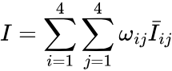

Where is the weight factor, and is the averaged intensity
value for each block.

Image brightness
The image brightness is calculated as the average of the brightness component after converting it into the YUV (Y is the luminance, while U and V are the chrominance) colour space. The conversion from RGB (red, green, and blue) space to the YUV is shown in (2). Brightness can be calculated as follow [7]:

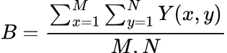

Where Y is the luminance of a pixel (x,y) and NxM is the size of the image.

Image contrast
Image contrast indicate the distinguishes of a face object over a background and can be calculated as in [3]:

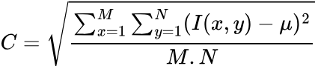

Where µ is the mean intensity value of the image I(x,y) of size NxM.

Results
In order to calculate the FIQ metrics, we use PreFace, a Software Development Kit (SDK) from Aware that can be used to calculate FIQ metrics and specifics described in both the Normative and Best Practices sections of ISO/IEC 19794-5 [8]. For each of the metrics used, PreFace reports the optimal values that the image should have to follow the standard.

To assess the effect that the environment has on facial images, we decided to consider two main characteristics: the effect that light exposition has on the image and the uniformity of the background.

- Brightness depending on the environment
To analyse the brightness in the image we used the following metrics:

- Facial Dynamic Range:
Facial Dynamic Range indicates the number of bits in the dynamic range of the facial region of the input image. A minimum of 7 is required, 8 is optimal. Both the Eye Contrast and the Facial Brightness depend on this metric.

- Facial Brightness:
Facial Brightness is the facial region's average luminance expressed in percent. Valid values are in the range 25-75%. Low values indicate that the facial region may be too dark, while high values indicate the facial region may be too light.

- Eye contrast:
Eye Contrast indicates how well the dynamic range is spread in the eye regions of the image. PreFace calculates the contrast value as an integer in the range of 1 to 5 where a score of 3 or higher is adequate (the higher the better).

We analysed the mean and the standard deviation of all images, making the distinction between the images taken with the SLR and with the ones taken with the smartphone camera. Images taken with the smartphones are also divided between the pose taken when indoors and the ones taken outdoors. The results are reported in Table 1.

As we can see, the Facial Dynamic Range for facial images taken indoors is really closed to the optimal value (7.67). Overall, all the images taken with the smartphone and with the SLR present the minimum Facial Dynamic Range required as the average mean value for each category is over 7.5. Standard deviation is higher in SLR images (0.39).

Facial brightness is lower (39.75) for the images taken indoor, meaning that the facial images taken with the smartphone when inside a building are darker compared to the one taken with the SLR (40.1) or outside (42.3).

Table I. PreFace metrics for brightness
Brightness | SLR Indoor | SLR Indoor | Smartphone Indoor | Smartphone Indoor | Smartphone Outdoor | Smartphone Outdoor
Brightness | x̄ | σ | x̄ | σ | x̄ | σ
Facial Dynamic Range | 7.6433 | 0.3962 | 7.6702 | 0.2600 | 7.6288 | 0.3323
Facial Brightness Range | 40.100 | 11.970 | 39.754 | 13.312 | 42.279 | 12.947
Eye Contrast | 4.3247 | 0.5859 | 4.2791 | 0.6045 | 4.2328 | 0.6810

The Eye Contrast is higher for the SLR images, and it is more or less stable to around 4.3 for all the three groups of comparison.
- Background uniformity depending on the environment
To assess the effect that the background has on facial images we calculated the following metrics:

- Background Percentage Uniformity
Background Uniformity reflects the variation of colour throughout the background of the image. Values can be in the range 0 to 100%. Optimal is 100%.

- Background Type
Background Type indicates the type of background the image has. At 1 indicates a simple background, a 2 indicates a complex background.

- Degree of Clutter
Degree of Clutter indicates how much background clutter occurs in the image. Scores are in the range 0 to 5. With 0 indicating no background clutter and 5 indicating a high degree of background clutter.

In Table II we report the mean and standard deviation values for the metrics used to evaluate the effect that the environment has on the background of the images. As can be seen, the Background Uniformity is closer to the optimal for images taken with the SLR, with a mean value around 90.5. Images taken outdoors with the smartphone recorded a mean value of almost 86.5 while the images taken indoor with the mobile device have a mean value closer to the one recorded using the SLR camera (89.07).

The background's complexity recorded with the mobile device camera is higher for images taken in outdoor locations, with a mean value of around 1.4. The complexity of the background recorded for indoor images are 1.24 and 1.28 for SLR and smartphone cameras respectively.

The higher values of Degree of Clutter is recorded overall with the images taken outdoor (3.35). The images taken with the SLR also have a higher value (3.29), while the images taken indoor with the smartphone recorded a mean value around 2.

Table II. PreFace metrics for background
Background | SLR Indoor | SLR Indoor | Smartphone Indoor | Smartphone Indoor | Smartphone Outdoor | Smartphone Outdoor
Background | x̄ | σ | x̄ | σ | x̄ | σ
Background Uniformity | 90.50 | 8.81 | 89.07 | 7.018 | 86.43 | 11.07
Background Type | 1.238 | 0.246 | 1.278 | 0.448 | 1.411 | 0.492
Degree of Clutter | 3.295 | 1.721 | 1.989 | 1.154 | 3.351 | 1.704

Table III. Biometric scores
SLR enrolment and smartphone indoor | SLR enrolment and smartphone indoor | SLR enrolment and smartphone outdoor | SLR enrolment and smartphone outdoor | smartphone enrolment and smartphone indoor | smartphone enrolment and smartphone indoor | smartphone enrolment and smartphone outdoor | smartphone enrolment and smartphone outdoor
x̄ | σ | x̄ | σ | x̄ | σ | x̄ | σ
95.62 | 39.21 | 72.09 | 20.10 | 112.9 | 40.45  3 | 102.5 | 44.74

- Biometric scores
Our analysis also aimed to determinate biometric scores on the different environments. We compared the images in the enrolment with 10 images selected from each location during the three sessions.

We performed 330 genuine comparisons for each subject i.e. 17.490 comparison scores in total. These comparison scores are obtained using the Neurotechnology VeriLook SDK [9]. Table III reports the mean and standard deviation values of the comparison scores. The maximum score recorded is 318 and the lowest is 22.

We compared the images using enrolment images taking with the SLR and with the smartphone camera as described in the Evaluation
Setup section of this paper. The mean value of the comparison score for SLR images is higher with the indoor images (95.62) while the standard deviation is almost 40, and the comparison scores obtained with the images taken from the smartphone is higher with the images taken indoor (112.9). Standard deviation is almost double the value that SLR images have when compared to the enrolment images taken from the smartphone camera.

- User experience and opinions

Participants were invited to express their opinions on the experience they had during the experiment. They were required to fill out a questionnaire at the end of each session. Participants could indicate the extent to which they agreed to a series of statements on a scale from 1 to 5 where 1 is strongly disagree and 5 is strongly agree.

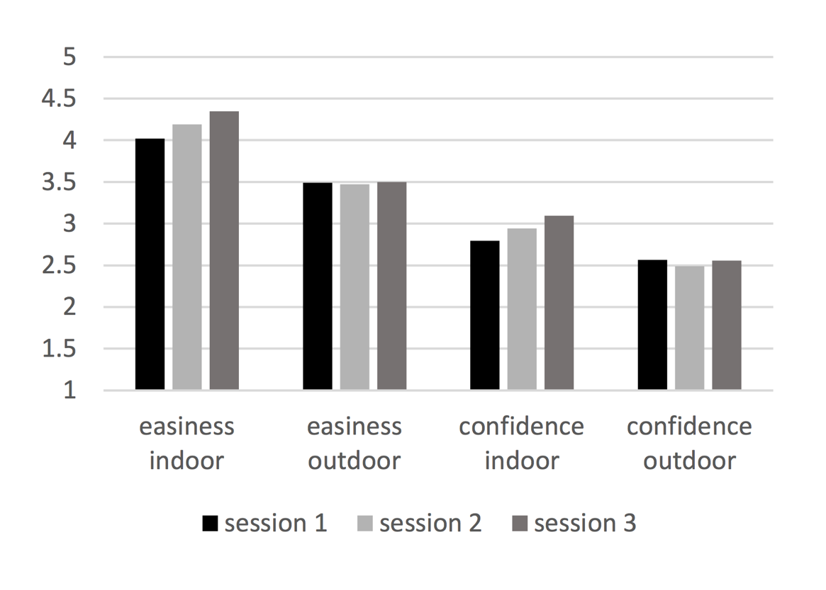

The bar chart in Fig. 1 shows the average results for each session. Participants level of agreement for ease of use while being indoors is 4, and for when outdoors is around 3.5.
The level of confidence that they felt while taking good presentation for biometric face recognition is around 3 for indoor locations and 2.5 for outdoor locations.
We can also see that while the level of confidence and the easiness for indoor location increases with the sessions, the same does not occur for outdoor locations.

Conclusions and future work
The study proposed in this paper investigates the user- biometric system interaction using a non-traditional lab based: we recreate real-life scenarios to test which factors influence the image quality in face recognition. Our results indicate the variability in face recognition performance when varying environmental conditions using smartphones

Overall, all the images have good Facial Dynamic Range, with the images taken indoors with the smartphone camera having the mean highest value which reaches almost the optimal levels. This means that overall the images taken with the smartphone camera have good facial symmetrical lighting. A deeper analysis will be conducted to understand how this quality metrics influence the biometric match scores.

The level of facial brightness is lower for the images taken indoor with the smartphone. This is probably because the images taken outside have more variability in terms of light exposure. Users should be given instruction on how to present the face to the system when the light comes from a fixed location like it happens when inside a building. It appears that when outdoors, participants realised that the light exposure can be an issue for the biometric authentication and they give more attention on their position more than when indoor. Eye Contrast appeared to be more or less the same for the three groups of facial images.

In terms of Background Uniformity, as expected, the mean values for images taken with the SLR is the closest to optimal one, as all the images had been taken with a white wall on the background while the images taken outside have a lower mean value as the uniformity varies enormously with the different scenarios on the background that includes trees, buildings and other people passing by. Nevertheless, both the complexity and the uniformity mean values are not that distant from the values recorded from the images taken indoor as we noticed that many images have only the sky on the background. This depends mostly on the interaction that the users' have with the device, as some participants do not raise the smartphone in front of their face, but tend to keep it lower, as they use it while typing. The Uniformity for images taken indoors does not differ from the SLR images because often within a building the background is a plain wall.

When comparing the verification images indoors and outdoors with the enrolment images using a smartphone, the mean of the biometric score is higher than the comparison with SLR images, probably because we are comparing images with the same characteristic for the camera. Future analysis will focus on understanding the correlation between each quality metrics and the effects that these FIQ metrics have on the performance of the system.

Users found difficulties especially due to the weather and light condition to take the images for face recognition when outside. Participants expressed concerns especially during windy days, where they had problems in taking images with the wind that was blowing their hair in the images and to locate themselves in a way that the light was going to be good for the images, all difficulties that they did not encountered indoors. As a consequence, the ease of use and confidence level that users expressed for outdoors scenarios did not increase within the sessions because the weather conditions were not the same in all the three sessions. Maybe receiving a feedback from the system while taking the images would help them to know how to take a conformant image.

Future analysis on the database will aim to understand if the level of confidence that participants have influences how they took the images (checking for instance the level of blurriness) and go deeper to see when, for each session, they found difficulties in reacting to a specific environment during capture.

Acknowledgements
This work was carried out with funding from the University of Kent 50th anniversary scholarship.

References

- "ISO/IEC 19794-5:2011 - Information technology -- Biometric data interchange formats -- Part 5: Face image data." [Online].

- "ISO/IEC TR 29794-5:2010 - Information technology -- Biometric sample quality -- Part 5: Face image data." [Online].

- X. Gao, S. Z. Li, R. Liu, and P. Zhang, "Standardization of Face Image Sample Quality," International Conference on Biometrics, no. Springer, Berlin, Heidelberg, 2007.

- P. Wasnik, K. B. Raja, R. Ramachandra, and C. Busch, "Assessing Face Image Quality for Smartphone based Face Recognition System," in Biometrics and Forensics (IWBF), 2017 5th International Workshop, 2017.

- Q. C. Truong, T. K. Dang, and T. Ha, "Face Quality Measure for Face Authentication," in International Conference on Future Data and Security Engineering, Springer, Cham, 2016, pp. 189-198.

- M. Abdel-Mottaleb and M. H. Mahoor, "Application notes - Algorithms for Assessing the Quality of Facial Images," in IEEE Computational Intelligence Magazine, vol. 2, no. 2, 2007, pp. 10-17.

- S. Bezryadin, P. Bourov, and D. Ilinih, "Brightness calculation in digital image processing," in International symposium on technologies for digital photo fulfillment, 2007, pp. 10-15.

- "Biometric Image Autocapture for Facial Recognition -PreFace." [Online].

- "VeriLook face identification technology, algorithm and SDK for PC, smartphones and Web." [Online].

