Resources Toolkit:

Supporting International Postgraduate Teaching Assistants

Dr Jo Collins, University of Kent

Dr Nicole Brown, UCL Institute of Education

Dr Jennifer Leigh, University of Kent

Table of contents
Welcome 6
About the authors 7
Dr Jo Collins 7
Dr Nicole Brown 7
Dr Jennifer Leigh 7
1.1 Introduction 9
1.2 What does international mean? 10
1.3 Methodology 11
1.3.1. Research design 12
1.3.1.1 Our approach to data collection 12
1.3.1.2 Using creative reflections 12
1.3.2 Research process 12
1.3.2.1 Participants 12
1.3.2.2 Data collection 12
1.4 Analysis 13
1.4.1 Validation theory 14
1.4.2 Identity work 14
1.4.3 Community of Practice 15
1.4.4 Transformation 16
1.5 Findings: What can we learn from our international teachers? 17
1.5.1 They bring knowledge with them 17
1.5.2 Adjustments 17
1.5.2.1 Anxieties around starting teaching 18
1.5.2.2 Not knowing protocols and procedures 18
1.5.2.3 Formality 19
1.5.3 They don’t feel like part of a university GTA community 20
1.5.4 School teaching support makes a difference 20
1.5.5 GTA as just a job versus teaching as a vocation 21
1.5.6 Visa checks are a pressure on them 21
2.1 How to use this Toolkit 22
2.2 Practical planning 23
2.2.1 Session description 23
2.2.2 Resources 23
2.2.3 Lesson plan 23
2.2.4 Descriptive commentary 24
2.2.4.1 Mind mapping and discussions 24
2.2.4.2 Examples of different kinds of plans 25
2.2.4.3 Microteaching 27
2.2.4.4. What makes a good teacher? Infographics activity 28
2.2.5 Critical, reflective commentary 30
2.3 Troubleshooting teaching 32
2.3.1 Session description 32
2.3.2 Resources 32
2.3.3 Lesson plan 32
2.3.4 Descriptive commentary 33
2.3.4.1 Teaching challenges 33
2.3.4.2 Challenging and ideal students 36
2.3.4.3 Activity to engage students 39
2.3.4.4 What have I learnt from this session 40
2.3.5 Critical, reflective commentary 41
2.4 Work-life balance 42
2.4.1 Session description 42
2.4.2 Resources 42
2.4.3 Lesson plan 42
2.4.4 Descriptive commentary 43
2.4.4.1 Work-life balance 43
2.4.4.2 What does your work-life balance look like now? 45
2.4.4.3 What do you want your work-life balance to look like? 46
2.4.4.4 Tools and activities to enhance work-life balance 46
2.4.4.5 What tools can I use to get from my current work-life balance to my ideal-work life balance? 47
2.4.5 Critical, reflective commentary 50
2.5 Becoming a teacher 52
2.5.1 Session description 52
2.5.2 Resources 52
2.5.3 Lesson plan 52
2.5.4 Descriptive commentary 52
2.5.4.1 What is the role of a teacher? 52
2.5.4.2 Lego modeling 53
2.5.4.3 What makes a good teacher? 53
2.5.4.4 Snowball activity 53
2.5.4.5 Visualisation 53
2.5.4.6 Recap 54
2.5.5 Critical, reflective commentary 55
2.6 Engaging students through Group work 57
2.6.1 Session description 57
2.6.2 Resources 57
2.6.3 Lesson plan 57
2.6.4 Descriptive commentary 58
2.6.4.1 Introduction 58
2.6.4.2 Brainstorm 58
2.6.4.3 Ground rules activity 58
2.6.4.4 Socrative 59
2.6.4.5 Article 60
2.6.5 Critical, reflective commentary 61
2.7 Engaging students through questioning techniques 62
2.7.1 Session description 62
2.7.2 Resources 62
2.7.3 Lesson plan 62
2.7.4 Descriptive commentary 62
2.7.4.1 Brainstorm 62
2.7.4.2 Blooms’ Taxonomy 64
2.7.4.3 Group discussions 64
2.7.4.4 Socrative questioning 66
2.7.5 Critical, reflective commentary 67
2.8 Assessment and Feedback 69
2.8.1 Session description 69
2.8.2 Resources 69
2.8.3 Lesson plan 69
2.8.4 Descriptive commentary 70
2.8.4.1 Building a tower 70
2.8.4.2 Assessing the towers 72
2.8.4.3 Reflecting on assessment 74
2.8.4.4 Plenary 75
2.8.4.5 Reflection on how feedback has been given 76
2.8.4.6 Using symbols for feedback 77
2.8.4.7 Using our own mark schemes 77
2.8.5 Critical, reflective commentary 77
2.9 The international classroom 81
2.9.1 Session description 81
2.9.2 Resources 81
2.9.3 Lesson plan 81
2.9.4 Descriptive commentary 82
2.9.4.1 What kind of educational culture do I come from? 82
2.9.4.2 What exercises and activities can I use, in my subject area, to engage learners across different educational backgrounds? 82
2.9.4.3 Group discussion 82
2.9.4.4 How can I ensure my lessons are inclusive? 85
2.9.4.5 What does my inclusive international classroom look like? 86
2.9.4.6 What have I learnt about myself as a teacher? 86
2.9.5 Critical, reflective commentary 86
3.1 Conclusion and recommendations 88
3.1.1 Building identity 88
3.1.2 Building understanding 89
3.1.3 Building community 89
3.1.4 Recommendations 90
3.2 Bibliography 91

Welcome
In the current neoliberal UK Higher Education sector, Graduate Teaching Assistants, and in particular International Graduate Teaching Assistants, are often the backbone of teaching delivery at undergraduate level (Raaper, 2018), with more and more teaching assistants being employed to support teaching and marking at postgraduate level. Most universities offer sessions that are meant to develop teaching skills in Graduate Teaching Assistants. However, the training provided in most universities focuses on practical skills and/or reflection, which is often at odds with the needs of International Graduate Teaching Assistants in particular, as cultural contexts, teaching conventions and administrative expectations are marginalised in this training. This type of knowledge is assumed to be tacit and implied, and rarely made explicit.

This toolkit aims to fill a huge gap in relation to publications on experiences and learning of International Graduate Teaching Assistants (Collins, 2019) by:

- providing a focus on International Graduate Teaching Assistants’ needs whilst drawing out tools and considerations relevant to all Graduate Teaching Assistants
- offering practical examples that can be used by those supporting Graduate Teaching Assistants

This guide is meant to offer useful ideas and a starting point for further developing awareness of the needs of International Graduate Teaching Assistants in their everyday practices. In this sense, the toolkit is not meant to be prescriptive at any level, but is intended to provide ideas and stimuli for which skills and techniques training sessions may be delivered and how.

The toolkit is primarily aimed at National and International Graduate Teaching Assistants and anyone supporting Graduate Teaching Assistants with their teaching, but may also be of interest to anyone involved in training and accreditation processes for the Higher Education Academy fellowships.

We would like to take this opportunity to thank SEDA for funding the research upon which much of this toolkit is based. This toolkit would also not have been possible without the GTAs who participated in our workshops and interviews: our thanks to you for working with us, challenging us, sharing with us, and inspiring us.

About the authors

Dr Jo Collins
Jo Collins is a Researcher Developer, GTA Developer and Coach at the University of Kent’s Graduate and Researcher College. Jo gained her doctorate from the University of Kent, and has worked for around twenty years in Higher Education as a teacher and researcher. She has an MA in Higher Education, a Postgraduate Certificate in Higher Education is a member of the Association for Coaching and a Fellow of the HEA. She supports doctoral students and research staff. Her research encompasses doctoral emotion work, reflection and wellbeing, and she has a particular interest in investigating support for international postgraduates.

Dr Nicole Brown
Dr Nicole Brown is a Lecturer in Education at UCL Institute of Education and Director of Social Research & Practice and Education Ltd. She joined academia as a teacher educator after a successful career in secondary education as a qualified teacher in Austria and the UK. Nicole gained her PhD in Sociology at the University of Kent for her research into the construction of academic identity under the influence of fibromyalgia. She also holds a Master of Teaching, a Master of Higher Education, a Magistra Philosophiae, a Diploma in Translation, and a Postgraduate Certificate in Higher Education. She is a UKCGE Recognised Research Supervisor and a Senior Fellow of the Higher Education Academy. She has edited Lived Experiences of Ableism in Academia: Strategies for Inclusion in Higher Education and Ableism in Academia: Theorising Experiences of Disabilities and Chronic Illnesses in Higher Education, co-authored Embodied Inquiry: Research Methods, and is currently authoring How to Make the Most of Your Research Journal. Nicole’s research interests relate to physical and material representations and metaphors, the generation of knowledge and, more generally, research methods and approaches to explore identity and body work. She also remains inherently interested in matters related to learning and teaching. She tweets as @ncjbrown, @FibroIdentity and @AbleismAcademia and can be contacted at office@nicole-brown.co.uk

Dr Jennifer Leigh
Jennifer Leigh is a Senior Lecturer at the Centre for the Study of Higher Education, University of Kent. Jennifer joined the Centre full-time in 2013. She initially trained as a chemist, somatic movement therapist, and yoga teacher before completing her doctorate in education at the University of Birmingham. She is a Senior Fellow of the Higher Education Academy. She edited a book for Routledge in 2019, Conversations on embodiment across higher education: Teaching, practice and research. Together with Nicole Brown, she edited and contributed to Ableism in Academia: Theorising Disabilities and Chronic Illnesses in Higher Education which was published by UCL Press in 2020, and co-wrote Embodied Inquiry: Research Methods for Bloomsbury in 2021. She is a founder member and Vice Chair of WISC (an international network for Women In Supramolecular Chemistry) and the only social scientist in the team. She has several projects underway with WISC that bring embodied research approaches (and glitter) into the world of chemistry. Her next books, WISC: Women in Supramolecular Chemistry and The boundaries of qualitative research: with art, education, therapy and science will both be published by Bristol University Press. Her research interests include embodiment, phenomenological and creative research methods, academic practice, academic development, marginalisation and ableism in higher education. She tweets as @drschniff @suprachem. She can be contacted at j.s.leigh@kent.ac.uk

1.1 Introduction
This toolkit is based on work that happened within the Graduate and Researcher College in Kent over a period of three years, including a SEDA funded research project that investigated the experiences of international postgraduates who teach. Specifically, the project built on the previous two years’ experience and used creative approaches to examine the adjustment experiences and the challenges and learning journeys international GTAs had undertaken teaching in UKHE. We situated our work in relation to our experience working with both home and international GTAs and research that investigated challenges experienced by international postgraduates in UKHE (Brown and Holloway, 2008; Matheson and Sutcliffe, 2017; Rizvi, 2010; Wu and Hammond, 2011), studies into HE teacher training (Wood, 2000; Ho, 2000; Trigwell and Prosser, 1996) and specifically Winter et al’s (2015) work on how international students experience challenges and benefits associated with training as GTAs. We examined the efficacy of existing support for international postgraduate researchers who teach at our institution. We evaluated the creative approaches we used to understand international students’ experiences. We shared our findings in conferences and workshops to initiate discussions about the benefits and limitations of our model of support.

Initially, we conceived of establishing a support group for PGRs who teach, where students would meet together and use creative methods for self-reflection over a nine-month period. However, in the early stages of the project Jo surveyed around 213 GTAs and HPLs (44% and 28% response rate from the overall communities respectively). From that we found a demand for workshops that taught core teaching skills, as individuals felt overworked and felt lacking confidence in their teaching alongside the need for opportunities to develop a sense of belonging and community. This echoed our experiences providing voluntary workshops for GTAs – the international students in particular chose to attend these teaching orientated sessions in much larger numbers than would be expected from the proportion at the university. The international GTAs told us that they appreciated sessions aimed at both home and international students, rather than being separated out from them.

We therefore revised our planned activities and decided to run two streams of workshops: reflective workshops with discussion and practice of skills development, and skills-based workshops which modelled teaching techniques throughout and allowed participants to analyse what was experienced and observed. Each workshop allowed time for the GTAs to connect and to talk in lieu of a separate support group. Alongside the workshops, Jo conducted interviews to explore key themes and experiences.

Unfortunately, the academic year was somewhat disrupted with a significant process of restructuring at the University of Kent from 2019 through to 2020, UCU strike actions in November 2019 and February 2020, and the emergence of the COVID-19 pandemic in the spring term of 2020. Nonetheless, we registered 89 attendances in the workshops and interviewed 20 international GTAs. Attendances in the workshops were constituted as follows: 49 (55%) were international or EU students (EU students were not counted as ‘international’ in visa terms, however they experienced similar cultural dissonances to other international students) and 64% were women. 29% were Humanities students, 48% were Social Sciences students, and 23% were Sciences students, which is broadly representative of the spread of PhD students across the faculties at the University of Kent. Of the 20 international GTAs Jo interviewed 14 were from Tier 4 countries, and 6 were EU GTAs. 11 participants were female and 10 were male, and across the sample 7 GTAs worked and taught in the Sciences, 11 in the Social Sciences and 2 in the Arts and Humanities.

The first phase of the project highlighted an important misconception regarding international GTAs. We had thought that students wanted and needed a support network to undertake reflections. Instead, there was significant need and desire for opportunities to make sense of experiences and differences in educational development and cultural upbringing in relation to their teaching and to other GTAs who were home students. They had no wish for a separate or separated group. The role of cultural identities and educational experiences amongst GTAs was addressed in detail throughout the workshops, which significantly changed individuals' views of their own teaching skills. The reflective practice sessions provided the tools needed to continue a process of self-reflection in order to improve on specific skills within the context of teaching.

As research findings are published elsewhere, we focus here on the practicalities of delivering training, thereby offering a toolkit of ideas and strategies for practice. Through the presentation of the resources needed along with the lesson plans, any additional information and materials from the sessions and an analytical critical commentary, we hope that International Graduate Teaching Assistants and those supporting Graduate Teaching Assistants (national and international) are able to reconstruct key messages from the workshops and use the learning to develop their own teaching and teacher training.

1.2 What does international mean?
When we initially conceived of this project, the term ‘international postgraduate’ meant something different to us from its connotation at the end of the project. For Ryan and Carroll (2005, 4) International students are those who travel abroad for tertiary study, compared to home students who remain in the country in which they have been educated. ‘International GTAs’ are often treated as a homogenous category (Collins, 2020), with little consideration of the variety of experience and educational background when they begin teaching. Consequently, we set out to ensure that both ‘EU’ and ‘Tier 4’ Graduate Teaching Assistants were part of the project. Tier 4 and EU designated different visa types in the UK when this project started in 2019. Prior to Brexit (and throughout the duration of our project), ‘Tier 4’ non-European Economic Area students were paying higher-rate international fees, whilst students from the European Union were paying fees that aligned financially with home charges. After Brexit both EU and Tier 4 visa students are liable for higher rate fees.

In the UK, with the distinction between EU and ‘Tier 4’ students, the term international has often (administratively at least) been equated with ‘Tier 4’ students from outside Europe. For example, one of our EU participants confided “I was told more than once you can’t attend this workshop on essay writing or referencing or whatever, because you’re not an international student” (14). Our conversations with EU students told us that they had to make transitions from different educational systems into teaching in the UK:

So I have done my undergrad in Italy […] it’s completely different. So what we do is we attend lectures, we don’t have seminars, so there’s no chat about what we are learning. So we go and listen to this guy who is talking about something that is written in the toolkits, we study the toolkits, and we learn them by heart.

Going to Uni in the Netherlands is a lot more affordable (2000 EUROS), but it also harder to get into than in England. The marking system is 0-10, so that was confusing for me at the beginning. Otherwise it was similar in the sense that I had lectures, seminars and practicals.

In what follows ‘international’ is an all-encompassing term that seeks to contain the experiences of students from a variety of cultures and educational backgrounds. Here English may or may not be a first language, and some form of cultural transition is taking place around learning new teaching practices when our participants began working as a GTAs in UKHE.

1.3 Methodology
In this section we set out how we collected the information that fed into our toolkit. We first conducted a survey of around 213 GTAs and HPLs (which had a 44% and 28% response rate respectively). What we found was a demand for workshops that taught core teaching skills. Our respondents said that they did not feel like part of a community. They told us that they were overworked. As such we decided to run two streams of workshops – more reflective workshops with some element of discussion and practice of skills development; and more skills-based workshops, where teaching techniques were modelled. We also found in our survey that international students and EU students were much less likely to critique the University and training support than home students. As such, interviews became a key way to understand their experiences.

1.3.1. Research design

1.3.1.1 Our approach to data collection
Our approach draws on conceptualisations of communities of practices (Lave & Wenger, 1991). We drew on Nicole’s work on staff and students developing a partnership for learning (Brown et al., 2018; Brown, 2019) where all stakeholders within the classroom take responsibility for learning, change and innovation, and Jennifer’s work on the importance of reflective practice in developing academic identity and its place within programmes for academic development (Leigh & Bailey, 2013; Leigh, 2016; Leigh, 2019). We understand practice-based enquiries as an egalitarian, participatory research, that allows both participants and researchers to enter and contribute to the learning and investigatory process. This kind of qualitative research combines workshops and classroom-based activities with conventional interviewing.

1.3.1.2 Using creative reflections
Our project design incorporated collection of data through creative elicitation methods. MacKay and Barton (2018: 358) argue that “reflecting through words alone may not allow the expression of deeper levels of emotion”. Creative reflections allow for non-habitual understandings of selfhood, such as new patterns of thinking. Creative reflections also encourage a more holistic sense of self by fostering a greater awareness of embodiment through the use of tactile materials in spontaneous ways. The element of ‘tactility’ and embodiment with and through materials which “involves […] the physical body in the construction of meaning” (Statler et al, 2011, 237) which enables these deeper insights to emerge and be woven together through art. As such creative activities enable new and often unexpected notions of meaning and knowledge to emerge as part of reflection, which to us seemed particularly pertinent in the context of international GTAs developing new notions of identity as teachers in UKHE.

1.3.2 Research process

1.3.2.1 Participants
Overall 109 GTAs took part in the project. Of these, 69 were Tier 4 and EU GTAs. Our workshops had 89 attendances of which 49 (55%) were international or EU students. We interviewed 20 international GTAs: these interviewees were selected because they replied to a general email call for participants. Of those interviewed, 14 were from Tier 4 countries, and 6 were EU GTAs. 10 participants were female and 10 were male, and across the sample 7 GTAs worked and taught in the Sciences, 11 in the Social Sciences and 2 in the Arts and Humanities.

1.3.2.2 Data collection
Prior to organising the workshops, we gained ethical approval for this research. In our workshops, attendees were informed about the dual purpose of the sessions. Firstly, the workshops were a training opportunity for postgraduate teachers, secondly they were an opportunity to gather data for research on international GTAs’ experiences. Attendees were then provided with information sheets and consent forms to opt in to the study. If they decided to not participate in the research, they were still able to attend and benefit from the workshops.

Table 1: Our workshops
Workshop title | Creative activity | Timing
Practical planning (Jen and Jo) | Infographics | 2-3 hrs
Troubleshooting teaching (Jen and Jo) | Lego modelling | 2-3 hrs
Becoming a Teacher (Nicole) | Lego modelling | 2 hrs
Engaging students in discussions (Nicole) |  | 2 hrs
Questioning techniques (Nicole) |  | 2 hrs
Work life balance (Jo) | Drawing | 2 hrs
Assessment and feedback (Nicole) |  | 2 hrs
The international classroom (Jo) |  | 2 hrs

The material included in this toolkit encompasses interview transcripts, fieldnotes and transcripts of reflection sessions, LEGO® models and timelines, feedback from students via anonymous exit slips, session plans and annotated transcripts from sessions. We collected data from eight (2-3 hour) workshops described here, and one shorter workshop which ran online after the beginning of lockdown in 2020. This last workshop was titled ‘developing as a teacher in HE’, and due to the nature of online sessions had to incorporate a very different pedagogical approach. As such it is not included in this toolkit. The workshops covered topics from becoming and developing as a teacher, questioning techniques, engaging a classroom, feedback and marking, planning, troubleshooting and work-life balance. In our interviews we commenced with a reflective exercise where participants built with LEGO® bricks (face to face) or (virtually) created a timeline of their journey as a teacher. Participants were asked about their challenges transitioning into teaching, their teaching philosophy, and their community.

1.4 Analysis
Data was coded using NVivo 12. This software’s design supports iterative coding cycles, through the cumulative compilation of transcript annotations, creating transcript memos, and theme memos (Saldaña, 2016, Ritchie et al, 2014). This continual building of description and analysis prompts movement to theorisation through a process of iterative spiralling between and across the different transcripts and themes to build a deeper understanding (Collins and Brown, 2020). All data sets were coded using the iterative, inductive, semantic thematic analysis in its intended reflexive form (Braun and Clarke, 2006, 2019). We looked specifically for evidence of transformation, challenges in transitioning into teaching, sense-making.

As GTA developers we found the following theories helpful in designing and evaluating our activities.

1.4.1 Validation theory
Laura Rendón argues that a major failing in higher education is that faculty and students exist in silos with circumscribed interactions (2009, 33). She calls for “faculty and staff to get closer to students, to reach out to students to offer assistance, and to help students make social and emotional adjustments” (2009, 35). In her research this process of ‘validating’ minority students, and in particular incorporating their experiences and cultures into teaching experiences, is particularly beneficial for their educational outcomes (Rendón, 1994). This was particularly important for us as our international GTAs were both PhD students and they were ‘faculty’ teachers. A number of our participants told us that they felt closer to the students than to the lecturers in their schools (6, 10, 14, 16, 19, 20). Indeed, research shows that GTAs and other part time teachers are systematically excluded from faculty process, such as meetings and curriculum development and as such often feel isolated (Beaton, 2017; Fairbrother, 2012; Leigh 2014; Collins, 2021). Some of our participants also felt that they specifically sought to acknowledge the experience of international students:

these are international and global beings that come in and try to accustom to the situation here, to the conditions here, which actually takes a lot of effort. So we should also be concerned to give these students extra care and effort as well.

As GTA developers it was also incumbent on us to ensure that the training we provided supported international GTAs from different educational backgrounds.

1.4.2 Identity work
Identity work provides a theoretical lens to consider how GTAs might concurrently develop and switch between multiple roles and identities (Winstone and Moore, 2017, 495). For example, postgraduate researchers are students, but as GTAs they are also teachers and employees. This theme emerged strongly in our interviews, as GTAs felt part of larger PhD communities in their schools. Yet even though those same PhD friends were also GTAs, they didn’t feel like part of a GTA community: the PhD took precedence. This echoes advice given in GTA programmes for academic development, as it is imperative that a PhD takes precedence over other activities for the university, to support the student having a successful outcome. Even the most excellent of GTA teachers will not receive a doctorate unless they also put in the work on their PhD. It was our intention that the workshops would be a space for identity work on these GTAs’ identities as teachers, so that they could explore this aspect of their time as a graduate student and teacher. Furthermore, an underpinning message in our work was that research and teaching identities do not have to be considered as mutually exclusive.

Identity work was also a useful way to understand how international students experienced changes in their understanding of teaching in UKHE.

In Greece it’s not like the professor is here and the student is here [hierarchy] […] you can talk with them in a more informal way […] when I tried to be open like in the first year, ‘you can send emails, you can contact me’, […] maybe 2 or 3 students […took] advantage of that, but then most of them wouldn’t because I think there is a different mentality[. …] so I always backed up a little bit during the second and third year, and said okay, that is how things work I can’t push everyone.

I am from Pakistan […] and the culture there is different as opposed to here […] I visualise myself in the middle of these two right. So I’m in the middle and what I do is that I take the best of both worlds, and I mix them together for example even in this hierarchy is something that is there in my culture […] I would say no, I’m not going to follow that thing, I am going to rebel against that, what does the other perspective provide me?

The first participant described UK teaching as very different from Greece because it differed from the ‘open’ approach the GTA wanted to take. This resulted in the GTA abandoning the Greek teaching style s/he intended to use in the UK classroom. The second participant found that teaching in the UK was an opportunity to blend the ‘best bits’ of Pakistani and English teaching practices. Here the kinds of identity work undertaken by the GTAs differed according to their home and educational cultures.

1.4.3 Community of Practice
We take from Lave and Wenger the notion that we are all part of a community of teachers within UKHE, and that ‘participation’ is learning, “both absorbing and being absorbed in […] the “culture of practice”” (1991, 95). In this way all those who are teachers, regardless of how many years they have been teaching, are continually learning – in their own classrooms and within our workshops too (including the instructors). We sought to foster the notion of a community of practice in our sessions by framing theme as sites of knowledge exchange, where participants could draw upon each other’s experiences and ideas to frame and enhance their practice. This community was bisected by perceptions of disciplinary differences in teaching, for example this GTA talking about how assessing ‘right’ and ‘wrong’ varies by subject:

It depends on the subject. If a question was what is 2+2 and you answered three … [I]n something like History it’s much harder to say there’s a factually incorrect answer to a question.

There were challenges to building such a community, which we discovered in our initial survey. Our GTAs told us they wanted more of a support network, but also told us that they felt that teaching and research commitments constrained their time. As GTAs our participants felt peripheral, it was particularly important to them to feel that their work was recognised and that they could have an input into curriculum design. Pyhältö and Keskinen (2012, 137) found that for doctoral students, community of practice were experienced most powerfully within their particular schools (through peer groups, seminars, and research groups), and then their discipline as a whole. Indeed, for many of our participants, research within the school was the most urgent attachment, and teaching did not straightforwardly coincide with this (with some teaching modules they had no knowledge of before, or had to learn new protocols. Our workshops offered a momentary space within which a different kind of community of practice could be imagined and enacted. As our workshops were attended on a one-off voluntary basis this did however present challenges to community sustainability. Nevertheless, we built a dedicated clutch of students who came to most sessions.

1.4.4 Transformation
We drew on literature of teacher training, specifically the idea that training facilitates transformation in attitude towards learning. Higher Education teacher training (e.g. PGCHE, PGCL&T, and programmes that lead toward Associate Fellowship or Fellowship of Advance HE) often seek to shift trainee’s approaches from teacher-centred to student-centred learning and teaching practices (Åkerlind, 2008, 633; Prosser and Trigwell (1996); Martin and Lueckenhausen (2005); Wood (2000)). However there are definite tensions in such programmes, as few take a holistic approach to academic development and instead do little to rebalance the hierarchy that exists in academia between teaching and research (Leigh, 2017). Most of this literature concentrates on the adjustment of teaching philosophy, rather than encompassing other larger adjustments that may be happening at the same time or the development of a holistic academic identity that encompasses both teacher and researcher (Collins, 2021). For some of our participants the shift towards more student-centred practices involved cultural shifts as well:

Most of the times [sic] in Taiwan, teachers speak […] no one else, everyone just listens. […]Here I think there’s more interactions between students and teachers […] which is a good thing.

I talk less in class and students talk more in class. […] I engage more in terms of talking with the students when compared to my previous experience.

Having highlighted this, it is important to note that this project did not set out to longitudinally map shifts in GTAs’ perceptions. Some GTAs came to our one-off workshops having done accredited modules on Kent’s Associate Fellowship Scheme leading towards Associate Fellowship of Advance HE (so any such shift may have already occurred). There was no obligation to attend the entire workshop series. In this way, we aim to exhibit an awareness about the kinds of transformations that might have occurred, but acknowledge we have just captured snapshots of this process and not a complete picture over time.

1.5 Findings: What can we learn from our international teachers?

1.5.1 They bring knowledge with them
Our interviews, and our experiences teaching international GTAs, have shown us that the majority of these GTAs bring not only subject but also teaching knowledge and experience with them. This is key, because some studies do tend to treat international GTAs from a perspective of ‘deficit’ (Collins, 2019). A number of our GTAs had taught during national service, others had worked in organisations in teaching roles, and some had taught in more than one country. Some international GTAs spoke about seeking to incorporate their pre-existing the peer-to-peer teaching experiences into their UK classrooms:

So when I came over I had already experienced a lot of the teaching I did in my organisation. If that experience was not there I would have taken a longer time to learn about how to facilitate learning. […] One thing that I learned from that workshop was that it helped me create this collective process.

I was in China in an internet company […] and we have our training academy. I was doing like statistics training [and…] research methods […] And because all other trainees are just our colleagues, it’s [a…] peer [relationship] so we are like of like sharing our knowledges in our special fields.

These examples suggest a counter-narrative to approaches by Åkerlind (2008); Prosser and Trigwell (1996); Martin and Lueckenhausen (2005) and Wood (2000) (see 1.3.4 above). These studies see teacher training as a shift from teacher-centred to student-centred learning. However, these examples show that for some GTAs student-centred learning constituted pre-existing patterns of thinking and experience before starting to teach in UKHE (see also Collins, 2021).

Adjustments
A number of our international GTAs talked about various challenges in becoming teachers in UKHE. These included:
- Anxieties around starting teaching
- Not knowing protocols and procedures
- Adjustments around levels of formality.
Taking each of these in turn:

1.5.2.1 Anxieties around starting teaching
Prior to teaching international GTAs worried about what was to come, and what was expected of them:

When I got here, in the first year I didn’t have anyone to talk to about what to expect. Because the people who were handling it had left.

There’s so many new information that you are confused.

I think at first, I thought I couldn’t face problems because of course I’m not a native English speaker and etc. but I remember well my first seminar that was really you know a bit anxiety-driven to me but then I realised that that’s okay.

I started teaching in roughly my third week […] So I had to adjust to teach […] and I felt like, for first year international students they should get at least the first term to adjust.

Anxiety about starting teaching was then compounded by linguistic shifts, uncertainties of how teaching worked, cultural shifts, and other adjustments. Things like sorting out a bank account and other practicalities added into teaching worries. Here gatekeepers were important – other PhD students who could give insight about how things worked, and people who might re-iterate initial key information given at induction, supportive GTA representatives that would bring GTAs interests to school meetings, as well as an academic within the department who proactively coordinated events and support for GTAs. Some Schools gave international PhD students the first term, or year to settle in, which was appreciated. Many international students were worried about their language competency, and in short micro-teaching sessions that formed part of one workshop several spoke about this. In our experience none of the International GTAs we worked with were incomprehensible, and indeed most needed reassurance that their English skills, as assessed on their recruitment to the doctoral programme, were sufficient for their work.

1.5.2.2 Not knowing protocols and procedures
Adjustments around marking protocols were mentioned by our GTAs:

I know other teachers, other GTAs, coming straight from Italy [where…]we don’t distinguish between undergraduate and postgraduate, we just do the whole thing […] so coming straight from that and having to mark essays and being completely lost.

In my country of origin the scale is 2-5 where 65% is a pass and it is quite doable to achieve 90%, [so I] would like more information on the UK grading system.

Other protocols were learned too – around laboratory work, with shifts to learn new processes and different regulations; and around the relationship between the student and the teacher. One GTA described how “there are a lot of rules in this country” and these became the “point of reference” for decision making rather than the authority of the teacher (as in the home country).

One GTA talked about how a move from memory-based learning to more discussion-based teaching in the UK allowed for more reflective discussions about “why are we reading this”. Another GTA who taught international postgraduates described her own and her students’ transition into understanding ‘how things are done’ in the UK.

I had no clue what an essay was when I came here, [and] I see that most of my students, some of them have a similar experience of having written or done things […] at their previous university in a certain way, and now they come here and they don’t see why they should be doing things [.…S]o I think in my lessons what I true to do is have a conversation with them [about…] what did you do before and why […] and how does it fit with what you are doing here.

Maribel Blasco (2015) discussed how international students need to be told the tacit knowledge in the subject areas they learn in (i.e. what is the purpose of doing things in this way). We make a similar argument in the context of international GTAs: they need to be talked through implicit processes and knowledge. This might include processes for entering grades on systems, the spaces they can use, where they can go if there is a problem, and the terminology used in the UK (e.g. BTec, A-Level) as much as more embodied and cultural differences in how education is delivered and received in UKHE.

1.5.2.3 Formality
Depending on the culture the GTA hailed from, transitioning to teaching in the UK might constitute an encounter with either greater or less formality than they were used to:

[There’s] more formality here [in teaching], at least at the beginning […] but then when you get used to it and students then it’s more informal

There’s a kind of cultural enforcement in my country to be in a formal [attire], it’s not by any way illegal, but people are expecting you should be formal, you should be a role model, but here, I feel more comfortable, I don’t have to hide my own character.

In contrast to the first international GTA quoted who saw teaching as gradually becoming more informal and friendly; another GTA, who started teaching more informally, felt that it was important to maintain formality to ensure efficacy and student engagement:
I realised that some things work a bit differently with students and how [the] University approaches things, so I tried to be more formal.

For some this appreciable difference in formality related to classroom sizes too. Some described how teaching in their home country involved more “instructional” as class sizes were bigger.

1.5.3 They don’t feel like part of a university GTA community
For some there was a sense that GTAs within schools pulled together. This was often based on having a proactive GTA coordinator and social events, or meetings, and supportive GTA representatives. One student mentioned that a uniting factor amongst GTAs was the “precariousness” of the occupation. Most felt that “There’s more of a PhD community than particularly a GTA community.” They felt more connected to other PhD students within their schools than the wider university as a whole. They connected to others on the basis or research rather than teaching. Thus GTAs from other departments did not really feel like part of a community (although they did training for the Associate Fellowship Scheme and with the Graduate and Researcher College with students from other schools).

1.5.4 School teaching support makes a difference
The flipside of not feeling part of a University GTA community was that involvement in teaching related groups within schools made a big difference to international GTAs’ confidence. Some described how valuable they found the practice of the module convenor gathering all the module’s GTAs to discuss together key points for learning, and to gain their input into the modules. This investment of time and knowledge was felt to translate directly into the teaching experience in the classroom. A key point that emerged (pre-COVID) was the importance of having a space for teachers within a school, where materials could be left overnight and other GTAs in their discipline met for informal interactions and conversation about their experiences.

Related to this, the liminality of the GTA role somewhere between staff and student (Winstone and Moore, 2017) was seen as problematic:

my main challenge will be one [of] recognition. […W]e don’t have staff badges, so wherever we go we are treated as a student. So imagine me going to teach students, and the students have a card with student on it, and I also have mine with student on it. So it actually stifles the respect that a student will have for you.

Being accorded the same rights as staff – such as access to photocopies, spaces, meetings and decision making, celebrations of success, parking spaces was crucial to GTAs’ sense of recognition and satisfaction within the institution.

1.5.5 GTA as just a job versus teaching as a vocation
One key distinction that GTAs made was between those who saw GTA work as a vocation (a stepping stone to a future teaching career) and those who saw it as a ‘job’ (a means to an end to get the PhD). Within this distinction, those who saw GTA teaching as a vocation would often tend to privilege the student experience and describe spending time preparing, it was perceived that those who treated teaching as a job favoured their research over teaching preparation as might be expected, as they prioritised their degree. Regardless of whether this binary would hold true under further empirical observation, evidence of the perception suggests something of a schism between teaching and research – where a GTA is expected to give more time and energy to one rather than the other. As such the implication is that teaching versus research, and one of these has to be chosen rather than intertwined.

1.5.6 Visa checks are a pressure on them
A couple of our interviewees mentioned the pressure of visa compliance as a negative impact:
in the UK system […] there’s always this feeling that you are being watched. ….like the immigration checking your hours.

to a certain extent I get that these principles are needed and these practices are necessary, but it does also feel like you are being watched.

Beyond this, they described a number of additional hoops they had to jump through such as IELTS tests – one English-speaking student said of this: “it was ridiculous the amount of money that I had to fork out before I got here, to prove that I was worthy enough to be here.” These circumstances, around visa compliance, entry requirements and (at the time) higher fees for international students differentiate them from home students and add an extra layer of vulnerability for international GTAs.

2.1 How to use this Toolkit
In the following, we provide detailed information on training sessions for and with the GTAs; how those sessions were run, and what happened in the moment, along with a critical, reflective commentary. We have taken the conscious decision to provide the materials and a descriptive annotation so that it may be easier to reconstruct the sessions, and teach from these materials.

This is not to say that these materials are perfect for the context in which you teach or learn. As educators, we strongly recommend you adjust the materials to fit your purposes, your audience and your context. Our plans were adjusted moment to moment to fit the groups that we found ourself with, and obviously if working with the same group over time, a different sense of community and continuity could be found.

The critical, reflective commentary is a second-layer annotation that is meant to make the tacit explicit, provide some information regarding teaching strategies and philosophies, and to give justifications for what was done why and how.

One word of warning, perhaps: occasionally, the critical, reflective commentary may feel repetitive. This is intentional. The toolkit can be used in such a way that readers dip in and out of specific sections. The underlying teaching philosophy and pedagogical approaches are therefore explained at every opportunity, so that no matter where someone starts or ends, they will not miss some crucial information. Also, we know that repetition makes information "stick". By exposing readers to similar information again and again, we hope they will engage with and critique some of the key pedagogical principles and philosophical outlooks presented in this toolkit.

2.2 Practical planning

2.2.1 Session description
Led by Jennifer Leigh and Jo Collins
This session is aimed at exploring how to plan or approach teaching sessions. Using practical exercises and discussion we will evaluate different approaches to planning, the aspects you might need to consider such as differentiating learning abilities, individual learning plans, using technology, engaging students etc. There will be time to examine the differences between planning a session and a longer course of study such as a module. This session will have a practical hands-on approach to equip postgraduates to plan their teaching. Participants should prepare a 10 minute teaching activity in advance of this workshop.

2.2.2 Resources
Plain paper
Pens
Infographic symbols
Scissors
Glue

2.2.3 Lesson plan
Timing | Activity | Aim
10 mins | Introduction to class  Introductions from students | Eliciting students’ particular challenges around planning, so content can be appropriately tailored to deal with their needs (this can be recorded on the board or on flipchart paper if there are bigger groups).
15 mins | Mindmapping:  - what makes a good plan?  - What challenges do we face when planning teaching? | .
10 mins | Different kinds of plans (examples – e.g. School lesson plans, notes, structured notes like this, emphasis on learning outcomes) | To give students an opportunity to reflect on what kind of planning techniques work for them.
Ideally up to 10 mins per student, plus 3 minutes each feedback.  60-90 minutes | Microteaching: ideally the lesson outline will indicate that students have to come prepared with a 5-10 minute presentation. The length of this section depends on how many participants there are. There should be at least 3 minutes per student for feedback. | To give each student an opportunity to perform as a teacher in front of a constructive and friendly audience.
10-15 mins to design  10-15 mins | Taking into account your own experiences of microteaching, what makes a good teacher? Infographic design.  To present and discuss | To instigate a discussion on qualities of good teachers, seeing how perceptions converge and diverge amongst the group.
5 minutes | Two stars and a wish for feedback | To model a simple and effective tool for evaluation.

2.2.4 Descriptive commentary

The lesson starts with introductions and elicitation of students’ own reasons for attending. In this group, reasons included wanting to learn about best practice, experiencing training: “I’m a lecturer at home and I’ve never had any kind of training, just shoved into a lecture room and asked to teach”, training before starting teaching, student engagement, customizing existing teaching plans.

2.2.4.1 Mind mapping and discussions
The first question students discuss as a class (this will depend on class size) is what makes a good plan? This was recorded as a mind map on the board (but might also be built up through paired discussions). Suggestions included:
- Learning outcomes: are these infantilising, how do we want to assess these as outcomes?
- Having enough material and a back-up plan or different tasks for those who are further ahead
- Structure: beginning, middle and end, (student time)
- What are expectations of students?
- How to keep students engaged, variety, having a hook/way in
- Timings for different activities (flexible)
- Recapping from last week and anticipating learning for next week.
- Abilities of students taken into account: do you target the minimum level? How do you take into account high flyers? Planning for independent learning plans and health issues? Are we explicit about the level that we teach to?
- What accommodations do you need to make for students with additional learning needs?
- What challenges do we face when planning lessons?
- Deviating from pre-existing plans (to customise them to own style)
- Navigating between what students expect and finding own style
- Balancing between teaching someone else’s material and creating your own (in terms of time commitment).
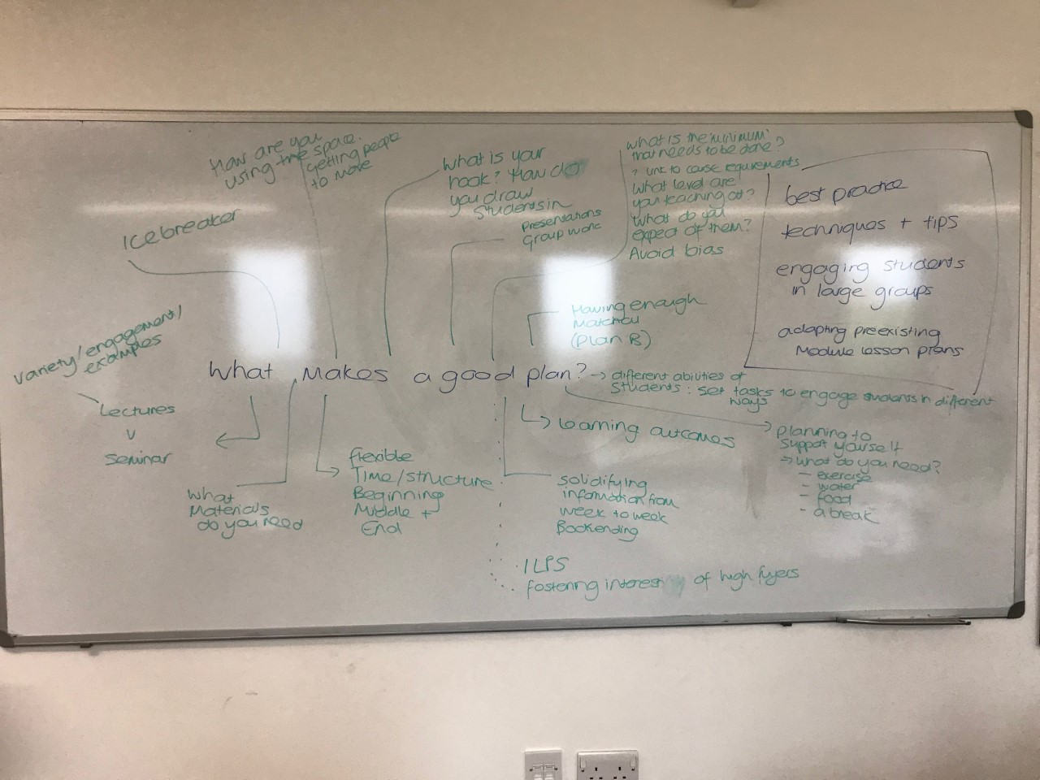

2.2.4.2 Examples of different kinds of plans
What kinds of things do people do when they plan? (Primary school plans which tend to be very formal and detailed displayed online, so that they can be compared with handwritten notes in a journal, and the plan structure below).
- Plans depend on familiarity with module material
- Checklists
- Bullet journaling
- Do we use ice-breakers?
- How do we prepare? (Jo: “For me writing out the plan is hugely reassuring”)
Some examples for discussion might be to ask participants what columns they would use/what are the advantages or disadvantages of planning in this way:
BEGINNINGG
Timing | Activity | Learning outcome/aim | Notes e.g. materials/prep needed

Participants here might also be prompted to consider ‘What will my students learn’ rather than ‘what will I teach’ (Blair, 2020). Other prompts include:
MIDDLE

END
- Can you plan what your students are going to learn?
- Can you design a series of activities to help them develop and demonstrate that learning?
- To what extent is the ‘Define, Do, Review’ model useful for what you teach?

A checklist of what a lesson is from Thomson and Wolstencroft (2018) might also provide another talking point about what needs to go into a lesson plan:
- Clear learning aims
- Opportunities to revisit previous learning
- A range of teaching strategies
- Effective learning checks
- Opportunities for learners to be challenged
- Activities which create an inclusive learning environment in which every learner can achieve

For this lesson we selected an example from https://www.teachingenglish.org.uk/article/lesson-planning with the headings: Activity/Task, Aim, Interaction Pattern (T = teacher, S = students, Ss = student to student), Minutes, and Notes. This allowed us to think more about the intersection of activity, learning objective and interaction pattern.

Underscoring that there is no ‘right way’ to plan, Jen elicited from participants any additional considerations, and best practice for planning from the participants. Key points that emerged from this discussion underscored the importance of having learning aims, but not sticking to them to rigidly and tailoring teaching for different groups, with the specific discipline and its pedagogies in mind (here our international participants articulated their experience in teaching):

I personally start with the learning objectives and I try and think of not only of how I talk and then about what are the different learning abilities in the groups that are coming, how do the table learn, are there any notes, and if there’s anything that’s worked when I’ve previously run the sessions. I have colleagues who go in with a script, and they don’t deviate from that script. […] I start with here’s what I want to achieve and here are different resources I can use to achieve that.

I’ll always start with aims or learning outcomes and think how best I can actually approach the students. […] I will try to determine how much they know. […] Law is a very technical subject, so just have a loose plan and make up as you go. Don’t be too fixated. If you are, you’ll lose the students.

I have a loose plan, a skeleton, and milestones, and I build it around the circumstances that come out of the class. […] How to introduce the class changes in every lesson. I will look for a way to introduce the subject that will press the interest of the students. […] For different seminar [groups…] the plan will be the same, but the implementation will change between groups.

Some groups are really silent so I’ll do more group work with them, and some are really chatty so we’ll have more of a collective discussion. I’ve adapted the style rather than the content really.

Another theme that emerged in discussion was how participants used the space in their rooms, and movement in the classroom. This included getting students moving around and planning for time to move desks and replace them (enlisting students to help). The final theme is planning to look after ourselves as teachers: e.g. stretching, comfort breaks, taking food into classroom.

2.2.4.3 Microteaching
Prior to the session students should have prepared a short 10 minute teaching activity. Participants are sent an email one week before the session asking them to prepare a presentation, information which is also signalled in the lesson outline.

Dear All
Thanks for signing up for ‘Practical Planning’ on [date/ time/ location]
We invite you to bring along a plan that you can work on and refine in the session. This could be a lesson plan you are working on, it might be a presentation you hope to give, or even a recipe. This way we can shape the session to give you the experience of reviewing, sharpening and delivering your plan. Aim for a 10 minute delivery slot!
Any questions please email […]
We look forward to seeing you next week!

In our session we allowed a short break in to allow for any alterations to be made to the plans in light of previous discussions. Planning microteaching slots within the session might mean that, if all participants are to present, class numbers would need to be capped to allow everyone sufficient time to present. Alternatively the presentation time could be shortened.

Often new teachers are concerned about the ‘performance’ aspect of teaching, and for international students in particular, they may have worries about teaching in a second language.

The class facilitators led on feedback on the participants’ microteaching, and other participants also gave feedback. Some things to consider might be:
- Are the aims clearly communicated? How were activities set up (clear inclusive language)? What knowledge is assumed?
- How is the learning environment used? Is any technology used? What could be done differently? (And what might the potential consequences of this be?)
- How are students engaged with? Teacher-centred learning? Student-centred?
- What did the audience learn? Was concept checking used/could it be used?
- Were the activities appropriate for the audience? For the subject?
- Does the teacher feel comfortable at the front of the class? What might make a difference (body language/eye contact/position)?
- Was any board work clear?
- How was the pacing of delivery?

Micro teaching gives an opportunity for constructive feedback, as well as modelling how presentations and class interaction can take place. Rewards for teaching including applause and gold stars were always welcomed!

2.2.4.4. What makes a good teacher? Infographics activity
Participants were instructed to work in small groups to create an infographic that displayed what they believed represented a good teacher. This open question then allowed them to discuss qualities, behaviours and activities, philosophies, and knowledge of a good teacher.

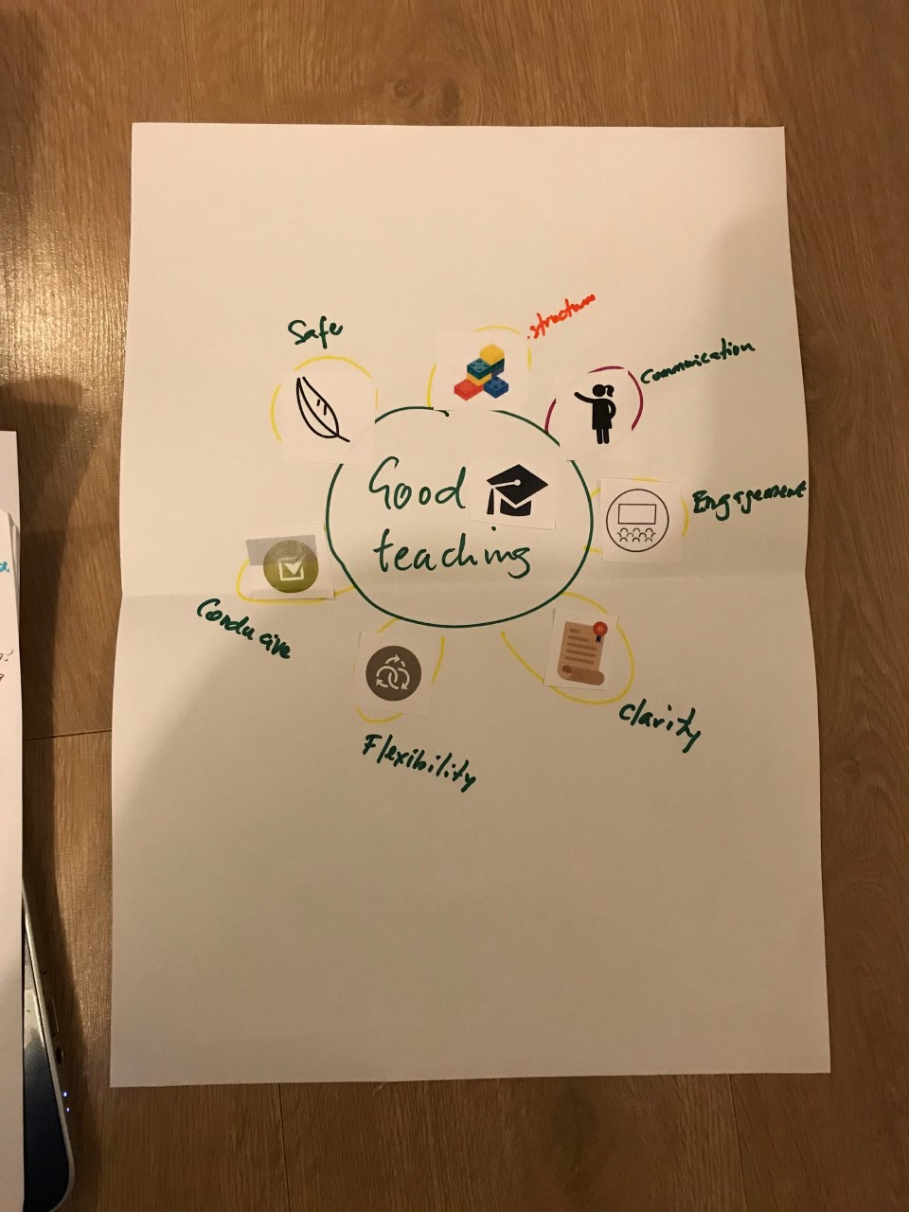

In this infographic the ‘graduation mortarboard’ (of good teaching) was comprised through a synthesis of structure, engaging and clear communication, flexibility, and a safe environment “where self-expression is encouraged” and “everyone can contribute as much as they want to without feeling intimidated or left out”. (Jen points out here that in some subjects, with difficult topics, “you may trigger your students, because they may not feel safe because of their own personal studies”; and “whose safety do you prioritise in the classroom?”).
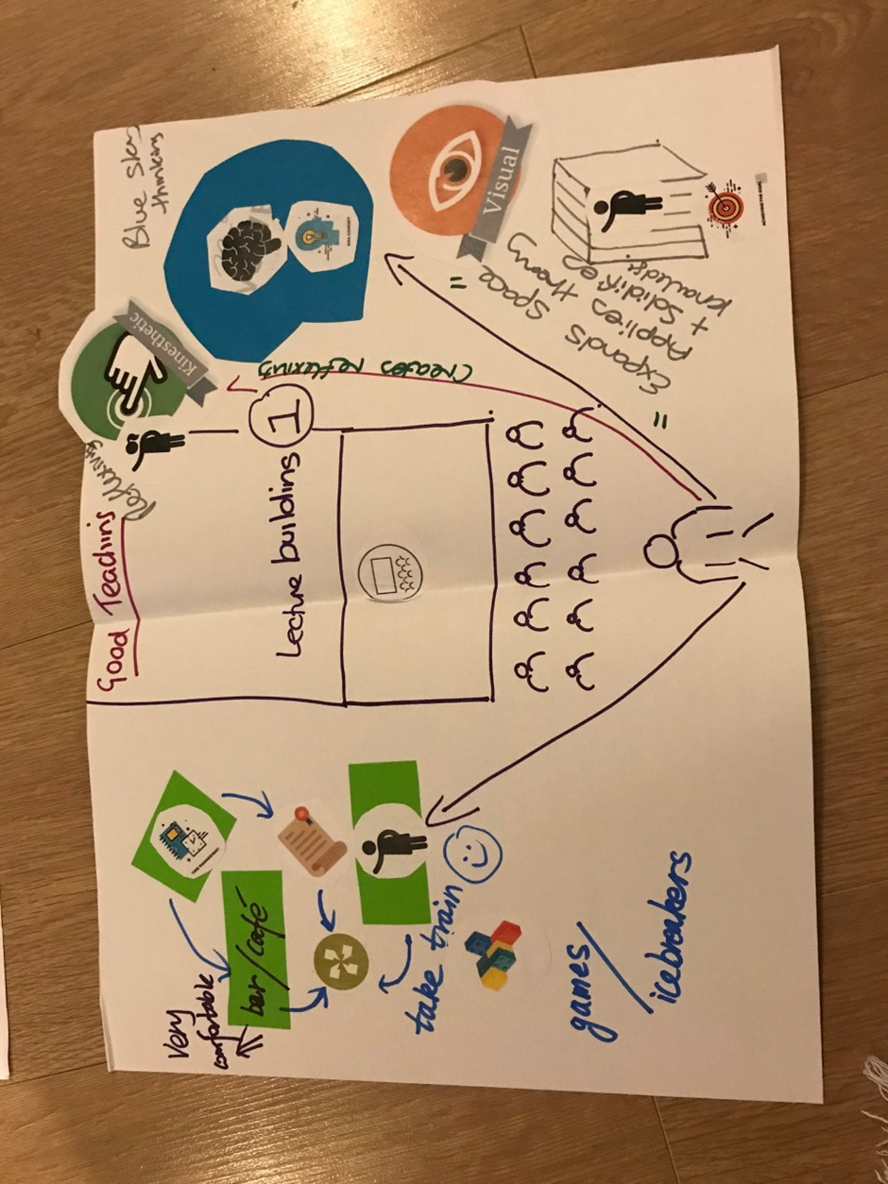

This second example represented examples of good teaching, conceptualised through ‘space’. The traditional idea of teaching (a lecture theatre with one person “speaking at people”) is depicted in the centre of the infographic. This was contrasted to “good teaching is where you can take the walls away and create reflexivity in the student, where they can think bigger and actually connect the theories and ideas”. The students commented that “visual experiences can create the ‘big thinking’”. The cage represents one of the participant’s teachers lecturing on Weber for an hour in a cage, “I remember every stage of that because I felt trapped”. On the other was an example of leaving the classroom, taking a train, and entering a café to talk with research participants to engage them in the student’s work. Safety was a theme that emerged across both infographics – feeling safe within the classroom, and comfortable enough to take teaching beyond the classroom.

2.2.5 Critical, reflective commentary
Building a discussion around what being a good teacher includes also gives space to consider what a good student is. Most students will be able to engage with their own memories and experiences of good (and bad) teachers, and this can be a starting point to explore your own values and philosophy of teaching. Recognising what good teaching looks like also allows the implementation of a pathway towards gaining those skills in oneself. In the PGCHE that is run at Kent, one of the first exercises in the first module is designed with this in mind, as it asks students to work in threes to tease out their own memories of good teaching. One student is interviewed, another asks the questions and the third takes notes which are given to the first student to form the base of part of an assignment for the course. The exercise in this workshop is a stand-alone activity designed to facilitate a similar kind of discussion, as the students worked in small groups on a combined infographic that they would later share with and explain to the rest of the group. The students were provided with a range of art materials, and given a few examples to demonstrate the different types of infographics that have been used in research and marketing. Infographics are a powerful took when it comes to research dissemination, and this activity also allowed the students to practice a new skill that they could use within other contexts.

2.3 Troubleshooting teaching

2.3.1 Session description
Led by Jennifer Leigh and Jo Collins
Teaching is not always trouble-free – what do you do if your students aren’t preparing? Won’t talk? Talk too much? How can you ensure that your teaching is engaging, stimulating and fun? This session is aimed at troubleshooting teaching. As such, it will be suitable for anyone involved in teaching whether that is in labs, seminars, or lectures. There will be opportunity to discuss problems, feedback solutions, and learn ‘tips of the trade’ to help engage and educate students. There will be a practical hands-on approach to equip postgraduate teachers in dealing with difficult or challenging students.

2.3.2 Resources
Lego
Any useful signposts for classroom challenges: e.g. differentiation, student engagement, communication
Flipchart paper
Pens

2.3.3 Lesson plan
Timing | Activity | Aim
10 mins | Introduction to class  Introductions from students  Elicitation of challenges participants face
10 mins  10-15 mins | Build your teaching challenge in Lego.  Explain model to the class (depends on group size – if group is larger (i.e. 15 plus), then the teacher should circulate and students should work as two groups. | To elicit their challenges (this can be recorded on the board or on a document projected on the screen to be returned to at the end)
10 mins | On separate whiteboards, or pieces of flipchart paper:  - What is a challenging student?  - What’s an ideal student? | Individual thoughts leading to group discussion. Students take a pen each and write their thoughts on the board.
5 mins  10 mins | Are the qualities that different?  How do you change a challenging into an ideal student? | Reflect on thoughts so far to think about what could happen in teaching to mitigate challenges.
10 mins  10-15 mins | Rebuild Lego model – how can I deal with my challenge? What will my classroom look like?  To explain model to the class (as before, optimum organisation of this depends on group size). | The aim is for students to build a solution to the problem they described earlier in the workshop.
25 mins  15 minutes to discuss, 10 minutes to present | Optional: in groups of 3, design an activity that could be used in one of your challenging classes. | One aim of this activity is to continue to develop solutions to the problems faced by those in the room. A secondary aim is to facilitate discussion, and build a sense of community among the group, so that they realise that many of the problems they face are common to HE teaching and not unique to them.
10 minutes | Q&A with teacher (if time) | As students may face more than one problem, or questions raised by earlier activities, this time allows for integration and full discussion.
5 minutes | Two stars and a wish for feedback | This activity models a simple and effective evaluation technique.

2.3.4 Descriptive commentary
The workshop begins with introductions from students and a short description what they hope to get from the session. This included understanding how teaching works at this University compared to other contexts such as in school or further education, student engagement, managing student anxiety in the classroom, and anticipating challenges before starting teaching.

2.3.4.1 Teaching challenges
Students are asked to build with Lego® and animals the issues that they have in the classroom, or an issue that they have seen as a student, or what they anxious about. They have 10 minutes to build the situation individually.
Challenges included distance from teacher through lack of understanding, keeping dry topics exciting, and similarly a maze with one person trying to find their way through to another:

Student
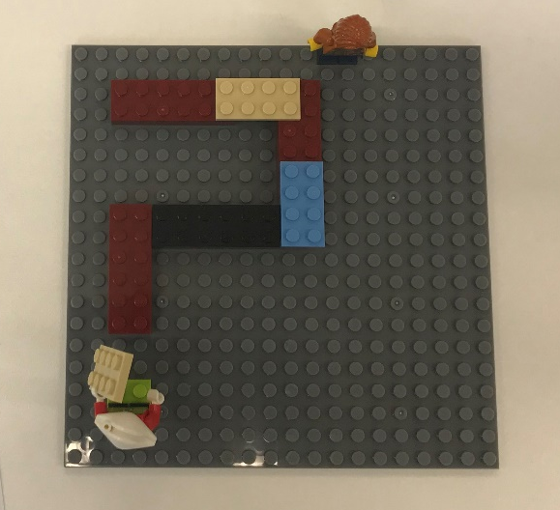
How do I reach my student?
Teacher

Here “one person is trying to get through and figure out the gaps to get through to another and the other person is trying to go to the other way. We [teacher and student] are both trying to figure out at the beginning what it is we are doing and how we are going to do it”. One participant highlighted the difficulty of students “all wanting to be my mate” (the fist bump), juxtaposed to the “elephant in the room” which is that no one wants to speak. “For me it is the worst thing ever to be facing that amount of silence”:
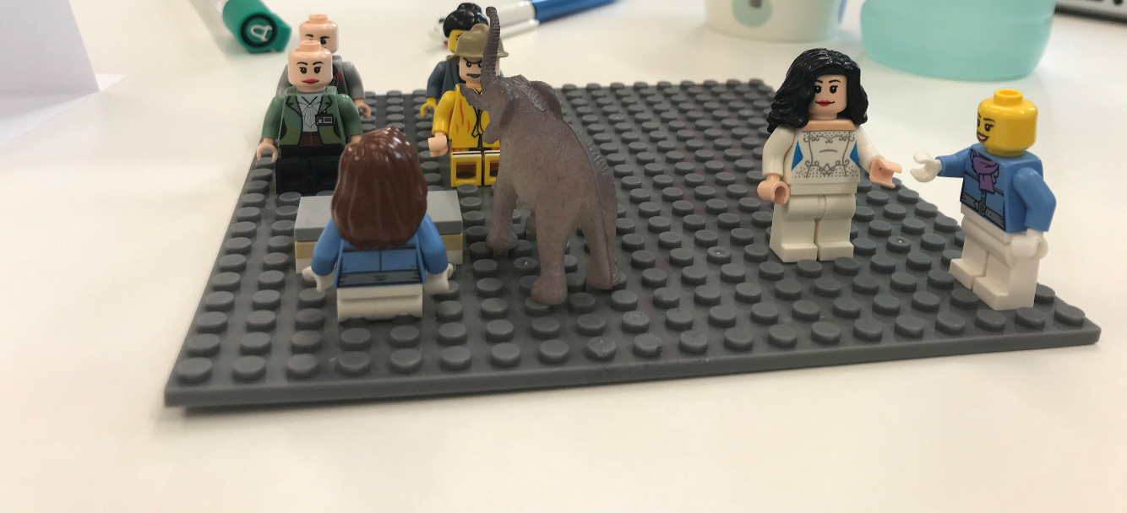
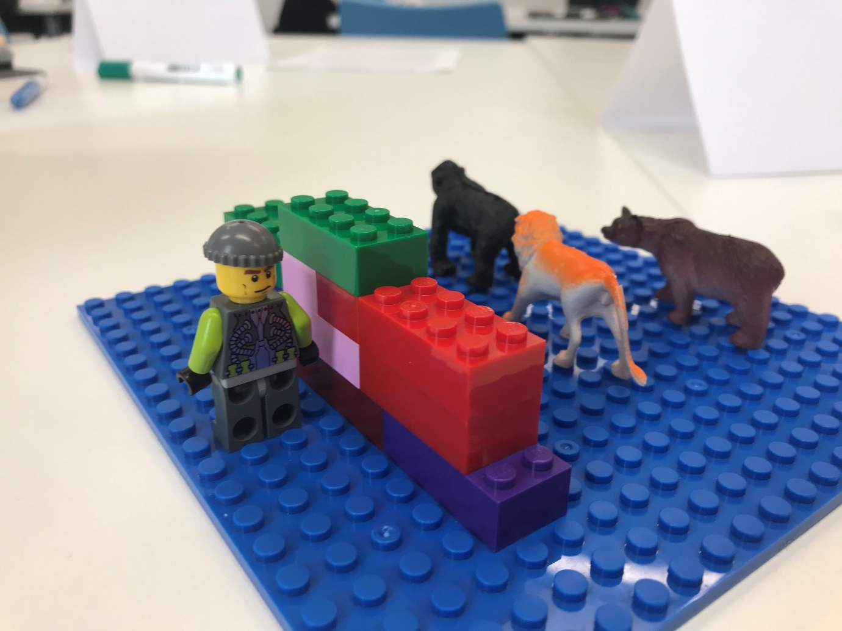
Another participant described not wanting to experience classroom bullying or hostility: “The worst thing that I have seen happen is that all the very ferocious animals kind of teamed up in a gender class and attacked a male student who was more or less trying to learn how to struggle to voice his opinion. He just never came back to class.” Another participant described anxious students: “students [are] constantly e-mailing constantly, like freaking out over assessments. I had someone who broke down in class the other day and had to leave. […] I guess I've made my bed a little bit because I said I was available to help and [answer] emails […] But I didn't anticipate quite how full on it was going to be”. (Jen and Jo engaged this GTA in a discussion about where sources of support for the GTA and the students might be). Two international GTAs talked about concerns around the teachers’ authority in the classroom, one said: “In Thailand, normally the teacher has high respect to the teacher, and this represent to me that they always believe and respect everything I taught them, no argue, no discuss with us after the class.”
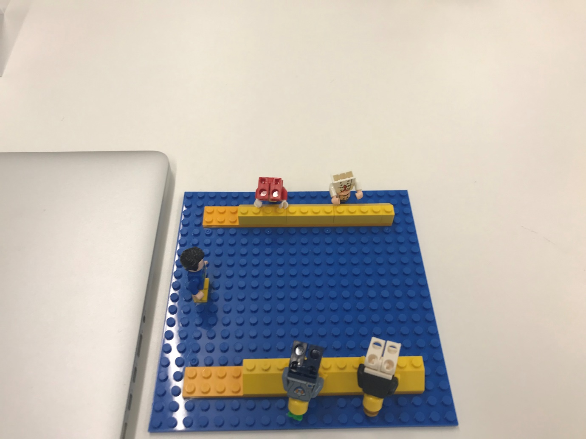
Another issue was communication: “I’m a little too abstract […] and they are all standing on their heads, a little confused at the next step in philosophy, as it’s perceived by some people to be a very very loose free thinking, where you can believe whatever you want, rather than one where you have to justify everything you say and do the crunchy logicy side. So my concern is getting people across that first bridge is the trickiest bit.” (Here Jen and Jo talk about Threshold concepts).

2.3.4.2 Challenging and ideal students
The participants were invited to use two whiteboards to record and discuss the qualities that they thought defined a challenging student, and those they thought defined an ‘ideal’ student. It was suggested that they could consider how ‘generalisable’ challenging and ideal qualities were by discipline.
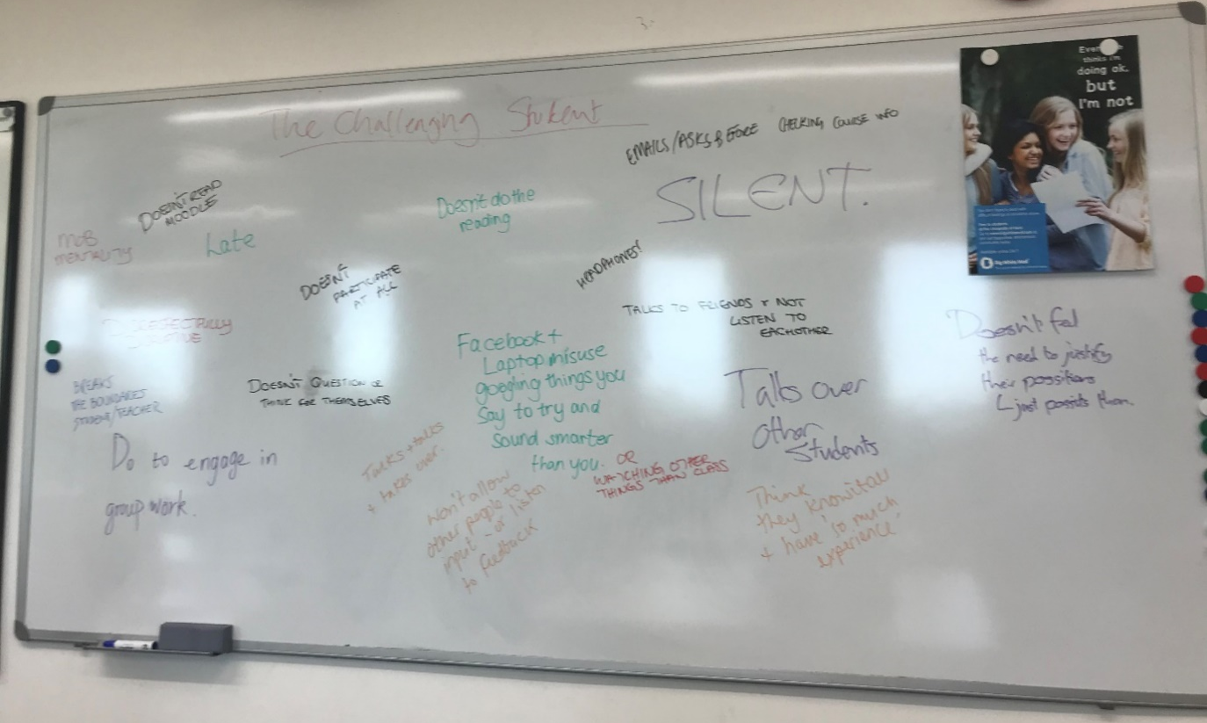

The challenging student might be one that doesn’t engage, or one that is dominant, one that questions the credibility of a PhD student as a teacher “I can’t believe that I have a PhD student teaching me, how are they like, experts?”. Communication appears here with talking too much, dominating, or talking over others or being silent, talking to assert a position without justifying it.
Meanwhile, the ideal student was able to talk considerately and courageously sometimes, pulling people into activities. A couple of participants pointed out that the enthusiastic student asking for extra reading might be problematic for PhD students teaching a module who might be “starting from a slightly educated blank slate”, or “learning as they go”. The class discussed whether different disciplines approached learning in different ways (being more directive, or giving students free reign to search out resources), and the function of and boundaries distinguishing a lecture and seminar (particularly in terms of the activities and preparation of GTAs). Asking students to move around the classroom was also discussed in terms of bringing students together into new configurations to talk to each other, and what to do if resistance is encountered.

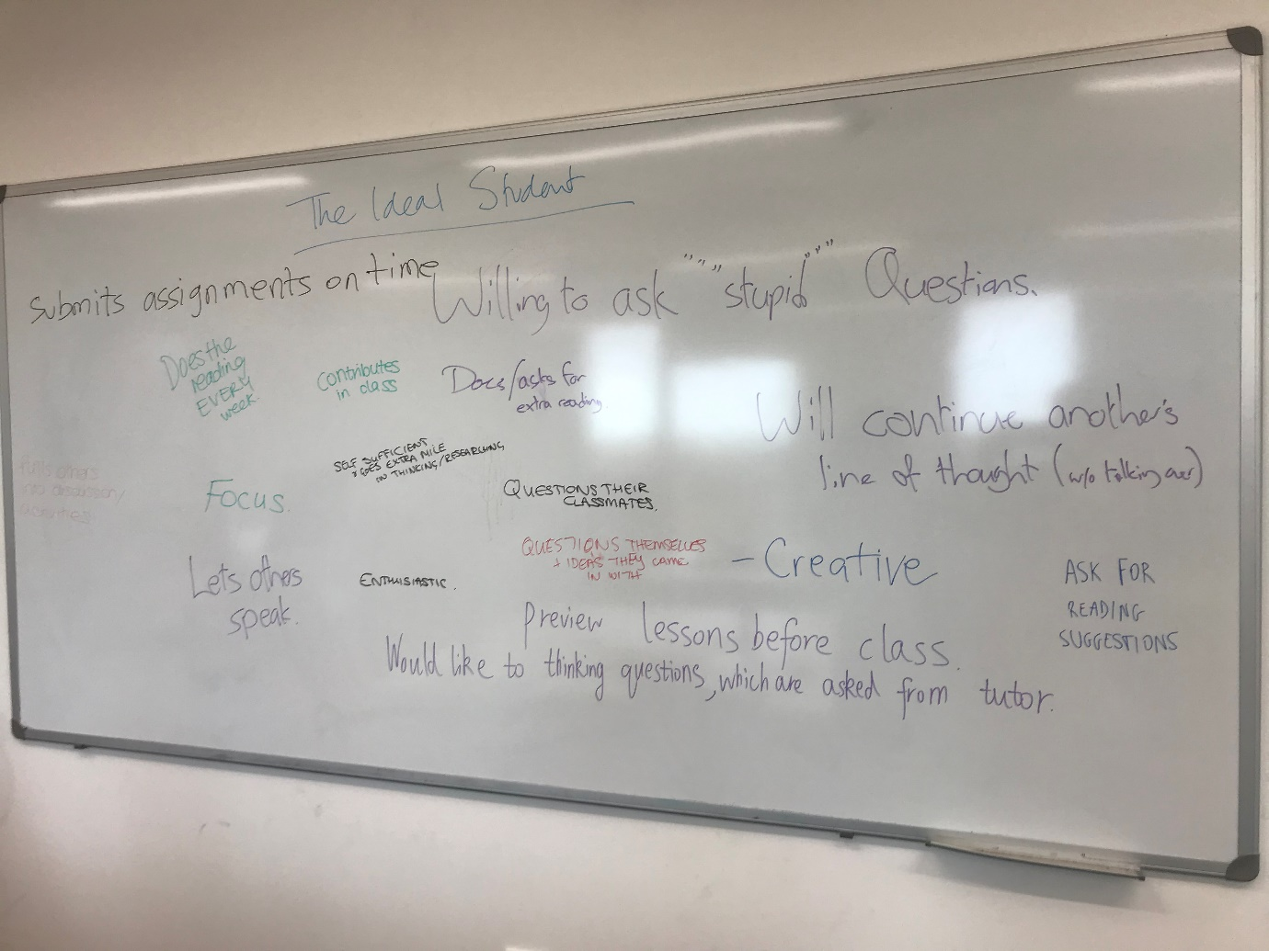
The class considers how a challenging student can become an ideal student? Here the limits of the challenge were considered:

GTA1: “In Philosophy If you have a student who asserts and isn’t good at justifying their opinions then challenging them back is usually a good way to get them pausing and thinking a bit more”.
Jo: “How do you frame that challenge?”
GTA1: “Most of the time, I just ask “why” and frequently there is one thing that could be logically wrong with it […] and that’s them having to deal with the just because it is intuitive doesn’t mean it’s right?”.
Jo: “Does that “why” challenge work in other subjects?”
GTA2: “I always have a fear of pushing them too hard and making them not talk again and so I always get the other students to talk. I always worry that if I challenge them too much then they will hide away and not come back out again.”
Jen: “You can always open it out to all students, so you can say “here’s an idea, why do we think this is?” and we can open it out to all people, rather than that one person having to justify their ideas”.

A lot of challenges are around engaging students and making them engage in their own learning. How do we get them on board? Engaging students through active learning, communication, and building a rapport can shift challenging students into ideal students. Some students are challenging because their specific needs are not recognised or accommodated.

2.3.4.3 Activity to engage students
The participants are instructed to work in threes to create an activity to get their students involved and engaged: what can you do to make them be an ideal student? It is suggested to them that they can work with people that they talked with in the board-work exercise, rather than people they are sitting with. They are given the option to use paper and pens. They are told to, in designing this activity, think about how they can do it, and how they can break down that activity to be as engaging as possible.
After 15 minutes participants are invited to talk the class through the activity and describe what their ideal and challenging students would get out of the activity.
Groups 1 and 2 describe getting students to work in groups, Jen asks: “so why does putting people in groups work well?” GTA1: “If someone’s a little less confident speaking out in front of the seminar it’s easier for them, and if someone is talking overmuch then there’s less of an impetus for them to perform for the class if they are in smaller groups.” GTA2: “It also helps the class know that the students learn by them, not just the teacher.” They also explore what might be done if a student was disrupting this arrangement (teacher checking in on groups and seeking to deal with it in the group setting and if this didn’t work, dealing with the student individually.
Jen: “so what are the different ways that you as a teacher can handle putting people into groups? The first is that you sit and you ignore them. Give me a couple of others.”
GTA 1: “Walking round and helping each group, give them something to think about then go and come back.”
Jen: “Another approach?”
Jo: “You could leave the classroom.”
GTA2: “They feel more responsible that way.
Jen: “What else could you do as a teacher?”
GTA3: “Mapping what they say on the board.”
GTA4: “Go round and not participate. So they know you are listening to what they are saying, so they have to talk.”
Jen: “What kinds of things would you take into consideration around getting the group to present back?”
GTA3: “Time.”
GTA2: “Group size.”
GTA1: “If we get them to branch off into different perspectives and methods then getting them to present back gets them to take into account where they overlap and wouldn’t.”
Group 3 worked through an activity of a debate, but instead of getting each group to ‘represent’ a topic and thus potentially a problematic view, to have participants in the group to summarise both sides of the debate, and come to the class with both sides of the argument prepared, so they couldn’t just articulate what they believed. Jen comments that it is important to know your students before you set up that activity, and asks “if you are pitting two positions against each other are you giving them both the same weight and saying they are as credible as each other?”.
On the subject of dealing with disagreement and controversial views:
GTA 5: “Does it depend potentially on where the expression of he is coming from. So I feel like it would be ignorance, interpretation or malice. And depending on what your assessment is of where that is coming from, if it is ignorance you can talk about why people might think this way, if it is interpretation, you might have to brush over it with “well you know everyone has their views, and we’re going to have to agree to disagree”. But that depends on how controversial the topic is. And if it’s to do with malice, then I think that there are big problems there and de-platforming is an option. […] If you have a module with controversial topics you can set limits by saying “we are dealing with a controversial topic, everyone may have their opinions on this, but we need to express our views in X, Y, Z kind of way. And also reflect back on yourself and say if you notice me breaking these ground rules then I would want you to challenge me”.

2.3.4.4 What have I learnt from this session
Students change model or build a new one to represent how they will take what they have learnt from the session and incorporate it into their teaching to understand their challenges. A couple of examples of students’ models are included below:

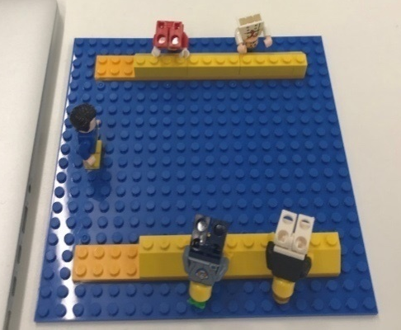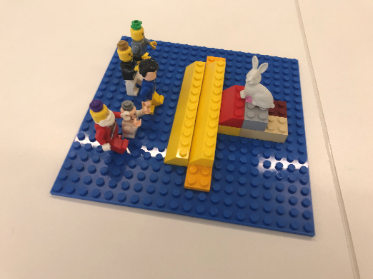
“So I started off with my students all very confused and inverted by the abstract problem. So I have decided that I'm going to try to take baby steps without getting through those threshold concepts. And it’s going to be a staircase, because those baby steps get you closer to the white rabbit in philosophy and then you start following it down rabbit holes, which is when you start thinking like a philosopher and you can’t help it anymore.”

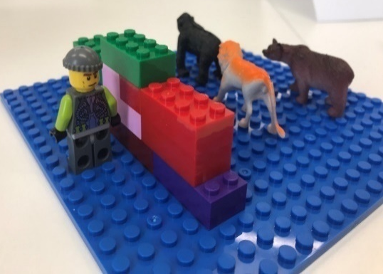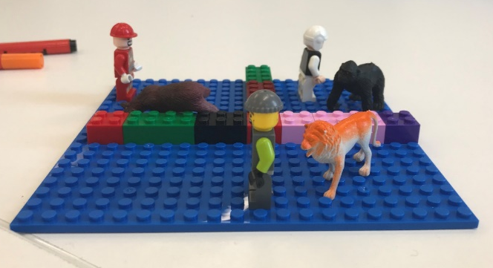

“So putting up some boundaries between the louder animals of the group and pairing them with people that they wouldn't normally sit with or at work and not necessarily allowing them to then ping pong off each other So putting little walls between the groups.”

A number of examples explored how group work might also address various difficulties they had explained initially. Jen: “It was really noticeable that you had taken the teacher out and you had moved off the pedestal and to where the students were.”

2.3.5 Critical, reflective commentary
Although this workshop did not state on its aims that it was modelling teaching techniques (as in Nicole’s workshops), as can be seen from the above plan and transcript extracts this is what Jen and Jo did. The activities were designed to model activities that could be used in class to engage students, from the whole group exercise pulling out concepts of the ideal teacher and ideal student, were each person who talked was also asked to choose the colour they wanted their statement written on the whiteboard, to the small group activities, and the use of Legos so that the group could literally (and metaphorically) see their problem and map a path to the solution. The workshop used a number of other strategies such as asking students to physically move around the room between activities and to from different groups, to breaking up the time into smaller chunks that were contained, and yet built into the whole. In addition, as can be seen above, Jen and Jo both ‘dropped’ theory and pedagogical approaches into the discussion where appropriate, so that the group could make the connections between theoretical ideas and their practical applications. Such work helps GTAs to connect what can seem like abstract learning and teaching theories to the practical reality of the classroom. Jen and Jo did not set out with a plan to introduce the group to particular teaching theory, and were led naturally by the problems the students presented and the discussions they had on the day. That said, the problems and situations described by the group are common. Other common situations teachers can face along with a lack of engagement from students can include anxiety, dealing with students’ additional needs, a lack of preparation, de-railing, and difficulties finding an appropriate relationship or rapport.

2.4 Work-life balance

2.4.1 Session description
Led by Jo Collins.
Preparing, teaching, and marking can take a lot of time. How do you balance this with PhD commitments and a healthy work-life balance? Where do or should your priorities lie? How can you be a good teacher, a good researcher and not burn out? This session will give the chance to discuss how to combine aspects of a GTA workload, along with practical input and advice. There will be a practical hands-on approach to equip postgraduate teachers in managing their time and workloads as teachers.

2.4.2 Resources
Lego or Wheel of work and life
Pens and paper (A3 or A4)
Youtube video on bullet journaling: e.g. https://www.youtube.com/watch?v=fm15cmYU0IM&list=TLPQMjcwMjIwMjAAJ5yg66uAqw&index=1
Durham’s website on PhD student wellbeing: www.thewellbeingthesis.org.uk
Post it notes
Steve Covey’s Urgent versus Important Matrix
(Optional) – Carson Tate’s Productivity Quiz

2.4.3 Lesson plan
Timing | Activity | Aim
10-20 mins | What is work-life balance?  - A) What is good work life balance?  B) What is bad work life balance? Both ends of the see-saw. Interrupt at 10 minutes – what is the tipping point?  - How many hours a week do I work? | Discussion  - What can we do (record hours)  - Join Union  - Allocate specific time slots to particular activities – timing making essays. Be careful around office hours.
25 mins | What does your work-life balance look like now?  Fill in the wheel of work and life (15 minutes)  Compare results (10 minutes) | Consider what aspects of life are prominent or neglected in current schedule
25 minutes | What do you want your work-life balance to look like?  Drawing – what are the essential elements? How much space do they have in your life? | Visualise a possible improved future
30 minutes | Tools and activities for work life balance  - Wellbeing thesis – taking breaks.  - Wellbeing thesis – debunking myths – you have to suffer, you owe your supervisor something  - Talk about productivity – and how this is a problematic concept.  - Time matrix – urgent versus important  - 24 squares – how do you spend your day, what could you change. Isolating distractions. Permission for non-productive time  - Bullet journaling. (Video from Youtube) | Consider what tools and activities might enable achievement of goals
20-30 minutes | How do you get from where you are now to where you want to be? What tools could you use or changes could you make. Build a bridge between the two. | Transform reflections into a plan for future actions.

2.4.4 Descriptive commentary

2.4.4.1 Work-life balance
In this section we explored how participants experienced and characterised good and bad work life balance. This included what happens when work life balance is good and what life is like when work life balance is bad. After 10 minutes, Jo asked participants how they understood the ‘tipping point’ – what begins to happen when good work life balance becomes bad work life balance. All of these were using post it notes and attaching them to a poster on the white board, so participants could move around and comment to each other.

One participant describes good work life balance as demarcated, free from pressure:

So you’re delineating it, you’re not just feeling that you have to nip in and do a bit of work, […] I set aside that time to do it in that time and I don’t feel under any pressure.

Bad work life balance was associated with pressure, different activities running into each other and feeling overloaded:
I think it’s the prep and the reflection afterwards, to be able to stop and reflect. I think that’s actually quite key for me to, I have just noticed that I am just charging to the next thing, and I do think I should take the time to stop and reflect.

One participant also noticed that time needed to be factored in to switch between cognitively heavy tasks:

Because my mind only focus on this project [so…] when I go to switch from one project to another project it takes me a long time.

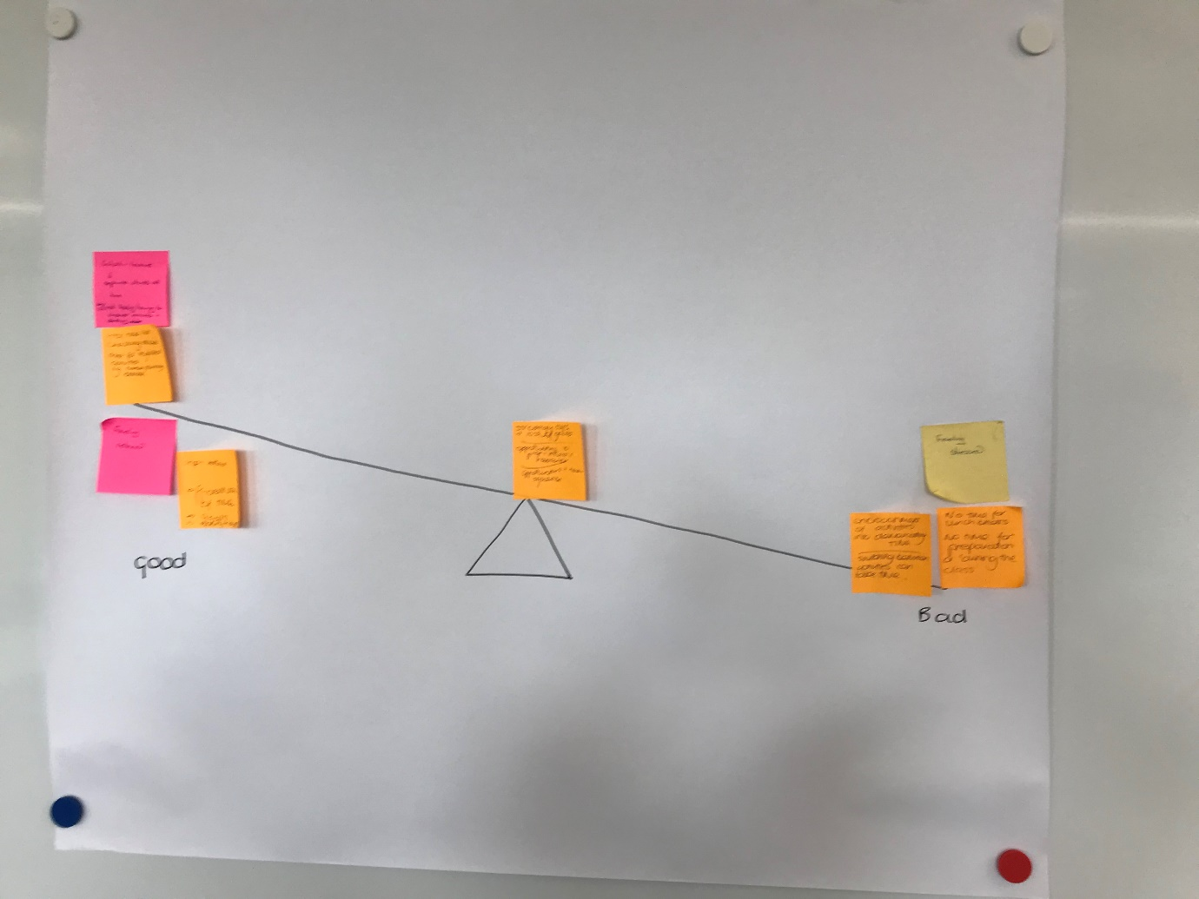

It was also key to talk about how many hours participants worked a week, and seek to deconstruct myths around overworking, particularly the idea that the more hours that are worked simplistically equate with ‘progress’. The Wellbeing Thesis was a useful resource for this, as it draw out the importance of breaks:

I work all through the weekend. Because my research is varied, I have to do a lot of the thing for it, I have a lot of responsibility and the supervisor has recommended me for publishing a paper and er, therefore I’m under pressure to conduct my PhD project in the best way and finish it as soon as possible.

Jo: But it’s interesting the train of your thought there, behind it there is “I must be doing my research, I must be doing my research.” But what are the trade offs? If I do an hour’s yoga, well maybe I come back [refreshed] or maybe if I do it on my own in the morning to a video or something before I start working, then maybe I feel a bit better about sitting down and doing it […] research shows significant benefits of taking breaks: reducing stress, maintaining performance throughout the day, and reducing the need of the long recovery at the end of the day.

2.4.4.2 What does your work-life balance look like now?
In this lesson participants completed a Wheel of work and life (see diagram). Another option is to ask participants to build a model of their work life balance in Lego and explain it to each other. Here participants were given 15 minutes to complete the exercise. This included 3 stages:
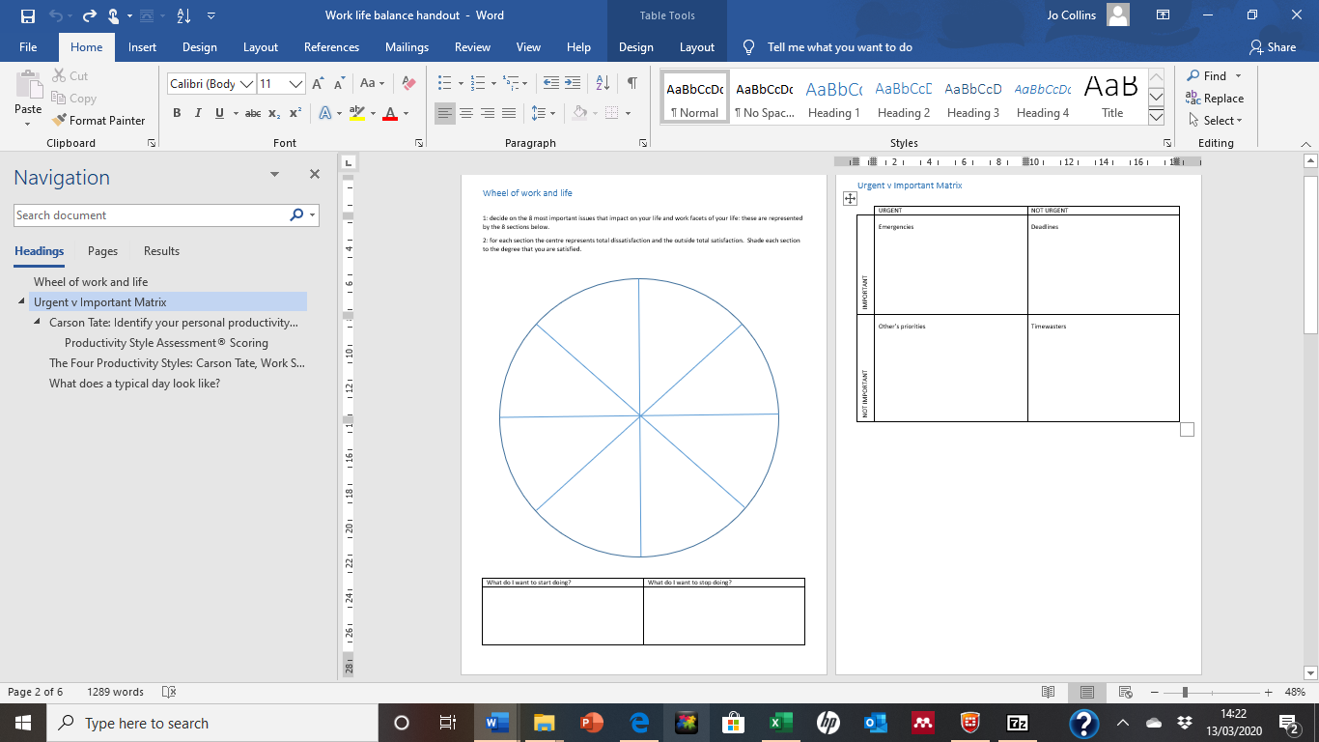
- Participants need to choose 8 areas of their life which are important to them. These are then represented in the eight segments of the circle. Suggestions might be: family, work, teaching, exercise, research etc.
- Participants then need to decide how happy they are with these eight areas of their lives. This can be achieved by deciding and mark the segments with rankings from 0 out of 10 (not at all satisfied) to 10 out of 10 (couldn’t be any more satisfied). Participants can also represent this visually by shading these 8 segments, each with a different coloured pen. For example, if it is an area they are not satisfied with, then there would little shading. For an area they are very satisfied with then most of the segment would be shaded. They can use their rankings to determine the scale of the shading in each segment.
- After this, participants can reflect on their scores, and/or on how ragged or even the line is around their circle. So for example, the lower rankings show areas demanding attention. Alternatively, if the circle is ragged, this gives participants a sense of which least shaded areas of their lives need attention.
- Participants can then use this exercise to decide what they want to do more of, and what they want to do less of in terms of future work-life balance.
- Finally, participants can compare and contrast their results and comment on anything of significance to them.

In this session participants identified how research time was at the expense of other activities:

research is actually quite low, I just sort of feel it sort of dominates, and most evenings I spend perhaps an hour on it, and I think, part of it is things like this where I say ah I’ve got a two hour session and I end up working in the evenings to almost make up for that.

I have no time for the gym. [But] if I can work it sometime with the gym and the sport I think it is much much better.

2.4.4.3 What do you want your work-life balance to look like?
This segment of the lesson is about visualising what an ideal work-life balance would look like. Again this might be built in Lego. Or it might include a drawing. Prompting questions might include:

- What does your ideal work life balance look and feel like?
- What is happening? What is not happening?
- What are your thoughts?

For one student, this exercise prompted reflection on the idea that the PhD is a journey rather than a final destination:

The other thing is your PhD is a snapshot. And afterwards you do more. That’s our life journey isn’t it, we improve, we get life experience so our PhD is never going to be our best piece of work, as it’s right at the beginning. It was really good to know that.

2.4.4.4 Tools and activities to enhance work-life balance
At this point current and ideal work-life balance are laid aside, and there is a discussion of different tools that can help with time management. These could include:
- Covey’s Urgent versus Important Matrix
This puts the onus on distinguishing between tasks that are urgent (often because they are unexpected) and tasks which are important goals (which are important to us, but end up slipping down the priority list).

Here students can be asked to fill in their own matrices, to encourage them to identify what things are urgent and important to them, compared to what things might be urgent and important to other people (thus ‘not important’ to them). Making this distinction and identified other’s priorities means that some tasks might be moved out of the urgent and important quadrant and down the list of priorities. The other thing this exercise gets people to do is identify time wasters – tasks that are not important and not urgent. Finally it helps to identify important goals. Here it is possible to identify things that have been de-prioritised, and is whether prioritising one of these would make a big difference to the participant.

Carson Tate has a quiz which identifies different productivity types. This can be useful for a discussion on productivity and what that means to PhD students who are teaching and researching. This can help deconstruct an idea that PhD productivity is related to words on a page or outputs rather than a more holistic sense of development. The results of our GTA survey also showed that people who spent more time preparing teaching felt more pressured, so this is also an interesting prompt to discuss how much time should be taken to prepare teaching, where boundaries might be drawn and where help might be sought.

It might also be appropriate here to consider project planning tools such as Gantt Charts, or Critical Path and whether having a more long term view of the PhD project may change how participants feel about time management.

2.4.4.5 What tools can I use to get from my current work-life balance to my ideal-work life balance?
In this session participants annotated their drawings of ideal work-life balance with what they thought they wanted to concentrate on after the session.

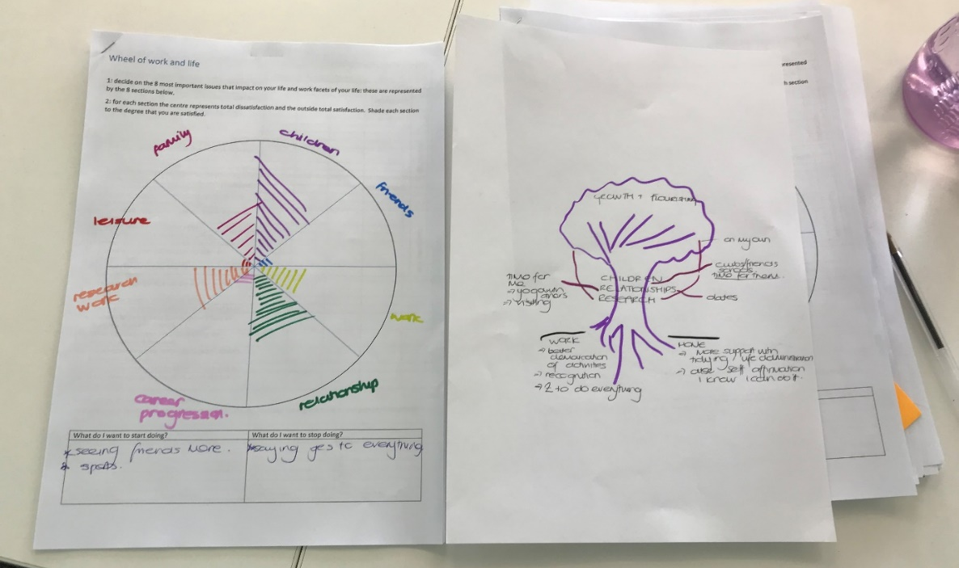
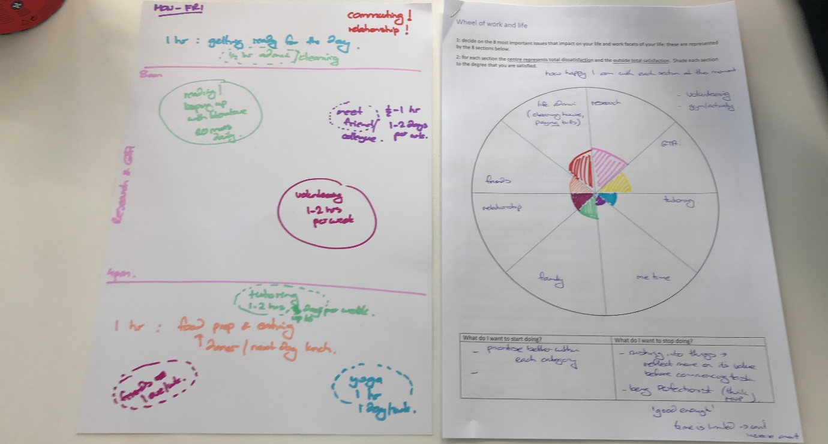
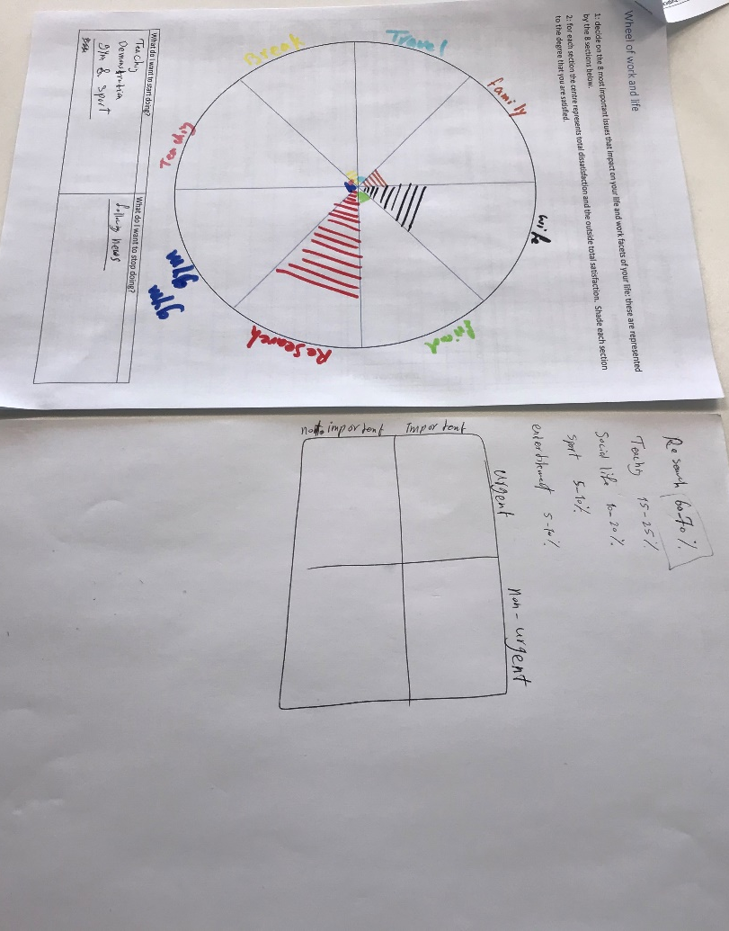If Lego® models have been built then a separate piece of paper can be used to note significant tools and commitments to take away from the session to reflect on:

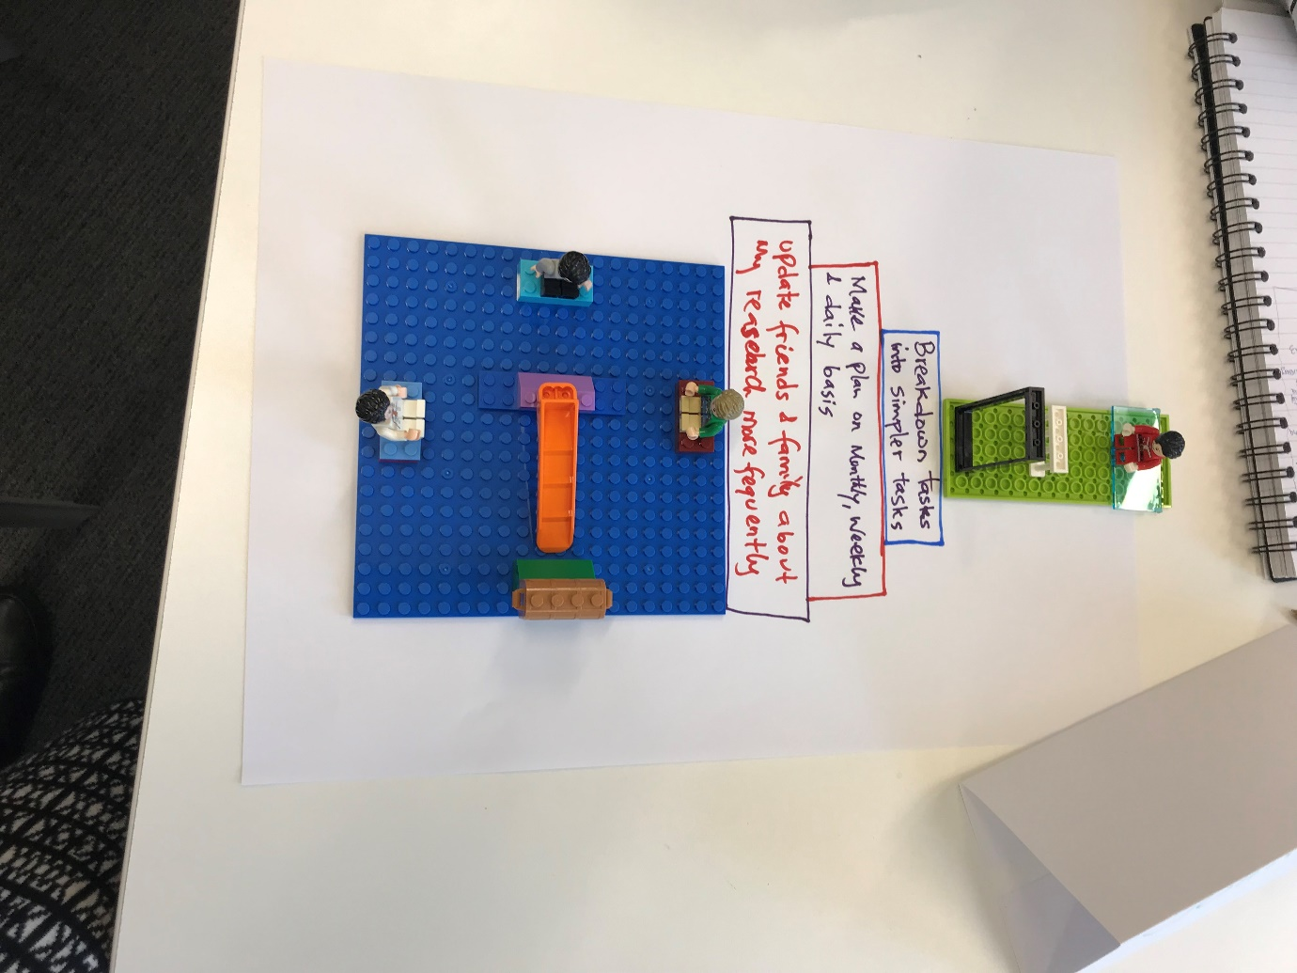
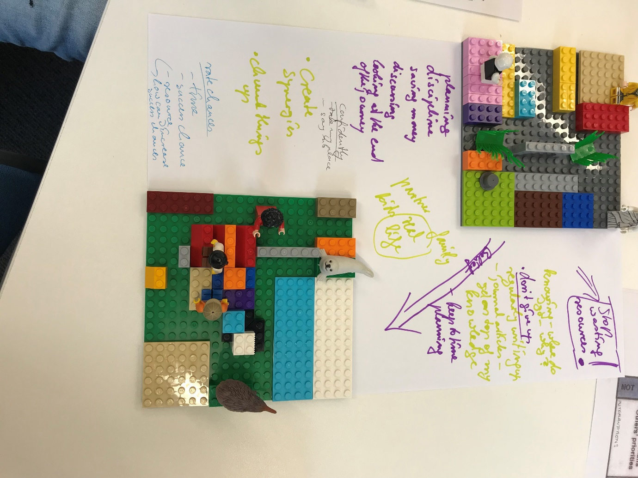

In this session participants’ take-aways were around productivity, and accountability for time:

Therefore the research should be maybe more than 50, 60% of my time should be my research but I should increase my productivity during the time, when I work for 2 hours it should be much more productive, I should use my time much better, it can be one solution. I cannot extend the time, but I can extend the quality of the time, quality of my work.

if you have issues with lists those whiteboards can work […] I love that, off it goes and there’s no line to remind you of the stuff that does build up.

2.4.5 Critical, reflective commentary

The inspiration for this workshop came in part from coaching techniques and in part from our own experiences as academics in UKHE. Gallway’s The Inner Game (2015) asks us to notice how we often berate ourselves for perceived failures: self 1 rebukes self 2, e.g. “you have wasted your time today haven’t you!”. As an alternative, Gallway (2013) counsels ‘getting it together’ by firstly having a distinct vision of what you want to achieve, secondly, learning to ‘trust yourself’ to perform optimally and, thirdly learning to see actions without judging them as good or bad. The workshop activities visualising future work-life balance were very much around “getting the clearest possible image of […] desired outcomes” (2015, 42). Whitmore’s GROW (2017) provided the template for our activities. We adapted the model of Goal setting, exploring Reality, Options and finally Way forward to start with ‘Reality’, setting a goal/visualising the future, and then devising a path to move from ‘reality now’ to a desired future. This reflective workshop sought to emphasise potential and possibility.

Another influence on this workshop was current work on postgraduate wellbeing. Our own survey of Hourly Paid Lecturers and GTAs showed that (from 19 HPL responses and 65 GTA responses) those who devoted 41-60% of their time to teaching, were more likely to cite time pressure as a challenge than those who devoted 21-40% or the few who devoted 61-80% of their time to teaching. A speculative interpretation of this is that the tipping point where time management becomes time pressure is between 21-40% time allocation (time is managed) and 41-60% time pressure (time becomes pressure). Hughes and Kirkman’s (2019) The Wellbeing Thesis, debunks PhD myths such as “postgraduate researchers should work very long hours”. Here, creative thinking techniques such as the Wheel of Work and Life (also a coaching tool) and Lego® modelling provide tools to reframe prevalent discourses of overwork in academia (Brown and Leigh, 2018) by approaching the topic metaphorically (Lego®) or laterally (Wheel).

We have run this workshop (or variations of it) for three years, most frequently as a co-taught session between Jo and Jen. When it came to planning the first iteration we were very conscious that our planning and arrangements for the session came in the gaps between our own academic work. We would meet for working lunches, where food was shovelled in alongside copious notes and planning. We would email and message each other at 11pm at night or 6am in the morning, fitting it in alongside everything else in our lives. On the day of the first workshop Jen arrived after a morning of harried back-to-back meetings. As such, we were very aware that we were not embodying a balance of work and life in academia. The culture of overwork and stress that is endemic in the academy (Thomas, 2020), coupled with the competition for jobs and precarity faced by many in early career roles, does not make setting a healthy balance of work and life easy.

What went well:
Receptiveness to using creative reflective tools to explore work-life balance and openness to the possibilities revealed by such explorations.

Even better if:
Greater focus on actions and the specifics of what might be needed to develop the future vision. Here working in pairs rather than a three or larger groups might be best.

2.5 Becoming a teacher

2.5.1 Session description
Led by Nicole Brown.
This session sets the tone for the series in that it focusses on what makes a good teacher, what we have to do to become good teachers. Activities will include group discussions and the use of visualisation and narratives.

2.5.2 Resources
Lego
Slide with questions
Paper and pens

2.5.3 Lesson plan
Timing | Activity | Aim
10 mins | Introduction to class  Introductions from students | To contextualise the theme
15 mins | Teaching task: what is the role of a teacher
25 mins | Lego building activity: what makes a good teacher | Short readings: getting students to work individually and then together
20 mins | What makes an expert teacher?  Snowball activity
30 mins | Visualisation activity: what teacher will you become
20 minutes | Q&A with teacher  Recap on previous activities  Which will they use in their own practice?
5 minutes | Two stars and a wish for feedback

2.5.4 Descriptive commentary

2.5.4.1 What is the role of a teacher?
Nicole starts with a question to the class in groups: What is the task of teacher?
She stops them after about 3 minutes – they have all written about areas of responsibility. The class are asked to consider “What can you do to enthuse your students?” and told to continue to add ideas as they are at the half way point.

2.5.4.2 Lego modeling
Nicole concludes the previous activity and asks students to grab Lego® bricks and bases, they are going to build a model of a good teacher. They are asked to think of a particular good teacher they have experienced. Specifically, students are directed to consider what it is that makes that person a good teacher. They are given a time limit of 15 minutes to build the model, with the instruction that once they have finished they have to discuss it with someone they haven’t talked to yet.

2.5.4.3 What makes a good teacher?
After this activity has concluded, Nicole elicits the key points to put on the board around the question of ‘What makes a good teacher?’ Is it about:
- communication of information?
- Engaging students? Challenging students?
- Managing the classroom
- Understanding students
- Pace?
- Professionalism?
- Ideas from the class: with a good teacher you shouldn’t be able to tell if they like the subject or not.
- A good teacher doesn’t necessarily have confidence, but they exude confidence, they assume it for the class. They pretend they own the place.
Nicole concludes that everyone brings something to the classroom.

2.5.4.4 Snowball activity
Students are instructed, to get into pairs and think of three things that make an expert teacher. They are given a time limit of 3 minutes for discussion and notes.
At the end of this time limit they are instructed to copy the three things down.
Each pair then joins with another pair to make a group of four. They then have to come to an agreement between the four of them about what makes an expert teacher in 3 minutes.
After this they make larger groups (in this case 6, people were paired with others they hadn’t sat with before).

2.5.4.5 Visualisation
Nicole asks the class to consider “How do we become an expert teacher?” This, she suggests, is “not about who you are as a teacher now. It’s about becoming that teacher. If you are an expert teacher how do ‘embody’/’be’ this?” Nicole suggests that students might want to look back on this exercise in a year’s time, to see this is how far they have come. Next she pulls up a slide with questions about the teacher identity they envisage themselves exhibiting and inhabiting:

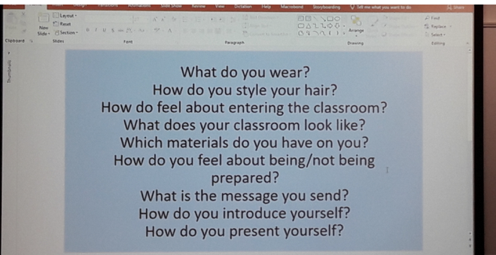
Other questions about how GTAs visualise themselves as expert teachers might include:
- How do you enter the room?
- How do you move about the classroom?
- How do you dress?
- How do you arrange the classroom?
- How do you address the classroom?
- What activities do you use?

Nicole frames the discussion by asking students to consider what might be done next in order to achieve the particular characteristics that have been examined so far. For example, “Can you start buying and wearing the kind of clothes you associate with the teacher personality you would like to embody? Could you plan how you enter a classroom and move about in the room? Can you start using some of these minor steps in your current teaching practice, already?”

2.5.4.6 Recap
Nicole asked students to pinpoint what activities had been used in the classroom. She add: “Which of these will be useful in your classrooms? What are the benefits of these activities, what are the drawbacks? Do they work in the room setting that you have?”
The activities had included:
- Discussion groups and then working with someone people hadn’t spoken to. This started with consideration of what are the teacher’s tasks, and then refined to skills.
- What does it mean to be a good teacher: Building activity with Lego®
- Working as a class to put things on the board to summarise.
- What does it mean to be an expert teacher: Snowball activity
- Visualisation
- Recap, considering advantages and disadvantages of the activities.
- 2 stars and a wish

2.5.5 Critical, reflective commentary
This session was planned with two main thoughts in mind: firstly, the session needed to be interactive and collaborative, and secondly, the session needed to provide significant stimulus for personal reflections as a starting point for learning. As such, this session was planned in alignment with the teaching strategies from initial teacher education, where educationalists often model how to deliver subject content (e.g. Hockly, 2000; Kyriakides et al., 2009; Utami, 2016; Couso and Garrido-Espeja, 2017; Körkkö et al., 2020). In current discourses of educational philosophies and pedagogic strategies, there is also a significant emphasis on collaborative learning (Koivuniemi et al., 2018; Le et al., 2018), problem-based learning (Major, 2018; Bridges, 2019) and co-construction (van Schaik, 2019; Vuopala et al., 2019). These basic principles are not at all new, but date back to educational philosophers and theorists like Dewey (1916), Schön (1987), and Lave and Wenger (1991).

With this in mind, it was important to start the session quickly with content and to focus on the classroom as a locale for joint learning for everyone present, including the presenter.
Although the focus of the session was entitled "becoming a teacher", the session really was all about instilling confidence in individuals: confidence in themselves as learners and teachers, confidence in their personal abilities and knowledge, confidence in each other's abilities and knowledge and confidence in the value of every person's experiences. Irrespective of educational upbringing and experiences, every person has an opinion on what makes a good or bad teacher, and therefore this session really was about teasing out the key messages and characteristics and providing tools for how these may be achieved in the long-term.

Through modelling, the session also highlighted a rather fast-paced delivery with the two-hour session split into shorter units of learning. Breaking down the contents in shorter segments means that learners' attention is captured even at times where there might otherwise be lapses in concentration. Usually, segments are between 15 and 20 minutes long. Activities with creative elements need to be allocated more time because learners need more time to settle down to the activity and to feel comfortable with the task in hand. The Lego and visualisation activities are quite a bit longer for that reason. The 30 minutes for the visualisation activity was unusually long, but planned in relation to the many questions that learners had to respond to.

What went well:
The visualisation activity worked particularly well because it took account of each person's own trajectory through education and cultural upbringing and educational experiences.

Even better if:
More emphasis on cultural similarities and differences.

2.6 Engaging students through Group work

2.6.1 Session description
Led by Nicole Brown.
Group work and discussions can take many forms, and in this workshop, activities will be presented to encourage group work and foster an atmosphere where students will contribute to discussions. The focus will lie on dealing with group dynamics through classroom management techniques and through using relevant technology.

2.6.2 Resources
Jennie Ingram and Victoria Elliott (2016)
‘How to lead a discussion’ Teaching Commons: teachingcommons.standford.edu
‘How to get students to talk in class’ Teaching Commons: teachingcommons.standford.edu
It helps this lesson if students are seated in groups of around 4-6.
Set up Socrative beforehand with a class number. If possible, have some pre-existing examples of activities to model.

2.6.3 Lesson plan
Timing | Activity | Aim
10 mins | Introduction to class  Introductions from students | To contextualise the theme  To reflect on previous class and signpost other support
20 mins | Brainstorm: experiences of group discussions and which activities have you done to get students to talk | A group discussion on group discussions: students begin to describe question what techniques they have used to facilitate group learning
25 mins | Ground rules for leading a discussion and getting students to talk | Short readings: getting students to work individually and then together
15 mins | Socrative and audience response systems
15 mins | Time to read article | Read article and then finding others to share knowledge of different parts of the article: using the classroom space
20 minutes | Q&A with teacher
5 minutes | Two stars and a wish for feedback

2.6.4 Descriptive commentary

2.6.4.1 Introduction
Nicole introduced the session by suggesting that the previous session was around how we think about ourselves in a classroom, this session was going to be begin with a focus on:
- How do we hold the space in a classroom?
- How do we lead a discussion when the students haven’t done the reading?

2.6.4.2 Brainstorm
- Nicole asked students are asked to write down activities that they have done in class to get students to talk. They are given a piece of flip chart paper, per group of 4-6, coloured pens, and asked to divide the paper into ‘good experiences’ and ‘bad experiences’. This makes a space for them to think things through, so they can genuinely reflect on their teaching.
- After 10 minutes the students are instructed to go through the experiences and note down what activities were happening at the time. (This also anticipates the next session which will look at ‘how can we mitigate the bad experiences by constructing questions differently?’).
Nicole asks students to consider: “For each experience; what happened before? What happened after? How? Why? What?”
For example, if undergraduate students don’t know about the subject: Why? How do they not know? What came next? This helps break down the reflections on teaching practice into experiences and what goes around it.
- After 10 minutes Nicole begins to elicit examples for the whole group to consider. One suggestion is “going off topic”. Nicole asks: “Is it bad?”, “In which way?”. It may be bad because module outcomes are set, but again they may be reached in the next session. Nicole asks – do undergraduates need to be managed because they are young? Do they understand the problem/work? How can we pose a question to check? The discussion elicits the point that if classroom is set up in such a way that you can move you are able to walk about and view their work. If undergraduates are writing things down you can see if they are going off on a tangent. However, we need to be realistic about what we can’t do, as this checking is not possible in a bigger class.

2.6.4.3 Ground rules activity
On each table the readings are placed face down (half the class should receive the text about leading classroom discussions, others about getting students to talk in class. If handed out alternately those sitting next to each other should be discussing different texts). Nicole gives an instruction to read the extract and talk in pairs about impressions of the argument, and “what it means to you in your teaching”.
After 5 minutes the groups are re-divided. Nicole nominates a student as number 1, another 2, another 3, another 4, and gives an instruction to the class to talk with the other students with the same numbers. At this point Nicole reveals that they have been given different texts. They are asked to consider: “What was the message of the text?”
After 5 minutes Nicole asks the students to go back to their original sheet of good and bad experiences. They have 10 minutes to do this. Students are instructed to “use the key points from the reading to discuss how we can remedy the situation described. Include any examples about turning a negative into a positive.” Nicole also makes a point about student engagement not just involving leading discussion, but relating to how do we ask questions in a good way to steer discussion back to what we want it to be.
Debrief: Nicole tells the class that she has modelled several strategies, she asks the students to tell her what these are.
The discuss pulls out the following points:
- To address the problem of not doing reading of class, get people to do reading of small sections in class.
- Switching with someone with a different reading and getting them to talk about it. Letting students talk to each other.
- Nicole makes students move tables. Some people can be reluctant to do this. The sensible way to do this is to get people to all move clockwise or anti-clockwise. This technique also gives people a rest if a previous partner was intense or very quiet. Furthermore, people whose first language is not English may get tired, so this gives them a break. Switching tables also changes the classroom dynamic, for example, by moving dominating people.
- The students go back to their original exercise having worked together with others. She has introduced a theory and got people to apply it.
Another technique that emerged in this discussion of ‘Leading discussion’ is parking a question. This is a way to ensure that seminars don’t go off on a tangent as the teacher gets to decide if that question gets addressed in this session, or the next. This way the student also gets to know the value of what has been said. Praising contributions also allows students to feel validated in the discussion.
Nicole asks students to consider “What is the optimum size of a group?”
She then draws the following on the board to stimulate thought about the different directions conversations can go in, in groups:

2.6.4.4 Socrative
Nicole asks students to return to their original places and instructs to bring out laptops and mobile devices and connect to the Wifi to explore audience response systems. She has already set up a classroom address in Socrative, and shows a pre-existing quiz to the class.
- Socrative can be used as an anonymous tool to encourage participation for students who might be quieter and more anxious.
- The teacher is able to check on the students’ understanding without displaying results on the board.
- Short answers can be very useful for a classroom poll to check understanding.
Nicole asks students to return to the A4 handouts and then answer a question on Socrative about what is the main argument of the text. The GTAs recognise this is a useful for students again who haven’t done the reading.
Nicole points out that she doesn’t rank the answers in terms of priority but whoever responded first. Now she reveals that the GTAs have not been given the same reading.
She displays the answers to the question and then gets students to vote on the most eloquent and accurate interpretation. It is possible before this to delete any answers which are duplicates.

2.6.4.5 Article
Now Nicole gives the class one journal article split into two sections. Each section has a part 1 and a part 2. The group are instructed to go and find people with the other pieces of the article. One section is about waiting time and the other is about turn taking. The group of WT1 go on one table, WT2 on another, TT1 on one table TT2 on another. The articles directly relate to the theme of engaging students. Nicole comments on the activity as a teaching tool as it is being set up: “yes, it is a bit of extra work for us as teachers to prepare, but we also get to select what we think is key in our reading, and a whole article which would have taken 15 or more minutes to read has now be distilled into 5 minutes reading time.”
The students are given 5 minutes on their tables to talk about what the article says. After this they are given 1 minute’s silence to reflect on the reading they have just done and think about a question to ask Nicole. Nicole asks them afterwards: “how long does that minute’s silence feel? It feels long!”. Now each person has had a minute to think of a question, and Nicole can pick on people. Nicole points out here that where a question is asked and another student knows the answer, the teacher doesn’t necessarily need to answer – questions can be turned back round to the class. Nicole introduces the ‘three before me technique’ any student has to ask three people from their group first before asking the teacher.
One student asks: Is it right to combine introverts and extroverts in group discussions?
Nicole: “You can’t stop a dominating dynamic, but mixing the class up and more variating in how activities are structured are strategies in classroom management that will allow flow to happen. It is also possible to talk to a student after a session, thanking them for their contribution, asking if others can go first.”
GTA2: “Should students be allowed to do group work in their home language?” The group considered how this might have advantages and disadvantages.
GTA3: “How should we deal with silence?” The group reflect on the point that silence can be wait time and that can help people think. It is not something to be afraid of. Here Nicole suggests to resist the urge to rephrase a question and ask a slightly different question: “If you do this then people who are ready to answer your first question will be put off by your second one. A) it encourages people not to listen to you. B. Wait time is important because people must think. Wait 8 seconds before you do anything.”

2.6.5 Critical, reflective commentary
As most of the sessions Nicole organises, the planning drew on teaching strategies from initial teacher education, where educationalists often model how to deliver subject content (e.g. Hockly, 2000; Kyriakides et al., 2009; Utami, 2016; Couso and Garrido-Espeja, 2017; Körkkö et al., 2020).

In this particular case, the aim was to demonstrate to participants that even if they were new to teaching practice, they still held significant amounts of knowledge from their own educational settings and experiences. With this in mind, we started with a brief recap on the previous session about "becoming a teacher", even though some participants had not attended that session before discussing participants' personal experiences of group discussions and activities in groups.

The most important element of the session was to explain and justify the reasoning behind some behaviours or choices. For example, many participants somehow knew or were aware of smaller groups being more conducive to discussions, but were not sure why this was the case until the consequences of group sizes were visualised in the quick graphs. Similarly, participants were not aware of the many consequences of switching up groups and moving students to different tables.

What went well:
Participants particularly liked to have been given practical examples for dealing with discussions and readings in class.

Even better if:
More emphasis on individuals' teaching personalities.

2.7 Engaging students through questioning techniques

2.7.1 Session description
Led by Nicole Brown.
In this session, delegates will consider formulating and delivering questions. The focus lies on enabling deeper-level learning and reflection and on encouraging debates without the discussions becoming side-tracked.

2.7.2 Resources
Handout on Socrative Questioning from Making every lesson count

2.7.3 Lesson plan
Timing | Activity | Aim
10 mins | Introduction to class  Introductions from students | To contextualise the theme  To reflect on previous class and signpost other support
20 mins | Brainstorm: what makes a good question?
15 mins | Bloom’s taxonomy
15 mins | A group discussion on group discussions
15 mins | Socrative questioning
15 mins | Creating questions | Exploring how there are specific questions for specific purposes
15 mins | Trialling techniques
10 minutes | Plenary with teacher
5 minutes | Two stars and a wish for feedback

2.7.4 Descriptive commentary

2.7.4.1 Brainstorm
Nicole asks what makes a good question and lets the students discuss this for about 5 minutes and then stops them to provide further focus on the following points:
- Start by considering questions in contexts which aren’t educational: e.g. you want to find out about someone’s holiday.
- What does a good question look like? How is it structured?
- What is the consequence of a good question? What is the consequence of a bad question? E.g. if you ask, where did you go on holiday? That assumes that everyone has been on holiday, when some people in your class may not have gone. The point is that questions need to be structured around the lesson aims. If the lesson aim is to find out about other cultures, then the question about holidays should be directed around the culture experienced: How was the food different from your home culture? Did people wake up and go to bed at the same time as at home? And if people didn’t go on holiday, they can be given very specific prompts to either imagine or remember another culture.
After a further 5 minutes Nicole stops the brainstorm. She’s got a seating plan and is able to nominate students by name to answer her questions. Below is how Nicole modelled a questioning technique with the class participants.

Nicole: GTA1, what makes a good question?
GTA1 replies: A good question makes somebody think.
Nicole: GTA2, why would he say that?
GTA2: It helps people to develop critical thinking.
Nicole: GTA3, do you agree with that?
GTA3: Yes, what is the point about asking the obvious?
Nicole: I want one statement from each table about asking questions.
GTA4: Questions should be boundaried.
Nicole: Great. GTA5: why would she say that?
GTA5: We want to avoid going off topic.
Nicole: GTA6, Do you agree?
GTA6: Yes, we want to get them to answer the question.
Nicole: GTA7 – can you give me another statement?
GTA7: A question should be clearly defined. Is that the same as being boundaried?
Nicole: In which way? Being specific is more than just being boundaried isn’t it? This question is open to anyone.

Nicole goes on to point out that sometimes we might want to allow going off topic if something is interesting (and pertinent). Specificity allows us to check knowledge and understanding. This is then where we might be boundaried, without being rigid (and potentially stifling creativity). At this point Nicole asks the class to explain back to her what specific strategy she has been using.

Here the students have questions for Nicole about whether this strategy will work with international students, or students with anxiety and other needs. Other participants have specifically been told not to nominate students. If you pick on students will they be fearful? Or is it challenge? Nicole qualifies that you want the environment you create to be as laid back as possible without instilling fear. People also have to know what your limits are, as to what you accept and what you don’t accept. With Individual learning plans a negotiation has to take place with the student, who can be asked “this is how I teach, would you feel comfortable with this”, and an arrangement is made on an individual basis. In teacher education, which delivers to primary and secondary schools, keeping students engaged and being in control of the classroom is crucial. Also this is one strategy, it’s not the only one. It’s about finding what is comfortable with your class, and using it on different days. It may work well with a particular session. You have to find your own teaching personality as well.
Summary:
- Using people’s names allows you to ask directive questions.
- This keeps people alert and engaged.
- At the same time, each stage is pushing people to think a bit more and a bit deeper. It gets people to move from evaluative thinking to analytical thinking.
- The follow up question has to add something to the original question, it is not simply a rephrasing of the previous question.

2.7.4.2 Blooms’ Taxonomy
Students are given handouts with Bloom’s taxonomy:
E.g. https://lynnleasephd.files.wordpress.com/2016/06/blooms-taxonomy.png?w=816
Teacher’s questions at: https://i.pinimg.com/originals/1c/1a/58/1c1a58e3b5fb7b916f59835fbf154cc8.png
They are asked to consider what was said about a good question and how this fits with Bloom’s taxonomy. Nicole suggests there are different kinds of thinking skills required and these are being checked through questioning. These are explained in order to demonstrate how Bloom’s taxonomy has been used in the previous modelling exercise:
Remembering is the easiest level of thinking: this allows for checking a person’s understanding in terms of what they have retained. The kinds of questions that have been modelled require people to move from lower level thinking skills to use higher level thinking skills.
E.g.: What – a statement of remembering
Why would he/she say that? Analysis
Do you agree? Evaluation.
These questions can be mapped onto particular structures using the matrix:
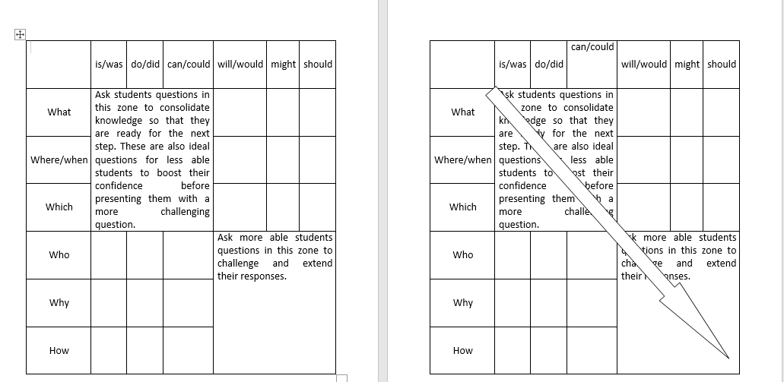
What is/what are => lower level remembering
How might/how should => higher level
The group are then instructed to use this sheet. They are told to look back at the questions they have identified as ‘good’ to see where they sit in the matrix structure illustrated (above).

2.7.4.3 Group discussions
The discussion continues about what a good question is, and a smiley faced cushion is produced. If someone wants to speak the cushion is thrown to them. The discussion focuses on how good questions work in relation to Bloom’s Taxonomy: which questions are good questions?
One respondent suggests that the nature of her subject [philosophy] means that she can’t spend the whole seminar on understanding but needs to move students to analysis.
Here students might help each other consolidate knowledge and build confidence. The more able students could be asked the more analytical questions: the students will find that knowledge closer to them if it comes from the class. More able students could also be asked to teach from the front of the room. Nicole suggests that teacher education recognises that different kinds of knowledge or elements required from different students. Students with different capabilities can be pushed differently to take into account those capabilities. The class might speculate that if you know someone is weak you can start from a simpler question, but this is qualified by the suggestion of being careful not to make assumptions. For example whilst research suggests that non-native speakers tend to be quieter this does not mean they are less clever. Nicole suggests that if there are non-native speakers in a group they can be allowed to discuss in their own language and use their devices (phones and laptops) to help support them to retrieve information. This does mean that they are happier to participate, and they can report back in English. This leads to a larger discussion amongst the students (where students throw the cushion to each other when they want to speak), about techniques of mixing and not mixing international students in their classes. They suggest that dynamics in a classroom are very difficult to judge. You know individuals after a while but you don’t know them in the group dynamics. If one person misses a class because they are absent it changes the class dynamics . Teaching is about trying things out and accepting that things might not go exactly as you want, and mixing things up again.
Nicole asks the class to take Bloom’s taxonomy and try to work out which key words are being used in the higher level of questioning, for 2-3 minutes. This leads to a discussion on how different questions are used for different purposes. For social sciences opinions might be asked for, for Maths it might be applying rules – different kinds of questions will be asked in different subjects. Nicole suggests that in terms of meeting learning objectives the basic things have to be addressed so students can be pushed into higher levels of thinking. “We need to be clear about what we want, and see if they understand the question.”
Nicole comes back to the smiley cushion. She asks: “What is its role and why did I throw it around?” (and throws cushion to those who want to answer question). The students suggest:
- Control – one person can speak at a time, this gives everyone a chance to think.
- It creates a clear physical connection with a person.
- You know when the person has started and finished speaking.
- It’s fun.
- For people with anxiety the cushion might be comforting (one person hugged it, another put it on the desk).
- Movement revitalises the class.
- Throwing stuff in the classroom is a bit risky – this is why a soft cushion is useful, as it can’t do too much damage.
- Students can throw it to each other: nominating each other to respond to the question. The cushion can be a tool to get students to ask questions of each other.

2.7.4.4 Socrative questioning
Nicole introduces the session as focusing on asking questions in a style of questioning attributed to Socrates.
Again, the focus will be on going through different levels, from specifics of remembered understanding to deeper level of questions.
Nicole gives out a four page handout: she assigns each one of the 4 groups a specific section to read and discuss in around 10 minutes. The class are asked to think of a situation in their subject area where they are applying/can apply what they have just read. The sections are:
- What is Socrative questioning
- Moving from closed to open questions
- Raising a challenge.
After around 10 minutes Nicole stops the class suggests they can ask each other what they have learnt. She gives them the cushion to throw to each other.
- Closed questions are best to ask early to ensure that the topic has been understood.
- Raising a challenge – you can build up to a goal question.
Nicole points out that asking questions isn’t easy. She also suggests that students can use the matrix as a cheat sheet, and that they can even give this to their students to help them formulate questions. Undergraduates can then write questions from the reading. Nicole also suggests that GTAs should never assume that the teacher knows everything or knows perfectly how to handle everything perfectly every time. Teachers bring baggage to the classrooms, but we use strategies and practice them a lot.
Nicole takes the students back to the question about last year’s holiday and observes discussion died out very quickly. This is because people needed to be asked questions on the higher-level thinking skills. Here GTAs can go into a classroom thinking, what resources are available to me? What questions can I ask?
Nicole asks everyone: “what is the learning objective?” The students were getting stuck in with questions, because the objective was unclear. A good question here is “What is it I am trying to achieve by the end of this?”, “What is it that I are moving towards?”. Nicole suggests that the questions asked should be leading somewhere. So the learning objective is learning the culture of a particular country. Learning objectives and questions go hand in hand.
Nicole gives every student a post it note. She instructs them that they have 5 minutes to think about the following questions.
- What strategies have you employed?
- What questions did you come up with?
Example questions:
Where did you go? What did you do? When and who with?
Students might like to pick out detail to explore like food. Possible questions might include: How should we behave when we are there? How might people react if…?
Nicole asks: “But what if you get a student who didn’t go anywhere. Or a disruptive student. Short answers could stop the discussion straight away, what could you do?”
She asks them to imagine a strategy and talk about it for 4 minutes. Suggestions that emerge were:
- Give them a few minutes to change task or find out new information
- They can watch a video or read a short paper
The discussion emphasises the importance of having a back-up plan. For example, if students don’t have that life experience they can be asked to imagine where they have been. Then they can watch a video to test their understanding. A whole room discussion could be broken down into pairs. Alternatively students can be designated 1, 2 ,and 3 and moved around to discuss the topic with someone new.
Nicole gives the students three minutes to think through the strategies that she has used today and jot them down. The answers are:
- Using names
- What is the first thing teachers need to know when they are going into a room: the learning outcomes?
- Someone thinks – they are asked what do you think of that? They next person is asked do you agree?
- Smiley soft toy as a prompt
- Introducing particular signs for students with ILP – i.e. I’m going to put down my pen and from that you know I don’t want to be included.
- Getting class to sum up at the end.
- Getting the undergraduates to ask questions of each other. Give them a matrix so they can know how to ask sensible questions
- Hierarchy: moving through the different levels from lower to higher thinking.
- Reading excerpts and asking the undergraduates what they have read
- Getting the undergraduates asking questions amongst themselves (perhaps before class).
The discussion considers that if students don’t engage, teachers can ask them why (even by asking them to talk individually after class). The session concludes with two stars and a wish.

2.7.5 Critical, reflective commentary
In this particular case, the session again drew on teaching strategies from initial teacher education, where educationalists often model how to deliver subject content (e.g. Hockly, 2000; Kyriakides et al., 2009; Utami, 2016; Couso and Garrido-Espeja, 2017; Körkkö et al., 2020). However, the emphasis for this session lay with the presentation of very specific strategies for questioning. The role of questioning in education and its impact on developing critical thinking skills, consolidating learning and assessing understanding is undisputed (e.g. Wragg, 2003; Dillon, 2004; Herbel-Eisenmann and Breyfogle, 2005; Nappi, 2017). Unfortunately, however, not many training sessions focus on questioning and good questioning techniques, so that often the questions asked in discussion groups and seminars are not helpful in developing learners' understanding.

The focus of this session was to highlight that good questioning relies on two main factors: 1.) asking the right questions and 2.) using appropriate strategies to involve learners. Naturally, there are strategies that may make individual learners uncomfortable, such as if they are put on spot in a big group. However, through the demonstration of different strategies, participants started to realise that a balance can be struck by simply changing the teaching approaches and not relying on one single technique all of the time. At the same time, the participants gained significantly through understanding how to move a question from simple recall to higher level thinking by applying Bloom's Taxonomy.

What went well:
The combination between academic and educational research and practical teaching strategies and questioning techniques.
Combining "Why would X say that?", "Do you agree with that?" with Bloom's taxonomy.

Even better if:
Opportunities for participants to try out some of the strategies taught

2.8 Assessment and Feedback

2.8.1 Session description
Led by Nicole Brown.
In this final workshop delegates will experience a "circuit training" set up, through which they will learn about techniques for assessing and providing feedback. The focus will be on the difference between formative and summative assessment, what can be assessed, how do assessments happen, what are their purposes, which feedback can be provided and how can a seminar leader make use of assessments and feedback.

2.8.2 Resources
Handout on assessment from Making Every Lesson Count.
Copies of the Metro paper, one for every group of 3 or 4 students
Scissors
Paper
Sticky Tape
Measuring Tape
Pens

2.8.3 Lesson plan
Timing | Activity | Aim
10 mins | Introduction to class  Introductions from students | To contextualise the theme  To reflect on previous class and signpost other support
10 mins | Build a tower  (only materials provided are one Metro Newspaper, sticky tape, a pair of scissors. A measuring tape is not provided)
15 mins | Assess the Towers
10-15 | Discuss in groups reflective questions on assessment choices | To talk through a whole range of assessment and reflect on how and why strategies were adopted
10 mins | Plenary on findings from reflection exercise
10 mins | Reflecting on feedback we have given in teaching
10 mins | Plenary on our own feedback
10 mins | Reading from ‘Making Every Lesson count’ on using symbols and shorthand for marking
10 mins | Examining feedback criteria:  - Either use that provided by a students for their individual modules or provide a version
5 minutes | Two stars and a wish for feedback

2.8.4 Descriptive commentary

2.8.4.1 Building a tower
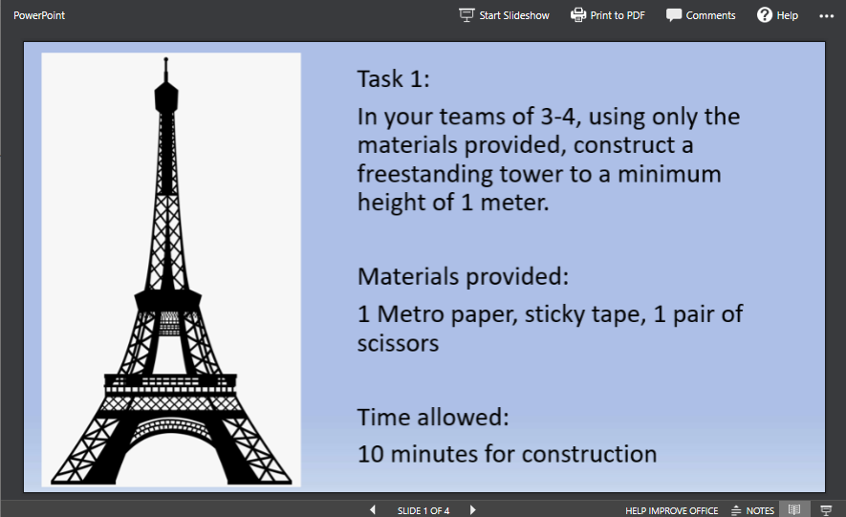

At this stage, the teacher should avoid discussion about the outcome of this exercise. The teacher should limit talking to repeating the instructions provide. The key details are provided on the slide. The teacher should try to read this neutrally and avoid unnecessary emphasis on any details about the tower’s construction. This is to see how the students respond to the exercise – any details they have missed can then lead to interesting discussions about how assessment works in instances when some criteria are met but others are not.

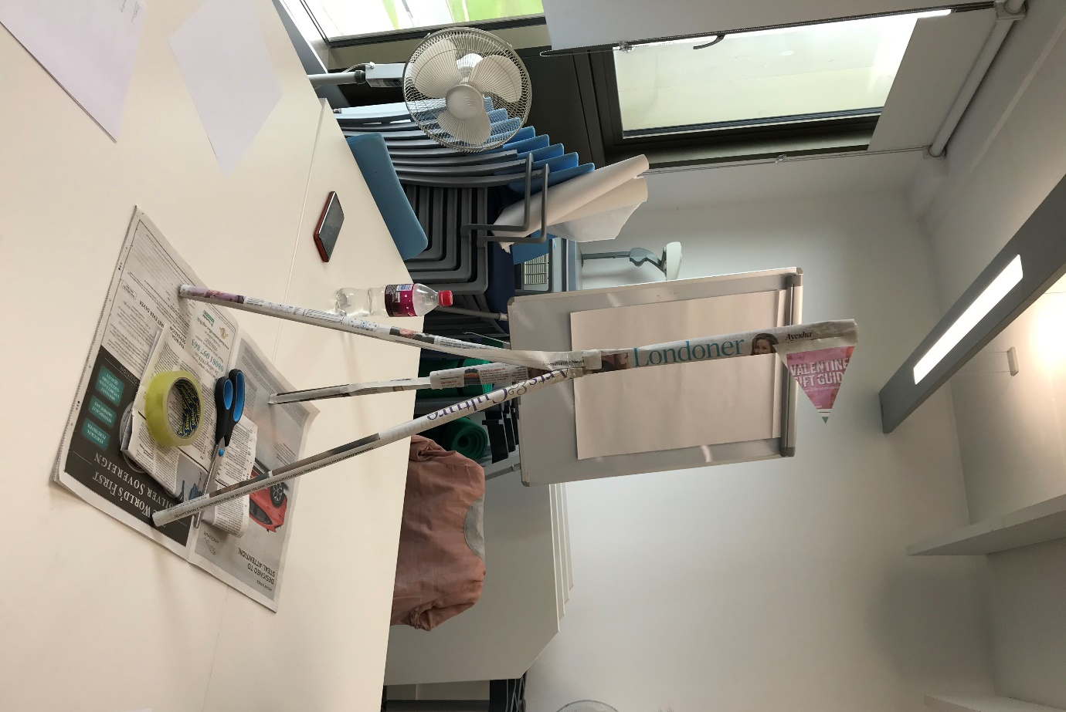
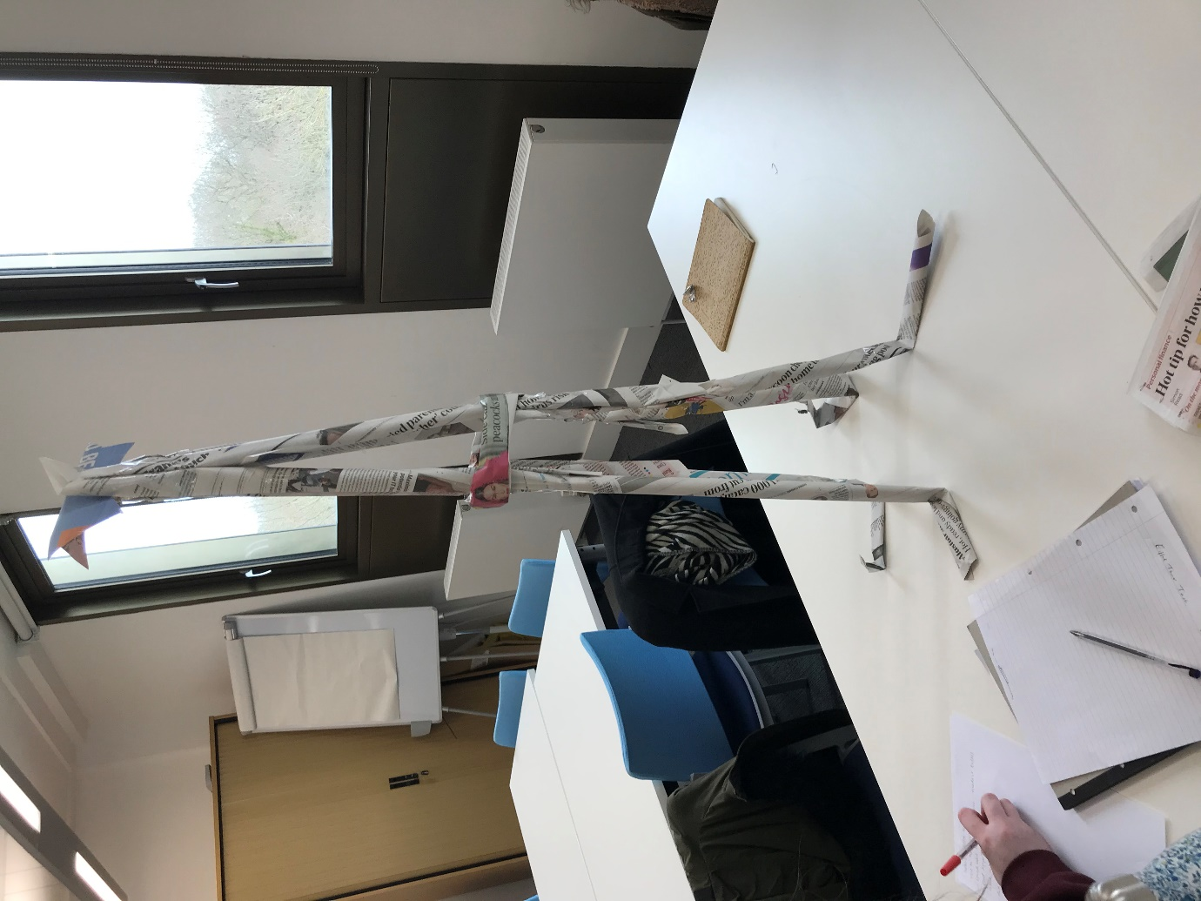

2.8.4.2 Assessing the towers
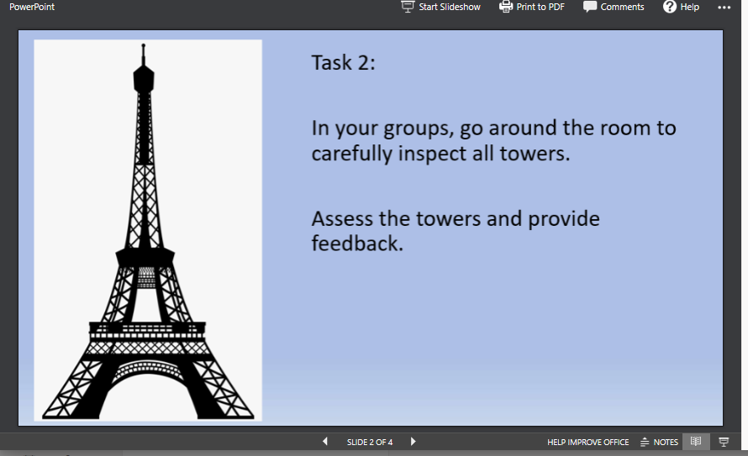
Once 10 minutes have been allowed for the tower’s construction, the participants are informed that they will be assessing and providing feedback on the other towers.
Nicole asserts quite formally “The instructions are very clear. I want to point out a few things to consider when you assess each other:
- The tower should be free standing, it should not be taped to the table.
- The towers should be a minimum height of 1m.
- Only the materials stipulated in the instructions are allowed in construction.”
Nicole takes out a tape measure and measures the height of all the towers. “Don’t touch the towers please”. She instructs the students to carefully inspect the towers and provide feedback on the towers. (Participants are given one piece of paper per group to give feedback).
Nicole also notes “It would also be nice for you to assess your own towers as you are giving feedback on others’ work. See other people’s towers first. Make notes and give feedback. How would you grade your own tower and what kind of feedback would you give?”
At this point students haven’t been given explicit instructions about how to grade. How will they grade these towers – will they give them grades A-F? A mark out of 100?
One student asks whether similarity to the appearance of the Eiffel Tower is a criterion (as the Eiffel tower is depicted on the instructions). Nicole points out that the task is a free-standing tower, it is not specified that it has to have a certain amount of legs or a resemblance to the Eiffel tower. This leads to the point that when we frame a task, we do need to think about whether we show students examples, and how this might constrain their thinking.
The groups develop various different feedback systems – one gives a mark out of ten for different criteria, another begins to discuss aesthetics.
Nicole stops the class: out of 3 groups 1 came up with a set of criteria for scoring, 2 gave written comments.
Nicole asks: “What grade or mark did you give and why did you decide to give that mark? Does assessment mean that you have to give a grade?”. The first response from a student was: “I gave a grade without even thinking about it!” (It was a mark out of 10 per category). A review of the assessments undertaken by the students showed that some had developed more criteria than the brief specified (e.g. sustainability and aesthetics), but decided that wasn’t fair as it wasn’t in the original instructions and took them out. For the groups who decided not to give a grade, one group assessed by pluses and minuses, and notes that assessment didn’t make them think about a mark, they wanted instead to recognise the specificity of the towers.
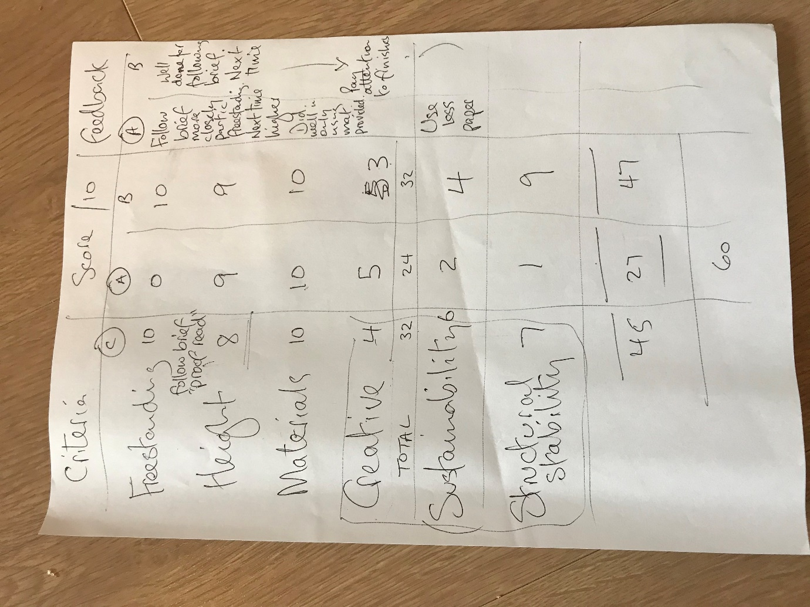
Nicole notes at this point “When you get a student essay you somehow have to compare it to something. Formative (comments) and summative (grading) assessment are not necessarily mutually exclusive.” Nicole asks the groups to go on to assess in a different way. Those groups which gave summative grades are instructed to spend 5 minutes giving formative feedback. Those groups who haven’t graded are told to spend 5 minutes grading the towers.

2.8.4.3 Reflecting on assessment
After 5 minutes Nicole stops the class, and asks: “You assigned grades using certain categories – how did you come up with these? Did the criteria you used incorporate the freestanding and 1 metre stipulation? The instructions had an image of the Eiffel tower on them, how did you deal with that in the criteria?”
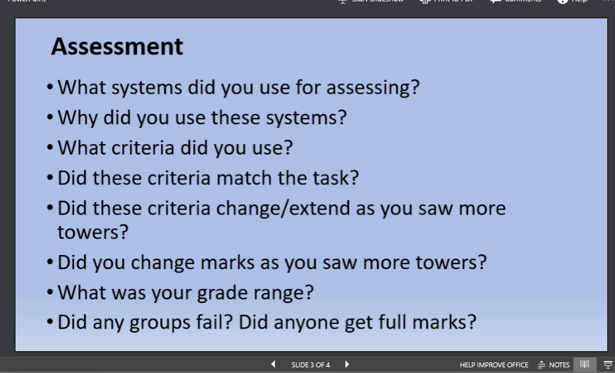
Nicole shows students the assessment slide and gives them 10-15 minutes (2-3 minutes per question) to discuss how they did things.

2.8.4.4 Plenary
Following the discussion the students make the following points:
- GTA1: If you have a criteria of marking how does it guide the specific grade? I try to make a structure – did they answer the question? Did they make a good argument?
- Nicole points out that none of the towers met the criteria of being 1 metre tall, although some came closer than others. She asks: “Does this mean that all failed? Or does it not matter as much, as they did all try to build a tower 1 metre high?”
- GTA2 asks: Does it matter which subject you are marking in? In Mathematics there is more of a right and wrong than in soft subjects in the Humanities. In Law the way you argue is looked at, in Accounting the steps the students have taken are followed, how they think is important, even if the final answer is wrong.
- One group discuss how they developed criteria that wasn’t in the original brief. Part way through they looked at these criteria of creativity, sustainability and structural stability. This was because they felt like they wanted to reward people that have done something good. Nicole interjects here: “But how do we account for that if it is not in the mark scheme?”
- Nicole points out that the assessment of the tower is a metaphor for assessment. Here she asks: “What happens if we take this back to our students’ essays? Should we give marks for things like good presentation?” GTA3 responds that we need to recognise elements of independent thinking, we haven’t told them to do it, but it also isn’t in the question.
- Nicole replies: Is it in the marking criteria? In HE we have a mark scheme and a criteria which will allow us to reward things like a good bibliography, and take marks off for a bad bibliography (unless it’s not in the mark scheme, and then you can’t mark on the basis of the bibliography). She laughs and says: “If I look at my criteria you have bombed!! I can say this to you because I know you: imagine if you say this in feedback to your students. It is crucial to maintain motivation for the student.”
- GTA4 suggests it is good if you can reward students for what they have done.
- NB recounts the anecdote about a school boy who received 26/26 for Geography homework, but a mark of a B. The teacher said if he gets full marks he will not be motivated to work towards an A. The school boy said – I’m not going to revise, there’s no point – if I get 100% I won’t get an A.
- Even if something is going wrong you can use assessment to provide motivation through positive feedback.
- GTA5: Logistics: it is hard to compare marks across over 100 essays.
- GTA4: “We had it in our heads that the design had to be modelled on the Eiffel Tower, although that was not in the question. In reality that is how students sometimes engage with questions – they are not straightforward and students don’t necessarily follow the set path. But we can give the feedback to the students BEFORE the assignment if we spot where instructions might be ambiguous.”
- GTA6: “If you show students really good examples it changes the outcome: The students I showed a good model to built models that emulated that design. Those I hadn’t shown the exemplar to were more creative.” Nicole comments: “Exemplars can stifle and an A grade might not necessarily be an A Grade.”
After this discussion the students are given another slide with questions to talk in groups about the kind of feedback they have given (for 8 minute).
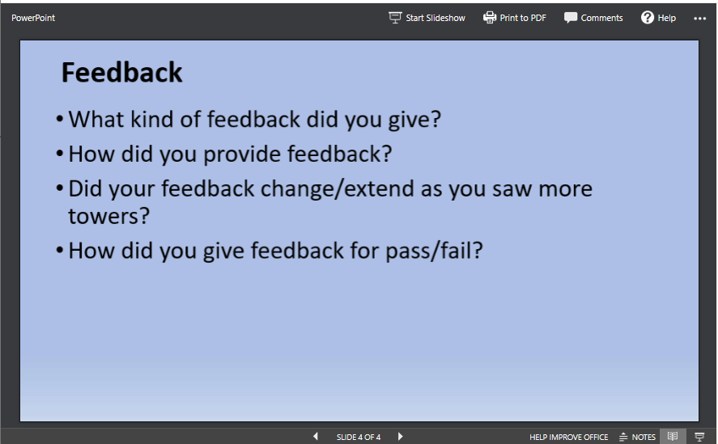

2.8.4.5 Reflection on how feedback has been given
- GTA7 points out that in feedback teachers are usually trying to be kind: e.g. I really appreciate you tried to answer this question, but you missed a), b) and c).
- GTA4: suggests that undergraduates don’t always look at the written feedback as the set-up of the online submission system means that you see a mark immediately.
- Nicole admits she doesn’t have a solution for that, and gives the example that in some UK universities feedback is given on a draft. She asks: “What are the possibilities for that in your teaching? Are these discussions you have had or could have with your module convenors? If we are not able to give them feedback on drafts what can you do in seminars? Can you go through the grade criteria with the students?”
- The discussion broadens out to include: How long do we spend on marking essays, and how long have we been told to spend?
- Do we mark up or down? What mindset do we approach the stack with?
- GTA4: Start at 100% and then deduct marks. That way you are not looking at the stack and seeing fails.

2.8.4.6 Using symbols for feedback
- The students are given a reading about how symbols can be used in giving feedback as a shorthand to communicate.
- They comment on the reading that the symbols T1 and T2 were confusing, and Nicole suggests that GTAs could customise their own symbols e.g. ‘Yoda’ – ‘Do or do not, there is no try’ – i.e. don’t use try. And ‘?’ ask yourself a question here.

2.8.4.7 Using our own mark schemes
- Nicole asks students to examine their mark schemes and ask themselves (in groups): “how do your criteria mean? Where are the difficulties? How do your approach marking with the criteria you have got?” At this point she asks the questions below:
- Do your criteria match the task you have been given?
- Are there some areas of the task that you don’t have criteria for?
- If this is the case, we have to address this in the seminar. (NB prepares a checklist for her undergraduate students).
The session concludes with two stars and a wish.

2.8.5 Critical, reflective commentary
Part of this session was directly taken from initial teacher education sessions, where educationalists often model how to deliver subject content (e.g. Hockly, 2000; Kyriakides et al., 2009; Utami, 2016; Couso and Garrido-Espeja, 2017; Körkkö et al., 2020). In primary and secondary education, trainee teachers often find assessing, marking and providing feedback difficult and are struggling with the differences between them.

Assessment for learning (Wiliam, 2011) has been a significant training element in teacher education for a long time. The Eiffel tower activity is a particularly powerful tool to demonstrate what it feels like for learners to be put under pressure to perform, to then be assessed and given feedback. Through this experiential element it is possible to demonstrate the significance of assessment and the importance of getting feedback right. At the same time, however, graduate teaching assistants generally do not have any leeway for developing assignments and so feel trapped between what they would like to do (be supportive and provide good formative feedback) and what they need to do (mark and grade).

With this in mind, it was important to organise and structure the session around what needs to be done as well as providing ideas and strategies for scoping out opportunities and time to provide supportive, formative comments.

What went well:
Demonstration of practical examples such as symbol marking and checklists.

Even better if:
More time to explore opportunities to break out of set structures.

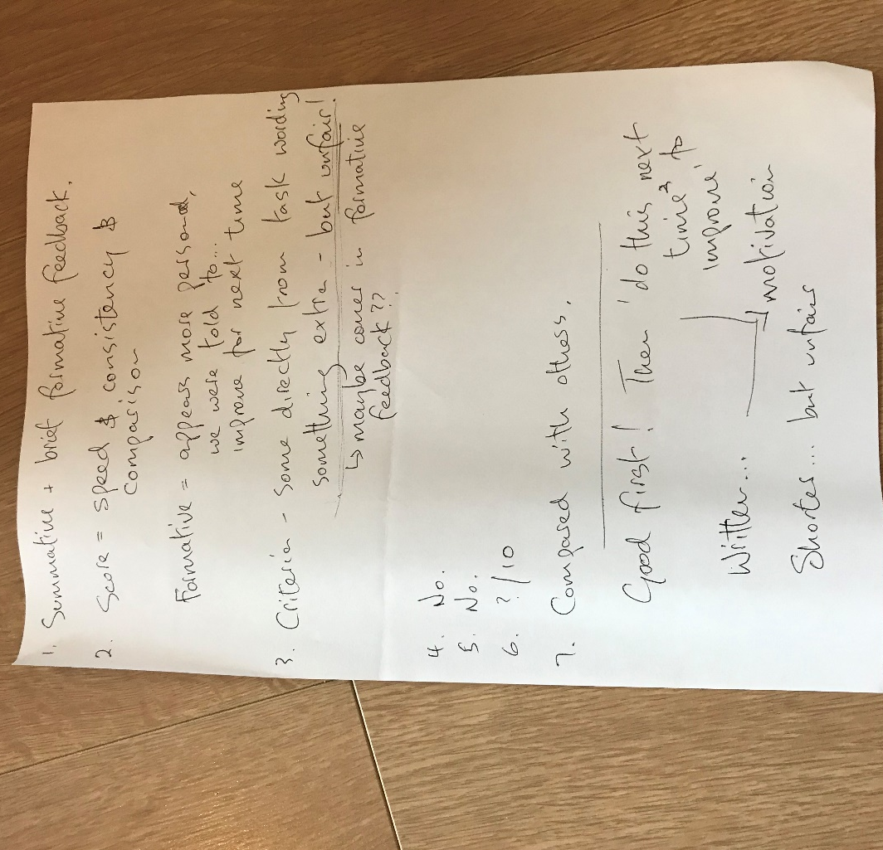
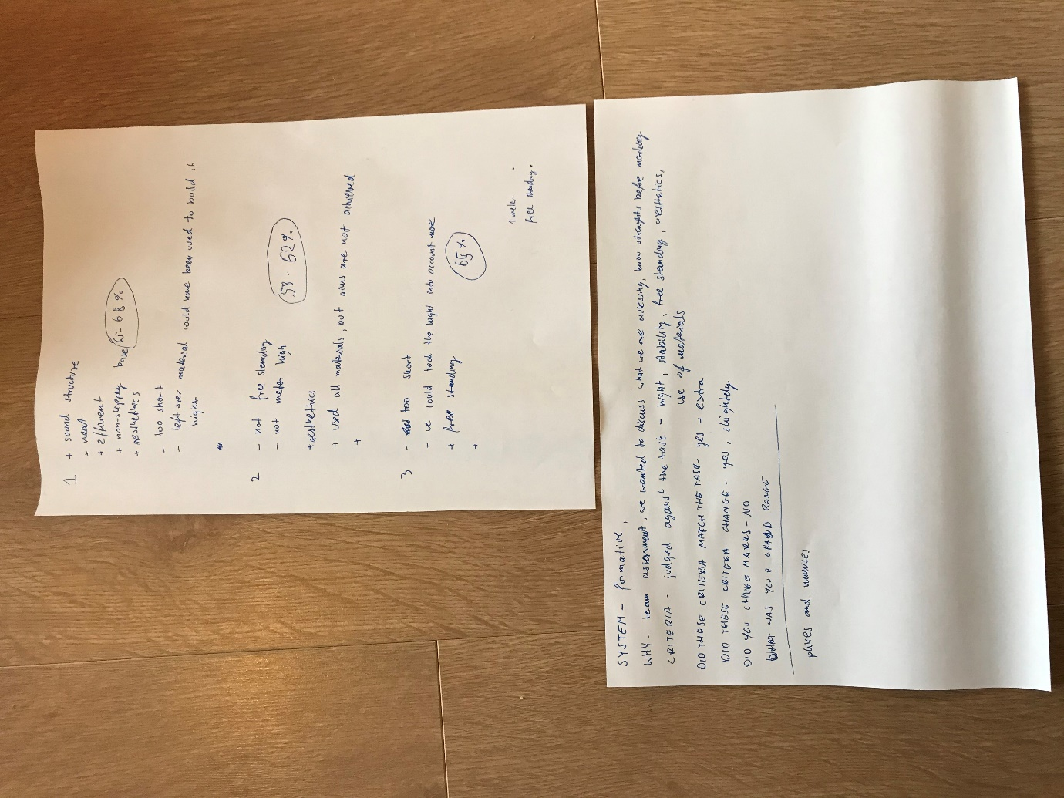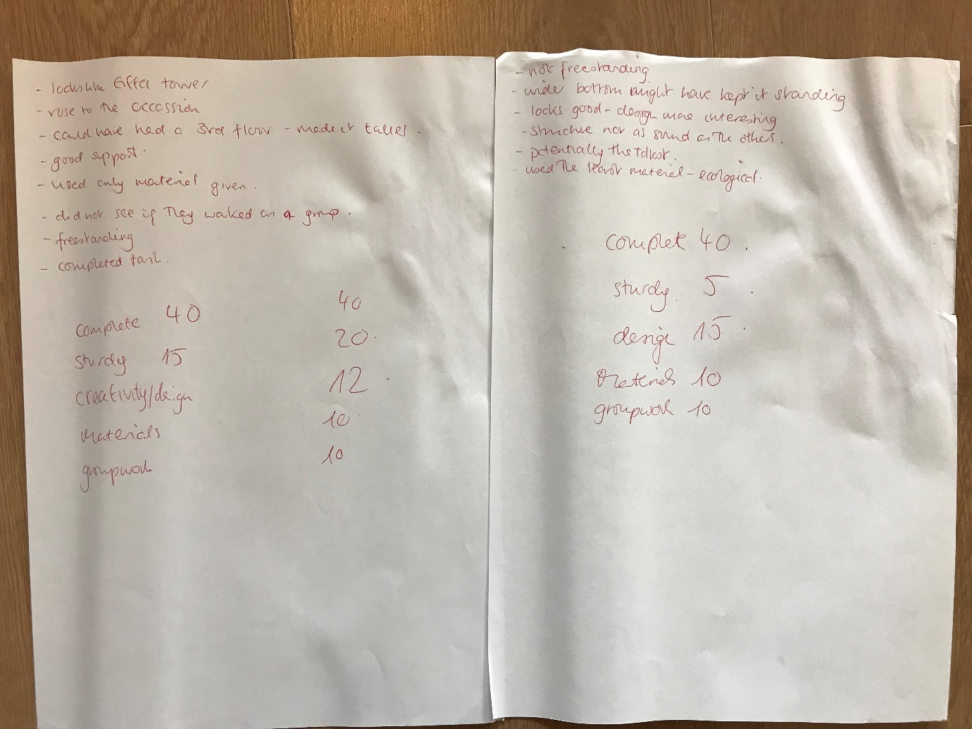

2.9 The international classroom

2.9.1 Session description
Led by Jo Collins.
The international classroom
This interactive 90 minute lunchtime café is open to international, home and EU postgraduates who teach. In this informal session we will explore teaching international students, and/or our roles as (international) teachers.

2.9.2 Resources
White board
Post it notes and pens
PowerPoint
Lego®

Lesson plan

Timing | Activity | Aim
20 | Introductions  What kind of educational culture do I come from? (Use board to plot position on various spectrums – e.g. Learner centred to Teacher centred, fixed curriculum v negotiated content) – smaller groups | Reflection on different kinds of norms, values, and structures of teaching in different educational cultures
20 | What exercises and activities can I use, in my subject area, to engage learners across different educational backgrounds? (different coloured post it notes to plot activities along spectrums) – smaller groups | Linking pedagogy to different educational spectrums
20 | Larger group discussion about findings  (Hofstede etc. slides) | To consider: What kinds of generalisations can we make? How can this exercise help our practice as teachers?
25 | How can I ensure that my lessons are inclusive?  Use Montgomery’s reflection questions for individual notes, followed by fishbowl discussion. | Fishbowl models a teaching activity which can then be discussed in terms of its inclusivity
20 | What does my inclusive international classroom look like? (option of Lego modelling or drawing)  e.g. What activities will you use? How do you foster interaction in this classroom? How do you group your students? How will I ensure that my learning aims are achieved in inclusive ways? | Consolidation of ideas into practice
15 | Discussion – what have I learnt about myself as a teacher? | Link designing learning activities to becoming a teacher and developing a teaching identity.

2.9.4 Descriptive commentary
As this lesson did not run, it will be discussed here in terms of the aims behind the planned activities.

2.9.4.1 What kind of educational culture do I come from?
The aim here is to prompt students to think of the complexity of their own educational backgrounds (and transitions into UKHE), in order to then consider how international students respond to learning in UKHE in the next activity.
Three spectrums were identified for this exercise (but can be customised):

Learner centred (culture) versus Teacher centred
Teacher as authoritarian versus teacher as facilitator of learning
Fixed curriculum versus negotiated content

These spectrums can then be marked on a white board, and students given pens to mark (either with their names or anonymously) where they see themselves. Students can work in small groups (depending on numbers) which different groups approaching the three spectrums in turn.

2.9.4.2 What exercises and activities can I use, in my subject area, to engage learners across different educational backgrounds?
Having considered their own educational backgrounds, participants now move on to considering learners from different backgrounds. Key questions here are what kinds of expectations learners might have, and they might experience activities in the classroom. Participants are giving post it notes and asked to write activities they have used or want to use on them. They then go round in small groups again and discuss where these activities might be placed on the different spectrums.

2.9.4.3 Group discussion
Working on the outcomes of the previous two activities, we consider what the outcomes are for our work as teachers with diverse classroom.
Discussion could also include (where relevant) the following theories and models, particularly to debate the saliency of the chosen spectrums:
- Bronfenbrenner’s ecosystems theory, as a way to consider the complexity and layering of what makes up a person’s culture and experience:

- De Vita’s (2001, 172) work on learning styles for discussions about how learners might engage differently with lessons. De Vita’s research project found that international students had the greatest diversity in learning styles, compared to home students:

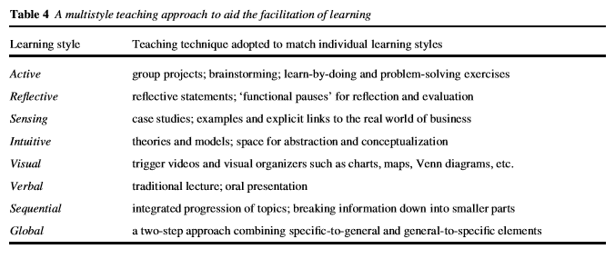
- Hofstede’s (1986, 309) work on the intersection of power distance and individualism in different countries. Hofstede maps here countries where inequality is accepted (high power distance) and not tolerated (low power distance) against cultures that are individualist or collectivist.
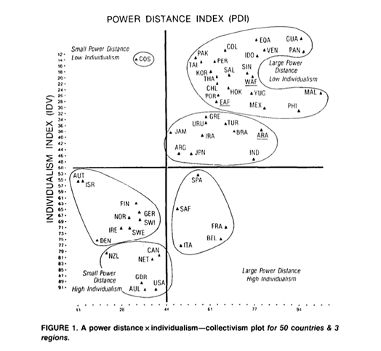
- Jenkins and Healey’s work (2009, 26) on the different way in which students and staff interact to build knowledge:
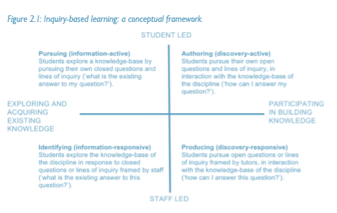
- Work by Jain and Krieger (2011, 100) on how language use contributes to convergence or divergence in communication:
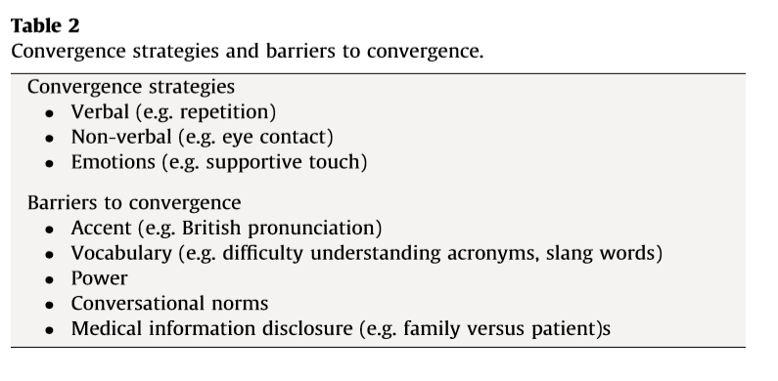

2.9.4.4 How can I ensure my lessons are inclusive?
Here participants should be provided with either a PowerPoint slide or a handout with reflective questions adapted from Montgomery (2001, 4), for quiet individual reflection and note taking:
- What is my definition of diversity?
- What cultures do the students in my class come from?
- What are my perceptions of students from different ethnic/cultural groups?
- What are the sources of these perceptions?
- How do I respond to these students based on these perceptions?
- What are the next steps I need to take to find out more about these students?
- In what ways can I make my lessons responsive to the needs of the diverse group in my classroom?
- What kinds of information, skills and resources do I need to acquire/negotiate with my module convenor to effectively teach them from a multicultural perspective?
- In what ways do I collaborate with other educators and groups to address the needs of my students?
This can then be followed with a fishbowl discussion where half the class observes group discussions on the main question, and then a swap where the observers discuss (and are themselves observed). This activity can be followed by a whole class reflection on the cultural inclusivity of this particular learning configuration. Participants here can be prompted to consider whether some activities are more or less inclusive than others. Cruickshank (2004, 136) suggests the notion of cultural inclusiveness lies “more in the willingness to negotiate learning and teaching strategies, to reflect on values and beliefs and to understand and embrace different ways of knowing, than in the adoption of any specific approach to pedagogy”. What do participants make of this? Some prompts from research on inclusive teaching activities might include:
- Inclusive activities: group art (Hajisoteriou and Angelides, 2017)
- Learner-centred activities where different roles reflect roles students might play in their culture (Hermida, 2010).
- Making tacit knowledge explicit (Blasco, 2015; Montgomery, 2001)
- Guest speakers from non-mainstream cultures (Hermida, 2010)
- Dialogue, which differs from discussion and debate because it helps foster a digging deeper and examining multiple viewpoints (Maxwell and Gurin, 2017)
- Storytelling: shared narratives about meaningful personal experiences (Hermida, 2010)
- Jigsaw, a cooperative classroom (Williams, 2004)
- Sharing personal stories of vulnerability (Linder et al, 2015, 187)
- Validation of individual cultures, establishing links with staff where students feel part of a larger community (Linder et al, 2015, 189; Montgomery, 2001).
- Allow students to use internet (i.e. if English is a second language; see Montgomery, 2001), and include texts of different language (Hermida, 2010)
- Instructional scaffolding (Montgomery, 2001)

2.9.4.5 What does my inclusive international classroom look like?
Here participants have the opportunity to visualise their class. Materials such as Lego® and pens and paper can be provided for this. Continuing from previous discussions, participants can be prompted to consider the following questions:
Build a model/draw a picture of your classroom.
- Where are you as a teacher? How are you interacting with your students?
- Do I talk to students about what forms of written information they find useful?
- Do I try not to speak too quickly and pause when I have made an important point?
- Do I use clear and concise visual aids?
- Do I use short clear sentences and address my students directly?
- What activities do I use to engage my students? Why?
- Do I incorporate/discuss knowledge about my subject from other systems or traditions? Do I model cultural awareness?
Ideally, this activity will incorporate time working alone, with some time for participants to discuss models and drawings with others.

2.9.4.6 What have I learnt about myself as a teacher?
This activity can include exit slips, where participants anonymous write comments on post it notes and attach them to a white board (where all comments are visible). Ideally this will consolidate key themes emerging from the session, along with an awareness of any institutional projects (e.g. ‘Decolonising the curriculum’, networks for international students, and/or BAME academics) or any sector work that focuses on inclusivity for international students.

2.9.5 Critical, reflective commentary
This session was planned to draw out two different sets of experiences – a consideration of how international undergraduates experience their learning and how international graduate teaching assistants experience their transition into UK higher education. This emphasis was influenced by Ryan’s (2013, 287) work on transcultural classrooms. Ryan emphasises the importance of reciprocal learning. Here the classroom is a space of exchange between students of different nationalities, but also between students and international teachers. This is complex, however, as in UKHE such exchanges need to occur within a space where particular kinds of learning (such as critical thinking, and independent learning) are valued. The initial activities around educational cultures and how particular pedagogies and activities might emerge in certain cultures rather than others, was designed to begin to draw out these ideas of transcultural learning.
Another important influence on this lesson is Blasco’s (2015) work on making the tacit explicit to international students. For Blasco a crucial element in teaching international students is reflecting on the information that they need to know and making sure that knowledge that may be hidden to them due to their cultural background and different educational expectations is brought to light. This is a process that needs to be carefully considered, with teachers fully engaging in reflections on what it means to be entering into an educational culture. Blasco argues (2015, 90): “[f]acilitating IS study adaptation is then, not only a matter of explaining the formal rules. Two strategies are needed: (1) excavating the tacit dimensions of learning in a given context, and (2) finding ways to communicate those intelligibly”. This process involves a recognition not only of what might be hidden from international students, but how and when to communicate and embed it effectively.
These reflective activities open out into prompts for participants to consider their own practice and what activities, instructions, scaffolding and support they do and could use to engage their international learners. Thus while Blasco and Ryan focus on international undergraduates, their arguments are also suggestive for international GTAs: what are the implicit things that they have not been made aware of? What opportunities for cultural exchange are they involved in? Our interview data showed us that School inductions into teaching, support from module convenors, and training opportunities like our workshop, were key in the process of making the tacit explicit. They also showed that cultural exchanges involved international GTAs making the tacit explicit to other international students: “they just need to know why they need to do things in a certain way and not how they need to do things”.

3.1 Conclusion and recommendations
In our toolkit we have sought to draw specific attention to the experiences and transitions made by international Graduate Teaching Assistants, as well as to provide practical resources for those supporting all Graduate Teaching Assistants. Much of our work invites further comment and is certainly not conclusive. We are open to engaging in dialogue with people who are interested to discuss our findings or workshops, would like to make comments, or would like to take these ideas further. We only ask that we are credited with the following reference:

Collins, J., Brown, N., Leigh, J. (2021). Supporting International Postgraduate Teaching Assistants: Resources Toolkit. UCL Open Access Resource.

We can be reached via j.p.collins@kent.ac.uk, j.s.leigh@kent.ac.uk, and office@nicole-brown.co.uk

Below we outline some of the key themes that emerged in our work, before moving on to our recommendations.

3.1.1 Building identity
A key theme in our workshops was encouraging our participants to build a sense of their identity as a teacher. We asked them to do this in Lego®, and through reflective exercises such as their future teacher selves, solving problems in the classroom, considering what their inclusive classroom looks like, and exploring the boundaries they place around their time researching, teaching and living other parts of their lives. The workshops were spaces where identity work (Winstone and Moore, 2017) took place: here participants considered the kind of good teaching that they had experienced and wanted to develop, and microteaching provided opportunities for reflection in and on practice (Schön, 1987). Reflective exercises provided spaces where transformations could begin: Smith and Hawkins (2013, loc. 624) talk about this in terms of meaningful change occurring when “we explore the feelings and emotional field which held the current behaviours in place and also the belief systems, assumptions and motivations that create the stories we tell ourselves”. Here at times workshops were places where different stories collided (e.g. narratives prioritising the research project, versus narratives around wellbeing) and were sometimes remade (e.g. moving from feeling powerless to determine assessment to feeling that feedback can be an ongoing process in seminars). Jennifer Leigh talks about the importance of an embodied aspect of reflection (2013; 2019) which is inherent with our choice to use creative approaches. With identity work there is also emotion work (see Brown and Collins, 2018). Our workshops are spaces of validation of the building of a teaching identity as an ongoing process – one that doesn’t have to be divorced from a research identity.

3.1.2 Building understanding
Whilst, as we have outlined above, the workshops sought to prompt an ongoing process of self-understanding and participants’ continuing identification as a teacher; our work also aimed to foster a larger process of ‘understanding’ in relation to how processes and protocols worked within the institution. We have referred to this using Blasco’s (2015) phrase “making the tacit explicit”. This emerged on a number of levels, from discussions around GTAs’ responsibilities and module convenor’s responsibilities (we have mainly omitted these from the transcripts provided in the interests of maintaining participant anonymity) to work around moving from teacher-centred approaches to students’ engagement to student-centred approaches common in UKHE, (Åkerlind, 2008 – see our ‘Troubleshooting teaching’ workshop, and the activities in ‘Becoming a Teacher’). It was also key in how we planned, communicated and executed our activities. Here reflections provided one way to prompt understanding, and participants’ interactive engagement in a number of different teaching activities built their understanding through experience. Our workshops included practical activities such as snowball discussions, visualisations, working in a team to assess each other, to jigsaw activities where they experienced different configurations of group work. These embodied, participatory experiences were in themselves opportunities for sense-making: e.g. what does it mean to categorise and classify before even devising a criteria for marking and beginning to mark?

3.1.3 Building community
One of our greatest hopes for this project, and also the most elusive outcome was to build a community amongst our GTAs. Much of our work on this project, and before (Brown and Collins, 2018), has been inspired by Lave and Wenger’s (1991) notion of community of practice. Here people are drawn together by sharing and developing knowledge. In our research we found that our international GTAs did not feel themselves to be part of a larger community of postgraduate teachers, even though they did feel themselves to be in a community with those same postgraduate teachers as researchers within their schools. Here then, the draw of belonging is to a School as a researcher, rather than as a teacher. This reveals a key challenge facing GTA Developers, the pressure and necessity on GTAs to complete (and thus implicitly prioritise) their PhDs. As our workshops were attended on a voluntary basis (and were separate from the compulsory and accredited Associate Fellowship Scheme, which led to Associate Fellowship of the Higher Education Academy), our participants were perhaps more likely to view themselves as teaching practitioners (as well as researchers). We were not reaching all of our international GTAs, nevertheless, levels of attendance from this group were high in comparison to the proportion they represented of total GTAs. For example whilst the proportion of international GTAs across the university was in the region of 25% of the total cohort, the proportion attending our workshops was 35%. Whilst these GTAs did not feel part of a larger community of GTAs across the University, they did, we thought, begin to forge small peer communities within the workshops themselves. Peer support and learning was a crucial element in building discussion and understanding in the workshops. This chimes with Vygotsky’s ideas in Thought and Language around peers as effective teachers. Whilst some sources suggest that peer teaching is not always effective, (e.g. Khanahmadi & Sarkhosh, 2018) research has shown that empathy and compassion (Duers, 2017) are key elements in building effective peer learning. This is an area that warrants further research: how can GTA developers foster empathetic spaces and activities conducive to effective peer support?

Recommendations
Based on our work with GTAs, we draw out the following recommendations and reflections for those working with International GTAs:
a) Opportunities and space within training for understanding the layered identities and transitions of all GTAs, and incorporating the particular needs and complexities for international GTAs.
b) Clarity around expectations: “why are we doing this in this way”. This might include how hours worked are calculated and interpreted, how a classroom works, boundary setting, building a rapport. These are also things that can be reiterated. Some international GTAs felt overloaded at induction.
c) Inductions to include UK School system and qualification information, British culture and cross-cultural communication, university processes and rules around difficult areas such as racism, harassment, how university programmes are structured. As well as providing the context for transitioning into teaching, teaching tips and best practice can be signposted. Some Universities produce GTA handbooks, this information might then appear in FAQs about terminology from School and University programme terminology.
d) Where are there opportunities to diversify role models within teacher training?
e) Create and provide meaningful spaces for international GTAs to connect with each other, e.g. Facebook. These are not necessarily just social spaces, but might be spaces where knowledge can be shared, or training provided.
f) Ideally a recognisable point of contact: somebody that international GTAs can check in with – this might be a module convenor, it might be a liaison within a Graduate School or a School.
g) Recognition of the value of GTAs’ teaching (validation) e.g. within departments, GTA prizes etc.

3.2 Bibliography
Allison, S., and Tharby, A. (2015). Making every lesson count: Six Principles to Support Great Teaching and Learning. Carmarthen: Crown House Publishing.
Åkerlind, G. S. (2008). A phenomenographic approach to developing academics’ understanding of the nature of teaching and learning. Teaching in Higher Education, 13(6), 633-644, DOI: 10.1080/13562510802452350
Beaton, F. (2017). Just in time and future-proofing? Policy, challenges and opportunities in the professional development of part-time teachers. International Journal for Academic Development, 22(1), 19-30, DOI: 10.1080/1360144X.2016.1261354
Blair, E. (2020). Teaching in Higher Education. Carmarthen: Independent Thinking Press.
Blasco, M. (2015). Making the tacit explicit: rethinking culturally inclusive pedagogy in international student academic adaptation, Pedagogy, Culture & Society, 23(1), 85-106, DOI: 10.1080/14681366.2014.922120
Braun, V. and Clarke, V. (2006). Using Thematic Analysis in Psychology. Qualitative Research in Psychology, 3, 77-101.
Bridges, S. M. (2019). Problem-based learning in teacher education. Interdisciplinary Journal of Problem-Based Learning, 13(1).
Bronfenbrenner, U. (2009). The Ecology of Human Development: Experiments by Nature and Design. Cambridge, Massachusetts: Harvard University Press.
Brown, L. and Holloway, I. (2008). The adjustment journey of international postgraduate students at an English university: An ethnographic study. Journal of Research in International Education, 7(2), pp. 232–249. DOI: 10.1177/1475240908091306
Brown, N. (2019). Partnership in learning: how staff-student collaboration can innovate teaching. European Journal of Teacher Education, 42(5), 608-620. DOI: 10.1080/02619768.2019.1652905.
Brown, N., Jafferani, A. & Pattharwala, V. (2018). Partnership in teacher education: developing creative methods to deepen students' reflections. Journal of Educational Innovation, Partnership and Change, 4(1). DOI: 10.21100/jeipc.v4i1.747.
Brown, N. and Collins, J. (2018) ‘Using LEGO(R) to understand emotion work in doctoral education. International Journal of Management and Applied Research. 5: 4, pp. 193-209. http://www.ijmar.org/v5n4/toc.html
Brown, N. and Leigh, J. (2018). Ableism in academia: where are the disabled and ill academics? Disability & Society, 33(6), 985-989, DOI: 10.1080/09687599.2018.1455627
Brown, N., and Collins, J. (2018). Using LEGO® to understand emotion work in doctoral education. International Journal of Management and Applied Research, 5(4), 193-209. DOI: 10.18646/2056.54.18-014
Collins, J. (2020). What support do International Graduate Teaching Assistants need? Supervising PhDs. < https://supervisingphds.wordpress.com/2020/02/11/what-support-do-international-graduate-teaching-assistants-need/>
Collins, J. (2021). Navigating the contact zone: postcolonial Graduate Teaching Assistants’ experiences in a UK Higher Education institution. Teaching in Higher Education: Special issue: Working in the Borderlands: critical perspectives on Doctoral Education https://doi.org/10.1080/13562517.2021.1881774
Collins, J. (2019) Towards Postcolonial Pedagogies: how Graduate Teaching Assistants foster collectivism and transcultural classrooms. Innovations in Education and Teaching International, https://doi.org/10.1080/14703297.2019.1702891
Collins, J. and Brown, N. (2020). ‘Where’s the Validation?’: Role of Emotion Work and Validation for Doctoral Students. (Published online). Higher Education Research and Development. https://doi.org/10.1080/07294360.2020.1833315
Couso, D., & Garrido-Espeja, A. (2017). Models and modelling in pre-service teacher education: Why we need both. In Cognitive and Affective Aspects in Science Education Research. Springer, Cham. 245-261.
Cruickshank, K. (2004). Towards diversity in teacher education. European Journal of Teacher Education, 27(2), 125-138. https://doi.org/10.1080/0261976042000223006
De Vita, G. (2001) Learning Styles, Culture and Inclusive Instruction in the Multicultural Classroom: A Business and Management Perspective. Innovations in Education and Teaching International, 38(2), 165-174. DOI: 10.1080/14703290110035437
Dewey, John (1916). Democracy and Education: An Introduction to the Philosophy of Education. New York: Macmillan.
Dillon, J. T. (2004). Questioning and teaching: A manual of practice. Wipf and Stock Publishers.
Duers, L. E. (2017). The learner as co-creator: A new peer review and self-assessment feedback form created by student nurses. Nurse Education Today, 58, 47-52.
Fairbrother, H. (2012). Creating space: maximising the potential of the Graduate Teaching Assistant role. Teaching in Higher Education, 17(3), 353-358.
Gallway, T. (2015). The Inner Game of Tennis. London: Pan Books.
Hajisoteriou, C. & Angelides, P. (2017) Collaborative art-making for reducing marginalisation and promoting intercultural education and inclusion. International Journal of Inclusive Education, 21(4), 361-375, DOI: 10.1080/13603116.2016.1197321
Hawkins, P. and Smith, N. (2013). Coaching and Mentoring and Organizational Consultancy. Berkshire: Open University Press.
Healey, M. and Jenkins A. (2009). Developing undergraduate research and inquiry. The Higher Education Academy. http://www.alanjenkins.info/publications/DevelopingUndergraduate_Final.pdf
Herbel-Eisenmann, B. A., & Breyfogle, M. L. (2005). Questioning our patterns of questioning. Mathematics teaching in the middle school, 10(9), 484-489.
Hermida, J. (2015). Inclusive Teaching: An Approach for Encouraging Non-Traditional Student Success. International Journal of Research and Review, 5, 19-30.
Ho, A. S. (2000). A conceptual change approach to staff development: A model for programme design, International Journal for Academic Development, 5(1), 30-41.
Hockly, N. (2000). Modelling and ‘cognitive apprenticeship’ in teacher education. ELT Journal, 54(2), 118-125.
Hofstede, G. (1986). Cultural Differences in Teaching and Learning. International Journal of Intercultural Relations. 10, 301-320.
Hughes, G. and Kirkman, A. (2019). The Wellbeing Thesis. < About The Wellbeing Thesis - The Wellbeing Thesis>
Jain, P and Krieger, L. (2011). Moving beyond the Language barrier: the communication strategies used by international medical graduates in intercultural medical encounters. Patient Education and Counseling, 84(1), 98-104.
Khanahmadi, F., & Sarkhosh, M. (2018). Teacher-vs. Peer-mediated Learning of Grammar through Dynamic Assessment: A Sociocultural Perspective. International Journal of Instruction, 11(4), 207-222. https://doi.org/10.12973/iji.2018.11414a
Koivuniemi, M., Järvenoja, H., & Järvelä, S. (2018). Teacher education students' strategic activities in challenging collaborative learning situations. Learning, culture and social interaction, 19, 109-123.
Körkkö, M., Kotilainen, M. R., Toljamo, S., & Turunen, T. (2020). Developing teacher in-service education through a professional development plan: modelling the process. European Journal of Teacher Education, 1-18.
Kyriakides, L., Creemers, B. P., & Antoniou, P. (2009). Teacher behaviour and student outcomes: Suggestions for research on teacher training and professional development. Teaching and teacher education, 25(1), 12-23.
Lave, J., & Wenger, E. (1991). Situated Learning: Legitimate Peripheral Participation. Cambridge: Cambridge University Press.
Le, H., Janssen, J., & Wubbels, T. (2018). Collaborative learning practices: teacher and student perceived obstacles to effective student collaboration. Cambridge Journal of Education, 48(1), 103-122.
Leigh, J. (2014) “I still feel isolated and disposable”: Perceptions of professional development for part-time teachers in HE. Journal of Perspectives in Applied Academic Practice 2(2):105-115.
Leigh, J. (2016). An embodied perspective on judgements of written reflective practice for professional development in higher education. Reflective Practice: International and Multidisciplinary Perspectives 17(1).
Leigh, J. (2017). Perceptions, tensions and expectations of programmes for academic and professional development. Journal of Perspectives in Applied Academic Practice 5(1).
Leigh, J. (2019). Exploring multiple identities: An embodied perspective on academic development and higher education research. Journal of Dance & Somatic Practices, 11(1), 99-114.
Leigh, J. & Bailey, R. (2013). Reflection, Reflective Practice and embodied reflective practice. Body, Movement and Dance in Psychotherapy, 8(3), 160-171.
Linder, C., Harris, J. C., Allen, E. L. & Hubain, B. (2015). Building Inclusive Pedagogy: Recommendations From a National Study of Students of Color in Higher Education and Student Affairs Graduate Programs. Equity & Excellence in Education, 48(2), 178-194, DOI: 10.1080/10665684.2014.959270
MacKay, L. and Barton, G. (2018) Exploring how arts-based reflection can support teachers’ resilience and well-being. Teaching and Teacher Education, 75, 356-365.
Major, T. (2018). Problem-based learning pedagogies in teacher education: The case of Botswana. Interdisciplinary Journal of Problem-Based Learning, 12(1), 1.
Martin, E. and Lueckenhausen, G. (2005). How university teaching changes teachers: Affective as well as cognitive challenges. Higher Education, 49, 389–412. DOI 10.1007/s10734-004-6782-x
Matheson, R. and Sutcliffe, M., (2017). Creating belonging and transformation through the adoption of flexible pedagogies in masters level international business management students. Teaching in Higher Education, 22(1), 15–29. DOI: 10.1080/13562517.2016.1221807
Maxwell, K., and Gurin, P. (2017). Using Dialogue to Create Inclusive Classrooms. Liberal Education, Summer/Fall, 10-15.
Montgomery, W. (2001). Creating Culturally Responsive, Inclusive Classrooms. Teaching Exceptional Children, 33(4), 4-9.
Nappi, J. S. (2017). The importance of questioning in developing critical thinking skills. Delta Kappa Gamma Bulletin, 84(1), 30.
Pyhältö, K. and Keskinen, J. (2012). Doctoral Students’ Sense of Relational Agency in their Scholarly Communities. International Journal of Higher Education. 1(2), 136-149.
Raaper, R. (2018). ‘Peacekeepers’ and ‘machine factories’: tracing Graduate Teaching Assistant subjectivity in a neoliberalised university. British Journal of Sociology of Education, 39(4), 421-435, DOI: 10.1080/01425692.2017.1367269
Rendón, L. (2009). Sentipensante (Sensing/Thinking) pedagogy. Sterling; VA: Stylus Publishing.
Ritchie, J., Lewis, J., McNaughton Nicholls, C., Ormston, R. (2014). Qualitative Research Practice. London and New York: Sage.
Rizvi, F. (2010). International Students and Doctoral Studies in Transnational Spaces. In: Walker, M. and P. Thomson, eds., The Routledge doctoral supervisor’s companion: Supporting effective research in Education and the Social Sciences. London: Routledge. pp.158-170. DOI: 10.4324/9780203851760
Ryan, J. (2013). Listening to ‘other’ intellectual traditions: Learning in transcultural spaces. In J. Ryan (Ed.) Cross-cultural teaching and learning for home and international students. Oxon: Routledge. 279-289.
Ryan, J. and Carroll, J. (2005). ‘Canaries in the Coalmine’ International students in Western universities. In Ryan, J. and Carroll, (Eds). J. Teaching International Students: Improving Learning for All. Routledge: London and New York, 4-10.
Saldaña, J. (2016). The Coding Manual for Qualitative Researchers. London; Los Angeles: Sage.
Schön, D.A. (1987). Educating the Reflective Practitioner: Toward a New Design for Teaching and Learning in the Professions. San Francisco: Jossey-Bass.
Statler, M., Heracleous, L., and Jacobs, C. D. (2011), SERIOUS PLAY as a practice of paradox. Journal of Applied Behavioral Science, 47(2), 236–256. https://doi.org/10.1177/0021886311398453
Tate, C. (2015). Work Simply. London: Penguin.
Thomas, A., Forsyth H. and Bonnell, A. G. (2020). ‘The dice are loaded’: history, solidarity and precarity in Australian universities. History Australia, 17(1), 21-39, DOI: 10.1080/14490854.2020.1717350

Thompson, C. and Wolstencroft, P. (2018). The Trainee Teacher’s Handbook . Sage: London.
Trigwell, K. and Prosser, M. (1996). Changing approaches to teaching: A relational perspective, Studies in Higher Education, 21(3), 275-284, DOI: 10.1080/03075079612331381211
Utami, I. W. P. (2016). A Model of Microteaching Lesson Study Implementation in the Prospective History Teacher Education. Journal of education and practice, 7(27), 10-14.
van Schaik, P., Volman, M., Admiraal, W., & Schenke, W. (2019). Approaches to co-construction of knowledge in teacher learning groups. Teaching and Teacher Education, 84, 30-43.
Vuopala, E., Näykki, P., Isohätälä, J., & Järvelä, S. (2019). Knowledge co-construction activities and task-related monitoring in scripted collaborative learning. Learning, Culture and Social Interaction, 21, 234-249.
Whitmore, J. (2017). Coaching for Performance. London: Nicholas Brealey.
Wiliam, D. (2011). What is assessment for learning?. Studies in educational evaluation, 37(1), 3-14.
Williams, D. (2004). Improving Race Relations in Higher Education The Jigsaw Classroom as a Missing Piece to the Puzzle. Urban Education, 39(3), 316-344.
Winstone, N and Moore, D. (2017). Sometimes fish, sometimes fowl? Liminality, identity work and identity malleability in graduate teaching assistants, Innovations in Education and Teaching International, 54(5), pp. 494-502, DOI: 10.1080/14703297.2016.1194769
Winter, J., Turner, R., Gedye, P. N. and Grant, V. (2017). Graduate teaching assistants: responding to the challenges of internationalisation. International Journal for Academic Development, 20(1), pp. 33-45. DOI: 10.1080/1360144X.2014.986661
Wood, K. (2000). The experience of learning to teach: changing student teachers’ ways of understanding teaching. Journal of Curriculum Studies, 32(1), 75-93.
Wragg, E. C. (2003). Questioning in the secondary school. Routledge.
Wu, W., and Hammond, M. (2011). Challenges of university adjustment in the UK: a study of East Asian Master’s degree students. Journal of Further and Higher Education 35 (3), 423-438.

