Title: Could Nintendo’s Animal Crossing be a tool for conservation messaging?

Keywords: biodiversity; education; video gaming; wellbeing; wildlife collecting; wildlife trade

Abstract:
- The current extinction crisis demands worldwide commitment to conservation across all sectors of society. By transcending the traditional disciplinary boundaries, conservationists can reach new audiences to communicate pro-conservation knowledge, education, and awareness messages.
- There are approximately 2.7 billion video-gamers worldwide, with millions more joining as a result of global lockdowns. In March 2020, Animal Crossing: New Horizons was released by Nintendo, fast becoming the second-best selling video game ever in Japan, and selling over 26.4 million units worldwide. Unlike many popular video games, its unique premise involves players creating an island, growing vegetation, catching wildlife, and donating fossils and species to a museum. The game has been praised for its positivity, escapism, and measurable benefits to mental wellbeing.
- Here, we articulate how different features of the game, including the islands, their biodiversity and inhabitants, encourage players to exhibit pro-conservation behaviours and attitudes (e.g. recycling litter, or planting a diversity of flowers), as well as improving players’ knowledge about the diversity of relatively little known taxa (marine and freshwater fishes and invertebrates). We also highlight where pitfalls exist (e.g. encouraging the collection of threatened species). We principally frame these discussions in the context of Japan's cultural relationship with the natural world, including its history of insect-collecting and its management of green spaces. We conclude by outlining some recommendations about potential improvements to future releases, or for similar games, that could further promote conservation messaging.
- This perspective sheds light on the avenues through which Animal Crossing: New Horizons encourages pro-conservation knowledge, attitudes, and behaviours of its international audience, with potential for these experiences to translate into real-world conservation actions. During a critical time in humanity’s history, video-gaming could therefore provide a huge opportunity for communicating conservation messages to billions of people worldwide.

Introduction
Conservation scientists are seeking new ways to help stem the loss of biodiversity and the myriad environmental crises that face humanity. Understanding human behaviour, and how best to communicate pro-conservation knowledge, education, and awareness messages, is becoming an increasingly important topic for researchers (Selinske et al., 2018; Smith et al., 2020). By transcending the traditional bounds of the discipline, conservation scientists can identify new strategies, audiences, and techniques to both widen the reach and strengthen the impact of pro-conservation messages (Bennett et al., 2017; Smith et al., 2020).
Globally, hundreds of millions of people participate in online gaming. Gaming market research company Newzoo estimated that in 2020 alone, 2.7 billion video-gamers spent approximately $159.3 billion USD on games (Financial News Media, 2020). Under the lockdowns imposed by COVID-19 the gaming industry has flourished even further (López-Cabarcos et al., 2020), facilitating socialising through online gameplay, while accentuating problems for those individuals who are vulnerable to social isolation and unhealthy stay-at-home lifestyles (King et al., 2020). The trade-off between gaming screen time and ‘green time’ (exposure to natural environments) has been shown to be particularly detrimental to the mental health of young adults from deprived backgrounds (Oswald et al., 2020). The addictive qualities of video gaming and the screen time it demands have both short and long-term health repercussions for people worldwide.
Yet, exposure to certain forms of virtual nature (e.g. through video games, television, or virtual reality) have been shown to benefit people’s mental wellbeing (Johannes et al., 2021; White et al., 2018; Yeo et al., 2020). These avenues for experiencing virtual nature could be pivotal to those who have difficulty accessing natural environments, who are housebound, or have physical mobility issues. More interactive media like video games can facilitate players to both experience virtual nature and engage in pro-conservation activities (e.g. Zoo Tycoon, MyConservationPark, Team Wild). These games are thought to result in education and behaviour change, fundraising, promoting conservation research, monitoring, and spatial planning (Sandbrook et al., 2015), as well as facilitating an emotional connection with and commitment toward environmental causes (Fletcher, 2017).
In March 2020, Japanese video game company Nintendo released its newest instalment of the popular Animal Crossing franchise, New Horizons, coinciding with the onset of several lockdowns across the globe. In the short time since its release, New Horizons sold over 26.4 million units internationally, and became the second-best selling video game ever in Japan (Doolan, 2020). In this perspective, we articulate how different features of Animal Crossing: New Horizons (hereafter ACNH) could act as a tool for conservation messaging amongst its many players. In turn, we give attention to areas where, from a conservation perspective, the game falls short. We set our arguments within the context of how game design could increasingly be used as a tool for pro-conservation messaging and conclude with a set of recommendations for Nintendo and developers alike to take forward.

What is Animal Crossing?
Animal Crossing is a series of social simulation games developed by Nintendo. At the time of writing, the series consists of five game releases over the last 20 years, across five of Nintendo’s home and handheld consoles. The premise of each game is broadly similar; the player controls a human character who moves to a town or island inhabited by anthropomorphic animals (villagers) with whom the player interacts. Each iteration of the game adds new elements, such as increased customisation of the islands and connectivity with other players online.
Unlike many video games, there is no way to ‘win’ Animal Crossing. Instead, players can indulge in open-ended gameplay, with short-term tasks such as gathering and selling fruit, to long-term goals such as donating each of the 200 catchable bugs, fish and sea creatures to the island museum. Players’ islands are judged via an automated star-rating system, where the player will receive a score out of five. This rating can be improved by engaging in pro-conservation behaviours (e.g. recycling litter into a usable material, planting many trees and flowers; Figure 1a). Animal Crossing is also educational, whereby upon donating to the museum players gain new knowledge about the catchable wildlife and evolution of biodiversity (e.g. through collecting fossils). However, the game’s main appeal is ascribed to its gentle pace, created by following the passage of real-time (MacDonald, 2020).
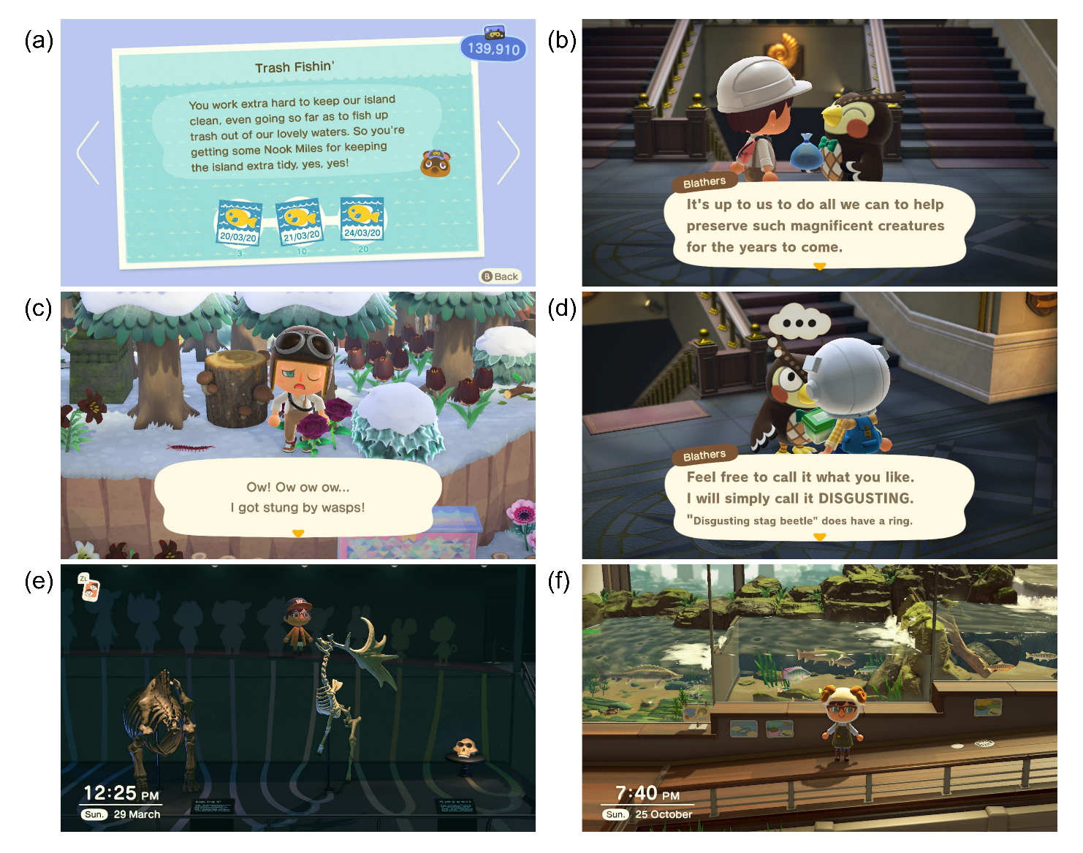
Figure 1 In-game screenshots from Animal Crossing New Horizons. (a) ‘Nook mile challenge’ to incentivise players to clean up litter, (b) The museum attendant promoting positive conservation messages, (c) A player is injured by a wasp sting, (d) The museum attendant reacting to a player donating a Stag Beetle, (e) Museum display illustrating the taxonomic lineage of mammals and how it relates to villagers, and (f) Museum enclosures for freshwater fish displayed by corresponding river zonation.
With the release of ACNH on 20th March 2020 coinciding with the COVID-19 pandemic, series producer Hisashi Nogami stated “Considering the timing, we hope that a lot of the Animal Crossing fans will use this as an escape, so they can enjoy themselves during this difficult time” (Webster, 2020). Indeed, using real play-time data, Johannes et al. (2021) suggested that time spent playing ACNH was positively associated with increased mental wellbeing. While ACNH had been hotly anticipated by long-time fans of the series, the pandemic led to far more interest than expected, including new fans outside of the traditional ‘gaming’ demographic.
ACNH has fast become the second-best selling video game ever in Japan (Doolan, 2020), second only to the original Pokémon Red, Blue, and Green titles. The internationalisation of the game has led to new features that encourage accessibility, including options to select the player character’s skin colour and the choice of which hemisphere the player is in (affecting which seasons take place in which months). Despite the target demographic being young girls, over half the players of ACNH are in their 20’s and 30’s, and there is little gender bias (Figure 2). Its popularity therefore represents a huge opportunity to engage millions of children, teens and adults with conservation issues in a fun and interactive way.
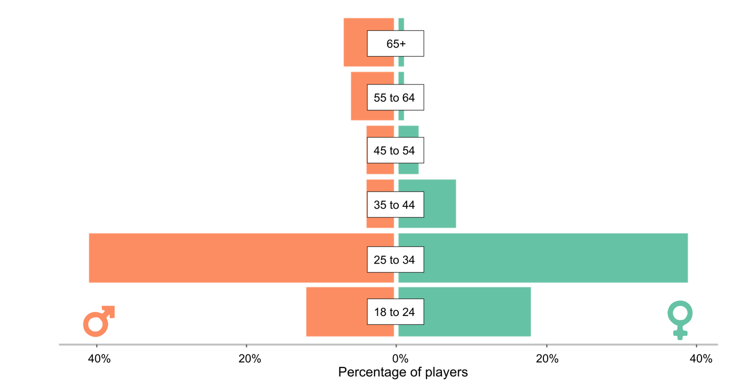
Figure 2 The demographic information of Animal Crossing New Horizons by sex and age class. Data sourced from Raquel Robles, https://public.tableau.com/s/ (Accessed December 2020)

While many aspects of the game promote conservation/ecological messages (Figure 1a-b), ACNH was not designed explicitly with the natural environment in mind. In fact, many of the aspects Western audiences may assume are based on natural history are in reality influenced by Japanese folklore and cultural traditions or associations. For example, Tom Nook (or Tanukichi in Japanese) is an island resident who operates the village store. He may be mistaken for a common racoon (Procyon lotor) by those who are unfamiliar with a tanuki (Nyctereutes procyonoides viverrinus), a Japanese raccoon dog with a folkloric history as both a trickster and a symbol of wealth (Bogost, 2020). While this misinterpretation may be largely inconsequential, other aspects of the game could impact a players pro-conservation behaviours, in particular the games’ pro-resource extraction message, and its relationship with the tradition of bug catching

Collectable wildlife
The game encourages players to seek out and catch invertebrates, as well as freshwater and marine species from different island habitats. At the time of writing, the total number of species available on the game sits at 236 (see Supporting Information Table S1 for a full list). This includes 80 insects, 120 marine, freshwater, and deep-sea species, 11 shrubs, six trees, 11 flowers, three ‘weeds’, and five types of mushroom. As the games have progressed, some species have been removed (e.g., cockroach). In line with the game's trademark real-time seasonal changes, species availability varies each month, and players can only collect all the species by travelling to other islands in the opposite hemisphere, or by playing across all 12 months.

The prominence of invertebrates and fishes in the game can be attributed to the game’s Japanese origins. Indeed, the country has a historic relationship with the marine and freshwater environment (Kalland, 1997) and is a world leader in the global trade of seafood produce (Swartz et al., 2010). Moreover, collecting invertebrates (or “mushi” which to older generations may also include animals such as frogs) is a long-standing tradition for Japanese youth. Since increased urbanisation, insects are often bought and bred but wild capture still occurs in rural regions. Each species is associated with a particular part of the day and season, which is reflected in traditional seasonal play, such as butterfly catching in spring, versus cicada and firefly catching in summer (Davies, 2020; Laurent, 2000). In ACNH, the seasonal availability of species is largely ecologically accurate (e.g. mushrooms are available in Autumn, and butterflies are abundant in the summer). However, in-game ‘seasons’ are always temperate and do not vary in daylight hours, and therefore associations between species and season are generic and constrained. Animal Crossing is by no means the first video game to be inspired by this tradition. Indeed, Pokémon (originally developed by Game Freak Co.) and Mushiking (developed by Sega) are both highly successful arcade/console games released alongside collectible card series’. Through multiple media, bug catching is perceived as one way to reconnect Japanese children with nature and with cultural traditions. For international audiences, the popularity of the ACNH could have far-reaching consequences for improving the public’s knowledge and awareness of the biodiversity and ecology of this region, given that catchable species are predominantly Asian.

After catching wild invertebrates and fishes on the islands, players can either display their catches (e.g. in the museum, aquarium, as decorations in your home) (see section Island museum, aquarium, and terrarium) or sell them for in-game currency, bells. There is a strong bias towards in-game species diversity for those considered to be commercially valuable in the real world. For example, a species based on the wasp spider (Argiope bruennichi), is only defined as “spider” (worth a low 600 bells, and classified as uncommon). In comparison, there are 23 species of beetle available, the most expensive and valuable of which includes the Hercules Beetle (Dynastes hercules), worth 12,000 bells. Of the 200 catchable animal species, approximately 86% had a real-world commercial value (Supporting Information S2; Figure 3).

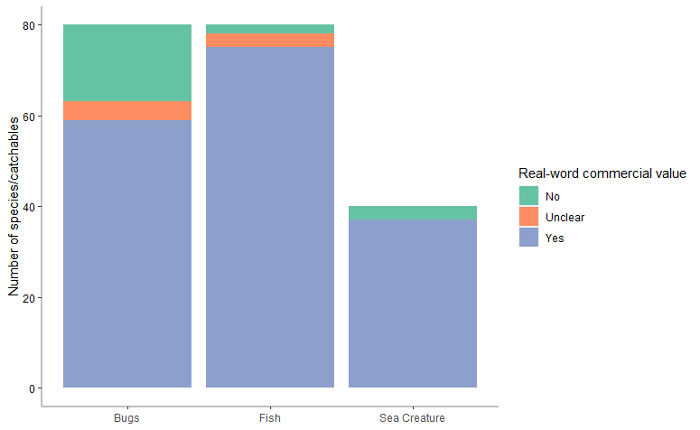
Figure 2 Proportion of catchable species in Animal Crossing: New Horizons which are considered to be of commercial value in the real world (see Supporting Information Table S2 for details). Categories (‘bugs’, ‘fish’, ‘sea creature’) are attributed by Nintendo. List includes species which are used as a food resource, as a collectible, for the pet industry, or sport fishing.

Incorporating these values into gameplay could risk encouraging or legitimising real-world demand for species (Nijman & Nekaris, 2017). In Japan, overexploitation of insects for the pet trade or for decoration are major drivers of population decline (Tournant et al., 2012), and recent reports by The National Geographic suggest international smuggling is being used to help meet this market demand (Actman, 2019; Berton, 2020). The valuable Hercules Beetle is native to Bolivia, playing an important role in the nutrient cycles of tropical forests, with their illegal harvest carrying up to six years imprisonment (Berton, 2020). They nonetheless remain popular pets in Japan. Similarly, firefly harvesting in Japan has been banned due to overexploitation, and there are numerous efforts trying to rehabilitate populations and their habitats (Oba et al., 2011). In ACNH however, fireflies are worth a small sum of 300 bells and there is no reference to the national efforts to restore populations which have been ongoing since 1924.

ACNH does highlight conservation concerns for two species, the Napoleonfish (Cheilinus undulatus) and the Asian arowana (Scleropages formosus), when a player donates them to the museum. Over 40% of species available to catch in the game are listed on the International Union for the Conservation of Nature (IUCN) Red List (Figure 4). As such, there is considerable potential to harness this existing infrastructure and expand the information provided to players on species’ profiles. Through using internationally recognised labelling (i.e., IUCN and CITES status’), Nintendo has the platform to educate its growing community on the detrimental impact the wildlife trade has on species populations. This could also provide players with an alternative way to catch and keep species virtually, therefore contributing two-fold to conserving wild populations.
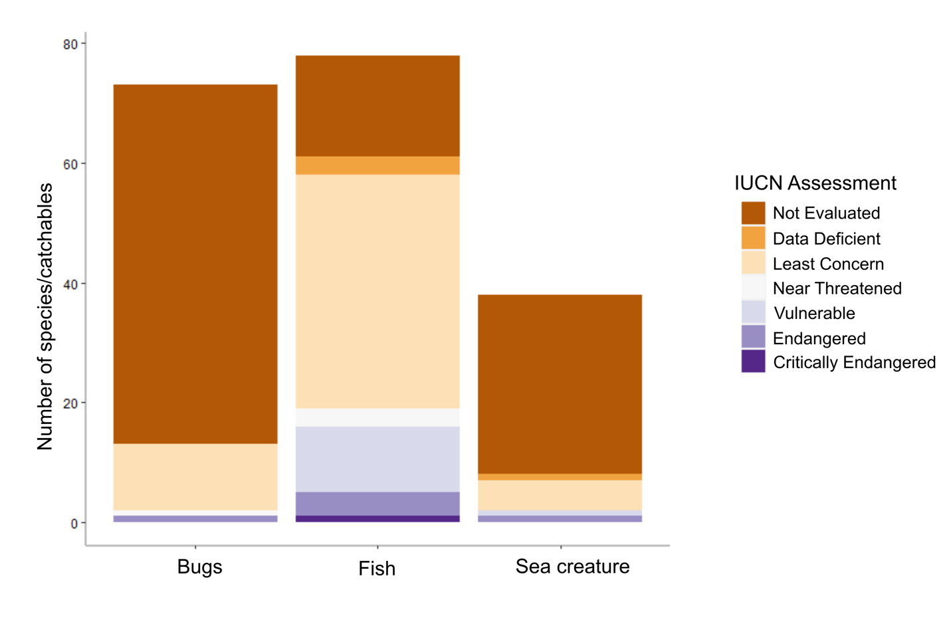
Figure 4 Proportion of catchable species in Animal Crossing New Horizons listed under the IUCN Red List. Categories (‘bugs’, ‘fish’, ‘sea creature’) are attributed by Nintendo.

Several aspects of ACNH provoke negative associations with invertebrates. While players never reach a ‘game over’, they can be attacked or ‘black out’ from wasp, tarantula, or scorpion stings (Figure 1c). This could hypothetically act as an educational tool for children to avoid these species in the real world. In previous versions of the game, wasps (referred to in previous versions as ‘bees’) resembled Giant Asian Hornets (Vespa mandarinia), which kill approximately 30-50 people in Japan each year (Yanagawa et al., 2007). In ACNH, their design and behaviour when nest building now better reflects a species of paper wasp (Supporting Information Table S1).

Many dangerous animals native to Japan are either not present in the game or do not cause any ill effects. For example, there are several venomous snake species in Japan, such as the Mamushi (Gloydius blomhoffii) which kill approximately 10 people per year and bite up to 3000, yet no snake species appear in the game (Okamoto et al., 2009). The venomous Giant centipede (Scolopendra subspinipes) is present in the game, however, does not pose a risk to the player. It is therefore unlikely wasps were included in the game as an educational tool without also including these other examples. Collecting the nests of edible wasp species used to be a traditional Japanese activity, but has since become uncommon (Laurent, 2000). It is therefore more likely that wasps are included in ACNH in relation to their commercial value as food or in the pet trade. Consideration of how species are portrayed in popular games like ACNH is pivotal. Indeed, Balmford et al. (2002) argue that games like Pokémon can inspire interest in species both real or imagined. ACNH already provides educational life history facts for many species in the game and it is known that conservation efforts are targeted towards species that the public value (Troudet et al., 2017). By expanding on the in-game infrastructure and tailoring information presented to players, whether about their role in the ecosystem or value to the Japanese economy, ACNH has the potential to inspire a real appreciation for biodiversity.

Island habitats and ecological interactions
ACNH allows players to transform their islands to the design of their choosing. Islands with a bigger diversity of habitats (e.g., forests, meadows, ponds), at different altitudinal terrains, will subsequently result in greater species diversity. For instance, certain species will only spawn (appear) on specific flora (e.g., the orchid mantis, Hymenopus coronatus, will only spawn on white flowers) and butterflies congregate in areas of high flower concentrations. Players are rewarded with ‘nook miles’ (another in-game currency) for completing activities including planting trees (Figure 1a), or keeping their island’s ocean clean by fishing up litter that can then be recycled through crafting (e.g., an old boot can be recycled into footwear for your character). Villagers who reside on players’ islands will pay you to remove litter, as the rating of an island drops if litter is around. These in-game rewards for engaging in pro-conservation behaviours could lead to real-world behavioural changes with positive implications for conservation.
Another ACNH feature with positive conservation messaging is the role of tree stumps. Dead wood is linked to high diversity of invertebrates, bryophytes, fungi and other taxa (Andringa et al., 2019; Ódor et al., 2006) but had no value in earlier versions of the game. ACNH has introduced species which exclusively spawn on them, including Rosalia Batesi Beetles, a hardwood boring species endemic to Japan (worth 3000 bells each, valuable). The presence of dead wood is often associated with lowered aesthetic preference, which can be alleviated by providing information about its ecological function (Gundersen et al., 2017). As such, informing players of the ecological value of dead wood in ACNH could lead to greater real-world tolerance of dead wood and its importance for biodiversity.
In-game, species-specific interactions between insects and flora work in combination with the island star-rating system to encourage players to increase the floral diversity of their own island. This inherently promotes the idea that species-rich habitats are more valuable, irrespective of whether the player originally sought to engage in a pro-conservation activity per se or improve their island rating However, many players found there were additional financial incentives to deforest/remove flora from other islands. Removing flora induces high spawn rates of usually rare (in-game) tarantulas and scorpions, both worth a high 8000 bells, and numerous articles were written instructing players how to do this (including, on 26 April 2020, the front page of the Financial Times). This reinforces the notion that it is the financial reward, not the island biodiversity, that is of value, reflecting real-world conservation issues (Smith et al., 2020). Nintendo have already been working towards updates which prevent players from using this approach to harvest tarantulas and scorpions, but there are additional measures that could be implemented to demonstrate how localised conservation efforts collectively impact a global biodiversity network (e.g., if there was a positive incentive to increase the flora on islands they visit). Moreover, it is likely that these efforts to exploit the game are undertaken by a small subset of devoted fans rather than casual players, thus lessening the impact of top-down changes on the wider demographic. Certainly, players can choose to intentionally devastate their island habitat, be it for resources, aesthetic preference, or intentionally destructive purpose. But by doing so, players miss the overall message of the game, as well as in-game rewards. Like conservation in the real world, people can be educated and incentivised to engage in pro-environmental behaviours, but can ultimately choose not to do so.

Other island features are also responsible for mixed messaging with respect to conservation. In previous game releases, over-using specific routes for walking led to the grass wearing down or being removed completely, mimicking real-world footpath erosion. In ACNH however, this feature does not exist, which could be seen as a step backwards in terms of pro-conservation messaging. In another example, ACNH encourages flowers, trees, and other aesthetically desirable flora, but discourages others. Weeds (three species with seasonal variation) randomly generate over time and decrease an island’s star-rating. Certain weeds reduce villagers’ happiness, whereas others act as contaminants, reducing the rate of flower breeding. Whilst this demonstrates inter-species interactions and how nature can impact wellbeing, the overarching message appears to be that manicured nature is preferable to wilderness. This is reflective of Japan’s current green spaces which have been actively managed since extensive deforestation for conversion to agriculture over the last 1000 years (Kalland, 1997). Whilst there has been growing support in Japan towards rewilding several of its green spaces, particularly where it is related to protecting or reintroducing iconic species (Bird, 2017; Zukowski, 2018), there are those who doubt the government's commitment and who argue this is not a solution to conserve biodiversity more broadly (O’Neill, 2019). Alternatively, there are initiatives that recognise the potential that human-influenced green spaces can play in Japanese conservation. A patchwork of human settlements and managed green spaces can provide a refuge to protect Japan’s biodiversity whilst also providing resources (such as wild foods) and human wellbeing benefits (Ishii & Nakamura, 2012). Animal Crossing provides an ideal platform for the player to explore the benefits and trade-offs of these patchwork landscapes.

Overall, there are very few in-game references to food despite entomophagy and seafood being popular in Japanese cuisine. Approximately 45% of the catchable species in the game are considered food resources, yet this is only mentioned for three species when they are donated to the museum (Supporting Information Table S2). The importance of sustainable harvesting for seafood from Japan’s fisheries was a key message promoted by Conservation International Japan (CIJ) in their ACNH island which was open for public visitation (Treasure Island October release; https://treasure-island.jp/, currently under maintenance). Partnered with the University of Marine Science and Technology, CIJ created Otakara Island, a sustainable floating city, where users could learn how to solve environmental problems. The design was informed by experts involved in the development of floating cities which tackle various global environmental problems, such as climate change, and included new villagers which represented critically endangered species (e.g., Amelia the California Condor). CIJ stated the key message of the island was “Nature is not infinite, let’s respect diversity and protect the environment”. Food security featured throughout its promotional material. Users were incentivised to visit the island for a chance to win prizes, including an environmentally friendly gastro experience, as well as snack bars made of crickets. Both of these gifts further promoted the education around food sustainability. For English speakers, American non-profit organisation Monterey Bay Aquarium has designed its own ACNH island from which it streams episodes of educational content, featuring marine biologists, entomologists, herpetologists and other specialists to engage players with science and the natural world (Gamers and Science Nerds Unite! Watch Us Build Our Island and Fish up Facts in Animal Crossing: New Horizons, 2020). These initiatives illustrate how games like ACNH can be used for outreach, education and pro-conservation messaging, within a fun and familiar format for both children and adults alike.

Several changes to the infrastructure of ACNH could further inform players about ecological processes and conservation management. For example, there is no process by which continuously fishing leads to fewer fish on an island (demonstrating resource-depletion). Moreover, building a beehive is purely aesthetic and has no effect on honeybee populations/spawning on the island. By introducing simple notifications about sustainable harvesting, or by allowing spawn rates of catchable species to increase or decrease in response to pro-conservation items or behaviours, players could be further incentivised to consider conservation in game play. Furthermore, players do not have options to invest their assets in conservation. In the real world, since online fundraising is becoming an important measure to address financial shortages in conservation (Kubo et al., 2021), the investment for environmental protection in ACNH might increase players’ awareness of fundraising for conservation, and encourage them to contribute financially in the real world.

While ACNH is not principally an educational game, it provides an introduction to biodiversity and offers a platform for international conservation organisations to harness the games’ popularity to further engage and communicate with a wider audience about environmental issues. Indeed, to limit the trade-off between enjoyment and education, ACNH provides a model for other video games that do not wish to make conservation a focal theme. For instance, ‘Coral Island’ (Stairway Games, 2021), scheduled for release in late 2021, will focus on conservation issues in Indonesia, educating players on issues such as coral bleaching and deforestation. While it does not have the legacy fan base of the Animal Crossing franchise, new generation games could benefit from lessons learnt by the mainstream gaming industry.

In-game characters
A limit in the game’s potential for conservation messaging is its representation of different taxonomic groups. ACNH features 391 non-playable animal characters (villagers) across 34 species who can inhabit the player’s island. The taxonomy of villagers is heavily skewed towards vertebrates, particularly mammals (Figure 5), which comprise nearly three-quarters (292) of villagers across 25 species. By contrast, 71 are birds (across six groups), 18 amphibians (all frogs), seven reptiles (all alligators), and three invertebrates (all octopuses). Indeed, the anthropomorphic villagers that inhabit the islands are predominantly higher vertebrates, mostly mammals, while all the catchable biodiversity is non-sentient invertebrates or lower vertebrates (Supporting Information Table S1). This taxonomic separation reinforces the fact that, across many studies (Albert et al., 2018; Troudet et al., 2017), people are more likely to care about charismatic megafauna such as lions, bears, deer and other mammals rather than taxa such as beetles which might be equally endangered or important to an ecosystem. There are a few exceptions in ACNH, where frogs and octopuses are available as both villagers and catchables, highlighting how it is not essential to separate these taxonomic groups.
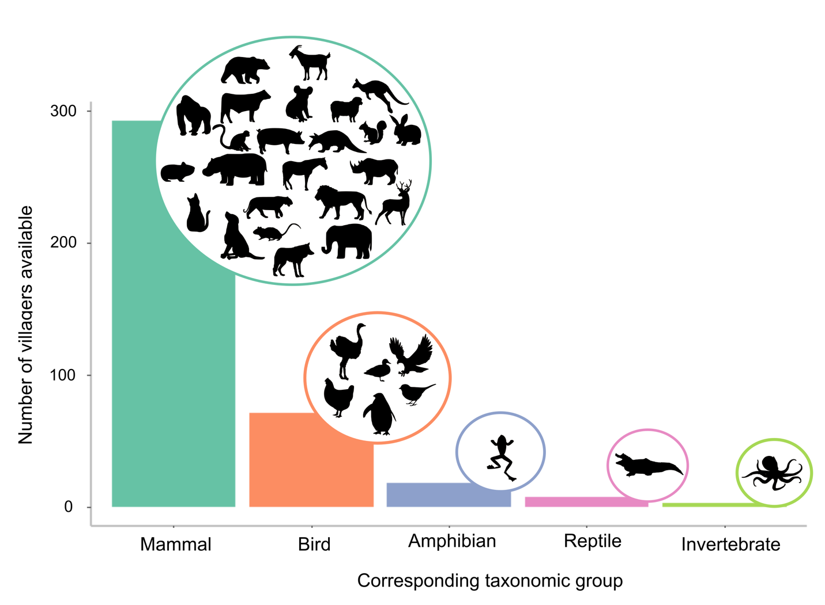
Figure 5 Number of villagers available in Animal Crossing New Horizons by taxa. The variety within each taxonomic group is demonstrated by the corresponding silhouettes, e.g., all amphibian villagers in the game are frogs.

Notably, there is considerable variation between the villagers of the same type of animal, and the diversity is broader than the species list suggests. For example, all ‘anteater’ villagers are classified as Anteaters, however villager Annabelle is designed after a pangolin. Additionally, the tiger Bianca is modelled after a snow leopard, Papi the horse is designed to look like an okapi and Amelia the eagle is based on the Californian condor (species respectively listed by the IUCN Red List as vulnerable, endangered and critically endangered). Despite this inclusion of species of notable conservation status, there is no distinction made in ACNH, which could be clarified in future releases.
The Animal Crossing franchise has emphasised socialising with other game users since the series’ inception. While connecting online, players have the ability to trade items and villagers with each other. Thanks to this feature and the game’s popularity, there are many websites where exchanges for villagers can be arranged (for in-game assets or even real-world money). This has led to the development of a tier system in which villagers are ranked from most to least desirable. The exact tier lists are in a state of constant flux and vary across websites, although some are regularly among the most coveted. At the time of writing, 13 of the top 15 villagers are mammals, but two are also octopus villagers, the only invertebrate taxa on the list (Villager Popularity Tier List - Animal Crossing: New Horizons, 2021). This reinforces the idea that ACNH players could be receptive to other taxa, and future game designs might consider broadening villager diversity to include other non-mammal taxa.
While collected species can be re-released back into the wild, each player’s island contains a museum connected to an aquarium, and an indoor greenhouse where collected species can be kept and displayed (see below). When catches are donated (for no monetary reward or other incentive), the museum attendant (‘Blathers’ the owl) imparts background facts, sometimes of conservation relevance, on the species in question. For example, upon donating a Queen Alexandra’s birdwing (Ornithoptera alexandrae), an endangered butterfly endemic to Papua New Guinea, Blathers states ‘endangered, not Japanese, & listed under Appendix 1 of CITES. But, a popular collectors’ species’. When the Citrus longhorned beetle (Anoplophora chinensis) is donated, Blathers conveys that ‘They are also an invasive species, and quarantine pest for the European Union’, perhaps beneficial in implying that invasive species should be caught and not re-released. Through Blathers, players can therefore learn new information about biodiversity with positive implications for conservation awareness. The game has the potential to take this one step further by removing the mechanism for re-releasing species which are known to be invasive. Whilst it may not be possible to make this regionally specific (e.g., the Citrus longhorned beetle is native in Japan but invasive to Europe), it could still promote pro-conservation behaviours.

Despite many positive in-game associations with invertebrates, Blathers conveys an intense entomophobia which has become more accentuated across game releases. The information he provides as museum curator is often limited and replaced with comments that reflect his disdain when they relate to insects (Figure 1d). Many players may recall the backstory that Blathers was brought up in the city, with few positive experiences with invertebrates, a perception that may resonate with many players. Certainly in Japan, children brought up in urban environments or who have a poor knowledge of invertebrates exhibit greater biophobia toward the taxa (Soga et al., 2020). If Blathers could overcome his fear and express an appreciation toward invertebrates, players could similarly be encouraged to challenge their own negative preconceptions. Additionally, ACNH uses other game characters to explore contrasts between rural and urban experiences. Celeste, Blathers’ sister, may visit a player’s island on clear nights to star-gaze, explaining that there is less light pollution outside of the city. This offers targeted educational material about the impacts of urbanisation.

Island museum, aquarium, and terrarium
Catches are displayed within enclosures that resemble the species’ real-world habitats (Figure 1e-f). For instance, the multi-tiered aquarium comprises exhibits for multiple habitats and the species synonymous, including upstream rivers (e.g., cherry salmon Oncorhynchus masou), rainforest rivers (e.g., Asian arowana S. formosus), open ocean (e.g., sunfish Mola mola), and tropical shallow seas (e.g., Gigas giant clam Tridacna gigas). In the greenhouse, pond skaters and aquatic bugs are found in the ponds, beetles can be seen on the trees, and fireflies are found swarming over the grass. Moreover, the behaviours exhibited by species within these displays are synonymous with the real world (e.g., punching behaviour of the mantis shrimp Odontodactylus scyllarus). As a result, these spaces enable players to learn more about biodiversity and increase their understanding of ecological phenomena. While plaques exist across the museum’s enclosures giving the identity of species within, there remains potential to incorporate further information such as IUCN status and life history traits.

ACNH also includes educational material regarding evolution and taxonomy. Each day, players can dig up fossils from around the islands. When donated to the museum, these fossils are transformed into the physical entity that they represent (e.g., a Tyrannosaurus rex skull), which together form an entrance hall of large skeletons. An evolutionary tree at the back of the hall contains the shadowed outlines of 18 villager types available in the game, each representing a taxonomic lineage, including humans (Figure 1d). Each shadow connects to a fossil that is related to its lineal descendant (e.g., cats are linked to the skull of a saber-toothed tiger). In the absence of religious opposition in Japan, the theory of evolution was readily adopted in the 19th century (Sakura, 1998). As such, these educational features of ACNH enable players from across all sectors of society to learn about evolution and the history of biological diversification.

Conclusion and recommendations
With multiple billions of players worldwide, video gaming offers a timely, pronounced, and previously untapped resource for conservation messaging. The growing popularity and internationalisation of ACNH, facilitated by its release coinciding with pandemic lockdowns, has led to a wide audience spanning a greater breadth of demographics far beyond those traditionally seen in gaming culture. Given this extensive reach, video games like ACNH and the messages they advocate could subsequently become a critical component of the conservation toolbox amid the current biodiversity extinction crisis and period of unprecedented global environmental change.

Augmenting conservation messaging in ACNH could detract from the enduring positivity and sense of escapism for which the game has been praised. Nintendo thus faces the difficult decision to trade-off between fact and fun, ultimately fundamental to the games’ success. Yet, ACNH already poses some solutions to this conflict, harnessing the power of humour through Blathers to help players learn: ‘Paper kite butterfly, do I read it, fly it, or spread it on toast?’. Nonetheless, the effectiveness of conservation messaging on influencing actual behavioural change will depend on each individual’s motivations, opportunities, and abilities (Smith et al., 2020). Indeed, both qualitative and quantitative data is still needed to evaluate the impact of playing ACNH on pro-conservation attitudes and behaviours.

Video games which have been specifically designed to alter human behaviour have been shown as effective, for example in promoting energy-efficiency (Morganti et al., 2017) or healthy eating (Chow et al., 2020). Games that involve players experiencing the consequences of decision-making are thought to be more effective learning processes than regular teaching (Garris et al., 2002). This has been demonstrated for conservation education specifically (Tan et al., 2018). Gaming psychologists have identified specific features that heighten the effectiveness of these educational games, such as the use of a customisable avatar (a prominent feature of ACNH), that raises the player’s sense of identity and investment in the content (Annetta, 2010). Nonetheless, it is still unclear how much education, awareness and positive attitudes lead to actual behaviour change (Waylen et al., 2009). Moreover, unlike video games aimed at changing behaviour, little research has explored the effects of games which are not intentionally designed to alter behaviour. More research is needed to elucidate the psychological mechanisms behind these video games and explore how they could be applied to conservation science.

Encouraging video-gaming indoors detracts from the time people spend in real-world natural environments (Oswald et al., 2020), experiences that are known to improve mental wellbeing and could themselves lead to pro-environmental behaviours and attitudes (Alcock et al., 2020; Martin et al., 2020). Virtual, indoor experiences allow players to avoid the negative aspects of real-world nature (e.g. mosquito bites, unpleasant odours, or noise), and could therefore reduce the likelihood of ever interacting with the outdoors. ACNH does in fact offer time-restricting features (e.g., limiting the number of fossils available per day), which encourages players to return later. Yet the wider implications of humanity’s reliance on screen-time have yet to be fully realised, and virtual nature experiences cannot fully compensate for the real thing, particularly in terms of mental health (Browning et al., 2020).

The popular video game Pokémon Go bridged this conflict by requiring players to explore the real world to progress in-game, seeking out virtual species to collect, and encouraging real-world social interactions. The Pokémon franchise, and Pokémon Go specifically, stimulated excitement amongst researchers about its implications for the conservation movement (Dorward et al., 2017; Oliveira Roque, 2016). Pokémon was however majorly limited by using imagined as opposed to real-world species (Balmford et al., 2002). Likewise, news media and advertising campaigns popularising charismatic and often exotic species (e.g. large species with forward-facing eyes, Smith et al., 2012), may bias people’s understanding and concern for local biodiversity. Overall, our understanding of how video games promote pro-conservation messaging that influences behavioural change, in both virtual and real-world natural environments, still warrants further research.

Overall, ACNH predicates the existence of a platform where conservation messaging can be used to not only augment, but to transform people’s relationship with the natural world. This poses a huge opportunity for Nintendo and developers alike to embed pro-conservation behaviours and attitudes into billions of people through gaming culture. Our perspective has shown that ACNH does operate as a tool for conservation messaging and should certainly be praised for its sophisticated ecological detail. However, we raise some simple adaptations for Nintendo to consider for future releases of the Animal Crossing franchise to strengthen its commitment to biodiversity loss worldwide.

- When donating catchable species to the museum, increase the consistency with which information about conservation importance is reported (i.e., IUCN status, CITES Appendices).
- Enhance the information provided by museum plaques to include detail about IUCN status, life history traits, and other ecological facts.
- Diversify the taxa that villagers represent to include non-vertebrate and non-mammal species, and provide information on their IUCN status where appropriate.
- Integrate the notion of sustainable resource use (e.g., beehive could increase the availability of catchable bees; overfishing of the island waters could decrease catchable fish).
- Ensure that in-game phenomena (e.g., the seasonal availability of catchable species), reflects real-world ecological life histories rather than Japanese cultural associations.
- Remove the mechanism for re-releasing invasive species (e.g., Citrus long-horned beetle) back onto the island.
- Improve Blathers’ attitude toward invertebrates and a mechanism or event through which he can overcome his entomophobia.
- Incorporate an avenue by which players are incentivised to invest their own assets into conservation (e.g., by donating nook miles to a conservation cause, players receive villager positivity, island star-rating increases, or increased availability of rare catchables)

For gaming developers more generally, several lessons can be learned from ACNH. Foremost, the use of real versus imagined species is a significant step forward in terms of enhancing players’ knowledge. There are certainly plenty of exciting, bizarre, interesting, or even grotesque, features of the natural world that could be harnessed to increase players’ interest in the same way that imagined species do. Likewise, incorporating elements of realism while minimising trade-off against fun is important to uphold educational integrity. This issue was raised by Sandbrook et al. (2015), who argue that oversimplifying conservation issues may raise a players’ awareness while simultaneously misguiding the players’ understanding. Game developers may also consider designing regionally-specific releases, without limiting global reach. This kind of specificity could give players a greater sense of affinity with the game, both aiding an understanding of any messages conveyed, while also likely facilitating sales as a ‘collectible’. Finally, game developers may also consider their moral position in the world of conservation, climate change, and pro-environmentalism more broadly. Elsewhere, game designers have successfully cooperated with researchers to tackle social issues, resulting in award-winning games (Fordham and Ball, 2019). Developers could harness this opportunity to incorporate social marketing for pro-environmental behaviours into the fabric of the gaming content. Features such as peer-to-peer (or in-game character to peer) messaging could be one such avenue to do this. Given increased access to the internet, smart-phones and gaming devices, a more connected world could be harnessed for good by those that have access to large, global audiences.

Conflict of Interest
The authors declare no conflict of interest.

Authors’ Contributions
JCF and DR conceptualised the manuscript; NY, JCF, and DR conceived the arguments and led the writing of the manuscript; NY summarised the data; TK contributed to the writing and reviewing. All authors contributed critically to the drafts and approved the final version for publication.
References
Actman, J. (2019). Bug smuggling is big business. National Geographic. https://www.nationalgeographic.co.uk/animals/2019/09/bug-smuggling-big-business
Albert, C., Luque, G. M., & Courchamp, F. (2018). The twenty most charismatic species. PLOS ONE, 13(7), e0199149. https://doi.org/10.1371/journal.pone.0199149
Alcock, I., White, M. P., Pahl, S., Duarte-Davidson, R., & Fleming, L. E. (2020). Associations between pro-environmental behaviour and neighbourhood nature, nature visit frequency and nature appreciation: Evidence from a nationally representative survey in England. Environment International, 136, 105441. https://doi.org/10.1016/j.envint.2019.105441
Andringa, J. I., Zuo, J., Berg, M. P., Klein, R., van’t Veer, J., de Geus, R., de Beaumont, M., Goudzwaard, L., van Hal, J., Broekman, R., van Logtestijn, R. S. P., Li, Y., Fujii, S., Lammers, M., Hefting, M. M., Sass-Klaassen, U., & Cornelissen, J. H. C. (2019). Combining tree species and decay stages to increase invertebrate diversity in dead wood. Forest Ecology and Management, 441, 80–88. https://doi.org/10.1016/j.foreco.2019.03.029
Annetta, L. A. (2010). The “I's” have it: A framework for serious educational game design. Review of General Psychology, 14, 105-113.

Balmford, A., Clegg, L., Coulson, T., & Taylor, J. (2002). Why Conservationists Should Heed Pokémon. Science, 295, 2367–2367. https://doi.org/10.1126/science.295.5564.2367b
Bennett, N. J., Roth, R., Klain, S. C., Chan, K., Christie, P., Clark, D. A., Cullman, G., Curran, D., Durbin, T. J., Epstein, G., Greenberg, A., Nelson, M. P., Sandlos, J., Stedman, R., Teel, T. L., Thomas, R., Veríssimo, D., & Wyborn, C. (2017). Conservation social science: Understanding and integrating human dimensions to improve conservation. Biological Conservation, 205, 93–108. https://doi.org/10.1016/j.biocon.2016.10.006
Berton, E. F. (2020). Why rare beetles are being smuggled to Japan at an alarming rate. National Geographic. https://www.nationalgeographic.com/animals/article/bolivian-beetles-smuggled-to-japan-for-fighting
Bird, W. (2017). For Japan’s Eagles, Hope Lies in “Rewilding” Long-Tamed Forests. Yale Environment 360. https://e360.yale.edu/features/for-japans-eagles-hope-lies-in-rewilding-long-tamed-forests
Bogost, I. (2020). The Quiet Revolution of Animal Crossing. The Atlantic. https://www.theatlantic.com/family/archive/2020/04/animal-crossing-isnt-escapist-its-political/610012/
Browning, M. H., Mimnaugh, K. J., van Riper, C. J., Laurent, H. K., & LaValle, S. M. (2017). Can simulated nature support mental health? Comparing short, single-doses of 360-degree nature videos in virtual reality with the outdoors. Frontiers in psychology, 10, 2667. https://doi.org/10.3389/fpsyg.2019.02667/
Chow, C. Y., Riantiningtyas, R. R., Kanstrup, M. B., Papavasileiou, M., Liem, G. D., & Olsen, A. (2020). Can games change children’s eating behaviour? A review of gamification and serious games. Food Quality and Preference, 80, 103823.

Davies, H. (2020). A Prehistory of Pokémon GO. American Journal of Play, 12(3), 33.
Doolan, L. (2020). Animal Crossing: New Horizons Is Now Japan’s Second Best-Selling Game Ever. Nintendo Life. https://www.nintendolife.com/news/2020/08/animal_crossing_new_horizons_is_now_japans_second_best-selling_game_ever
Dorward, L. J., Mittermeier, J. C., Sandbrook, C., & Spooner, F. (2017). Pokémon Go: Benefits, Costs, and Lessons for the Conservation Movement. Conservation Letters, 10(1), 160–165. https://doi.org/10.1111/conl.12326
Financial News Media. (2020). Global Gaming Market Expected to Exceed $256 Billion By 2025. CISION PR Newswire. https://www.prnewswire.com/news-releases/global-gaming-market-expected-to-exceed-256-billion-by-2025-301182238.html
Fletcher, R. (2017). Gaming conservation: Nature 2.0 confronts nature-deficit disorder. Geoforum, 79, 153–162. https://doi.org/10.1016/j.geoforum.2016.02.009
Fordham, J & Ball, C. (2019). Framing mental health within digital games: An exploratory case study of Hellblade. JMIR Mental Health, 6 (4), e12432. https://doi.org/10.2196/12432
Garris, R., Ahlers, R., & Driskell, J. E. (2002). Games, motivation, and learning: A research and practice model. Simulation & gaming, 33, 441-467.
Gamers and science nerds unite! Watch us build our island and fish up facts in Animal Crossing: New Horizons. (2020). Monterey Bay Aquarium. https://www.montereybayaquarium.org/stories/aquarium-animal-crossing
Gundersen, V., Stange, E. E., Kaltenborn, B. P., & Vistad, O. I. (2017). Public visual preferences for dead wood in natural boreal forests: The effects of added information. Landscape and Urban Planning, 158, 12–24. https://doi.org/10.1016/j.landurbplan.2016.09.020
Ishii, M., & Nakamura, Y. (2012). Development and future of insect conservation in Japan. In Insect Conservation: Past, Present and Prospects (pp. 339–357). Springer. https://link.springer.com/chapter/10.1007%2F978-94-007-2963-6_15
Johannes, N., Vuorre, M., & Przybylski, A. K. (2021). Video game play is positively correlated with well-being. Royal Society Open Science, 8(2), 202049. https://doi.org/10.1098/rsos.202049
Kalland, A. (1997). Review of Fishing Villages in Tokugawa Japan [Review of Review of Fishing Villages in Tokugawa Japan, by L. L. Cornell]. Journal of Japanese Studies, 23(2), 430–433. https://doi.org/10.2307/133166
King, D. L., Delfabbro, P. H., Billieux, J., & Potenza, M. N. (2020). Problematic online gaming and the COVID-19 pandemic. Journal of Behavioral Addictions, 9(2), 184–186. https://doi.org/10.1556/2006.2020.00016
Kubo, T., Veríssimo, D., Urya, D., Mieno, T., & MacMillan, D. (2021). What determines the success and failure of environmental crowdfunding. Ambio. https://doi.org/10.1007/s13280-021-01522-0
Laurent, E. L. (2000). Children, “insects” and play in Japan. In A. L. Podberscek, E. S. Paul, & J. A. Serpell (Eds.), Companion Animals and Us: Exploring the Relationships Between People and Pets. Cambridge University Press.
López-Cabarcos, M. Á., Ribeiro-Soriano, D., & Piñeiro-Chousa, J. (2020). All that glitters is not gold. The rise of gaming in the COVID-19 pandemic. Journal of Innovation & Knowledge, 5(4), 289–296. https://doi.org/10.1016/j.jik.2020.10.004
MacDonald, K. (2020, May 13). “It’s uniting people”: Why 11 million are playing Animal Crossing: New Horizons. The Guardian. https://www.theguardian.com/games/2020/may/13/animal-crossing-new-horizons-nintendo-game-coronavirus
Martin, L., White, M. P., Hunt, A., Richardson, M., Pahl, S., & Burt, J. (2020). Nature contact, nature connectedness and associations with health, wellbeing and pro-environmental behaviours. Journal of Environmental Psychology, 68, 101389.
Morganti, L., Pallavicini, F., Cadel, E., Candelieri, A., Archetti, F., & Mantovani, F. (2017). Gaming for Earth: Serious games and gamification to engage consumers in pro-environmental behaviours for energy efficiency. Energy Research & Social Science, 29, 95-102.

Nijman, V., & Nekaris, K. A.-I. (2017). The Harry Potter effect: The rise in trade of owls as pets in Java and Bali, Indonesia. Global Ecology and Conservation, 11, 84–94. https://doi.org/10.1016/j.gecco.2017.04.004
Oba, Y., Branham, M. A., & Fukatsu, T. (2011). The terrestrial bioluminescent animals of Japan. Zoological Science, 28(11), 771–789. https://doi.org/10.2108/zsj.28.771
Ódor, P., Heilmann-Clausen, J., Christensen, M., Aude, E., van Dort, K. W., Piltaver, A., Siller, I., Veerkamp, M. T., Walleyn, R., Standovár, T., van Hees, A. F. M., Kosec, J., Matočec, N., Kraigher, H., & Grebenc, T. (2006). Diversity of dead wood inhabiting fungi and bryophytes in semi-natural beech forests in Europe. Biological Conservation, 131(1), 58–71. https://doi.org/10.1016/j.biocon.2006.02.004
Okamoto, O., Oishi, M., Hatano, Y., Kai, Y., Goto, M., Kato, A., Shimizu, F., Katagiri, K., & Fujiwara, S. (2009). Severity factors of Mamushi (Agkistrodon blomhoffii) bite. The Journal of Dermatology, 36(5), 277–283. https://doi.org/10.1111/j.1346-8138.2009.00638.x
Oliveira Roque, F. (2016). Could Pokémon Go boost birding? Nature, 537(7618), 34–34. https://doi.org/10.1038/537034e
O’Neill, D. (2019). Rewilding futures: Japan’s nuclear exclusion zone and post 3.11 eco-cinema. Journal of Japanese and Korean Cinema, 11(1), 85–100. https://doi.org/10.1080/17564905.2019.1600697
Oswald, T. K., Rumbold, A. R., Kedzior, S. G. E., & Moore, V. M. (2020). Psychological impacts of “screen time” and “green time” for children and adolescents: A systematic scoping review. PLoS ONE, 15, e0237725. https://doi.org/10.1371/journal.pone.0237725
Sakura, O. (1998). Similarities and Varieties: A Brief Sketch on the Reception of Darwinism and Sociobiology in Japan. Biology and Philosophy, 13(3), 341–357. https://doi.org/10.1023/A:1006504623820
Sandbrook, C., Adams, W. M., & Monteferri, B. (2015). Digital Games and Biodiversity Conservation. Conservation Letters, 8(2), 118–124. https://doi.org/10.1111/conl.12113
Selinske, M. J., Garrard, G. E., Bekessy, S. A., Gordon, A., Kusmanoff, A. M., & Fidler, F. (2018). Revisiting the promise of conservation psychology. Conservation Biology, 32(6), 1464–1468. https://doi.org/10.1111/cobi.13106
Smith, R. J., Veríssimo, D., Isaac, N. J., & Jones, K. E. (2012). Identifying Cinderella species: uncovering mammals with conservation flagship appeal. Conservation Letters, 5, 205-212.
Smith, R. J., Salazar, G., Starinchak, J., Thomas-Walters, L. A., & Veríssimo, D. (2020). Social marketing and conservation. In W. J. Sutherland, P. N. M. Brotherton, Z. G. Davies, N. Ockendon, P. Nathalie, & J. A. Vickery (Eds.), Conservation Research, Policy and Practice (pp. 309–322). Cambridge University Press. https://doi.org/10.1017/9781108638210.019
Soga, M., Evans, M. J., Yamanoi, T., Fukano, Y., Tsuchiya, K., Koyanagi, T. F., & Kanai, T. (2020). How can we mitigate against increasing biophobia among children during the extinction of experience? Biological Conservation, 242, 108420. https://doi.org/10.1016/j.biocon.2020.108420
Stairway Games. (2021, January 5). Press Release: Stairway Games invites gamers to Coral Island. Games Press. https://www.gamespress.com/Stairway-Games-invites-gamers-to-Coral-Island
Swartz, W., Rashid Sumaila, U., Watson, R., & Pauly, D. (2010). Sourcing seafood for the three major markets: The EU, Japan and the USA. Marine Policy, 34(6), 1366–1373. https://doi.org/10.1016/j.marpol.2010.06.011
Tan, C. K. W., Lee, J. W., Hii, A., Loo, Y. Y., Campos-Arceiz, A., & Macdonald, D. W. (2018). The effect of using games in teaching conservation. PeerJ, 6, e4509.

Tournant, P., Joseph, L., Goka, K., & Courchamp, F. (2012). The rarity and overexploitation paradox: Stag beetle collections in Japan. Biodiversity and Conservation, 21(6), 1425–1440. https://doi.org/10.1007/s10531-012-0253-y
Troudet, J., Grandcolas, P., Blin, A., Vignes-Lebbe, R., & Legendre, F. (2017). Taxonomic bias in biodiversity data and societal preferences. Scientific Reports, 7(1), 9132. https://doi.org/10.1038/s41598-017-09084-6
Villager Popularity Tier List—Animal Crossing: New Horizons. (2021). Animal Crossing Portal. https://www.animalcrossingportal.com/games/new-horizons/guides/villager-popularity-list.php#/
Webster, A. (2020, March 18). The creators of Animal Crossing hope New Horizons can be “an escape” in difficult times. The Verge. https://www.theverge.com/2020/3/18/21185608/animal-crossing-new-horizons-nintendo-switch-coronavirus-escape-interview

Waylen, K. A., McGowan, P. J., Milner-Gulland, E. J., & Pawi Study Group. (2009). Ecotourism positively affects awareness and attitudes but not conservation behaviours: a case study at Grande Riviere, Trinidad. Oryx, 43, 343-351.

White, M. P., Yeo, N. L., Vassiljev, P., Lundstedt, R., Wallergård, M., Albin, M., & Lõhmus, M. (2018). A prescription for “nature” – the potential of using virtual nature in therapeutics. Neuropsychiatric Disease and Treatment, 14, 3001–3013. https://doi.org/10.2147/NDT.S179038
Yanagawa, Y., Morita, K., Sugiura, T., & Okada, Y. (2007). Cutaneous hemorrhage or necrosis findings after Vespa mandarinia (wasp) stings may predict the occurrence of multiple organ injury: A case report and review of literature. Clinical Toxicology, 45(7), 803–807. https://doi.org/10.1080/15563650701664871
Yeo, N. L., White, M. P., Alcock, I., Garside, R., Dean, S. G., Smalley, A. J., & Gatersleben, B. (2020). What is the best way of delivering virtual nature for improving mood? An experimental comparison of high definition TV, 360° video, and computer generated virtual reality. Journal of Environmental Psychology, 72, 101500. https://doi.org/10.1016/j.jenvp.2020.101500
Zukowski, D. (2018). Restore wolves or slaughter deer to save Japanese forests? Mongabay Environmental News. https://news.mongabay.com/2018/11/restore-wolves-or-slaughter-deer-to-save-japanese-forests/

