A software based solution to estimate the angles of incidence of AK bullets using bullet hole features on 1mm sheet metal

Major Bandula Nishshanka#1 Dr Chris Shepherd2 and Major Randika Ariyarathna3

1,3Centre for Research and Development (CRD) – Ministry of Defence, Sri Lanka

2School of Physical Sciences, Universityof Kent, UK   
#bmsnishshanka@yahoo.com

Abstract *— Bullet holes and their characteristics are considered important evidence in shooting incidents and can play a major role in the determination of a fired bullet’s trajectory. This research aimed to design a software based tool for bullet trajectory determination in shooting investigations. The development of the tool was based on the analysis of data from previous empirical test results of two research papers from the authors relating to the numerical relationship of AK bullet hole features and the angles of incidence when AK bullets (7.62mm x 39 mm) perforate and ricochet off 1mm zinc coated automotive sheet metal. The proposed solution suggests an alternative method to existing bullet trajectory estimation methods used in shooting investigations through a novel software based approach.*

Keywords— Forensic Ballistics, Shooting Incident Reconstructions, Bullet Trajectory Determination

I. INTRODUCTION

Bullet holes and their characteristics are considered an important source of evidence from shooting incidents and can potentially play a major role in the determination of fired bullet’s trajectories to estimate the approximate location of the shooter ([Bureau of Criminal Apprehension](https://dps.mn.gov/divisions/bca/), 2009). There are currently a few methods that are used to determine the trajectory of fired bullets from bullet holes and the trajectory rod method (Haag & Haag, 2006) can be identified as the most commonly used method. This method ideally uses two consecutive bullet holes caused by a single bullet in a primary and secondary target surface to determine the trajectory of fired bullet and the approximate angle of incidence is identified using a rod to connect the two bullet holes. The laser method (Vecellio, 2013) and stringing method (Parkinson, 2003) may also assist to indicate angles using lasers and strings respectively between two bullet holes. However, when there is a single bullet hole, it is challenging to identify the angle of incidence for a perforating bullet interacting with any surface. In such occasions the lead-in method and ellipse methods are used and the approximate angle of the bullet is estimated using the physical characteristics and dimensions of the bullet hole on the target surface. However, each method has its own limitations and the accuracy and the reliability of the estimated angles of incidence are dependant on many factors, most importantly the target surface and the bullet design (Mattijssen and Kerjhoff , 2009). Therefore, alternative methods to accurately identify the angles of incidence for fired bullets interacting with a target surface types have become a contemporary requirement to correctly identify trajectories for accurate incident reconstructions.

Out of the many bullet types and associated target surface types reported in previous shooting incidents, the AK family rifles (Figure 1) and zinc-coated 1mm sheet metal are a common firearm and surface combination in urban shooting incidents worldwide, including in Sri Lanka. With this rifle type being a popular choice of terrorists and criminals with its availability, all weather use, reliability to name but a few reasons (The Economist, 2014) and the great existence of 1mm sheet metal in urban environments in various forms, such as automotive bodies, partitioning, house walls, roofs, electronic equipment, storage equipment, display and sign boards, air craft wings etc., this combination makes it ideal for simulating an urban environment for bullet trajectory reconstruction studies. This combination of materials is only expected to become more prevalent in the future due to increased use of 1mm sheet metal used in different urban constructions, applications and the continuous popularity of the AK family firearms amongst criminals, already dubbed the “deadliest gun of the earth” (Balke, F 2018).

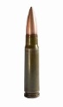

Figure 1. An AK-47 Assault rifle with its ammunition (7.62x39mm) Source: Business insider, 2017

This research aimed to design a software based tool for trajectory determination of fired AK bullets, using the previously observed numerical relationships between AK bullet holes, feature dimensions and angles of incidencs for AK bullets. The source of data to produce the software came from author’s previous studies; an AK bullet ricochet study on 1mm sheet metal (Nishshanka, Shepherd and Parnitharan, 2020) and an AK bullet perforation study on 1mm sheet metal (Nishshanka, Shepherd, Ariyarathna, 2020). The tool was initially designed to be a desktop application and it later proved to be possible for development as an android application which can be installed and used with a mobile phone or smart device.

II. METHODOLOGY

Reported consistent relationships between the lengths of the ricochet, perforation marks, lengths of the double headed ricochet mark (Figure 2) and the bullet’s angle of incidence during the two empirical studies (Nishshanka, Shepeherd and Parnitharan, 2020) and (Nishshanka, Shepherd, Ariyarathna 2020) were utilised to design the software based tool. The summary of measurements recorded in both the experiments with regard to the average full lengths and average lengths of the first head of the double headed impact mark is summarised in Tables 1 and 2. Data had been collected under similar conditions during both the studies and involved firing 7.62 mm x 39 mm bullets (Ball rounds with a lead and steel core bullet and copper casing) into 1 mm sheet metal surfaces from 3 degree to 90 degree angles. The experimental arrangement that was used for data collection is shown in Figure 3 .

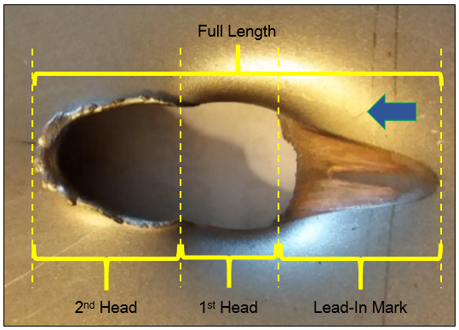

Figure 2. A double headed impact mark and its characteristics. The phenomenon was reported in both the studies as a common occurrence when AK bullets interact with 1mm sheet metal at low angles of incidence.

Screen

Scissor lift table

Mounted AK rifle

Target holder

1 mm sheet metal placed on the tray at different angles

Figure 3: Experimental Arrangement  
(Nishshanka, Shepherd and Paraneetharan (2020))

|  |  |  |
| --- | --- | --- |
| **Angle of incidence (Degrees)** | **Average full length of the impact mark (mm)** | **Reference** |
| 90 | 7.63 | Nishshanka, Shepherd and Ariyarathna, 2020 (AK Bullet Perforation Study) |
| 80 | 7.78 |
| 70 | 7.96 |
| 60 | 8.87 |
| 50 | 9.98 |
| 40 | 12.23 |
| 30 | 17.71 |
| 20 | 27.36 |
| 15 | 37.96 | Nishshanka, Shepherd and Parnitharan, 2020  (AK Bullet Ricochet Study) |
| 13 | 36.66 |
| 10 | 42.31 |
| 8 | 47.84 |
| 5 | 64.97 |
| 3 | 94.73 |

Table 1. Summary of angles of incidence and the average full lengths of the double headed impact marks created by AK bullets.

.

|  |  |  |
| --- | --- | --- |
| **Angle of incidence (Degrees)** | **Average length of first head from impact mark (mm)** | **Reference** |
| 30 | 5.01 | Nishshanka, Shepherd and Ariyarathna, 2020  (AK Bullet Perforation Study) |
| 20 | 6.69 |
| 15 | 8.16 | Nishshanka, Shepherd and Parneetharan, 2020  (AK Bullet Ricochet Study) |
| 13 | 10.35 |
| 10 | 13.42 |
| 8 | 17.62 |

Table 2. Summary of angles of incidence and the average length of first head from impact markrelated to the double headed impact marks created by AK bullets.

The full lengths of the bullet hole and the measurement of the first head of a special bullet hole feature, the double headed impact mark, were analysed and these two variables were identified as having a very consistent relationship with the angles of incidence of the AK bullets. Data was imported to MATLAB software and a regression analysis was performed. The equations proposed by the analysis were used to design the software based application. Figures 4 and 5 highlight the relationship identified along with the equation of the best fitted curves.

Intentionally Blank

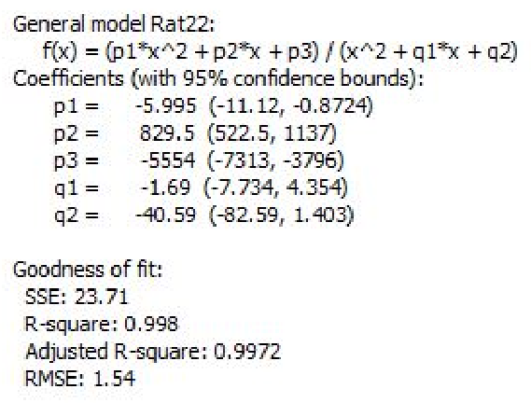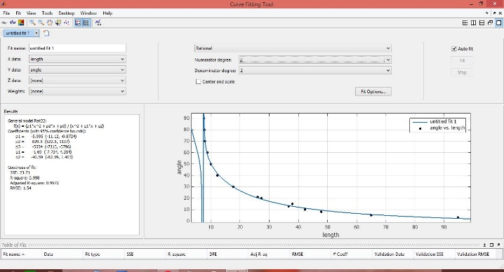

Figure 4. Relationship identified in MATLAB between the average full lengths of the AK bullet mark and the angles of incidence of AK bullets.

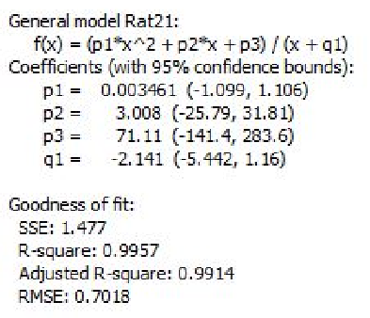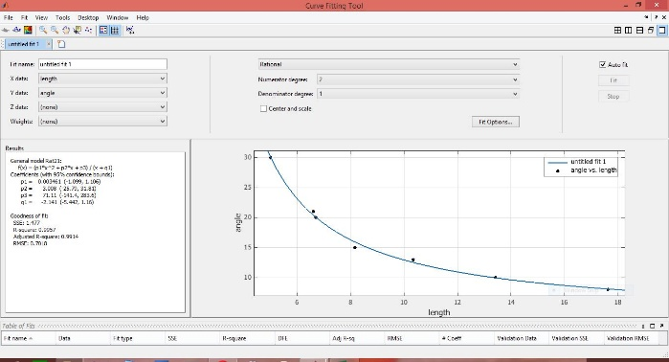

Figure 5. Relationship identified in MATLAB between the average first head lengths for the bullet holes and the angles of incidence of AK bullets.

The technologies associated with the development of the software tool are illustrated in Figure 6 and the system diagram is illustrated in Figure 7.



Figure 6. Technologies used to implement the angle of incidence finder desktop application.

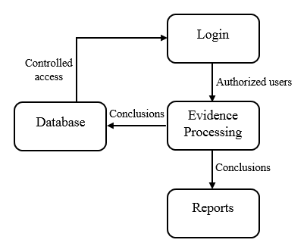Figure 7. The system diagram for the software tool.

The development of the software program was done using Microsoft Visual Studio and Visual C#. The MySQL relational database management system, which runs on the XAMPP cross-platform web server solution, was used to store user logins. MySQL Connector for .NET handled the data parsing between the C# and MySQL. Logged in users can see the output results generated by the software and outputs can either be generated as presentable reports via iTextSharp library support or stored in the database.

III. RESULTS AND DISCUSSION

The designed software tool was capable of directly inserting the manually measured full lengths of a bullet impact mark and first head’s length of double head impact marks to the system to generate a value for the approximate incoming angle of fired bullets. An example of the designed solution is illustrated in Figures 8 and 9.

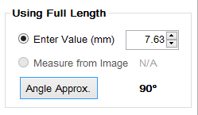

Figure 8. Using mark full length value directly to generate the approximated incidence angle.

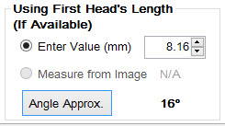

Figure 9. Using first head’s length value directly to generate approximated incidence angle.

Alternatively, the tool was designed to use an image of the bullet impact mark as an input to generate the approximate angles of incidence. An investigator who wishes to use the second option needs to take a close picture of the bullet hole, placing a crime scene ruler adjacent to the bullet hole. The picture is then imported into the software and two reference points which depict a known distance along the crime scene ruler be marked as reference points A and B using a mouse pointer or a digital pen. This is done to find how many pixels were there to represent the measured length. With reference to that the software identifies the actual distances represent in the captured image. This process calibrates the software. Afterwards, the distance inputs are to be feed in to the system in the same way two reference points were marked. A system generated message is designed to appear with the relevant instruction in the software to guide the user through the process. This method is illustrated in Figure 10.

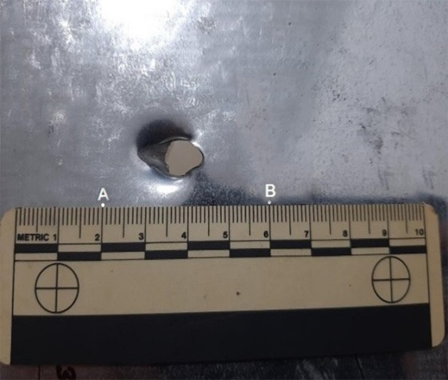

**Measured length for image calibration**

Figure 10. A pictorial illustration of the calibration process.

Thereafter, the system generates results for the full impact length and the first head’s length measured on the image by using pixel references. The system also indicates whether the bullet hole is produced as a result of an AK bullet perforation or ricochet off the surface, based on the ricochet and perforation data in Tables 1 and 2. An example case of generating an incidence angle based on the lengths measured on a calibrated image is shown in Figure 11.

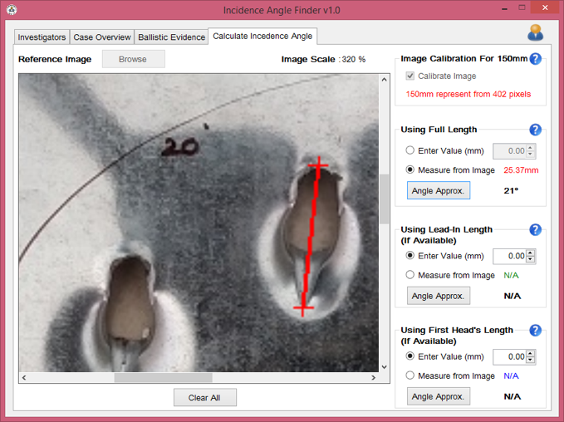

Figure 11. Using full length measurements on calibrated image to generate approximated incidence angle.

The system was developed initially as a desktop application to assess the feasibility of designing a software based solution and proved to be viable for upgrading to an android application for the practical use so that an investigator can install the app on their smart devices and use at a shooting scene to instantly scan an AK bullet hole on 1 mm sheet metal surface. The system also has the possibility of introducing this tool for other ammunition and target combinations which are commonly reported in shooting incidents, should experimental data already be available or can be produced as a result of an investigation.

The results were tested using a field test in which a different AK rifle (Type 56 MK II) was randomly fired at 1mm sheet metal surfaces in different angles from 90 to 3 degrees. The obtained approximate angles through the new tool were compared with the actual angles of incidence for the bullets. The generation of the approximated angle of incidence achieved up to 95% accuracy when the user inputs the full mark length and the first head’s length of the bullet hole while a 92% accuracy rate achieved when the image processing method was employed. It is understood that errors made while marking the reference points for the calibration and when marking the exact edges of the bullet impact mark can affect the outputs, helping explain the reported lower accuracy rate from the image processing option over direct value input. However, as the “accepted margin of error for bullet trajectory determination within the shooting reconstruction community is typically plus or minus 5 degrees, both vertically and horizontally” (Huesky E.E, 2020), the results are viable for use in reconstruction efforts.

IV. CONCLUSION

Empirical test result from two previous studies by the authors were used to design a software based tool to support AK-related shooting incident reconstructions when impacting 1 mm zinc-coated sheet metal. A software solution was designed based on the relationships identified between the lengths of the bullet holes, the lengths of the first head of the previously reported double headed impact marks and angles of incidence of AK bullets. The initial desktop application proved to be an effective method to quickly provide approximate angles of incidence for AK bullets perforating through or ricocheting off 1mm sheet metal surfaces. Based on the results, it is also expected that an android-based application compatible with mobile phones or smart devices can now be produced as well. In relation to the direct analysis from photographs, image processing and machine learning may be employed to generate more accurate results invariant of colour, rotation, scaling, skewing of the source image along with a cloud services-based solution are also expected to be incorporated to further upgrade the system for the effective use of this tool by authorised individuals or investigation organisations globally.

This tool has added an alternative method for the analysis of single bullet holes to the currently practised processes (lead in method and ellipse method (Mattijssen and Khoff 2016). Therefore, the solution proposed here could also be used as an alternative method to confirm the findings from existing methods or could be used alone as a reliable method to estimate the approximate angle of incidence for AK bullets fired into 1mm sheet metal. The software tool can be further expanded by incorporating empirical test results for other ammunition types and interaction surface combinations and could be made accessible to law enforcement and other investigative end users around the world .

V. REFERENCES

Balke, F (2018). Meet the AK-47 Assault Rifle: The Deadliest. Available at: <https://nationalinterest.org/blog/buzz/meet-ak-47-assault-rifle-deadliest-gun-planet-37042>

[Bureau of Criminal Apprehension](https://dps.mn.gov/divisions/bca/) (2019) Shooting Scene Reconstruction. Available at: <https://dps.mn.gov/divisions/bca/bca-divisions/forensic-science/Pages/forensic-programs-crime-scene-ssrecon.aspx>. Accessed; 9 April 2020. Business insider, 2017

# The Economist (2014) Why did the AK-47 become so popular? Available at <https://www.economist.com/the-economist-explains/2014/01/08/why-did-the-ak-47-become-so-popular>

Haag, M. G and Haag, M. C (2006) Shooting Incident Reconstruction. First Ed. Elsevier Inc.

<https://www.sciencedirect.com/science/article/pii/S0379073820301754>. DOI <https://doi.org/10.1016/j.forsciint.2020.110313>

[Mattijssen](https://www.sciencedirect.com/science/article/pii/S0379073816301268" \l "!) E.J.A.T and Kerkhoff, W (2016) ‘Bullet trajectory reconstruction – methods, accuracy and precision’, Forensic Science International, 262, pp. 204-211 Available at: <https://www.sciencedirect.com/science/article/pii/S0379073816301268>

[Mattijssen](https://www.sciencedirect.com/science/article/pii/S0379073816301268#!) E.J.A.T, Kerkhoff, W, Besterbreurtje, M.E (2018) ‘Bullet Trajectory After Impact on Laminated Particle Boards’, Journal of Forensic Sciences, 63 (5).

Nishshanka, B, Shepherd, C and Paraneetharan, P (2020) Forensic based empirical study on ricochet behaviour of Kalashnikov bullets (7.62 mm × 39 mm) on 1 mm sheet metal. <https://doi.org/10.1016/j.forsciint.2020.110313>

Nishshanka, B Shepeherd, C and Ariyarathna, R (2020) Unpublished Research work submitted to Forensic Science International.

Parkinson, G.A (2003) ‘Stringing a Crime Scene to Determine Trajectories’, Journal of Forensic Identification, 54 (3) Available at: <https://studylib.net/doc/7835301/stringing-a-crime-scene-to-determine-trajectories>

Vecellio, M (2013) ‘Lase visualization of bullet paths’, Evidence Technology Magazine, 54 (3) Available at: <http://www.nxtbook.com/nxtbooks/evidencetechnology/20130708/index.php?startid=14#/16>

Acknowledgment

An image analysis based solution to estimate the angles of incidence of perforated AK bullets on 1mm sheet metal; A tool for bullet trajectory determination is a research project carried out at the Centre for Research and Development, Ministry of Defence, Sri Lanka.

Author Biographies

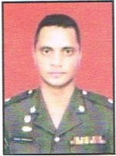Major Bandula Nishshanka. A forensic ballistics and firearms specilist at the Centre for Research and Devlopment. Followed a Masters Degree on Forensic Ballistics at Cranfield Univerrsity of the UK and currently a reading for a PhD on Forensic Ballistics at the University of Kelaniya.

Dr Chris Shepherd. A ballistics expert and senior lecturer in forensic science based in the School of Physical Sciences at the University of Kent in the United Kingdom. Chris previously completed his undergraduate BSc(Hons) in Biochemistry at the Bristol University before completing his MSc in Forensic Engineering and PhD in Shock Physics and Wound Ballistics at Cranfield University.

Major Randika Ariyarathna. A Graduate of University of Colombo School of Computing from the field of Computer Science. Currently attached to the Explosive, Armament, Ammunition and Ballistic Wing-CRD.