Does Corporate Social Responsibility Impact Firms' Innovation Capacity? The Indirect Link between Environmental & Social Governance Implementation and Innovation Performance

David C. Broadstock^{1,} Roman Matousek², Martin Meyer^{3*}, Nickolaos G. Tzeremes⁴

¹School of Accounting and Finance, Center for Economic Sustainability and Entrepreneurial Finance, The Hong Kong Polytechnic University, Hung Hom, Kowloon, Hong Kong. Email: david.broadstock@polyu.edu.hk
² Nottingham University Business School, Jubilee Campus, Nottingham NG8 1BB, UK. Email: Roman.Matousek@nottingham.ac.uk
^{3*}Kent Business School, University of Kent, Canterbury, Kent, CT2 7FS, UK. Email: M.S.Meyer@kent.ac.uk (Corresponding author)
⁴Department of Economics, University of Thessaly, 28th October street, 78, 38333, Volos, Greece. Email: bus9nt@econ.uth.gr

Abstract
Firms’ choices on corporate social responsibility (CSR) and on environmental, social and governance (ESG) implementation strategies can arguably have a positive impact on their value and performance. This “doing well by doing good” view remains debated in the literature. Our study contributes to this debate by investigating the impact of firms’ engagement on ESG policies on their innovation capacity levels. More specifically, we apply a nonparametric frontier analysis framework to a sample of 320 Japanese firms over the period 2008-2016. Our study provides evidence of a nonlinear relationship between ESG policy adoption and firms’ innovation capacity. In other words, our findings are consistent with a process of “indirect value-creation” under which firms’ CSR/ESG policy adoption initially enhances their ability to pursue innovation activities and, then, eventually affects positively their value creation and financial/operational performance.
Keywords: Corporate Social Responsibility (CSR); Environmental and Social Governance (ESG); Corporate Social Performance (CSP); Innovation capacity; Efficiency and Productivity; Nonparametric Analysis.
JEL Classification: C14; D24; M14; O3

1. Introduction
The Berle-Dodd debate challenges whether there is any impact of firms’ engagement in corporate social responsibility (CSR) activities to shareholder valuation and firms’ performance, and is the basis of an ongoing research agenda (Ferrell et al. 2016). Specifically, Berle’s view is that firms should be seen only as the maximisers of shareholders’ value. Dodd’s view supports the notion that firms should be accountable to stakeholders and general public. Deng et al. (2013) assert that when firms are well governed they are able to be both socially responsible and of higher performance, maximizing also shareholders’ value. However, the opposing view suggests that firms’ objective functions are to generate profits and any managerial involvement in CSR activities is rather a barrier to the accomplishment of the profit maximizing purpose (Cheng et al., 2013). There has been a large number of empirical studies that support both the positive and negative effect of CSR activities on firm’s performance (Jawahar et al., 2001; Jensen, 2001; Freeman et al. 2004; Surroca and Tribo, 2008; Cronqvist et al., 2009).
However, empirical studies that test the “doing well by doing good” hypothesis (Bénabou and Tirole, 2010; Krüger, 2015) are rather inconclusive and conflicting. Factors which contribute to this myriad of findings include applying different methods, sample sizes and using different proxies of CSR activity/performance (Margolis and Walsh, 2003; Wang et al., 2016). The phenomenon of conflicting results may however also be attributed to the fact that there are missing links between CSR activities and firms’ performance which have not been thoroughly parameterized, analyzed and explained (Isaksson and Woodside, 2016; Bhardwaj et al. 2018). Lioui and Sharma (2012) refer to these ‘missing links’ as the indirect effects of CSR on firms’ performance, which can give rise to indirect value creation. Moreover, Lioui and Sharma (2012) contend that this indirect effect of CSR activities to firms’ performance comes through the enhancement of firms’ research and development (R&D) efforts. It is evident that there remains a gap in the literature to investigate the influences of CSR practices on firms’ performance through its indirect effect on firms’ innovation capacity (McWilliams and Siegel, 2000; Lioui and Sharma, 2012; Hull and Rothenberg, 2008; Bocquet et al. 2013; Costa et al., 2015). The European Commission (2011) also identifies this as a research gap and has placed an emphasis on the need to further explore the empirical influences of CSR to economic growth through the process of innovation.
In this paper, given the above identified gap in the literature and set against the backdrop of institutional relevance established by the European Commission, we explore whether enhanced CSR acts as a stimulant of successful innovation activity. Starting out from the premise that CSR ‘needs some shaking up’, Mirvis and colleagues argue that “successful innovation is about dramatically improving what currently exists or creating something new that is significant and useful. This requires new voices, new ideas, new processes and interactions, and renewed passion to make a difference in the world” (Mirvis et al., n.d.; p. 8). Building on the work of stakeholder theorists (Freeman, 1984; Donaldson & Preston, 1995; Battacharya & Korschun, 2008; Freeman et al., 2010; Brower & Mahajan, 2013) who remind us that managers seek to satisfy a variety of constituents who can influence or are influenced by the firm’s objectives, Costa el. (2015) argue that satisfying their organization’s stakeholders depends on managers’ ability to learn about the stakeholder landscape, develop a good understanding of and effectively incorporate this wide range of interests. Establishing and maintaining good external stakeholder relations in this framework can enable the firm to access diverse external knowledge and information (Choi & Wang, 2009; Costa et al.; 2015) and thereby increase its absorptive capacity as well as grow its innovation related knowledge, encouraging higher levels of innovation activity and capacity (McWilliams & Siegel, 2000). Some authors go so far as to suggest that companies which do not take CSR into account, may not survive as they may struggle to innovate (see, e.g., MacGregor et al., 2007; Mahlouji & Anaraki, 2009). While not arriving quite at that conclusion, Porter and Kramer (2007, 2011) make the case that CSR can be a potent source of innovation and competitive advantage, pointing to a wide range of case studies. In this contribution, we will look more systematically at the link between CSR engagement and innovation performance.
We advance the literature on innovation by gleaning new insights on the positive effects of firms’ engagement in corporate social responsibility activities to their innovation capacity levels. Our analysis, and evidence, is consistent with the idea that CSR activities act as a source of organizational ambidexterity, catalyzing both traditional, and non-technological innovation processes that can be exploited by firms to enhance corporate financial performance. For the purpose of our analysis, we apply a nonparametric frontier estimation procedure (Daraio and Simar, 2005; Bădin et al., 2012, 2014). We examine whether firms’ involvement in CSR activities affects the technological change levels (i.e., movements of firms’ estimated production frontier). According to Shao and Lin (2016), the technological change levels reveal firms’ innovation capacity. We use a sample of 320 Japanese firms over the period 2008-2016. We apply conditional time-dependent estimators (Mastromarco and Simar, 2015) that allow us to reveal potential dynamic nonlinear effects of firms’ environmental, social and governance (ESG) practices on their innovation capacity levels. Our estimation is based on the method introduced by Daraio et al., (2018) that further allows us to assume that firms’ decisions which are related to ESG adoption criteria, affect the shape and the level of the boundary of the estimated production frontier alongside with the distribution of firms’ efficiency levels. As a result of that, the adopted methods reveal the existence of potential dynamic nonlinear effects of ESG practices on firms’ operational performance levels through their impact on firms’ innovation capacity (technological change).
To our best knowledge this is the first study which models the indirect effect of CSR practices on firms’ performance levels through its impact on firms’ innovation capacity. The related literature (McWilliams and Siegel, 2000; Lioui and Sharma, 2012; Hull and Rothenberg, 2008; Bocquet et al., 2013) provides empirical evidence of the impact on CSR practices on firms’ R&D levels but fails to link this indirect effect on firms’ operational performance. Our study fills this gap by using a probabilistic approach for estimating firms’ production frontiers. The remainder of the paper is as follows. Section 2 discusses the background literature, while, Section 3 presents the data and the methods adopted. Section 4 presents our main findings and finally, the last Section offers a discussion of findings vis-à-vis the literature and outlines avenues for further research.
2. Corporate social responsibility as an enabler of firm performance
In this section we provide a brief synopsis of the background literature relevant to our own study. There are several core bodies of literature which are relevant. We begin by first setting out the conflicting studies of the CSR-firm performance link and briefly reflect on the importance of and perils involved in measuring CSR and corporate social performance (or CSP) i.e. the positive/negative outcomes that come with CSR activities. We then move towards a more thorough summary of existing research findings on the impact of CSR to firm financial, or operational, performance. After this we proceed to discuss additional literature outlining potentially more nuanced channels through which CSR can foster indirect benefits to firm performance, with a special emphasis on CSR’s role in catalyzing innovation.

2.1 CSR and Firm Performance
There has been a long-standing interest among scholars, in understanding whether CSR activities enhance, diminish, or have no material impact to firm performance. The tension in this hypothesis can be easily established. Good CSR should in principle align with good overall governance, which is a core component of a strong and sustainable business model (albeit not guaranteed to be) capable of delivering long term financial performance. However good CSR also comes at a cost, requiring firms to engage in new activities to build and maintain their CSR image, some of which having intangible returns. If CSR expenses are material, and returns to CSR intangible, investors and stakeholders may struggle to accurately appraise the long-run value proposition. The literature studying this relation has until now accrued in excess 50 years of contributions and is booming in interest during recent years. In light of the large body of existing literature and in lieu of the fact that regarding this aspect of the literature we essentially ‘inherit’ existing conceptualizations and theories, as opposed to developing new ones of our own, to keep our review both succinct and focused we do not provide a comprehensive review of existing work. Instead we take advantage of several high-quality review studies that provide sound coverage of the corpus of prior work.
Margolis and Walsh (2003) was perhaps the earliest major review article in this space, providing an extensive literature review of 127 papers over the period 1972-2002. They look for evidence about the overall effect of corporate social performance (CSP) on firms’ financial performance. The results of the literature are inconclusive since half of the evaluated studies provide evidence of a positive statistical significant effect of CSP on firm financial performance levels. These general conclusions, namely that the relation between CSR and firm performance is sometimes positive, and sometimes negative also survives (i) among more recent literature and (ii) when scrutinized using more systematic literature analysis tools as can be observed from the meta-analytic review conducted more recently by Wang et al. (2016). Taking some specific examples, Shen and Chang (2009) verify a positive effect of CSR on firms’ financial performance. Gillan et al., (2010) provide evidence of a positive effect of ESG score on firms’ value over the period 1992-2007. Ameer and Othman (2012) suggest that those companies that apply sustainability policies have increased financial performance. Interestingly, Becchetti et al. (2012) provide evidence of negative abnormal returns around the dates in which CSR related events had occur. Similar results have also been found by Doh et al. (2010), who argue that CSR activities do not generate positive market reactions.
However, Wu and Shen (2013) show, in their study that examines data covering the period 2003-2009, that there is a positive influence of firms’ CSR policies on their ROE (return on equity) and ROA (return on assets) levels. Kemper et al. (2013) furthermore provide evidence of a positive effect of CSR activities on the impact of firms’ marketing strategies. In contrast Di Giuli and Kostovetsky (2014), who use a data sample from 2003 to 2009, show a negative correlation between CSR and firms’ operating performance. Fatemi et al. (2015) present similar findings that are derived by using simulation analyses. They suggest that firms’ CSR practices have a positive effect on firms’ value creation. Saeidi et al. (2015) who examines 205 Iranian manufacturing and consumer product firms suggest that the positive effect of CSR policies on firms’ performance levels is direct through the generation of competitive advantages, increased firm reputation, and customer satisfaction. In addition, Wang et al. (2015) examine a sample of Taiwanese high-tech companies over the period 2010–2013. They use a quantile regression and structural equation models. The results indicate a significant positive effect of brand equity and CSR on firms’ performance levels. These results, however, contradict with Jain et al.’s (2016) findings. They argue that firms’ higher performance levels are associated with lower values of the composite ESG scores. Brower et al. (2017) then suggest that firms’ prior CSP reputation has influence not only on future firms’ social but also financial performance. Price and Sun (2017), who study relations using a sample of US firms point out that firms which are not highly engaged on both CSR and corporate social irresponsibility (CSI) activities, are the ones which perform better. CSR and CSI are essentially opposing forces, one working to enhance corporate reputation, and the other resulting in reputation losses. It is difficult to say which has a stronger effect, though Price and Sun (2017) argue that the negative effects of CSI are more enduring. The implications of this are that firms not only have an expectation (from their stakeholders) to engage in CSR activities, but moreover that there are potentially material consequences lapses in corporate social responsibility performance. Finally, Bhardwaj et al. (2018) provide evidence that the firms’ which pursue first on CSR activities are more advantageous in comparison with their competitors, which are not investing on such activities i.e. that there is evidence of a first-mover advantage to CSR adoption. The discussion in this section, to this point, does not lend itself to an emphatic conclusion concerning whether CSR benefits firms or otherwise. It is at this point useful to bring attention to concerns of measurement.

2.2 Measuring the CSR – Firm Performance Relationship
While there are some obvious differences that will arise as a result of empirical sample structures (dates, country, and firm coverage etc.) as well as differing choices of empirical methodology, there is an additional, and intuitively unavoidable, measurement issue that must be acknowledged when engaging in CSR research. Put simply, there is no standard way to measure the performance of CSR activities e.g. CSR performance, or more compactly CSP. Measures of CSP serve as a proxy for CSR activity by reflecting the level and extent of efforts by firms in CSR activities. Early research in this area, for example Sonnenfeld (1982) recognized that ‘corporate social audits’ embedded a high degree of diversity in their reported content, in terms of what was reported and what stakeholders hoped to see. Different stakeholders wanted different information from each other, and often also different information from that which the firm wanted to present. The diversity of information gives rise to an immediate problem of lack of comparability, but is difficult to avoid as stressed by Griffin and Mahon (1997) who summarized the incomparability of 25 years of study on CSP. The problem remains today as highlighted by the more recent review by Wood (2010). Even when comparable/consistent measures are provided, this is not guaranteed to eliminate all measurement concerns either. Sharfman (1996) for instance explored ‘the construct validity of the Kinder, Lydenberg & Domini social performance ratings data’ and (among other things) reminded us that there is no single best way to measure CSP. Notwithstanding these points however, for some time there has been a growing consensus that CSP can be found to correlate closely with firm performance metrics, even in the presence of CSP measurement issues, see for instance Orlitzky et al (2003).

2.3 The Link between CSR and Innovation Capacity
2.3.1 CSR, R&D expenditure and innovation
A separate strand of the literature that is closely related to our own work is concerned with the interlinkages of environmental regulation, CSR and innovation or in the establishment of an empirical link among CSR and R&D expenditure. One of the first studies was presented by Jaffe and Palmer (1997). They provide evidence of significant positive effects of environmental compliance expenditures on R&D expenditure for regulated industries. Similarly, McWilliams and Siegel (2000) provide empirical evidence for a positive correlation among CSR and R&D investment.
This finding also aligns with Porter’s view (Porter 1991; Porter & van der Linde, 1995). Porter and colleagues (Porter, 1991; Porter & van der Linde 1995) suggested that environmental regulation has a positive effect on firms’ performance levels through the enhancement of innovation and competitiveness. More recently, Porter & Kramer (2007, 2011) advocate that CSR can be a potent source of innovation and competitive advantage and have refined these ideas in the notion of shared-value creation. More recently, Saedi et al. (2015) offer evidence that link competitive advantage and financial performance to CSR engagement for the businesses they surveyed.
Hull and Rothenberg (2008) suggest that firms’ involvement in CSR activities affect positively their performance through the adoption of innovation related processes. In particular they argue that CSR activities enhance firms’ innovation capacity, from which they increase their ability to differentiate and gain competitive advantages (Hart, 1995; McGahan and Porter, 1997; Russo and Fouts, 1997). This is supported also by Bocquet et al. (2013) who find that firms engaging in CSR activities are more likely to be innovative in terms of their processes and generation of products.
Following a stakeholder perspective, authors, such as Costa el. (2015) and Herrera (2015), suggest that management is better placed to identify and respond to strategic opportunities and challenges thanks to them engaging in CSR and continually evaluating corporate influences and relationships with stakeholders and the environment. Stakeholder and macro-environment assessments are seen as critical for successful innovation and achieving competitive advantage (Ferauge, 2013; Herrera, 2007; Li & Liu, 2014). As Herrera (2015) argues drawing on case studies at 3M and Intel, implementing CSR and institutionalizing social innovation can allow firms to secure a competitive advantage while improving corporate social and financial performance. Other recent work offers further support for this notion.
The studies presented so far have in common that they link externally focused activities (R&D, CSR, stakeholder and macro-environment assessments) to innovation capacity and/or financial performance. Padgett and Galan (2010) emphasize the fact that both R&D investments and CSR policies are based on firms’ ability to possess intangible resources which they link to firms’ competitive advantage. Studying technology exporters, Costa et al. (2015) find that there is a positive relationship between CSR and exploratory (rather than exploitative) innovation. Their results show that CSR can be used to develop innovation competencies that are new to the firm. Interestingly, they also found that, at least in the in the sector they studied, implementing CSR principles is not associated with what they termed ‘exploitative’ innovation, i.e., fostering efficiency, cost reduction, or superior delivery of customers’ needs in international markets (exploitation). In the authors’ view, CSR principles may be more associated with process than product innovation. The observed divergence may also help explain the more divergent findings in previous research.

2.3.2 Capturing innovation capacity
Innovation capacity can be defined in many ways and at various levels. According to Szeto (2000), innovation capacity is “a continuous improvement of the overall capability of firms to generate innovation for developing new products to meet market needs” (Szeto, 2000, p. 150). Irrespective of level (micro, meso or macro), often innovation capacity is operationalized via proxy measures that are focused on technological change, i.e., R&D expenditures, technology output, such as patents or patent applications. At the aggregated level, Furman et al. (2002) provide evidence that innovation capacity is associated with total factor productivity growth. Similarly, Hamidi et al. (2018) suggest that innovation capacity refers to productivity growth or other innovative processes, products and/or services. Halkos & Skouloudis (2018) offer an overview of macro-level indicators that underline this. Acknowledging that, also at firm-level, innovation capacity is often associated with formal R&D activities and innovation output with new products (e.g., Kirner et al., 2009), Forsman (2011) argues that innovation cannot be created simply by R&D investment, but instead emerges from a complex process of business development and the optimization of firms’ production processes. Several studies (e.g., de Jong and Marsili 2006; Hirsch-Kreinsen, 2008; Santamaría et al., 2009) link innovation capacity also to experimentation, learning, technological catch-up which is not necessarily linked to the engagement in formal R&D activities. We recognize the point these authors make and acknowledge that future research will need to explore new ways of capturing innovation capacity.
For the purpose of this study we follow Shao and Lin (2016) in suggesting that firms’ technological change levels (i.e. movements of firms’ technological production frontier) reveal firms’ innovation capacity levels. We contend that improvements of firm’s technological levels can signify also higher innovation capacity levels. Boly et al. (2014) show that innovation capacity can be described by a three-stage innovation process containing resources, activities and innovation outcome.
Furthermore, in an extensive review of the literature Boly et al. (2014) conclude that innovation capacity among other factors interrelates to firms’ ability to adopt and foresee technological changes. Firms’ ability to utilize effectively their resources has been proven to be an incremental factor within firms’ innovation capacity processes (Yam et al., 2004; Guan et al., 2006). Therefore, we contend that firms’ ability to increase their technological change levels is a reasonable proxy for their innovation capacity (Furman et al., 2002; Shao and Lin, 2016; Hamidi et al., 2018).

2.3.3 CSR and non-technological innovation
Much of the focus of innovation literature is on technological innovation, captured usually through a variety of R&D related outcomes. However, there are many more nuanced innovation outcomes, non-technological in nature, which can underpin firm performance. We develop the case here that CSR related initiatives may contribute to such non-technological innovation processes.
At the firm level, there is an interwoven nexus spanning exploration and exploitation that can be levered to promote the supply, demand and spatial search for innovation by employees (Sidhu et al., 2007). In a somewhat nuanced strand of the literature, it has been demonstrated that innovation can be fostered through non-technological developments (social innovation) as well, in some cases more impactful benefits than from pure technological change. Research on absorptive capacity and ambidexterity also demonstrates the importance of social and organizational factors in fostering value-enhancing exploratory innovation, see for example Jansen et al. (2005, 2006). Bridging the connection to our own work, CSR may be taken as an antecedent which gives rise to heightened levels of organizational ambidexterity thereby fostering both exploitative and explorative innovation. Management innovation, which may result from enhanced CSR activities, can improve the underlying conditions for innovation within a firm as emphasized by Volberda et al. (2013) and Walker et al. (2015). While in this paper we do not go as far as disentangling the unique effects of individual CSR dimensions to innovation capacity, this additional strand of literature helps to reinforce our underlying hypothesis that enhanced CSP creates the potential, likelihood even, for superior innovation capacity.

3. Data Description and Methodological framework
3.1 Data description
In our analysis, we use a sample of 320 Japanese firms over the period 2008-2016 that are collected from Bloomberg. The reason why we have used the particular sample is twofold. Firstly, by choosing firms from a single country we are able to eliminate any institutional differences which appear in cross country studies and can mask over the estimated CSR effect (Cai et al. 2016). Moreover, we follow Reverte et al. (2016) and we choose a sample of eco-responsible firms’. In the Bloomberg database these firms are those which report their CO2 emissions (among other pollutants) and provide unique access to firm level emissions data over several years. As a proxy of firms’ corporate social responsibility (CSR), we use a third-party rating calculation (ESG Disclosure Score) developed by Bloomberg. Husted and de Sousa-Filho (2018) show that the Bloomberg ESG measures provide consistent and comprehensive estimates of CSR practices that minimize the potential error in measurement. This ESG score evaluates the quality and comprehensiveness of firms’ Environmental and Social Governance disclosure and reporting activities and is based on several quantitative and policy-related measures. The ESG scores range from 0.1 for firms that disclose a minimum amount of ESG data to 100 for those that disclose every data point collected by Bloomberg, where each data-point reflects a type of CSR activity and with some mediation by Bloomberg to account for the quality of reporting. As a result, the higher the ESG score the higher the firms’ involvement in CSR activities. For the estimation of the firms’ production function, we use as inputs firms’ total employee numbers and total assets, while total revenues are used as the only output. Table 1 presents diachronically the descriptive statistics of the variables used in our analysis. It is evident that, over the years, firms’ ESG scores are varying (in average terms) from 35 to 40 suggesting a medium ESG compliance.

Table 1 about here

3.2 Methodological approach
In this section we outline our methodology, which is adapted from the framework outlined by Daraio and Simar (2005, 2006, 2007a, 2007b). Let $X∈R_{+}^{p}$ and $Y∈R_{+}^{q}$ denote the input and output vectors relating to a firms’ production process. Given these, the ‘attainable’ set can be characterized as:
$Ψ=\left\{\left.\left(x,y\right)∈R_{+}^{p+q}\right|x can produce y\right\}$, (1)
and the output correspondence set as:
. (2)
Following the influential works by Debreu (1951), Farrell (1957) and Shephard (1970) the efficient boundaries (or the isoquants) can be defined in radial terms as:
, (3)
whereas the output measure of efficiency for a firm operating at level $\left(x,y\right)$ can be defined as:
. (4)
Building on the work by Cazals et al. (2002), Daraio and Simar (2005) proposed a probabilistic approach towards efficiency measurement that is based on the probability $H\left(x,y\right)$ of dominating a firm operating at level$\left(x,y\right)$. The probability, $H\left(x,y\right)$, can be expressed as:
, (5)
which then can be decomposed to:
(6)
Then the output-oriented efficiency measure in eq. (4) can be presented as:
(7)
Furthermore, let $Z∈R^{d}$ to be the vector of a factor influencing firms’ technological change levels. In our case this factor is the ESG criterion, which is adopted by firm decision makers. Then the conditional distribution of $\left(X,Y\right)$ given $Z=z$ can be defined as:
(8)
where . Then the conditional output measure of efficiency facing the effect of $Z=z$ can be defined as:
(9)
Mastromarco and Simar (2015) suggest that in order to account for dynamic effects and thus to create time-dependent conditional efficiency measure, we also must add time, $T$, as an extra conditional variable. Then the conditional attainable set can be re-defined as, where and its distribution can be characterized as:
$H^{t}\left(\left.x,y\right|z\right)=Prob\left(\left.X≤x,Y≥y\right|Z=z,T=t\right).$ (10)
Thus, a firm’s conditional output-oriented efficiency measure at level at time facing the effect of ESG criteria can be defined as:
(11)
where
. (12)
The estimation of firms’ efficiency measures is obtained using data envelopment analysis (DEA) estimators. Moreover, in order to take account of firms’ scale effects in our efficiency estimations, we impose the assumption of variable returns to scale (VRS). To construct conditional estimates, we need to apply a localizing procedure that determines the data points in a neighborhood of $\left(z,t\right)$.
In order to graphically represent the effect of ESG criteria adoption on firms’ innovation capacity (technological change), we follow Bădin et al. (2012, 2014). We construct the following ratio which will act as the dependent variable in our nonparametric regression analysis:
$\hat{Q}\left(\left.x,y\right|z,t\right)=\frac{{\hat{λ}}_{t}\left(\left.x,y\right|z\right)}{\hat{λ}\left(x,y\right)}$ . (13)
A next step of our analysis is the following nonparametric regression model:
(14)
Where the dependent variable represent the ratio defined in (13) and (the independent variables) represent the ESG criteria and time. In expression (14), $g\left(.\right)$ is the unknown smooth function and is interpreted as the conditional mean of $y$ given $x$(see Li and Racine 2007, Theorem 2.1, p. 59). Then, as described by Li and Racine (2007), we can estimate the unknown function using a local linear estimator, since it minimizes the bias when estimating a regression function near the boundary of support. In our analysis we use product kernels and bandwidths based on Least Squares Cross-Validation (LSCV) criterion as described, for example, by Hall et al. 2004; Li and Racine, 2007. By applying the nonparametric regressions, we can determine the effect of time and ESG criteria on firms’ technological change levels (i.e. on its innovation capacity). As suggested by Bădin et al. (2012), an increasing regression line indicates a positive effect on firms’ technological change (shift on the frontier) whereas, the opposite phenomenon indicates an unfavorable effect. In the output-oriented case when the impact of the exogenous factors (time and ESG criteria) is positive, then, these factors act as extra inputs which are ‘freely available’, whereas, in the opposite case they act as ‘compulsory’ or ‘unavoidable’ output on firms’ estimated production process (Bădin et al. 2014, pp. 15-16).

4. Empirical findings
Firstly, we analyze diachronically the distributions of firms’ estimated efficiency levels obtained from both the conditional and unconditional cases. Figure 1 presents kernel density plots displaying the original (unconditional) estimates of firms’ efficiency with black lines, whereas the conditional estimates are presented in red. Additionally, two vertical lines are used to indicate the mean values of the estimated efficiency scores with respect to each of the distributions. It should be noted that the plotted efficiency estimates, both for original and conditional cases, are defined and presented in terms of Shephard-type efficiency measures taking values between 0 (fully inefficient firms) to 1 (fully efficient firms). Subfigure 1a contains the efficiency distributions for all years, while 1b through 1j plot the efficiency scores for individual years. For both the unconditional and conditional measures we observe bimodality with a cluster of firms concentrated around 1 and a second larger mass centered just below 0.5. This pattern persists for all the years in our analysis, therefore the mean of the estimated efficiencies (for both the original and the conditional estimates) is also stable over the examined periods. It is particularly noteworthy that when taking into consideration the potential effect of ESG criteria (conditional estimates), the distributions of the estimated efficiencies became more platykurtic. It appears under the effect of the ESG criteria adoption firms’ efficiency levels have a lower likelihood of taking values less than 0.5, and a higher likelihood of taking efficiency scores closer to 1 – this also reflects in consistently higher mean efficiency scores.
Figure 1 about here
In line with our above finding of overall diachronic stability among the estimated efficiency measures, Table 2 deepens our analysis and presents sector specific summaries of the conditional efficiency estimates, concentrating on the full sample. The evidence suggests that, on a per sector basis, the deviations in efficiency scores are similar across the sectors, with an overall standard deviation ranging from 0.23 to 0.28 (with the exception of the Utilities sector). The sectors with higher performance under the effect of ESG criteria adoption are ‘Utilities’ and ‘Energy’ with mean efficiency scores of 0.820 and 0.950 respectively, whereas the sector with the lowest performance is the ‘Healthcare’ sector with a mean efficiency score of 0.466. All the other sectors at least on average terms have similar efficiencies reported around 0.5. The similarity of the conditional estimates across the sectors suggests that (on average) the benefits emerging from ESG criteria adoption are not uniquely available/biased to any given sector, i.e. that all sectors can in principle derive benefits of similar magnitude.
Table 2 about here
The overall effect of ESG criteria to firms’ innovation capacity (i.e. technological change) is graphically examined in Figure 2. Subfigure 2a examines the effect for the entire sample, while 2b through 2k present sector specific results. In these plots the vertical axis represents the ‘$\hat{Q}\left(\left.x,y\right|z,t\right)$’ ratio while the other two axes represent the ESG score and time (i.e. the years of our study), therefore these plots illustrate how time and ESG scores align with efficiency. It is evident that as the ESG adoption criteria imparts a positive effect to firms’ innovation capacity, further confirming that that ESG practices enhance firms’ ability to innovate. However, this innovation capacity enhancement increases up to a certain level after which diminishing returns appear. It is therefore evident that we have a nonlinear behavior of ESG policies on firms’ innovation capacity, which incidentally provides some implicit validation that the flexible nonparametric methodology we adopt is suitable for the analysis. As a generalization of our findings we can infer that CSR engagement stimulates innovation but up to a certain threshold after which over adoption causes the effects of socially responsible business practice may become negative to the process innovation capacity enhancement. In order to check of the robustness of this finding we perform our analysis separately for each of the industrial sectors contained in our data sample. The results are, in the majority of cases, robust (refer to subfigures 2b, 2c, 2d, 2g, 2h and 2i) signifying in several cases an inverted ‘U’-shape relation albeit with some variation in the strength of inflection. However, for the cases of the ‘Energy’ (subfigure 2e), ‘Financials’ (subfigure 2f), ‘Technology (subfigure 2j) and ‘Utilities’ (subfigure 2k) sectors, the effect of ESG policy adoption is more consistently positive across all levels of ESG adoption, as indicated by an increasing nonparametric regression line and the absence of a clear inverted ‘U’-shape profile. Notwithstanding the absence of clear inverted ‘U’-shapes for these sectors, the nonparametric regression surfaces uncover clear non-linearities and patterns that would not otherwise emerge using simple linear regressions.
In summary, we find empirical evidence of a positive influence of CSR to innovation which is robust to industry and time. In an effort to pull out the contributions as they relate to specific bodies of literature we note first that our work supports several previous studies in the literature spanning innovation and CSR (McWilliams and Siegel, 2000; Hull and Rothenberg, 2008; Bocquet et al. 2013; Reverte et al. 2016; Ueki et al., 2016). However none of these studies, or others that we are aware of within the wider literature on CSR/ESG performance, reported a possible nonlinear association between CSR and innovation capacity. Thus, we feel our analysis provides a unique contribution salient to two core strands of literature spanning innovation, and CSR/ESG performance. Finally, we note the fact that our primary findings point towards an inverted ‘U’-shape profile containing decreasing returns of ESG policies to firms’ innovation once some threshold level of CSR engagement has been reached, allows us also to reconcile our analysis against studies arguing negative returns to firms’ CSR engagement activities (Margolis and Walsh, 2003; Wang et al. 2016).

Figure 2 about here

5. Discussion and Conclusions
5.1 The CSR-Innovation Capacity Relationship: a Case of Indirect Value-Creation
The effect of CSR practices on firms’ performance is an ongoing research priority for scholars of business and related disciplines. The “doing well by doing good” hypothesis (Bénabou and Tirole, 2010; Krüger, 2015) under which the engagement in CSR activities will result on maximizing both firms’ performance and shareholders value, has been often debated and the empirical findings over the years provide contradictory results (see Cheng et al. 2013; Deng et al., 2013; Ferrell et al. 2016; Wang et al. 2016). However, the opposing results can be attributed at least in part to the fact that CSR indirectly affects firms’ value and performance, through its positive influence on firms’ ability to engage in innovation creating activities. This is to say that once a more nuanced view is taken as to how CSR activities can stimulate value enhancing business activity through indirect channels such as innovation, the scales are more favorably tilted towards a positive impact from CSR.
Our study provides new evidence of the existence of an indirect link. By using nonparametric frontier analysis our paper models explicitly, the effect of ESG policies adoption on the estimation of firms’ production efficiency levels. Specifically, through the application of the recently developed probabilistic approach to efficiency analysis (Bădin et al., 2012. 2014, Mastromarco and Simar, 2015; Daraio et al., 2018), we could examine firms’ production efficiency measurement and the effect of ESG choices on firms’ innovation capacity levels. We confirm of the existence of a nonlinear effect of ESG adoption policies on firms’ innovation capacity.
Our findings provide empirical evidence of the indirect value-creation hypothesis (Lioui and Sharma, 2012) under which the engagement on CSR/ESG activities influence firms’ performance. We provide convincing evidence that firms’ engagement on ESG activities catalyzes firms’ mechanisms for innovation capacity creation, which in turn reflects on their performance levels. This path of value creation implies that we have a potential delay and/or indirect effect of the CSR/ESG impact to firms’ performance levels since the CSR activity stimulates a sequence of events that eventually give rise to the indirect benefit, and which justifies conflicting empirical findings reported in the related literature (Deng et al., 2013; Ferrell et al., 2016; Wang et al., 2016). Our findings further show that the engagement on ESG activities enable firms to utilize successful innovation processes (Wang et al., 2008), which initiate R&D related activities (Reverte et al., 2016; Ueki et al., 2016) and greater innovation intensity. As a result, this phenomenon reflects on firms’ innovation capacity levels and then on firms’ technological change levels. Finally, our findings align with those by Hull and Rothenberg (2008) by suggesting that the positive effect of CSR/ESG activities on firms’ performance levels is moderated by firms’ innovation capability levels. In fact, this adjustment effect attributed to different levels of firms’ innovation capability is evident from the observed nonlinear behavior of ESG impact on firms’ technological levels.

5.2 Nonlinearity of the Relationship and Sectoral Differences
Overall our results further suggest that there is a positive effect on innovation capacity as firms’ compliance with ESG criteria increases. However, there is critical cut-off ESG level after which the effect becomes negative. We deploy a robustness check on our main results by performing our analysis separately for different sectors. The results, in the majority of cases, verify the presence of an inverted “U”-shape profile, suggesting a nonlinear relationship.
Nevertheless, in some instances and especially for the sectors of: Energy, Financials, Technology and Utilities, the effect is positive characterized by a nonparametric (curvilinear) increasing line. Specifically, as firms’ ESG criteria compliance increases, the positive effect to firms’ innovation capacity also increases but in a nonlinear manner. Our results provide support that the nonlinear effect on the examined sectors is consistent with unique sectoral characteristics. Such an outcome is to be expected especially when the effect of CSR/ESG policies is evaluated among industries. Beschorner and Hajduk (2017) provide convincing evidence that the industry-specific characteristics shape the CSR/ESG practices and the interlink among the different ‘actors’ involvements. This is referred to as ‘industry-specific corporate social responsibility’ (Beschorner and Hajduk, 2017; p.635). Matten and Crane (2005) and Kinderman (2011) argue that the different institutional arrangements and different business systems among the sectors have a different impact on CSR/ESG opportunities and practices. Thus, the effect on firms’ performances is also expected to vary. Jain et al. (2017) argue that specific industries’ institutional dynamics initiate different stakeholders’ orientations across firms in different industries. As a result, industry-specific characteristics that include competitive environment, nature of product/services, negative externalities, and social activism among others will give rise to difference influences over the potential benefits from CSR/ESG practices. Carrigan et al. (2017) suggest that to avoid such diverse effects and practices among industries, policy makers are advised to pursue initiatives to all the “actors” that are engaged to co-transform their business model and enhance multi-stakeholder involvements alongside industries and business of different size and operations. Carrigan et al. (2017) further argue that such solutions can only be obtained through the redesign of national and international legislative frameworks. Therefore future research should be directed on the examination of potential unified industry interrelated CSR adoption frameworks, alongside with simulated potential effects on the performance both on industry and firm level. Though the complexity of developing such frameworks is formidable (Hess, 2001), and requires a concerted effort.
Our finding supports those studies providing empirical evidence of a positive effect of firms’ CSR on their R&D activities (McWilliams and Siegel, 2000; Hull and Rothenberg, 2008; Padgett and Galan, 2010; Lioui and Sharma, 2012; Bocquet et al., 2013; Reverte et al., 2016; Ueki et al., 2016). Finally, by using a production efficiency framework, our findings further show that the revealed positive effect of ESG policies on firms’ innovation capacity (movements of the estimated frontier) translates also to a positive effect on firms’ operational performance supporting (at least for some cases) i.e. the “doing well by doing good” hypothesis is empirically supported.

5.3 Future research
With respect to future research directions, there are several ways in which our work might be extended. Disentangling the unique contributions of CSR activities to explorative and exploitative innovation seems to be a viable research objective. Within the performance benchmarking paradigm, it may be feasible to map exploitative innovation to efficiency scores with respect to conditional frontiers, and explorative innovation to the technology gap implied by the distance between conditional frontiers.
The dynamics of the CSR-innovation nexus may be of interest also. Tsekouras et al. (2016) examine, among other things, the absorptive capacity of firms within a dynamic modeling context, uncovering patterns of technological evolution and convergence. In a related literature, Makni et al. (2009) also consider dynamic patterns by exploiting dynamic causality tests. It seems intuitive that similar dynamics might also carry over to the processes of innovation capacity expansion and exploitation. Also, it remains important to better understand the measurement of corporate social performance and to further inquire into the potential influence to the multiple dimensions of firm performance and value creation. In this spirit additional insights into the relative importance of specific/individual types of CSR activities may uncover richer insights that can translate into more prescriptive managerial implications. Further explorations in this direction might also remain cognizant of opportunities to link specific CSR activities to specific stakeholder groups.
In this contribution, we focused on the link between CSR and innovation capacity with the latter being viewed through the lens of technological change. While we follow Shao and Lin (2016) and their claim that technological change levels reveal firms' innovation capacity, we recognize this is a focus that is chosen. Innovation goes beyond technological change. As many authors, in particular Volberda and colleagues (e.g., Volberda et al, 2016; Jansen et al., 2005, 2006) have highlighted, innovation results also from non-technological developments, which often can be more important than technological change. Extant work on absorptive capacity and ambidexterity illustrates the importance of social and organizational drivers of innovation. In many ways one can argue that engagement in CSR and innovation activities of various nature are a sign of absorptive capacity (Cohen & Levinthal 1990, Zahra & George 2002, Todoreva & Durisin, 2007) that firms have developed. These broader inter-relationships, in particular links between CSP and different types of innovation remain a relevant topic to be explored in future research.
Finally, our research examined the CSR/innovation capacity connection drawing on data on large firms. We know of some studies that explicitly address SMEs (e.g., Martinez-Conesa et al., 2017) or cover a sample of firms that includes mostly SMEs (e.g., Reverte et al., 2016). While these studies tend to concur with our observation of a positive effect of firms’ CSR on their R&D activities or innovation capacity, there is a need to further explore the CSR/ESG-innovation connection for firms in this category. In light of the nonlinear relationship we found for our sample of firms, there may be value in exploring also for SMEs if there is critical cut-off ESG level after which the innovation capacity effect becomes negative.

Acknowledgments

The authors wish to thank three anonymous referees for their helpful and stimulating feedback. Any remaining errors and inaccuracies are solely the responsibility of the authors.

References

Ameer, R., & Othman, R. (2012). Sustainability practices and corporate financial performance: A study based on the top global corporations. Journal of Business Ethics, 108 (1), 61-79.
Bădin, L., Daraio, C., & Simar, L. (2010). Optimal bandwidth selection for conditional efficiency measures: a data-driven approach. European Journal of Operational Research, 201(2), 633-640.
Bădin, L., Daraio, C., & Simar, L. (2012). How to measure the impact of environmental factors in a nonparametric production model. European Journal of Operational Research, 223 (3), 818-833.
Bădin, L., Daraio, C., & Simar, L. (2014). Explaining inefficiency in nonparametric production models: the state of the art. Annals of Operations Research, 214 (1), 5-30.
Battacharya, C.B., & Korschun, D. (2008). Stakeholder marketing: Beyond the four Ps and the customer. Journal of Public Policy and Marketing, 27(1), 113–116.
Baumann, O., & Stieglitz, N. (2014). Don’t offer employees big rewards for innovation. Harvard Business Review, available at https://hbr.org/2014/06/dont-offer-employees-big-rewards-for-innovation.
Becchetti, L., Ciciretti, R., Hasan, I., & Kobeissi, N. (2012). Corporate social responsibility and shareholder's value. Journal of Business Research, 65 (11), 1628-1635.
Bénabou, R., & Tirole, J. (2010). Individual and corporate social responsibility. Economica, 77 (305), 1-19.
Beschorner, T., & Hajduk, T. (2017). Responsible practices are culturally embedded: Theoretical considerations on industry-specific corporate social responsibility. Journal of Business Ethics, 143 (4), 635–642.
Bhandari, A., & Javakhadze, D. (2017). Corporate social responsibility and capital allocation efficiency. Journal of Corporate Finance, 43, 354-377.
Bhardwaj, P., Chatterjee, P., Demir, K. D., & Turut, O. (2018). When and how is corporate social responsibility profitable? Journal of Business Research, 84, 206-219.
Bocquet, R., Le Bas, C., Mothe, C., & Poussing, N. (2013). Are firms with different CSR profiles equally innovative? Empirical analysis with survey data. European Management Journal, 31(6), 642-654.
Boly, V., Morel, L., & Camargo, M. (2014). Evaluating innovative processes in French firms: Methodological proposition for firm innovation capacity evaluation. Research Policy, 43 (3), 608-622.
Brower, J., Kashmiri, S., & Mahajan, V. (2017). Signaling virtue: Does firm corporate social performance trajectory moderate the social performance–financial performance relationship? Journal of Business Research, 81, 86-95.
Cai, Y., Pan, C. H., & Statman, M. (2016). Why do countries matter so much in corporate social performance? Journal of Corporate Finance, 41, 591-609.
Carrigan, M., McEachern, M., Moraes, C., & Bosangit, C. (2017). The fine jewellery industry: Corporate responsibility challenges and institutional forces facing SMEs. Journal of Business Ethics, 143(4), 681-699.
Cazals, C., Florens, J. P., & Simar, L. (2002). Nonparametric frontier estimation: a robust approach. Journal of Econometrics, 106(1), 1-25.
Charnes, A., Cooper, W. W., & Rhodes, E. (1978). Measuring the efficiency of decision making units. European Journal of Operational Research, 2(6), 429-444.
Cheng, I. H., Hong, H., & Shue, K. (2013). Do managers do good with other people's money? (No. w19432). National Bureau of Economic Research.
Choi, J., & Wang, H. (2009). Stakeholder relations and the persistence of corporate financial performance. Strategic Management Journal, 30 (8), 895–907.
Christensen, J.F. (1995). Asset profiles for technological innovation. Research Policy, 24 (5), 727–745.
Cohen, W.M., & Levinthal, D.A. (1990). Absorptive capacity: A new perspective on learning and innovation. Administrative Science Quarterly, 35 (1), 128-152.
Costa, C., Lage, L.F., & Hortinha, P. (2015). The bright and dark side of CSR in export markets: Its impact on innovation and performance. International Business Review, 24, 749–757.
Costa, C.; Lages, L.F.; & Costa, P.H. (2015). The bright and dark side of CSR in export markets: Its impact on innovation and performance. International Business Review, 24, 749–757.
Cronqvist, H., Heyman, F., Nilsson, M., Svaleryd, H., & Vlachos, J. (2009). Do entrenched managers pay their workers more? Journal of Finance, 64(1), 309-339.
Daraio, C., & Simar, L. (2005). Introducing environmental variables in nonparametric frontier models: a probabilistic approach. Journal of Productivity Analysis, 24(1), 93-121.
Daraio, C., & Simar, L. (2006). A robust nonparametric approach to evaluate and explain the performance of mutual funds. European Journal of Operational Research, 175(1), 516-542.
Daraio, C., & Simar, L. (2007a). Conditional nonparametric frontier models for convex and nonconvex technologies: a unifying approach. Journal of Productivity Analysis, 28(1-2), 13-32.
Daraio, C., & Simar, L. (2007b). Advanced robust and nonparametric methods in efficiency analysis: Methodology and applications. Springer Science & Business Media.
Daraio, C., Simar, L., & Wilson, P.W. (2018). Central limit theorems for conditional efficiency measures and tests of the “separability” condition in nonparametric, two‐stage models of production. The Econometrics Journal, doi: 10.1111/ectj.12103.
De Jong, J. P., & Marsili, O. (2006). The fruit flies of innovations: A taxonomy of innovative small firms. Research Policy, 35(2), 213-229.
Debreu, G. (1951) The coefficient of resource utilization. Econometrica, 19, 273–292.
Deng, X., Kang, J.K., & Low, B.S. (2013). Corporate social responsibility and stakeholder value maximization: Evidence from mergers. Journal of Financial Economics, 110(1), 87-109.
Di Giuli, A., & Kostovetsky, L. (2014). Are red or blue companies more likely to go green? Politics and corporate social responsibility. Journal of Financial Economics, 111(1), 158-180.
Doh, J.P., Howton, S.D., Howton, S.W., & Siegel, D.S. (2010). Does the market respond to an endorsement of social responsibility? The role of institutions, information, and legitimacy. Journal of Management, 36(6), 1461-1485.
Donaldson, T., & Preston, L. (1995). The stakeholder theory of the corporation: Concepts, evidence and implication. Academy of Management Review, 20(1), 65–91.
Dyson, R.G., Allen, R., Camanho, A.S., Podinovski, V.V., Sarrico, C.S., & Shale, E.A. (2001). Pitfalls and protocols in DEA. European Journal of Operational Research, 132(2), 245-259.
European Commission. (2011). Towards a greater understanding of the changing role of business in society. Luxembourg, Belgium: General Directorate for Research and Innovation, Socio-economic Sciences and Humanities.
Farrell, M.J. (1957). The measurement of productive efficiency. Journal of the Royal Statistical Society, 120 (3), 253-290.
Fatemi, A., Fooladi, I., & Tehranian, H. (2015). Valuation effects of corporate social responsibility. Journal of Banking & Finance, 59, 182-192.
Ferauge, P. (2013). The complementarity of corporate social responsibility and innovation: Evidence from Belgian firms. Global Journal of Business Research, 7(5), 99–113.
Ferrell, A., Liang, H., & Renneboog, L. (2016). Socially responsible firms. Journal of Financial Economics, 122(3), 585-606.
Forsman, H. (2011). Innovation capacity and innovation development in small enterprises. A comparison between the manufacturing and service sectors. Research Policy, 40(5), 739-750.
Freeman, R. E. (1984). Strategic management: A stakeholder approach. Boston: Pitman
Freeman, R. E., Wicks, A. C., & Parmar, B. (2004). Stakeholder theory and the corporate objective revisited. Organization Science, 15(3), 364-369.
Freeman, R.E., Harrison, J., Wicks, A., Parmar, B., De Colle, S. (2010). Stakeholder Theory: the State of the Art. Oxford University Press, Oxford.
Furman, J. L., Porter, M. E., & Stern, S. (2002). The determinants of national innovative capacity. Research Policy, 31(6), 899-933.
Gillan, S., Hartzell, J. C., Koch, A., & Starks, L. T. (2010). Firms’ environmental, social and governance (ESG) choices, performance and managerial motivation. Unpublished working paper, available at: http://www.business.pitt.edu/faculty/papers/koch3.pdf. Accessed May, 03 2017.
Griffin, J.J., & Mahon, J.F. (1997). The corporate social performance and corporate financial performance debate: Twenty-five years of incomparable research. Business & Society, 36 (1), 5-31.
Guan, J.C., Yam, R.C., Mok, C.K., & Ma, N. (2006). A study of the relationship between competitiveness and technological innovation capability based on DEA models. European Journal of Operational Research, 170 (3), 971-986.
Halkos, G., & Skouloudis, A. (2018). Corporate social responsibility and innovative capacity: Intersection in a macro-level perspective. Journal of Cleaner Production, 182, 291-300.
Hall, P., Racine, J., & Li, Q. (2004). Cross-validation and the estimation of conditional probability densities. Journal of the American Statistical Association, 99(468), 1015-1026.
Hamidi, S., Zandiatashbar, A., & Bonakdar, A. (2018). The relationship between regional compactness and regional innovation capacity (RIC): Empirical evidence from a national study. Technological Forecasting and Social Change. https://doi.org/10.1016/j.techfore.2018.07.026.
Hart, S.L. (1995). A natural-resource-based view of the firm. Academy of Management Review, 20(4), 986-1014.
Herrera, M.E.B. (2015). Creating competitive advantage by institutionalizing corporate social innovation. Journal of Business Research, 68, 1468–1474.
Hess, D. (2001). Regulating corporate social performance: A new look at social accounting, auditing, and reporting. Business Ethics Quarterly, 11(2), 307-330.
Hirsch‐Kreinsen, H. (2008). ‘Low‐Tech’ Innovations. Industry and Innovation, 15(1), 19-43.
Hull, C. E., & Rothenberg, S. (2008). Firm performance: The interactions of corporate social performance with innovation and industry differentiation. Strategic Management Journal, 29(7), 781-789.
Hull, C. E., & Rothenberg, S. (2008). Firm performance: The interactions of corporate social performance with innovation and industry differentiation. Strategic Management Journal, 29 (7), 781-789.
Husted, B. W., & de Sousa-Filho, J. M. (2018). Board structure and environmental, social, and governance disclosure in Latin America. Journal of Business Research. https://doi.org/10.1016/j.jbusres.2018.01.017
Isaksson, L. E., & Woodside, A. G. (2016). Modeling firm heterogeneity in corporate social performance and financial performance. Journal of Business Research, 69 (9), 3285-3314.
Jaffe, A. B., & Palmer, K. (1997). Environmental regulation and innovation: a panel data study. Review of Economics and Statistics, 79 (4), 610-619.
Jain, T., Aguilera, R. V., & Jamali, D. (2017). Corporate stakeholder orientation in an emerging country context: A longitudinal cross industry analysis. Journal of Business Ethics, 143 (4), 701-719.
Jansen, J.J.P., Van den Bosch, F.A.J., & Volberda, H.W. (2005). Exploratory innovation, exploitative innovation, and ambidexterity: The impact of environmental and organizational antecedents. Schmalenbach Business Review, 57 (4), 351-363.
Jansen, J.J.P., Van den Bosch, F.A.J., Volberda, H.W. (2006). Exploratory innovation, exploitative innovation, and performance: Effects of organizational antecedents and environmental moderators. Management Science, 52 (11), 1661-1674.
Jawahar, I. M., & McLaughlin, G. L. (2001). Toward a descriptive stakeholder theory: An organizational life cycle approach. Academy of Management Review, 26(3), 397-414.
Jensen, M. C. (2001). Value maximization, stakeholder theory, and the corporate objective function. Journal of Applied Corporate Finance, 14(3), 8-21.
Jeong, S. O., Park, B. U., & Simar, L. (2010). Nonparametric conditional efficiency measures: asymptotic properties. Annals of Operations Research, 173(1), 105-122.
Jeong, S. O., Park, B. U., & Simar, L. (2010). Nonparametric conditional efficiency measures: asymptotic properties. Annals of Operations Research, 173(1), 105-122.
Kemper, J., Schilke, O., Reimann, M., Wang, X., & Brettel, M. (2013). Competition-motivated corporate social responsibility. Journal of Business Research, 66 (10), 1954-1963.
Kinderman, D. (2011). ‘Free us up so we can be responsible!’ The co-evolution of Corporate Social Responsibility and neo-liberalism in the UK, 1977–2010. Socio-Economic Review, 10 (1), 29-57.
Kirner, E., Kinkel, S., & Jaeger, A. (2009). Innovation paths and the innovation performance of low-technology firms—An empirical analysis of German industry. Research Policy, 38 (3), 447-458.
Kneip, A., Simar, L., & Wilson, P. W. (2016). Testing hypotheses in nonparametric models of production. Journal of Business & Economic Statistics, 34 (3), 435-456.
Krüger, P. (2015). Corporate goodness and shareholder wealth. Journal of Financial Economics, 115 (2), 304-329.
Li, D., & Liu, J. (2014). Dynamic capabilities, environmental dynamism, and competitive advantage: Evidence from China. Journal of Business Research, 67(1), 2793–2799.
Li, Q., & Racine, J. (2004). Cross-validated local linear nonparametric regression. Statistica Sinica, 14, 485-512.
Li, Q., & Racine, J. S. (2007). Nonparametric econometrics: theory and practice. Princeton University Press.
Lioui, A., & Sharma, Z. (2012). Environmental corporate social responsibility and financial performance: Disentangling direct and indirect effects. Ecological Economics, 78, 100-111.
MacGregor, S., Bianchi, M., Hernandez, J. L. & Mendibil, K. (2007a). Towards the tipping point for social innovation. Response Project, working paper.
MacGregor, S., Espinach, X. & Fontrodona, J. (2007b). Social innovation: using design to generate business value through corporate social responsibility. International Conference on Engineering Design, Cité des Sciences et de l’Industrie, Paris, France.
MacGregor, S.P, Spinach. X. & Fontrodona, J. (2007). Social innovation: Using design to generate business value through corporate social responsibility. IESE Business School, Spain.
MacGregor, S.P., Fontrodona, J. (2008). Exploring the fit between CSR and innovation. IESE, Centre for Business in Society, University of Navarra, Working paper WP-759.
Mahlouji, H.; Anaraki, N.K. (2009). Corporate Social Responsibility: Towards Social Responsible Innovation: A Dynamic Capability Approach. International Review of Business Research Papers, 5 (6), 185-194.
Mahoney, L., & Roberts, R. W. (2007). Corporate social performance, financial performance and institutional ownership in Canadian firms. Accounting Forum, 31(3), 233-253.
Makni, R., Francoeur, C., & Bellavance, F. (2009). Causality between corporate social performance and financial performance: Evidence from Canadian firms. Journal of Business Ethics, 89 (3), 409.
Margolis, J. D., & Walsh, J. P. (2003). Misery loves companies: Rethinking social initiatives by business. Administrative Science Quarterly, 48 (2), 268-305.
Martinez-Conesa, I., Soto-Acosta, P., & Palacios-Manzano, M. (2017). Corporate social responsibility and its effect on innovation and firm performance: An empirical research in SMEs. Journal of Cleaner Production, 142 (P4), 2374-2383.
Mastromarco, C., & Simar, L. (2015). Effect of FDI and time on catching up: New insights from a conditional nonparametric frontier analysis. Journal of Applied Econometrics, 30 (5), 826-847.
Matten, D., & Crane, A. (2005). Can corporations be citizens? Corporate citizenship as a metaphor for business participation in society. Business Ethics Quarterly, 15 (3), 427–451.
McGahan, A. M., & Porter, M. E. (1997). How much does industry matter, really? Strategic Management Journal, 18 (S1), 15-30.
McWilliams, A., & Siegel, D. (2000). Corporate social responsibility and financial performance: correlation or misspecification?. Strategic Management Journal, 21(5), 603-609.
McWilliams, A., & Siegel, D. (2000). Corporate social responsibility and financial performance: Correlation or misspecification? Strategic Management Journal, 21(5), 603–609.
McWilliams, A., & Siegel, D. (2001). Corporate social responsibility: A theory of the firm perspective. Academy of Management Review, 26 (1), 117–127.
Mirvis, P.; Googins, B.; Kiser, C. (n.d.). Corporate Social Innovation. Babson College, mimeo.
Orlitzky, M., Frank L. Schmidt, F.L., & Sara L. Rynes, S.L. (2003). Corporate social and financial performance: A meta-analysis. Organization Studies, 24 (3), 403-441.
Padgett, R. C., & Galan, J. I. (2010). The effect of R&D intensity on corporate social responsibility. Journal of Business Ethics, 93 (3), 407-418.
Porter, M. E. (1991) America’s green strategy. Scientific American, 264 (4), 168.
Porter, M.E., & Kramer, M.R. (2011). Creating shared value. Harvard Business Review, 89 (1/2), 62-77.
Porter, M.E., & van der Linde, C. (1995). Toward a new conception of the environment competitiveness relationships. Journal of Economic Perspectives, 9 (4), 97-118.
Porter, M.E.; & Kramer, M.R. (2007). Strategy and Society: The Link Between Competitive Advantage and Corporate Social Responsibility. Harvard Business Review, 84 (12), 78-92.
Price, J. M., & Sun, W. (2017). Doing good and doing bad: The impact of corporate social responsibility and irresponsibility on firm performance. Journal of Business Research, 80, 82-97.
Rennings, K., & Rammer, C. (2011). The impact of regulation-driven environmental innovation on innovation success and firm performance. Industry and Innovation, 18 (3), 255-283.
Reverte, C., Gómez-Melero, E., & Cegarra-Navarro, J. G. (2016). The influence of corporate social responsibility practices on organizational performance: evidence from Eco-Responsible Spanish firms. Journal of Cleaner Production, 112, 2870-2884.
Russo, M. V., & Fouts, P. A. (1997). A resource-based perspective on corporate environmental performance and profitability. Academy of Management Journal, 40(3), 534-559.
Saeidi, S. P., Sofian, S., Saeidi, P., Saeidi, S. P., & Saaeidi, S. A. (2015). How does corporate social responsibility contribute to firm financial performance? The mediating role of competitive advantage, reputation, and customer satisfaction. Journal of Business Research, 68 (2), 341-350.
Santamaría, L., Nieto, M. J., & Barge-Gil, A. (2009). Beyond formal R&D: Taking advantage of other sources of innovation in low-and medium-technology industries. Research Policy, 38 (3), 507-517.
Shao, B.B., & Lin, W.T. (2016). Assessing output performance of information technology service industries: Productivity, innovation and catch-up. International Journal of Production Economics, 172, 43-53.
Shao, B.B., & Lin, W.T. (2016). Assessing output performance of information technology service industries: Productivity, innovation and catch-up. International Journal of Production Economics, 172, 43-53.
Sharfman, M. (1996). The construct validity of the Kinder, Lydenberg & Domini social performance ratings data. Journal of Business Ethics, 15 (3), 287-296.
Shen, C. H., & Chang, Y. (2009). Ambition versus conscience, does corporate social responsibility pay off? The application of matching methods. Journal of Business Ethics, 88, 133-153.
Shephard, R. W. (1970). Theory of cost and production function. Princeton University Press, Princeton.
Sidhu, J.S., Commandeur, H.R., & Volberda, H.W. (2007). The multifaceted nature of exploration and exploitation: Value of supply, demand, and spatial search for innovation. Organization Science, 18, (1), 20-38.
Simar, L., & Wilson, P. W. (2011). Two-stage DEA: caveat emptor. Journal of Productivity Analysis, 36 (2), 205.
Simar, L., & Wilson, P.W. (2007). Estimation and inference in two-stage, semi-parametric models of production processes. Journal of Econometrics, 136 (1), 31-64.
Surroca, J., & Tribó, J. A. (2008). Managerial entrenchment and corporate social performance. Journal of Business Finance & Accounting, 35(5‐6), 748-789.
Szeto, E. (2000). Innovation capacity: working towards a mechanism for improving innovation within an inter-organizational network. The TQM Magazine, 12 (2), 149-158.
Todorova, G., & Durisin, B. (2007). Absorptive Capacity: Valuing a Reconceptualization. Academy of Management Review, 32 (3), 774-786.
Tsekouras, K., Chatzistamoulou, N., Kounetas, K., & Broadstock, D.C. (2016). Spillovers, path dependence and the productive performance of European transportation sectors in the presence of technology heterogeneity. Technological Forecasting and Social Change, 102, 261-274.
Ueki, Y., Jeenanunta, C., Machikita, T., & Tsuji, M. (2016). Does safety-oriented corporate social responsibility promote innovation in the Thai trucking industry? Journal of Business Research, 69 (11), 5371-5376.
Volberda, H.W., Van Den Bosch, F.A.J. & Heij, C.V. (2013). Management innovation: management as fertile ground for innovation. European Management Review, 10 (1), 1-15.
Waddock, S. A., & Graves, S. B. (1997). The corporate social performance–financial performance link. Strategic Management Journal, 18 (4), 303-319.
Walker, R.M., Chen, J. and Aravind, D. (2015). Management innovation and firm performance: an integration of research findings. European Management Journal, 33 (5), 407-422.
Wang, C.H., Lu, I.Y., & Chen, C.B. (2008). Evaluating firm technological innovation capability under uncertainty. Technovation, 28 (6), 349-363.
Wang, C.H., Lu, I.Y., & Chen, C.B. (2008). Evaluating firm technological innovation capability under uncertainty. Technovation, 28 (6), 349-363.
Wang, D.H.M., Chen, P.H., Yu, T.H.K., & Hsiao, C.Y. (2015). The effects of corporate social responsibility on brand equity and firm performance. Journal of Business Research, 68 (11), 2232-2236.
Wang, Q., Dou, J., & Jia, S. (2016). A meta-analytic review of corporate social responsibility and corporate financial performance: The moderating effect of contextual factors. Business & Society, 55 (8), 1083-1121.
Westley, F., Olsson, P., Folke, C., Homer-Dixon, T., Vredenburg, H., Loorbach, D., Thompson, J., et al. (2011). Tipping toward sustainability: emerging pathways of transformation. Ambio, 40 (7), 762.
Wilson, P. W. (2008). FEAR: A software package for frontier efficiency analysis with R. Socio-Economic Planning Sciences, 42 (4), 247-254.
Wilson, P. W. (2018). Dimension reduction in nonparametric models of production. European Journal of Operational Research, 267 (1), 349-367.
Wood, D.J. (2010). Measuring corporate social performance: A review. International Journal of Management Reviews, 12, (1), 50-84.
Wu, M.W., & Shen, C.H. (2013). Corporate social responsibility in the banking industry: Motives and financial performance. Journal of Banking & Finance, 37 (9), 3529-3547.
Yam, R. C., Guan, J. C., Pun, K. F., & Tang, E. P. (2004). An audit of technological innovation capabilities in Chinese firms: some empirical findings in Beijing, China. Research Policy, 33 (8), 1123-1140.
Zahra, S.A., & George, G. (2002). Absorptive Capacity: A Review, Reconceptualization, and Extension. Academy of Management Review, 27 (2), 185-203.

Table 1: Descriptive statistics of the variables used
 |  | Total Assets | Number of Employees | Total Revenues | ESG Disclosure Score
2008 | Mean | 25503.170 | 18640 | 7964.965 | 35.084
 | Std | 153239.444 | 41797 | 18559.305 | 7.067
2009 | Mean | 25355.665 | 18749 | 8172.855 | 35.849
 | Std | 157169.533 | 41855 | 17815.059 | 6.634
2010 | Mean | 27727.665 | 19197 | 8050.451 | 37.844
 | Std | 171639.686 | 44026 | 17720.812 | 6.762
2011 | Mean | 32088.886 | 19498 | 9074.516 | 38.622
 | Std | 200624.985 | 44197 | 19844.122 | 6.861
2012 | Mean | 33268.132 | 19473 | 9815.627 | 38.700
 | Std | 210397.155 | 42877 | 21306.216 | 6.685
2013 | Mean | 30933.789 | 19654 | 9624.169 | 39.179
 | Std | 196623.916 | 42503 | 21808.299 | 6.897
2014 | Mean | 30122.077 | 20001 | 8842.086 | 39.635
 | Std | 191969.618 | 42836 | 20339.210 | 7.020
2015 | Mean | 28353.931 | 20457 | 8394.349 | 40.113
 | Std | 182649.193 | 43428 | 19475.312 | 7.072
2016 | Mean | 30628.731 | 20704 | 7751.555 | 40.545
 | Std | 200712.476 | 43580 | 18198.937 | 7.212

Figure 1: Density plots of firms’ estimated efficiency levels
a  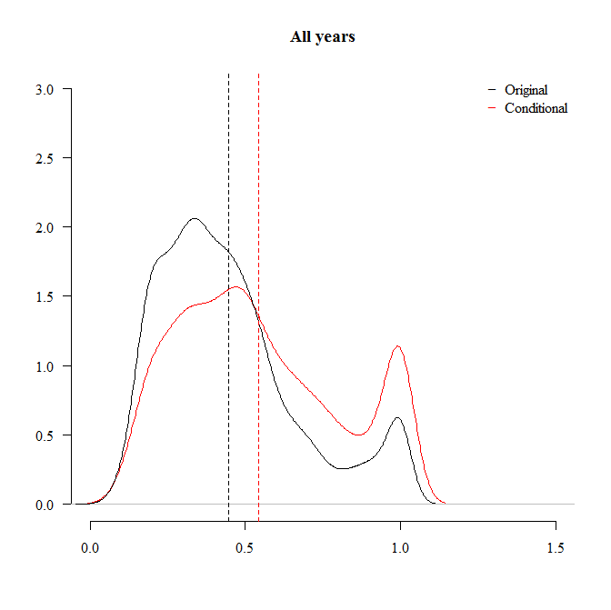 | b  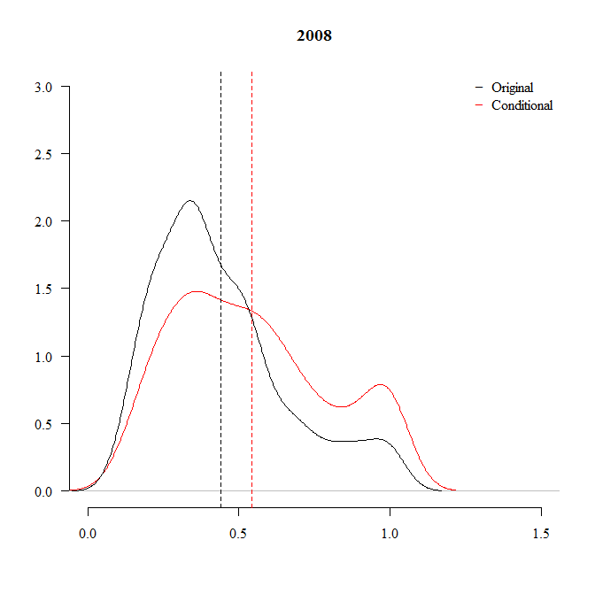 | c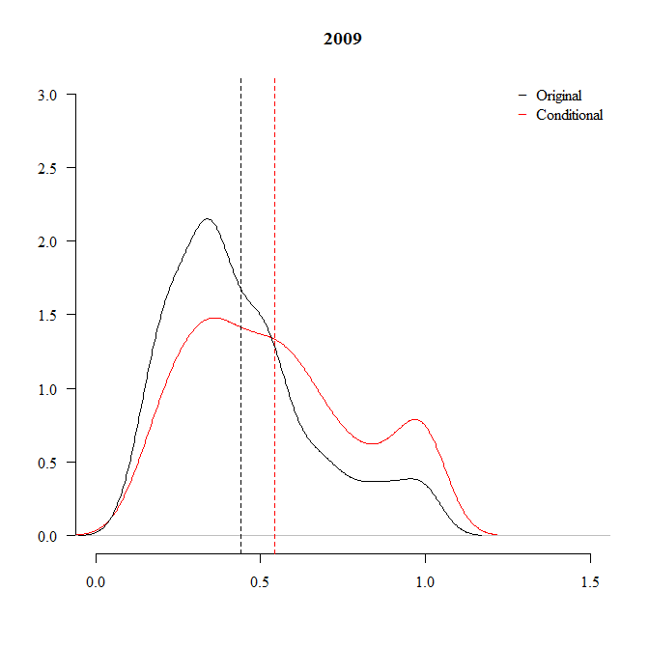
d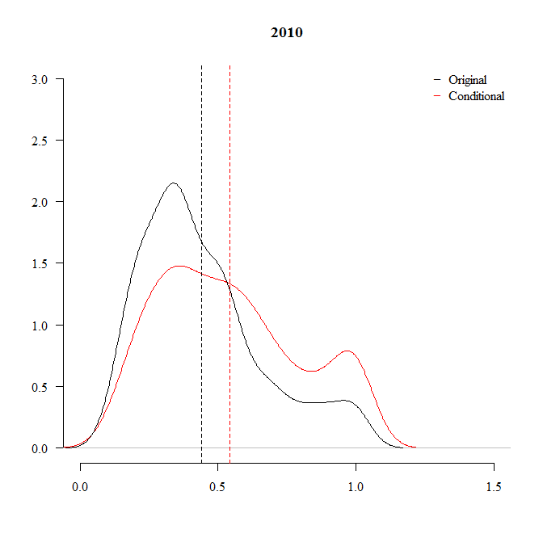 | e  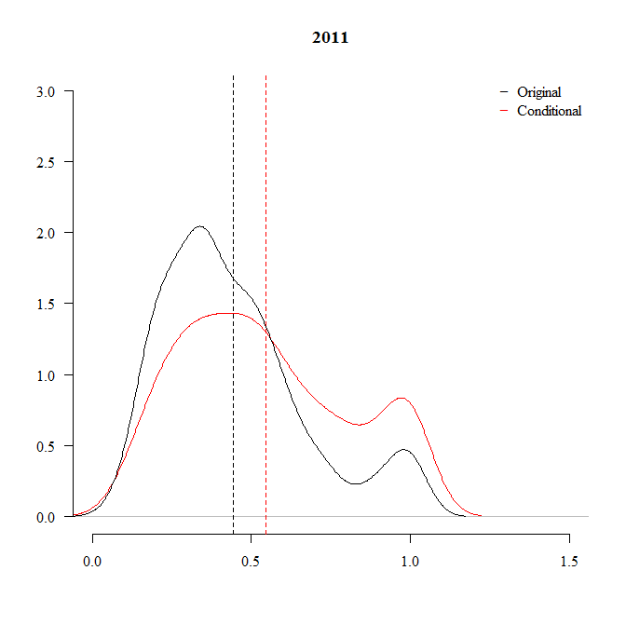 | f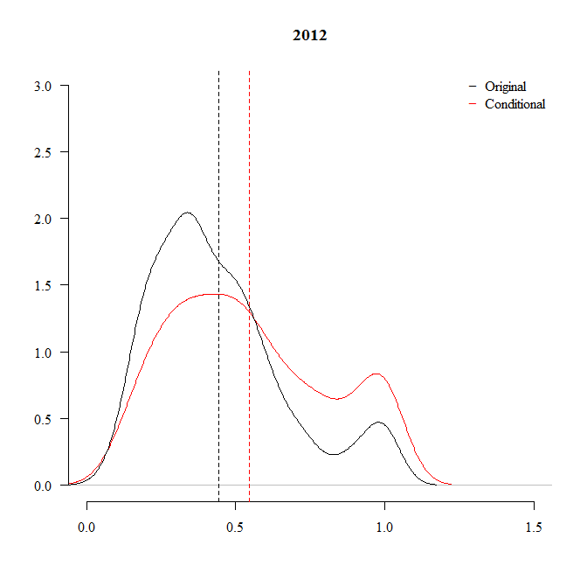
g  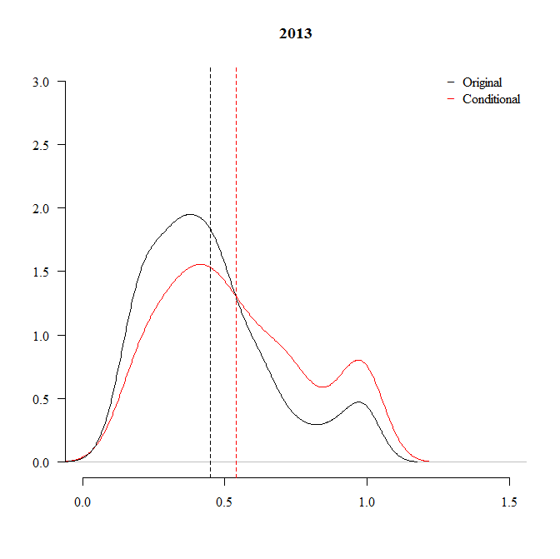 | h  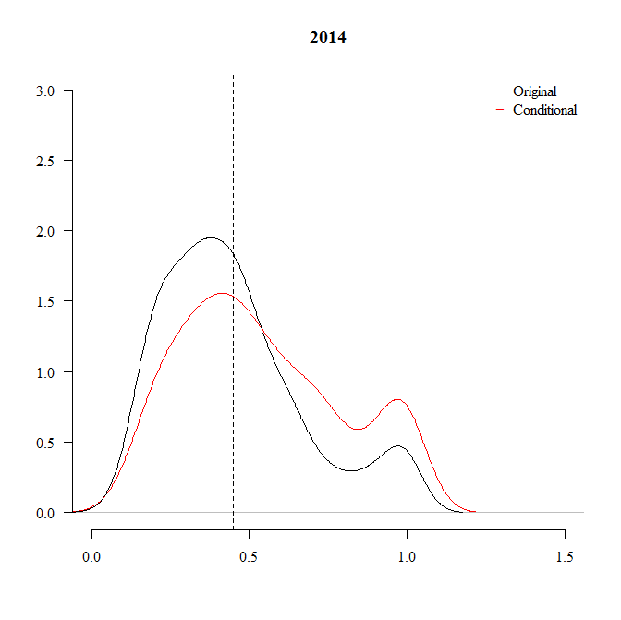 | i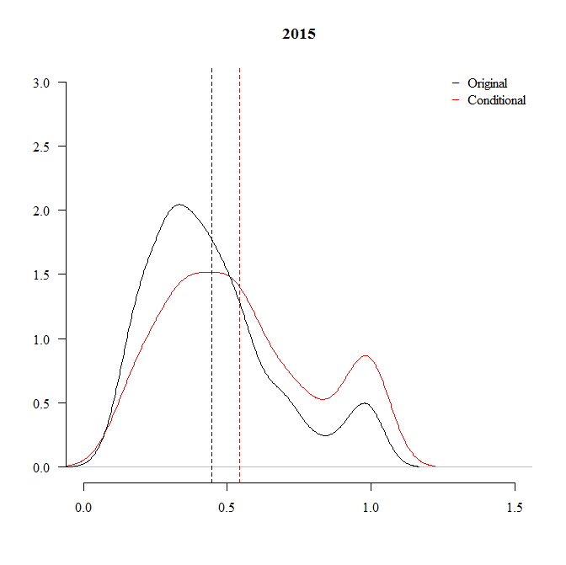
j
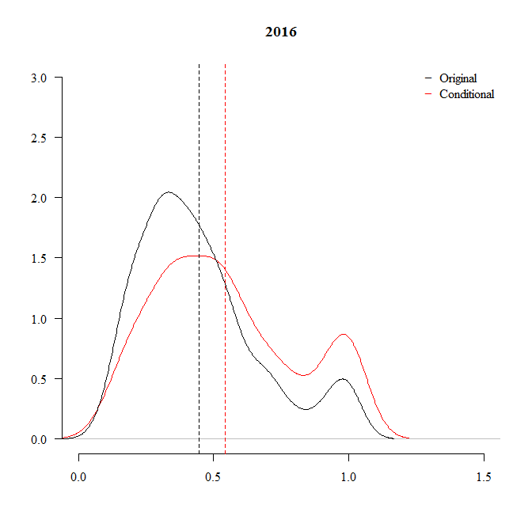

Table 2: Per industry conditional efficiencies estimates
INDUSTRY |  |  |  | INDUSTRY
COMMUNICATIONS | mean | 0.534 | COMSUMER STAPLES |  | mean |  | 0.574
 | std | 0.275 |  |  | std |  | 0.250
CONSUMER DISCRETIONARY | mean | 0.577 | ENERGY |  | mean |  | 0.820
 | std | 0.251 |  |  | std |  | 0.224
FINANCIALS | mean | 0.514 | HEALTHCARE |  | mean |  | 0.466
 | std | 0.248 |  |  | std |  | 0.249
INDUSTRIALS | mean | 0.508 | MATERIALS |  | mean |  | 0.428
 | std | 0.251 |  |  | std |  | 0.234
TECHNOLOGY | mean | 0.542 | UTILITIES |  | mean |  | 0.950
 | std | 0.284 |  |  | std |  | 0.114

Figure 2: The effect of ESG criteria on firms’ innovation capacity
a  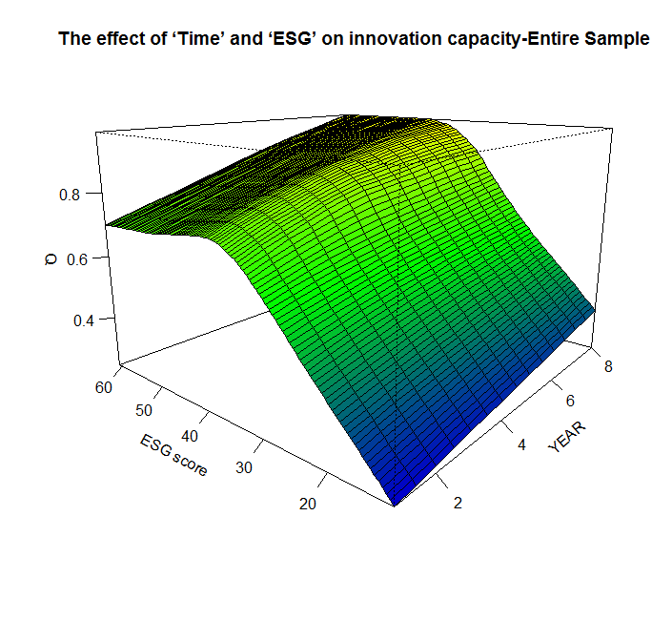 | b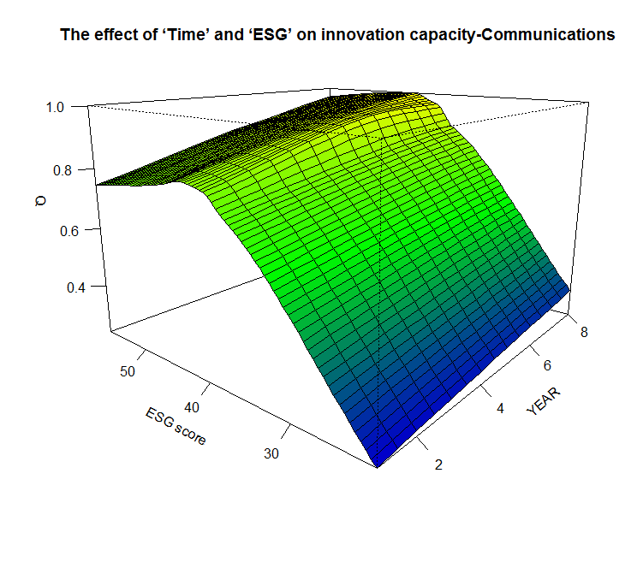 | c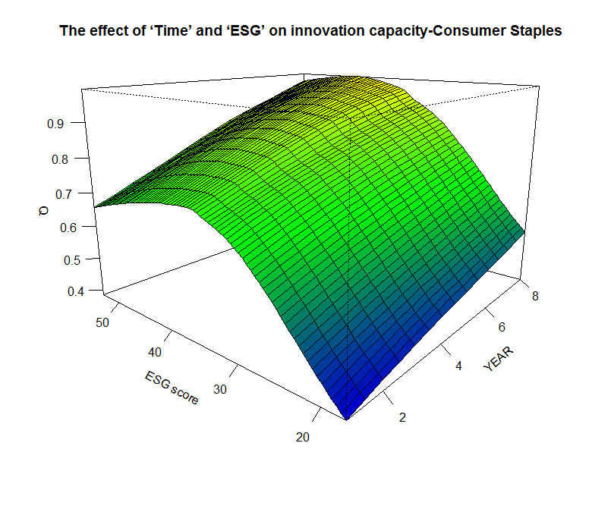
d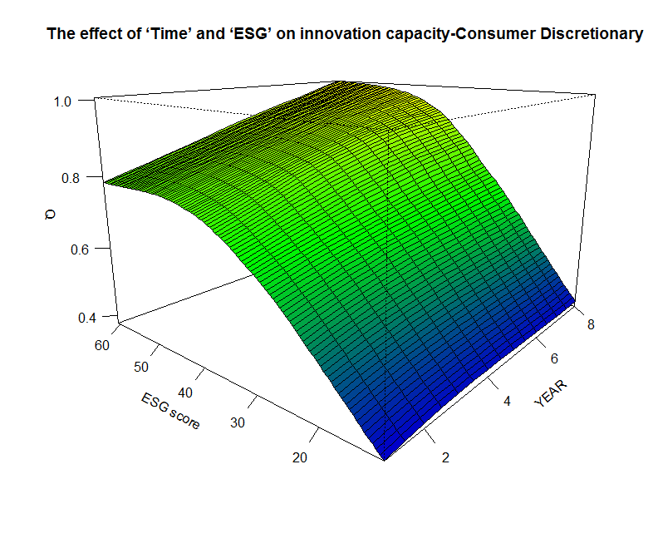 | e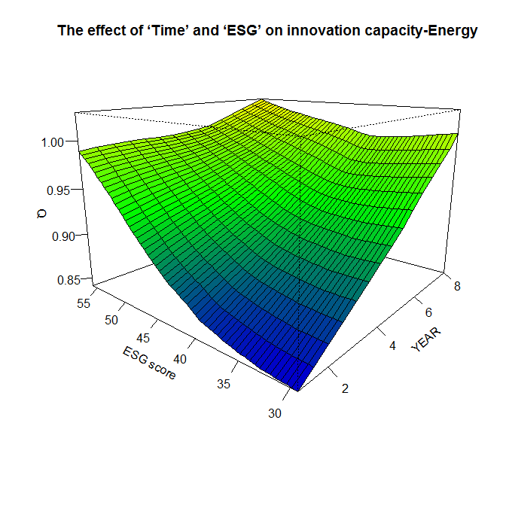 | f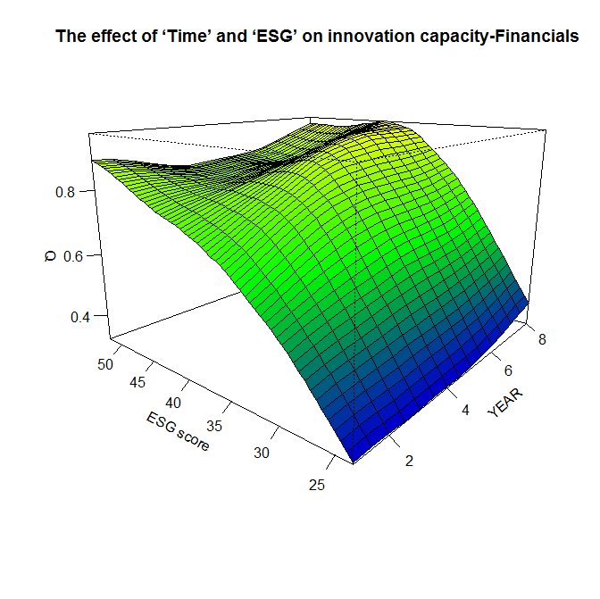
g  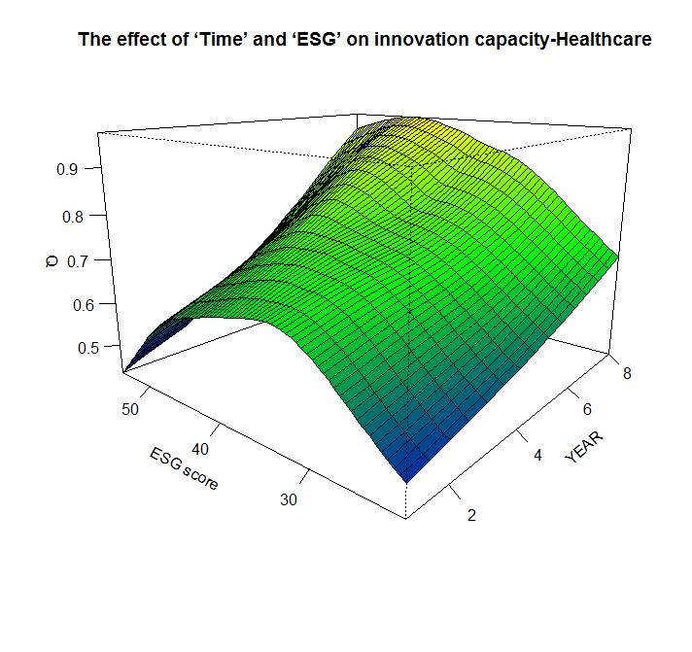 | h  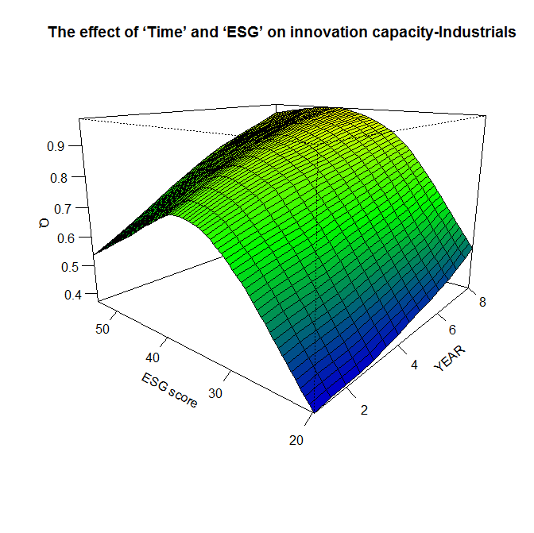 | i  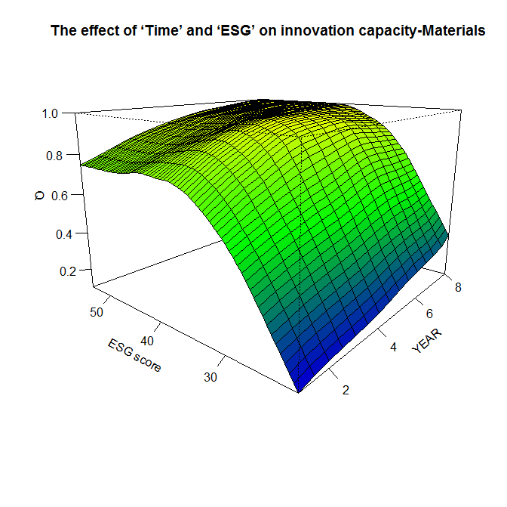
j  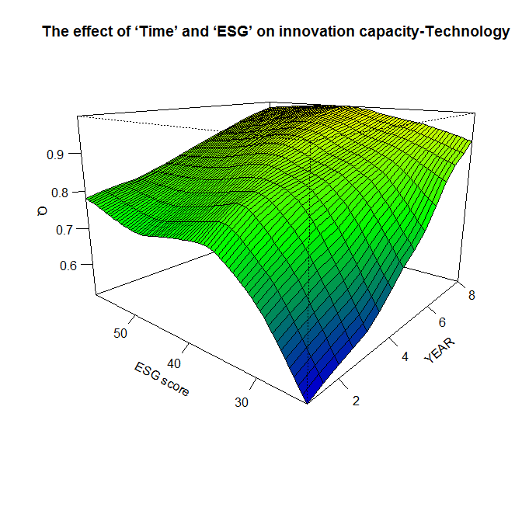 | k  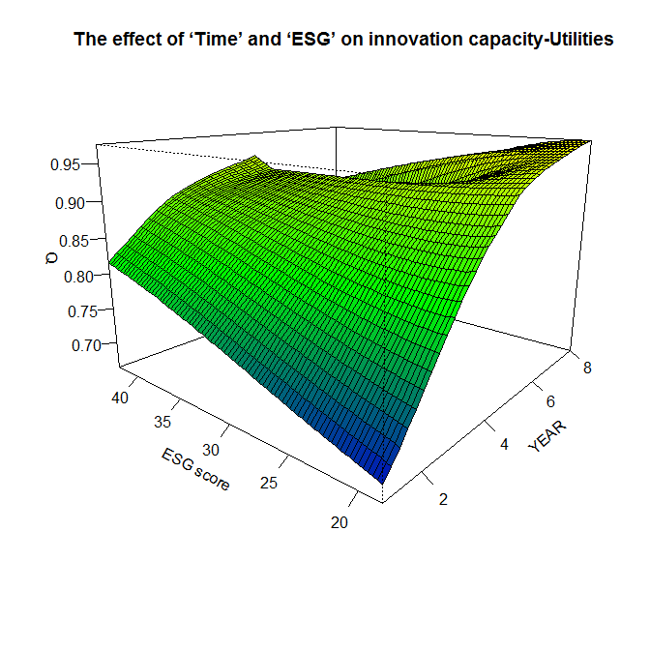

Environmental, Social and Governance (ESG) is composite index (score) which is provided by Bloomberg and is used as a proxy of firms’ engagement on CSR activities (Gillan et al.,2010). More specifically, one might think of CSR as a subjective and broadly encompassing notion, with imprecisely defined (or fuzzy) boundaries. Conversely, ESG scores are objectively and consistently defined measures permitting like-for-like measurement of firm-specific CSR activities. ESG and CSR are intimately connected though it should be recognised that CSR may encompass additional activities that either are not, or cannot be, reflected in standard ESG scores processes.
Similarly, Mahoney and Roberts (2007) in their literature review argue that CSR practices can have an either positive, negative or neutral unidirectional effect on firms’ financial performance.
Similarly, Waddock and Graves (1997) demonstrate that the conflicting results presented in the related literature can be rather attributed (among other factors) to the different CSR measures that are adopted.
It should be noted that Rennings and Rammer (2011) examine firms in Germany and could not provide evidence of a positive impact of environmental regulation on firms’ innovation capacity. These results may reflect the inherently complex relationship between regulation and innovation capacity. Lioui and Sharma (2012) support the view that there is an indirect effect of CSR activities on firm performance through the reinforcement of firms’ R&D activities.
For instance, Reverte et al. (2016) for the case of Spain using a sample of 133 eco-responsible firms provide evidence that the adopted CSR policies had a direct effect on their performance and innovation capacity. Ueki et al. (2016) using questionnaire survey data on Thai trucking firms provide empirical evidence of a positive significant effect of firms’ CSR activities on innovation.
Forsman (2011) highlights an important distinction in her work by exploring the difference between innovation capacity and capability. Pointing to Amit and Schoemaker (1993) who define resources as stocks of available factors that are owned or controlled by an organization, she defines capabilities as the capacity to deploy the resources of an organization. As a result, the innovation capabilities have an impact on innovation capacity.
Hakos and Skouloudis (2018, 294-295) compiled an overview of composite measures of innovation capability: (a) the World Economic Forum (WEF) macro-level innovation potential is assessed through a composite measure examining: (i) Capacity for innovation, describing how companies in a country obtain technology; i.e. by licensing or imitating foreign companies vs. by conducting formal R&D and new product development; (ii) Quality of scientific research institutions; (iii) company R&D spending; (iv) University-industry collaboration in R&D; (v) government procurement of advanced technology products; (vi) availability of scientists and engineers; (vii) patent applications per million population. (b) INSEAD's Global Innovation Index (GII) captures enabling conditions facilitating innovation and the innovation outcomes: (i) Institutions, via attraction of business opportunities, fostering growth through good governance, adequate protection and incentives for innovation; (ii) human capital, i.e. the level and standard of education and research activity; (iii) infrastructure, esp. information and communication technologies, energy supply and dissemination-quality of general infrastructure; (iv) market sophistication, i.e., access to credit, investment funds and international markets; (v) business sophistication, via the employment of highly qualified professionals-technicians; (vi) knowledge and technology outputs, i.e., patent applications, utility model applications as well as scientific and technical articles; (vii) creative outputs, including creative intangibles. (c) the Innovation Capacity Index (ICI), proposed by the European Business School, covers five variables: (i) Institutional environment, i.e., good governance and effective country policy assessment; (ii) human capital training and social inclusion, i.e., level of education system as well as social inclusion and equity policies; (iii) regulatory and legal framework facilitating doing business; (iv) R&D, assessing available infrastructure and workforce, plus registered patents, trademark applications and royalty-license fees; (v) adoption and use of information and communication technologies.
We thank an anonymous referee for reminding us that the decision to disclose CSR activities may not be perfectly correlated with actual CSR activities. There is a possible scenario in which firms engage in CSR activities but never report them. We acknowledge this possibility, but within the scope of our data we are unable to explore this possibility more carefully. We note however that our sample is restricted to reporting firms only, limiting the influence to our analysis.
As discussed in the literature review, we recognize that this is not the only possible measure for CSP, but it has the distinct advantage of being consistently measured, which is an important pre-requisite for comparability. While different indicators might give rise to quantitative differences, we do not anticipate they would result in any qualitative challenge to our main findings.
Even though we have a relatively large sample 2880 observations we estimate a simple production function and in order to minimize the well-known dimensionality problem (Dyson et al., 2001 ; Wilson, 2018).
Assuming free disposability and convexity of the production set (see, Shephard 1970) the measurement of efficiency can be obtained by linear programming estimators, known as data envelopment analysis-DEA estimators (Charnes et al. 1978).
For the asymptotic properties of conditional measures see the study by Jeong et al. (2010).
Based on Simar and Wilson (2007, 2011) and Daraio et al. (2018), in our estimation we assume that the separability assumption does not hold.
The calculation of the full and partial frontiers (both for the conditional and the unconditional measures) several LP programs were carried out using ‘FEAR’ which is an integrated program in ‘R’ language (Wilson 2008).
This requires smoothing through appropriate bandwidths using Kernels with compact support. See the study by Bădin et al. (2010) for computational issues regarding the choice of the optimal bandwidth based on least squares cross-validation (LSCV) criterion (Hall et al. 2004; Li and Racine 2004, 2007).
The 'time' variable is discrete; therefore, discrete kernels have been used following Mastromarco and Simar (2015).
According to Shao and Lin (2016) the estimated technological change reveals firms’ innovation capacity levels.

