The Simple Matcher: A generic, application independent triggering engine.
Author: Neil Fuller
Project assistant – Mobile and Context Aware Computing Research Project
University of Kent at Canterbury, UK
27/08/1999

Abstract
At the heart of any context aware devices there is a requirement for a matching/triggering engine that can match information against some desired criteria. Most devices currently available that can be made mobile and context-aware are relatively primitive; hence good performance and simplicity as well as platform independence are key requirements. This paper describes the design and implementation of one possible solution, describes concepts and tricks to achieve some complex results from simple operations.

Introduction
This work follows closely behind that of P. J. Brown, especially his work on stick-e notes and information retrieval [1]. The concepts behind this work are described later in this introduction. I have also based my work on P. J. Brown’s context matcher application [2] but with a number of significant changes, simplifications and extensions.

My follow up work has been driven by the desire to produce a concrete, working example of a triggering engine that can be used to quickly and easily prototype context aware applications for placing on a variety of platforms. The mechanism described in [2] is a complicated one. It provides much useful and complicated functionality but at the cost of performance.

Those that are familiar with the work of the Mobile Computing in a Fieldwork Environment research project at the University of Kent, Canterbury, UK should also be familiar with the concept of a “stick-e note”. For more information on this read [1] and follow up work. All that is really required for understanding is that an application builds up a “context”. A context contains information about the application’s current situation, e.g. location, user interests, temperature or anything else that happens to be relevant. In addition to this there will be a number of “stick-e notes” which contain all the information available and may have significantly fewer fields than the context. The application does a “context match” using a “matcher” or “triggering engine” to take the context information and operate over all the notes it has to get the individual notes that are relevant to the current context.

An example of a triggering engine at work might be where each stick-e note contains information about a particular landmark and the context-aware device stores a context containing current temperature and location. The note concerning a local landmark would be triggered as the location part of the user’s context comes within a pre-defined range, the temperature part of the user context would be irrelevant for this match and would not be used. This system is basically a filtering operation to restrict all the information available to just the information that is currently relevant.

The context is usually also represented as a stick-e note with field names and values to represent each part of the context. Matching is done in a note-against-note fashion, which allows for a simple and extensible design.

The process behind creating my own “simple matcher” was driven by the requirements I have set out above and previous experience. Up to now I have focussed on object-oriented development in Java. Java-like systems provide the platform independence that I require and so I have continued in this vein. The environment I have chosen to develop for is Waba [3], a Java compatible system that provides almost everything in the Java language except the larger types (long and double), multithreading and exception handling. Once Java source is compiled using the Waba classes they can be downloaded to a hand-held device such as a Palm Pilot or a Windows CE machine and run there. Alternatively they can be run under a Java virtual machine on any platform supporting Java. This is a key concept I will return to later in the Client-side/Server-side section.

What is provided?
A major difference between my work and that of Peter Brown is that I have taken a different approach to interfacing my matcher. Peter’s work provides a command line interface to allow user to submit the context and the notes. Applications using his matcher then parse the textual results and proceed from there. My matcher is based on different assumptions and design ideals. I am providing a set of classes that encapsulate all the functionality required for a triggering engine but I leave it up to application designers to decide how they are plumbed together. One implementation might be a command line application that produces textual output to be parsed by a third party, but equally it might be a context-aware application that uses the classes internally and therefore doesn’t need to parse textual information. The core matcher is a relatively simple beast and I leave the complex, intelligent, side of things to the application designer.

I provide the following things:

- A suitable programmer API to allow easy prototyping of context aware applications.
- The basic requirements for a triggering/matching engine.
- High performance matching (approximately two times faster than P. J. Brown’s matcher implementation).
- The possibility of later expansion in many directions.
- A separation of the internal and external representations of notes and their associated components.

The last point in the list is important. Up till now most of the work done in the Mobile and Context Aware Computing project at UKC has been centred around SGML and XML as the basic notation for context and information. The textual notation has been closely coupled with the internal matching implementations that have been produced to date. My implementation is somewhat different in that if something can be represented as a note conceptually it can be matched against.

Divorcing internal and external representations has led to input/output classes for the following formats being produced which are separate from the core classes:
- XML style for all the types of “note”.
- Jason Pascoe’s Stick-e note implementation on the Palm Pilot [4,6]
- Plain-text output routines for producing human-readable text.

Another key aim in this design was to keep the matcher as simple as possible. Some of the more powerful features of P. J. Brown’s context matcher have been discarded to speed up the matching process. When you consider that a low performance context aware device may be matching over thousands of notes this is a good step to make. What remains is relatively swift and ideal for client-side matching (e.g. on a low power hand-held device).

Client-side / Server-side?
As I have mentioned previously, the matcher I have implemented is designed to run quickly on a context aware device. A fair amount of work in the MCFE project has gone into looking into the merits of server-side context matching. In all but the most trivial scenarios there will be thousands of notes, far too many to store or match over on a simple context aware device in reasonable time. The accepted solution is to have some form of remote link to a more powerful server either permanently, via wireless link or at various “way stations”. A context aware device might upload a general context and a server program would use a matcher to match all the notes it holds over that general context. The server then sends the notes to the context aware device, effectively restricting the number of notes the context aware device has to match over and doing the major matching operations where this distributed system is most able to handle it.

An example of a client and server-side matcher being used together would be a city tour. As the context aware device reaches the edge of its knowledge area it would contact the server and request all notes for the surrounding region, perhaps within a square mile of the current location. As the context aware device is moved around the square mile it would use a more specific context when matching, e.g. within 50 metres, to pull up information on sights and points of interest close to the user. This example is one of many I could give and it demonstrates there is a very definite need for server-side matching in addition to client-side, at least until context aware devices become fast enough and have enough storage to hold all the information they could possibly need. Thankfully, in choosing Waba I have already addressed this need. The same Java byte-code can run server side and client side ensuring compatibility and reducing implementation effort. Hey presto! – server side matching if required with very little effort.

Core Classes
There are five main classes in the matcher.core package.
- matcher.core.Note
- matcher.core.Rule
- matcher.core.Recipe
Which is a holds two classes:
- matcher.core.OutputRecipe
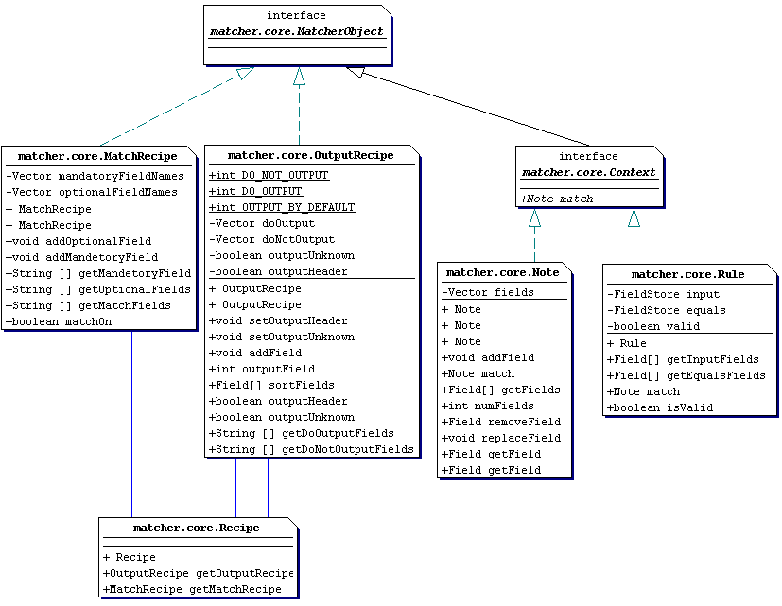
- matcher.core.MatchRecipe

The Note class consists of a number of Fields and allows their manipulation. Fields are objects that consist of a name and one or more values. Field names are not checked to make sure they are unique within a note and behaviour is undefined if Notes exist with more than one field of the same name in them.
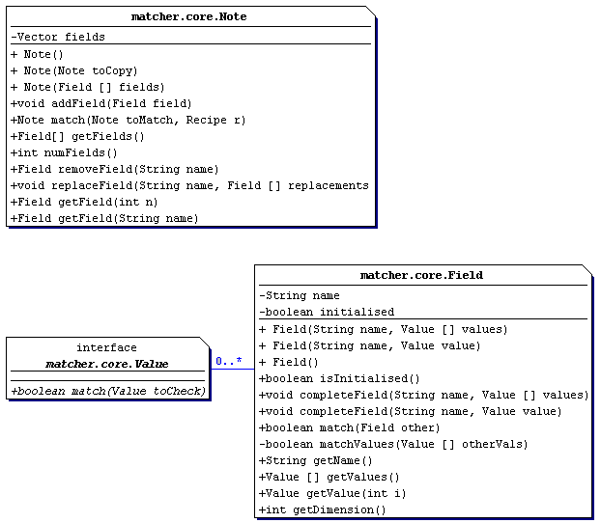

Currently there are three main types of Value:
- StringValue
- Range
- MatchAll

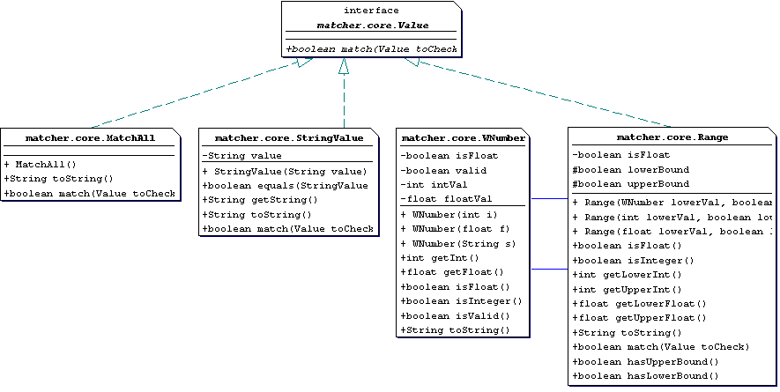
Values are the only classes in the matcher.core package to implement the toString method (and thereby provide a standard external representation). The reasoning behind this to save development effort since Strings and numbers have a reasonably standard form.

A StringValue contains any valid text string, as you would expect. A StringValue can contain an empty string (“”).

A Range is a range of numbers with optional upper and lower bounds. Ranges have two roles, to provide a range of values to match against (e.g. I want to match all notes that have a field with a temperature in the range 35..50), and also for conversions in rules where the range is used as a sample (see [2]) as part of the conversion. Conversion is described in more detail in the Rules section.

Ranges without an upper bound are considered to be infinite (within reason) in the positive direction and are represented by having two dots after the values, e.g. in the form “1..2..”.

Those Ranges without a lower bound are said to be infinite towards the negative direction and are represented by ranges in the form “..1..2”.

Ranges may omit both upper or lower bounds in which case they simply represent infinity. There are differences between “..1..2..” and, say, “..10..100..” but these only become apparent when you start looking at rules and conversion (see the Rules section).

Internally, a range is made up of two matcher.core.WNumber objects that give the upper and lower values in the range. The WNumber class has been provided to mask the differences between floating point and integer representations. A WNumber can return its value as a floating point or integer value but will hold it internally as the correct type. A Range can be created by passing it two WNumber objects. A Range can be a floating point or integer range and if this is ambiguous, it is decided by the type of the lower value in the range.

E.g. The following are valid ranges. Pay special attention to the leading and training “..”’s as these indicate the lack of lower and upper bounds respectively.
Range | Explanation
1..2 | Integer range from 1 to 2 with upper and lower bounds (1 and 2)
..1..2 | Another integer range like the one above, except this time it has no lower bound and is effectively infinite in that direction.
..1..2.. | Effectively this represents infinity within the matcher. There is no upper or lower bound. Explanations about how this differs from, say, ..2..20.. are in the section below on rules.
1.2..4.5 | A floating point range from 1.2 to 4.5
1 | This represents the number 1. Although this may seem odd, this is a range too but the same as 1..1.

The final type of Value is called “MatchAll”. Basically this is the equivalent of the “*” wildcard. It will match any other type of value including itself. It is represented externally by the lower case string “any”. To prevent confusion between the text string “any” and a MatchAll this document will refer to a MatchAll as <MatchAll>.

Matching
A match is something done between a Note and a Context object (either a Note or a Rule). The Note is applied to the Context via the match method and the result of the match is returned.

When you wish to do a match between a Note and a Context object you must provide a “recipe”. A recipe contains a “match recipe” and an “output recipe”. The output recipe is not discussed in this section as it concerns the external representation of notes, but the match recipe will be described in some detail here.

The match recipe specifies which fields are “turned on” in a match by the names of the fields that are held. When doing a match, if a field name appears in the match recipe a field of that name must appear in both notes in order to begin the match (the match will fail if the fields do not exist). Because fields can contain multiple values, what we call “multiple dimensions” (e.g. both x and y co-ordinates in a field called “position”), the fields must also contain the same number of values to match successfully.

A match recipe contains two sorts of fields. Those fields specified as mandatory must be present during a Note match in both the matching note and the context note for the match to succeed. Field names can be specified as “optional” and do not have to be present, but if they are present in both, should match for the note match to be successful. If the field is missing in one side, no match on that field will take place and the result is entirely dependent on how well the other fields in the match recipe match (if there are any).

It is important to understand that specifying an optional field is a way of making a note fail to match rather than making it succeed. Also, an empty match recipe will let all notes through unchanged. When matching notes, a match recipe just consisting of optional records will act like an empty match recipe except where both sides of the match contain the optional fields, at which point the match may fail if the fields don’t match or are incompatible.

Finally, Rule matches make no distinction between mandatory and optional fields.

Matching Notes
When you match one note to another using the match method, the following rules apply at the field level:
Value One | Value Two | Result | Condition/Reason
<MatchAll> | - | Match | A <MatchAll> will match anything.
- | <MatchAll> | Match | A <MatchAll> will match anything.
Range | Range | Match | If ranges intersect.
Range | StringValue | No match | A range cannot be matched to a string.
StringValue | Range | No match | A string cannot be matched to a range.
StringValue | StringValue | Match | If the strings are equal.

As you can see, matching is symmetrical, if field A matches B, field B matches A. Also, if all the fields turned on in note A match all the fields turned on in note B, note B also matches note A.

Matching notes is done via the match method on all Context objects. The returned result of a successful match is the note that was matched against the context. It is exactly the same note as before the match and is not altered in any way. An unsuccessful match will return null. Matching Note objects against a Note context object is a way of restricting the notes you have to deal with.

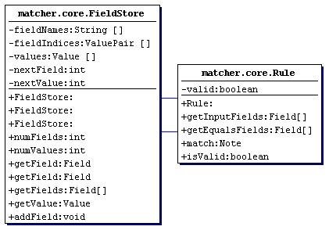
Rules

The Rule class consists of a set of “input” fields and a set of “equals” fields. The input fields map onto the equals fields and allow conversion from one field type to another or to manipulate the values held by fields.

For the purposes of this documentation I will stick to XML notation for the rule but this is just one possible way of representing a rule.

This is a valid rule:

<rule>
<input>
<expression> smile </expression>
</input>
<equals>
<mood> happy </mood>
</equals>
</rule>

Rule Matching
Since the Rule class implements the Context interface you can match notes against rules. Rules provide a method of altering the contents of a note in a relatively powerful manner. Rule matching is done, like Note matching, at the field level using the field name to identify a field.

The field names can be altered by a rule but the field names of the input field list must match that of the note applied exactly. The field name of the result produced is that of the equals field used in the match. You cannot match a rule against a note since the match method expects a Note object and returns a Note.

<rule>
<input>
<expression> smile </expression>
</input>
<equals>
<mood> happy </mood>
</equals>
</rule>

This rule will match any note which contains the field with the name “expression” with the value “smile” and change it to be a field with name “mood” with a value of “happy”.

A rule match will operate over variable dimensions. For example, it can take two fields with a single value each as input fields, and a single field of two values as an equals field. E.g.

<rule>
<input>
<one> any </one>
<two> any </two>
</input>
<equals>
<three> any, any </three>
</equals>
</rule>

This rule, once matched would produce a note in which a field with two arguments and a field name “three” replaces the field “one”. The field named “two” will be removed. The values held by the “one” and “two” fields would now belong to the “three” field in the result note. For example, applying the note:

<note>
<one> 1
<two> 2
</note>

would produce the note:

<note>
<three> 1,2
</note>

The following conditions apply during a match with a rule:
- All the rule’s input fields must be in the match recipe being used or the match will not succeed (and the note will be returned unchanged).
- The rules’ input fields must have the same number of values as the field of the same name found in the note being matched.
- The total number of values in the input and equals sections must the same.

Unlike Note matching, if a match against a rule is unsuccessful the note being matched remains unchanged (when notes are matched, an unsuccessful match results in a null Note being returned). This allows multiple rules to be applied one after the other in an easy manner.

In a rule there are three distinct types of match. The input field could be a Range, a <MatchAll> or a StringValue. A Range match is successful if the applied field is a Range and the two ranges intersect. It’s useful to remember that single values like “1” or “2.4” are actually represented internally as ranges too, albeit in the form 1..1 and 2.4..2.4.

Something very special happens if the input and equals parts of a rule are Range’s and the value being applied is also a Range. The matcher will do some “massaging” of the Value being applied by assuming that the relationship between the input range and the output range is linear.

For example:

Input | Equals | Value applied | Result | Explanation
1..3 | 4..6 | 2 | 5 | 2 intersects 1..3 and gets mapped in a linear fashion within the range 4..6, resulting in 5.

Applying a range has the effect you would expect. The lower and upper bounds of the “Value applied” field are both applied to the rule, e.g.
Input | Equals | Value applied | Result | Explanation
1..3 | 4..6 | 2..3 | 5..6 | 2..3 intersects 1..3 and gets mapped in a linear fashion within the range 4..6, resulting in 5..6.

A slightly odd side effect of Range matching succeeding on intersection is demonstrated below:

Input | Equals | Value applied | Result | Explanation
1..3 | 4..6 | 2..100 | 5..103 | 2..100 intersects 1..3 and gets mapped in a linear fashion within the range 4..6, resulting in 5..103.

This can have slightly strange effects when you start using ranges like:
Input | Equals | Value applied | Result | Explanation
..3 | 4..6 | ..100..101 | 4..6
5..10 | 10..20 | ..100..101 | 200..202

Both these results are unintuitive. It may help to know the following:
- Whether or not the result has upper or lower bounds is decided by the equals field and is not influenced by the upper or lower bounds of the input or value applied.
- If the input is a single value the lower range is returned, e.g. 3..3 mapping to 4..5 will result in 4..5 if the value applied matches 3.
- The linear calculation works out a ratio relationship between the equals field and the input field. This ratio is used to manipulate the value applied in a similar ratio.

The lesson here is, use lower and upper bound calculations sparingly and when you know what you’re doing as you might get very odd results!

Confusion might also arise when using a mixture of integer and floating point ranges or values. The things to remember here are:
- The value applied will be converted to the same type as the input Range.
- The calculation will be done with the equals range being used as the same type as the input range.
- The result will be converted to the same type as the equals range.

Obviously conversion from a float to an integer value will trim the fractional part of the number and could make range conversions appear strange. See the next table for examples of this at work.

Besides numbers a range will also match a <MatchAll>. If a <MatchAll> is matched against the range, the output range is output instead. A StringValue will never match a Range and the rule match will not be succeed.

Rules can take things other than Ranges as inputs. In these situations the output field is output as you would expect (and the output could include a MatchAll).

Here are some examples of rule use:

Input | Equals | Value applied | Result | Explanation
1..2 | 4..6 | 1 | 4 | 1 falls within 1..2 and gets mapped in a linear fashion within the range 4..6
1..2 | 4..6 | 1.5 | 4 | Since 1..2 is an integer range, 1.5 is converted to an integer (to become 1), then matched and converted.
1.0..2.0 | 4..6 | 1.5 | 5 | 1.5 is used as a float and the conversion is made. The result is then converted to an integer as the equals field is an integer range.
1..2 | 4.0..6.0 | 1.5 | 4.0 | 1.5 is converted to an integer, matched and the rule is applied.
1.0..2.0 | 4.0..6.0 | 1.5 | 5.0 | As you would expect.
1.0..2.0 | 4.0..6.0 | 1 | 4.0 | The result is floating point because the equals field is a floating point range.
Hello | Goodbye | Hello | Goodbye | Hello matches Hello so the equals value, Goodbye is the result.
Hello | Goodbye | Greetings | Greetings | Greetings doesn’t match Hello so the rule cannot be applied. The field is left unchanged.
<MatchAll> | 42 | Hello | 42 | Hello matches the <MatchAll>, the value of the equals field is output.
<MatchAll> | 42 | 122 | 42 | 122 matches the <MatchAll>, the value of the equals field is output.
<MatchAll> | <MatchAll> | Hello | Hello | A <MatchAll> in the input and equals field lets Hello through.
<MatchAll> | <MatchAll> | 42 | 42 | A <MatchAll> in the input and equals field lets 42 through.
1..2 | <MatchAll> | 1 | <MatchAll> | A <MatchAll> is the result. This allows rules to insert <MatchAll>’s, perhaps as a single step in one of many matches.
1..2 | 1..2 | 1 | 1 | The value is passed through untouched. This may be useful to you if you wish to change the field name but not the value.

Important Differences between the Simple Matcher and P. J. Brown’s Matcher

Field Names
Peter’s matcher handles multiple fields with the same name, optionally with different “labels”. My matcher doesn’t deal with this situation at all because of some of the complications involved (see the section later in this paper called Extensions to Add for a discussion of some of the more obvious difficulties).

Symmetry
Matching in the simple matcher is symmetrical, if note A matches note B then note B matches note A. In Peter Brown’s matcher, symmetry does not hold because the context is assumed to have lots of fields while there are assumed to be many notes each with a subset of those fields. Matching a note to a large context will usually produce good matches because matching is done using the fields of the note as a match recipe. Swapping the note and the context would fail to produce the same matches because there would be fields present in the note that are not present in the context and so the match would fail.

In my system, the match recipe can be configured with “optional” fields to match the fields that may not be present in the notes (or context). Alternatively, the application programmer can construct a new match recipe for each note he/she applied to the context containing only those fields that are present in the note being matched. For most purposes these solutions will be sufficient to produce equivalent results in the simple matcher.

Match / Output Recipes
The simple matcher has been designed so that the programmer can do a lot of manipulation of notes before outputting them. In P. J. Brown’s matcher, the recipe is used at every stage of the way.

I assume the user may wish to run several filters or run the results from one match against a second context. Generally, the first time the application designer is concerned with the ordering of a note’s output fields (if at all) is on output of the note. This is where the Output Recipe comes in. It allows easy parsing of results by programs separate from the simple matcher by enforcing an order to fields and also allows users to easily restrict the amount of information from a note that comes out of an application. Support for extension to applications is provided via the “output unknown” attribute. This allows some flexibility and should make applications based on the simple matcher smaller and less complex. See the Input/Output section for more details.

Rules
In the simple matcher, Rules are considered context and you apply a Note to a Rule with the aim of producing a new note. In Peter Brown’s matcher, rules are applied to notes (the reverse of mine). In retrospect Peter’s version makes more sense. The difference arises from my own ideas that the traditional context is absolute, potentially changing all the time as sensors update the values and provided by the environment. Applying a rule to the context to produce a new context is not something I wish to encourage. There’s nothing to stop a user applying the note that represents the context to a rule and using that so no doors have been closed. Because of the symmetry of matching I have employed, there is no difference in doing this and so the developer is free to alter the context if they wish.

If it help, you might like to thing of the Context objects acting like “mutators”.

- Applying a Note to a Note Context could mutate the applied note into a null (or let the note pass through unaffected).
- Applying a Note to a Rule context could mutate what the applied Note contains (or let the note pass through unaffected).

Inserting fields using Rules
In Peter Brown’s matcher, there is no restriction on the equals part of the rule. This part can contain as many fields as user likes and can be used to insert fields into Notes. Because I provide a programmer API and expect applications to be working at this level, fields can be added using the addField method of the Note class to achieve this instead.

Useful Matching Concepts
Through the course of my context aware device research a number of useful ideas have surfaced that allow context aware application based on a matcher do a number of quite important and useful things.

Change to Context / Change to Data / Unique ID’s
Peter Brown has described the ideas concerned with changing data, context and data validity in his paper on Change [5].

Imagined Context
This idea has been mentioned many times in the UKC papers on context aware applications. However, it is worth bringing up again because it is a powerful tool for testing and in actual context aware applications. The context the application provides need not be correct or related to the user’s actual situation. What the user can do is pretend to be somewhere they are not (or at a temperature they are not, in a mood they are not, or anything else that might be contained in the context). At the simplest level this can be used to say “What could I see from there?” or “What happens when the radiation level gets this high?”.

Staged matching on the context-aware device
On low performance devices context matching is still a reasonably costly action. Each match could take in the region of 0.3 seconds to complete (this is true on a Palm Pilot IIIx, the slowest platform that runs Waba we can find). When you stop thinking about trivial applications with small numbers of notes then this is an appreciable time delay. Given that Waba restricts the application to operating in a single thread of control, the user cannot interact with the application during the matching cycle. One solution is to do a staged match where only a few notes are matched against the context in one go and this is done regularly enough to work through the entire note set in reasonable time.

There are arguments both for and against this approach. It could be that it doesn’t matter if the application displays a “Please wait” message box and freezes for several seconds, especially if the context check is driven by something triggered by the user. However, this is not the case if the context check is something that is done periodically, e.g. in a wildlife tour as the user moves around information is brought up as it becomes applicable. If the application freezes while the context check is done, it can be very annoying for the user to have to wait for the cycle to finish before being able to continue using the information that is being presented.

A fine balance has to be struck between cycling through all the notes in a reasonable time and allocating enough time to provide adequate response to user interaction.

Input/Output Classes
One of the main aims when designing the classes for the core of the matcher was that there should be no fixed external representation for the Note, Rule and the Recipe’s. This should ensure that the matcher remains generic and is not closely tied to one particular method of representation.

An important class that is concerned with output is the matcher.core.OutputRecipe. This deals with how a note should be represented externally. The OutputRecipe is concerned with filtering and ordering the fields in Note objects so that only the ones the user is interesting in are output (or displayed).

The OutputRecipe
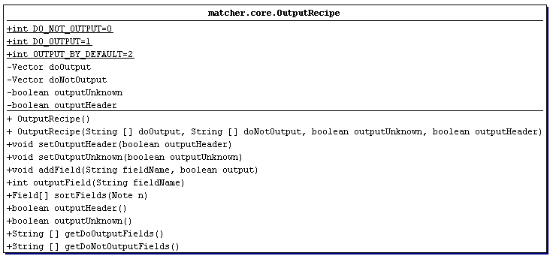
The output recipe allows control of the order in which fields are to be output as well as restricting them.
This is done via the sortFields method on the OutputRecipe class. This method will take a Note object and return all the fields that should be output in the order that they appear in the OutputRecipe.

The output recipe allows the user to specify fields that should be output as well as those that shouldn’t. Fields which are listed in the “doOutput” list are output in the order in which they appear in the output recipe (if they exist) to allow easy parsing by separate applications. The “doNotOutput” fields will never be output.

The output recipe copes with Note extension as well by allowing the user to specify how the output recipe should deal with fields it knows nothing about. This may arise, for example, if at some point the designer of a context aware application adds an extra field to all or some of his notes called “temperature”. The output recipe allows unknown fields to be let through or stopped by the “outputUnknown” property. If the outputUnknown property is set to true, unknown fields are output in the order in which they appear in the Note and placed after the doOutput fields.

Finally, the output recipe has a further property that could have different meanings depending on the application in which it is used. This outputHeader attribute is used where, for example, the application developer just wants to output a list of fields without note boundaries between them. In the XML output routines this flag controls whether or not the fields are indented and placed within <note> and </note> tags. In the PlainText output methods the outputHeader property is used to decide whether or not to have a dividing line between notes.

The output recipe is a convenient place to keep this information and has been included for use by programmers implementing input/output methods but is not used internally by the OutputRecipe or core matching classes.

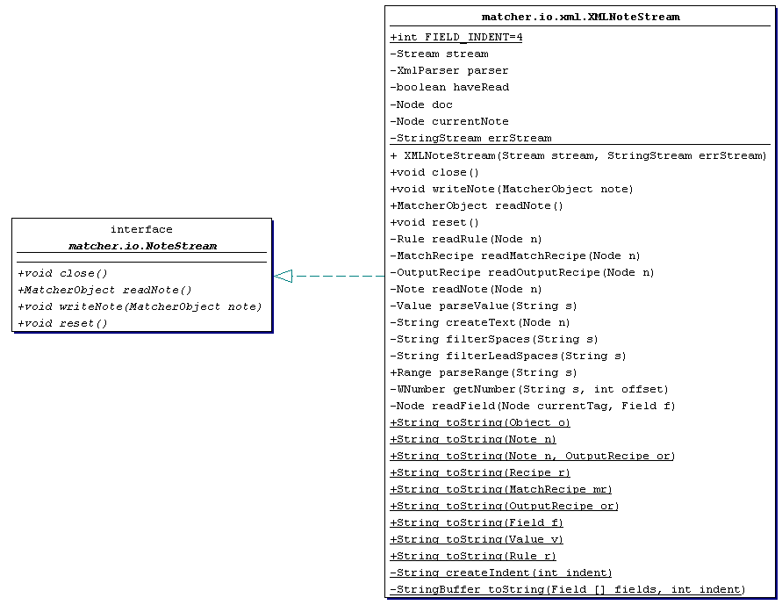
matcher.io.xml
Currently the XMLNoteStream supports input from a stream only. Writing XML is not directly supported but the XMLNoteStream provides a set of “toString” methods that will take the internal, object representations of matcher.core objects and return the XML textual equivalents in String object form.

All XML files the XMLNoteStream is asked to parse should contain a <sticke_xml> </sticke_xml> tag pair.

e.g.

<sticke_xml>

<rule>
<input>
<name> Rutherford </name>
</input>
<equals>
<new_name> Rubberfood </new_name>
</equals>
</rule>

</sticke_xml>

The Note

A Note should look like this:

<note>
<field_one> field_one_value </field_one>
<field_two> field_two_value_one, field_two_value_two </field_two>
</note>

As you can see, the note is everything within the <note> and </note> tags. Each field’s values should be enclosed in field-name tags. A field can be of multiple dimensions with the fields separated by commas. Quotes (“) can be used to prevent commas from being identified as field separators or to allow for empty strings.

The Rule

Example rule:

<rule>
<input>
<name> Eliot </name>
</input>
<equals>
<new_name> Helliot </new_name>
</equals>
</rule>

The rule is very similar to the Note in construction. Again it should have entry and exit tags <rule> and </rule>. The input field that the rule should match against is held in the <input> </input> tags. The field is specified in the same way as in the note, with the value held between field-name tags.

The input fields must map to some “equals” fields, and these are held within the <equals> </equals> tags in the standard fashion.

The MatchRecipe

The MatchRecipe is specified within <match> </match> tags. The active match fields are specified by name alone within <mandatory></mandatory> and <optional></optional> tags.

E.g.
<match>
<mandatory> name </mandatory>
<optional> with </optional>
</match>

The OutputRecipe

The OutputRecipe looks like this:

E.g.
<output output_unknown="no" output_header="yes" >
<yes> name, details </yes>
<no> location </no>
</output>

The opening <output> tag has two attributes that have been explained in the sections above, output_unknown and output_header. The values expected are “yes” and “no”.

As with the MatchRecipe, field names are all that are needed to specify a field for output. There are two optional tags you can use within the output recipe: <yes> and <no>. These tags allow you to specify field that should be output and should not be output respectively.

The Values

The XMLNoteStream recognises the following types of values:
- The string “any” is recognised as a MatchAll.
- Integer numbers are recognised as numbers that don’t contain a decimal point.
- Floating point numbers are recognised as those numbers that contain a single decimal point (even ones like “1.”, which will be recognised as 1.0).
- Any other alphanumeric string is recognised as a StringValue.

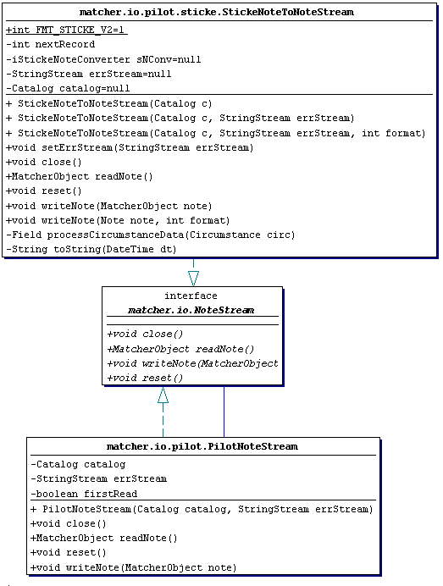
matcher.io.pilot

The PilotNoteStream provides an “intelligent” front end for the Palm Pilot implementations of matcher.io.NoteStream. PilotNoteStream accepts a catalogue on construction and when you first try to read a note, it will try to work out what format the Note is using the matcher.io.NoteDecoder class. Currently only Jason Pasoe’s V2 Sticke-notes [4,6] are supported via the StickeNoteToNoteStream and V2NoteConverter classes. This might change as later sticke-note formats appear or other Palm Pilot formats are required.

As with the XML, only reading is currently supported.

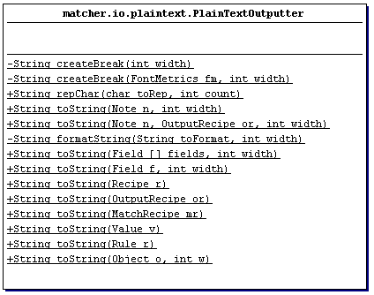
matcher.io.plaintext

The matcher.io.plaintext routines are provided to produce rudimentary plain text outputs of all the basic core matcher classes. Intended mainly for debug and “quick and dirty” output the toString routines provided allow you to turn you internal objects into visible output.

Extensions to Add
This section details issues I plan to / would like to address in the future.

Multiple fields with the same name
Mainly for performance reasons, the matcher assumes that a field name uniquely identifies a field within a note. No checking is done to see if running a rule over a note will result in a duplicate field or to see if the user attempts to add duplicate fields.

Besides performance, there are some serious issues here, for example – what if a rule acts over a <temperature> field, if there is more than one, which one is the valid one to choose? I have chosen to side-step these issues for the moment but I might go back and address them later, if only to say “no duplicate fields are allowed”.

Rule extension: Why use a Match Recipe?
It has become apparent there is little point in providing a match recipe when matching rules. It would be far better to assume that the match recipe of a rule consists of all the fields in the <input> section.

Rule extension: Unbalanced rules – Inserting / Removing fields
There are situations where the user may wish to add fields as the result of a rule. I have already provided a partial solution to this in the “Important Differences” section. However, it is apparent that fixing rules such that the input and output dimensions of the rule have to be the same is restrictive. There are situations where you may wish to have a pair of values specifying a vague position (e.g. using ranges to specify a rectangle) and return a single value. E.g. You may specify the range of latitude and longitude values that vaguely specifies Canterbury and a rule that determines if a note pertains to a position in that rectangle. If so the user may wish to replace the two ranges with a StringValue “In Canterbury”. This cannot currently be done easily using Rules and should be addressed.

Rule extension: Not equals?
There is some advantage to specifying what happens in a rule when a Value doesn’t match. It might be advantageous to specify the value a field should take if a match doesn’t take place.

With this extension you could provide rules like:

<rule>
<input>
<name> Rutherford </name>
</input>
<equals>
<new_name> Rubberfood </new_name>
</equals>
<not_equals>
<new_name> No nickname </new_name>
</not_equals>
</rule>

Extending the match - Notes
The current system supports boolean Note matching, where a note either matches completely or not at all. This is naïve and probably won’t stand up well to real world applications where the programmer may be interested in quite how well a Note matched. This can be implemented in the current system by gradually adding fields to a match recipe used in a match until a note no longer matches. However, this is hideously inefficient and some “scoring” facility could be provided to specify quite how well a note matched a context.

Extending the match - Fields
As with notes, there is an issue when dealing with partial matching of fields. More obviously this could include case independent StringValue matching or “how well does this range intersect this other range”? This needs to be addressed and probably means assigning “scores” to fields. This could also allow the user to prioritise certain fields over others by assigning them a higher score.

Field scores could be cumulative and thus, a note matching a “radioactivity” criteria that warns a user they are in danger and suggests they evacuate immediately might score more highly than one matching a “mood” criteria that detects when somebody is unhappy and suggests a night out ☺.

Changing the API
From looking at the sticke-note input routines it becomes apparent that the conversion from a sticke-note to a matching note is, in many ways, a redundant step, can be unnecessary and causes information to be lost. A better approach would be to specify an interface that all note-like objects must implement to support the matching operation. This way any object could act like a note and implements the Note interface could be matched against regardless of the internal representation of a Field. Providing it can produce Field objects on request this model works well and could reduce significant overhead, not to mention keeping away from conversion routines.

The match method would probably need to change to look something like this:

boolean match(Note toMatch, Recipe r, Note result)

The result parameter would be of the same type as the toMatch object. Again, providing it allows fields to be added to it, the matching system wouldn’t need to know about the internal storage of fields, thus saving the effort of having to convert the resulting note into something the outside application recognises as a note.

I would want to provide a BasicNote which implements the Note interface and would act like the current Note in every way and provide just a Field store without any whistles and bells.

Summary
The work I have done on the simple matcher is just a start. It has helped to highlight useful features and better understand what is required in a basic triggering engine. The next step is to attempt to take the best points from this work and that of Peter Brown and produce a system that not only draws on the strengths of both but moves beyond, exploring the ideas of partial matching and discarding the less useful aspects.

With this work I have hopefully demonstrated the flexibility granted by interfacing a matcher at the class interface level, retaining platform independence and given some idea of the advantages afforded by being able to “plumb together” a triggering engine without being concerned with external representations of the notes and rules.

References

- Brown, P. J., ‘Stick-e note documentation’, http://www.cs.ukc.ac.uk/people/staff/pjb/papers
- Brown, P. J., ‘STICK-E NOTES: the Context Matcher User Manual’, http://www.cs.ukc.ac.uk/people/staff/pjb/papers/matcher_user_manual.html
- Wabasoft, ‘Product Overview’, http://www.wabasoft.com/products.html
- Pascoe, J., Stick-e suite for the Palm Pilot, http://www.cs.ukc.ac.uk/people/staff/nsr/mobicomp/Fieldwork/Software/index.html
- STICK-E Notes: Change, http://www.cs.ukc.ac.uk/people/staff/pjb/papers/change.html
- Pascoe, J., The Sticke Suite 2.0 User Manual, http://www.cs.ukc.ac.uk/people/staff/nsr/mobicomp/Fieldwork/Software/Pilot/OnlineManual/StickeV2UserManual.html

