Ch 7 Illustrations

Malcolm Andrews

Dickens was the most intensely visual of Victorian writers and yet his novels, more than any by his contemporaries, have come to seem incomplete without their original illustrations. Several questions arise from this apparent contradiction. I shall address three of them in particular in this chapter: how well served was Dickens by his illustrators, Cruikshank and Phiz particularly; what are the functions of illustration; and does Dickens need illustrating? As to the last question, we seem to have become conditioned into thinking that those original illustrations are inseparable from the verbal text, and much ingenuity has been exercised in analysis of their iconography with the implicit or explicit aim of justifying their integral presence in Dickens’s books. This chapter offers a dissenting view.

It might be helpful at the outset briefly to take stock of the particular graphic traditions to which Dickens’s principal illustrators were heirs. This is ground already covered in considerable detail elsewhere, and the reader who wishes to explore it more extensively and in greater depth is recommended to the work of, among others, John Harvey (1970), Jane Rabb Cohen (1980), and Martin Meisel (1983). I am going to focus on the issue of caricature and on some of the tensions between narrative and tableau, which book illustrations traditionally generate.

Early Dickens drew heavily on traditions of graphic satire both for his narrative structures and for his characterization. He was a lifelong admirer of William Hogarth, and his Gad’s Hill home contained 48 prints by the artist. Hogarth was his great ideological model, as uncompromising social realist, moral propagandist, and satirist, “with a power and depth of thought which belonged to few men before him,” as he wrote in his 1841 Preface to Oliver Twist. Dickens saw himself as the literary successor to the great artist in his own candid, unromanticized portrayal of “the very dregs of life” in Oliver Twist.

The affinities between Dickens and Hogarth were recognized early in Dickens’s career. Sydney Smith in 1837 remarked of Sketches by Boz that “the Soul of Hogarth has migrated into the Body of Mr. Dickens” (Smith 1837: 5). T. H. Lister in 1838 wrote:

What was in painting, such very nearly is Mr. Dickens in prose fiction. The same turn of mind – the same species of power displays itself strongly in each. Like Hogarth he takes a keen and practical view of life – is an able satirist – very successful in depicting the ludicrous side of human nature, and rendering its follies more apparent by humorous exaggeration – peculiarly skilful in his management of details, throwing in circumstances which serve not only to complete the picture before us, but to suggest indirectly antecedent events which cannot be brought before our eyes. Hogarth’s cobweb over the poor-box, and the plan for paying off the national debt, hanging from the pocket of a prisoner in the Fleet, are strokes of satire very similar to some in the writings of Mr. Dickens. (Lister 1838: 76)

R. H. Horne in 1844 developed an extended comparison between the two. He argued that they were “in their true element” and at their best “when dealing with characters full of unscrupulous life, of genial humour, or of depravities and follies; or with characters of tragic force and heart-felt pathos” (Horne 1844: 94); that they both had a predilection for the lower classes of society; that both used principal characters not so much to concentrate attention on them as to function as “centres of attraction” to introduce numerous other characters which “circle them continually with a buzzing world of outward vitality” (1844: 95); and that both had an inclination for what Charles Lamb called “the dumb rhetoric of the scenery”, for animating furniture and houses.

Cruikshank, regarded as the “modern Hogarth,” was the obvious choice for illustrator, both for the “Every-day Life and Every-day People” portrayed by Boz in his Sketches and for Oliver Twist. Cruikshank was familiar not only with Hogarth but the whole tradition of graphic satire, the work of Rowlandson (especially admiring his tinted drawings), and Gillray, acclaiming the latter as “the prince of caricaturists” (Patten 1992: 83).

In insisting on his own realism in Oliver Twist, Dickens does not comment on Hogarth’s zest for caricature – that aspect would not help his case. And yet caricature is one issue that complicated the affinities between Dickens and Hogarth, made Cruikshank and Boz ideal collaborators for a short while, and then later bedeviled Dickens’s more ambitious mature work. Social realism does not necessarily entail pictorial naturalism, and both Dickens and Hogarth, and Dickens’s illustrators, are caught up in the complexities of this relationship. What is caricature? Thackeray pin-pointed what he felt to be Dickens’s deviation from true realism in the depiction of Nancy, in the course of an essay published the year before Dickens’s Preface: indeed, Dickens may well have been responding to this criticism in his Preface. Thackeray is reporting on his attending a public hanging. Dickens is coupled with Cruikshank and the case against them is made carefully; the passage needs quoting at some length:

There were a considerable number of girls, too, of the same age; one that Cruikshank and Boz might have taken as a study for Nancy. The girl was a young thief’s mistress evidently; if attacked, ready to reply without a particle of modesty; could give as good ribaldry as she got; made no secret (and there were several inquiries) as to her profession and means of livelihood. But with all this, there was something good about the girl; a sort of devil-may-care candour and simplicity that one could not fail to see. Her answers to some of the coarse questions put to her, were very ready and good-humoured. She had a friend with her of the same age and class, of whom she seemed to be very fond, and who looked up to her for protection. Both of these women had beautiful eyes. Devil-may-care’s were extraordinarily bright and blue, an admirably fair complexion, and a large red mouth full of white teeth. Au reste, ugly, stunted, thick-limbed, and by no means a beauty. Her friend could not be more than fifteen. They were not in rags, but had greasy cotton shawls, and old, faded, rag-shop bonnets. I was curious to look at them, having, in late fashionable novels, read many accounts of such personages. Bah! what figments these novelists tell us! Boz, who knows life well, knows that his Miss Nancy is the most unreal fantastical personage possible; no more like a thief’s mistress than one of Gesner’s shepherdesses resembles a real country wench. He dare not tell the truth concerning such young ladies. They have, no doubt, virtues like other human creatures; nay, their position engenders virtues that are not called into exercise among other women. But on these an honest painter has no right to dwell; not being able to paint the whole portrait, he has no right to present one or two favourable points as characterizing the whole; and therefore, in fact, had better leave the picture alone altogether. (Thackeray 1840: 45–6)

Caricature is the selective amplification of specific features, moral or physical, and represents personality as dominated by those features. Its synechdochic manipulation of character distorts by both commission (deliberate exaggeration) and omission (deliberate neglect of elements that would compromise the narrowed focus). It needs to upset the dynamic balance of the heterogeneous elements that go to make up human personality, and in doing so simplifies identity and flattens character, and this can result in reductively grotesque forms as well as reductive idealization. Charlotte Brontë, for example, thought Esther’s narrative in Bleak House “weak and twaddling,” and that in Esther herself “an amiable nature is caricatured, not faithfully rendered” (Brontë 1852: 4). Thackeray’s carefully balanced picture – “the whole portrait” – of these two prostitutes emphasizes the mixed composition of characteristics that makes them both attractive and repulsive, physically and morally. It is from this point of view that he challenges Dickens’s creations on the grounds that Dickens has been too selective in his portrait of Nancy: the girl’s virtues dominate her character and distort her into a caricature of pious remorse and womanly tenderness. Nancy’s first appearance, with her friend Bet, is actually not dissimilar to Thackeray’s description of the two girls at the hanging:

They wore a good deal of hair: not very neatly turned up behind; and were rather untidy about the shoes and stockings. They were not exactly pretty, perhaps; but they had a great deal of colour in their faces; and looked quite stout and hearty. Being remarkably free and agreeable in their manners, Oliver thought them very nice girls indeed. As there is no doubt they were. (Oliver Twist ch. 9)

Dickens is ironically using Oliver’s naïve viewpoint here, probably so as to avoid too explicit an introduction to the girls’ appearance and profession. Stout, hearty, and disheveled – these are the guidelines for the illustrator, and this is the figure that Cruikshank renders in the few illustrations to feature Nancy. Dickens might argue that, as Nancy changes, these virtues (remorse and womanly tenderness) do indeed represent the core of the girl, her essence, and they have come to dominate her life. But how are the caricaturist illustrators to respond to these problems? Cruikshank, in following Dickens’s story in Oliver Twist, sometimes moved from one caricature mode to another in depicting characters who undergo development. In the famous illustration of Oliver asking for more food (figure 7.1), the hero is depicted as indistinguishable from the other boys, broken-spirited, emaciated, head craning up. He and the others, rendered in Expressionist manner, resemble hungry baby birds, all mouths and plaintive eyes. But when Oliver’s spirit is roused, and in his impassioned loyalty he fells Claypole for insulting his mother, Cruikshank not only depicts him in heroic posture but also performs cosmetic surgery on him (figure 7.2). Oliver’s features have been grecianized. The lank, dark hair of the earlier portrait has been crisped and gilded, and the profile given classical nobility with the nose now continuing the line of the forehead. Both versions caricature the subject in externalizing the psychological transformation.
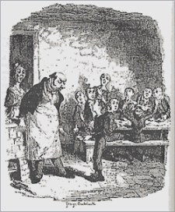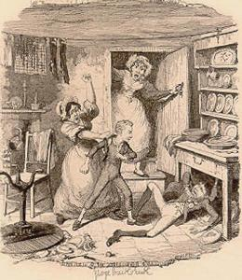
Fig. 7.1 Fig. 7.2
These two plates and the relationship between them have drawn much discussion, and not surprisingly, since they raise fundamental questions about the purpose and value of book illustration, as well as more specific questions about Dickens’s relationship with his illustrator. Let us take the second of those questions first. Dickens does not comment on these two plates in the surviving correspondence between him and Cruikshank, beyond telling his publisher that for the first scene he thought he had “hit on a capital notion for myself, and one which will bring Cruikshank out” (Letters 1: 224). However, Cruikshank did have something to say about their initial collaboration on the story. In a letter to The Times (December 30, 1871) he claimed that he and Dickens had disagreed about the appearance of Oliver:

Mr. Dickens wanted rather a queer kind of chap, and although this was contrary to my original idea, I complied with his request, feeling that it would not be right to dictate too much to the writer of the story, and then appeared “Oliver Asking for More” … I earnestly begged of him to let me make Oliver a nice pretty little boy, and if we so represented him, the public – and particularly the ladies – would be sure to take a greater interest in him, and the work would then be a certain success. Mr. Dickens agreed to that request, and I need not add here that my prophecy was fulfilled: and if any one will take the trouble to look at my representations of “Oliver”, they will see that the appearance of the boy is altered after the first two illustrations. (Kitton 1899: 21)

Cruikshank’s claims here and elsewhere to have originated much of Oliver Twist’s characterization and storyline (see, for example, Patten 1996: 56) remain largely uncorroborated. It is interesting, incidentally, that in that letter to The Times Dickens is reported as envisaging Oliver as “rather a queer kind of chap.” If those were Dickens’s own words, they closely resemble the way he used to talk about his own childhood self, “a very odd little child” (Letters 8: 51), and the “queer small boy” (his former self) encountered in his Uncommercial Traveller essay “Travelling Abroad” – all of which suggests a degree of identification with his hero. However, there is no such description of Oliver in the text. Cruikshank’s account certainly helps to explain the change in Oliver’s appearance evident in the plates shown in figures 7.1 and 7.2, though subsequent portraits of Oliver never quite restore the classical nobility of that third plate (figure 7.2), nor make him conspicuously “pretty.”

Oliver Twist is in some respects an allegory, as Dickens hinted in his 1841 Preface: “I wished to shew, in little Oliver, the principle of Good surviving through every adverse circumstance, and triumphing at last.” In this mode of fiction the illustrator has a license to mark moral change in the language of physical alterations (how else could it be done?), even though such change seems to flout realist consistency. Here is Dickens amused by the sight of some moralistic prints in the window of a bookshop in “Dullborough,” where Goodness and Evil are depicted in the transformation of a Dustman and Sailor from tipsy layabouts to virtuous citizens:

When they were leaning (they were intimate friends) against a post, drunk and reckless, with surpassingly bad hats on, and their hair over their foreheads, they were rather picturesque, and looked as if they might be agreeable men if they would not be beasts. But when they had got over their bad propensities, and when, as a consequence, their heads had swelled alarmingly, their hair had got so curly that it lifted their blown-out cheeks up, their coat-cuffs were so long that they never could do any work, and their eyes were so wide open that they never could do any sleep, they presented a spectacle calculated to plunge a timid nature into the depths of Infamy. (Journalism 4: 146)

This is what has happened to Oliver as his righteous indignation acts like a dose of steroids and he seems to burst out of his meager clothing, his head impressively enlarged and his hair thick with curls. Something of the same process happens to Fagin, but in reverse. The “merry old gentleman” of the first scenes in which he appears becomes “the hideous old man … like some loathsome reptile, engendered in the slime and darkness through which he moved” (ch. 19). The same process happens to Sikes, who looks increasingly simian in the illustrations as the story moves toward its end. The bestialized Fagin is finally represented by Cruikshank in the condemned cell as a scrawny bird of prey, with his claw hands up to his beak nose (figure 7.3). It is a wonderful image, as is the plate of Sikes on the roof, “The Last Chance.” It is worth noting, though, that the bestialization of both villains is counterpointed in the text when the narrator briefly discloses their mental anguish and underlines their humanity in their last days and hours (Fagin at his trial and Sikes in flight tormented by his deed).

These are touches disappointingly beyond the reach of the illustrator, who simply confirms them as caricatured evil, and concentrates on the cruder counterpointing of good and evil as the story reaches its end. Thus the wholly opposite fortunes of the story’s villain and hero are focused in the comparison between the “Condemned Cell” plate and the last plate, “Rose Maylie and Oliver” (figure 7.4). The hunched animal posture of Fagin is contrasted with the upright statuesque young Oliver; and the contrast is paradoxically accentuated by a degree of parallelism in the two designs. The configuration of the two rooms has similarities. In each case, we view a right-hand corner, a high-set window (with harsh cross-barring on the one and delicate diamond lattice on the other), a bench against the wall, an inscription on the right-hand wall (the Sheriff’s order for execution on the one and the memorial to Oliver’s mother on the other). Light from outside falls on the dread notice and rims the dark figure of the condemned man. In the church picture, the light seems to come from inside and bathes Oliver in its glow.
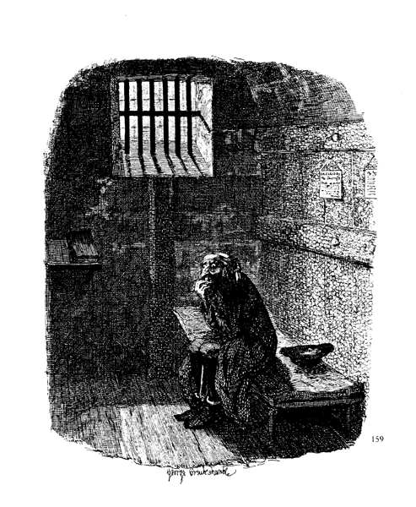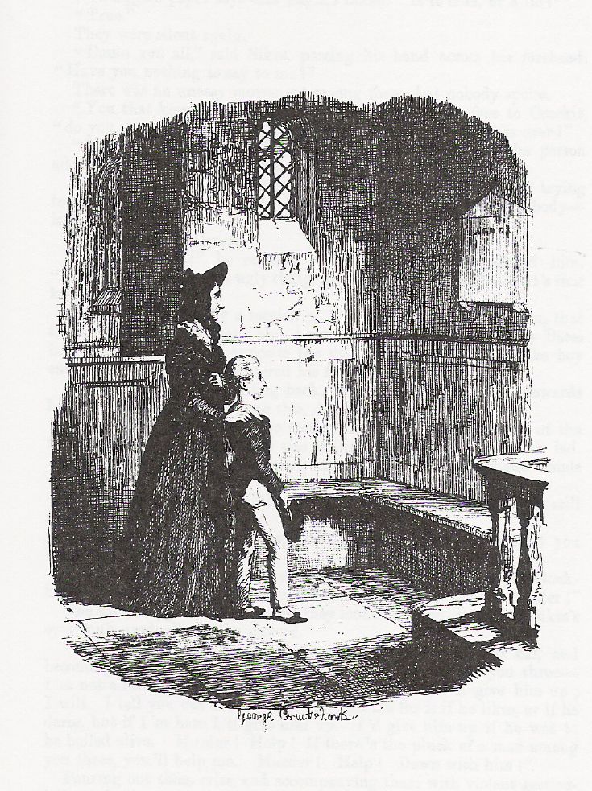
Fig. 7.3 Fig. 7.4
Parallels of this kind occur also near the start of the story, in the two plates “Oliver Asking for More” (figure 7.1) and “Oliver Introduced to the Respectable Old Gentleman [Fagin].” In each one, Oliver is seen standing in supplicant posture before his adult provider. The spoon and plate in his hands in the first are replaced by stick and hat in the second. Immediately behind him in each is a group of boys, all hungry eyes and mouths in the first and all plump-faced and pipe-smoking in the second. The adult providers are contrasted: the workhouse master is fat and outraged, Fagin is shriveled and genial.

This system of structural parallelism and thematic contrast is something that Cruikshank continued to rely on, in, for example, his sequence of prints warning of the evils of drink, The Bottle (1847). Cruikshank drew this scheme of parallels from Hogarth’s Progress pictures. The first, second, and fourth plates of Industry and Idleness (1747), for example, show the Industrious Apprentice on the right, bathing in the approval of his adjacent master or in the pious adoration of his master’s daughter, soon to be his wife. It is as though that corner becomes reserved for Virtue and Beauty and the other side for Vice and Ugliness. This kind of schematic patterning worked well for Cruikshank not only in his own “Progress,” The Bottle, but also for his collaboration with Dickens. Oliver Twist was a kind of Progress novel: indeed, it was subtitled A Parish Boy’s Progress, in allusion to Bunyan’s Pilgrim’s Progress and Hogarth’s Progress sequences. It is no wonder the early collaboration with Cruikshank was so successful. Their artistic relationship was symbiotic, and recognized as such. The Spectator in 1836 acclaimed Boz as “the Cruikshank of writers.”

Hogarth was also highly influential on Dickens in formal terms. His Progress paintings and their wide dissemination as prints provided Dickens with models for constructing a narrative as a sequence of significant scenes, especially in cautionary fables. One early example can be seen in “Meditations in Monmouth Street.” In this sketch, Boz puts an imaginary inhabitant into a second-hand suit of boy’s clothes and fancies he can trace the growth and development of that boy, stage by stage through other sets of second-hand clothes, into a delinquent man and eventually into a hardened criminal. The sequence is strongly visualized as if a succession of scenes were literally being paraded before Boz: “We knew at once, as anybody would, who glanced at that broad-skirted green coat, with the large metal buttons … We saw the bare and miserable room … crowded with his wife and children, pale, hungry and emaciated; the man … staggering to the tap-room” (Sketches by Boz 100–1). The tableauesque format of the narrative, the attention to telling small details, and the over-arching didactic agenda all derive from Hogarth and from Hogarth’s descendants in that graphic tradition. The same technique is detectable in Oliver Twist.

Cruikshank’s illustrations depicted Oliver Twist’s action in shallow spaces, with dramatic chiaroscuro, and to that degree matches Dickens’s theatrical mode in Oliver Twist. Most of the scenes happen in small rooms like low-budget stage sets. The characters, singly or in groups, press forward with urgency and energy. When we turn to Phiz’s illustrations to Pickwick Papers we are, of course, in different country. For one thing, much of what is illustrated is countryside. Spaces open wide, and fade away into the distance. Characters are rather more recessed in the picture space; they have more room to move. They do not bear down on the reader as they do so often in Cruikshank. The wonderfully concentrated, grotesque vitality of Cruikshank is diffused as Phiz finesses scenic details that absorb much of the energy drawn from the characters themselves. Phiz followed a steep learning curve in Pickwick. John Harvey (1970) has demonstrated clearly how, when Phiz had to redraw the early plates for Pickwick (as the originals for the part-issue were too worn to use for the volume edition), he transformed the scenes. The stiff poses of the figures in the originals became relaxed and more diverse and more expressive in attitude. Spatial proportion was better defined, and more fully and more eloquently detailed.

This development of greater anecdotal depth and dramatic energy can be seen in the two versions of the plate “Mrs. Bardell Faints in Mr. Pickwick’s Arms” (a focus for interesting discussions and conflicting evaluations by James Kinsley [1986], John Harvey [1970], and Michael Steig [1978]. In the first version (figure 7.5), the figures are arranged in a frieze, absolutely parallel to the picture plane, as are the open door and the back wall of Mr. Pickwick’s room. The characters lack volume and animation. In fact, they look like little cut-outs for a toy theater, mounted on a single batten and slid in from stage left. The room is fairly featureless. The great blank space of the mirror is surmounted by a picture of dull, sketchy landscape. On top of the bookcase behind the door is a bust of what is probably a philosopher and (according to Steig) a stuffed owl, two shadowy items presumably to signify Mr. Pickwick’s philosophical inclinations.

The revised plate (figure 7.6) dispenses with these and introduces much more commotion in the main scene. A larger Mrs. Bardell collapses more realistically against Pickwick, who braces his leg to receive the weight of his “lovely burden,” only to have it kicked by a bigger and more ebullient Master Bardell. The door is angled out, the better to suggest that it has just been opened, and the tall middle character is caught in mid-stride as he enters. The group of clubmen is broken up: they tilt in different directions to express their astonishment, and the one on the far right breaks the straight ground-line. The recession in the room is better managed, and some pertinent detail is introduced. The blank of the mirror is interrupted by a clock with the figure of Father Time, and the framed picture replaces the empty landscape with a drama depicting Cupid aiming his bow at a languorous woman, as a comic take on the action below. Thus the setting and the human event collaborate more energetically.
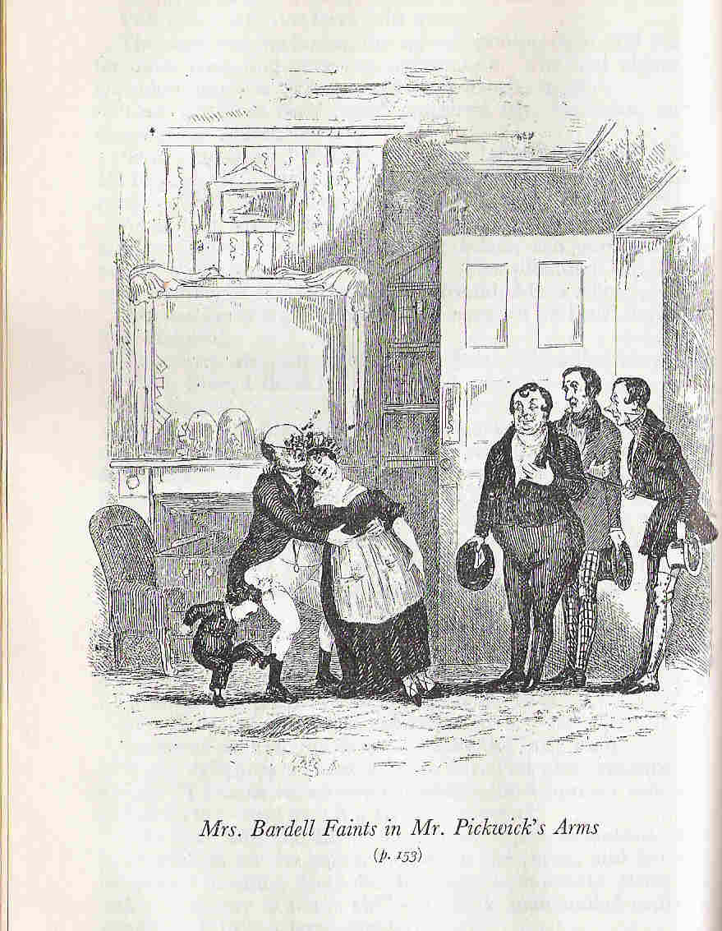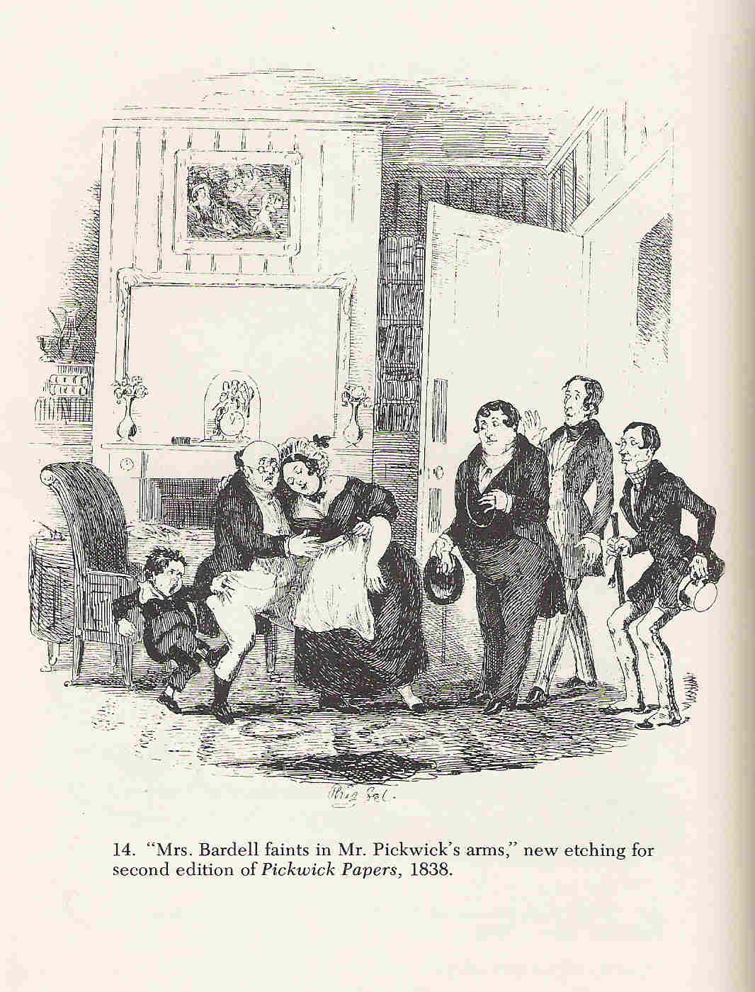
Fig. 7.5 Fig. 7.6
How does it relate to the text at this point? This raises important issues of focus and selection, of the kind well exemplified by Edward Hodnett in his discussion of the famous scene of Don Quixote and the windmills:

The decision to illustrate that passage is only the beginning. There are roughly four moments to choose from in order to illustrate it: (a) Don Quixote and Sancho Panza disagreeing about whether they are looking at giants or windmills at a distance in the mist; (b) Don Quixote with spear leveled riding toward the windmills; (c) the moment of impact; and (d) the moment after. But each of these moments can be subdivided. The fourth choice can show Don Quixote whirled aloft on a sail, deposited on the ground in disarray, or being put back together by Sancho Panza. Then the artist has to decide at what distance the action takes place. (Hodnett 1982: 7–8)

Phiz in the fainting scene, as in so many other illustrations, confronts the same problems. What he designs here looks like the freezing of one particular moment in the narrative, but in fact he has compressed a sequence of incidents into one image: first, the sudden entry into the room of the clubmen and Master Bardell; second, the paralyzed moment when everyone is staring at everyone else; third, Master Bardell’s assault on Mr. Pickwick. The revised plate gives the impression of the clubmen walking in to discover Master Bardell hard at work kicking Mr. Pickwick. The first version, for all its stiffness, is probably the more accurate snapshot of a single moment in the text, the third one described above.

Phiz is now well into his stride. In fact, there had been rapid development in his work in the months following the fainting scene. He was managing boisterous crowds with gusto and skill, especially given the confined picture space in which he had to work. The very next illustration, “The Election at Eatanswill” (figure 7.7), establishes a pattern in the relationship between the stately, would-be detached Pickwick and the unruly world he is commissioned to observe and report on. Robert Patten (1969) has pointed out how, in the illustrations to Part VII, Pickwick is shown relatively isolated from either the community, as in “Mr. Pickwick in the Pound,” where he is fenced off from the jeering villagers, or officialdom, as in “Mr. Pickwick and Sam in the Attorney’s Office,” where the smirking clerks look down on Pickwick, “the supposed trifler with female hearts,” as he waits in humiliation for his appointment with Mr. Fogg. In each case, baffled dignity is thrown into strong relief by the environing riotous or wily populace.

It is the story of the novel itself, and Phiz tunes into it from Eatanswill onward as this motif is enacted in illustrations across the whole book. In the Eatanswill plate (figure 7.7), Pickwick and the civic dignitaries are literally elevated above the mob, and their stiff upright poses, accentuated by their top hats, are counterpointed by the swirling, brawling human chaos below. It looks like a cartoon representation of the British class system. In a later plate, “Mr. Bob Sawyer’s Mode of Travelling” (figure 7.8), Pickwick is boxed in again, inside the carriage, his dignity affronted by his traveling companion’s conspicuously boozy nonchalance, which forms a disreputable spectacle for the coachload they are about to pass (seen above Pickwick’s head) and the Irish family of beggars swarming round the carriage itself, their shapes almost assimilated to the clouds of dust stirred up by the carriage.

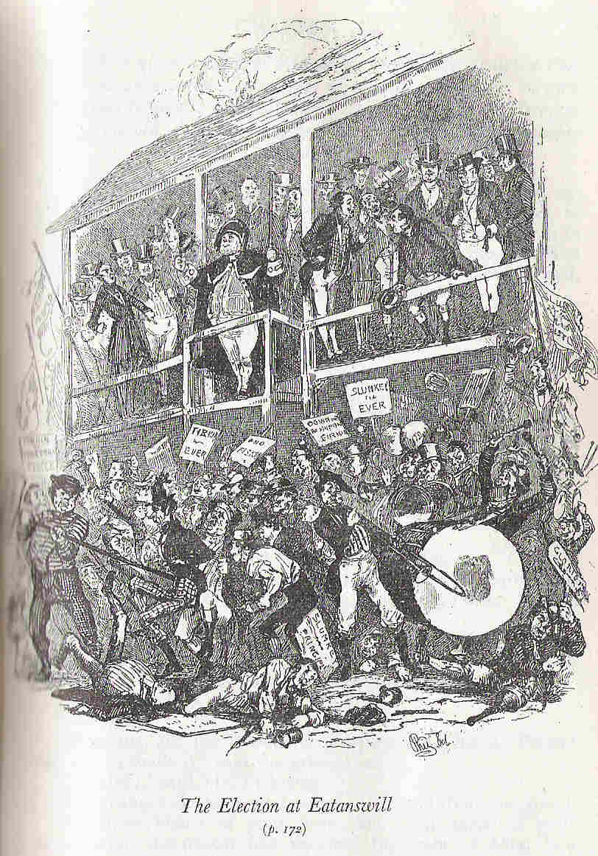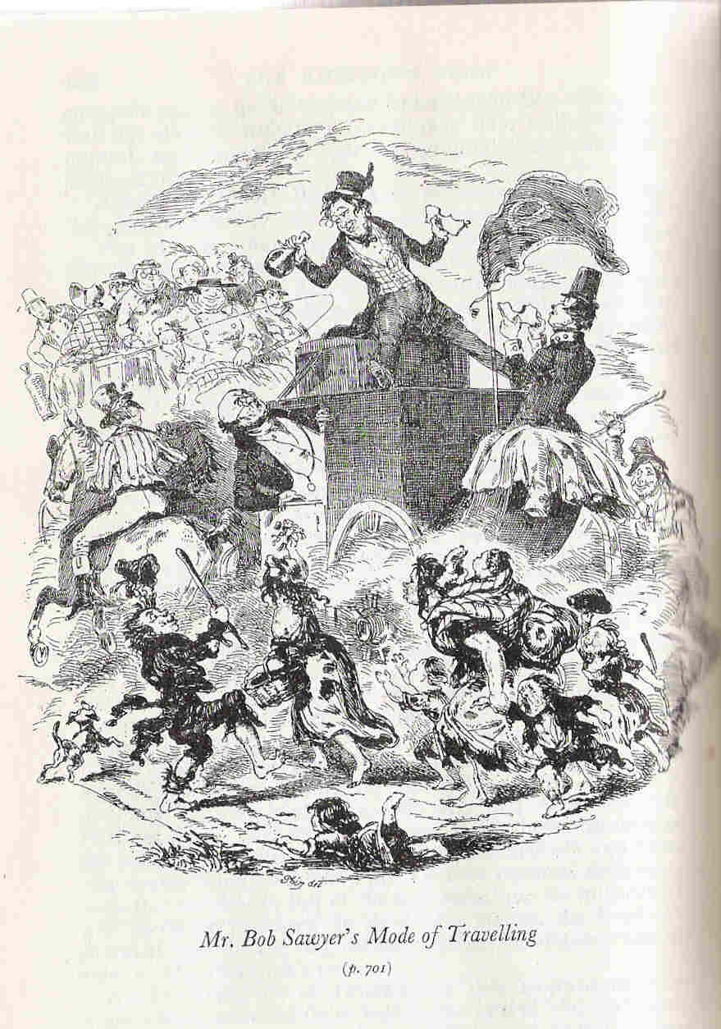
Fig. 7.7 Fig. 7.8

The plate could serve almost as an emblem-picture figuring the novel’s theme. The relationship captured between Pickwick and the crowds gives visual form to Bakhtin’s concept of carnival and the bodily element in grotesque realism, which is “something universal, representing all the people”:

As such it is opposed to severance from the material and bodily roots of the world … [it] is contained not in the biological individual, not in the bourgeois ego, but in the people, a people who are continually growing and renewed … The leading themes of these images of bodily life are fertility, growth, and a brimming-over abundance … The people’s laughter which characterized all the forms of popular realism from immemorial times was linked with the bodily lower stratum. Laughter degrades and materializes. (Bakhtin 1984: 19–20)

This schema is caught by Phiz in plate after plate: the monolithic “bourgeois ego” of Pickwick, standing on his dignity, isolated from and harried by “the people” with their laughter and “brimming-over abundance” of vitality. Once caught, he could repeat the confrontational theme with endless variations throughout Pickwick.

The 1840s saw Phiz developing some of his best work, and joining a group of other illustrators for various new publishing projects by Dickens. Master Humphrey’s Clock (1840–1) had woodcut illustrations incorporated into the pages of text and carried work by George Cattermole, Samuel Williams, and Daniel Maclise. The five Christmas books, beginning with A Christmas Carol (1843), were illustrated by John Leech, Maclise, Richard Doyle, Clarkson Stanfield, Edward Landseer, John Tenniel, and Marcus Stone. Pictures from Italy (1846) had four engravings by Samuel Palmer. But it was Phiz, and Phiz only, who illustrated the twenty-number novels of the 1840s, Martin Chuzzlewit, Dombey and Son, and David Copperfield. Thereafter, he illustrated just three more of the monthly-number novels: Bleak House, Little Dorrit, and A Tale of Two Cities.

The Pickwick plate just discussed (Bob Sawyer traveling, figure 7.8), its functioning both microcosmically as an illustration of a particular moment in the novel and macrocosmically as a kind of allegory of the novel’s master-motif, represents Phiz the book-illustrator at his best. It also prompts questions about the strategic role of book illustration, especially its dual agenda: should illustration be sharply localized or more broadly summative, or some hybrid of the two? The issue arises in interesting ways in Dombey and Son.

In the monthly wrapper design for Dombey and Son (figure 7.9), Phiz was presumably charged with giving a broad outline of the rise and fall of the House of Dombey. In the event, Dickens was pleased: “I think the cover very good: perhaps with a little too much in it, but that is an ungrateful objection” (Letters 4: 620). Phiz has depicted a wheel-of-fortune chronicle, moving clockwise from the dawn of mercantile prosperity up the left side as people scramble toward the throne of Dombey triumphant, with scenes from the firm’s office on the left and on the right Dombey MP and Dombey’s wedding; then we follow down via the fragile house of cards to scenes of shipwreck and crippled old age as Dombey and Daughter are reconciled. This is narrative, promising a lively, developing history of Dombey and his fortunes, a reconfiguration in circular form of the Progress. Dickens referred to Phiz’s wrapper designs as “shadowing out [the story’s] drift and bearing (Letters 4: 648–9), and commended the work as a kind of model for what he called the “general illustration” he required for one of his Christmas books.

Phiz had to come up with his wrapper design before the story was written. But his Frontispiece was done once the novel had finished its run. This time he produced a more concentrated allegorical picture (figure 7.10), and it represents a rather different novel. The wrapper design was predominantly about the public world of Dombey and his business, patriarchy and plutocracy, and linearly mapped. The Frontispiece accentuates the other story, the feminine narrative, curvaceous rhythms, the language of the waves and of Florence’s dissolving in tears, a world teeming with children seeming to pay tribute to the two central children, Paul and Florence. Instead of circling up to images of Dombey’s supreme commercial, material power, this picture rises to heavenly radiance. Avenging angels and demon figures on either side lower over the doomed figures of corruption, Carker and Mrs. Skewton. The wrapper mapped the story that was planned; the frontispiece distilled the story that was written.
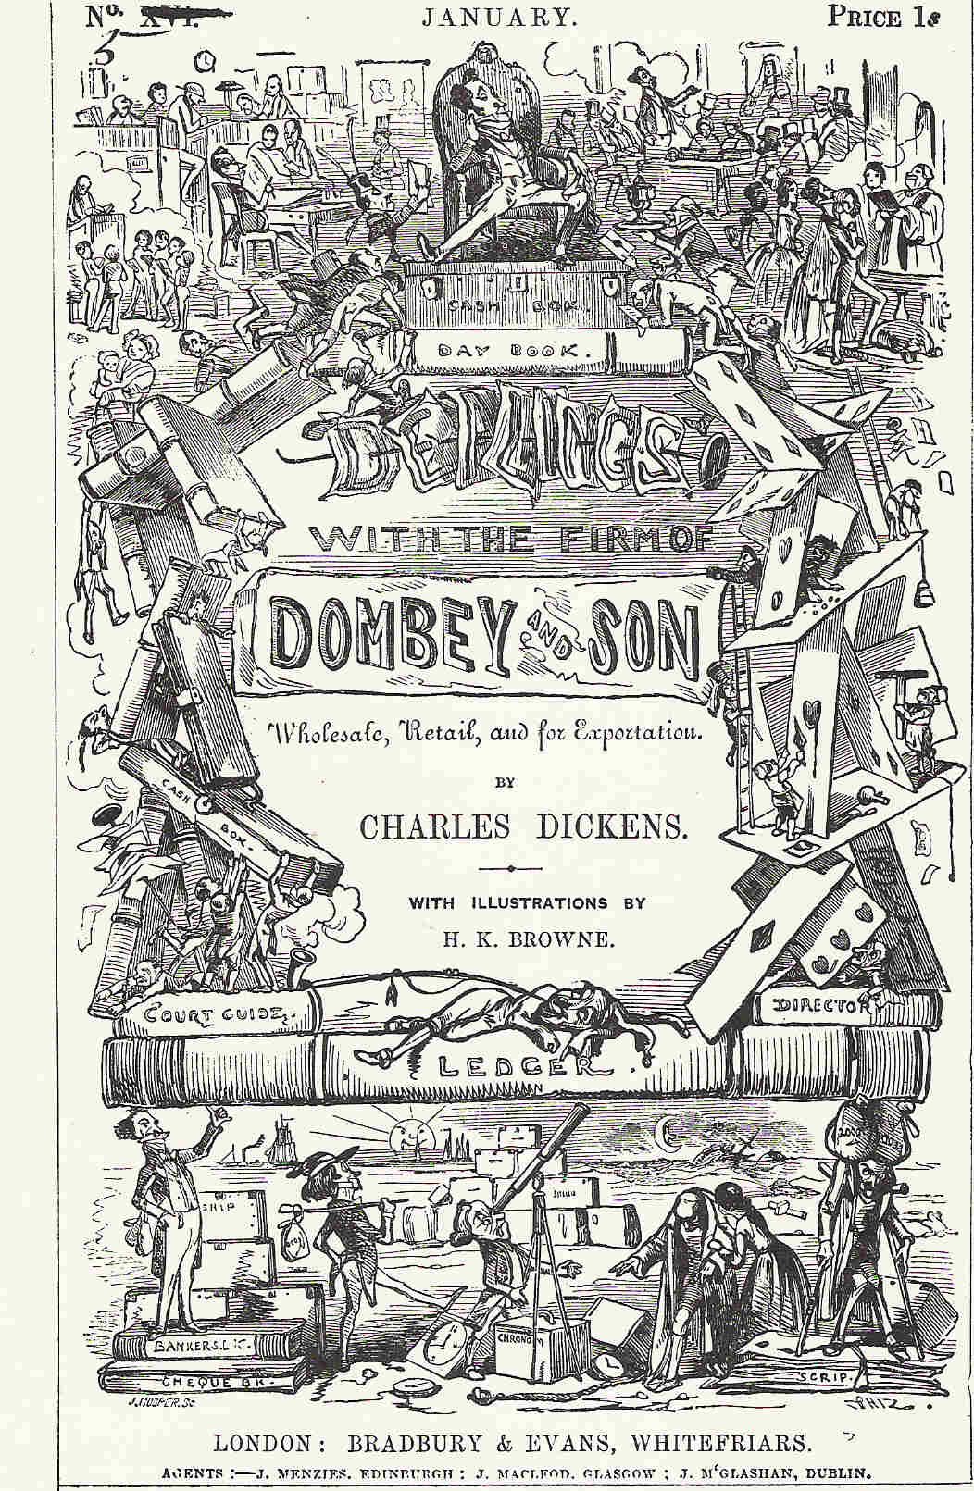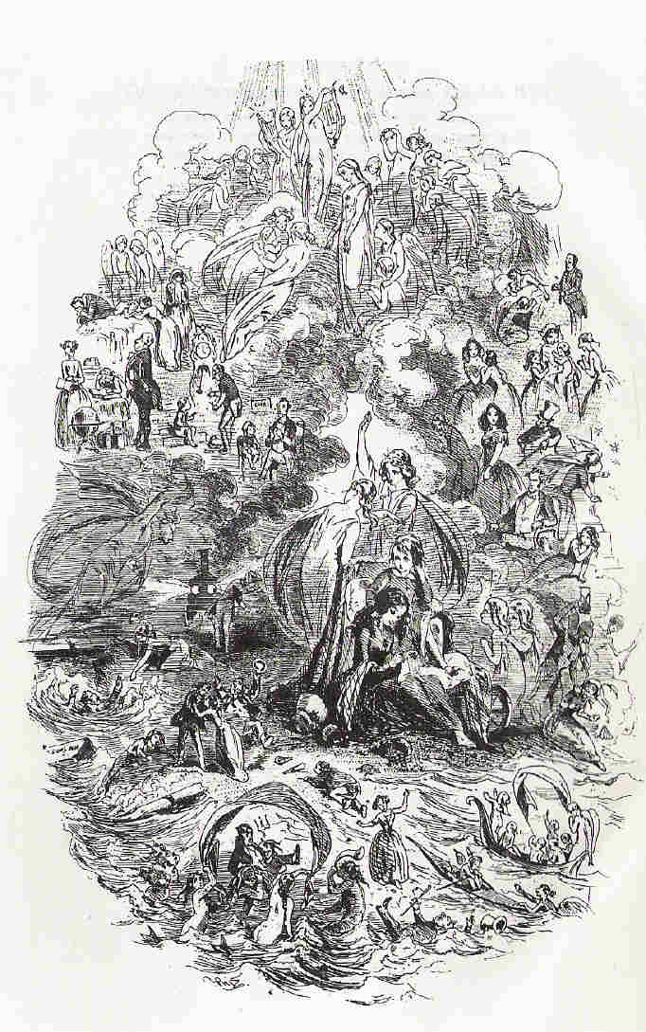
Fig. 7.9 Fig. 7.10

The question presses out at us from these reflections: what is an illustrator supposed to do? Is his (or her) primary job to intervene in the reading experience with a freeze-frame moment in the passing story, a still from the movie? Or should he (or she) try to encapsulate within his (or her) single vignette hints of the larger thematic design to which this brief moment relates? Book illustrations are “Bursts of lateral development in a progressive movement,” as Martin Meisel put it in his excellent discussion of these issues in Realizations (1983: 56). They are browsing pastures, rest areas on the narrative journey. They may have direct service value in relation to the text in, for example, amplifying information or giving sharp visual focus to character, but they can absorb the reader in other ways – and powerfully so. It can take some time to wander around Phiz’s “sets,” whether exterior or interior, absorbing the details and the general ambience. The illusion of the fictional world is reinforced, as the mind’s-eye construction from the text of a scene, a room, a figure, is supplemented by the actual eye’s spectacle of the picture of that room and figure. Illustrations can thus tuck you more tightly and deeply into the world of the novel, and increase the competition for your attention between its own world and the real world.

Testimony to the power of illustration to do just this comes from the recollections of the poet Norman Nicholson. He is recalling his childhood (he was born in 1914) and his early reading of Dickens – in this case Dombey and Son – and was particularly struck by the plate “Paul and Mrs. Pipchin”:

[It] shows old Mrs. Pipchin, in her widow’s weeds, sitting beside little Paul Dombey, and staring into the fire. I had never seen widow’s weeds, of course, but everything else in that illustration, drawn in the 1840s, was as familiar to me eighty years later, as the flags of my own back yard. The little, high, wooden chair, with rails like the rungs of a ladder, is the chair I sat in at meal-times when I was Paul Dombey’s age. The fireplace itself, the bars across the grate, the kettle on the coals, the bellows hanging at the side, the brass shovel on the curb, the mirrored over-mantel, the mat, the table swathed in plush, the aspidistra on the wall-bracket – all these I had seen many times in my own house, or Grandpa Sobey’s, or Grandma Nicholson’s or Uncle Jim’s. On a winter tea-time, before the gas was lit, the fitful firelight populated the room with fantasies as weird as any in Dickens. I would pick up my book sometimes and try to read by the glow of the coals, and the world I entered seemed not far removed from the world I had left. It was no more than walking from one room to another. (Nicholson 1975: 144–5)

This degree of closeness between Dickens’s imaginary world and the real world of the reader has largely passed away. The furnishings that Nicholson describes as part of his life have now passed into museums, where they lie in period-room reconstructions. The pictures, like the old furniture they contain, are similarly period pieces, with a period charm, but Dickens, though very much of his time, has amazingly transcended his period. Dickens in modern dress is not unimaginable; the pictures date him more than he deserves.

Let us return to the tensions between text and illustration. The issue depends a lot on their physical relationship, the positioning of the illustrations, and here Dickens made a number of interesting experiments. The 1840s saw Phiz joining a group of other illustrators for a variety of new publishing projects by Dickens. Master Humphrey’s Clock (1840–1), as already noted, inserted woodcut illustrations into the pages of the text, not as separate plates, and carried work by George Cattermole, Samuel Williams, and Daniel Maclise. The Christmas books tried other combinations and positioning of pictures by various artists. Here are two examples, the sensational page 187 from The Old Curiosity Shop in Master Humphrey’s Clock (figure 7.11) and a page from The Cricket on the Hearth (figure 7.12).
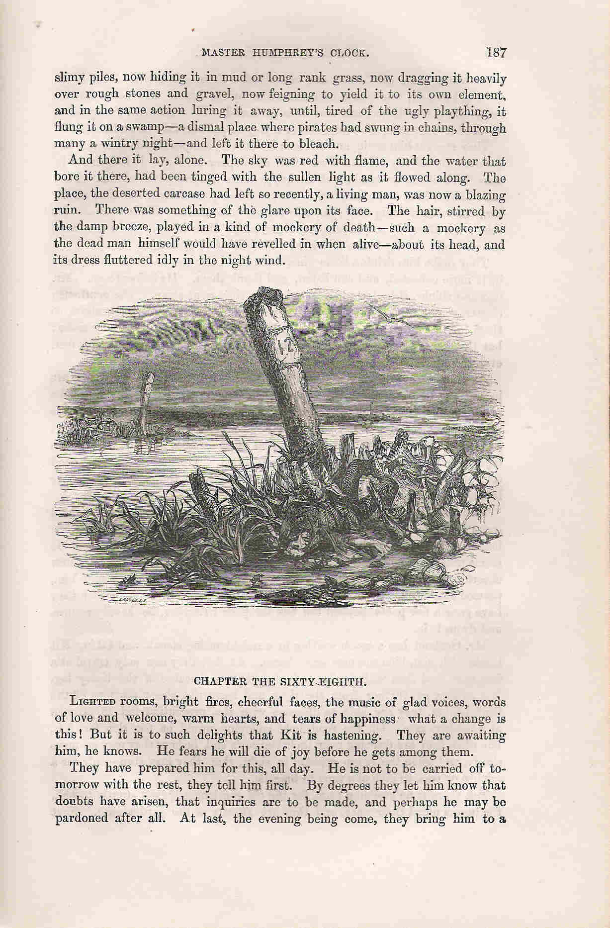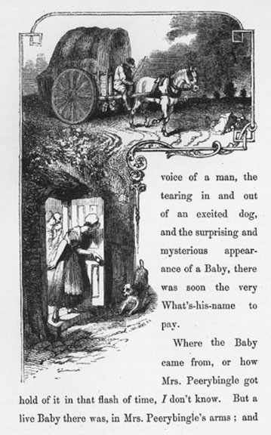
Fig. 7.11 Fig. 7.12

How does the Phiz woodcut work? The picture functions as a dark paragraph in the text, to borrow Martin Meisel’s evocative description (1983: 00), and its positioning precisely here has great impact on the reading experience. It is intimately part of the rhetoric of the novel. The text at the top revels in the lurid details of Quilp’s corpse battered and flung onto a desolate spot out on the Estuary marshes: death, chill, and darkness. The text immediately below the picture pulls us abruptly away to life, warmth, and light with “Lighted rooms, bright fires, cheerful faces, the music of glad voices.” The page as a whole, the composite of text and illustration, spectacularly epitomizes the design of the novel as articulated in chapter 53: “Everything in our lives, whether of good or evil, affects us most by contrast.”

Sometimes, then, as in this instance, the text sandwiches a vignette. At other times, the picture coils itself around the text, as in Stanfield’s wood engraving for The Cricket on the Hearth. The words here are subordinated to the picture, assuming the status of a straggling narrative caption. Both these combinations of text and picture are intimate alliances, and are helped to be so not only because of their positioning but also because of their format. The Quilp woodcut is a vignette. The Cricket engraving is part-vignette and part-framed: it is decoratively bordered off at the top but not below; Dot Peerybingle opens her door to a dog and the unscrolling text. The vignette’s porous borders, and its being composed of black marks on a white page, give it a kind of organic affinity with printed text. The reader’s movement from text to picture has no barrier to cross, such as might be constituted by a frame or by color-printing or by some other feature that would more clearly territorialize the difference between the image and the text.

The usual format for the novels was a ration of two plates for each monthly number. The editions of Dickens that we read today usually aim to position the illustrations close to the text they illustrate, as happened when the novels finished their monthly run and were published in volume form. However, the illustrations for the monthly numbers were separated from the text and stood between the advertisements and the opening chapter of that number, rather like frontispieces. So when one says that Dickens’s novels were illustrated, it can give a slightly misleading impression as far as the original publication was concerned. The illustrations were there, but they did not intercept the reading process, as illustrations customarily do: rather they could be referred to, as one might refer to an endnote for fuller elaboration of something in the text, and that would entail a voluntary interruption of the reading experience.

These may seem finicky discriminations, but consider some of the implications from one particular example of interruption, Phiz’s famous dark plate, “Tom-all-Alone’s,” for Bleak House Number 14. In the first single-volume edition of the novel, the illustration stood as the recto facing a page with the last few paragraphs of chapter 45 and the opening paragraph of chapter 46 (figure 7.13). Chapter 45 is Esther’s narrative. She comes to the alarming realization that Richard is ill and, while waiting for the coach to take her away, asks Woodcourt if he could help Richard sometimes with his companionship while he is in London. Woodcourt agrees to do so, with a warmth that says more about his feelings for Esther than for Richard; and as Esther is driven away she struggles with her own feelings for Woodcourt. The illustration, as one turned over to this page of the text, would have been a spectacular distraction, bearing no relationship to this part of the story, tugging attention away from the narrative and yet seeming to bear down upon it.
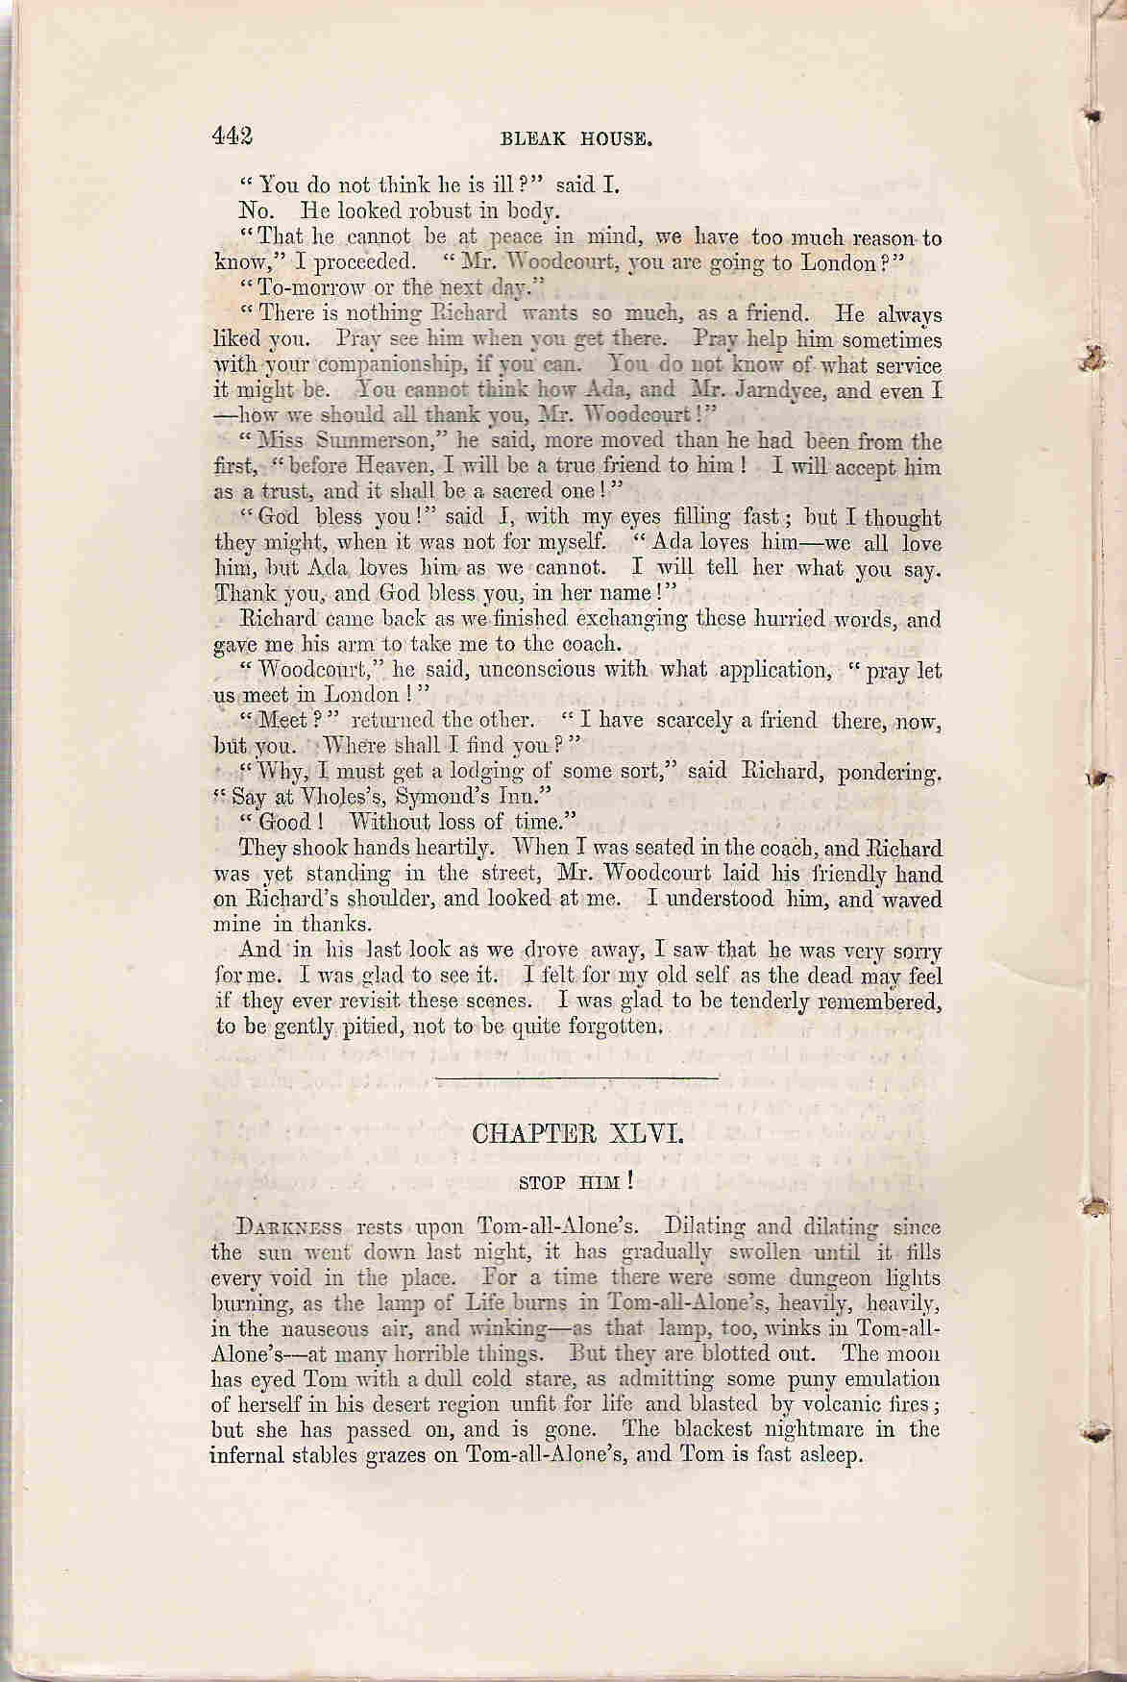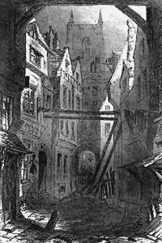

Fig. 7.13

This kind of inappropriate intrusiveness is one problem involved in integrated illustration. But I want to stay with this example in order to identify another, more serious problem to do with the appropriateness or otherwise of illustrations to Dickens. The start of chapter 46 immediately engages the plate, with its brooding evocation of Tom-all-Alone’s by night:

Darkness rests upon Tom-all-Alone’s. Dilating and dilating since the sun went down last night, it has gradually swelled until it fills every void in the place. For a time there were some dungeon lights burning, as the lamp of Life burns in Tom-all-Alone’s, heavily, heavily, in the nauseous air, and winking – as that lamp, too, winks in Tom-all-Alone’s – at many horrible things. But they are blotted out. The moon has eyed Tom with a dull cold stare, as admitting some puny emulation of herself in his desert region unfit for life and blasted by volcanic fires; but she has passed on, and is gone. The blackest nightmare in the infernal stables grazes on Tom-all-Alone’s, and Tom is fast asleep.

This is powerful writing, agile and muscular in its descriptive movement, sonorous in tone, edging into surrealism, heaving with animism. The darkness, like the fog at the novel’s opening, becomes an almost palpable agent, “dilating,” “swelling”; light burns “heavily” and winks at the horrors of this god-forsaken slum. The moon, personified, takes a casual, passing interest in the place, like everyone else. How is all this embodied or implied in Phiz’s image? Clearly, it can’t be. The sinister life of natural forces at work in night-time Tom-all-Alone’s is not there at all. This is a carefully drawn slum court, with rickety houses on crutches, heaps of garbage, derelict businesses, the graveyard at the end. Just above the foreground porches on each side are the mirror-flaps leaning out at 45-degree angles, straining pathetically to catch any light from the sky and reflect it back through the windows into the houses. Everything is observed with care, and designed to illustrate the miserable condition of this quarter. And it worked, certainly for some: “What a sermon that little drawing preaches,” remarked Beatrix Potter of this plate (Cohen 1980: 110). But compared with Dickens’s description, it is lifeless.

We accept that he and Phiz are working in different media, that Phiz has all the problems facing any adapter of Dickens (and illustrations are a form of adaptation, just as stage or movie versions), but here Phiz simply doesn’t belong to the same idiom in which Dickens is working. This opening description is preparing for the statement two paragraphs further on of the great theme of the book: “[Tom] has his revenge … not a drop of Tom’s corrupted blood but propagates infection and contagion somewhere. It shall pollute … the choice stream … of a Norman house … not an atom of Tom’s slime … but shall work its retribution, through every order of society, up to … the highest of the high” (ch. 46). Just like the creeping, drooping, pinching fog, so the “dilating” darkness, the “heavily” burning light, Tom’s blood and slime, all take on a malignant life, they become the virulent agents of revenge on those who have forsaken their responsibilities.

This kind of thing cannot be adequately illustrated, and yet it is one of the principal modes in which Dickens is now working: it is what is distinctively powerful about his writing in Bleak House. Was there any longer any point in illustrating only those elements that lent themselves to illustration of the kind in which Phiz specialized, such as the lively plate of Richard and Vholes, showing Richard haggard with exasperation and the office littered with supportive allegorical detail? The question is not new, of course, and most verdicts have gone against Phiz in his work for Dickens from Bleak House onward.

Not every novel in those last two decades of Dickens’s life was illustrated in its original publishing format. Those run initially only in weekly installments in Dickens’s journals, Hard Times and Great Expectations, had no pictures, either in their original serial form or in their first volume editions. Does anyone seriously regret the lack of illustration in these books? If not, what does that say about the value of illustration in his other books? Dickens’s choice of Marcus Stone and Luke Fildes to illustrate his last two novels was a reflection of his realization that the Cruikshank–Phiz idiom was out of fashion and that their mode of caricature was inappropriate to his fiction of the 1860s. He was in favor of a more naturalistic, low-key style. This is clear from his comments in 1867 on Sol Eytinge’s illustrations to the American edition of Our Mutual Friend: “They are remarkable for a most agreeable absence of exaggeration … and a general modesty and propriety which I greatly like” (Letters 11: 349). The reaction against the caricature style of Phiz and Cruikshank in the 1860s is reflected in Dickens’s own histrionic illustrations of his characters as performed in his Public Readings. These surprised many who had come to view Dickens as an inveterate caricaturist:

The great value of Dickens’s readings was the proof they afforded that his leading characters were not caricatures. His illustrators, especially Cruikshank, made them often appear to be caricatures, by exaggerating their external oddities of feature or eccentricities of costume, rather than by seeking to represent their internal life; and the reader became accustomed to turn to the rough picture of the person as though the author’s deep humorous conception of the character was embodied in the artist’s hasty and superficial sketch … – when [the audience] saw him visibly transform himself into Scrooge or Squeers … [these] characters then seemed, not only all alive, but full of individual life; and, however odd, eccentric, unpleasing, or strange, they always appeared to be natural, always appeared to be personal natures rooted in human nature. (Whipple 1912: 2. 328–9)

So Dickens himself unwittingly (perhaps deliberately?) contributes to the discrediting of his illustrators.

Harry Furniss, himself one of the most elegant and witty book illustrators, remarked that “When we mentally recall Boz’s characters it is through Phiz’s etchings that we see them” (Cordery 2005: 54), a view similar to R. H. Horne’s observation 60 years earlier: “That Mr. Dickens often caricatures, has been said by many people; but if they examined their own minds they would be very likely to find that this opinion chiefly originated, and was supported by certain undoubted caricatures among the illustrations” (Horne 1844: 96). Dickens in his Readings could begin to repair the damage done to him by his illustrators, and on the platform he proved to be a more resourceful and subtler illustrator than any of them.

Even the best of Dickens’s artists reduced his art. They distilled it to caricature and tableau; they developed a greater density of allegorical detail as an attempt to match the fullness, richness, and vitality of Dickens’s scenes, but still fell short; and they made his human beings into small toy figures. Furniss thought that “Dickens’s pen was worth a thousand pencils, and if ever a writer could dispense with an artist to illustrate his works, that author was Charles Dickens” (Cordery 2005: 54). That is something that each reader of Dickens will decide for himself or herself. Of course, it is difficult to think of Dickens’s books and characters without many of those drawings. They have the effect not only of reinforcing the caricature mode but more generally of preserving Dickens in a particular period. For some that is part of their – and Dickens’s – charm; for others, Dickens under a bell-jar is a melancholy spectacle. “I cannot help thinking,” said Furniss, knowing he was risking heresy, “that it would have been better for Boz today, had Phiz never existed” (Cordery 2005: 54). We see Dickens better without the illustrations.

References and Further Reading
Bakhtin, M. M. (1984). Rabelais and his World. (H. Iswolsky, Trans.). Bloomington, IN: Indiana University Press.
Brontë, Charlotte (1852). Letter to George Smith. In Jeremy Tambling (Ed.), Bleak House: New Casebook (p. 4). Houndmills: Macmillan, 1998.
Cohen, Jane Rabb (1980). Charles Dickens and his Original Illustrators. Columbus, OH: Ohio State University Press.
Cordery, Gareth (2005). An Edwardian’s View of Dickens and his Illustrators: Harry Furniss’s “A Sketch of Boz.” Greensboro, North Carolina: ELT Press.
Dickens, Charles (1840). Master Humphrey’s Clock, vol. 1. London: Chapman and Hall.
— (1853). Bleak House. London: Chapman and Hall.
— (1995). Sketches by Boz. (Dennis Walder, Ed.). Harmondsworth: Penguin.
Harvey, John (1970). Victorian Novelists and their Illustrators. London: Sidgwick and Jackson.
Hodnett, Edward (1982). Image and Text: Studies in the Illustration of English Literature. Aldershot: Scolar Press.
Horne, R. H. (1844). Charles Dickens. In Michael Hollington (Ed.), Charles Dickens: Critical Assessments, vol. 1 (pp. 94–101). Mountfield, East Sussex: Helm Information, 1995.
Kinsley, James (1986). Ed. The Pickwick Papers. Oxford: Clarendon Press.
Kitton, F. G. (1899). Dickens and his Illustrators. London: George Redway.
Lister, T. H. (1838). [Review of Dickens’s early works]. Edinburgh Review, 68, 75–97.
Meisel, Martin (1983). Realizations: Narrative, Pictorial, and Theatrical Arts in Nineteenth-century England. Princeton, NJ: Princeton University Press.
Nicholson, Norman (1975). Wednesday Early Closing. London: Faber and Faber.
Patten, Robert L. (1969). Boz, Phiz, and Pickwick in the Pound. ELH 36, 575–91.
— (1992). George Cruikshank’s Life, Times, and Art, vol. 1. London: Lutterworth Press.
— (1996). George Cruikshank’s Life, Times, and Art. Vol 2. London: Lutterworth Press.
Smith, Sydney (1837) Letter of September 1837. In Philip Collins (Ed.), Charles Dickens: The Critical Heritage (p. 5). London: Routledge, 1971.
Steig, Michael (1978). Dickens and Phiz. Bloomington, IN: Indiana
University Press.
Thackeray, W. M. (1840). Going to see a man hanged. In Philip Collins (Ed.), Charles Dickens: The Critical Heritage (pp. 45–6). London: Routledge, 1971.
Whipple, Edwin P. (1912). Charles Dickens: The Man and his Work, 2 vols. Boston: Houghton Mifflin.

Captions
Figure 7.1 G. Cruikshank, “Oliver Asking for More.”
Figure 7.2 G. Cruikshank, “Oliver Plucks up a Spirit.”
Figure 7.3 G. Cruikshank, “Fagin in the Condemned Cell.”
Figure 7.4 ”Rose Maylie and Oliver.”
Figure 7.5 First etching of “Mrs. Bardell Faints in Mr. Pickwick’s Arms.”
Figure 7.6 New etching of “Mrs. Bardell Faints in Mr. Pickwick’s Arms” for the second edition of Pickwick Papers.
Figure 7.7 Phiz, “The Election at Eatanswill.”
Figure 7.8 Phiz, “Mr. Bob Sawyer’s Mode of Travelling.”
Figure 7.9 Phiz, Monthly wrapper for Dombey and Son.
Figure 7.10 Phiz, Frontispiece to Dombey and Son.
Figure 7.11 Phiz, “Death of Quilp.”
Figure 7.12 Stanfield, The Cricket on the Hearth.
Figure 7.13 Phiz, “Tom-all-Alone’s.”

