Enhancing information retrieval and resource discovery from data using the Semantic Web
Anna Jordanous
School of Computing
University of Kent
Medway, Kent, UK
a.k.jordanous (at) kent.ac.uk

Abstract—Data are everywhere. Often the sheer quantities of data that we store or archive in repositories or digital libraries make it difficult to navigate data; information in the data is obscured, particularly where we have Big Data. Traditionally, we record metadata on our data items to assist data classification and some information retrieval. The Semantic Web enables us to further unlock and enrich our data, by exploring how different data are related or connected. Using ontologies and Linked Data we can declare, navigate and discover semantic relationships. Relationships exist both locally, within the data, and globally, such that we can enhance our data with information retrieved from a wider context. To illustrate how the application of Semantic Web technologies aids data discovery and information retrieval, I discuss two case studies: (1) Sharing Ancient Wisdoms (SAWS), a Dynamic Library of information on selected ancient wisdom literature; and (2) the DEFRA DTC archive, a repository of data about freshwater quality in the UK.
Keywords—data repositories; digital libraries; information retrieval and discovery; semantic web; linked data; ontologies

Introduction
Data repositories and digital libraries are a useful tool in library and information science, helping us to store and archive data for later retrieval. Technically, digital tools make it reasonably simple to access and retrieve the data from these data stores; however an issue in digital information management arises: how do we retrieve information from data stores?
The Sharing Ancient Wisdoms project was funded by a grant from HERA (Humanities in the European Research Area) under the “Cultural Dynamics: Inheritance and Identity” theme. The DEFRA DTC Archive project is funded through a grant from the UK Government’s Department for Environment, Food and Rural Affairs (DEFRA).
Information, or data in context, is not necessarily stored within data repositories. Digital data stores employ some limited mechanisms with which to store data about data, i.e. metadata. Much information comes not from data items themselves but in how data items relate to each other and how data items within a dataset relate to external resources.
The Semantic Web has emerged as a useful way in which to record, disambiguate and discover relational information inherent within data repositories. Here we investigate how Semantic Web ontologies and Linked Data can enhance data repositories. We consider examples of ontologies that may be useful in digital information management and examine two case studies where Semantic Web technologies are successfully being employed to enhance information retrieval and resource discovery from digital data stores.

BackGround
This paper addresses the issue of how to retrieve information from data repositories and digital archives. Data and information are distinct (but highly related) entities. Data are the raw facts or details, without any context, such as a list of numbers or text. Once you process, analyse or interpret data, it becomes information. In other words, information is data that has been interpreted within a particular context. As the author Daniel Keys Moran says [1], “You can have data without information, but you cannot have information without data”. What this means for digital archive management is that although we can store data in repositories, extra thought is required to make sure that we preserve the information inherent in data. It is this information that makes our data valuable to us, as the information provides the meaning behind the data.
Traditionally, digital data stores employ metadata. Metadata are data about data; descriptors, standards and schemas which govern how the data is stored and classified. Metadata provide some context to individual data items and datasets, so can often be helpful for making data more informative, by classifying and organising data into coherent meaningful groupings. Often, though, we wish to record more about data than traditional metadata annotations. Significant information comes from how data within datasets are linked together, and how they relate to each other. Further informative context comes from how the meanings of such links are defined. The Semantic Web provides us with tools and technologies to record exactly this type of information, complementing existing metadata.

Semantic Web, Ontologies, Linked Data
The Semantic Web is useful for our purposes in retrieving information from data repositories, being a framework within which to navigate data through meaningful links.
The Semantic Web is “[t]he Web of data with meaning in the sense that a computer program can learn enough about what the data means to process it” [2]. Like the traditional concept of the World Wide Web, the Semantic Web consists of resources, which we can traverse between using links. Unlike the traditional World Wide Web, the resources on the Semantic Web are data, not documents, and the resources are connected by shared semantics rather than HTML references. If two data items are about the same entity, we can record the link between each individual data item to the shared entity. In doing so, we allow others to navigate from the shared entity to discover the two related data items, even if they were not aware of them prior to this.
For example, if we have two books about William Shakespeare, we can record RDF statements for each book: individual Subject-Predicate-Object (SPO) triples, relating the book to the entity William Shakespeare:
Subject: <myLibrary:book1>
Predicate: <frbr:P129_is_about>
Object: <dbpedia:William_Shakespeare>
Example RDF statement:
<myLibrary:book1>
<frbr:P129_is_about>
<dbpedia:William_Shakespeare>

Note that we are using a Unique Resource Identifier (URI) for each term. In particular, we are using a URI from dbpedia.org [3] to link our internal data to external data, creating Linked Data (Semantic Web Data that contains links to external data sources as well as internal links). Now, if people want to discover resources about William Shakespeare, they can use information discovery tools such as Sindice [4] to navigate the Semantic Web and therefore discover the two books we have declared to be about William Shakespeare. Additionally, if we had used a different URI for William Shakespeare, then services such as sameAs.org [5] can help to resolve multiple URIs for the same resource.
The predicate of our SPO triple above is “frbr:P129_is_about”. What this means is that we are using terms from an ontology: a vocabulary that is defined in a machine readable way. In this case, we are using an ontology that documents Functional Requirements for Bibliographic Records: FRBR-oo [6]. The term ‘is_about’ is being used as defined in the FRBR-oo Model to indicate that a ‘FRBR-oo_information_object’ ‘is_about’ a ‘FRBR-oo-entity’. Hence it is further possible to infer that myLibrary:book1 is an Information Object (as defined by FRBR-oo) and that William Shakespeare is an entity. Further information about each resource can then be inferred with this additional information.
The use of ontologies is crucial for maintaining the semantics of the Semantic Web. Ontologies enable us to use defined vocabularies across multiple data stores, expressing links between resources in a standardised and meaningful manner which can be navigated by machines for information discovery from data. It is often the case that terms from multiple ontologies are used within an individual data set, or that an ontology may be extended slightly to include vocabulary specific to that data. This practice recognises that one ontology may not cover all the vocabulary needed for a use-case in digital information management. For purposes within Library and Information Sciences, several ontologies may be useful alongside FRBR-oo. Here, I list a selection:
- The CIDOC Conceptual Reference Model (CRM) is an ISO standard (ISO 21127) for information published on cultural heritage, such as by archives, museums or libraries [7].
- An extension of the CIDOC-CRM, CRM_{dig} [8], has been proposed for documenting digital objects, making significant enhancements to CIDOC-CRM for recording SPO triples on data about digital documents.
- SKOS [9] is used to represent the hierarchical structure and organisation of information within the content of a resource.
- To exemplify that traditional metadata and Semantic Web are complementary rather than separate, Dublin Core Metadata [10] is often used as a vocabulary for describing information about a resource’s content.
This paper’s thesis is that using the Semantic Web can enhance information retrieval and resource discovery from data repositories and digital libraries. Below, two case studies are presented which incorporate Semantic Web techniques into data repositories. Each case study involves users who wish to retrieve known, and discover unknown, information from datasets. The first use case we examine is the Sharing Ancient Wisdoms (SAWS) Dynamic Library, containing data and information relevant to mediaeval wisdom literature. The second use case is the DEFRA DTC Archive of information pertaining to freshwater quality data in the United Kingdom, which also employs a mix of traditional metadata and Semantic Web relations to allow users to navigate the data in the archive. For each case study, the use of relevant ontologies and linked data is examined, to investigate ways in which the Semantic Web has enhanced information discovery and retrieval.

Case Study: The Sharing Ancient Wisdoms (SAWS) Dynamic Library
The Sharing Ancient Wisdoms (SAWS) has developed a Dynamic Library [11] containing many collections of ancient wise sayings, theological texts and philosophical maxims. For centuries, such collections were originally collated and transmitted through spoken traditions and manuscripts copied by hand. Such collections of ideas and opinions, ranging from pithy sayings to short passages from longer philosophical texts, are traditionally described as Wisdom Literature. Such collections became an important conduit for exchange of ideas between cultures, and a swifter route to new knowledge than complete texts. Collections were frequently translated and disseminated throughout Europe and the Middle East.
The gathering of excerpts involved exercise of judgement and selection and thus are of interest because they provide insights into what the priorities were in a given field at the time, whether the writer was collecting maxims, laws, or opinions. Consequently, there is much scholarly interest in the changes between collections and the relationships between different versions of a collection, by different compilers.
The advent of printing moved focus from collections to a complete text. SAWS’s collections became particularly difficult to publish in print, because the emphasis was on reproduction of an archetype text rather than compilation of a unique collection that improved upon previous versions. With multiple versions of each collection existing, there was much dispute over what the authoritative version of the collection should be (or if there should even be a single authoritative version). When collections were published as printed editions, the editor faced serious difficulties. It became necessary to associate each item in the collection with lengthy commentary and discussion, often in long footnotes which disrupted the reading flow and took up much space on the page.
Digital publication and the Semantic Web offer new ways of tackling the problems that arise in printed publications. Essentially these texts are dynamic, changing over time, and online publication is far better suited to publishing editions of these texts than the static medium of print. The aim of the SAWS project was to explore and develop the potential of online publication, taking a novel approach to understanding the relationships between texts through using contemporary developments in these technologies.
The Dynamic Library contains collections in Greek, Arabic (which is closely related to the Greek), and Spanish texts translated from the Arabic. Also included is an 11th century advisory text that draws on wisdom literature, published with commentary and several full translations. Each collection is transcribed fully or partially and is stored as data in TEI XML [12], an XML language for encoding text.
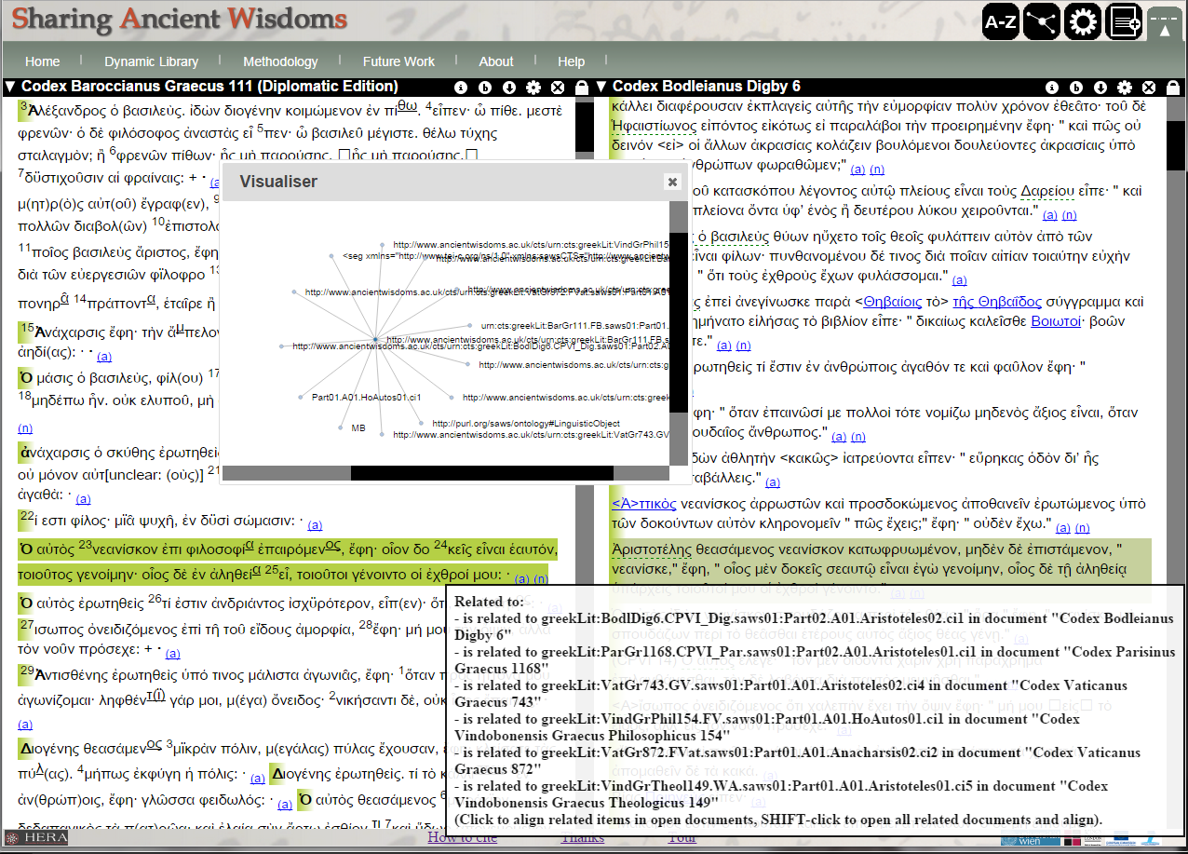
Figure 1: The Folioscope viewer for the Sharing Ancient Wisdoms (SAWS) Dynamic Library, revealing relationships and links between textual data.
All this material was published in the Dynamic Library on the project website, with the option of exploring them in conventional format beside their translation into the user’s language with the help of various aids produced by the project. The Dynamic Library also presents a more innovative explorative route through the material through comparative display of links to related texts and visualisations of textual relationships. Here the project engaged with the Semantic Web, taking advantage of the overlapping common focus on relationships within this scholarly manuscript study and within Semantic Web frameworks. The Folioscope window (see Figure 1) provides a typical route for users into these relationship-based explorations.
An important step was to agree a vocabulary of statements that can be made about the relationships between any two manuscripts, or any two sections of text. Within collaborations with interested scholars, SAWS constructed, defined and published a Semantic Web ontology [13]. Here SAWS followed good practice in terms of reuse of existing materials wherever possible, to avoid inconsistencies in terms used, misunderstanding of terms’ meanings, or duplication of effort. The SAWS ontology extended the FRBR-oo model to cater for manuscripts containing collections of sayings.
To discover and publish information about the collections, the project built on established Semantic Web standards and current research. Data preparation, publication and exploratory visualisations were based around the data in the TEI XML transcriptions of the selected collections. Some RDF statements (SPO triples) could be extracted directly from the TEI markup, such as structural markup. To add informative context about the textual relationships, the TEI markup was enriched with <relation> elements which used the ontology vocabulary to mark the type of relationships present in the texts (these relationships were also extracted as RDF XML statements using XSLT). For example, most place names mentioned in the texts are linked (as Linked Data) to online gazetteers using resources from the Pelagios project [14], which provides structures and formats for recording geographical information about the ancient world. Similarly, where possible, parts of the texts that mention people have been linked to online resources about these people. Also, several excerpts from the SAWS texts were linked to online editions of related texts in other digital libraries such as the Perseus digital library [15], directing the reader to the related texts and providing information about the context in which these texts are related.
This project achieved significant scholarly results, providing a valuable resource for researchers in wisdom literature. But the project team acknowledges that: “[i]n many ways this project was most important for the tools, methods and knowledge that it created for further application and exploration. [SAWS] … hopes to empower colleagues to publish further collection texts, not only gnomologia [collections of wise sayings], but also other kinds of material, such as medical or legal collections” [16]. The specific tools and technologies produced within the SAWS project, particularly the ontology, are published alongside the Dynamic Library content with documentation on how to use them. In this rapidly developing world, these specific tools may become obsolete now that the SAWS project has been completed, as technologies and frameworks rapidly progress. Nonetheless, the principles and methodologies which SAWS has put into place are instrumental in showing how Semantic Web technologies can make digital library collections more informative and how they can assist the user in discovering related information.

Case Study: The DEFRA DTC Archive
The DEFRA Demonstration Test Catchment (DTC) Archive [17] is an ongoing joint project of the UK Freshwater Biological Association and the Centre for e-Research at King’s College London. Supported by the UK Department for Environment, Food and Rural Affairs (DEFRA), the project is building a substantial digital archive of water quality and pollution data captured by catchments (the liminal areas surrounding rivers). The purpose of the archive is to assist scientists in constructing novel solutions to the problem of diffuse pollution, through gaining information from various fresh perspectives on the data and its metadata.
The DEFRA DTC archive is constructed as a Fedora repository with an Islandora [18] front-end as its user interface. Islandora consists of various solution packs: Drupal modules for repository management. All interactions with the data repository contents are handled by Islandora solution packs. As well as the existing Islandora solution packs, the DEFRA DTC Archive team have developed a number of customised solution packs to customize the generic archival facilities to best suit the requirements of environmental scientists. Models have also been defined to assist in standardising data from multiple sources, rendering it interoperable such that diverse user groups can interact with and explore across all the data.
Similarly to the first case study, controlled vocabularies (ontologies) have been constructed for the archive. Most prominently, the ontology of standard terms for data entry and their interrelations/hierarchy [19] (exemplified in Figure 2) extends the AGROVOC agricultural vocabulary [20]. Controlled vocabularies give data interoperability at the semantic level, providing a common language for the integration of data from diverse sources. The vocabularies have now been completed and fully implemented as a solution pack. Correspondingly, a user interface has been constructed to assist the user in locating the optimum vocabulary item when entering data, taking advantage of the Mulgara RDF triplestore (a data store for RDF statements) and Semantic Web tools that are incorporated within Fedora.
Innovative use has been made of the Semantic Web, particularly queries on RDF data (using the SPARQL query language for Semantic Web data). Developing an existing autocomplete module, a new sub-module Object Linker [21] has recently been developed by the Archive team. This module incorporates some ontology-processing functionality contained in the stand-alone Relationship Editor Module [22]. Object Linker allows SPARQL queries to control the suggestion of options from the vocabulary (or any other collection of objects) based on the user's initial input. On submitting the form, RDF statements linking the corresponding objects are created or deleted as appropriate. The Object Linker module is written to be deployed within Islandora repositories, thus it is possible for object linking to be integrated into core Islandora functionality.
The use of RDF as relational data within the Fedora repository has also been employed in organising information retrieval within the Archive. A favoured method for collecting data in the environmental science user community is to record measurements in CSV files or similar spreadsheets. The Archive team has developed models for standardising the formats of these CSV files across different catchments and collating multiple CSV files relating to the same measurements into individual Fedora objects. A solution pack has been developed to check the validity of the data being entered and, for valid data, generate RDF statements capturing the data enclosed in these files and the semantic links between files and related data objects in Fedora. The generated RDF enables more direct access to the actual data within these files and also links together related sets of measurements from different sources, to facilitate collective analysis of data.
The interoperability of the contents of the Archive is central to the Archive's data and metadata strategy for information retrieval and discovery, particularly in combining data from diverse sources. The Archive’s preferred approach is to use open standards wherever possible and complement them with extensive semantic mappings, to take full advantage of the potential of the Semantic Web (alongside traditional metadata) for increasing the Archive’s informativeness.
The implementation of the DEFRA DTC Archive will be complete in December 2014, and the Archive itself will continue as a working research and analytical environment after that. It is expected that the advances made in developing this data infrastructure will be readily translatable into future archives, an avenue currently being explored with potential partners for future developments.
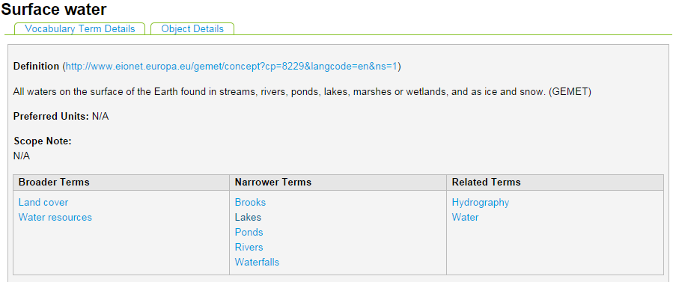
Figure 2: An example of an ontology term within the DEFRA DTC Archive vocabulary, 'Surface water', and how it relates to other terms in the vocabulary

Reflections and concluding remarks
A wealth of data is becoming available in data stores such as digital libraries and data repositories. While many digital tools are available for data management, storage and archiving, this is not necessarily the case for accessing information inherent in the data, i.e. contextual information that arises from processing, analysing or interpreting the data. Without contextual information, data is limited in its usefulness to end users.
In digital information management, traditional metadata help us to access data and provide some context for data classification. However this is usually done through annotating individual data items or individual datasets. Further informative context can be gained by becoming aware of links within and between datasets. The Semantic Web helps us make data more informative by providing a mechanism for recording semantic (rather than categorical) relationships between data items. Relationships between data items can be explored and navigated. Such navigation enables broader perspectives on data through using semantic links to discover related (and perhaps previously unknown) information.
In both case studies discussed above, Semantic Web technologies have been employed to enhance the informativeness of stored data. Both use cases use ontologies as controlled vocabularies, to define and standardise the terms and to avoid misinterpretation or semantic confusion. In both cases, these ontologies reuse existing work and employ specific extensions for the individual use cases, as is good practice in the Semantic Web.
In the Sharing Ancient Wisdoms (SAWS) Dynamic Library, data is stored as XML within the Library. Using XSLT, RDF statements are extracted that enrich the XML data with context about the types of relationships present in the collections of sayings. Here Semantic Web technologies directly model a key area of scholarly interest: how different collections of sayings relate to each other and how collections develop from version to version.
In the ongoing work on the DEFRA DTC archive, data on scientific measurements of freshwater quality and pollution is stored within a data repository. Information about the data is accessed and collated via a combination of traditional metadata and RDF statements generated by the repository software. Hence we discover information from the data within the repository by analysing multiple data sources from a collective perspective, rather than individual sets of measurements.
Both these case studies demonstrate the effectiveness of adding Semantic Web representations to digital data stores, for information retrieval and resource discovery. Additionally, both case studies act as exemplars of how to incorporate the Semantic Web within data repositories or digital libraries, for better digital information management.

Acknowledgments
Thanks to Richard Gartner, Mark Hedges, Mike Haft, Nicholas Bywell and Simon Fox for comments on an earlier draft of the information on the DEFRA DTC Archive project. Also many thanks to the Sharing Ancient Wisdoms team, particularly Charlotte Roueché, for helpful information regarding the Sharing Ancient Wisdoms case study.

References
- D. K. Moran. BrainyQuote.com, Xplore Inc. http://www.brainyquote.com/quotes/quotes/d/danielkeys230911.html , accessed September 2014.
- T. Berners-Lee with M. Fischetti, Weaving the Web: The Past, Present and Future of the World Wide Web by its Inventor. London: Texere Publishing Limited, 2000, p.260.
- DBpedia, http://dbpedia.org , accessed September 2014.
- Sindice: The Semantic Web Index, http://www.sindice.com/ , accessed September 2014.
- sameAs: interlinking the Web of Data, http://sameas.org/ , accessed September 2014.
- M. Doerr and P. LeBoeuf, “Modelling Intellectual Processes: The FRBR – CRM Harmonization” Digital Libraries: Research and Development, vol. 4877, pp. 114-123. Springer, 2007.
- M. Doerr, “The CIDOC CRM - an Ontological Approach to Semantic Interoperability of Metadata”, AI Magazine, Vol. 24, No. 3, 2003.
- M. Doerr and Maria Theodoridou, “CRM_{dig}: A A generic digital provenance model for scientific observation”, Proceedings of TaPP'11: 3rd USENIX Workshop on the Theory and Practice of Provenance, Heraklion, Greece, 2011.
- A. Miles and S. Bechhofer, SKOS Simple Knowledge Organization System Reference, http://www.w3.org/TR/skos-reference/ , 2009, accessed September 2014.
- Dublin Core Metadata Initiative (DCMI) Metadata Terms, http://www.dublincore.org/documents/dcmi-terms/ , accessed September 2014.
- C. Roueché et al., Sharing Ancient Wisdoms (SAWS) Dynamic Library, http://www.ancientwisdoms.ac.uk/library , 2013, accessed September 2014.
- Text Encoding Initiative, http://www.tei-c.org/ , accessed September 2014.
- A. Jordanous et al., SAWS ontology, http://purl.org/saws/ontology , accessed September 2014.
- Pelagios Project, http://pelagios-project.blogspot.co.uk/ , accessed September 2014.
- Perseus Digital Library, http://www.perseus.tufts.edu/hopper/ , accessed September 2014.
- C. Roueché et al., Sharing Ancient Wisdoms: Exploring the Tradition of Greek and Arabic Wisdom Literatures (SAWS), in “HERA Joint Research Programme: Outcomes and Achievements”, HERA (Humanities in the European Research Area), 2013.
- DEFRA DTC Archive, http://www.dtcarchive.org/ , accessed September 2014.
- Islandora Foundation, Islandora, http://islandora.ca/ , accessed September 2014.
- DEFRA DTC Archive Vocabulary Terms, http://www.dtcarchive.org/vocabulary , accessed September 2014.
- AGROVOC Multilingual agricultural thesaurus, http://aims.fao.org/agrovoc , accessed September 2014.
- DEFRA DTC Archive Object Linker solution pack, https://github.com/FBA/DTCArchive/tree/master/Drupal/Islandora/SolutionPacks/fba_solution_pack_object_linker , accessed September 2014.
- G. Birello and R. Le Faive, Relationship Editor Module, https://github.com/giancarlobi/islandora_relationship_editor , accessed September 2014.

