Imagining O encountering India: Recounting an embodied experience

Roanna Mitchel, University of Kent
Pablo Pakula, University of Kent

Abstract
In February 2012, Richard Schechner’s performance-installation Imagining O travelled from its original place of creation in Canterbury (UK) to the International Theatre Festival of Kerala in Thrissur (India). Imagining O is an immersive and participatory experience that brings together voices of Shakespeare’s women and Pauline Reage’s classic French erotic novel The Story of O. This performance report explores the encounter of a primarily European company with the bodies/gazes of an Indian audience, and their role as spectators in shaping the living organism of the performance. Taking a dialogic structure, it exists in the space between two authors’ voices and experiences — Roanna Mitchell as movement director, Dr Pablo Pakula as performer – mirroring the production’s decentred nature and its refusal of an objective standpoint.

Keywords
Richard Schechner
audience interaction
embodiment
submission
Shakespeare’s women
the gaze
The Story of O

In February 2012, Richard Schechner’s and Benjamin Mosse’s performance-installation Imagining O travelled from its original place of creation in Canterbury (UK) to the International Theatre Festival of Kerala in Thrissur (India). Imagining O brought together voices of Shakespeare’s women and Pauline Reage’s classic French erotic novel The Story of O (1954). Thematically, the piece explored submission, pleasure, love, sacrifice, empowerment and notions of the authorship of lived and written embodiment. The production’s structure echoed this by occupying different spaces, placing performers and audience in intimate proximity, dispersing and drawing together all participants in a dynamic play of control and submission.

Entering the grounds of the Kerela Sangeetha Nataka Akademi’s out of town campus, the audience follow strings of lights strung through the trees to enter a vast concrete warehouse-style building. The space is filled with monitors, large screens suspended from the ceiling show film-projections or are covered in collages of words and images. In one area, a cluster of chairs in disarray, are surrounded by sumptuous red silk. An old bath reflects images from a monitor. High up under the roof a naked woman moves, moth-like, against a glass window. The audience begins to discover the performers, displayed as part of this living installation, all seated in the same way: in evening gown, breathing softly with slightly opened mouths, their legs parted, lacy underwear suspended around their calves. Their bodies are open and available to the audience’s gaze, who roam freely and soon begin to own the space as visitors to an exhibition would, discussing, examining. [Insert photo 1 here]

Imperceptibly, the atmosphere changes as the performers’ breath becomes a panting sound from which words begin to emerge. In a crescendo the performers rise, and the audience is suspended in a moment of silence and stillness, before being engulfed by a rush of movement. Now the audience is moved and shifted, sometimes implicitly through the flow of the action, sometimes explicitly as performers command or invite them. They are addressed by Ophelia, in an iteration of herself as the commanding queen she would never become, and are then drawn into a bilingual and ambivalent bedtime reading from The Story of O, one reader savouring the French text’s sultriness, the other delighting in the English translation’s naughtiness. Draped around and into the audience, half-clad bodies create a moving painting, echoing Balthusian angles.

For a while, the audience is divided into groups and asked to submit to the guidance of the performers. They are led to dispersed scenes taking place simultaneously in various areas in and around the building, in which the words of Shakespeare and Reage are woven into a thematically rich tapestry of submission, love, power, authorship and the dynamics between feminine and masculine. The first half of the performance culminates in an ensemble scene in which fragments of O and Ophelia inhabit the same space, confronting their past, their choices and their sense of worth and worthlessness.

After this emotional climax, submitting to the rules of the performance and facing the experience of someone submitting to their actions, each audience member must complete one of three tasks: rubbing lotion into a performer’s back, brushing another’s hair or tearing a piece off a paper dress covered in words. This will reward them with the right to proceed to the second half of the performance, and a map that will help them navigate the second space.
Within the womb-like winding walkways and cavities of this building, dimly lit by hundreds of candles, the audience is free to roam and explore in their own time. A woman wanders the roof, playing a saxophone, its sound haunting the passageways. A wooden peep-house takes up the central space, while in another area a live-feed displays the action of those who peep into it. Audience members encounter isolated performers, with whom they share intimate secrets, physical touch or simply silence.

Finally, the saxophone calls all to the central space. A complex chorus sounds from within the peep-house; then, clothed all in white, the performers emerge and lead the audience out into the open. The water of an artificial river throws patterns of light against the overhanging branches of a tree. Surrounded by a delighted, then quieted audience, the performers drown in the river, again and again; a mad frenzy, which is gradually worn by time into exhausted repetition. One by one the performers leave, defeated. Two white-clad bodies remain, floating in the water. Finally, under the night sky, the audience is left with only the echoes of screams and splashing, and the river scene turns into a silent tableau.

-----------------------------------------------------------------------------------------------------

Roanna Mitchell (RM): In the role of movement director for Imagining O, the production’s journey to Kerala fascinates me in terms of the way the performers’ bodies were perceived by, interacted with, and moved the Indian audience – and were perceived and moved by them.

Pablo Pakula (PP): Yes, the complexity of these relationships did become apparent very early on, in fact, during our first technical run-through on location, only a few hours after having landed. Although our audience of technicians let itself be guided with ease and politely followed the piece, what unsettled some performers was the nature of their gaze. They looked at us intently, their faces at rest, not giving away any sense of reaction. It was a timely reminder that, being immersed in a different culture, we would encounter different bodies and gazes to those we had experienced the previous summer when the piece was performed in Canterbury. As a highly participatory and immersive piece, Imagining O relies heavily on its audience, and its relationship to the performers. No matter how much we rehearsed, there was no way for us to predict or pre-empt the Indian audience. Once the piece opened and had public audiences, we quickly realized that what we had misinterpreted as a lack of reaction during our first run-through was not indicative of Indian spectators. It took time for us to begin to understand the nuances of these other gazes and gain a cautious awareness of our inbuilt capacity to misunderstand.

RM: One of the themes of the piece is submission – both of the observed and of the observer. Watching the performance take life in India, I was struck by the submission of audience and performers to one another – a submission enacted through spatial arrangements, proximity and exchanging gazes, sometimes so complete that it erased the boundaries between ‘real’ life and performance.

As the piece opened, crowds of audience members surrounded the performers, the installation setting inviting the gaze to roam and investigate bodies on display. Initially self-conscious, the audience soon took up this invitation to look with abandon, and as they discovered the freedom to look, their relation to the space shifted. Groups fanned out, dissipated, people rearranged props and touched the performers. Throughout, I was reminded of John Berger’s distinction between nakedness and nudity in art, where encountering nakedness of a person in art includes ‘her will and her intentions in the very structure of the image, in the very expression of her body and her face’ (1973: 58), while in the nude the will has become pacified, the person turns herself into an object, watches herself being seen.
In Imagining O we explore the power in that watching, the power in watching you watching me, the play between the possessive gaze that owns the nude and the exchange of gazes that suggests the vulnerability and intentions of nakedness. The Indian audience’s willingness to engage in this play was both striking and disarming. One performer notes:

In the UK… there was perhaps a sense of shame, a sense of ‘I shouldn’t really be watching this’. Perhaps it wasn’t so much shame as much as a desire to view the ‘performer-persona’ as a very different entity to the ‘performer-the-individual’. In India… the audience were looking at us, taking in what they were seeing… ‘You are looking at me, I am looking at you’. There was no sense of disguise. (Mayer-Thibault 2012)

PP: The straightforwardness of our Indian audience’s gazes was not only a particularly frank attitude, but was fully embodied and became manifest in action. During the opening, as I sat motionless with my eyes fixed to a point in the horizon, several people actively sought eye contact. This act felt simultaneously intrusive and liberating, and seemed to signal a readiness to engage in an encounter, which I had not anticipated. [Insert photo 2 here]

RM: It did feel as though, more than in UK iterations of Imagining O, there was an increasing sense of a shared journey, as all the bodies within the space became part of an unpredictable organism.

PP: It was precisely the relationships between those bodies, which gave rise to that dynamic situation. How the audience behaved in relation to our physical presence was not the only factor, equally if not more important was how they related to each other. There was a particular moment during the first performance, as the audience was asked to perform one of the three tasks that their enthusiasm for participation spilled over into chaos. Displaying a different sense of personal space to their British counterparts, audience members in Thrissur crowded around the three stations where the performers were sat awaiting them. Bodies pressed against other bodies, hands eagerly stretching forwards, the performers were overwhelmed by this human swarm. We had come with an expectation that the audience would automatically queue, keeping some distance between each other. Whilst this ‘mobbing’ took us by surprise, it was clear that it was the result of their enthusiasm to take part, and the different cultural proxemics audience members had with each other. It highlighted that the audiences’ experience of Imagining O in India was affected by cultural difference not only conceptually, but practical ways.

RM: Both audience and observers appeared to come alive in the celebration of all the facets of ‘otherness’ that emerged through their exchange, complicated and fractured through the transcultural lens of an all-white mainly female British cast performing questions of power and submission to – and with – an Indian, predominantly male audience. The performers’ initial submission in the simple display of bodies for the gaze was subverted and reasserted multiple times throughout the piece, as the audience in a sense shifted, from observing a painting to becoming a part of its creation, sharing in the ‘nakedness’. In ‘The Masterspeech’, taken from The Story of O, a female performer orders the audience to sit, then describes in gruesome detail what will be done to them in the next room. This scene, initially one that revolved around the pleasure and pain of submission in love, carried with it in India the problematic echoes of colonialism. But it also offered other dimensions. Selecting a man from the audience, the performer commands that from now on he will be naked under his skirt. The fact that in India he was clad in the traditional skirt-like pancha turned this moment into an accidental exposure of cultural difference, which also shifted gendered assumptions of vulnerability from a male–female binary to a more general vulnerability of the human. ‘Otherness’ became a part of the story of Imagining O in India – an otherness that then was fractured so many times that it seemed to lose its relevance, as each individual was other to the next in a shared humanity. As the audience continued to fluctuate between two ways of seeing, each new encounter became a re-questioning of the body, of boundaries – between selves, between multiple versions of identity and culture. I thought for a moment of the billboards I had seen in Thrissur, where the influence of the western way of displaying the female body erupt in bright colours and vast images over the bustle of Indian everyday life.

PP: It is interesting that you mention westernized advertisements. Of course this is a ubiquitous, modern representation of the female body in India. However, it is worth taking into account what Schechner wrote in his programme note for the festival:

Before the advent of Islam and British prudery, explicit sexuality flavoured Indian thought, writing, religion, visual art, dance, drama, and ritual. The dancing women of Chidambaram, the sculptings of Konarak and Khajuraho, and the Kama Sutra represent an India displaying, investigating, and celebrating eroticism by means of art and writing. To some degree, and in its own Euro-American idiom, Imagining O is in dialogue with this Indian erotic tradition – a tradition enacting pleasure, submission, and the seeking for ultimate being by means of the human body – especially the female human body. (Schechner 2012)

Moreover, and unlike those westernized billboards, Imagining O did not present a homogenous or commodified female body. Having three directors meant that throughout the devising process we had different insights and approaches to the material. We explored the various facets of O and Ophelia, and the script was largely made up of words by different female characters in Shakespeare. In more ways than one, multiplicity and simultaneity played an important role in Imagining O. There was not a single conception or presentation of the female body, and this meant the piece always encouraged different readings. As a result, the bodies performing were not just objects of desire, as is the case with advertisements. These were also sensitive, vulnerable bodies.

RM: Indeed, as they shared the journey, many audience members seemed to feel responsibility for the bodies they were encountering. As gazes touch one another, perception becomes physical touch which shapes the performance – a ‘sleepwalking’ blindfolded performer found herself led to safety across a flight of steps, a dancer suspended in struggle to reach a bucket of water was presented with this bucket by helping hands, true secrets were shared with tearful eyes, folded into paper flowers…. [Insert photo 3 here]

PP: The way in which some audience members ‘took care’ of the performers is evidence that Imagining O moved towards emergence. Many of the ‘rules’ shaping the piece were only implicit, and audience members often had to define their own role. Whilst the intensity of their responses and excitement could sometimes be overwhelming in its lack of boundaries, there was a powerful sense that the audience received the performance with the genuine gratitude of receiving a gift. I had been told that for many it was their first experience of an immersive and participatory performance, making these expressions of kindness the more touching. Several performers noted that, at the end of intimate scenes or brief personal encounters, audience members gently and politely thanked them:

It was an incredible moment; I was so surprised by his response. I felt that he had truly appreciated the moment we had shared. I do not know how much of what I said or did he understood, but we had shared a moment. (Smith 2012)

At the same time, it is important to note that this kindness coexisted with the production’s sexual nature. I recall a young man who approached us after the performance and, full of perplexed excitement, stated that this was the first time he had seen a naked woman. He said this with humility and gratitude, as if something deeply personal and meaningful had been facilitated by the piece.

RM: Throughout the piece, the increasing intimacy changed the rhythm of the performance. As the audience gathered around the peep-house in the penultimate moment of the piece, I tasted an almost sexual frenzy. The bodies inhabiting Imagining O had wooed one another, submitted and demanded submission, gazed and touched, been exposed to gaze and touch. Now suddenly sectioned off by the wood of the peep-house, the performers whispered the last lines of all women who died in Shakespeare, anticipating silence, perhaps reverence. But like waves of energy that need to break against something, the audience continued to talk, to exchange, pressing up against the wood, peeping, dancing, taking over the space at the heart of which the performers were clustered behind peep-holes that spell temptation. This frenzy continued as everyone was led to the river and here, le petit mort took place in a final release of tension, as the audience laughed and gasped while the performers ploughed through the water, again and again. As the white shirts became soaked, the performers’ near-nakedness seemed to be held, now, with almost tenderness by the gaze of the audience. Two policemen removed their hats. A young man cried silently. Finally, the audience’s bodies, pressed closely together, held between them the silence of the calmed water, embodiment and presence made palpable through absence and memory. From a distance, through the trees, the audience was beckoned to leave: Shakespeare’s words, penned in a faraway time and place, were calling them back to the present world with enduring ambivalence: ‘To bed, to bed, to bed’.

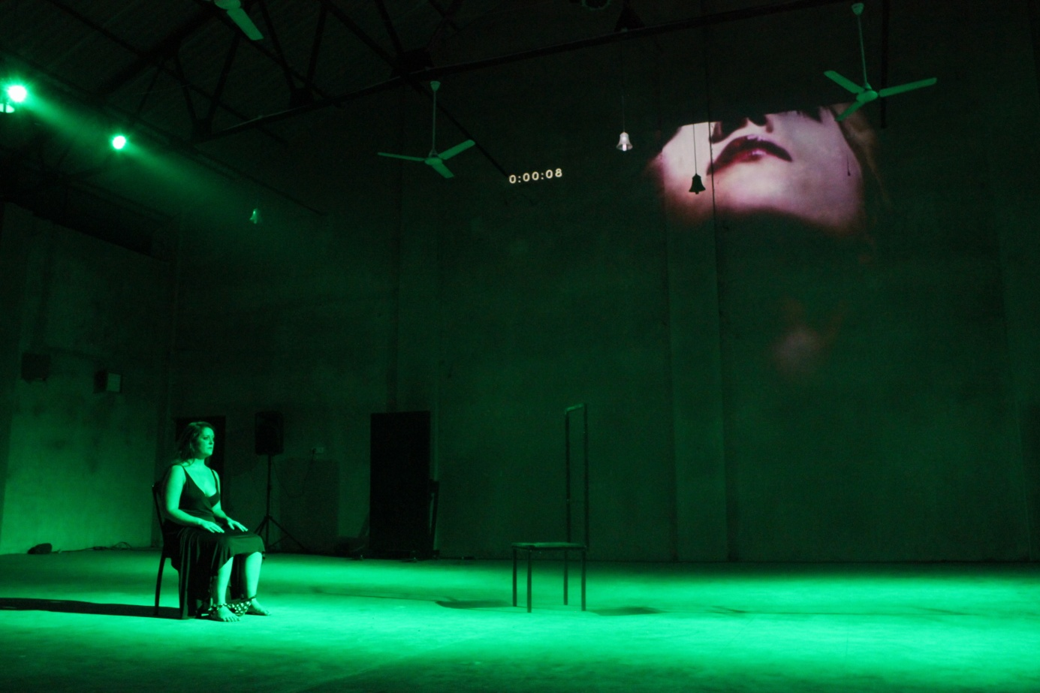
Figure 1 © Ken Plas

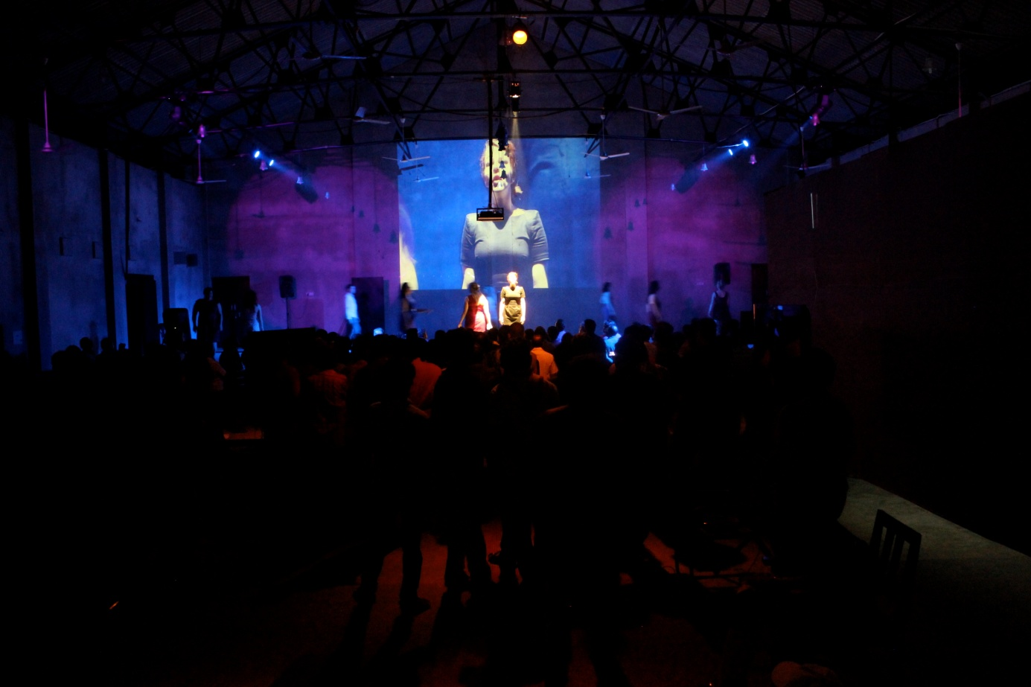
Figure 2 © Ken Plas

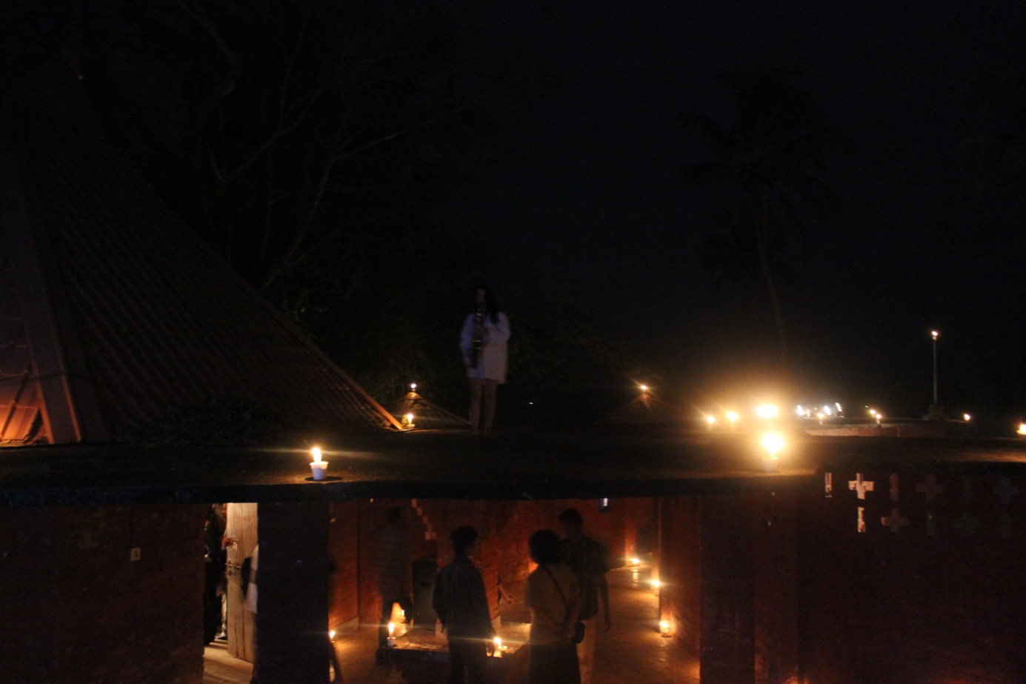
Figure 3 © Ken Plas

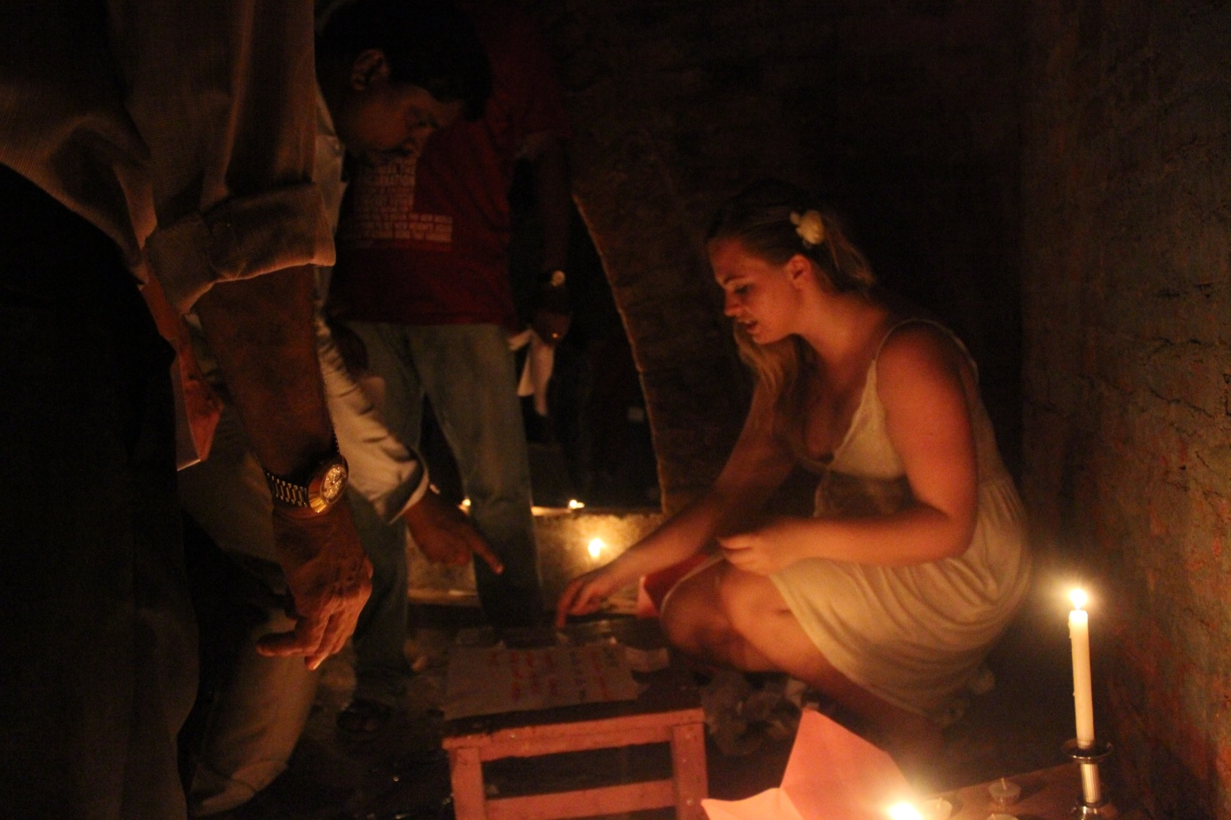
Figure 4 © Ken Plas

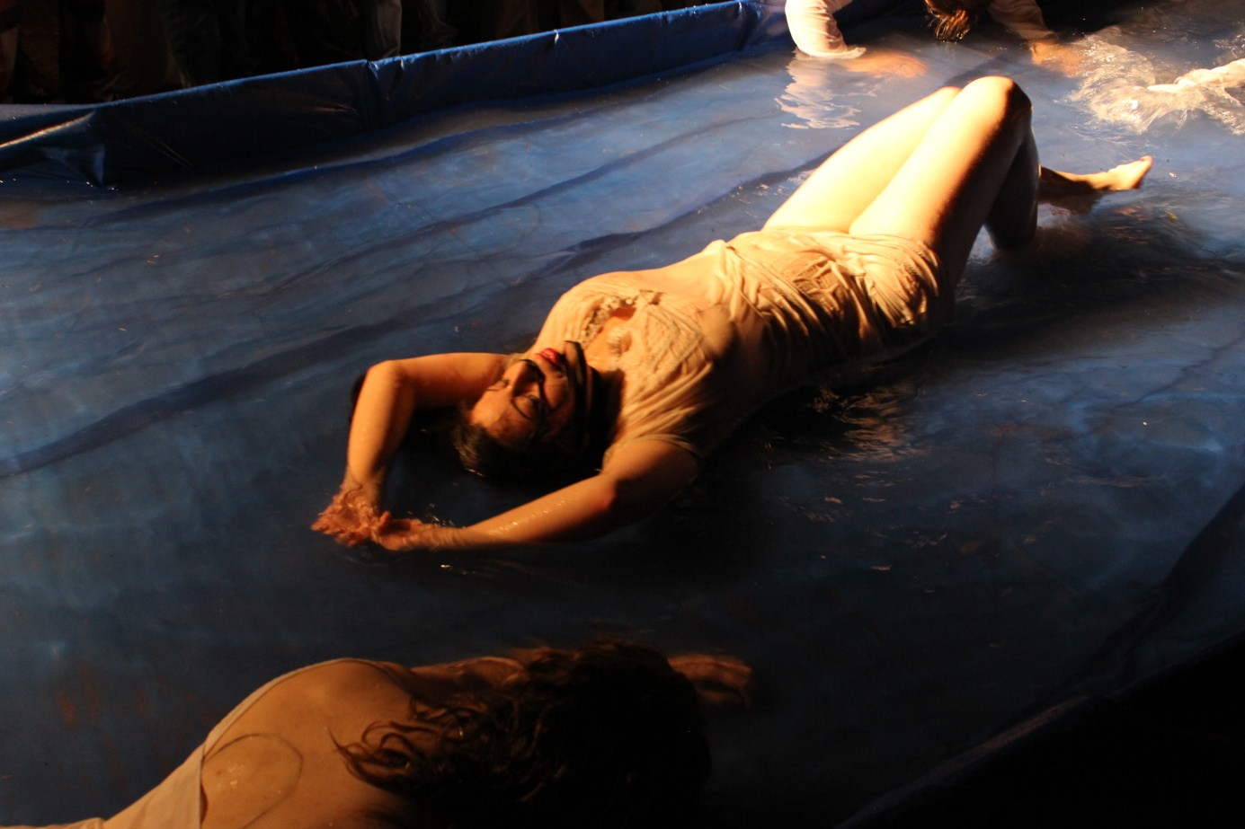
Figure 5 © Ken Plas

References
Berger, J. (1973), Ways of Seeing, p 56-60 London: British Broadcasting Corporation & Penguin Books.

Mayer-Thibault, Marinne (2012), ‘In-person Interview’, Canterbury, 12 August.

Schechner, R. (2011), ‘Imagining O’, audience discussion (after a screening of the first performance’s documentation), University of Kent, Canterbury. 18 October.

____ (2012), ‘Imagining O in an Indian context’, programme note for the Fourth International Theatre Festival of Kerala, Thrissur, 1 to 8 February.

Smith, Rachael Eleanor (2012), ‘‘In-person Interview’, Canterbury 12 August.

Contributor details
Roanna Mitchell is a movement director, teacher and writer, and is currently completing her Ph.D. at the University of Kent, investigating the Body Politics of Acting. Roanna teaches at the University of Kent, the Central School of Speech and Drama and Goldsmiths; she is also artistic director for the local–global initiative Endangered Bodies.

Pablo Pakula worked under the auspices of the AHRC-funded British Grotowski Project from 2006 to 2009, researching Grotowski’s influence on British theatre. He teaches as an associate lecturer at the University of Kent, specializing in contemporary theatre, live art and devising. Pablo is also co-director of Accidental Collective, a performance company creating site-specific and participatory experiences.

Contact:
62a Braxfield Road
London, SE4 2AN, UK
Rem.mitchell@gmail.com
Web address: www.roannamitchell.com
Web address: www.accidentalcollective.co.uk
Notes

As one of the performers remarked: On the way back to the UK, queueing in front of the airport in Kerala a group of women were starring intensely at me and ended up caressing my arm. It really highlighted for me that I was misreading ‘sexual’ into the Indian gaze during the performance, simply because we do not look in such a way in Europe. (Mayer-Thibault 2012)
The link with the painted nude is not coincidental. My collaboration with Schechner began through an exchange of the paintings of Polish French painter Balthus, which found their way into the movement language of the piece in their play with the gaze, and use of angles in the body.
Richard Schechner himself acknowledged that, for Imagining O, he had worked in a very collaborative way. ‘I felt really good about it. For the first time in my creative life I felt like I was a football coach. That was a good thing’ (2011).
The term ‘emergence’ explains the ways in which complex systems (i.e. ant colonies, cells and living things) self-organize and self-regulate without a central authority figure. I discussed this aspect of the production in detail in a paper delivered with Dr Rosie Klich at PSi#18 in June 2012.

