A Parallel-Beam Radiometric Instrumentation System for the Mass Flow Measurement of Pneumatically Conveyed Solids

I. R. Barrattª, Y. Yan^{a*}, B. Byrne^{b}

ª Advanced Instrumentation and Control Research Centre, School of Engineering, University of Greenwich, Medway University Campus, Chatham Maritime, Kent ME4 4TB, UK
^{b} Measurement Science and Technology Research Group, School of Science and Technology, University of Teesside, Middlesbrough, Cleveland TS1 3BA, UK

Abstract
This paper describes the design and experimental evaluation of a radiometric instrumentation system that has recently been developed for the measurement of volumetric concentration, velocity and mass flow rate of pneumatically conveyed solids. The system employs ‘micro’ beam collimation of gamma radiation to generate multiple, parallel interrogation beams of small cross-sectional area. This configuration is shown to almost eliminate the geometrical errors associated with more conventional divergent-beam interrogation. Experimental results obtained off-line using idealised flow models, and also on-line using a pneumatic conveyor, demonstrate the performance of the system and highlight where further development is needed.

Keywords: Radiometric sensors, mass flow, flow measurement, particulate solids, pneumatic conveying

- Introduction

On-line, continuous measurements of volumetric concentration, velocity and ultimately mass flow rate of pneumatically conveyed solids have become increasingly important to improve productivity, product quality and process efficiency [1]. Several types of non-invasive measurement system for metering particulate flow have been proposed over the last three decades, including acoustic, microwave, electrostatic, and capacitive techniques [2]. However, in the presence of inhomogeneous flow regimes with irregular velocity and concentration profiles, interpretation of the signals in terms of an absolute mass flow rate can be difficult. A major factor here is the constraint on spatial resolution achievable when ‘soft-field’ sensors are used.

Hard-field sensors such as those using ionising radiation or optical fields are in principle more adaptable to absolute measurements because of the possibility of better definition of the interrogation geometry. Radiological sensing is preferred in this particular application due its greater tolerance to particle accumulation on the pipe windows and because the line attenuation of a narrow radiation beam predominantly depends on the total effective mass per unit area of material traversed along the beam trajectory and is independent of solids distribution along the path of the beam line [3].

However, radiological systems previously reported employ divergent interrogation beam geometry, which can lead to a spatial sensitivity error across the pipe cross-section (see section 2 below). The system described here aims to address this source of error by using an array of highly-collimated, parallel radiation beams of relatively small cross-sectional area. A detailed description of the sensing principle and on-line experimental evaluation of a demonstration system operating on such principle have been reported in a separate paper [4]. This paper focuses on the design, implementation and off-line evaluation of a sensing head together with on-line data.
- Divergent beam interrogation

A common feature of pneumatic transport systems is that both the concentration and the velocity of solids can be highly inhomogeneous and unstable over the conveying pipe cross-section and are dependent on the pipeline orientation, conveying air velocity and many other factors. Radiometric flow sensors have typically employed a single ‘point’ source and broad-beam interrogation of the whole or a proportion of the pipe cross-section. A ‘one shot’ interrogation geometry based on a single broad gamma-ray beam and a single-element detector with uniform sensitivity profile has been reported by Yan et al 1994 [5]. The sensing configuration was simple in design, and in principal, could accommodate any possible flow regime. However, the system operated on the assumption of low-attenuation linear approximation and was thus susceptible to large measurement uncertainty.

When higher attenuation is used, multi-path interrogation is required. This can be implemented by replacing the single-element detector with an array of sensing elements as shown in figure 1. The beam elements are defined by the width of the sensing elements in a multi-element discrete array, with simultaneous attenuation measurements made for each element. These measurements are then used to determine the solids line concentration along each beam element, and integrated to obtain overall solids concentration. To derive chordal solids velocity, a pair of in-line, upstream and downstream arrays are used. The signals from corresponding beams are cross-correlated to give time of flight values from which chordal velocities are determined.

A significant geometrical error in solids concentration measurement can arise from the divergence of the beam elements. The magnitude of the geometrical error depends on the exact solids distribution within the pipeline – its upper limit is determined by the distance between the source and the pipeline [6]. Figure 1 shows a simple illustration of the nature of divergence problem in solid concentration measurement for distributions at positions A and B. The two flow distributions, with differing solid volumes V₁ and V₂, would produce the same response from the detector, as that from a standard volume in the centre of the pipe. Minimising the geometrical error entails the use of a longer distance between the source and the pipeline, making this approach impractical in many industrial applications where large pipe diameters or confined spaces are encountered.
Figure 1. Divergent nature of the interrogation beam

Figure 2 shows the magnitude of the divergence in the solids volume (%) as a function of L_{c}/D. The extreme variations in the flow distributions are rare in actual conveying, however, any error in the solids concentration measurement due to this effect must lie within these boundaries [7].
Figure 2. The magnitude of the divergence in solids volume

- Parallel beam sensing configuration

  - Sensing strategy
It is proposed that the geometrical errors associated with a divergent radiation field may be largely eliminated by using a ‘micro sensing’ parallel-beam profile to interrogate the whole pipe cross-section [8] as shown in figure 3. This arrangement uses a pair of line sources, generating two mutually perpendicular, co-planar, sets of parallel radiation beams interrogating the entire pipe cross-section. A multi-element detector array, used to measure the intensity of the transmitted beams, provides attenuation data. The total radiation field consists of individual beam elements, each of which has a total length L, width W and uniform beam spacing w_{s}. To avoid cross-talk between adjacent beams, the length of each stage of the collimation C_{L} has a specific value. If the uniform beam spacing w_{s} is made equal to the width of the beam W, the beam length L is dependent on the overall pipe diameter D. L is equal to 3D, producing a minimum length for each stage of collimation C_{L} equal to D for any value of W. To avoid ‘dead space’ between the radiation beams, a second collimating layer is introduced in the sensing system. To enhance the capability of the system to accommodate highly inhomogeneous flow regimes, two orthogonal sensing directions are utilised (Figure 3). Such sensing arrangement also allows the mapping of the solids concentration across the pipe section using a simple ART tomographic reconstruction algorithm, from which a measurement of solids concentration may be derived.

  - Radiation source selection
The radiation attenuation measurement is subject to some degree of uncertainty due to photon counting statistics. This is often the predominant source of error within the intensity measurement and effectively constrains the minimum solids concentration that can be measured in a particular system. To measure the more dilute phases of a pneumatic conveying process it is essential that a low photon-energy, high-intensity radiation field is employed. A gamma-ray source of low photon-energy, ideally monochromatic, is preferred in this application, as both geometry and beam hardening present problems if an X-ray tube is used [7].

Figure 3. Parallel beam sensing configuration

A survey of commercially available and suitable radioisotopes highlighted two candidates, Gadolinium-153 (Gd-153) and Americium-241 (Am-241). Gd-153 predominately emits photons of 44 and 100keV energy. It is available with a high activity per unit area (37GBq, over a 3mm diameter pellet). This source has been used extensively by Tuzun and Nikitidis [9] for tomographic imaging, however it is extremely expensive to purchase. Am-241 with principle photon energy of 59.5keV is readily available as a 30x2.6mm line source or as a point source with an active diameter of 3∼5mm. A 3.7GBq line source and 1.6 GBq point source were used in the preliminary investigation. However, from an early stage it was evident that, although the overall line source activity was higher than the point source, the intensity of a collimated beam was significantly lower than achieved with the point source. This is attributed to the construction of the line source, which is made up of ten 2mm diameter ceramic beads of lower activity than the 3mm diameter bead of the point source. Photon count rates depend strongly on the collimation length, but using the above activities, lie in the region of 17 kHz for 130mm collimation and a 36.5mm bore pipe. Figure 4 shows the estimated count rates from available point sources.
Figure 4. Estimated count rate from Am-241 sources
- Sensing head characteristics

4.1 Construction
The design of the prototype sensing head is shown in figures 5 and 6. Due to the unavailability of a higher activity strip sources for cost reasons, only effectively four radiation beam elements were implemented in the prototype sensing head, which were generated from two-independent point sources. A computer controlled scanning mechanism was incorporated into the sensing head for complete interrogation of the pipe cross-section. Since the radiation beams were reconfigurable over two axially spaced pipe cross sections along the pipe axis, the investigation into the effectiveness of the micro-sensing approach and the capacity of the system for measuring discrete solids concentration and velocity profiles was essentially preserved. An important aspect of the computer controlled scanning mechanism was the ability to accurately scan the pipe cross-section using discrete beam step increments. A 36.5mm bore nylon spool/window is mounted directly on the pipeline. Supported from this is a stepper motor and positioning spindle. Two supporting frames (sandwiching both the radiation source and detector assemblies) locate into slots in the spool and glide up-down via the stepper motor threaded spindle. To detect the photon fluxes directed through the collimation channels, an evaluation of both scintillation and solids state detectors was undertaken [10]. For this particular application a Hamamatsu R5900-M4 photomultiplier tube coupled to a hermetically sealed NaI(Tl) array was chosen. The PMT/scintillator assembly was mounted in a foam insulated steel box within the collimator housing to minimise the susceptibility of the tube to the effects of magnetic fields and mechanical vibrations. To monitor the local temperature around the PMT an LM35CZ precision temperature sensor was also fitted within the steel box.

Figure 5. Cross-section of the sensing head

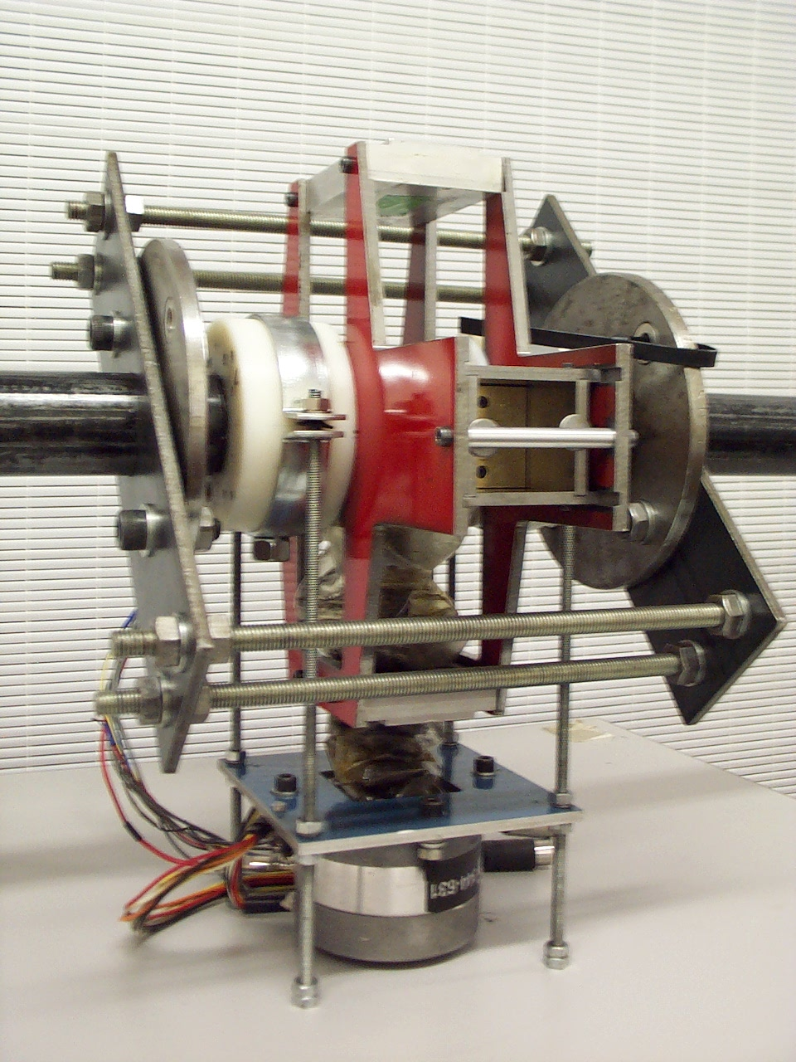
Figure 6. Photograph of the radiometric sensing head

4.2 Radiation beam profile
The aim of the collimation is to limit divergence, thus generating parallel interrogating beams, each one having uniform cross-sectional intensity with minimal inter-beam cross-talk. Assuming that photon emission is isotropic from the source, each beam will inevitably have an element of non-uniformity. An ideal radiation line source used for this application would contain a number of active areas each with a flat emitting surface with spacing equal to W and area equal or slightly larger than beam cross-section. The maximum divergence for a number of beam widths (1 to 5mm) was determined over a range of collimation lengths (equivalent to 25 ~ 100mm pipe diameter) with full derivation given in [11]. Figure 7 highlights the relationship between non-uniformity and length of the collimation for a given beam width. As expected, high beam uniformity is achievable when a small beam width and long beam length are utilised. The maximum non-uniformity (0.11%) occurs when using a 5mm beam width on a 25mm diameter pipe. The effect of non-uniformity from an ideal source on the measurement can be regarded as negligible when compared to the attenuation anticipated from the flow medium.
Figure 7. Non-uniformity of a collimated radiation beam over a range of pipe diameters

4.3 Americium-241 point radiation source
Due to the spherical nature of the active bead contained within the source used, minimum theoretical non-uniformity may not be achieved. Although the collimation width W was set to the active bead diameter, the cross-sectional area of the square collimating channel is 21.4% greater than that of the active bead. The non-uniformity over a collimated Am-241 beam cross-section was evaluated by measuring the intensity of a collimated beam cross-section with a computer controlled scanning ‘pinhole’ detector. Figure 8 shows the 3×3mm profile of the beam cross-section. The intensity value of each measurement is low due to the small aperture used. To reduce the standard deviation of the measurement due to counting statistics, the count rate was recorded over 2 minutes with the average value given for each point. Figure 9 indicates that the error of the system is in the order of ±1%. At this level, the system will not have the resolution to measure beam non-uniformity below 2%. To summarise, if the beam width is equal to the diameter of the spherical radiation source, the non-uniformity in the parallel-beam intensity profile is estimated to be less than 2%. Furthermore, the values from the theoretical investigation would indicate that this error might be at least an order of magnitude less.

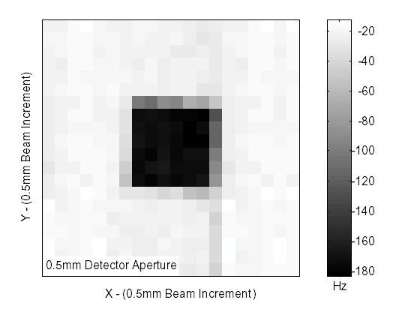
Figure 8 Intensity profile of the radiation beam at the point of detection

Figure 9. A typical example of the intensity profile of the interrogating beam

4.4 Attenuation relationship
To evaluate the suitability of applying a simple exponential attenuation law in this application, attenuation measurements were taken using precision aluminium calibration foil. Figure 10 shows the attenuation for aluminium sheets of thickness 0.095mm to 7.00mm (equivalent solids concentration of 0.26~19% in a 36.5mm pipe for homogeneous distribution). The linear attenuation coefficient (μ) for aluminium of density 2700kgm⁻³ at 60keV is 74.6m⁻¹ [12]. A least-square regression analysis of the results shown in figure 10 yields a measured value of μ = 74.76m⁻¹. A simple exponential attenuation relationship appears to be sufficient in this case, with little evidence of build-up.
Figure 10. Linear relationship of the attenuation model

4.5 Position-sensitivity and cross-talk over the pipe cross-section
An ideal requirement for true mass flow measurement is that the overall attenuation by the flow medium is independent of solids distribution within the pipeline. A series of attenuation measurements was taken for an absorber traversing along the path of the two interrogating beams from source to detector collimator. The absorber was positioned at 5mm increments, giving a total of 9 attenuation measurements for each beam. The absorber was in the form of a 0.6mm thick titanium sheet, equivalent to a chordal solids concentration of 1.65%. Figure 11 shows the deviation in attenuation for the two beams. Both sets of data were normalised to the first measurement position (5mm from the source collimator). There is no obvious positional sensitivity across the range of attenuation measurements. Included in figure 11 is the standard deviation in the measurement expected from counting statistics. Most of the deviations in attenuation measurements lie within these boundaries. One of the aims of using collimation channel lengths equal to the pipe diameter and beam spacing equal to the beam width, is to eliminate cross-talk between adjacent radiation beams. With both detector and source collimation equal to the pipe diameter, the cross-talk was approximately 0.12% of the adjacent radiation beam and increases if the pipe diameter is beyond the collimation length.
Figure 11. Deviation in attenuation along a 50mm beam length

- Off-Line experimental evaluation

5.1 Solids concentration measurements with idealised static flow models
Evaluation of the solids concentration measurement and spatial sensitivity of the radiometric sensing head was performed using static flow models to simulate solids flow within the sensing volume. A nylon rod of diameter 20.7mm and an aluminium rod of diameter 12.7mm were used to represent ‘perfectly tight’ roping flow regimes. The rods were set at various positions across the diametrical axis of the 36.5mm bore, in both the X and Y planes, as shown in figure 12. For each position, thickness profiles were recorded using a 3mm beam step increment over a scan range of ±24mm.
Figure 12. Position of the idealised flow model in the pipe

The average count rate was recorded over a 15-second period, which corresponds to a standard deviation of 0.35% due to photon counting statistics. Measurement results are summarised in table 1. The measured concentration β_{M} was determined directly from the radiation attenuation measurements, whilst the measured concentration β_{T} was derived from the corresponding flow images reconstructed from the two-dimensional radiation attenuation measurements. Table 1 indicates that the measured solids concentration (either β_{M} or β_{T}) is in close agreement with the expected value β with a relative error no greater than ±3%. It is evident that the measured spatial sensitivity over the entire pipe cross-section is insignificant.

Table 1. Measurement of the volumetric concentration of the idealised flow models
Idealised Flow Model | Diameter (mm) | Calculated Concentrationβ (%) | Measured  Concentrationβ_{M} (%) | Measured Concentration via Tomography  β_{T} (%) | Positional Sensitivity  Relative to XY (%)
 |  |  |  |  | −X | +X | −Y | +Y
Nylon rod | 20.7 | 32.2 | 31.2 | 32.1 | +0.19 | -0.02 | +0.19 | +0.14
Aluminium rod | 12.7 | 12.1 | 11.9 | 12.2 | -0.25 | +0.56 | -0.56 | -0.71

5.2 Velocity measurement of gravity fed solids
The derivation of a mass flow rate requires both solids concentration and velocity information. Accurate cross-correlation velocity measurement relies on the fact that precise sensing field spacing is known. This has been problematic for many measurement systems where either non-uniform or divergent sensing fields are employed [8]. In this particular application, the implementation of an essentially parallel radiometric sensing field enables a more precise spacing between a pair of in-line beam elements to be calculated.

The radiation beam intensity is modulated by particle fluctuations in the flow. It is therefore a requirement that the signal processing elements have a frequency response wide enough to transmit all of these fluctuations. Mennell [7] measured signal bandwidths of 150Hz for gravity fed aluminium solid/gas flows at 3ms⁻¹. At these frequencies, high count-rates and processing sampling rates are essential. Byrne et al [13] calculated that in their radiometric system count rates in the order of 3MHz would be required to achieve a statistical standard deviation of 1%. The count rates achieved with the micro-sensing field using 1.6GBq Am-241 and PMT/scintillator configuration are in the region of 17kHz. With such a low radiation field intensity available, the range of velocity measurement possible by cross-correlation is quite limited. However, if beam attenuation is sufficiently large, the fluctuations in sensor output may retain significant low frequency components from which cross-correlation can be successfully applied.

A series of experiments was undertaken to measure the velocity of gravity-fed ilmenite powder supplied from a hopper [1]. A variation in particle velocity was achieved by changing the height of the hopper relative to the radiometric sensing head. The free-fall velocity of the powder was estimated to verify crudely the validity of the measured correlation velocity. The centre-to-centre spacing the two radiation beams was set as 33.4mm. Correlation coefficients between 0.2 and 0.8 were observed. Figure 13 shows a direct comparison between the measured correlation velocity and the estimated free-fall velocity. It is noted that the actual particle velocity is always lower than the free-fall velocity due to air drag, inter particle collision, and spinning effect of the particles. This phenomenon agrees well with the results obtained using electrostatic sensors [14].

Figure 13. Velocity measurement of gravity fed particles

- On-Line experimental evaluation

  - Test facility
A series of experimental tests was conducted on a pneumatic conveying test facility to assess the ability of the system to measure the mass flow rate of solids, irrespective of the various flow regimes. The test facility at the Wolfson Centre for Bulk Solids Handling Technology has been previously used by the research team for the evaluation of electrostatic and radiometric sensors [5, 14]. Ilmenite powder (FeTiO₃), a common ore for the extraction of titanium, was chosen to be the conveying medium due to the fact that it is a fairly dense material and would therefore have relatively high attenuation to Am-241 radiation. The conveying pipeline was in the form of a loop consisting of an 8m lower run, 90° vertical bend, 3m riser, 90° vertical to horizontal bend and 8m return run (figure 14). All pipe sections in the loop had an identical inner diameter of 36.5mm. The sensing head was mounted immediately after the bends, denoted by A and B in figure 14. Such deliberate positioning of the head after a bend was to create the worst-case scenarios to evaluate the ability of the system to accommodate inhomogeneous flow regimes.

The ilmenite powder discharged from a blow tank feeder was conveyed through the loop and eventually delivered into a receiving hopper. The reference mass flow rate of solids was obtained from the calibrated load cells mounted under the hopper. Air flow into the system was regulated by a bank of computer-controlled calibrated flow nozzles. Pressure transducers were also installed at the test section, allowing the volumetric flow rate of air through this section to be evaluated assuming ideal gas behaviour. The average velocity of air within the test section was estimated from the superficial air velocity [1]. During the tests, it was not possible to characterise quantitatively the flow regime in the pipeline. Observation through a transparent section near to the sensing head gave certain indications of flow patterns.

At each location, the interrogation beams scanned through the pipeline cross-section in orthogonal (X) and (Y) directions. A computerised data acquisition system logged all relevant data including measurements from the pressure transducers and receiving hopper load cells to estimate the superficial air velocity (V_{sa}), and time averaged solids mass flow rate (M_{SL}). A number of test runs were performed at each sensing location, assuming that the flow condition did not vary significantly between the runs. The flow profiles presented for each sensing plane are displayed using both thickness of material across the beam chord and chordal solids concentration. The thickness profile in each plane is the average distribution over several runs. The uncertainty in the chordal thickness at each beam position is represented by combining standard deviations determined over the test runs.
Figure 14. Outline of the test facility

  - Location A
The sensing head at location A was mounted vertically, 0.35m past the first 90º bend. In total six runs were performed in the two sensing planes. Table 2 summarises the measured parameters.

Table 2. Results at location A
Location A | β  (%) | σ(β) | σ(β_{I}) | β_{T}  (%) | V_{c}  (m/s) | V_{sau} V_{sad}  (m/s) | M_{SL} (kg/s) | M_{s}  (kg/s)
Run 1 X* | 3.06 | 0.17 | 0.02 | 3.29 | 4.39~6.96 | 23.9 25.1 | 0.99 | 0.79
Run 2 Y* | 3.89 | 0.22 | 0.03 | 3.29 | 4.70~5.80 | 22.9 23.2 | 1.02 | 0.79
Run 3 X | 2.97 | 0.17 | 0.02 | 3.23 | 4.38~6.90 | 23.3 23.5 | 0.97 | 0.73
Run 4 Y | 3.81 | 0.21 | 0.03 | 3.23 | 4.70~6.92 | 23.3 24.6 | 0.98 | 0.74
Run 5 X | 3.06 | 0.15 | 0.02 | 3.14 | 4.64~8.08 | 22.5 24.1 | 0.96 | 0.74
Run 6 Y | 3.41 | 0.16 | 0.03 | 3.14 | 4.75~5.85 | 23.4 23.7 | 0.98 | 0.74
* Shown in figures 15-18

X-plane head orientation
The solids distribution at this position was relatively uniform over the scan plane, as shown by the data from run 1, (figure 15). The chordal thickness ranges from 0.4 to 1.1mm with a total solids volumetric concentration (β) of 3.06%. The standard deviation in the concentration measurement σ(β) was 0.17 while the estimated instrumental uncertainty σ(β_{I}) of 0.02. Cross-correlation velocities (V_{c}) were measured in the range 4.39 to 6.96m/s. The superficial air velocity during the conveying run was measured at positions 250mm upstream (V_{sau}) and 550mm downstream (V_{sad}) of the bend and yielded 23.9 and 25.1m/s, respectively, which are significantly higher than the velocity derived from the radiometric system.
Figure 15. Ilmenite chord thickness and solids concentration at location A(X)

Using both chordal solids concentration and velocity data, the mass flow rate was calculated for each beam chord (figure 16). The chord velocity at position –18 was not obtainable and is therefore assumed to be similar to the preceding beam value. The low chord mass flow rates at the edges of the pipe (±18) can be attributed to the smaller chord volume at these positions. The average load cell mass flow rate (M_{SL}) over the run was 0.99kg/s, whilst M_{s} determined by the radiometric system is 0.79kg/s. The underestimation in M_{S} will be discussed in Section 7.
Figure 16. Mass flow rate and velocity at location A(X)

Y-plane head orientation
Rotation of the beams through 90° highlights the degree of stratification at this location along the conveying loop. The data from run 2, shown in figure 17, indicate that the flow is constrained by the bend, which causes a concentration of particles against the back wall of the vertical conveying pipe. This phenomenon is similar to that reported by Yilmaz and Levy [15], who used a similar pipeline configuration. The ilmenite thickness across the pipe cross-section ranges from 0.04 to 3.34mm giving a total solids concentration of 3.89% during the run. The standard deviation of β is higher in this orientation and can be attributed to viewing the more inhomogeneous components of the flow regime.
Figure 17. Ilmenite chord thickness and solids concentration at location A(Y)

Velocity measurements were possible using the radiometric system in the denser areas of the stratified flow medium with chordal velocities between 4.7 and 5.8m/s. Due to the partial velocity information in the leaner areas of the flow regime, an estimation of certain chord velocity values is required for the calculation of chordal and overall mass flow rates. V_{sa} measured during the run was 22.9m/s upstream and 23.2m/s downstream respectively. Assuming that the conveying air will tend towards these values at some point over the pipe cross-section, the missing velocity values were estimated (as shown in figure 18). The chord mass flow rates give information as to the severity of the roping in this plane and indicate that 77% of the mass flow rate is conveyed in only 30% of the pipe cross-sectional area. The average M_{SL} over the run was 1.02kg/s, whilst M_{s} calculated by the system is 0.79kg/s with a standard deviation of 0.05. The tomographic representation of the flow highlights how the flow is distributed against the back wall of the vertical section of the pipeline, as shown in figure 19 where X_{p} denotes the effective thickness of particles in a pixel.
Figure 18. Mass flow rate and velocity at location A(Y)

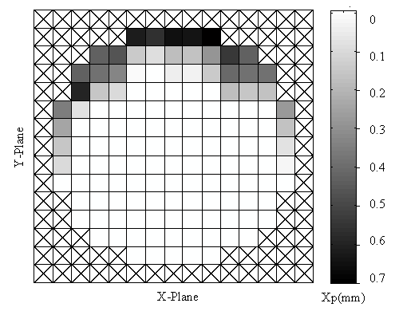
Figure 19. Tomographic representation of the flow regime at location A

  - Location B
The sensing head at location B was mounted 0.35m beyond the second 90° bend on the upper horizontal pipe section. Table 3 details the results from six conveying runs.

Table 3. Results at location B
Location B | β  (%) | σ(β) | σ(β_{I}) | β_{T}  (%) | V_{c}  (m/s) | V_{sau} V_{sad}  (m/s) | M_{SL}  (kg/s) | M_{s}  (kg/s)
Run 1 X* | 2.45 | 0.12 | 0.03 | 2.43 | 7.09~9.82 | 27.1 29.0 | 0.98 | 0.84
Run 2 Y* | 2.33 | 0.07 | 0.03 | 2.43 | 6.95~18.50 | 27.3 29.4 | 0.97 | 0.95
Run 3 X | 2.18 | 0.09 | 0.03 | 2.19 | 6.60~9.40 | 27.4 29.5 | 0.92 | 0.77
Run 4 Y | 2.21 | 0.09 | 0.02 | 2.19 | 6.18~9.80 | 27.3 28.8 | 0.93 | 0.75
Run 5 X | 2.34 | 0.10 | 0.02 | 2.31 | 7.27~9.01 | 27.0 28.6. | 0.94 | 0.85
Run 6 Y | 2.42 | 0.07 | 0.03 | 2.31 | 7.26~8.94 | 27.2 29.3 | 0.95 | 0.87
* Shown in figures 20-23

X-plane head orientation
In the X-plane, one would expect the flow to be dispersed more evenly over the pipe cross-section. However, the flow profile of run 1 (figure 20) shows that the solids are still affected by the preceding bend and distributed towards one side of the pipe.
Figure 20. Ilmenite chord thickness and solids concentration at location B(X)

Velocity measurements were possible in the denser areas of the flow (beam position 0 to -15). As the interrogation beams traverse towards the less dense flow in the centre of the pipe, an increase in velocity was observed. Correspondingly, the correlation coefficients reduce to a point where cross-correlation velocity measurements are not possible. An estimation of certain chord velocity values was therefore required for the mass flow calculations. The superficial air velocity during the conveying run was measured at positions 250mm before and 550mm after the second bend and yielded 27.1 and 29.0m/s, respectively. Assuming that the conveying air would tend towards these values at some point over the pipe cross-section the missing velocity values were estimated (figure 21). The average M_{SL} over the run was 0.98kg/s whilst M_{s} determined by the system is 0.84kg/s.

Figure 21. Mass flow rate and velocity at position B(X)

Y-plane head orientation
Rotation of the sensing head through 90° enabled the evaluation of the degree of stratification at this location along the conveying loop. The solids distribution of run 2, given in figure 22, indicates that the constraining effect of the bend concentrates the flow regime towards the top wall of the horizontal conveying pipe. The radiation beams interrogate the pipeline 0.35m past the bend at this point. The core of the flow is suspended at beam position (+9), which would indicate that the flow is slipping around from the top internal wall of the pipe, and is falling through to the bottom of the horizontal pipeline. The total solids concentration (β) is 2.33% with a standard deviation σ(β) of 0.07.

Figure 22. Ilmenite chord thickness and solids concentration at location B(Y)

Due to an increased dispersion of particles in this plane, a greater number of velocity measurements were possible (beam position +15 to -9). The measured solids phase core velocity range increased to 6.95∼18.5m/s. The superficial air velocity during the conveying run was measured at 27.3 and 29.4m/s with the estimated velocity values and mass flow rates being shown in (figure 24). The average M_{SL} over the run was 0.97kg/s whilst M_{s} given by the system is 0.95kg/s. The tomographic representation of the flow (figure 24) clearly shows the flow distribution towards the top left of the horizontal section of pipeline. The solids concentration β_{T} derived from the reconstructed flow image is 2.43%.
Figure 23. Mass flow rate and velocity at location B(Y)

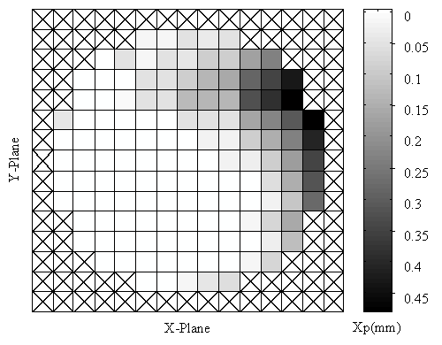
Figure 24. Tomographic representation of the flow regime at location B

- Discussion

  - Solids concentration measurement
The concentration profiles presented indicate that trends occur in the distribution of the solids within the pipeline. The measured solids concentration reduced at location B as a result of the increase in solids velocity. The solids concentration derived from the bi-directional tomographic reconstruction (β_{T}) lies persistently between the two uni-directional values at both sensing head locations (tables 2 and 3).

  - Velocity measurement
Velocity measurements by cross-correlation were only possible in the denser areas of the flow medium where beam modulation was sufficiently high. The velocity profiles obtained indicate that the core of the flow has a reasonably uniform velocity profile. The methodology employed in this system assumes that the velocity value will be an average over the corresponding beam chord. However, due to the high density of the particles and the inhomogeneous regime present, this assumption may not be valid. This problem is highlighted at location A(X). The beams in this plane interrogate two distinct layers of particles: a denser layer flowing against the back wall of the pipe and a more dilute layer occupying the central region. The velocity measurements obtained are only representative of the layer that gives the stronger signal modulation; i.e. the denser region in this case.

7.3 Mass flow calculations
The mass flow rates determined at orientations A(X) and A(Y) are underestimated by an average of 23% and 24% respectively. This underestimation is reduced at location B to 13%(X) and 10%(Y). Uncertainties in the determination of the true mass flow rate will stem from the errors in the chordal solids concentration measurement and/or the chordal velocity measurement. In the static experiments performed, the solids concentration measurements were within 1% of the true values. Errors in the on-line chordal solids concentration measurement may stem from several possible sources. The method assumes uniform lateral distribution of solids across the beam elements, as these are narrow. Any lateral non-uniformity will result in error when the solids concentration is deduced from the measured solids thickness traversed by the beam element. Quantification of this effect is difficult, as it depends strongly on the detailed distribution of solids over the pipe cross-section. Reduction in the beam element width would minimise any such error, however this will increase uncertainty due to counting statistics and place further demand on the radioactive source strength.

Dynamic bias is a well-documented problem [16] when applying radiological sensing techniques to a time-fluctuating medium. Such effects may be reduced by increasing the sampling rate of the system. One would expect the effects of dynamic bias to be more pronounced at the higher velocity. However, the error in the calculation of the mass flow rate is lower at the higher velocities. This suggests that the most significant error, when calculating the mass flow rate, stems from the assumption that the chordal velocity used is an average across the whole of the interrogation chord and subsequent solids distribution. This assumption may hold true for dilute homogeneous flow regimes but may not be the case when dense inhomogeneous flows are present. This problem is demonstrated at location A where particles form a layer 3∼6mm thick against the back wall of the pipeline (figure 25). The measurement range where the chordal velocities in the X and Y plane were obtained is shown by the two arrows. There are a number of chords where there must be a boundary layer (marked by the curved line). Within these pixels, the flow velocity is at an intermediate value between the core velocity (measured by cross-correlation) and the superficial air velocity. This boundary layer velocity is not considered in the single plane calculation of the mass flow rate, as the low solids concentration will contribute little to the correlation measurement. This will result in an underestimation of the mass flow rate. The measurement error in the mass flow rate is reduced at location B, which may well be attributed to the higher phase velocity and a more dispersed flow regime. With the higher phase velocity there will be a lower velocity difference between the boundary layer and the superficial air velocity.

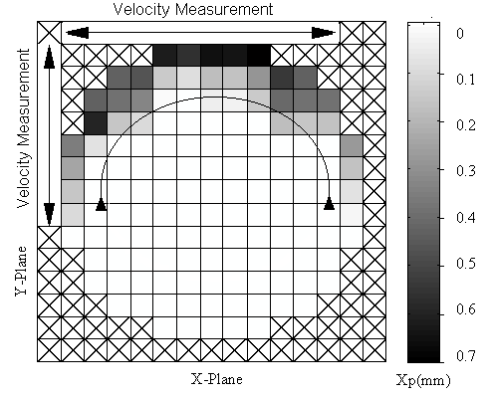
Figure 25. Boundary layer problems in the velocity measurement at location A

- Conclusions

A radiometric sensing head utilising parallel beam geometry and a multi-channel photomultiplier tube has been designed, fabricated, and applied to the measurements of concentration, velocity and mass flow rate of pneumatically conveyed solids. A parallel-beam geometry has been shown to reduce the inherent geometrical errors found in divergent-beam configurations. The prototype system has been evaluated on highly inhomogeneous flow media, with consistent results that can usefully characterise the nature of the flow regime. The system proved reliable and stable in operation throughout the on-line trials on the pneumatic conveying test facility. Instrumental drift measured between the scans of the pipeline was no greater than 0.5%, which is negligible when compared to the attenuation by the flow medium.

Margins of error in mass flow measurement are thought to lie with the velocity measurement part of the system. The relatively low count rate achieved with the current Am-241 point sources also places a limit on the range of lean solids concentration and velocity profiles that can be measured. Extension of the measurement range will require the use of line or strip radiation sources of significantly higher activity.

Acknowledgments
The authors would like to acknowledge the support of the Leverhulme Trust that provided funding for the research project. The technical staff at the Wolfson Centre for Bulk Solids Handling Technology are thanked for their technical advice and assistance throughout the on-line experimental work.

References
[1] Yan Y and Stewart D, ‘Guide to the flow measurement of particulate solids in pipelines’, The Institute of Measurement and Control, ISBN 0 904457 34 6, 2001.
[2] Yan Y., ‘Mass flow measurement of bulk solids in pneumatic pipelines’, Measurement Science and Technology, Vol.7, No.12, pp.1687-1706, 1996.
[3] Yan Y., Byrne B., Coulthard J., ‘Radiation attenuation of pulverised fuel in pneumatic conveying systems’, Transactions of the Institute of Measurement Control, Vol.15, No.3, pp.98-103, 1993.
[4] Barratt I.R., Yan Y., Byrne B., Bradley M.S.A., ‘Mass flow measurement of pneumatically conveyed solids using radiometric sensors’, Special Issue of Flow Measurement and Instrumentation, Vol. 11, No.3, pp.223-235, 2000.
[5] Yan Y., Byrne B. and Coulthard J., ‘Radiometric determination of dilute inhomogeneous solids loading in pneumatic conveying systems’, Measurement. Science and Technology, Vol.5, No.2, pp.110-119, 1994.
[6] Mennell J., Byrne B., and Yan Y., ‘Appraisal of radiometric techniques to determine absolute solids fraction in pneumatic suspensions of particulate solids’, Special Issue of Flow Measurement and Instrumentation, Vol.11, No.3, pp.213-221, 2000.
[7] Mennell J., ‘Radiometric characterisation of pneumatic suspensions of particulate solids’, PhD Thesis, University of Teesside, 1997.
[8] Yan Y., Byrne B. and Coulthard J., ‘A true flowmeter for non-restrictive measurement of bulk solids’, Proceedings of 2nd International Conference on Multiphase Flows, Kyoto, Japan, 1995.
[9] Tuzun M.E. and Nikitidis M.S., ‘Centre for computer assisted tomography, University of Surrey, UK’, Bulk Solids Handling, Vol. 15, No. 3, pp.467-470, 1995.
[10] Barratt I., Byrne B., Mennell J. and Yan Y., ‘The application of position-sensitive detectors in multi-phase flow measurement’, Nuclear Instruments and Methods in Physics Research, Vol.A392, pp.450-455, 1997.
[11] Barratt I.R., ‘Radiometric determination of the true mass flow rate of solids in a pneumatic suspension’, PhD Thesis, University of Greenwich, 2000.
[12] Hubble J.H., ‘Photon mass attenuation and energy-absorption coefficients from 1keV to 20MeV’, International Journal of Applied Radiation and Isotopes, Vol.33, pp.1269-1290, 1982.
[13] Byrne B., Coulthard J. and Yan Y., ‘Radiological sensors for cross-correlation flow metering’, IEE Colloquium on Nucleonic Instrumentation, IEE Digest No.039, 1990.
[14] Yan Y., Byrne B., Woodhead S.R., Coulthard J., ‘Velocity measurement of pneumatically conveyed solids using electrodynamic sensors’, Measurement Science and Technology Vol. 6, No.5, pp.515-537, 1995.
[15] Yilmaz A. and Levy E.K., ‘Roping phenomena in pulverised coal conveying lines’, Powder Technology, Vol. 95, pp.43-48, 1998.
[16] Oyedele J.A., ‘Statistical errors in void fraction determinations in voided liquids employing radiation beams’, International Journal of Applied Radiation and Isotopes, Vol.43, No.4, pp.537-542, 1992.

