Sustainable Value Stream Mapping:
A Practical Aid to Sustainable Production

Ann Norton
Imperial College
&
Andrew Fearne
Kent Business School

Background
Since the adoption of Agenda 21 at the Rio Conference on Environment and Development in 1992, there has been recognition of the need to counter the adverse environmental effects of unsustainable patterns of consumption and production in industrialized countries. It was proposed within Agenda 21 that changing these patterns requires “… a multipronged strategy focusing on demand, meeting the basic needs of the poor, and reducing wastage and the use of finite resources in the production process” (UN, 2004). Within the UK government’s Sustainable Development strategy, the proposition is expanded by the view that “much current consumption, and business models based on it, remain unsustainable in the longer term under present technologies and supply patterns”, and that there is a need for “process re-design, lean manufacturing and ways to use waste from one business as a resource for another”, using an approach that promotes “cleaner, more efficient production processes, which strengthen competitiveness” (Anon., 2005). Thus the UK government emphasizes the need for greater efficiency and competitiveness in addition to environmental performance improvements.

Within all industries, physical wastes and wasted resources occur at every stage in the supply chain. Once solid wastes have been generated, they require appropriate management so as to minimize the environmental impacts and risks to human health. However, all waste management methods have certain drawbacks: inefficiency due to energy losses or additional energy usage; risks of emissions to environmental media; and not least the compounded wastes and wasted resources within the discarded materials from earlier stages in the supply chain. Therefore waste reduction is environmentally preferable to waste management, as the waste hierarchy illustrates (Figure 1). Undoubtedly some wastes are unavoidable, for example, a certain fraction of raw materials, and these should be managed using the best practicable environmental option, an approach well established in EU and UK legislation. However, the economic benefits to be derived from preventing avoidable waste make this a highly worthwhile objective: businesses benefit from reduced costs for materials, resources and waste disposal; and consumers benefit from improved value because the price paid does not incorporate the costs of waste incurred throughout the supply chain. Given the undeniable benefits of waste reduction, the question arises as to how it should be achieved within manufacturing industries. How might the avoidable wastes be identified and eliminated?

Figure 1. The waste hierarchy
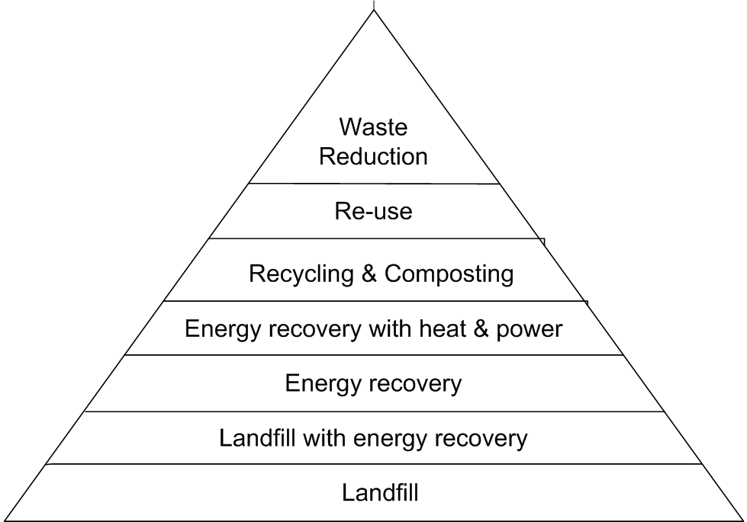

Source: (Anon., 2002a)

The Lean Paradigm
Whilst working for the Japanese car manufacturer, Toyota, Taiichi Ohno formulated the ideas underlying what is now known as lean manufacturing. His primary aim was to reduce the time between the receipt of an order and the receipt of payment for its delivery by eliminating the non-value-adding wastes that he called muda, frequently called the Seven Wastes (Ohno, 1988). The Seven Wastes are:

- Waiting, by operators and machines;
- Transportation of materials;
- Unnecessary or overcomplicated processes;
- Excess stock or materials (inventory);
- Excess movement by operators;
- Defective products;
- Overproduction.

A lack of awareness of the Seven Wastes within the production chain results in low productivity, poor quality and increased costs. Ohno (1988) viewed overproduction as “our worst enemy – because it helps hide other wastes”. In other words, the six other wastes are compounded within overproduction.

Ohno’s ideas for reducing muda formed the basis for lean thinking, which can be applied to the provision of any good or service (Womack and Jones, 2003). Womack and Jones (2003) propose that the Seven Wastes can be eliminated by minimizing the activities that absorb resources but create no value, and aiming to provide the end-consumer with what he wants when (and only when) he wants it. Lean thinking has five basic principles (Womack and Jones, 2003).

- Specify value
Delivering value is fundamental to lean thinking. Only the end-consumer can define value, and it can only be expressed in reference to a specific product that meets the consumer’s needs at a specific price and at a specific time.
- Identify the value stream
The value stream comprises all the activities necessary for the creation of a specific product, from the procurement of raw materials up to the point of sale to the end-consumer. Any value stream typically has three types of activity: those that create value; those that create no value but are essential; and those that create no value and are avoidable. The avoidable activities that create no value are wasteful and should be eliminated.
- Make value flow
After eliminating wasteful activities, the remaining activities are made more efficient by introducing greater flow, that is, by working on the product without interruptions so that it is completed more quickly and with less likelihood of defects or damage. This requires working on smaller quantities, using the ‘right size’ machine and reducing changeover time, thereby allowing inventory levels, production lead times and costs to be reduced.
- Let the customer pull value
The shorter lead times made possible by improving flow should allow production to be more responsive to actual demand and less reliant on inaccurate forecasts that can result in under- or over-production. The overall aim is to avoid keeping contingency stocks that risk non-requirement and wastage.
- Pursue perfection
Once the value stream has undergone a lean implementation, further reductions in wasteful activities should become apparent in a process of continuous improvement.

Jones and Womack (2003) propose that overproduction, unnecessary inventories and unnecessary transportation should be the initial focus for reduction by carrying out improvements in information flows and logistics using the following criteria.

- All participants in the value stream need to know the rate of demand by the final consumer so that the ‘signal’, can be distinguished from ‘noise’ caused by distortions, such as the bullwhip effect or promotional activity.
- There should be the minimum inventory levels of raw materials, intermediate products and finished goods necessary to support demand from the next process downstream, and the holding of quantities above the minimum should be avoided.
- There should be the minimum number of transport links, with the elimination of links preferable to faster delivery by methods such as air-freighting.
- Information flows should be “pure signal and no noise”.
- The lead time should be minimized in order to respond to end-consumer demand rather than forecasts.
- Any changes introduced to implement the above improvements should be at minimum or zero cost, with the easiest and quickest changes carried out first.

After implementing these improvements, Jones and Womack (2003) recommend that smaller, more frequent shipments are made, followed by the introduction of ‘milk run’ logistics between facilities. However, before improvements can be carried out, an analysis of the current state of activities in the value stream is essential.

Value Stream Mapping
Value stream mapping (VSM) is a diagnostic technique that originated from lean manufacturing principles. Its purpose is to identify value-adding and non-value-adding activities in the value stream so that wasteful activities can be eliminated, and production aligned with demand. The first step is to draw a current-state map by ‘walking’ a specific product’s value stream door to door within a plant.

Figure 2. General example of a value stream map

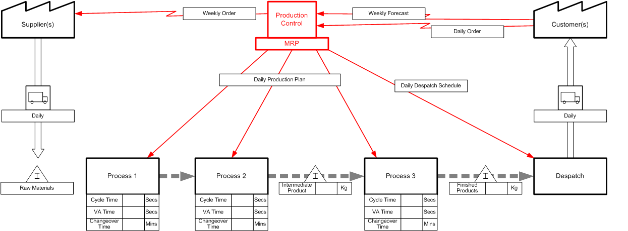

Source: Norton (2007)
(Drawn using eVSM v.2.3 from GumshoeKI, Inc. 2000-2005)

Figure 2 shows a general example of a value stream map, where each process box represents one area of material flow. The data boxes below each process box show typical lean measurements, such as cycle time, changeover time and value-adding time. If inventory is accumulating between processes, these points are shown at the appropriate location on the map as a ‘warning triangle’ to indicate where flow is interrupted and how much inventory is involved in terms of quantity and/or number of days’ production. Information flows between Material Requirements Planning (MRP) and the customer, suppliers and manufacturing processes, along with their frequency, are also recorded. This is a crucial aspect of VSM because information flows are the drivers for production and, if inaccurate or untimely, can be a significant cause of waste.

Ideally, the extended value stream, from raw materials to end-consumer, should also be mapped in order to evaluate the overall efficiency of the entire value stream by determining performance indicators such as total lead time, total value-adding time, the number of inventory turns, the level of defects at each stage, occurrences of the bullwhip effect and total miles travelled (Jones and Womack, 2003).

Environmental Issues and the Lean Paradigm
There are numerous examples from a range of industries illustrating the commercial benefits that can be derived from lean principles, for example, Taylor (2000), Scaffede (2002), Haque (2003), Rooney (2005) and Simons and Zokaei (2005), to name but a few. However, lean principles must be applied cautiously to ensure that environmental performance is not compromised. The US Environmental Protection Agency now advises the integration of lean implementation and environmental performance improvements (Anon., 2006). They define environmental wastes as “any unnecessary use of resources, or substance released to the air, water or land that could harm human health or the environment” and propose that “environmental wastes, although not considered one of lean’s seven deadly wastes, are embedded in or related to the wastes targeted by lean methods”. This integrated approach has been piloted in the USA by a voluntary programme, the Green Suppliers Network (Karp, 2005). Karp points out that large companies have the resources to monitor and enhance their own environmental performance, but these do not extend to their suppliers. In turn, few small suppliers have sufficient resources to address environmental performance because they are pressurized by customers to reduce costs. The Green Suppliers Network provides advice to small companies on lean manufacturing and pollution prevention with the aim of improving production efficiency and enhancing environmental performance, leading to significant savings for participating companies. The large manufacturers also realize benefits because improvements in the efficiency and environmental performance of their supply chain contribute to their own success.

Importantly, the implementation of lean principles without consideration of the effects on environmental performance might lead to adverse impacts. Companies adopting lean techniques aim for reductions in lead times and inventory levels that necessitate more frequent replenishment. Venkat and Wakeland (2006) used a simulation model to analyse the influence of lead time compression on CO₂ emissions. Their findings were as follows.

- Lean supply chains can produce higher CO₂ emissions, especially when there are long distances between facilities.
- When cold storage is not necessary, emissions are highly dependent upon the vehicle size, with larger, less frequent deliveries typically resulting in the lowest emissions. However, the lean paradigm promotes frequent deliveries of smaller quantities.
- When cold storage is essential, it is beneficial within companies to hold smaller stocks so as to reduce electricity consumption and the associated CO₂ emissions, but this necessitates more frequent deliveries and might lead to an overall increase in CO₂ emissions.

Therefore there is an optimal order size within any individual supply chain that balances inventory level and delivery frequency in order to generate the lowest CO₂ emissions. The overall findings of this study were that lean supply chains might not have the lowest CO₂ emissions unless the entire supply chain is located within a small region.

Of course, CO₂ emissions are but one aspect of the environmental performance of a supply chain. In a study of the manufacture of processed dairy products, Berlin (2005) found that food waste from product changeovers could be substantially reduced if individual varieties were made less often and in larger batches, an approach at odds with the lean principles of shorter, more frequent production runs. In view of these conflicting imperatives, it follows that a lean-oriented analysis of the activities in the value stream combined with a quantification of the environmental wastes arising from each activity is more beneficial than carrying out each evaluation as a separate exercise; the application of lean techniques provides the insights to re-evaluate current activities and improve efficiency, whilst the measurement of the environmental wastes associated with each activity ensures that operational improvements do not worsen environmental performance.

Sustainable Value Stream Mapping
Clearly, standard VSM does not explicitly consider environmental performance, which may or may not be improved by a lean implementation. Therefore Simons and Mason (2002) proposed a method called Sustainable Value Stream Mapping (SVSM) as a means of enhancing sustainability in product manufacture by analysing emissions of the greenhouse gas, CO₂, in addition to value-adding time, throughout the value stream. SVSM is intended as “a simple, do-it-yourself method for establishing the facts” and determining the sustainability of the procurement and distribution of products (Simons and Mason, 2003). The aim is to maximize the proportion of value-adding time and minimize carbon dioxide emissions over the supply chain as a whole, as follows:

Maximize “Value Add %” = $\frac{\text{Supply Chain Value Adding Time}×\text{100}}{\text{Total Supply Chain Time}}$

Minimize “CO₂ %” = $\frac{\text{Supply Chain CO}2×\text{100}}{\text{Market Weight of Product}}$
Any ensuing economic and environmental benefits are assumed to be accompanied by social benefits and therefore contribute to sustainability (Simons and Mason, 2002). Mason et al. (2002) used SVSM in a study carried out for the UK Department for Transport in order to model CO₂ emissions from farm gate to retail outlet for alternative distribution scenarios for three supply chains: lettuce, apples and cherries. The CO₂ emissions from the transport steps were quantified but those from the process steps were not included. However, it is vital to include the process steps and to measure other performance indicators in addition to CO₂ when attempting to improve the sustainability of a supply chain.

Extending SVSM to Include Other Environmental Performance Indicators
In a study of waste in the UK chilled food sector, the SVSM approach was extended to include additional environmental performance indicators (EPIs) in order to evaluate the occurrence of physical wastes and wasted resources in the manufacture of a specific product or product family, and to attribute those wastes to discrete activities (Norton, 2007). An example of a general aim of the extended method might be expressed as:

Minimize “Food Waste%” = $\frac{\text{Supply Chain Food Waste}´\text{100}}{\text{Unit Weight of Product}}$

It is proposed that this extended form of SVSM provides a pragmatic and systematic approach to the improvement of operational efficiency and environmental performance, especially for small companies whose limited resources would not extend to the employment of external consultants.

The question remains as to what EPIs should be selected for any individual analysis. The UK Department for Environment, Food and Rural Affairs (DEFRA) recommends the use of particular EPIs in order to help companies identify their most important impacts and to form a basis for improvement targets (DEFRA, 2001). The recommended EPIs are categorized as:

- Basic indicators – to be used as a minimum starting point by all organizations;
- Other indicators – for significant impacts that are specific to the particular type of organization.

The basic indicators proposed are waste (as total tonnes sent for disposal), greenhouse gas emissions (as total tonnes of CO₂ equivalents) and water use (as total tonnes purchased or abstracted). These absolute figures are then normalized so that environmental performance is related to, for example, the number of employees or the unit of output. DEFRA (2001) suggests that any additional EPIs used should be those recommended by the relevant sector or trade organization. In the study of waste in the UK chilled food sector, the selected EPIs reflected the Key Performance Indicators (KPIs) proposed by the UK Food and Drink Federation (FDF) (Anon., 2002b).

Solid wastes
For the purposes of the specific study of waste in the supply/manufacture of a chilled food product, the FDF KPI for solid waste (total waste ex factory) was further subdivided as follows (in grams per unit weight of product):

- Food waste;
- Biodegradable packaging waste, that is, cardboard and paper;
- Plastic packaging waste, categorized by type, for example, PET, PP, LDPE, HDPE;
- Metal waste, for example, steel drums, aluminium foils.

CO₂ Emissions
DEFRA provides conversion factors for calculating the quantity of CO₂ emissions associated with various types of energy use, including grid electricity, natural gas, petrol and diesel (DEFRA, 2005). In the study of the chilled food sector, it was considered useful to attempt to subdivide CO₂ emissions to indicate their source as follows (in grams per unit weight of product):

- CO₂ emissions arising from energy use during the manufacturing process;
- CO₂ emissions arising from energy use during cold storage;
- CO₂ emissions arising from energy use during transport and distribution.

Liquid waste
In addition to a KPI for water consumption, the FDF also specifies a KPI relating to liquid waste, that is, the BOD/COD (biochemical/chemical oxygen demand) of wastewater discharges (Anon., 2002b). As BOD/COD is a localized effect, it would be inappropriate to aggregate values from all sites in the value stream. Therefore the EPIs relating to water consumption and liquid waste disposal decided upon for the study were (in grams per unit weight of product):

- Water consumption;
- BOD/COD of effluents at each site in the value stream.

Mapping of Environmental Performance Indicators
During the quantification of each EPI for each activity, its association with each type of activity is noted. In other words, does the EPI arise from, or is it related to, value-adding, necessary but non-value-adding or avoidable and non-value-adding (that is, wasteful) activity?

Figure 3. General example of a value stream map showing additional performance indicators

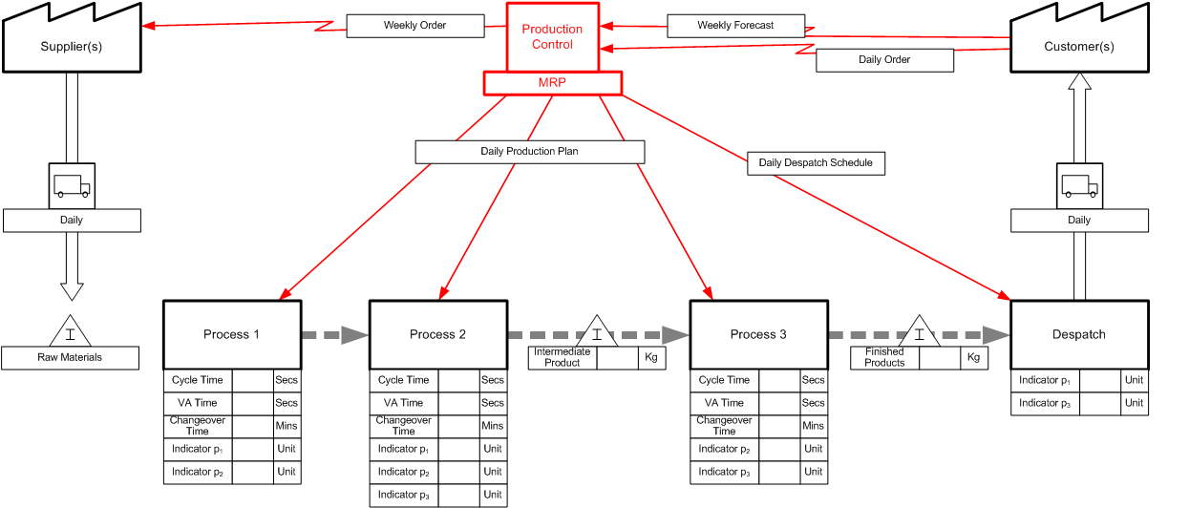

Source: Norton (2007)
(Drawn using eVSM v.2.3 from GumshoeKI, Inc. 2000-2005)

This encourages the application of lean thinking to performance indicators other than just time. On the value stream map, quantities for each EPI are shown in data boxes below each process box in a similar way to the usual lean measurements (Figure 3). This helps in visualizing the association between each activity and the various EPIs, in order to provide insights into opportunities for improvement.

After measuring and mapping the various performance indicators in the current state, the next step is to evaluate how these might be improved in the future state. Table 1 shows some generic objectives for each performance indicator used in SVSM when applied within the chilled food sector.

Table 1. Objectives for EPIs Within the Chilled Food Sector (quantities to be expressed per unit weight of product)
INDICATOR | TO BE QUANTIFIED | OBJECTIVES
Production Time | Time spent in manufacturing, transport and storage activities, in units of time. | Eliminate avoidable non-value-adding time and minimize necessary but non-value-adding time, thereby increasing the proportion of value-adding time.
CO₂ Emissions | Delivered energy used in manufacturing, cold storage and transport activities, expressed as grams CO₂ equivalents. | Eliminate or minimize transport and cold storage stages.  Optimize manufacturing activities.
Water Usage | Water used in manufacturing and cleaning activities, in grams. | Eliminate unnecessary water usage, e.g. minimize the number of wash-outs by sequencing products to ‘follow on’.  Reduce consumption, e.g. re-use water for cleaning.
Food Waste | Food waste arising as trimmings, unusable partially/fully prepared items and unsold finished products, in grams. | Eliminate or reduce, e.g. minimize over-production and buffer stocks.  Investigate disposal options other than landfill.
Biodegradable Packaging Waste | Cardboard/paper waste mainly from transit packaging, in grams. | Eliminate or reduce.  Investigate re-usable alternatives.  Recycle where unavoidable.
Plastic Packaging Waste | Various plastic wastes from primary and/or secondary packaging of raw materials, intermediate items and finished products, in grams. | Eliminate or reduce.  Investigate re-usable alternatives.  Recycle where unavoidable.
Waste Metal Containers | Waste metal containers used for some wet raw materials, in grams. | Eliminate or reduce.  Investigate re-usable alternatives.  Recycle where unavoidable.
Biodegradable Matter in Effluents | Food waste discharged in trade effluents (charged on basis of volume and concentration by water treatment company), in grams. | Eliminate or reduce, e.g. minimize washouts, filter or separate from effluents.
Source: Norton (2007)
Example of the Application of Extended SVSM
The extended SVSM methodology was piloted on a simple value stream: the sourcing and packing of cherry tomatoes. The value stream of the selected product was mapped during a single site visit. From the outset, the intention was not to become ‘bogged down’ in the minutiae of individual activities. Each activity comprises a number of work elements which may or may not add value, and all such elements would normally be measured when carrying out standard VSM (Rother and Harris, 2001). However, a top-down approach was considered more appropriate for this research: firstly, because many activities in food production are automated, preventing their division into separate elements; and, secondly, because the aim was to capture the ‘big picture’. This top-down approach involved deciding whether each activity was predominantly value-adding, non-value-adding or necessary but non-value-adding and recording it as such. As many SVSM performance indicators as possible were measured and attributed to discrete activities. Where attribution to individual products was impractical because of multifunctionality, values were allocated using methods similar to those recommended in life cycle assessment (Guinee, 2002). Seasonal variations in waste levels were captured by analysis of historical waste data provided by the company. Additional information was gathered via semi-structured interviews with key staff.

Sourcing and packing of cherry tomatoes
Figure 4 shows a current state map for the activities in the cherry tomato value stream at a salad supplier, called Company X to safeguard confidentiality, and the types and annual quantities of waste arising from each activity. Analysis of historical waste data for a 12-month period provided a breakdown of quantities of wasted cherry tomatoes by activity at Company X (Table 2).

Figure 4. Current state map for the cherry tomato value stream at Company X showing types and annual quantities of waste

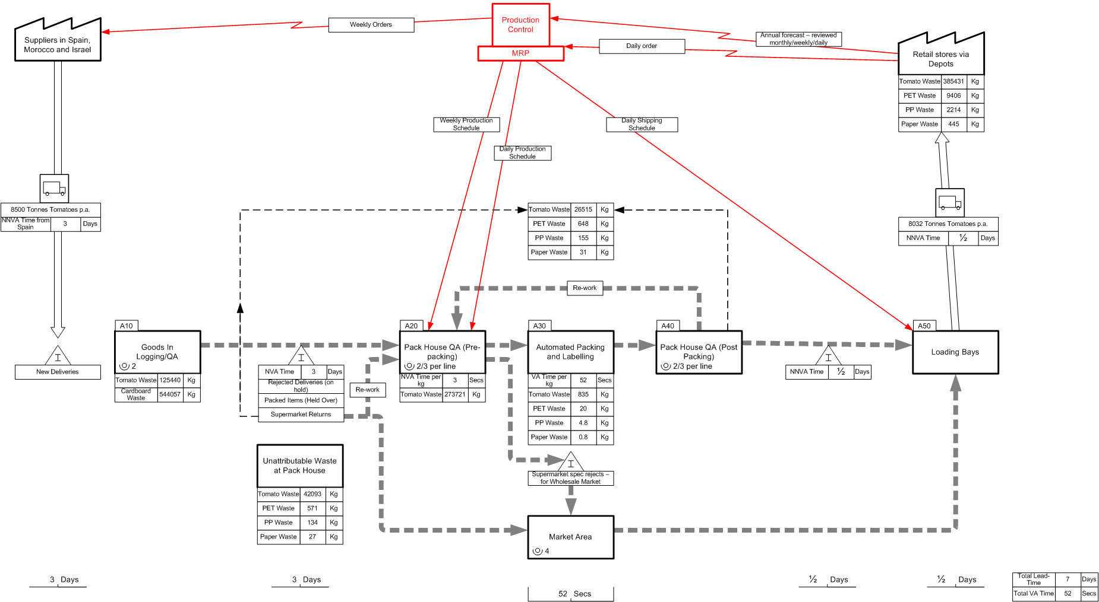

Source: Norton (2007) (Drawn using eVSM v2.3, GumshoeKI Inc. 2000-2005)
Table 2. Total annual quantities of physical waste arising in the cherry tomato value stream at Company X during a 12-month period from total imports of 8500 tonnes

Activity | Cherry Tomato Waste (kg/year) | Packaging Waste (kg/year)
Activity | Cherry Tomato Waste (kg/year) | Cardboard Transit Cases  from Raw Materials | PET from Packed Items* |  | PP from Packed Items* |  | Paper Labels from Packed Items*
Activity | Cherry Tomato Waste (kg/year) | Cardboard Transit Cases  from Raw Materials | SKU A | SKU B | SKU A | SKU B | SKU A | SKU B
Transport from Supplier |  | 544057
Goods In QA | 125440
Buffer Stock in Chilled Storage
Pre-packing QA | 273721
Weighing/Packing/Labelling | 835 |  | 3 | 17 | 0.8 | 4 | 0.2 | 0.6
Post-packing QA/Returns/Re-work | 26515 |  | 364 | 284 | 97 | 58 | 21 | 10
Chilled Storage of Packed Items
Transport to depots and stores
Disposal of unsold items | 385431 |  | 4764 | 4642 | 1270 | 944 | 274 | 171
Unattributable (at Pack House)** | 42093 |  | 281 | 290 | 75 | 59 | 16 | 11
TOTALS | 854035 | 544057 | 5412 | 5233 | 1443 | 1065 | 311 | 193

* Underestimates, as values for waste from setting-up, changeovers and equipment jamming on the packing lines were not captured.
** From figures for stocktaking and data entry errors
Source: Norton (2007)

Lead-times and value categories for major activities in the value stream are shown in Table 3. The company considers it essential to hold several days’ buffer stock to ensure temperature compliance and, more importantly, availability but with a strict application of lean principles this would be considered wasteful, more so because storage is in refrigerated conditions that consume a significant amount of energy. Also, although Lean proponents would not consider packing as value-adding, it has been categorized as such because packed tomatoes are more expensive at the retailer, and presumably something for which the consumer is willing to pay.

Table 3. Lead-times for activities in the Company X cherry tomato value stream, categorized as value-adding (V), necessary but non-value-adding (N), or wasteful, i.e non-value-adding and avoidable (W)

Activity | Lead-Time per kg | Value Category
Transport from supplier (in Spain) | 3 days | N
Goods In QA | Not observed | N
Buffer stock held in chilled storage (average) | 3 days | W
Pre-packing QA | ~3 sec | W
Automated weighing/packing/labelling | ~52 sec | V
Post-packing QA, returns and re-work | Not observed | W
Chilled storage of packed items (average) | 0.5 day | N
Transport to depots and supermarkets (average) | 0.5 day | N
Disposal of unsold items by retailer | n/a | W
Total Lead-Time | 7 days
Source: Norton (2007)

Table 4 shows the fuel-related CO₂ emissions, water consumption, tomato waste and packaging wastes attributable to specific activities. Values have been normalized to unit weight (kg) of cherry tomatoes sold at the checkout. It was not possible to attribute some historical waste data relating to stocktaking and data entry errors. Similarly, because energy usage and water consumption were measured by only a single meter in each case and had to be estimated using the economic allocation method from life cycle assessment (Guinee, 2002) , these indicators could not be attributed to individual activities.
Table 4. CO₂ emissions, water consumption and wastes, per kg sold at checkout, in the Spanish cherry tomato value stream served by Company X

Activity | Value Category | Fuel-related CO₂ Emissions  (g/kg) | Water Consumption  (g/kg) | Cherry Tomato Waste (g/kg) | Packaging Waste
 |  |  |  |  | Cardboard  (g/kg) | PET*  (g/kg) | PP*  (g/kg) | Paper Labels*  (g/kg)
Transport from Spanish Supplier | N | 149 |  |  | 69
Goods In QA | N |  |  | 9.8
Buffer Stock in Chilled Storage | W
Pre-packing QA | W |  |  | 21.3
Weighing/Packing/Labelling | V |  |  | 0.1 |  | 0.00 | 0.00 | 0.00
Post-packing QA/Returns/Re-work | W |  |  | 2.1 |  | 0.05 | 0.01 | 0.00
Chilled Storage of Packed Items | N
Transport to depots and stores | N | 12
Disposal of unsold items | W |  |  | 47.1 |  | 1.20 | 0.28 | 0.06
Unattributable Waste at Pack House** | W |  |  | 3.3 |  | 0.04 | 0.01 | 0.00
Unattributable to Specific Activities at Pack House |  | 18 | 70
TOTALS |  | 179 | 70 | 84 | 69 | 1.29 | 0.30 | 0.06

* Underestimates, as values for waste from setting-up, changeovers and equipment jamming on the packing lines were not captured.
** From figures for stocktaking and data entry errors
Source: Norton (2007)
The overall findings from the application of SVSM in this case study were as follows.

- The quality of materials was a major cause of waste, especially in relation to imports from distances further than Spain, probably due to greater deterioration during longer journeys.
- The order lead-time of less than 24 hours was greatly exceeded by the lead-time for supply of at least 7 days to reach the retail outlet.
- Buffer stocks were held for 3 days on average to ensure temperature compliance and, more specifically, availability so as to compensate for forecast inaccuracy and order volatility.
- Overall waste of cherry tomatoes at Company X was 5.5% of imports, but might have been higher if surplus stocks had not been sold to wholesale markets.
- Estimated waste of cherry tomatoes at the retail outlet was 4.5% of imports and was probably the result of over-supply to ensure on-shelf availability, although wastage per SKU per branch per week would have amounted to only a few cases.

Difficulties in Applying SVSM and Possible Solutions
The difficulties encountered in applying SVSM in the pilot study were largely related to being carried out by an individual investigator external to the company with access to only limited data, although this was sufficient for grasping the ‘big picture’. As originally proposed by Simons and Mason (2002), SVSM is intended as a ‘do it yourself’ method to be carried out by companies themselves. A team comprised of company employees representing each department would have access to the information required for a more accurate analysis with less estimation than that employed in this study. Some estimates would still be required for certain aspects of attribution, for example, for the allocation of total values for water and energy consumption to individual products, but allocation methods from life cycle assessment can be used for this purpose. With regard to energy consumption, some means of more accurately estimating that used for specific activities would be helpful, particularly for cold storage in order to determine the true environmental impact, and financial costs, of holding large buffer stocks in refrigerated conditions.

The top-down approach used in the research proved to be a useful way of getting started. At the site of another case study (a manufacturer of chilled ready meals), a number of production staff trained in standard VSM had found it difficult to apply to food manufacture due to the complexity of the production process. However, after applying the suggested top-down approach, two previously confused staff felt that it helped in clarifying differences between the categories of activity, and that the current state maps constructed would serve as a useful starting point for targeting specific activities and quantifying the finer detail of value-adding and non-value-adding elements within each activity. This approach might also make the construction of value stream maps at other manufacturing sites of complex products seem less daunting and more likely to be carried out.

Conclusions
The application of SVSM in a study of waste in the value stream of a simple product, cherry tomatoes, highlighted that nearly all the wasted tomatoes at the Pack House arose from QA activities and that waste was exacerbated by the need to hold buffer stocks in order to ensure availability due to uncertainty in supply/demand and forecast inaccuracy.

The method itself was found to be of practical value, as exemplified by its effectiveness in successfully capturing the quantities and causes of the predominant wastes and resource usage in the pilot case study. The adoption of SVSM by industry as a diagnostic tool might provide the insights into production efficiency and environmental performance that would pave the way towards more sustainable production.

Acknowledgements
The authors are grateful to the UK Department for Environment, Food and Rural Affairs for funding the study of waste in the UK chilled food sector.

References

ANON. (2002a) Waste not, Want not: A strategy for tackling the waste problem in England. Cabinet Office Strategy Unit, Crown copyright.
ANON. (2002b) World Summit on Sustainable Development 2002: Contribution by the UK Food and Drink Manufacturing Industry, London, Food and Drink Federation.
ANON. (2005) Securing the future: delivering UK sustainable development strategy. UK, Crown copyright.
ANON. (2006) The Lean and Environment Toolkit Version 1.0, USA, Environmental Protection Agency.
BERLIN, J. (2005) Environmental Improvements of the Post-Farm Dairy Chain: Production Management by Systems Analysis Methods. PhD Thesis. Goteborg, Sweden, Chalmers University of Technology, Department of Energy and Environment.
DEFRA (2001) Environmental Reporting: General Guidelines. UK, Crown Copyright.
DEFRA (2005) Guidelines for Company Reporting on Greenhouse Gas Emissions: Annexes updated July 2005. UK, Crown copyright.
GUINEE, J. (Ed.) (2002) Handbook on Life Cycle Assessment: Operational Guide to the ISO Standards, Dordrecht, The Netherlands, Kluwer Academic Publishers.
HAQUE, B. (2003) Lean engineering in the aerospace industry. Proceedings of the Institute of Mechanical Engineers - Part B - Engineering Manufacture, 217, 1409-1420.
JONES, D. & WOMACK, J. (2003) Seeing the Whole: Mapping the Extended Value Stream Version 1.1, Brookline, USA, Lean Enterprise Institute.
KARP, H. R. (2005) Green Suppliers Network: Strengthening and Greening the Manufacturing Supply Base. Environmental Quality Management, Winter 2005, 37-46.
MASON, R., SIMONS, D., PECKHAM, C. & WAKEMAN, T. (2002) Wise Moves Modelling Report: Life cycle modelling CO₂ emissions for lettuce, apples and cherries. UK, Department for Transport.
NORTON, A. (2007) Sustainable Value Stream Mapping as a Technique for Analysing and Reducing Waste in the UK Chilled Food Sector. PhD Thesis. University of London, Imperial College, Centre for Environmental Policy (Applied Economics and Business Management Research Section).
OHNO, T. (1988) Toyota Production System: Beyond Large-Scale Production, Portland, Oregon, Productivity Press.
ROONEY, M. J. (2005) Toyota System Production Meets Large Scale Change: A Synergy for Sustainable Improvements. Organization Development Journal, 23, 21-28.
ROTHER, M. & HARRIS, R. (2001) Creating Continuous Flow: An Action Guide for Managers, Engineers and Production Associates Version 1.0, Brookline, USA, Lean Enterprise Institute.
SCAFFEDE, R. (2002) What it takes to turn manufacturing lean: the experience of Donnelly Corporation. Journal of Organizational Excellence, Autumn 2002, 3-16.
SIMONS, D. & MASON, R. (2002) Environmental and transport supply chain evaluation with sustainable value stream mapping. 7th Logistics Research Network Conference. Birmingham, UK.
SIMONS, D. & MASON, R. (2003) Lean and green: 'doing more with less'. ECR Journal, 3(1), 84-91.
SIMONS, D. & ZOKAEI, K. (2005) Application of the lean paradigm in red meat processing. British Food Journal, 107, 192-211.
TAYLOR, D. H. (2000) The Application of Lean Principles to the Improvement of a Global Supply Chain. 5th International Symposium on Logistics. Iwate, Japan.
UN (2004) Sustainable Development. UN Department of Economic and Social Affairs.
VENKAT, K. & WAKELAND, W. (2006) Is Lean Necessarily Green? 50th Annual Meeting of the International Society for the Systems Sciences. Sonoma State University, USA.
WOMACK, J. & JONES, D. (2003) Lean Thinking, London, Simon & Schuster UK Ltd.

