Sound Connections online symposium : Training workshop leaders in a time of Covid.

First published online:

Walduck, J., (2020), Sounding Board, Sound Sense 2020, Issue 2. [accessed 26/10/2021, https://www.soundsense.org/DB/sounding-board-2/sounding-board-2020-issue-2?ps=Q25KNeFMI8z9dXPn5SPCmAXR8spvOk]

Full text:

How is Community Music adjusting to the current social restrictions due to Covid-19? How do we re-frame changing practice for our trainees and students? How relevant is current training to the post-Covid CM landscape?

On 9th June, 28 delegates joined Sound Connections for a Zoom event Training Music Leaders in a Time of Covid, to discuss these issues. The event was a vibrant meeting of minds – perspectives were offered by emergent practitioners, mid and late-career practitioners, music leader trainers, researchers, and arts engagement programme directors.

What follows is a summary of the ideas that emerged. Whilst similar discussions have taken place elsewhere, this one was framed by a specific context: the need to reshape music leader training for digital and blended futures. However, I hope the ideas will resonate with everyone involved in music and communities.

Training Music Leaders in a Time of Covid offered short provocations, punctuated by low key improvised music from the speakers – modeling a willingness to disrupt expected ways of running a meeting, and reminding us that, after all, it’s still about music. The ensuing discussion embraced both current challenges and possible ways forward.

The provocations.

Jackie Walduck:
How can we meaningfully move practice online, when much practice is built upon real-time interaction, physical presence and embodied music making? What do these elements look like in online practices? What do we gain or lose from the pivot? What does the “new normal" mean for workshop leader training?

Simon Limbrick:
The networked environment is now a location for some wonderfully creative and educational activities. If much of the world chooses to engage through gaming and shared social behaviours, then this is also a space for creative participation. Networked participation shifts artistic energies to a locus, that by its fluid nature, runs counter to the conventions of institutionalised performance and creativity. For me, this is a beginning, not a version of the past.

Rosie Bergonzi:
Our system of hierarchies and apprenticeships has failed. How can I be the only Black person in this whole meeting? How can we use the opportunities of lockdown to create a workforce that reflects the participants we work with, and the diversity found in London?

Pam Burnard (excerpt):

A POETIC PROVOCATION:

And in these moments, we are not afraid
And in these moments, ideas come into play
And in these moments, new spaces unite and re-enable us,
And in these moments, we become social entrepreneurs; solving social problems and affecting social change

Themes from the discussions:

Early-career practitioners, adapting their recently-honed leading skills to online contexts, felt that emerging track records would now be based on risks taken in a new environment, as much as on their growing expertise in creative delivery. Evaluation supported by programme managers and colleagues plays a crucial role in developing confidence. We accept that online requires new benchmarks for success.

As teachers and mentors, we have created ways of supporting trainees to develop embodied practice. Some training processes will migrate on-screen, and other new methods will grow. Reading “Gallery View” instead of reading the circle is something we are all adapting to. What many of don’t yet have is online “context” experience, the (years of) experience that enable us to make wider sense of what’s happened when giving feedback.

On access: digital technology collapses geographical distance, enables access for people who face mobility or anxiety barriers, and for parents or carers who may be time-poor. Some participants love to interact through the screen, and are more active within sessions. However, the question of digital poverty has been brought into sharp focus for others, highlighting a need for strategies to enable access to IT equipment, phone credit, and quiet-enough space from which to take part in synchronous online events. Soundcastle’s move to online practice was a journey, a process in which the whole team became zoom-coaches, supporting participants with the new platform.

Hugh Nankeville spoke of low-tech solutions: playing outside the care homes he works with, and exchanging letters instead of digital files.

Adrian Lee suggested allowing participants to have agency over how they use the tech – this open approach allowing creativity to transpire.

Our meeting in June felt like a time of new possibilities – a future that might be fairer, kinder, more accessible, greener, exploring networked technologies. Many of these are familiar CM values. There was a real sense of seizing the moment of disruption brought about by lockdown to step into new approaches: take creative risks, welcome an online/blended space that could both refresh current practices, and offer new opportunities. This echoes widespread calls for social change post-Covid. However, if now turns out to be a period of sticking-plaster solutions to bide time until everything returns to normal, it is vital to weigh “back to normal” (access, embodied experience, travel time, carbon footprint, forms of creativity) against “what might have been” (if we’d only had the courage to step into the new). Knowing the difference between the dream and the reality helps us focus on the kind of change we want.

Thanks to everyone who took part in the original symposium, and your generosity in sharing your thoughts and ideas.

Call-out for Sounding Board readers’ experiences:
We are planning a series of articles for future Sounding Board editions. If you have experiences you are willing to share along these themes, please contact Jackie at J.Walduck@Kent.ac.uk.

What training do you need now to address an online or blended future CM practice? What skills are you currently developing? What models of practice would you like to know more about? Is there any research that would inform your current online/socially distanced/blended practice?

What support do freelancers currently need? eg opportunities to develop new practice? Opportunities to evaluate with programme managers? Evaluations and feedback to be shared? Sharing of new project models?

Does the CM workforce reflect the communities we work with? We do we need to do to create a more diverse workforce, and in what ways will this enrich the CM tapestry further?

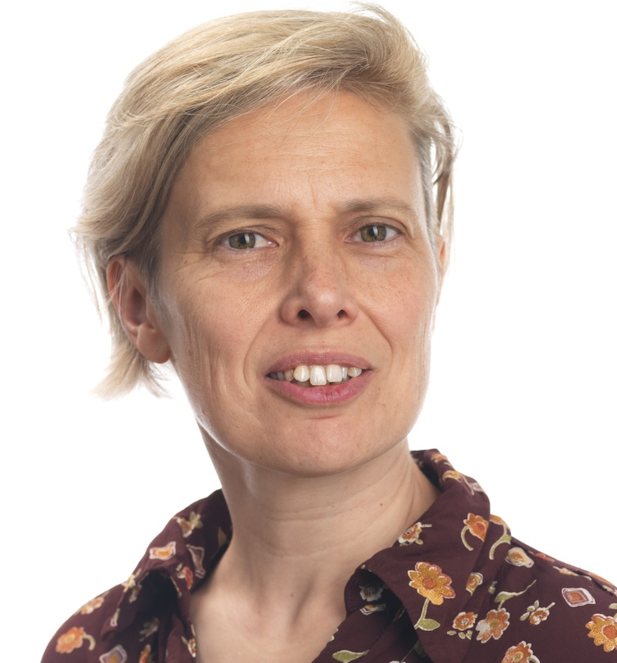

Photo credit: Gianluca de Girolamo

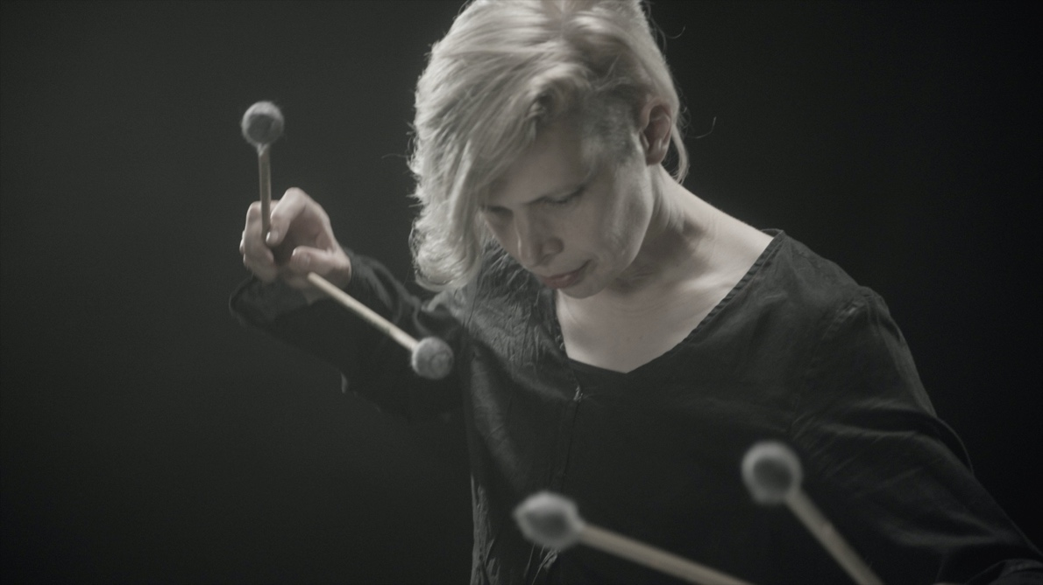

Photo credit: Brendan McGuinen

Biog

Jackie Walduck is a composer and improviser, whose work explores the interface between the two with different communities of learners. She is a Lecturer in Community Music at the University of Kent
www.jackiewalduck.org

