13. Using photo diaries as an inclusive method to explore information experiences in Higher Education
Ben Watson and Jennifer Leigh (University of Kent, UK)

Abstract
In this chapter we discuss our method of ‘diary-photograph: diary-interview’ (which included photo-elicitation diaries and face-to-face interviews) as used in a comparative study to understand how print disability affects students’ access to information.

A person with a print disability may have a visual impairment, have dyslexia, or a physical disability that prevents them from being able to access a physical copy of a print publication. Students with a print disability may therefore be disadvantaged within an HE setting.

We asked participants with and without a print disability to keep a diary for a week and record experiences accessing information in relation to their studies, and also socially.

In addition to sharing details of our method and analysis, we discuss how it worked in practice, and the potential challenges of using the method, These included; variation in quality of diaries, the lack of researcher control, the selectivity of responses, and possible inequities of the format. Overall, it was
an effective and inclusive method, delivering a wide range of data from all participants. The data did not focus on the electronic and physical aspects of reading or accessing texts as had been expected. Our participants showed that they experienced barriers in accessing information beyond print accessibility. The participants relayed wider issues relating to accessibility which presented as informational barriers to students both with and without disabilities.

Introduction
In this chapter we describe the use of a multi-method solicited diary approach that we call diary-photograph: diary-interview. It was used with an aim of comparing the information experiences of students with and without print disabilities in Higher Education (HE). We asked participants to create a log of their learning activities over the course of a ‘typical week’, and supplement the written log with photographs that highlighted particular issues when accessing information. The students then had the opportunity to discuss their entries in detail with researchers in an interview. They reflected on their entries and explained the context and feelings behind the events that impacted either positively or negatively on their learning experiences.

We use this study to highlight the ways in which diary methods, and in particular this variation of a diary method, can challenge the researcher in HE and provide unexpected insight. For example, what was perceived as straightforward accessibility of print materials through information services, actually impinged on larger issues of identity and belonging.

In addition to critically appraising the methodology, we share some of our findings, as they highlight some criticism often directed at diary methods. The first issue is variation in quality and quantity of entries. The nature of participant responses can leave the method open to standard criticisms levelled at qualitative research methods. However, diaries, particularly when the structure and format is left open as here, can result in a huge variety of types and richness of data depending on the level of engagement, involvement and situation of the individual respondent. This can be a strength, as the data may reach beyond that gathered using a more structured or rigid technique. Our study showed how using an open diary-photograph: diary-interview led to the data encompassing a range of areas of HE that were not originally anticipated.

Connected to this, the second issue might be a lack of control from the perspective of the researcher. They are in control of neither content nor nature of the data, and it could easily go beyond what would be manageable and relevant. We choose to see this as a creative opportunity (Brown & Leigh, 2019), bringing in possibilities of genuine discovery, and creation of knowledge. However, there is a tension between keeping the brief absolutely clear to all participants at the beginning of the study to minimise the risk, and allowing it to be open to new connections.

A third issue is the selectivity of participant responses, which is in turn connected to the final issue of inequity of the form. Diary research may be a form that encourages engaged students to provide more information than respondents who are not so confidant or whose personal circumstances do not elicit the same level of emotional involvement in the study. In this chapter, we will discuss, using examples from our data, how some of these issues seemed to us to be positive benefits, all the while aware of Alaszewski’s (2006:80) constant dilemma of diaries ‘attaining relevant data without restricting the diarists writing flow unnecessarily’.

Information, print, and accessibility in HE
The nature of modern university education requires the smooth flow of large amounts of information. Technological and cultural barriers may mean that students (or staff) with a print disability are not always enabled to access information as fluidly as their non-disabled counterparts. Print disability is defined by the Copyright Licensing Agency (CLA) as ‘a visual, cognitive or physical disability [that] hinders the ability to read print’ (CLA, 2016).

A person with a print disability may have a number of different impairments. They might have a visual impairment, so they cannot access text visually or at the same size as those without a disability. They may have dyslexia, or a similar specific learning disability. They may have a physical disability that prevents them from being able to handle a physical copy of a print publication. Any type of print disability may have negative implications for academic outcomes, as it would affect the ability they would have to access and process information. A typical barrier to accessing information is when a source is not available in a format that is accessible to their requirements. For example, this might be a visually impaired person being unable to access module reading because the resource does not work with their screen reading software, or a person with a hearing impairment finding multimedia content difficult due to a lack of captions or transcripts. Beyene, 2018:126. highlights the potential impact this could have:
“Users with print disability who rely on screen reader technologies could effectively be excluded from digital services if the search interfaces are not easily navigable, or if resources such as ebooks cannot be “read” by screen readers.”

There has been a welcome shift towards a more mainstream and inclusive approach to supporting students with disabilities in HE. The adoption of the social model of disability seeks to embed inclusive design in an effort to deliver accessible by design services at the point of need without any retrospective adaptation. The traditional medical (individual) model of disability would posit that it is the “functional limitations” of disabled people that are the reason for exclusion and rather than institutional oversight:
Firstly, it locates the 'problem' of disability within the individual and secondly it sees the causes of this problem as stemming from the functional limitations or psychological losses which are assumed to arise from disability. These two points are underpinned by what might be called 'the personal tragedy theory of disability' which suggests that disability is some terrible chance event which occurs at random to unfortunate individuals. (Oliver, 1990:n.p.).

The social model of disability demands a fundamental overhaul of thinking around how the preeminent culture has developed:
The genesis, development and articulation of the social model of disability by disabled people themselves is a rejection of all of these fundamentals. It does not deny the problem of disability but locates it squarely within society. It is not individual limitations, of whatever kind, which are the cause of the problem but society's failure to provide appropriate services and adequately ensure the needs of disabled people are fully taken into account in its social organisation. Further, the consequences of this failure does not simply and randomly fall on individuals but systematically upon disabled people as a group who experience this failure as discrimination institutionalised throughout society (Oliver, 1990:n.p.).
This is reinforced by the Disabled Students Sector Leadership Group (2017:12) which calls for the implementation of an inclusive, and technologically advanced practice to support students with disabilities:
HE providers could embrace and adopt this approach as it supports and guides the ways in which pedagogy; curricula and assessment are designed and delivered to engage students in learning that is meaningful, relevant and accessible to all. It embraces a view of the individual and individual difference as the source of diversity that can enrich the lives and learning of others.

It is imperative that a university looking to change their practice and ensure it is inclusive seeks feedback from people with disabilities to understand the barriers from the user perspective (DSSLG, 2017). This helps with to identify and address the patterns of difficulties experienced by all students (Newman et al. 2018). Solicited narrative diary research is a good option for the ‘methodological and theoretical flexibility’ (Mackrill, 2008:12) it offers and the facility to capture the everyday lives of participants’ experiences, practices, habits, actions in order to gain an authentic insight into ‘their inner world’ (Milligan and Bartlett, 2019:1450) in a more holistic way than the ‘snapshot views’ of social practice’ (Mackrill, 2008:9).

At Kent, the university has sought to embed inclusive approaches to the delivery of information and the use of assistive technologies for all, and take a holistic approach to the mainstreaming of adjustments as an approach to learning, teaching, research and support as a key strategy to benefit from the new opportunities to improve access for everyone. The aim is for the general information services to be as accessible as possible. Beyenes (2018:122) notes that the ‘advent of digital technology and the production of information in electronic formats, coupled with the introduction of accessibility guidelines, have created a favorable ground for pursuing the ideals of all-inclusive information services.’ In order to achieve this, it is important to know where the barriers are for students with print disabilities, so that work can be put in place to eliminate them. We as authors undertook this diary-photograph: diary-interview study to help understand the different ways that students access information in order to shed light on:
- barriers that print disabled students experience (with a view to removing those barriers), and
- how positive or negative information experiences make people feel about their place within the institution

The diary method provides a very effective means of ‘shadowing’ the student to reveal differentiated or inequitable experiences to inform strategies to improve educational opportunities. A particular benefit of the diary-photograph: diary interview format was the richness and feeling of the responses it enabled us to document, and the potential to ‘access data that subjects otherwise conceal’ (Milligan et al., 2005:1892). This is reiterated by Harvery who recommends diary method ‘particularly in research that seeks to track changes and differences’ (2011:66).

We were very aware that whilst the definition of print disability is encompassing, the nature of a profound physical impairment is not the same as dyslexia or a visual or hearing impairment. Whilst there are many things an HE institution can put into place in order to increase accessibility, there will always be individuals with specific requirements or needs that have not been anticipated. By acting to increase accessibility in ways that we know affect many students we would be able to indicate to the university where it was possible to free up specialist time to support those with additional requirements. Where possible we did not want to assume and negate the experiences of our students, and instead, we wanted to capture their voices and learn from them.

Our diary-photograph: diary-interview study
Our phenomenological study incorporated twelve students, six with a print disability and six without. After gaining institutional ethical approval we asked for volunteers through our Careers and Employability Service who run a scheme that incentivises and rewards students for their active engagement in co-curricular activities with experiences of work. We found these were more than sufficient incentive and reward to attract a cohort of research participants. The students were chosen carefully in order to provide a varied sample spanning a range of year groups, disciplines and types of print disability.

We asked each student to keep a diary of their day-to-day experiences of accessing information at the university (both educationally and socially) for one week. We asked them to highlight positive and negative experiences, and reflect on the way the success or failure of the interaction made them feel. We specified that we were interested in barriers to information, and where the students felt a specific experience was particularly impactful, we asked them to take a photograph. With every image, the students gave us context with a textual annotation describing the barrier, how it hindered their research or study progress and how it made them feel. The students emailed their diaries and images to us at the end of the week.

Following the submission of the diaries, we set up interviews with each student, where we could meet them and review and use their diary as ‘a basis for further interviewing and communication between researcher and participants’ (Crilly et al., 2006:210). We wanted to make sure that we understood the diary entries, and had opportunity to clarify details relating to the reflective textual and photo elicitation elements. We wanted to make sure that we could understand as much as possible about the context of information interactions and associated factors the students experienced when comparing similar print disabled and non-print-disabled experiences.

We used a form of comparative analysis between the responses from print-disabled students and their non-print-disabled peers as a ‘basic logical approach of observation and interpretation’ (Teichler, 2014:394) to understand the experience of information access at Kent, and to begin to understand the potential causes of any difference in experiences. In analysis, any differences in experiences were categorised in order to seek to establish a ‘borderline’ (Teichler, 2014:394) between the experiences of these two groups and understand the reasons for difference. In order to do this, we used contextual information about the participants as it was essential for ensuring the relatability of findings between those who identified as print disabled and those who did not. For example, these contextual differences included the subject of study, nature of print disability and academic stage. These influenced the relevance of subsequent qualitative comparative analysis and the identification of relatable trends and themes.

Although we had not specified a format for the diaries, we were surprised that every student took a similar approach, writing a reflective diary and captioning images- either integrated into the main narrative diary or included as an appendix. The reflexivity precipitated by the diary method (Mackrill, 2008) was particularly useful for distinguishing between perceptions of similar information experiences and digging deeper in to how these experiences made the participants feel.

For example, a visually impaired student included the following entry in her diary (figure 1). She was highlighting the steps outside the university library where the poor contrast directly affected her experience of accessing information as it inhibited her use of the service, and elicited the following commentary at the interview stage:

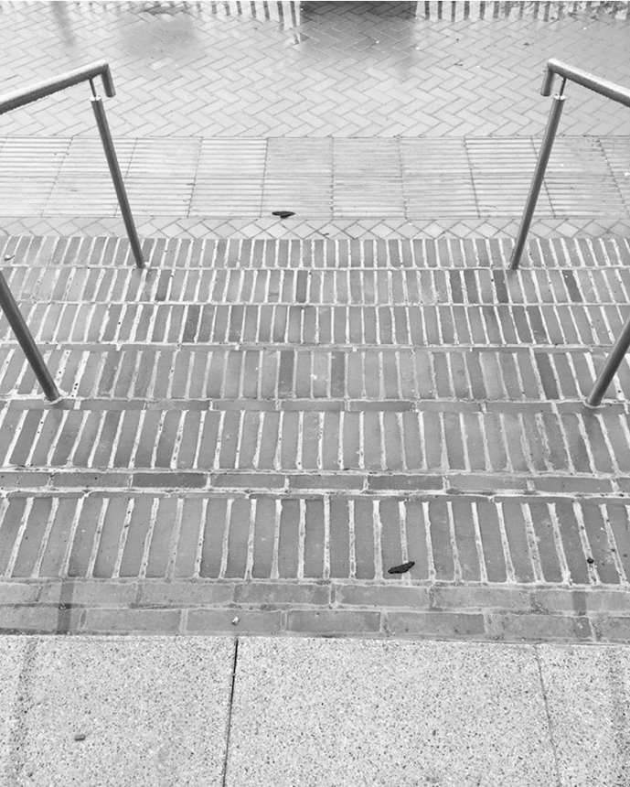
Figure 1 Lack of contrast on the library steps (participant photo).
But these stairs outside can just completely put a stop on my day and they made me really nervous, and the threat of falling down because they’re all the same– same facing brick, there’s no distinction between the stairs.
I think it’s something like the fact that I do get on with things so independently, it’s the fact that such a small thing can so regularly just jar me back into this having to stop and go, ‘Oh I’m disabled, I’m gonna have to go over here and do this.’
We shared this feedback immediately with key stakeholders, who were moved and convinced by the sheer detail and emotional impact of the student’s words to resolve this issue. The architects and our Estates department worked with the student to identify and test a range of solutions.

In a second example, a postgraduate mature student without a print disability recorded the following signage indicating the location of lecture theatres as problematic (figure 2).
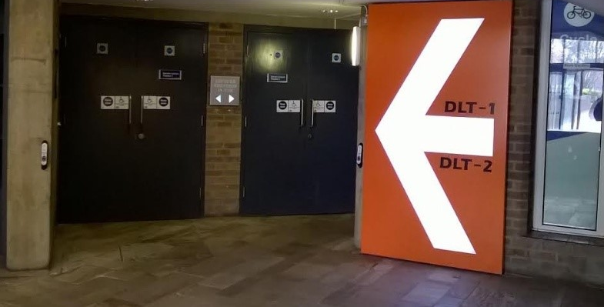
Figure 2 Image taken by participant indicating confusing use of acronyms to signpost lecture theatre location. Image description from student stated: ‘Pic 6 – Lecture hall (despite large arrow – spent ages looking for!)’ DLT-1 and DLT-2 are Darwin Lecture Theatres.

The student expanded on her difficulty in interpreting the sign in the interview:

Interviewer: What happened there? [referring to photo of Darwin lecture theatre sign]
Participant 6: So, well I think that was also me just being a bit ridiculous, because… So, this is at the back of the ground floor, and in front are, like, wooden benches. And the people, I didn’t know anyone that was going to be in this talk, but there was a group of maybe five or six people waiting outside to go in. But, not directly outside the lecture hall, they were waiting just in the middle milling around. So, I just, I don’t use Darwin that much, I came in and the last time I’d been in Darwin I’d had to go upstairs, that’s going back a bit. So, I didn’t know the layout, I went upstairs, realised I had no idea where I was or where the hall was. And I came downstairs, again, and looking around, like, is it, could it possibly be on the ground floor? Is it here? And then I saw the sign and there was clearly an arrow and I just missed it. It was probably because there was this group of people that I didn’t know that were stood in the middle, and I didn’t want to stare at them. And it’s different in every building, it’s coded. And a lot of the time, I have my timetable on my phone also, it will say the lecture hall I’m in, but not the building. And the, so I have to google Kent and then this weird string of numbers and then find out what building its in. Yeah. [laughs]
She felt uncertain, and as if it was her mistake, which impacted on her confidence and raised her stress levels as she had an unsettled entry into the lecture theatre.

Diary-photograph: diary-interview in practice
Our primary aim in the study was to capture a range of student experiences in text and visual means to categorise a variety of barriers to information access that all students might face, and through careful analysis begin to identify how far issues might relate to the nature of a participant’s disability. In this discussion, we explore how by incorporating creative and participatory research (Brown & Leigh, 2019) into what could have been a more conventional evaluation or assessment of accessibility, we felt we were able to access a deeper understanding of students’ experiences, and some of the implications of the diary-photograph: diary-interview method. Through using a combination of photo diaries and interviews we got beyond descriptions of simple processes and barriers and were able to tap into how the information experience made people feel as students and about their place within the institution. As one of the print disabled students commented in the follow up interview: “I guess that's kind of the big thing about accessibility: you just want to feel the same as everyone else”. This reinforced our desire and mission to build in accessibility, so that all students (and staff) had those barriers minimised where possible.

Variation in quality and quantity of entries
The facility offered by the diary method to enable the ‘absent’ researcher to be ‘present’ (Gibson, 2005:36) was particularly valuable to us. It provided the opportunity to see and attend to detail critical to understanding lived experiences of students (with and without disabilities) and to begin to understand differences in the broader student journey through HE:
We need to know a lot about how people with atypical functions get around and get along…This kind of information is no different from that routinely elicited from nondisabled people in designing facilities. But it requires the representation of people with a wide array of impairments, and it requires respectful attention to the minutiae of their daily lives (Wasserman et al, 2016:n.p).

The essence of Wasserman’s comment is echoed by Gill and Liamputtong (2009:1452) who identify that the diary form ‘can also be useful where a researcher is interested in uncovering routine, everyday processes and events that may be viewed by the participant as trivial and hence easily forgotten’. The ‘relatively unobtrusive’ (Milligan and Bartlett, 2019:1450) nature of this approach proved to be very beneficial. The range of responses subverted our initial expectations of what students would report. Based on the National Student Survey, we assumed that the topics covered by our students would relate mainly to technical issues, such as the library catalogue or electronic resources, or to access to physical resources such as finding library books. However, the experiences students shared included far more nuanced preferences for print or electronic resources, building access, signage, teaching spaces, university communication and processes, the student union, the importance of wellbeing for studying, and the natural environment of the campus.
In fact, the ‘freedom of expression’ (Mackrill 2008:13) engendered by the diary method meant that the data we received was wide-ranging, even to the point where we thought students had misunderstood the brief and began to question our strategy in relation to mitigating ‘data overload, selectivity and manageability’ (Cohen et al 2013:529). Mackrill (2008:13) similarly highlights this as a challenge of the diary method but also considers it equally a strength:
The diarist may choose to record data about topics other than the one the researcher set out to study. Thus, the diarist may reveal connections between topics that the researcher had not foreseen. Similarly, the diarist may present data about a topic in ways that do not immediately make sense to the researcher, but which, upon further investigation, prove to be useful. In diary studies this is more likely to occur than in an interview study, as in a diary study there is no interviewer to get the subject back on the researcher's track. This can lead to surprising data, as the tracks the diarist goes off on may be highly relevant. This challenges the researcher to be extra open to the diary data and search for possible relevancies that do not immediately catch the eye.
However, in every case when we explored the diaries with participants in interviews, even apparently irrelevant issues (like the campus shop stocking culturally appropriate items or access to food and drink while studying) directly impacted their access to information. In one case, the student described how not being able to afford to eat or get a hot drink on campus meant that they did not get to the library and physical copies of the text at all.

The range of data presented a definite challenge to how we would process the findings. The range of barriers to information was broad. Topics covered included: library borrowing, library search systems, University events, teaching and teaching spaces, student support, wellbeing, study space, time management, forms, access to PCs and printing, software issues, storage, physical access on campus, e-resources, food and drink, web access, lecture recording and University communication methods.

The data was textual and visual. It was sometimes emotive and difficult to categorise as it was so rich capturing the surrounding data (Macgrill, 2008). It revealed many facets of students’ informational experiences. Even identifying a means to code and categorise each participant’s range of responses and information was challenging. Before using NVivo to manage and analyse the data, we used ‘old school’ post it notes on a wall attempting to make sense (figure 3):
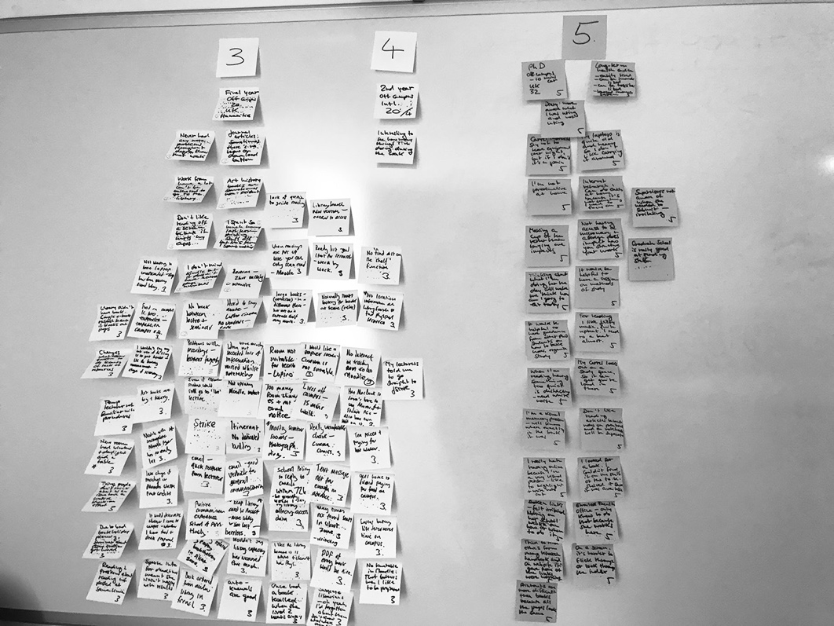
Figure 3 Our initial efforts to use Post-it notes to begin the process of filtering
Although time-consuming to analyse, generating lots of data to process is a strength of this type of study. Our data was a good vehicle for providing ‘unique insights into the life-worlds inhabited by individuals; their experiences, actions, behaviors, and emotions and how these are played out across time and space’ (Milligan and Bartlett, 2019:1447), such was the diversity of topics identified and the detail with which they were described. Indeed, the range of topics covered by our participants served to highlight how unique each student’s experience is (regardless of print disability) and made it particularly noteworthy and meaningful where commonalities and trends were identified.

Lack of researcher control
A related criticism levelled at such diary methods is the lack of control the researcher has concerning the structure of the data that is going to be returned. Mackrill (2008:14) notes that ‘solicited diary methods require the researcher to relinquish control of part of the research process’, however, again, this represented one of the key advantages of the format for us, namely ‘participant independence’ (Gibson, 2013:396), which supported the researcher’s ability to act as a passive observer of real lived experiences from a diverse range of areas of student life that we would otherwise be unable to enter.

Each one of our participants was provided with a basic framework detailing the parameters of our research, and clearly outlining what kinds of experience we would like them to capture, for how long, and advising of ethical steps to ensure their wellbeing and privacy. We did not offer a prescribed format or template– preferring an unstructured approach to enable participants to create responses they felt would best reflect their personal experiences.

Although this lack of structure posed a potential risk in that we could not control what we got back, we found the participants brought their individual understanding to the brief, and, as a result, provided us with a very rich source of qualitative data and an insight into their lives across a range of stages, subjects and social experiences. These were relatable enough to be effectively dissected at the interview stage with careful questioning based on each diary entry and supporting image. Even the images and text which did not immediately seem to relate to information accessibility, had clear connections once placed in its context in the interview.

The unstructured approach had the advantage of being less likely to be directly influenced by the researcher, enabling participants to document authentic and immediate experiences. Indeed, Cohen et al (2013:530) note that photo elicitation can be a good method to provide alternative focus, avoiding ‘awkward silences’ and ‘intimidating eye contact’ between researcher and researched and therefore may provide a good record of the genuine ‘lived’ experiences. This was particularly beneficial as an approach for participants with autistic spectrum conditions who stated that they felt more comfortable with the freedom of the diary format to document their thoughts in their own time and space. This corresponds with the findings of Filep et al. (2015:461) who observed that ‘if participants are comfortable with the method, diaries can provide space in which…[participants] feel free to reflect or reminisce’. This not only allows elaboration on the complexity of thoughts and emotions at any moment, but also challenges temporal and relational sequences of how we process the world.

However, to be successful, it is vital that participants are clear about the basic parameters of the study and the relevance of experiences they should be aiming to record to avoid the risk that the entries of each participant will not be relatable (notwithstanding similar subject focus, stage etc.) which would ultimately limit the verisimilitude of the comparative analysis stage.

Selectivity of participant responses
The ‘difference’ or ‘selectivity’ in what is recorded is interesting in itself as a form of data and ‘these choices reveal aspects of the self as much as diary content' and can be probed further within an interview’ (Mackrill, 2008:14). This was evident as we attempted to distinguish experiences of students with and without disabilities. Indeed, as our analyses of the data progressed, we noticed alternate perspectives and areas of differentiation that we had not initially anticipated. For example, international students had concerns about lack of availability of culturally diverse food in the student shop, while most students expressed concerns over costs of refreshments on campus. Visually impaired students highlighted physical access alongside the digital and informational, while commuting students included photographs of public transport to indicate the challeneges faced by commuting students when University communications are unclear around the cancellation of classes.
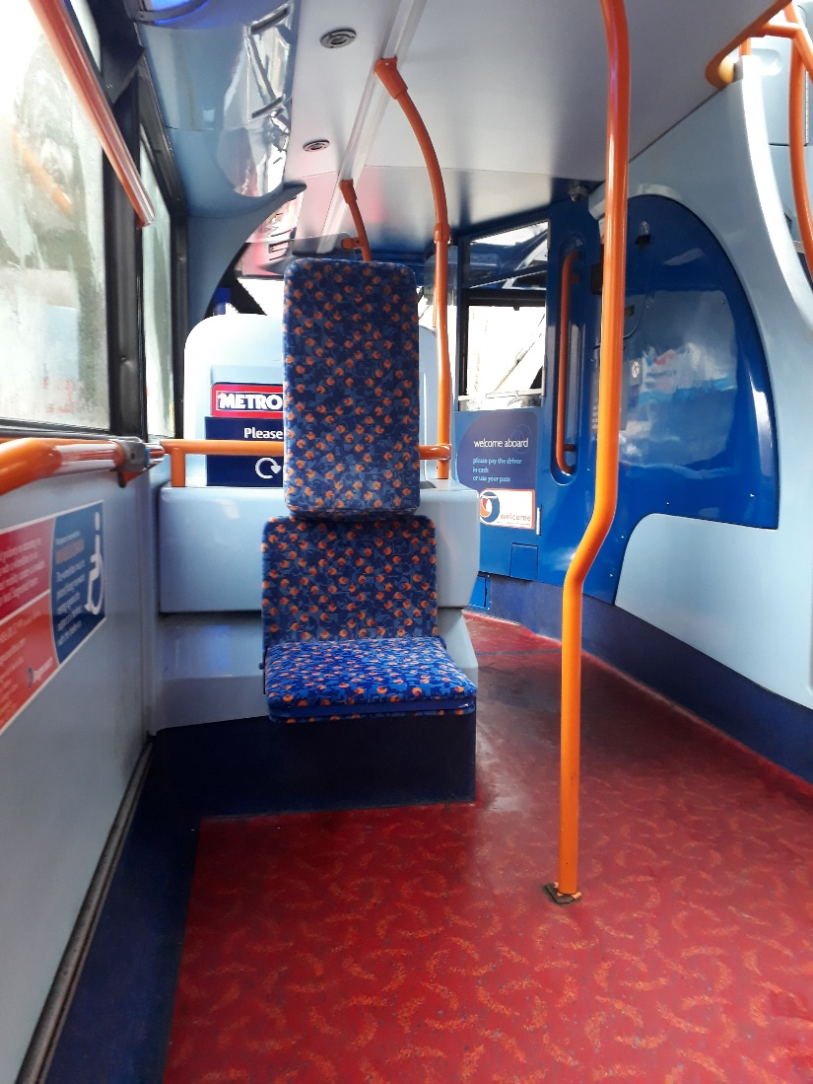
Figure 4 Photograph of inside of bus taken by a student to indicate inconvenience to commuting students when classes are cancelled.

In relation to the selectivity of photo elicitation, Cohen et al (2013:529) highlight the potential pitfalls of the camera being selective and fleeting and failing to therefore deliver a ‘singular objective reality’:

Whilst cameras report what they see and what really happens (rather than the selective observation of the human observer), nevertheless images are selective, in that the image maker has already decided what to include or not to include, what to focus on and what not to focus on, where to point the camera and where not to point the camera. Images also create their own representational and symbolic forms and they are time-­bound– they catch a particular moment (or several).

In a study such as ours there were many variables to be aware of. How can we be certain that the barriers experienced are genuinely related to the nature of a person’s print disability and how can this be disaggregated from other factors such as general academic performance, motivation and engagement? These may also have a bearing on how students perceive (and feel about) barriers to information access. For example, some students may be more resourceful and able to find solutions to problems and may therefore not experience them as negatively. The relatability of the qualitative experiences of each student will also be dependent on factors such as subject of study and their academic stage.

Inequity of the format for all participants
There is criticism of the potentially inequitable nature of keeping a diary as something that is hostile to people with differing abilities and that the form ‘favor[s] more literate and better-educated participants’ which can be ‘exclusionary to those with poor literacy skills or those with cognitive or physical limitations that hinder their ability to perform the task of diary keeping (Milligan and Bartlett, 2019:1457). This was a particular concern for us given our focus on print disability, and because we were asking visually impaired students to document their experiences visually. This is feasible using talking camera type applications such as Seeing AI which the researchers provided to all participants in the form of a briefing summary that gave ideas for record keeping (to gently suggest an approach without seeking to overly prescribe one.). However, this was not borne out in our findings- our perception based on the student feedback we received was that any differences in quality of diary entry were more a product of the student’s lack of time or general organisation.

The photo elicitation part of the diary was, in fact, quite a leveller in terms of capturing ‘knowledge that is not reducible to language’ (Bagnoli, 2009:547) and proved a helpful methodology to apply to understanding the potential differentiation of user experiences in modern university education. Gibson (2013:386) notes this by stating ‘photographs…provide a visual illumination of the unthought or unstated that, when combined with other methods, reveals how identities are produced and reproduced in the everyday’.

Bagnoli (2009:547) argues that ‘the inclusion of non-linguistic dimensions in research…may allow us to access and represent different levels of experience’ - offering new and unforeseen insights that traditional methods may not be able to elicit: ‘The use of interviews relies on language as the privileged medium for the creation and communication of knowledge. However, our daily experience is made of a multiplicity of dimensions, which include the visual and the sensory, and which are worthy of investigation but cannot always be easily expressed in words, since not all knowledge is reducible to language (ibid).

Whilst we are aware of the issues and considerations that using the diary-photograph; diary-interview method entailed with regard to variation in quality of data; lack of researcher control; selectivity of participant responses and potential inequity of the method; we feel strongly that its benefits added much value to our research.

Conclusion
The study exceeded our expectations in relation to the range of information access issues it helped us to identify, and this is due to the methodology that we employed. The relatively unstructured approach of diary-photograph: diary-interview elicited a wide range of responses by offering all participants the freedom to creatively document their information access processes for the week of the study. By not limiting our participants to a particular format or by being too controlling about a structure, we were able to find out how they perceived ‘information access’ as a much wider topic than just the technological or physical aspects of library searches and software we were expecting. To the contrary, the students shared barriers to information that shadowed larger aspects of inclusion for students with disabilities or from different cultural backgrounds. We also gained insights into how information barriers made them feel which enabled us to begin to formulate a sense of the collective impact of even apparently small barriers to a broader sense of wellbeing. This is important for understanding factors around digital inclusion which requires a thorough examination of issues related to access, skills, participation, and usage in context (Beyene, 2018:136).

We feel that there is much here of relevance to the sector, particularly in light of the rollout of the Public Sector Bodies (Websites and Mobile Applications) Accessibility Regulations (2018) (PSBAR) which require all public sector bodies to meet the requirements of WCAG by September 2020 (W3C, 2018). We feel that to meet these requirements it is paramount universities have an understanding of usability as well as technical accessibility criteria (meeting WCAG standard). One way to meaningfully achieve this is through dialogue with users to understand how they feel about the services at a deeper, emotional level. The diary-photograph: diary: interview method is highly suited to this type of work.

Among the students’ own words, we found much inspiration to inform our future work at the University, well in excess of what we had originally hoped to gain from the study. We end with a participant’s words on how best to support students with disabilities:

I am always telling non-disabled people that the best way to approach a disabled person is with the question ‘How can I help?’ Because from that I know that you want to help, you don’t know how to help, you trust me that I can explain, and you don’t have any preconceptions which can destroy the helping process.

References
Adams, M., Brown, S. (2006). Towards inclusive learning in higher education: developing curricula for disabled students. London: Routledge.
Alaszewski, A. (2006). Using diaries for social research. London: Sage.
Beyene, Wondwossen M. (2018) Digital Inclusion in Library Context: A Perspective from Users with Print Disability, Journal of Web Librarianship, 12(2):121-140.
Brown, N., Leigh, J. (2019). Creativity and playfulness in higher education research. In M. Tight, J. Huisman (Eds.), Theory and method in higher education research, Vol 4:49-66. Bingley: Emerald.
Cohen, L., Manion, L., Morrison, K. (2013). Research Methods in Education. Taylor and Francis, 2013. :https://ebookcentral.proquest.com/lib/kentuk/detail.action?docID=1144438. (Accessed:12/03/2019)

Copyright Licensing Agency (CLA) (2016). ‘User guidelines. Higher Education Licence’. https://www.cla.co.uk/sites/default/files/HE-User-Guidelines.pdf (Accessed: 20/03/2019).
Crilly, N., Blackwell, A., Clarkson, P. (2006). 'Graphic Elicitation: Using Research Diagrams as Interview Stimuli', Qualitative Research 6(3):341-66.
Disabled Students Sector Leadership Group (2017) Inclusive Teaching and Learning in Higher Education as a Route to Excellence. https://www.gov.uk/government/uploads/system/uploads/attachment_data/file/587221/Inclusive_Teaching_and_Learning_in_Higher_Education_as_a_route_to-excellence.pdf [Accessed 28/04/2017].
Filep CV, Thompson-Fawcett M, Fitzsimmons S, Turner S. (2015). Reaching revelatory places: the role of solicited diaries in extending research on emotional geographies into the unfamiliar. Area. 47(4):459–65.
Gibson, B. (2005). Co-producing Video Diaries: The Presence of the “Absent” Researcher. International Journal of Qualitative Methods, 34–43. https://doi.org/10.1177/160940690500400403
Gibson, B., Mistry, B., Smith, B., Yoshida, K., Abbott, D., Lindsay, S., Hamdani, Y., (2013). The integrated use of audio diaries, photography, and interviews in research with disabled young men. International Journal of Qualitative Methods, 12(1):382-402.
Harvey, L. (2011). Intimate reflections: private diaries in qualitative research. Qualitative Research, 11(6):664-682.
Latham, A. (2003). Research, performance, and doing human geography: Some reflections on the diary-photograph, diary-interview method. Environment and Planning A, 35(11):1993–2017.
Mackrill, T (2008) Solicited diary studies of psychotherapy in qualitative research – pros and cons, European Journal of Psychotherapy and Counselling, 10(1):5–18.
Meth P. (2003). Entries and omissions: using solicited diaries in geographical research. Area, 35(2):195–205.
Milligan C., Bartlett R. (2019). Solicited diary methods. In Liamputtong P. (eds) Handbook of Research Methods in Health Social Sciences, Singapore: Springer.
Newman, I., Healey, C., Osborne, A., Newman, V., (2018) ‘Diversity for Everybody, Achievement for All, Patterns Not Labels’. The Journal of Inclusive Practice in Further and Higher Education, 10:1.
Oliver, M. (1990). The individual and social models of disability. Paper presented at Joint Workshop of the Living Options Group and the Research Unit of the Royal College of Physicians on people with established locomotor disabilities in hospitals (23/07/1990). https://disability-studies.leeds.ac.uk/wp-content/uploads/sites/40/library/Oliver-in-soc-dis.pdf [Accessed: 8/04/2019).
Teichler, T., (2014) ‘Opportunities and problems of comparative higher education research: the daily life of research’. Higher Education, 67.
Wasserman, D., Asch, A., Blustein, J., Putnam, D., (2006). "Disability: Definitions, Models, Experience", The Stanford Encyclopaedia of Philosophy (Summer Edition), Edward N.
W3C, (2018) Understanding WCAG 2.1. https://www.w3.org/WAI/WCAG21/Understanding/ [Accessed: 12/04/2019).
Zalta (ed.), https://plato.stanford.edu/archives/sum2016/entries/disability/ (Accessed: 7/04/2019).

The University of Kent was awarded the Times Higher Education Award for Outstanding Support for Students for the OPERA (Opportunity, Productivity, Engagement, Reducing barriers, Achievement) project, which is aimed at ensuring information services are accessible to all.

