Raw material optimisation and stone tool engineering in the Early Stone Age of Olduvai Gorge (Tanzania)

Alastair Key ª, Tomos Proffitt ^{b}, Ignacio de la Torre ^{c}

ª School of Anthropology and Conservation, Marlowe Building, University of Kent, CT2 7NZ, UK
^{b} Institute of Archaeology, 31-34 Gordon Square, University College London, WC1H 0PY, UK
^{c} Departamento de Arqueología y Procesos Sociales, Instituto de Historia, CSIC, Albasanz 26-28. 28037, Madrid, Spain

Keywords: stone tool; fracture mechanics; controlled experiment; cutting; blunting; abrasion

Abstract
For >1.8 million years hominins at Olduvai Gorge were faced with a choice: whether to use lavas, quartzite or chert to produce stone tools. All are available locally and all are suitable for stone tool production. Using controlled cutting tests and fracture mechanics theory we examine raw material selection decisions throughout Olduvai’s Early Stone Age. We quantify the force, work and material deformation required by each stone type when cutting, before using these data to compare edge sharpness and durability. Significant differences are identified, confirming performance to depend on raw material choice. When combined with artefact data, we demonstrate that Early Stone Age hominins optimised raw material choices based on functional performance characteristics. Doing so flexibly: choosing raw materials dependent on their sharpness and durability, alongside a tool’s loading potential and anticipated use-life. In this way, we demonstrate that early lithic artefacts at Olduvai Gorge were engineered to be functionally optimised cutting tools.
Introduction
Olduvai Gorge in northern Tanzania has a near continuous record of hominin occupation spanning >1.8 million years. Stone tool artefacts constitute a major source of evidence supporting this extended period of habitation and visitation ¹⁻⁵. Hominins produced a variety of stone technologies at Olduvai during Beds I and II (c. 1.85 – 1.2 million years ago), including tools from the Oldowan and Acheulean ¹.
Each recovered artefact provides behavioural evidence relating to the individual who produced it. Perhaps the most obvious behaviour-related feature is the type of material a stone tool is made from. Indeed, where multiple suitable raw materials exist in a landscape, tool producers made a decision (conscious or otherwise) to use one material over another. The decision processes underlying raw material selection behaviours represents a major element of Palaeolithic research ⁶⁻⁹, and is often vital to interpreting the behaviour and cognitive capabilities of early hominins ¹⁰⁻¹².
Olduvai Gorge has three main raw material groups suitable for producing stone tools; lavas, chert, and quartzite ² (Fig. 1). Each was used by hominins, but their selection varies chronologically, between sites, and is dependent on the tool type produced. Chert, available from a few localised sources, was primarily only accessible by hominins in Lower and Middle Bed II ^{7,13-15}. However, whenever it was available, hominins selected and exploited this material for flakes and retouched tools ^{7,14,16,17}; although tools and cores tended to be relatively small in size due to available blank dimensions ^{13,14,16,17}. The other two raw materials, lavas and quartzite, were continuously available to hominins for stone tool production ^{2,15,18}. Lavas, available in river channels across the Olduvai paleo-basin, were used to produce flakes, cores and large cutting tools (LCTs), including handaxes, and are abundant in Oldowan and Acheulean sites. When smaller lava tools were made there is a notable disparity between the number of cores and flakes present at sites ^{7,14,16,19-23}. Quartzite, mostly sourced from the Naibor Soit inselberg ~3 km north of the confluence of the Main and Side Gorges, was extensively used at Olduvai; predominantly for the production of small flakes (debitage) which frequently (but not always ²⁴) outnumber their lava counterparts ^{1,2,7,14,16-19,22,23,25}. Quartzite LCTs are also well represented at many Acheulean sites, although notable inter-site variation in LCT raw material composition exists ^{7,15,18,19,21,24-26}.
Why Olduvai hominins preferentially chose one raw material over another, in these variable ways, has puzzled archaeologists for >60 years. Proposed hypotheses explaining these phenomena include their disparate suitability for knapping (size, shape and material properties), edge functionality (durability, retouch frequency), production efficiency and expediency, cultural differences, and their relative accessibility or availability for hominins ^{1,2,7,14-19,22,27-30}. Given that some stone types available to hominins such as lavas and quartzite remained relatively consistent through time, it is possible that a single unifying factor could help explain the raw material selection behaviours of hominins at Olduvai Gorge. Yet, to date, no single factor is able to satisfactorily explain raw material selection decisions over the Oldowan and Acheulean. Here, we put forward the hypothesis that the sharpness and durability of a raw material’s cutting edge, and in turn their relative functional performance, may provide a unifying explanation.
Only recently have archaeologists started to investigate the attribute of edge sharpness empirically ³¹⁻³⁴. Controlled cutting tests have previously been used to record mechanical definitions of this attribute on lithic objects ^{32,33}, following techniques regularly applied within fracture mechanics research ³⁵⁻³⁷. Here, we apply a similar experimental procedure that allows the force (N), work (J) and material deformation (mm) required for a stone edge to initiate cuts in a material to be recorded. Using these data, we address whether the sharpness and durability of raw materials from Olduvai Gorge can explain their selection and use by hominin species across nearly a million years of the Oldowan and the Acheulean.
Methods
Fracture mechanics research regularly utilises controlled cutting experiments during investigations of edge sharpness, blunting rates, and the impact of edge geometry on cutting mechanics ^{e.g. 35,37,52,54}. Only recently has archaeological literature utilised similar techniques to answer Palaeolithic questions ^{32,33}. Here, we adapt the techniques used during fracture mechanics research ^{35,37}, and improve on those used previously for archaeological purposes ³², to compare the sharpness and durability of the three raw materials used to produce stone tools at Olduvai Gorge.
Raw material selection
The three raw materials used in this study, quartzite, lava and chert, dominate the archaeological record of Beds I and II of Olduvai Gorge ².
Quartzite blocks were collected from the primary source at Olduvai, the Naibor Soit Inselberg, located north of the confluence of the Main and Side Gorges. This quartzite is of metamorphic origin, is coarse grained, and possessed micaceous layers which are foliated and lineated ^{2,15}. The lava at Olduvai originated from the surrounding volcanic outcrops ^{2,27}, however, is abundant in the seasonal rivers and streams present today and during Beds I and II. A variety of different lavas would have been available to Beds I and II hominins, including trachyte, phonolite, and basalt ². For this study only basalt was used. The chert at Olduvai is formed through the precipitation of sodium silicate minerals from the saline, alkaline Olduvai lake during Bed II, over a short period of time (<10ka) ^{2,13}. The chert is fine grained with a chalk cortex and the nodules possess an irregular shape, which vary greatly in size. All chert flakes used in this study were produced from nodules collected in the primary known chert source at Olduvai, the Main Chert Unit at MNK ¹³.
Flake selection
Two nodules of quartzite, basalt, and chert were reduced by one of us (TP) to produce the flakes used in this experiment (Fig. 1). Each was flaked using hard hammer percussion, with the sole intention of producing edges suitable for cutting. Between 50 and 70 flakes were produced for each raw material. These stone types can display variation in their composition, which could influence their cutting performance. These differences will, however, likely be subtle relative to any differences observed between the three distinct raw material types examined here. From each raw material 30 flakes were selected on the basis of displaying straight, homogenous and relatively acute cutting edges. Each length of cutting edge was required to be greater than 15mm. A 10mm segment of this edge was clearly marked and assigned as the portion applied during the cutting tests.
Edge angle is known to significantly impact the performance of stone tools during cutting tasks ³². To control for its influence here, edge angle was consistent between the three raw materials. Using the ‘caliper method’ ⁵⁵, edge angle measurements were recorded at depths of 2mm and 4mm away from the edge apex, at three locations on the predetermined length of cutting edge (at 0mm, 5mm, and 10mm). The mean of these six measurements was the recorded ‘edge angle’ for each tool. The 30 edge angle measurements for each raw material were normally distributed (Shapiro-Wilk tests; p = .500 - .895), and were statistically compared for differences using t-tests (α = .050). No significant differences were identified between the three raw material samples (p = .066 - .546). Mean edge angle values for each material ranged between 31-35°.
For the cutting tests, each flake was secured into a wooden block measuring 116 x 30 x 22 mm using a commercially available polyurethane adhesive (Supplementary Fig. 1). Each flake was orientated such that the predetermined cutting edge was parallel to the motion of cutting.
Recording sharpness and durability through controlled cutting tests
The sharpness of a stone cutting edge can be defined geometrically or mechanically ³¹. Geometric definitions of sharpness rely on the measurement of tip radius at the apex of an edge ⁵². A first attempt to record this edge-form attribute on stone tools was recently performed by Stemp et al. ³⁴, who used multiple high-powered 3D microscopy techniques and tip curvature algorithms to examine geometric-sharpness on five stone tools. Here, we follow Schuldt et al. ³⁷, Key et al. ³² and others ^{33,36,35,51-54} by using a mechanical definition of sharpness. That is, sharpness “refers to the ability of a blade to initiate a cut at low force and deformation” ³⁷. Previous research has repeatedly confirmed that comparative measurements of force (N), work (J), and material deformation (mm) at the point of cut initiation can provide accurate measures of sharpness ^{35-37,51,54}. An Instron 3345 tensile testing machine is used here to record these attributes, at a rate of 20 herts (Hz) (i.e. 20 readings per second).
Tensile testing machines allow the movement of a cutting edge in a vertical plane, such that it can be lowered onto a worked material. Here, the wooden blocks containing the stone flakes were secured into the upper grip of the Instron device. Thus, the flake’s cutting edge was able to be lowered onto a worked material; in this case, polyvinyl chloride (PVC) tubing with a diameter of 2 mm. PVC tubing provides increasing resistance to a cutting edge as it is deformed prior to a cut initiation (as similarly observed in soft-solid bio-materials [e.g. muscular tissue]), while also maintaining identical material conditions for each cutting test. Previous experiments using similar materials have proven its efficacy for sharpness tests ^{32,33,54}. Tubing was secure using a steel frame and pulled taut (but not stretched) perpendicular to the flake’s cutting edge.
Each flake’s cutting edge was aligned with the surface of the PVC tubing prior to the start of the cutting test, at which point ‘loading’ measures on the Instron were balanced and ‘distance moved’ records were zeroed. Subsequently, flakes were lowered into the PVC at a rate of 20mm/minute until the cutting edge created stress enough to fracture the tubing and a cut formed (Fig. 1). Force (N) and material deformation (mm) at the point of cut initiation were recorded; as was the area under each cutting test’s stress-strain curve, which was used to calculate the work (energy [J]) required for cut initiations. Identical material conditions between cutting tests produced matching stress-strain curve shapes between samples. This allowed the area under each curve to be treated as a triangle (Supplementary Fig. 2), such that a curve area (a) equalled half the force (N) required multiplied by the distance moved (m) (i.e. $a=\left(F x m\right)× 0.5$).
Relative edge durability between the three raw materials was investigated by comparing reductions in performance across the duration of a known cutting task. In theory, more durable edges should better retain a relatively acute edge and small edge apex radius, and in turn, their capacity to cut efficiently ³¹. A randomly selected sample of 15 flakes from each raw material performed five longitudinal cutting strokes on an oak branch (with the bark already removed), which in turn created six ‘durability conditions’ (i.e. condition one was a fresh flake, condition two was after one cut, and condition three was after two cuts, etc.). In addition to the initial cutting test performed by each flake prior to use (see above), another five identical cutting tests were performed for each flake, one after each cutting stroke. Hence, each durability condition had its own record of force, work, and material deformation. It was, therefore, possible to calculate edge performance, and in turn edge durability, for each of these raw materials in the face of a cutting activity likely to cause edge attrition and blunting.
Raw material comparisons
Sharpness was compared between the three raw materials using the force, work and material deformation records produced from the full 90 flake sample (i.e. prior to any wood cutting activities). In this way, sharpness is recorded from each material in its sharpest state, immediately after being flaked. Shapiro-Wilk tests revealed force, work and material deformation values to contain a mix of normally distributed and non-normally distributed data (p = <.000 - .469). In turn, Mann-Whitney U tests were used to examine differences in these sharpness metrics between the three raw materials (α = .050).
Raw material durability was examined through relative changes in performance across the six controlled cutting tests. First, this was examined through percentage changes in mean force, work, and material deformation from each flake’s initial controlled cutting test, through to their sixth (n = 15 in all instances). Subsequently, Mann-Whitney U tests examined whether individual abrasive cutting strokes were enough to cause significant reductions in performance in durability conditions one through to six, and how this varied between the three raw materials. These tests were performed sequentially, such that sharpness measures from cutting test one were compared to test two, while test two’s data were compared to test three’s, and so on.
Results
Sharpness
Chert and quartzite from Olduvai Gorge are demonstrated to be significantly sharper than basalt collected from the same location. This result is consistent for the three sharpness metrics recorded here; the force (N), work (J), and material deformation (mm) required to cut (Table 1). Mean values emphasise the scale of these differences, with basalt’s force and material deformation results being at least twice as great as the other raw materials (Table 2; Fig. 2). This difference increases substantially for work (energy) values (Table 2; Fig. 2). Quartzite is marginally sharper than chert in all instances; these differences are not, however, significant (Table 1).
Durability
Edge durability was first assessed through percentage changes in force, work, and material deformation, from each material’s initial sharpness, through five separate use events. Basalt consistently returned the lowest levels of change (≤ 25%), and therefore displays the most durable edges (Supplementary Table 1). Chert returned lower percentage change values relative to quartzite (Supplementary Table 1). Differences between the chert and quartzite flakes were reduced relative to the basalt comparisons. Mean force, work, and material deformation values across the six durability conditions support these results (Supplementary Table 2; Supplementary Fig. 3).
Mann-Whitney U tests for each sharpness metric between sequential durability conditions (i.e. 0 ↔ 1, 1 ↔ 2, etc.) similarly identified basalt as the most durable raw material at Olduvai. Significant differences were only identified between conditions zero and one; supporting previous work identifying the earliest stages of blunting to have the proportionately greatest impact on stone tool performance. It was, however, only chert and quartzite that returned significant changes in force, work, and material deformation. Basalt did decrease in sharpness, but this was never to a significant extent.
It should be noted, however, that the cutting performance of chert, quartzite and basalt recorded here are specific to Olduvai Gorge, and caution is necessary before applying these results to similar raw materials (particularly quartzite) from other locations.
Discussion
For every stone tool produced at Olduvai Gorge, a decision of which raw material to use had to be made. Here, we demonstrate that edge sharpness and durability, and in turn functional performance, varies significantly between chert, basalt and quartzite. These substantive differences had potential to impact raw material selection-related behaviours throughout the Early Stone Age at Olduvai. Quartzite is identified as the sharpest raw material, requiring significantly less force and energy to use relative to basalt. Chert is nearly as sharp quartzite, but exhibits more durable edges. Basalt is confirmed as being substantially more durable than both chert and quartzite, but has significantly lower initial sharpness. Therefore, not only do raw materials at Olduvai Gorge display disparate performance characteristics ^{c.f. 38}, each has advantages and could have been preferentially chosen dependent on a tool’s context of use.
These fundamental differences would have remained consistent throughout the Early Stone Age at Olduvai. Thus, functional pressures should have equally affected the behaviour of Oldowan and Acheulean populations. The question of whether raw material selection decisions were optimised according to their respective performance characteristics is, therefore, applicable to the potentially different human species that produced stone tools at Olduvai Gorge, including smaller brained hominins with a diminutive stature (e.g. H. habilis) and larger brained species with more modern human-like anatomy (e.g. H. erectus s.l.).
As the sharpest raw material, quartzite required hominins to input the lowest force and energy levels during cutting activities. The ‘ease’ with which cuts are created is, then, greatest in this raw material. This difference applies equally to all tools made from quartzite. Why, then, did Oldowan and Acheulean hominins at Olduvai preferentially select quartzite for flake tools (debitage), chert whenever available, and lavas/quartzite disproportionately at different sites for LCTs? We propose that, in addition to stone sourcing distance factors, these choices reflect flexible, functionally-related raw material selection decisions by Olduvai hominins; different stone types were selected according to not only their initial sharpness, but the durability and longevity of their edges, and possibly the anticipated loading potential and use-life of tools.
The Oldowan is often considered an expedient cutting technology at Olduvai ^{1,14,24} and other Early Stone Age sites ^{39,40}, and thus the preferential selection of quartzite for flake tools is expected. It represents the most effective and efficient raw material for short-term cutting activities, where its initially greater edge sharpness maximises functional output (i.e. cut material volume) while minimising energy expenditure and loading (cutting force) requirements. Within this functional context there would be no substantive need for a more durable edge; although the harder the cut material, the briefer quartzite’s benefits would have been ^{32,41}. Chert displays benefits to its use – increased edge durability and longevity – relative to quartzite, but no demonstrative cost to the initial sharpness, and therefore efficiency, of tools. Given potentially high raw material transportation costs ²⁹ and a palaeo-environment where tools may be required for longer than initially predicted or used to cut hard materials, chert represents an enhanced raw material. This explains the preferential selection of chert during its limited period of availability. The relative increased prevalence of retouch on chert tools (e.g. at HWK EE retouched chert artefacts make up 12.9% of the total chert assemblage compared to 0.5% of the quartzite assemblage ¹⁷) can similarly be associated with the exploitation of a superior raw material over extended durations or multiple tool-use events ^{14, 16, 21}. Basalt would have represented a comparatively poor choice for expedient cutting tools; particularly those used for cutting activities involving highly extensible or flexible materials ³¹. Our results do not mean that basalt is not effective at cutting, but that it is significantly less efficient relative to quartzite and chert in the earliest stages of an edge’s use.
Over extended periods of use stone edges wear down ^{42,43}, become blunter (i.e. less sharp), and require greater force and energy inputs to perform a cut ^{32,33,44}. Confirming early experimental work by Jones ¹⁹, we demonstrate that basalt edges are significantly more durable than quartzite and chert, meaning that relative differences in performance between these stone types reduces over time. At a point basalt would not just display similar sharpness and cutting performance as quartzite and chert, but would likely overtake them (Supplementary Fig. 4). Recent experimental work¹¹ suggests that this point may not be reached until after a substantial number of cutting strokes (perhaps > 300). For tools with long use-lives basalt would, therefore, represent the superior raw material choice at Olduvai.
Handaxes and other LCTs are thought to have displayed (relatively) long use-lives and/or were used during heavier duty cutting activities that cause increased blunting ^{19,39,45-47}. Moreover, their larger size and longer cutting edges facilitate the exertion of greater cutting forces ^{45,48,49} and cutting stroke velocities ^{31,42,48,50} (respectively), which help counteract increased force requirements caused by reduced sharpness ^{41,44,50.51}.Within this functional context basalt (and other lavas) should represent the optimal raw material at Olduvai. Some Acheulean sites do display proportionately high numbers of lava LCTs ^{7,24}, which could potentially suggest the preferential selection of this raw material based on functional performance attributes. These factors alone, however, cannot explain assemblages displaying equal or greater proportions of quartzite LCTs ³.
We do not necessarily interpret such occurrences as the production of sub-optimal cutting implements by Acheulean individuals. Certainly, for short term heavy-duty cutting behaviours quartzite LCTs could have been more efficient and thus favoured. We do, however, suspect that such occurrences also reflect the functional and landscape- based complexities at Olduvai, as previous research highlights the impact that other raw material-related factors, such as transportation distances and available core sizes/shapes ^{15,17,18,24,29}, likely had on assemblage composition. These factors and others ⁸ need to be considered alongside the data reported here to fully understand all Olduvai raw material selection behaviours across the Early Stone Age.
Sharpness and durability data can, however, help decipher lava flake and core production as many Olduvai sites display disproportionate numbers of flake scars relative to flakes ^{14,17,18,20,22}, suggesting dynamic input and output of artefacts at assemblages. This has been interpreted as lava flakes either being preferentially removed for cutting activities away from the gorge, potentially suggesting extended use durations, or the active movement of lava core tools within the gorge for ‘heavy-duty’ cutting behaviours ^{14,22}. Our data cannot distinguish between these options as the use of lava in both contexts is advantageous; however, it helps explain why only lavas display this phenomenon. Future works investigating these and other raw material-related behaviours, such as core reduction intensity and efficacy ^{7,14,16-19,22}, retouching frequency ^{13,16,17,24}, tool function ^{19,21,28} and transportation distances ^{8,15,22,29}, may similarly profit from the data provided here at Olduvai and elsewhere ^{[e.g. 56, 57]}. Indeed, such factors and how they relate to raw material considerations (including between Oldowan and Acheulean sites) can now consider the potential influence of cutting performance differences; in turn, increasing our understanding of non-functional behavioural elements.
Together, experimental and archaeological evidence indicates that Olduvai hominins may have optimised raw material selection behaviours to maximise the efficiency and/or longevity of their stone cutting-tools, as indicated by the preferential use of chert whenever available and quartzite for flake (debitage) tools. LCT artefacts, however, underscore the complex decision processes faced by Olduvai hominins, whereby multiple functional and non-functional considerations affected raw material selection behaviours. When combined with earlier work ¹¹, our data demonstrates that Early Stone Age hominins at multiple east African locations selected stone tool raw materials based on functional considerations. Such capabilities may, therefore, be more widespread during this period than currently recognised. Olduvai data however go further, demonstrating that a tool’s loading potential, anticipated use-life, and required force and energy expenditure were likely influencing the raw material related decisions practiced over an extended archaeological sequence. This represents previously unseen complexity in how raw material functional considerations were flexibly managed by multiple hominin species. Although Pleistocene individuals may not have been aware of doing so, a series of mechanical principles routinely applied during the design of modern metal cutting tools were being exploited to maximise each tool’s functional potential and ease of use ^{37,42,44,52}. In this way, stone tools at Olduvai Gorge were engineered, functionally optimised cutting implements.
Author Contribution
AK conceived the study, designed the experiments, performed the experiments, analysed the data, prepared figures and/or tables, authored drafts of the paper, approved the final draft; TP performed the experiments, contributed reagents/materials/analysis tools, authored drafts of the paper, approved the final draft; IT contributed reagents/materials/analysis tools, authored drafts of the paper, approved the final draft.
Data Accessibility
All relevant data are freely available as supplementary information.
Acknowledgments
We are grateful to Leslie Irwin and the UCL Department of Civil, Environmental and Geomatic Engineering for use of the Instron device. Three anonymous reviewers provided constructive feedback that allowed us to improve this article; we are grateful for their time and advice.
Funding Statement
AK and TP are funded by British Academy Postdoctoral Fellowships (pf160022 and pf170157, respectively), and IT is funded by an European Research Council Advanced Grant (grant agreement No. 832980). Collection of raw materials from Olduvai Gorge was authorized by COSTECH and Department of Antiquities, Tanzania, and funded by the European Research Council—Starting Grants (ORACEAF: 283366).

References
- Leakey, M.D. 1971. Olduvai Gorge. Excavations in Beds I and II 1960 – 1963. Cambridge University Press, Cambridge.
- Hay, R.L. 1976. Geology of the Olduvai Gorge. University of California Press, Berkeley
- Leakey, M.D. and Roe, D.A. 1994. Olduvai Gorge: Excavations in Beds III, IV, and the Masek Beds 1968-1971. Cambridge University Press, Cambridge
- Skinner, A.R., Hay, R.L., Masao, F., and Blackwell, B.A.B. 2003. Dating the Naisiusiu Beds, Olduvai Gorge, by electron spin resonance. Quaternary Science Reviews 22 (10-13): 1361-1366
- Deino, A.L. 2012. ⁴⁰Ar/³⁹Ar dating of Bed I, Olduvai Gorge, Tanzania, and the chronology of early Pleistocene climate change. Journal of Human Evolution 63 (2): 251-273
- Rolland, N. and Dibble, H.L. 1990. A new synthesis of Middle Paleolithic variability. American Antiquity 55 (3): 480-499
- Stiles, D. 1991. Early hominid behaviour and culture tradition: raw material studies in Bed II, Olduvai Gorge. The African Archaeological Review 9: 1-19
- Brantingham, P.J. 2003. A neutral model of stone raw material procurement. American Antiquity 68 (3): 487-509
- Eren, M.I., Roos, C.I., Story, B.A., von Cramon-Taubadel, N. and Lycett, S.J. 2014. The role of raw material differences in stone tool shape variation: an experimental assessment. Journal of Archaeological Science 49: 472-487
- Stout, D., Quade, J., Semaw, S., Rogers, M.J. and Levin, N.E. 2005. Raw material selectivity of the earliest stone toolmakers at Gona, Afar, Ethiopia. Journal of Human Evolution 48 (4): 365-380
- Braun, D.R., Plummer, T., Ferraro, J.V., Ditchfield, P., and Bishop, L.C. 2009. Raw material quality and Oldowan hominin toolstone preferences: evidence from Kanjera South, Kenya. Journal of Archaeological Science 36 (7): 1605-1614
- Goldman-Neuman, T. and Hovers, E. 2012. Raw material selectivity in Late Pliocene Oldowan sites in the Makaamitalu Basin, Hadar, Ethiopia. Journal of Human Evolution 62 (3): 353-366
- Stiles, D.N., Hay, R.L. and O’Neil, J.R. 1974. The MNK chert factory site, Olduvai Gorge, Tanzania. World Archaeology 5 (3): 285-308
- Kimura, Y. 1999. Tool-using strategies by early hominids at Bed II, Olduvai Gorge, Tanzania. Journal of Human Evolution 37 (6): 807-831
- McHenry, L.J. and de la Torre, 2018. Hominin raw material procurement in the Oldowan-Acheulean transition at Olduvai Gorge. Journal of Human Evolution 120: 378-401
- Proffitt, T. 2018. Is there a Developed Oldowan A at Olduvai Gorge? A diachronic analysis of the Oldowan in Bed I and Lower-Middle Bed II at Olduvai Gorge, Tanzania. Journal of Human Evolution 120: 92-113
- de la Torre, I. and Mora, R. 2018a. Oldowan technological behaviour at HWK EE (Olduvai Gorge, Tanzania). Journal of Human Evolution 120: 236-273
- Kimura, Y. 2002. Examining time trends in the Oldowan technology at Beds I and II, Olduvai Gorge. Journal of Human Evolution 43 (3): 291-321
- Jones, P.R. 1994. Results of experimental work in relation to the stone industries of Olduvai Gorge. In: Leakey, M.D. and Roe, D. (Eds.) Olduvai Gorge Volume V: Excavations in Beds IV, V and the Masek Beds 1968-1971. Cambridge University Press, Cambridge pp. 254 - 298
- McNabb, J., 1998. On the Move. Theory, Time Averaging and Resource Transport at Olduvai Gorge, in: Ashton, N., Healy, F., Pettit, P. (Eds.), Stone Age Archaeology. Essays in honour of John Wymer, Oxbow Monograph 102, Oxford, pp. 15-22.
- de la Torre, I. and Mora, R. 2005. Technological Strategies in the Lower Pleistocene at Olduvai Beds I & II, ERAUL 112, Liege.
- Reti, J.S. 2016. Quantifying Oldowan stone tool production at Olduvai Gorge, Tanzania. PLoS ONE 11(1): e0147352
- Pante, M.C. and de la Torre, I. 2018. A hidden treasure of the Lower Pleistocene at Olduvai Gorge, Tanzania: The Leakey HWK EE assemblage. Journal of Human Evolution 120: 114-139
- de la Torre, I. and Mora, R. 2018b. Technological behaviour in the early Acheulean of EF-HR (Olduvai Gorge, Tanzania). Journal of Human Evolution 120: 329-377
- de la Torre, I and Mora, R. 2014. The transition to the Acheulean in East Africa: an assessment of paradigms and evidence from Olduvai Gorge (Tanzania). Journal of Archaeological Method and Theory 21 (4): 781 – 823
- Diez-Martin, F., Yustos, P.S., Uribelarrea, D., Baquedano, E., Mark, D.F., Mabulla, A., Fraile, C., Duque, J., Diaz, I., Perez-Gonzalez, A., Yravedra, J., Egeland, C.P., Organista, E. and Dominguez-Rodrigo, M. 2015. The origin of the Acheulean: the 1.7 million-year-old site of FLK West, Olduvai Gorge (Tanzania). Scientific Reports 5: 17839
- Kyara, O. 1999. Lithic raw materials and their implications on assemblage variation and hominid behaviour during Bed II, Olduvai Gorge. Unpublished PhD Thesis, Rutgers University
- Tactikos, J.C. 2005. A Landscape Perspective on the Oldowan from Olduvai Gorge, Tanzania. Unpublished PhD Thesis, Rutgers University
- Blumenshine, R.J., Masao, F.T., Tactikos, J.C., and Ebert, J.I. 2008. Effects of distance from stone source on landscape-scale variation in Oldowan artifact assemblages in the Paleo-Olduvai Basin, Tanzania. Journal of Archaeological Science 35 (1): 76-86
- Gurtov, A.N., Buchanan, B., and Eren, M.I. 2015. “Dissecting” quartzite and basalt bipolar flake shape: a morphometric comparison of experimental replications from Olduvai Gorge, Tanzania. Lithic Technology 40 (4): 332-341
- Key, A.J.M. 2016. Integrating mechanical and ergonomic research within functional and morphological analyses of lithic cutting technology: key principles and future experimental directions. Ethnoarchaeology 8 (1): 69 – 89
- Key, A, Fisch, M.R., and Eren, M.I. 2018. Early stage blunting causes rapid reductions in stone tool performance. Journal of Archaeological Science 91: 1-11
- Bebber, M.R., Key, A.J.M., Fisch, M., Meindl, R.S. and Eren, M.I. 2019. The exceptional abandonment of metal tools by North American hunter-gatherers, 3000 B.P. Scientific Reports 9: 5756
- Stemp, W.J., MacDonald, D.A. and Gleason, M.A. 2019. Testing imaging confocal microscopy, laser scanning confocal microscopy, and focus variation microscopy for microscale measurements of edge cross-sections and calculation of edge curvature on stone tools: preliminary results. Journal of Archaeological Science: Reports 24: 513 – 525
- McCarthy, C.T., Hussey, M., and Gilchrist, M.D. 2007. On the sharpness of straight edge blades in cutting soft solids: part I – indentation experiments. Engineering Fracture Mechanics 74 (14): 2205-2224
- Schuldt, S., Arnold, G., Roschy, J., Schneider, Y., and Rohm, H. 2013. Defined abrasion procedures for cutting blades and comparative mechanical and geometrical wear characterization. Wear 300 (1-2): 38-43
- Schuldt, S., Arnold, G., Kowalewski, J., Schneider, Y. and Rohm, H. 2016. Analysis of the sharpness of blades for food cutting. Journal of Food Engineering 188: 13-20
- Schiffer M.B. and Skibo, J.M. 1997. The explanation of artefact variability. American Antiquity 62 (1): 27-50
- Toth, N. 1985. The Oldowan reassessed: a close look at early Stone artifacts. Journal of Archaeological Science 12 (2): 101-120
- Stout, D., Semaw, S., Rogers, M.J. and Cauche, D. 2010. Technological variation in the earliest Oldowan from Gona, Afar, Ethiopia. Journal of Human Evolution 58 (6): 474-491
- Atkins, T. 2009. The Science and Engineering of Cutting. Butterworth-Heinemann, Oxford
- Tringham, R., Cooper, G., Odell, G., Voytek, B., and Whitman, A. 1974. Experimentation in the formation of edge damage: a new approach to lithic analysis. Journal of Field Archaeology 1 (1-2): 171-196
- Braun, D.R., Pobiner, B.L., and Thompson, J.C. 2008. An experimental investigation of cut mark production and stone tool attrition. Journal of Archaeological Science 35 (5): 1216-1223
- McGorry, R.W., Dowd, P.C. and Dempsey, P.G. 2003. Cutting moments and grip forces in meat cutting operations and the effect of knife sharpness. Applied Ergonomics 34 (4): 375-382
- Jones, P. 1980. Experimental butchery with modern stone tools and its relevance for Palaeolithic archaeology. World Archaeology 12 (2): 153-165
- Key, A.J.M. and Lycett, S.J. 2017a. Reassessing the production of handaxes versus flakes from a functional perspective. Archaeological and Anthropological Sciences 9 (5): 737-753
- Key, A.J.M. and Lycett, S.J. 2017b. Form and function in the Lower Palaeolithic: history, progress, and continued relevance. Journal of Anthropological Sciences 95: 67-108
- Jobson, R.W. 1986. Stone tool morphology and rabbit butchering. Lithic Technology 15: 9-20
- Key, A.J.M. and Lycett, S.J. 2014. Are bigger flakes always better? An experimental assessment of flake size variation on cutting efficiency and loading. Journal of Archaeological Science 41: 140-146
- Atkins, A.G., Xu, X. and Jeronimidis, G. 2004. Cutting, by ‘pressing and slicing,’ of thin floppy slices of materials illustrated by experiments on cheddar cheese and salami. Journal of Materials Science 39 (8): 2761-2766
- Schuldt, S., Schneider, Y. and Rohm, H. 2018. High-speed cutting of foods: cutting behaviour and initial cutting forces. Journal of Food Engineering 230: 55-62
- Reilly, G.A., McCormack, B.A.O., and Taylor, D. 2004. Cutting sharpness measurement: a critical review. Journal of Materials Processing Technology 153 - 154: 261 – 267
- Arcona, C. and Dow, T.A. 1996. The role of knife sharpness in the slitting of plastic films. Journal of Materials Science 31 (5): 1327-1334
- McCarthy, C.T., Ní Annaidh, A., and Gilchrist, M.D. 2010. On the sharpness of straight edge blades in cutting soft solids: part II – analysis of blade geometry. Engineering Fracture Mechanics 77 (3): 437 - 451
- Dibble, H.L. and Bernard, M.C. 1980. A comparative study of basic edge angle measurement techniques. American Antiquity 45 (4): 857 – 865
- Shipton, C. 2016. Hierarchical organization in the Acheulean to Middle Palaeolithic transition at Bhimbetka, India. Cambridge Archaeological Journal, 26 (4): 601-618.
- Isaac, G.L. 1977. Olorgesailie: Archaeological Studies of a Middle Pleistocene Lake Basin in Kenya. The University of Chicago Press, Chicago

Tables
 |  | Raw Material
 |  | Basalt | Chert
Force (N) | Chert | <.0001 | -
 | Quartzite | <.0001 | .141
Work (J) | Chert | <.0001 | -
 | Quartzite | <.0001 | .222
Material Deformation (mm) | Chert | <.0001 | -
 | Quartzite | <.0001 | .246

Table 1: Mann-Whitney U tests between the three Olduvai raw materials for the three metrics used to investigate edges sharpness.

 | Raw Material
 | Basalt | Chert | Quartzite
Mean Force (N) | 88.1 | 41.1 | 33.4
Mean Work (J) | 1.60 | 0.36 | 0.24
Mean Material Deformation (mm) | 35.3 | 15.0 | 13.1

Table 2: Mean force (newtons [N]), work (joules [J]), and material deformation (millimetres [mm]) measures for the three Olduvai raw materials during each of the six durability conditions. These sharpness metrics detail how easily the three raw material types initiate a cut in the PVC tubing.

Figures

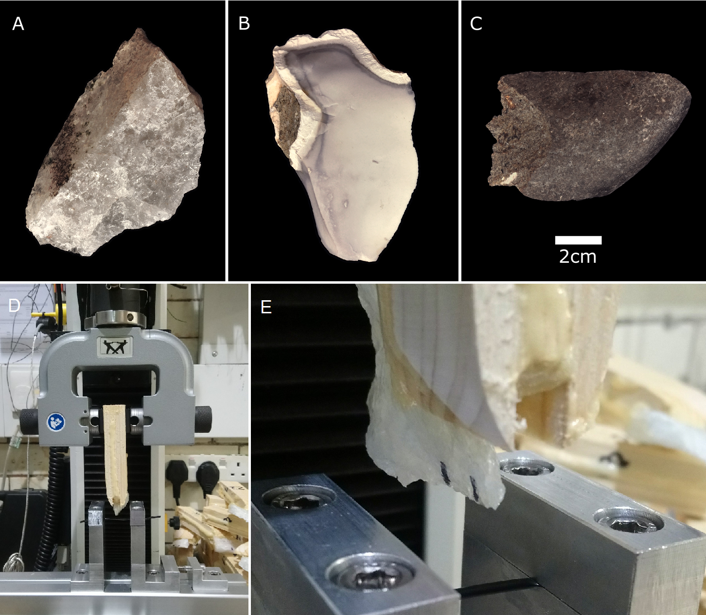
Figure 1: Representative flakes made from quartzite (A), chert (B) and basalt (C). The Instron 3345 tensile testing machine used during the controlled cutting tests (D). A quartzite flake, prior to being used to cut, is clearly depicted, along with the metal framework and PVC tubing (E).

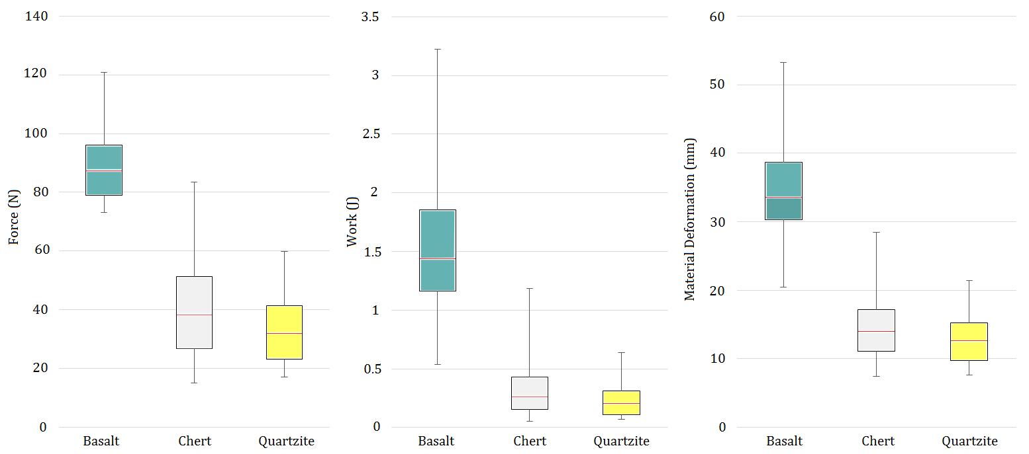
Figure 2: Force (N), work (J), and material deformation (mm) values for each Olduvai raw material (n = 30 for basalt and chert, while quartzite is represented by 28 flakes [two edges crushed during the first cutting test]). Mean values are in red. A consistent pattern emerges for all sharpness measures, in which basalt is the poorest in terms of performance.

