Selling with purpose: the mindset of high performing sales people
Vlatka Hlupic, Ben Laker

We are entering a period of change and uncertainty in politics, culture and business. In this climate, organisations are increasingly looking to their salespeople to make the difference. But sales isn’t unique to business. We all sell, every day. Across countries and cultures, industries and age groups, selling is persuasion. Recent research presented in "The Salesperson’s Secret Code" book, found that the world’s most successful salespeople describe the mindset that allowed them to keep on selling around the globe, across different industries and through good times and bad. Perhaps for the first time, the inner life of the salesperson is given equal attention to their outer life, revealing the beliefs and systems of thinking that together bring about the kind of person who outsells the competition time and time again. Why? Because it is not ‘what’ you do but ‘why’ you do it. Top sellers demonstrate the exact same mindset shift as each other, which means as you believe, you will behave. And one of the key drivers for successful sales people is purpose.
The 5 Levels of The Management Shift® can be also mapped to the area of sales, among other application areas discussed in previous articles,,,. At Level 1, a dominant mindset is 'Lifeless' and not much gets done as people are too depressed to do anything and there is a lot of fear and blame present. At Level 2 the individual mindset is 'Reluctant' and people do the minimum they can get away with just to get a pay cheque. At Level 3 the individual's mindset is 'Controlled', leadership style is based on traditional command and control, employees are micromanaged and they do what they are told to do. A fundamental shift in performance, innovation and engagement happens when a critical mass of individuals move from Level 3 to Level 4. The dominant mindset among employees becomes 'Enthusiastic', power and authority are distributed, there is a strong teamwork ethos and employees feel purposeful and passionate about their work. Employees at Level 4 can occasionally reach Level 5 where the individual's mindset becomes 'Limitless'. At this Level, anything seems possible to achieve at this level, people work on big problems that affect humanity and produce amazing innovations.
Interestingly, these 5 Levels of an individual mindset can be mapped to sales drivers, as shown in Figure 1. At Level 1, people sell things out of desperation (e.g. selling family jewellery to buy food). At Level 2, selling is means to an end, people sell professionally to get by. At Level 3, selling is aggressive, controlled, and money driven. It does not matter if customer wants/needs particular product of service, it is all about meeting sales targets. This may work short time, but not long term. Then after the Big Shift, at Level 4 selling is all about fulfilling the purpose, both for salespeople and clients. Finding meaning in selling particular product/service that serves the purpose/need of a client is the main driver. Sales people often feel proud in the process by helping to meet someone's needs. As a result, sales performance, volume and revenue increases. This is well described in Lisa Earle McLeod book "Selling with Noble Purpose".
At Level 5, selling becomes focused on providing both purpose but also a value to the client. Salespeople have no problem walking away from the deal if the product/service is not right for a client. With this and Level 4 mindset they get more recommendations, more trust, repeating business, less need for advertising, higher sales volume etc.
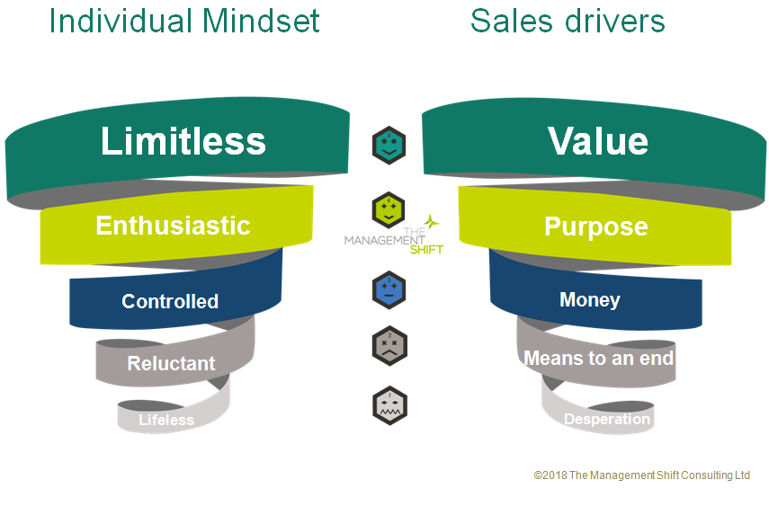
Figure 1. The levels of individual mindset mapped to sales drivers

As in other areas of business, sales performance is closely related to a mindset. At Level 4 and 5 selling is focused on win/win, it is more humanised and more profitable (especially long term) . Salespeople at Levels 4 and 5 become catalysts for social change. When their mindset is anchored at Lower levels, they may experience some short term gain, but this is not sustainable and it is narrow minded. It is time now to humanise all aspects of business operations, including sales operations to create positive ripples for salespeople, their organisations, their customers and society at large.

http://www.salespersons-secret-code.com/
Vlatka Hlupic (2014) : “The Management Shift - How to Harness the Power of People and Transform Your Organization for Sustainable Success”, Palgrave Macmillan, Basingstoke.
http://www.hrmagazine.co.uk/article-details/hollywood-mindsets-the-connection-between-power-and-harassment
http://www.hrmagazine.co.uk/article-details/approaches-to-failure-and-management-maturity
http://www.hrmagazine.co.uk/article-details/developing-an-entrepreneurial-mindset
http://www.hrmagazine.co.uk/article-details/power-as-a-catalyst-for-humanising-organisations
Lisa Earle McLeod (2012): "Selling with Noble Purpose: How to Drive Revenue and Do Work That Makes You Proud", John Wiley & Son, New Jersey.

