Mastery, enjoyment, tradition and innovation: A reflective practice model for instrumental and vocal teachers
Tom Parkinson [Accepted version: to cite this article please use the published version, found here: http://ijm.sagepub.com/content/early/2014/12/12/0255761414563196.abstract]
Institute of Education, University of Reading, UK / Institute of Contemporary Music Performance, UK
Abstract
This paper offers a model to assist music teachers in reflecting on their teaching practice in relation to their aims and values. Initially developed as a workshop aid for use on a music education MA programme, the model is intended to provoke critical engagement with two prominent tensions in music education: that between mastery and enjoyment, and that between tradition and innovation. The experiential and theoretical bases of the model are discussed, and literature relating to the theoretical issues is reviewed. The design and application of the model are then outlined in detail, and explored through the perspectives of an international group of instrumental teachers. The model contributes to music education practice in three ways: as a workshop aid for music teacher trainers; as a versatile tool for instrumental teachers, assisting both critical reflection and teaching practice; and as an adaptable data collection instrument for future research in music education.
Keywords
aims and values of music education; instrumental pedagogy; reflective practice

Introduction
This paper gives an account of the design and application of a graphic model, devised to help instrumental and vocal teachers reflect upon their teaching practices in relation to their understanding of their aims and values for instrumental and vocal teaching. The model is designed to provoke critical engagement with the challenges of prioritising across different and potentially competing aims and values, specifically those of mastery, enjoyment, innovation and tradition. It was originally designed as a workshop aid, for use by an international cohort of teachers studying towards an MA by distance learning in instrumental and vocal teaching. Participants reported that using the model to construct a visual representation of their teaching practices had drawn to light surprising tacit assumptions, and had lent clarity to their understanding of how their teaching approaches related to their aims and values.
Firstly, a theoretical framework is constructed from my own experiences of guitar teaching, and considered in relation to existing literature and research. The design of the model is then outlined, followed by an account of its application in a postgraduate workshop setting. The responses of five professional instrumental teachers are presented and discussed, and suggestions are made for further use and development of the model.
Reflections on personal experience
The application of experiential theory (Kolb, 1984) underpinning this model derives from my background as a peripatetic guitar teacher working with children and adults in South East London and Kent. Over many years, I have encountered the persistent challenge of ensuring my students make good, measurable progress in terms of developing their musical understanding and technical abilities, and at the same time enjoy both their experiences of music-making and the learning process. While progress and enjoyment are not mutually exclusive (Hallam & Creech, 2010), and indeed are often complimentary rather than oppositional, they can also be set against each other in practice, where the music teacher must make decisions of priority. I have found that overly privileging one can be to the detriment of the other; where too much attention is given to students’ technical development they can become visibly bored and demotivated. On the other hand, where too much focus is given to students’ enjoyment, progress can stall and key skills can be neglected. The question encountered in both cases is, how much is too much? The answer requires the striking of an appropriate balance.
Another prominent challenge I have faced is that of teaching students to perform according to accepted standards and norms, while also nurturing their creativity and confidence to pursue their musical curiosities. I have felt this challenge most acutely in teaching the electric guitar, where students are enculturated into musical traditions in which performers commonly compose their own music, improvisation features heavily, and experimentation is prized. Again, I have found this to be a matter of balance. However, my discussions with fellow music teachers have yielded markedly different opinions as to how and where this balance is best struck.
Engaging with these challenges over several years has forced me to reflect on what I consider to be the aims and values of instrumental teaching, and to ask such questions as: Are some aims and values more important than others? How do aims and values relate to each other? Are they reflexive? Are they context-specific? Are they specific to the instrument being taught? Doing so deliberatively has led me to a better understanding of my teaching practice and enhanced my ability and confidence to adapt.
Existing research
A lack of general research into the experiences and practices of instrumental teachers has frequently been noted (Creech & Gaunt, 2012; Jaramillo, 2008; Ward, 2004). While there has been a recent increase in attention given to the profession, it remains “a relatively under-theorized area [that] has most commonly been characterised by anecdote” (Creech & Gaunt, 2012, p. 695), and empirical studies testing the anecdotal foundations of instrumental teaching are scarce. Nonetheless, the beliefs (Mills & Smith, 2003; Robinson, 2012), aims (Hallam & Creech, 2010; Ward, 2004) and values (Creech & Gaunt, 2012) held by instrumental teachers, and underpinning their practice, have emerged as common foci within the limited extant literature surrounding instrumental teaching.
It has been observed that instrumental teachers typically rely on tacit knowledge built up experientially (Lennon & Reed, 2012), and on teaching strategies understood to be “commonsensical” (Persson, 1994, p. 241), rather than learned through formal education (Mills & Smith, 2004) or underpinned by research. Thus while instrumental teachers maintain tacit frameworks of beliefs, values and “implicit theories” (Jaramillo, 2008, p. 349), these are rarely made explicit or reflected upon critically. Jaramillo (2008) suggested that reliance on this store of personal knowledge leads to “automatisms” (p.349) governing teachers’ actions, while others have pointed to a discrepancy between teachers’ values and their teaching practice (Creech & Gaunt, 2012; Persson, 1994; Robinson, 2012; Ward, 2004).
A lack of opportunities for professional dialogue within instrumental teaching has also been identified. Robinson (2012) noted that the isolated nature of the profession is such that experiences and knowledge are rarely shared between teachers. The need for increased knowledge share, especially at international level, has been asserted by Hallam and Creech (2010) and Lennon and Reed (2012), among others.
The broad values of mastery (e.g., Lacaille, 2007; Miksza, 2011; Persson, 1994; Pike, 2014; Schenck, 1989; Schmidt, 2005), enjoyment (e.g., Hallam & Creech, 2010; Lacaille et al, 2007; Lowe, 2012; Mills & Smith, 2003; Schenck, 1989), tradition (e.g., Creech & Gaunt, 2012; Jaramillo, 2008; Metcalfe, 1987; Plummeridge & Philpott, 2001) and innovation (e.g., Creech & Gaunt, 2012; Ward, 2004) have been identified in research and other literature, as has the challenge of balancing them in terms of priority. In relation to mastery and enjoyment, Hallam and Creech (2010) wrote that “while expecting high standards and making learning enjoyable are not mutually exclusive there is a need to ensure that a balance is maintained” (p. 89). Mills and Smith (2003) identified this same challenge, with one teacher interviewee in their study recounting the challenge of “trying to lay the foundations for good technique and habits, while trying to keep lessons fun and interesting.” (p.7). Interestingly, their research found that teachers assigned far less value to enjoyment in higher education instrumental teaching than in instrumental teaching generally, highlighting that teachers’ aims and values can be contextually contingent.
Marked differences in priorities are also identified elsewhere. Hallam and Creech (2010) noted that while most learners would not seek a professional career in music, enjoyment may lead to their maintaining a lifelong musical engagement; they reason therefore that “the aims of instrumental and vocal teaching should [...] be to make musical experiences enjoyable while continuing to provide challenge and intellectual stimulation” (Hallam & Creech, 2010, p. 101). On the other hand, Persson (1994) identified in his case study “a conviction that […] the target of teaching must be to prepare students for a professional world” (p. 226). Creech and Gaunt (2012) suggested that one-to-one music tuition is generally located within a community of practice that prioritises “lifelong learning, musical heritage, performance artistry, technical skills competency and career preparation” (2012, p. 702).
Regarding the values of tradition and innovation, Creech and Gaunt (2012) identified a “perceived opposition between tradition and innovation in musical terms” leading to “a strong focus in tuition on preserving a tradition, its values and practices” (2012, p. 703). Plummeridge and Philpott (2001) drew on Metcalfe’s (1987) distinction between “trads” and “rads”, and suggested that “progressive” instrumental music teachers (the rads) are more concerned with developing “qualities of mind” (p.26) such as creativity and imagination than with obedience to musical orthodoxies. Persson (1994) on the other hand discerned in one teacher observee a belief that “compliance to norms and standards must be total if any success is to be reaped” (p. 226, cited in Ward, 2004, p. 209). Such compliance is attributed by Creech and Gaunt (2012) to close ties between teaching and performance communities. Writing in the Spanish context, Jaramillo (2008) observes that professional knowledge in music teaching (here encompassing statutory and peripatetic teaching) is “based mainly on tradition, and [that] this is the knowledge which constitutes a central reference.” (p.348). She added that this traditional paradigm is perpetuated by a strong resistance to change, in accord with Ward’s (2004) noting of an “inherent conservatism in the instrumental teaching profession which has tended to inhibit innovation” (p. 211). Ward’s (2004) empirical findings showed that teaching and performance elements associated with innovation were consistently rated as being of low importance by instrumental teachers: in response to the question of what makes a good performance, a low rating was given to “individuality”; regarding the values of performance teaching, a low rating was given to “encouraging personal choice”; and in response to lesson content, “composition” and “improvisation” were considered to be of low importance (Ward, 2004). In Mills and Smith’s (2003) study, attention to innovation was only considered by teachers to be important at higher education level. Robinson (2012) suggested that instrumental teachers “subscribe to a cultural default” (Finney & Philpott, 2010, p. 12, cited in Robinson, 2012, p. 360) of teaching according to established traditions, even where they have not learned under such a tradition themselves.
In summary, within the relatively limited literature on the aims and values of instrumental teaching, dualisms of mastery and enjoyment, and tradition and innovation, have been frequently noted and have emerged in empirical research findings. This chimes brightly with my own experiences, discussed earlier. What is also apparent from the literature reviewed here is that the values of instrumental teaching tend to inhere tacitly in anecdotes, conventions and axioms, as opposed to being made explicit.
Jaramillo (2008) suggested that “when teachers learn about the meaning of their actions [...] they start the process of developing their professional knowledge by being aware of its present condition” (p. 349). Similarly, Ward (2004) stated that “an understanding of the theoretical and practical beliefs of instrumental teachers [...] begins to open up the possibility of direct comparisons with teaching practice.” (p. 213). Teaching on a postgraduate music education programme, my role is to facilitate instrumental teachers' critical reflection on their aims and values. Informed by descriptionalist understandings of diagrammatic function, I sought to create an external diagrammatic representation (Shin, Lemon, Oliver & Mumma, 2013) that would provide a focus for a lively, discursive workshop.
The model
The design of the model is informed by Kolb's (1984) experiential learning theory model, in which “dual”, “dialectic” (p. 51) processes of learning are placed at opposite ends of two continua (active experimentation- reflective observation; abstract conceptualisation-concrete experience), which are set as axes on a crosshair graph, creating a matrix of four quadrants. Users of the model are brought to engage dialectically with each continuum, and consider the processes against their own experiences of and preferences for learning. Drawing structurally (but not thematically) from Kolb's (1984) model, I paired the value concepts of Mastery, Enjoyment, Tradition and Innovation into dualisms of Mastery/Enjoyment and Tradition/Innovation in accordance with the theoretical framework discussed above, and presented them as continua set as axes (see figure 1). In applying the model, a quadrilateral shape (shown in Figure 1 as a black square placed evenly across the apex) is stretched and moved across the graph to represent the participants’ teaching emphases. For example, if a teacher pays more attention to students’ enjoyment than their mastery, the shape is moved to the right to the degree they feel is representative of their teaching practice (Figure 1, grey square).
It should be stressed that although the model resembles a Cartesian graph, it is not scaled and the axes are notional (although as discussed later under Suggestions for Use, it could be adapted into a scaled graph for capturing quantitative data for each of the four variables). The size of the quadrilateral in relation to the grid is therefore irrelevant; its shape and positioning express relative emphases, and as such the position of each side has meaning only in relation to the others.
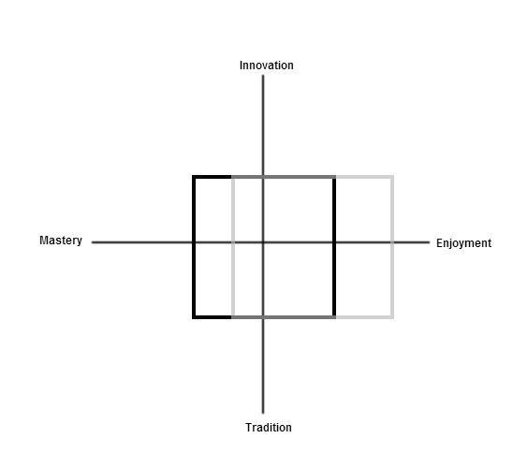
Figure 1. Mastery/Enjoyment/Tradition/Innovation model
The workshop
As a short “warmer” exercise, participants were asked to consider what they understood each of the four terms to encompass. This was done alone initially, and then opened up to the whole class for discussion. I then introduced the class to the model on the whiteboard, explaining that we were going to use it to plot our teaching practices. I began by plotting my own shape (see Figure 2).
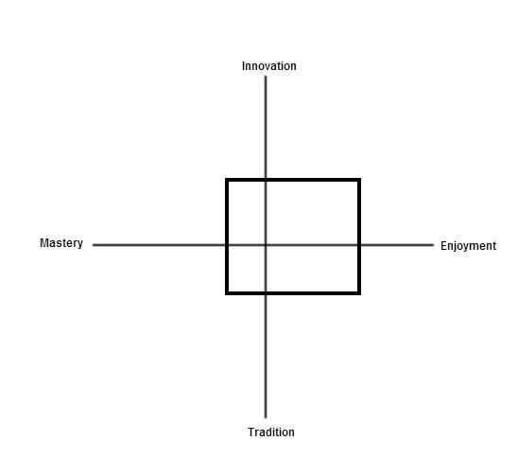
Figure 2. The author's representation of his teaching practice
I explained that I always try to select repertoire that I think students will enjoy; that where possible I encourage them to learn songs they enjoy listening to, and to develop a style of playing that reflects their interests; that I try and develop their technical skills “by stealth” rather than through paying too much attention to technical exercises, and that I encourage students to improvise and compose if they show interest in, and enjoy, doing so. I did not at this stage make explicit reference to the aims and values underpinning these practices. The participants were then invited to each plot their square on the graph. Once all participants had drawn their square on the graph, they were each asked in turn to explain its positioning to the group. This led naturally into a discussion in which the participants’ practices, encompassing choice of repertoire, pedagogical techniques, the setting of targets and so on, were compared and contrasted.
The group was then divided into a group of three and a pair. Drawing on a method devised by Smith (2012) to uncover the values underpinning higher education teachers' decision-making, I asked the students to try and uncover their counterparts’ musical values by interviewing them about the placement of their square. I explained that by repeatedly asking “why?” questions, they would be able to drill down to the values and “implicit theories” (Jaramillo, 2008, p. 349) behind their partners' placement of their shape, and thus behind their teaching practices. The session ended with each sub-group presenting their findings to the class, and discussing the implications with the group as a whole.
Participants' responses to the model
As the workshop was not recorded, participants were asked to reiterate their responses in written form following the session. As such, the data presented in the following section do not correspond to the specific phases of the workshop outlined above, but represent participants' summative insights. Presented here are the participants' responses to, and reflections upon, the model. Their graphic representations were as follows:
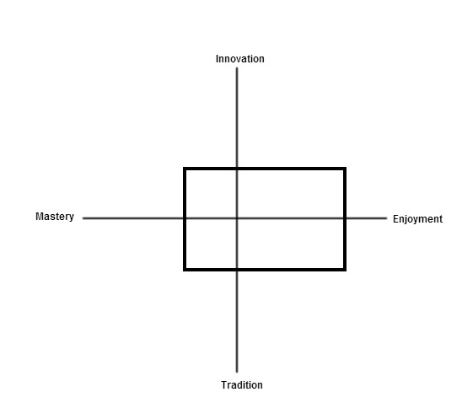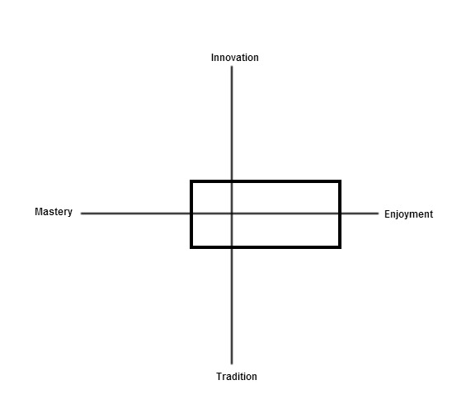
Participant A (Piano; all ages; all grades; UK) | Participant B (Piano/voice; all ages; all grades and Arts Award; UK)

Participant C (Piano; all ages; all grades; UAE) | Participant D (Flute/primary classroom; all ages; all grades plus national curriculum; UK)
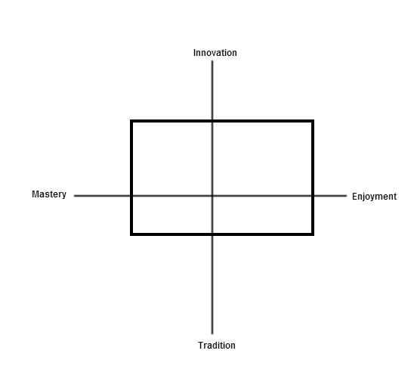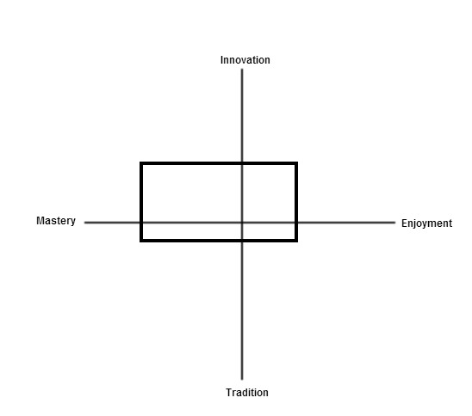

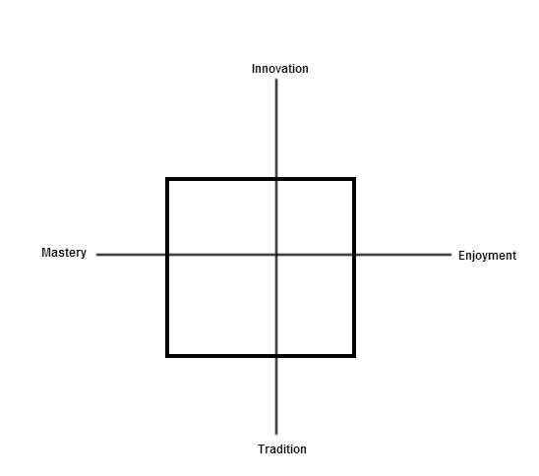
Figure 7. Participant E (Piano; all ages; all grades; Greece)

Mastery and enjoyment
There were marked differences among participants in how they perceived their practice in relation to the Mastery/Enjoyment continuum. Three of the five participants were clear that they placed greater emphasis on their students' enjoyment than on mastery:
A: I see technique and mastery of an instrument only as a means to an end of being able to play for enjoyment […], technique/mastery can usually be incorporated into the playing of pieces rather than working on studies/techniques independently.
B: Enjoyment is the primary concern of my teaching. If a student is not enjoying the process of learning, what’s the point?
C: Music-making and enjoyment of music is my aim. Enjoyment is very important, […] you know the research pointing towards students’ motivation if they enjoy what they are doing.
Two participants qualified their statements, noting that they conceived of enjoyment as a long-term, holistic goal, rather than as something equivalent to “having fun” in every aspect of every lesson:
B: That’s not to say that there won’t be times when motivation flags and interest wanes, but overall enjoyment is key. […] I don’t necessarily mean “had a nice half hour”.
A: My aims as a teacher are to encourage a lifelong enjoyment of playing an instrument and making music.
All three of the above participants noted that their approaches in this regard were in contrast to their own experiences of being taught to play an instrument. For two participants, this was most notable in the lack of emphasis they placed on formal measures of achievement:
A: [My approach is] different to my own formal education in that I place more emphasis on enjoyment of playing rather than progression through graded exams.
C: Much emphasis was on examinations, with becoming a concert pianist as the main aim […]. Music making and love for music is my main aim, not exams, becoming a concert pianist or taking part in competitions.
Another had developed his teaching practice in conscious opposition to his own learning experiences:
B: My approach was based to a large extent on a rejection of the way I was taught myself. […] It was largely developed in reaction to negative role models rather than emulating good practice.
In particular, the enduring negative impact that his piano teacher's appraisals had on his self-image had informed the emphasis he placed on enjoyment over mastery:
B: My teacher […] had very fixed ideas about the way musical training, and I use that word deliberately, should be done. He actually told me I had the potential to be a good pianist, but never a great one, an image I still struggle with to some extent. I deliberately fostered a teaching style which would make students feel valued, capable, and able to play whatever it was that interested them, in whichever way they chose. I saw my role as a facilitator, and made student-centred choices wherever possible.
The remaining two participants however, while recognizing the value of enjoyment, asserted that they prioritized students' progression towards mastery:
D: I value my students enjoying their music education, but above all believe it is about progression. I believe the aims of instrumental teaching are to work towards mastery on an instrument whilst introducing students to all aspects of music as a whole to promote a sense of heritage.
E: I deeply believe that unless a level of mastery is established, the pupil does not manage to actually play anything, and no real and long lasting pleasure (enjoyment) can come out of not playing. […] Of course I try to make sure that my pupils enjoy our classes, but in order to achieve this enjoyment, I put my weight in the relationship between us, and the overall atmosphere during class.
While all participants acknowledged this reflexivity between mastery and enjoyment, their perspectives on this relationship differed according to their stated priorities. For one participant, enjoyment was a point of pragmatism in order to sustain students' long-term engagement with music:
D: Primarily I am looking to help my students reach their potential of mastery. However, I believe this is pointless if there isn’t enjoyment as it may result in discontinuation.
Another recognized a positive dimension to the relationship between mastery and enjoyment, but asserted that in situations where these properties were oppositional he would always prioritise the latter:
B: I understand that mastery is an important part of enjoyment, but at times when the two come into conflict, and they do, enjoyment is given priority every time. I would rather have a student enjoying and engaged with music who makes little objective “progress” than a student who is becoming very capable but does not actually enjoy themselves.
Uniquely among the group, one participant spoke of the sociocultural conditions in which she worked, and the bearing that this had upon her approach to balancing mastery and enjoyment:
C: In Dubai where I am based it is very multicultural and a multiplicity of competing aims and values exists between student, teacher and parent, depending on each one’s background and what they think is of value.
She suggested that understandings of the aims and value of instrumental teaching were culturally and geographically contingent:
C: Those coming from an Asian background, in my years of teaching, value the “exam” system more than any other, whereas non-Asian backgrounds value enjoyment more than examinations. Exceptions to the rule exist and if you can have a balance between both that would be the ideal.
Tradition and innovation
There was significant variation in participants' approaches to the Innovation/Tradition continuum, and also in their interpretations of these concepts. Speaking in distinctly canonical terms, one participant explained her positioning of her shape in relation to what she saw as the unassailable talent of the great composers:
E: My square is more to the bottom than to the top, because I believe that classical masters have composed music of unsurpassed value, educational as well as artistic- In my own words “it is unlikely that another Brahms or another Mozart will ever be born”- and that no real education can come from not practising their works.
She felt it was important to locate works within the context of their composers' lifetimes, so as to promote a sense of historical narrative:
E: I also prefer that the works I teach “carry” a story […], in other words give me an interesting excuse to speak about the composer and his or her era
Her understanding of tradition extended beyond the Western classical canon however; artists that she considered “classic”, and might incorporate into her syllabi, included John Lennon and the Beatles, Brahms, Ravel, Carla Bley and Luigi Nono.
Another participant (D) saw custodianship as an aspect of the instrumental teacher's role and considered the “promot[ion of] a sense of heritage” to be a major aim of instrumental teaching. However, in contrast to the above participant, she did not approach the tradition/innovation continuum in terms of repertoire or musical content, relating it instead to issues of pedagogy. Accordingly, she located her practice slightly more towards the innovation end of the axis, to account for her exploration of innovative teaching practices:
D: I placed my square towards the innovation end slightly more than the tradition end because I am constantly reflecting and learning new ways of teaching. I have thought of the way in which I was taught as a student and have adapted this, and hopefully improved on this to work towards what I feel is best practice.
Accounting for the portion of her shape positioned across the Tradition side of the model, she spoke of drawing on established teaching traditions and theory:
D: A lot of the methods I use are traditional and based on a mixture of thoughts of the influential educators such as Suzuki and Kodaly and therefore this gives some idea of using a traditional method.
Another participant appeared to interpret the Tradition/Innovation axis in relation to both pedagogy and repertoire. Explaining her graphic representation, she spoke of employing non-traditional approaches when teaching technique, and also of incorporating less traditional repertoire:
A: Any new techniques are generally taught creatively using improvisation/ composition. […] I aim to use a balance between traditional repertoire and more recent works and popular music and improvisation.
Relating her approach to her understanding of the norms of piano tuition in the UK, she noted that it was:
A: […] typical in that I teach on a one-to-one basis and that some pupils follow the ABRSM/Trinity exam route [but] different in that I teach a lot by ear now and don’t place so much emphasis on notation or on traditional repertoire.
This reflected her belief in the value of a pluralistic musical understanding, both in terms of styles and skills:
A: This is underpinned by the value I place on the enjoyment of playing an instrument and being able to play in a variety of styles, and using a variety of skills such as notation, playing by ear, improvising and composing and ensemble playing.
Another participant also emphasized the value she placed on students receiving “overall music education”, as distinct from an education rooted in a particular performance tradition or musical genre. In seeking to achieve this she drew upon repertoire that reflected a range of styles:
C: [I] recommend jazz and pop. I think it adds a good balance to the classical repertoire, especially for those who are interested in it.
A final participant distinguished his teaching from traditional approaches in the UK:
B: [My] approach to teaching aligns in many ways to what has been labelled the “progressive” rather than “traditional” approach to teaching in the UK.
Interpreting the axis in terms of pedagogy, and from a collaborative, professional perspective, he located the value of innovative teaching in its potential to enrich and enhance practice beyond the individual teacher's milieu and across the profession as a whole:
B: Innovative ideas are important in that they can be used again and shared with other teachers. In that way, the pool of ideas available can be developed and the standard of teaching can hopefully be improved.
However, he explained that the Tradition/Innovation continuum was not important to him, and that, as with mastery, these aspects were subordinate to students' enjoyment. He held the view that that neither tradition nor innovation were ends unto themselves, but should be conceived as alternative means of fulfilling the paramount aim of sustaining students' participation in and enjoyment of music-making:
B: Tradition and innovation are of relatively little interest to me. Both have pros and cons […]. My concern is that a student is engaged with and enjoying music making. If the means by which that occurs is very traditional, or completely new, it doesn’t particularly matter. […] As far as an individual student or lesson is concerned, I don’t see that tradition or innovation are important.
Participants' reflections upon the model
Participants were asked to reflect on whether and how the model had informed their reflection on their teaching practice, and on their understandings of the aims and values of instrumental teaching. Participation in the session had led one participant to identify occasional discrepancies between how she saw her approach to teaching and the day-to-day reality of her teaching practice:
A: I was clear on where I placed myself on the graph but on reflection, my lesson content and repertoire doesn’t always represent this.
She noted that representing her practice graphically had lent clarity to her considerations of her teaching aims and values:
A: Using this visual representation made it easier for me to think about what my aims and values as a teacher are.
In particular, it had drawn to light the possible impressions students might derive from her teaching:
[It] also highlighted how my pupils may perceive my aims and values to be different [...] because lesson activities and repertoire choices don’t always match up with how I see my position on the graph.
For another participant the model had helped her to examine how students' aims and values for learning (which she prioritised) corresponded with her own aims and values for teaching:
C: While keeping my overall aims, values and goals for instrumental teaching in mind, understanding and helping the student to achieve his or her aims and goals in instrumental learning is what is important. Sometimes, their goals may differ from mine and this graph is very helpful in that aspect.
Similarly, another participant suggested that the model helped with consideration of students' experiences where issues of motivation and engagement arose:
E: It is helpful because [it] gives me some food for thinking in cases when something goes wrong and a pupil seems to lose interest. I can move my square a bit and monitor the results.
Two other participants noted that the model had forced them to identify and engage with inherent tensions in their practice that hitherto they had not considered explicitly. For one, the task of representing her practice visually and subsequently explaining it had forced her to articulate her deliberations and decision-making, thus making formerly tacit processes explicit:
D: It is helpful because it makes you reflect in a focussed way, knowing you are going to have to make a decision rather than just having an internal discussion which often doesn’t lead to a specific answer.
For another participant the enjoyment-mastery axis in particular had led him to “identify a huge tension within [his] practice”:
B: I judge the effectiveness of the lessons overall by how far a student has enjoyed themselves. I judge the effectiveness of my teaching however, on how far a student has progressed. While these two assessments aren’t entirely oppositional, they have created tension within my practice because I haven’t been fully aware of it. There have been days when I feel like students are having a good time with music, but I’m somehow not doing my job “properly”.
Engaging with the model had provoked a reappraisal of his teaching:
B: I have been able to consider the relationship between enjoyment and mastery more fully, and to assess my teaching in a different way. I have also been able to identify and adjust my attitudes towards what "proper" teaching entails. […] It has been hugely helpful in allowing me to identify and position my attitudes and aims towards teaching.
I asked the participants if and how they might employ the model, and if and how they would adapt or build upon it. Suggestions ranged from using it as a reflective aid to facilitate discussion of collective pedagogical strategy:
D: I would be very useful for a department that is trying to decide, as a whole, the direction or mission statement it is working towards.
to using it as a practical aid for selecting repertoire collaboratively with students:
E: I could ask my pupils to place a number of piano works in the areas between the axes. For example, mastery and tradition: Beethoven’s Appassionata. Mastery and innovation: Nino Rota’s Piano Concerto, Enjoyment and tradition: any challenging classic work that a pupil loves and is eager to play, hopefully Appassionata again! Enjoyment and innovation: Yann Tiersen’s music for the film Amelie, a rather minimalist work that most pupils in Greece are fond of. Come to think of it, no matter how lovely it is, it is not easy to play, which brings me back to my original thought that no pleasure can come if no hard work has preceded it!
Reflecting on how the model might be adapted or developed, one participant, who had commented that the model had forced her to commit to and justify decisions (see above), suggested that this function might be enhanced by replacing the quadrilateral shape with a dot:
D: Perhaps putting a mark such as a dot rather than allowing a box would be even tougher and force difficult-to-vocalise beliefs to be discussed and decided.
Other participants suggested that the model might be used to explore different dualisms:
B: While I don’t have use for tradition-innovation as an axis, other people might. For encouraging teacher development, something like knowledge transmission-learning facilitation might be a more interesting point of departure for discussion.
Discussion
These findings illustrate the efficacy of the model as an aid to reflective practice. To return to the afore-quoted statements by Jaramillo (2008) and Ward (2004) regarding the enhancement of professional knowledge through awareness of the meaning of, and beliefs underpinning, actions, the model (and accompanying workshop design) can be seen to have focused instrumental teachers' attention on both the practical realities of their teaching and the values that informed them. This led to the generation of fresh insight and the drawing-out of hitherto implicit assumptions, allowing for the latter to be interrogated critically. Furthermore, employing the model in a peer-learning environment facilitated the sharing of insight and perspectives within a professional space, thus addressing a need within the instrumental teaching profession (Hallam & Creech, 2010; Lennon & Reed, 2012; Robinson, 2012). Owing to the nature of this particular event (a residential summer school on an MA by distance learning), this was achieved on an international level.
The data presented in this paper are intended primarily to be indicative of the model's efficacy rather than as a basis for theoretical generalization. Nonetheless, it is noteworthy that while some of the participants' responses were in accord with the findings of earlier studies, or with trends or norms identified in earlier literature, others were not. In general terms, the data illustrate that all participants identified a reflexive relationship between mastery and enjoyment, although understanding of the nature of this relationship differed. Mastery was variously understood as one of many means to the end of enjoyment, an essential prerequisite for enjoyment, and the ultimate aim of instrumental teaching. Conceptions of enjoyment ranged from a means to ensure sustained engagement with music, to the ultimate aim of instrumental teaching with which mastery had no axiomatic relationship. These conceptions evidence the tensions surrounding the mastery/enjoyment dualism that have been identified within the profession (Hallam & Creech, 2010; Mills & Smith, 2003). In relation to tradition and innovation, two participants' commitment to heritage, together with their prioritising of progress towards technical mastery, chimes with Creech and Gaunt's (2012) characterization of the community of practice within which one-to-one music tuition typically takes place. However, two other participants placed little importance on these aspects, except where they corresponded to students' enjoyment, and indeed positioned their own practice in direct opposition to priorities identified as characterizing that community of practice, in particular “career preparation” (Creech & Gaunt, 2012, p. 702). That these participants recognized the preoccupations identified by Creech and Gaunt (2012) in their own former teachers' approaches points to a reactionary impetus behind their approaches to teaching. Furthermore, one participant's experiences of negotiating these four values within a multicultural locus highlight a cultural-geographical contingency, in relation to which the profession has seldom been considered in depth.
Suggestions for use
The model outlined in this paper is a versatile tool with many potential applications across practice and research. Presented here are some suggestions.
Reflective practice
As illustrated in this paper, the model can be used as the focus of a workshop activity in instrumental teacher education, helping participants to explore their understandings of the aims and values of instrumental and vocal teaching, and to orient their own teaching practice in relation to those understandings. By initiating in-depth, critical engagement with theory and practice, it accords with the normative expectations of higher education learning, and fulfils many of the “intellectual” and “personal development” benchmark standards for higher music education as set out by the Quality Assurance Agency (QAA, 2008, pp. 17-19). The model might also be adapted for use in statutory teacher training, such as on PGCE programmes or short teacher development courses, since similar challenges relating to aims, values and purpose arguably exist in classroom teaching (see Jaramillo, 2008).
Teaching practice
As was suggested by one participant in this study, the model might be used as a tool for communication and negotiation between teacher and student, and within the “harmonious trio” (Creech, 2010) of parents, pupil and teacher. This might help to enhance the student voice in instrumental teaching, and to establish clear, mutually-agreed-upon aims.
The model might also be used as a tool for repertoire selection and syllabus design. Teachers may use the quadrants as “banks” into which to collate repertoire and exercises according to the intentions to which they correspond, either for individual students or for their teaching practice in general. Used in such a way, the model would facilitate an aims- and outcome-focused approach to syllabus creation.
Research instrument
As shown from the figures presented here, the model can be used to gather diagrammatic representations of teachers’ approaches to and understandings of the aims and values of instrumental and vocal teaching. The model might therefore be used as a research instrument for collecting such data; benefits would include its ease of use, its visual simplicity and the ability to present findings clearly and diagrammatically. It might also be used as stimulus for gathering rich-thick data through interview or focus group.
As touched upon earlier, the model might be adapted into a scaled Cartesian graph for presenting data relating to each of the four variables, collected through (for example) likert-type questionnaires. Such an approach would involve approaching each variable discretely (rather than as continua) in data collection, but would provide a visual means of considering inter-variable relationships.
As set out at the beginning of this paper, the theoretical bases for this model derive from my own reflective practice in guitar teaching, and from literature review. Application of the model within a workshop setting generated valuable insight into the experiences of instrumental teachers working within other contexts, but many contexts remain. For example, no participant in this study taught in a conservatoire or university music department, both loci in which distinct teaching and learning cultures have been identified (e.g. Mills & Smith, 2003; Nettl, 1995; Persson, 1994). Furthermore, all participants in this study (including the author) taught within Western art and/or popular music traditions, and related their practice, aims and values to these traditions; as such, the model has yet to be applied in the context of teaching in (for example) folk or sacred music traditions. Further application of the model in research and practice across the many contexts of instrumental and vocal teaching may help to establish shared understanding of and within this often isolated profession.

References
Creech, A. (2010). Learning a musical instrument: the case for parental support. Music Education Research, 12(1), 13-32.
Creech, A., & Gaunt, H. (2012). The changing face of individual instrumental tuition: Value, purpose and potential. In G. McPherson & G. Welch (Eds.), The Oxford handbook of music education, volume 1 (pp. 694-791). Oxford: Oxford University Press.
Hallam, S., & Creech, A. (2010). Learning to play an instrument. In S. Hallam and A. Creech (Eds.), Music education in the 21st Century in the United Kingdom. Achievements, analysis and aspirations (pp. 85-104). London: Institute of Education.
Jaramillo, J. (2008). The music educator’s professional knowledge. Music Education Research, 10 (3), 347-359, DOI: 10.1080/14613800802280084
Kolb, D. A. (1981). Learning styles and disciplinary differences, In A. W. Chickering (Ed.), The modern American college (pp. ?? - ??). San Francisco: Jossey-Bass.
Kolb, D. A. (1984). Experiential learning: Experience as the source of learning and development. New Jersey: Prentice-Hall.
Lacaille, N., Koestner, R., & Gaudreau, P. (2007). On the value of intrinsic rather than traditional achievement goals for performing artists: a short-term prospective study. International Journal of Music Education, 25(3), 245-257.
Lennon, M., & Reed, G. (2012). Instrumental and vocal teacher education: competences, roles and curricula. Music Education Research, 14(3), 285-308.
Lowe, G. (2012). Lessons for teachers: What lower secondary school students tell us about learning a musical instrument. International Journal of Music Education, 30(3), 227-243.
Metcalf, M. (1987). Towards the condition of music. The emergent aesthetic of music education. In P. Abbs (Ed.), Living powers: The arts in education (pp. 97-119). London: Falmer Press
Miksza, P. (2011). The development of a measure of self-regulated beginning and intermediate instrumental music students. Journal of Research in Music Education, 59(4), 321-338. doi:10.1177/0022429411414717
Mills, J., & Smith, J. (2003). Teachers' beliefs about effective instrumental teaching in schools and higher education. British Journal of Music Education, 20, 5-27. doi:10.1017/S0265051702005260
Persson, R. (1994). Control before shape. On mastering the clarinet: A case study on commonsense teaching. British Journal of Music Education, 11, 223-23.
Plummeridge, C. (2001). The justification for music education. In C. Philpott & C. Plummeridge (Eds.), Issues in music teaching (pp. 21-31). London: Routledge.
Robinson, T. (2012). Popular musicians and instrumental teachers: the influence of informal learning on teaching strategies. British Journal of Music Education, 29, 359-370. doi:10.1017/S0265051712000162
Schenck, R. (1989). Above all, Learning an instrument must be fun! British Journal of Music Education, 6, 3-35. doi:10.1017/S0265051700006811
Schmidt, C. P. (2005). Relations among motivation, performance achievement, and music experience variables in secondary instrumental music students. Journal of Research in Music Education, 53(2), 134-147.
Shin, S. J., Lemon, O., & Mumma, J. (2013). Diagrams. In E. Zalta (Ed.), The Stanford encyclopedia of philosophy (Fall 2013 Edition). Retrieved at http://plato.stanford.edu/archives/fall2013/entries/diagrams/>.
Smith, H. (2011). Values in higher education. An annotated bibliography. Retrieved from http://www.ucl.ac.uk/calt/support/cpd4he/resources/values
Pike, P. D. (2014). The differences between novice and expert group-piano teaching strategies: A case study and comparison of beginning group piano classes. International Journal of Music Education, 32(2), 213-227.
Ward, V. (2004). Good performance, music analysis and instrumental teaching; towards an understanding of the aims and objectives of instrumental teachers. Music Education Research, 6(2), 191-215. DOI: 10.1080/1363243041000222491

Corresponding author: Tom Parkinson, Institute of Contemporary Music Performance, 1A Dyne Road, London NW6 7XG, United Kingdom. Email: tom.parkinson@icmp.co.uk

