BIOINFORMATICS ANALYSIS OF THE GENOME OF E. FAECALIS E-10 STRAIN ISOLATED FROM COW ENDOMETRIUM

Elena A. Yildirim^{1,2}, Georgi Yu. Laptev¹, Daria G. Tiurina¹, Valentina A. Filippova^{1,2}, Larisa A. Ilina^{1,2}, Natalia I. Novikova¹, Kseniya A. Sokolova^{1,2}, Nataliia S. Patiukova¹, Irina A. Klyuchnikova², Alesya A. Savicheva¹, Vasiliy A. Zaikin¹, Elena A. Korochkina³, Vladislav N. Bolshakov¹, Anna A. Fisenko², Darren K. Griffin^{4,5}, Michael N. Romanov^{2,4,5,6}
¹Molecular Genetics and Microbiomics Laboratory, BIOTROF+ Ltd, Pushkin, St. Petersburg, 196602, Russia
²Federal State Budgetary Educational Institution of Higher Education “St. Petersburg State Agrarian University”, Pushkin, St. Petersburg, 196605, Russia
³Federal State Budgetary Educational Institution of Higher Education “St. Petersburg State University of Veterinary Medicine”, St. Petersburg, 196084, Russia
⁴School of Natural Sciences, University of Kent, Canterbury, Kent, CT2 7NJ, UK
⁵Animal Genomics and Bioresource Research Unit (AGB Research Unit), Faculty of Science, Kasetsart University, Chatuchak, Bangkok 10900, Thailand
⁶L. K. Ernst Federal Research Center for Animal Husbandry, Dubrovitsy, Podolsk Urban Okrug, Moscow Oblast, 142132, Russia
Abstract Studying the microbiome of the cow's reproductive system is crucial for maintaining the animals' reproductive capacity. In 2025, the E. faecalis E-10 strain was isolated from the endometrium of a healthy Ayrshire cow kept at the Valaam Monastery eco-farm. The aim of the study was a whole-genome analysis of the strain using the MiSeq sequencer (Illumina, Inc., USA) and bioinformatics tools, including the Trimmomatic-0.38 (http://www.usadellab.org/cms/?page=trimmomatic), SPAdes-3.11.1 (https://github.com/ablab/spades), QUAST Version: 5.0.2 (http://quast.sf.net), BV-BRC (https://www.bv-brc.org), RAST (https://rast.nmpdr.org), KEGG (https://www.kegg.jp), Prokka (https://github.com/tseemann/prokka), and HMMER (hmmsearch) (https://hmmer.org) databases. Whole genome analysis of the E. faecalis E-10 strain showed that the genome consists of 108 contigs and has a total length of 2,882,409 bp, with a GC content of 37.49%. Analysis of the antimicrobial activity of the strain showed that the largest growth inhibition zones (up to 29±1.5 mm) were noted for test cultures of Clostridium perfringens, Streptococcus agalactiae, Aspergillus spp. and Penicillium spp. The genes for the synthesis of organic acids were found in the genome of E. faecalis E-10, such as ldh1 and ldh2 (associated with the synthesis of L- and D-lactic acids), pta1/2 and ackA (responsible for acetic acid), pflA/B (for formate), and fumC, frdA, and mae (for succinate). Genes for resistance to oxidative and osmotic stress were also identified. These included genes encoding glutathione biosynthesis, the CoA-disulfide thiol disulfide redox system, the choline and betaine uptake system, and betaine biosynthesis. Adhesion proteins, such as Sortase A, the WxL repertoire (more than 10 proteins), and LysM multidomain proteins (including autolysins), were also detected. These results indicate a potential role for E. faecalis E-10 in maintaining a favorable microbial balance in the endometrium.
Keyword. Bioinformatics, whole genome sequencing, endometrial microbiome, high-yielding cows, eco-farm, E. faecalis

1. Introduction
Cow fertility is a critically important economic indicator in modern animal husbandry [1]. The female bovine reproductive tract microbiome is a complex and dynamic system that significantly impacts upon fertility [1,2]. This microbiome represents a dynamic community of bacteria, fungi, viruses, and archaea existing in a symbiotic relationship with the host. Under normal conditions, it performs a number of vital functions, including the formation of colonization resistance, modulation of local and systemic immunity, and participation in maintaining the integrity of mucous membranes [2]. However, the physiological balance of this system is extremely vulnerable, especially during periods of increased physiological stress such as pregnancy, parturition, and the early postpartum period. An imbalance in the endometrial microbiota, associated with an increase in the number of opportunistic microorganisms, can lead to the development of inflammatory postpartum diseases that, in turn, negatively impact fertility and milk production [3–5]. The development of these conditions leads not only to significant economic losses due to treatment costs, an extended calving-to-conception interval, and premature culling of animals. It directly reduces fertilization rates and milk yields, creating a vicious cycle: disease - decreased productivity - economic damage.
In response to this problem, veterinary science and practice have seen a shift from traditional antibiotic therapy - associated with risks of developing resistance and disrupting the microbiota - towards «green technologies». In recent years, there has been growing interest in maintaining a healthy reproductive tract microbiome, and in developing probiotic approaches to prevent and treat endometritis [6,7]. Some strains of Enterococcus faecalis, which is a component of the intestinal microbiota, demonstrate, along with strains of other bacteria, promising probiotic properties. Its resistance to unfavorable intestinal conditions, its ability to adhere to intestinal epithelial cells, and its modulation of the host immune response have also made it a candidate for therapeutic use [8]. These properties open prospects for their use not only as intestinal probiotics but also for correcting the microbiocenosis of other mucous membranes, including the reproductive tract. In relation to the reproductive health of cows, the isolation, genome annotation [9] and use of probiotic bacterial strains obtained directly from the uterine and vaginal microbiota thus appears to be a useful approach [3]. The use of bioinformatics methods for whole-genome analysis allows for the rapid and highly accurate identification of genes responsible for safety (absence of virulence factors, antibiotic resistance genes) and the potential efficacy of the probiotic (synthesis of beneficial metabolites, adhesion factors, bacteriocins) [9].
The aim of the study was therefore to perform a bioinformatic analysis of the genome of the E. faecalis E-10 isolate that was obtained from the endometrium of a healthy cow kept at the Valaam Monastery eco-farm to identify its potential probiotic properties.

2. Materials and Methods
The study was conducted in accordance with the ethical standards of the European Convention for the Protection of Vertebrate Animals (ETS No. 123, Strasbourg, 1986) used for research and other purposes and was approved by the bioethics commission of the L. K. Ernst Federal Research Center for Animal Husbandry.
E. faecalis E-10 strain was isolated in 2025 from the endometrium of a clinically healthy Ayrshire cow kept at the Valaam Monastery eco-farm (Valaam Monastery, Valaam Island, Sortavala District, Republic of Karelia, Russian Federation). Scrapings from the vaginal surface were collected using a cytobrush from the upper lateral fornix at the level of the cervix under aseptic conditions. Animals were fed and maintained according to generally accepted recommendations as described elsewhere [10].
Microbiota samples collected from the vaginal surface scrapings under aseptic conditions were delivered to the laboratory in a mobile refrigerator. Microorganisms were cultured on the selective agar nutrient medium Enterococcalgar (State Research Center of Applied Microbiology and Biotechnology, Serpukhov, Russia), followed by isolation of a pure culture using classical microbiological methods.
The isolated strain's antimicrobial properties were assessed against pathogenic and opportunistic microorganisms, primarily those playing a significant role in the pathogenesis of bovine endometritis. Agar block and perpendicular streaking techniques were used against 10 microbial species.
A whole-genome analysis was subsequently performed, including DNA sequencing using a MiSeq instrument (Illumina, Inc., San Diego, CA, USA). The DNA library was prepared using the Nextera XT kit (Illumina, Inc., San Diego, CA, USA). Nucleotide sequences were determined using the MiSeq NGS system (Illumina, Inc., San Diego, CA, USA) with the MiSeq Reagent Kit v3 (300-cycle) "Illumina, Inc., San Diego, CA, USA).
The data were subjected to bioinformatic processing, including removal of adapters and artifacts using Trimmomatic-0.38 (http://www.usadellab.org/cms/?page=trimmomatic), de novo genome assembly using SPAdes-3.11.1 (https://github.com/ablab/spades), assembly quality assessment using QUAST Version: 5.0.2 (http://quast.sf.net) and genome comparison with NCBI databases (https://www.ncbi.nlm.nih.gov/). Primary structural and functional annotation of genomes was performed using the BV-BRC web platform (https://www.bv-brc.org). For additional functional annotation, genomes were examined using the RAST service (https://rast.nmpdr.org). Metabolic pathways were reconstructed using the KEGG database (https://www.kegg.jp). Standardized gene and protein annotation for subsequent analyses was performed using Prokka (https://github.com/tseemann/prokka). Target genes and protein families were identified using the hidden Markov model profile method with the HMMER (hmmsearch) program (https://hmmer.org). Amino acid sequences were compared with the corresponding HMM profiles, which allowed us to identify genes and proteins conserved at the domain architecture level.
Mathematical and statistical data processing was performed using RStudio (Version 1.1.453) and Microsoft Excel, including multifactorial analysis of variance (ANOVA). Results are presented as mean values and standard errors of the mean.

3. Results and Discussion
Analysis of the antimicrobial activity of E. faecalis E-10 demonstrated its ability to inhibit the growth of 10 pathogenic and opportunistic bacteria. The largest growth inhibition zones (up to 29±1.5 mm) were observed for test cultures of Clostridium perfringens, Streptococcus agalactiae, Aspergillus spp., and Penicillium spp. (Table 1). This suggests that E. faecalis E-10 possesses mechanisms, such as metabolites with antimicrobial properties, that allow it to compete with other microorganisms in the endometrial microbiome.
Whole genome analysis of the E. faecalis E-10 strain showed that its genome consists of 108 contigs and has a total length of 2,882,409 bp (Table 2). The GC content is 37.49% that conforms to the values characteristic of representatives of the genus Enterococcus [11]. The number of predicted protein-coding sequences (CDS) was 2,877. The genome contains a complete set of genes essential for translation: 59 tRNA genes and 4 rRNA genes (Fig. 1). Notably, the assembly lacks partial CDS, other predicted non-coding RNAs, as well as significant repeat regions, indicating the high quality and completeness of the obtained genomic assembly.

Table 1. The size of the growth inhibition zones of test strains under the influence of E. faecalis E-10, mm (M±m, n=3)
# | Name of microorganism | Retention zone, mm
1 | Clostridium perfringens | 29±1,5
2 | Streptococcus agalactiae | 14±0,8
3 | Aspergillus spp. | 26±1,0
4 | Penicillium spp. | 15±0,4
5 | Salmonella spp. | 4±0,1
6 | Streptococcus uberis | 5±0,6
7 | Trueperella spp. | 3±0,7
8 | Staphylococcus aureus | 4±0,2
9 | Escherichia coli 1 | 5±0,8
10 | Escherichia coli 2 | 6±0,3

Functional categorization of the predicted proteins revealed that 573 proteins (approximately 19.9% of the total CDS) were annotated as hypothetical, lacking an established function in current databases. The remaining 2,304 proteins (80.1%) received a functional prediction. A detailed analysis of the distribution of these proteins across major functional databases revealed the following: 703 proteins were associated with Enzyme Commission (EC) numbers, 576 proteins were assigned Gene Ontology (GO) terms, and 475 proteins were reliably mapped to specific metabolic pathways in the KEGG database (https://www.kegg.jp). Classification using the PATRIC database (http://www.patricbrc.org) allowed the vast majority of proteins to be assigned to phylogenetic families: 2,800 proteins were defined as belonging to genus-specific families (PLfam), and 2,852 proteins to broader, cross-genus families (PGfam).

Table 2. Main characteristics of the genome of the E. faecalis E-10 strain
# | Parameters | Value
1 | Number of contigs | 108
2 | GC content, % | 37.49
3 | Number of plasmids | 0
4 | Contig L50 | 7
5 | Genome length, bp | 2,882,409
6 | Contig N50, bp | 146,329
7 | Protein-coding sequences (CDS) | 2,877
8 | tRNA genes | 59
9 | rRNA genes | 4
10 | Partial CDS | 0
11 | Other non-coding RNAs | 0
12 | Repeat regions | 0
13 | Hypothetical proteins | 573
14 | Proteins with functional prediction | 2,304
15 | Proteins with Enzyme Commission (EC) numbers | 703
16 | Proteins with Gene Ontology (GO) assignments | 576
17 | Proteins assigned to KEGG pathways | 475
18 | Proteins assigned to PATRIC genus-specific families (PLfam) | 2,800
19 | Proteins assigned to PATRIC cross-genus families (PGfam) | 2,852

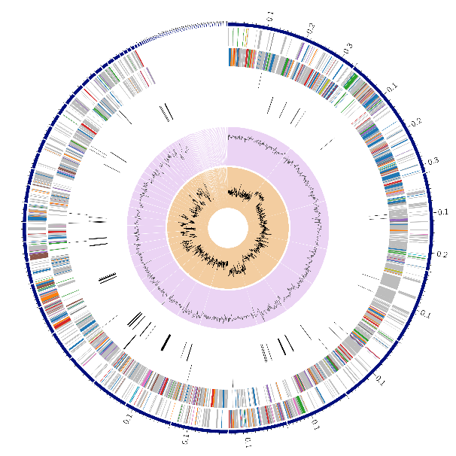
Fig . 1. A circular diagram of the E. faecalis E-10 genome annotations. Starting from the outer ring, the following are shown: contigs, coding sequences (CDS) on the forward strand, CDS on the reverse strand, RNA genes, CDS with homology to antimicrobial resistance genes, CDS with homology to known virulence factors, GC content, and GC skew.
Genome annotation of E. faecalis E-10 strain revealed 2,034 proteins with assigned functions, including 703 enzymes (with EC numbers), 576 proteins with Gene Ontology categories, and 475 proteins involved in KEGG metabolic pathways (Fig. 2).
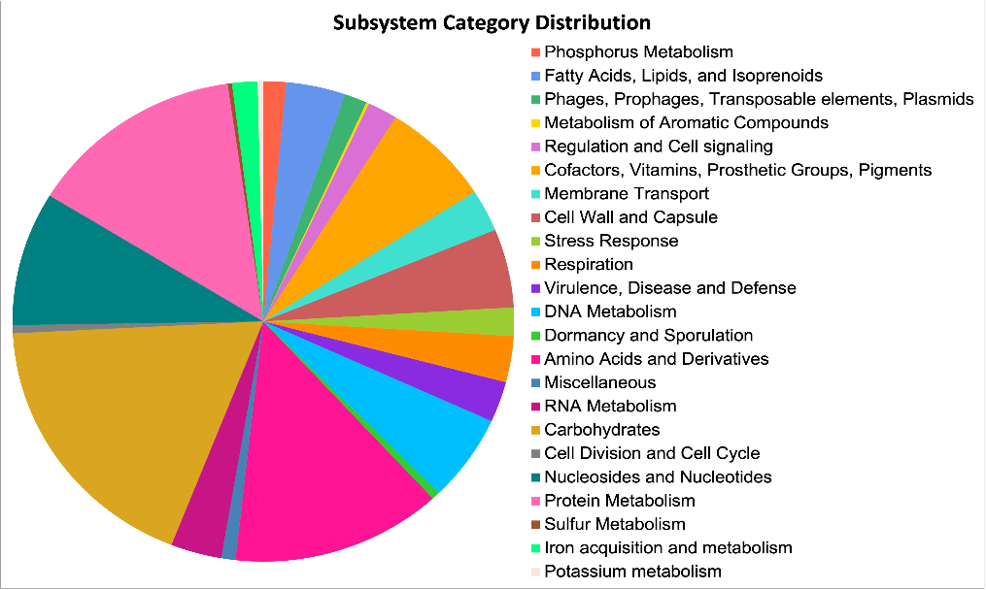
Fig. 2. Predicted metabolic networks of E. faecalis E-10 strain. Subsystems, i.e., sets of predicted proteins, are indicated by colors.
A significant number of genes encoding predicted proteins potentially associated with probiotic properties were annotated. In particular, genes encoding organic acids were identified, such as ldh1 and ldh2, which are associated with the synthesis of L- and D-lactic acids; pta1/2 and ackA that are involved in the synthesis of acetic acid; pflA/B that is responsible for formate; and fumC, frdA, and mae that are associated with the succinate synthesis. It is important to note that the strain's genome lacks genes for lactate racemase (larA), pyruvate oxidase (poxB), and the malolactic enzyme (mleS). This genetic profile indicates that strain E-10 predominantly produces L-lactic acid and is incapable of its racemization into the D-isomer. Additionally, a complete citrate utilization gene cluster (citC–citG–citX–citE–citF–citD–citN) was identified in the genome, suggesting the strain's ability to metabolize citrate with the formation of acetate, acetoin/diacetyl, and CO₂. This trait is characteristic of microorganisms involved in aroma formation and environmental buffering. The presence of a citrate/malate transporter (cimH) further supports the strain's potential for regulating the acid-base balance (pH) in its habitat [12]. Thus, strain E-10 can be characterized as a facultatively anaerobic homofermentative microorganism, whose primary metabolic products are L-lactic and acetic acids [13]. These acids may provide the strain with a competitive advantage by lowering the pH of the medium and inhibiting the growth of pathogenic microorganisms [13].
Genes involved in the biosynthesis of various valuable amino acids (glutamine, glutamate, aspartate, asparagine, proline and 4-hydroxyproline, arginine, alanine, serine and glycine, lysine, threonine, methionine and cysteine, etc.) were identified. These can serve as a source of nutrients for beneficial lactobacilli in the reproductive system [14]. In addition, genes for the biosynthesis of the following vitamins were found in the genome of the E. faecalis E-10 strain: riboflavin, pyridoxine and biotin.
In addition, genes for resistance to oxidative and osmotic stress were identified. These included genes encoding components of glutathione biosynthesis, the CoA-disulfide thiol-disulfide redox system, the choline and betaine uptake system, and betaine biosynthesis. These mechanisms may enhance probiotic survival if the cow is under reproductive stress [15].
An important aspect was the presence of genes encoding adhesion proteins, such as Sortase A, the WxL repertoire (more than 10 proteins), and LysM multidomain proteins (including autolysins). I particular, Sortase A, a transmembrane enzyme, plays a key role in the covalent binding of cell surface proteins to the cell wall peptideglycan, which ensures adhesion to epithelial cells [16]. WxL proteins contain a conserved WxL motif and are involved in interactions with extracellular matrix components, promoting adhesion and biofilm formation [17]. The presence of adhesion genes such as Sortase A and LysM multidomain proteins suggests the effective ability of E. faecalis E-10 to colonize the cow’s endometrial mucosa [18, 19]. The evolutionary importance of these systems for enterococci is confirmed by the fact that their expression is regulated by conserved mechanisms, such as the small RNA sRNA 84. It has been demonstrated that sRNA 84 directly enhances the synthesis of surface adhesins required for binding to mucin and host colonization [20].

4. Conclusion
In vitro, the Enterococcus faecalis E-10 strain exhibited pronounced and broad-spectrum antagonist activity, particularly against significant pathogens such as Clostridium perfringens and Streptococcus agalactiae, indicating its ability for effective microbial competition.
Whole-genome sequencing and subsequent bioinformatics annotation allowed us to elucidate the molecular mechanisms underlying the potential probiotic activity of this strain. From the perspective of probiotic potential, the genes involved in the synthesis of organic acids (lactic, acetic, etc.), which facilitate acidification of the medium and suppression of pathogens, are significant. The identified genes for resistance to oxidative and osmotic stress may enhance the strain's survival capacity. The discovered adhesion protein genes (Sortase A, WxL, LysM) are likely capable of facilitating colonization of the mucous membrane.
The combination of high antimicrobial activity with predicted adhesion mechanisms and metabolic lability may be important for the competitive exclusion of pathogens and the maintenance of a healthy microbiome. This suggests that E. faecalis E-10 may be a promising component of probiotic formulations.

Acknowledgments. This research was financially supported by the Russian Science Foundation, Grant No. 24-16-00131 «Development of a new biotechnological approach to the prevention and treatment of endometritis in cows»

References
- Poole RK, Soffa DR, McAnally BE, Smith MS, Hickman-Brown KJ, Stockland EL. Reproductive microbiomes in domestic livestock: insights utilizing 16S rRNA gene amplicon community sequencing. Animals. 2023;13(3):485. https://doi.org/10.3390/ani13030485.
- Yildirim EA, Laptev GY, Tiurina DG, Filippova VA, Ilina LA, Novikova NI, Sokolova KA, Ponomareva ES, Zaikin VA, Klyuchnikova IA, Bolshakov VN, Korochkina EA, Romanov MN. Comparison of the endometrial microbiome of cows under eco-farm conditions in the early and late dry periods. Anim Husb Fodder Prod. 2025;108(3):21–35. https://doi.org/10.33284/2658-3135-108-3-21.
- Adnane M, Chapwanya A. A review of the diversity of the genital tract microbiome and implications for fertility of cattle. Animals. 2022;12(4):460. https://doi.org/10.3390/ani12040460.
- Yildirim EA, Laptev GY, Ilina LA, Ponomareva ES, Brazhnik EA, Smetannikova TS, Novikova NI, Turina DG, Filippova VA, Dubrovin AV, Dubrovina AS., Kalitkina KA, Klyuchnikova IA, Zaikin VA, Griffin DK, Romanov MN. Metagenomic composition and predicted metabolic pathway analyses of the endometrial and rectal microbiota in dairy cows following the introduction of a complex feed additive. Front Biosci (Elite Ed). 2025;17(1):25725. https://doi.org/10.31083/FBE25725.
- Yildirim EA, Laptev GY, Tiurina DG, Filippova VA, Ilina LA, Novikova NI, Sokolova KA, Ponomareva ES, Brazhnik EA, Zaikin VA, Klyuchnikova IA , Bolshakov VN, Korochkina EA, Vorobyov NI, Griffin DK, Romanov MN. Compositional and functional metabolic shifts in the endometrial microbiota of cows (Bos taurus) during the transition period: A metagenomic next-generation sequencing approach. Front Biosci (Elite Ed). 2026;18(1):39439. https://doi.org/10.31083/FBE39439.
- Adnane M, Whiston R, Tasara T, Bleul U, Chapwanya A. Harnessing vaginal probiotics for enhanced management of uterine disease and reproductive performance in dairy cows: a conceptual review. Animals. 2024;14(7):1073. https://doi.org/10.3390/ani14071073.
- Laptev G, Yildirim E, Ilina L, Ponomareva E, Kalitkina K, Turina D, Filippova V, Dubrovin A, Bashir K, Smetannikova T, Malakhov I, Novikova N, Romanov M. Effect of a probiotic strain administration in different feeding phases on α- and β-diversity and gene expression of the rumen microbiome in lactating cows. In International Conference on Agriculture Digitalization and Organic Production 2023 Jun 5 (pp. 181–191). Singapore: Springer Nature Singapore.
- Han KI, Shin HD, Lee Y, Baek S, Moon E, Park YB, Cho J, Lee JH, Kim TJ, Manoharan RK. Probiotic and postbiotic potentials of Enterococcus faecalis EF-2001: a safety assessment. Pharmaceuticals. 2024;17(10):1383. https://doi.org/10.3390/ph17101383.
- Filippova VA, Laptev GY, Ilina LA, Yildirim EA, Ponomareva ES, Brazhnik EA, Novikova NI, Tiurina DG, Dubrovin AV, Dubrovina AS, Sokolova KA, Klyuchnikova IA, Zaikin VA, Griffin DK, Romanov MN. Comparative genomics of two novel Bacillus strains: Microbiomic insights into the sequences, metabolomics, and potential safe use in the creation of biopreparations. Front Biosci (Elite Ed). 2025;17(2):28227. https://doi.org/10.31083/FBE28227.
- Volgin VI, Romanenko LV, Prokhorenko PN, Fedorova ZL, Korochkina EA. Full feeding dairy cattle is the basis of realization of the genetic productivity potential [in Russian]. Moscow: Russian Academy of Sciences; 2018.
- Krawczyk B, Wityk P, Gałęcka M, Michalik M. The many faces of Enterococcus spp.—commensal, probiotic and opportunistic pathogen. Microorganisms. 2021;9(9):1900. https://doi.org/10.3390/microorganisms9091900.
- Li H, Ramia NE, Borges F, Revol-Junelles AM, Vogensen FK, Leisner JJ. Identification of Potential Citrate Metabolism Pathways in Carnobacterium maltaromaticum. Microorganisms. 202118;9(10):2169. doi: 10.3390/microorganisms9102169.
- Goffin P, Deghorain M, Mainardi JL, Tytgat I, Champomier-Vergès MC, Kleerebezem M, Hols P. Lactate racemization as a rescue pathway for supplying D-lactate to the cell wall biosynthesis machinery in Lactobacillus plantarum. J Bacteriol. 2005;187(19):6750-61. doi: 10.1128/JB.187.19.6750-6761.2005.
- Kovanda L, Zhang W, Wei X, Luo J, Wu X, Atwill ER, Vaessen S, Li X, Liu Y. In vitro antimicrobial activities of organic acids and their derivatives on several species of Gram-negative and Gram-positive bacteria. Molecules. 2019;24(20):3770. https://doi.org/10.3390/molecules24203770.
- Shah AB, Baiseitova A, Zahoor M, Ahmad I, Ikram M, Bakhsh A, Shah MA, Ali I, Idress M, Ullah R, Nasr FA, Al-Zharani M. Probiotic significance of Lactobacillus strains: a comprehensive review on health impacts, research gaps, and future prospects. Gut Microbes. 2024;16(1):2431643. https://doi.org/10.1080/19490976.2024.2431643..
- Peng W, Jiang Q, Wu Y, He L, Li B, Bei W, Yang X. The role of glutathione for oxidative stress and pathogenicity of Streptococcus suis. Virulence. 2025;16(1):2474866. https://doi.org/10.1080/21505594.2025.2474866.
- Sivaramalingam SS, Jothivel D, Govindarajan DK, Kadirvelu L, Sivaramakrishnan M, Chithiraiselvan DD, Kandaswamy K. Structural and functional insights of sortases and their interactions with antivirulence compounds. Curr Res Struct Biol. 2024;8:100152. https://doi.org/10.1016/j.crstbi.2024.100152.
- Chagnot C, Zorgani MA, Astruc T, Desvaux M. Proteinaceous determinants of surface colonization in bacteria: bacterial adhesion and biofilm formation from a protein secretion perspective. Front Microbiol. 2013;4:303. https://doi.org/10.3389/fmicb.2013.00303.
- Desvaux M, Candela T, Serror P. Surfaceome and Proteosurfaceome in Parietal Monoderm Bacteria: Focus on Protein Cell-Surface Display. Front Microbiol. 2018;14;9:100. doi: 10.3389/fmicb.2018.00100. PMID: 29491848; PMCID: PMC5817068.
- Bowden S, Jennings KC, Zlitni S, Brooks EF, Davin ME, Natarajan A, Asare L, Fremin BJ, Wilmes P, Hettich RL, Salzman NH, Bhatt AS. A conserved sRNA regulates mucin adhesion and gut colonization across the Enterococcaceae. bioRxiv [Preprint]. 2025; 11:2025.11.10.687296. doi: 10.1101/2025.11.10.687296.

