Bioinformatic Data Analysis from Metagenomic Whole Genome Sequencing of Endometrial Microorganisms in Cows with Normal and Pathological Conditions
Elena A. Yildirim^{1,2}, Georgi Yu. Laptev¹, Daria G. Tiurina¹, Valentina A. Filippova^{1,2}, Larisa A. Ilina^{1,2}, Natalia I. Novikova¹, Kseniya A. Sokolova^{1,2}, Ekaterina S. Ponomareva¹, Vasiliy A. Zaikin¹, Irina A. Klyuchnikova¹, Elena A. Korochkina³, Darren K. Griffin^{4,5}, Michael N. Romanov^{2,4,5,6}
¹Molecular Genetics and Microbiomics Laboratory, BIOTROF+ Ltd, Pushkin, St. Petersburg, 196602, Russia
²Federal State Budgetary Educational Institution of Higher Education “St. Petersburg State Agrarian University”, Pushkin, St. Petersburg, 196605, Russia
³Federal State Budgetary Educational Institution of Higher Education “St. Petersburg State University of Veterinary Medicine”, St. Petersburg, 196084, Russia
⁴School of Natural Sciences, University of Kent, Canterbury, Kent, CT2 7NJ, UK
⁵Animal Genomics and Bioresource Research Unit (AGB Research Unit), Faculty of Science, Kasetsart University, Chatuchak, Bangkok 10900, Thailand
⁶L. K. Ernst Federal Research Center for Animal Husbandry, Dubrovitsy, Podolsk, Moscow Oblast, 142132, Russia
Abstract There remains no consensus on the microbiological causes of endometritis in cows. The aim of this study, therefore, was to analyze the endometrial microbiome using metagenomic whole genome sequencing (WGS) with subsequent bioinformatic data analysis using high-yielding cows kept on an organic farm (Group 1A) compared to animals kept on a large industrial complex as follows: clinically healthy (Group 2A), with subclinical (Group 2B), or purulent-catarrhal endometritis (Group 2C). Using Illumina MiSeq platform, WGS results revealed that the dominant bacterial phyla were Bacillota in Groups 2A, 2B and 2C, as well as Bacteroidota, Fusobacteriota and Bacillota in Group 1A. In industrial farm conditions, subclinical and clinical endometritis was associated with an increase in the amount of Clostridium botulinum in the uterus (p < 0.05). In contrast to Group 2A, the dominant bacterial species in the organic eco-farm Group 1A were Bacteroides fragilis (55.1 ± 3.92%) and Fusobacterium necrophorum (28.8 ± 2.63%). The use of bioinformatic techniques demonstrated that the endometrial microbiome of clinically healthy cows kept in eco-farm conditions (Group 1A) was enriched in bacteriocin genes compared to other studied animal Groups 2A, 2B and 2C. Thus, the standards of feeding and cattle husbandry adopted to eco-farm conditions imply a different composition and functionality of the cattle endometrial microbiome compared to the more common industrial approaches.
Keywords. Bioinformatics, metagenomic whole genome sequencing, endometrial microbiome, high-yielding cows, eco-farm

1. Introduction
Postpartum endometritis is one of the main reasons for culling cows. Despite numerous publications examining the bovine endometrial microbiome using molecular tools, there is still no consensus on the microbiological causes of endometritis. This, in turn, complicates the choice of the correct treatment strategy [1,2]. Frequently, in connection with inflammatory uterine diseases, an increased content of such representatives of the vaginal normobiota as Arcanobacterium pyogenes, Escherichia coli, Prevotella melaninogenicus and Fusobacterium necrophorum is found [3]. However, there are other hypotheses regarding the causes of endometritis. In particular, Miranda-CasoLuengo et al. [4] identified a low ratio of the Firmicutes phylum to Bacteroidetes in the cattle endometrium as a marker for the development of endometritis. On the other hand, Pascottini et al. [5] observed an increase in Trueperella bacteria in the uterus of cows with clinical endometritis.
In recent years, targeted next-generation sequencing (NGS) of the 16S rRNA gene [6,7] has been employed as the most popular technology for studying the microbiome of the bovine reproductive tract [1,2]. Metagenomic whole genome sequencing (WGS) used to establish the taxonomic composition and metabolic pathways in a community differs from targeted sequencing in that it is an analysis of the entire genomes of microorganisms. Herewith, bioinformatic analysis is an important part of metagenomic sequencing [8]. Unlike the targeted NGS, metagenomic sequencing has not been previously used to study the endometrial microecosystem in cows. In addition, previous studies of the endometrial microbiota were carried out exclusively on industrial farms and in animals subject to intensive breeding. That is, they were performed against the background of factors that permanently provoke dysbiotic disorders. This has made it near impossible in practical terms to assess the true microbial diversity of the endometrial normobiota when cows were kept in conditions akin to those of a natural environment.
As a rule, specialists can expect endometritis in cattle on Day 5 to 7 after calving based on thermometry test and other clinical signs. Combining and comparing a set of molecular genetic and bioinformatic methods with the phenotypically observed health status of animals in the early post-calving period will reveal a holistic view of the functioning of the host organism and the microbiome in its reproductive tract.
In this regard, the aim of the present study was to perform an analysis of the endometrial microbiome using the metagenomic WGS technique followed by bioinformatic data analysis in cows kept on an organic farm (with housing and feeding close to their natural habitat) in comparison to animals (clinically healthy, with subclinical or purulent-catarrhal endometritis) kept in a large industrial complex.

2. Materials and Methods
The experiment was conducted in 2024 using (1) Holstein cows kept at a highly productive industrial livestock enterprise SPK Polyany (Vyborg District, Leningrad Oblast); and (2) Ayrshire cows at an eco-farm known as Monastery Farm (Valaam Monastery, Valaam Island, Sortavala District, Republic of Karelia).
Guidelines established by the European Convention for the Protection of Vertebrate Animals used for Research and Other Purposes (ETS No. 123, Strasbourg, 1986) were followed in the current experiment. The protocol was also accepted by the L.K. Ernst Federal Research Center for Animal Husbandry’s bioethical panel.
Feeding and maintenance of animals were carried out in accordance with the recommendations [9].
In the early post-calving period, veterinary and preventive measures were applied and the following experimental groups of animals established: Group 1A – clinically healthy cows without complications during/after calving and without signs of postpartum endometritis kept in organic eco-farm conditions; Group 2A – clinically healthy cows maintained in the industrial farm conditions; Group 2B – animals kept in the industrial farm conditions with a preliminary diagnosis of post-calving subclinical endometritis; and Group 2C – animals maintained in industrial farm conditions with a preliminary diagnosis of post-calving purulent-catarrhal endometritis.
Endometrial surface scraping samples were collected from the above four groups of cows (n = 3 in each group) during five days after calving under aseptic conditions using a cytobrush. DNA samples were frozen at −20 °C immediately after collection.
Using the collected samples, metagenomic WGS was performed. DNA amount in the samples was equilibrated. To prepare the samples for WGS using the Illumina MiSeq platform, the Nextera DNA Flex Library Prep kit (Illumina) was employed. The MiSeq Reagent Kit v3 – 600 (Illumina) was used to sequence the resultant libraries.
Using bioinformatic tools, metagenome assembly was initiated with cleaning the original reads from the host animal DNA. Then, the genome was indexed in the bowtie2 program (https://bowtie-bio.sourceforge.net/bowtie2/index.shtml), and kneaddata (https://huttenhower.sph.harvard.edu/kneaddata/) was launched for quality control of the metagenomic sequencing data. SeqPrep (https://github.com/jstjohn/SeqPrep) was utilized to merge paired Illumina final reads. Reads were processed with splitFastq (https://github.com/gdefazio/SplitFastq), after which the MegaHit assembler program (https://github.com/voutcn/megahit) was used. The obtained dataset was uploaded into the Prokka program (https://github.com/tseemann/prokka) for further analysis and comparison with other databases. After that, the assembly was uploaded into the KEGG database for functional annotation analysis using the KEGG Automatic Annotation Server program (https://www.genome.jp/tools/kaas/) and the GHOSTX and bi-directional best hit (BBH) algorithms. The dataset was also analyzed using the SEED database. For taxonomic annotation of sequences, the Kraken2 software (https://ccb.jhu.edu/software/kraken2/) was employed that uses an algorithm built on the basis of k-mer construction. For targeted analysis of bacteriocin genes, the BACTIBASE Database (http://bactibase.pfba-lab.org) was implemented.
Using RStudio (Version 1.1.453) and Microsoft Excel XP/2003, the results were processed mathematically and statistically using multivariate analysis of variance (multi-factor ANOVA). Results included the means (M) and standard errors of the mean (± SEM).

3. Results and Discussion
The results of this study are presented in Table 1. The average proportion of filtered reads assigned to bacteria amounted between 88.9% and 94.9% of the total number of reads, depending on the experimental group. Herewith, less than 0.01–1.01% of reads were attributed to eukaryotes. Minor viral sequences (0.00002–0.08%) were designated as DNA-containing viruses.

Table 1 Results of the cow endometrial microbiome study using metagenomic WGS sequencing
Parameters | Experimental groups
Parameters | 1A | 2A | 2B | 2C
Raw data reads | 51,800,855 | 24,071,857 | 32,751,118 | 50,518,224
Annotated reads | 15,407,942 | 767,093 | 1,038,556 | 2,234,188
Bacteria, % | 88.87 | 89.72 | 91.28 | 94.87
Eukaryotes, % | 0.01 | 1.01 | 0.5 | 0.68
Virome, % | 0.00002 | 0.08 | 0.00009 | 0.02

The dominant phyla of the kingdom Bacteria representatives were Bacillota in Groups 2A, 2B and 2C, as well as Bacteroidota, Fusobacteriota and Bacillota in Group 1A (Fig. 1A,B, 2A,B).

А | 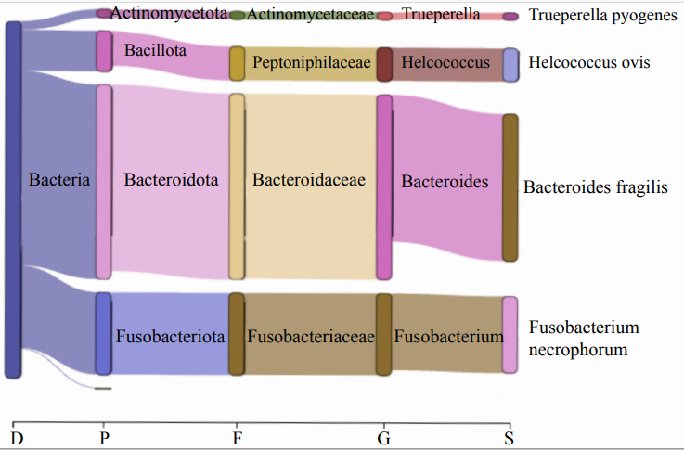
В | 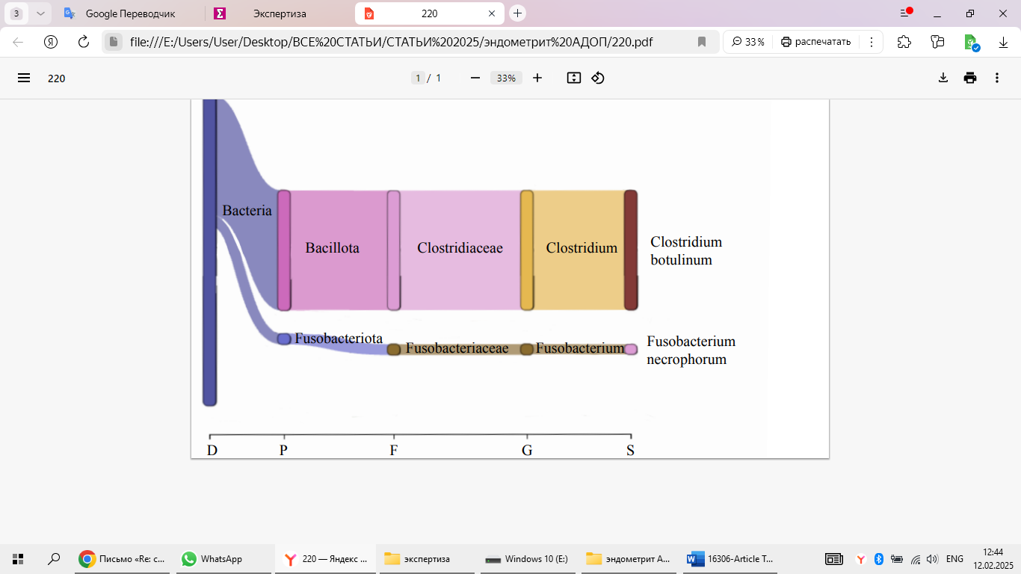
Fig. 1 Microbial composition of endometrial microbiomes in clinically healthy cows at the domain (D), phylum (P), family (F), genus (G) and species (S) levels using Sankey diagrams (Kraken2 software). Taxonomic abundance in the Sankey diagrams is represented by the thickness of the branches. (A) Control Group 1A; (B) experimental Group 2A
А | 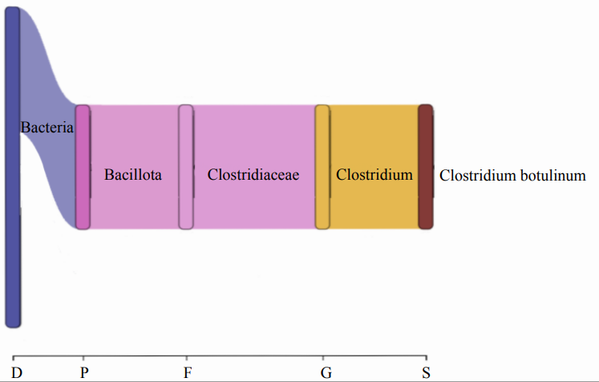
В | 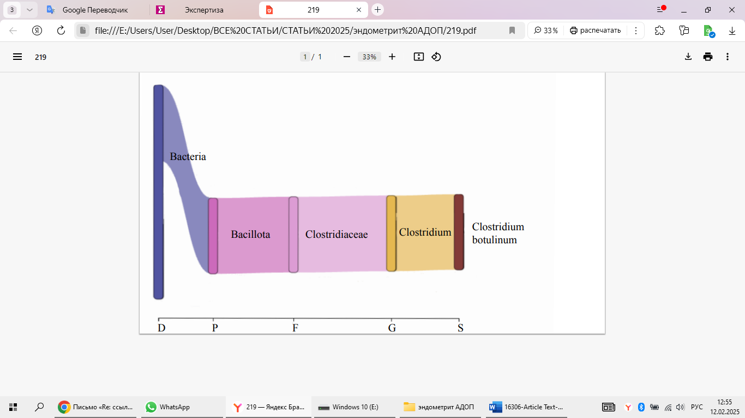
Fig. 2 Microbial composition of endometrial microbiomes in cows with subclinical and purulent-catarrhal endometritis using Sankey diagrams (Kraken2 software). Taxonomic abundance in the Sankey diagrams is represented by the thickness of the branches. (A) Experimental Group 1B; (B) experimental Group 2C
At the species level, the most striking differences in the endometrial microbiome of cows between groups, arising under the influence of endometritis disease, were found in the abundance of the species Clostridium botulinum. The content of this microorganism was increased (by 9.0–9.6%) in cows with a pathological postpartum period (Groups 2B and 2C) compared to healthy animals (Group 2A) within an industrial farm (p < 0.05). Interestingly, C. botulinum has until now been associated mainly with intestinal diseases and lesions of the nervous system [10].
The data reported here suggest, for the first time, that C. botulinum plays a distinct biological role in the pathogenesis of uterine diseases. The significance of this pathogen as a cause of uterine infections in cattle has not been known until now. This may be due to the limitations of diagnostic techniques. Kronfeld et al. [11], however, found that the C. perfringens occurrence in the endometrium of dairy cows was associated with pathologies in the postpartum period. Indeed, uterine infections are often treated with antibiotics, which can potentially cause an increase in the number of spore-forming clostridia. Interestingly, Korochkina and Nikitin [12] revealed a negative impact of the intestinal clostridiosis on the reproductive performance of dairy cows, as well as on the effectiveness of hormonal treatment for synchronizing the estrous cycle.
The difference in the abundance of C. botulinum between clinically healthy animals from the organic farm and clinically healthy animals from the industrial farm was 88.4% (p < 0.05). In contrast to Group 2A, the dominant bacterial species in cows from the organic farm (Group 1A) were other bacteria, i.e., Bacteroides fragilis (55.1 ± 3.92%) and Fusobacterium necrophorum (28.8 ± 2.63%). B. fragilis is considered to be a representative of the mammalian normobiota. The effect of inflammation suppression in the intestinal tract under the influence of colonization by this microorganism was noted [13]; however, a case of abortion in cattle under the influence of B. fragilis is also known [14]. Excess abundance of F. necrophorum is often associated with the occurrence of endometritis. However, this bacterium is considered to be a representative of the reproductive system microbiota in cows under normal conditions [1]. Our data confirm this hypothesis.
The use of the ANTIMIC database allowed us to identify bacteriocin-lanbiotic genes in the endometrial microbiome of cows (Table 2). In particular, in the endometrial microbiome of clinically healthy cows kept in eco-farm conditions, an enrichment of bacteriocin genes was observed compared to other studied groups of animals, which echoes the data on the fundamentally different composition of the endometrial microbiome of animals in this group compared to the industrial farm.

Table 2 Bacteriocin-lanbiotic genes in the endometrial microbiome of cows according to metagenomic sequencing data using the ANTIMIC database (http://research.i2r.a-star.edu.sg/Templar/DB/ANTIMIC)
Experimental groups
1A | 2A | 2B | 2C
HAJ49387.1 | MBU5584571.1 | – | EPZ57426.1
HAJ49387.1 | MBU5584571.1 | – | EPZ57426.1
WP_133170842.1 | MBU5584571.1 | – | EPZ57426.1
EPZ57426.1 | MBU5584571.1 | – | EPZ57426.1
HCX70376.1 | MBU5584571.1 | – | EPZ57426.1

4. Conclusion

The standards of feeding and housing cows adopted in the conditions of an eco-farm determine a different composition of the endometrial microbiome of cows than in traditional industrial livestock farming. Our data, for the first time, suggest that C. botulinum plays a crucial role in the pathogenesis of inflammatory diseases in the cow uterus. The use of bioinformatic methods demonstrated that there is a shift in the composition and functions of the endometrial microbiota under intensive conditions compared to raising animals in conditions close to a natural environment, which leads to a reduction in the number of genes associated with the synthesis of bacteriocins.
Acknowledgments This research was financially supported by the Russian Science Foundation, Grant No. 24-16-00131.

References
- Adnane, M., Chapwanya, A.: Role of genital tract bacteria in promoting endometrial health in cattle. Microorganisms 10, 2238 (2022). https://doi.org/10.3390/microorganisms10112238
- Yildirim, E.A., Laptev, G.Y., Ilina, L.A., Ponomareva, E.S., Brazhnik, E.A., Smetannikova, T.S., Novikova, N.I., Tyurina, D.G., Filippova, V.A., Dubrovin, A.V., Dubrovina, A.S., Kalitkina, K.A., Klyuchnikova, I.A., Zaikin, V.A., Griffin, D.K., Romanov, M.N.: Metagenomic composition and predicted metabolic pathway analyses of the endometrial and rectal microbiota in dairy cows following the introduction of a complex feed additive. Front. Biosci. (Elite Ed.) 17, 25725 (2025). https://doi.org/10.31083/FBE25725
- Carneiro, L.C., Cronin, J.G., Sheldon, I.M.: Mechanisms linking bacterial infections of the bovine endometrium to disease and infertility. Reprod. Biol. 16, 1–7 (2016). https://doi.org/10.1016/j.repbio.2015.12.002
- Miranda-CasoLuengo, R., Lu, J., Williams, E.J., Miranda-CasoLuengo, A.A., Carrington, S.D., Evans, A.C.O., Meijer, W.G.: Delayed differentiation of vaginal and uterine microbiomes in dairy cows developing postpartum endometritis. PLoS One 14, e0200974 (2019). https://doi.org/10.1371/journal.pone.0200974
- Rousseau, J., Weese, J.S., LeBlanc, S.J.: Dynamics of uterine microbiota in postpartum dairy cows with clinical or subclinical endometritis. Sci. Rep. 10, 12353 (2020). https://doi.org/10.1038/s41598-020-69317-z
- Laptev, G.Yu., Yildirim, E.A., Ilina, L.A., Ponomareva, E.S., Kalitkina, K.A., Turina, D.G., Filippova, V.A., Dubrovin, A.V., Bashir, Kh., Smetannikova, T.S., Malakhov, I.G., Novikova, N.I. Romanov, M.N.: Effect of a probiotic strain administration in different feeding phases on α- and β-diversity and gene expression of the rumen microbiome in lactating cows. In: Ronzhin, A., Kostyaev, A. (Eds.), Smart Innovation, Systems and Technologies: Proceedings of the Third International Conference on Agriculture Digitalization and Organic Production (ADOP 2023), Vol. 362, pp. 181–191. Springer Nature Singapore Pte Ltd., Singapore (2023). https://doi.org/10.1007/978-981-99-4165-0_17
- Laptev, G.Yu., Turina, D.G., Yildirim, E.A., Ilina, L.A., Gorfunkel, E.P., Filippova, V.A., Dubrovin, A.V., Melikidi, V.Kh., Novikova, N.I., Kalitkina, K.A., Molotkov, V.V., Ponomareva, E.S., Gromov, D., Romanov, M.N.: Analysis of changes in broiler microbiome biodiversity parameters due to intake of glyphosate and probiotic Bacillus sp. GL-8 using next-generation sequencing. In: Ronzhin A., Kostyaev A. (Eds.), Smart Innovation, Systems and Technologies: Proceedings of the Third International Conference on Agriculture Digitalization and Organic Production (ADOP 2023), Vol. 362, pp. 161–170. Springer Nature Singapore Pte Ltd., Singapore (2023). https://doi.org/10.1007/978-981-99-4165-0_15
- Xiong, Y.F., Cai, Z., Li, S.C., Song, Y.J., Hu, X.M., Zheng, L.: [Bioinformatics analysis in metagenomic next-generation sequencing of pathogenic microorganisms: current status and challenges]. Zhonghua Yi Xue Za Zhi 103, 1098–1102 (2023). https://doi.org/10.3760/cma.j.cn112137-20221208-02598. (In Chin.)
- Volgin, V.I., Romanenko, L.V., Prokhorenko, P.N., Fedorova, Z.L., Korochkina, E.A.: [Full feeding dairy cattle is the basis of realization of the genetic productivity potential]. Russian Academy of Sciences, Moscow, Russia (2018). https://elibrary.ru/item.asp?id=35379443. Accessed 15 Feb 2025. (In Russ.)
- Rawson, A.M., Dempster, A.W., Humphreys, C.M., Minton, N.P.: Pathogenicity and virulence of Clostridium botulinum. Virulence 14, 2205251 (2023). https://doi.org/10.1080/21505594.2023.2205251
- Kronfeld, H., Kemper, N., Hölzel, C.S.: Phenotypic and genotypic characterization of C. perfringens isolates from dairy cows with a pathological puerperium. Vet. Sci. 9, 173 (2022). https://doi.org/10.3390/vetsci9040173
- Korochkina, E.A., Nikitin, V.V.: [The effectiveness of using hormonal synchronization protocols Presynch and Ovsynch in the manifestation of clinical signs of the intestinal form of clostridiosis in Holstein cows at a farm in the Leningrad Region]. In: Zootechnical Science in the Context of Modern Challenges: Proceedings of the 3rd Scientific and Practical Conference with International Participation, pp. 100–103. Vyatka State Agrotechnological University, Kirov, Russia (2021). https://www.elibrary.ru/item.asp?id=50387081. Accessed 15 Feb 2025. (In Russ.)
- Shao, X., Sun, S., Zhou, Y., Wang, H., Yu, Y., Hu, T., Yao, Y., Zhou, C.: Bacteroides fragilis restricts colitis-associated cancer via negative regulation of the NLRP3 axis. Cancer Lett. 523, 170–181 (2021). https://doi.org/10.1016/j.canlet.2021.10.002
- Kraipowich, N.R., Morris, D.L., Thompson, G.L. Mason, G.L.: Bovine abortions associated with Bacteroides fragilis fetal infection. Vet. Diagn. Invest. 12, 369–371 (2000). https://doi.org/10.1177/104063870001200413

