Bioinformatic Analysis of NGS Sequencing Data of the Intestinal Microbiome in Broilers Fed Supplements of Glyphosate, Probiotic Bacterial Strains and Antibiotics
Elena A. Yildirim^{1,2}, Georgi Yu. Laptev¹, Daria G. Tiurina¹, Vitaliy Yu. Morozov², Valentina A. Filippova^{1,2}, Larisa A. Ilina^{1,2}, Natalia I. Novikova¹, Kseniya A. Sokolova^{1,2}, Ekaterina S. Ponomareva¹, Vasiliy A. Zaikin¹, Darren K. Griffin^{3,4}, Michael N. Romanov^{2,3,4,5}
¹Molecular Genetics and Microbiomics Laboratory, BIOTROF+ Ltd, Pushkin, St. Petersburg, 196602, Russia
²Federal State Budgetary Educational Institution of Higher Education “St. Petersburg State Agrarian University”, Pushkin, St. Petersburg, 196605, Russia
³Federal State Budgetary Educational Institution of Higher Education “St. Petersburg State University of Veterinary Medicine”, St. Petersburg, 196084, Russia
⁴School of Natural Sciences, University of Kent, Canterbury, Kent, CT2 7NJ, UK
⁵Animal Genomics and Bioresource Research Unit (AGB Research Unit), Faculty of Science, Kasetsart University, Chatuchak, Bangkok 10900, Thailand
⁶L. K. Ernst Federal Research Center for Animal Husbandry, Dubrovitsy, Podolsk, Moscow Oblast, 142132, Russia
Abstract Xenobiotics have a negative impact on the composition and function of the intestinal microbiome; this requires measures to correct these disorders. The aim of the study was thus to conduct bioinformatic processing and analysis of NGS sequencing data of the intestinal (caecum) microbiome in broiler chickens, including the analysis of the taxonomic composition and predicted metabolic pathways. Experimental groups of broilers included: Group I fed the basic diet (BD); experimental Group II received BD and glyphosate; experimental Group III fed BD, glyphosate and probiotic bacterial strains; and experimental Group IV received BD along with a combination of glyphosate, antibiotics and probiotic bacterial strains. As a result, a reduction in the live weight of broilers by 4.2% (p < 0.05) was observed in Group II (against the background of glyphosate present in feed). Introduction of a mixture of probiotic bacteria into feed (Group III) resulted in an increased body weight compared to Group II (p < 0.05). In Group II, dysbiotic changes in the composition of the caecum microbiome were observed: an 8.7-fold increase in the number of Streptococcus genus members compared to the control Group I (p < 0.05). In Group IV, an increase in Bacteroidota by 6.2% was observed compared to Group II (p < 0.05). In birds from Group II, compared to Group I, a decline (p < 0.05) in the intensity of various types of predicted metabolic pathways of the microbiome in the intestinal chyme was established. In particular, those associated with energy, carbohydrate, protein types of metabolism, methanogenesis, synthesis of cofactors, etc. were noted.
Keywords: NGS sequencing, gut microbiome, broiler chickens, bioinformatics, glyphosate, antibiotics, probiotic bacterial strains

1. Introduction
The homeostasis of the intestinal microbiome is known to be dependent on many external factors, including infections and various xenobiotics. These factors can alter the microbiota, affecting both the abundance of microbial taxa and their functions and causing dysbacteriosis that can lead to morbidity and decreased productivity in poultry [1–3].
Glyphosate is a broad-spectrum pesticide that has recently become the most widely used herbicide in the world [4]. Studies have repeatedly identified glyphosate in poultry feed samples, suggesting its potential effects on the body and the symbiotic microbiome [5]. A growing number of studies report health risks associated with glyphosate exposure. For example, we previously showed that glyphosate has a toxic effect on many taxa of intestinal microorganisms, making the body more susceptible to pathogens [6,7].
It has been demonstrated that antibiotics can increase the bioavailability of pesticides and, thus, increase the risk of their exposure. Antibiotic-induced altered gut microbiota can affect the expression of liver metabolic enzyme genes and the proteome associated with intestinal absorption processes, which is the main reason for the increased bioavailability of pesticides in the body [8]. There is, however, a lack of data providing evidence of the relationship between the effects of xenobiotics on representatives of the commensal microbiota. These include both pesticides and antibiotics, and their effects on metabolic pathways and key metabolites could be used as biomarkers of xenobiotic exposure [7,9–11].
To restore the microbiome compromised by a number of xenobiotics, it is advisable to implement preventive measures. Recent studies suggested that microbiota can play an important role in xenobiotic metabolism [12]. Therefore, the introduction of probiotic microorganisms-biodestructors into the digestive system [13–15] can become the basis of a biological strategy for the prevention of microbiota dysbiosis when xenobiotics are consumed with feed [9,16].
In this regard, the aim of the present study was to conduct bioinformatic processing and analysis of NGS sequencing data of the intestinal microbiome in broiler chickens. This included analysis of the taxonomic composition and predicted metabolic pathways of the microbiome, against the background of glyphosate, a combination of glyphosate with probiotic bacterial strains, as well as a combination of glyphosate with antibiotics and probiotic bacterial strains.

2. Materials and Methods
Following the rules established by the European Convention for the Protection of Vertebrate Animals Used for Research and Other Purposes (ETS No. 123, Strasbourg, 1986), the current study also received approval from the L. K. Ernst Federal Research Center for Animal Husbandry’s bioethical panel.
The experiment was conducted on 290 Cobb 500 cross broiler chickens in 2024. The studied birds were divided into four experimental groups: Group I (control) was fed the basic diet (BD); experimental Group II, in addition to BD, received glyphosate throughout the growing period; experimental Group III was fed, in addition to BD, glyphosate and a mixture of two probiotic strains of microorganisms, Bacillus subtilis 1-85 [17] and Enterococcus faecium 1-35, applied to the carrier (bran) in the amount of 1 kg per ton of feed throughout the growing period; experimental Group IV received glyphosate, a mixture of two probiotic strains of microorganisms throughout the growing period, as well as the veterinary antibiotics Enroflon 10% (OOO NPK-VIK, Russia) on Days 0–5, added to water (1 ml per 2 liters of water), and Colistin (developed by Areal Medical LLC and manufactured by AVZ-SP, Russia) on Days 27–31, added to water (1 ml per 4 liters of water). Glyphosate was applied by coarse spraying onto compound feed at a dose of 20 mg/kg of feed.
The chickens were grown in BB-1 cages (NPO Stimul-Ink). Feeding and keeping of the birds complied with the maintenance guidelines for the Cobb 500 broiler flock [18]. The BD up to 28 days of age included the complete compound feed PK-5 for broilers aged 1 to 4 weeks (Gatchinsky KKZ, Russia), and from 28 to 35 days the complete compound feed PK-6 (Gatchinsky KKZ, Russia).
During the experimental period, individual body weight records of birds were taken.
Samples of the caecum contents for microbiota analysis were collected from 35-day-old birds, immediately frozen at −20°C and sent to the laboratory until molecular genetic studies were completed.
Total DNA from the samples was isolated using the Genomic DNA Purification Kit (Thermo Fisher Scientific, Inc., USA) according to the manufacturer’s instructions. The composition of the microbial community was assessed using targeted NGS sequencing. The latter was performed using the MiSeq platform (Illumina, Inc., USA) and the following primers for the V3-V4 region of the 16S rRNA gene: forward primer, 5´-TCGTCGGCAGCGTCAGATGTGTATAAGAGACAGCCTACGGGNGGCWGCAG-5´, reverse primer; and 5´-GTCTCGTGGGCTCGGAGATGTGTATAAGAGACAGGACTACHVGGGTATCTAATCC-3´. Sequencing was performed using Nextera® XT Index Kit (Illumina Inc., USA) reagents for library preparation, Agencourt AMPure XP (Beckman Coulter Inc., USA) reagents for PCR product purification, and MiSeq® Reagent Kit v2 (500 cycle) (Illumina Inc., USA) reagents for sequencing.
Bioinformatic analysis of NGS sequencing data was completed using the Qiime2 software (version 2020.8; https://docs.qiime2.org/2020.8/). After the initial import of sequences into the Qiime2 format, paired read lines were aligned. Further, the sequences were quality-filtered using the default settings. Noise sequences were pruned using the Deblur method. De novo phylogeny was reconstructed using the MAFFT software package, followed by masked sequence alignment. The Silva 138 reference database (https://www.arb-silva.de/documentation/release-138/) was used for taxonomy analysis. Reconstruction and prediction of the functional content of gene families and enzymes were carried out using the PICRUSt2 software package (version 2.3.0). The MetaCyc database (https://metacyc.org/) was used to analyze metabolic pathways and enzymes. Predicted MetaCyc pathway profiles were estimated based on the abundance of amplicon sequence variants (ASVs).
The findings were processed mathematically and statistically using multivariate analysis of variance (multi-factor ANOVA) and Microsoft Excel XP/2003 and RStudio (version 1.1.453). The data were shown as means (M) and standard errors of the mean (± SEM).

3. Results and Discussion
Birds from Group II (with glyphosate) showed a decrease in live weight by 4.2% at the age of 35 days compared to the control Group I (p < 0.05; Fig. 1). The introduction of a mixture of probiotic bacteria into the feed (Group III) led to an increased body weight of birds compared to Group II (p < 0.05). However, such an effect was not observed with the additional introduction of an antibiotic (Group IV).

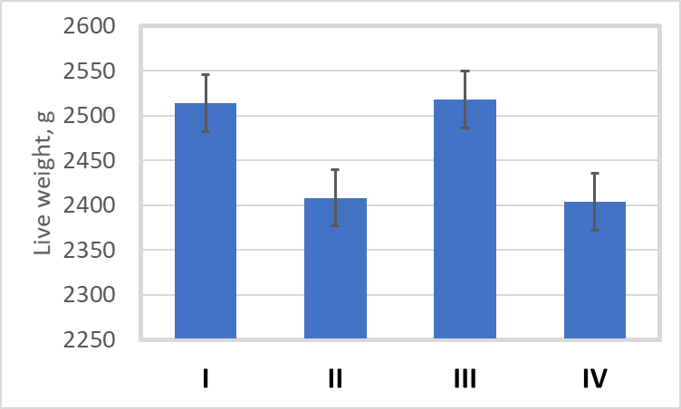
Fig. 1 Live weight of broilers at 35 days. I–IV, numbers of experimental groups

Results of the microbiome study in the caecal appendages of birds using the NGS sequencing method are presented in Figs. 2 and 3. As can be seen from Fig. 2, there was a decline in the bacteria of the superphylum Bacteroidota in the intestine of Group II birds (against the background of glyphosate in mono-mode) by 10.5% in favor of an increase in Firmicutes members as compared to the control Group I (p < 0.05). The decrease in Bacteroidota could have made a negative contribution to the physiological processes of the birds’ body. Fermentation of carbohydrates by representatives of this taxon leads to the formation of a pool of volatile fatty acids reabsorbed through the large intestine and used by the host as a source of energy, providing a significant part of its needs [19]. With the introduction of a mixture of probiotic bacteria along with antibiotics (Group IV), some correction of dysbiosis disorders caused by glyphosates was observed, i.e., an increase in Bacteroidota by 6.2% and a reduction in Firmicutes as compared to Group II (p < 0.05).

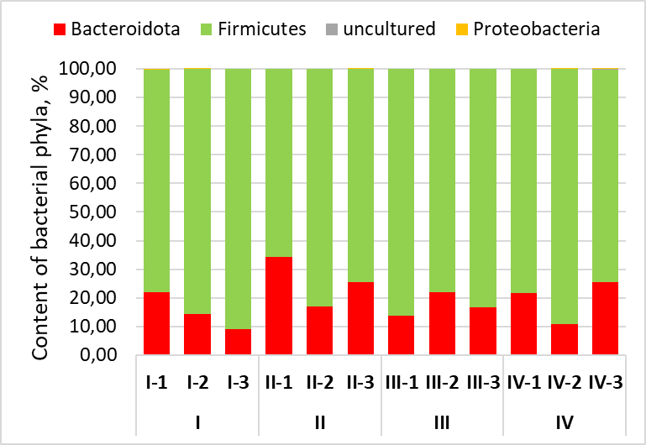
Fig. 2 Taxonomic composition of the broiler gut microbiome at the phylum level using NGS sequencing. I–IV, numbers of experimental groups; 1–3, numbers of birds (replicates) within one experimental group

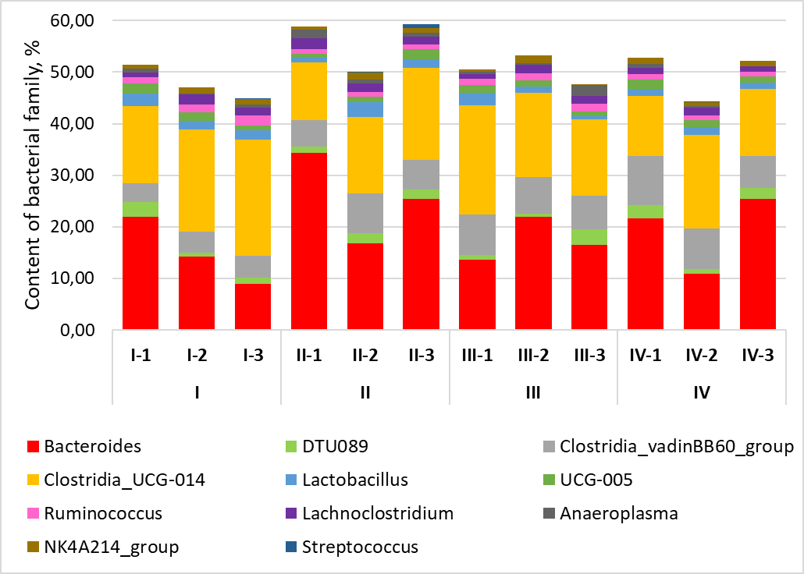
Fig. 3 Taxonomic representation of the most significant genera of bacteria in the intestinal chyme of broilers using NGS sequencing. I–IV, numbers of experimental groups; 1–3, numbers of birds (replicates) within one experimental group

In addition, an 8.7-fold increase in the number of Streptococcus bacteria was noted against the background of glyphosate in mono-mode (Group II) compared to the control Group I (p < 0.05; Fig. 3). When a mixture of probiotic bacteria was added to the feed (Group III), as well as bacterial strains in combination with antibiotics (Group IV), a reduction in the number of Streptococcus spp. was noted compared to Group II (p < 0.05). Some representatives of Streptococcus spp., for example, S. equi subsp. zooepidemicus, can cause acute septicemia with mortality rates in poultry from 11% to 80%. A fecal type of spread of this pathogen, present in the caecal appendages of the bird’s intestine, was noted [20].
Using bioinformatic methodologies, we reconstructed and predicted the functional content of the microbial community in the caecal appendices of birds. As a result, 319 different metabolic pathways of the gut microbiome were annotated. The greatest changes (p < 0.05) in the level of predicted functional potential were observed in relation to 10 pathways in birds of different experimental groups (Fig. 4).

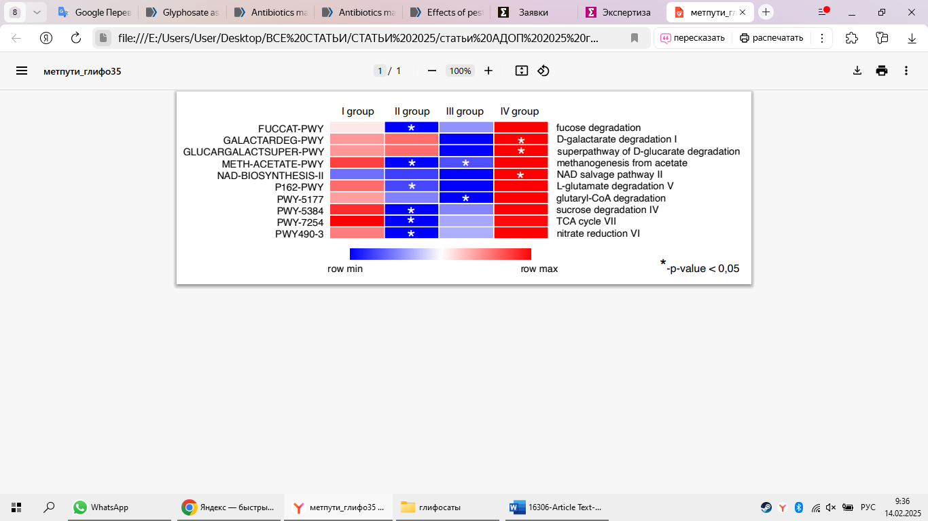
Fig. 4 Data of functional annotation of metabolic pathways from the caecum microbial community in the broiler intestine in different experimental groups (I–IV)

In Group II birds compared to Group I, there was a significant decline (p < 0.05) in various types of predicted microbiome metabolic pathways in the intestinal chyme. In particular, these were associated with energy (tricarboxylic acid cycle), carbohydrate (fucose, sucrose and D-galactarate degradation, etc.), protein types of metabolism, methanogenesis, cofactor synthesis, etc. This could affect the change in the body weight of birds against the background of glyphosate. Thus, a decrease in the intensity of the Krebs cycle could lead to a disruption of energy metabolism in the intestine, since the Krebs cycle plays a central regulatory role in the functioning of macro- and microorganisms. It is a complex, multi-step sequence of reactions that supply energy and plastic equivalents, as well as reduced and phosphorylated cofactors of the main biosynthetic pathways that largely determine the subsequent intensity and direction of the main metabolic flows [21].
Under the influence of adding antibiotics to the mixture of probiotic bacterial strains (Group IV), there was a pronounced intensification (p < 0.05) of the level of the described metabolic pathways compared to Groups II (glyphosate) and III (glyphosate against the background of probiotic strains). This may be associated with different levels of body weight gain in the experimental groups.

4. Conclusion
A decrease in body weight of broilers was herein observed against the background of glyphosate present in feed. The occurrence of dysbiotic changes in the caecum microbiome composition was also noted. In particular, the content of the Bacteroidota superphylum bacteria decreased and the proportion of Firmicutes increased. Also, an increase in the number of the Streptococcus genus members was noted, among which there are known bird pathogens. These taxa can be designated as markers associated with such a stress factor as the effect of a xenobiotic herbicide on the body of birds. Disturbances in the number of intestinal microbiota were associated with changes in several predicted metabolic pathways. This may be associated with dysregulation of host metabolic pathways and a decrease in meat productivity. The use of probiotics is a promising direction for restoring the composition and functions of the intestinal microbiome of birds, compromised under the influence of xenobiotics, as well as improving productivity.

Acknowledgments This research was financially supported by the Russian Science Foundation, Grant No. 22-16-00128.

References
- Laptev, G.Yu., Yildirim, E.A., Ilina, L.A., Filippova, V.A., Kochish, I.I., Gorfunkel, E.P., Dubrovin, A.V., Brazhnik, E.A., Narushin, V.G., Novikova, N.I., Novikova, O.B., Dunyashev, T.P., Smolensky, V.I., Surai, P.F., Griffin, D.K., Romanov, M.N.: Effects of essential oils-based supplement and Salmonella infection on gene expression, blood parameters, cecal microbiome, and egg production in laying hens. Animals 11, 360 (2021). https://doi.org/10.3390/ani11020360
- Kochish, I.I., Romanov, M.N., Nikonov, I.N., Ilyina, L.A., Laptev, G.Yu.: [Determination of intestinal microbiocenoses in hens of egg-type crosses]. In: [World and Russian Trends in the Development of Poultry Industry: the Realities and Challenges of the Future: Proceedings of the 19th International Conference], pp. 240–243. All-Russian Poultry Research and Technological Institute, Sergiyev Posad, Russia (2018). https://elibrary.ru/item.asp?id=32798612. Accessed 15 Feb 2025. (In Russ.)
- Nikonov, I.N., Il'ina, L.A., Kochish, I.I., Romanov, M.N., Podobed, L.I., Laptev, G.Yu., Panin, A.N., Smolenskij, V.I., Suraj, P.F.: Changing the intestinal microbiota of chickens in ontogenesis. Ukr. J. Ecol. 7, 492–499 (2017). https://doi.org/10.15421/2017_150
- Davoren, M.J., Schiestl, R.H.: Glyphosate-based herbicides and cancer risk: a post-IARC decision review of potential mechanisms, policy and avenues of research. Carcinogenesis 39, 1207–1215 (2018). https://doi.org/10.1093/carcin/bgy105
- Đokić, M., Nekić, T., Varenina, I., Varga, I., Solomun Kolanović, B., Sedak, M., Čalopek, B., Vratarić, D., Bilandžić, N.: Pesticides and polychlorinated biphenyls in milk and dairy products in Croatia: A health risk assessment. Foods 13, 1155 (2024). https://doi.org/10.3390/foods13081155
- Laptev, G.Yu., Tuirina, D.G., Gorfunkel, E.P., Yildyrym, E.A., Ilyina, L.A., Filippova, V.A., Dubrovin, A.V., Brazhnik, E.A., Novikova, N.I., Dunyashev, T.P., Melikidi, V.Kh., Kalitkina, K.A., Ponomareva, E.S.: The effects of glyphosate and probiotic on cecal microbiota in broilers. Ptitsevodstvo 71, 35–43 (2022). https://doi.org/10.33845/0033-3239-2022-71-11-35-43. (In Russ.)
- Yildirim, E.A., Laptev, G.Yu., Tiurina, D.G., Gorfunkel, E.P., Ilina, L.A., Filippova, V.A., Dubrovin, A.V., Brazhnik, E.A., Novikova, N.I., Melikidi, V.Kh., Kalitkina, K.A., Ponomareva, E.S., Griffin, D.K., Romanov, M.N.: Investigating adverse effects of chronic dietary exposure to herbicide glyphosate on zootechnical characteristics and clinical, biochemical and immunological blood parameters in broiler chickens. Vet. Res. Commun. 48, 153–164 (2024). https://doi.org/10.1007/s11259-023-10195-x
- Zhan, J., Liang, Y., Liu, D., Ma, X., Li, P., Liu, C., Liu, X., Wang, P., Zhou, Z.: Antibiotics may increase triazine herbicide exposure risk via disturbing gut microbiota. Microbiome 6, 224 (2018). https://doi.org/10.1186/s40168-018-0602-5
- Laptev, G.Yu., Turina, D.G., Yildirim, E.A., Ilina, L.A., Gorfunkel, E.P., Filippova, V.A., Dubrovin, A.V., Melikidi, V.Kh., Novikova, N.I., Kalitkina, K.A., Molotkov, V.V., Ponomareva, E.S., Gromov, D., Romanov, M.N.: Analysis of changes in broiler microbiome biodiversity parameters due to intake of glyphosate and probiotic Bacillus sp. GL-8 using next-generation sequencing. In: Ronzhin, A., Kostyaev, A. (Eds.), Smart Innovation, Systems and Technologies: Proceedings of the Third International Conference on Agriculture Digitalization and Organic Production (ADOP 2023), Vol. 362, pp. 161–170. Springer Nature Singapore Pte Ltd., Singapore (2023). https://doi.org/10.1007/978-981-99-4165-0_15
- Laptev, G.Yu., Turina, D.G., Morozov, V.Yu., Yildirim, E.A., Gorfunkel, E.P., Ilina, L.A., Filippova, V.A., Brazhnik, E.A., Novikova, N.I., Melikidi, V.Kh., Sokolova, K.A., Ponomareva, E.S., Zaikin, V.A., Dubrovin, A.V., Surai, P.F., Griffin, D.K., Romanov, M.N.: Changes in expression of key genes in ceca of chicken broilers as affected by glyphosate, antibiotics and a coccidiostat. Animals 14, 3544 (2024). https://doi.org/10.3390/ani14233544
- Laptev, G., Tyurina, D., Yildirim, E., Gorfunkel, E., Ilina, L., Filippova, V., Dubrovin, A., Dubrovina, A., Novikova, N., Melikidi, V., Kalitkina, K., Ponomareva, E., Zaikin, V., Klyuchnikova, I., Griffin, D., Romanov, M.: Effects of glyphosate and antibiotics on the expression of genes related to performance, antioxidant protection and histological barrier in the cecum of broilers. In: Ronzhin, A., Bakach, M., Kostyaev, A. (Eds.), Smart Innovation, Systems and Technologies: Proceedings of the Fourth International Conference on Agriculture Digitalization and Organic Production (ADOP 2024), Vol. 397, pp. 337–345. Springer Nature Singapore Pte Ltd, Singapore (2024). https://doi.org/10.1007/978-981-97-4410-7_28
- Lindell, A.E., Zimmermann-Kogadeeva, M., Patil, K.R.: Multimodal interactions of drugs, natural compounds and pollutants with the gut microbiota. Nat. Rev. Microbiol. 20, 431–443 (2022). https://doi.org/10.1038/s41579-022-00681-5
- Romanov, M.N., Grozina, A.A., Ilina, L.A., Laptev, G.Yu., Yildirim, E.A., Filippova, V.A., Tyurina, D.G., Fisinin, V.I., Kochish, I.I., Griffin, D.K., Surai, P.F.: From feed regulation to regulated feeding: intestinal microbiome and performance optimization in broiler chickens in response to antibiotic and probiotic treatment. In: Life of Genomes 2022: Abstracts of the International Conference, p. 44–45. Research Center “Regulatory Genomics”, Institute of Fundamental Medicine and Biology, Kazan (Volga Region) Federal University, Kazan, Russia (2022). http://lifeofgenomes.r-genomics.com/wp-content/uploads/2022/12/Absctracts.pdf#page=45. Accessed 15 Feb 2025.
- Grozina, A.A., Ilina, L.A., Laptev, G.Yu., Yildirim, E.A., Ponomareva, E.S., Filippova, V.A., Tyurina, D.G., Fisinin, V.I., Kochish, I.I., Griffin, D.K., Surai, P.F., Romanov, M.N.: Probiotics as an alternative to antibiotics in modulating the intestinal microbiota and performance of broiler chickens. J. Appl. Microbiol. 134, lxad213 (2023). https://doi.org/10.1093/jambio/lxad213
- Laptev, G.Yu., Yildirim, E.A., Ilina, L.A., Ponomareva, E.S., Kalitkina, K.A., Turina, D.G., Filippova, V.A., Dubrovin, A.V., Bashir, Kh., Smetannikova, T.S., Malakhov, I.G., Novikova, N.I., Romanov, M.N.: Effect of a probiotic strain administration in different feeding phases on α- and β-diversity and gene expression of the rumen microbiome in lactating cows. In: Ronzhin, A., Kostyaev, A. (Eds.), Smart Innovation, Systems and Technologies: Proceedings of the Third International Conference on Agriculture Digitalization and Organic Production (ADOP 2023), Vol. 362, pp. 181–191. Springer Nature Singapore Pte Ltd., Singapore (2023). https://doi.org/10.1007/978-981-99-4165-0_17
- Ampatzoglou, A., Gruszecka-Kosowska, A., Torres-Sánchez, A., López-Moreno, A., Cerk, K., Ortiz, P., Monteoliva-Sánchez, M., Aguilera, M.: Incorporating the gut microbiome in the risk assessment of xenobiotics and identifying beneficial components for one health. Front. Microbiol. 13, 872583 (2022). https://doi.org/10.3389/fmicb.2022.872583
- Kochish, I.I., Romanov, M.N., Laptev, G.Yu., Yildirim, E.A., Ilina, L.A., Filippova, V.A., Dubrovin, A.V., Novikova, N.I., Tyurina, D.G., Tarlavin, N.V., Dunyashev, T.P., Selina, M.V., Bernikova, K.E., Motin M.S.: [Methodological recommendations for the use of modern biotechnology for assessing the expression of genes associated with the productivity and resistance of poultry to adverse factors]. Sel'skokhozyaistvennye tekhnologii, Moscow, Russia (2019). https://elibrary.ru/item.asp?id=42367977. Accessed 15 Feb 2025.
- COBB Broiler Management Guide. Cobb-Vantress Inc., Siloam Springs, USA (2017). https://www.eaglespride.co.za/wp-content/uploads/2020/07/COBB-500-BROILER-GUIDE.pdf. Accessed 15 Feb 2025.
- Wexler, H.M.: Bacteroides: the good, the bad, and the nitty-gritty. Clin. Microbiol. Rev. 20, 593–621 (2007). https://doi.org/10.1128/CMR.00008-07
- Garmyn, A., Van de Velde, N., Braeckmans, D., Ronsmans, S., Boyen, F., Verlinden, M.: An outbreak associated with Streptococcus equi subsp. zooepidemicus in layers: Evidence of fecal transmission. Avian Dis. 64, 343–346 (2020). https://doi.org/10.1637/aviandiseases-D-19-00191
- Krebs, H.A., Eggleston, L.V.: Metabolism of acetoacetate in animal tissues. 1. Biochem. J. 39, 408–419 (1945). https://pmc.ncbi.nlm.nih.gov/articles/PMC1258257/. Accessed 15 Feb 2025.

