Reflections on the Binding Treaty process: War economies & voices from the Global South
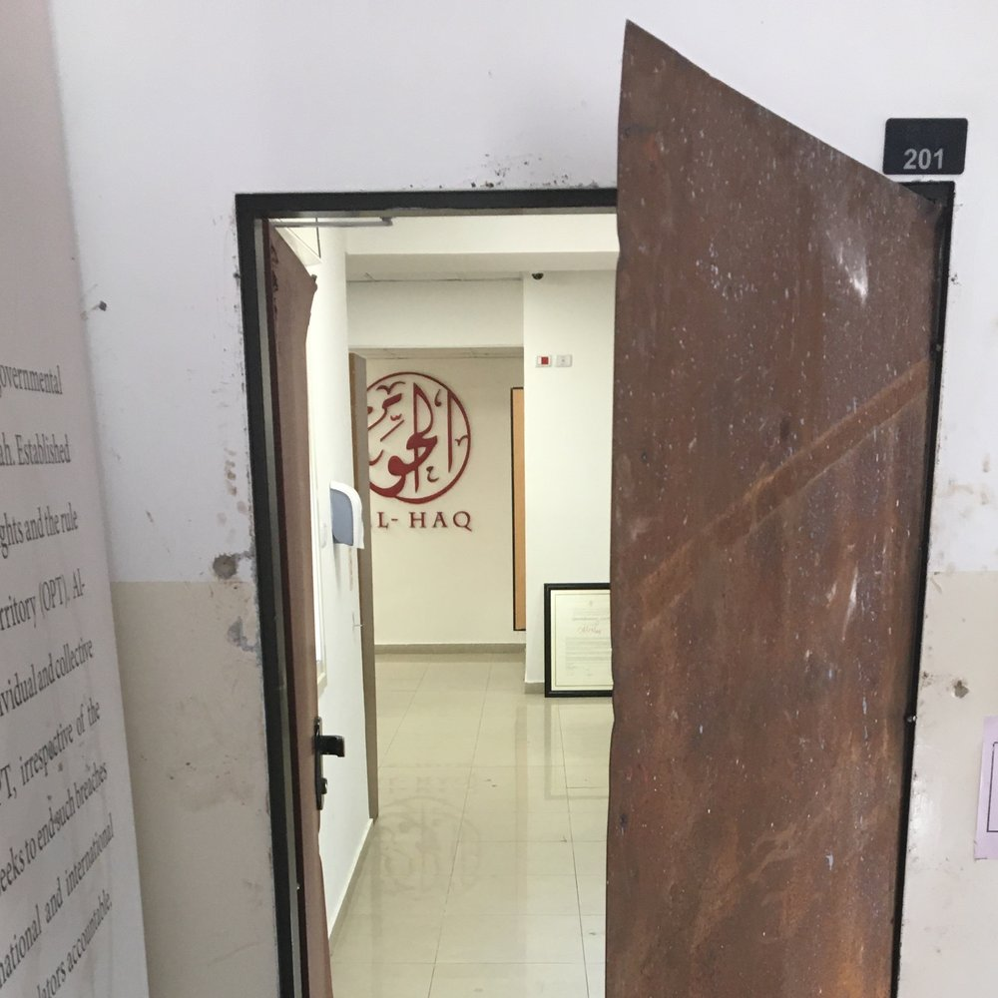
Al-Haq
As a Palestinian human rights organisation championing a binding treaty on business and human rights, Al-Haq’s journey has been defined by dedication, historical resonance, and the ever-evolving panorama of global endeavours. Al-Haq's relentless push to emphasise the significance of war economies and conflict-torn regions not only serves as a cornerstone for global transformation but also sparks broader systemic advancements. In a world grappling with over a hundred active armed conflicts, comprehending the interplay between transnational corporations and war economies becomes pivotal. We assert that acknowledging these intricate interconnections is indispensable for fostering a more equitable and just world, and the existing treaty draft inadequately acknowledges them.
In 1972, President Salvador Allende of Chile delivered a resonant address to the UN General Assembly, denouncing the neo-colonial role of transnational corporations. This seminal moment catalysed international efforts to regulate corporate behaviour through the UN Centre for Transnational Corporations - then a meeting point for academics and practitioners from the Global South. Subsequently, the draft UN Code on Transnational Corporations sought to establish direct corporate responsibilities, acknowledging the economic imbalances spawned by centuries of colonisation. However, these efforts did not materialise, as the draft Code was met with substantial corporate backlash, supported by many states in the Global North.
Al-Haq joined the treaty process a little late in the game during the third session of the intergovernmental working group discussions in 2017 but quickly realised the importance of its participation and the convergence of the Palestinian struggle which echoed with many others around the world. This reinforced the organisation’s position that the injustices facing the Palestinian people are a microcosm of global injustices which need to be addressed in a holistic manner. At the same time, we came to appreciate our engagement in the binding treaty discussions was part of a longer historical effort to shape the global social positioning of corporate actors.
Over the past seven years, our primary objective has been to ensure the treaty framework pays due attention to war economies and regions marred by conflict. We have worked to underscore the pivotal roles that transnational corporations play in shaping the vulnerabilities of populations embroiled in conflicts, especially in the context of occupation. War economies can be lucrative for business, and the corporate form can facilitate exploitative ventures. Without proper legal frameworks, profit driven corporations can exploit such opportunities at the expense of the affected population, causing harm or shaping circumstances which facilitate harm. Al-Haq has steadfastly championed a more comprehensive conceptualisation of vulnerability which recognises both historical and contemporary roles of transnational corporations in shaping these vulnerabilities.
The unique case of Palestine, ensnared in colonisation amid the global decolonisation movement, underscores the imperative of broadening our perspective to encompass all forms of economic domination which shape collective vulnerability. Corporate involvement in contemporary war economies, particularly in the Global South, can engender collective harm primarily of an economic nature, a facet not directly addressed by the treaty.
While the prevailing draft of the binding treaty predominantly addresses direct human rights violations, it falls short of confronting the broader structural economic harm inflicted by transnational corporations in war economies. The current treaty draft primarily underscores remedies for individual victims and facilitates transnational access to justice. Although an essential stride, we perceive it as merely the inception. Unlike the prior draft UN Code, the draft of the binding treaty does not impose on corporations the duty to respect sovereignty over natural resources or economic self-determination among other duties. Further, it steers away from a serious conversation about the core principles of international investment law, a conversation which Global South states have historically sought to integrate within such frameworks.
Our journey toward a binding treaty has yielded affirmative systemic outcomes. National legislations across diverse European jurisdictions have surfaced, concurrent initiatives concerning mandatory human rights due diligence have gained traction, and corporate accountability has become a focal point in the realm of international human rights discourse.
As look back across the past seven years’ efforts, our commitment to advocating for a binding treaty on business and human rights that comprehends the complexities of war economies and conflict-affected areas, including situations of occupation, remains unwavering. We draw inspiration from the broader systemic strides which have emanated from these endeavours. Nelson Mandela recognised the interconnected nature of our struggles when he said South Africa will truly be free when Palestine is free. Our engagement in this process is a recognition that the Palestinian people will truly be free when the people of the world are free from corporate capture. Al-Haq's vision extends beyond addressing individual cases; it envisions a world where communities emerge as agents of change rather than victims, and where transnational corporations are held accountable for both their historical and contemporary actions. The journey persists, and the pursuit of justice remains unyielding.
Dr Shahd Hammouri is a lecturer in law at the University of Kent and a non-resident academic fellow with the Al-Haq Center for Applied International Law regularly advising on the area of BHR.
Wesam Ahmad is the Head of the Al-Haq Center for Applied International Law engaged in the binding treaty process since 2017 as part of the ESCR-Net Corporate Accountability Working Group.

