If you are not a wolf, you will be eaten by wolves
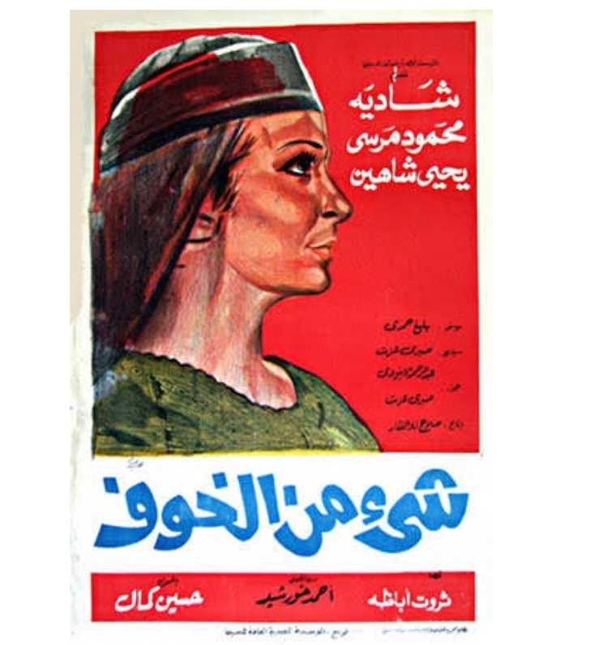
Shahd Hammouri examines the cyclical interrelations of micro-fascisms through the lens of a classroom discussion on war economies, and an iconic piece of Egyptian cinema.

The Arms Trade in the Classroom
During a class on the regulation of the international arms industry, I engage the students with the case of CAAT v. the UK. In the case, the Campaign against the Arms Trade (CAAT) challenges the British government’s decision to license the export of arms to Saudi Arabia. CAAT argues that Britain is able to foreseeably know that the weapons will be used in infringements of international humanitarian law, particularly in the case of the Saudi-led War on Yemen. I use the case to demonstrate to the students the changing dynamics of the market, the relevant regulations, and the role of private power in shaping both. A student raises their hand and says: I know you seem very much against this, but it does make sense for the government to do this – if they did not sell the weapons, someone else will. Of course, I am not new to this argument, but the student caught me off guard.
For the past while, my mind has been over-engaged with this issue. The accumulation of power and the normalization of tragedy are driven by the sustenance of fear and competition among people, states and corporations. Nuclear weapons were not considered unlawful by the International Court of Justice because they may still be used as a tool of self-defense. Hence, fear that the other might strike is used as a justification to normalize the possibility of cross-generational mass tragedy, underlined by a competition to accumulate power by states. Now we stand at the brink of mass-bombings justified by the claim of: if we do not do it, they will. This logic reminded me of an Arabic saying: ‘if you are not a wolf, you will be eaten by wolves’. This logic of self-interest dictates that one must become a wolf, i.e. a figure seeking the accumulation of power at the cost of others. This is a logic that I personally associate with a patriarchal mode of thought.
I admit that I responded to the student with a lack of logical grace; an answer was not ready yet. I went back to the board and stressed the causality between the export license and the harm in Yemen. In the next class, I decided to pre-empt the student’s line of inquiry and posed the question myself. Many students agreed: yes, Britain ought to sell the weapons for the benefit of its people. In response, I shamelessly utilized the disciplinary boundaries I have argued against elsewhere. I responded by saying that our job as lawyers, studying public law, is to think of the protection of public considerations. Globalization and interdependence have made the interests of Yemeni citizens directly affected by actions of the British government. As such, we cannot use a logic that finds virtue in power to dismiss the calls for justice and self-determination. In such cases of interdependence, those with power and privilege often have no interest in protecting the people. It is the job of the law to protect such interests. Then I rant about some successful efforts of strategic litigation for the benefit of people in the global South, the most recent of which is in relation to the responsibility of a British-based corporation for the storage of the materials which led to the Beirut explosions in 2020.
The argument against me is only logical only if we accept the wolf’s rhetoric at the heart of the normalization of war. I find war to be a patriarchal invention normalized by decades of power accumulation. Yes, I find the need for the proliferation of wolves to be humanity’s doom. The logic described by the student bears so much normalized violence that they do not see. Or perhaps it is me who directly dissects this logic to locate the violence in it. The idea that legal positions are premised on debate among equally viable arguments overlooks the biases in legal language, and distortions of our own perceptions. How can I debate if notions such as the collective right against domination are not incorporated in international legal language?

The Logic of Fear and Competition
In 1969, an Egyptian movie called A Taste of Fear was released. The script was taken from a novel by Tharwat Abatha and written by Abdel Rahman al Abnoudi, one of Egypt’s most admired poets. The film features the iconic Shadia in her most feminist role. As children, the peasant Fou’ada (later played by Shadia) and Atris, the grandson of the village’s tyrant, had a loving relationship. When they grow up, Atris promises Fou’ada that he will not be like his grandfather, who taxes the peasants, and terrorizes anyone who tries to defy him. Fou’ada’s character symbolizes strength, wisdom and good will. She makes it clear to her beloved that a drop of an innocent man’s blood will defile their love. Soon enough, Atris’s grandfather dies protecting Atris from an assassination. Atris is filled with rage and punishes the whole town, starting a series of collective punitive measures against the peasants. Atris, who used to be dressed in white, is now dressed in black – connotating the symbolic move into what is known in the Nubi language as ‘el shoom’ i.e. that place of darkness and bad will.
At some point, Atris punishes the peasants by cutting off the water from their land. In one of the most iconic scenes in Egyptian film, Fou’ada opens up the shields (al hawies) closed off by Atris, defying his power. In response to her act of defiance, Atris is perplexed – as he still loves her. He forcefully requests to marry her, despite her refusal – her father lies and says she accepted out of fear that he will be killed otherwise. In Atris’s home, Fou’ada refuses him, claiming that the marriage is null. Atris tries to do anything to prove otherwise. The news reaches the village, and Fou’ada’s refusal steers a strength in the people to rebel under the slogan of ‘Atris’s marriage to Fou’ada is null’.
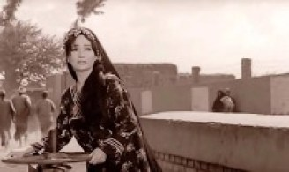The iconic scene of Fou’ada (played by Shadia) opening al hawies
Through its simplicity and strong symbolism, the movie can be read as an epic. When defending himself throughout, Atris uses the logic of the wolf. He tries to show his beloved that his use of power was necessitated by the other wolves. Meanwhile, when defending their positions to Fou’ada the villagers used fear as their excuse, while those close to Atris remained in competition to gain his wealth. One of the villagers hallucinated that he himself was Atris, dancing with joy. The collective normalized equilibrium was an acceptance of tyranny fed by fear, creating common norms which necessitated exaggerated tragedies. Fou’ada’s character also symbolized to me a form of feminine resistance in the face of this overly patriarchal logic.

A Symbol of Uprising against the Logic of the Wolf
During the Egyptian revolution of 2011, the symbolism of the movie was called upon by the protestors. Many held signs saying ‘Atris’s marriage to Foua’da is null’. They later created people’s commissions called the Fou’ada Watch, whose purpose was monitoring and reporting actions which impede on justice. Examples of their work include a campaign to oversee media reporting of the presidential campaign, and coordinating efforts for a draft law against sexual harassment. The symbol of Fou’ada functions here as the rejection of a logic which finds virtue in power, not accepting norms premised on fear.
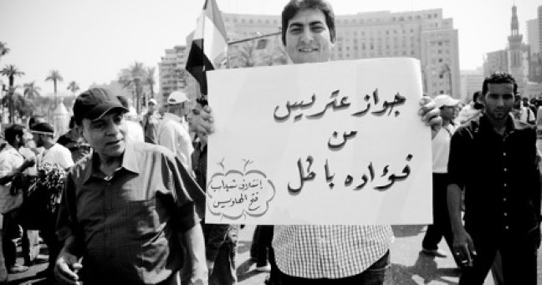A protestor from the self-proclaimed ‘Affiliation of Youth for the opening Al-Hawies’ holding a sign which says ‘The marriage of Atris to Fou’ada is null’, symbolizing a refusal of the logic of the wolf.
Image: Enas Enas on facebook
Fou’ada is also the symbol onto which I annotate my understanding of justice. Engraining Fou’ada’s voice into the international realm starts for me with guarding against logics which find virtue in the accumulation of power, through sustaining and prompting conditions of fear and competition. The survival of the severely outdated Hague regulations on occupation, for example, and the hollowing out of the Arms Trade Treaty are such cowardly acts in the name of pragmatism. The negotiations for drawing more equitable terms into those documents were halted by representatives of advanced capitalist states. The limitations on this debate, and the subsequent engraving of these laws unto the body of international law normalize tyrannical acts against the other, and lead us to a dystopia for those in the margins and the periphery. A dystopia where the logic of the wolf is normalized, and the symbol of Fou’ada is marginalized.
The expansion of this dystopia seems more real by the day. The near craziness of the normalized status of fear and ignorance depicted in A Taste of Fear is mirrored in our current global situation. A simple act like blocking global oil and gas corporations from practicing their religion of profit maximization can halt climate change, which has already started to cause so much tragedy in the lives of those most precarious. A simple act of bursting the patriarchal logic of bloated military spending can halt the endless proliferation of life-destroying machines. Yet such acts are so unimaginable under the pressure of the wolf’s logic.
On the contrary, the further I look outside my academic bubble the more I am confronted with the proliferation of the wolf’s logic. Interrelations of micro-fascisms feed on each other online, prompted by emotions of fear for oneself and competition with the other. Echoes of the contemptible pontifications of Andrew Tate, Jordan Peterson and Itamar Bin Gvir connect to hail ‘el shoom’. In this context, the destitution of Fou’ada under the global call to wolf-ism is my biggest feminist fear. The student’s remark stayed with me because I do not know how to dialogue with this logic – I only know how to dismiss it on the premises of justice and ethics, two considerations often devalued under the current norms upheld by a positivist rhetoric. The positive body of international law has incorporated arguments premised on fear and competition within its politically-shaped making. Calling on considerations of justice and ethics, I am deemed an idealist, whose blabbering is only fit for the pages of academic journals. Further, I am seen as advocating a Pandora’s box of indeterminacy by bringing the contingencies of ethics and morals into my logic. With the changing forms of domination, imagining the changing forms of resistance is necessary. Fou’ada’s strategy of resistance was strengthened by Atris’s weakness towards her. Her resistance was indirectly critical of the wolf’s logic and powerfully symbolic, prompting willful acts of strength and solidarity. The international order’s weakness is perhaps located in its need for legitimacy, a logical abstract appeal to universal justice. Its legitimacy is built on the competition of the global market and fear-based politics in international law-making, among other things. It is reaching a point where its logic is blatantly self-destructive. Who knows, perhaps the wolves will eat each other. Yet even if they do, conscious refusal of the wolf’s logic through acts of strength and solidarity are pivotal to an evolution in human consciousness beyond the normalized cyclical revival of tragedies.

