ICJ Gaza delay lays bare the moral collapse of international law


Shahd Hammouri
2 May 2025 08:40 BST
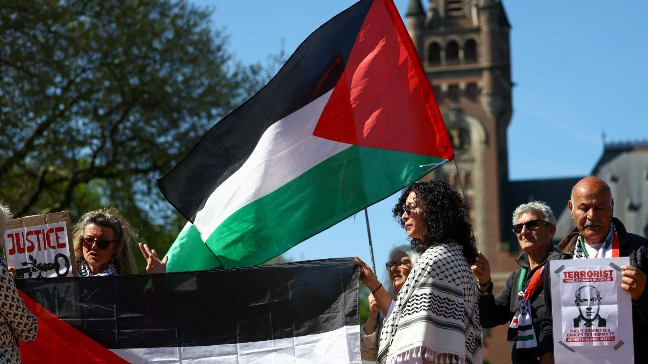
People hold Palestinian flags outside The International Court of Justice (ICJ), in The Hague, Netherlands, on 28 April, 2025 (Reuters)
The International Court of Justice (ICJ) has recently postponed the deadline for Israel's defence in the case of South Africa v Israel to January 2026.
The World Court is tasked with determining whether Israel has committed genocide in Gaza.
The international community - which swiftly condemned the 7 October attack within hours - has shown a striking reluctance to use the word genocide in this context, instead waiting for the world's highest court to validate the term.
This hesitance persists even as the refusal to call a spade a spade breeds unimaginable horror.
Worst of all, there remains a risk that the court might ultimately decline to label the events as genocide.

New MEE newsletter: Jerusalem Dispatch

Sign up to get the latest insights and analysis on Israel-Palestine, alongside Turkey Unpacked and other MEE newsletters

Its hesitation to name what is unfolding, despite the vast amount of evidence available and the affirmative findings of major human rights organisations - coupled with its casual tolerance for added bureaucracy in what may be the most urgent case of the century - suggests that it is susceptible to a form of moral bribery.

Law versus justice
International law is often mistaken for justice, but the two are not the same.
Law can become a technical discipline so divorced from lived reality that it borders on the absurd.
This is largely because many international lawyers are reluctant even to use the word justice. They argue that there is no clear way to define it, and so they adhere strictly to the rules set by states.
Post-war international law upheld empire by resisting every attempt to reckon with colonisation
Unsurprisingly, those rules tend to reflect the political will of the world's most powerful countries - most of which are former colonial powers.
The rules and case law the court will rely on to assess whether genocide has occurred in Gaza are narrow. These precedents fail to incorporate the lessons of genocides committed in colonial contexts.
As elegantly illustrated by Raoul Peck in his documentary Exterminate All the Brutes, many such genocides were erased from history by their perpetrators, while accounts by the descendants of victims continue to be silenced.
Indigenous peoples in Canada, Australia, the US and elsewhere were denied the right to tell their stories. The same applies to the millions massacred or maimed in retaliation for their resistance in Algeria, the Congo, Namibia, Latin America, Vietnam and beyond.
We must acknowledge that much of the world remains ignorant of the history of colonisation - and that this ignorance is by design.
International law, as a discipline, was a powerful instrument of colonial erasure. It developed in the service of European upper-class interests at the height of empire.
Its legitimacy was justified under the banner of "civilisation" - a term that in practice meant anything serving European interests and egos.
Post-World War Two international law did not mark a clean break with this history. On the contrary, it repeatedly resisted efforts by the Global South to force a reckoning with the legacy and ongoing reality of colonisation.

An unspoken rule
Even within the narrow legal precedents on genocide, Israel's conduct since its founding speaks for itself.
The court has already acknowledged that Israel is violating the highest-ranking norms of the international legal system.
Any rational reading of the court's advisory opinion on the legality of the Israeli occupation, issued last July, reveals the full picture.
If Israel is violating the right to self-determination, annexing land, enacting a system of racial segregation and apartheid, and committing countless other grave, systemic violations, then it is unmistakably a colonising state.
Yet there remains an entire community of international lawyers afraid to call a spade a spade. To do so would mean breaking an unspoken rule: one must not acknowledge the history of colonisation.

As Israel terrorises Palestinians, the world looks away
Read More »
And once we accept that this is a colonial context, history shows us that genocide is a natural practice in such contexts.
Moreover, Israel has worked meticulously to ensure it meets all the criteria for genocide under the Convention.
It has deprived a population of more than two million people of water, electricity and food for extended periods. It has flattened entire cities and terrorised civilians with the most advanced weaponry the world has ever seen. Technological asymmetry and efficient mass killing are hallmarks of colonial violence.
Today, Gaza has the highest number of child amputees ever recorded. The mutilation of bodies is a familiar image in colonial warfare.
Thousands of Palestinian prisoners are subjected to systemic torture. These acts are not random - they are carried out with the clear intention of ethnically cleansing the Palestinian people. That intention is carved into the very foundation of the Israeli state.

Litmus test
The only way to rule that this is not genocide is to deny both the history of colonisation and the reality on the ground.
The judges of the ICJ are not ordinary people - they are, supposedly, among the most respected and well-educated legal minds in the world. They know the history of colonisation, and the parties to this case have ensured they are informed about the current reality in Gaza.
The case of Palestine has become a litmus test - not just for the humanity of the judges, but for the credibility of international law as a discipline
The court's recent decision to grant a delay should have set off alarm bells across the entire discipline. Why? Because without ink on paper, powerful states retain the leverage to avoid looking at themselves in the mirror.
Delaying justice in this case strengthens the hand of a settler-colonial project. It buys time - time to reshape the narrative and erase the evidence.
The case of Palestine has become a litmus test - not just for the humanity of the judges, but for the credibility of international law as a discipline.
The question that remains is whether the judges will succumb to political pressure and the unspoken rules of their field, resorting to vague language that leaves room for ambiguity and evasion.
If the answer is yes, then the judges will have embraced the kind of wilful ignorance that the status quo rewards - especially in the face of normalised atrocity.
Will they be morally bribed - consciously or unconsciously? Or will they finally break with international law's long history of normalising colonial erasure, and speak a word of justice in the face of the bloodiest atrocity of our lifetimes?

