A protective force must be deployed to occupied Palestine
States have the duty to stop genocide. Sending a peacekeeping force to Gaza and the West Bank would fulfil this obligation.





By Nicola Perugini and Shahd Hammouri
Senior Lecturer in International Relations at the University of Edinburgh. Lecturer in International Law at the University of Kent.
Published On 28 Apr 202528 Apr 2025
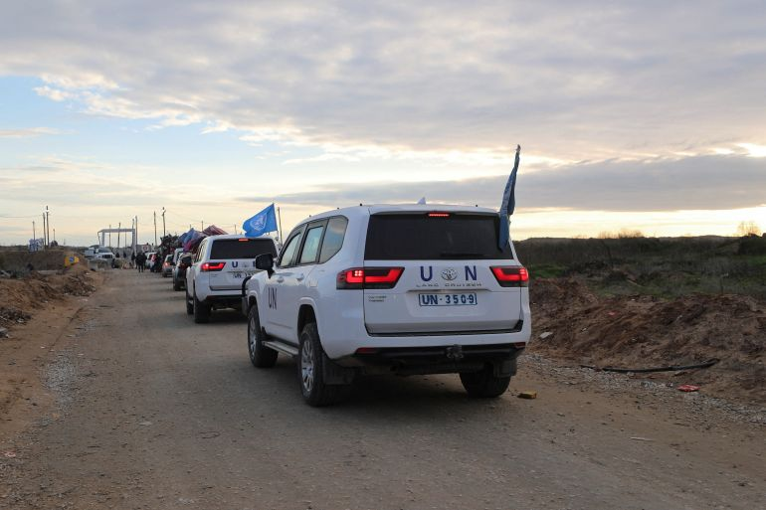
UN vehicles and other cars wait to cross through a checkpoint run by security contractors after Israeli forces withdrew from the Netzarim Corridor, in Gaza City on February 9, 2025 [File: Dawoud Abu Alkas/Reuters]
In the past few weeks, demands for the deployment of a protective force in Gaza and the West Bank have resurfaced. They have come from health professionals and medical organisations, Palestinian NGOs and even Arab civilians. Last year, the Arab League and human rights organisations also called for a peacekeeping force to be sent to Gaza.
In light of the global normalisation of livestreamed genocide and the political reluctance to enforce international law, this demand represents a bare minimum measure to safeguard Palestinians against unimaginable horrors.
The demand is firmly grounded in international law. In Gaza, a peacekeeping force could advance the duty of states and the United Nations to protect a people facing genocide, war crimes and crimes against humanity under investigation at the International Court of Justice and International Criminal Court. In both Gaza and the West Bank, such forces could support the process of ending the occupation, as demanded by the UN General Assembly and the International Court of Justice.
And yet, the demand for a protective force faces major challenges. The crucial question is: Can they be overcome?

The justification for a protective force
The situation in Gaza and the West Bank has reached unprecedented urgency and extremity. Military pressure from armed groups in Lebanon and Yemen exerted in an attempt to protect the Palestinian people did not manage to stop the atrocities, and the Lebanese and Yemeni people have paid a heavy price.
That is why an international protective force is urgently needed. Its deployment would fulfil what the Palestinian population is asking the international community to do: to protect them. This force would serve as a “human shield” – not in the derogatory sense weaponised by the Israeli military to justify its genocide by framing the entire Palestinian population as human shields but in the sense of a literal peaceful barrier between the Palestinians and their annihilation.
Advertisement
Its presence could mean the difference between life and mass death for civilians who have faced a year and a half of bombardment, siege and starvation.
Moreover, this force offers a critical alternative to more sinister “solutions”. As Israel escalates its genocidal campaign, imposing conditions designed to destroy Palestinian life, the United States has floated the idea of deploying its troops to Gaza to “take it over”.
Such a move would constitute an illegal US invasion of Palestine, further entrenching colonial violence under the guise of maintaining “stability”. By contrast, forces tasked with the responsibility to protect Palestinians – and not imperial and colonial interests – could provide a legitimate, internationally grounded countermeasure.

The challenges of forming a protective force
Deploying protective forces through a mandate of the UN requires a UN Security Council resolution. The US will most definitely veto any attempt to create such a force, just as it has struck down various ceasefire resolutions, in effect enabling genocide and blocking any effort to uphold even the most basic principles of humanity under the UN Charter.
Get instant alerts and updates based on your interests. Be the first to know when big stories happen.
The situation is undoubtedly growing more hopeless under a US administration that is actively supporting the mass expulsions and deportations of the Palestinian population from Gaza. US President Donald Trump himself has described the Gaza Strip as a “demolition site” and expressed his desire for the US to turn it into the “Riviera of the Middle East”.
Since a resolution calling for a protective force would be blocked at the Security Council, the alternative is for a multilateral call to action through the UN General Assembly. There, too, US coercive power heavily influences votes – including that of the Palestinian Authority – but it is still a viable option. The earliest such a move could happen is at the next session of the General Assembly in May and would require immense diplomatic pressure.
A vote for a protective force by the General Assembly would not be binding and would require approval by the Security Council. However, it could help create a coalition of countries signalling their willingness to intervene with concrete protection measures in defence of Palestinian life after 19 months of empty words without tangible action.
Another challenge is that the mechanism of deploying peacekeeping forces has long been regarded with suspicion by states in the Global South – and for a good reason. UN peacekeeping troops have often served as tools of policing in the Global South and as extensions of imperial control, at times committing atrocities themselves.
Advertisement
Historically, peacekeeping has largely aligned with imperial interests, rarely opposing them. Troop-contributing countries often have questionable military alliances, and peacekeeping operations depend on funding from large donors, such as the US. A good example of this is the UNIFIL peacekeeping mission in Lebanon, which has an unusually high European presence and which has failed to protect the south of the country from Israel’s aggression.
Given all these challenges, do we abandon the demand for a protective force in occupied Palestinian territory? Absolutely not.

A radical reimagining of protective forces
The obstacles are real, but the demand for a protective force is legitimate. It comes from within multiple sectors of Palestinian society itself and is endorsed globally by antigenocide individuals and groups.
In a recent petition, Palestinian and international health workers proposed a model: a neutral, multinational protective mission – not to mediate, but to shield. Their demands include excluding nations complicit in the assault from contributing troops and a mandate for the protective force to physically shield Palestinian civilians and healthcare workers, to restore safe humanitarian and medical corridors, and to support Palestinian-led rebuilding of Gaza’s obliterated infrastructure.
Similarly, the Palestinian NGOs Network has called for international protection, open crossings into Gaza and guaranteed safe aid corridors.
Meanwhile, Egyptian civilians have repeatedly declared their readiness to enter Gaza as a civilian shielding force if borders are opened. This underscores the potential for people-powered protection alongside formal mechanisms.
To translate into action these multiple calls, a radical reimagination of what a protective force might look like and how it could work is required.
First, we need states uninvolved in the genocide and civil society groups to push for bypassing the UN Security Council. They must focus all efforts and leverage on the UN General Assembly’s Emergency Special Session in May to stand up to US pressure and push for a vote on a peacekeeping mandate.
Second, we need new South-South alliances. This means strategic partnerships among Global South nations uninvolved in the genocide to fund and staff a mission free from imperial influence that can proceed even without Security Council permission.
Third, we need an unprecedented mobilisation of civil society in a single direction: pressuring governments to endorse and participate in a truly neutral protective force.
The US would oppose the creation of new coalitions that centre Palestinian life and present themselves as the Southern champions of the responsibility to protect doctrine. It would see this as defiance of its hegemony and the Western monopoly over antigenocide discourse, and it would use its veto at the council. However, the countries and civil society groups involved in establishing the protective force should disregard the veto, form the mission autonomously and defy the genocidal international order in which we live.
The challenges facing this radical reimagination effort are formidable. But the alternative is to continue leaving Palestinian lives unprotected – at the mercy of an intensifying process of settler-colonial extermination. We must act now and push for a protective force for occupied Palestine.

