Figure 1. Illustrating the Process Leading to the Analytical Framework.

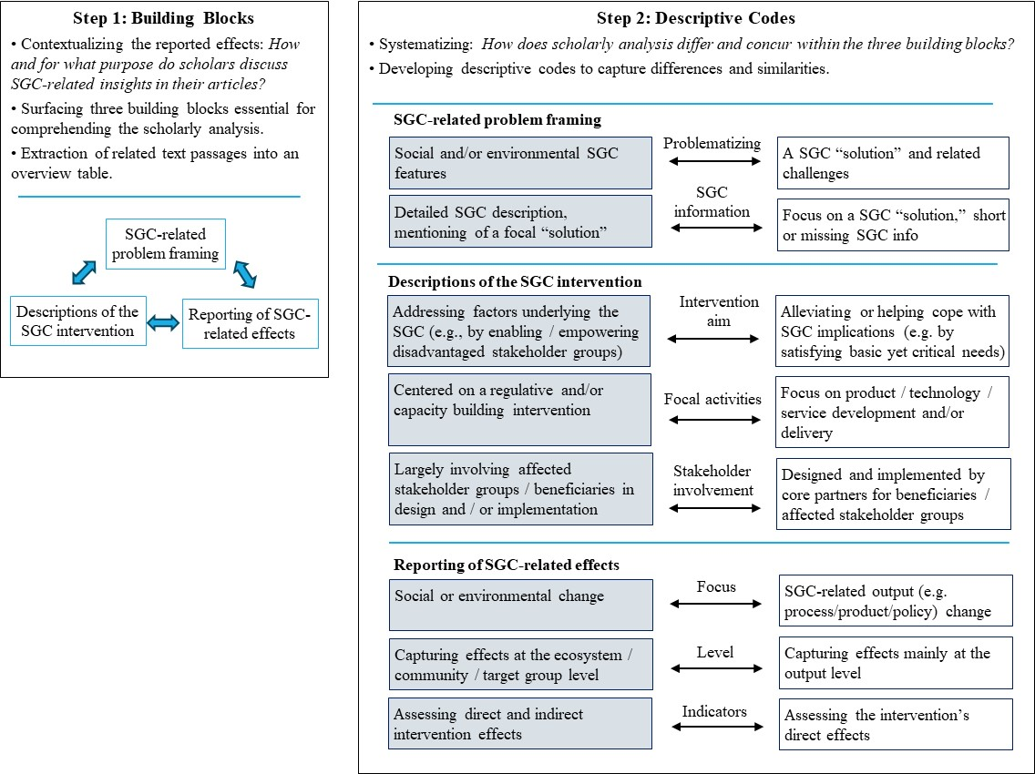
Figure 1 (continued)
