Phillips v Eyre – A Study of Constitutional Law and Empire

Tom Frost

“No one will ever believe the things that were done here in that mad bad time. And very few will ever hear of the tenth part of them – including some of the worst”

Governor John Peter Grant to Colonial Secretary, 23 July 1867

Contents
1. List of Figures 3
2. Abbreviations 4
3. Introduction 5
4. ‘No man is above the law’ 7
5. British Rule in Jamaica 10
6. The Morant Bay Rebellion – the background 14
7. The Morant Bay Rebellion – the rebellion 23
8. The Morant Bay Rebellion – the repression 27
9. The case of George William Gordon 39
10. The Morant Bay Rebellion – The Investigation 44
11. The legal challenges 50
12. Phillips v Eyre – the background 52
13. Phillips v Eyre – the judgment 55
14. Conclusion 64
15. Reading List 67
16. Questions 68

List of Figures

Figure 1 – Map of newly conquered English Jamaica, 1670 10
Figure 2 – Map of Jamaica, 1893 12
Figure 3 - Edward John Eyre, Governor of Jamaica in 1865 15
Figure 4 – An excerpt from the Underhill Letter 17
Figure 5 – Parishes of Jamaica 18
Figure 6 – George William Gordon 21
Figure 7 – Paul Bogle 25
Figure 8 – Morant Bay Court House 22
Figure 9 – Baron Maximilian von Ketelhodt 24
Figure 10 – Excerpt from a copy of a letter signed by leaders of the rebellion 25
Figure 11 – An Image of the Morant Bay Uprising, 11 October 1865 26
Figure 12 – A detailed map of St Thomas in the East parish 27
Figure 13 – Proclamation of Martial Law 28
Figure 14 – An 18th century ‘cat o’ nine tails’, designed to lacerate the skin and cause great pain 30
Figure 15 – Colonel Alexander Fyfe and six Maroons 33
Figure 16 – “Grave of eighty Rebels near Morant Bay, Jamaica.” Photograph album documenting the Morant Bay rebellion, Graphic Arts Collection, Department of Rare Books and Special Collections, Princeton University Library 34
Figure 17 – Execution of Rebels at the ruins of the Court House, Morant Bay 35
Figure 18 – Legal advice from Mr William Wemyss Anderson to George William Gordon 44
Figure 19 - George William Gordon’s Last Letter to his Wife 42
Figure 20 – The town of Morant, Morant Bay, Jamaica 43
Figure 21 – Report of the Jamaica Royal Commission 48
Figure 22 – The common law courts before the Judicature Acts 54
Figure 23 – Acting Prime Minister Donald Sangster looking at the statue of Paul Bogle, erected in front of the Morant Bay Courthouse, which was unveiled on 11 October 1965, on the 100th anniversary of the Morant Bay uprising 65

Abbreviations

CO – Colonial Office Records, The National Archives, London
JRC – British Parliamentary Papers, 1866, [3683-I], XXXI, Report of the Jamaica Royal Commission, Part II, Minutes of Evidence and Appendix
Papers – British Parliamentary Papers, 1866, [3682], XXX, Papers Laid before the Royal Commission of Inquiry by Governor Eyre
PRO – Public Record Office, London
Report – British Parliamentary Papers, 1866, [3683], XXX, Report of the Jamaica Royal Commission

Introduction

When studying law, you are presented with hundreds and hundreds of cases in your modules. You will be taught about them in lectures, and read about them in textbooks, or in law reports.

But these only provide summaries or snapshots of what the cases were about. Even in law reports, the judges and law reporter will only summarise the relevant facts which are at issue in the legal dispute, and they will not provide the full story behind the case.

More than this, it is the court, lawyers and judges who decide what the relevant facts are. Individual testimonies are mediated through witness statements and rules of evidence. Wider questions of morality and justice are made to fit into legal tests recognised by the common law.

In this resource, we take a close look at a case from 1870, Phillips v Eyre, and (more importantly) its background.

This case is often presented as no more than a footnote in textbooks for law students, worthy of a few sentences of comment.

Yet this case was the final chapter in a long, bloody struggle in the history of the British Empire (and one which has been all but forgotten in the United Kingdom), the Morant Bay rebellion.

The rebellion took place in the British colony of Jamaica in October 1865.

The colonial administration in Jamaica viewed it as a direct challenge to British imperial rule and set out to suppress it and to ensure that another rebellion would not happen again.

Following these events, a lengthy political and legal dispute arose.

You will consider the events of the rebellion, and the response of the colonial administration that led to the dispute arising.

You will read the words of the people involved in the rebellion, the colonial administrators of Jamaica, British Government officials, and those Jamaicans caught up in the tumult and its aftermath.

You will also read about the history of British rule in Jamaica, Jamaica’s history of slavery, and the problems facing the island in the 19th century.

Ultimately, you will read about how the case of Phillips v Eyre has been presented by lawyers. You will also read an excerpt of the judgment of the case itself.

As you work your way through these materials, consider whether the case of Phillips v Eyre accurately represented the events of the Morant Bay rebellion.

You should also think about the ways in which the British Empire administered its colonies, and how it treated its colonial subjects.

What does this history tell you about the role of law in the British Empire? And what does this case tell you about the ability of colonial subjects to receive justice in the imperial legal order?

You are to answer the questions which can be found at the end of this document.

The research for this project was carried out at The National Archives, in Kew, London.

It was funded by a grant from the University of Leicester College of Social Sciences, Arts and Humanities, Teaching Development Fund 2021-22.

‘No man is above the law’

Our starting point is the rule of law. The rule of law is considered a main constitutional principle in the United Kingdom. It is an envelope that contains a set of more specific principles.

In the UK, the rule of rule is treated as an important political principle as it informs political discourse.

In the UK, the main practical effects of the rule of law are threefold:

- Courts will strike down government action that is inconsistent with the rule of law.
- Courts try, whenever possible, to give legislation a meaning that is compatible with the rule of law.
- Courts will generally hold legislation (other than Acts of Parliament) to be invalid if it cannot be interpreted compatibly with the rule of law.

A V Dicey’s principle of the rule of law supports the idea of equality before the law.

Dicey stated that this meant two things:

[N]ot only that with us no man is above the law, but (what is a different thing) that here every man, whatever be his rank or condition, is subject to the ordinary law of the realm and amenable to the jurisdiction of ordinary tribunals.

The underlying idea here is that all people, whatever their position in society, their profession, or their status, should be subjected to the same laws. As Dicey explains:

With us every official, from the Prime Minister down to a constable or a collector of taxes, is under the same responsibility for every act done without legal justification as any other citizen.

In this country, courts have respected this longstanding tradition to protect individual rights.

The Case of Proclamations stated that the monarch could make laws only through Parliament, and not by themselves only.

The Habeas Corpus Act 1679 was passed to define and strengthen the ancient prerogative writ of habeas corpus, which required a court to examine the lawfulness of a prisoner's detention and thus prevent unlawful or arbitrary imprisonment.

The case of Entick v Carrington laid down the principle that the state could not lawfully override an individual’s property rights unless the law authorised the state to do so.

Dicey explained that no-one can be punished without transgressing a law:

[N]o man is punishable or can be lawfully made to suffer in body or goods except for a distinct breach of law … In this sense the rule of law is contrasted with every system of government based on the exercise by persons in authority of wide, arbitrary or discretionary powers of constraint.

By this, Dicey claims that the law should not have retrospective effect. You cannot be punished for doing something which was legal at the time you did it, but later was criminalised. This ensures everyone is equal and treated fairly.

In support of these claims, Dicey cited a number of cases, including the case of Phillips v Eyre, as examples of where officials have been brought before the courts to account for alleged breaches of the law.

Phillips v Eyre is presented in legal texts as an example of the rule of law, showing that the law applies equally to everyone, regardless of status.

It is likely that you have not heard of it before, but it is mentioned in several Constitutional & Administrative Law textbooks (you do not need to consult these yourselves but can read the excerpts presented here).

Those textbooks all mention a judgment delivered by Willes J, in which he said:

The general principle of legislation by which the conduct of mankind is to be regulated ought to deal with future acts and ought not to change the character of past transactions carried on upon the faith of the then existing law.

Willes J is not just saying that the law should apply equally to everyone. He is also saying that legislation should be prospective, not retrospective. That means that laws passed by the legislature should only cover situations in the future. Legislation should not penalise conduct that was lawful when it occurred. It would be unfair for someone to be held responsible for something that was lawful when they did it.

But what was the case about?

Why did this dispute, presented to readers as helping defend the rule of law, arise?

The case of Phillips v Eyre was the ending to an intense legal and political debate over the Morant Bay Rebellion, and the colonial government’s response to the rebellion, which took place in colonial Jamaica in 1865.

What we will explore in this guide is how a colonised people’s rebellion against the excesses and unfairness of British imperial rule has all but been excised from textbooks and histories.

In the United Kingdom the rule of law reflected equality before the law.

Phillips v Eyre shows that this was not the case in the British Empire.

We will explore this case, and the Morant Bay Rebellion and its aftermath, through the testimonies and evidence of the main actors and witnesses to the events. Sources and names will be provided throughout this document.

At the end of this document, you will find questions you need to prepare for your final tutorial, based on the materials contained here.

Before considering the rebellion, and the reasons for its being brought about, we will first briefly outline the history of British possession of the island of Jamaica.

British Rule in Jamaica

The island of Jamaica was initially inhabited in around 600-650 CE by the Redware people.

A second wave of inhabitation occurred by the Arawak tribes prior to Christopher Columbus arriving at the island in 1494. Columbus’s arrival started a wave of Spanish colonisation.

The capital of the colony was called Spanish Town (which is still the second largest settlement in Jamaica today).

The Spanish enslaved many of the Arawaks, most of whom died from disease and overwork. In response, the Spanish introduced the first African slaves to the island.

From 1654-1660 England was at war with Spain. This was a minor part of a wider 25-year war between many European countries, in which casualties totalled 600,000 dead, wounded or missing.

In 1655, England invaded Spanish Jamaica. Jamaica was formally ceded to England by the Treaty of Madrid in 1670.

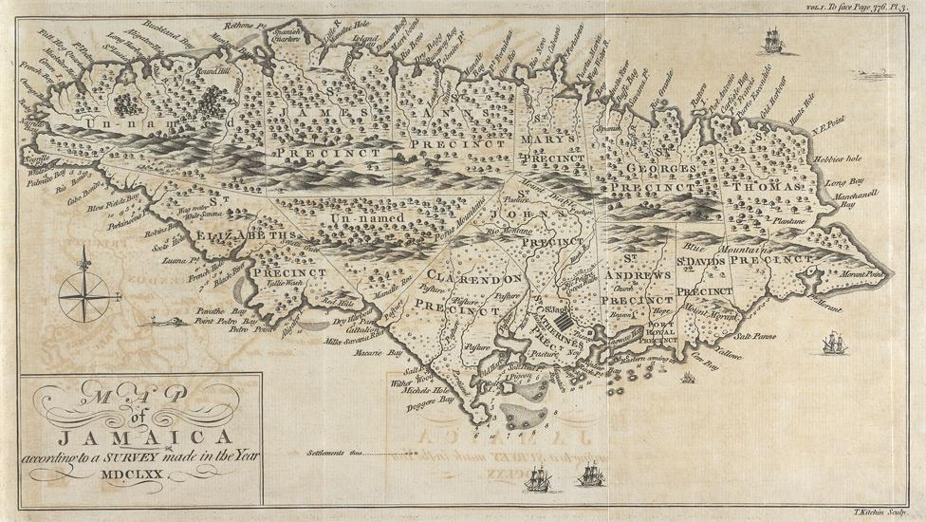
Figure 1 – Map of newly conquered English Jamaica, 1670
English Jamaica became British Jamaica in 1707, when the state of Great Britain was formed.

By the end of the 17th century, England began transporting African slaves to the colony.

Throughout the transatlantic slave trade, approximately 2.3 million enslaved Africans were transported to the British Caribbean. Almost half of these slaves, 1.02 million, disembarked in Jamaica, which was Britain’s most profitable possession in the Caribbean.

Source: https://www.statista.com/statistics/1150546/number-slaves-arrived-in-each-region-of-british-caribbean-from-africa/.

What made Jamaica valuable was its sugar cane plantations. The slaves in Jamaica worked (without pay) on these plantations.

Sugar was so valuable because it was being consumed more and more in Europe as a way to sweeten tea.

Tea was popular as it was easier to make than coffee.

Britons came to adore sweet, milky tea as no other nation had (or even perhaps could).

Sweet tea became a national indulgence. By 1770 per capita consumption of sugar was running at 9kg per person each year. That sounds like quite a lot until you realise that Britons today eat over 35kg per person per year.

In 1673 there were only 57 sugar estates in Jamaica. By 1739, there were 430. By 1832, the average sugar plantation had about 150 slaves.

The oppression of the slaves in Jamaica was considered by contemporaries to be amongst the most brutal in the world.

African slaves transported to the British Caribbean resisted enslavement, both passively and actively.

The Maroons were communities of free black people, living in the interior of Jamaica. Many were runaway slaves or descended from runaway slaves. Jamaican Maroons established communities in the eastern parishes of the island.

In 1739 the British colonial authorities signed treaties with the Maroon communities, legally recognising them and distinguishing between them and the rest of the Jamaican population.

After 1739 the British colonial government started employing the Maroons as a sort of internal police force, who would track down and capture runaway slaves and help prevent slave rebellions (an irony given that the Maroons themselves were runaway slaves or their descendants).

By 1800, enslaved Jamaicans outnumbered white Jamaicans by a ratio of 20:1.

In 1864 Jamaica contained some 440,000 citizens, more than 350,000 of whom were former slaves or the descendants of former slaves. Approximately 80,000 colonists were regarded as persons of ‘coloured’ or mixed ethnicity. Fewer than 14,000 were viewed as ‘white’ persons.

With few exceptions, black and mixed ethnicity Jamaicans were desperately poor. There was little cash employment.

There were over a dozen major slave conspiracies and uprisings in Jamaica. They were all violently suppressed by colonial troops and Jamaican Maroons.

The slave trade was abolished in 1807. The Jamaican Assembly decided to try and avoid the complete emancipation and freedom of the slaves. The Assembly resisted attempts from free black people to secure equal rights, and these were only granted in the early 1830s after a long campaign.

In 1831, enslaved Baptist preacher Samuel Sharpe led a strike among slaves, demanding more freedom and a working wage. Upon the colonial authorities refusing their demands, the strike escalated into a full rebellion, which has become known as the Baptist War.

This was the largest slave rising in the British West Indies, lasting 10 days and involving 60,000 of Jamaica’s 300,000 slaves.

The rebellion was suppressed by British forces with a high death toll. Approximately 500 slaves were killed – 207 through the result, and around 300 being executed for various crimes.

An 1853 account by Henry Bleby described how three or four simultaneous executions were commonly observed; bodies would be allowed to pile up until slaves in the workhouses carted the bodies away at night and bury them in mass graves outside town.

The continual slave attacks and uprisings, as well as the way the 1831 rebellion was brutally suppressed, accelerated the process of emancipation, and slavery was abolished in 1834.

The House of Assembly was the legislature of the British colony of Jamaica. It held its first meeting on 20 January 1664 at Spanish Town.

Jamaica also had a Governor, appointed by the British Government in London, who would administer the colony with the Assembly.

The constitution of the Government of Jamaica was modelled on that of England, with a system of administration entirely independent of the control of the British Government in the United Kingdom.

For many years, Jamaican law stated that to vote and stand for election to the Assembly, you needed to own a certain amount of property. As a result, it was dominated by white men who owned a house, a plantation, and who also owned black slaves.

In 1840 the requirements were an income of £180 a year (around £13,000 in today’s money), or land worth £1,800 (around £130,000 today), or if all their property was worth £3,000 (around £215,000 today).

At the election of 1864, the number of persons qualified to vote for the forty-seven members of the Assembly was only 1,903. The actual voters were not more than 1,457, out of a population of 436,807 persons.

These figures excluded nearly all freed black Jamaicans from the right to vote in Assembly elections, even after the end of slavery.

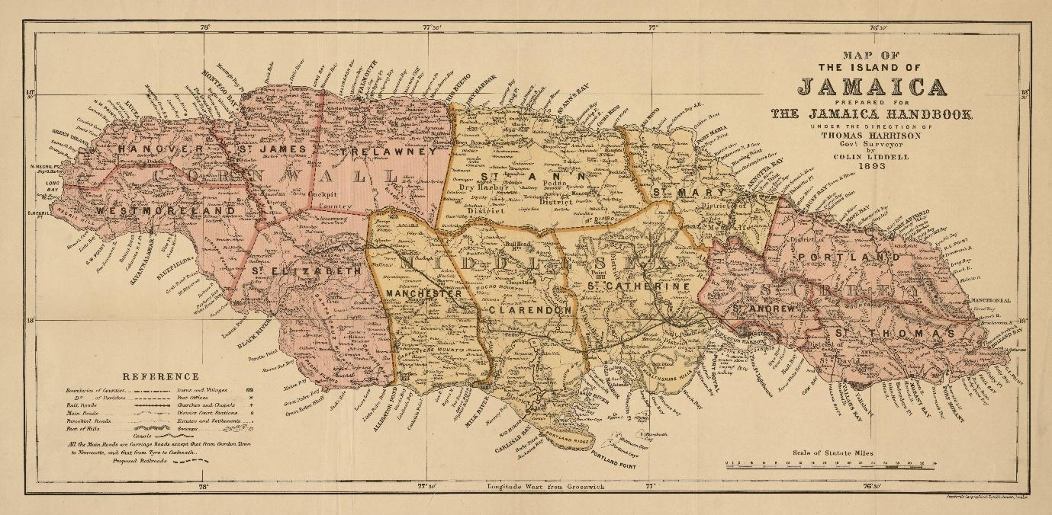
Figure 2 – Map of Jamaica, 1893

After the end of slavery, the island’s economy faltered, as it was based on sugar and slaves.

The Morant Bay Rebellion – the background

Jamaica had a long history of resistance. During slavery, slaves resisted passively through malingering and actively through sabotage and rebellion. But this continued after the abolition of slavery.

In 1839 and 1848 conspiracies to rebellion were found amongst black Jamaicans, which were driven by a fear of re-enslavement.

There were also riots in 1859, directed against high taxes imposed by the Assembly which had shifted a heavy proportion of taxes on to ex-slaves and away from the white propertied population.

The events in Morant Bay in 1865 were therefore preceded by a long history of slave rebellions and riots in the post-emancipation period. It did not appear from nowhere.

Edward Cardwell, the Secretary of State for the Colonies, and the British Government Minister responsible for overseeing Jamaica, had harboured doubts about “whether the measures actually adopted [after slavery was abolished] were in all respects perfectly adapted and most conducive to the interests of the negro”.

Edward John Eyre was appointed Lieutenant-Governor of Jamaica in early 1862 and became Governor of Jamaica in May 1864.

Eyre was born in 1815 as the son of a clergyman. He emigrated to Australia as a teenager, and both farmed sheep and became an explorer. He was eventually appointed to the position of ‘Protector of the Aborigine’ in South Australia. By some accounts he undertook the role with considerable sympathy for native peoples.

His perceived success in this post led to a series of colonial appointments spanning the next twenty years. By 1864, Eyre was a seasoned imperial functionary.

When he was Governor of Jamaica Eyre believed that black people were incorrigibly idle and barbarous, and that they could be ruled only by coercion or the threat of coercion. So normalised was this view that Eyre felt able to voice them in official despatches:

First. That the negroes form a low state of civilization and being under the influence of superstitious feelings could not properly be dealt with in the same manner as might the peasantry of a European country.

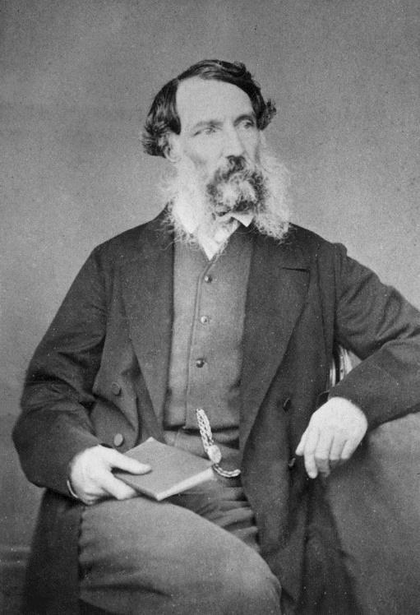
Figure 3 - Edward John Eyre, Governor of Jamaica in 1865

By 1864 Jamaica had been experiencing a drought for over two years. The sugar crop was reduced, wages were falling, and crime was increasing. The British Government, and the Jamaica Assembly, did not send relief.

The drop in wages was accompanied by a dramatic rise in the price of food. This led to people having to steal food to feed themselves and their families, which Governor Eyre disapproved of:

[T]he great increase and almost universal prevalence throughout the country of larceny of provisions or of domestic animals, calls for the most prompt and stringent measures to repress an evil which frustrates the toil of the industriousness, and paralyses all efforts at improvement or comfort.

Governor Eyre believed that the poverty and crime in the colony was due to the apathy and laziness of black Jamaicans.

The press in London shared Eyre’s view. Writing after the rebellion, The Times newspaper expressed puzzlement at why some black Jamaicans felt compelled to rebel:

[T]he negro had no grievances – no grievances, at least, but what he had a legal mode of redressing. He was the most fortunate of cottier proprietors. No peasant in England, Scotland, France, or Belgium could compete with him in his command of the comforts of life. He almost always had land of his own. On this he could grow such cereals and vegetables as were necessary for his subsistence. He could, and often did, grow spices and fruits for exportation. He required no fuel but for the purposes of cooking, and this was abundantly supplied by the neighbouring forests. Whether he lived on the coast or on the mountains, he had fish ready for his net or his rod. If he wanted money for the luxuries of life, a few days’ labour for a few successive weeks gave him all he wanted. If he did not earn this, it was only his own fault. If he idled, lounged, loafed, and starved, it was because he liked this sort of life better than working. If he worked and earned wealth, he acquired the other privileges which wealth brings with it.

[…]

He could protect his own interests; he could influence the interests of others, whether black or white. He had Anglo-Saxon institutions and a constitutional form of Government. Within two generations of African savagery he acquired what the English people won after six centuries of civilized despotism. If he had wrongs, he had the legal means of obtaining redress.

In January 1865, Edward Underhill, a Baptist missionary, wrote a letter to Edward Cardwell describing “the extreme poverty of the people”:

Figure 4 – An excerpt from the Underhill Letter
Letter from E. B. Underhill, Esq. LL.D., to the Right Hon. Edward Cardwell, M.P.

“33, Moorgate Street, E.C.,
5th January 1865.

“DEAR SIR, -- I venture to ask your kind consideration of a few observations on the present condition of the Island of Jamaica.
“For several months past, every mail has brought letters informing me of the continually increasing distress of the coloured population. As a sufficient illustration I quote the following brief passage from one of them :-
“ ‘Crime has fearfully increased. The number of prisoners in the penitentiary and gaols is considerably more than double the average, and nearly all for one crime – larceny. Summonses for petty debts disclose an amount of pecuniary difficulty which has never before been experienced, and applications for parochial and private relief prove that multitudes are suffering from want little removed from starvation.’
“The immediate cause of this distress would seem to be the drought of the last two years; but, in fact, this has only given intensity to suffering previously existing. All accounts, both public and private, concur in affirming the alarming increase of crime, chiefly of larceny and petty theft. This arises from the extreme poverty of the people. That this is its true origin is made evident by the ragged and even naked condition of vast numbers of them; so contrary to the taste for dress they usually exhibit. They cannot purchase clothing, partly from its greatly increased costs, which is unduly enhanced by the duty […] which it now pays, and partly from the want of employment and the consequent absence of wages.
“The people, then, are starving, and the causes of this are not far to seek. No doubt the taxation of the island is too heavy for its present resources, and must necessarily render the cost of producing the staples higher than they can bear to meet competition in the markets of the world. […]
“But the simple fact is, there is not sufficient employment for the people; there is neither work for them, nor the capital to employ them.
[…]
“I shall say nothing of the course taken by the Jamaica Legislature; of their abortive Immigration Bills; of their unjust taxation of the coloured population; of their refusal of just tribunals; of their denial of political rights to the emancipated negroes.
[…]
“I have, etc.,
(Signed) “EDWARD B. UNDERHILL.

The reply was received on 14 June 1865 from the Colonial Office. The response enraged the people. It stated:

“The prosperity of the Labouring Class depends […] upon their working for Wages […] steadily and continuously, at times when their labour is wanted, and for so long as it is wanted”. This blamed black Jamaicans for their own condition.

Underhill noted that:

People longed for change. Weak, vacillating, and undignified in conduct and character, [Governor Eyre] proved himself to be a ruler lacking in tact, wisdom, and penetration. His removal was regarded as an event to be ardently desired, in order that the affairs of so fine and important an island as Jamaica might be placed in more capable hands.

Black Jamaicans continued to petition the Governor for relief. The following request was made from people living in the parish of St David:

We the undersigned Freeholders and other inhabitants of this Parish, respectfully request your honor will be pleased to grant us a place, and appoint a time, where we might meet for the purpose of expressing our sentiments in reference to the distressed condition of the inhabitants occasioned by the drought and other causes, that we might adopt a memorial for presentation to Her Majesty’s Government.
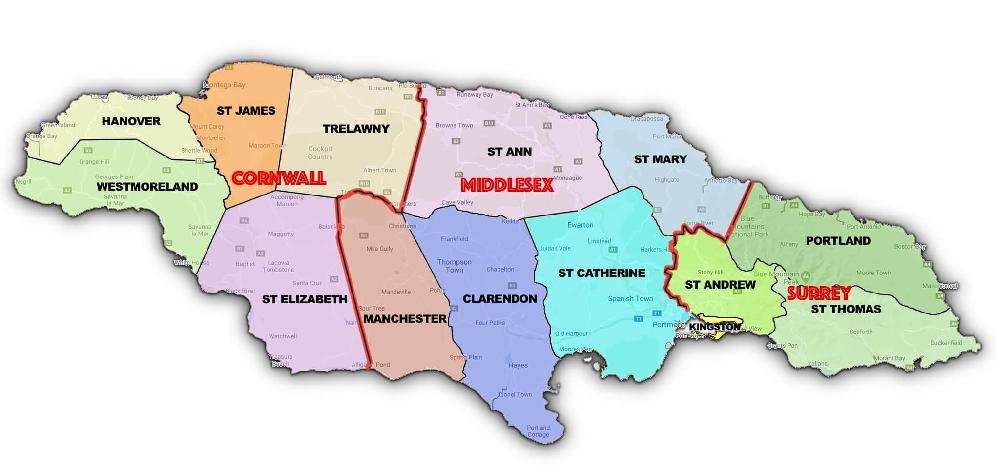
Figure 5 – Parishes of Jamaica today. St David Parish now forms part of St Thomas Parish.

Governor Eyre felt these petitions would make the ‘peasantry’ “discontented with their lot and disinclined to confirm to the laws which regulate their taxation, their civil tribunals or their political status, all of which they have been informed are unjust, partial or oppressive”.

Meetings to discuss the need for political reform were held throughout the island in the Summer and Autumn of 1865 and attended by hundreds. Resolutions were passed at the meetings criticising the ruling class and complaining about the lack of jobs, unfair laws, and low pay.

The Governor, the Assembly and the Colonial Office should have known that civil unrest was likely.

It was so obvious that even Jamaican newspapers mentioned it. The County Union reported that “a state of anarchy is gaining ground that will soon bid defiance to the civil power under its most energetic exercise”.

The parish of St Thomas in the East was the scene of the Morant Bay rebellion. It was also the scene of bitter political disputes in the 1860s.

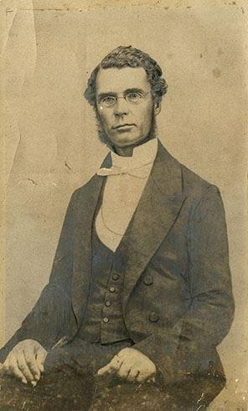
Figure 6 – George William Gordon

The bitterest of those disputes involved George William Gordon, a mixed-ethnicity politician and Assembly member, the son of a white Jamaican slave owner and one of his slaves.

By the late 1850s Gordon campaigned on behalf of the ex-slave population.

Paul Bogle, a Baptist preacher and small landowner living in St Thomas in the East, served as Gordon’s political agent.

Bogle was born into slavery in 1822. He acquired his freedom in 1838 after the abolition of slavery and apprenticeship. He acquired substantial property. He fought for land rights, fair wages, and better living conditions for the poor as there was no social welfare programmes available to ex-slaves.

Gordon and Governor Eyre became political opponents.

When Gordon complained to Eyre about an ill and poor man who had been wrongly imprisoned and as a result died, Eyre removed Gordon from his position as a magistrate and criticised his behaviour.

Gordon described Governor Eyre as an ‘evil doer’ and “a plague spot on poor Jamaica”.

In 1865, Governor Eyre refused to even see Bogle who had led a 45-mile march to the capital Spanish Town from Stony Gut, a town in St Thomas in the East. Bogle was trying to petition for better living conditions for the people of the parish.

By the summer of 1865 Bogle began openly to discuss the possibility of armed resistance. There is evidence that his followers began to drill and prepare for conflict.

By October 1865, mounting political tension in the parish was exacerbated by a series of angry clashes at the court hearings held in Morant Bay. For Bogle and his followers, the courthouse at Morant Bay had become a symbol of their oppression.

On 9 October 1865, Baron von Ketelhodt, a magistrate in the parish of St Thomas in the East, and based in the town of Morant Bay, issued a warrant for the arrest of Paul Bogle and several of his companions.

von Ketelhodt was German born, owned a plantation and was a former slaveowner.

On 10 October, an unsuccessful attempt was made by the police to effect the arrests in villages near Morant Bay.

This ended in the rough ejection of the police, accompanied by alleged threats against von Ketelholdt’s life.

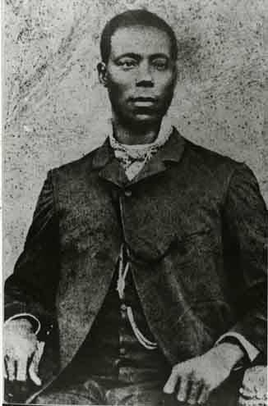
Figure 7 – Paul Bogle

Bogle petitioned Governor Eyre after the event, complaining that:

An outrageous assault was committed upon us by the policemen of this parish, by order of the Justices, which occasion an outbreaking for which warrants have been issued against innocent person, of which we were compelled to resist. We therefore, call upon your Excellency for protection, seeing we are Her Majesty’s loyal subjects.

In response, the Baron mustered the local white militia and sent an urgent plea to the Governor for help.

With these precautions in place von Ketelhodt decided to hold a meeting at the Morant Bay courthouse on 11 October 1865.

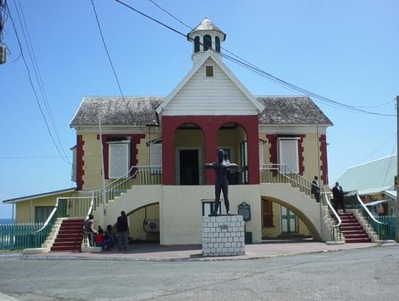
Figure 8 – Morant Bay Court House

The Morant Bay Rebellion – the rebellion

On 11 October 1865, several hundred black Jamaicans marched into the town of Morant Bay from the nearby village of Stony Gut. They went into the town “like a mob, dancing and blowing horns”.

The choice of marching to the Morant Bay courthouse was no accident. Jamaica’s local courts of law were operated by white plantation owning magistrates, who were biased. Any disputes between black Jamaicans and white Jamaicans were invariably decided in favour of the white Jamaicans. In addition, the local courts were expensive, cumbersome, and inaccessible to black Jamaicans.

Among the crowd, and its leader, was Paul Bogle.

The people were armed and said that “we will kill every white and Mulatto man in the Bay, and when we finish, we will return and go to the estates”.

As the mob surged forward, Baron von Ketelhodt cried out, “Peace!” and other officials called out, “Peace in Her Majesty’s Name!” But the people responded “No Peace! Hell today!”

Baron von Ketelhodt began reading the Riot Act.

(The Riot Act is a historical British Act of Parliament enacted in 1714, which stated that once a specific form of words was read out to rioters and they failed to disperse within one hour, then the authorities may use any force to disperse them without legal consequences).

The crowd began throwing stones and bottles, injuring some of the militia. The crowd got close enough to the militia to badly beat some of them, and to take away some of the militia’s weapons.

Baron von Ketelhodt gave the order to fire, and several members of the crowd were killed and wounded.

The militia and the Baron and other civilians retreated to the courthouse, and once inside they barricaded the doors.

After about two hours, members of the crowd decided to burn down the courthouse and force those inside out.

With the courthouse on fire, some people jumped out of a back window and escaped. Some were not so lucky. Eighteen including von Ketelhodt were mobbed and killed.

It appeared the victims were specifically targeted. Many white and mixed-ethnicity inhabitants of the town of Morant Bay were allowed to escape the violence.

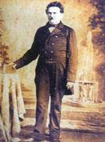
Figure 9 – Baron Maximilian von Ketelhodt

One volunteer heard Ketelhodt asking, “What are you beating me for? What have I done to you?” as he was dragged along by the crowd and beaten to death. von Ketelhodt had angered much of the populace as an opponent of George William Gordon.

The crowd was organised. Bogle generally gave orders and was referred to as ‘General Bogle’.

Apart from burned out buildings there was little other destruction in Morant Bay.

The rebellion would spread throughout the parish of St Thomas in the East before being savagely repressed.

Figure 10 – Excerpt from a copy of a letter signed by leaders of the rebellion

MR. GRAHAM and other gentlemen, it is time now for us to help ourselves. Skin for skin, the iron bars is now broken in this parish, the white people send a proclamation to the Governor to make war against us, which we all must put our shoulder to the wheels and pull together.

[…]

Blow your shells, roal your drums, house to house take out every man, march them down to Stoney Gut, any that you find in the way takes them down, with there arms; war is at us, my black skin war is at hand from to-day to to-morrow. Every black man must turn at once, for the oppression is too great, the white people are now cleaning up they guns for us, which we must prepare to meet them too. Chear men, chear, in heart we looking for you a part of the night or before daybreak.
We are, &c
(Signed) PAUL BOGLE
J. G. MCLARREN
B. CLARKE
P. CAMERON

Get a bearer to send us a answer to this, for they determine to make us a slave again. When you do come to “Stoney Gut” or Hayfield blow your shells and tell what place you is from first before entired.
(Signed) E. K. BAILEY

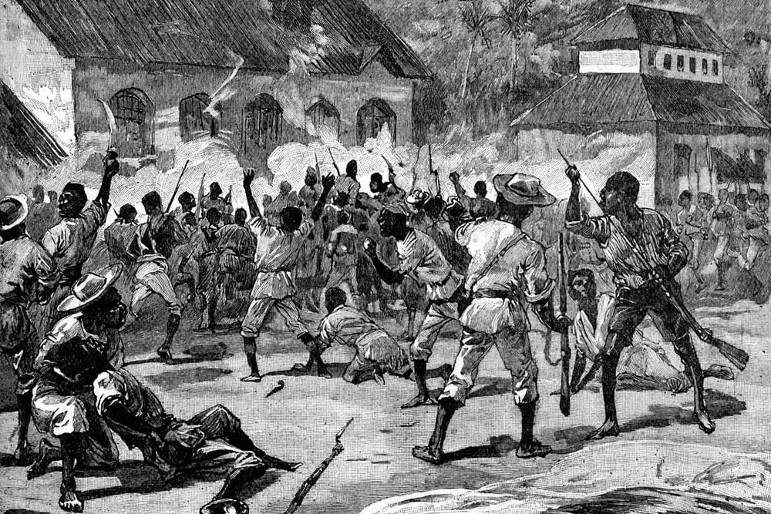
Figure 11 – An Image of the Morant Bay Uprising, 11 October 1865

The rebellion spread to the borders of St David to the west and to Portland to the north and east. Various groups of black Jamaicans unaffiliated with Bogle attacked property, took prisoners and, in two cases, killed two white Jamaicans associated with the plantations. During the few days after 11 October many of the estates in the north-west of the parish were pillaged.

On learning that a plantation had been plundered, Bogle ordered two men to be flogged for their role in taking the goods and fired a volley over their heads as a warning to others.

The Morant Bay Rebellion – the repression

When reading these accounts of the Jamaican Government’s response to the Morant Bay rebellion, you should remember that every person on the island of Jamaica, regardless of their ethnicity or background, born a slave or born free, was a British subject.

By 12 October, Governor Eyre was informed that rebellion had broken out. Eyre was nervous. He had fewer than 1,200 uniformed soldiers under his command, two field guns and two small naval vessels. Eyre requested troops reinforce Morant Bay and march to block a rebel advance. He could spare only 500 regular troops. Martial law was declared for the entire county of Surrey, and troops arrived at Morant Bay the same day:

I immediately landed the troops and the field gun and occupied the square, where the still burning Court House, and the bodies of the murdered men in all directions evinced but too clearly the results of the previous day. Many ill looking persons were loitering about the town but the armed insurgents had retired.

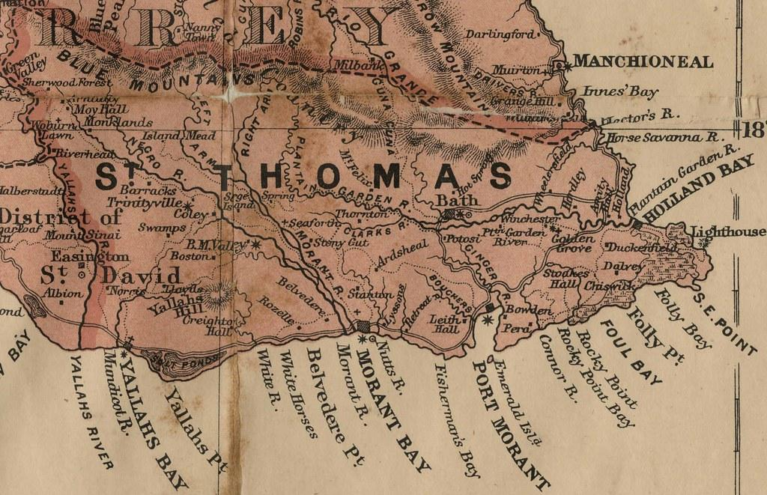
Figure 12 – A detailed map of St Thomas in the East parish

Figure 13 – Proclamation of Martial Law

Jamaica, ss.

VICTORIA, by the grace of God, of the United Kingdom of Great Britain and Ireland, Queen, and of Jamaica supreme Lady, Defender of the Faith –
To all our loving subjects!

Whereas we are certified of the committal of grievous trespasses and felonies within the parish of St. Thomas in the East of this our Island of Jamaica, and have reason for expecting that the same may be extended to the neighbouring parishes of the county of Surry of our said island: We do hereby, by the authority to us committed by the laws of this our island, declare and announce to all whom it may concern, that martial law shall prevail throughout the said county of Surry, except in the city and parish of Kingston; and that our military forces shall have all power of exercising the rights of belligerents against such of the inhabitants of the said county, except as aforesaid, as our said military forces may consider opposed to our Government, and the well-being of our loving subjects.

Given at Head Quarter House, Kingston, on the thirteenth day of October, in the year of our Lord one thousand eight hundred and sixty-five, and in the twenty-ninth year of our reign,

Witness: -- His Excellency Edward John Eyre, Esquire, Captain-General and Governor-in-chief in and over our said Island of Jamaica, and other the territories thereon depending in America, Governor and Commander-in-chief of the Colony of British Honduras, Chancellor of our said Island of Jamaica, and Vice-Admiral if the same.

(Signed) E. EYRE.

By his Excellency’s command.
(Signed) EDWARD JORDAN, Governor’s Secretary.

Martial law involves the military taking over the whole business of government from civilian administrators. Ordinary law is suspended during the duration of martial law.

The military interpreted martial law to mean that in times of rebellion they were entitled to take whatever action was necessary to suspend a rebellion and were not required to desist from using force just because there was no imminent local threat to peace.

The initial stories of the rebellion told to Eyre were highly livid and wildly inaccurate, including reports that the victims had their tongues cut out, burned alive and had their eyes and brains dashed out.

Governor Eyre himself declared that by 15 October, the rebellion had been crushed and peace restored. This was on the fourth day after the rebellion. Despite this, martial law remained in place for thirty days. For the remainder of the period, and often with the direct knowledge and approval of Governor Eyre, the military engaged in what one commentator later called a “hell-like saturnalia” of retaliatory violence.

Soldiers were ordered not to bring in any prisoners unless they were leaders of the rebellion. Those people found armed were “to be shot on the spot”. Legal niceties were not observed by troops.

Under the proclamation of martial law, no fewer than 439 black Jamaicans, as an English magazine story later recounted, “were either shot down or executed, sometimes with, sometimes without the formality of a trial, and over 600, amongst whom were included a number of women, were flogged, in some cases with revolting cruelty”.

In the village of Long Bay, twenty people were killed, many shot while running away from the troops.

On 19 October troops shot ten people without trial, three of whom they believed were involved in a murder during the rebellion.

The soldiers were particularly brutal. Christopher Codrington was involved in the whipping of two men, one of whom was called Johnson Speed. As Speed was receiving one hundred lashes, the whip broke. While another was being prepared, a bystander indicated that he had seen Speed in one of the great houses which had been destroyed. A soldier then shot and killed Speed.

Many women were flogged and had salt brine rubbed into the wounds immediately after the flogging.

Courts martial were held in many cases. The officers at Manchioneal were young and inexperienced. Thirty-three people were executed at Manchioneal and seventy-seven flogged.

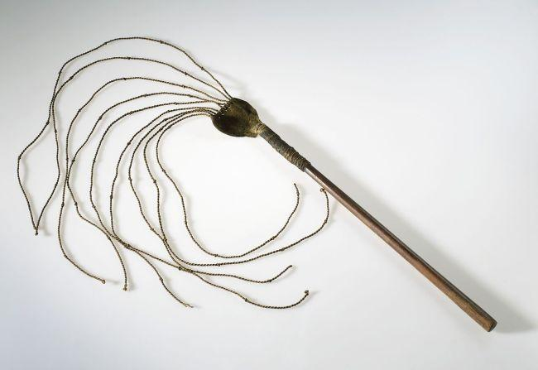
Figure 14 – An 18th century ‘cat o’ nine tails’, designed to lacerate the skin and cause great pain

British troops were shooting people without even interrogating them first. An example was recounted by one witness:

[The troops] asked [the prisoner], ‘how came you by that wound’, he said he went to Morant Bay the day of the fight to buy medicine for his sweetheart, and suddenly he felt something here, and when he looked he saw he had received a wound. They said, ‘Oh, this is one of the Morant Bay men; shoot him’, and he was put out.

On 17 October, a soldier belonging to the 1st West India Regiment, on his way from Manchioneal to Long Bay, met some constables with four black prisoners in their charge. He inquired what these men were, and being informed they were prisoners, he deliberately took 'them, one by one, and, placing them at a convenient distance, shot them all in detail.

Andrew Clarke was shot in his own house at Manchioneal. His widow described the events as follows:

I was sitting with the baby, and I saw a black soldier approach. He said to Andrew Clarke, ‘Where are all the men’s goods you have? Please bring them out.’ Clarke said, ‘I have been sick for three months, and did not interfere.’ The soldier then entered the house, and searched it, but found nothing. Three other soldiers then came in and another man with them … They then shot my husband, and he dropped on his side and bawled for mercy : the soldiers told me to take myself out, and I came out. One of them then said, ‘Put another bullet into that fellow's head;’ and they blew out his brains. Having done all this, they then burnt the house with fire they had brought from the kitchen.

Colonel Thomas Hobbs commanded troops in the western part of St Thomas in the East. On the march to Stony Gut troops brought in eleven prisoners. Assembling a court martial, Hobbs had these men tried, shot and hanged.

Hobbs also openly boasted about how he had terrorised then executed the servant of one of the leaders of the uprising.

On his way back to Moncklands at Chigoe Foot Market, Hobbs assembled a court to deal with over 70 prisoners who had been taken on the march. Twenty-seven were found guilty. Nine were shot and hanged at the Native Baptist chapel at Font Hill and eighteen were shot at Coley.

Hobbs’s troops destroyed homes, looted property and indiscriminately shot civilians. John Shand, a physically disabled man who had been ill for several years, was sitting in his house when the soldiers shot him. His mother later recounted:

I rise and say, ‘Sir, it is a sick person: it is a son that is sick’; and against as I say so, the other one fire off, and the young man drop down, and they said they were truly sorry, it was an innocent person; but they can’t help it, it was done already; them doing their duty.

An old blind man was shot in the village of Somerset whilst sitting in his house.

Chloe Munro was raped by a soldier. Four soldiers took everything out of her house as well as her ring, but one later returned and told her to lie on the bed. When she refused:

He fix me against the wall and drop his breeches and pulled my clothes. I called to my mother; him fix me on the wall, and I took my knee and shove him off; he tore up all my front. I can’t pea for two days.

After Arthur Wellington was shot, a soldier cut off his head and placed it on a stump.

During the suppression Hobbs sent a dispatch to his commander stating “flesh and blood could not stand the incessant strain and never-ceasing wetting to which [they] had been exposed for the last nine days”, and later he testified more fully to the harsh conditions faced by his troops.

After the rebellion, Hobbs was the subject of public criticism for his actions in Jamaica and the United Kingdom.

Unaccustomed to questions about his professional actions, “he sulked silently in his quarters, then he muttered his protests at the injustices done him; then he ranted, and quite wildly”. A board of medical examiners pronounced him of unsound mind. Hobbs was shipped home to England under the care of several medical attendants along with his wife and children. On 28 April 1866, Colonel Hobbs jumped from the ship carrying him home to England from the island of Jamaica and drowned.

If the soldiers inspired fear among the populace, then the other group to suppress the rebellion, the Maroons, aroused sheer terror.

The Role of the Maroons

Once the Jamaican government learned of the outbreak at Morant Bay it sought to ensure that the Maroons in the eastern parishes would stay loyal. The Maroons quickly proclaimed their loyalty and indicated that they were prepared to support the government in whatever form was required.

A former commander of the Maroons, Colonel Alexander Fyfe, met about 200 Maroons on 15 October at Port Antonio with Governor Eyre. On 19 October, Brigadier-General Nelson, commander of the Queen’s forces at Morant Bay, ordered the Maroons to patrol various routes out of St Thomas in the East.

The Maroons under Fyfe’s leadership engaged the rebels at Torrington, a village just north of Stony Gut, killing seven rebels and burning all the houses.

On 23 October the Maroons caught Paul Bogle unarmed coming out of the bush on the road between Torrington and Stony Gut.

Fyfe believed some innocent people would be caught up in the retribution but that this was unavoidable.

The Maroons entered villages, burning houses as they advanced. 136 houses were burned at Torrington, effectively the entire village. Three old men were shot in their homes, and a 16-year-old girl was shot and killed as she hid in the bush with her mother; the Maroons mistakenly took her for a man.

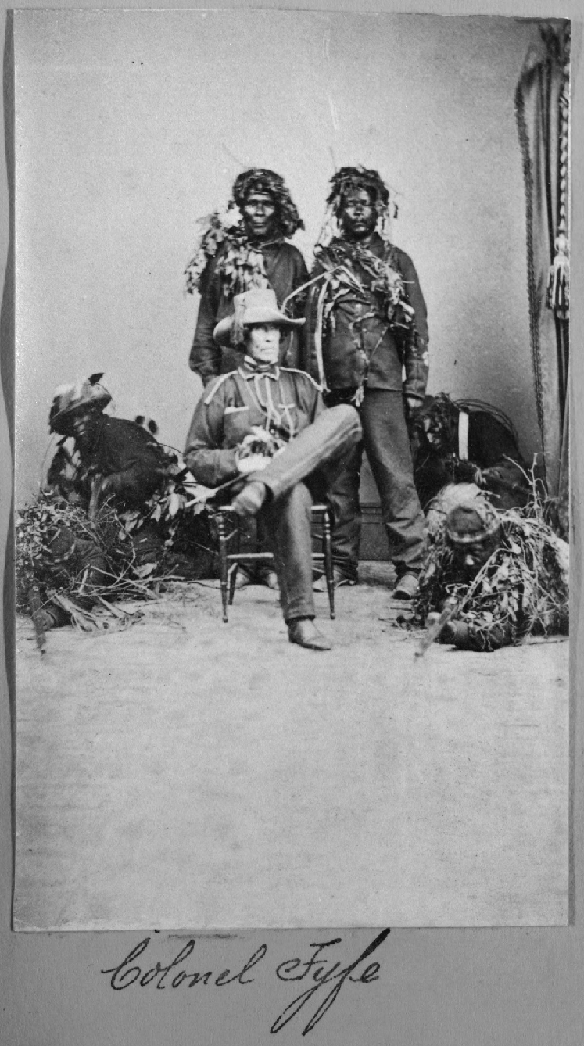
Figure 15 – Colonel Alexander Fyfe and six Maroons

Closer to Morant Bay, at the settlement of Nutts River, the Maroons continued to shoot people without hesitation. Thomas Duncan, a labourer from Port Morant, described the slaughter of his father-in-law, an old African man who had been ill for many years:

[The Maroons] ordered him out of the house, and he said he could not go, and they shoved open the door, and took him out, and took out this rope (witness produced a rope), and bound his hands, and bound him to a tree, and shot him, and left word with Mr Woodrow [a magistrate] that they must not interfere with the body.

The Maroons came into Henrietta Bailey’s house and shot her son, who was lying in bed with fever. They then saw her husband and ordered him to “put your face to me”; he turned around, and the Maroons shot him.

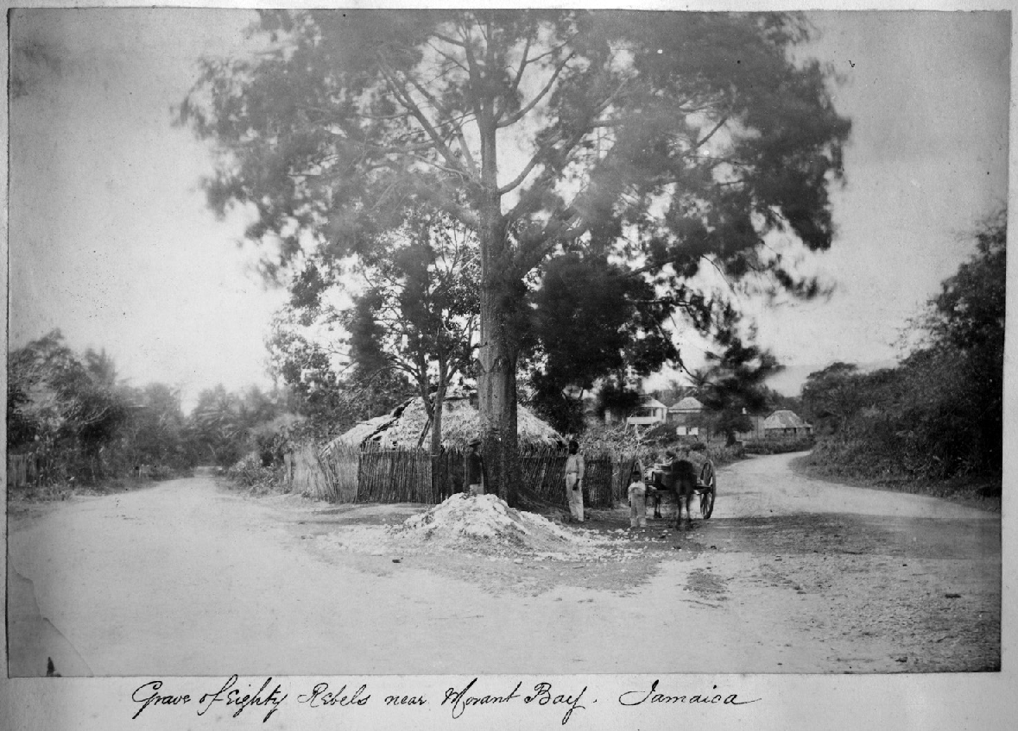
Figure 16 – “Grave of eighty Rebels near Morant Bay, Jamaica.” Photograph album documenting the Morant Bay rebellion, Graphic Arts Collection, Department of Rare Books and Special Collections, Princeton University Library

At Port Morant some Maroons entered the bouse of John Noble. He was sick and had been lying bed-ridden for many years. They directed him to get up and go out of the house. He said he could not, for he was not able. They then forced him out, tied him up to a tree, and shot him, leaving him there dead, and giving instructions that the body was to remain there and not to be buried.

Of the 600 people who were whipped, 200 of them were women, including some pregnant women.

Martial Law at Morant Bay

Martial law lasted from 13 October to 13 November. During the period nearly 1,000 prisoners were brought to Morant Bay. Just under 200 were executed and 200 flogged.

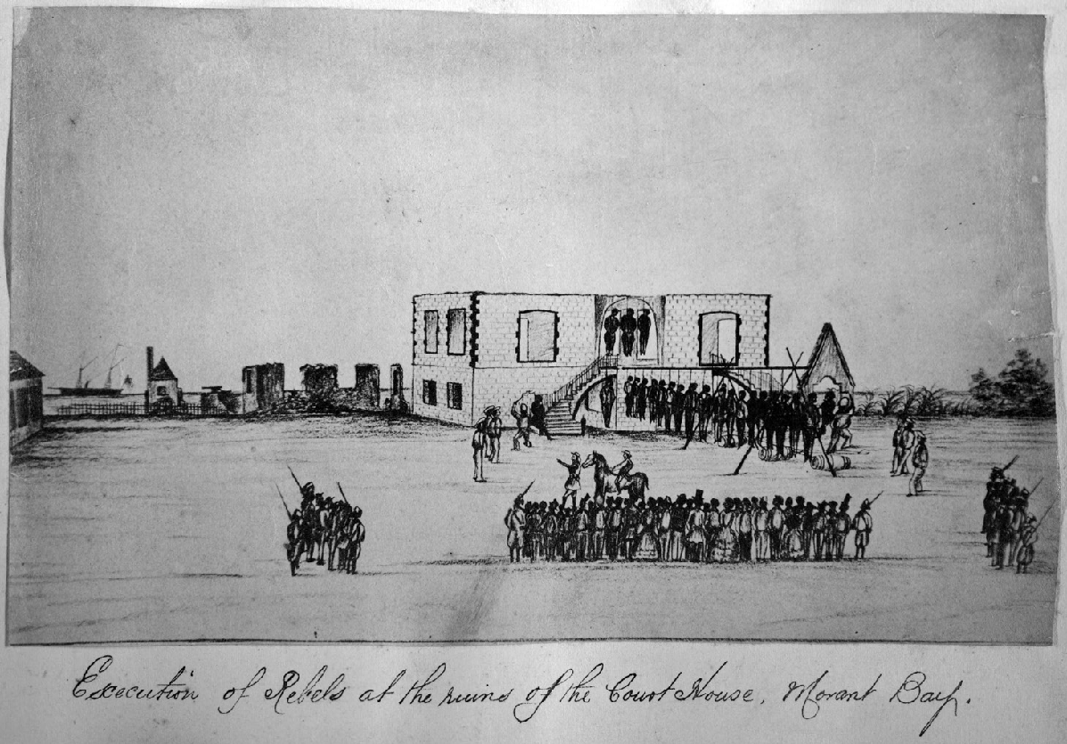
Figure 17 – Execution of Rebels at the ruins of the Court House, Morant Bay

Gordon Ramsay, an inspector of police given the title of Provost-Marshal, oversaw martial law. Ramsay estimated there were almost 400 prisoners under his jurisdiction at the height of this period.

The atmosphere at Morant Bay was brutal. Prisoners were tortured to extract confessions.

Soldiers gagged victims to stifle their cries of pain by shoving stones into their mouths and holding them in place.

Amongst the troopers on duty at Morant Bay, was Mr Joseph Gordon Smith, a nephew of George William Gordon. He described what he witnessed:

Ramsay flogged the prisoners without even asking their names – nearly all, I believe; but I did not see all, because we were dismissed when a shower of rain came on. Afterwards I went to the guard-room, and he was then swearing five of them with their hands fastened and a rope round their necks; and he was swearing them in these words : ‘You shall well and truly state what G. W. Gordon has to do with the rebellion;’ and between each part of this, a sailor came down with the whip over their shoulders.

Ramsay ordered other prisoners to be flogged without any charge or trial. Joseph Hall was imprisoned for three weeks and received seventy-five lashes, because Ramsay reasoned Hall came from Font Hill, a settlement which had “a bad character”.

Prisoners who remained in captivity were forced to watch the executions which took place in Morant Bay. In addition, prisoners had to bury the people who had been executed. It was usual practice for the bodies to be left on the gallows overnight and for the prisoners to bury them the next day.

The procedure at the executions was relatively simple. The condemned prisoners were marched onto a board placed over two barrels; they stood on the board with their hands and feet tied and the rope around their neck. When the board was pulled away the noose tightened.

A politician for Kingston, William Kelly Smith, described the scene:

All the military officers were there … and a number of other gentlemen, and after that the Provost-Marshal, as I found it to be usual with him, took the watch out of his pocket and placed it to his ear, and gave the order to be hanged. Just as the plank upon which they were was drawn, their bodies swung, and a few seconds after that the sailors went one by one to them as they were kicking and drew down the noose tight, knocking it down, laid hold of each of their necks, and broke the neck and, after that, if they were kicking again, they would lay hold of their legs and drag the legs.

Paul Bogle was hanged on 25 October, with several other leaders of the rebellion, including his brother, Moses. Eyewitnesses state he went calmly and bravely to his death.

Seven women were also hanged at Morant Bay – one of the women was pregnant.

People were tried at Morant Bay without being aware of the charges against them. When witnesses did not give satisfactory evidence in Ramsay’s view, he ordered them to be flogged. Several of the witnesses who gave evidence against the accused were ordered to be hanged alongside the individuals they helped to convict.

At the courts martial held at Morant Bay, the procedures of dealing with the alleged rebels varied considerably.

Ramsay’s anger could be sparked off by relatively trivial incidents.

Ramsay ordered a prisoner who was being flogged, George Marshall, to be hanged immediately without a trial. Ramsay claimed Marshall was a dangerous prisoner who, while being flogged, threatened his life:

I did not know how many lashes he had received at the time but as the other prisoners were muttering and expressing sympathy I ordered him to be taken down. He then shook his fist and growled at my again saying words to the effect he would do for me – there was no Court Martial likely to sit for some days and considering that his remaining in the yard with other prisoners would be dangerous I ordered him to be hanged.

Marshall had been given nearly fifty lashes and was unlikely to be in a condition to pose a threat either to Ramsay personally or to law and order generally.

Ramsay had a woman, Polly Levingston, flogged in Stony Gut, then threatened her with execution and had her tied up outside in the rain for two days.

In Easington on 14 October Ramsay shot Archy Francis for no reason as he emerged from his yard at White Horses to meet the troops. Ramsay ordered that Francis not be buried “but must remain there as an example to the rest”.

After the rebellion, the civilian press labelled Ramsay as a sadistic villain.

In February 1866 Ramsay was accused of the murder of George Marshall, a man he had flogged mercilessly and then hanged without trial. He became the first Jamaican-born British citizen charged with a criminal offence for an action taken under martial law.

A panel of magistrates declared that Ramsay had no case to answer. Ramsay never denied flogging and hanging Marshall.

Ramsay later lost his job as a police inspector, partly because of his notoriety. He later fled to the United States.

On 17 July 1870 Ramsay killed himself with a gunshot to the head in New York City.

Governor Eyre issued an amnesty on 30 October, but it did not include prisoners already in custody awaiting sentence or those found guilty of murder or arson. More significantly the amnesty had no effect on martial law, which continued until 13 November.

The government was intent on establishing its authority and on stifling black political expression of any kind. At Morant Bay there was a political as well as a military dimension to the suppression.

The case of George William Gordon

Governor Eyre identified his most virulent political opponent, George William Gordon, with the rebellion. He maintained it was essential that Gordon was arrested to ensure the rebellion did not spread to other parts of the island. Eyre ordered Gordon’s immediate arrest on 17 October.

When Gordon heard of the charge, instead of fleeing he drove immediately to army headquarters in Kingston to see Governor Eyre:

On seeing the Governor enter, Mr Gordon turned towards him and said, ‘I regret, Mr Gordon, I can hold no communication with you.’ On which Mr Gordon said, ‘Why?’ His Excellency replied, ‘Because you are a prisoner.’ Mr Gordon answered, ‘What for?’ The Governor gave no answer, but turned to me. I immediately arrested Mr Gordon in the name of the Queen on a charge of treason. As I laid my hand on his shoulder he got very pale and trembled much.

Gordon was transported from Kingston (which was not under martial law) to Morant Bay (which was under martial law), to be court-martialled.

According to Eyre’s own declaration of martial law, such a transfer was unlawful. An individual could only be subject to court-martial if they committed an offence in the areas of the island subject to martial law (which Gordon did not).

Gordon was denied access to a solicitor, William Wemyss Anderson; Anderson tried to write to Gordon with legal advice.

General Nelson admitted having received that letter; and added, “I either tore it up at once, or gave it to my aide-de-camp to tear it up. It was not given to Mr. Gordon. I read it before it was destroyed”.

The advice was as follows:

Figure 18 – Legal advice from Mr William Wemyss Anderson to George William Gordon
“TITCHFIELD, October, 1865.
“MY DEAR GORDON,
“HAVING been prohibited communication with you on board the ‘Wolverine,’ I have requested the favour of the General to forward this. I know nothing of the charges against you; but, as an old friend and professional adviser, I cannot refrain from tendering to you my advice, assuming that, whatever your errors may have been, they were committed before the proclamation of martial law. I advise you to plead:-
“First. That, on that account, you are amenable only to the ordinary civil and criminal courts of the country; and,
“Second. That only is crime which is prompted by criminal intention; and that you, having no such intention, are not criminally liable for the consequences, however disastrous these unhappily may have been.
“I need not add one word to assure you of my deepest sympathy; but on such a topic it would be out of place now to enlarge.
“Yours very truly,
“W. WEMYSS ANDERSON.”

Whilst Gordon was imprisoned, his creditors seized all his property and goods.

Gordon arrived in Morant Bay on 20 October, and his court-martial took place on 21 October.

The president of the court, Lieutenant Brand, had been a lieutenant for less than seven years. The other two men were Lieutenant Errington, a lieutenant for under four years, and Ensign Kelly, who had been an ensign for less than a year. Lieutenant Brand was accused of having said that he:

had the pleasure of hanging the first damned rebel … but nothing would give me greater pleasure than the hanging of this d---d son of a b---h [George William Gordon].

Gordon was charged on two counts: “high treason and sedition” as well as “having complicity with certain persons in the insurrection at Morant Bay on the 11th October 1865”.

Gordon was not given any chance to prepare his case and had no legal adviser, but he was able to cross-examine each witness.

During the trial, the Provost-Marshal, Gordon Ramsay, submitted several depositions.

One from a dying prisoner, Thomas Johnson, claimed that Gordon had held meetings next to his house and that he had heard the rebels talking about war. A further piece of written evidence came from a wounded prisoner, George Thomas. In his statement he emphasised that Gordon was “the head of the rebellion [and] he put up the Bogles to do it”.

Not all the prosecution witnesses implicated Gordon. James McLaren, Paul Bogle’s secretary and a leader of the rebellion, denied that Gordon had anything to do with the outbreak.

Gordon made a long statement denying involvement in the rebellion and attacking the witnesses against him. When Gordon had concluded his statement the trial ended, and he was taken back to the cells to await the court’s verdict. The trial had lasted just six hours.

There were serious irregularities in the procedure and in the evidence at the trial. Gordon claimed he was unwell and could not attend the vestry meeting on 11 October. There was a witness, Dr Major, who Gordon claimed could attest to his illness, but the court did not allow him to testify.

The evidence was also flawed. The prosecution rested on depositions taken in Gordon’s absence, meaning he could not question the witnesses and they would have been inadmissible as evidence against him in any English court, whether civil or military. No witness accused Gordon of being present or participating in the rebellion at Morant Bay.

However, the court found George William Gordon guilty and sentenced him to be hanged. Brigadier-General Nelson, who approved of the sentence and delayed the execution until Monday morning. On Sunday evening at 6pm Governor Eyre wrote to Nelson concurring “in the justice of the sentence, and the necessity of carrying it into effect”.

Gordon was not told of the sentence until early Monday morning. Gordon requested paper to write to his wife; Nelson acceded on the grounds that the letter would be handed to him.

Figure 19 - George William Gordon’s Last Letter to his Wife

23 October 1865

“My Beloved Lucy, General Nelson has just been kind enough to inform me that the court-martial on Saturday last has ordered me to be hung, and that the sentence is to be executed in an hour hence, so that I shall be gone forever from this world of sin and sorrow. […]

I do not deserve this sentence, for I never advised or took part in any insurrection; all I ever did was to recommend the people who complained to seek redress in a legitimate way, and if in this I erred, or have been misrepresented, I don’t think I deserve this extreme sentence. It is, however, the will of my Heavenly Father that I should thus suffer in obeying his command to relieve the poor and needy, and to protect, so far as I was able, the oppressed; and glory be to His name, and I thank Him that I suffer in such a cause. […]

Comfort your heart. I certainly little expected this. You must do the best, and the Lord will help you, and do not be ashamed of the death which your poor husband will have suffered. The judges seemed against me, and from the rigid manner of the court, I could not get in all the explanation I intended. […]

I did not expect that, not being a rebel, I should have been tried and disposed of in this way. I thought His Excellency the Governor would have allowed me a fair trial, if any charge or sedition or inflammatory language were partly attributable to me; but I have no power of control; May the Lord be merciful to him. General Nelson, who has just come for me, has faithfully promised to let you have this; May the Lord bless him, and the soldiers and sailors, and all men. […]

As the General is come, I must close. Remember me to Aunt Eliza in England, and tell her not to be ashamed of my death. And now, my dearest one, the most beloved and faithful, the Lord bless, keep, preserve, and keep you. A kiss for dear mamma, who will be kind to you, to Janet. Kiss also Ann, Janet, say good-bye to dear Mr. Davison, and all others. I have only been allowed one hour. I wish more time had been allowed. […]

Your truly devoted and now nearly dying husband,
Geo. W. Gordon

[…]

Mr. Ramsey has for the last two days been kind to me, and I thank him.”

Nelson’s account of Gordon’s final words to him was revealing:

G.W. Gordon said to me, ‘I am innocent, sir.’ My reply was, ‘It is not for me to judge, hourly communications induce me to think your words caused the riot.’ He replied, ‘I never intended.’ ‘’Perhaps not, such has been,’ was my response, and I left him.

Gordon was executed at 7.10am on 23 October.

He was hanged on the centre arch of the courthouse, and seventeen others were hanged below him. According to George Clarke, who witnessed it, Gordon first took off his hat and then, as he was about to be executed, his glasses. His body was left hanging for twenty-hour hours before being brought down.

In executing Gordon, Governor Eyre was using the rebellion to remove political opposition to his rule in Jamaica.

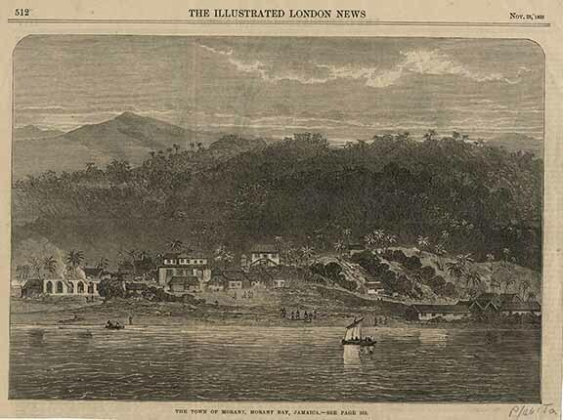
Figure 20 – The town of Morant, Morant Bay, Jamaica

The Morant Bay Rebellion – The Investigation

News took time to reach the United Kingdom from Jamaica about the events in October 1865. Letters, despatches and other information had to be sailed across the Atlantic, taking around a month.

There was initially “great relief” in the United Kingdom that the rebellion had been snuffed out in its infancy.

When Governor Eyre wrote his first official despatch to the Colonial Office on 20 October explaining what had happened and how he had responded to the rebellion, he appears to have expected ample praise and reward for his conduct.

But his report gave the impression that military forces under his command had gone on a bloody rampage against the black population of Jamaica.

By 16 and 17 November, more information arrived from Jamaica from military officers which supported this interpretation of events.

The letter of one Captain Ford, a cavalry officer, proudly drew a picture in which he and his men had taken sport in shooting black men and women in the back as they fled for their lives. Captain Ford stated:

This morning we made raid with 30 men, all mounted, and got back to head-quarters at 4 P.M., bringing in a few prisoners, and having flogged 9 men and burned 3 negro houses, and then had a court-martial on the prisoners, who amounted to about 50 or 60. Several were flogged without court-martial, from a simple examination. One man, John Anderson, a kind of parson and schoolmaster, got 50 lashes; 9 were convicted by court-martial; one of them to 100 lashes, which he got at once; the other eight to be hanged and shot; but it was then quite dark, so their execution is postponed till morning.

[…]

This is a picture of martial law; the soldiers enjoy it, the inhabitants have to dread it; if they run on their approach, they are shot for running away. The contents of all the houses we have been in, except only this very house, but including the barracks, have been reduced to a mass of broken and hacked furniture, with doors and windows smashed by the rebels.

This letter, and many others, recounted in minute detail how government troops had hunted, burned out, shot, and whipped scores of men and women, sometimes without benefit even of a court martial.

George William Gordon’s last letter to his wife was published in the Manchester Guardian on 1 December.

This generated much sympathy for Gordon. Many British people sympathised with him as they saw him as “nearly white”, educated in England and married to a white English woman.

Abolishing the Assembly and passing an Act of Indemnity

Governor Eyre took the opportunity of the rebellion to try and abolish the Jamaican House of Assembly and change the Jamaican Constitution. Since he arrived in Jamaica, Eyre considered that the House of Assembly was ruining Jamaica and that it should be abolished. Writing privately on 23 October to the Secretary of State for the Colonies, Edward Cardwell, Eyre indicated that members of the House would now be prepared to support the government in whatever measures seemed necessary.

Eyre believed that:

[T]here is nothing like striking whilst the iron is hot if we are to get a change of constitution thro’ the medium of the Assembly itself, now is the time to do it when everybody is in a state of the greatest alarm and apprehension and looking to the Gover’ for everything.

Eyre wanted Jamaica to be run directly from London as a Crown Colony. This would, in his view, block the ability of black and mixed-ethnicity Jamaicans to gain political power.

In the process, representative government was destroyed for nearly another century.

Before abolishing it, Eyre got the House of Assembly to pass an Indemnity Act in November 1865.

In legal terms, an Act of Indemnity is a statute passed to protect people who have committed some illegal act which would otherwise cause them to be subjected to legal penalties.

The Jamaica Indemnity Act of 1865 included a preamble and only three discrete provisions, all drafted to provide the widest indemnity to as many persons (who had acted on the side of the authorities) as possible. The preamble asserted that martial law had been proclaimed in order to suppress persons threatening “the general massacre of all loyal and well disposed subjects”.

The first section indemnified “civil and military authorities” for “all acts ordered or done during the continuance of martial law” in order “to suppress the said insurrection’ either ‘within or beyond the proclaimed districts”.

The second section indemnified “the Governor” or “persons acting under his authority” for actions taken to “put an end to the said rebellion”. This provision also indemnified any other person who had acted ‘bona fide’ to put down the revolt.

The final section of the statute stated that the Governor might issue a ‘certificate’ that was to amount to “conclusive evidence that any act was done under the authority of the Governor, or was done bona fide in order to suppress the rebellion”. In other words, the Governor was empowered to dispense a presumptive immunity from any civil or criminal liability to anyone he thought deserving of it.

Acts of Indemnity today

Acts of Indemnity are not a matter of history. They are still in use in the United Kingdom today.

Let us take one little-known example.

Section 7 of the Intelligence Services Act 1994 states:

If … a person would be liable in the United Kingdom for any act done outside the British Islands, he shall not be so liable if the act is one which is authorised to be done by virtue of an authorisation given by the Secretary of State.

This provision means British intelligence agents are immune from both criminal and civil liability for any actions committed overseas, including killings, as long as those actions are authorised by a Government Minister.

Because the intelligence services activities are so sensitive, all requests for a section 7 authorisation are made in secret, and all section 7 authorisations by Government are made in secret.

British spies do very much have a ‘licence to kill’.

The Colonial Office’s Response

Back to Edward Eyre’s attempt to indemnify himself.

The Secretary of State for the Colonies, Edward Cardwell, wrote to Eyre on 23 November expressing concern about George William Gordon’s arrest in Kingston and subsequent execution.

On 1 December, Cardwell became more insistent, writing to Eyre that declaring martial law was not necessary as there was “no proof yet given to us that the conspiracy itself exists. On the contrary, it appears that there has been no resistance in any case even to the smallest bodies of troops…”.

Eyre responded by stating that he needed to crush the rebellion quickly, because as a race “the negroes are most excitable and impulsive”. If black Jamaicans were given any reason to believe that the rebellion might succeed, the rebellion would have spread to the rest of the island.

The negro was also “most reticent”, and it is “almost impossible to arrive at anything like correct details of their plans and intentions”. Eyre considered that he was “fully justified in continuing martial law … until … the rebellion itself so crushed out as to deter any similar outbreak elsewhere”.

In the first week of December, only a month after news of the Jamaica rising had reached England, the cabinet already had resolved (privately) to suspend Eyre from his duties while a Royal Commission undertook a thorough investigation both rebellion and suppression.

Eyre was temporarily relieved as Governor while the commission was in progress. Sir Henry Storks, Governor of Malta, presided as Governor of Jamaica during the investigation, as well as leading the commission of inquiry.

Eyre was surprised by the development, reportedly telling his wife:

“Would you believe it, Ada! they have suspended me – actually suspended me. But never mind, darling, I have done my duty,” and he said no more that day on the subject.

The Royal Commission

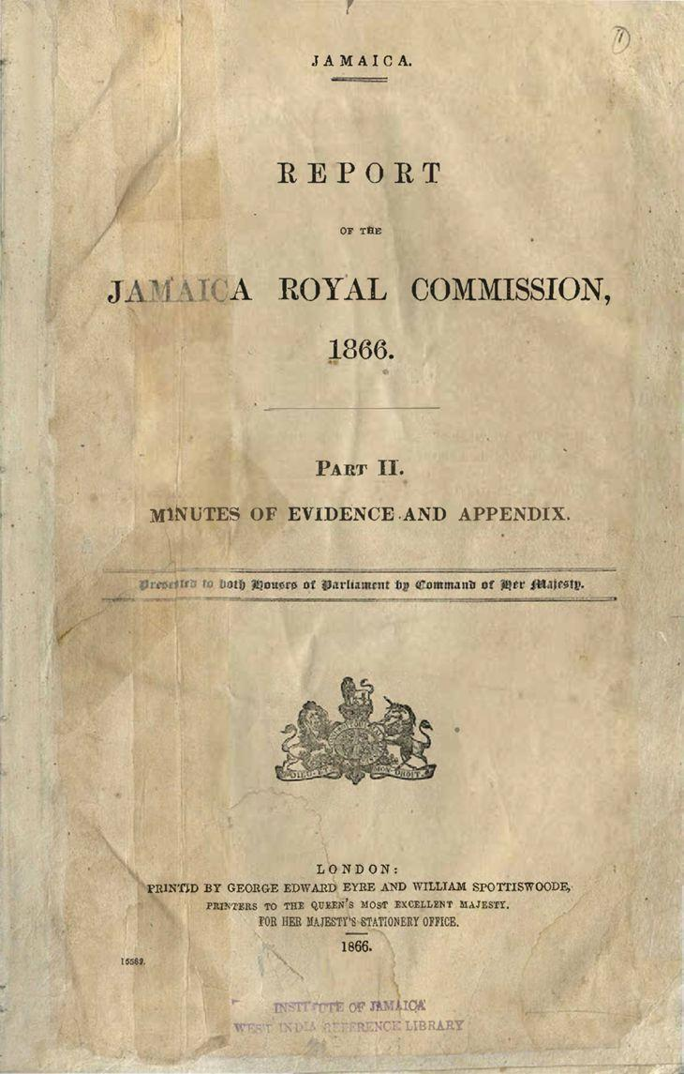
Figure 21 – Report of the Jamaica Royal Commission

The Royal Commission first met on 20 January 1866.

730 witnesses appeared before the Commission over a period of fifty-one days and answered over 70,000 questions. The Report totalled over 2,000 pages.

Witnesses included several senior members of the government, including Eyre and members of his executive committee as well as black peasants whose creole had to be translated for the commissioners.

When the Commission concluded on 9 April 1866 there was a great deal of conflicting evidence, and it was not always clear who was telling the truth.

In their conclusion the commissioners praised Governor Eyre for his “skill, promptitude and vigour” in quickly dealing with the rebellion.

But the Report concluded that some military officers had inflicted unnecessary and, in some instances, “positively barbarous” punishments.

Recourse to capital punishment was “unnecessarily frequent”, the burning of 1,000 houses was “wanton and cruel” and the floggings were “reckless”.

Martial law was continued far longer than necessary which deprived British subjects of their “constitutional privileges”.

On 18 June 1866 the Royal Commission’s final report and evidence was laid before Parliament. The Government agreed with the report’s conclusions.

As for Edward Eyre, the Government stated that the Act of Indemnity passed in Jamaica protected him from being prosecuted for the acts he ordered. But they decided Eyre would not be restored to his previous office. Effectively, Eyre’s career as a civil servant was over.

A compensation commission in 1867 concluded that the damage done in suppression of the rebellion to those who had nothing to do with the outbreak totalled £2,426 (around £190,000 today). The Secretary of State for the Colonies made it clear that these funds were to come from Jamaica itself and not from any Imperial sources.

Jamaicans themselves would pay through their own taxes for the damage caused by the British troops and Maroons.

The public outcry

Once the report reached England the effects were dramatic. Meetings were held denouncing Eyre and the Jamaican authorities.

Yet when Eyre left Jamaica people lined the streets waving and cheering. On board ship, Eyre met a group of leading planters and merchants in the colony who praised him for having put down the rebellion.

Eyre stated that although he was being dismissed from public service, “there has been nothing in my conduct to merit it, nothing to occasion self-reproach, nothing to regret”. Edward John Eyre simply felt that blacks were simply “not up to freedom”.

The legal challenges

In July 1866, Liberal MP Charles Buxton moved resolutions in the House of Commons to debate the ‘Jamaica affair’. The Government gave assurances to Buxton that it would support the investigation of alleged criminal wrongdoing by civilian and military officials in Jamaica.

But the British Government chose not to initiate criminal prosecutions in England against Eyre or any of the regular military officers.

All criminal charges were brought as private prosecutions by a group of individuals called the ‘Jamaica Committee’ who felt that crimes were committed and that those responsible should be brought to justice.

The Jamaica Committee brought a private prosecution against Eyre in March 1867, but at a preliminary hearing magistrates concluded there was no case to answer.

In February 1867, Brigadier-General Abercrombie Nelson and Lieutenant Herbert Brand were charged as accessories to the murder of George William Gordon. Nelson was the senior military officer in the field during martial law. His orders were to suppress the uprising by any means possible. Brand was responsible for the trial and punishment of prisoners at Morant Bay during the period of martial law. He was responsible for the execution of 189 men and women.

Nelson and Brand faced a grand jury in April 1867. A grand jury numbered between 14 and 23 persons. They were abolished in England and Wales in 1948. In proceedings overseen by a judge they heard the charge against an individual and debated whether there was sufficient evidence to put the accused on trial. A majority was needed for a decision. If the grand jury determined that there was not enough evidence, then the accused would go free, having no case to answer.

Despite the Lord Chief Justice, Sir Alexander Cockburn, told the grand jury that martial law did not allow the Governor and military to arrest, try and execute civilians (including Gordon) in the way they did.

The grand jury, presented with all the evidence from Jamaica, and the instructions from the judge, concluded Nelson and Brand had no case to answer. As was customary, no reasons were provided for the conclusion.

A further attempt to prosecute Eyre for being an accessory to the murder of Gordon by the Jamaica Committee was made in May 1868. This was dismissed by a grand jury.

The penultimate attempt to hold Eyre liable was made under the Colonial Governors Act 1700. This Act held Governors of British colonies liable for a broad range of crimes and offences committed against British subjects in those colonies.

Appearing before a different magistrate on 15 May 1868, when asked whether he had anything to say, Eyre made an impassioned speech:

I have only this to say, that not upon me, but upon those who brought me here, lies the foul disgrace that a public servant, who has faithfully discharged his duty for upwards of twenty years, has been now, after two years and a half of persecution, brought to a criminal court and committed for trial for having performed his duty at a trying moment, and thereby saved, indubitably, a great British colony from destruction, and its well-disposed inhabitants, white and black, from massacre or worse.

The end of the speech was greeted by impassioned applause from the public gallery. His trial took place in June 1868. Again, the grand jury found there was insufficient evidence to indict Eyre.

Phillips v Eyre – the background

One last chance presented itself to bring Edward Eyre to some form of justice.

Two British subjects’ resident in Jamaica, Alexander Phillips and Dr Robert Bruce, sued Eyre, Abercrombie Nelson and Herbert Brand in England.

The claim was made for a list of civil wrongs, including assault, battery, and false imprisonment.

Both Phillips and Bruce had been arrested on the orders of Governor Eyre and transferred to the prison at Morant Bay, the camp ran by Gordon Ramsay.

Phillips alleged that on 24 October 1865, Phillips had been arrested at his home and then conveyed in irons to the Governor’s residence thirty miles away at Spanish Town. After a brief interrogation, he was forcibly conveyed to a temporary military prison at Uppark Camp, before being put on a ship bound for the military prison at Morant Bay. Phillips asserted that, on 4 November 1865, he was “cruelly beaten, flogged, wounded, and tortured” before being released. It was further alleged that these wrongs had caused the plaintiff significant pain, sickness, and disability.

Both Phillips and Bruce were tried in civilian courts for conspiracy to commit treason. Both men were acquitted.

Due to the Indemnity Act Phillips and Bruce could not sue Eyre in the Jamaican courts.

They brought a case against Eyre in London. Bruce removed himself from the proceedings due to illness, meaning Phillips continued the action alone.

Eyre’s defence was that he “was not guilty to the action, and also that he was protected by the Act of Indemnity passed by the Jamaica legislature”.

The central matter at issue in Phillips v. Eyre was the legal validity of Eyre’s blanket plea of ‘not guilty’ on grounds that his actions, even if wrongful at law, were privileged by the Act of Indemnity passed by the Jamaica Assembly.

The case was first heard in the Court of Queen’s Bench, who delivered a judgment in January 1869.

Lord Chief Justice Cockburn delivered the judgment for the unanimous court. He agreed that the Act of Indemnity was an example of retrospective legislation, and it was designed to give immunity to Governor Eyre for crimes he had committed. He said:

There can be no doubt that every so-called Indemnity Act involves a manifest violation of justice, inasmuch as it deprives those who have suffered wrongs of their vested right to the redress which the law would otherwise afford them, and gives immunity to those who have inflicted those wrongs, not at the expense of the community for whose alleged advantage the wrongful acts were done, but at the expense of individuals who, innocent possibly of all offence, have been subjected to injury and outrage often of the most aggravated character. It is equally true […] that such legislation may be used to cover acts of the most tyrannical, arbitrary, and merciless character, – acts not capable of being justified or palliated even by the plea of necessity, but prompted by local passions, prejudices or fears […] characterized by reckless indifference to human suffering and an utter disregard of the dictates of common humanity.

Despite this, Cockburn CJ concluded that the Jamaican legislature did have the power to pass an Act of Indemnity.

What is more, that Act of Indemnity meant that Eyre was immune from prosecution in both Jamaica and the United Kingdom.

One of the decision’s implications, cautioned the Law Times, was that “British subjects may be abandoned to the caprice and malignity of colonial legislatures”.

In February 1869 it was announced that Phillips would appeal to the Court of Exchequer Chamber.

The decision of the Court of Exchequer was delivered by Willes J in June 1870.

We need to pause here for a moment to speak about the English courts system. It is likely that you will not have heard about the Exchequer Chamber before.

The Judicature Acts of 1873 and 1875 reformed the English courts, creating a unified High Court, and a Court of Appeal sitting beneath the House of Lords (later the Supreme Court) in the court hierarchy. This is the structure that you learn about today in your law degrees.

Prior to 1873, the courts were structured as follows:
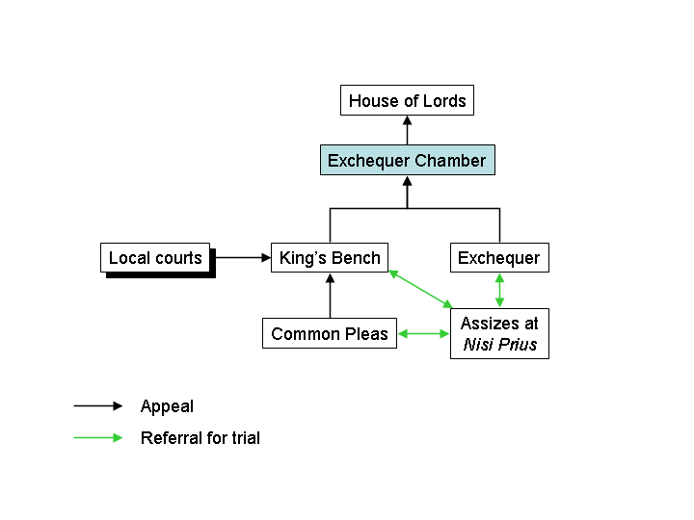
Figure 22 – The common law courts before the Judicature Acts

The first instance case in Phillips v Eyre was heard at the Court of Queen’s Bench (which is signified by the Court of King’s Bench in Figure 22 but was so named because Queen Victoria was the monarch at the time). The Court of Queen’s Bench had a position in the court hierarchy broadly equivalent to the High Court today.

The appeal was then heard by the Court of Exchequer Chamber, whose decisions could only be overruled by the House of Lords. The Exchequer Chamber could therefore be seen as equivalent to today’s Court of Appeal.

Phillips v Eyre – the judgment

Phillips v Eyre (1870) LR 6 QB 1

Court of Exchequer Chamber

On appeal from the Court of Queen’s Bench

Judgment delivered on 23 June 1870

Judges: Kelly CB, Martin B, Piggott B, Cleasby B, Willes J, Brett J

Judgment delivered by: Willes J

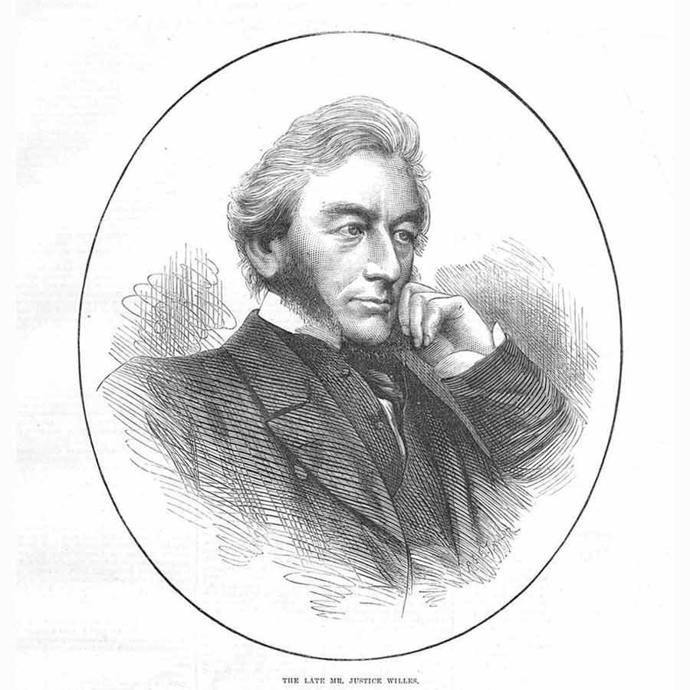

[Page 13]

This is an action complaining of false imprisonment and other injuries to the plaintiff by the defendant in the island of Jamaica.

The plea states in effect that the defendant was governor of the island; that a rebellion broke out there which the governor and others acting under his authority had arrested.

[Page 14]

by force of arms; that an Act was afterwards duly passed by the legislature of the island; and received the royal assent, by which, after resisting the rebellion, a proclamation of martial law within certain local limits by the governor with the advice of a council of war, that the rebellion had been suppressed and imminent general sacrifice of life thereby averted, that the military, naval, or civil authorities might, according to the law of ordinary peace, be responsible in person or purse for acts done in good faith for the purpose of restoring public peace and quelling the rebellion, and that all persons who in good faith and loyal resolve had acted for the crushing of the rebellious outbreak ought to be indemnified and kept harmless for such their acts of loyalty, it was enacted by the governor, legislative council, and assembly of the island, amongst other things that the defendant and all officers and other persons who had acted under his authority, or had acted bona fide for the purpose and during the existence of martial law, whether done in any district in which martial law was proclaimed or not, were thereby indemnified in respect of all acts, matters, and things done in order to put an end to the rebellion, and all such acts were “thereby made and declared lawful, and were confirmed.”

The plea further states that the grievances complained of in this action were measures used in the suppression of the rebellion, and were reasonably and in good faith considered by the defendant to be proper for the purpose of putting an end to, and bona fide done in order to put an end to, the rebellion, and so were included in the indemnity.

[Page 15]

[I]t may be convenient to consider generally the condition of the governor of a colony and other subjects of Her Majesty there in case of open rebellion. To a certain extent their duty is clear to do their best and utmost in suppressing the rebellion.

[…]

[Page 16]

This perilous duty, shared by the governor with all the Queen’s subjects, whether civil or military, is in an especial degree incumbent upon him as being entrusted with the powers of government for preserving the lives and property of the people and the authority of the Crown; and if such duty exist as to tumultuous assemblies of a dangerous character, the duty and responsibility in case of open rebellion are heightened by the consideration that the existence of law itself is threatened by force of arms and a state of war against the Crown established for the time.

To act under such circumstances within the precise limits of the law of ordinary peace is a difficult and may be an impossible task, and to hesitate or temporize may entail disastrous consequences.

Whether the proper, as distinguished from the legal, course has been pursued by the governor in so great a crisis, it is not within the province of a court of law to pronounce.

Nor are we called upon to offer any judicial opinion as to the lawfulness or propriety of what was done in the present case, apart from the validity and legalizing effect of the colonial Act.

It is manifest, however, that there may be occasions in which the necessity of the case demands prompt and speedy action for the maintenance of law and order at whatever risk, and where the governor may be compelled, unless he shrinks from the discharge of paramount duty, to exercise de facto powers which the legislature would assuredly have confided to him if the emergency could have been foreseen, trusting that whatever he has honestly done for the safety of the state will be ratified by an Act of indemnity and oblivion.

There may not be time to appeal to the legislature for special powers. The governor may have, upon his own responsibility, acting upon the best advice and information he can procure at the moment, to arm loyal subjects, to seize or secure arms, to intercept munitions of war, to cut off communication between the disaffected, to detain suspected persons, and even to meet armed force by armed force in the open field.

If he hesitates, the opportunity may be lost of checking the first outbreak of insurrection, whilst by vigorous action the consequences of allowing the insurgents to take the field in force

[Page 17]

may be averted.

In resorting to strong measures he may have saved life and property out of all proportion to the mistakes he may honestly commit under information which turns out to have been erroneous or treacherous.

The very efficiency of his measures may diminish the estimate of the danger with which he had to cope, and the danger once past, every measure he has adopted may be challenged as violent and oppressive, and he and every one who advised him, or acted under his authority, may be called upon, in actions at the suit of individuals dissatisfied with his conduct, to establish the necessity or regularity of every act in detail by evidence which it may be against public policy to disclose.

The bare litigation to which he and those who acted under his authority may be exposed, even if defeated by proving the lawfulness of what was done, may be harassing and ruinous.

Under these and like circumstances it seems to be plainly within the competence of the legislature, which could have authorized by antecedent legislation the acts done as necessary or proper for preserving the public peace, upon a due consideration of the circumstances to adopt and ratify like acts when done, or, in the language of the law under consideration, to enact that they shall be “made and declared lawful and confirmed.”

Such is the effect of the Act of Indemnity in question, which follows the example of similar legislation in the mother country and in other dominions and colonies of the Crown.

In England, upon numerous occasions from the fourteenth century downwards, similar laws have been passed after great troubles, with the view of indemnifying those who took arms to maintain the authority of the Crown, and of putting an end to occasions, of discord, even by way of general Act of oblivion, prohibiting civil suits and criminal prosecutions in respect of acts done in the course of a rebellion.

[…]

[Page 20]

It was further argued that the Act in question was contrary to the principles of English law, and therefore void.

This is a vague expression, and must mean either contrary to some positive law of England, or to some principle of natural justice, the violation of which would induce the Court to decline giving effect even to the law of a foreign sovereign state.

In the former point of view, it is clear that the repugnancy to English law which avoids a colonial Act means repugnancy to an imperial statute or order made by authority of such statute applicable to the colony by express words

[Page 21]

or necessary intendment; and that, so far as such repugnancy extends, and no further, the colonial Act is void.

The 28 & 29 Vict. c.63 [Colonial Laws Validity Act 1865], s, 2, enacts that, “Any colonial law which is or shall be in any respect repugnant to the provisions of any Act of Parliament extending to the colony to which such law may relate, or repugnant to any order or regulation made under authority of such Act of Parliament, or having in the colony the force and effect of such Act, shall be read subject to such Act, order, or regulation, and shall, to the extent of such repugnancy, but not otherwise, be and remain absolutely void and inoperative.”

And to remove all doubt, s. 3 of the same Act affirmatively enacts that “No colonial law shall be, or be deemed to have been, void or inoperative on the ground of repugnancy to the law of England, unless the same shall be repugnant to the provision of some such Act of parliament, order, or regulation as aforesaid.”

To what Act, order, or regulation, then, is the Jamaica Act of Indemnity and oblivion repugnant?

It was argued to be repugnant to the [Governors of Plantations Act 1698] […] by which any governor who shall be guilty of oppressing any of Her Majesty’s subjects within this government or of any other crime or offence, may be tried and punished by indictment before the Court of King’s Bench, or a special commission appointed by the Crown.

[…]

The argument, therefore, is, that because the imperial legislature has provided that for oppression, crime, or offence of a governor he shall be criminally answerable in this country, therefore it ought to be held incompetent for the local legislature to protect him by an Act of indemnity or oblivion against the civil consequences of excessive zeal, however sincere, or mistaken exertions, however honest, in the suppression of a rebellion.

In dealing with this argument, it should be borne in mind that upon an indictment against a governor for conduct alleged to be oppressive and criminal, circumstances, and above all motives, may be taken into account, which would be excluded in deciding the dry question of civil liability; and that the proceedings upon such indictment, as in all other criminal cases, would be subject to the control and restraint of the Crown.

[…]

[Page 22]

[T]he proper course to test the alleged criminal responsibility is not by civil action, with a suggestion of a possible indictment, but by actual indictment presented if the facts warrant such a proceeding. If that course cannot be successfully resorted to, the objection of its possibility is a phantom; and if it can, the restraint of a civil action cannot affect its success.

In this point of view, therefore, the operation of the colonial Acts upon the present action is not "repugnant to the law of England.”

Another objection affecting the defendant personally was, that he was a necessary party to the passing of the Act, and, therefore, could take no benefit thereunder. This objection is founded upon a supposed analogy between legislative and judicial proceedings.

In the latter, as. a rule, the judgment of an interested judge is voidable and liable to be set aside by prohibition, error, or appeal, as the case may be; but it is not absolutely void, and persons acting under the authority of such a judgment before it is set aside by competent authority would not be liable to be treated as trespassers. This was the opinion of the judges acted upon by the House of Lords in Dimes v. Grand Junction Canal Co.

[…]

The supposed analogy between judicial and legislative proceedings is, moreover, imperfect.

The governor is no more a party to the colonial Act than the Legislative Council or House of Assembly, or, in legal theory, every inhabitant of the island represented therein.

[…]

[Page 23]

It was further objected, that the colonial law was contrary to natural justice, as being retrospective in its character, and taking away a right of action once vested, and that for this reason, like a foreign law against natural justice, it could have no extra-territorial force.

Retrospective laws are, no doubt, prima facie of questionable policy, and contrary to the general principle that legislation by which the conduct of mankind is to be regulated ought, when introduced for the first time, to deal with future acts, and ought not to change the character of past transactions carried on upon the faith of the then existing law.

[…]

Accordingly, the court will not ascribe retrospective force to new laws affecting rights, unless by express words or necessary implication it appears that such was the intention of the legislature.

But to affirm that it is naturally or necessarily unjust to take away a vested right of action by act subsequent, is inconsistent […] with the […] constant practice of legislation.

[…]

[Page 24]

The statute book of every parliament in this century […] contains an Act or Acts of Indemnity, or otherwise retrospective by which numerous rights of action have been swept away.

[…]

[Page 25]

[I]t would fill a long chapter in history to enumerate all the instances of retrospective legislation.

[Page 27]

In fine, allowing the general expediency of retrospective legislation, it cannot be pronounced naturally or necessarily unjust.

There may be occasions and circumstances involving the safety of the state, or even the conduct of individual subjects, the justice of which, prospective laws made for ordinary occasions and the usual exigencies of society for want of prevision fail to meet and in which the execution of the law as it stood at the time may involve practical public inconvenience and wrong, summum jus summa injuria.

Whether the circumstances of the particular case are such as to call for special and exceptional remedy is a question which must in each case involve matter of policy and discretion fit for debate and decision in the parliament which would have had jurisdiction to deal with the subject-matter by preliminary legislation, and as to which a court of ordinary municipal law is not commissioned to inquire or adjudicate.

[…]

[Page 28]

The last objection to the plea of the colonial Act was of a more technical character; that assuming the colonial Act to be valid in Jamaica and a defence there, it could not have the extra-territorial effect of taking away the right of action in an English court

[…]

A right of action, whether it arise from contract governed by the law of the place or wrong, is equally the creature of the law of the place and subordinate thereto.

[…]

Therefore, an act committed abroad, if valid and unquestionable by the law of the place, cannot, so far as civil liability is concerned, be drawn in question elsewhere unless by force of some distinct exceptional legislation, superadding a liability other than and besides that incident to the act itself.

[…]

As a general rule, in order to found a suit in England for a wrong alleged to have been committed abroad, two conditions must be fulfilled.

First, the wrong must be of such a character that it would have been actionable if committed

[Page 29]

in England […] Secondly, the act must not have been justifiable by the law of the place where it was done.

[…]

As to foreign laws affecting the liability of parties in respect of bygone transactions, the law is clear that, if the foreign law touches only the remedy or procedure for enforcing the obligation, as in the case of an ordinary statute of limitations, such law is no bar to an action in this country; but if the foreign law extinguishes the right it is a bar in this country equally as if the extinguishment had been by a release of the party, or an act of our own legislature.

[…]

[Page 30]

It may be proper to remark, before quitting this part of the subject, that the colonial Act could not be overruled […] without laying down that no foreign legislation could avail to take away civil liability here in respect of acts done abroad; so that, for instance, if a foreign country after a rebellion or civil war were to pass a general Act of oblivion and indemnity, burying in one grave all legal memory alike of the hostilities, and even the private retaliations which are the sure results of anarchy and violence, it would […] be competent for a municipal court of any other country to condemn and disregard, as naturally unjust or technically ineffectual, the law of a sovereign state, disposing, upon the same constitutional principles as have actuated

[Page 31]

our own legislature, of matters arising within its territory – a course which to adopt would be an unprecedented and mischievous violation of the comity of nations.

The judgment of the Court of Queen’s Bench for the defendant, was right, and is affirmed.

Judgment affirmed.

This ended the last attempt to hold someone responsible for the actions committed in repressing the Morant Bay Rebellion.

The Times reported that with the judgment “it may be hoped that we have heard the last of the Jamaica rebellion”.

The Times continued:

The duty of the defendant to put down the rebellion was recognized, and the general principle that acts performed bona fide for such a purpose may be rightly protected was admitted. But the great point was the capacity of a Colonial Legislature to grant an indemnity for acts committed in the Colony, so as to take away the right of a plaintiff in this country. The Exchequer Chamber has decided that the Colonial Legislature has this power, and that its Act protects the ex-Governor. On general grounds we welcome this decision as just and expedient.

Conclusion

No individual was ever held responsible for any crime committed in Jamaica in the Autumn of 1865, either in the courts of Jamaica or the courts of the United Kingdom.

Eyre had returned to England from Jamaica in August 1866. For the next three and a half years he was almost constantly embroiled in litigation. While Eyre eventually avoided liability in every case, the experience left him a broken man.

The novelty of the Phillips v Eyre case was the issue of whether a colonial legislature could “take away the right of a plaintiff in this country”. The appeals court ruled that it did, and The Times welcomed this decision as “just and expedient”.

It had been established by a British court that colonial legislatures were able to pass laws which might make legitimate even the worst excesses of martial law and shield its worst offenders. It was also beyond dispute that a colonial legislature could prevent the victims from seeking recourse to justice in the mother country.

British citizenship was officially divisible. The nature and extent of the most basic civil and constitutional rights were to be a function of local legislation, not imperial citizenship.

Some months after the Phillips case concluded, Eyre once again pressed the Government to pay legal bills in the sum of £4,133 (for expenses relating only to the criminal prosecutions).

In 1872 the House of Commons voted to fund Eyre’s legal expenses.

This was not Eyre’s final political victory. Two years later, Disraeli’s Tory Government voted to grant Eyre the full pension of a retired Governor.

His finances secure, Eyre moved to Devon, where he lived in obscurity until he died, in 1901, at the age of 86.

Edward Eyre was regarded as a hero by many in the United Kingdom, but he is now nearly forgotten.

Jamaica received its independence from the United Kingdom on 6 August 1962. Throughout the early 20th century there was a long campaign against inequalities in the colony itself. After World War Two the British Government and Jamaican politicians began a long transition of turning Jamaica from a Crown Colony ruled from London into an independent state.

Paul Bogle and George William Gordon were declared as Jamaican national heroes in 1969. Only 7 individuals have ever received this honour.

Today they are seen as early proponents of Jamaican nationalism, and are celebrated on currency, in song and throughout Jamaican culture.

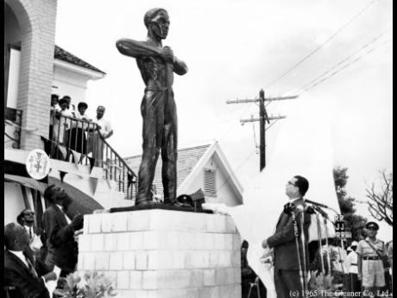
Figure 23 – Acting Prime Minister Donald Sangster looking at the statue of Paul Bogle, erected in front of the Morant Bay Courthouse, which was unveiled on 11 October 1965, on the 100th anniversary of the Morant Bay uprising

To date, the United Kingdom has not apologised for the suppression of the Morant Bay rebellion.

In 2007 Prime Minister Tony Blair apologised for the UK’s role in the transatlantic slave trade.

Successive Jamaican Governments have campaigned for the UK to pay reparations to Caribbean and African countries to compensate them for the psychological, sociological and economic inequalities caused by slavery.

In 2020 the UK Government dismissed the possibility of paying reparations for its role in the slave trade, saying:

The UK deplores the human suffering caused by slavery and the slave trade. They are among the most abhorrent chapters in the history of humanity. While reparations are not part of the Government’s approach, we feel deep sorrow for the transatlantic slave trade, and fully recognise the strong sense of injustice and the legacy of slavery in the most affected parts of the world. We also believe that we have much to do today and in the future to address the reality of slavery in the UK and around the world.

To date, the only people to receive compensation from the British Government for the transatlantic slave trade were the slave owners themselves. They received £20m in 1834 (equivalent to £17bn today) for the loss of their property. This debt was only repaid in 2015.

---

You have now been presented with information, historical records and testimony regarding the Morant Bay rebellion, its causes, its suppression and aftermath, its investigation and the various legal challenges brought to try and seek justice for the wrongs committed.

The case of Phillips v Eyre is not mentioned widely in texts on Constitutional and Administrative Law. Where it is mentioned, it is used to discuss the idea of the rule of law.

Does this give an accurate picture of this period of imperial history?

Is the Morant Bay rebellion, and its suppression, an example of the law applying equally to all?

Why do you think that much of the history of Morant Bay, and of colonial Jamaica, is omitted from the versions of constitutional law presented to you?

If you are interested in learning more about the Morant Bay rebellion and how it impacted the British Empire, Jamaican independence and UK constitutional law, please consult the sources listed in the reading list below.

The questions for your tutorial are at the end of this document.

Reading List

Books

William Francis Finlayson, A Treatise on Martial Law, as Allowed by the Law of England in Time of Rebellion (Stevens 1866)
Priyamvada Gopal, Insurgent Empire: Anticolonial Resistance and British Dissent (Verso 2019), ch 2
Gad Heuman, ‘The Killing Time’: The Morant Bay Rebellion in Jamaica (The University of Tennessee Press, 1994)
Rande W Kostal, A Jurisprudence of Power: Victorian Empire and the Rule of Law (OUP 2008)
Bernard Semmel, The Governor Eyre Controversy (McKibbon & Kee 1962)
A W Brian Simpson, Human Rights and the End of Empire (OUP 2004) 58-70

Journal Articles

Gad Heuman, ‘1865: Prologue to the Morant Bay Rebellion in Jamaica’ (1991) 65 Nieuwe West-Indische Gids / New West Indian Guide 107
B A Knox, ‘The British Government and the Governor Eyre Controversy, 1865-1875’ (1976) 19 The Historical Journal 877
Dylan Lino, “The rule of law and the rule of empire: A.V. Dicey in imperial context” (2018) 81 Modern Law Review 739
Anna Kasafi Perkins, ‘’Mr Gordon met his fate in the religious spirit’: A letter, empire, Christianity and the death of George William Gordon’ (2019) 31 Cultural Dynamics 224
Stephen C Russell, ‘’Slavery Dies Hard’: A Radical Perspective on the Morant Bay Rebellion in Jamaica’ (2022) 43 Slavery & Abolition 186
Bernard Semmel, ‘The Issue of “Race” in the British Reaction to the Morant Bay Uprising of 1865’ (1962) 2 Caribbean Studies 3
Mimi Sheller, ‘Hidden Textures of Race and Historical Memory: The Rediscovery of Photographs Relating to Jamaica's Morant Bay Rebellion of 1865’ (2011) 72 The Princeton University Library Chronicle 533

Questions

- Describe the main issues facing Jamaica in 1865.

In answering this question consider the following:
- The position of black Jamaicans in Jamaican society, and who held the power in the Jamaica colony?
- Whether there were any economic problems facing the island
- The effectiveness of Governor Eyre’s leadership

- Do you think Paul Bogle was justified in his actions on 11 October 1865?

In answering this question consider the following:
- Whether there were other alternative available to the marchers
- Whether the use of violence, especially by colonised peoples, could ever be justified or ‘right’
- Whether the violence used was targeted and focused, or widespread and indiscriminate

- Was the colonial administration’s response to the rebellion proportionate?

In answering this question consider the following:
- How did the colonial troops behave in putting down the rebellion?
- Did martial law need to last as long as it did?
- What were Governor Eyre’s motives in declaring martial law and suppressing the rebellion?
- Did George William Gordon receive a fair trial?

- Why was Governor Eyre so concerned with having an Act of Indemnity passed, and then abolishing the Assembly?

In answering this question consider the following:
- What an Act of Indemnity is and what legal effects it has
- What Governor Eyre assumed the British Government’s reaction would be to his actions
- What impact abolishing the House of Assembly would have on Jamaican politics

- Read the case of Phillips v Eyre. Does the judgment adequately explain the reasons for the Morant Bay rebellion, and details of its suppression?

In answering this question consider the following:
- What is the role of a court, compared to the role of the Royal Commission which investigated the rebellion?
- Do you think the judges wanted to hold Edward Eyre liable?
- Do you find the judge’s defence of the retrospective Act of Indemnity convincing?

- Consider again the definition of the rule of law. Is Phillips v Eyre a good example of the rule of law in action?

In answering this question consider the following:
- Was the law applied equally to everyone in Jamaica?
- Why do you think the textbooks do not provide more detail about the rebellion?
- What do you think this case tells us about the operation of law in the British Empire? In considering this, think about what you have learned in lectures about British governance of colonial Kenya and the Chagos Islands.

AV Dicey, Introduction to the Study of the Law of the Constitution (JWF Allison ed, OUP 2013) 110.
ibid.
(1610) 12 Co Rep 74.
(1765) 19 St Tr 1029.
ibid.
(1870) LR 6 QB 1.
ibid 23 (Willes J).
The Times (London, 15 March 1866) 8.
Edward Bean Underhill, The Tragedy of Morant Bay: A Narrative of the Disturbances in the Island of Jamaica in 1865 (Alexander & Shepheard, 1895), 2-3.
CO 884/2, Eyre to Cardwell, 19 December 1864, No 303, Appendix.
Gad Heuman, ‘The Killing Time’: The Morant Bay Rebellion in Jamaica (The University of Tennessee Press 1994) ch 3.
Rt Hon Edward Cardwell MP, Secretary of State for the Colonies, Letter dated from 74, Eaton Square, London, 11 February 1862.
R W Kostal, A Jurisprudence of Power: Victorian Empire and the Rule of Law (OUP 2005) 82-83.
ibid 83.
British Parliamentary Papers, ,1866, [3682], XXX, Papers Laid before the Royal Commission of Inquiry by Governor Eyre, In the Special Commission, 6 March 1866, Eyre to Cardwell, Enclosure No. 1, 1 (Papers).
Underhill (n 9) xi.
The Falmouth Post (Falmouth, Jamaica, 18 August 1865).
The Times (London, 20 November 1865) 8. A cottier was a rural labourer who lived in a cottage.
Underhill (n 9) 26-27.
Underhill (n 9) 28.
The Colonial Standard and Jamaica Despatch (Kingston, Jamaica, 12 June 1865).
CO 137/390, Eyre to Cardwell, 19 April 1865, no.115.
The County Union, n.d., reprinted in The Morning Journal (Kingston, Jamaica, 17 July 1865).
CO 137/367, Eyre to Newcastle, 24 July 1862, no.52, Taylor’s minute.
British Parliamentary Papers, 1866, [3683-I], XXXI, Report of the Jamaica Royal Commission, Part II, Minutes of Evidence and Appendix, Appendix, Gordon to Price, 16 September 1865, 1155 (JRC).
Kostal (n 13) 12.
Report – British Parliamentary Papers, 1866, [3683], XXX, Report of the Jamaica Royal Commission, 14 (Report).
Papers, In the Special Commission, 6 March 1866, The Queen v Bogle, Henry Theophilus and others for Felonious Riot, Evidence of John Drubruison, 355.
Kostal (n 13) 95.
Papers, In the Special Commission, 6 March 1866, The Queen v Bogle, Henry Theophilus and others for Felonious Riot, Copyevidence for Mr Attorney-General, Statement of Stephen Cooke, 389.
JRC, Evidence of William Alvarenga, p.136.
Papers, In the Court held under Special Commission, January 1866, The Queen v Bogle, and others, Copyevidence for Mr Attorney-General, Statement of Francis Bowen, 396; JRC, Evidence of Arthur Warmington, 58; Evidence of James Britt, 178.
Papers, In the Special Commission, 5 March 1866, The Queen v Bogle, Henry Theophilus and others for Felonious Riot, Copyevidence for Mr Attorney-General, Statement of Stephen Cooke, 352.
JRC, Evidence of Edward William Major, 17; Papers, R G Harrison, Volunteer, to J S Williams, 78.
Kostal (n 13) 12-13.
Papers, Statement of Edward William Major, 28.
Papers, In the Special Commission, 7 March 1866, The Queen v Bogle, Henry Theophilus and others for Felonious Riot, Evidence of Joseph Hardy Williams, 358; JRC, Evidence of Cecilia Gordon, 180.
CO 884/2, Eyre to Cardwell, 20 October 1865, Inclosure 34 in No. 1, Copy of a Letter taken at a House at Stoney Gut.
JRC, Evidence of Isaac Panton, 413.
JRC, Evidence of W Anderson, 160-1.
Kostal (n 13) 1.
CO 137/393, Eyre to Cardwell, 20 October 1865, no.251.
CO 137/397, Report of Captain de Horsey, 22 October 1865: Riots in Jamaica.
CO 884/2, Eyre to Cardwell, 20 October 1865, Inclosure 19 in No. 1, Proclamation of Martial Law.
Dicey (n 1) 287-8.
William Francis Finlayson, A Treatise on Martial Law, as Allowed by the Law of England in Time of Rebellion (Stevens 1866), xiv-xx, 36, 366.
CO 137/393, Eyre to Cardwell, 20 October 1865, no.251.
Underhill (n 9) 64.
Charles Roundell, as quoted in John Gorrie, Illustrations of Martial Law in Jamaica, Jamaica Papers No. VI (London, 1867), 3.
J B Atlay, ‘The Case of Governor Eyre’ (1902) 12 Cornhill Magazine 202, 209.
JRC, Appendix: Military Orders and Documents, Memo for Captain Hole, 1124.
JRC, Appendix, Explanations of Officers under the Requisition of the Secretary of State, Hole to Nelson, 19 October 1865, 1130.
JRC, Evidence of Christopher Codrington, 581-2.
JRC, Evidence of Charlotte Scott, 461.
JRC, Evidence of John Wighan, 585-6; Evidence of Capt. Lewis Hole, 717.
JRC, Evidence of John March, 253.
Henry Bleby, The Reign of Terror: A Narrative of Facts Concerning Ex-Governor Eyre, George William Gordon, and the Jamaica Atrocities (William Nichols 1868) 71.
ibid 73.
JRC, Evidence of Col Thomas Hobbs, 754-5.
The Times (London, 17 November 1865) 9.
JRC, Evidence of Col. Thomas Hobbs, 758-61.
JRC, Evidence of Edward Reid, 931; Evidence of Charlotte Ross, 933.
JRC, Evidence of Roderick McLaren, 912.
JRC, Evidence of Chloe Munro, 932.
JRC, Evidence of Richard Sherrington, 240.
JRC, Evidence of Col. Thomas Hobbs, 759.
Bernard Semmel, The Governor Eyre Controversy (McKibbon & Kee 1962) 85.
JRC, Appendix: Military Orders and Documents, Memo for Col Fyfe, 19 October 1865, 1125.
JRC, Evidence of Thomas Burton, 982; Evidence of George Bernard, 947; CO 137/394, Eyre to Cardwell, 8 November 1865, no.272; Fyfe to Eyre, 28 October 1865.
CO 137/394, Fyfe to Eyre, 29 October 1865.
JRC, Evidence of Alexander Fyfe, 896.
JRC, Evidence of James Stewart, 212.
JRC, Evidence of Thomas Duncan, 528.
JRC, Evidence of Henrietta Bailey, 969.
Bleby (n 57) 70.
Thomas Harvey and William Brewin, Jamaica in 1866: A Narrative of a Tour Through the Island, with Remarks on its Social, Educational and Industrial Condition (A W Bennett 1867) 13; JRC, Evidence of William Murray, 530.
JRC, Evidence of Gordon Ramsay, 930.
Bleby (n 57) 86-7.
JRC, Evidence of Joseph Hall, 241.
JRC, Evidence of Joseph Hall, 242; Evidence of Arthur Beckwith, 123; Evidence of W G Astwood, 265.
JRC, Evidence of William Kelly Smith, 196.
The Morning Journal (Kingston, Jamaica, 8 November 1865).
The Colonial Standard and Jamaica Despatch (Kingston, Jamaica, 20 October 1865), The Colonial Standard and Jamaica Despatch (Kingston, Jamaica, 26 October 1865).
JRC, Evidence of George Clarke, 130-1.
CO 137/399, Storks to Cardwell, 18 January 1866, confidential: Ramsay to Jordon, 6 January 1866.
JRC, Evidence of Edwin Gentle, 65; Evidence of George Clarke, 128; Evidence of George Levy, 814; Evidence of Alfred Penny, 774.
JRC, Evidence of William Fuller, 82; Evidence of Robert Jones, 91-2; Evidence of Polly Levingston, 350.
JRC, Evidence of Penny Atkin, 111; Evidence of James Loague, 430.
‘More About the Jamaica Horrors’, Reynold’s Newspaper (London, 18 February 1866).
Kostal (n 13) 107.
Pall Mall Gazette (London, 13 November 1866) 9.
‘Justice for Jamaica’, Anti-Slavery Reporter (London, 15 July 1867) 160.
PRO 30/48/44, Cardwell Papers, ‘Narrative of the Rebellion in Jamaica, October, 1865 taken from the official Despatches: Confidential, Printed for the use of the Cabinet, 14 December 1865.
Heuman (n 11) 143.
PRO 30/48/44, Cardwell Papers, ‘Jamaica’ by Lewis Q Bowerbank, 8.
PRO 30/48/44, Cardwell Papers, ‘Jamaica’ by Lewis Q Bowerbank, 8; JRC, Evidence of Captain de Horsey, 206.
JRC, Evidence of William Wemyss Anderson, 794-5; Evidence of Brigadier-General Nelson, 795.
Bleby (n 57) 103-4.
Rev David King, A Sketch of the Late G.W. Gordon, Jamaica (William Oliphant and Co., 1866) 14.
JRC, Evidence of Lt Herbert Brand, 661.
JRC, Evidence of Augustus Lake, Trial of George William Gordon, 277; Trial of George W Gordon, 1051.
JRC, Trial of George W Gordon, 1052.
JRC, Evidence of Lt Herbert Brand, 655; Trial of George W Gordon, 1052; Evidence of Augustus Lake, 280.
JRC, Evidence of Dr E W Major, 27; Evidence of Augustus Lake, 281.
Heuman (n 11) 149.
ibid 150.
JRC, Nelson to Eyre, 23 October 1865, 621.
JRC, Nelson to Eyre, 23 October 1865, 621; JRC, Evidence of George Clarke, 129; Evidence of Gordon Ramsay, 636; Evidence of Augustus Lake, 282.
The Times (London, 17 November 1865) 9.
Kostal (n 13) 24.
ibid 29.
Spectator (London, 2 December 1865) 1330-1.
CO 884/2, Cardwell to Eyre, 1 December 1865, Inclosure 5 in No. 10, Newspaper Extract.
Kostal (n 13) 29.
Manchester Guardian (Manchester, 1 December 1865) 8.
Fortnightly Review (London, 1 December 1865) 240-7.
CO 137/393, Eyre to Cardwell, 24 October 1865, confidential.
Heuman (n 11) 159-60.
CO 137/402, Eyre to Cardwell, January 1866.
Statutes of Jamaica, 29 Vict. c 1.
Kostal (n 13) 106.
Intelligence Services Act 1994 c 13, s 7(1).
PRO 30/48/42, Cardwell Papers, Cardwell to Eyre, 23 November 1865.
PRO 30/48/42, Cardwell Papers, Cardwell to Eyre, 1 December 1865.
Papers, Eyre to Cardwell, January 1866, No.1, Enclosure No. 1, 2.
Papers, Eyre to Cardwell, January 1866, No.1, Enclosure No. 1, 3.
Kostal (n 13) 38.
PRO 30/48/42, Cardwell Papers, Cardwell to Eyre, 17 December 1865.
Henry Clarke, ‘The Journals of Henry Clarke,’ vol. 2, 16 February 1866.
Kostal (n 13) 120-1.
Report, 41.
Report, 41.
CO 137/427, Grant to Buckingham, 8 October 1867. No. 196; ibid., enclosure: Buckingham to Grant, 16 December 1867, no. 167.
The Colonial Standard and Jamaica Despatch (Kingston, Jamaica, 25 July 1866, 26 July 1866).
Catherine Hall, ‘The Economy of Intellectual Prestige: Thomas Carlyle, John Stuart Mill, and the Case of Governor Eyre’ (1989) 12 Cultural Critique 167, 178, 182, 190.
Kostal (n 13) 170.
Hansard, xxxiv (31 July 1866), 1789.
Kostal (n 13) 297-9.
ibid 309.
ibid 271-3.
ibid 333.
ibid 341.
ibid 372.
ibid 380.
Bernard Semmel, The Governor Eyre Controversy (McKibbon & Kee 1962), 171-3.
Heuman (n 11) 173.
Law Times (London, 5 January 1867) 181.
Kostal (n 13) 438.
Pall Mall Gazette (London, 10 February 1868) 6.
Kostal (n 13) 439.
ibid 440.
Phillips v. Eyre (1869) LR 4 225 (QB), 242-3 (Lord Cockburn CJ).
ibid 238.
ibid 239.
Law Times (London, 20 February 1869) 304.
The Times (London, 24 June 1870) 9.
ibid.
Kostal (n 13) 450-1.
The Times (London, 24 June 1870) 9.
Kostal (n 13) 451.
ibid 454.
Petitions, UK Government and Parliament. ‘Pay Slavery Reparations to all Caribbean & African Descendants’ (4 August 2020) https://petition.parliament.uk/petitions/325237.

