{Title} The Secret Code of Success

{Authors} Ben Laker, Mark Ridley and Ian Mills

What is the greatest formula for high-level succes? In this article, the authors highlight the significance of fulfilment, control, resilience, influence and communication in making performance at its best. Armed with this insight, when recruiting in the future, leaders will be far better equipped to investigate the deeper motivations and beliefs that drive the best-of-the-best.

Based on 20,000 hours of comparative analyses across the spectrum of performance and interviews with the world’s most iconic leaders from organisations including Adidas, Cisco, GSK, JP Morgan, Microsoft, Oracle, Steinway & Co. and Vodafone, a recent study from Transform Performance International (LID Publishing, 2017), presents the most rigorous global evaluation of how leaders behave and are driven, which in doing so reveals the “secret code” behind consistent and high-level success.

Insights from this study are fascinating and suggest that five core beliefs are held by all leaders, referred to as Destination Beliefs because many of those interviewed regard their professional (and personal) life as an ever-expanding journey. Whilst they acknowledge the importance of the belief in shaping their mind-sets and behaviours, they point out repeatedly that these core beliefs are aspirational, evolving continuously, and certainly not finite.

But this was not the whole story. It was clear that the Destination Beliefs are necessary components of a leaders’ belief system, but what really separated the top performers from the lower performers was how those beliefs were interpreted and synthesised internally. Put simply, for each Destination Belief the interviewees described attitudes towards the belief which spanned a spectrum. These were the 10 sub-beliefs, referred to as Journey Beliefs because they demonstrate how we respond to what happens to us on the journey.

High performers are constantly evaluating themselves against a personal progress goal to be the most professional, productive person they can be.
- What is most interesting is that the interviewees experience and even wrestle internally with journey beliefs from either and/or both ends of the spectrum. The most successful leaders respond to certain journey beliefs with greater intensity than they do to others. And it is their response to the intensity of the journey belief which then drives a behaviour. Journey Beliefs lay out in front of leaders the path that they will walk through. And whilst much may have been said and written about having the “right kind of attitude”, now, for the first time, it can be measured in a specific population. Here, finally, is a causal chain of five components, a formula for success – The Secret Code.
- 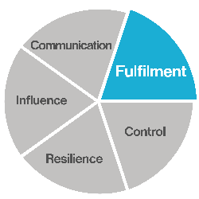Fulfilment is the first component. It’s a state of satisfaction that comes from knowing you’ve either achieved, or are on track to shift performance from good, to better, to best. High performers are constantly evaluating themselves against a personal progress goal to be the most professional, productive person they can be. They know the extent to which a potential customer (internal or external) engages with them is a reflection of their personal style of Communication (more on this later), credibility and persuasiveness.

- 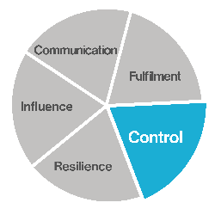They understand the concept of Control, the second element. They believe in having a plan, and regularly evaluate where they want to be, where they are, and what the gap is. They show a sense of personal accountability for their success or failure. When failure comes (it does even for top performers), they don’t blame the economy, their company, or the marketing department. They embrace it as something they own, because when you own a problem, you can do something to change it. Failure is therefore seen as a temporary setback on the road to inevitable success, where every mile of asphalt, every pothole, every bridge, tollgate, and detour is seen as something you can control.

- 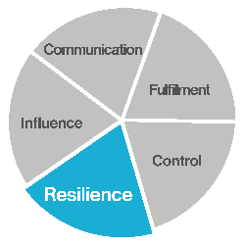Resilience comes next. It is connected to Control as it represents your ability to bounce back from setbacks and get back on track. Like Control, Resilience is revealed through taking action. Like a muscle that grows after exercise, or a chunk of coal that gains value after being squeesed under pressure, resilient leaders face whatever the world throws at them, convert the stress to positive energy, and get busy shaping their own destiny. Resilience means being adaptable to change, and showing a “can do” approach when the pressure is on to meet deadlines, advance the sale, win the deal and hit quota. Resilience is a fundamental building block for achieving Influence as a leader.

- 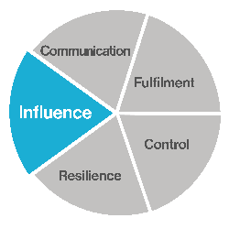Influence is the fourth piece in this jigsaw. As a leader, you need to gain influence with others to open doors, get on the calendar, gain stakeholder support, and win business. You also need influence with people in your own company to secure resources, support or the pricing needed to win specific deals. You need influence to plug in to the internal grapevine and know about changes, risks or opportunities before they’re general knowledge. Some people see this type of behaviour as being political – and they’re right. You will always encounter politics on the job. People will always be jockeying to be noticed, gain allies, build a power base, or exert influence over their work environment. It requires extra effort to navigate this, which is why resilience is needed as a foundation. Influence is gained by networking, talking to a lot of people, and using the wisdom of crowds to your advantage so you’re never caught by surprise. When you know in advance what changes are coming, how people feel about them, what they most want, and whose opinion matters most, you can take action faster and more precisely than others. You build a track record of success. You gain partisans and friends in all the right places. This gives you Influence. A key building block to do all this is your ability to communicate.

- 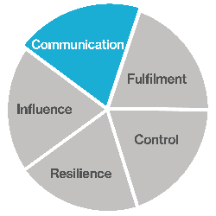Communication is the fifth piece of the puzzle. You can never over-communicate with your colleagues or with a customer. Speed and clarity are the keys. Speed is important because today people ingest and send information in person, or by phone, video, email, blog and tweet. If you can’t say it in 200 characters or less, some people switch off. So instead of long meetings, letters or emails every few weeks, try having shorter exchanges every few days. The important thing is to stay front of mind. Clarity is important because there’s so much noise competing for people’s attention, your message needs to be precise and stand out from the static. Try thinking of every communication as a three-part story: you need an attention-grabbing headline, a reason it matters and a call to action. This applies to what you write and what you say. The lesson we took from the interview analysis was clear. High performers think about how they communicate. They recognise that communication is never about one-size-fits-all. In short, they are flexible, chameleon-like. And they are like this because they come from a place where they believe that they have a duty to help others understand, to enable the asking of questions; in short, to generate dialogue.

- Let’s summarise:
- • The better your communication, the more conversations and ideas you explore with people, and the more opportunities you can uncover to pursue your personal goals for fulfilment.
- • The more fulfilled and confident you become, the more gravitas you project, and the more control you exert over your environment.
- • The more in-control you are, the easier you evade obstacles. But even when you can’t, you deal with challenges in a way that builds your emotional, mental, or spiritual muscles; your resilience.
- • The more resilient you are, the more you choose to act rather than be acted upon; the more people and events you will influence.
- • The more influence you gain, the more doors open to connect you with other influencers. You become better informed, hear of opportunities before others, and greatly improve the quality of your communication with others.
- • The better your communication, the more conversations and ideas you explore with people, and the more opportunities you can uncover to pursue your personal goals for fulfilment . . . and so on.
- 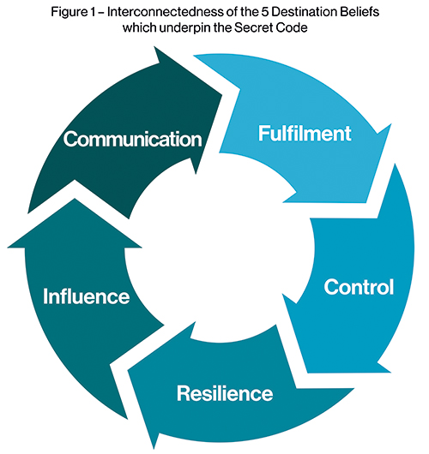
- How did these Journey Beliefs manifest themselves? In summary, top-performers believe in giving themselves permission to be better than they ever dreamed possible. Low-performers believe that success comes from avoiding failure. Top-performers hold themselves accountable for their success: low-performers are happier to attribute lack of success to factors which they perceive to be outside of their control. The highest-performing group look for ways to work smarter when facing tough times; the lower-performers talk about working even harder. High achievers know that having influence comes through demonstrating flexibility, not brute force due to position or power. And finally, the top-performing leaders regard communication as an ever-deepening dialogue, whereas lower performers tend to view communication as more transactional and transmission-centric.

- The highest-performing group look for ways to work smarter when facing tough times; the lower-performers talk about working even harder.
- As you can see, the Secret Code is a self-actualising, self-supporting cycle of behaviour and beliefs. The implications for leaders are huge. Let’s liken their performance to the body of a racing car. We see the shape, the style and color, assembled and ready to hit the road. A person’s education and skills might be likened to fuel in the tank; the more they have, the further they’ll go. Their needs, ambition and hunger might be likened to spark plugs that ignite the fuel to create combustion to drive the wheels. Within this analogy, where do belief systems fit in? They’re at the driver’s feet: the accelerator and brake. It doesn’t matter how suited to any role a psychometric assessment says a person is, if deeply-held beliefs make them drive with the brakes on.

- About the Authors

- Dr Ben Laker is Partner at Transform Performance International. He helps Fortune 500 firms including Apple, American Express, Cisco, Dow Chemical and Liberty Global to do more, more quickly with more certainty using analytics, machine learning and big data. Formerly a Visiting Professor at The Russian Presidential Academy of National Economy, he maintains an active interest in academia through an association with the Centre for High Performance, a research institute he cofounded in 2013 that works with NASA, The New Zealand All-Blacks, The Royal College of Art and The Royal Shakespeare Company among others.

- Mark Ridley is Founding Partner at Transform Performance International. Mark is a driving force behind this highly successful UK-based firm. An inspirational coach and co-author of 100 Big Ideas to Help You Succeed (LID, 2013), he has worked as a strategist, chair and facilitator with global brands, investment houses and academic institutions for over 25 years, in 60 countries, inspiring leadership and coaching talent, growing sales and transforming the way people communicate. He facilitates regularly at major conferences and events worldwide and is an acknowledged expert in sales leadership, emotional intelligence and collaborative excellence.

- Ian Mills is Managing Partner at Transform Performance International, Ian is a co-author of 100 Big Ideas to Help You Succeed (LID, 2013) and numerous white papers. He has been a salesperson and led sales organisations in the fast-moving consumer goods, financial and technology sectors. Since 1999 Ian has been a leading light in the building of a globally successful performance improvement consultancy that has delivered solutions in over 60 countries. From Lima in the west to Beijing in the east, he has led behaviour change and transformation projects with corporations such as Hewlett-Packard and Maersk.

