The palliative care needs of people severely affected by neurodegenerative disorders:
A qualitative study

S. Veronese

Fondazione Assistenza e Ricerca in Oncologia (FARO) onlus, Turin, Italy

G. Gallo

Fondazione Assistenza e Ricerca in Oncologia (FARO) onlus, Turin, Italy

A.Valle

Fondazione Assistenza e Ricerca in Oncologia (FARO) onlus, Turin, Italy

C.Cugno

Fondazione Assistenza e Ricerca in Oncologia (FARO) onlus, Turin, Italy

A.Chiò

ALS Centre, Department of Neuroscience, University of Turin, Turin, Italy

A.Calvo

ALS Centre, Department of Neuroscience, University of Turin, Turin, Italy

C Rivoiro

Istituto di Ricerche Economico Sociali del Piemonte Ires Piemonte, Turin, Italy

D. J. Oliver
Centre for Professional Practice, University of Kent, Chatham, UK

Correspondence to:
S. Veronese
Fondazione Assistenza e Ricerca in Oncologia (FARO) onlus
Turin,
Italy.
Email: simone.veronese@fondazionefaro.it

Abstract

Specialist palliative care services are often involved in the care of people with progressive neurological disease, in particular amyotrophic lateral sclerosis. However, the particular needs of people with advanced and progressive neurological disease are not well known. A qualitative approach was used, interviewing people with advanced amyotrophic lateral sclerosis/motor neurone disease (ALS/MND), multiple sclerosis (MS), Parkinson’s disease (PD), and multiple systems atrophy (MSA) and their family carers to ascertain their particular needs. Focus groups of health and social care professionals allowed a professional view of the needs. People with progressive disease have many, difficult and distressing symptoms: physical, including pain, movement issues, swallowing and speech problems, psychological, feelings of being abandoned and of anxiety and depression, social, of isolation, of being a burden and of financial issues, and spiritual, of loss of hope and the meaning of life as they approach death. These issues could be helped by the development of a palliative care approach and the involvement of a specialist palliative care team, which was supported by patients, carers, and professionals.
Keywords: Palliative care, Needs assessment, Neurology, Progressive neurological disease

Introduction

Patients with progressive neurodegenerative conditions experience a high burden of physical symptoms as well as psychosocial and spiritual unmet needs during the progression of the disease.^{1,2} The family carers are exposed to an increasing burden of care as the patient’s disability progresses.^{3–5} Although there is evidence of the needs for specific diseases, such as in amyotrophic lateral sclerosis – ALS/MND,⁶ in Parkinson’s disease⁷ and in multiple sclerosis,⁸ there is little evidence of the overall group of people with neurodegenerative conditions.³

There is increasing recognition of the need for service development for patients in the advanced stages of neurological conditions, but little evidence of the efficacy of specialist palliative care services (SPCS) to meet the needs that could be helped by palliative care in this population and how this can best be provided to address them. Before any service can be developed, it is necessary to establish the needs of patients and families and establish how they would envisage the help provided to them.

There are concerns that improving the awareness of the needs of patients dying from diseases other than cancer may lead to an increase in referrals to SPCS.⁹ However, palliative care services have been involved in the care of people with neurological disease since the early days of St Christopher’s Hospice, the first of the modern hospices which developed patient care, research and education. In a letter in 1990 Dame Cicely Saunders, the founder of modern palliative care, wrote to Dr Mary Eleanor Toms that they had been caring for patients in terminal stages of motor neurone disease (MND) since the opening of the hospice, and that their first patient with ALS/ MND had been admitted in 1967¹⁰ ( p. 322). Recently, the interface between neurology, rehabilitation, and palliative care has been explored and suggested a framework indicating that each specialty was involved with particular tasks with overlapping fields of intervention.^{11,12} An appreciation of the role of palliative care in neurological conditions was expressed in 1996 in a document published by the American Academy of Neurologists which suggested that neurologists have to understand, learn, and apply the principles of palliative care because many patients affected by neurological disorders die after long illness and the neurologist is often the principal or the only consulting physician.¹³ In 1999, the AAN published the results of a survey that highlighted a gap between established legal, medical, and ethical guidelines for the care of severely ill neurological patients and the practice and beliefs of many American neurologists.¹⁴

In Italy, there has been a rapid growth of new hospices over the past 10 years, but the majority provide care only for cancer patients. Palliative care for non- cancer patients has been advocated by many official statements, and it is now part of the new Italian law on palliative care released by the Italian Parliament in March 2010. The Piedmont Regional Health Commission produced guidelines on palliative care provision in 2002 stating that hospice care is indicated when patients are affected by progressive disease, in advanced stages, with a poor prognosis, for which no therapies aimed at the cure or stabilization are possible or appropriate. Neurodegenerative conditions are clearly included within these criteria, but often patients severely affected by these illnesses still do not have access to specialist palliative care in Italy.

This study aimed to look at the needs of people with neurodegenerative disease in the Turin area and assess how they would see a specialist palliative care service helping them.

Methods

This was a qualitative observational study comprising two main areas:
- Face-to-face interviews with adult patients severely affected by amyotrophic lateral sclerosis/motor neurone disease (ALS/MND), multiple sclerosis (MS), Parkinson’s disease (PD), or multiple systems atrophy (MSA). For inclusion these patients, and their lay carers, usually a family carer, had mental capacity to give consent to participation in the study, and be resident in the area covered by Foundation for Assistance and Research in Oncology (FARO) domiciliary home care service in order to be potentially involved in the future new SPCS. If the patient did not have a carer or preferred to be interviewed alone this was undertaken.

- Focus groups held with professional carers directly involved in the patients’ care – usually neurologists, but also rehabilitation specialists, physiotherapists and speech and language therapists. It had been planned to include nurses and general practitioners, but these focus groups did not take place owing to organizational problems.

The patients were referred by neurologists and other professionals involved in their care. Ten potential interviewees, representative of all conditions and with different clinical features, were selected and interviewed at their home, if possible, to enable participants to be in their own environment, reducing the stress induced by being in an external setting. Recruitment continued until there was a saturation of the themes, with no new information from further interviews.

Focus groups were held in the professionals’ place of work in order to allow better participation and a relaxed environment. Both focus groups and interviews were video- and audio-taped and field notes were taken.

The interviews

Patients and their informal carers are recruited from the database of the centres of the two hospitals hosting the specialist centres for these diagnoses (neurological tertiary clinics, pulmonary, and
rehabilitation wards).

The inclusion criteria for patients were
- Affected by MND/ALS, MS, PD, MSA.
- In advanced stages of the disease whom they would not be surprised if could die in the next 6 months owing to their neurological conditions¹⁵ or that could have important palliative care needs.
- Resident in Turin city and its province.
- Able to communicate or let their opinion be under- stood (communication aids were allowed when used by the patients).
- Able to give consent to the study.
- Informal-familiar caregivers of these patients if they were able to participate and if this was allowed by the patients.

The exclusion criteria were patients
- With diagnosis different from those listed above.
- Not willing to participate.
- Resident in other areas.
- Showing severe cognitive impairment or totally unable to communicate.

A purposive sampling technique¹⁶ was adopted, and subjects were selected because of various
characteristics such as the neurodegenerative disorder, the level of disability, and the opinion of the professional carer about their life expectancy and the presence of palliative care unmet needs. The sample size was not determined beforehand but it was determined when the theoretical saturation of the data was obtained, when no further aspects were seen.¹⁷

Following selection, the participants were contacted by telephone by their known specialist, in order to explain why they had been selected and to obtain a preliminary consent to be contacted by the research team. If the feedback was positive, the participants were referred to the study, and a telephone call was used to arrange the interview. Interviews were con- ducted in the preferred place of the participants, usually at their home, or other settings if they wished– hospital or nursing home.

At the interview site, two researchers explained the aims of the study, why the participants were selected and an information leaflet was provided. The general practitioner was also informed by letter, giving a summary of the study. Written, or clear expression of consent for patients with restricted communication and/or limb function, was obtained. If the patient wished and agreed, family members or carers were included in the interview.

Participants were asked to give a brief story of the disease focusing on the most difficult part that they had to face. They were then asked to focus on the actual problems and needs suggesting the four components of the total pain ( physical, psychological, social, and spiritual components)¹⁸ but letting them decide which to discuss, in the order they felt more pertinent to their situation and asking which kind of help they would expect from a new palliative care service.

Participants were reassured that the content of the interviews would be kept anonymous and that the
professionals who had made the referral would not read the transcript verbatim.

When communication impairment did not allow the patient to talk, augmentative or alternative
communication aids were used, if they were available. When this was not possible, the informal carer spoke and the patient was filmed at his or her side in order to catch from the non-verbal expressions when he or she agreed or not with the story.

The focus groups

Professionals providing care to people with the selected diagnoses in two of the main hospitals in the Turin area were selected to participate to the focus groups. They were recruited after direct contact with the specific disease centres. They were asked to describe how many people with advanced neurodegenerative conditions they see on average every year, how long they have been involved in their care, their thoughts of the patients’ and informal carers’ unmet palliative care needs and how an SPCS could be of help.

Focus groups were conducted within the hospitals with the aim of including the wider multidisciplinary team and to allow the discussion among the participants and encouraging a wider debate, rather than just the opinions of a single professional group.

Data analysis
The interviews and focus groups were transcribed verbatim, and the transcriptions were read and re-read by two independent researchers (S.V. and G.G. among the authors) to draw the significant themes from the data (microanalysis).¹⁹ Following the individual coding, a third researcher (C.R.) undertook the coding of five randomly chosen interviews allowing an inter-rater reliability test to be undertaken, matching the number of quotes selected and coded in the same categories among the three independent coders.

The coding process focused on the physical, psychological, social, and spiritual needs of the patients together with the burden of care of the informal carers and the opinion about the existing services.

A content analysis^{20,21} of the highlighted codes was then performed aiming at counting how many similar needs appeared in the different events within the different categories of needs. A final thematic analysis²² searched through the data to identify any recurrent themes or links between categories conveying similar meanings.

Ethics
Ethical approval was obtained from the ethics committees (ECs) of the two hospitals involved in patients recruitment: Molinette hospital (Turin) and S. Luigi Gonzaga hospital (Orbassano).

Results

Twenty-two interviews involving 22 patients and 21 informal carers, and three focus groups with 11 professionals were performed between May and July 2007. The demographics, the clinical features, and method of classification for the participants, with the abbreviations used, are shown in the Table A1. The details of participants of the focus groups are described in Table A2 – including their roles and areas of interest and the method of classification for these participants.

The content analysis of the interviews showed a high number of unmet needs that were coded into the four predefined categories of needs highlighted from the interviews – physical, psychological, social, and spiritual needs – and the results are shown (Figures 1–4).

Physical issues

The physical issues faced by patients were widely reported. In particular, all participants reported impairment of movement and related symptoms (rigidity, tremors, and falls). Patients described a high degree of disability and described many issues that affected them, and these were often the first reported physical needs.

Patients still able to walk underlined the difficulties met in reduced ambulation, fluctuation of symptoms, and progression of the disability:
(He walks) with a walking stick. We have a wheelchair to go out. We had a walker (walking aid) but we returned it because it didn’t help.(…) another problem is his muscular rigid- ity. (…)
CPD1 wife of PPD1 (male, 80 years, PD diag- nosed 9 years ago).

As there was progressive deterioration in walking, falls, and the consequent complications were reported and were seen as the trigger for physical dependence and became accepted by patients and carers as normal occurrence in their life:

in these 5 years he progressively lost the capability to walk. Before he needed a crutch, then 2 and now the wheelchair.

CALS3 wife of PALS3 (male, 60, on a wheel- chair, diagnosed 5 years ago).

Subjective distress was reported from dyskinesias owing to the drugs needed to avoid the freezing phases.^{23–25}

I don’t have many tremors. I’ve never had. I have these dyskinesias. It’s a continuous movement, I don’t have rest. But not tremors. (…) I can’t stop all my limbs from moving continuously. I dance and can’t control it.

PPD2 (male 70 years old. Diagnosed 6 years ago).

Dyspnoea and respiratory symptoms were reported in 18 (82%) patients and were particularly prevalent in ALS patients, and 10 patients were using mechanical ventilation (six non-invasive, four invasive via tracheostomy), but none was taking any opioids to control breathlessness.

It was clear that although non-invasive ventilation (NIV) can improve these symptoms, there was further distress due to the progression of the symptoms

(I feel) great weakness in my legs, tiredness, I can’t climb the stairs anymore, and above all, shortness of breath’ - he said this with a very low voice, sustaining his head with one arm.

His carer: ‘breathlessness debilitated him a lot. He couldn’t walk because of it more than because of muscle impairment. (…) and this cause great fatigue (…). In the night he uses NIV by mask. Now he also uses it many hours during the day.

PALS4 (male, 61, quadriplegic, diagnosed 3 years ago, wheelchair, severely dyspnoeic on NIV).

Pain syndromes, painful muscular spasms, or cramps appeared in 18 interviews (82%). Despite the high prevalence, only two patients were receiving opioids (one patient received tramadol and one patient low doses of oral morphine) for chronic pain, whereas one was taking medication for neuropathic pain. Many participants did not immediately recognize pain as a problem related to the disease:
I don’t have pain. No, what am I saying? I have leg pain, a lot. But I think they’re age related or due to rheumatisms or arthrosis (…) I don’t have cramps, but spasms and inexhaustible clonus at my right leg.
PMS4 (woman, age 69, diagnosed 42 years ago. She lives alone, cared for by paid carers, spends alone most part of the day and the night).

Choking when taking food or liquids, saliva aspiration and nutritional issues were reported in 21/22 (96%) interviews. Nine patients were receiving feeding and hydration via a gastrostomy. Issues with swallowing had a very bad impact on the carers, forcing them to spend a great deal of time with the patient and changing their habits in food preparation. Often, episodes of food aspiration led to aspiration pneumonia with hospitalization.
We can’t leave him alone. Today is a good day for him, but often he has sudden worsening and requires constant attendance. For instance he can’t swallow saliva, so frequently he chokes and we have to aspirate his mouth.
CMS3 wife of PMS3 (Male, age 46, blind).

Swallowing difficulties, and often the resulting drooling of saliva, impacted adversely on patient’s quality of life (QoL) and caused important changes in other functions – impacting on communication, loss of plea- sure in eating, and leading to the fear of choking
Swallowing is another trouble. I have to whirl everything I cook for her. But she complains that everything has the same flavour (…) she’s still eating by herself, but it happens that I have to spoon feed her. The bad aspect of this disease is that it changes quickly.
CPD5 carer for PPD5 (a woman in her 70s, diagnosed 18 years ago, wheelchair bound, many afinalistic movements, spasms and tremor).

Communication problems were described in 14 (64%) interviews, with intensity varying from mild to severe with total impairment and loss of speech. Three patients could not talk at all and were not using any alternative communication aid. Four patients were using aids to communicate, such as alphanumerical boards read by the caregiver, electronic devices, or a computer with communication software. Loss of normal communication was seen as the major factor affecting the QoL because it limits social relationships for several patients:
Now we use this table. The paid carer and I were able to communicate quickly. If others come, we must act as an intermediate. So what happens? After a while nobody wanted to come and visit him.
CALS1 wife of PALS1 (male, 48 years old, bed- ridden quadriplegic, totally aphonic, tracheostomized. He communicates using an alphanumerical table).

Urinary problems were reported in 13 (59%) inter- views – including urinary incontinence, retention of urine, and severe infection:
He uses incontinence pads in the night because of his incontinence. He’s been using it for two years. During the day he wears the pads, but can control urine. Sometimes he has urinary tract infections. We had to come to the hospital because he had urinary retention.
CPD1 wife of PPD1 (male, age 80, cognitively slow but able to understand and severely disabled in his movements).

Seventeen of 22 (73%) patients reported intestinal problems. Constipation was the most frequent problem and it was present in all the diagnostic groups. It was described as a consequence of the disability induced by the neurological disorders. The loss of sphincter control caused problems with nursing and dignity.
He has his pad on for the whole day. He lost his stimuli so he does everything in it. We have to change it in the night as well, we need to set the alarm clock to remind us. For instance last night I forgot to change it and when this morning the home assistants came to wash him he was soaked in the excrements.
CMS6 wife of PMS6 (a 53 years old gentleman EDSS 9, fed by PEG, almost totally dependent in the activities of the daily living).

Sleep disturbance was also reported in 14 interviews (64%), patients sleeping badly because of symptoms.
He wakes up 2–3 times per night to urinate. He needs a person who removes his mask and replace it afterwards, he can’t do it by himself’.
CALS9 wife of PALS9 (male, age 77, diagnosed 8 months ago, in NIV).

Carers also reported problems with sleep, often as there was the need for continuous care throughout the day and night.
He takes his drops of anxiolytic to sleep. He has frequent awakenings, he does not sleep continuously. He wakes up because he has to be aspirated and turn in the bed. Some nights are quiet, others are not. I sleep in the double bed with him so I feel when he needs me’.
CALS 6 carer of PALS6 (male, age 50, diagnosed
13 years ago, tracheostomized, bedridden –
wheelchair, quadriplegic, aphonic).

Skin problems affected 10 patients (45%) and were reported as causes of suffering. The discomfort was often from bed sores, owing to immobilization, but could be caused by the masks used for NIV or comorbidity.
He has a mycosis under his armpits and this caused itching. He also has psoriasis (…) He had bedsores on his back due to an episode of diarrhoea syndrome that he had on spring. I cured it with creams. Now I still put it because his skin remained very sensitive. And then there are the ulcers around his nose due to the mask.
CALS8, wife of PALS8 (male in his 70, diagnosed 9 years ago wheelchair bound, totally anarthric).

Psychological issues

Table 2 shows the main psychological issues described by patients and families. Twenty-one (96%) of patients and 14 (64%) of carers gave the area of feeling abandoned, confused, and concerned for the future as the areas of greatest concern:
We are isolated. We have lost many friends. Since he’s ill they disappeared. We looked for them, but the plea is always the same: -we can’t see him like this- or - we are so sorry for him.
CALSA 1 – wife of PALS1 (man, 48, bedridden, quadriplegic, totally aphonic, tracheostomized).

This often included professional carers:
I’m really angry with the neurologist that has always cared for him … he should come to see how he is going on … If you need help there is no-one available.
CPD3 wife of PPD3 (man, 70 years old, diagnosed 27 years before, cognitive impairment, constant shaking, moaning, in nursing home).

Many expressed fear of future symptoms, especially when they were dependent on life sustaining
interventions, such as a ventilator:
‘I’m really worried about the future. I think about tomorrow, how will it finish?’
PALS3 (man, 60, very dyspnoeic, on NIV, at home).

Some carers talked of mood changes in the patients – rage, emotionality, anxiety, and depression. These feelings were often expressed about the illness, the professional carers, particularly for rage, and the fears of deterioration:
He has so many fears … he fears to die.
CALS5 wife of PALS5 (man, 60, quadriplegic, aphonic, wheelchair-dependent).

The problems of having to cope with losses and coping with unmet expectations were frequently raised by patients and carers when talking about patients’ feelings – including difficulties in accepting the physical disability caused by the disease, the relentless progression of the symptoms, the loss of social activities, and the loss of loved people. This was also expressed as the uncertainty of what will happen as the disease progresses and the seeking for cure through improbable and costly journeys to distant countries and looking for strange therapies found on the internet.
When you have to go in a one way street, you can’t turn or do a u-turn. (looking at his wife) you must accept it … if my nose is itchy I need someone to scratch it.
PMS2 (male, 43 quadriplegic, totally dependent).
He fell continuously. He had two devastating years. That was a horrible period where psycho- logically you don’t accept the disease. We did not believe the doctors anymore and we went abroad looking for alternative solutions.
We tried everything: Germany for injection of stem cells, France for macrobiotics, Perugia for a fasting regime. Within the medical system we participated to a trial with IGF (…) and Riluzole. When we attended medical conferences we could see that when there are benefits they are limited in time and this was disillusioning. You wonder if it’s worth to continuing.
CALS2 wife of PALS2 (male, age 39, tracheostomized, fed by PEG, quadriplegic, diagnosed 14 years ago, aphonic).

Many patients talked of being a burden for people living around and was seen as a very negative experience:
After so many years you start feeling like a burden for the others. A deathly burden. Because I have a devastating condition and alter other people’s choices. You always need to ask. I don’t like it.
PMS1 (male, age 53, diagnosis of MS 18 years ago, quadriplegic, using NIV in the night).

These concerns were also expressed for the family and carers:
Another cause for my suffering is that I can’t help her (crying), and she has her physical problems too.
PPD2 (male, age 70, fluctuating motor symptoms with freezing episodes alternate to severe dyskinesias).

The use of psychological support varied. Some families had been greatly helped but others spoke of little support, or had refused support:
Psychological support is so important. It’s not just talking to someone, but it’s receiving help. I learnt that in the morning I have to create a list of the things that must be done. Anytime I complete one I cancel it from the list. It helps a lot by keeping your mind busy and don’t let worries enter.
PALS7, (woman 60 years old, diagnosed 12 years ago, quadriplegic, dysarthric, dyspnoeic, NIV 24 hours a day).

Social issues

Among the different categories of social needs reported in the interviews, the sense of social isolation for both the patients and the carers was the most frequent and burdensome. Economic and financial problems were also discussed, together with the need of home care assistants and volunteers required to provide help, but who were often difficult to obtain from the existing services. The long duration of the diseases together with the high disability of the patients raised other particular social issues such as the problems associated with trans- port and the need for holiday and respite:

Friends were very helpful when he was at the hospital, but since we came home they aren’t so
collaborative. Some of them disappeared and we lost them before he was admitted to the hospital. Some were very close to him, we wouldn’t expect them to vanish like this.
CALS1 wife and carer for PALS1 (male 48 years old, bedridden quadriplegic, aphonic, tracheostomized).

There were many economic issues, resulting from the loss of income from work and extra expenses in care. The loss of employment also added to the social isolation of both patient and carer:
I lost my first job because of the disease. It was very important to me. I created the company where I worked, together with my boss. I left that place because of the several hospital admissions. I entered there when I was 18 … that was a family to me. (…) … my sister in law found me another place of work as a secretary in a school. I had to quit that too because I had to climb some stairs and I reached a point where I couldn’t afford it anymore.
PMS4 (woman, age 69, diagnosed 42 years ago. She lives alone, cared for by paid carers, spends alone most part of the day and the night).

The families and carers spoke of their needs for help with care and the need for respite, to allow them to recover to care again:

I have always refused to be helped. I have many unmet needs, but this is the way I am. (…) I’d feel I could only go out and leave him if I knew he’s being well cared for.(…) A respite care admission would really be of help.

Before I had some time for me, I went out for a pizza with my colleagues. Now I’m shut in this
house and I knew it. I reached a point where I can’t have a chat with others. …
About myself I must say that that I’m burned out..

I think respite care could be helpful, but I have to see if I’d be able to leave him.
It’s so hard to leave. I left him only twice, always to go to visit my daughter who’s living abroad. I need a strong motivation and the certainty that he’s well cared for.
CMS7 wife and carer for PMS7 (Male, age 73, diagnosed 25 years ago. Wheelchair bound, anarthric, cognitively slightly impaired).

Spiritual issues

Spiritual issues were less frequently reported by participants than other categories of unmet needs. Often, the researchers had to probe this group of existential needs with direct questions and in only a few interviews did participants talk about these themes at the beginning of their stories. The themes that were discussed focused mainly on the concept of meaning of the experience of the disease and ambivalence about the role of faith, religiousness, and spirituality at these stages of the disease. Other profound spiritual issues reported by participants were the sense of justice or injustice related to what was happening to them, the need and difficulty to hope, the sense of rage, and fear to lose control of their existential values:
I’ve never hurt anyone and I’m not even able to swear … and that’s the funny part of the story. I never swear, I kept it all inside, including the pain. This is the way I’m paid back.
PMS1 (male, age 53, diagnosis of MS 18 years ago, quadriplegic, using NIV in the night).
It looks like I’m the only crucified here! I’ve always been correct with the other people, polite with everyone. This is the way I’m paid back.
PMS1 (male, age 53, diagnosis of MS 18 years ago, quadriplegic, using NIV in the night).

Faith issues were rarely expressed spontaneously, but on close questioning, it was apparent that for some families their religious faith, usually Roman Catholic Christian, was helpful and gave support:
Faith helps in the important things of life. This was our lives journey. I’ve never thought to be immune from illnesses. I had friends who died of cancer, two sons of our family friends died in car accidents … nobody was born with guarantees.
PALS7 (woman 60 years old, diagnosed 12 years ago, quadriplegic, dysarthric, dyspnoeic, NIV 24 hours a day).
He’s very happy when the priest and his friends come and talk about their past, the things they did together …
CALS9 wife and carer for ALS9 (male, age 77, diagnosed 8 months ago, in NIV).
Thus, the patients and families did express a great many concerns and issues, many of which had not been recognized or discussed with the family or professional carers, before.

Focus groups of professionals

The professionals that participated in the focus groups provided deep insights about the various aspects of the care of patients severely affected by neurodegenerative conditions They were aware of the high burden of physical, psychological, spiritual, and social unmet needs faced by their patients and their family carers and some recognized their lack of expertise in managing the peculiar problems caused by the advanced stages:
Pain is definitely misdiagnosed in PD and related disorders. It’s frequent and we are impotent. Pain killers are used, but generally it is an under- treated symptom.
EDP2 (Neurologist with interest in PD).
In PD the impact of these symptoms is equal to motor symptoms. Depression, in the end, affects everyone. Often it precedes diagnosis.
EPD1 (Neurologist with interest in PD).
Psychological issues were also discussed within the groups, and there was discussion of the difficulties of patients asking for their lives to be ended:
I remember a 60 years old ALS patient who asked his neurologist if he could end his life. He had just been diagnosed. He discussed with me and the other colleague about euthanasia. He was a cultured man who knew how he could die because of the disease and explicitly asked to die. Another patient with MSA, after an evident worsening of her conditions asked about how to terminate her life, she asked why in Italy it’s not possible to be helped to die. I’ve never had a patient who took his life, but with these diagnoses the problem is real.
EPC (Neurologist with interest in palliative care).

Professionals could also see the need for psychological, social, and spiritual support, but often felt that
they were unable to provide this themselves and could see these unmet needs:

I think that a psychological support should start soon after diagnosis. They have to focus on end of life decisions, like if they are to decide for a tracheostomy, yes or no. It would be sensible if
psychologists were included in the information and support pathways. In fact, in reality, they are not.
Speech and language therapist (SLT).
Typically patients report something like this: You see dear doctor the main question is ‘Why me?’ And above all ‘Why now?’ I worked all my life and now that I could enjoy it … the matter is that we don’t know how to answer, there’s no- one we can refer them to.
EPD1 (Neurologist with interest in PD).

The professionals confirmed the difficulties in determining the number of potential people in advanced stages that could require specialist palliative care. They did feel that they were often unable to continue care for this group when patients became very disabled and were unable to attend the clinics. The potential role of specialist palliative care, both for the home assistance and for the hospice respite admissions, was widely recognized and participants confirmed their keenness to help the development of a new specialist palliative care service for their advanced patients.

Discussion

This qualitative study reveals a high number of unmet palliative care needs among this patient group with progressive neurological disease. Physical symptoms were highly prevalent such as movement impairment (100%), owing to the high disability level of the enrolled sample, and other symptoms were even more frequent than previously found in other published studies²: pain, breathlessness, and swallowing issues were reported in more than 80% of the interviews.

Symptoms associated with bowel and urinary function and sleep disturbance affected more than half of the sample and were found in all the different diagnostic groups. It is known that these symptoms are more frequent in some conditions,² including respiratory problems and sleep disturbance in ALS,²⁶ constipation in movement disorders,²⁵ urinary symptoms in MS,²⁷ but the findings suggest that they can be experienced in other neurodegenerative conditions.

Psychological issues were found for many patients and were cause of distress for patients and carers/ families. In particular, patients felt a feeling of abandonment, partly owing to their own difficulty in asking for help, the lack of sensitivity of others, and the perceived loss of interest of professionals. The need for emotional support to help with these issues has been suggested in a study of people with advanced MS²⁸ and for Parkinson’s disease.²⁹ Depression has been reported in this patient group in previous studies,^{30–32} even leading to consideration of shortening of life.^{33,34} These feelings appeared to be related to the losses suffered by patients and families and showed the need for emotional and psychological help.²⁷

The social aspects of care were seen in the responses of patients and families – in particular, social isolation, financial, and the stress on family carers. Families are so often involved in care from early in the disease pro- gression, with increasing burden of care over time and carers become more involved in care.⁴ Financial hard- ship, as both patient and carers are no longer able to work has been shown to be an area of concern to patients with neurological disease²⁹ and can affect the ability of a person to remain at home.³⁵
Spiritual issues have been less frequently investigated, although studies have shown that patients change their values towards more self-transcendence with disease progression³⁶ and QoL changes from physical to other areas.³⁷ Some patients did find hope and help from spiritual/religious support but others did not show any interest in these issues, showing the importance of individualized care.

The health and social care professionals appeared to be aware of the many issues facing patients and families and that they were not always able to meet these needs within their own resources, especially as the patients became less mobile and unable to attend for outpatient clinics. They did feel that a specialist palliative care service would be helpful in providing the care needed, although there were concerns of how they would identify people coming towards the end of life. This has been an area of wider concern and certain triggers for end of life care have been suggested, including general deterioration, aspiration pneumonia, swallowing issues, cognitive change, and patient or family request.^{38,39}

Limitations

The study was conducted in an area of the North West of Italy and all the social issues can be influenced by the local conditions bound to the regional health service. We can assume that the patients QoL and symptoms were not different from patients with the same pathological conditions living in different places, but the results would need to be confirmed by wider and multicentre studies.

Patients were affected by a heterogeneous group of neurological conditions, even though many unmet needs appeared in the different disease groups, confirming that palliative care should be more concerned about this issue rather than the diagnosis.⁴⁰
The fact that patients were interviewed with a family carer, allowed a good interaction among the dyads, but might have affected the patients’ attitude to open about true concerns.

Conclusion

This study has shown that patients with progressive neurological disease are encountering many different issues – physical, psychological, social, and spiritual. These may not always be recognized and the involvement of a wider multidisciplinary specialist palliative care team approach may be helpful in addressing these issues.

Acknowledgements

We thank the professionals who actively participated at this study, selecting, and referring the participants and supporting the research team:
At the Department of Neuroscience, University of Torino, Italy: All the members of the ALS Centre; Dr. P. Cavalla and Dr M. Vercellino of the MS Centre; Dr M. Zibetti of the Parkinson’s disease and Movement Disorders Centre; At S. Luigi Gonzaga hospital, Orbassano, Italy; Dr A. Bortolotto, Dr
- Malucchi, MS Centre (CRESM); Dr M. Zerbini and dr F. Gamna, pulmonary rehabilitation depart- ment; Prof L. Durelli, Dr S. Clerico, Dr A. Tavella, department of neurology.

Disclaimer statements

Contributors SV: first author, principal investigator, interviewer, transcript verbatim, data analysis and manuscript writing. GG: interviewer, transcript verbatim, data analysis. CR: interviewer, transcript verbatim, data analysis. AV: study design, data analysis, manuscript revision. CC: study design, data analysis, manuscript revision. AC patients selection, study design, manuscript revision. AC: patients selection, study design, manuscript revision. DO: study supervisor, data analysis, study design.
Funding
None.

Conflicts of interest
The authors declare that there are no competing interests.

Ethics approval
This study was submitted and approved by two independent Ethics Committees: Molinette Hospital EC (Turin, Italy) and San Luigi hospital EC (Orbassano, Italy) these two ECs guaran- teed for the participants (patients and families) and for the professionals involved in the interviews and focus groups. The overall project was then approved by the FARO Foundation (Turin, Italy) Ethics Committee and finally a copy sent for authorization to the University of Kent EC, where the principal investigator (S.V.) was doing his PhD.

References

  - Kristjanson LJ, Toye C, Dawson S. New dimensions in palliative care: a palliative approach to neurodegenerative diseases and final illness in older people. Med J Aust 2003;179(6 Suppl): S41–3.
  - Saleem T, Leigh PN, Higginson IJ. Symptom prevalence among people affected by advanced and progressive neurological conditions--a systematic review. J Palliat Care 2007;23(4):291–9.
  - Kristjanson LJ, Aoun SM, Yates P. Are supportive services meeting the needs of Australians with neurodegenerative conditions and their families? J Palliat Care 2006;22(3):151–7.
  - Mockford C, Jenkinson C, Fitzpatrick R. A review: carers, MND and service provision. Amyotroph Lateral Scler 2006; 7(3):132–41.
  - McIlfatrick S. Assessing palliative care needs: views of patients, informal carers and healthcare professionals. J Adv Nurs 2007; 57(1):77–86.
  - Andersen PM, Borasio GD, Dengler R, Hardiman O, Kollewe K, Leigh PN, et al. EFNS task force on management of amyo- trophic lateral sclerosis: guidelines for diagnosing and clinical care of patients and relatives. Eur J Neurol 2005;12(12):921–38.
  - Richfield EW, Jones EJ, Alty JE. Palliative care for Parkinson’s disease: a summary of the evidence and future directions. Palliat Med 2013;27(9):805–10. Epub 2013/07/11.
  - EMSP. Palliative Care among People severely affected with Multiple Sclerosis. [Consensus Paper] London2014; Available from: http://www.emsp.org/attachments/article/134/Consensus
%20Paper%20on%20Palliative%20Care.pdf
  - Edmonds P. Organization of palliative care services. Medicine 2004;32(4):2–3.
  - Clark D. Cicely Saunders. Founder of the Hospice Movement. Selected letters 1959–1999. Oxford: Oxford University Press; 2002.
  - Turner-Stokes L, Sykes N, Silber E, Khatri A, Sutton L, Young
E. From diagnosis to death: exploring the interface between neurology, rehabilitation and palliative care in managing people with long-term neurological conditions. Clin Med 2007; 7(2):129–36.
  - Turner-Stokes L, Sykes N, Silber E. Concise Guidance to Good Practice. Long-term neurological conditions: management at the interface between neurology, rehabilitation and palliative care: Royal College of Physicians; 2007 [cited 2009 22 October]; Available from: http://www.rcplondon.ac.uk/pubs/contents/ 55a60dba-3ba6–429c-8d2d-b1f178513b2b.pdf
  - AAN. Palliative care in neurology. The American Academy of Neurology Ethics and Humanities Subcommittee. Neurology 1996;46(3):870–2.
  - Carver AC, Vickrey BG, Bernat JL, Keran C, Ringel SP, Foley KM. End-of-life care: a survey of US neurologists’ attitudes, behavior, and knowledge. Neurology 1999;53(2):284–93.
  - The-Gold-Standards-Framework. Prognostic Indicator Paper vs
2.25 Department of Health England 2005; 2008 [updated September 2008; cited 2009 17 November 2009]; Prognostic Indicator Guidance to aid identification of adult patients with advanced disease, in the last months/ year of life, who are in need of supportive and palliative care]. Available from: www
.goldstandardsframework.nhs.uk
  - Patton MQ. Qualitative evaluation and research methods. 2nd ed. Newbury Park, CA: Sage; 1990.
  - Strauss A, Corbin J. Basics of qualitative research. 2nd ed. Strauss A, Corbin J, (eds). Thousand Oaks, CA: Sage; 1998. Ch. 13 p. 214.
  - Clark D. ‘Total pain’, disciplinary power and the body in the work of Cicely Saunders, 1958–1967. Soc Sci Med 1999;49(6): 727–36.
  - Miles MB, Huberman AM. Qualitative data analysis. An expanded sourcebook. 2nd ed. Thousand Oaks, CA: Sage; 1994.
  - Mayring P. Qualitative content analysis 2000 [cited 2009 30th November 2009]; Available from: http://qualitative-research
.net/fqs/fqs-e/2-00inhalt-e.htm
  - Mostyn B. The content analysis of qualitative research data: a dynamic approach. In: Brenner M, Brown J, Cauter D, (eds) The research interview. London: Academic Press; 1985. p. 115–45.
  - Attride-Stirling J. Thematic networks: an analytic tool for qualitative research. Qual Res 2001;1(3):385–405.
  - Clough CG, Blockley A. Parkinson’s disease and related disorders. In: Voltz R, Bernat L, Borasio G, Maddocks I, Oliver D, Portenoy R, (eds.) Palliative care in neurology. Oxford: Oxford University Press; 2004. p. Ch. 5 pp. 48–57.
  - Chase TN, Engber TM, Mouradian MM. Palliative and prophylactic benefits of continuously administered dopaminomimetics in Parkinson’s disease. Neurology 1994;44(7 Suppl 6):S15–8.
  - Lee MA, Prentice WM, Hildreth AJ, Walker RW. Measuring symptom load in Idiopathic Parkinson’s disease. Parkinsonism Relat Disord 2007;13(5):284–9.
  - Ganzini L, Johnston WS, Silveira MJ. The final month of life in patients with ALS. Neurology 2002;59(3):428–31.
  - Higginson IJ, Hart S, Silber E, Burman R, Edmonds P. Symptom prevalence and severity in people severely affected by multiple sclerosis. J Palliat Care 2006;22(3):158–65.
  - Edmonds P, Vivat B, Burman R, Silber E, Higginson IJ. Loss and change: experiences of people severely affected by multiple sclerosis. Palliat Med 2007;21(2):101–7.
  - Hudson PL, Toye C, Kristjanson LJ. Would people with Parkinson’s disease benefit from palliative care?. Palliat Med 2006;20(2):87–94.
  - Galeazzi GM, Ferrari S, Giaroli G, Mackinnon A, Merelli E, Motti L, et al. Psychiatric disorders and depression in multiple sclerosis outpatients: impact of disability and interferon beta therapy. Neurol Sci 2005;26(4):255–62.
  - Lou JS, Reeves A, Benice T, Sexton G. Fatigue and depression are associated with poor quality of life in ALS. Neurology 2003;60(1):122–3.
  - Shulman LM, Taback RL, Rabinstein AA, Weiner WJ. Non-rec- ognition of depression and other non-motor symptoms in Parkinson’s disease. Parkinsonism Relat Disord 2002;8(3):193–7.
  - Ganzini L, Johnston WS, McFarland BH, Tolle SW, Lee MA. Attitudes of patients with amyotrophic lateral sclerosis and their care givers toward assisted suicide. N Engl J Med 1998; 339(14):967–73.
  - Veldink JH, Wokke JH, van der Wal G, Vianney de Jong JM, van den Berg LH. Euthanasia and physician-assisted suicide among patients with amyotrophic lateral sclerosis in the Netherlands. N Engl J Med 2002;346(21):1638–44.
  - Grande GE, Addington-Hall JM, Todd CJ. Place of death and access to home care services: are certain patient groups at a dis- advantage?. Soc Sci Med 1998;47(5):565–79.
  - Fegg MJ, Wasner M, Neudert C, Borasio GD. Personal values and individual quality of life in palliative care patients. J Pain Symptom Manage 2005;30(2):154–9.
  - Stromberg SF, Weiss DB. Depression and quality of life issues in patients with amyotrophic lateral sclerosis. Curr Treat Options Neurol 2006;8(5):410–4.
  - Dorman S, Jolley C, Abernethy A, Currow D, Johnson M, Farquhar M, et al. Researching breathlessness in palliative care: consensus statement of the National Cancer Research Institute Palliative Care Breathlessness Subgroup. Palliat Med 2009;23(3):213–27. Epub 2009/03/03.
  - Shimizu T, Hayashi H, Kato S, Hayashi M, Tanabe H, Oda M. Circulatory collapse and sudden death in respirator-dependent amyotrophic lateral sclerosis. J Neurol Sci 1994;124(1):45–55.
  - Kennedy C. Palliative care based on need not diagnosis; challenges for nurses. Br J Community Nurs 2010;15(11):539–40.

Figure 1 Physical needs

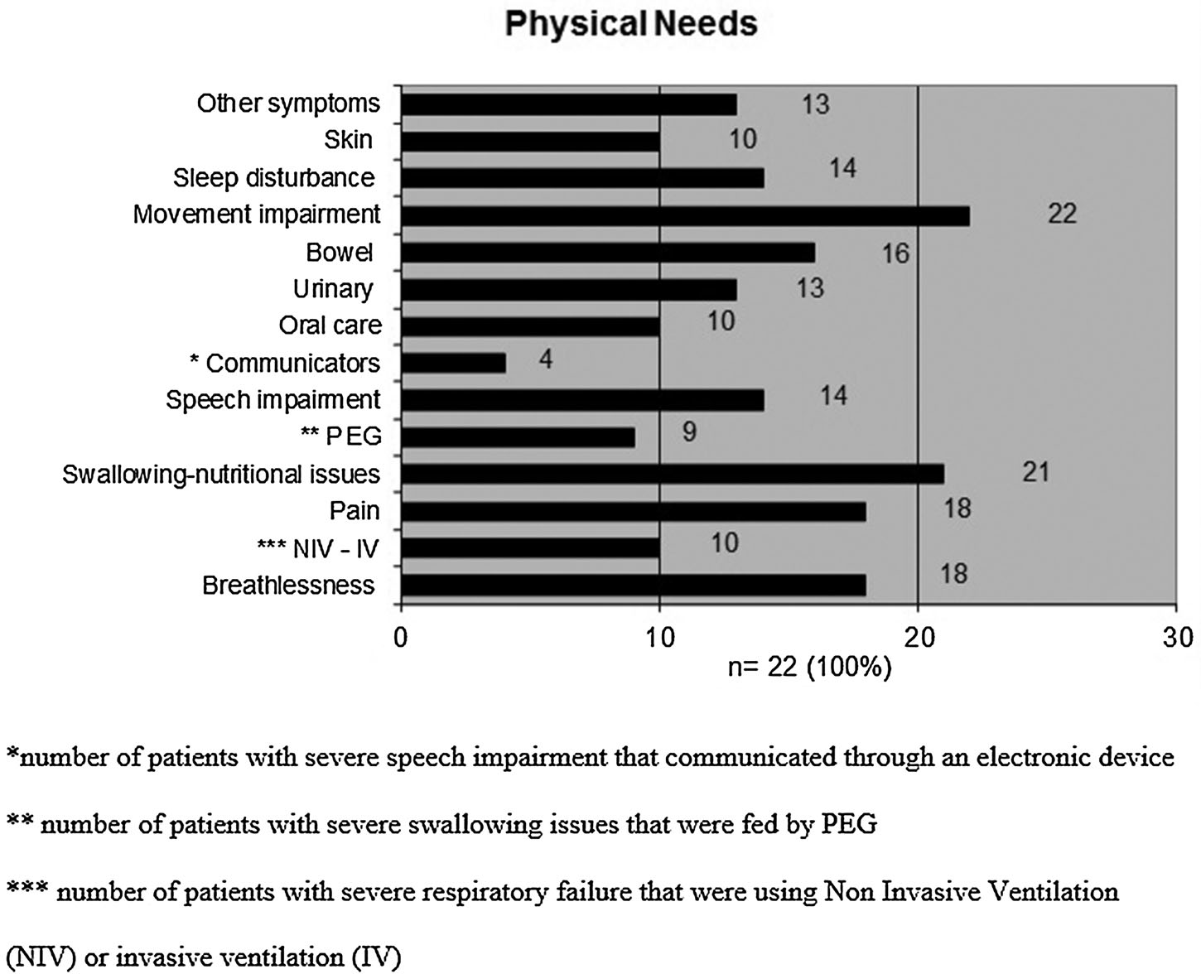

Figure 2 Psychological needs

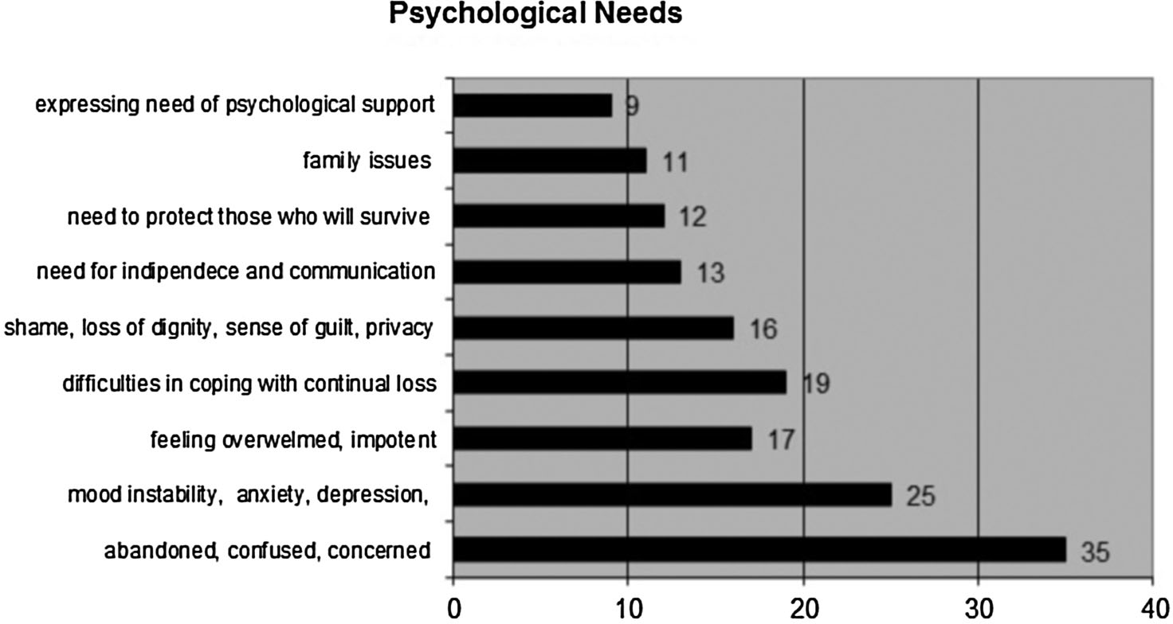

Figure 3 Social needs

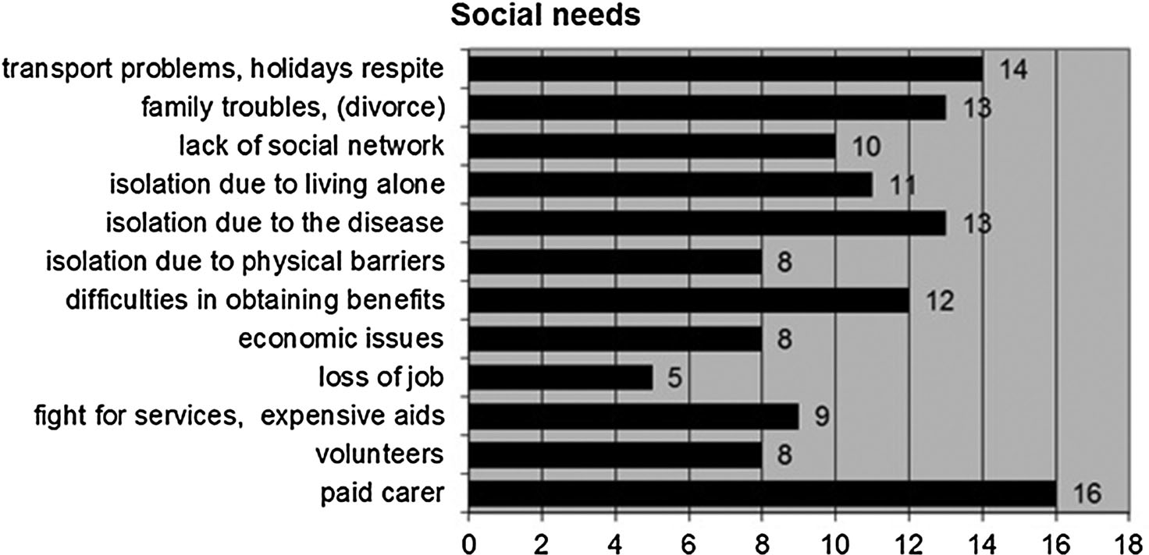

Figure 4 Spiritual needs

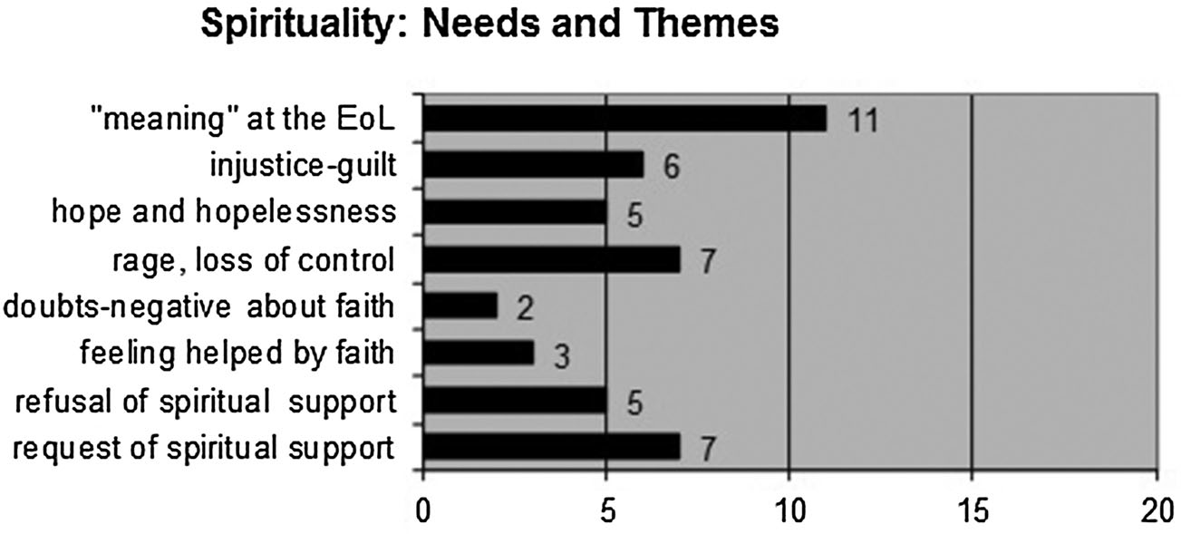

Appendixes

Table A1 interviews participants’ demographics and clinical features

Interviews | (n = 22)
Patient’s gender | M = 18 (82%) | F = 4 (18%)
Patient’s age | Mean = 61.5 | Range (39–80)
Main carer Wife = 16; husband = 3; daughter = 1; mother = 1; none = 1
Place of interviews | Home = 20 | Hospital = 1 | Nursing home = 1
Paid carers | Yes = 13 (59%) |  | No = 9 (41%)
Diagnosis | ALS (n = 9) | MS (n = 7) | PD (n = 5) MSA (n = 1)
Disability level | ALSFRS-R* | EDSS** | H&Y***
 | Mean = 11.3 | Mean = 9 | Mean = 4.5
 | Range = 3–23 | Range = 8–9.5 | Range = 4–5
*ALSFRS-R (Cedarbaum et al. 1999) relates to ASL/MND.
**EDSS (Kurtzke 1983) relates to MS.
***H&Y (Hoehn and Yahr 1967) relates to PDs.
Classification of participants: P, patient; C, Carer; ALS, amyotrophic lateral sclerosis; MS, multiple sclerosis; PD, Parkinson’s disease; MSA, multiple systems atrophy.
Patients and carers were numbered consecutively: e.g. PALS1, patent with ALS, number 1; CALS1, carer of patient with ALS, number 1.

Table A2 Participants of the Focus Groups

Focus |  |  | Specific
number | Participant | Professional role | interest
1 | EPD1 | Neurologist | PD
1 | EMS1 | Neurologist | MS
1 | EMS2 | Neurologist | MS
1 | EMS3 | Neurologist | MS
1 | EPC | Neurologist | Palliative
 |  |  | care
2 | EALS1 | Neurologist | ALS
2 | EPD2 | Neurologist | PD
2 | EMS4 | Neurologist | MS
3 | EALS2 | Rehabilitation | ALS
 |  | medicine specialist
3 | PHT | Physiotherapist | ALS
3 | SLT | Speech and | ALS
 |  | language therapist

